

Sampling and Analysis Plan

Department of Defence HydroScheme Industry Partnership Program

Banks Strait to Cape Barren

Permit Application Number: **PA2021-00114**

Customer Reference Number: AU429

Prepared By: iXblue Pty Ltd

Prepared For: Department of Agriculture, Water and the Environment



Document Date: 19 November 2021

iXblue Pty Ltd

ABN 61 128 811 978

[www.ixblue.com.au](http://www.ixblue.com.au/)

© 2020 iXblue Pty Ltd. All Rights Reserved.

Location Diagram

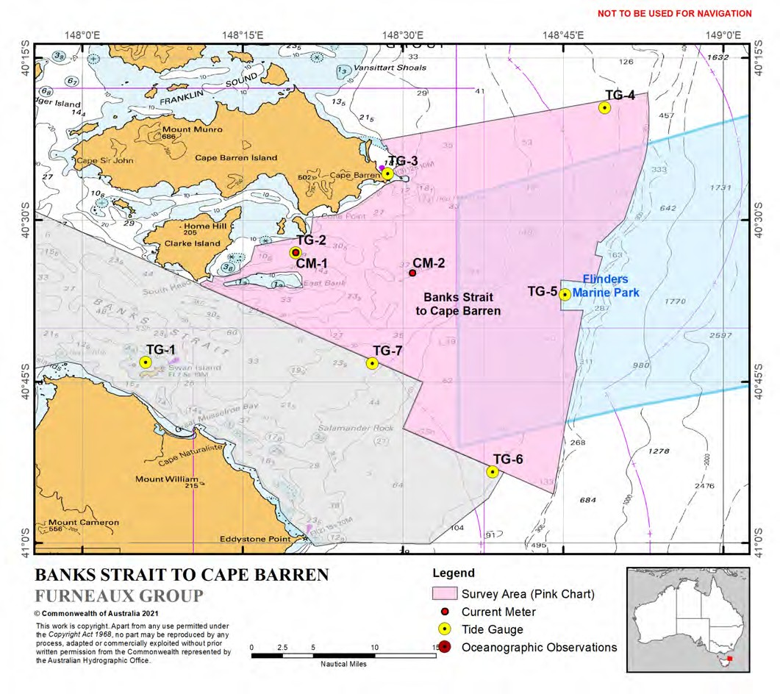

Document Control

iXblue Representative

|  |  |
| --- | --- |
| **Name** | David Donohue |
| **Position** | Managing Director |
| **Address** |  |
| **Telephone** |  |
| **Mobile** |  |
| **Email** |  |

iXblue Supervisor

|  |  |
| --- | --- |
| **Name** | Chris Walter |
| **Position** | Assistant Project Manager |
| **Address** |  |
| **Telephone** |  |
| **Mobile** |  |
| **Email** |  |

Client Representative

|  |  |
| --- | --- |
| **Name** | Dr Rebecca Haughey |
| **Position** | Protected Species and Communities Branch – Biodiversity Conservation Division |
| **Address** | Department of Agriculture, Water and the Environment |
| **Telephone** |  |
| **Mobile** |  |
| **Email** |  |

Document Revision

|  |  |  |  |  |
| --- | --- | --- | --- | --- |
| **Revision No** | **Issue Purpose** | **Prepared** | **Checked** | **Approved** |
| 1 | Initial Issue | C. Walter | M. Tunwell | D. Donohue |
| 2 | Revision 2 | C. Walter | E.Johnstone | D. Donohue |
| 3 |  |  |  |  |
| 4 |  |  |  |  |

Approval for Issue

|  |  |  |
| --- | --- | --- |
| **Name** | **Signature** | **Date** |
| David Donohue |  | 24 November 2021 |

Revision History

|  |  |  |  |
| --- | --- | --- | --- |
| **Item** | **Description of Change** | **Section** | **Revision** |
| 1 | Initial Issue | All | 1 |
| 2 | Amendments to legacy text and removal of editing comments | Section 4 | 2 |
| 3 |  |  |  |
| 4 |  |  |  |
| 5 |  |  |  |

Contents

1. Introduction 7
   1. About iXblue 7
2. Routine Commercial Research Project 8
   1. Project Background 8
   2. Purpose of Project 8
   3. Project Duration 8
   4. Project Risk Management 8
3. Proposed Methodology 10
   1. Entry Details 10
      1. OFFSHORE SOLUTION 10
      2. Vessel Tender 11
   2. Routine Commercial Research 11
   3. Biodiscovery 11
4. Sampling Design 12
   1. Phase 1 – Mobilisation 12
      1. Swan Island 12
      2. Cape Barren – Barren Island 12
   2. Phase 2 – Surveying 13
      1. Sonar Sensor (Multibeam Echosounder) 13
      2. Management of Marine Mammals and Reptiles 13
      3. Potential Impacts to Susceptible Marine Mammals 13
      4. Proposed Marine Mammal Mitigation Measures 14
      5. Seabed Sampling (Inspection Only) 15
   3. Phase 3 – De-Mobilisation Phase 15
      1. Swan Island 15
      2. Cape Barren – Cape Barren Island 15
5. Equipment 17
   1. Subsea and Shore Based Equipment 17
   2. Survey Equipment 19
   3. Vessel Mounted Sonar 19
   4. Water Temperature Sensor 20
   5. Sound Velocity Profiler 20
   6. Water Level Data Loggers 20
   7. Acoustic Doppler Current Profiler 21
   8. GNSS Buoy 21
      1. Seafloor Clump Weight 22
6. Research Sites and Locations 24
7. Marine Park Zone / Buffer Zone Access 25
8. Glossary 27

Appendix A:............................................................................................................................................................... A-1

A.1 Survey Instruction 1024 ........................................................................................................................ A-1

Appendix B:............................................................................................................................................................... B-1 B.1 Department of Defence Letter of Introduction ...................................................................................... B-1 Appendix C: .............................................................................................................................................................. C-1

C.1 Project Risk Assessment ...................................................................................................................... C-1

Tables

Table 1 : OFFSHORE SOLUTION Specifications 10

Table 2 : Deployed Subsea Equipment Details 17

Table 3 : Deployed Shore Based Equipment Details 17

Table 4 : Equipment Survey Summary OFFSHORE SOLUTION 19

Table 5 : Kongsberg EM2040 Mk II Multibeam Echo Sounder Specification 20

Table 6 : Tide Equipment Summary 21

Table 7 : ADCP Specification 21

Figures

Figure 1 : Indicative Survey Locations, Activities and Timeframes 9

Figure 2 : OFFSHORE SOLUTION 10

Figure 3 : OFFSHORE SOLUTION Vessel Tender 11

Figure 4 : Comparison of marine megafauna hearing ranges with anthropogenic sources 14

Figure 5 : iXblue Subsea Tripod Mount 18

Figure 6 : Subsea Sensors – Top Left & Centre Nortek Signature 500 ADCP, Top Right Deepwater Buoyancy Pop Up Buoy and Bottom RBR Virtuoso Water Level Logger 18

Figure 7 : Shore Based Equipment - Solinst Barologger (Dimensions: 22x160mm, Weight 166grams) 19

Figure 8 : iXblue GNSS Buoy 22

Figure 9 : Seafloor Clump Weight 23

Figure 10 : Survey Area (Pink Chart) - Research Sites and Locations 24

# Introduction

This Sampling and Analysis Plan (SAP) has been developed in support of iXblue’s Australian Marine Parks permit application (PA2021-00114) as submitted via the online portal on 20 October 2021.

iXblue are committed to the protection and conservation of our Australia’s Marine Parks and we will comply with all conditions defined within an issued Marine Park permit.

## About iXblue

iXblue is a global high-tech company specialising in the design, manufacturing and use of advanced autonomous, marine and photonics technologies. The group expertise includes innovative systems and solutions devoted to inertial navigation, subsea positioning, underwater imaging, hydrographic and geophysical surveying, as well as shipbuilding and test / simulation systems.

Underpinned by its unique and innovative technologies, iXblue offers expert services and turnkey solutions to its civil and defence customers to help them conduct their sea, land and space operations with optimum efficiency and reliability.

The iXblue Sea Operations division, previously known as iXSurvey, has been operating in Australia, New Zealand and the South Pacific since 2007. We have several long-term clients for whom we provide hydrographic survey services and have been one of the few continuous key suppliers to Land Information New Zealand since the inception of their hydrographic standing offer panel. Our primary focus is to provide our clients with detailed and precise surveys of the marine and littoral environment.

Our survey teams, based in Australia, New Zealand and France, are comprised of highly qualified and experienced hydrographers, oceanographers, marine environmental biologists, engineers, geologists, geophysicists and divers. Many have extensive Naval experience and others have considerable experience in oil and gas, construction and the offshore industry.

In addition to our highly qualified personnel, iXblue owns and operates a large inventory of state-of-the-art equipment and technology that is regularly refreshed to ensure that we can provide the most reliable, predictable and high-quality outcomes for our clients.

iXblue also operates within an ISO9001:2015, ISO14001 and AS4801 accredited Quality, Health, Safety and Environmental integrated management system, certified by SAI Global, so that our clients can rest assured that we will manage risk and optimise the outcome of their project.



# Routine Commercial Research Project

## Project Background

iXblue have been contracted by the Australian Government Department of Defence under the HydroScheme Industry Partnership Program (HIPP) to deliver a modern hydrographic survey consisting of bathymetric and geodetic collection activities within and adjacent the Flinders Marine Park which is close east of the Furneaux Group and Banks Strait.

A copy of the Survey Instruction 1024 (Banks Strait to Cape Barren) and Letter of Introduction from the HIPP are included at Appendix A and Appendix B to this SAP.

iXblue have sub-contracted Guardian Offshore Australia Pty Ltd for the provision of the Marine Vessel OFFSHORE SOLUTION and qualified marine crew. Guardian Offshore are an experienced marine vessel provider who have been operating in numerous sensitive Marine Parks around the Australian Coastline for over a decade for a wide variety of clients.

## Purpose of Project

The purpose of the prescribed survey activity is to increase the safety and navigational accuracy of existing Australian Hydrographic Service nautical charting products to facilitate the continued safe navigation of international shipping and domestic commercial vessels in the region. The project will also deliver a wide range of derivative products that will be provided to the GeoScience Australia led AusSeabed program.

These products will provide valuable marine science benefit across the nominated survey area.

## Project Duration

The survey is a six-month undertaking which is divided into four discrete phases, namely:

* Phase 1 – Mobilisation;
* Phase 2 – Surveying;
* Phase 3 – De-Mobilisation; and
* Phase 4 – Processing and Reporting.

The Data Acquisition Phases (namely Phases 1, 2 and 3) will see iXblue onsite collecting bathymetric and geodetic survey data within the nominated survey area over the period 13 December 2021 to 31 May 2022. Further detail on the locations, activities and timeframes for each of the three phases relevant to this SAP are depicted in Figure 1.

## Project Risk Management

Effective risk management is an operational necessity and the cornerstone of iXblue’s Integrated Management System. Risk management processes are applied to activities that iXblue controls or can influence, to identify, assess and manage existing and / or potential Health Safety Environment Quality risks.

A copy of iXblue high level Project Risk Assessment is included at Appendix C to this SAP.

**Data Acquisition Phase**

**Phase 1 - Mobilisation**

**(Hobart / Banks Strait / Flinders Marine Park)**

**1 Dec 21 - 12 Dec 21**

OFFSHORE SOLUTION vessel

and hydrographic survey system alongside installation, set-to- work and underway calibration period in Hobart

Transit to Survey SIte

(Hobart to Banks Strait)

Deployment of tide gauge and current meter infrastructure within Banks Strait and Flinders Marine Park

**Phase 2 - Surveying (Banks Strait)**

**13 Dec 21 - 30 May 22**

Mulitbeam Echo Sounder data gathering and water column sound velocity measurement within the Banks Strait survey area

Tide gauge calibrations (All Tide Stations)

Geodetic observations

(Swan Island and Cape Barren)

Seabed inspections

(Within Banks Strait survey area)

**Phase 3 - De-Mobilisation**

**(Banks Strait / Beauty Point)**

**Late April / Early May exact time TBD**

Recovery of tide gauge and current meter infrastructure within Banks Strait survey area

Transit from Survey Site (Banks Strait to Cairns)

OFFSHORE SOLUTION

hydrographic survey system alongside removal in Cairns

*Figure 1 : Indicative Survey Locations, Activities and Timeframes*

**Note:** Phase 3 De-Mobilisation timeframe includes 12 days of weather downtime allowance. The Data Acquisition Phase of the Project may finish as early as early April if weather downtime is not excessive.

# Proposed Methodology

## Entry Details

iXblue will operate solely from the OFFSHORE SOLUTION on a 24/7 basis for the duration of Phases 1 to 3. The data acquisition phases of the survey will be interspersed with vessel and personnel resupplies on an approximate 28-day cycle using the ports of Hobart and Beauty Point – Launceston.

### OFFSHORE SOLUTION

OFFSHORE SOLUTION is a 54 meter steel, mono-hull vessel with excellent seakeeping characteristics. OFFSHORE SOLUTION is crewed and homeported out of Cairns. The vessel is fitted with a highly efficient and economical diesel electric propulsion system and DP. This allows the use of DP in lieu of having to anchor the ship and with it – disturbing the seabed.

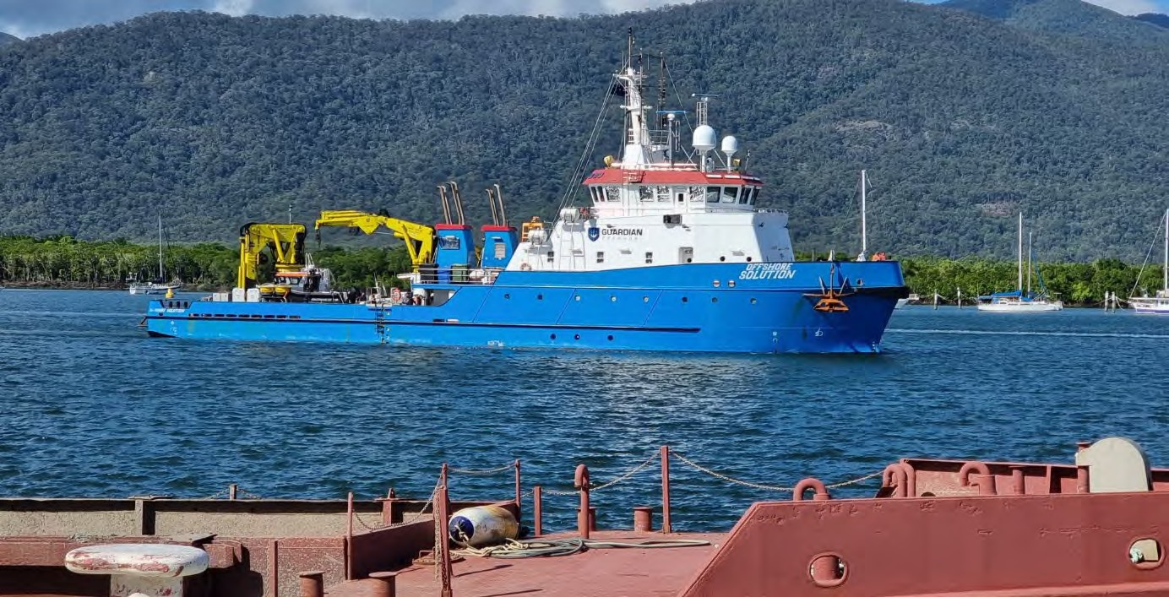

*Figure 2 : OFFSHORE SOLUTION*

*Table 1 : OFFSHORE SOLUTION Specifications*

|  |  |
| --- | --- |
| **Item** | **Detail** |
| **Vessel Name** | OFFSHORE SOLUTION |
| **State of Registration** | Australian Flagged |
| **Registration / Callsign Number** |  |
| **Survey Class** | 1A |
| **Length Overall** | 54.0m |
| **Beam** | 11.3m |
| **Draft** | 3.0m |
| **GRT** | 902 |
| **Year Built** | 2016 |
| **Construction** | Steel |
| **Engine / Propulsion** | 6 x Volvo D13 – 420kW each |
| **Generators** | 2 x Volvo D9 – 260kW each |
| **Crew** | 7 (6 Marine Watchkeepers + 1 Cook) |

|  |  |
| --- | --- |
| **PAX – Permitted and Intended** | Permitted: 24 Intended: 14 (7 Crew + 7 Surveyors) |

### Vessel Tender

OFFSHORE SOLUTION’s tender is a 5.3 metre rigid hull inflatable boat and will be secured on the vessel’s rear deck when not in use. The tender will be used to transfer survey personnel from the OFFSHORE SOLUTION to shore-based locations and to aid in the deployment and recovery of tide gauge and current meter infrastructure.

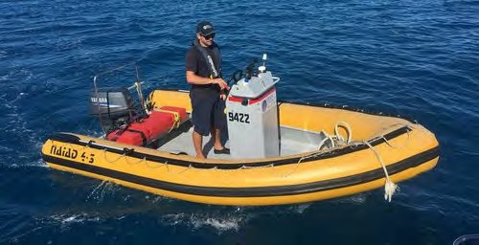

*Figure 3 : OFFSHORE SOLUTION Vessel Tender*

## Routine Commercial Research

Although the survey is being completed under contract for the Australian Government Department of Defence, the activity is considered extractive Routine Commercial Research. This has been determined as a Sonar sensor (High Frequency Multibeam Echosounder) will be used and temporary subsea (tide gauge / current meter sensors) and shore based (GNSS and barometric sensors) will be deployed throughout the survey area.

## Biodiscovery

During the survey, neither iXblue nor any of our identified sub-contractors will be required to access biological resources for the purposes of biodiscovery. Subsequently, no detail has been provided within this SAP on biodiscovery.

# Sampling Design

## Phase 1 – Mobilisation

### Swan Island

**Primary Requirement:** Access Swan Island to recover historical survey benchmarks AU0005, AU0007 and AU0017. These benchmarks were established by iXblue (OFFSHORE SOLUTION) during SI1020 in April 2021. The benchmarks be occupied by iXblue to recover the historical tidal datum.

**Planning Considerations:** iXblue acknowledge that Swan Island is a National Park and that it is a an important habitat for several bird species. iXblue will adopt a zero-footprint policy ensuring that everything brought onto the island, including the vessel’s tender, survey equipment, personnel clothing and footwear are clean so as to prevent any potential for cross contamination. Additionally, at Swan Island, the tender will not beach when disembarking personnel and equipment and will return outside the intertidal zone on completion.

**Planned Activities:** Two survey personnel will land ashore via a tender from OFFSHORE SOLUTION or via chartered helicopter to:

* Conduct precise levelling observations between the three established benchmarks.
* Temporarily establish Global Navigation Satellite System (GNSS) field equipment directly over the benchmarks for three, independent 24-hour observation sessions (72 hours total) to validate their documented horizontal coordinates and vertical heights; and
* Temporarily establish two Solinst Barologgers. These small sensors record real-time atmospheric pressure and aid in tidal modelling. The sensors will be discretely positioned and cause no impact to the flora and fauna of Swan Island.

**Planned Access:** Shore based activities on Swan Island are planned to occur as soon as possible after the OFFSHORE SOLUTION arrives on site. Wind and sea conditions are considered the primary determinant of achieving this. We estimate that this activity will occur on or shortly after 13 December 2021.

### Cape Barren – Barren Island

**Primary Requirement:** Access Cape Barren to establish three new bench marks and to deploy two (primary and secondary) Solinst Barologgers.

**Planning Considerations:** iXblue will adopt a zero-footprint policy ensuring that everything brought onto the island, including the vessel’s tender, survey equipment, personnel clothing and footwear are clean so as to prevent any potential for cross contamination.

**Planned Activities:** Two survey personnel will land ashore via a tender from OFFSHORE SOLUTION or via chartered helicopter to:

Establish three permanent bench marks, and

Temporarily establish two Solinst Barologgers. These small sensors record real-time atmospheric pressure and aid in tidal modelling. The sensors will be discretely positioned and cause no impact to the flora and fauna of Border Island.

**Planned Access:** Shore based activities on Barren Island are planned at the commencement of the survey at the following periods:

* 15 December 2021; and
* Early April 2022.

## Phase 2 – Surveying

The survey area covers an area of approximately 570nm2 with approximately half of the area planned to be undertaken within the designated Flinders Marine Park. To inform other vessels operating within the immediate area of potential interaction, iXblue will issue a Notice to Mariners prior to commencing survey operations. The Notice to Mariners will provide sufficient information to other vessels of the proposed survey activities and will cover the entire data acquisition phase. Additionally, in accordance with Collision Regulations, OFFSHORE SOLUTION will display restricted in ability to manoeuvre shapes (by day) and lights (by night) to inform other vessels of the nature of work being conducted.

### Sonar Sensor (Multibeam Echosounder)

In order to accurately map the seafloor, iXblue will install, set-to-work and calibrate an integrated hydrographic survey system onboard OFFSHORE SOLUTION prior to the commencement of the data acquisition phase. The primary sensor used to map the seafloor is a Multibeam Echosounder (MBES). A MBES calculates the depth of the seafloor by measuring the two-way travel time of a soundwave from the vessel mounted transducer to the seafloor and then back.

### Management of Marine Mammals and Reptiles

iXblue are accustomed to operating within sensitive marine environments. In the last two years our Australian and New Zealand survey teams have planned, executed and delivered the following successful hydrographic survey campaigns:

* Land Information New Zealand survey of Fiordland National Park (World Heritage listed Dusky, Doubtful, Thompson, Bradshaw, Nancy and Charles Sounds); and
* Land Information New Zealand and Marlborough District Council survey of Western Marlborough Sounds (New Zealand’s centre for aquaculture industry).

In November 2019, in support of the Western Marlborough Sounds survey, iXblue worked with New Zealand’s National Institute of Water and Atmospheric Research (NIWA) to obtain specialist Marine Mammal Observer (MMO) training. iXblue survey teams were trained on:

* Roles and responsibilities of an MMO;
* Identification and behaviours of species;
* Equipment (processes and, procedures); and
* Reporting.

The underpinning knowledge and skills gained from this training are transferable and remain relevant to the potential encounters of species that may be possible during this survey within the Flinders Marine Park.

### Potential Impacts to Susceptible Marine Mammals

In April 2019, New Zealand’s largest independent science organisation, Cawthron Institute, provided Marlborough District Council technical advice on the potential effects on marine mammals from hydrographic survey Sonar sensors (i.e. High Frequency Multibeam Echosounders operating at 200kHz to 400kHz)1. The advice highlighted that:

* High frequency multibeam surveys are generally audible to dolphins but not to baleen or beaked whales and therefore, any impacts are only likely for dolphins. Due to the high frequency profile of the source, the range of audibility (i.e., the area of effect) will be limited and highly directional

1https://www.marlborough.govt.nz/repository/libraries/id:1w1mps0ir17q9sgxanf9/hierarchy/Documents/Environment

/Coastal/Seabed%20Habitat%20Mapping%20List/Review_of_multibeam_echosounder_surveys_and_marine_ma mmals.pdf

(e.g., at maximum several hundred metres around the source), and will be inaudible outside of this area;

* The overall risk of general multibeam surveys to dolphins is low (and extremely low / negligible for baleen and beaked whales) but the exact risk will vary, dependent on the specific nature of the survey type (e.g., source strength, frequency range, duration, location). While the overall risk of multibeam survey is low, multibeam surveys utilising medium frequencies represent a higher risk than high frequency surveys due to the increased audibility of medium frequency sound to dolphins; and
* While there have been a range of new studies looking at potential impacts from MBES surveying, there has been no significant change to the previous conclusions that high frequency (i.e. >200 kHz) multibeam surveys are unlikely to be audible to most to marine mammal species, and even if they are, the narrow beam and high attenuation of the sonar signal will mean that any impacts will be very localised to the area immediately around (i.e. within 200m) the vessel.

The Multibeam Echosounder that will be used by iXblue during this survey is the Kongsberg EM2040 Mk II which has an operating frequency of 200kHz to 400kHz. The Sonar will be set to 300kHz for the duration of the survey. Figure 5 identifies where the 2040 lies on the acoustic frequency spectrum.

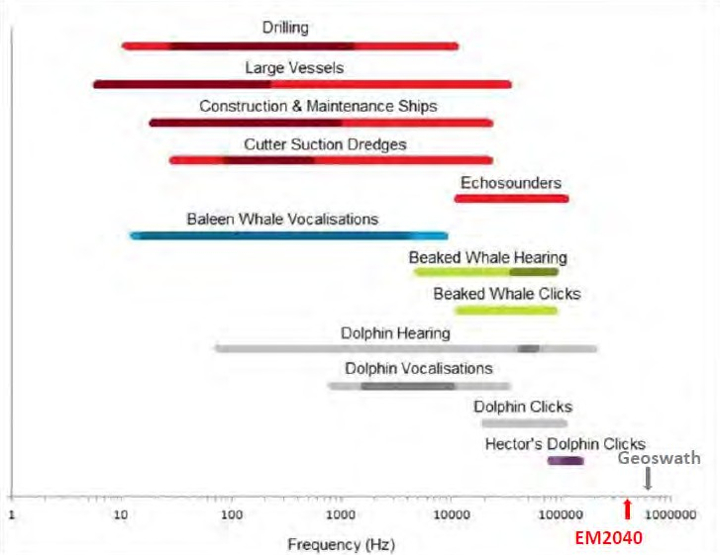

*Figure 4 : Comparison of marine megafauna hearing ranges with anthropogenic sources*

### Proposed Marine Mammal Mitigation Measures

The proposed multibeam survey of Cape Barren region, including inside Flinders Marine Park represents a low risk to marine mammals, but this risk can still be reduced through careful planning and undertaking some reasonably simple mitigation actions.

There are a range of mitigation measures for reducing or eliminating the impacts on marine mammals from hydrographic survey sensors. Although there is a strong focus on mitigation associated with seismic surveys, some guidelines do broadly apply to multibeam surveys (i.e., USA, UK). Based on a review of risk avoidance and minimisation measures, the following simple mitigation and pre-survey planning actions shall be implemented for Banks Strait to Cape Barren survey area; Recommended mitigation actions for any multibeam survey undertaken in the region include:

* Selection of lowest possible output power and highest possible frequency range.
* Survey spatial design should aim towards reducing the potential for impact.
* Pre-start observations and soft start (ramp-up) procedures are followed whenever possible.
* Dedicated observations for whales and dolphins at potentially sensitive times.
* Development of protocols for shut down of the acoustic source when marine mammals show strong avoidance behaviour and / or appear to be at risk of stranding.
* Marine mammal induction for personnel involved in the survey.

### Seabed Sampling (Inspection Only)

At the conclusion of the data acquisition phase of the survey, one day of seabed sampling (by physical collection) will be undertaken to ground truth the acquired multibeam backscatter mosaic. The number and locations of the inspection sites will be informed by the backscatter mosaic with due consideration to historical seabed sample locations and their distribution.

Should approval to collect physical samples be denied, a drop camera will be employed to capture video (and a derived digital image) to determine the seabed composition at each location in lieu of using a traditional seabed sampler to obtain a physical sample. For planning purposes, 12 inspections have been assumed, however this is for timing purposes rather than a definitive number.

## Phase 3 – De-Mobilisation Phase

### Swan Island

**Primary Requirement:** Access Swan Island to recover the deployed Solinst Barologger sensors.

**Planning Considerations:** iXblue will adopt a zero-footprint policy ensuring that everything brought onto the island, including the vessel’s tender, survey equipment, personnel clothing and footwear are clean so as to prevent any potential for cross contamination.

**Planned Activities:** Two survey personnel will land ashore via a tender from OFFSHORE SOLUTION or via chartered helicopter to:

* Recover two Solinst Barologgers.

**Planned Access:** Shore based activities on Swan Island planned to occur at the completion of the survey over the following period:

* Late March to early April 2022.

### Cape Barren – Cape Barren Island

**Primary Requirement:** Access Barren Island to recover the deployed Solinst Barologgers.

**Planning Considerations:** iXblue will adopt a zero-footprint policy ensuring that everything brought onto the island, including the vessel’s tender, survey equipment, personnel clothing and footwear are clean in order to prevent any potential for cross contamination.

**Planned Activities:** Two survey personnel will land ashore via a tender from OFFSHORE SOLUTION to:

* Recover two Solinst Barologgers.

**Planned Access:** Shore based activities on Cape Barren Island planned to occur at the completion of the survey over the following period:

* + Late March to early April 2022.

# Equipment

## Subsea and Shore Based Equipment

In support of the planned bathymetric survey activities, tide gauge and current meter monitoring equipment is to be temporarily deployed on the seafloor and shore within the Banks Strait to Cape Barren survey area. The temporary nature of each deployment ensures that a zero footprint is left at each of the sites. An overview of the subsea and shore-based equipment to be deployed during the survey period is included in Table 2 and Table 3.

For each seabed deployment, a Notice to Mariners will be lodged with the Australian Hydrographic Office and Marine and Safety Tasmania covering the duration of the deployment period.

*Table 2 : Deployed Subsea Equipment Details*

|  |  |  |  |  |  |
| --- | --- | --- | --- | --- | --- |
| **Type of Equipment** | **Dimensions (m)**  **(L x W x H)** | **Number in Total** | **Number Per**  **Location** | **Method of Deployment** | **Length of Deployment** |
| Subsea Tripod Mount (Stainless Steel) to house tide gauge and current meter oceanographic sensors. See Figure 6. | 1.150 x 0.992 x 0.535 | 7 | 1 | Standalone subsea mount. Controlled deployment from the sea surface to the seafloor. Tripod mount will sit on the seafloor under its own weight.  Recovered via acoustic Pop-Up Buoy. | 15 Dec 21 –  15 April 22 |
| RBR Virtuoso DTide 16 Water Level Logger. See  Figure 7. | Attached to the Tripod Mount | 14 | 2 | As per subsea Tripod Mount | 15 Dec 21 –  15 April 22 |
| RBR Virtuoso DTide 16 Water Level Logger. See Figure 7. | Deployed with dual acoustic releases and a subsea floatation sphere using sacrificial moorings | 4 | 2 | To be deployed on the western boundary of the survey area where depth is too great  for pop up buoys | 15 Dec 21 –  15 April 22 |
| Nortek Signature 500 Acoustic Doppler Current Profiler (600kHz).  See Figure 7. | Attached to the Tripod Mount at CM-1 and CM-2 (offshore tide stations) | 2 | 1 | As per subsea Tripod Mount | 15 Dec 21 –  15 April 22 |
| Deepwater Buoyancy Pop-Up Buoy (Tripod Mount recovery device). See  Figure 7. | Attached to the Tripod Mount | 7 | 1 | As per subsea Tripod Mount | 15 Dec 21 –  15 April 22 |

*Table 3 : Deployed Shore Based Equipment Details*

|  |  |  |  |  |  |
| --- | --- | --- | --- | --- | --- |
| **Type of Equipment** | **Dimensions (m)**  **(L x W x H)** | **Number in Total** | **Number Per**  **Location** | **Method of Deployment** | **Length of Deployment** |
| Solinst Barologger. See Figure 8. | 0.159 x 0.022 x 0.022 | 2 | 2 | Attached to an outdoor fixed structure at Swan Island and Cape  Barren | 15 Dec 21 –  15 April 22 |

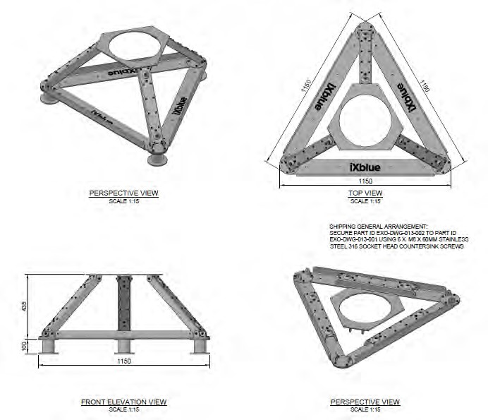

*Figure 5 : iXblue Subsea Tripod Mount*

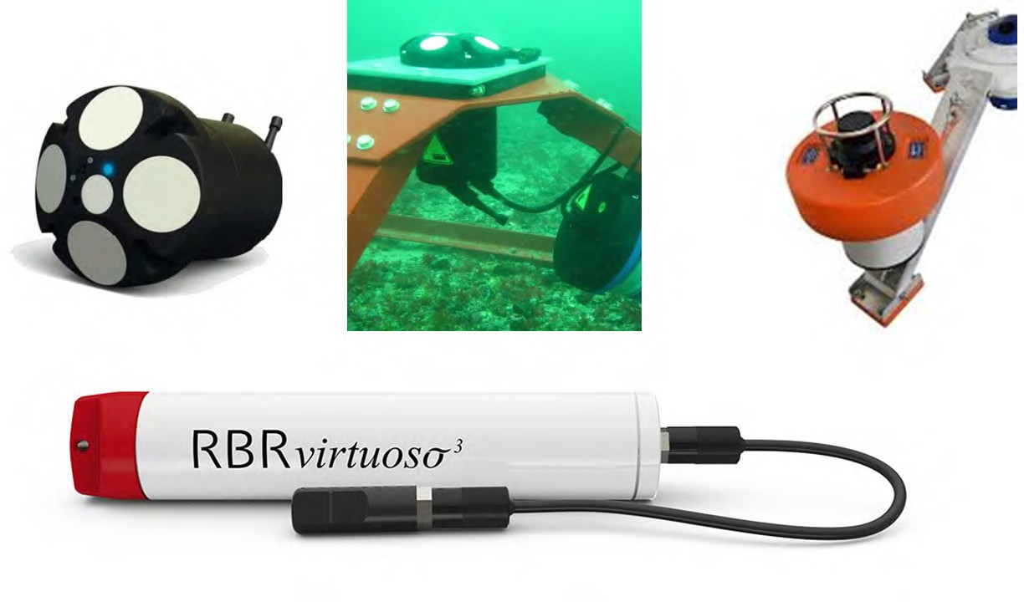

*Figure 6 : Subsea Sensors – Top Left & Centre Nortek Signature 500 ADCP, Top Right Deepwater Buoyancy Pop Up Buoy and Bottom RBR Virtuoso Water Level Logger*

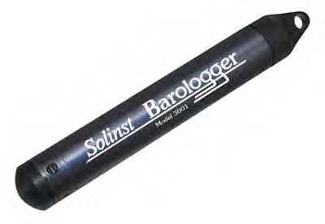

*Figure 7 : Shore Based Equipment - Solinst Barologger (Dimensions: 22x160mm, Weight 166grams)*

## Survey Equipment

iXblue intend to utilise owned hydrographic survey sensors which are to be considered industry best for the purposes of safety of navigation surveys. The high-level equipment summary intended for the Project is included in Table 13.

*Table 4 : Equipment Survey Summary OFFSHORE SOLUTION*

|  |  |  |
| --- | --- | --- |
| **Equipment** | **Type** | **Comments** |
| **Multibeam Echo Sounder (MBES)** | Kongsberg EM2040 Mk II (0.4 x 0.7 Deg) Single Head | Owned by iXblue  Custom designed over the side MBES mount |
| **Primary Motion Compensation** | iXblue ROVINS | Owned by iXblue |
| **Secondary Motion Compensation** | iXblue ROVINS | Owned by iXblue |
| **Primary Positioning Solution** | Septentrio AsteRx-U Marine Fg  GNSS Receiver with PolaNt-x Antenna | Owned by iXblue |
| **Secondary Positioning Solution** | Trimble GA830 antenna Fugro 9205 GNSS receiver | Owned by iXblue |
| **Sound Velocity Tx** | Valeport Mini SVS | Mounted on MBES Pole |
| **Sound Velocity Profiler** | Valeport SWiFT SVT | Owned by iXblue |
| **Data Acquisition** | QPS QINSy, Kongsberg SIS, iXblue MultiLogger, Septentrio Rx Logger | Latest Version |
| **Data Acquisition** | Alidade Constellation | SVP Management |
| **Data Processing** | CARIS HIPS & SIPS, Novatel GrafNav, iXblue APPS | Latest Versions |

## Vessel Mounted Sonar

The vessel will be fitted with the iXblue owned Kongsberg EM2040 Mk II (0.4 x 0.7 degree) single head Multibeam Echosounder (MBES) system. This system is optioned with dual ping option which yields double the sounding density of a ‘standard’ system. The combination of narrow across track beams (0.4 degree), a wide swath (theoretically equal to 7 x Water Depth), a dual ping capability and electronic pitch stabilisation make this an ideal sensor choice for this project. In combination with the ROVINS Inertial Navigation Systems and an automated sound velocity profiling system, there is not a better suited system that could be

used for this project. The specifications for the EM2040 Mk II with proposed deployment configurations are detailed in Table 14.

*Table 5 : Kongsberg EM2040 Mk II Multibeam Echo Sounder Specification*

|  |  |
| --- | --- |
| **EM2040 MKII Multibeam Echo Sounder Specifications** | |
| **Frequency** | User selectable 200 - 400 kHz in 10 kHz steps 300 kHz to be used for the duration of SI1007 |
| **Maximum Ping Rate** | 50 Hz |
| **Number of Soundings Per Ping** | 1024 per sonar head |
| **Beamwidth** | 0.5 (Tx) x 1.0 (Rx) degrees at 300 kHz |
| **Beam Spacing** | Equidistant / Equiangular / High Density Equidistant |
| **Coverage Sector** | 140 degrees (Limitation set by Survey Instruction Specification) |
| **Maximum stated depth (Kongsberg)** | 600m – 200 kHz cold ocean water |
| **Transmit Beam steering** | +/- 10 degrees steps along track |
| **Range Resolution** | 18 mm @ 25 µs pulse length |
| **Beam Forming method** | Time delay with dynamic focusing in near field |
| **Data Storage Rate** | 50 to 400 MB/h |

## Water Temperature Sensor

The Valeport miniSVS sensors used by iXblue to measure the sound velocity at the MBES sonar face are configured to measure and record the sea surface temperature in real time. Note that the temperature will be valid for the actual depth of the Sound Velocity Sensor (SVS) sensor at the MBES sonar which may be up to 2m below the sea surface for small boat, shallow water operations. The temporal resolution for these readings is determined by the path (vessel tracking) of the survey vessel.

## Sound Velocity Profiler

The Valeport SWiFT sensor operated by iXblue to undertake water column Sound Velocity Profile (SVP) measurement will be configured to calculate salinity for each SVP conducted. Whilst the SWiFT is not a Continuity Temperature and Depth sensor, it does use a combination of pressure sensor and temperature to derive both sound velocity and salinity. The downloaded SWiFT profiles are loaded into the Alidade Constellation software which calculates a mean salinity value for each cast. The mean salinity value is then entered into the online acquisition software and used in real-time to update absorption coefficient values.

## Water Level Data Loggers

iXblue proposes that the primary and secondary water level pressure sensors at each tide gauge location will be RBR Virtuoso DTide units with a 20m pressure sensor used at nearshore tide stations and a 100m pressure sensor used at offshore tide stations. The primary and secondary pressure sensors will be configured using the native RBR Ruskin software and will record water level observations at five-minute intervals for the entire deployment period. Both the primary and secondary sensors will be non-vented and therefore will not remove the effects of local atmospheric pressure from the sensor recordings.

Atmospheric pressure readings will be recorded at five-minute intervals by Solinst Barologger Sensors deployed at shore-based tide station locations and onboard OFFSHORE SOLUTION. These sensors will be used to accurately represent the changes of barometric pressure experienced.

*Table 6 : Tide Equipment Summary*

|  |  |  |
| --- | --- | --- |
| **Instrument Detail and Setting** | **Water Level Logger** | **Barometric Sensor** |
| **Make and Model** | RBR Virtuoso DTide 16 | Solinst Barologger |
| **Logging Method** | Linear Averaging | Linear |
| **Logging Interval** | 5 minutes (configured for ‘on the hour’ readings) | 5 minutes (configured for ‘on the hour’ readings) |
| **Interval Samples** | 60 @ 1 second | 1 second |
| **Pressure Units** | dbar | mbar |
| **Temperature Units** | Celsius | Celsius |
| **Depth Units** | Metres | N/A |
| **Density** | 1.024 | N/A |
| **Range / Max Deployment Depth** | 20m (Shore + Nearshore) 100m (Offshore) | 30 psia (16.5psi) |
| **Resolution** | 20m <0.001% Full Scale 100m <0.001% Full Scale | ±0.002% Full Scale |
| **Accuracy** | 0.05% of full scale | ± 0.05 kPa |

## Acoustic Doppler Current Profiler

iXblue will deploy Nortek Signature 500 Acoustic Doppler Current Profiler’s (ADCP) for the survey. It is planned to deploy these units in the designated locations for CM-1 and CM-2 as per Paragraph 6.1. The ADCP specification is detailed in Table 7.

*Table 7 : ADCP Specification*

|  |  |
| --- | --- |
| **Item** | **Specification** |
| **ADCP Model and Type** | Nortek Signature 500 600kHz |
| **Number of Beams** | 4 lateral (25deg) + 1 vertical |
| **Current Speed** | Range user selectable 2.5 or 5.0m/s  Accuracy +/- 0.3% of measured value +/-0.3cms-1 Resolution 0.1 cm/s |
| **Compass** | Range 0-360 degrees Accuracy +/-2%  Resolution 0.01 degrees |
| **Tilt** | Range +/- 15 degrees Accuracy +/- 0.5 degrees  Resolution 0.01 degrees |
| **Water Temperature** | Range -4 to 40 degrees Celsius Accuracy +/-0.1 degrees Celsius Resolution 0.01 degrees Celsius |

The ADCP will come fitted with an 1800W/Hr internal battery. iXblue propose a sampling regime for current measurement every 10 minutes using a two-minute averaging period. For wave measurement, iXblue propose to sample at 2Hz for a period of 2048 seconds (17minutes) every 20 minutes. With the battery capacity fitted, this will provide for 132 days of measurement which is ample for this Project. The ADCP will also be fitted with a pressure sensor which will add a third layer of tidal redundancy for the project.

## GNSS Buoy

iXblue have utilised Global Navigation Satellite System (GNSS) buoy technology for its traditional ‘pole to tide gauge’ calibrations process since 2013 in a variety of locations and conditions. For the Banks Strait Project, iXblue propose to employ a 1200mm diameter GNSS buoy (Figure 9) due to the exposed nature of the tide gauge sites.

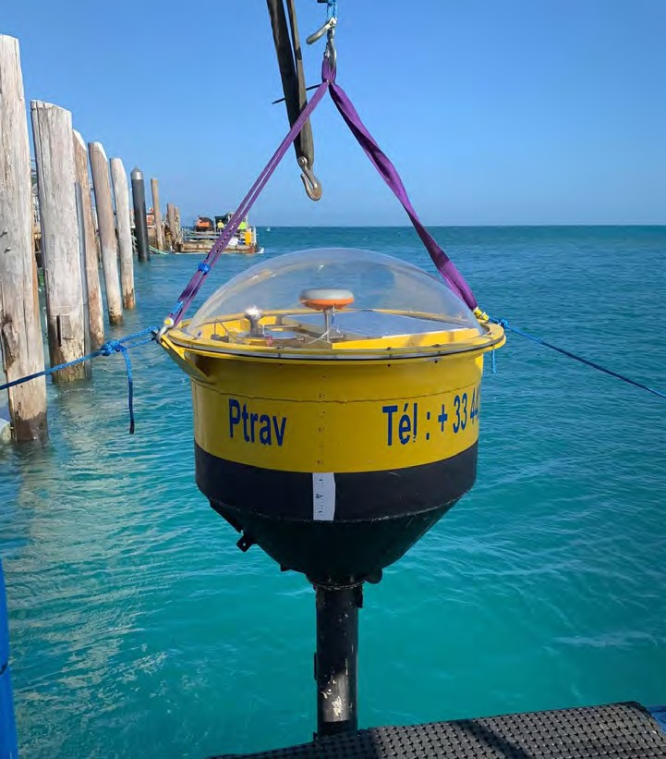

*Figure 8 : iXblue GNSS Buoy*

The GNSS buoy will be equipped with a Septentrio GNSS receiver and will be temporarily co-located in the vicinity of the deployed tide gauges. The buoy (Figure 9) is yellow in colour and is fitted with a light and radar reflector.

The system will provide high accuracy results following post processing using Novatel GrafNav software and a Post Processed Kinematic (PPK) solution for shore-based / nearshore tide stations and a Precise Point Positioning (PPP) solution for offshore tide stations.

The ‘GNSS Buoy to Tide Gauge Calibration’ determines the linear correlation between the relative height differences from the tide gauge depths and GNSS Buoy ellipsoidal heights throughout a 72-hour tide cycle (over Spring tide conditions).

OFFSHORE SOLUTION is fitted with a 20T heave compensated knuckle boom crane and is ideally suited for the safe launch, recovery and relocation of the GNSS buoy.

### Seafloor Clump Weight

The GNSS buoy will be temporarily moored to the seafloor using a steel clump weight (Figure 10). The weight is made from ¾ inch steel chain welded together. The clump weight has a small footprint measuring 300mm in diameter and weighing approximately 30kg (in-air and in-water).

The clump weight will have a 10mm winchline UHM12 rope connecting the weight from the seafloor to the GNSS buoy on the surface. The weight will be recovered on completion of each GNSS buoy deployment.

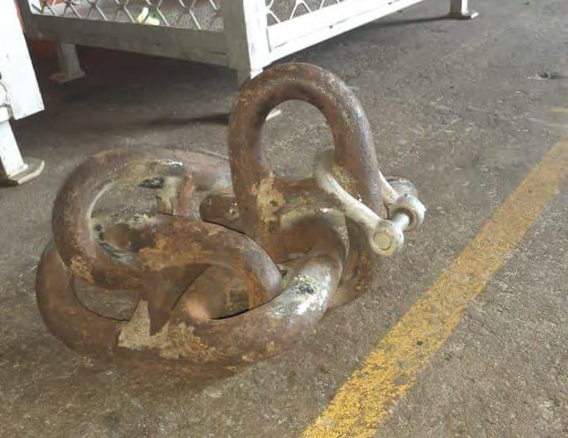

*Figure 9 : Seafloor Clump Weight*

# Research Sites and Locations

The bathymetric survey area and temporary deployment locations of all tide gauges and current meters are depicted in Figure 12.

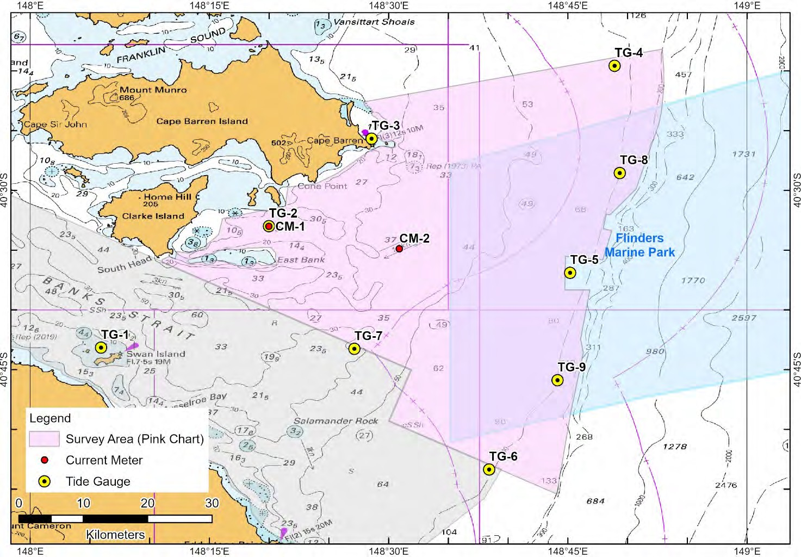

*Figure 10 : Survey Area (Pink Chart) - Research Sites and Locations*

# Marine Park Zone / Buffer Zone Access

In accordance with the *Environment Protection and Biodiversity Conservation Act 1999* (EPBC Act), iXblue requests on-water access to Marine Park Zones (only). We acknowledge these are within *Biologically Important Areas (BIAs)* for several large megafauna species, including marine mammals and sharks.

Cetacean permits have been applied for alongside our main Marine Parks permit.

iXblue’s justification for the request to conduct ‘extractive’ research is based on the following:

* The primary purpose of this Australian Government Department of Defence survey is to increase the safety and navigational accuracy of existing Australian Hydrographic Service nautical charting products to facilitate the continued safe navigation of international shipping and domestic commercial vessels in the region.
* Shore access to Swan Island is an essential component of the on-water data acquisition phase. Access will allow the collected bathymetric data to be reduced to the Lowest Astronomical Tide Datum for inclusion on the updated nautical charting products and to establish a recoverable connection to the known land Datum.
  1. What steps will be taken to minimise impacts on cetaceans.

In order to reduce the potential for vessel collision or disturbance to blue whales and other cetaceans encountered during the project, iXblue will adhere to the following precautions:

1. Multibeam echosounders will be operated at high frequencies (200-400kHz) to avoid noise impacts on marine mammals.
2. One Dedicated MMO and two trained bridge crew will observe for marine mammals during daylight hours at all times the survey equipment and vessel is operating within the Biologically Important Area for blue whales.
3. Bridge crew will complete a project-specific Marine Mammal Observer training course that covers the following topics:
   1. General introduction and project overview;
   2. Environmental responsibilities and legislation, company environmental policy;
   3. Key environmental issues and sensitivities;
   4. Documentation relevant to the project (e.g. approval & permit conditions);
   5. MMO roles and responsibilities;
   6. Marine fauna species of concern
   7. Potential impacts of vessels, hydrographic surveys and other activities on marine fauna;
   8. Mitigation zones and operations protocols for vessels and standard hydrographic activities;
   9. Marine mammal observation techniques, including species ID and marine fauna behaviour;
   10. Distance determination, including suggested equipment to aid with distance estimation;
   11. Data recording and reporting; and
   12. MMO Health and Safety.

N.B. Some bridge crew have already completed Marine Fauna Observer inductions delivered by marine mammal experts for previous projects.

1. Adhere to the minimum approach distances set out in Part 8 Division 8.1 of the *EPBC Regulations 2000* and the [*Australian National Guidelines for Whale and Dolphin Watching*.](https://www.environment.gov.au/system/files/resources/7f15bfc1-ed3d-40b6-a177-c81349028ef6/files/aust-national-guidelines-whale-dolphin-watching-2017.pdf) The minimum approach distance will be extended to 500 m in all directions around blue whales.
2. Operate at speeds of less than 8 knots while completing survey activities and during periods of low visibility and at less than 12 knots while in transit during good visibility conditions.
3. Use of Dynamic Positioning thrusters will be minimised or eliminated where possible. DP will only be required for short periods at the start and end of the project.
4. Maintain communications between vessels, as well as contacting any other vessels in the vicinity, to warn of any cetacean sightings.
5. Alter course to avoid cetaceans whenever practical.
6. Adhere to conditions based on and adapted from section *A.3.6 Night-time and low visibility procedures* of EPBC Act Policy Statement 2.1:
   1. At night-time or at other times of low-visibility (when observations cannot extend to 3km from the vessel, e.g. during fog or periods of high winds), the following measures apply for start up of survey equipment and operations:
      1. Start up may be commenced:
         * provided that there have not been 3 or more whale instigated mitigation actions (i.e. the vessel needing to shut down or alter course to maintain minimum approach distances) during the preceding 24 hour period; or
         * if operations were not previously underway during the preceding 24 hours, the vessel (and/or a spotter vessel or aircraft) has been in the vicinity (approximately 10km) of the proposed start up position for at least 2 hours (under good visibility conditions) within the preceding 24 hour period, and no whales have been sighted.
      2. Operations may proceed provided that there have not been 3 or more whale instigated mitigation actions during the preceding 24 hour period.
      3. During low visibility, where conditions allow, continuous observations to spot whales should be maintained with a particular focus on the area 500m around the vessel. If whales are detected then the survey will cease until visibility conditions allow MMOs to observe to 3km from the vessel and no whales are detected.
      4. If sightings of whales have been frequent or are higher than were anticipated during the planning of the survey, iXblue will contact the Department to discuss appropriate night-time provisions and whether additional management measures should be employed for day and/or night-time operations.
7. MMOs and trained bridge crew will be provided with reticle binoculars that allow them to estimate distances up to 5.3 km from the bridge of the OFFSHORE SOLUTION (12m above sea level).

# Glossary

|  |  |
| --- | --- |
| **Acronym** | **Full Context** |
| **ADCP** | Acoustic Doppler Current Profiler |
| **AHO** | Australian Hydrographic Office |
| **BPM** | Blue Planet Marine Australia Pty Ltd |
| **CM** | Current Meter |
| **DM** | Degrees Minutes |
| **EPBC** | Environment Protection and Biodiversity Conservation |
| **GBRMP** | Great Barrier Reef Marine Park |
| **GBRMPA** | Great Barrier Reef Marine Park Authority |
| **GNSS** | Global Navigation Satellite System |
| **HIPP** | HydroScheme Industry Partnership Program |
| **iXblue** | iXblue Pty Ltd |
| **LAT** | Lowest Astronomical Tide |
| **MBES** | Multibeam Echosounder |
| **MMO** | Marine Mammal Observer |
| **NIWA** | National Institute of Water and Atmospheric Research |
| **PPK** | Post Processed Kinematic |
| **PPP** | Precise Point Positioning |
| **RAN** | Royal Australian Navy |
| **ROV** | Remotely Operated Vehicle |
| **RV** | Research Vessel |
| **SAP** | Sampling and Analysis Plan |
| **SI** | Survey Instruction |
| **SVP** | Sound Velocity Profile |
| **SVS** | Sound Velocity Sensor |
| **TG** | Tide Gauge |

# Appendix A:

A.1 Survey Instruction 1024

Project No: SI 1024 Banks Strait to Cape Barren

Contract No: CASG/SHIPS/CON/7138/5 Page A-1

**SURVEY INSTRUCTION (SI) 1024 BANKS STRAIT TO CAPE BARREN**



**Task Identifier: HIPP SI 1024**

#### Amendment Record

|  |  |  |
| --- | --- | --- |
| AHO Ref: BN32976232  The version of this document is the same for all pages.  *All references to the HIPP Statement of Requirements (SOR) are to SOR 2021.1 (05 Nov 2020).* | | |
| **Version** | **Description** | **Date** |
| 1.0 | Finalised Survey Instruction for RFQTS | 27 Aug 2021 |

#### © Commonwealth of Australia 2021

##### This work is copyright. Apart from any use permitted under the *Copyright Act 1968*, no part may be reproduced by any process, adapted or commercially exploited without the written permission from the Commonwealth represented by the MG Branch, AGO.

#### TABLE OF CONTENTS

##### Project Specification 3

##### Survey Standards 3

##### Survey Area(s) 3

##### Project Requirements 5

##### Positioning and Horizontal Control 5

##### Vertical Control 5

##### Bathymetry 7

##### Views, Conspicuous Objects and Coastline 9

##### Seabed Topography 9

##### Miscellaneous 9

##### Oceanographic and Meteorological Observations 10

##### Deliverables 11

##### Deliverables 11

##### Annex A – List of Survey Area Coordinates 13

#### PROJECT SPECIFICATION

|  |  |  |
| --- | --- | --- |
| **1.1 Survey Standards** | | **Requirements** |
| 1.1.1 | Order of Survey  (*IAW SOR Sect 4 & Table 1*) | IHO S44 Order 1a |
| 1.1.2 | Time Datum  (*IAW SOR Sect 5.4*) | Coordinated Universal Time (UTC) is to be the survey time datum and used for all records. |

|  |  |  |
| --- | --- | --- |
| **1.2 Survey Area(s)** | | **Details / Requirements** |
| 1.2.1 | General Description of Each Survey Area | There is one (1) area to be surveyed and one (1) additional survey task as detailed in Section 2.6.3.  The area adjoins an area surveyed under SI 1020 Banks Strait (*HydroScheme 2020)*, extending South-East from Clarke and Cape Barren Islands towards the edge of the continental shelf.  **Survey operations are to be planned such that data delivery is no later than 03 Jun 2021 so that the project can be completed within FY 21/22. Bids will be assessed against their ability to achieve this tight timeline in an environmentally challenging area. Operations can begin as soon as mobilisation and permitting can be achieved once contract is signed. AHO will ensure a rapid turnaround between RFQTS and contract award. Additional task 1 is to be completed at the start of the project and an ellipsoidal version of the data delivered to the AHO under an AH68 as a matter of priority.**  In all areas, survey coverage is to achieve the extent of the Pink Chart, or to inshore of the 20m contour (reduced to LAT) if that has not been achieved within the defined Pink Chart extent; except for surrounding Moriarty Bank and East Bank where survey coverage is to extend to the 15m contour (reduced to LAT).  For locations close inshore (such as in the vicinity of South Head, Moriarty Point, Moriarty Bank, East Bank, Passage Island, Cone Point, Cape Barren or Gull Island), if the required contour has not been achieved and it is not considered safe or practical to continue further inshore to the full extent of the Pink Chart or to achieve the required depth contour, this is to be discussed with the AHO Approving Authority at the first available opportunity to agree on the required cut off.  Systematic historical data is predominately from HMAS *Moresby* II (1966), and generally charted as ZOC B in depths less than 50m and ZOC C in depths greater than 50m. The Eastern limits adjoin deep-water MBES data from RV S*outhern Surveyor* (GA 2355 - 2004 and GA 2448 - 2007) and RV  *Challenger* (GA 0331 – 2011 and GA 0337 – 2012).  The total survey area is approximately 570 NM2. |
| 1.2.2 | Purpose | To facilitate safe navigation of domestic commercial, military and recreational vessels in the region. |

|  |  |  |
| --- | --- | --- |
| 1.2.3 | Waterspace Management | The Eastern portion of the survey area lies within the Flinders Marine Park. Appropriate permits are to be sought, no less than 8 weeks prior to the planned commencement of any survey operation.  Cape Barren Island is listed as an historical unexploded ordnance locality (gazetted for Defence use 1969-70). While no specific details are available, shore activities should be conducted in a manner cognisant of the remote possibility of UXOs in the region. Source: [https://www.whereisuxo.org.au](https://www.whereisuxo.org.au/)  An adjoining survey is being planned to the North, also for conduct during *HydroScheme 2021*, and will be required to overlap along the Northern boundary of the survey area (by 100m) to ensure full bathymetric coverage is achieved.  Deconfliction of survey activities with be discussed at the kick- off and subsequent meetings, with any concerns to be brought to the attention of the AHO Client Representative at the first available opportunity. The extent of this adjoining survey will be provided in the GFI accompanying the Official Order. |
| 1.2.4 | Native Title  (*IAW SOR Sect 3.7*) | N/A |
| 1.2.5 | Charts Affected (*largest scale*) | ENC: AU411148  Paper: AUS 487, 767, 798, 800  *Digital chart products have been provided in the GFI – whilst the most recent edition/update has been provided, these are not to be used for navigation as they may not be corrected for the latest Notice to Mariners.* |

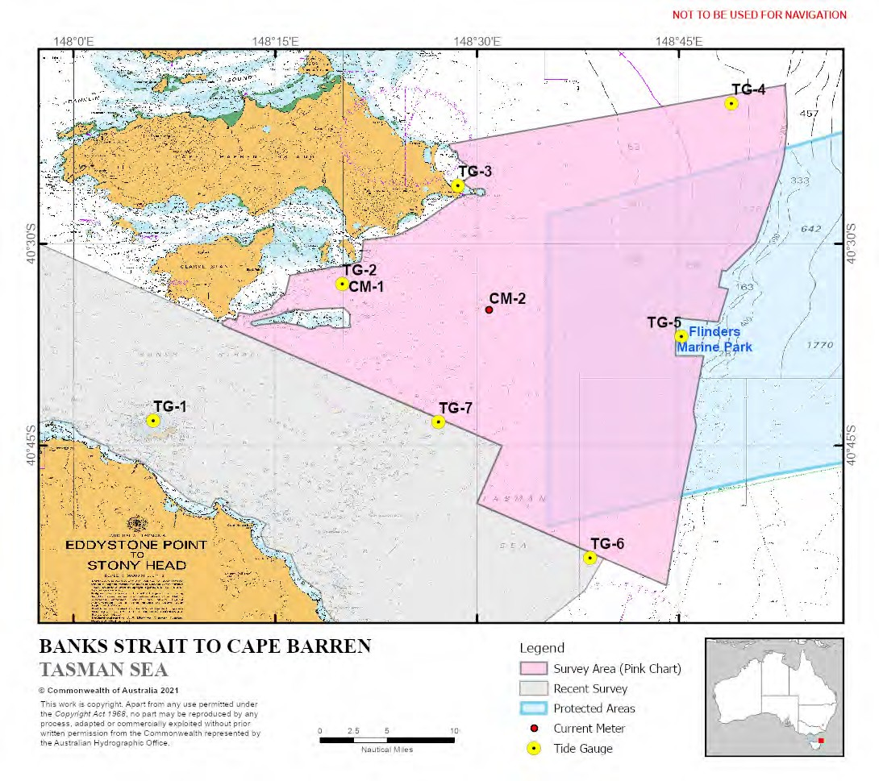

##### Figure 1 - Pink Chart

#### PROJECT REQUIREMENTS

|  |  |  |
| --- | --- | --- |
| **2.1 Positioning and**  **Horizontal Control** | | **Requirements** |
| 2.1.1 | Horizontal Datum  (*IAW SOR Sect 5.2*) | Datum: ITRF 2014 – EPSG:7912 (3D) or EPSG:9000 (2D)  Spheroid: GRS 80  Projection (if used): WGS 84 / UTM Zone 55 South (CM 147°E)  – EPSG:32755 |
| 2.1.2 | Positioning | In accordance with order of survey specified in section 1.1.1 and SOR Table 1 and Table 2. |
| 2.1.3 | Extension of Existing Control  (*IAW SOR Sect 5.2 & 6.1*) | The three benchmarks established on Swan Island during SI 1020 (*HydroScheme* 2020) are to be to recovered and levelled to TG-1. Details of these will be provided to the successful tenderer with the Official Order GFI.  New benchmarks are to be established at Cape Barren and levelled to TG-3. These are to be established early in the survey, and are expected to also be used by the adjoining survey to the North. Preliminary details will be requested by the AHO Client Representative as required. |
| 2.1.4 | AUSHYDROID  Requirements  (*IAW SOR Sect 5.2 & 6.1*) | A connection between LAT and the ellipsoid is to be established for Hydroid model development via 72 hours of GNSS observations (3x 24 hour session) over the new benchmarks to be established at Cape Barren (TG-3), as per SOR section 5.2; with concurrent 25 hour tide gauge / pole (or GNSS tide buoy) observations, as per SOR 6.1.  For all other tide gauge locations listed in section 2.2.3, a connection between LAT and the ellipsoid is to be established for Hydroid model development via GNSS tide buoy observations. Concurrent GNSS tide buoy / bottom mounted tide gauge (BMTG) observations are required for a minimum period of 72 hours. |

|  |  |  |
| --- | --- | --- |
| **2.2 Vertical Control** | | **Requirements** |
| 2.2.1 | Sounding Datum | To approximate Lowest Astronomical Tide (LAT). |
| 2.2.2 | Reduction of Soundings  (*IAW SOR Sect 5.3*) | Soundings shall be reduced for observed tides in all depths. Soundings are to be presented as depths below LAT.  A tide model is to be developed through the deployment of tide gauges IAW section 2.2.3.  LAT is to be recovered from benchmarks on Swan Island and transferred to TG-1.  LAT at all other locations is to be determined by analysis of a minimum of 35 days of tidal observations at the locations listed in section 2.2.3.  All LAT analysis and calculations are to be submitted to the AHO for verification and approval prior to the production of Final Survey Data. |

|  |  |  |  |
| --- | --- | --- | --- |
|  |  |  |  |
|  |  |  |  |
|  |  |  |  |
|  |  |  |  |
|  |  |  |  |
|  |  |  |  |
|  |  |  |  |

|  |  |  |  |
| --- | --- | --- | --- |
|  |  |  |  |
|  |  |  |  |

|  |  |  |
| --- | --- | --- |
| **2.2 Vertical Control** | | **Requirements** |
|  |  | Proposals to reduce soundings via AUSGeoid09 or AUSGeoid2020 will not be accepted, as these Geoid models do not have the required accuracies off the coast.  The Surveyor in Charge shall demonstrate that the method chosen for tidal reduction results in the overall depth accuracy (TVU) requirements being achieved. |
| 2.2.3 | Deployment of Tidal Infrastructure  (*IAW SOR Sect 5.3 & 6.1)* | Tide gauges are to be deployed in the vicinity of the following locations:  TG-1 Swan Island 40° 43.2' S 148° 05.9' E  TG-2 Passage Island - 40° 33.0' S 148° 20.0' E  South  TG-3 Cape Barren 40° 25.7' S 148° 28.6' E  TG-4 *offshore North-East* 40° 19.6' S 148° 48.9' E (~92m)  TG-5 Flinders Marine Park 40° 36.9’ S 148° 45.2' E  - West  TG-6 *offshore South-East* 40° 53.4' S 148° 38.4' E (~100m)  TG-7 Salamander Rock – 40° 43.3' S 148° 27.1' E North-East  In consultation with the AHO, deployment locations may be modified or expanded to improve the tidal model or for safety of navigation purposes.  Tide gauges / GNSS tide buoys are to be deployed for a minimum of 35 days, and for the duration of the data collection activity, to allow a MSL – LAT relationship to be determined.  TG-1 and TG-3 are to be connected to shore benchmarks as detailed in section 2.1.4.  TG-4 has been intentionally located within the survey area to avoid interference from survey activity to the North. TG-5 lies within the Flinders Marine Park and appropriate permits should be obtained prior to mobilisation. |
| 2.2.4 | Deployment of Current Meters  (*IAW SOR Sect 6.2*) | Current meters are to be deployed in the vicinity of the following locations:  CM-1 Passage Island - 40° 33.0' S 148° 20.0' E  South  CM-2 *Charted TS check* 40° 34.9' S 148° 30.9' E |
| 2.2.5 | Existing Tide Stations  (*IAW SOR Sect 6.1.3*) | The locations and accuracy of predicted tide stations are provided in the GFI to assist with survey planning. Predicted tidal heights and harmonic constituents for Standard and Secondary Ports can be exported from the AusTides software. |

|  |  |  |
| --- | --- | --- |
| **2.3** **Bathymetry** | | **Requirements** |
| 2.3.1 | Coverage Requirements  (*IAW SOR Sect 7.3 & 7.5*) | Full Bathymetric Coverage (FBC) |
| 2.3.2 | Backscatter  (*IAW SOR Sect 7.2.1.10*) | Required, for feature detection and seabed texture.  Collection of quality bathymetric data is to take precedence over backscatter collection. Specific requirements include:   * System changes (including power, gain, pulse length and pulse type) to be minimised throughout the survey. * Maintain log of all system settings in use for each line. * Maintain single frequency for specific depth ranges. * Seafloor incident angle <70° for depths less than 30m, otherwise < 60°. Selected swath angles need to fully support IHO Order 1a for the bathymetric data. * Full Bathymetric Coverage (minimum 20% overlap). * Absorption to be adjusted daily prior to commencement of data collection and detailed in Report of Survey. * Oversaturation to be minimised, maintaining an average of 70-90% saturation for >95% of the data collection. * Collect backscatter data on crosslines. * Conduct of backscatter Reference Lines. This involves running the same line for each pulse length used during the survey, with direct overlap for a minimum distance of 500m (allowing sufficient run-in to achieve this). * File formats as per SOR. If R2Sonic multispectral processed backscatter products are proposed these are to be fully described in the SMP. |
| 2.3.3 | Water Column Data  (*IAW SOR Sect 7.2.1.9*) | Required for all wreck and obstruction investigations. |
| 2.3.4 | Side Scan Sonar (SSS)  (*IAW SOR Sect 7.2.5*) | At the discretion of Surveyor in Charge. The Surveyor in Charge is to demonstrate that IHO Order 1a feature detection has been achieved. |
| 2.3.5 | Wreck Investigations  (*IAW SOR Sect 7.9 & 7.10*) | There are no charted wrecks within the survey area; however a number of uncharted wrecks are suspected to exist, particularly inshore in the vicinity of Cone Point and Cape Barren. The majority of these wrecks are wooden vessels from the 1800s or early 1900s, and are estimated positions only. The locations and further details of these are provided in the GFI.  Targeted investigations are not required unless they are detected during the course of the survey; in which case suspected wrecks are to be further investigated to determine their position, orientation, extent and least depth. |
| 2.3.6 | Shoal Examinations and Disproving Searches  (*IAW SOR Sect 7.7 & 7.8*) | Required to determine least depth over significant features detected during the survey and reported on in Annex G to the Report of Survey - “Significant Bathymetric Shoal Summary”. |

|  |  |  |
| --- | --- | --- |
| **2.3 Bathymetry** | | **Requirements** |
|  |  | Significant features are defined as per S44 Ed 6, and S57  Supplement 3 dated June 2014 as depths rising above the depicted depth by:   * 2m in depths < 40m, or * 10% of depth in depths > 40m   Newly discovered features which may be dangerous to surface navigation and charted features which are found to be significantly different to that depicted on the official chart are to be reported without delay by a Hydrographic Note.  For the purpose of completing Annex G to the Report of Survey (“Significant Bathymetric Shoal Summary”) the following are defined as “Reportable Features” to be included in Annex G:   * All significant features in depths < 40m, * All significant features within 500m of a recommended route or within the charted two way route, * Controlling depths over complex or sand wave areas, and * Any feature that should be depicted on a navigation chart.   All reportable features are to be “designated” or “golden soundings”, and applied to the final surface so as to preserve the features depth and position.  Definitive statements are to be made with respect to the **7.3m Reported (1973) PA** shoal in approximate position 40° 28.0’ S 148° 32.2’ E, 3.2NM South-East of Cape Barren. |
| 2.3.7 | Crosslines  (*IAW SOR Sect 7.2.1.4*) | A minimum of **three** (**3**) bathymetric crosslines are required for each survey sub-area conducted, with crosslines no more than 4 NM apart, at approximately equal spacing. Crosslines are to be planned perpendicular to the typical mainline orientation in that survey area.  At least one crossline should be repeated on numerous occasions (at least 3 different occasions during the survey, such as after port visits) to allow for analysis of system performance and repeatability independent of tides.  Crosslines shall be rendered in folders separate from the mainline data structure, and the data should be cleaned for systematic errors to allow for a statistical analysis.  Crosslines shall not be included in the Final Surface generation. |
| 2.3.8 | Passage Sounding  (*IAW SOR Sect 7.11*) | Not Required |
| 2.3.9 | Channels and Recommended Tracks  (*IAW SOR Sect 8.9*) | Not Applicable |

|  |  |  |
| --- | --- | --- |
| **2.4 Views, Conspicuous Objects and Coastline** | | **Requirements** |
| 2.4.1 | Views  (*IAW SOR Sect 8.8*) | Required  Views are to be taken of the approaches to Sea Lion Narrows, between Cape Barren Island and Passage Island, and as per Section 2.4.2. |
| 2.4.2 | Conspicuous Objects (*IAW SOR Sect 8.2.2*) | Required  Any conspicuous objects that would be relevant to the mariner, and that are not charted, are to be identified and captured in a photographic view (IAW SOR Sect 8.8). These are to be discussed in the Report of Survey. Positioning of shore based conspicuous objects is not required. |
| 2.4.3 | Coastline Delineation  (*IAW SOR Sect 8.2 & 8.3*) | Not Required |

|  |  |  |
| --- | --- | --- |
| **2.5 Seabed Topography** | | **Requirements** |
| 2.5.1 | Seabed Sampling  (*IAW SOR Sect 8.5, see also SOR Sect 7.2.1.10 & 7.8*) | Required, to ground-truth backscatter mosaic. |
| 2.5.2 | Seabed Sample Retention  (*IAW SOR Sect 8.5*) | Required  Small samples to be retained using generic sample bags, kept refrigerated and delivered to GA as per the SOR. |
| 2.5.3 | Seabed Texture Layer  *(IAW SOR Sect 12.1.3)* | Required  Digital seabed textures layers are required based on collected backscatter and seabed samples. The layers are to be based on the modified HIPP SSDM geodatabase format outlined SPEC_03_33_BN32048462 HIPP Modified SSDM Data Dictionary and emails of 27 April 2021 and 29 July 2021. A template has been provided in the GFI using EPSG:9000 for consistency across geographic coordinates (as per SI Section  2.1.1 and SOR Section 5.2). Seabed texture symbology is detailed in the SSDM v2 documentation and associated ArcGIS style file. Template ArcGIS layer files have also been provided. |

|  |  |  |
| --- | --- | --- |
| **2.6 Miscellaneous** | | **Requirements** |
| 2.6.1 | Aids to Navigation  (*IAW SOR Sect 8.1*) | Any discrepancies noted regarding charted Aids to Navigation are to be reported to the AHO immediately via Hydrographic Note. All checks are to be annotated in the Report of Survey. |
| 2.6.2 | Amendments to Admiralty Sailing Directions (Pilot)  (*IAW SOR Sect 8.7*) | Australian Pilot (NP 14) is to be reviewed, and any recommended amendments detailed in the Report of Survey. |

|  |  |  |  |
| --- | --- | --- | --- |
|  |  |  |  |
|  |  |  |  |
|  |  |  |  |

|  |  |  |
| --- | --- | --- |
| **2.6 Miscellaneous** | | **Requirements** |
| 2.6.3 | Additional Tasks | **Additional Task 1 – National Reference Surfaces, Banks Strait**  One National References Surface (NatRefSurf_BanksSt_1) is to be established to the North-West of Banks Strait. This is to be a minimum of 500m x 500m, surveyed to the GRS80 Ellipsoid as well as being reduced to LAT using observed tides for TG-1 (Swan Island).  An indicative position has been identified, based on preliminary data acquired during SI 1020 (*HydroScheme* 2020) and is depicted in the GFI; with proposed extents to be confirmed prior to contract kick off meeting.  A deconflicted bathymetric surface containing past survey data in the area will be provided in the Official Order GFI data pack.  The reference surface is to be surveyed in accordance with SOR 7.3. If the Surveyor in Charge considers an area to be unsuitable for use as a National Reference Surface they may propose alternative areas to the AHO. See also Section 3.1.4. |

|  |  |  |
| --- | --- | --- |
| **2.7 Oceanographic and Meteorological Observations** | | **Requirements** |
| 2.7.1 | Sound Velocity  (*IAW SOR Sect 7.4*) | Required, to support MBES operations.  All sound velocity profiles observed during the conduct of this survey are to be rendered, in both source and processed format (i.e. manufacturer’s format and that of processing software). |
| 2.7.2 | Bioluminescence  (*IAW SOR Sect 9.3.6*) | Required nightly during survey operations. Nil observed bioluminescence should also be reported. |
| 2.7.3 | Water Clarity  (*IAW SOR Sect 9.3.5*) | Required  Repeated observations (at least 10) are to be conducted throughout the course of the survey at the locations listed below. These are to be conducted at different tide states (HW, LW, Flood, Ebb, Neap, and Spring) and different weather states to develop a time series of water clarity observations. The exact location is at the discretion of the Surveyor in Charge, but should be within 1NM of the nominated position.  WC-1 Cape Barren – South 40° 28.8’ S 148° 29.5’ E  WC-2 IVO Washy Rock 40° 32.5’ S 148° 16.4’ E  WC-3 Franklin Sound – 40° 22.2’ S 147° 56.4’ E  South-West  Observations are also to be conducted at each seabed sample site. If seabed samples are taken during the night a representative spread of secchi disc observations are to be conducted in those areas during daylight hours. |

|  |  |  |
| --- | --- | --- |
| **2.7 Oceanographic and Meteorological Observations** | | **Requirements** |
| 2.7.4 | Magnetometer  (*IAW SOR Sect 9.3.7*) | Not Required |
| 2.7.5 | Meteorological  (*IAW SOR Sect 9.3.11*) | Optional |
| 2.7.6 | Salinity  (*IAW SOR Sect 9.3.4*) | Optional  Collect and render salinity data if equipment in use has capability to do so. |
| 2.7.7 | Sea Surface Temperature  (*IAW SOR Sect 9.3.4*) | Required |
| 2.7.8 | Additional Observations | Nil |

#### DELIVERABLES

|  |  |  |
| --- | --- | --- |
| **3.1** | **Deliverables** | **Description** |
| 3.1.1 | Supporting | * Final Survey Management Plan |
|  | Documentation | * Pre-Acquisition Report |
|  | (*IAW SOR Sects 3.6, 13.2*  *and 13.3*) | * Daily Progress Reports (during data collection phase) |
|  |  | * Weekly Progress Reports |
|  |  | * Demobilisation Plan / Checklist (2 weeks prior to 100% data |
|  |  | collection) |
|  |  | * Demobilisation Report / Final Weekly Report |
|  |  | * Copies of any relevant correspondence |
| 3.1.2 | Data Packs  ~~(~~*~~IAW SOR Sect 11.3~~*~~)~~ | The file structure for rendering is to be in accordance with the email distributed 27 Apr 2021. A template file structure has been provided in the GFI.  The following data packs are to be rendered:   * Survey Reports Data Pack (including those items previously listed under the Quality Assurance Data Pack) * Raw Bathy Data Pack (including Backscatter raw data) * FSD Bathy Data Pack (including backscatter project data) * Tides and Geodetics Data Pack * Ancillary Data Pack (including the SSDM file geodatabase and associated files) * HIPP Contractor Data Pack (including copies of all client/contractor correspondence) |

|  |  |  |
| --- | --- | --- |
| **3.1** | **Deliverables** | **Description** |
| 3.1.3 | Hydrographic Notes  (*IAW SOR Sect 7.8 & 7.10*) | Any Hydrographic Notes produced in the execution of this survey are to be emailed to [datacentre@hydro.gov.au](mailto:datacentre@hydro.gov.au) at the first available opportunity. |
| 3.1.4 | Report of Survey (ROS)  (*IAW SOR Sect 13.4*) | A full Report of Survey and associated data is to be rendered IAW the SOR and Contract schedule.  The National Reference Surface are to be rendered as a separate deliverable with its own Summary Report of Survey (AH68a) and data packs. Naming conventions are to be in accordance with SOR Section 7.3.2.2 and 7.3.2.4. |
| 3.1.5 | Resolution of Final Survey Data (FSD) | Final Survey Data for the main survey area is to be rendered as finalised CUBE surfaces as follows: |
|  | (*IAW SOR Sect 7.6 and Table 6*) | * at 1 metre resolution for depths 0-40 metres, * at 2 metre resolution for depths >36 metres to 80 metres, or |
|  |  | * at 4 metre resolution for depths >76 |
|  |  | Final Survey Data for the National Reference Surface is to be rendered as finalised CUBE surfaces at 0.5m resolution. For each reference surface, Final Survey Data is to include a surface reduced to LAT as per section 2.2.2 and a surface referenced to the GRS80 ellipsoid. |
|  |  | The MBES resolution achieved at the survey depth must be sufficient to generate gridded surfaces at the resolutions indicated, with these surfaces to be supported by relevant statistical layers. |
|  |  | Final Survey Data should be rendered consisting of as few finalised surfaces as practical, i.e. adjacent data acquisition blocks should be combined based on the above depth bands, and where relevant any variation in survey quality achieved. |
| 3.1.6 | Additional rendering requirements | In addition to the requirements specified in the SOR the following files types are to be supplied generated from the FSD surfaces above:   * A 32-bit floating point GeoTIFF is to be rendered that includes depth, density and uncertainty attributes for use within QC tools (and as a background layer for the SSDM); and * BAG files are to be generated from the FSD. * QAX QC using Mate and Grid checks are to be conducted during field operations and the QCJSON supplied as part of the Quality Control data pack. |

#### END OF DOCUMENT

#### Annex:

##### A. List of Survey Area Coordinates

#### ANNEX A – LIST OF SURVEY AREA COORDINATES

|  |  |  |  |  |
| --- | --- | --- | --- | --- |
| Main Survey Area |  |  |  |  |
| 40° 36.057' S | 148° 11.098' E |
| 40° 35.810' S | 148° 11.023' E |
| 40° 35.617' S | 148° 11.426' E |
| 40° 35.528' S | 148° 11.614' E |
| 40° 35.729' S | 148° 12.137' E |
| 40° 35.114' S | 148° 12.276' E |
| 40° 35.261' S | 148° 13.265' E |
| 40° 34.831' S | 148° 14.708' E |
| 40° 34.499' S | 148° 14.811' E |
| 40° 33.717' S | 148° 15.758' E |
| 40° 32.352' S | 148° 16.106' E |
| 40° 31.722' S | 148° 19.287' E |
| 40° 31.718' S | 148° 19.867' E |
| 40° 31.326' S | 148° 21.329' E |
| 40° 31.196' S | 148° 21.379' E |
| 40° 29.724' S | 148° 21.564' E |
| 40° 29.440' S | 148° 23.927' E |
| 40° 28.572' S | 148° 25.700' E |
| 40° 26.954' S | 148° 28.034' E |
| 40° 26.700' S | 148° 28.366' E |
| 40° 26.336' S | 148° 29.218' E |
| 40° 26.301' S | 148° 29.892' E |
| 40° 26.477' S | 148° 30.289' E |
| 40° 26.335' S | 148° 30.573' E |
| 40° 26.223' S | 148° 30.576' E |
| 40° 25.998' S | 148° 30.583' E |
| 40° 25.878' S | 148° 30.283' E |
| 40° 25.960' S | 148° 29.633' E |
| 40° 25.495' S | 148° 28.960' E |
| 40° 25.225' S | 148° 29.132' E |
| 40° 24.689' S | 148° 29.918' E |
| 40° 24.224' S | 148° 29.346' E |
| 40° 23.687' S | 148° 28.607' E |
| 40° 23.324' S | 148° 28.568' E |
| 40° 23.067' S | 148° 28.413' E |
| 40° 23.174' S | 148° 28.213' E |
| 40° 22.838' S | 148° 27.971' E |
| 40° 22.596' S | 148° 27.900' E |
| 40° 18.181' S | 148° 52.900' E |
| 40° 19.750' S | 148° 53.022' E |
| 40° 21.321' S | 148° 53.037' E |
| 40° 23.341' S | 148° 52.841' E |

|  |  |
| --- | --- |
|  |  |
|  |  |
|  |  |
|  |  |
|  |  |
|  |  |
|  |  |
|  |  |
|  |  |
|  |  |
|  |  |
|  |  |
|  |  |
|  |  |
|  |  |
|  |  |
|  |  |
|  |  |
|  |  |
|  |  |
|  |  |
|  |  |
|  |  |
|  |  |
|  |  |

|  |  |  |  |  |
| --- | --- | --- | --- | --- |
|  |  | 40° 24.479' S | 148° 52.605' E |  |
| 40° 29.904' S | 148° 50.701' E |
| 40° 32.048' S | 148° 48.506' E |
| 40° 31.969' S | 148° 48.221' E |
| 40° 33.211' S | 148° 47.958' E |
| 40° 33.369' S | 148° 48.686' E |
| 40° 35.815' S | 148° 47.923' E |
| 40° 35.514' S | 148° 44.795' E |
| 40° 38.330' S | 148° 44.749' E |
| 40° 38.333' S | 148° 46.845' E |
| 40° 39.854' S | 148° 46.557' E |
| 40° 40.917' S | 148° 46.356' E |
| 40° 42.423' S | 148° 46.070' E |
| 40° 43.561' S | 148° 46.298' E |
| 40° 48.715' S | 148° 45.214' E |
| 40° 55.413' S | 148° 44.086' E |
| 40° 53.393' S | 148° 39.413' E |
| 40° 49.313' S | 148° 29.975' E |
| 40° 45.035' S | 148° 31.841' E |
|  | | | |
| Main Survey Area **exclusion** – IVO Moriarty Bank & East Bank |  | 40° 35.932' S  40° 35.797' S | 148° 13.180' E  148° 13.259' E |  |
|  |  | 40° 35.704' S | 148° 13.678' E |  |
|  |  | 40° 35.468' S | 148° 14.747' E |  |
|  |  | 40° 35.227' S | 148° 15.476' E |  |
|  |  | 40° 35.042' S | 148° 15.743' E |  |
|  |  | 40° 34.999' S | 148° 16.205' E |  |
|  |  | 40° 34.854' S | 148° 16.462' E |  |
|  |  | 40° 34.981' S | 148° 17.307' E |  |
|  |  | 40° 34.834' S | 148° 18.262' E |  |
|  |  | 40° 34.767' S | 148° 20.121' E |  |
|  |  | 40° 35.246' S | 148° 20.557' E |  |
|  |  | 40° 35.862' S | 148° 20.527' E |  |
|  |  | 40° 36.220' S | 148° 20.621' E |  |
|  |  | 40° 36.280' S | 148° 19.358' E |  |
|  |  | 40° 36.073' S | 148° 19.047' E |  |
|  |  | 40° 36.135' S | 148° 18.119' E |  |
|  |  | 40° 36.317' S | 148° 17.866' E |  |
|  |  | 40° 36.322' S | 148° 17.428' E |  |
|  |  | 40° 36.127' S | 148° 17.069' E |  |
|  |  | 40° 35.857' S | 148° 15.597' E |  |
|  |  | 40° 35.903' S | 148° 15.149' E |  |
|  |  | 40° 36.021' S | 148° 13.847' E |  |
|  |  | 40° 36.124' S | 148° 13.433' E |  |

|  |  |
| --- | --- |
| Additional Task 1 – National Reference Surface | *Proposed National Reference Surface coordinates to be confirmed prior to contract award* |

Appendix B:



Client: Australian Government Department of Defence

* 1. Department of Defence Letter of Introduction

Project No: SI 1024 Banks Strait to Cape Barren

Contract No: CASG/SHIPS/CON/7138/5 Page B-1



HIPP 162/21 BN38798652

**To Whom It May Concern**

**HYDROSCHEME INDUSTRY PARTNERSHIP PROGRAM (HIPP) SURVEY OPERATIONS — BANKS STRAIT TO CAPE BARREN, TAS.**

I am writing to you in my capacity as the Assistant Director of the National Hydrography Program from the Australian Hydrographic Office (AHO) in Wollongong. Recently Defence has entered into a new partnership with Australian industry to collect hydrographic survey information under an initiative referred to as the HydroScheme Industry Partnership Program (HIPP). Under this programme seven existing Hydrographic Survey companies have been selected to form the HIPP Panel. Following a competitive tender process HIPP Panellist will be awarded contracts to collect hydrographic survey data in locations all around Australia that will contribute towards the National Hydrographic Program aimed at promoting maritime safety and lead to updated nautical charts.

The HIPP planning process has identified Banks Strait to Cape Barren, TAS, as a high priority for hydrographic survey activity. I have included a graphic to allow you to see the extent of the survey area and its location. The survey is to map the seabed to increase the safety and navigational accuracy of existing charts of the region, to conduct an assessment of the water clarity and for the deployment of short term tide gauges to develop a spheroidal model known as the “Hydroid” which will increase the accuracy of future surveys around Australia.

Following a competitive tendering process, iXblue Pty Ltd have been awarded the contract for this survey to be undertaken during the period early 01 December 2021 to April 2022. A key component of the HIPP is that iXblue as the designated contractor, will be responsible for all logistic support for their activities and for liaising with any appropriate authorities. For this particular tasking they intend to utilise the vessel *MV Offshore Solution and its tender SMB Indigo.* The nominated iXblue project manager is Mr David Field, [david.field@ixblue.com](mailto:david.field@ixblue.com) who may be in contact with you in due course.

As you can see from the attached graphic, in addition to the primary survey area in pink, there will be a requirement to deploy several seabed tide gauges for the duration of the survey. iXblue will be responsible for ensuring that they are deployed and recovered in safe manner, cognisant of any laws or regulations within Tasmanian waters. They will also liaise with the appropriate authorities to ensure a Notice to Mariners (NTM) is raised to cover their activities.

**OFFICIAL**

***Defending Australia*** *and its National Interests*

1 of 3

While any specific enquires about this activity should be forwarded to the iXblue project director in the first instance; my POC for this activity is the Manager HIPP Survey Projects, LCDR Ian Phillips, who can be contacted by telephone on: 0408 244 127, or by email: [ian.phillips@defence.gov.au](mailto:ian.phillips@defence.gov.au) or directly to myself on the number below or email [nigel.townsend1@defence.gov.au](mailto:nigel.townsend1@defence.gov.au)

Yours sincerely

**Nigel Townsend**

Commander, RAN

Assistant Director National Hydrography

Australian Hydrographic Office 8 Station Street

WOLLONGONG NSW 2500

02 4223 6662

23 Nov 2021

Enclosure:

* + 1. Diagram of the Banks Strait to Cape Barren, TAS Area Survey

**Enclosure 1 to HIPP 162/21**

**DIAGRAM OF THE BANKS STRAIT TO CAPE BARREN, TAS SURVEY AREA**



Appendix C:

C.1 Project Risk Assessment

A Project Risk Assessment (PRA) has been developed for this SAP. A detailed risk review process will be completed prior to the commencement of the project and reviewed throughout the life of the project. A high-level approach to managing project risk (non-exhaustive) is detailed below.

|  |  |  |  |  |
| --- | --- | --- | --- | --- |
| **Discipline: Health, Safety, Env, Quality.** | **Process / Task** | **Hazard / Risk / Unwanted Outcome** | **Existing System Controls** | **Project Specific Risk Considerations and Approach** |
| **1 - PRE-MOBILISATION** | | | | |
| **Env** | Vessel movement between areas | Transfer of invasive marine species on vessel hull | * Anti Foul Protection System applied * Vessel SMS requires management of this. * Any trailer vessels are cleaned at local boat access points before transporting to a new area. * Sub-contractor prequalification and Vessel Inspection. | OFFSHORE SOLUTION  operates within the Australian EEZ in a Business-as-Usual capacity. The vessel will slip for Dimensional Control Survey during mobilisation – during this time the vessel will undergo a routine hull clean and check for marine species. |
| **Env** | Marine equipment transfer between areas | Transfer of invasive marine species on equipment | * Clean equipment between projects. * Inspect equipment prior to deployment. | * All existing equipment will be checked and cleaned prior to deployment. * New equipment will be deployed. |
| **2 – MOBILISATION** | | | | |
| **Env, Safety** | Bunkering / Refueling of Vessel | Environmental Spill | * Bunkering managed by vessel supplier following SMS. * Any refueling conducted at approved locations e.g. refueling wharves. | Refueling during the Acquisition Phase is required at approximate 28- day intervals. OFFSHORE SOLUTION will refuel in approved fueling facilities at  Beauty Point, Launceston. |
| **Env** | Waste Management | Release of unwanted substances into the environment | * Vessels - operated in accordance with Vessel SMS. Evidence checked during prequalification or Vessel Inspection. * iXblue personnel ensure facilities are available for rubbish waste to be disposed of and removed from site. * iXblue personnel through planning recognise any sensitive areas that require specific approaches. Ensure   this is communicated to vessel and other parties. | * All waste will be contained onboard OFFSHORE SOLUTION and be disposed of at approved facilities ashore during planned resupply. * Waste holding capacities checked to ensure they are sufficient for the duration of the planned activity. * General waste to be separated from recycling prior to appropriate disposal ashore. |
| **3 - SURVEYING** | | | | |

|  |  |  |  |  |
| --- | --- | --- | --- | --- |
| **Safety Env** | Vessel Operations – Traffic Density within IGBR Two- Way Route | Collision / Grounding / Near Miss | * Sub-contractor prequalification process. * Vessel crew holding all relevant state / national qualifications. * Vessel crew having recent experience operating within the Banks Strait region | * Early two-way comms with other vessels. * RIATM Shapes and Lights.   -   * Raise TAS NtM covering survey activities for the duration of the operation. |
| **Env** | Transfer of equipment between work sites | Transfer of unwanted flora or fauna between sites | * Check and clean equipment before embarking on vessel. * Inspect equipment between work sites and prior to deployment. * Inspect vessel for rodents. | - All equipment will be checked and cleaned on recovery prior to movement to new work site |
| **Env** | Tide Gauge / Current Meter Deployment | Deployment on seafloor may disrupt sensitive areas | * Review environmental or sensitive areas during planning stage and obtain necessary permissions from relevant Government bodies. * Plan all work for minimal impact / footprint. | * Deployments will have minimal seafloor disturbance and all seabed infrastructure will be recovered upon completion of the survey. * Any impact is considered negligible. * All sensors and equipment to be removed from site at   end of observation period. |
| **Env** | Hydrographic Survey Operations | Noise disturbance to marine mammals | * Review environmental or sensitive areas during planning stage and permissions. * Select survey systems known to not impact marine mammals. | * Survey area is within a BIA for pygmy Blue Whales and Southern Right Whales * Proposed survey systems are not within the acoustic range marine mammals and pose no risk. * Members of the survey team have undergone Marine Mammal Observer training from NIWA (2019). |
| **Env** | Hydrographic Survey Operations | Collision with marine mammals | * Maintain effective lookout for marine mammals. * Ensure applicable separation distance between vessel and marine mammals observed. | * Members of the survey team have undergone Marine Mammal Observer training from Blue Planet Marine (planned for Dec 2021). * Where significant marine mammals are present such that maintaining the designated separation is not possible then operations to   cease until clear to recommence. |
| **Env** | Recovery of Tide Gauges / Current Meters | Acoustic Release fails | * Ensure systems tested prior to deployment. * Ensure all moving parts on acoustic release are coated with antifoul. | - Where possible seabed mounts located in 30-40m water depth to allow recovery by divers or ROV should acoustic release mechanisms fail. |
| **Env** | Recovery of Tide Gauges / Current Metres | Noise disturbance to marine mammals. | - Select survey systems known not to impact marine mammals. | * Use of acoustic releases not allowed when marine mammals are within 300m of the source. * Acoustic release source transmission limited to less than 1-minute at each offshore site. |

|  |  |  |  |  |
| --- | --- | --- | --- | --- |
| **Env** | Conduct operations on remote islands. | Disturbance to vegetation and wildlife | * Review environmental or sensitive areas during planning stage and obtain necessary permissions from relevant Government bodies. * Plan all work for minimal impact / footprint. | -Limit landing on Islands to that necessary for operational requirements.   * Limit personnel in landing party to minimum number required for safe completion of the task. * Ensure all equipment is cleaned prior to landing. * Remain clear of roosting or nesting birds. * Care taken to avoid damage to vegetation and wildlife. |
| **Env** | Shore based survey infrastructure | Disturbance to vegetation and wildlife | -Plan all work for minimal impact / footprint. | * Temporary and permanent survey infrastructure placement location to cause least disturbance to wildlife and vegetation. * Clearing of vegetation is to be avoided where possible. If this is not possible, limited to that which is essential for siting an antenna and/or geodetic mark. * Excavation for the purposes of siting a geodetic mark to be kept to the minimum required. * Placement in the vicinity of nesting or roosting birds to   be avoided. |
| **Env** | Conduct seabed sampling operations | Disturbance to seabed fauna. | * Seabed samples returned to the sea following analysis. * Grab sampler chosen to minimise disturbance for given sediment type. * Minimum number of samples taken to ground truth sonar   data. | - Drop Camera to be used which will avoid the necessity to take any seabed samples if seabed sampling is not permitted |
| **Env** | Conduct seabed sampling operations | Disturbance of historic wrecks in area | -Sample locations determined after bathymetric survey operations.  - Bathymetric survey used to pick sample locations away from wreck locations. | - Drop Camera to be used which will avoid the necessity to take any seabed samples. |