# iXblue Survey Plan: Banks Strait to Cape Barren

Project: SI 1024

Client: Australian Government Department of Defence Project No: SI 1024 Banks Strait to Cape Barren

Official Order for SI 1024 Under HIPP Deed Standing Offer: SON3665645

Survey Participants and qualifications:

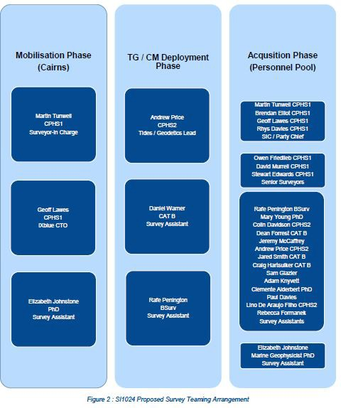

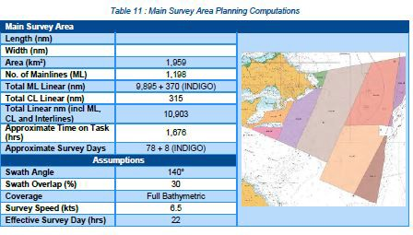

# The equipment and methods used to comply with the EPBC Act Regulations.

iXblue is planning on conducting a hydrographic survey (in contract) for the Department of Defence. iXblue intend to utilise owned hydrographic survey sensors which are to be considered industry best for the purposes of safety of navigation surveys. The high-level equipment summary intended for the Project is included in Table 13. The survey system fitted to OFFSHORE SOLUTION and SMB INDIGO are near identical, therefore only where there is a difference will this be expanded upon in the following sub-sections.

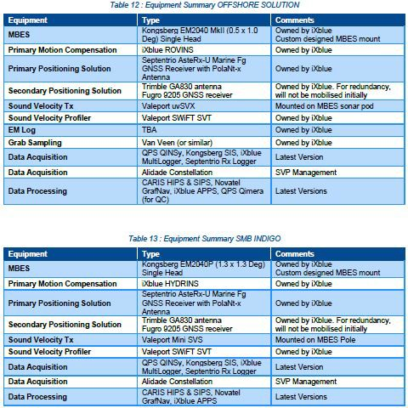

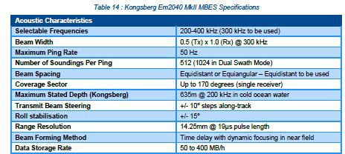

## On-site Calibrations

On arrival to site, the HSS will be readied to complete on-site calibrations. The Additional Task 1 – National Reference Surface, Banks Strait will be surveyed to the NW of Banks Strait. We acknowledge that this reference surface will be used by other contractors operating in the area and the importance of a timely submission.

Periodic MBES Patch Tests, MBES Reference Surface, Backscatter calibration lines and crossline reference checks will be completed throughout the course of the survey as required as well as additional checks, as directed by the SIC, to ensure the integrity of the MBES dataset. Once the calibration and confidence check of the OFFSHORE SOLUTION and SMB HSS have been completed, the vessels will commence survey data acquisition activities.

## Survey Data Acquisition Phase

MBES Survey operations will be conducted on a 24/7 basis. OFFSHORE SOLUTION has an underway endurance (conducting survey operations) of 60 days, as such LOGVISITS have been planned every 28 days to allow for crew changes, re-fuel and re-supply operations. It is planned that these LOGVISITS will take place at Beauty Point wharf.

SMB INDIGO will be carried on the deck of OFFSHORE SOLUTION for the duration of the survey. The INDIGO is being carried as a force multiplier and as a risk mitigation strategy to survey the shallowest areas of the area which are best undertaken with a vessel draft of less than 3.5m (SOLUTION). The SMB will operate on a 24/7 basis if wind and sea conditions permit safe operation, and it will be manned with one Coxswain and one surveyor. The operational teaming arrangement detailed in Table 9 identifies sufficient teaming to run concurrent ship / SMB operations relevant to all proposed options.

The marine crew and survey team’s fatigue will be proactively monitored and managed throughout the course of the survey. Where it is deemed necessary, overnight periods at anchor (DP) will be integrated into the plan. However, given the size of the vessel this scenario is considered unlikely.

**Intended Underway Survey Teaming** 24/7 Operations **Data Acquisition**:

1 x SIC / Party Chief 1x Senior Surveyor 4 x Field Surveyors

**Intended Marine Crew Teaming** 24/7 Operations 1 x Master

1x Chief Mate

4 x Deck Watchkeepers (4 x 6h rotations per day) 3 x Engineers

1 x Chef / General Purpose Deckhand 2 x SMB Coxswains

## Crosslines

iXblue acknowledge the crossline spacing requirements (i.e. achieve a minimum of 3 crosslines per survey sub-area and being no more than 4nm apart) and the need to create and repeat a reference crossline as detailed in the Tasking Statement [2]. These requirements have been built into the survey line plan.

## Sound Velocity Sampling

OFFSHORE SOLUTION will be fitted with an automated underway Sound Velocity Profiling winch which will minimise downtime associated with undertaking Sound Velocity measurements. The automated winch is integrated into the data acquisition system and ensures that sufficient Sound Velocity measurements are taken throughout the survey to account for spatial and temporal variations.

The SMB INDIGO has not been fitted with the automated SVP winch. When the INDIGO is deployed, it is intended to stop the vessel and manually deploy the SVP sensor. For this survey, the depth of water is shallow, and the time taken to undertake an SVP cast considered to be several minutes only per occasion.

## Sea Surface Temperature

The Valeport uvSVX sensor will be mounted at the MBES head and will, along with Sound Velocity, measure, and log Sea Surface Temperature (SST). These SST log files will be provided with the final deliverables.

## Sounding Datum and Reduction of Soundings

All bathymetric data will be reduced to approximate LAT (through observed tides using a multi-tide station weighted average solution). iXblue’s LAT determination will be validated by the AHO (Tides and Geodetics Section) prior to its application to the finalised bathymetric surfaces.

## Backscatter

To collect high quality and consistent backscatter, it is best practice to use a single MBES system. Unfortunately, the iXblue plan to utilise a variety of different Kongsberg EM family MBES sonars does not permit this. However, all sonars proposed for use will be operated at the 300kHz frequency range and all have similar specifications. The shallow nature of the survey area and anticipated sounding density will permit the backscatter product to be rendered at a minimum grid size of 1m. Sediment character will be delineated, and geomorphological features identified. Sedimentary units will be incorporated into the SSDM using the feature codes compatible with AUS Seabed functionality.

Backscatter data provides high-resolution information on the acoustic reflectivity of the seafloor. The data will be used to delineate geomorphic features and organize them in a spatial database.

Experienced geophysical experts will interpret the data results and assign sedimentary units to the survey area with local classifications (e.g., rock, sand, mud) based on sediment type and grain size. Geomorphological patterns will be described using pattern recognition.

## Water Clarity

Water clarity observations are required. Two observing mechanisms will be utilised to achieve both temporal and spatial clarity data.

Temporal sampling will be undertaken in the prescribed locations using a Seabird ECO-NTU-SB backscatter turbidity sensor, deployed at a depth of approximately 1.5m on an 800mm lit special spar buoy. The buoy will be constructed in Cairns, solely for the purpose of in-situ oceanographic data monitoring. This sensor will provide turbidity observations across a range of 0-250NTU with time intervals matching the current observations. The sensors will be deployed in each prescribed location up to 28 days to capture turbidity variation across a tidal cycle. The ECO-NTU-SB is a fully calibrated sensor, fitted with internal battery and logging capability, and a copper rotating window for anti-fouling. This allows it to remain in-situ for extended periods without disturbance

Spatial sampling will also be conducted using a Secchi disc during daylight seabed sampling. At each seabed sample site, when the ship is stopped in the water, a Secchi depth and Forel-Ule scale turbidity colour observation will be collected.

## Bioluminescence

Bioluminescence observations will be undertaken at night whilst underway. A faired Logsheet (Form F_03_32_R31776871) of daily observations will be provided as the final deliverable. The requirement to collect 12 water samples is acknowledged. It is acknowledged that specialist training will be provided by DSTO prior to mobilisation and that DSTO personnel will collect the retained water samples.

## Seabed Sampling

When the Acquisition Phase of the survey is complete, backscatter data will be analysed and used to determine sediment sampling locations. Seabed sampling will be conducted during a 24-hour period to acquire information on seabed types and ground truth backscatter. iXblue will employ a Van Veen grab sampler for this activity if physical seabed samples are permitted for collection. Otherwise, iXblue will deploy a colour video camera and record imagery of the seabed for later analysis.

The number and locations of the sample sites will be determined by the collected MBES acoustic backscatter results with due consideration to the historical seabed sample locations and their distribution. Physical samples will be obtained to ground truth the backscatter mosaic and will be retained as per [1]. For planning purposes, 25 samples have been assumed, however this is for timing purposes rather than a definitive number. The samples will be photographed on a dedicated white tray and photographed with a Nikon DSLR camera mounted on a camera frame for consistent imagery.

Following image acquisition, each sample will be labelled and placed in separate plastic bags and stored in the freezer. Upon arrival in Cairns for demobilisation, iXblue will arrange freighting of the samples to GA via airfreight.

## Wreck Investigations

iXblue acknowledges that a number of uncharted wrecks are suspected to exist, particularly inshore in the vicinity of Cone Point and Cape Barren. Any wrecks found will be examined IAW SOR Section 7.9

and 7.10, such that a wreck investigation will be planned and executed to determine the position, orientation, extent and least depth.

Water Column Data (WCD) will be collected during all wreck investigations to aid in least depth determination.

# What steps will be taken to minimise impacts on cetaceans.

1. iXblue uses a high frequency (300kHz) sonar which is not harmful to marine mammals.
2. Ship speed is slow (7knots) and the vessel will always have observers on the bridge, therefore reducing any chance of impact or strikes.
3. iXblue will follow regulations set forth by the EPBC Act and report any strikes that could possibly occur.

# The objectives and purposes of the action.

The objectives are to survey the seafloor without harming or disturbing any marine mammals in the process.