# General Information

Project Plan for Research Cruise SO292

* 1. PIs

|  |  |
| --- | --- |
| Christian Betzler, Prof. Dr. | Sebastian Lindhorst, Dr. |
| Thomas Lüdmann, Dr. | Christian Hübscher, Prof. Dr. |

* 1. Topic

Towards an understanding of carbonate platforms in the icehouse world.

* 1. Code Name

ICECARB

* 1. Discipline and Subject Area

Carbonate Sedimentology, Seismic Stratigraphy, Marine Geology.

* 1. Large Equipment
     + Location of working area: Coral Sea. First station: 149.31°E /17.83°S, last station: 194.75°E /15.60°S.
     + Large equipment: Seismic streamer, ROV, gravity corer, box corer, OFOS, CTD.
  2. Summary

The superordinate project objective is to verify the hypothesis that tropical carbonate platforms since the onset of the middle and late Miocene global cooling are strongly controlled by ocean currents. It is proposed that the modern carbonate platforms are in an "icehouse world mode". Four aims will allow achieving this goal: By linking seismic reflection- with stratigraphic data from Ocean Drilling Program Leg 133 sites at the Queensland Plateau carbonate platform, the backstepping of carbonate bank margins will be understood. Here, the focus is on the mapping and correlation of current features such as submarine dunes, drift bodies or current moats. Recent and youngest depositional processes of the carbonate banks will be analyzed with multibeam and Parasound determining ocean current impact on the carbonate source to sink system (e.g. sediment thickness distribution, slope instabilities). Sedimentary variations with regard to carbonate bank exposure to currents and wind will be analyzed via sediment composition (grain size, texture, components), linking geological and geophysical data. To assess how the carbonate banks exposed to ocean currents disturb the water mass stratification, CTD stations will be measured up- and downcurrent of the buildups.

# Current State of Research and Preliminary Work

* 1. Current State of Research and Preliminary Work

**Controlling factors of carbonate platform architecture.** Carbonate platforms are edifices that are formed by the growth of shallow-water carbonates in the photic zone of the tropics. Organic reefs and/or bioclastic and oolitic bars form the rim of these platforms, where wind-driven waves induce an agitated hydrodynamic regime. These facies separate more or less wide and more protected lagoons from the open sea. Due to the high sediment production potential of the tropical shallow-water carbonate factory, an increase in accommodation space through either sea-level variation or tectonically driven, can be equilibrated by accumulating several thousand meters of platform deposits. Carbonate

platforms may develop steep rims, either with reef boundstone or with cemented and/or microbially-bound grainy deposits. Carbonate platform edges may migrate basinward, with bank margin facies progradation as the stratigraphic result of this process. In the case of Great Bahama Bank (GBB), progradation occurs on the leeward side of the carbonate platform, where components produced in the shallow-water areas are transported mainly through wind-driven currents later cascading down the slope (Eberli and Ginsburg, 1987). The windward edge of the platform displays an aggradational pattern.

During the last decade, studies on different isolated carbonate platforms around the world have shown that ocean currents are a major additional factor affecting carbonate platform facies and stratigraphy: Ocean currents have proven to be a major contributor to the drowning of carbonate platforms (John and Mutti, 2005, Eberli et al., 2010, Betzler et al., 2009, 2016a), but also a major controlling factor of carbonate platform slope sedimentation (Betzler et al., 2009, 2014, 2016a, b, Lüdmann et al., 2016), which ultimately also affects platform stratigraphy. In fact, with exception of GBB, all large isolated carbonate platforms and complexes in the world ocean (Fig. 1), like the Maldives, the South China Sea carbonate banks, the Queensland and the Marion Plateaus, have been subjected to the action of currents during the Neogene and shrinking through time.

The currents contribute to the drowning of carbonate platforms through their physical, i.e. erosive action, but also because reef banks and platforms located in the course of the currents trigger a topographically induced upwelling, especially on the downcurrent side of the banks (de Vos et al., 2014). Such an upwelling may inject nutrient-rich waters into the shallow-water realm therefore potentially reducing or suppressing reef growth (Hallock and Schlager, 1986). The GBB is herein proposed to be exempted from this general principle, because its leeward flank is bathed by currents in the Florida Straits and the Santaren Channel inducing downwelling (Lüdmann et al., 2016).

Recently it has been shown that the physical transport capacity of currents also induce sediment winnowing and redistribution along the flanks of the platforms. In areas of lower current velocity, extensive periplatform drifts form (Betzler et al., 2014), irrespective of the orientation of the wind-driven surface currents (Mullins and Neumann, 1979). Current acceleration leads to slope oversteepening, or slope starvation (Betzler et al., 2016a, Principaud et al., 2016, Wunsch et al., 2016). Especially slope oversteepening induces impressive slope instabilities with the detachment of large mass transport complexes (Mulder et al., 2012, Wunsch et al., 2016, 2018).

|  |  |
| --- | --- |
|  | **Figure 1.** Major isolated tropical carbonate platforms in the world ocean. GBB: Great Bahama Bank; MAL: Maldives; SCS: South China Sea platforms; QMP: Queensland and Marion Plateaus (Australia). |

Flank exposure of the carbonate platforms to currents possibly also determines the occurrence and size of channels along platform slopes. This is indicated by channel distribution around GBB, where several multibeam surveys show the link between current exposure of the platform flanks and number and size of channels (Betzler et al., 2014, Principaud et al., 2016, Wunsch et al., 2018): slopes are rather uniform in areas of periplatform drifts and sculptured in areas of highest current impact.

Summarizing, it has been shown that the effect of bottom currents is as important, or even more important than the pure gravitational redistribution of sediment components derived from the interior of the carbonate platforms. This is a step away from the supposedly established concepts of carbonate platform slope depositional systems which assume line

shedding (Schlager, 2005), i.e. a constant sediment influx along the edge of carbonate banks and component grain size (Playton, 2010) as controlling factors for slope facies and thickness distribution. All of the processes named above leave diagnostic signatures in the stratigraphy, facies and sediment composition of carbonate platforms, and thus can be resolved and mapped by seismic and hydroacoustic surveys backed up by sediment sampling (Betzler et al., 2013, 2014, 2016a, b). Therefore the validity of the discussed concepts can be straightforwardly tested elsewhere.

**Miocene initiation of modern carbonate platforms.** Many elements that distinguish the modern climate and ocean circulation system were emplaced during the Neogene. Earth’s bi-polar glaciation is characterized by a permanent Antarctic Ice Sheet (Sugden et al., 1993) and ephemeral northern hemisphere ice sheets paced by orbital variations (Hays et al., 1976; Lisiecki and Raymo, 2005). The establishment of major East Antarctica ice sheets let to a globally steeper meridional temperature gradient intensifying pressure systems and ocean circulations (Flower and Kennett, 1994; Zachos et al., 2001). The deep-water circulation system developed a bi-polar aspect during the Neogene when the North Atlantic end member became an important component during the middle Miocene, complementing the southern deep-water circulation source (Wright and Miller, 1996).

There are now several lines of evidence indicating that the current-controlled carbonate platform mode described above started at this time of middle to late Miocene stepwise global cooling (Holbourn et al., 2013) and onset of modern ocean circulation. In the Maldives, a partial drowning and the start of current-controlled slope sedimentation began at ~ 13 Ma (Betzler et al., 2016a), at GBB the current signatures appear at 12 – 13 Ma (Bergman et al., 2010), in the South China Sea at ~ 11 Ma (Shao et al., 2017) and at the Marion Plateau at ~ 13.6 Ma (John and Mutti, 2005). Therefore, the late Middle Miocene is seen as a major break in global carbonate platform evolution. We propose that this break separates the greenhouse carbonate depositional systems from the icehouse systems which thrive in our oceans today. With regard to the aspect of the carbonate platform geometries as discussed above, we see this break even more relevant than the recently postulated start of euphotic coral reef growth during the Tortonian (Pomar et al., 2017).

The test of this hypothesis is the objective of the proposed research, which has the goals to understand how Neogene isolated carbonate platforms shrunk, what the dominating acting depositional processes are, what the sedimentary variations are with respect to wind and current exposure, and how the water mass stratification is affected by the banks.

**The East Australian carbonate province.** The East Australian carbonate province which encompasses the Great Barrier Reef, the Marion Plateau and the Queensland Plateau has been in the focus of integrated sedimentological, stratigraphic, and paleo- ceanographical research during ODP Leg 133 which cored several sites (Davies et al., 1991; Fig. 1) as far down as the basement. Our overview will focus on the Queensland Plateau as the working area for the project (Figs. 2 – 4). The isolated carbonate banks of the Queensland Plateau (NE Australia, Fig. 2) show a major turnover of the stratigraphic architecture and facies at the same time, which is, however, not well understood. The Queensland Plateau lies in the flow of the North Caledonia Jet (Fig. 3a), which is a branch of the South Equatorial Current (Ganachaud et al., 2007, Kessler and Cravatte, 2013).

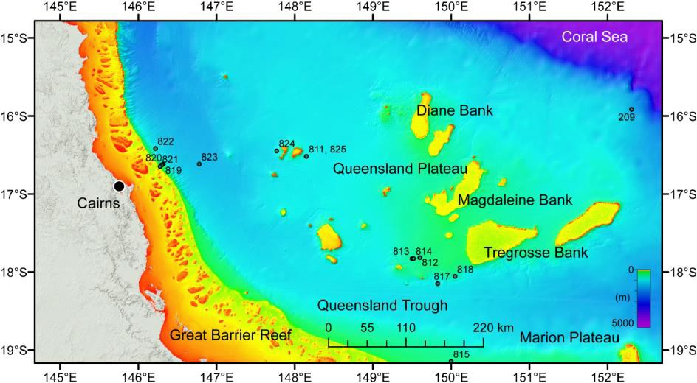

**Figure 2.** Location of the Queensland Plateau with DSDP Leg 21 and ODP Leg 133 sites.

The wind regime in the area of the Queensland Plateau is dominated by the trade winds (Fig. 3b), which as elsewhere are expected to have intensified at 12 Ma (Groeneveld et al., 2017). The surface and upper thermocline waters therefore flow from E to W until reaching the Great Barrier Reef, where the currents divide into a north-flowing and a south-flowing branch. The south-flowing limb of the current system is the one which is probably linked to the Miocene drowning of the Marion Plateau (Isern et al., 2004, Eberli et al., 2010). The active reef and banks of the Queensland Plateau, which form tower-like structures elevated above the plateau area (Figs. 2, 4), act as obstacles and divert these currents (Ceccarelli et al., 2013). These reefs and banks are relicts of a larger Miocene carbonate platform which covered ~ 64.000 km² (Mutter, 1977, Betzler et al., 1993).

Figures 4b and c show seismic lines from the Queensland Trough to the Coral Sea Basin. The low resolution of the data does not allow for an in-depth interpretation, but several relevant features can be observed. DSDP Leg 21 and ODP Leg 133 sites allow age assignments for the stratigraphic units. The basement of the Queensland Plateau consists of metasedimentary rocks (Feary et al., 1993) covered by Paleogene syn-rift sediments (Mutter, 1977). The Eocene-Oligocene boundary is expressed as a regional unconformity capping the rift succession. Carbonate platforms on the Queensland Plateau were established during the middle Eocene (Betzler et al., 1993), but the geometry and distribution of these neritic carbonates are not clearly imaged in the available data.

The growth pattern of the Queensland Plateau carbonate platforms shows a pronounced W – E asymmetry, as displayed in the seismic line running over Magdaleine Bank (Fig. 4c). To the east, the bank is characterized by an aggrading margin, whereas to the west the margin has stepped back through time. The area of this backstepping has been investigated in several studies based on sediment samples from ODP Sites 812, 813, and 814 and some low-resolution seismic lines (Fig. 4b). The backstepping of the margin was preceded by a geometrical turnover from a rimmed platform to a carbonate ramp (Betzler, 1997). The turnover at ~ 12 Ma has been interpreted to be a response to a cooling of surface waters, a higher nutrient influx, as well as a changed current and energy regime (Isern et al., 1993, 1996, Brachert et al., 1993, Betzler et al., 1995). This would also cause a turnover from a chlorozoan to heterozoan carbonate factory as described by Brachert et al. (1993) and Betzler et al. (2000). The age of the second backstepping episode (Fig. 4c) is unknown, because minor coverage and low resolution of the seismic lines do not allow for a correlation from the ODP Sites to this area.

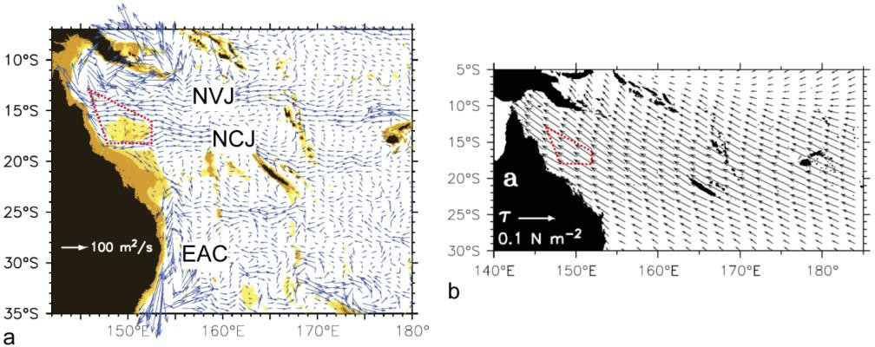

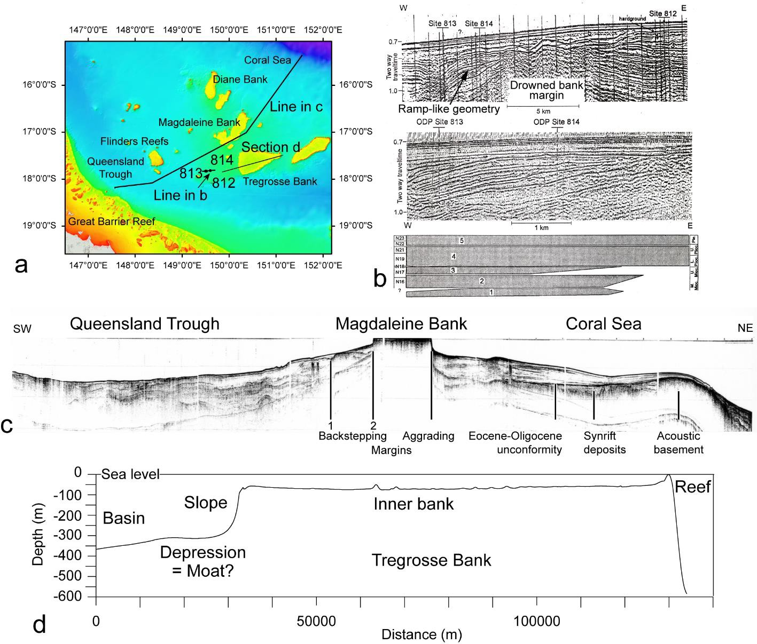**Figure 3**. **a.** Surface currents in the Coral Sea (Kessler and Cravatte, 2013). NVJ: North Vanuatu Jet; NCJ: North Caledonia Jet; EAC: East Australian Current. **b.** Mean wind stress vectors of the trade winds (1991 – 2000, Kessler and Cravatte, 2013). Red dotted lines: Outline of the Queensland Plateau.

**Figure 4. a.** Map showing location of ODP sites and seismic lines in b and c. **b.** Seismic lines across ODP sites 812 – 814 with wheeler diagram (Betzler, 1997). 1 is the oldest sequence with a carbonate ramp geometry, which overlies the drowned margin of the carbonate bank. **c.** Seismic line through Magdaleine Bank with a backstepping on the leeward side of the bank and an aggradation at the windward flank. **d.** Section through the periplatform area and the inner part of Tregrosse Bank. Bathymetry from Beaman (2010).

Nevertheless, the seismic data bear important key information: Although Magdaleine and Tregrosse Banks were and are well located within the trade wind belt, the leeward margin of the precursor platform has stepped back since the Middle Miocene. A viable and simple explanation for this pattern is that a wind-driven current system was established during the late Middle Miocene and that the backstepping developed on the downcurrent, i.e. leeward side, of the carbonate banks as upwelling cells either injected more nutrients or colder waters in the wake of the banks.

The carbonate banks of the Queensland Plateau appear to follow the classical windward – leeward inner platform facies asymmetry: reefs grow along the windward edge of the banks and protect an open lagoon (Figs. 4a and d). These open lagoons, however, are underfilled with respect to the sediment infill and have water depths of 50 – 75 m (Fig. 4d). Pinnacles and knolls representing living coral heads are scattered around the sea floor of the open lagoons (Orme, 1977). Coral reefs, in general, occur along a transect of different environmental conditions from the shallowest water to the mesophotic zone. Within this system, the shallowest reefs are the most affected by factors such as high sediment stress or rising water temperatures. Mesophotic reefs are characterized by the low availability of light for photosynthesis and the presence of soft corals, sponges and algae as the dominant structural components. The depth window where these reefs are thriving hinders direct and extensive observation and mapping of these bodies and ecosystems through conventional SCUBA diving. Therefore, little is known of such mesophotic reef distribution, abundance, productivity and susceptibility. Knowledge on mesophotic reefs, however, is a crucial aspect to understanding how neritic shelf carbonates may look like in a world subjected to climate change. Mesophotic reefs in such a system may act as refugia, protected from exposure to higher water temperature.

The two major banks exposed to the North Caledonia Jet (Magdaleine and Tregosse Banks) exhibit this pattern, and we exclude differential subsidence to create the pattern of reef distribution. The subsidence rate for the Queensland Plateau has been calculated to 9 – 11 cm / 1000 yr (past 5 Ma), with lower rates before ~5 Ma (Müller et al, 2000). Our working hypothesis is that wind driven currents sweep the platform unhindered, exporting the material produced in the inner platform to the slope and adjacent basin.

A further indicator of the oceanic current impact on the carbonate bank, also in the slope and basinal area, is given by the sea floor features on the downcurrent side of Tregrosse Bank, where bathymetric data (Beaman, 2010) indicate a moat-like depression at the sea floor (Fig. 4d) which could be explained best as a broad moat sculptured by contour currents. The flanks of the Queensland Plateau banks appear to be affected by complex currents, including downslope and upwelling systems (Orme, 1977). The seafloor in the passages separating the banks in water depths of 230 - 240 m are covered by carbonate sands with small- and large-scale ripples observed during spot dives with a submersible (Orme, 1977). Some areas even have no sediment cover and are formed by uneven and eroded surfaces. The surface currents in and around the banks are controlled by the trade winds and the tides which have amplitudes of up to 1.80 m.

Bottom flows possibly also affect sedimentation in greater water depths of the Queensland Plateau. Figure 5a shows a detail of the seafloor north of Magdaleine Bank, where a sinuous, 3 km wide and 60 m deep channel originates at a water depth of ca. 500 - 600 m. This feature can be followed more than a 100 km into the deep Coral Sea. The channel seems not to originate from the flank of Magdaleine Bank, but rather from the otherwise flat and regular sea floor. Here it proposed that the channel is formed by sedimentary density flows, possibly triggered by sediment remobilization related to internal waves, which may have a certain erosional potential (Hübscher et al., 2016). This is supported by CTD data showing a pycnocline just below 500 m (Fig. 5b). Internal waves, probably tidally driven, would propagate along this surface initiating sediment remobilization when the waves touch ground in the passage separating Magdaleine from Willis Bank.

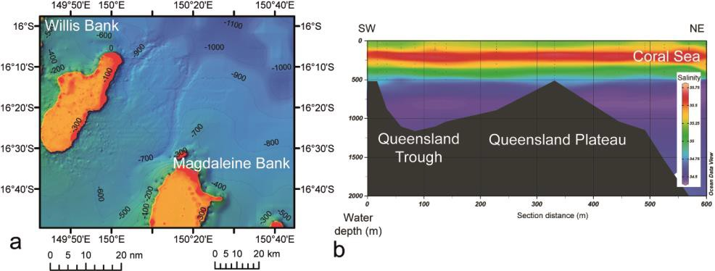

**Figure 5. a** Seafloor with meandering submarine channel (bathymetric data from Beaman, 2010). **b** Salinity profile through the coral sea (Ocean Data View).

Summarizing, the Queensland Plateau provides a world unique key area to test and amend our hypothesis and model of icehouse-world isolated carbonate platforms.

# Preliminary Work.

The proponents during the past years have been working on the sedimentology and seismostratigraphy of the carbonate platforms of the Bahamas, Maldives, S- and NE- Australia. CB, TL, and CH were lead proponents for IODP Exp. 359, CB co-chief of this Exp. 359. Many of concepts introduced and discussed above result from this groundwork. CB has participated at ODP Leg 133 which visited the Queensland Plateau.

* 1. Literature Mentioned in 2.1 (with participation of the proponents)

Beaman, R.J., 2010. Project 3DGBR: A high-resolution depth model for the Great Barrier Reef and Coral Sea. Marine and Tropical Sciences Research Facility (MTSRF) Project 2.5i.1a Final Report, MTSRF, Cairns, Australia, pp. 13 plus Appendix 1.

Bergmann, K., Westphal, H., Janson, X., Poiriez, A., Eberli, G.P., 2010. Controlling Parameters on Facies Geometries of the Bahamas, an Isolated Carbonate Platform Environment. In: H. Westphal, B. Riegl, G.P. Eberli (Eds.), Carbonate Depositional Systems: Assessing Dimensions and Controlling Parameters, Heidelberg, pp. 5-80.

Betzler, C., Hübscher, C., Lindhorst, S., Reijmer, J. J. G., Römer, M., Droxler, A. W., Fürstenau, J., and Lüdmann, T., 2009. Monsoonal-induced partial carbonate platform drowning (Maldives, Indian Ocean). Geology, 37: 867-870.

Betzler, C., Fürstenau, J., Lüdmann, T., Hübscher, C., Lindhorst, S., Paul, A., Reijmer, J. J. G., and Droxler, A. W., 2013. Sea-level and ocean-current control on carbonate-platform growth, Maldives, Indian Ocean. Basin Research, 25: 172-196.

Betzler, C., Lindhorst, S., Eberli, G. P., Lüdmann, T., Möbius, J., Ludwig, J., Schutter, I., Wunsch, M., Reijmer, J. J. G., and Hübscher, C., 2014. Periplatform drift: The combined result of contour current and off-bank transport along carbonate platforms. Geology, 42: 871-874.

Betzler, C. et al., 2016a. The abrupt onset of the modern South Asian Monsoon winds. Scientific Reports, 6: 29838.

Betzler, C., 1997. Ecological controls on geometries of carbonate platforms: Miocene/Pliocene shallow-water microfaunas and carbonate biofacies from the Queensland Plateau (NE Australia). Facies, 37: 147-166.

Betzler, C., Brachert, T.C., Kroon, D., 1995. Role of climate in partial drowning of the Queensland Plateau carbonate platform (northeastern Australia). Marine Geology, 123: 11-32.

Betzler, C., Hübscher, C., Lindhorst, S., Lüdmann, T., Reijmer, J.J.G., Braga, J.-C., 2016b. Lowstand wedges in carbonate platform slopes (Quaternary, Maldives, Indian Ocean). The Depositional Record, 2: 196-207.

Betzler, C., Kroon, D., Gartner, S., Wei, W., 1993. Eocene to Miocene chronostratigraphy of the Queensland Plateau: Control of climate and sea level on platform evolution. Proc. Ocean Drill. Proj., Sci. Results, 133: 281-289.

Betzler, C., Kroon, D., Reijmer, J.J.G., 2000. Synchroneity of major late Neogene sea level fluctuations and paleoceanographically controlled changes as recorded by two carbonate platforms. Paleoceanography, 15: 722-730.

Brachert, T.C., Betzler, C., Davies, P.J., Feary, D.A., 1993. Climatic change: Control of carbonate platform development (Eocene-Miocene, Leg 133, Northeastern Australia). Proceedings of the Ocean Drilling Program, Scientific Results, 133: 291-300.

Ceccarelli, D.M. et al., 2013. The Coral Sea. Advances in Marine Biology, 66: 213-290.

Davies, P. J., McKenzie, J. A., Palmer-Julson, A., et al., 1991. Proceedings of the Ocean Drilling Program, Initial Reports, Vol. 133.

de Vos, A., Pattiaratchi, C.B., Wijeratne, E.M.S., 2014. Surface circulation and upwelling patterns around Sri Lanka. Biogeosciences, 11: 5909-5930.

Eberli, G.P., Anselmetti, F.S., Isern, A.R., Delius, H., 2010. Timing of changes in sea level and currents along Miocene platforms on the Marion Plateau. In: W.A. Morgan, A.D. George, P.M. Harris, J.A. Kupecz, J.F. Sarg (Eds.), Cenozoic carbonate systems of Australasia. SEPM Spec. Pub., 219-242.

Eberli, G.P., Ginsburg, R.N., 1987. Segmentation and coalescence of Cenozoic carbonate platforms, northwestern Great Bahama Bank. Geology, 15: 75-79.

Feary, D.A., Champion, D.C., Bultitude, R.J., Davies, P.J., 1993. Igneous and metasedimentary basement lithofacies of the Queensland Plateau (Sites 824 and 825). Proceedings of the Ocean Drilling Program, Scientific Results, 133: 535-540.

Flower, B.P., Kennett, J.P., 1994. The middle Miocene climatic transition: East Antarctic ice sheet development, deep ocean circulation and global carbon cycling. Palaeogeogr., Palaeoclimatol., Palaeoecol., 108: 537-555.

Ganachaud, A. et al., 2014. The Southwest Pacific Ocean circulation and climate experiment (SPICE). Journal of Geophysical Research: Oceans, 119: 7660-7686.

Groeneveld, J., J. Henderiks, W. Renema, C.M. McHugh, D. De Vleeschouwer, B.A. Christensen,

C.S. Fulthorpe, L. Reuning, S.J. Gallagher, K. Bogus, G. Auer, T. Ishiwa, and Expedition 356 Scientists, 2017. Australian shelf sediments reveal shifts in Miocene Southern Hemisphere Westerlies. Science Advances 3, e1602567.

Hallock, P., Schlager, W., 1986. Nutrient excess and the demise of coral reefs and carbonate platform Palaios, 1: 389-398.

Hays, J.D., Imbrie, J., &, Shackleton, N.J., 1976. Variations in the earth's orbit: pacemaker of the ice ages Science, 194: 1121-1132.

Holbourn, A., Kuhnt, W., Clemens, S., Prell, W., Andersen, N., 2013. Middle to late Miocene stepwise climate cooling: Evidence from a high-resolution deep water isotope curve spanning 8 million years. Paleoceanography 28, 688-699.

Hübscher, C., Betzler, C., Reiche, S., 2016. Seismostratigraphic evidences for deep base level control on middle to late Pleistocene drift evolution and mass wasting along southern Levant continental slope (Eastern Mediterranean). Marine and Petroleum Geology, 77: 526-534.

Isern, A., Anselmetti, F.S., Blum, P., 2004. A Neogene carbonate platform, slope and shelf edifice shaped by sea level and ocean currents, Marion Plateau (Northeast Australia). In: G.P. Eberli, J.L. Masaferro, J.F. Sarg (Eds.), Seismic imaging of carbonate reservoirs and systems. AAPG Mem., pp. 291-307.

Isern, A., McKenzie, J.A., Feary, D.A., 1996. The role of sea-surface temperature as a control on carbonate platform development in the western Coral Sea. Palaeogeogr., Palaeoclimatol., Palaeoecol., 124: 247-272.

Isern, A., McKenzie, J.A., Müller, D.W., 1993. Paleoceanographic changes and reef growth off the Northeastern Australian margin: Stable isotopic data from Leg 133, Sites 811 and 817, and Leg 21, Site 209. In: J.A. McKenzie, P.J. Davies, A. Palmer-Julson, e. al. (Eds.), pp. 263-280.

John, C.M., Mutti, M., 2005. Relative Control of Paleoceanography, Climate, and Eustasy over Heterozoan Carbonates: A Perspective from Slope Sediments of the Marion Plateau (ODP LEG 194). Journal of Sedimentary Research, 75: 216-230.

Kessler, W.S., Cravatte, S., 2013. Mean circulation of the Coral Sea. Journal of Geophysical Research: Oceans, 118: 6385-6410.

Lisiecki, L.E., Raymo, M.E., 2005. A Pliocene-Pleistocene stack of 57 globally distributed benthic D18O records. Paleoceanography, 20, PA 1003.

Lüdmann, T., Paulat, M., Betzler, C., Möbius, J., Lindhorst, S., Wunsch, M., Eberli, G. P., 2016. Carbonate mounds in the Santaren Channel, Bahamas: A current-dominated periplatform depositional regime. Marine Geology, 376: 69-85.

Müller, R.D., Lim, V.S.L., Isern, A.R., 2000. Late Tertiary tectonic subsidence on the northeast Australian passive margin: response to dynamic topography? Marine Geology, 162(2): 337-352. Mullins, H.T., Neumann, A.C., 1979. Deep carbonate bank margin structure and sedimentation in the Northern Bahamas. In: L.J. Doyle, O.H. Pilkey (Eds.), Soc. Econ. Paleont. Mineral., Spec. Publ., pp. 165-192.

Mutter, J.C., 1977. The Queensland Plateau. Bur. Min. Resour., Geol. Geophys., Bull., 179: 1-55. Orme, GR. The Coral Sea Plateau – A major reef province. In: Biology and geology of coral reefs Vol. 2 (Jones, AJ and Endean, R. eds.), pp 267-306

Playton, T.E., Janson, X., Kerans, C., 2010. Carbonate slopes. In: N.P. James, G.B. Dalrymple (Eds.), Facies models 4. Geological Association Canada, pp. 449-476.

Pomar, L., Baceta, J.I., Hallock, P., Mateu-Vicens, G., Basso, D., 2017. Reef building and carbonate production modes in the west-central Tethys during the Cenozoic. Marine and Petroleum Geology, 83: 261-304.

Principaud, M., Ponte, J. P., Mulder, T., Gillet, H., Robin, C., and Borgomano, J., 2016. Slope‐to‐ basin stratigraphic evolution of the northwestern Great Bahama Bank (Bahamas) during the Neogene to Quaternary: interactions between downslope and bottom currents deposits. Basin Research, 29:699-724.

Schlager, W., 2005. Carbonate sedimentology and sequence stratigraphy. Concepts Sediment. Paleont., 8, Tulsa, Oklahoma, 200 pp.

Shao, L. et al., 2017. Neogene carbonate platform development in the NW South China Sea: Litho-

, bio- and chemo-stratigraphic evidence. Marine Geology, 385: 233-243.

Sugden, D.E., Marchant, D.R., Denton, G.H., 1993. The Case for a Stable East Antarctic Ice Sheet: The Background. Geografiska Annaler. Series A, Physical Geography, 75: 151-154.

Wright, J. D., and K. G. Miller, 1996. Control of North Atlantic deep water circulation by the Greenland-Scotland Ridge, Paleoceanography, 11, 157–170.

Wunsch, M., Betzler, C., Lindhorst, S., Lüdmann, T., Eberli, G.P., 2016. Sedimentary dynamics along carbonate slopes (Bahamas archipelago). Sedimentology, 64: 631-657.

Zachos, J., Pagani, M., Sloan, L., Thomas, E., Billups, K., 2001. Trends, Rhythms, and Aberrations in Global Climate 65 Ma to Present. Science, 292: 686-693.

* 1. National and International Cooperation

The proposal is not linked to a specific ongoing project. It is part of the research activity of our group to unlock the controlling factors of Neogene carbonate platforms. In the frame of this project we cooperate with Prof. J. Webster (Sydney) and Drs. J. Daniell, R. Beaman, and T. Bridge (all Townsville). These scientists will be cruise participants. The cooperation with Prof. Webster will focus on the slope depositional systems, slope instabilities and youngest sea level changes, which are fields of research which he is extensively treating in the Great Barrier Reef. The cooperation with Dr. Beaman will be on the multibeam mapping.

# Aims and Program of Work

* 1. Aims

The superordinate objective of this proposal is to verify the hypothesis that tropical carbonate platforms since the onset of the middle and late Miocene global cooling are to a large degree controlled by ocean currents, i.e. that the modern carbonate platforms are in an "icehouse world mode". This will be achieved with four aims (see Fig. 6).

# To understand the backstepping of the carbonate bank margins

Cores from several ODP Sites (Fig. 2) provide a solid facies record for the middle Miocene to Pliocene from the Queensland Plateau carbonates. This record, however, is not linked to any detailed and systematic sequence stratigraphic and seismic facies reconstruction. Such data are crucial for achieving the aims of this proposal. To fill this gap, we will use multichannel seismics to investigate the depositional geometries of the backstepping carbonate bank margins and to correlate this to the available biostratigraphic and lithostratigraphic framework at the different drill sites. Determination and mapping of seismic facies will be performed to reconstruct the onset, strengthening and evolution of the current system around the Queensland Plateau. Indicative features in this regard are submarine dunes, drift bodies or moats. We will further determine if the backstepping of the shallow water areas goes hand into hand with the onset in occurrence of bottom current signatures. Together, the aim of this part of the proposal is to provide a robust new framework to better interpret the geometrical and stratigraphical changes recorded at the different ODP sites. Combining all this information will give us the necessary datasets to establish the link for a correlation and comparison of our model with the Miocene and Pliocene paleoceanographical evolution.

|  |  |
| --- | --- |
|  | **Figure 6.** Linkage of our four research aims: Margin backstepping (1), synchronous onset of drift deposition (2), indicating current control on the stratigraphic packaging. The present-day current control is reflected by moat and drift formation (3), and upwelling at  the downcurrent side of the banks (4). |

# To investigate the Recent and youngest depositional processes

Mapping (multibeam, Parasound) the flanks and toe of slope of the active carbonate banks will determine the ocean current impact on the carbonate source to sink system (sediment thickness distribution, slope instabilities, sediment pathways). The understanding of this system, with the discovery of the current impact on carbonate platforms, has proven to be fragmentary. We will investigate windward – leeward slope variations, toe of slope and basinal successions at the seafloor and in the shallow subsurface of different carbonate banks (Fig. 1). A systematic multibeam mapping will allow classification of seafloor features, including sedimentary current indicators (e.g. ripples); Parasound mapping provides insight into the youngest temporal evolution of the deposits (shifts in depocenters, thickness variations) and will close the gap in resolution between seismic data and sediment observations (sediment samples). Hydroacoustic data will be backed up and ground-truthed by visual data acquisition via ROV and OFOS. In the shallow parts of the carbonate banks the ROV will be used, whereas the OFOS will be deployed in deeper waters where a smoother seafloor is expected.

# To investigate the sedimentary variations with regard to the exposure of the carbonate banks to currents and wind

Sediment composition (grain size, texture, components) varies in function of the depositional processes. Current impact on slope sedimentation has been shown to override gravitational downslope sediment sorting (grain size). Therefore, a dedicated sedimentological sampling with Van Veen grabs and box corers will be performed to calibrate the multibeam and backscatter data acquired at the distinct flanks of the carbonate banks with different orientations with respect to wind and currents. Gravity coring will be performed at locations previously defined in the Parasound data. These locations will be chosen in such a way that the best records with respect to recoverable core length and completeness of the stratigraphic record is expected.

# To assess the water mass stratification and dynamics

Isolated carbonate platforms and their banks positioned in the flow of a current induce turbulence and upwelling at the downcurrent flanks of these bodies. There are also cases, however, where bank or platform interior waters have higher densities than the surrounding waters, leading to downwelling at the leeward flanks. In any case, there is a measurable deflection of the depth position of the water mass boundaries, which can be measured through CTD stations. These will also allow us to answer the question of the relevance of internal waves for the sedimentary dynamics at the sea floor in deeper areas (500 m) of the Queensland Plateau. ADCP measurements of the water column will allow determining the direction and velocity of the water masses. These data are essential for the interpretation of the present sedimentation processes in respect of bottom current activity.

* 1. Work Program

The objectives of the cruise are in direct context with our previous work on carbonate platforms. Consequently, the planned research integrates the following disciplines: Carbonate sedimentology, carbonate stratigraphy (seismics and Parasound), seafloor

mapping, facies mapping; The working program consists of five main components (A – E), with a shipboard and a post-cruise, shorebased part.

## Shipboard studies

1. **Seismic stratigraphy surveys.** High resolution seismic lines will cross ODP Sites 811/825, 812, 813, 814, 817, and 818. This will allow linking the biostratigraphy as established at these sites to the seismostratigraphy, and also to calibrate seismic and sediment facies. Lines are oriented in such a way that the zones of the Miocene platform drowning as recognized in different low-resolution lines (Fig. 4) will be crossed at several positions (Figs. 6, 7). The planning assumes that the proposed line orientation is normal to the drowned bank edge. The seismic data will allow mapping the depositional geometries, with a special focus on the successions of the drowning sequences. Special attention will be put on forward testing for the occurrence of drift deposits or other sedimentary signatures of bottom current activity overlying the drowned banks. In particular, to analyze whether the deposits previously interpreted as carbonate ramps (Betzler, 1997, Betzler et al., 2000) are such deposits or rather current accumulated sediment bodies. Seismic data will also help characterizing the youngest sedimentary succession at the flanks of the carbonate banks to reconstruct the slope depositional system as backup of the higher resolution Parasound surveys. The seismic survey will be performed in seven survey areas, each treated as an individual block. A first brute-stack processing of the seismic data will be carried out during the cruise with the commercial ProMAX software (Halliburton-Landmark). Data then will be loaded in the seismic interpretation software Petrel (Schlumberger) for preliminary examination and to determine the necessity of a potential adaption of the further cruise planning.
2. **Hydroacoustic (multibeam and Parasound) surveys.** Multibeam mapping (accompanying seismic surveys and also as stand-alone) will resolve seafloor features such as submarine channels and escarpments, but also display large and medium scale sediment structures such as current moats or submarine dunes. This will produce a set of data amending the FALKOR cruise data which will allow us to determine impact of the currents on sedimentation processes. Backscatter data will provide a data set with regard to lateral variations of the sedimentary facies, which also serves as the basis for surface sediment sampling. Multibeam mapping and backscatter data acquisition will be performed with the hull-mounted Kongsberg EM 710 echosounder in shallower waters, and with the Kongsberg EM 122 in deeper waters. Survey planning for stand-alone Multibeam and backscatter surveys will be based on existing bathymetric data of the working area (Figs. 2, 4, 5) and on the data acquired during the seismic surveys. Survey areas are placed in such a way that windward and leeward margins of the banks will be analyzed, as well as margins with different orientations to contour currents. A first cleaning of the multibeam data as well as production of bathymetric charts and backscatter images will be done during the cruise using the software packages Fledermaus and Qimera (QPS BV).

The Parasound system will be accompanying the seismic surveys, but will also be performed as stand-alone in four dedicated areas. Parasound data will be used to discriminate the facies of the youngest interval of the sedimentary succession in basinal, slope, and inner bank area, but also to determine sedimentary structures at the sea floor indicative for bottom currents. Parasound data will be essential for the determination of sites for the planned systematic sediment sampling with grab sampler, box- and gravity corer. Parasound data will be recorded in native ASD format and subsequently converted to the SEGY format. Subsequently, data will be loaded into Petrel to ensure quick availability for sampling site selection and potential adaption of the further cruise planning and directly loaded in the Petrel project to ensure.

Hydroacoustic surveying in each area consist of two phases: 1) a sparse grid of lines will provide a first overview on the area. These lines will be acquired parallel to the seismic surveys (at 5 kts.); 2) dense grids of parallel lines in selected key areas will provide a spatial coverage of the seafloor (multibeam) as well as a 2.5- dimensional insight into the sub-seafloor (Parasound). The location of these grids has been chosen based on the available bathymetric data (Fig. 2), and with regard to the external forcing (oceanic

currents and direction of prevailing wind systems) of the particular slope areas.

Calculations of required ship time for hydroacoustic surveys is based on a survey speed of 8 kts., 120° swatch angle and 20% overlapping of adjacent lines. Spacing of individual lines is calculated with regard to water depth as known from the existing low-resolution sea-floor bathymetry and will be adapted based on the results of the overview lines if necessary. In areas with a high bathymetric gradient (e.g. the slopes of the carbonate banks), lines will be oriented parallel to the isobaths to ensure a constant overlap of adjacent multibeam profiles as well as an orientation of Parasound profiles perpendicular to the expected sediment transport paths. See Appendix 1 for calculation of distances and the geographic location of survey areas.

1. **ROV and OFOS surveys.** A direct seafloor observation along transects will be performed using a MOHAWK ROV (Universität Hamburg) in shallower waters of the inner bank, bank edge and slope, and with a towed OFOS in deeper waters. Both procedures will allow to resolve seafloor features (sediment structures, components, fauna and flora) which are below the resolution of the multibeam and backscatter imagery, but provide important information for the understanding of the depositional dynamics (e.g. occurrence of hardgrounds, colonization of the seafloor, direction of traction by bottom currents). OFOS will be used in deeper waters and with the primarily aim of identifying small scale sediment structures and changes in surface sediment facies. ROV operations will be concentrated to the shallower waters of the inner bank, bank edge and slope, where rough morphology and high bathymetric gradients complicate OFOS operation. The ROV, due to its mobility, further allow for an in-deep observation of faunal associations including assessing the state of the inner bank mesophotic reefs. The data collected with the ROV and OFOS will be collected along dedicated transects in areas previously identified in the multibeam data, which also form the base of a systematic sediment sampling.
2. **Sediment sampling.** Sediment sampling aims on defining the sedimentary provinces and facies in the different working areas (sediment surface and shallow subsurface) and resolving the temporal sedimentological changes e.g. in response to sea level changes, but also show if the depositional area displays short term sedimentary variations (e.g. turbidites). Sediment sampling in general will be an important work package to determine and resolve current impact on sedimentary facies. Sediment samples and cores will be macroscopically described during the cruise, and first sets of samples will be taken for further post-cruise processing.
3. **CTD measurements.** CTD transects will be performed on the upcurrent and downcurrent sides of the isolated carbonate banks to understand the deflection of the water mass boundaries. At three positions at the downcurrent flanks of the banks yo-yo CTD stations will be performed to consider potential tidal effects, which for example may generate baroclinic tides. The tides around the Queensland Plateau are semidiurnal, i.e. two high tides and two low tides of approximately equal size per day.

## Postcruise studies

Postcruise, seismic and hydroacoustic data will be subjected to a final processing, including suppression of multiples, dip and normal moveout, CDP stack and time migration as well as cleaning of the hydroacoustic data, e.g. deletion of outliers. All geophysical data will be imported into the Petrel application for analysis and interpretation following the standard seismostratigraphic approach, i.e. defining sequence boundaries and stratigraphic packages. The well data from ODP sites 811/825, 812, 813, 814, 817, 818 (sites covered by the seismic surveys) will be introduced into the project, thus a chronostratigraphy for the relevant Middle Miocene to Recent succession will be achieved. This work will allow to address Aim 1 and parts of Aim 2.

Sediment samples will be analyzed for composition (pelagic vs. shallow-water components such as e.g. large benthic foraminifera, as well as coral and green algal debris), carbonate mineralogy (aragonite content as indicator of fine-grained shallow- water export), and grain size, thus defining depositional facies and sources of components. Based on these data, sedimentary facies will be defined and linked to the previously fully processed hydroacoustic (multibeam and Parasound) and visual data

(ROV, OFOS). Cores will be XRF scanned (Sr-content to trace differences in shallow water input at a high resolution) as a first step for establishing a stratigraphy. To understand the temporal evolution of the younger (since the last glacial sea-level lowstand) and the ongoing sedimentary processes, a high-resolution age model will be established based on radiocarbon and stable oxygen isotope data of benthic foraminifera.

The postcruise workload will be as follows: Processing of the seismic and hydroacoustic data will be mainly supervised by TL and SL and performed by master students, work related to the sedimentological packages will be mainly supervised by CB and performed by a PhD student (applied in the frame of this project). In addition, the Australian partners will be strongly contributing to the sedimentological work.

* + 1. Working Area Including Maps of Stations and Profiles

The research area is subdivided into seven working areas (Fig. 7), which represent different zones with regard to wind and current exposure. Detailed maps of the survey areas are provided as Appendix 1, together with the coordinates of start and end points of seismic lines and coordinates delimiting the multibeam mapping areas. The survey areas were chosen to (1) reconstruct the evolution of the bank margins back in time using seismic data (e.g. retrogradation as a function of the exposure to the wind and current regime), and (2) to characterize the present-day sedimentary facies based on hydroacoustic surveys and surface to shallow subsurface sediment sampling.

**Survey area 1.** Survey area 1 (Fig. 7) is a seismic survey area for resolving the Miocene

– Pliocene backstepping of the bank margins (Aim 1). Along of one of the lines crossing the bank margin of Tregrosse Bank and reaching into the bank, the bank-interior shallow area will be visually mapped with the ROV; the deeper outer-bank area with the OFOS. A sedimentological sampling program (gravity core, box core, grab samples) will be derived based upon the data acquired via Parasound, multibeam and ROV / OFOS.

**Survey area 2.** Survey area 2 (Fig. 7) is an area of multibeam mapping along a windward and leeward flank of Tregrosse Bank. Along transects to be determined based on the multibeam mapping results, a visual mapping will be performed with the ROV, deeper areas with the OFOS. A sedimentological sampling program (2 - 4 gravity cores, box cores, and grabs; Distinct sampling locations will be defined after evaluation of multibeam, parasound and OFOS data) will be established based upon the data acquired via Parasound, multibeam and ROV / OFOS. Direct sea floor observation will allow to address the question whether inner banks are current swept, but also provide information about occurrence and state of mesophotic reefs (Aims 2, 3). Two CTD station will record water masses on the up- and downcurrent flanks of Tregrosse Bank (Aim 4), two coring stations (gravity cores) at the same localities are planned for defining variations of the corresponding sedimentation regime in time.

**Survey area 3.** Survey area 3 (Figs. 7) is the second seismic survey area to address the aim of resolving the Miocene backstepping of the bank margins (partial drowning; Aim 1) by linking the stratigraphy developed at ODP Site 817 and 818 to the seismic lines obtained in Survey area 1. Survey area 3 also lies in the axis of a passage between both banks, to trace the evolution of post-drowning current-controlled sedimentation.

**Survey area 4.** Survey area 4 (Fig. 7) addresses the aim of resolving the Miocene – Pliocene backstepping of the bank margins (partial drowning; Aim 1) by linking the stratigraphy developed at ODP Site 811/825 to the backstepping and partial drowning of the carbonate banks. The survey is also the first part of a longitudinal transect through a passage separating two carbonate banks, to trace evolution of post-drowning current- controlled sedimentation (Aim 2).

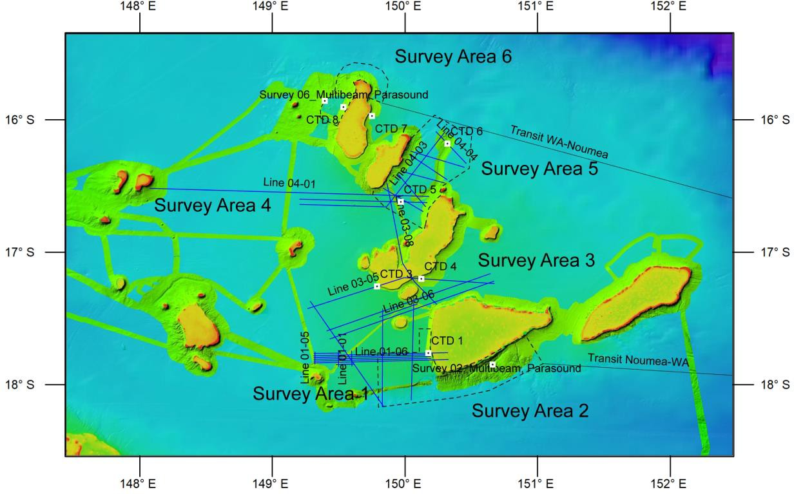

**Figure 7.** Overview map of the Queensland Plateau survey areas with position of ODP sites.

**Survey area 5.** Survey area 5 (Fig. 7) is located on the upcurrent side of the carbonate banks and therefore on the one hand completes the longitudinal transect of survey 5 (Aims 1, 2). On the other hand, this survey will provide data to interpret a channel system reaching from a carbonate bank into the deeper basin (Fig. 5). Together with a CTD station this will address the potential effect of internal waves on sedimentation in the deeper parts of the Queensland Plateau (Aim 4). Gravity cores (2 - 3) will be recovered at locations previously defined in the hydroacoustic data.

**Survey area 6.** Survey area 2 (Fig. 7) is an area of multibeam mapping at Diane Bank at a current and wind-exposed flank and a leeward flank. Along transects to be determined based on the ongoing multibeam mapping results, a visual mapping will be performed with the ROV, deeper areas with the OFOS. A sedimentological sampling program (gravity core, box core, grab samples) will be derived based upon the data acquired via Parasound, multibeam and ROV / OFOS (Aims 2, 3) in order to recover the distinct facies as imaged in the hydroacoustic data. 1 CTD station will record water masses on the downcurrent flank of Diane Bank (Aim 4).

* + 1. Use of Large Equipment

The hull-mounted Kongsberg EM 710 echosounder will be used in shallower waters, and the Kongsberg EM 122 in deeper waters (multibeam and backscatter mapping; Aims 2, 3). The Atlas Parasound DS P-70 will be used for imaging the shallow seafloor subsurface (stratigraphy and lateral facies variations; Aims 2, 3). ADCP data will be recorded continually (current velocity and direction; Aims 3, 4). Water column characterization will be performed using the shipboard CTD and the rosette (water mass characterization; Aim 4). Visual underwater mapping will be performed using the shipboard OFOS (characterization of sedimentary facies; Aims 2, 3).

**External equipment** will consist of a gravity corer (6 m), a box corer and a Van Veen grab for the sedimentological studies (characterization of sedimentary facies; Aims 2, 3). Seismic surveys will be performed using the University of Hamburg digital streamer (144 channel, 900 m total length, own winch) (subsurface mapping of the backstepping and partial drowning, characterization of current controlled Miocene to Pleistocene sedimentary geometries; Aims 1 – 3). Sea floor observation will also be performed using the University of Hamburg MOHAWK ROV (operational depth down to 1000 m, own winch) (characterization of sedimentary facies; Aims 2, 3).

* + 1. Use of Large Equipment

For the cruise planning, we propose the following approach: Seismic, Parasound and multibeam surveys can be performed irrespective of the time of day. This also applies for sedimentological sampling and CTD measurements. ROV and OFOS surveys will be performed during daylight times. As some survey areas are adjacent to each other, transit distances are only introduced when areas are geographically separated. Survey speeds of MCS 5 kn and MBES-SSS stand-alone 8 kn. Seismic acquisition will be performed in 48 h blocks separated by 5 h breaks (airgun maintenance; included in calculation below).

|  |  |  |  |  |
| --- | --- | --- | --- | --- |
| Day | Surv Area | Task | nm | Time (h) |
| **1-3** | **Transit Noméa - Survey area 1** | | **934** | **74** |
|  | 1 | Seismic, Parasound and multibeam survey (10 lines) | 305 | 61 |
| 6-9 | 2 | Multibeam and Parasound survey (stand-alone) |  | 48 |
|  | 2 | 2 Yo-Yo CTD stations |  | 48 |
| 9 | 1 | ROV survey along a selected bank to slope transect  (shallow part), observation of features previously identified in the Parasound and multibeam data. |  | 6 |
| 10 | 1, 2 | OFOS survey along a selected slope to basin transect (deep part). |  | 6 |
| 10-11 | 1 | Sediment sampling at dedicated and previously identified (hydroacoustic and visual data) locations (gravity core, box core and Van Veen grab) |  | 24 |
| 12 | 2 | Yo-yo CTD station downcurrent side of Tregrosse Bank |  | 24 |
| 13 | 2 | Yo-yo CTD station upcurrent side of Tregrosse Bank |  | 24 |
|  | 3 | Seismic, Parasound and multibeam survey (8 lines) | 430 | 86 |
| 18 | 3 | ROV survey along a selected bank to slope transect, observation will concentrate on features previously  identified in the Parasound and multibeam data. |  | 6 |
| 19 | 3 | OFOS survey along a selected slope to basin transect |  | 6 |
| 20 | 3 | Sediment sampling at dedicated and previously identified (hydroacoustic and visual data) locations (gravity core, box core and Van Veen grab) |  | 24 |
|  | 3 | 2 CTD stations |  | 8 |
|  | 4 | Seismic, Parasound and multibeam survey (9 lines) | 380 | 76 |
| 26-28 | 5 | Multibeam and Parasound survey (stand-alone) |  | 35 |
| 29 | 5 | OFOS survey along a selected slope to basin transect |  | 6 |
| 29 | 5 | Sediment sampling at dedicated and previously  identified (hydroacoustic and visual data) locations (gravity core, box core and Van Veen grab) |  | 12 |
|  | 5 | CTD sation |  | 4 |
| 31-33 | 6 | Multibeam and Parasound survey (stand-alone) |  | 24 |
| 34 | 6 | OFOS survey along a selected slope to basin transect |  | 6 |
| 34 | 6 | ROV survey along a selected bank to slope transect,  observation will concentrate on features previously identified in the Parasound and multibeam data. |  | 6 |
| 35 | 6 | Sediment sampling at dedicated and previously identified (hydroacoustic and visual data) locations  (gravity core, box core and Van Veen grab) |  | 12 |
|  | 6 | 3 CTD stations (1X Yo-Yo) |  | 38 |
| **37-39** | **Transit Survey area 6 - Nouméa** | | **1026** | **82** |
| **Sum** | | |  | **746** |

* + 1. Measures to Conduct Responsible Marine Research

Sampling will be conducted in a minimal invasive manner, by applying rosette samplers in the water column, grabs, box cores, and gravity cores. A large part of the cruise will collect non-invasive hydroacoustic and seismic data. During Parasound and swath

echosounder data acquisition, mammal protection modes will be used. Transmission of acoustic energy to the water column will be kept as low as possible by adjustment of transmission level according to water depth. Acoustic transmission will be stopped during station work. Sediment samples will be cooled and no live material will be transported. The multi-disciplinary team assures a maximum of synergy when analyzing the samples.

The seismic surveys will use 1 standard GI gun 210 in3 (combined 208dB ref 1 µPa at 1M) and 1 mini GI gun 90 in3 (173dB ref 1 µPa at 1M); This represents a volume of less than 10 % of airgun arrays used in petroleum industry surveys. The airguns will be towed about 30 m behind the vessels during data acquisition and used in GI mode. The source level of a single GI-gun in airgun mode has a source sound exposure level of 202 dB re 1 µPa2 s @ 1 m. A 3 GI gun array has a sound exposure level of 211 dB re 1 µPa2 s@ 1 m. In the absence of measurements for 2 GI guns, we have estimated the source level of 2 GI guns as double that of one i.e. 208 dB re 1 µPa2 s@ 1 m. This source level is below the threshold for injury and below the level for injury for multiple pulses within a few meters of the guns. It also means that the Department of Environment preferred threshold for Temporary Threshold Shift (TIS) in whale hearing of 160 dB re 1 µPa2 s@ 1 m is reached at 251 m from the source assuming spherical spreading of the sound. This means that the TIS threshold will be reached in a circle much less than 1 km and that extends about 130 meters in front of the vessel. In summary, the seismic source for the proposed survey will produce sound pulses which will be within the range of natural sources and below TIS levels beyond 251 m from the airgun.

The interaction with cetacean will be minimized by including Marine Mammal Observers during seismic and hydroacoustic surveys.