LABaleine



**Antarctic Whale Research Project: Humpback Whales in a Changing Ocean**

Southern hemisphere humpback whales (*Megaptera novaeangliae*) are a keystone species of the Antarctic. Relying on summer abundance of Antarctic krill (*Euphausia superba*) to fuel one of the longest-known mammalian migrations on the planet, Humpback whales are indicators of long-term biological effects of climate driven environmental change in vulnerable Polar regions.

# Contributing to Global Targets: 30% ocean protection by 2030

Antarctica and its whales are under increasing pressure from climate change, krill fishing and a growing tourism industry. Conservation International in partnership with Ponant Foundation, aims to conduct science to inform the conservation and management of whales, ultimately contributing to the design of new marine protected areas in Antarctica and the monitoring and minimizing impacts of Antarctic tourism operations as they grow in coming years. Protection of the Antarctic ecosystem is not only critical for the adaptation of marine life to climate change, but also as the resource on which Polar tourism relies.

# The Project

Is an international collaboration of whale researchers working closely with national Antarctic programs to deliver science in data deficient areas of the Southern Ocean from tourism ships as platforms of opportunity, where the berths are donated by Ponant and travel sponsored by Conservation International. The project will use genetics, acoustics, distance sampling, and photographic matching to assess distribution and population genetics, generate density estimates, and asses impacts of ship noise on humpback whales.

# Research Objectives

* Determine feeding acoustic behaviour, connectivity to breeding geographies, and impacts of vessels on humpback whales in Antarctic feeding grounds using passive acoustic survey methods
* Generate distribution and migratory pathway information for humpback whales using photo identification
* Define humpback population structure using biopsy sampling methods
* Generate density estimates for large whales in CCAMLR management areas Domain 1 and 9 using distance sampling sightings data

# Partnerships

The single largest expense in polar research is transport to remote areas. In exchange for free berths from Ponant (French Flagged cruise ship), the researchers will contribute to passenger enrichment and education providing lectures and recaps, working with the expedition team and allowing for passenger involvement in data collection where possible. Researchers will carry out distance sampling from the ships bridge during ocean transits and conduct biopsy, acoustic recording and photo ID from a zodiac during concurrent passenger landing activities.

All data collected will be open source and contributed to national Antarctic programs such as the Australian Antarctic Division and inform the PhD research of 2 candidates.

1



**Voyage Map**

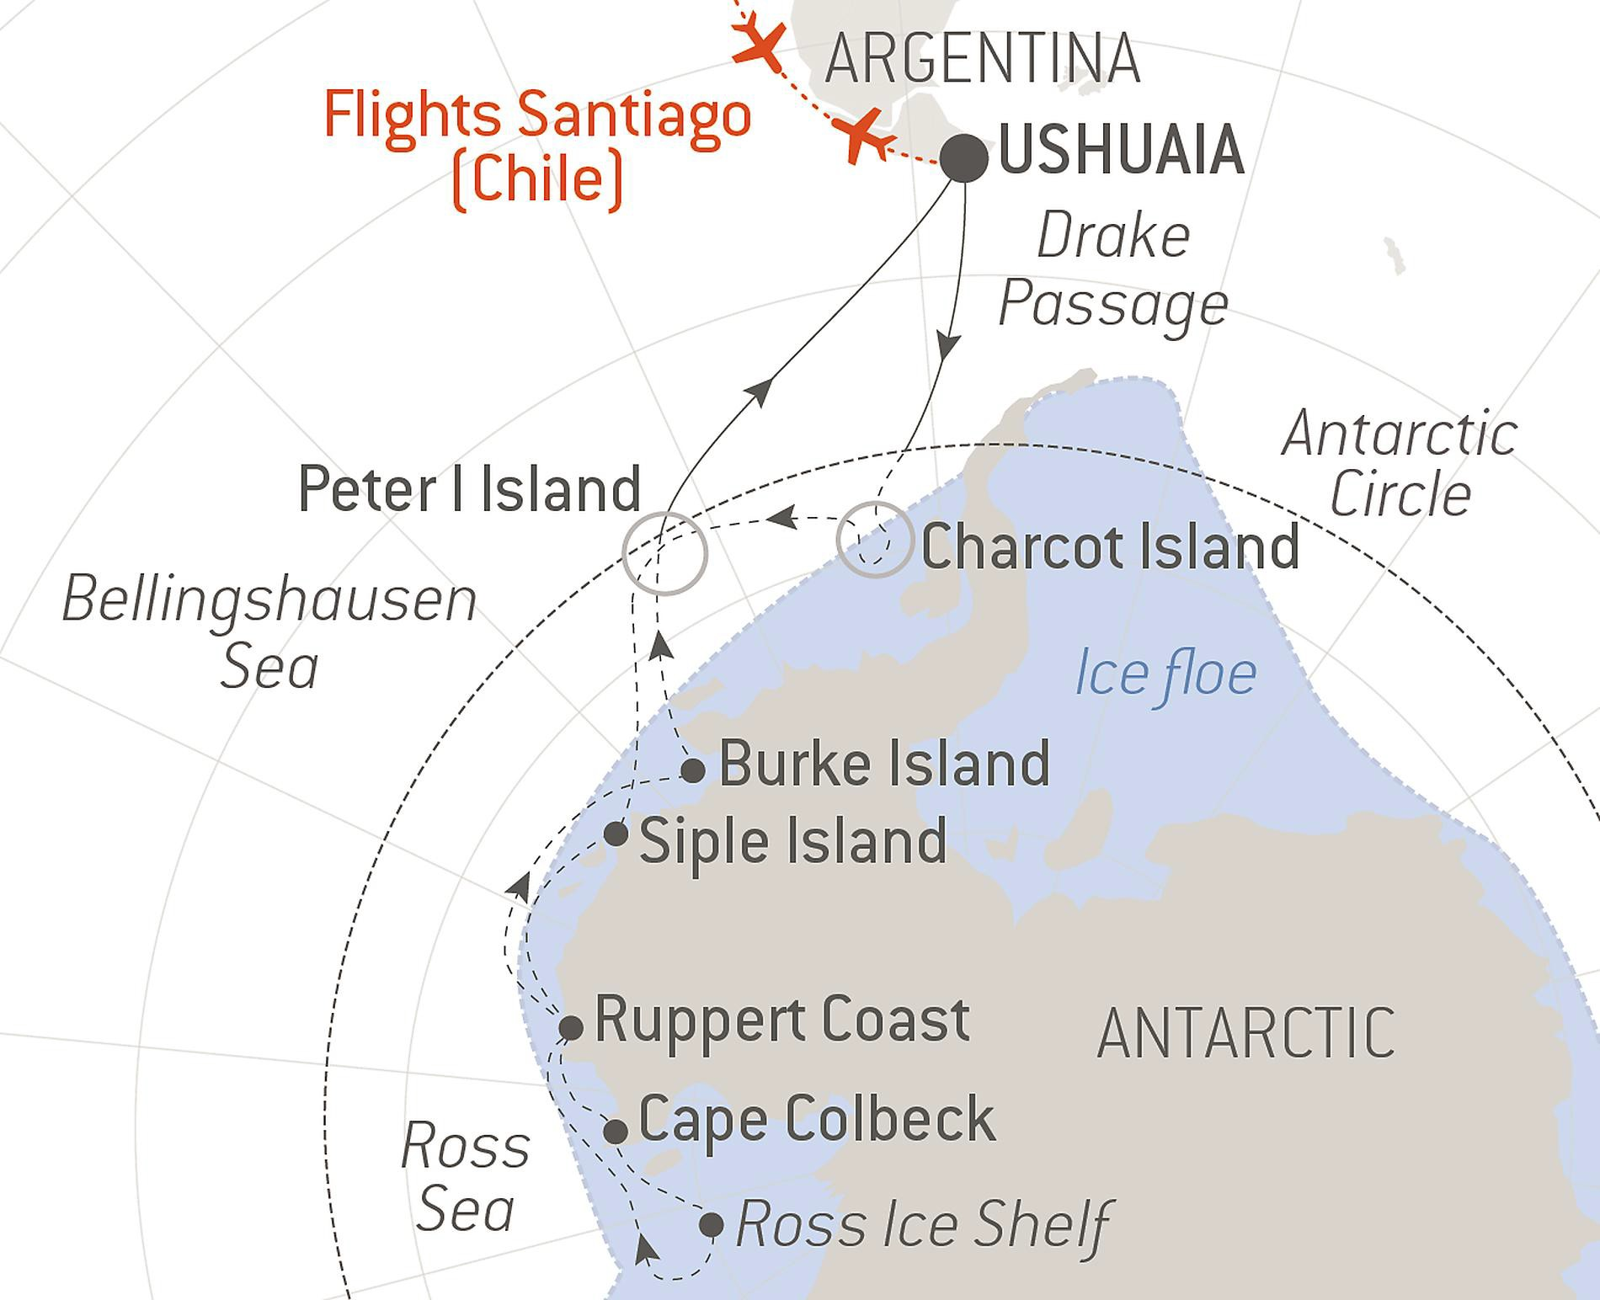

|  |  |
| --- | --- |
| **Collaborating Scientists/Institutions** | **Expertise contributed** |
| Olive Andrews, Executive, South Pacific Whale Research  Consortium (SPWRC), Senior Polar Guide, New Zealand | Photo ID, partnerships |
| Dr Carlos Olavarria, Executive Director Ceaza, National Council  of Science, Chile | Molecular ecology |
| Anthony Muyt, Earth and Sea Environmental, Australia | Small boat Captain, marine mammal  safety and compliance |
| Professor Scott Baker, Marine Mammal Institute, Oregon State  University , USA | Population genetics analysis |
| Dr Brandon Southall, President and Senior Scientist for Southall  Environmental Associates, Inc. USA | Behavioral responses of marine mammals  to anthropogenic sounds |
| Dr Elanor Bell, Australian Marine Mammal Centre, Australian Antarctic Division, Southern Ocean Research Partnership,  Australia | Status, health, population dynamics |
| Dr. Ellen Garland, Royal Society Research Fellow, University of St Andrews, Scotland | Acoustics and culture in marine mammals  – song function and transition |
| Ted Cheeseman, PhD Candidate - Happy whale, USA | AI Photo ID matching |
| Angus Henderson, PhD candidate, University of Tasmania, Australia | Distance sampling marine mammal density estimates |