Equipment

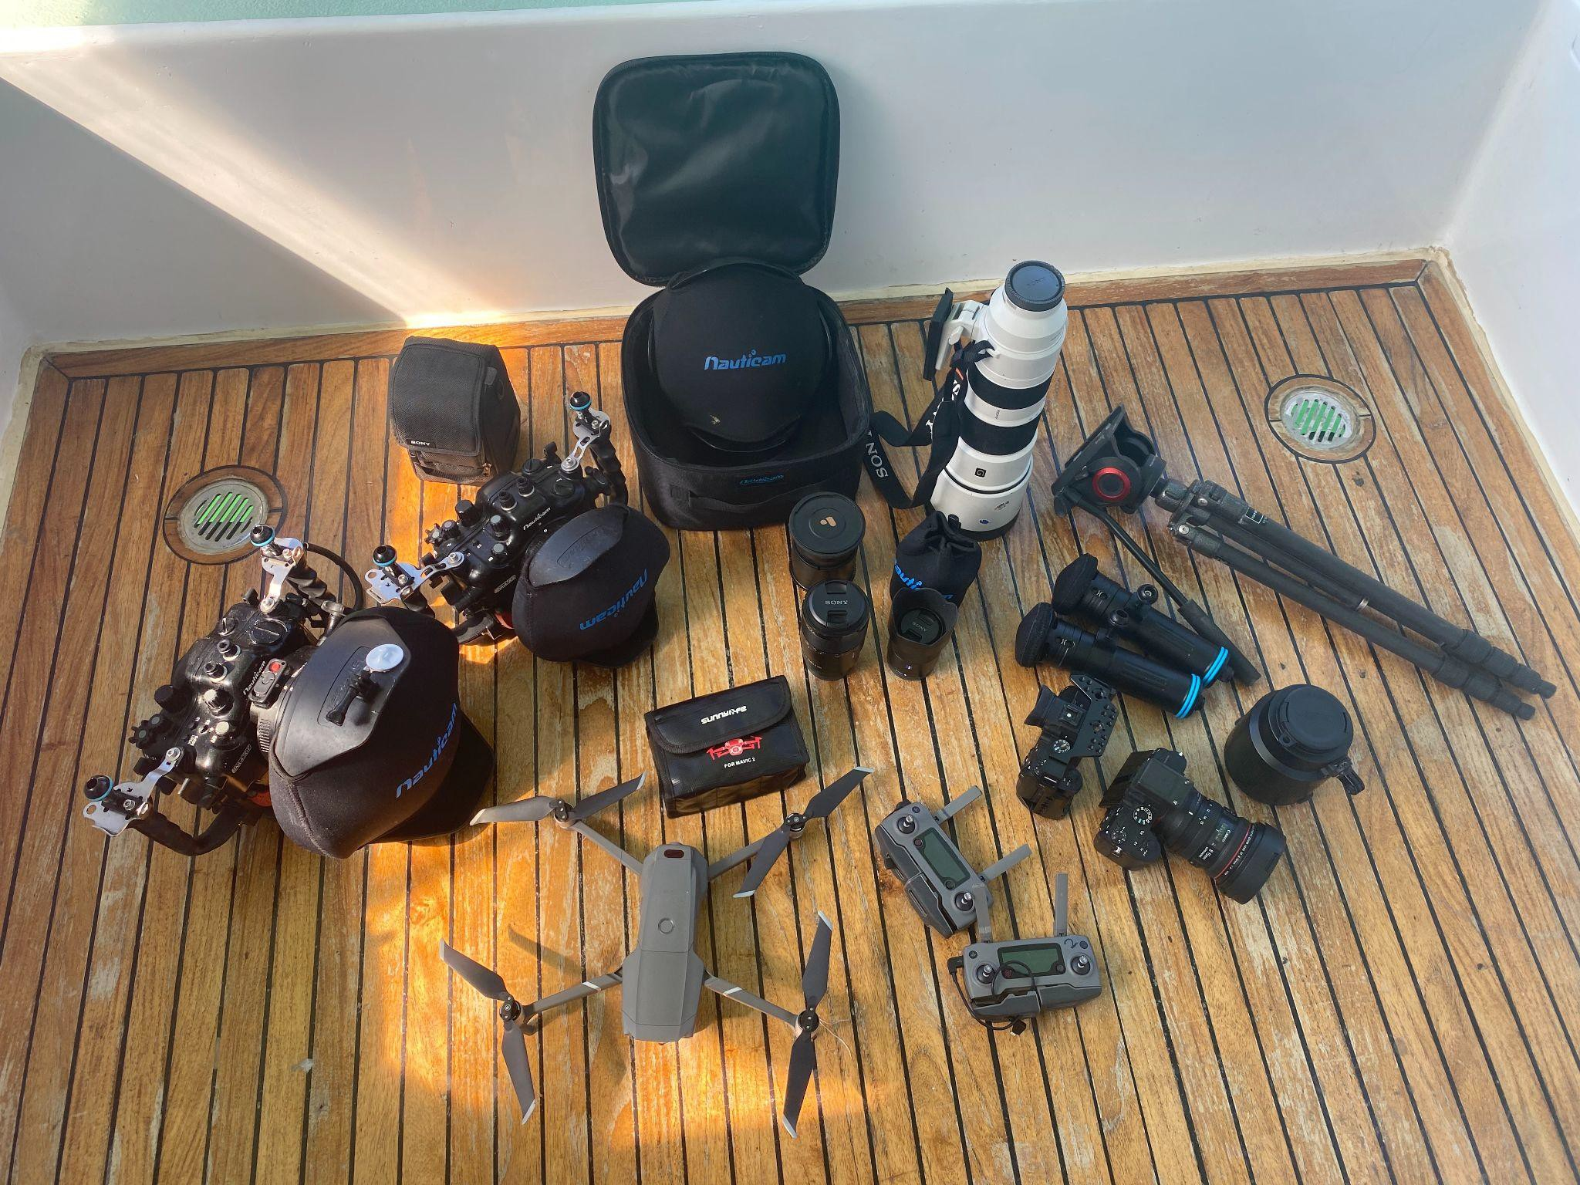
(note Paul Hilton Equipment not pictured (Cannon C300 600mm Telephoto Mavic Inspire drone ect..))

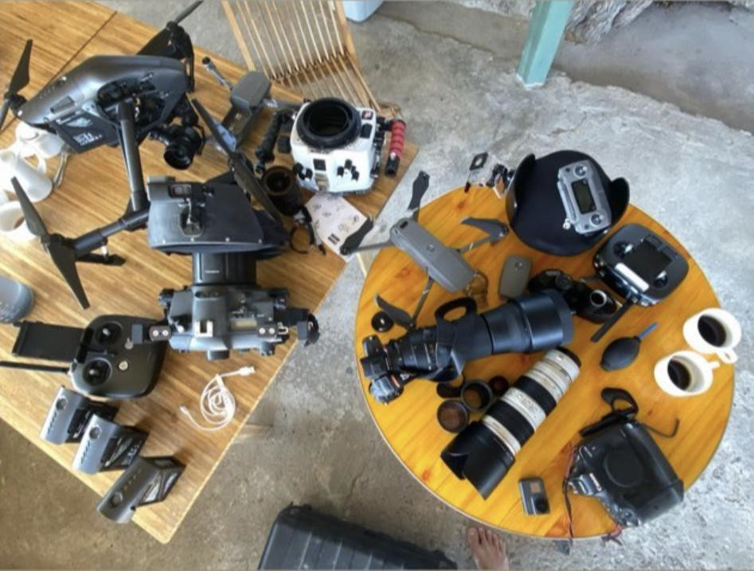
(Paul Hilton and Alex Westover Equipment, Mitchells equipment not pictured)

