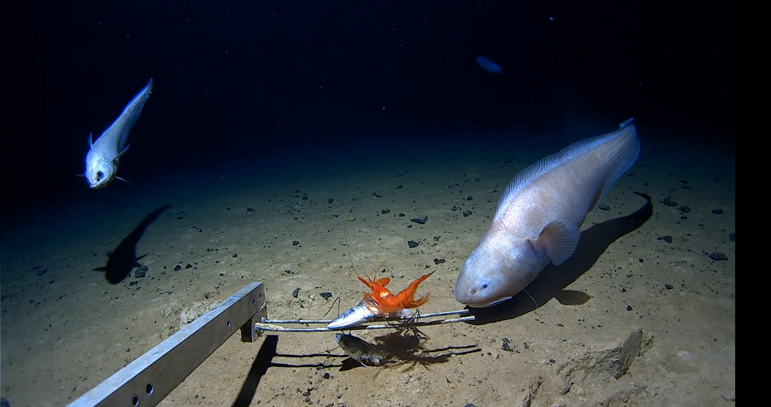
Figure 1: examples of fish and decapods found at 6000 m water depth in the eastern Indian Ocean.
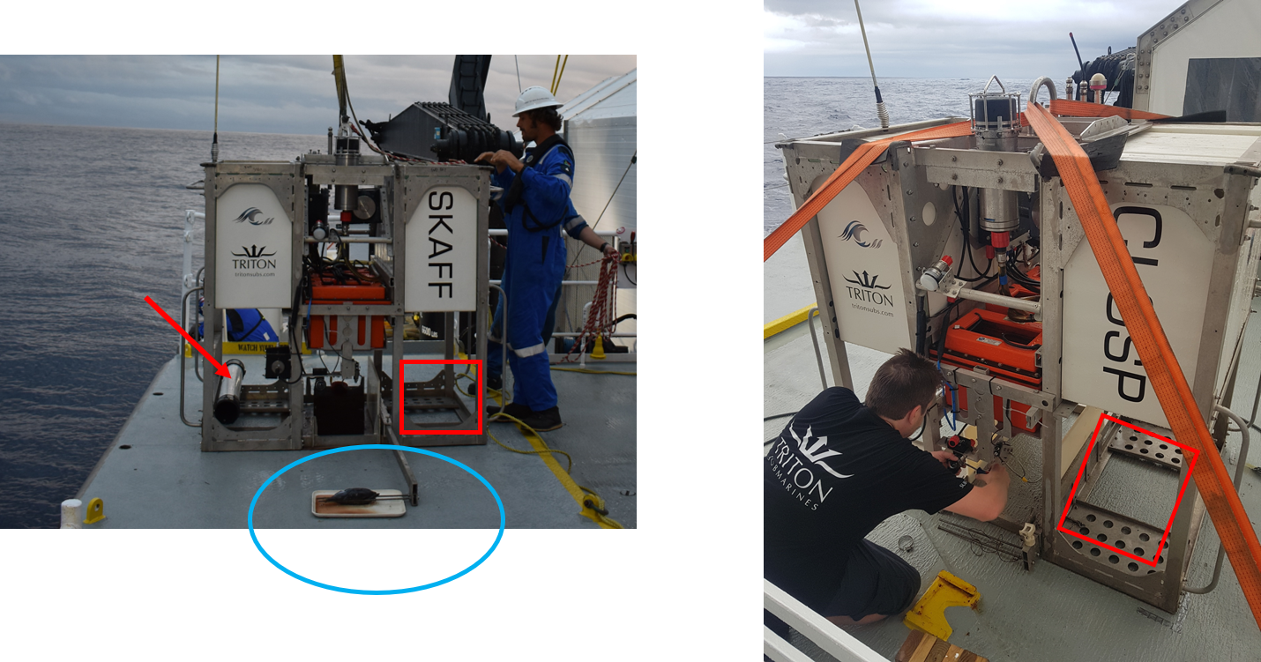
Figure 2: Example of landers. Red rectangle identifies the location of the rectangular trap or opera trap. Blue circle indicated identifies the location of the butterfly style net. Red arrow point to a PVC amphipod trap with black rubber funnels at either end.

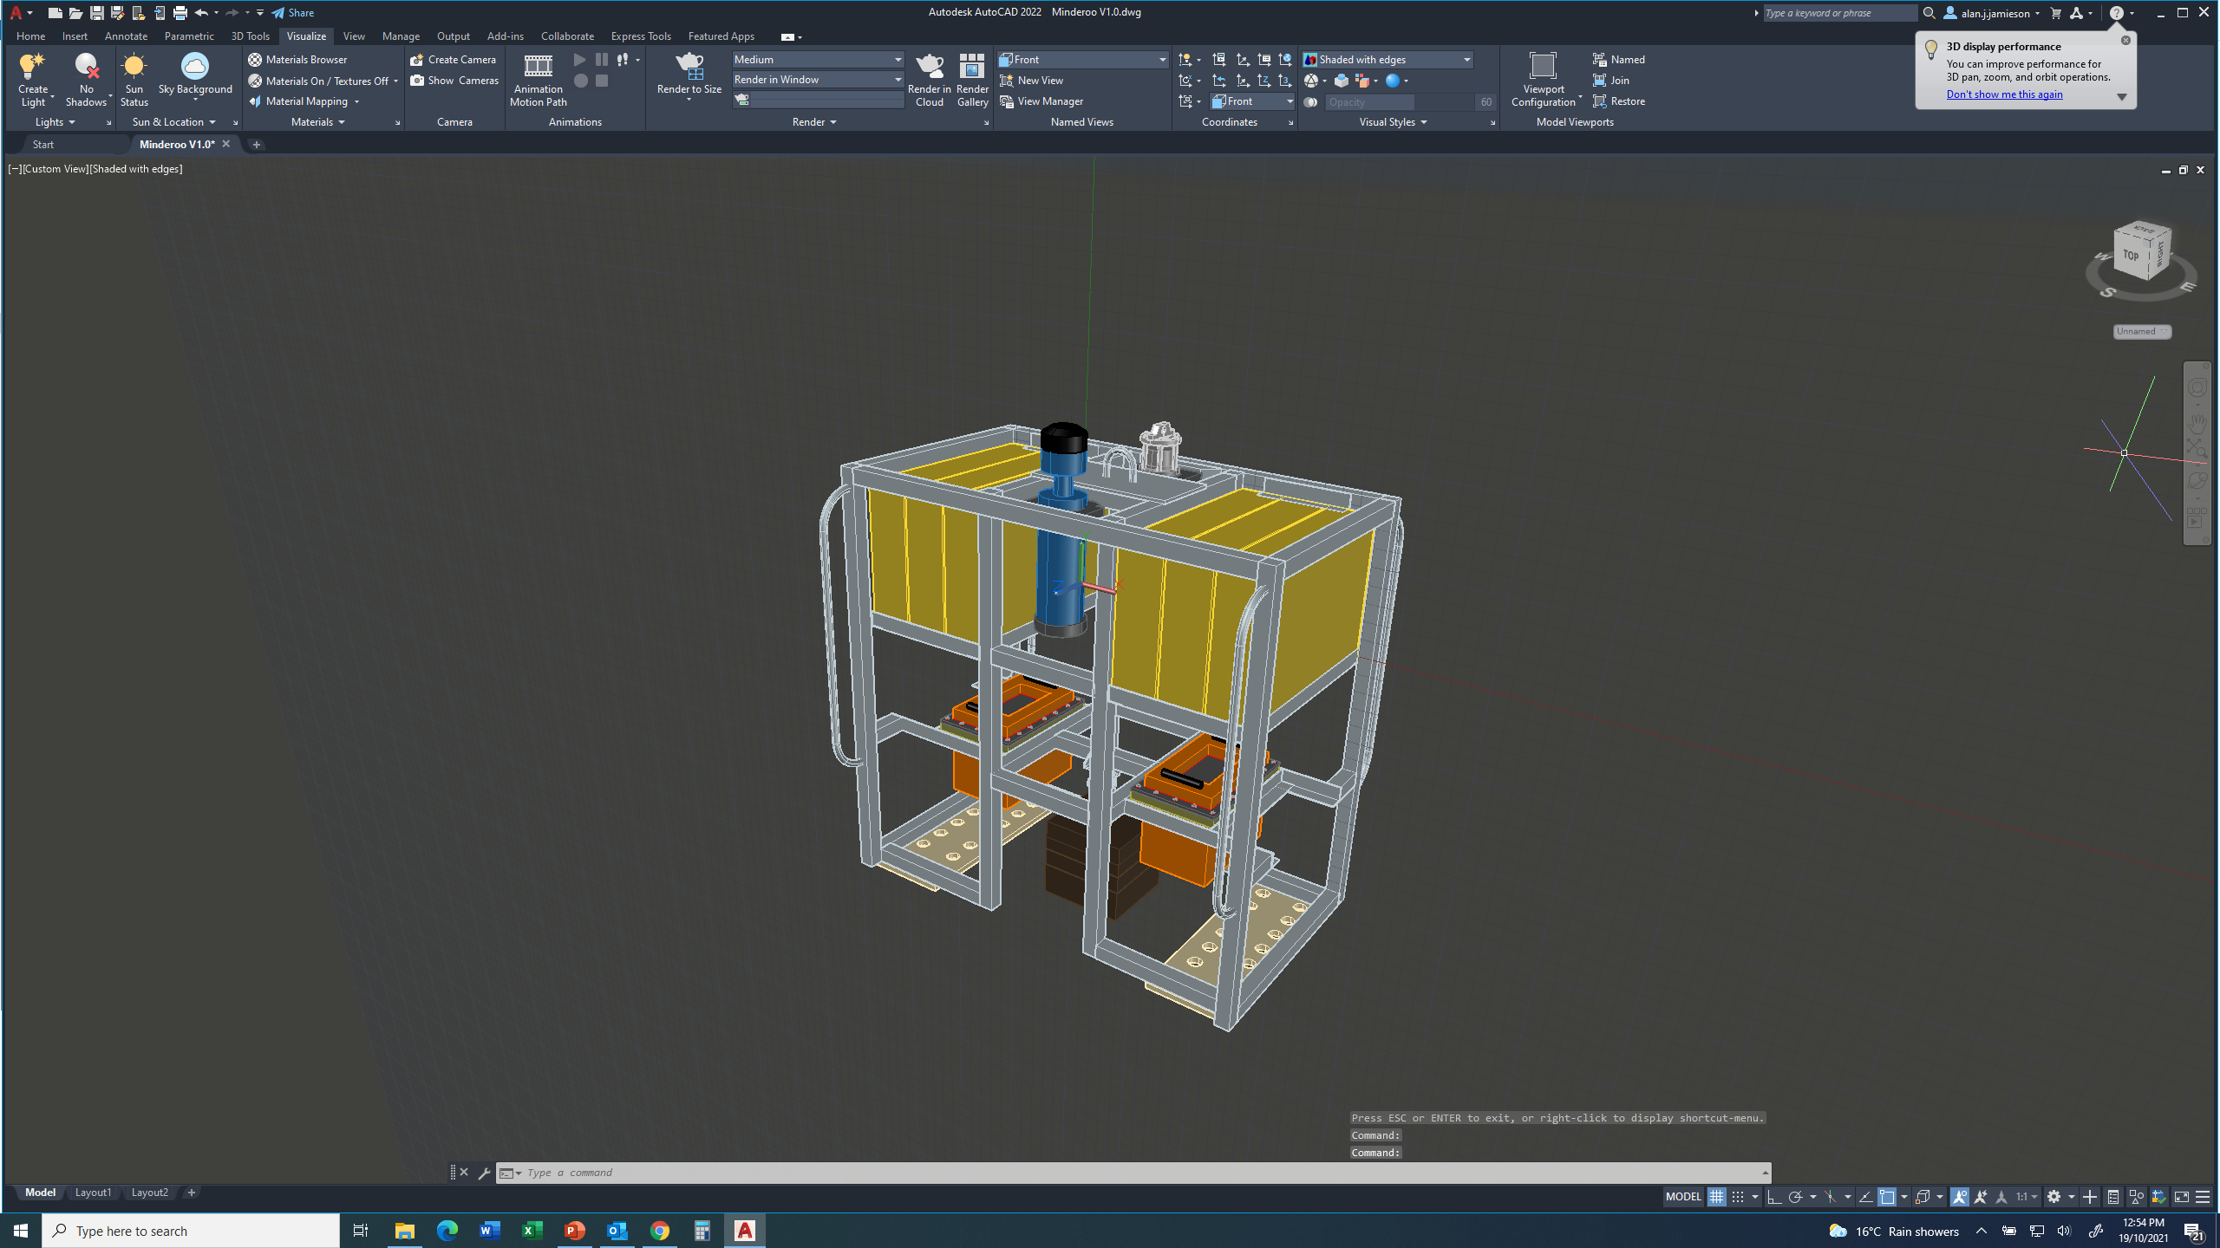
Figure 3: Drawing of lander frame under construction. Design is similar to those pictured in Figure 2.

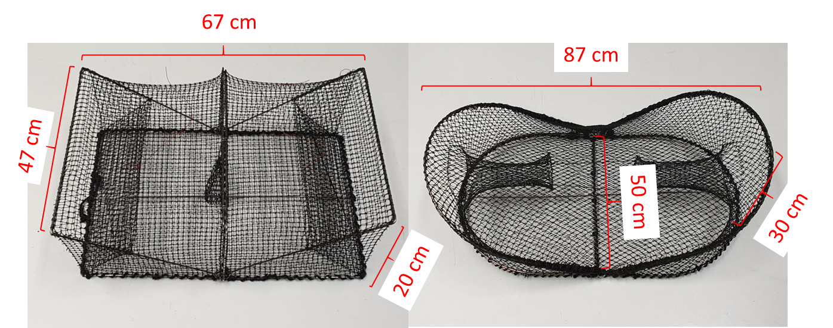
Figure 4: rectangular funnel trap and opera trap. Opening on rectangular trap can reach 20 cm. Funnel opening on opera trap is 22 cm and the internal ring is 12 cm. Net size on both traps is 15 mm square.

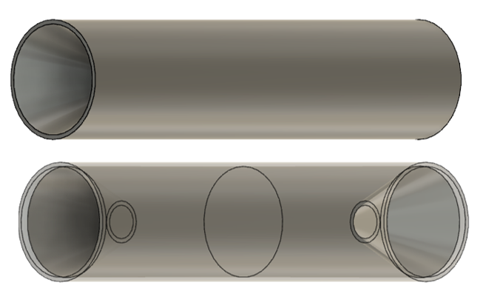
Figure 5: Model of cylindrical funnel trap used for amphipods. Bait is secured on the inside of the tube. Funnel opening is 10cm and internal end of funnel is 4 cm. NB: image is not to scale.

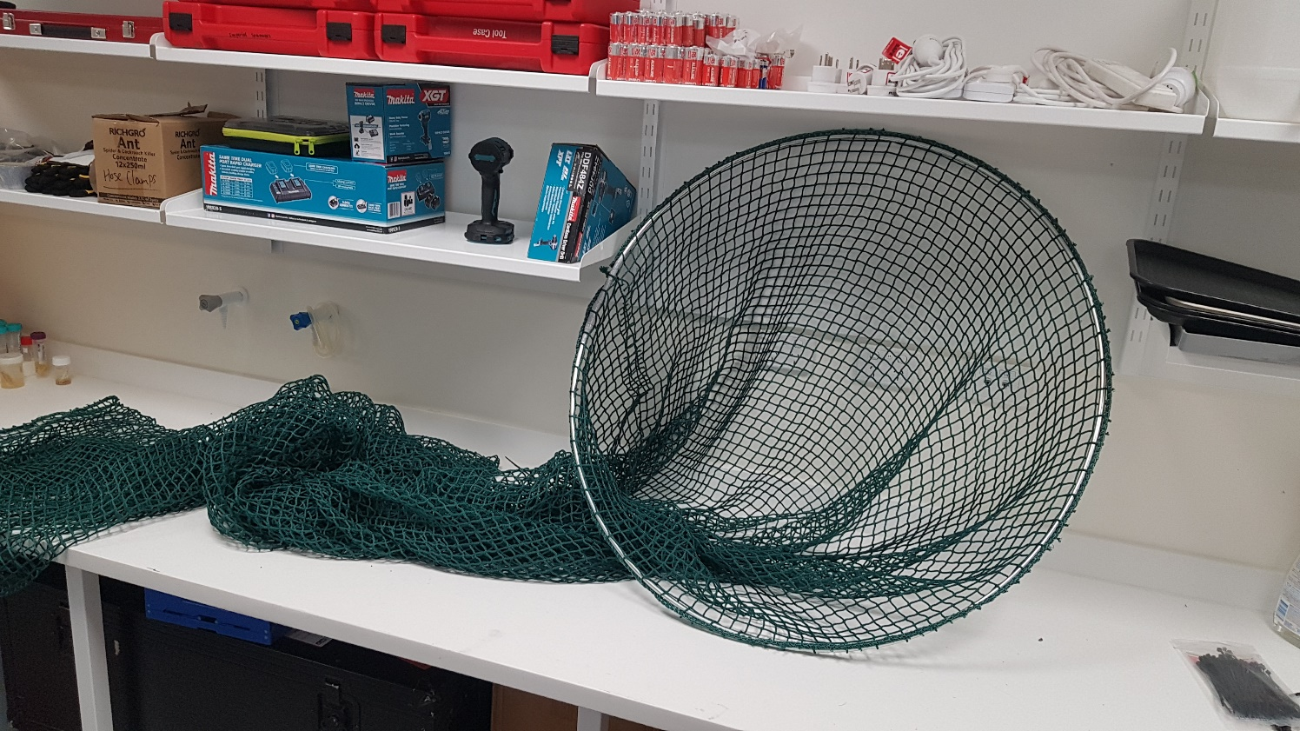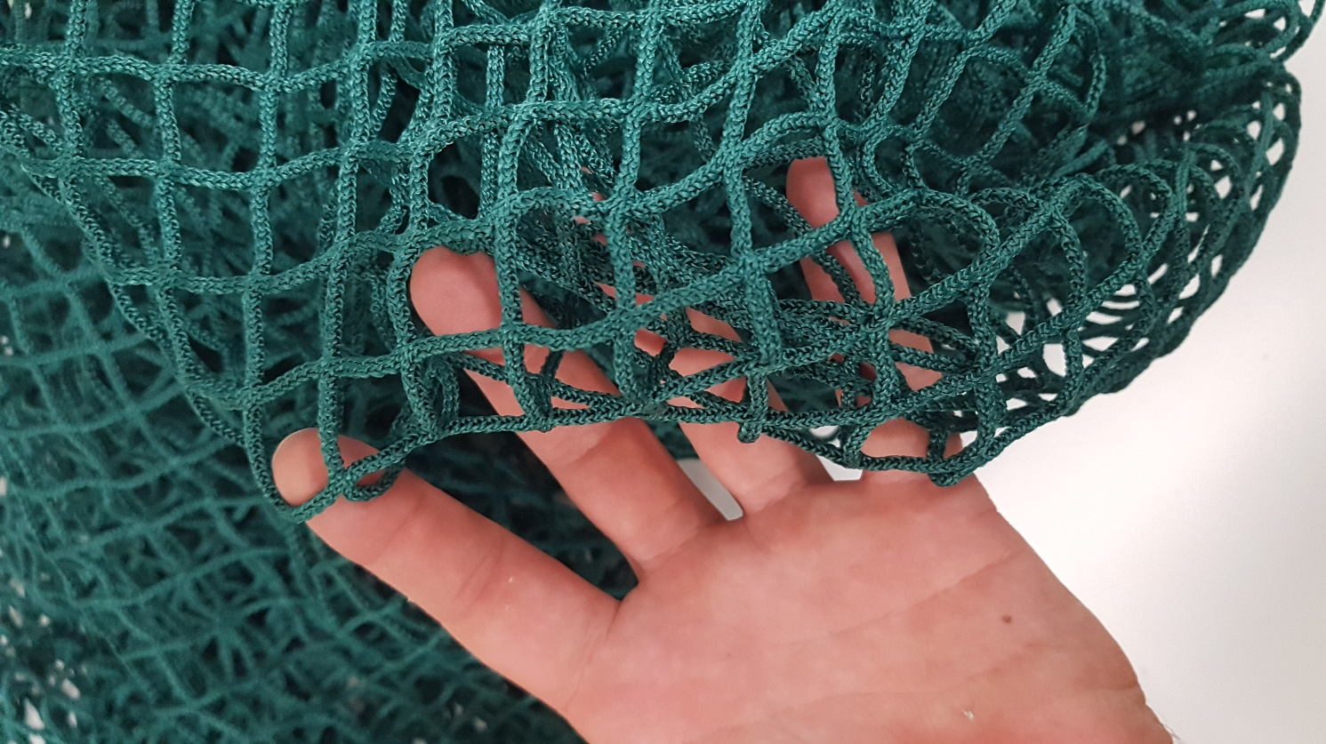
Figure 6: Hoop style net made from knotless nylon netting. Opening has a 90 cm diameter and mesh size is 20 x 20 mm.

