**PROJECT PLAN 2022-2026**

**Introduction:**

The Indian Ocean is the world’s third largest ocean spanning 70,560,000 km2, accounting for 19.5% and 19.8% of the global ocean area and volume respectively. It is thought to be the least understood of the five oceans and historically it was largely neglected scientifically up to the late-1950s. The west coast of Australia bounds the Indian Ocean and encapsulates many Australian Marine Parks. Of the 60 Commonwealth Marine Parks around Australia, 29 include water depths >3000 m and 15 of the 60 have >50% (two Parks have 49%) of their total area in water depth >3000 m. Furthermore, the Indian Ocean has one third of Commonwealth Marine Parks >3000 m water depth including the deepest point (~6200 m) of any Australian Marine Park at the eastern edge of the Diamantina Fracture Zone (DFZ) in the South-west Corner Marine Park.

The key objective of this research project is to explore the biology, ecology, geomorphology and oceanography at the deepest part of Australia’s Marine Park Network and the numerous other deep-sea environments within Australia’s EEZ encapsulated within the network of Australia Marine Parks off Western Australia.

This research aims to sample and map key topographical features in the South-west Corner, Perth Canyon, Eastern Recherche, Carnarvon Canyon, and Gascoyne Marine Parks using RV Pangaea Ocean Explorer. A EM304 multibeam echosounder (MBES) and deep-sea landers will be used to map the seafloor, take >1,000,000 m of CTD hydrographic data, acquire >2500 h of HD video footage of mobile abyssal and hadal species, and collect fish, decapods and amphipods from some of the deepest and most complex topographies in the Indian Ocean. Physical samples of fish and decapods are essential to confirm identification and describe new species. DNA barcoding of new species, rare species and those important to science will provide information on the connectivity between basins and oceans, and an insight into the evolution history of deep-sea organisms. Such barcodes are essential for future, non-extractive methods including the use of eDNA. Methods of collection and the total number of animals collected will have approval from UWA Animal Ethics Committee. Collection permits are also in review.

Furthermore, we propose to deploy two long-term observatories; one in the Perth Canyon Marine Park and one in Gascoyne Marine Park. Each observatory will sit on the seafloor and record video and oceanographic information at daily intervals. The observatory will be serviced twice a year to download data and replace batteries. We plan to deploy each observatory for at least two years, pending grant success. This research represents the greatest exploration of Australia's deep-sea environment ever and will document the unique and fascinating habitats and fauna found in the deepest parts of Australia's Marine Parks.

**Methods:**

Our research will utilize the advanced deep-water multibeam echosounder (MBES) on the RV Pangaea Ocean Explorer. The MBES will map during all transits and perform several survey lines prior to lander operations. These data represent high resolution bathymetric maps, reproducible in three-dimensions. These maps provide large scale geological context to the study sites and underpin the habitat characterization as per obtained visually by lander imaging. We envisage >100,000 km2 of new maps of the East Indian Ocean to be generated.

The autonomous free-fall landers will be deployed ~250 times from the RV Pangaea Ocean Explorer over the course of the research program. These systems carry an array of scientific sampling equipment. Each lander is equipped with a duel baited camera system to visual record mobile species (essentially a BRUV), CTD and current doppler, and three styles of traps.

The first includes a standard netted rectangular box trap and opera trap (see examples in appendix 1) used to recreationally catch mud or yabbies. The rectangular trap is 47 cm wide, 20 cm high and 67 cm long, and housed inside the lander frame. Funnel opening can stretch the full height of the trap (20 cm). The opera trap measures 87 cm long, 50 cm wide and 30 cm high. The funnel opening is 22 cm and the internal ring is 12 cm. Both traps have a 15 mm square mesh size. The second trap is a prawn or butterfly style hoop net attached to the lander. The net lies flat on the seafloor underneath the bait used to attract animals into the field of view of the camera. The net is gathered together and secured with a galvanic release for deployment. The galvanic release corrodes in seawater and will untie the net when the lander is on the seafloor but it will remain in place flat on the seafloor. Upon acoustic trigger, the lander is jettisoned to the surface and the net scoops animals surrounding the bait into the unravelling net. The net opening is 90 cm in diameter and the funnel of the net is 3 m long. The net is made from 20 x 20 mm holes and made from nylon in a knotless fashion. The third trap is a cylindrical funnel trap primarily targeting amphipods. Typically made from PVC pipe with a funnel at either end where animals enter, attracted by bait inside the pipe. Cylindrical funnel traps are housed inside the lander frame. All traps and the lander are baited with pilchards caught in Western Australia.

Once the landers have completed a survey (5-8 hours) an acoustic release will drop untreated carbon steel weights and the lander will float to the surface where it will be retrieved by the RV Pangaea Ocean Explorer and auxiliary vessels. Each lander deployment will require 100 kg of steel ballast which will be left in-situ.

Two long-term observatories with a maximum depth of 6500 m water depth are planned for deployment at Perth Canyon and Gascoyne Marine Parks. Both observatories house a time-lapse still/video camera, a conductivity, temperature and depth (CTD) recorder, oxygen probe, doppler current profiler, and sediment trap used to capture vertically settling material at monthly intervals. Each observatory will sample for 6-9 months before they require servicing (download data and change batteries). Each observatory is weighted with untreated carbon steel weights which released acoustically and remain in-situ.

**Voyage Plan PANGAEA OCEAN EXPLORER 2022**

20 days of Pangaea time allocated. Split into two locations:

* + ~13 days to Diamantina Fracture Zone and Naturalist Plateau
  + ~7 Days on Perth Canyon

**PANGAEA EXPEDITION 1 (PX_DSC_01)**

13 days > Total transit time = 88 hours, or 4 days > 9 days of science time.

First location is the eastern edge of the Diamantina Fracture Zone. Undertake three sets of two landers are 6050, 5500, and 5000 m

Second location is the Naturalist Plateau. Undertake six sets of landers at 2000, 2500, 3000, 3500, 4000 and 4500m, culminating at the Perth Abyssal Plain.

Daily routine would be to deploy landers early evening, leave overnight and recovery early morning. Landers are downloaded, rest, re-programmed during the day.

Multibeam mapping operations between the lander sites during day time hours.

**Outcomes:** First survey of the biggest and deepest Marine Park. Data will be used in conjunction with the North Australian basin and Wallaby Zenith Fracture Zone data from 2021, and the Java Trench expedition in 2019 to establish a geographical widespread baseline dataset from the East Indian Ocean.

**PANGAEA EXPEDITION 2 (PX_DSC_02)**

9 days > Total transit time = 16 hours, or 1 day1 > 6 days of science time.

Each science day will be two landers at equivalent depths inside and outside of the canyon between 2500 and 4800 m. Daily routine would be to deploy landers early evening, leave overnight and recovery early morning. Landers are downloaded, rest, re-programmed during the day.

Multibeam mapping operations between the lander sites during the day time hours.

**Outcomes:** This will test the effects of the canyon itself and also add an important shelf dataset for the wider Indian ocean data set.

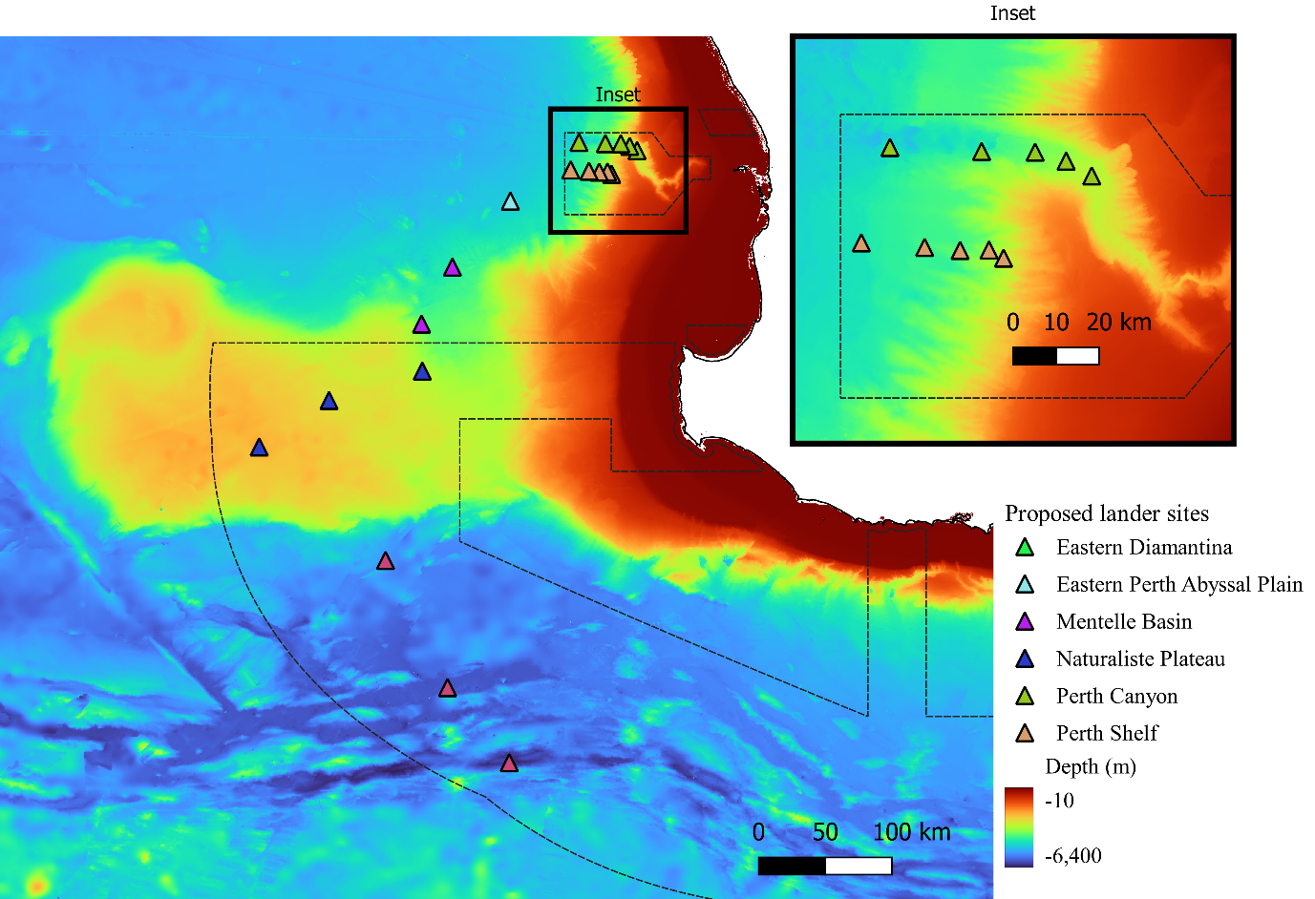

**Scientists Involved**

Professor Alan Jamison – Chief Scientist – The University of Western Australia

Dr. Todd Bond – Research Fellow (Ecologist) – The University of Western Australia

Dr. Prema Arasu – Research Fellow (Humanities) – The University of Western Australia

**Relationship of researchers to permit applicant**

All researchers listed above work for The University of Western Australia within the Minderoo-UWA Deep-Sea Research Centre. The Centre, within UWA was funded through the Minderoo Foundation.