## Anatomy

### Crustaceans

#### Prawns

The common names ‘prawn’ and ‘shrimp’ are often used synonymously for the same crustaceans in different parts of the world. This field guide uses the terms most commonly used in Australia. Where Australian species of crustaceans are primarily involved in the disease, they are referred to as prawns. However, where the species of crustacean involved in the disease are exotic to Australia, they are referred to as shrimp.

Figure 1 External anatomy of prawn 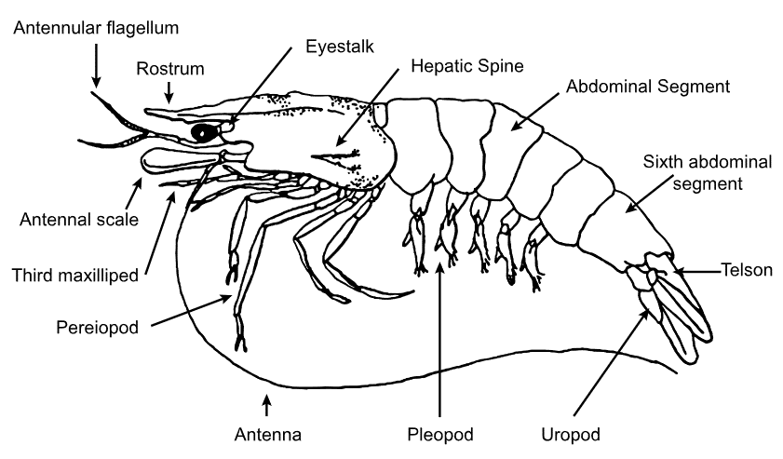

Source: R Bowater, Queensland Department of Primary Industries and Fisheries

Figure 2 Black tiger prawn (Penaeus monodon)

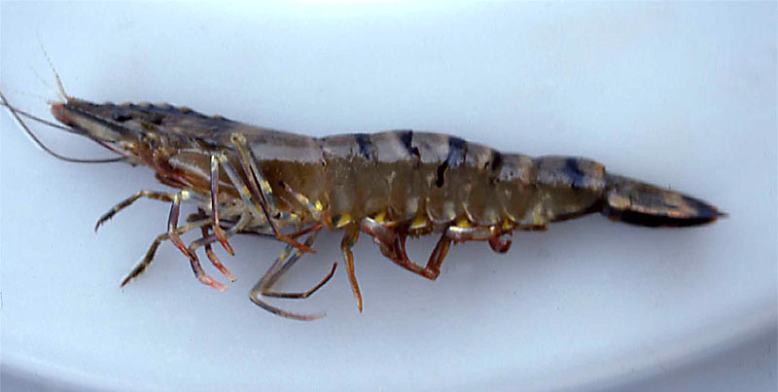

Source: Australian Government Department of Agriculture, Water and the Environment

#### Crabs

Figure 3 External anatomy of crab

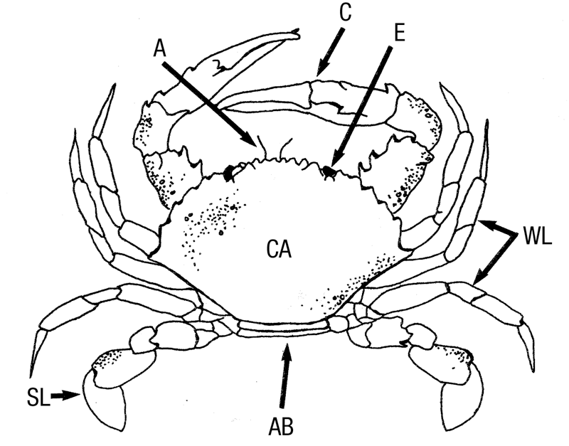

**A** antenna. **AB** abdomen (underneath). **C** claw. **CA** carapace. **E** eye. **SL** swimming leg. **WL** walking leg.

Source: R Bowater, Queensland, Department of Primary Industries and Fisheries

Figure 4 Internal anatomy of crab—saggital section

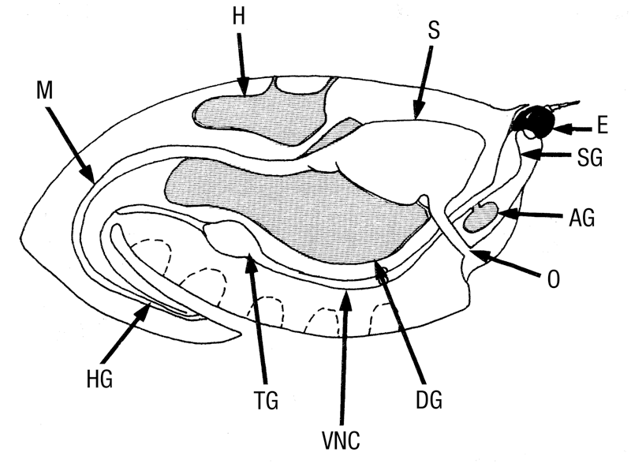

**AG** antennal gland. **DG** digestive gland (hepatopancreas). **E** eye. **H** heart. **HG** hindgut. **M** midgut. **O** oesophagus. **S** stomach. **SG** supraoesophageal ganglion. **TG** thoracic ganglion. **VNC** ventral nerve cord.

Source: R Bowater, Queensland Department of Primary Industries and Fisheries

Figure 5 Internal anatomy of blue swimmer crab (Callinectes sapidus)

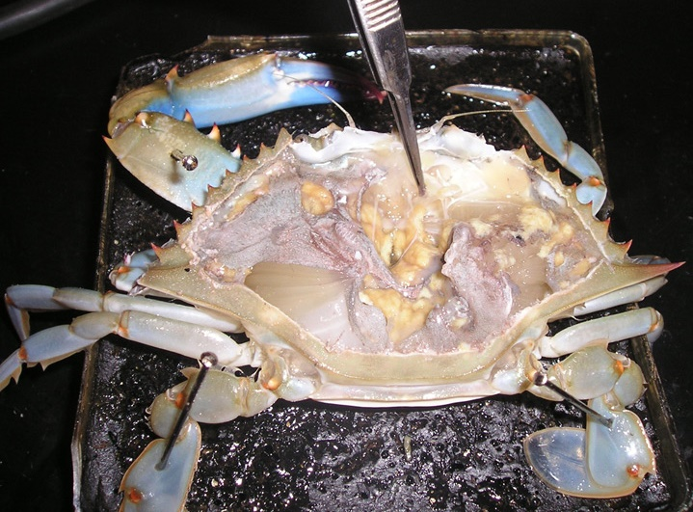

Source: O Zmora

#### Crayfish

Figure 6 External anatomy of freshwater crayfish

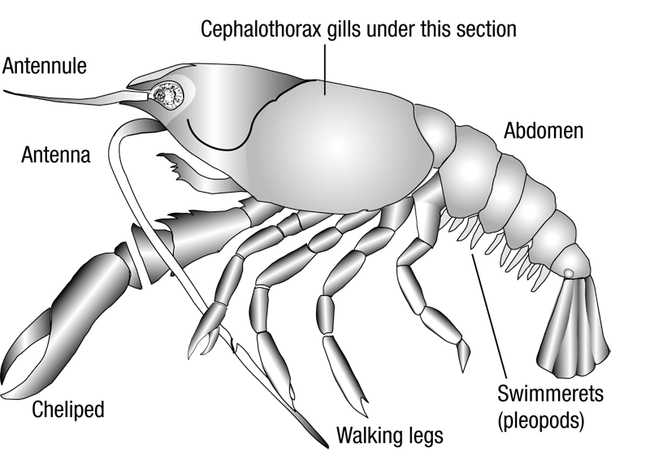

Source: Australian Government Department of Agriculture, Water and the Environment

Figure 7 Internal anatomy of freshwater crayfish—sagittal section

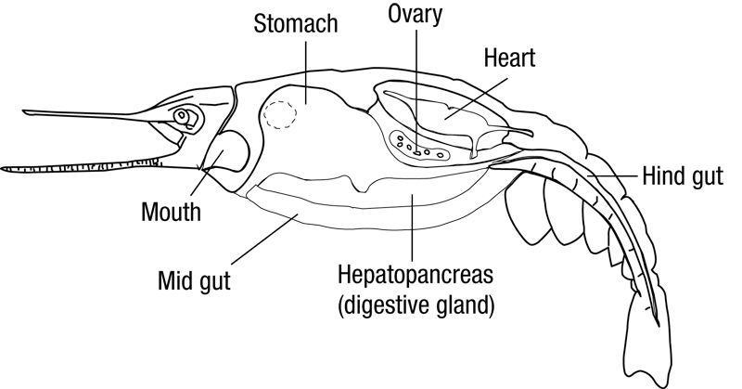

Source: Australian Government Department of Agriculture, Water and the Environment

Figure 8 Redclaw crayfish (Cherax quadricarinatus)

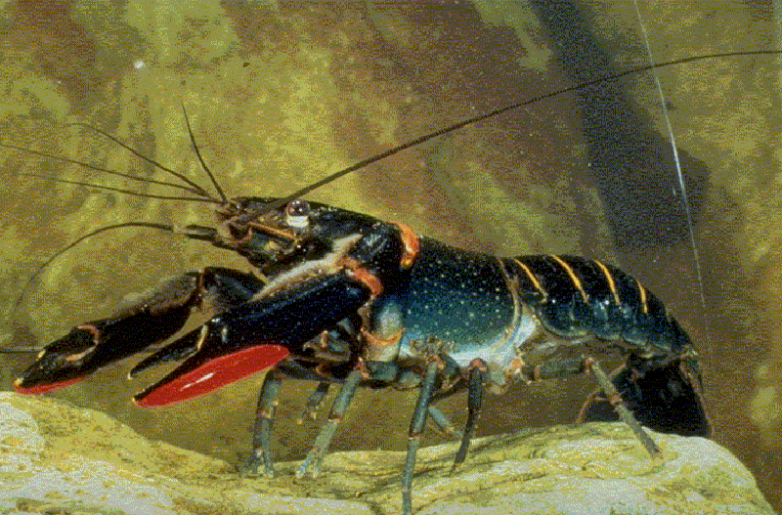

Source: C Jones

Figure 9 Gills of redclaw crayfish (Cherax quadricarinatus)

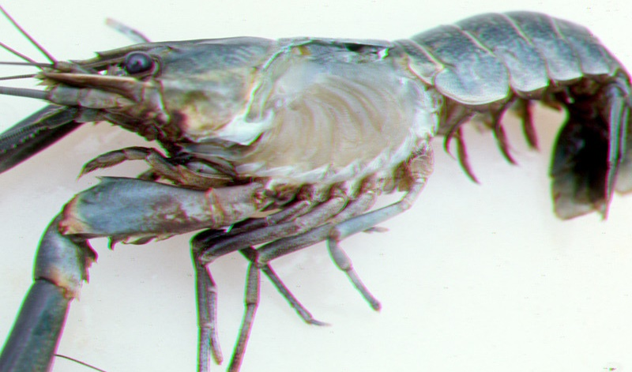

Source: C Jones