Climate-Smart Agriculture Program: MEL Framework and Implementation Plan
© Commonwealth of Australia 2026
Ownership of intellectual property rights
Unless otherwise noted, copyright (and any other intellectual property rights) in this publication is owned by the Commonwealth of Australia (referred to as the Commonwealth).
Creative Commons licence
All material in this publication is licensed under a Creative Commons Attribution 4.0 International Licence except content supplied by third parties, logos and the Commonwealth Coat of Arms.

Cataloguing data
This publication (and any material sourced from it) should be attributed as: DAFF 2026, Climate-Smart Agriculture Program: MEL Framework and Implementation Plan, accessible version of a report prepared by Clear Horizon Consulting for the Department of Agriculture, Fisheries and Forestry, Canberra. CC BY 4.0.
This publication is available at agriculture.gov.au/agriculture-land/farm-food-drought/natural-resources/landcare/climate-smart.
Department of Agriculture, Fisheries and Forestry
GPO Box 858 Canberra ACT 2601
Telephone 1800 900 090
Web agriculture.gov.au
Disclaimer
The Australian Government acting through the Department of Agriculture, Fisheries and Forestry has exercised due care and skill in preparing and compiling the information and data in this publication. Notwithstanding, the Department of Agriculture, Fisheries and Forestry, its employees and advisers disclaim all liability, including liability for negligence and for any loss, damage, injury, expense or cost incurred by any person as a result of accessing, using or relying on any of the information or data in this publication to the maximum extent permitted by law.
Acknowledgement of Country
We acknowledge the continuous connection of First Nations Traditional Owners and Custodians to the lands, seas and waters of Australia. We recognise their care for and cultivation of Country. We pay respect to Elders past and present, and recognise their knowledge and contribution to the productivity, innovation and sustainability of Australia’s agriculture, fisheries and forestry industries.

Contents
Summary v
Program overview v
MEL Framework scope v
Theory and delivery design vi
Approach to measurement, evaluation and learning vi
Implementation and reporting vii
1 Framework overview 1
2 Program overview 2
2.1 Program context 2
2.2 Climate-Smart Agriculture Program 2
3 MEL Framework scope 4
3.1 Key terms used in this MEL Framework 4
3.2 MEL purpose and boundaries 4
3.3 Evaluation domains and key questions 5
3.4 Principles for the MEL Framework 6
4 Program theory and delivery design 7
4.1 CSAP theory introduction 7
4.2 Program theory models 8
4.3 Program theory narrative 10
4.4 Program delivery design 12
4.5 Program assumptions 15
5 Approach to measurement, evaluation and learning 16
5.1 Overall approach to measurement, evaluation and learning 16
5.2 Measurement 17
5.3 Evaluation and learning 19
6 MEL implementation and reporting plan 25
6.1 DAFF implementation and reporting 25
6.2 Delivery provider implementation and reporting 25
7 Operationalising the MEL Framework 27
Appendix A: Established program stream outcomes 28
Appendix B: Assumptions 30
Appendix C: Stream-specific theory models for merit 34
Glossary 36
References 37

Tables
Table 1 MEL audiences 5
Table 2 Evaluation domains and key questions 5
Table 3 Principles underpinning the CSAP MEL Framework 6
Table 4 Climate-Smart Agriculture Program streams overview 12
Table 5 Summary of critical assumptions underpinning the program theory 15
Table 6 Measurement and evaluation in relation to the program theory 16
Table 7 Standard measures and methods for delivery provider collection 18
Table 8 Proposed measures for population-scale survey of agricultural practices and sustainability 19
Table 9 Critical evaluation studies that will inform strategic learning for the program 20
Table 10 Design review approach – Key evaluation question 1: ‘How well does the program design respond to the problem context?’ 21
Table 11 Overview of measures to be included in farmer survey for design review 22
Table 12 Outcomes evaluation approach – Key evaluation question 2: ‘To what extent were the intended outcomes of the program achieved?’ 23
Table 13 Measures to be included in the farmer survey for the outcomes evaluation 24
Table 14 DAFF reporting requirements 25
Table 15 Delivery provider MEL implementation and reporting requirements 25
Table A1 Capacity building theme 28
Table A2 Facilitation and extension theme 29
Table B1 Types of assumptions 30
Table B2 Detailed assessment of assumptions 30

Figures
Figure 1 MEL Framework structure 1
Figure 2 Program theory terms and definitions 7
Figure 3 Climate-Smart Agriculture Program theory model (excluding ANSIS and NSMP) 8
Figure 4 ANSIS and NSMP process map 9
Figure C1 Partnerships and innovation logic – to align with entry into MERIT 34
Figure C2 Capacity-building logic – to align with entry into MERIT 35

Summary
This section summarises the Measurement, Evaluation and Learning (MEL) Framework and implementation plan for the Climate-Smart Agriculture Program (CSAP).

Program overview
Through the Natural Heritage Trust (NHT), the Australian Government has established the $302.1 million CSAP over 5 years from 2023–24 to 2027–28. CSAP is delivered by the Department of Agriculture, Fisheries and Forestry (DAFF). It will support farmers to manage climate risks, invest in their on-farm natural capital, and undertake effective natural resource management (NRM). This aims to help the sector respond to climate change issues, better withstand future bushfires, floods and droughts and protect its productivity.
CSAP funding is delivered under 4 thematic areas:
- Farmer Capacity Building projects, facilitation and extension services, including the Sustainable Agricultural Facilitators and Regional Soil Coordinators.
- Soil information improvement including the Australian National Soil Information System (ANSIS) and commencement of the National Soil Monitoring program (NSMP).
- Operational support for regional delivery providers.
- Funding for the DAFF program administration.
The program is part of the Australian Government’s enduring commitment to sustainable agriculture, environmental protection and NRM. It is the latest iteration of funding commitments that take a long-term perspective on the time required for change to occur and outcomes to be achieved within the agricultural sector.

MEL Framework scope
The scope of the MEL Framework is determined by its purpose, boundaries, audiences, principles, and resources. The overall purpose of the MEL Framework is to:
- assess the effectiveness of the program in achieving the established outcomes
- assess how well the program design responds to the problem context
- surface evidence and insights to inform the business case and design of future government investments in climate-smart sustainable agriculture.
The MEL Framework covers all activities funded under CSAP except for operational support for delivery providers and DAFF internal program administration. The primary audiences of the MEL Framework include relevant ministers, the Natural Heritage Trust, program owners, delivery providers and the DAFF program team.
The CSAP MEL Framework is structured around 2 key evaluation questions that respond to the MEL purpose and audience needs:
- How well does the program design respond to the problem context?
- To what extent were the intended outcomes of the program achieved?
The main principles underpinning this framework are that it is fit-for-purpose, useful, robust, credible, and enduring. The MEL Framework has been designed to be commensurate with the human and financial resources available within the program team.

Theory and delivery design
The MEL Framework explains CSAP theories, delivery design with underpinning assumptions, which will inform the approach to MEL. These theories will outline how to influence farmer practices (including practice change and extension theories). Through engaging a variety of providers to deliver activities that shape the ‘Climate-Smart, Sustainable Agriculture’ (CSSA) knowledge, awareness, skills, and attitudes of farmers, this program seeks to build the CSSA capability of farmers, with the intention that they will in turn adopt these practices. The adoption of CSSA practices is then expected to contribute to Australian agricultural, food and fibre industries that are sustainable, productive, internationally competitive, and profitable.

Approach to measurement, evaluation and learning
The overall approach to measurement, evaluation and learning includes:
- routine measurement of program activity, output, reach and influence by delivery providers, and of farmer population-scale trends regarding the use of sustainable farm practices by DAFF. This may include occasional supplementary questions to the Australian annual farm broadacre and dairy surveys.
- 2 critical point-in-time evaluation studies that seek to assess the program’s design and outcomes respectively, supported by point-in-time measurement activities, undertaken by an external supplier commissioned by DAFF. The timing and focus of these studies have been designed to inform learning by aligning with departmental budgeting processes to ensure findings are used to inform the design of future programs and demonstrate accountability for the investment. The MEL Framework highlights relevant data collected through the program that will inform each evaluation study. Additional data collection will be undertaken by the external suppliers at the point of evaluation. The 2 evaluation studies are
  - a design review in 2026 – will assess the 2023 to 2028 program design to determine its likely effectiveness in responding to the broader problem context. This will include testing the validity of the underpinning design assumptions and harvesting learnings from program delivery to date. The findings of the design review will be used to inform the design of the 2028-2033 program.
  - outcomes evaluation in 2028 – will assess the effectiveness of the 2023 to 2028 program in relation to the achievement of intermediate outcomes, and progress towards program end outcomes, and harvest learnings that can inform the 2033 to 2038 program design.

Implementation and reporting
Both DAFF and delivery providers have roles and responsibilities for MEL implementation and reporting. DAFF is required to coordinate the implementation of the MEL Framework and deliver a range of reports that draw on the information collected through its implementation. Delivery providers also have specific roles in MEL implementation. In addition to the measurement and reporting requirements defined under delivery provider funding agreements, which for some includes utilising the monitoring, evaluation, reporting and improvement tool (MERIT) for their reporting, delivery providers are also required to participate in the evaluation activities conducted by DAFF.

Framework overview
The MEL Framework was developed in mid-2024 using a participatory and user-focused approach to build the MEL thinking capability of the program team, and ensure the framework was fit-for-purpose.
This document systematically guides the planning and implementation of measurement, evaluation and learning activities at both the CSAP program and stream levels (Figure 1):
- chapter 2 – is an overview of the program and the drivers for MEL. It includes the overarching program and policy objectives and agency context.
- chapter 3 – the MEL Framework purpose, boundaries, audiences, key evaluation questions, resources and underpinning principles of the MEL design.
- chapter 4 – theory and critical assumptions underpinning the program design, and its delivery mechanisms.
- chapter 5 – approach to routine measurement, the design and delivery of evaluation studies and strategic learning processes.
- chapter 6 – reporting requirements for both DAFF and delivery providers.
- chapter 7 – activities and responsibilities for implementing the measurement, evaluation and learning activities.
The information generated through MEL Framework implementation will be captured through discrete reporting outputs and inform the design of both the current and future iterations of the program.
Figure 1 MEL Framework structure
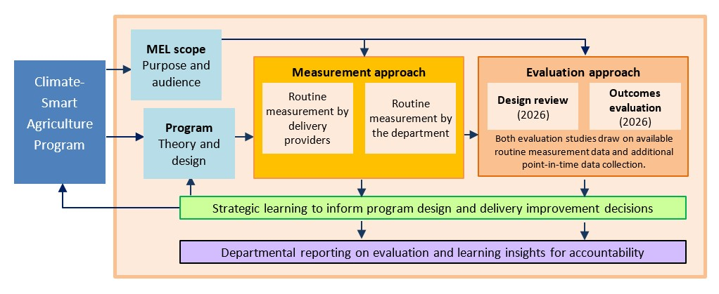

Program overview

Program context
Australian farmers need to utilise practices that will reduce emissions and build climate resilience to secure their future and remain globally competitive. Actively managing emissions from agriculture and increasing its sustainability will be critical to maintaining and growing Australia’s agricultural export markets and achieving the industry target of a $100 billion agriculture sector by 2030 (DAWE 2020). Accelerated adoption of sustainable farming practices and access to innovative technologies will support strengthened productivity and competitiveness while transitioning to a net zero economy by 2050 (DCCEEW 2022).
The Australian Government is committed to supporting the agriculture sector to sustainably manage the impacts of climate change, including the challenge of increasing food production to meet global demand while reducing the adverse impact of agricultural production on the environment and natural capital. Further, it is committed to the vision for sustainably managed soils set out in the National Soil Strategy (DAWE 2021), and to working in partnership with the state and territory governments to deliver the priorities of the first National Soil Action Plan.
The Australian Government is also committed to ensuring Australia’s agriculture sector has a secure future and can continue to support thriving and prosperous regional communities. To this end, it is working with CSIRO on Ag2050 (CSIRO 2024) to create a long-term vision of what farming businesses and communities might look like in 2050 to enable the agricultural industry to drive progress towards this future.
The Australian Government has an extensive history of investment in sustainable agriculture that commenced with the first National Landcare Program (1990–91 to 2007–08) and continued through to the most recent National Landcare Program Phase 2 (2018–19 to 2022–23), including the Regional Land Partnerships and Smart Farms programs.

Climate-Smart Agriculture Program
Through the Natural Heritage Trust (NHT) the Australian Government has established the $302.1 million Climate-Smart Agriculture Program (CSAP) over 5 years from 2023–24 to 2027–28 for climate-smart, sustainable agriculture projects.
CSAP will drive agricultural sustainability, productivity, and competitiveness through investing in projects that will support farmers to manage climate risks, grow their resilience, and protect their productivity through investment in their on-farm natural capital, and best-practice NRM. The program also takes a long-term perspective on the time required for change to occur and outcomes to be achieved within the agricultural sector.
This program’s design was informed by a co-design process with key stakeholders and experts in the agriculture sector in early 2023. Through this process, the department sought feedback on priorities for investment to aid implementation of climate-smart, sustainable agricultural (CSSA) practices, the types of projects that the NHT could invest in, and how to enhance engagement and collaboration with First Nations people to inform its design.
The program is designed to contribute to the following Ministerial ‘Established Outcomes’:
- the agriculture sector is adopting practices to reduce emissions and build resilience to climate change.
- the agriculture sector is supported to harness carbon and biodiversity incentives and implement industry sustainability frameworks.
- farmers are supported to drive agricultural growth, while adopting sustainable NRM practices that protect and conserve natural capital and biodiversity.
The program will also contribute to the following 2 key performance indicators from the department’s corporate performance framework:
- Emissions reduction.
- Supporting industry to undertake sustainable agricultural practices.
The program activities are delivered under the following thematic areas:
- Farmer capacity building ($158.6 million) – Direct procurement of local and regional NRM priority projects through the Australian Government’s Panel of Regional Delivery Partners for Environmental Protection, Sustainable Agriculture and other NRM Services (the panel), across Australia’s 52 regional areas; and a range of open-competitive grants for projects focused on adoption of CSSA and innovative tools and practices that enable CSSA across a broad range of recipients.
- Facilitation and extension ($49.1 million) – Provision of a trusted network of Sustainable Agricultural Facilitators through direct procurement with all 52 Regional Delivery Partners; provision of 8 Regional Soil Coordinators through restricted competitive grants with Drought Hub lead agencies; and support for a National Soils Community of Practice through a targeted grant with Soil Science Australia.
- Soil information improvement ($27.6 million) – Enhancement of the Australian National Soil Information System (ANSIS) and commencement of the National Soil Monitoring Program (NSMP) to be delivered by CSIRO.
- Operational support ($35.7 million) – Delivered via procurement for Regional Delivery Partners and closed competitive grants for the National Landcare Network and Landcare Australia Limited.
- Program administration ($31 million) – Operational funding for DAFF to design and administer the program.
CSAP is delivered through a range of streams under these thematic areas. Each stream has its own objectives, mechanisms and target cohort aligned with the broader program outcomes (chapter 4) with some streams having their own stream-specific established outcomes (Appendix A).

MEL Framework scope

Key terms used in this MEL Framework
- Climate-smart – Agricultural practices that focus on reducing carbon emissions and enhancing climate resilience. ‘Smart’ in this context does not specifically focus on technology.
- Sustainable agriculture – The use of agricultural practices and systems that maintain or improve the following
  - the economic viability of agricultural production
  - the social viability and well-being of rural communities
  - the ecologically sustainable use of Australia’s biodiversity
  - the natural resource base
  - ecosystems that are influenced by agricultural activities.
- Farmers – Any farmer, primary producer, landholder and/or land manager, including First Nations peoples involved in agricultural production.
- Delivery providers – Organisations whose services have been obtained through a properly constituted procurement process (including Regional Delivery Partners) and grantees that have been funded under the program to deliver activities.

MEL purpose and boundaries
The MEL Framework has dual accountability and learning purposes: to transparently demonstrate the impact of program investment and inform the continuous improvement of the design and delivery of CSAP.
The overall purpose of the MEL Framework therefore is to:
- Assess the effectiveness of the program in achieving the Established Outcomes.
- Assess how well the program design responds to the problem context.
- Surface evidence and insights to inform the business case and design of future government investments in climate-smart sustainable agriculture.
The MEL Framework covers all activities funded under the program with the exception of the funding for operational support for delivery providers and DAFF internal program administration (section 4.4).
The MEL Framework takes an outcome-focused approach and builds on the findings of the Australian National Audit Office (ANAO 2021) performance audit of the Regional Land Partnerships (RLP) program in November 2021. RLP was the largest component of the National Landcare Program Phase 2, and the audit identified a need for stronger attention to reporting on progress towards outcomes. The MEL Framework does not however seek to measure or assess the biophysical or resource condition outcomes resulting from the program, which is considered through a range of other initiatives across agencies and jurisdictions. The framework does not seek to assess activities funded by other government or non-government programs that may also contribute to outcomes for sustainable agriculture.
The MEL Framework adopts a longer-term view of the achievement of outcomes, with the intention that the performance of each 5-year tranche of funding is demonstrated, and built on, within a broader long-term arch of investment in sustainable agriculture.
The MEL Framework is designed to meet the needs of its primary audiences – those that will use MEL information to make decisions about the program. The primary and secondary audiences for the MEL Framework, and their respective uses of MEL information, are outlined in Table 1.
Table 1 MEL audiences
Category | Audience | Information needs and uses
Primary | Ministers | - Evidence of the outcomes and impact of the program to provide the rationale for future continued investment.
Primary | Program owners  Climate-Smart Agriculture Program team | - Evidence of the program’s contribution to DAFF corporate performance framework KPIs.  - Evidence and insights of the program’s reach, outcomes and impact to demonstrate effectiveness and inform improvements to future program designs.  - Evidence and insights of the program’s design to demonstrate appropriateness and inform improvements to future program designs.  - Evidence and insights of the program’s effectiveness and appropriateness to respond to the ANAO (2021) Findings and demonstrate alignment with the Commonwealth Evaluation Policy (Australian Centre for Evaluation, The Treasury).
Secondary | Delivery providers and other intermediaries (e.g. farming, industry and NRM bodies). | - Insights about how to effectively influence adoption of sustainable agricultural practices to inform their own decisions, such as the design of their own programs and practices to be more influential.
Secondary | Farmers and farmer peak bodies | - Evidence of the evaluation and continuous improvement of sustainable agricultural practices in Australia, to inform communications to domestic and international markets.
MEL Measurement, evaluation and learning.

Evaluation domains and key questions
The MEL Framework is structured around 2 key evaluation domains and associated questions that respond to the MEL purpose and audience needs (Table 2).
Table 2 Evaluation domains and key questions
Evaluation domain | Key evaluation questions
Design | - How well does the program design respond to the problem context?
Outcomes | - To what extent were the intended outcomes of the program achieved?

Principles for the MEL Framework
The principles listed in Table 3 describe what ‘good’ MEL looks like for the program and align with those established by the Commonwealth Evaluation Policy. The principles have been adopted in the design of the MEL Framework and will also guide the implementation of, and future revisions to, the framework.
Table 3 Principles underpinning the CSAP MEL Framework
Principle | Description
Fit-for-purpose | - The scale of effort and resources allocated to MEL are proportional to the value, impact, strategic importance and risk profile of the CSAP program, and the broader context.  - Recognises linkages with, and clarifies distinctions between, other similar programs.
Useful | - Produces information that meets the specific needs of intended audiences.  - Is designed for use in continuous improvement and accountability.  - Produces timely information to inform relevant reporting, design and budgeting processes.  - Provides a consistent approach to MEL across the broad range of program activities.  - Provides clarity on what needs to be done, by whom, when, and how, and leverages existing tools and processes.
Robust, credible and enduring | - Well-designed, identifying limitations and potential biases.  - The collection and analysis of evidence is impartial, systematic and has regard to the perspectives of all relevant stakeholders.  - Future-proofed: resilient to staff turnover, adaptable to changes in context, and able to accommodate new initiatives.
CSAP MEL Framework Climate-Smart Agriculture Program: Measurement, Evaluation and Learning Framework.

Program theory and delivery design

CSAP theory introduction
The CSAP theory presents the whole-of-program rationale behind its design including:
- theory of change – the expected cause-and-effect relationships between the short, medium- and longer-term outcomes.
- theory of action – the foundations, strategies and short-term outcomes/outputs that influence longer term change.
The program’s theory is based on the outcome hierarchy defined in Figure 2, and further explained in Figure 3 with a supporting narrative in this chapter. It is based on the established outcomes that were developed for the program and streams (section 2.2 and Appendix A). These outcomes have been synthesised and re-arranged to align with this hierarchy.
While CSAP is delivered through several streams (Table 4), most of them use the same overarching theory of change (Program theory models) to influence farmer practices (expanded on in program theory narrative). However, the ANSIS and NSMP streams are unique and are understood as foundational strategies with unique foundational outcomes. Therefore, they have their own detailed program theory which is presented in a separate process map (Figure 4).
Figure 2 Program theory terms and definitions
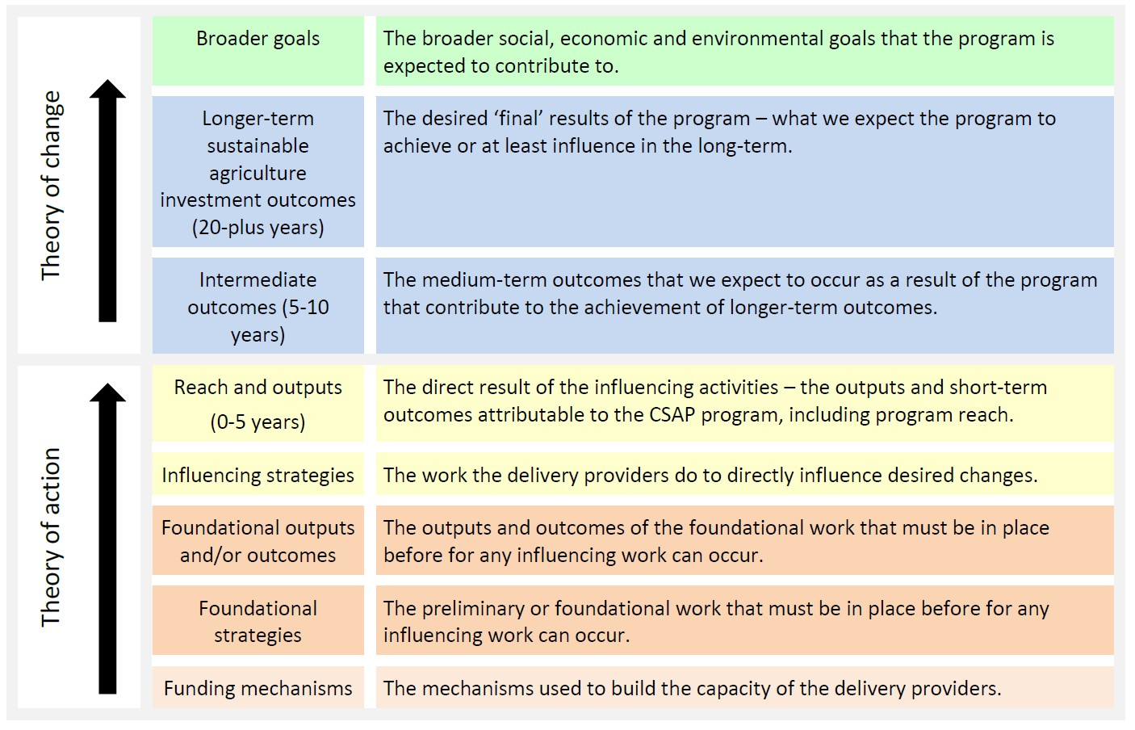

Program theory models
Figure 3 Climate-Smart Agriculture Program theory model (excluding ANSIS and NSMP)
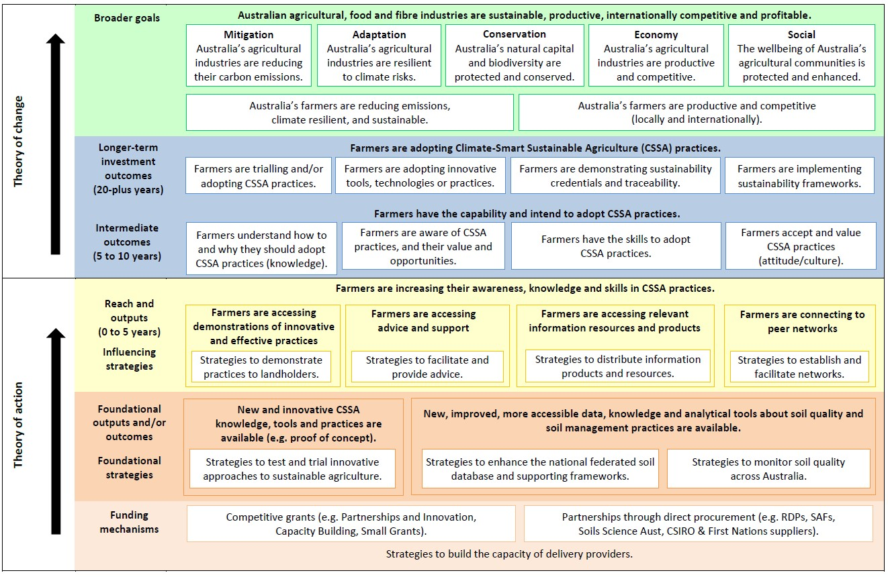
ANSIS Australian National Soil Information System. FN First Nations. RDP Regional Delivery Partner. NSMP National Soils Monitoring Program. SAF Sustainable Agriculture Facilitator.
Figure 4 ANSIS and NSMP process map
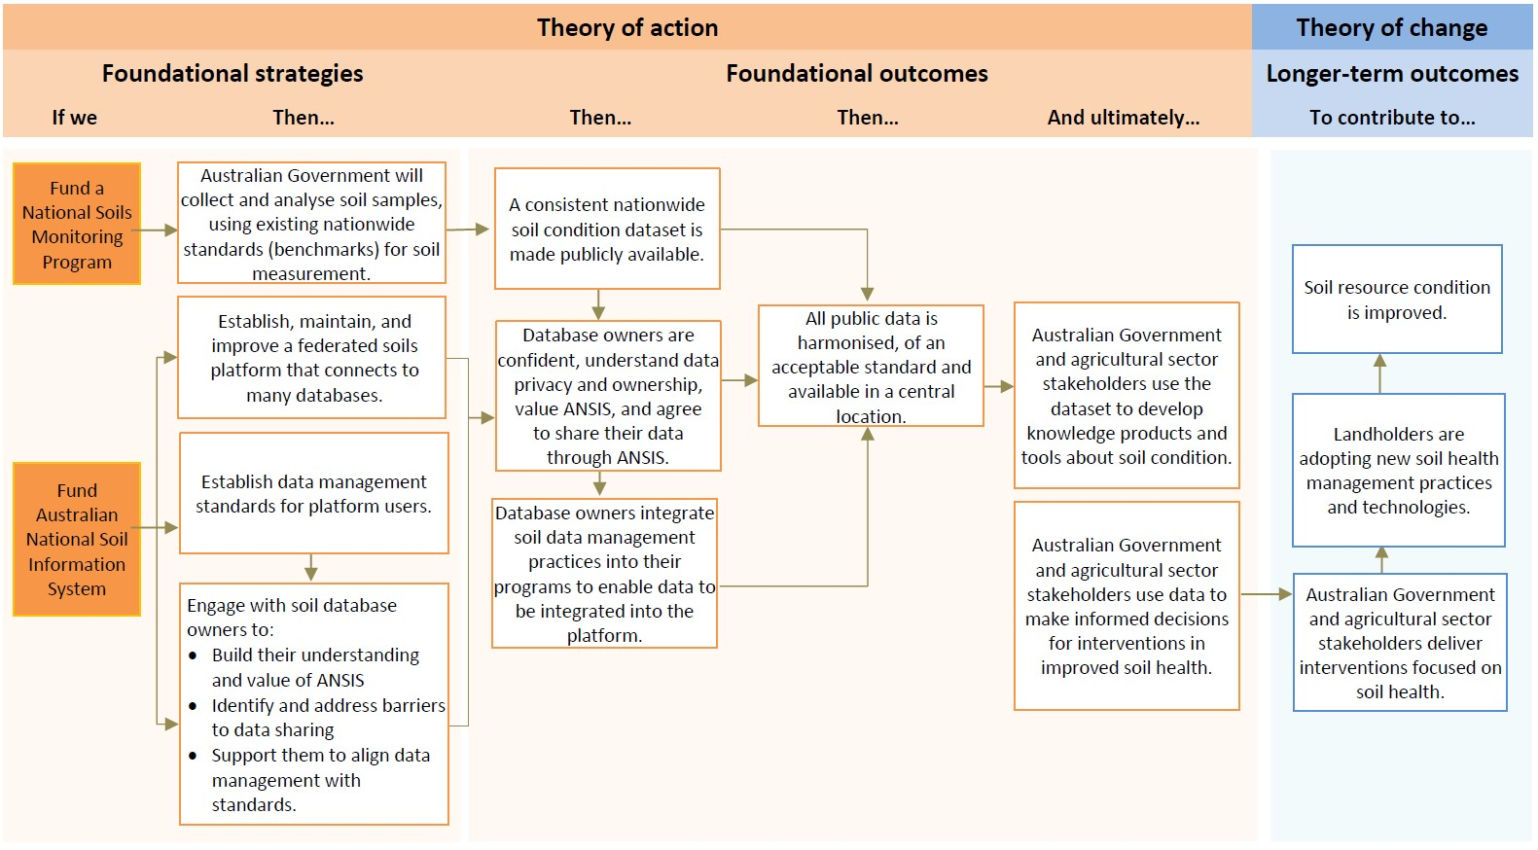
ANSIS Australian National Soil Information System. NSMP National Soils Monitoring Program.

Program theory narrative
The following narrative further details the theory of change, context and rationale.
CSAP is substantially informed by the academic theories of how to influence farmer practice including practice change and extension theories such as Bennett’s Hierarchy (1975), and behaviour change theory such as Fishbein and Ajzen’s Theory of Planned Behaviour (1975). These are described in section 4.5.
The broader goal of the program is to contribute to the sustainability, productivity, international competitiveness and profitability of the Australian agricultural, food and fibre industries. This includes contributing to Australia’s:
- agricultural industries reducing their carbon emissions (Mitigation)
- agricultural industries becoming resilient to climate risks (Adaptation)
- agricultural industries being productive and competitive (Economy)
- natural capital and biodiversity being protected and conserved (Conservation)
- agricultural communities having protected and enhanced wellbeing (Social).
CSAP sets out to achieve this through funding delivery providers to deliver a range of activities that seek to influence farmer adoption of CSSA practices, and/or establish the foundations for influence.
The delivery provider activities that seek to directly influence farmer adoption of CSSA practices will develop and organise their activities within each of the following influencing strategies:
- Demonstrating CSSA practices to farmers.
- Distributing CSSA information products and resources.
- Facilitating and providing advice regarding CSSA.
- Establishing and facilitating CSSA networks.
The delivery provider strategies will ensure farmers know about and access relevant information about the CSSA resources and products. Through participating in demonstrations, farmers are also introduced to innovative and effective CSSA practices in more practical ways. Their introduction to, and the relevance of, these CSSA practices is further supported by the use of consulting advisors and connecting with peer groups, as trusted sources of information and advice. These are the reach and outputs required for farmers to consider adopting CSSA practices.
The delivery provider activities that seek to influence adoption, develop and organise their activities within the following foundational strategies:
- Testing and trialling new and innovative CSSA knowledge, tools and practices.
- Developing new, improved and more accessible data, knowledge and analytical tools about soil quality and soil management practices.
The foundational outcomes of these can then be used to inform the 4 influencing strategies listed in this section.
By drawing on the experiences from the demonstrations of:
- CSSA practices and information
- resources and products available about CSSA practices
- the peer networks that are formed and the advice facilitated.
Farmers build an understanding of why they should adopt these practices. They are aware of the value and opportunities the CSSA practices could provide them. Farmers also have the skills needed to adopt appropriate CSSA practices and accept the need for and value of CSSA to them (attitudes). These intermediate outcomes have been identified in practice change theories such as Bennett’s Hierarchy (1975) and behaviour change theory such as Fishbein and Ajzen’s Theory of Planned Behaviour (1975) point to the capabilities needed for farmers to adopt CSSA practices.
The adoption of CSSA practices is the longer-term sustainable agriculture investment outcome. This includes farmers: adopting and trialling appropriate practices at different scales; demonstrating their sustainability credentials and traceability; implementing sustainability frameworks; and sharing their knowledge of, and experiences with, CSSA practices through their peer networks.
The adoption of CSSA practices by farmers demonstrates their contribution to the broader goals. This includes:
- farmers’ operating sustainable, productive, competitive and profitable farm business and in turn accessing new markets (local and international) through their efforts to manage carbon emissions
- their resilience to climate change
- their contribution to protecting natural capital and biodiversity on their properties
- their contribution to the enhancement and protection of the wellbeing of their agricultural communities.
Appendix C explains how CSAP theory may be adapted to the project scale for specific delivery streams. Those examples may be used for project MEL planning in MERIT.

Program delivery design
CSAP utilises a range of funding mechanisms such as grants, procurements and delivery partners – for example, grantees and regional delivery partner to provide activities that achieve the outcomes. Our theory is delivered through a range of streams that engage different delivery providers using a different funding mechanism, each focusing on a specific purpose and theme. presents each of the funding stream’s themes and the associated delivery providers, funding mechanism and period for delivery and stream specific purpose.
Table 4 Climate-Smart Agriculture Program streams overview
Theme | Stream | Delivery provider | Funding mechanism and period for delivery | Purpose
Farmer capacity building | Regional Landscape Priority projects ($85.6 million) | Regional Delivery Partners (RDPs) in all 52 NRM regions | Procurement 4.5 to 5 years (2023-24 to 2027-28) | Local and regional projects focusing on NRM priorities. They will deliver long term sustainable agriculture outcomes, including on-farm demonstrations and support for implementation of practices.
Farmer capacity building | Partnerships and Innovation grants ($45 million) | Consortium agreement between 2 or more individuals or organisations  (incl. Australian universities RDPs, RDCs, CRCs, government) | Open-competitive grants of $250 k to $5 million. Round 1: Apr 2024 to 4 years (2024–25 to 2027–28). | Medium- to large-scale projects focusing on ‘action research’. They will drive the development, trialling, roll-out and adoption of innovative tools and on-ground farm practices.
Farmer capacity building | Capacity Building grants ($25.5 million) | Any eligible individual or organisation | Open-competitive grants of $10 k to $3 million. 2 rounds.  - Round 1: Apr 2024 for 4 years (2024–25 to 2027–28)  - Round 2: October 2025 (3 years) | Small- to medium-scale projects focusing on increasing community capacity and capability and drive on-ground adoption. They will build on the success of existing projects, initiatives, and information sources.
Farmer capacity building | Small Grants ($2.5 million) | Community groups, Landcare groups, First Nations groups and research organisations | Open-competitive grants of $10 k to $250 k. Round 1: Apr 2024 – up to $4.33 million, grants for a 2-year period. ($10 k to $100 k) | Small- to medium-scale on-ground projects that support adoption.
Facilitation and extension theme | Sustainable Agriculture Facilitators  ($40.7 million) | Regional Delivery Partners | Procurement 4.5 to 5 years (2023–24 to 2027–28) | Local and regional projects that will provide a trusted network who will communicate, influence and drive farmer awareness, knowledge and skills on climate-smart sustainable agriculture practices, and who will provide an understanding of carbon and biodiversity markets.
Facilitation and extension theme | Regional Soil Coordinators  ($6.3 million) | 8 coordinators in total – housed in Drought Hub lead agencies. | Restricted competitive grants  (max. $782,500 per application for 4-year period)  4 years: 1 July 2024 to 30 June 2028 | Medium scale projects that will support the continuation of a national network of Regional Soil Coordinators who will focus on soil extension activities, which aim to give farmers and landholders – including First Nations peoples – the practical tools and information they need to make evidence-based decisions.
Facilitation and extension theme | National Soil Community of Practice  ($2.1 million) | Soil Science Australia | Targeted grants 4 years: 1 July 2024 to 30 June 2028 | Support networks for researchers, farmers, and community groups to work together, and provide a forum for soil practitioners to share the latest soil science information and tools.
Soil information improvement theme | National Soil Monitoring Program  ($21.6 million) | CSIRO | Procurement (2023–24 to 2027–28) | To collect data on the condition and trends of soils nationally and make it available through ANSIS
Soil information improvement theme | Enhance Australian National Soil Information System (ANSIS)  ($6 million) | CSIRO | Procurement (2023–24 to 2027–28) | The data will support a range of stakeholders to make evidence-based decisions to improve soil health at a range of scales.
Operational support theme (out of scope of outcomes evaluation) | Regional Capacity Services  ($27.1 million) | Regional Delivery Partners (All 52) | Procurement (2023–24 to 2027–28) | To support the operational capacity of a national network of Regional Delivery Partners to deliver NHT outcomes efficiently and at scale.
 | National Landcare Organisations  ($14.5 million, with $8.6 million from DAFF) | National Landcare Network and Landcare Australia Limited | Closed Competitive Grants (1 round) (2023–24 to 2027–28) | To maintain operational capacity. To ensure they are primed to deliver NHT outcomes efficiently and at scale.
Administration theme (out of scope of outcomes evaluation) | Program Design and Administration  ($31 million) | DAFF | Operational (2023–24 to 2027–28) | For the program to deliver best practice program design and administration.

Program assumptions
The program theory and delivery mechanisms are underpinned by a range of assumptions, each posing a differing degree of ‘risk’ to the program’s achievement of intended outcomes. The explicit articulation of the assumptions enables their effective consideration in the approach to MEL. Those assumptions critical to the effectiveness of the program will be further investigated through the design review planned for the program (section 5.1).
Table 5 outlines the critical assumptions surfaced along with an assessment of the risk they pose to achieving the program outcomes based on the availability of supporting evidence. A detailed assessment of all the assumptions underpinning the program theory is presented in Appendix B.
Table 5 Summary of critical assumptions underpinning the program theory
Assumption area | Risk and evidence
Longer-term sustainable agriculture investment outcomes  The structural conditions favouring uptake of CSSA practices exist (markets, industry focus, policy). | High risk: The evidence suggests that the structural conditions favouring farmer adoption of CSSA practices may not exist. While the market and broader industry (including agronomists and suppliers) remain ‘productivist’ and focused on profitability, this will work against adoption. The evidence suggests this is a market and policy issue moreprogram th so than a farmer practice issue. Anibaldi, Rundle-Thiele & Roemer (2021) point out that there has been a disproportionate focus on the roles of farmer and farm-level characteristics relative to those of political, economic, social, and cultural structures on farmer practices.
Intermediate outcomes  Primary producers don’t have the knowledge, awareness, skills, or attitudes to adopt CSSA practices. | High risk: The evidence to support the assumption that farmers are not adopting CSSA practices because they do not have the knowledge, awareness, skills, or attitudes requires further substantiation.  The evidence demonstrates that farmers are experts in their own right, and have a breadth of knowledge, awareness and skills that inform the practices they choose to adopt on their farms. There is therefore a need to establish two-way ‘knowledge exchange’ approaches to ensure their expertise are considered in program design (Kuehne et al. 2019).  The literature presents 10 categories that influence farmer adoption beyond just knowledge, skills, awareness and peer networks (Liu, Bruins & Heberling 2018).  Building on this, the Theory of Planned Behaviour suggests that a person’s performance of a specific behaviour depends on their behavioural intentions, their attitudes towards the behaviour, subjective norms, and perceived behavioural control (Rundle-Thiele et al. 2021).
Reach  Engaging a broad range and type of farmers will increase the program’s impact on the Ag sector. | High risk: The evidence to support the assumption that engaging a broad range of farmer types will result in longer-term sustainable agricultural investment outcomes, specifically including reduced emissions and enhanced sustainability and resilience of the agricultural sector needs further substantiation.
Mechanisms  The mix of direct procurement and competitive grant mechanisms will reach the farmers targeted for practice change. | High risk: The evidence to support the assumption that the mix of funding mechanisms being used to deliver the program requires further substantiation.

Approach to measurement, evaluation and learning

Overall approach to measurement, evaluation and learning
The overall approach to measurement, evaluation and learning (MEL) is summarised in Table 6 and detailed in the following sections. It has been informed by the MEL purpose and scope and the program theory. The approach includes:
- Routine measurement of program activity, outputs, reach and influence and of farmer population scale trends regarding the use of sustainable farm practices.
- Two critical point-in-time evaluation studies that seek to assess the program’s design and outcomes respectively, supported by point-in-time measurement activities. The timing and focus of these studies have been designed to inform learning by aligning with departmental budgeting processes to ensure findings are used to inform the design of future programs and demonstrate accountability for the investment.
Table 6 Measurement and evaluation in relation to the program theory
Program theory hierarchy | Measurement | Evaluation study – design review (DAFF) | Evaluation study – outcomes (DAFF)
Broader goals  Changes in the sustainability indicators for Australian agriculture. | Measurement (by DAFF) of population scale trends regarding the use of sustainable farm practices. | Assessing the problem context and the associated design assumptions. | Assessing the achievement of intended outcomes. Assessing the impacts (positive and negative)
Longer-term sustainable agriculture investment outcome  Changes in farmer practices. | Measurement (by DAFF and/or delivery providers) of the influence of the program on farmer capability and adoption of sustainable practices. | Assessing the program theory and the associated design assumptions. | Assessing the achievement of intended outcomes. Assessing the impacts (positive and negative)
Intermediate outcomes  Changes in farmer capability and intention to adopt sustainable practices. | Measurement (by DAFF and/or delivery providers) of the influence of the program on farmer capability and adoption of sustainable practices. | Assessing the program theory and the associated design assumptions. | Assessing the achievement of intended outcomes. Assessing the impacts (positive and negative)
Strategies and reach  The influencing and foundational activities delivered, including outputs and reach. | Measurement (by delivery providers) of program activity and reach. | Assessing the program’s reach and the associated design assumptions (drawing on grantee reach data). | Assessing the activities delivered and their reach.
Funding mechanisms  The mechanisms for providing deliver provider capacity to deliver. | n/a | Assessing the funding mechanisms and associated design assumptions. | n/a

Measurement
Measurement for CSAP involves the routine collection of data regarding the activities, outputs and reach of the program. This will help to understand progress, the influence of the program on farmer practices, and of broader population scale trends so that we can understand the ‘problem context’. Measurement data will be used to inform progress reporting as well as the point-in-time evaluation studies. This section presents the approach to measurement, including the measures to track and the method for collecting the data.
The approach to routine measurement includes 2 measurement activities, routine measurement of CSAP activities, outputs, reach and influence and routine measurement of the problem context.

Routine measurement of program activities, outputs reach and influence
Delivery providers are responsible for the routine measurement and reporting of standardised activity, output and reach data such as what they are delivering and who they have reached (engaged) while delivering this program. This standardised approach across all CSAP streams will ensure the data needed to inform the evaluation and learning activities is available in a consistent and timely manner.
CSAP outcomes will measure the influence of delivery providers on farmer capability, intention and adoption of sustainable practices. This is the focus of the point-in-time evaluation studies (section 5.3), and will be conducted by DAFF to produce a consistent, national-scale understanding of program influence and outcomes.
A standardised approach to routine outcome measurement by delivery providers has not been proposed within this MEL Framework. Beyond the specific outcome measurement and reporting requirements that are set in funding agreements for delivery providers (within the RDP stream), delivery providers are invited but not required to routinely measure and report on outcomes.
To support the measurement of outcomes through the point-in-time evaluation studies, delivery providers are required to record and collate (and if needed, provide) the contact details (email addresses) of the farmers they engage with to facilitate the point-in-time measurement undertaken as part of the evaluation activities. The measures to be collected by delivery providers are described in Table 7. Outcome information collected by RDPs is expected to contribute to the DAFF initiated evaluation studies as appropriate and available subject to timing.
Table 7 Standard measures and methods for delivery provider collection
Program theory hierarchy | Measures | Responsibility
Strategies and reach  Influence and foundational activities delivered, the outputs produced, and the stakeholders engaged. | - Communication products – number and type, purpose  - Training workshops  - number delivered, attendees  - improvement of knowledge, build skills, etc.  - Measures of change (based on aims)  - Field days  - number delivered, attendees  - improvement of knowledge, build skills, etc.  - Measures of change (based on aims)  - On-farm trials and demonstrations  - number delivered, attendees  - improvement of knowledge, build skills, changes practice, etc.  - Measures of change (based on aims)  - Number of new or innovative tools by type, purpose, industry | - All delivery providers to measure and report in-line with grant requirements.  - DAFF to synthesise reporting for use in the design review (2026) and outcomes evaluation (2028).
Intermediate outcomes  Changes in farmer capability and intention to adopt sustainable practices. | - Number of farmers who self-report post program engagement, changes in:  - understanding of how and why to adopt CSSA practices,  - awareness of CSSA practices, by type, and their value and opportunities  - skills to adopt CSSA practices, by type  - valuing accepting CSSA practices, by type | - RDPs to measure and report in-line with-procurement requirements.  - All grantees to collect email addresses, linked to the activity delivered, and consent to be contacted in future to be invited to participate anonymously in voluntary surveys as part of program evaluation activities.  - DAFF to synthesise grantee reporting.  - DAFF to collect additional data for use in design review (2026) and outcomes evaluation (2028)
Longer-term outcomes  Changes in farmer practices. | - Number of farmers who self-report adopting new CSSA practices, by type, post-program engagement  - Number of land managers and area of land where new practices have been adopted to:  - Manage soil acidification  - Reduce the risk of soil and nutrient loss from wind erosion  - Reduce the risk of soil and nutrient loss from hillslope (water) erosion  - Increase soil organic carbon  - Protect and enhance on-farm biodiversity and native vegetation  - Number of farmers who self-report adopting innovative tools, etc, by type, post-program engagement  - Number of farmers who self-report changes in demonstrating credentials and traceability, by industry, post-program engagement  - Number of farmers who self-report demonstrating sustainability frameworks post-program engagement | - RDPs to measure and report in-line with procurement requirements.  - Synthesise grantee reporting and  - Collection of additional data for design review (2026) and outcomes evaluation (2028)

Measurement of problem context
DAFF is responsible for the routine collection and reporting of population scale data of Australian agricultural practices and sustainability data to ensure they have a current understanding of the broader ‘problem context’ in which the program operates. Collection of the population scale data will occur through, what will likely be, a broad survey of farmers across Australia’s agricultural industries to understand the current ‘state or context’ of farmer’s sustainability practices. DAFF will likely commission the Australian Bureau of Agricultural and Resource Economics and Sciences (ABARES) to undertake this survey to complement past farm broadacre and dairy surveys. It is anticipated that this survey will be administered every 2 to 3 years. This survey will be useful for informing an understanding of the problem context and trends across the industry; it will, however, not be useful for demonstrating direct causality or influence of CSAP on the problem context.
A special, one-off, high-resolution farmer survey encompassing all industries may be undertaken complementary to, and to inform, the design review as described in section 5.3.1. Surveys are to be designed by the commissioned organisation in collaboration with DAFF, with Table 8 outlining potential focus areas and measures.
Table 8 Proposed measures for population-scale survey of agricultural practices and sustainability
Focus | Description | Potential measures (finalised by commissioned survey provider)
Farm demographics | Information about the farm | Measures such as: industry (cropping, etc.), size (ha), value ($ product/year), location (postcode), ownership (individual, family, or company (national)), company (international), etc.
Farmer demographics | Information about the farmer | Measures such as respondent decision-making authority (owner, manager, etc.), age, etc.
Current farm practices | Farm sustainability/resilience practices | Information about farmer knowledge, awareness, skills, attitudes (KASA) and practices regarding climate-smart sustainable agriculture (CSSA).
Information sources | Information about the role or influence of government programs on decision making. | Information sources such as independent consultants, peers, industry groups (e.g.e.g. RDCs), community or landcare groups, government funded programs or NRM bodies.

Evaluation and learning
Evaluation involves a judgement of the merit and worth of the evaluand (the thing being evaluated) against agreed criteria, as guided by the key evaluation questions. Evaluation draws on both routine measurement data, as well as additional data collection activities conducted at the point in time.
Learning involves the strategic and intentional approach to reflecting on the insights surfaced through the evaluation and using them to make decisions about the program.
The evaluation and learning approach include 2 critical evaluation studies. The timing and focus of these studies have been designed to align with departmental budgeting processes, to ensure findings are used to inform the design of future programs and demonstrate accountability for the investment.
An overview of the 2 studies, including the KEQs, study description, timing and use is presented in this section. It is anticipated that external suppliers will be commissioned by DAFF to undertake the evaluation studies. Both evaluation studies are expected to develop an evaluation project plan outlining how they will draw on the measurement data referred to in section 5.2. The project plan will also identify additional data to be collected for the specific purpose of the evaluation study. It is expected that additional data collection during the evaluation will include a survey of farmers (by an external supplier in collaboration with DAFF). Table 9 outlines the approach to undertaking these studies.
Table 9 Critical evaluation studies that will inform strategic learning for the program
KEQ | Evaluation study | Timing and use
- How well does the program design respond to the problem context? | Design review (section 5.3.1)  A review of the 2023 to 2028 program design to assess its likely effectiveness in responding to the broader problem context, underpinning design assumptions, and learnings drawn from program delivery to date. | 2026  The review will be undertaken in time to be completed before September 2026 to enable the findings to inform strategic learning and be used in the 2028–2033 program design and budget process, which will commence from October 2026.
- To what extent were the intended outcomes of the program achieved? | Outcomes evaluation (section 5.3.2)  An evaluation of the effectiveness of the 2023 to 2028 program in relation to the achievement of intermediate outcomes, and progress towards end outcomes. | 2028  The evaluation will commence following the completion of the CSAP program (July 2028) to enable it to consider all activities delivered through this period. The evaluation findings will be used to demonstrate the current (2023–2028) effectiveness of CSAP. These findings will be used for accountability purposes, and to inform strategic learning and used in the design and budget process for the subsequent 2033–2038 program which will commence from October 2031.

Design review
The design review will be delivered by an external supplier contracted by the program. The approach to undertaking the design review, including the sub-questions that will guide data collection and analysis to answer the KEQ, are detailed in Table 10. These measurements will be collected through CSAP and will be relevant to and available for the design review. The external supplier will be required to survey participating farmers, with support from the program team and delivery providers, as necessary. The purpose, focus, and potential for measures of the survey are outlined in section 5.3.1.1. It is anticipated that the external supplier will also undertake additional data collection activities at the point of evaluation.
The design review will test the program theory as well as the underpinning assumptions identified as high risk. This review approach draws on 2 forms of evaluation:
- Proactive evaluation to assess what program focus is needed, drawing on available evidence and expertise to understand the problem context the program is operating in, what is ‘needed’ to address this problem (i.e. the discrepancy between the desired state, and the actual state) and what other attempts to address this solution have been or are being made.
- An ex-ante evaluation to assess the feasibility and validity of the design of a program. It is designed to determine, prior to finalising the design of the 2028 to 2033 program, whether it is likely to be successful/effective, and whether implementation will lead to the stated objectives and outcomes.
Table 10 Design review approach – Key evaluation question 1: ‘How well does the program design respond to the problem context?’
Sub-questions | Approach | Relevant component of the MEL Framework
- What is the broader problem context for the program?  - What is needed to enhance the climate resilience and sustainability of agriculture in Australia?  - What is already happening to enhance the climate resilience and sustainability of agriculture in Australia (across jurisdictions and the market)?  - What is DAFF’s role in relation to this problem context under the NHT Act? | Needs/problem analysis (Proactive Evaluation) to assess the discrepancies between the desired state, and the actual state. | 5.2.2 Measurement of problem context – undertaken by DAFF in collaboration with ABARES  5.3.1.2 Additional data collection for design review – undertaken by external supplier
- How relevant is the program design and expected outcomes in relation to the problem context?  - Is seeking to build farmer capacity the most appropriate strategy for the program?  - Is the broad interpretation of ‘farmer’ the most appropriate strategy for the program?  - Is the mix of influencing strategies appropriate (building knowledge, awareness, skills, attitudes, peer networking and facilitation) to build farmer capacity?  - Is the mix of direct procurement and competitive grants appropriate for the program? | Ex-ante evaluation (clarificative evaluation) to assess the validity of program theory and supporting assumptions. | 5.2.2 Measurement of problem context – undertaken by DAFF in collaboration with ABARES  5.3.1.2 Additional data collection for design review – undertaken by external supplier
- How could DAFF’s response to the problem be improved?  - Who has the program reached to date?  - What influence is the program having on farmers?  - How could the design of future NHT-funded programs be improved to effectively enhance the climate resilience and sustainability of agriculture in Australia?  - How could the design of MEL be improved? | Review of program activities and reach to-date. Survey of farmers reached through the program, and associated demographic details | 5.2.1 Routine measurement of program reach by delivery providers  5.3.3.1 Survey of farmers utilising email addresses collected by delivery providers.  5.3.1.2 Additional data collection for design review – undertaken by external supplier

Survey of farmers: design review
As outlined in Table 10, farmers engaged through the program to date will be surveyed to provide information regarding who the program has reached to date, and how the design of NHT funded programs could be improved to enhance the climate resilience and sustainability of Australia’s farms.
At a high level, it is anticipated that the farmer surveys for each evaluation study will cover the information outlined in Table 11. The survey will be designed and delivered by the external supplier as part of the design review.
Table 11 Overview of measures to be included in farmer survey for design review
Focus | Description | Potential measures (finalised at point of evaluation design)
Farm demographics | Information about the farm | Measures such as: industry (cropping, etc.), size (ha), value ($product/year), location (postcode), ownership (individual/family, or company (national/international), etc.
Farmer demographics | Information about the farmer | Measures such as respondent decision-making authority (owner, manager, etc.), age, etc.
Farm practices | Farm sustainability or resilience practices | Information about farmer knowledge, awareness, skills, attitudes (KASA) and practices regarding climate-smart sustainable agriculture (CSSA).
Factors influencing climate resilience | Factors influencing farm sustainability or resilience practices | Information about the factors influencing farmer decision-making regarding CSSA, i.e. KASA, national or international market dynamics, policy.
Relevance of program | Information about the role or influence of government programs on decision-making. | Information about either the sources of advice or that farmers use to inform decision-making (i.e. independent consultants, peers, Industry groups RDCs, community or landcare groups, government funded programs or NRM bodies).
Influence of program | Measuring the program’s influence and progress toward intermediate outcomes | - knowledge, awareness, skills and attitudes regarding CSSA practices (across types or kinds of practices)  - participation in peer networks and peer knowledge sharing  - intention to adopt CSSA practices  - adoption of CSSA practices

Additional data collection: Design review
As outlined in Table 10, additional data collection will be designed and conducted by the external supplier for the design review. Data sources are likely to include existing program data and documentation, literature, and key stakeholders – both within and outside the program. The additional data will aid in filling gaps and answering other questions that may arise during the design review.

Outcomes evaluation
The outcomes evaluation will be delivered by an external supplier contracted by the program. This evaluation is primarily focused on accountability (i.e. demonstrating the achievements of the 2023–2028 program) but will also be used to inform the design of the 2033–2038 program. It will be undertaken once the program has matured to assess progress towards its expected outcomes, and broader impact (section 4.1).
The approach to undertaking the outcomes evaluation, including sub-questions that will guide data collection and analysis to answer the KEQ, is detailed in Table 12. The external supplier will be required to survey participating farmers, with support from the program team and delivery providers, as necessary. The purpose, focus and potential for measures of the survey are outlined in section 5.3.2.1.
Table 12 Outcomes evaluation approach – Key evaluation question 2: ‘To what extent were the intended outcomes of the program achieved?’
Sub-questions | Relevant component of MEL Framework
- Was the program delivered as planned?  - What influencing strategies and outputs were delivered?  - What foundational strategies and outputs were delivered?  - What was the reach of the program? | 5.2.1 Routine measurement of program reach  5.3.2.2 Additional data collection
- What progress was made toward the achievement of intended outcomes?  - To what extent has the program influenced farmers capacity to adopt climate-smart sustainable agricultural practices?  - To what extent has the program influenced farmer adoption of climate-smart sustainable agricultural practices?  - To what extent are the outcomes achieved likely to endure? | 5.3.2.1 Survey of farmers: Outcomes evaluation  5.3.2.2 Additional data collection
- What was the broader impact of the program?  - What was the program’s influence on carbon emissions reduction?  - What were the unintended outcomes (positive and negative)? | 5.3.2.1 Survey of farmers: Outcomes evaluation
- How could DAFF’s response to the problem be improved?  - How could the design of future NHT funded programs be improved to effectively enhance the climate resilience and sustainability of agriculture in Australia? | 5.3.2.2 Additional data collection

Survey of farmers: Outcomes evaluation
Farmers engaged through CSAP to date will be surveyed to assess the program’s influence on changes in farmer behaviour and progress towards intended outcomes. At a high level, it is anticipated that the farmer survey will also cover information outlined in Table 13. The survey will be designed and delivered by the external supplier as part of the evaluation study.
Table 13 Measures to be included in the farmer survey for the outcomes evaluation
Focus | Description | Potential measures (finalised at point of evaluation design)
Influence of program | Measuring the program’s influence and progress toward intermediate outcomes | - knowledge, awareness, skills and attitudes regarding CSSA practices (across types/kinds of practices)  - participation in peer networks and peer knowledge sharing  - intention to adopt CSSA practices  - adoption of CSSA practices
Interview permission | Seeking permission to establish a sample of farmers to participate in anonymous interviews | Rich qualitative insights.
The survey will utilise a retrospective baselining methodology, as opposed to a randomised control trial or quasi-experimental methodologies that might seek to establish a baseline and control or comparison groups to assess change. This is considered appropriate based on the MEL purpose, scope and available resources.
This approach also recognises the time required for outcomes to be achieved, avoids measuring outcomes too early, and establishes a broad survey sample and standardised survey design to inform the evaluation studies.

Additional data collection: outcomes evaluation
As outlined in Table 12, additional data collection will be designed and conducted by the external supplier for the outcomes evaluation. Data sources are likely to include existing program data and documentation, literature and key stakeholders – both within and outside the program. The additional data will aid in filling gaps and answering other questions that may arise during the evaluation design.

MEL implementation and reporting plan

DAFF implementation and reporting
DAFF is responsible for delivering a range of reports that draw on the information collected through the implementation of this MEL Framework. Each of the reports is presented in Table 14, along with a description of the purpose, timing, information sources and outputs.
Table 14 DAFF reporting requirements
Report name | Timing | Description | Primary audience | MEL content | Input source
Annual reporting | As of 30 June 2025, 2026, 2027, 2028 | Departmental annual report | Ministers, Dept of Finance, Parliament of Australia, ANAO, Australian public | 5.2.1 Routine measurement of program reach | MERIT  Community Grants Hub (reports from grantees)
Progress reporting | Routine Measurement of program reach | Dashboard or placemat report on program activity. Responses to enquiries from ministers. Senate estimates. | Ministers, Senate committees, public enquiries. | 5.2.1 Routine measurement of program reach | MERIT  Grants Hub (reports from grantees)
Community Grants Hub (reports from grantees) | June 2025, June 2027 | Reporting on the findings of the population scale farm survey | Program team | 5.2.2 Routine measurement of problem context | ABARES survey report
Design review | Sept 2026 | 5.3 Evaluation and learning | 5.3 Evaluation and learning | 5.3 Evaluation and learning | 5.3 Evaluation and learning
Outcomes evaluation | Sept 2028 | 5.3 Evaluation and learning | 5.3 Evaluation and learning | 5.3 Evaluation and learning | 5.3 Evaluation and learning

Delivery provider implementation and reporting
All reporting requirements and processes are defined under the funding agreement for each stream. Table 15 presents the measurement, evaluation and reporting implementation requirements for each stream, including the reporting systems to be used. Appendix C presents versions of the CSAP theory tailored to the Partnerships and Innovation and Capacity Building grant streams to align the language and structure with MERIT.
Table 15 Delivery provider MEL implementation and reporting requirements
Delivery provider | Stream | Routine measurement | Evaluation studies | Reporting
Regional Delivery Partners (all 52 NRM regions) | Regional Landscape Priority Projects; Sustainable Agriculture Facilitators | Measure activities, outputs and reach.  Measure outcomes in line with grant agreements.  Log farmer email addresses and permissions. | Participate in the design review and outcomes evaluation as agreed in the evaluation design.  Distribute farmer survey through logged emails. | Report into MERIT quarterly.
Grantees | Partnerships and Innovation grants; Capacity Building grants  Small Grants | Measure activities, outputs and reach.  Log farmer email addresses and permissions. | Participate in the design review and outcomes evaluation as agreed in the evaluation design.  Share farmer emails with DAFF for surveying or distribute farmer survey through logged emails. | Report into Grants Hub, and MERIT where relevant, 6-monthly.
Drought Hub lead agencies | Regional Soil Coordinators | Measure activities, outputs and reach. Log farmer email addresses and permissions. | Participate in the design review and outcomes evaluation as agreed in the evaluation design.  Distribute participant and farmer survey through logged emails. | Report into Community Grants Hub 6-monthly.
Soil Science Australia | National Soils Community of Practice | Measure activities, outputs and reach. Log farmer email addresses and permissions. | Participate in the design review and outcomes evaluation as agreed in the evaluation design.  Distribute farmer survey through logged emails. | Report into Grants Hub 6-monthly.
CSIRO | National Soil Monitoring Program.  Enhance Australian National Soil Information System (ANSIS) | Measure activities, outputs and reach. | Participate in the design review and outcomes evaluation as agreed in the evaluation design. | Report on progress to the department’s program management team
MEL Measurement, evaluation and learning.

Operationalising the MEL Framework
The key tasks and responsibilities for operationalising the MEL Framework include:
- Routine measurement
  - Project reports – Program managers will establish the expectations and processes for delivery providers to routinely measure and report on their activity and reach. These are to be established as part of negotiating the funding agreements with delivery providers at the commencement of CSAP. These must include standard outputs, where relevant, to enable aggregated reporting, and the collection and collation of participant contact information to allow for follow-up surveys by or on behalf of the department.
  - Broader context – Program managers will commission ABARES to conduct the broad sample survey of Australian farmers to provide information about the ‘state/context’ of Australian farmer practices on a regular basis – such as every 2 or more years.
- Design review
  - Study – Program managers are to commission the design and delivery of the design review with sufficient time to ensure it is completed before September 2026 so that the learnings and insights can be used in the budgeting and design process for the next iteration of the program. It is likely that the design review will be informed by a desktop review of available data and literature, and also require the engagement of experts, farmers and delivery providers in the process. It is anticipated that the tools and processes for this engagement and collection of new data, including the farmer survey (design), will be designed following the completion of the desktop review to ensure it provides the information needed.
  - Learning – Program managers should be involved in reflecting on the findings of the design review to collaboratively surface findings, insights and lessons for future program design, including future MEL arrangements.
- Outcomes evaluation
  - Study – Program managers are to commission the design and delivery of the outcomes evaluation to commence from July 2028. It is anticipated that the outcomes evaluation will be primarily informed by the routine measurement data collected by delivery providers, and a farmer survey (outcomes) to assess progress towards outcomes. It is anticipated that the design of the tools and processes for this engagement and collection of new data, will be undertaken as part of the evaluation design process.
  - Learning – Program managers should be involved in reflecting on the findings of the outcomes evaluation to collaboratively surface findings, insights and lessons for future program design and future MEL arrangements.
- Reporting – Program managers are to regularly review and maintain their reporting requirements, and ensure the appropriate information is being reported to meet the needs of the report audiences.

Appendix A: Established program stream outcomes
Table A1 Capacity building theme
Stream overview | Relevant outcomes
Regional Landscape Priority Projects  ($85.6 million)  Local and regional NRM priority projects to deliver long term sustainable agriculture outcomes, including on-farm demonstrations and support for implementation of practices. | Established program outcomes:  - Outcome 1 The agriculture sector is reducing emissions and building resilience to climate change  - Outcome 2 The agriculture sector is supported to harness carbon and biodiversity incentives and implement industry sustainability frameworks; and  - Outcome 3 Farmers are supported to drive agricultural growth, while adopting sustainable NRM practices that protect and conserve natural capital and biodiversity.
Partnerships and Innovation Grants  ($45 million)  Medium to large scale ‘action research’ projects that drive the development, trialling, roll-out and adoption of innovative tools and on-ground farm practices. | Stream-specific established outcomes:  - Outcome 1 By 2028 Partnerships and Innovation grants will have increased the number and area of Australia’s agriculture sector entities and land managers that have trialled, developed and/or implemented innovative technologies, tools or practices to improve the uptake and use of sustainable agricultural practices leading to the protection and enhancement of our soil, water and vegetation resources.  - Outcome 2 By 2028 Partnerships and Innovation grants will have increased the number and area of Australia’s agriculture sector entities and land managers that have adopted practices which have or will build resilience to the impacts of climate change, increase carbon sequestration and/or reduce emissions in farming systems.  - Outcome 3 By 2028 Partnerships and Innovation grants will have supported the operationalisation and uptake of industry sustainability frameworks and credentials and will have increased the number of sustainable agricultural practices that meet evolving market access requirements.
Capacity Building Grants  ($25.5 million)  Projects that increase community capacity and capability and drive on-ground adoption.  Build on the success of existing projects, initiatives, and information sources. | Stream-specific established outcomes:  - Outcome 1 Farmers and land holders have increased awareness, knowledge and skills of best practice climate-smart sustainable agriculture approaches.  - Outcome 2 Community, Landcare groups, First Nations peoples and industry have increased capacity and capability to assist farmers and land holders to adopt climate-smart and sustainable agriculture practices.  - Outcome 3 The agriculture sector is utilising proven climate-smart and sustainable agriculture practices, initiatives and information sources to increase adoption at scale.
Small Grants  ($2.5 million)  For on-ground focused projects that support adoption. | Stream-specific established outcomes:  - Outcome 1 Farmers, land holders and community groups have increased knowledge and skills in implementing best practice, locally applicable, climate-smart, sustainable agriculture approaches, including practices that conserve natural capital and biodiversity.  - Outcome 2 There is an increase in the number of farmers, land holders and/or communities that have adopted climate-smart, sustainable agriculture practices.
Table A2 Facilitation and extension theme
Stream overview | Relevant outcomes
Sustainable Agriculture Facilitators  ($40.7 million)  Provide a trusted network who will communicate, influence and drive farmer awareness, knowledge and skills on climate-smart sustainable agriculture practices and understanding of carbon and biodiversity markets. Housed within the Regional Delivery Partners. | Stream-specific established outcomes:  - Outcome 1 Farmers, land holders and community groups have increased knowledge and skills in implementing best practice, locally applicable, climate-smart, sustainable agriculture approaches, including practices that conserve natural capital and biodiversity.  - Outcome 2 There is an increase in the number of farmers, land holders and/or communities that have adopted climate-smart, sustainable agriculture practices.
Regional Soil Coordinators  ($6.3 million)  Support the continuation of a national network of Regional Soil Coordinators who will focus on soil extension activities, which aim to give farmers and landholders – including First Nations peoples - the practical tools and information they need to make evidence-based decisions. | Stream-specific established outcomes:  - Outcome 1 Farmers, land holders and community groups have increased knowledge and skills in implementing best practice, locally applicable, climate-smart, sustainable agriculture approaches, including practices that conserve natural capital and biodiversity.  - Outcome 2 There is an increase in the number of farmers, land holders and/or communities that have adopted climate-smart, sustainable agriculture practices.
National Soil Community of Practice  ($2.1 million)  Support networks for researchers, farmers, and community groups to work together, and provide a forum for soil practitioners to share the latest soil science information and tools. | Stream-specific established outcomes:  - Outcome 1 Farmers, land holders and community groups have increased knowledge and skills in implementing best practice, locally applicable, climate-smart, sustainable agriculture approaches, including practices that conserve natural capital and biodiversity.  - Outcome 2 There is an increase in the number of farmers, land holders and/or communities that have adopted climate-smart, sustainable agriculture practices.

Appendix B: Assumptions
An assumption is what is taken for granted as true. However, assumptions are often implicit in the design of a program and it is important to explicitly articulate them and consider ‘risky’ assumptions through our MEL. Assumptions can be grouped into the 4 categories (Table B1).
Table B1 Types of assumptions
Program theory | Assumption type | Description
Broader goal | Diagnostic assumptions | Root causes of the problem or opportunity.
Theory of change | Causal assumptions | How intervention outputs are expected to lead to desired long-term outcomes.
Theory of action | Prescriptive assumptions | Most appropriate strategy.
Context | External assumptions | Important factors outside the programs control that are critical to the success of the intervention.
Table B2 presents the assumptions that were identified as underpinning the program, along with evidence available to support the assumption, and an assessment of our confidence in the evidence and the level of ‘risk’ the assumption poses to the achievement of anticipated outcomes if the assumptions don’t hold. High ‘risk’ assumptions have informed the design of the MEL Framework. The identification and assessment of assumptions was informed by a literature review undertaken as part of the MEL Framework development process.
Table B2 Detailed assessment of assumptions
Theme | Key assumptions (We assume that …) | Evidence for or against assumption | Confidence (C) and risk (R) | Investigate further? If yes, how
Broader goal (diagnostic assumptions) | Many common existing farmer practices are not climate smart or sustainable. | Evidence of resource condition depletion (Nash et al. 2017; Rockström et al. 2009) | C = Medium  R = High | Yes – Design review study
Broader goal (diagnostic assumptions) | The structural conditions favouring uptake of CSSA practices exist (industry focus, markets, policy). | Most evidence points to the need for structural alignment to achieve adoption not just individual issues relating to adoption. So, if the broader industry (e.g. suppliers, agronomists) remains ‘productivist’ and focused on profitability, this will work against adoption. It is an economic and cultural issue and systemic. | C = High  R = High | Yes – Design review study
Broader goal (diagnostic assumptions) | Farmers don’t have the knowledge, awareness, skills, or attitudes to adopt CSSA practices. | Farmers need to be recognised as experts in their own right – therefore, there is a need to avoid one-way ‘knowledge transfer’ approaches and establish relational ‘knowledge exchange’ approaches (Kuehne et al. 2019)  Anibaldi, Rundle-Thiele & Roemer (2021) also point out that there has been a disproportionate focus on the roles of farmer and farm-level characteristics relative to those of political, economic, social, and cultural structures – which may be harder to measure in terms of their influence on farmer practices. | C = Medium  R = High | Yes – Design review study and outcomes evaluation study
Theory of change (causal assumptions) | Farmers accessing CSSA information will lead to adoption of practices using the information. | There is no evidence indicating that accessing information alone is adequate. Accessing information is not sufficient to lead to action but is a prerequisite for many behaviours as a source of knowledge. (Kollmuss & Agyeman 2002).  There are a range of factors that influence adoption. Ten categories include:  - Information and awareness  - Financial incentive  - Social norms  - Macro factors  - Farmers’ demographics, knowledge, and attitudes  - Farmers’ risk and time preferences and uncertainty  - Farmer’s environmental awareness  - Characteristics of farms  - Characteristics of sustainable practices  - Interaction among sustainable practices (Liu, Bruins, Heberling 2018).  The literature shows that most ‘barriers to adoption of innovation have a rational basis such as costs, risk, complexity and incompatibility with other aspects of farm management’ (Vanclay & Lawrence 1994). | C = High  R = High | Yes – Design review study and outcomes evaluation study
Theory of change (causal assumptions) | Farmers changing their beliefs and perceptions will lead to adoption of CSSA practices. | Kragt et al. (2014) find that beliefs and attitudes about climate change are important considerations for CSSA adoption, and this needs to be accompanied by promotion of the associated productivity benefits of CSSA.  The Theory of Planned Behaviour goes further than just a person’s knowledge and skills in relation to practice change – and includes perceptions about how easy the behaviour is, as well as perceived self-efficacy (belief that they have the skills to undertake the behaviour) and perceived controllability (extent to which they believe it is possible to control a situation, regardless of skills and abilities). The Theory of Planned Behaviour suggests that a person’s performance of a specific behaviour depends on their behavioural intentions, their attitudes towards the behaviour, subjective norms, and perceived behavioural control (Rundle-Thiele et al. 2021). | C = High  R = Low | No
Theory of change (causal assumptions) | Farmers value the knowledge, information, and skills of their peers. | Mainly supporting evidence for this assumption. Regarding the effectiveness of peer learning in the farmer community, research on the adoption and diffusion of innovations has consistently confirmed that one of farmers’ most commonly cited sources of information and ideas are other farmers (Cooreman et al. 2018).  Also confirmed within the stakeholder consultation during design. | C = High  R = Low | No
Theory of change (causal assumptions) | Engaging a broad range and type of farmers will increase the programs impact on the Ag sector. | No available evidence. | C = Low  R = High | Yes – Design review study and outcomes evaluation study
Theory of action (prescriptive assumptions) | Farmers participating in demonstrations will enable adoption of CSSA practices. | Some evidence that practical demonstrations are helpful but the literature shows that most ‘barriers to adoption of innovation have a rational basis such as costs, risk, complexity and incompatibility with other aspects of farm management’ (Vanclay & Lawrence 1994). Sutherland and Marchand (2021) also identify the value of ‘roadside farming’ where farmers informally observe and learn from each other.  Stakeholder consultation during design emphasised the value of demonstration in providing regionally specific information. | C = Medium  R = Medium | No
Theory of action (prescriptive assumptions) | Farmers require support to access CSSA information, resources, and products. | Stakeholder consultation during design highlighted the value of the Sustainable Agricultural Facilitators and Regional Soil Coordinators – noting the limitation of both in their capabilities as technical advisors.  Trust and credibility are important, Blackstock et al. (2010) note that use of people from farming backgrounds or trusted networks is likely to enhance message uptake. | C = Medium  R = High | Yes – Design review study and outcomes evaluation study
Theory of action (prescriptive assumptions) | New or innovative knowledge, tools and practices are what will enable farmers to value and adopt CSSA practices. | Evidence that some tools (for example decision-making tools) are not useful to farmers. Cary, Webb and Barr (2002) caution against a ‘one-size-fits-all’ approach that can be embedded within approaches to innovation and diffusion of new knowledge, tools, and practices.  There are a number of articles about including farmers as researchers when designing developing tools and communicating new knowledge to farmers.  Stakeholder consultation during design identified an interest amongst farmers to trial new technologies to reduce emissions – but noted sentiment that there was insufficient information to inform decisions. Literature confirms this, with Kragt et al. (2014) also identifying uncertainty and need for knowledge about carbon farming as a barrier, whilst also clarifying the importance of beliefs and attitudes. | C = Medium  R = Medium | Yes – Design review study and outcomes evaluation study
Theory of action (prescriptive assumptions) | Farmers require support to build CSSA networks. | Communication within a social system or a group is regarded as an important process in articulating, sharing and exchanging ideas amongst farmers. Theories drawn from knowledge networking; social networking; social capital, and social learning and systems research underpin much of the research undertaken, which seeks to understand the role of extension in facilitating collective processes (Blackstock et al. 2010).  Kuehne et al. (2019) indicate that peer learning fits with farmers’ learning preferences – in that it is often opportunistic, informal, and timely.  It would be valuable to gather evidence to determine whether CSSA networks would develop without the program. | C = Medium  R = Medium | Yes – Design review study and outcomes evaluation study

Appendix C: Stream-specific theory models for merit
Figure C1 Partnerships and innovation logic – to align with entry into MERIT
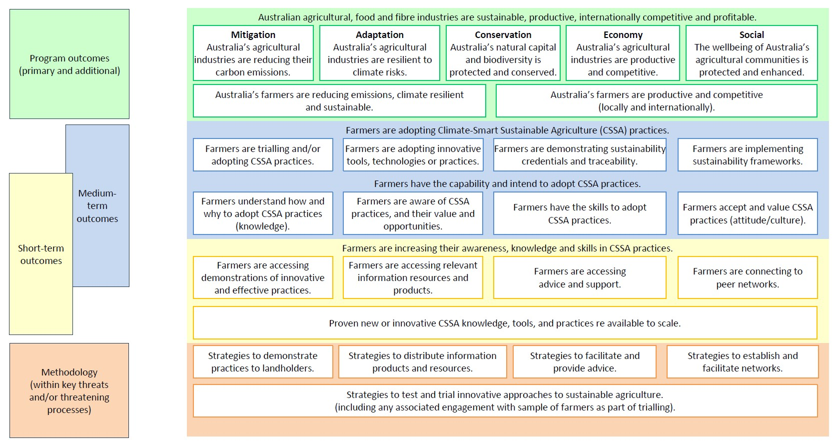
MERIT Monitoring, evaluation, reporting and improvement tool.
Figure C2 Capacity-building logic – to align with entry into MERIT
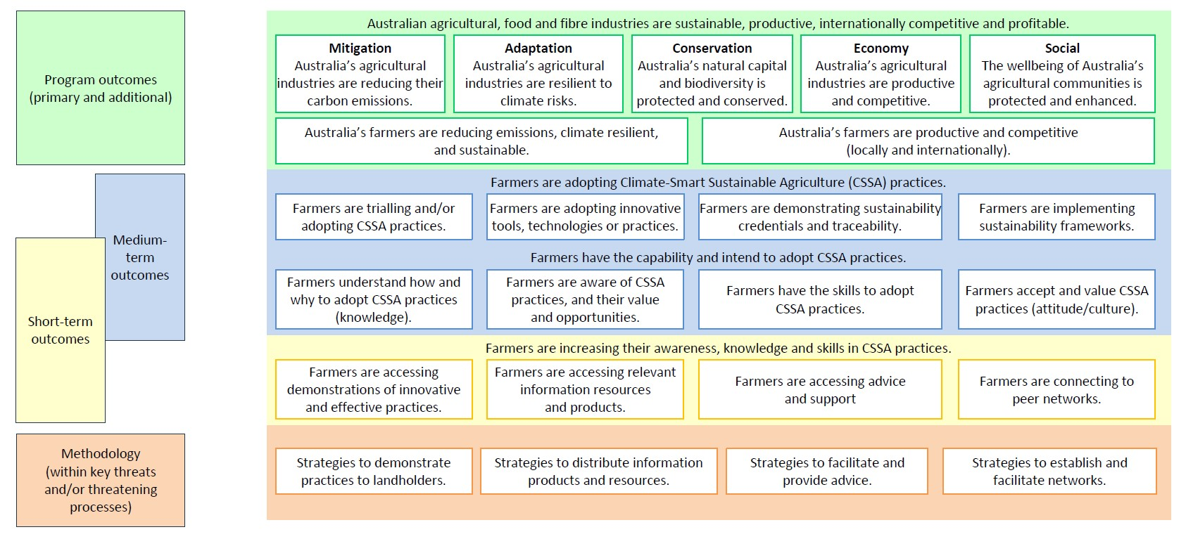
MERIT Monitoring, evaluation, reporting and improvement tool.

Glossary
Term | Definition
ABARES | Australian Bureau of Agricultural and Resource Economics and Sciences
ABS | Australian Bureau of Statistics
activity | Components of a funded project that are carried out by program owners who deliver projects.
agricultural sector | DAFF Stakeholders that include experts, farmers, delivery providers and program owners
ANAO | Australian National Audit Office
ANSIS | Australian National Soil Information System
Australian Government | Also known as the Commonwealth. They are represented by the Department of Agriculture, Fisheries and Forestry for the CSAP program
climate-smart | See 3.1 Key terms used in this MEL Framework
CRC | Cooperative Research Centre
CSIRO | Commonwealth Scientific and Industrial Research Organisation
CSAP | Climate-Smart Agriculture Program
CSSA | climate-smart, sustainable agriculture
DAFF | Department of Agriculture, Fisheries and Forestry
DCCEEW | Department of Climate Change, Energy, the Environment and Water.
delivery provider | See 3.1 Key terms used in this MEL Framework. Lead organisations or individuals who operate on ground to support farmers in understanding and adopting CSSA practices.
established outcomes | A set of outcomes set by the minister that were developed for CSAP.
farmers | See 3.1 Key terms used in this MEL Framework
KEQ | key evaluation question
KASA | knowledge, awareness, skills, attitudes
MEL | measurement, evaluation and learning
MERI | monitoring, evaluation, reporting and improvement (the process)
MERIT | monitoring, evaluation, reporting and improvement tool
minister | Any minister that leads functions related to Australian agriculture.
NHT | Natural Heritage Trust
NRM | national resource management
NSMP | National Soil Monitoring Program
program manager | DAFF officers who manage the requirements set out in binding agreements.
program owner | Recipients who are funded to deliver projects
program team | DAFF officers who develop the program and/or streams
RDP | Regional Delivery Partner
RSC | Regional Soil Coordinator
SAF | Sustainable Agriculture Facilitator
sustainable agriculture | See 3.1 Key terms used in this MEL Framework.

References
ANAO 2021, Regional Land Partnerships, report no.9 2021-22 performance audit (PDF 2.19 MB), Australian National Audit Office, Canberra, accessed 24 May 2024.
Anibaldi, R Rundle-Thiele, S & Roemer, C 2021, Barriers to Sustainable Farming Practices, Scholarly Community Encyclopedia, accessed 25 March 2024.
Bennett, C 1975, Up the hierarchy, Journal of Extension, vol. 13, issue 2, accessed 20 February 2024.
Blackstock, KL, Ingram, JR, Burton, R, Brown, KM & Slee, B 2010,‘Understanding and influencing behaviour by farmers to improve water quality, Science of the Total Environment, vol. 408, issue 23, accessed 20 February 2024.
Cary, J, Webb, T, & Barr, N 2002, Understanding landholders’ capacity to change to sustainable practices: Insights about practice adoption and social capacity for change (PDF 8.21 MB), Canberra: Bureau of Rural Sciences, accessed 13 May 2024.
Cooreman, H, Vandenabeele, J, Debruyne, L, Ingram, J, Chiswell, H, Koutsouris, A, Pappa, E, & Marchand, F 2018, A conceptual framework to investigate the role of peer learning processes at on-farm demonstrations in the light of sustainable agriculture, International Journal of Agricultural Extension 2018, 13th European International Farming Systems Association Symposium, Greece, accessed 18 March 2024.
CSIRO 2024, Ag2050 scenarios report, Commonwealth Scientific and Industrial Research Organisation, Canberra, accessed 13 May 2024.
DAWE 2021, National Soil Strategy, Department of Agriculture, Water and the Environment, Canberra, accessed 20 February 2024.
——2022, Delivering Ag2030, Department pf Agriculture, Water and the Environment, Canberra, accessed 20 February 2024.
DCCEEW 2022, Net zero, Department of Climate Change, Energy, the Environment and Water, Canberra, accessed 20 February 2024.
Fishbein, M, & Ajzen, I 1975, Belief, attitude, intention and behavior: An introduction to theory and research, Addison-Wesley, Massachusetts.
Kollmuss, A & Agyeman, J 2002, Mind the gap: Why do people act environmentally and what are the barriers to pro-environmental behavior?, Environmental Education Research, vol. 8, issue 3, DOI: 10.1080/13504620220145401, accessed 20 February 2024.
Kragt, ME, Blackmore, L, Capon, T, Robinson, CJ, Torabi, N & Wilson, KA 2014, What are the barriers to adopting carbon farming practices?, Working paper 1407, School of Agricultural and Resource Economics, University of Western Australia, Crawley, accessed 2 April 2024.
Kuehne, G, Nettle, R & Llewellyn, N 2019, Key social processes sustaining the farmer/advisor relationship (PDF 3.56 MB), Rural Extension and Innovation Systems Journal, vol. 15, issue 1, accessed 18 March 2024.
Liu, T, Bruins, RJF, Heberling, MT 2018, Factors Influencing farmers’ adoption of best management practices: a review and synthesis, Sustainability, vol. 10, issue 2, accessed 20 February 2024.
Nash, N, Whitmarsh, L, Capstick, S, Hargreaves, T, Poortinga, W, Thomas, G, Sautkina, E, Xenias, D 2017, Climate-relevant behavioral spillover and the potential contribution of social practice theory, WIREs Climate Change, vol. 8, issue 6, accessed 27 March 2024.
Rockström, J, Steffen, W, Noone, K, Persson, Å, Chapin III, FA, Lambin, EF, Lenton, T, Scheffer, M, Folke, C, Schellnhuber, H, Nykvist, B, de Wit, C, Hughes, T, Van der Leeuw, S, Rodhe, H, Sörlin, S, Snyder, P, Costanza, R, Svedin, U and Foley, J 2009, A safe operating space for humanity, Nature, vol. 461, accessed 20 February 2024.
Rundle-Thiele, S, Roemer, C, Anibaldi, R & David, P 2021, Identifying factors that support sustainable farming practice change: application of theory of planned behaviour in project evaluation (PDF 2.18 MB), Rural Extension & Innovation Systems Journal, vol. 17, issue 2, accessed 20 February 2024.
Sutherland, L-A & Marchand, F 2021, On-farm demonstration: enabling peer-to-peer learning, The Journal of Agricultural Education and Extension, vol. 27, issue 5, accessed 18 March 2024.
Vanclay F, & Lawrence, G 1994, Farmer rationality and the adoption of environmentally sound practices; A critique of the assumptions of traditional agricultural extension, European Journal of Agricultural Education and Extension, vol. 1, issue 1, accessed 20 February 2024.

