
Field assessment of the Curiosity® bait for managing feral cats in the Pilbara

M. Johnston, M. O’Donoghue, M. Holdsworth, S. Robinson, A. Herrod, K. Eklom, F. Gigliotti, L. Bould and N. Little

2013
Arthur Rylah Institute for Environmental Research
Technical Report Series No. 245



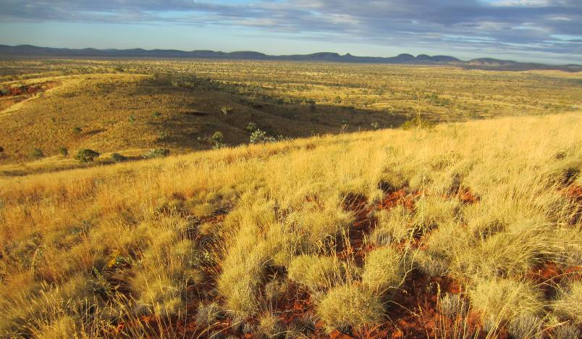



Field assessment of the Curiosity® bait for management of feral cats in the Pilbara
Michael Johnston, Michael O’Donoghue, Mark Holdsworth, Sue Robinson, Ash Herrod, Kylie Eklom, Frank Gigliotti, Les Bould and Neville Little
Arthur Rylah Institute for Environmental Research
123 Brown Street, Heidelberg, Victoria 3084
May 2013
In partnership with:



Arthur Rylah Institute for Environmental Research
Department of Sustainability and Environment
Heidelberg, Victoria

Report produced by: Arthur Rylah Institute for Environmental Research
Department of Sustainability and Environment
PO Box 137
Heidelberg, Victoria 3084
Phone (03) 9450 8600
Website: www.dse.vic.gov.au/ari
© State of Victoria, Department of Sustainability and Environment 2013
This publication is copyright. Apart from fair dealing for the purposes of private study, research, criticism or review as permitted under the Copyright Act 1968, no part may be reproduced, copied, transmitted in any form or by any means (electronic, mechanical or graphic) without the prior written permission of the State of Victoria, Department of Sustainability and Environment. All requests and enquiries should be directed to the Customer Service Centre, 136 186 or email customer.service@dse.vic.gov.au
Citation: Johnston, M., O’Donoghue, M., Holdsworth, M., Robinson, S., Herrod, A., Eklom, K., Gigliotti, F., Bould, L. and Little, N. (2013) Field assessment of the Curiosity® bait for managing feral cats in the Pilbara. Arthur Rylah Institute for Environmental Research Technical Report Series No. 245. Department of Sustainability and Environment, Heidelberg, Victoria.

ISSN 1835-3827 (print)
ISSN 1835-3835 (online)
ISBN 978-174287-816-4 (print)
ISBN 978-174287-817-1 (online)
Disclaimer: This publication may be of assistance to you but the State of Victoria and its employees do not guarantee that the publication is without flaw of any kind or is wholly appropriate for your particular purposes and therefore disclaims all liability for any error, loss or other consequence which may arise from you relying on any information in this publication.
Accessibility:If you would like to receive this publication in an accessible format, such as large print or audio, please telephone 136 186, or through the National Relay Service (NRS) using a modem or textphone/teletypewriter (TTY) by dialling 1800 555 677, or email customer.service@dse.vic.gov.au
This document is also available in PDF format on the internet at www.dse.vic.gov.au
Front cover photo: Looking across the field site on the Turee Plains in the late afternoon. (Michael Johnston).
Authorised by: Victorian Government, Melbourne
Printed by: NMIT Printroom, Preston, Victoria.

Contents
Acknowledgements iv
Summary 1
Background 2
1.1 Introduction 2
1.2 Site description 3
1.3 Objectives 4
2 Methods 5
2.1 Project timing 5
2.2 Field study 5
2.2.1 Detection of site occupancy using automated cameras 5
2.2.2 Trapping and radio-telemetry of feral cats 6
2.2.3 Non-target fauna surveys 9
2.2.4 Weather 9
2.2.5 Baiting 9
2.2.6 Monitoring of radio-collared cats 11
2.2.7 Scat collections 12
2.2.8 Recovery of surviving cats 12
3 Results 14
3.1 Baiting 14
3.1.1 Weather 14
3.1.2 Bait condition 14
3.1.3 Assessment of bait spread 15
3.2 Collared Feral Cats 16
3.2.1 Accuracy of GPS collars 18
3.2.2 Recovery of collared feral cats 19
3.2.3 Whisker analysis 19
3.2.4 Activity of collared feral cats after baiting 19
3.3 Detection of site occupancy using automated cameras 20
3.3.1 Bush cameras 20
3.3.2 Track-side cameras 22
3.4 Non-target species 22
3.5 Analysis of predator scats 23
4 Discussion 26
5 References 30
Appendix 1 32
Appendix 2 33
Appendix 3 35

Acknowledgements
This study was funded by the Department of Sustainability, Environment, Water, Population and Communities (Australian Government) as part of the implementation of the Threat Abatement Plan for Predation by Feral Cats. The administrative and field support received from Julie Quinn is greatly appreciated.
Staff from the Karijini National Park (Department of Environment and Conservation (DEC - Western Australia) demonstrated a genuine interest in the project and provided logistical support when required. Steve Berris, Brendan Jellay, Greg Mann, ‘Ranger Dan’ Petersen and Margaret Morrison are sincerely thanked for their support and the welcome we received in their park.
The aerial application of Curiosity® baits was undertaken with the assistance of Robyn Wilcockson and Neville Garvey (Thunderbird Aero Service).
Advice and support from Dave Algar (DEC) is gratefully acknowledged. Cameron Tiller and Louisa Bell (DEC) loaned some of the automated cameras used in the study. Jim Morris (Scientec Research) assisted with manufacture of toxic doses.
This project required considerable field work and we thank both the field crew and their families for their understanding and support.
Statistical analyses were conducted by Paul Moloney (Department of Sustainability and Environment (DSE) - Victoria). Luke Woodford (DSE) fitted the IGotU GPS loggers to the Holohil collars. Silvana Acevedo prepared the GIS figures used in this report. Barbara Triggs undertook the analysis of items found in scats. Ric How (Western Australian Museum) determined the species of three rodents found during the course of the study. Peter Lock (LaTrobe University) provided access to the microscope used to analyse cat whiskers for presence of Rhodamine B.
Julian di Stefano and Carolina Galindez-Silva (The University of Melbourne - Department of Forest and Ecosystem Science) loaned equipment that enabled the remote download of collars.
Simon Humphries (Invasive Animals Co-operative Research Centre) granted access to data on susceptibility of goannas to para-aminopropiophenone.
Numerous permits were received prior to the initiation of field work;
- The DSE Animal Ethics Committee approved the procedures used in protocol 12/14. This protocol was also endorsed by Kirsty Dixon on behalf of the DEC Animal Ethics Committee.
- The DEC issued Regulation 17 Licence to take fauna for scientific purposes (licence number SPF008715) and Regulation 4 licence to take fauna on DEC managed lands (licence number CE003579).
- The Australian Pesticides and Veterinary Medicines Authority issued PER 13464 allowing the use of the unregistered bait product at Karijini National Park.
- The Department of Sustainability, Environment, Water, Population and Communities (Australian Government) determined that the procedures used in this study were not controlled actions under the Environment Protection and Biodiversity Conservation Act 1999.
- The Western Australian Police approved the ‘Interstate Group Permit” #212 to endorse the transport and use of Victorian registered firearms in Western Australia.
- A ‘Shoot Plan’ was prepared to meet Department of Environment and Conservation requirements associated with the use of firearms within Karijini National Park.

Drafts of this report were reviewed by Peter Menkhorst and Lindy Lumsden.

Summary
Management of feral cat populations over large areas in Australia is currently limited by lack of a cost-effective control techniques. Existing techniques, including trapping, shooting and fencing are subject to limitations associated with significant input cost when used in broad areas. The distribution of poison baits can provide a lower cost alternative but must necessarily address the hazard that the baits may present to non-target species as baits intended for feral cats must be surface-laid. A bait, known as Eradicat®, has been developed for application in areas where native wildlife have a high tolerance to the poison (sodium fluoroacetate) used in that product. This bait is not suitable for use in other areas, such as eastern Australia, where this tolerance does not exist due to potential for consumption of the bait by wildlife species.
The Australian Government has funded the development of an alternative poison bait product that is a based on Eradicat. This bait, known as Curiosity®, exploits differences in feeding behaviour between feral cats and non-target species by presenting the toxicant, para-aminopropiophenone (PAPP), in an encapsulated pellet.
Curiosity baits were aerially distributed over a 268 km² area within Karijini National Park, Western Australia in August 2012. This trial was part of a series of field trials conducted across Australia to assess the efficacy of this bait product and will contribute to the data submitted for product registration purposes.
Monitoring of the bait efficacy program was undertaken by assessing site occupancy of feral cats prior to and following baiting using automated cameras. Additionally, the survival of eight cats that had been trapped and fitted with a GPS datalogger / VHF telemetry collar prior to baiting was monitored. The study included replicated counts of birds prior to and following to determine whether the Curiosity® baits led to a decrease in populations of non-target species. Impacts on reptile populations were expected to be mitigated given that the application of baits was timed for winter when these species were minimally active.
An analysis of site occupancy data showed that there was no significant reduction in the feral cat population after baiting. None of the collared cats died as a result of bait consumption, despite numerous opportunities to encounter the bait as indicated by the GPS datalogged locations.
Corvids and dingoes were photographed removing and consuming baits from a limited number of sites. However, as these individuals were not ‘marked’ or otherwise identifiable, it was not possible to monitor their fate throughout the study. Counts of non-target bird species did not show any broad population decline, suggesting that presence of baits did not lead to loss of population viability.
Several problems encountered during the study affected the results:
- The visual lures used with the automated camera surveys were not ideal.
- The baiting aircraft was delayed, which meant that baits were applied in hotter weather. This affected increases in both the desiccation rate of baits and potentially also the abundance of available prey resource particularly with small reptiles.
- Baits developed a putrescent odour and exhibited limited ‘sweating’ (i.e. exudation of the chicken fat component) which reduced bait attractiveness.
- Insufficient cats were fitted with collars to make confident statements about changes in the feral cat population.
Ongoing development efforts are required to confirm that the Curiosity bait efficacy is an effective management tool for reducing feral cat populations in semi-arid Australia.
Background
  - Introduction
Feral cats (Felis catus) are defined as cats that live and reproduce in the wild and survive by hunting or scavenging (DEWHA 2008). Feral cats are distributed throughout all Australian states and territories, and also inhabit many offshore islands (Abbott and Burbidge 1995; Dickman 1996). Predation by feral cats is a primary cause of the decline of over 80 species of Australian native fauna species listed as threatened nationally under the Environment Protection and Biodiversity Conservation Act 1999 (Commonwealth). Cats are known to kill a wide range of animals — invertebrates, birds, reptiles and mammals with body mass 10 g – 3.5 kg — and compete for resources such as food and den sites with native species (Dickman 1996).
The Australian Government has funded the development of a poison bait for use in managing feral cat populations, in a collaborative research program between the Western Australian and Victorian State Governments. The project seeks to obtain registration for the Curiosity® bait as an agricultural chemical in order to provide land managers of ‘conservation estate’ with a bait product that can be used to help manage feral cat populations. A key difference between the Curiosity bait and conventional baits is that the toxicant is housed in an encapsulated pellet which is inserted into the meat bait. Numerous wildlife species are expected to consume the bait however the size and hardness of the pellet has been demonstrated to lead to rejection, i.e. spitting out, of the pellet in many species. This approach reduces the exposure of non-target native species by exploiting different feeding behaviours exhibited by feral cats compared to native species (Marks et al. 2006; Hetherington et al. 2007). The Curiosity bait is based on the Eradicat® bait but has been modified by making the pH of the meat slightly alkaline (approximately pH 7.5). This modification has previously assisted in retaining the robustness of the encapsulated pellet for more than 10 days.
Field efficacy trials of the Curiosity bait are a necessary component of product evaluation for registering agricultural chemicals. A demonstration of product efficacy is required at sites that are representative of where the product may be used following registration. Initial field studies were undertaken at island sites where the hazard that the bait presented to resident wildlife species was low — French Island in Victoria (Johnston et al. 2011), Christmas Island in the Indian Ocean Territory (Johnston et al. 2010a), Dirk Hartog Island in Western Australia (Johnston et al. 2010b) and Tasman Island in Tasmania (Robinson et al., in prep.). Subsequent studies were undertaken at mainland sites — Cape Arid in Western Australia (Algar et al. pers. comm.), Wilsons Promontory in Victoria (Johnston 2012) and the Flinders Ranges in South Australia (Johnston et al. 2012). The present study contributes to this series of field efficacy studies. Sites were initially nominated by state, territory or Commonwealth conservation agencies, and the field trials were undertaken progressively as the necessary resources became available.
The toxicant used in these studies, with the exception of the study Dirk Hartog Island, was para-aminopropiophenone (PAPP). This compound oxidises haemoglobin to methaemoglobin, which is unable to transport oxygen (Savarie et al. 1983; Scawin et al. 1984). Toxicosis in feral cats is characterised by increasing lethargy leading to unconsciousness and death (Johnston, unpublished data).
Paralleling the trial of the Curiosity bait at Karijini was a baiting program for feral cats using Eradicat, conducted by the Department of Environment and Conservation (Western Australia) in the Fortescue Marsh, approximately 200 km north-east of Karijini National Park (Tiller et al. 2012). The intention was to use this parallel program as a comparative efficacy study between the two bait types, but this was not possible because of various delays that affected the timing of the study by Tiller et al. (2012).

  - Site description
The study site was located on the Turee Plains, within the Karijini National Park, in the Pilbara region of Western Australia (centroid 22°40.6446′ S, 118°20.5979′ E). The site is semi-arid, receiving an average of 459 mm rainfall annually as measured at Wittenoom which is 45 km north of the study site (Bureau of Meteorology 2012). The site is north of the Tropic of Capricorn and is occasionally subject to cyclones. Approximately 230 mm of rain fell over the site associated with Cyclone Heidi in January 2012, i.e. six months prior to baiting.
The trial site area was 268 km² and could be accessed by two roads: Juna Downs Track running north–south and Vigors South Track running east–west (Figure 1). Two other short tracks were also used. A total of 32 km of vehicle accessible track existed within the baited study area. Juna Downs Track is a through road that is used by a low volume of traffic (< 10 vehicles per day), and the other tracks are ordinarily subject to less frequent use. The bird survey included a transect outside of the baited study area of which 22 km was along a road that is subject to considerable traffic, increasing the likelihood of ‘road killed’ food resources for scavenging birds (Figure 7).
Vegetation at the site is Low Mulga Shrubland and is typically dominated by native grasses (Atriplex spp., Themeda spp.) and shrubs (Acacia spp.) on the plains. The elevated range country is vegetated with Snappy Gum (Eucalyptus racemosa) over native grasses.
There is no formal or regular control of invasive carnivorous mammals within the site. Dingoes (Canis lupus dingo) and wild dog hybrids are common. Red foxes (Vulpes vulpes) have not been recorded at the site. There is a low abundance of invasive herbivores, including Domestic Cattle (Bos taurus) and One-humped Camels (Camelus dromedarius), which are mustered off the site or shot infrequently.
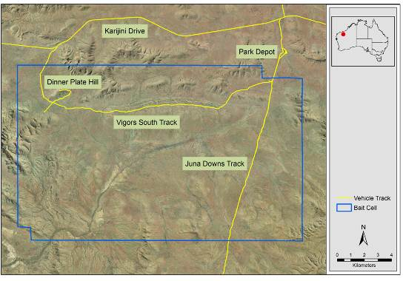
Figure 1. Location of study site within Karijini National Park.

  - Objectives
The overall aim of the project was to collect data for use in preparing a registration dossier of the Curiosity bait as an agricultural chemical. This was undertaken by addressing four key deliverables that were specifically aimed at assessing the efficacy of the Curiosity bait at a semi-arid/tropical mainland site.
- Trap 10-20 feral cats in the trial area and monitor their survival using VHF and/or GPS collars after baiting.
- Aerially deploy Curiosity baits at a rate of 50 baits / km².
- Undertake monitoring of the resident feral cat population pre- and post- baiting to determine abundance and survival using at least two indices.
- To monitor native wildlife species to determine whether the baits lead to a decline in population viability at the site.
- Methods
  - Project timing
An initial visit to the field site was undertaken to determine the suitability of the site for conducting the trial on 16 May 2012. The field study was undertaken from 29 June to 1 September 2012 and included a week (13–20 August) during which the field crew was not working on site.
  - Field study
    - Detection of site occupancy using automated cameras
Automated cameras were installed at 67 locations to assess the presence of feral cats within the study area prior to and following baiting (Figure 2). Cameras used were Reconyx RM45 (15 units), Reconyx Rapidfire semi-covert LED HC500 (12 units), Reconyx Covert HC600 (40 units) (Reconyx, Wisconsin, USA). The locations were determined using a semi-randomised process in which each 1 km² grid cell that was within 3 kilometres of a vehicle track (i.e. within walking distance of the vehicle) was numbered (1–99). A camera was allocated to every second cell, and other cells were selected according to their topography, i.e. with preference given to the elevated ranges where Northern Quolls (Dasyurus hallucatus), a key non-target species, were more likely to be detected if present on the site. A series of random three-digit X and Y axis numbers generated from the program ‘R’ (R Development Core Team 2012) were fitted against each cell to form a complete geographic reference.
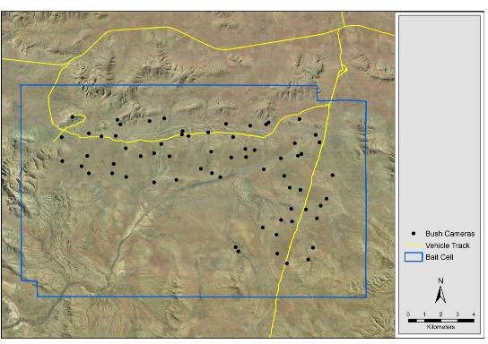
Figure 2. Location of automated cameras used to assess site occupancy

At each site the camera was mounted on a timber stake facing south, and the surrounding vegetation was trimmed to minimise false detections caused by moving vegetation (Figure 3a). At the time of installation, all cameras were test-fired to confirm functionality and correctness of aim. A series of set-up photos was taken in which a white board with the location details and date recorded was held in front of the camera. Cameras remained operational throughout the entire study. All cameras were configured to record three photos at every motion detection, with no pause between detections.
Visual and scent lures were placed at each camera site and operated for a period of 14 nights during each monitoring session (Figure 3b). The cat anal gland scent lure ‘Catastrophic’ (Outfoxed Pest Control, Victoria) was smeared onto an absorbent cloth as per the manufacturer’s recommendation. The visual lure was fabricated on site from strips of aluminium foil and orange and yellow flagging tapes, which were tied onto stout vegetation in the centre of the camera’s field of view at a distance of 3–4 m.
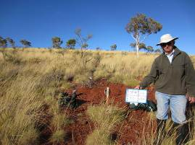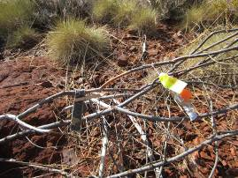
Figure 3. (a) Typical camera site layout. (b) Visual and scent lures in position.

The statistical analysis associated with modelling of the occupancy rate of the various species or guilds was undertaken using a dynamic occupancy model (MacKenzie et al., 2003; MacKenzie et al., 2006). This technique allows the occupancy rate to change from one period to another. In this case the periods of interest were when the visual and olfactory lures were installed during both the pre- and post-baiting monitoring periods. Three models were generated for each species or guild of interest to take into account any possible variation in detection because of the camera used or the effect of baiting. The model with the lowest Akaike Information Criterion (AIC) was selected, and its estimates were used in the analysis. The analysis was conducted using R 2.15.2 (R Development Core Team 2012) and the package unmarked 0.9-9 (Fiske and Chandler 2011). Confidence intervals for the post-baiting occupancy rates were determined by bootstrapping. The goodness-of-fit for the model was tested using a chi-squared (χ²) statistic compared to a bootstrapped χ² distribution.
Twenty additional cameras were placed at ‘track-side’ locations (Figure 4). These were used to collect data on cat activity on vehicle tracks and determine the species responsible for removing baits. No lure, other than a Curiosity bait, was supplied at these track-side camera sites.
    - Trapping and radio-telemetry of feral cats
Trapping was based on the procedures described in Sharp and Saunders (2004). The traps used were rubber-padded leghold traps (Duke #1.5 and #3, West Point, USA) that had been modified with a stronger base plate and additional swivels, and were waxed and dyed by Outfoxed Pest Control (Victoria). Seventy trap sets (consisting of two traps set as pairs in a ‘walk-through’ configuration) were located along vehicle tracks with a 100–500 metre separation (Figure 5). Three additional trap sets were installed on drainage lines. Traps were not placed within 2 km of the edge of the study area in an attempt to minimise the capture of cats which were likely to spend time outside the study area. Cat faeces and urine sourced from domestic animals were used as the scent lure at all trap sets. Audio lures, known as the Feline Audio Phonic (FAP), were operated on alternate nights at trap sites.
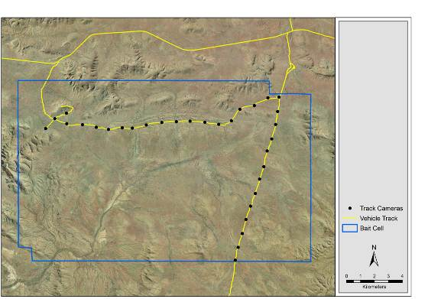
Figure 4. Location of track-side automated cameras.
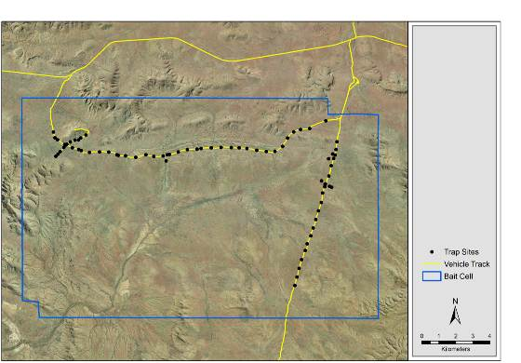
Figure 5. Trap locations within the site.

Trapped feral cats were restrained with a catch pole and covered with a blanket. The cats were then released from the trap and transferred into a hessian sack which was labelled with a site identifier. Once all traps had been cleared, trapped cats were transported to the depot for processing. Cats were lightly sedated (Zoletil® 100, Virbac) to allow the sex and body mass of animals to be safely determined and recorded (Figure 6a). A saline injection (c. 20 mL) was administered into the scruff to increase body fluids, as recommended by the DSE Animal Ethics Committee.
Radio-tracking collars sourced from three different suppliers were used in this study:
- Sirtrack Ltd (Havelock North, NZ) — Two GPS datalogger / VHF 150 MHz collars. These were beta-level test equipment. The collars weighed 132 g and were fitted with an automated collar drop-off timed for 0100 hrs on 25 August (local time) (Figure 6a).
- Telemetry Solutions (California, USA) — Four GPS datalogger / VHF 150 MHz collars. These collars had a mass of 100 g and included the necessary hardware to enable remote download of GPS data. One additional collar was placed on the ground in the study site to collect accuracy data.
- Holohil Systems (Canada) — Two VHF collars transmitting at 152 MHz. These collars were modified to include an IGotU GPS logger and had a total mass of 80 grams. These were configured to record a GPS location every hour. Two additional collars of this type were placed within the study site to collect data on the accuracy of the GPS loggers over the period of the study. It was intended that these collars would be used only after all the other collars GPS collars had been fitted. However, difficulties in configuring the Telemetry Solutions collars led to the Holohil collars being used earlier than planned.

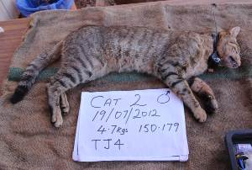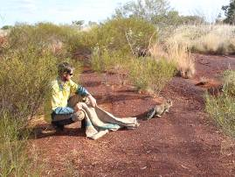
Figure 6. (a) Sedated cat fitted with Sirtrack collar. (b) Release of cat at point of capture. (courtesy of N. Little)

The Holohil and Telemetry Solutions collars included a mortality sensor that doubled the transmission rate if the cat did not move for 10 hours.
Cats were returned to the hessian sack after processing and allowed to recover from the sedative in a shaded, ventilated position. Once recovered from sedation, they were released at the point of capture (Figure 6b).

    - Non-target fauna surveys
Surveys of bird species observed on site were undertaken to collect data on the impact of the baiting of non-target fauna. The surveys entailed several methods:
- Counts of individual carnivorous birds that may consume Curiosity baits (i.e. raptors and corvids) as seen from a vehicle driven at 20–25 km/h along a 42 km transect through the study area. The same method was used to obtain a count over a 44 km transect in a bait-free ‘control’ area located in similar topography and vegetation. Counts were conducted on the 10 days immediately prior to and following baiting, i.e. total survey distance was 420 and 440 km respectively. The start/finish location was alternated daily to allow for variations in bird behaviour that occur throughout the day (Figure 7).
- A skilled observer identified all birds visually or by vocalisation during a 5 minute survey. These surveys took place at 3 km intervals along the driven transect with the vehicle switched off and the observer standing on the tray of the vehicle (Figure 7a).
- A species list was generated for all bird species observed opportunistically during the study.
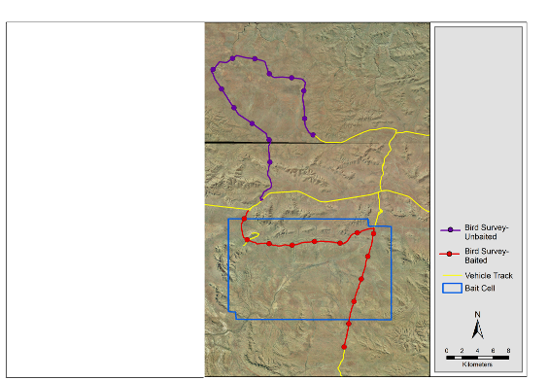
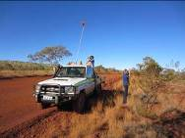
Figure 7. (a) Bird surveys conducted by skilled observers. (b) Bird survey transect and 5 minute survey points.

    - Weather
The Bureau of Meteorology maintains a recording station at Wittenoom (site number 005026) and publishes data from this station online. This station is approximately 45 km from the field site. Meteorological data is referred to in this report from the perspective of impact on bait attractiveness, and activity of cats and non-target species.
    - Baiting
Baits were manufactured by a commercial sausage factory (Pendle Ham and Bacon, Sydney, Australia), overseen by Scientec Research, during May–June 2012. Baits were manufactured using a recipe modified from that used to make Eradicat baits, comprising 70% minced kangaroo meat, 20% chicken fat, and 10% digest and flavour enhancers (Australian Patent No. 781829). The pH of the meat emulsion used in the Curiosity baits was buffered to 7.5 using sodium carbonate (Scientec 2012). One encapsulated pellet containing a formulation of approximately 80 mg PAPP and a trace amount of Rhodamine B dye was inserted manually into each bait. Baits were counted into batches of 200 and stored frozen in onion netting bags as per the procedures used for Eradicat baits.
Baits were transported to the study site in a domestic chest freezer and stored frozen until 28 July 2012. Prior to deployment, all baits were removed from the freezer and allowed to thaw overnight on a series of racks. Baits were then transported to the Auski airstrip on the morning of 1 August and arranged on bait racks such that they would be in full sun. This completed the thawing process and allowed the aromatic chicken fats to leach onto the surface of the sausage. Baits were sprayed with a residual insectide (Coopex, Bayer Crop Science, Australia) to reduce ant activity (Figure 8).

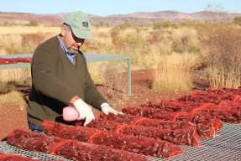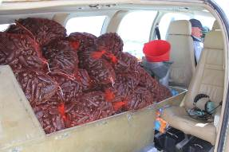
Figure 8. (a) Sweating baits and treating with Coopex. (b) Baits loaded into aircraft. (courtesy N. Little)

Baits were loaded into the rear of a Beechcraft Baron B58 twin-engine aircraft (Thunderbird Aero Service, Western Australia). This aircraft is fitted with computerised, GPS-linked equipment to ensure accurate application of baits. All 13 500 baits used in this study were deployed during a single flight. A series of panel lights indicate to the bombardier when to release baits; in this study the bombardier was instructed to drop 5 baits every 3 seconds. The GPS-linked mechanism closed the bait drop hole to prevent baits from being dropped when outside the cell. The location of the aircraft was logged each time baits were released through the chute.
A practice baiting exercise was conducted over the Auski airstrip to confirm that the procedures and data recording systems were functioning correctly. Non-toxic baits with red skins were tagged with yellow flagging tape to improve their detectability on the red soil. The airstrip was searched after the plane had dropped baits. The location of each bait was recorded using a GPS to generate a position using waypoint averaging over one minute, and the distance between groups of baits and the baits within the groups was measured with a tape measure.
Toxic baits were then dropped on the study site between 1500 and 1800 hours (1 August 2012) with the aircraft operating at approximately 135 knots at a height of 500 ft. Baits were dropped across the 268 km² site at a rate of 50 baits per km². The plane flew north–south bait transects spaced at 500 m intervals, dropping 25 baits per kilometre (Figure 9). The baiting cell data for the toxic Curiosity baits within Karijini National Park had been pre-loaded into the aircraft navigation system (Airguide). Swath width, i.e. distance between baited transects, and the rate of bait drop were also configured within the Airguide system.
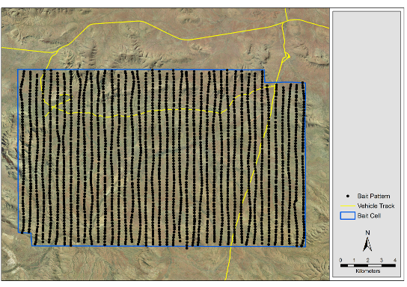
Figure 9. Map showing aerial distribution of Curiosity baits across the study site.

Fifty randomly selected Curiosity baits were placed in a metal cage at the depot (i.e. 2.5 km from the north-east corner of the bait cell). Five baits were withdrawn from this cage on 5 and 6 August and assessed for attractiveness, palatability (i.e. odour and hardness) and condition of the encapsulated pellet after incising the bait with a scalpel. Further inspections were not undertaken after this date because of the results from these two days. The internal temperature of one bait that had been placed in full sunlight for 5 hours was measured with a digital stem thermometer (Jaycar Electronics, Australia) on 23 August 2012.

    - Monitoring of radio-collared cats
Radio-telemetry techniques were used to determine the approximate location and status (alive or dead) of cats. The pulse rate of the transmitted tones on the Holohil and Telemetry Solutions collars doubled if the collar had remained motionless for 10 hours (i.e. the cat was dead or the collar had dropped off). Hand-held Yagi and vehicle-mounted omni-directional antennae connected to VHF receivers — Australis 26K (Titley Scientific, Australia) and R1000 (Communication Specialists, USA) — were used determine the cat status. Hills within the bait cell were accessed daily throughout the study, and a record was kept of the cats detected and their status (alive/dead) at these locations (Figure 10).
The GPS data was downloaded remotely from Telemetry Solutions collars using a UHF modem and Yagi antenna connected to a laptop computer. Radio-telemetry techniques were used to approach the cat to within about 40 m where the UHF modem could undertake the data transfer.
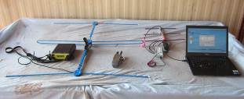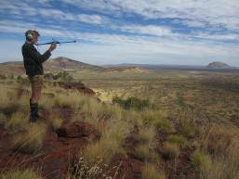
Figure 10. (a) VHF radio-telemetry receiver and Yagi (left) and UHF Yagi and modem used to undertake remote download of Telemetry Solutions GPS collars (right). (b) Radio-tracking from a hill top.

The data from the GPS datalogger collars was filtered to remove all points where the collar failed to collect a location (i.e. cat may have been in an enclosed den site), or had a horizontal dilution of precision value greater than 5.0, or was a two-dimensional fix. Filtered data were projected and manipulated in Arcview 3.2 (ESRI, Redlands, USA) and home range analysis was conducted using the Home Range Extension tool (Rodgers and Carr 1998).

    - Scat collections
Predator scats were collected to identify prey species of cats within the study area and also provided an additional method of determining whether the Northern Quoll (Dasyurus hallactatus) was present. Scats were placed in plastic bags and labelled with a site identifier These were stored frozen on site and then forwarded to an expert for identification of species of origin and dietary items contained with each scat. Techniques used for this analysis are described in Brunner and Triggs (2002). Three dead native mice found within the study site were sent to the Western Australian Museum for identification.

    - Recovery of surviving cats
Several methods were attempted to recover cats and their collars twenty-four days after baiting, including:
- targeted baiting — After locating a cat using VHF telemetry, its position was encircled with baits dropped every 10–20 m in a circle about 50–100 m in diameter from the location of the cat. Baits were also dropped along animal trails located near cats.
- collar drop-off — Automated functionality of the collar that is programmed prior to fitting the collar onto a cat. Only the Sirtrack collars had this feature.
- trapping — A size 3 leghold trap set in the top of a 20 litre plastic bucket. A food lure (fried chicken drumstick) was suspended above the bucket with the expectation that the cat would stand on the bucket to access the food (Figure 11a). This trap design had been used successfully at other sites (Christmas Island, Tasman Island) and was used in this study in preference to a conventional trap set, given the expectation that the cats would be ‘trap shy’. These traps were placed at sites close to where the target cat was located.
- cage traps — Collapsible cage traps were also placed at sites close to where the target cat was located. A hessian sack was fixed over the trap to provide shade. Fried chicken was used as the lure (Figure 11b).
- VHF-guided hunting — The initial approach attempted to stalk the cat and shoot it at its daytime den site. This was not successful given the height and density of the vegetation. Instead, this technique was revised to a VHF-guided pursuit until the cat could be readily approached and shot.

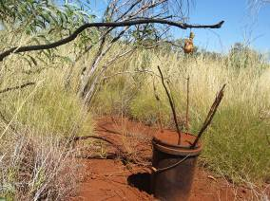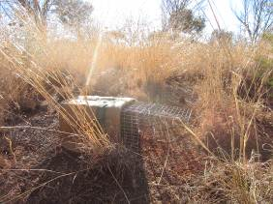
Figure 11. (a) Bucket trap set. (b) Cage trap used during collar-recovery trapping.

Facial whiskers were plucked from each side of the face of cats that were shot (# 2 and 4). These were examined for the presence of Rhodamine B dye that would indicate that a Curiosity pellet had been ingested, using techniques described in Fisher (1998) and Fisher et al. (1999). A microscope (Nikon Ti Eclipse, USA) fitted with a TRITC filter was used to view the whiskers samples.

- Results
  - Baiting
    - Weather
The weather was generally characterised by cool nights and warm to hot days throughout the study period. No rain was recorded at the site during the study, and several frosts were recorded during July. The weather on and after 1 August 2012 was good for baiting (Table 1), in that maximal sweating of maximal baits was evident although the daytime temperatures did promote rapid desiccation of the baits.

Table 1. Summary of weather observations at Wittenoom when baits were available.
Date | Min. temp. °C | Max. temp. °C | Relative humidity (%)
1 August | 7.3 | 26.6 | 28
2 August | 11.1 | 27.6 | 27
3 August | 12.0 | 28.0 | 43
4 August | 12.6 | 30.3 | 30
5 August | 13.3 | 29.0 | 21
6 August | 11.1 | 29.9 | 25
7 August | 15.6 | 30.5 | 23
8 August | 14.8 | 29.2 | 34

    - Bait condition
There was variation in the degree of chicken fat sweating from baits across different production batches. A small proportion of baits (< 1%) were paler and sweated to a much greater degree than the bulk of the baits used in this study (Figure 12). All baits had a slight putrescent odour to them that reduced their attractiveness.
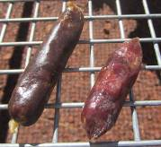
Figure 12. Variation in bait colour and sweating in baits caused by different drying procedures.

Five randomly chosen baits were withdrawn from the test cage on 5 and 6 August and inspected. These baits had dried out to the extent that they were difficult to cut. The encapsulated pellets were damaged in opening the bait, but it was evident that there had also been some degradation of the polymer in situ and leakage of pellet contents into the surrounding meat. A similar number of baits was also withdrawn from an unused supply in the freezer which provided an effective comparison. In the case of these baits, the pellets were in the intended condition, i.e. tough and with no leaks (Figure 13).
Preliminary observations of the internal temperature of a bait that had been placed in the full sun for a period of 5 hours indicated that the internal temperature was ~ 10° C higher than the ambient air temperature (42 and 32° C respectively). This work was not completed as thoroughly as desired as a crow took the bait and thermometer shortly after the first reading was taken.
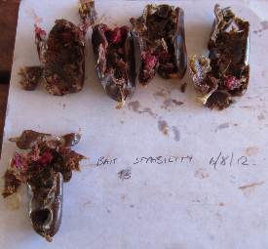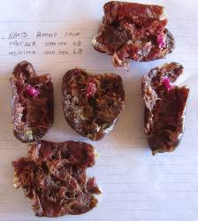
Figure 13. (a) Baits removed from the weathering cage. Note the dye-stained meat adhered to the pellet (b) Baits withdrawn from the freezer and assessed on same day.

    - Assessment of bait spread
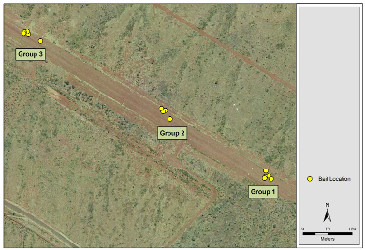
The ground spread of each group of five baits dropped on the airstrip to test the accuracy of the bait drop was likely to be less than 15 metres. It was difficult, however, to obtain a meaningful average value from the data collected at Auski airstrip given (a) the variable results over the three drops undertaken, and (b) the bombardier had to estimate the timing for each bait drop rather than being prompted by the AirGuide computer (Figure 14, Appendix 1) because there was no pre-loaded bait cell.
Figure 14. Measured results from non-toxic bait spread test at Auski airstrip
  - Collared Feral Cats
Nine feral cats were trapped over 966 trap-set nights (i.e. the number of sets active per night, as distinguished from the number of traps). Eight of these cats were fitted with collars that included a VHF transmitter (Table 2). The remaining cat (cat 3) was euthanased shortly after trap clearing as it was judged to be too small (800 g) to be used in this study.
All eight cats were known to be alive prior to the application of baits on 1 August 2012, although cat 9 had moved to a location about 8 km outside the bait cell.
Two Wild Dogs or Dingoes, one Barn Owl (Tyto alba) and an Australian Bustard (Ardeotis australis) were trapped during this phase. Both dogs and the owl were released at the capture location. The Bustard was euthanased following consultation with DEC rangers, due to injury.

Table 2. Details of trapped and collared feral cats.
Cat ID | Date | Morphometric detail | GPS collar | Fate at end of project
1 – 150.161 | 19 June | 2.6 kg ♂ tabby | Sirtrack | Survived. Collar dropped off 25 August
2 – 150.178 | 19 June | 4.7 kg ♂ tabby | Sirtrack | Dead. Shot 30 August
3 – N/A | 19 June | 0.8 kg ♀ tabby | No | Euthanased after capture 19 June
4 – 152.006 | 20 June | 2.9 kg ♀ tabby | Holohil / IgotU | Dead. Shot 31 August
5 – 152.099 | 20 June | 3.9 kg ♂ tabby | Holohil / IgotU | Unknown. Regularly detected alive throughout study. However, not detected between 23 and 31 August.
6 – 150.003 | 21 June | 3.7 kg ♂ tabby | Telemetry Solutions | Survived. GPS activity data retrieved.
7 – 150.285 | 23 June | 3.3 kg ♂ black / ginger | Telemetry Solutions | Survived. GPS activity data retrieved.
8 – 150.245 | 28 June | 3.8 kg ♂ tabby | Telemetry Solutions | Survived. GPS activity data retrieved.
9 – 150.344 | 28 June | 2.9 kg ♀ black | Telemetry Solutions | Survived. GPS activity data retrieved.

GPS location data were retrieved from six collared cats and are summarised in Table 3. The sampling schedule for each collar varied according to the date of capture; collars fitted to cats caught early in the trapping program were programmed for less frequent sampling to prolong the battery life. No data was recovered from the collar fitted to cat 4. It is uncertain whether this was because of an error made when fitting to collar or failure of the device.
Table 3. Details of location sampling programmed into GPS datalogger collars.
Cat ID | Date | GPS sampling routine | Total no. of locations
1 – 150.161 | 19 June – 28 July  29 July – 25 August | 180 mins  30 mins | 907
2 – 150.178 | 19 June – 28 July  29 July – 30 August | 180 mins  30 mins | 1627
4 – 152. 006 | 20 June – 29 August | 60 mins | 0
5 – 152.099 | 20 June – N/A | 60 mins | Not recovered
6 – 152.003 | 21 June – 22 August | 30 mins | 1442
7 – 150.285 | 23 June – 22 August | 30 mins | 1396
8 – 150.245 | 28 June – 23 August | 15 mins | 2340
9 – 150.344 | 28 June – 23 August | 15 mins | 2384

The data sourced from the GPS collars indicate that seven of the eight cats remained within the bait cell throughout the study and are assumed to have encountered baits (Figure 15). Cat 7 left the study area immediately after release and did not encounter any baits until supplementary baits were placed around it.
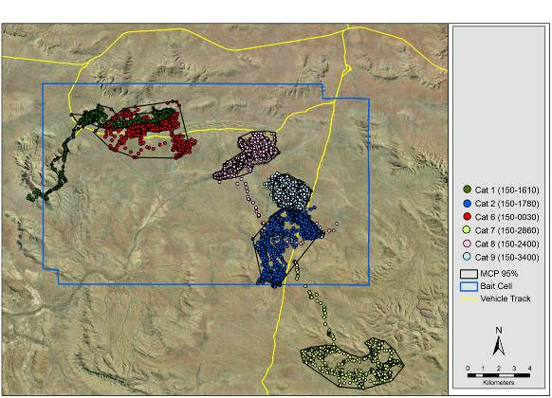
Figure 15. Location data and MCP95% sourced from six GPS collared feral cats.

The home range of these six cats was calculated using the 95% Minimum Convex Polygon, as based on these data are shown in Table 4. This analysis overstates the home range of cats 1, 7 and 8 by including large areas that the cats were not recorded using and is a factor of the linear pattern of their movement data. A second polygon was manually drawn that closely followed the datapoints included in the original MCP95% and this area is presented in Figure 12 and Table 3.

Table 4. Home range of feral cats calculated using MCP 95%.
Cat ID | MCP 95% | Modified MCP 95%
Cat 1 – 150.1610 | 20.1 km² | 6.6 km²
Cat 2 – 150.1780 | 12.6 km² | Not required
Cat 6 – 150.0030 | 16.3 km² | Not required
Cat 7 - 150.2850 | 28.1 km² | 13.2 km²
Cat 8 - 150.2450 | 42.0 km² | 6.7 km²
Cat 9 - 150.3440 | 4.3 km² | Not required

    - Accuracy of GPS collars
The ‘home range’ (MCP95%) of the Telemetry Solutions collar that was located in a fixed-position to assess accuracy was found to be 3709 m². This dataset comprised 842 records, of which 65 were removed when no fix was achieved and a further 47 for which a two-dimensional fix was achieved (Figure 16). Despite the filtering, one data point placed the collar 300 m from its actual location (top of Figure 16).
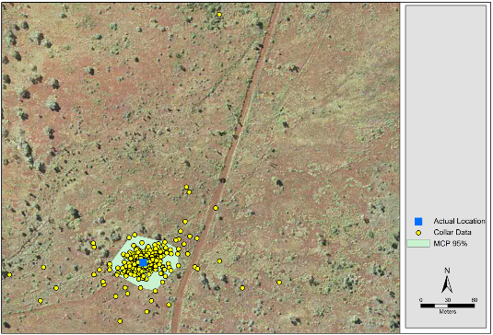
Figure 16. MCP95% and spread of location data for a collar placed in fixed position.
    - Recovery of collared feral cats
A total of 42 trap nights were accumulated in attempting to retrap collared feral cats using cage and leghold traps. This was time-consuming and unsuccessful. Similarly, the use of supplementary Curiosity baits placed around cats did not lead to any cat deaths.
The two cats for which VHF-guided hunting was attempted were successfully recovered. Stalking was initially attempted on cat 2, but the height and density of grass and other vegetation throughout the site rendered this unsuccessful. Instead the technique was modified to an active VHF telemetry-guided pursuit. This was undertaken over 4.19 km until the cat was observed at close range and shot. A similar technique was used to recover the collar fitted to cat 4 over a distance of 5.42 km.

    - Whisker analysis
Sixteen whiskers were examined under fluororescence microcope from cats 2 and 4. None of the whisker samples viewed indicated any evidence of Rhodamine B dye indicating that they had not consumed a Curiosity bait (Figure 17). Only naturally occurring auto-fluorescence was observed.
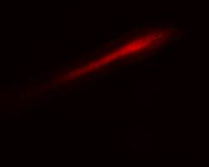
Figure 17. Cat whiskers showing (a) natural auto-fluorescence in whiskers taken from cat 2, and (b) fluororesence when marked with Rhodamine B in whiskers from a cat used in a previous study. Note that natural auto-fluorescence is visible only in the core of the whiskers.

    - Activity of collared feral cats after baiting
A subset of the GPS location data for baiting day and the following three days (1–4 August) demonstrates that the six cats should have had many opportunities to encounter and consume baits when they were at their most attractive and palatable (Figure 18).
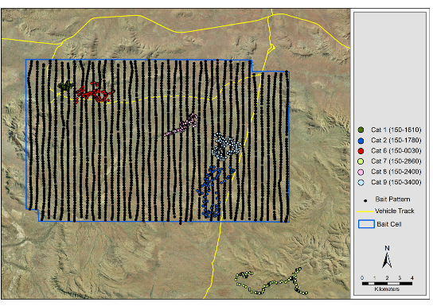
Figure 18. Pattern of bait spread across the study site and locations used by collared feral cats, 1–4 August.

  - Detection of site occupancy using automated cameras
    - Bush cameras
Data was collected at the ‘bush camera’ sites to measure site occupancy across two species or guilds, being feral cats and carnivorous birds. Insufficient detections of dingoes, goannas and quolls were made to undertake a useful statistical analysis. The consistent result across these four species / guilds was that the model with most evidence was the default model, in which camera type and baiting were not included as factors affecting the detection rates. This does not mean, however, that baiting did not have an impact on occupancy rates. Interpretation of the statistic indicates that occupancy rates from pre- and post-baiting periods were affected by the local extinction and colonisation rates. Extinction in this analysis refers to the sites in which the species was detected in the pre-bait but not the post-bait monitoring periods. Colonisation refers to the converse of this. The estimated occupancy rates pre- and post-baiting are given in Table 5 and displayed in Figure 19.
Feral cats were estimated to have had an occupancy rate of 43.9% (range: 24.2 – 65.7%) in the period prior to application of Curiosity baits. A lower occupancy rate of 33.7% (range: 17.9–56.8%) was observed during the post-baiting monitoring period. This lower result is not however statistically significant as the confidence interval for the growth rate (0.38–1.48) included values >1.0 indicating no change in occupancy (Table 5).
In the groups of interest, there is insufficient evidence to suggest that the Curiosity bait significantly affected their occupancy rate (Table 6).
It was intended that an estimate of feral cat population abundance may have been made possible based on capture–recapture models using the collared feral cats. However, no collared cats were photographed during the post-baiting monitor period. Six of the cats were active in the area where cameras were installed, indicating that there was sufficient opportunity to encounter the cameras (Figure 20).

Table 5. The estimated pre-and post-baiting occupancy rates and detection rates for each species / group with confidence intervals (CI). The goodness-of-fit statistics (GOF) are also given for each model.
Species / Group |  | Occupancy (%) |  |  |  |  |  | Detection (%)  95% CI
Species / Group |  | Pre-baiting  95% CI |  |  | Post baiting  95% CI
 | GOF | Estimate | Lower | Upper | Estimate | Lower | Upper | Estimate | Lower | Upper
Feral Cat | 0.21 | 43.9 | 24.2 | 65.7 | 33.7 | 18.8 | 57.1 | 5.5 | 3.4 | 8.7
Carnivorous birds | 0.49 | 51.5 | 20.8 | 81.1 | 43.7 | 20.1 | 94.5 | 3.4 | 1.8 | 6.5

Table 6. The estimates of local extinction rate, colonisation rate and the growth rate for each group with confidence intervals. Growth rate confidence interval was calculated through parametric bootstrapping.
Species / Group | Local Colonisation (%) |  |  | Local Extinction (%) |  |  | Growth Rate
Species / Group |  | 95% CI |  |  | 95% CI |  |  | 95% CI
Species / Group | Estimate | Lower | Upper | Estimate | Lower | Upper | Estimate | Lower | Upper
Feral Cat | 37.4 | 15.6 | 67.5 | 70.9 | 35.3 | 91.6 | 0.77 | 0.38 | 1.48
Carnivorous birds | 41.5 | 7.9 | 85.4 | 54.4 | 13.2 | 90.3 | 0.85 | 0.43 | 1.63

Figure 19. Plot of the estimated occupancy rates pre- and post-baiting for each group.

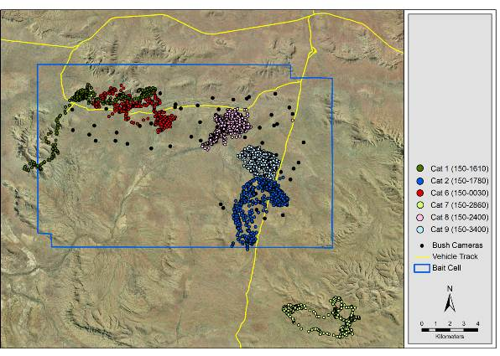
Figure 20. Automated camera sites and locations used by collared cats during the post-baiting monitor period.

    - Track-side cameras
Automated cameras set along tracks to assess predator activity along roads operated for 648 device nights during the pre-baiting monitoring period, and 832 device nights during the post-baiting period. There was no change in the detection of feral cats prior to and following baiting Table 7. Wild Dogs or Dingoes were detected less frequently in the post-baiting monitoring period.

Table 7. Detection of cats and canids by automated cameras at track-side locations
 | Detections |  | No. of detections per device night
 | Pre- bait | Post- bait | Pre- bait |  | Post- bait
Cats | 15 | 21 | 0.023 | 0.025
Wild Dog / Dingo | 27 | 28 | 0.041 | 0.033

  - Non-target species
Counts of the bird species that were considered to be most likely to consume Curiosity baits indicated a generally low abundance of raptorial and other large carnivorous or omnivorous species. Decreases in counts were observed in eight species, but because of the low numbers of individuals across the total transect there was insufficient statistical power to attribute the post-baiting counts with deaths associated with the Curiosity bait (Table 8). Several species of potential bait-consuming bird species were recorded at the study site, although as ‘incidental observations’ as they were not recorded during the driving transects. These included Emu (Dromaius novaehollandiae), Square-tailed Kite (Lophoictinia isura), Black Falcon (Falco subniger) and Blue-winged Kookaburra (Dacelo leachii). A Grey Falcon (Falco hypoleucos) was also observed as an incidental record after baiting (Johnston and O’Donoghue, pers. obs.) but not detected during the driven transect count. The counts of Nankeen Kestrel (Falco cenchroides) dropped at both baited and unbaited sites, suggesting that there was a migration out of the sites. The list of species observed throughout the baited area during the pre- and post-baiting monitoring periods is provided in Appendix 2.
Little Crows (Corvus bennetti) were observed removing baits placed in view of track-side cameras on 18 occasions. They removed baits from the same location over sequential days at four sites. However, it was not possible to determine whether the same bird (or birds) was responsible, nor whether the baits were wholly consumed.

Table 8. Pre-and post-baiting counts of birds considered to be potential bait-consuming species.
 | Baited study site |  | Unbaited Study Site
 | Total Count over 10 day survey / (count per km)
Species | Pre-bait | Post-bait | Pre-bait | Post-bait
Black-shouldered Kite Elanus axillaris | 2 (0.004) | 4 (0.009) | 1 (0.002) | 3 (0.006)
Whistling Kite Haliastur sphenurus | 0 (0) | 0 (0) | 2 (0.004) | 0 (0)
Brown Goshawk Accipiter fasciatus | 2 (0.004) | 0 (0) | 2 (0.004) | 3 (0.006)
Collared Sparrowhawk Accipiter cirrhocephalus | 1 (0.002) | 1 (0.002) | 1 (0.002) | 0 (0)
Spotted Harrier Circus assimilis | 21 (0.05) | 16 (0.03) | 11 (0.02) | 13 (0.02)
Wedge-tailed Eagle Aquila audax | 0 (0) | 0 (0) | 2 (0.004) | 1 (0.002)
Little Eagle Hieraaitus morphnoides | 0 (0) | 1 (0.002) | 1 (0.002) | 1 (0.002)
Nankeen Kestrel Falco cenchroides | 25 (0.05) | 3 (0.007) | 15 (0.03) | 2 (0.004)
Brown Falcon Falco berigora | 24 (0.05) | 17 (0.04) | 17 (0.03) | 5 (0.01)
Australian Hobby Falco longipennis | 6 (0.01) | 5 (0.01) | 5 (0.01) | 1 (0.002)
Grey Falcon Falco hypoleucos | 2 (0.004) | 0 (0) | 0 (0) | 0 (0)
Australian Bustard Ardeotis australis | 3 (0.007) | 3 (0.007) | 0 (0) | 0 (0)
Pied Butcherbird Craticus nigrogularis | 3 (0.007) | 1 (0.002) | 4 (0.009) | 0 (0)
Australian Magpie Gymnorhina tibicen | 19 (0.04) | 6 (0.01) | 6 (0.01) | 7 (0.01)
Little Crow Corvus bennetti | 13 (0.03) | 4 (0.009) | 4 (0.009) | 3 (0.009)

While no index or formal measure was attempted to assess reptile activity in this study, incidental observations indicated that there was little reptile activity during July and early August. Those reptiles that were observed were mostly small dragons (Agamidae sp.) less than 100 mm long. Reptiles were more frequently observed during late August as the daytime temperatures increased.
Two small goannas were observed during the study. One was photographed by automated camera and the second was observed by field crew (F. Gigliotti, pers. obs.). Both observations were made after baiting on 11 and 22 August.
  - Analysis of predator scats
A total of 182 scat deposits were collected, and the contents of each scat was investigated (Figure 21). At least 77 (and perhaps 90) of the scats were from Feral Cats, and 72 were from Wild Dogs or Dingoes.
Traces (hair, teeth) of small mammals found in Feral Cat scats permitted identification of nine prey species (Table 9). Remnants of bird feathers, reptiles, invertebrates and plant material was also observed in the cat scats (64, 16, 3 and 29 scats respectively) although identification of these remains to species level was not possible.

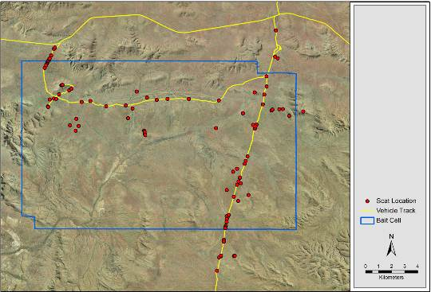
Figure 21. Locations where scats were collected

Table 9. Mammalian prey species identified in feral cat and canid scats.
Predator | Prey species
Feral Cat | Kaluta (Dasykaluta rosamondae)  Pilbara Ningaui (Ningaui timealeyi)  Long-tailed Planigale (Planigale ingrami)  Western Chestnut Mouse (Pseudomys nanus)  Stripe-faced Dunnart (Sminthopsis macroura)  Desert Short-tailed Mouse (Leggadina lakedownensis)  House Mouse (Mus musculus)  Spinifex Hopping Mouse (Notomys alexis)  Common Rock Rat (Zyzomys argurus)
Wild Dog / Dingo | Kaluta (Dasykaluta rosamondae)  Pilbara Ningaui (Ningaui timealeyi)  Western Chestnut Mouse (Pseudomys nanus)  House Mouse (Mus musculus)  Cat (Felis catus)  Dog (Canis lupus)  Euro (Macropus robustus)  Red Kangaroo (Macropus rufus)  One-humped Camel (Camelus dromedarius)

The prey items from Wild Dog or Dingo scats included both small and large mammals, ranging from Pilbara Ningauis (Ningaui timealeyi) to One-humped Camels. It is not possible to determine what species may have been consumed as carrion. Four Wild Dog /Dingo scats contained cat hair that was considered to have been consumed as prey. The complete scat analysis is provided in Appendix 3.
- Discussion
The objective of the study was to assess the efficacy of the Curiosity bait in reducing a population of feral cats in the Pilbara region of Western Australia. This was undertaken by dropping 13 500 Curiosity baits on 1 August 2012 from a fixed wing aircraft fitted with specialised baiting equipment. The baits were applied in a manner consistent with the preferred rate and pattern of 50 baits per km² and in suitable weather conditions. Monitoring of the feral cat population using a variety of methods indicated that the Curiosity bait did not lead to a significant decrease in post-bait results. Importantly, no obvious impacts on non-target species were detected.
The intention was to trap 10–20 feral cats within the site, which would provide statistical robustness by following the fate of sufficient cats across different age and sex classes. However, only nine cats were trapped during the pre-baiting period. Of these, one was too small to be fitted with a collar and was euthanased. Cats were observed to have visited six trap sites but did not trigger the trap and thus were not caught. While traps were initially only placed at the edge of vehicle tracks, subsequently five trap sites were also established at off-track locations in areas where cats had been photographed during the pre-baiting survey in an attempt to increase the number of collared cats. A 2 km buffer between the edge of the bait cell and trap sites was built into the project. However, this buffer proved to be too narrow as one of the collared cats (cat 7) left the planned baiting cell immediately following release. This meant that only seven collared cats (5♂, 2♀) remained and were known to be alive within the study area when baits were applied. The GPS location data collected from these animals indicates that they all had multiple opportunities to encounter baits within the 3 days following bait application. The size of the buffer area may have to be increased in future studies.
Track-side cameras were not placed near trap sets to minimise the potential for cats to be startled by the operation of the camera. However, the results from roadside cameras indicated that cats were infrequently detected by these devices. Together with the data sourced from the GPS collars, this suggest that cats at this site do not make extensive use of the roads. Further, cats may actually avoid the roads because of the presence and activity of Wild Dogs or Dingoes at the site. Dog tracks and scats were found regularly on the Juna Downs Track, indicating frequent use. There was a much greater potential for canids to influence the behaviour of cats at this site than in previous bait efficacy trials. This may also have contributed to the lower trap success achieved in this study compared to the Flinders Ranges study (Johnston et al. 2012), which used the same equipment, lures and operators. In this study, cats were frequently trapped and observed along tracks. However, the Flinders Ranges site also had a very high abundance of cats at the time of the study. Dingoes and Red Foxes were in very low abundance at the Flinders Ranges study site, where there had been the regular and broadscale control for these species (Johnston et al. 2012).
None of the collared cats in this study died as a result of consuming Curiosity bait. The GPS location data indicates that the cats within the baited area were active and should have encountered baits on numerous occasions. The data obtained from the ‘fixed location collar’ indicated error of less than 30 m for the majority of positions, which is sufficiently accurate to determine whether cats were encountering baits. The targeted follow-up hand-baiting that encircled each cat’s location during the collar recovery period was also unsuccessful, suggesting that the baits used in this study were less preferred than other food, i.e. less preferred than live prey. The analysis of whiskers collected from both cats that were shot indicated that these cats had not consumed Curiosity baits.
In retrospect, the effort that went into establishing and monitoring the follow-up trapping would have been better directed into VHF hunting. This proved to be a successful procedure that enabled the recovery of the collar and GPS activity data. Hunting at this site was aided by topography and vegetation that facilitated rapid walking and assisted our ability to pursue and tire the cat. In the case of cat 2, two people were engaged for the entire pursuit, one as the radio-telemetry operator and the other as the shooter. While this worked well, we opted to delay sending the shooter in the pursuit for cat 4 until the cat was fatigued. This was thought to be a better technique with respect to operator safety as it minimised the amount of time that the firearm was carried.
The condition of the baits and manufacture processes used in this study are likely to have contributed to the poor result. Baits and pellets were considered to be fit-for-purpose given the condition of the samples withdrawn from frozen storage on 1 August. However, a slightly putrescent odour became noticeable soon after the baits had thawed and commenced sweating. A small proportion of baits (<1%) were observed to sweat to a greater degree than the bulk of baits used in this study. It is was later determined that these had been dried at a lower temperature during manufacture and retained the chicken oil component more favourably. In contrast, the bulk of baits were dried in fan-forced controlled temperature room at an elevated temperature. This rapid drying procedure seems to have favoured bacterial growth and degradation and led to gaseous voids in the sausage and the observed putrescent odour. As such, the bulk of baits used were not as attractive as they should have been from the outset. Once deployed into the field, the baits dried out, becoming hard and jerky-like over a period of 3 days which further reduced their attractiveness to cats.
A Dingo was photographed taking and consuming a bait laid 4 days previously at a track-side camera site, but the bait hardness at this time is expected to have been sufficient to prevent consumption by cats. Similarly, the baits would have become too hard for crows to break apart and consume after 3 days in the field. It is also expected that corvids would have actively rejected the pellets in fresher baits consumed in the field, as observed in our previous pen trials with Australian Ravens (Gigliotti, pers. comm.) and other corvid species (Avery et al. 2004).
No Northern Quolls were detected at this site using automated cameras. Additionally, no traces of quolls were detected in scats collected from the site either. As a result we were unable to assess the impact of the Curiosity bait on this species.
Reptiles appear to be highly susceptible to PAPP and similar compounds, in comparison to cats (S. Humphries, pers. comm.; Johnston et al. 2002; Murphy et al. 2007). To address this issue, the study was timed to take place when reptiles were at their least active. This mitigation was undertaken to, a) minimise potential for non-target poisoning, b) reduce competition for baits by reptiles and c) reduce the abundance of small reptiles as a prey resource for cats.
Only two observations were made of goannas and these both occurred after baiting. Both goannas were under 50 cm in snout–vent length and would probably have struggled to consume the bait.
The premature release of toxicant/dye into the surrounding meat of the baits placed in the weathering cage after day 5 is thought to have been a result of the melting of the chicken fat within the bait (caused by the ambient temperature), leading to softening and wicking of the pellet content through the end seal. On-site testing demonstrated that the polymer encapsulation did not soften over a period of 8 hours when placed in full sun. However, leakage was observed when pellets were immersed in warm liquid chicken fat over a similar period (Scientec, pers. comm.).
The observed differences in the bait colour and sweating rate between batches of baits was caused by differences in the manufacturing process. The darker ‘low sweat’ baits were dried over a period of less than 3 days in a fan-forced and temperature-controlled room at an elevated temperature (c. 30°C). Although this dried the baits to the preferred moisture level quickly, an unforseen consequence appears to have been ‘sealing’ of the bait surface, adversely affecting bait attractiveness by restricting sweating of the chicken fat (O’Donoghue, pers. obs). This drying process also fostered bacterial activity, leading to the generation of putrescent odours and the formation of gaseous voids within the baits. The collapse of gaseous voids in the baits tended to lead to misshapen baits. The paler, sweaty baits were dried at a lower ambient temperature in still air which produced a more optimal product. Future batches of baits will be prepared in this manner, and the addition of a preservative agent will be considered.
Baiting took place two weeks later than initially planned, a consequence of delays associated with aircraft scheduling. This delay may have led to an increase in the food resource available to feral cats, particularly the availability of small reptiles, given the increase in daily ambient temperatures. Anecdotal reports from the DEC rangers suggest that granivorous bird species were more abundant than in previous years, and there was also a flush of vegetation brought about by rainfall following Cyclone Heidi in January 2012. These effects could not be quantified, but flocks of Budgerigars (Melopsittacus undulates) and Little Button-quails (Turnix velox) were frequently flushed in walking across the site. Active burrows of native rodents throughout the site suggest that food may not have been a limiting factor for Feral Cats. Both of the cats that were shot were found to have quail feet in their stomachs. The traces of birds observed in Feral Cat scats do not generally permit identification of the species.
The results of the dynamic occupancy modelling indicate that there is insufficient evidence to conclude that the application of Curiosity baits made a significant difference to the occupancy (or detection) levels of Feral Cat or of non-target species populations. Biometric advice following the study suggested that such a change may have been detected if there was greater power in the analysis, i.e. a greater number of cameras per unit area (P. Moloney, pers. comm.).
An alternative explanation is based on the success rate of camera trapping. Review of the photographic imagery collected at the automated camera sites indicated that the visual lures did not attract feral cats. The coloured flagging tape and aluminium foil lures used in this study were fabricated on site, because the intended lures that were similar to those used by Tiller et al. (2012) were not delivered on time. These lures did not appear to be attractive to cats or caused them to avoid the camera sites. Cats were, however, photographed investigating the olfactory Catastrophic lure used at these sites. The identification and use of a non-food lure that is attractive over a period of about 2 weeks is to be sought for future studies.
Because none of the collared cats were photographed during the post-baiting monitor period, we were unable to estimate the size of the population. The data sourced from the GPS collars indicates that each of the six cats for which data were obtained were active in areas where the cameras were installed. This failure to detect collared cats was also noted in the Flinders Ranges study (Johnston et al. 2012). The explanation may be a combination of several factors, including poor lure attraction, avoidance of areas with human scent following trapping and handling, and insufficient camera density.
Home range data has been presented in this report, but with limited analysis because this is outside the scope of the study. The data does show cats 7 and 9 undertaking one-way movements shortly after capture and release, but it is not possible to determine the reason for these movements. The short-term nature of these bait efficacy studies do not facilitate in-depth or multi-season investigations into cat ranging behaviour.
Similarly, an investigation into the diet of cats at the site is outside the scope of the study but does provide some useful information on the presence of small mammals at the site. Ideally, a more comprehensive dietary study would include a measure of abundance of the various prey species.
The outcomes of the study were disappointing in that the application of the Curiosity baits did not lead to a measurable decrease in the population of feral cats within the site. Primarily, this failure may be attributed to the ready availability of live prey and the less than optimal attractiveness and palatability of the baits used. With subtle improvements to the bait medium and appropriate timing of the application, it is possible that the Curiosity bait will demonstrate sufficient efficacy to warrant registration as an agricultural compound and become available for use in managing populations of feral cats in semi-arid Australia.

- References
Abbott, I. and Burbidge, A.A. (1995) The occurrence of mammal species on the islands of Australia: a summary of existing knowledge. CALMScience 1, 259–324.
Avery, M.L., Tillman, E.A. and Savarie, P.J. (2004) Responses of captive fish crows (Corvus ossifragus) to acetaminophen baits and bait stations for brown tree snake (Boiga irregularis) control on Guam. Bird Behaviour 16 (1), 1–6.
Brunner, H. and Triggs, B. (2002). Hair ID: An interactive tool for identifying Australian mammalian hair, CD-Rom, Ecobyte Pty Ltd., CSIRO Publishing, Melbourne.
Bureau of Meterology (2012) Climate statistics for Australian locations: Wittenoom, Western Australia. Website accessed December 2012, www.bom.gov.au/climate/averages/tables/
cw_005026.shtml
Christidis, L., & Boles, W. (2008). Systematics and Taxonomy of Australian birds. CSIRO Publishing. Australia.
DEWHA (2008) Background document for the threat abatement plan for predation by feral cats, Department of Environment, Water, Heritage and the Arts, Canberra.
Dickman, C. (1996) Overview of the impacts of feral cats on Australian native fauna. Australian Nature Conservation Agency. Canberra.
Fisher, P. (1998) Rhodamine B as a marker for the assessment of non-toxic bait uptake by animals. Report Series Number 4. Vertebrate Pest Research Department, Department of Natural Resources and Environment, Victoria.
Fisher, P., Algar, D. and Sinagra, J. (1999). Use of Rhodamine B as a systemic bait marker for feral cats (Felis catus). Wildlife Research 26, pp. 281–285.
Fiske, I.J. and Chandler, R.B., (2011). Unmarked: An R package for fitting hierarchical models of wildlife occurrence and abundance. Journal of Statistical Software 43, 1–23.
Hetherington, C.A., Algar, D., Mills, H., and Bencini, R. (2007) Increasing the target-specificity of ERADICAT® for feral cat (Felis catus) control by encapsulating a toxicant. Wildlife Research, 34, 467–471.
Johnston, J.J., Savarie, P.J., Primus, T.M., Eisemann, J.D., Hurley, J.C., and Kohler, D.J. (2002). Risk assessment of an acetaminophen baiting program for chemical control of brown tree snakes on Guam: evaluation of baits, snake residues, and potential primary and secondary hazards. Environmental Science and Technology 36(17), 3827–3833.
Johnston, M. (2012) Field assessment of the Curiosity® bait for management of feral cats after fire at Wilsons Promontory National Park: Black Saturday Victoria 2009 - Natural values fire recovery program. Department of Sustainability and Environment, Heidelberg, Victoria.
Johnston, M., Algar, D., Hamilton, N. and Lindeman, M. (2010a) A bait efficacy trial for the management of feral cats on Christmas Island. Arthur Rylah Institute for Environmental Research Technical Series No. 200. Department of Sustainability and Environment.
Johnston, M., Algar, D., Onus, M., Hamilton, N., Hilmer, S., Withnell, B. and Koch, K. (2010b) A bait efficacy trial for the management of feral cats on Dirk Hartog Island. Arthur Rylah Institute for Environmental Research Technical Series No. 205. Department of Sustainability and Environment.
Johnston, M., Algar, D., O’Donoghue, M. and Morris, J. (2011) Field efficacy of the Curiosity feral cat bait on three Australian islands. In: Veitch, C. R.; Clout, M. N. and Towns, D. R. (eds.). 2011. Island Invasives: Eradication and Management, pp. 182–187. IUCN, Gland, Switzerland.
Johnston, M., Gigliotti, F., O’Donoghue, M., Holdsworth, Robinson, S., Herrod, A. and Eklom, K. (2012) Field assessment of the Curiosity® bait for management of feral cats in the semi-arid zone (Flinders Ranges National Park). Arthur Rylah Institute for Environmental Research Technical Series No. 234. Department of Sustainability and Environment.
MacKenzie, D.I., Nichols, J.D., Hines, J.E., Knutson, M.G. and Franklin, A.B. (2003) Estimating site occupancy, colonization, and local extinction when a species is detected imperfectly. Ecology, 84: 2200–2207.
MacKenzie, D.I., Nicols, J.D., Royle, J.A., Pollock, K.H., Bailey, L.L. and Hines,J.E. (2006) Occupancy Estimation and Modeling. Elsevier, San Diego, California, USA.
Marks, C.A., Johnston, M.J., Fisher, P.M., Pontin, K. and Shaw, M. (2006) Differential particle size ingestion: promoting target-specific baiting of feral cats. Journal of Wildlife Management 70 (4) 1119–1124.
Murphy, E.C., Eason, C.T., Hix, S. and MacMorran, D.B. (2007). Developing a new toxin for potential control of feral cats, stoats and wild dogs in New Zealand. Managing Vertebrate Invasive Species: Proceedings of an International Symposium (eds. GW Witmer, WC Pitt, KA Fagerstone). USDA/APHIS/WS, National Wildlife Research Centre, Fort Collins, CO. pp. 469–473.
R Development Core Team, (2012). R: A Language and Environment for Statistical Computing. R Foundation for Statistical Computing, Vienna.
Robinson, S., Gadd, L. and Johnston, M. (in prep) Long term protection of important seabird colonies on Tasman Island through eradication of cats.
Rodgers, A.R., and A.P. Carr. (1998). HRE: The Home Range Extension for ArcView. Ontario Ministry of Natural Resources, Centre for Northern Forest Ecosystem Research, Thunder Bay, Ontario, Canada.
Savarie, P.J., Ping Pan, H., Hayes, D.J., Roberts, J.D., Dasch, G.L., Felton, R. and Schafer, E.W. Jr. (1983) Comparative acute oral toxicity of paraaminopropiophenone. Bulletin of Environmental Contamination and Toxicology 30, 122–126.
Scawin, J.W., Swanston, D.W.and Marrs, T.C. (1984) The acute oral and intravenous toxicity of p-aminopropiophenone (PAPP) to laboratory rodents. Toxicology Letters 23(3), 359–365.
Scientec (2012) Sci3769A: Scientec Report 923. Pilbara production trials (Pt xxxii). Unpublished report. Scientec, Warrandyte, Victoria.
Sharp, T. and Saunders, G. (2004). Development of a model code of practice and standard operating procedures for the humane capture, handling or destruction of feral animals in Australia. Report to the Australian Government Department of Environment and Heritage.
Tiller, C., Comer, S., Speldewinde, P., Cowen, S. and Algar, D. (2012) Fortescue Marsh Feral Cat Baiting Program (Christmas Creek Water Management Scheme) Year 1 Annual Report. Department of Environment and Conservation, Western Australia.

Appendix 1
Table 10. Assessment of the ground spread of baits.
Batch | Distance between group  (m) | Distance from reference bait  (m)
1 |  | 16
1 |  | 12
1 |  | 6
1 |  | 4
1 |  | 0
 | 358
2 |  | 42
2 |  | 13
2 |  | 12
2 |  | 0
2 |  | Not found
 | 460
3 |  | 56
3 |  | 12
3 |  | 6
3 |  | 1
3 |  | 0

The bombardier was confident that he released five baits at each drop. However, we were not able to locate one bait despite searching the airstrip and surrounds (Figure 22). While the yellow ribbon greatly assisted in locating the red baits on red soils, it is possible that the missing bait landed in the shrubby vegetation on the periphery of the runway apron. It is also possible that the missing bait was from group 3 and not group 2 as shown in Table 10.

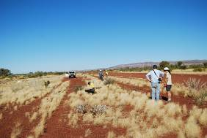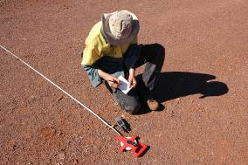
Figure 22. Measurement of non-toxic bait spread at Auski airstrip.

Appendix 2
This list includes bird species observed during survey transects as well as incidental observations throughout the baited area during each monitor period by competent bird observers. The naming convention of bird species follows Christidis and Boles (2008).
Table 11. List of bird species observed within the baited area
Species | Pre-bait | Post-bait
Emu Dromaius novaehollandiae | ✓
Stubble Quail Coturnix pectoralis | ✓
Common Bronzewing Phaps chalcoptera | ✓ | ✓
Crested Pigeon Ocyphaps lophotes | ✓ | ✓
Spinifex Pigeon Geophaps plumifera | ✓ | ✓
Diamond Dove Geopelia cuneata | ✓ | ✓
Tawny Frogmouth Podargus strigoides | ✓
Spotted Nightjar Eurostopodus argus | ✓
Australian Pelican Pelecanus conspicillatus | ✓
Black-shouldered Kite Elanus axillaris | ✓ | ✓
Square-tailed Kite Lophoictinia isura | ✓
Whistling Kite Haliastur sphenurus | ✓ | ✓
Brown Goshawk Accipiter fasciatus | ✓ | ✓
Collared Sparrowhawk Accipiter cirrhocephalus | ✓ | ✓
Spotted Harrier Circus assimilis | ✓ | ✓
Wedge-tailed Eagle Aquila audax | ✓ | ✓
Little Eagle Hieraaetus morphnoides | ✓ | ✓
Nankeen Kestrel Falco cenchroides | ✓ | ✓
Brown Falcon Falco berigora | ✓ | ✓
Australian Hobby Falco longipennis | ✓ | ✓
Grey Falcon Falco hypoleucos | ✓
Black Falcon Falco subniger | ✓
Australian Bustard Ardeotis australis | ✓ | ✓
Bush Stone-curlew Burhinus grallarius |  | ✓
Little Button-quail Turnix velox | ✓ | ✓
Galah Cacatua roseicapilla | ✓ | ✓
Little Corella Cacatua sanguinea | ✓ | ✓
Cockatiel Nymphicus hollandicus | ✓ | ✓
Australian Ringneck Barnardius zonarius | ✓ | ✓
Budgerigar Melopsittacus undulatus | ✓ | ✓
Pallid Cuckoo Cuculus pallidus | ✓
Southern Boobook Ninox boobook |  | ✓
Blue-winged Kookaburra Dacelo leachii | ✓ | ✓
Red-backed Kingfisher Todiramphus pyrrhopygia | ✓ | ✓
Sacred Kingfisher Todiramphus sanctus |  | ✓
Rainbow Bee-eater Merops ornatus | ✓ | ✓
Black-tailed Treecreeper Climacteris melanura | ✓
Western Bowerbird Ptilonorhynchus guttatus | ✓ | ✓
Species | Pre-bait | Post-bait
Splendid Fairy-wren Malurus splendens | ✓
White-winged Fairy-wren Malurus leucopterus | ✓ | ✓
Variegated Fairy-wren Malurus lamberti | ✓ | ✓
Weebill Smicrornis brevirostris | ✓ | ✓
Western Gerygone Gerygone fusca | ✓ | ✓
Inland Thornbill Acanthiza apicalis | ✓
Red-browed Pardalote Pardalotus rubricatus | ✓ | ✓
Striated Pardalote Pardalotus striatus | ✓ | ✓
Pied Honeyeater Certhionyx variegatus | ✓ | ✓
Singing Honeyeater Lichenostomus virescens | ✓ | ✓
Grey-headed Honeyeater Lichenostomus keartlandi | ✓ | ✓
White-plumed Honeyeater Lichenostomus penicillatus | ✓
White-fronted Honeyeater Phylidonyris albifrons | ✓
Yellow-throated Miner Lichenostomus flavicollis | ✓ | ✓
Spiny-cheeked Honeyeater Acanthagenys rufogularis | ✓ | ✓
Grey Honeyeater Conopophila whitei | ✓ | ✓
Crimson Chat Epthianura tricolor | ✓ | ✓
Black Honeyeater Certhionyx niger | ✓ | ✓
Brown Honeyeater Lichmera indistincta | ✓ | ✓
Black-chinned Honeyeater Melithreptus gularis | ✓ | ✓
Grey-crowned Babbler Pomatostomus temporalis | ✓ | ✓
Varied Sitella Daphoenositta chrysoptera | ✓
Rufous Whistler Pachycephala rufiventris | ✓ | ✓
Grey Shrike-thrush Colluricincla harmonica |  | ✓
Crested Bellbird Oreoica gutturalis | ✓ | ✓
Black-faced Woodswallow Artamus cinereus | ✓ | ✓
Pied butcherbird Cracticus nigrogularis | ✓ | ✓
Australian Magpie Gymnorhina tibicen | ✓ | ✓
Willie Wagtail Rhipidura leucophrys | ✓ | ✓
Little Crow Corvus bennetti | ✓ | ✓
Torresian Crow Corvus orru | ✓ | ✓
Magpie-lark Grallina cyanoleuca | ✓ | ✓
Hooded Robin Melanodryas cucullata | ✓ | ✓
Horsfield's Bushlark Mirafra javanica |  | ✓
Rufous Songlark Cincloramphus mathewsi | ✓ | ✓
Spinifexbird Eremiornis carteri | ✓
Mistletoebird Dicaeum hirundinaceum | ✓ | ✓
Zebra Finch Taeniopygia guttata | ✓ | ✓
Painted Finch Emblema pictum |  | ✓
Ground Cuckoo-shrike Coracina maxima | ✓
Black-faced Cuckoo-shrike Coracina novaehollandiae | ✓ | ✓
White-winged Triller Lalage tricolor | ✓ | ✓
Masked Woodswallow Artamus personatus | ✓ | ✓

Appendix 3
Results of the analysis of items found in scats. Mammals were identified to species level where possible. Other species are indicated with a ‘x’ when they were observed in scats.
Scat ID | Mammal ID – definite | Mammal ID – probable | bird | reptile | insect | plant
Cat | few rodent hairs |  | x
Cat | no hairs |  | x | x
Cat | no hairs |  |  | x
Cat | no hairs |  |  | x | x
Cat | no hairs |  | x |  |  | x
Cat | F. catus (grooming) |  | x | x |  | x
Cat | Planigale sp. | P. ingrami |  | x | x
Cat | no hairs |  | x |  |  | x
Cat | P. nanus |  |  |  |  | x
Cat | no hairs |  | x | x
Cat | dasyurid; Pseudomys sp. | Sminthopsis sp.; P. nanus | x |  |  | x
Cat | Pseudomys sp. | P. nanus | x
Cat | dasyurid; few rodent hairs | Sminthopsis sp.; Pseudomys sp. | x
Cat |  | Leggadina lakedownensis | x |  |  | x
Cat | no hairs |  | x
Cat | no hairs |  | x
Cat | no hairs |  | x |  |  | x
Cat | few rodent hairs | Pseudomys sp. | x
Cat | no hairs |  | x
Cat |  | L. lakedownensis | x
Cat | no hairs |  | x
Cat | no hairs |  | x
Scat ID | Mammal ID – definite | Mammal ID – probable | bird | reptile | insect | plant
Cat | N. timealeyi |  | x
Cat | D. rosamondae; Pseudomys sp. | P. nanus | x
Cat | no hairs |  | x
Cat | no hairs |  | x
Cat |  | L. lakedownensis | x |  |  | x
Cat | no hairs |  | x
Cat | M. musculus |  | x
Cat | Pseudomys sp.; F. catus (grooming) |  | x
Cat | no hairs |  | x
Cat | no hairs |  | x
Cat | no hairs |  | x
Cat | Pseudomys sp. | P. nanus |  |  |  | x
Cat | few rodent hairs | Pseudomys sp. |  | x |  | x
Cat | no hairs |  |  | x
Cat | F. catus (grooming) |  |  |  |  | x
Cat | Zyzomys argurus
Cat | no hairs |  | x
Cat | no hairs |  |  |  |  | x
Cat |  | L. lakedownensis
Cat | no hairs |  | x
cat | Felis catus (grooming) |  | x
Cat | Zyzomys argurus |  |  |  |  | x
Cat | Z. argurus |  |  |  |  | x
Cat | no hairs |  | x
Cat | few macropod hairs | Macropus sp. | x |  |  | x
Cat | P. hermannsburgensis |  | x |  |  | x
Cat | few dasyurid hairs | Sminthopsis sp. | x |  |  | x
Cat | Sminthopsis sp. | S. macroura | x
Scat ID | Mammal ID – definite | Mammal ID – probable | bird | reptile | insect | plant
Cat | no hairs |  | x
Cat | fine rodent hairs | Pseudomys sp. | x | x
Cat | fine rodent hairs | Pseudomys sp. | x
Cat | no hairs |  | x
Cat | F. catus (grooming)
Cat | fine rodent hairs | Pseudomys sp. | x
Cat | no hairs |  | x
Cat | fine rodent hairs | Pseudomys sp. | x |  |  | x
Cat | no hairs |  |  | x |  | x
Cat | fine rodent hairs | Z. argurus | x |  |  | x
Cat | Pseudomys sp | P. nanus |  | x
Cat | no hairs |  | x
Cat | no hairs |  | x
Cat | fine rodent hairs | Notomys alexis |  |  |  | x
Cat | no hairs |  | x
Cat | few rodent hairs |  |  | x
Cat | no hairs |  | x
Cat | Pseudomys sp. | P. nanus |  |  |  | x
Cat | no hairs |  | x
Cat | fine rodent hairs | N. alexis | x |  |  | x
Cat | fine rodent hairs | N. alexis | x
Cat | no hairs |  | x |  |  | x
Cat | no hairs |  | x |  |  | x
Cat | F. catus (prey) |  |  | x |  | x
Cat | Pseudomys sp. | P. nanus | x
Cat | few rodent hairs |  | x
Cat | no hairs |  | x
?Cat | no hairs |  | x
Scat ID | Mammal ID – definite | Mammal ID – probable | bird | reptile | insect | plant
?Cat | no hairs |  | x
?Cat | Sminthopsis sp. | S. macroura | x |  |  | x
?Cat | no hairs |  | x |  |  | x
?Cat | no hairs |  |  | x
?Cat | no hairs |  | x
?Cat | few rodent hairs | Pseudomys sp. | x |  |  | x
?Cat | no hairs |  | x |  |  | x
?Cat | no hairs |  | x | x
?Cat | few rodent hairs |  | x
?Cat | no hairs |  | x
?Dog/Dingo | no hairs |  |  |  |  | x
?Dog/Dingo | no hairs |  |  | x
?Dog/Dingo | no hairs |  | x | x |  | x
?Dog/Dingo | P. hermannsburgensis |  | x | x
?Dog/Dingo | no hairs |  |  | x |  | x
Dog/Dingo | Pseudomys sp. | P. nanus | x |  |  | x
Dog/Dingo | Canis lupus (prey) |  |  |  |  | x
Dog/Dingo | C. lupus familiaris /dingo (grooming) |  |  |  |  | x
Dog/Dingo | no hairs |  |  |  |  | x
Dog/Dingo | no hairs |  | x | x
Dog/Dingo | C. lupus familiaris /dingo (grooming) |  |  | x
Dog/Dingo | Pseudomys sp. | P. hermannsburgensis | x |  |  | x
Dog/Dingo | C. lupus familiaris /dingo (grooming) |  | x |  |  | x
Dog/Dingo | no hairs |  | x
Dog/Dingo | no hairs |  |  |  |  | x
Dog/Dingo | M. robustus
Dog/Dingo | C. lupus familiaris /dingo (grooming) |  |  |  |  | x
Dog/Dingo | C. lupus familiaris /dingo (grooming) |  |  | x
Scat ID | Mammal ID – definite | Mammal ID – probable | bird | reptile | insect | plant
Dog/Dingo | M. robustus |  |  | x |  | x
Dog/Dingo | no hairs |  |  | x |  | x
Dog/Dingo | M. robustus |  |  |  |  | x
Dog/Dingo | no hairs |  |  | x
Dog/Dingo | Camelus dromedarius |  |  | x
Dog/Dingo | no hairs |  | x |  |  | x
Dog/Dingo | no hairs |  |  | x
Dog/Dingo | no hairs |  |  | x |  | x
Dog/Dingo | C. lupus familiaris/dingo (prey)
Dog/Dingo | Macropus sp. (tail hairs) | M. robustus
Dog/Dingo | no hairs |  | x | x
Dog/Dingo | C. lupus familiaris/dingo (grooming) |  | x | x
Dog/Dingo | no hairs |  |  | x |  | x
Dog/Dingo | P. nanus; few dasyurid hairs |  | x |  |  | x
Dog/Dingo | Pseudomys sp. | P. nanus | x | x
Dog/Dingo | no hairs |  | x | x
Dog/Dingo | no hairs |  | x | x |  | x
Dog/Dingo | no hairs |  | x | x |  | x
Dog/Dingo | no hairs |  | X
Dog/Dingo | M. rufus
Dog/Dingo | M. rufus |  |  |  |  | x
Dog/Dingo | no hairs |  |  | x |  | x
Dog/Dingo | M. rufus
Dog/Dingo | no hairs |  | x | x |  | x
Dog/Dingo | no hairs |  |  | x
Dog/Dingo | no hairs |  |  | x
Dog/Dingo | no hairs |  | x
Dog/Dingo | M. rufus |  |  |  |  | x
Scat ID | Mammal ID – definite | Mammal ID – probable | bird | reptile | insect | plant
Dog/Dingo | M. rufus
Dog/Dingo | Ningaui timealeyi |  | x | x |  | x
Dog/Dingo | Macropus sp. (few hairs) | M. robustus | x | x
Dog/Dingo | no hairs |  |  | x
Dog/Dingo | Macropus sp. (few hairs) | M. robustus |  | x |  | x
Dog/Dingo | no hairs |  | x | x |  | x
Dog/Dingo | F. catus (prey)
Dog/Dingo | Pseudomys sp. | P. nanus | x |  |  | x
Dog/Dingo | no hairs |  | x | x |  | x
Dog/Dingo | no hairs |  | x | x |  | x
Dog/Dingo | M. rufus |  |  |  |  | x
Dog/Dingo | no hairs |  | x |  |  | x
Dog/Dingo | no hairs |  | x |  |  | x
Dog/Dingo | Mus musculus |  |  | x
Dog/Dingo | few rodent hairs | Pseudomys sp. | x |  |  | x
Dog/Dingo | Dasykaluta rosamondae |  | x
Dog/Dingo | M. robustus
Dog/Dingo | M. rufus |  |  |  |  | x
Dog/Dingo | no hairs |  |  | x
Dog/Dingo | few macropod hairs | Macropus sp.
Dog/Dingo | Macropus rufus |  |  |  |  | x
Dog/Dingo | Canis lupus familiaris /dingo (prey) |  |  |  |  | x
Dog/Dingo | no hairs |  | x
Dog/Dingo | C. lupus familiaris /dingo (grooming) |  |  |  |  | x
Dog/Dingo | C. lupus familiaris /dingo (prey) |  | x |  |  | x
Dog/Dingo | no hairs |  | x
Dog/Dingo | no hairs |  |  | x


ISSN 1835-3827 (print)
ISSN 1835-3835 (online)
ISBN 978-174287-816-4 (print)
ISBN 978-174287-817-1 (online)

