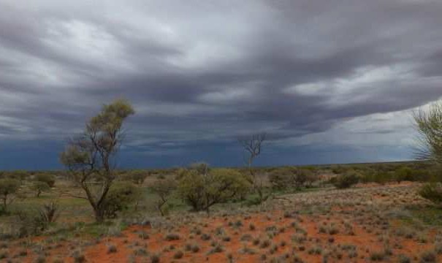

Field efficacy of the Curiosity® bait for management of a feral cat population at Roxby Downs, South Australia.

M. Johnston, L. Bould, M. O’Donoghue, M. Holdsworth,

P. Marmion, R. Bilney, A.E. Reside, D. Caldwell, R. Gaborov and T. Gentles.

# 2014

Arthur Rylah Institute for Environmental Research Technical Report Series No. 253

# Field efficacy of the Curiosity® bait for managing feral cats at Roxby Downs, South Australia.

#### Michael Johnston, Les Bould, Michael O’Donoghue, Mark Holdsworth, Peter Marmion, Rohan Bilney, April Reside, Dave Caldwell, Rena Gabarov and Tim Gentles.

Arthur Rylah Institute for Environmental Research 123 Brown Street, Heidelberg, Victoria 3084

February 2014 In partnership with:



Arthur Rylah Institute for Environmental Research Department of Environment and Primary Industries Heidelberg, Victoria

**Report produced by:** Arthur Rylah Institute for Environmental Research

Department of Environment and Primary Industries PO Box 137

Heidelberg, Victoria 3084

Phone (03) 9450 8600

Website: [www.depi.vic.gov.au/ari](http://www.depi.vic.gov.au/ari)

© State of Victoria, Department of Environment and Primary Industries 2014

This publication is copyright. Apart from fair dealing for the purposes of private study, research, criticism or review as permitted under the *Copyright Act 1968*, no part may be reproduced, copied, transmitted in any form or by any means (electronic, mechanical or graphic) without the prior written permission of the State of Victoria, Department of Environment and Primary Industries. All requests and enquiries should be directed to the Customer Service Centre, 136 186 or email [customer.service@depi.vic.gov.au](mailto:customer.service@depi.vic.gov.au)

**Citation:** Johnston, M., Bould, L., O’Donoghue, M., Holdsworth, M., Marmion, P., Bilney, R., Reside, A.E., Caldwell, D., Gaborov, R. and Gentles, T. (2014) Field efficacy of the Curiosity® bait for management of a feral cat population at Roxby Downs, South Australia. Arthur Rylah Institute for Environmental Research Technical Report Series No. 253. Department of Environment and Primary Industries, Heidelberg, Victoria.

ISSN 1835-3827 (print)

ISSN 1835-3835 (online)

ISBN 978-1-74326-747-9 (print)

ISBN 978-1-74326-755-4 (online)

**Disclaimer:** This publication may be of assistance to you but the State of Victoria and its employees do not guarantee that the publication is without flaw of any kind or is wholly appropriate for your particular purposes and therefore disclaims all liability for any error, loss or other consequence which may arise from you relying on any information in this publication.

**Accessibility:**

If you would like to receive this publication in an accessible format, such as large print or audio, please telephone

136 186, or through the National Relay Service (NRS) using a modem or textphone/teletypewriter (TTY) by dialling 1800 555 677, or email [customer.service@depi.vic.gov.au](mailto:customer.service@depi.vic.gov.au)

This document is also available in PDF format on the internet at [www.depi.vic.gov.au](http://www.depi.vic.gov.au/)

**Front cover photo:** Rain storm approaching the field site (Les Bould).

**Authorised by:** Victorian Government, Melbourne

**Printed by:** NMIT Printroom, Preston, Victoria.

# Contents

Acknowledgements iv

Summary 1

Background 2

* 1. Introduction 2
  2. Site Description 3
  3. Objectives 3

1. Methods 4
   1. Project timing 4
   2. Field study 5
      1. Site occupancy 5
      2. Trapping and radio-telemetry of feral cats 6
      3. Track counts 8
      4. Non-target fauna surveys 9
      5. Weather 9
      6. Baiting 10
      7. Monitoring of radio-collared cats 11
      8. Post-mortem examination 12
      9. Recovery of surviving collared cats 12
2. Results 13
   1. Baiting 13
      1. Weather 13
      2. Baits 13
      3. Assessment of bait spread 15
   2. Collared Feral Cats 15
   3. Post-mortem investigation 19
   4. Whisker analysis 21
   5. Track Counts 22
   6. Site occupancy 22
   7. Non-target species 24
3. Discussion 26
4. References 32

Appendix 1 35

iii

## Acknowledgements

This study was funded by the Department of the Environment (Australian Government) as part of the implementation of the Threat Abatement Plan for Predation by Feral Cats. The administrative and field support received from Julie Quinn is greatly appreciated.

Peter Paisley (BHP Billiton) facilitated approvals for the conduct of the project. Leo McMormack granted access to Roxby Downs / Purple Downs Station.

The aerial application of Curiosity® baits was undertaken with the assistance of Lindsay Matthews and Talia Sheppard (Opal Air).

Advice and support from Dave Algar (Department of Parks and Wildlife, Western Australia) is gratefully acknowledged. Jim Morris (Scientec Research) manufactured the toxic doses. The Arid Recovery Project provided logistical support to this study.

This project required considerable field work and the senior author thanks both the field crew and their families for their work ethic and support.

Statistical analyses were conducted by Paul Moloney (Department of Environment and Primary Industries (DEPI), Victoria). Luke Woodford (DEPI) fitted the IGotU GPS loggers to the Holohil collars. Frank Gigliotti (General Dog’s Body Technical Services) conducted feeding trials with Australian ravens on behalf of the Curiosity® bait development project.

Simon Humphries (Invasive Animals Co-operative Research Centre) granted access to data on susceptibility of Australian wildlife species to para-aminopropiophenone.

David Forsyth and David Ramsey (DEPI) and Trish Lothian provided comments on a draft of this report.

The following permits were received prior to the initiation of field work:

* The Department of Environment, Water and Natural Resources (South Australia) Wildlife Ethics Committee approved the procedures used in protocol 13/2013.
* The Australian Pesticides and Veterinary Medicines Authority issued PER 13464 allowing the use of the unregistered bait product at Roxby Downs.
* A ‘Shoot Plan’ was approved by BHP Billiton covering the use of firearms during this project.

iv

## Summary

The management of feral cat (*Felis catus*) populations over large areas in Australia is currently limited by a lack of cost-effective control techniques. Existing techniques, including trapping, shooting and fencing when used to manage large areas are limited by their significant cost. The distribution of poison baits can provide a lower-cost alternative but must address the hazard that the surface-laid baits may present to non-target species. The Eradicat® bait was developed for application in areas where native wildlife have a high tolerance to the poison, sodium monofluoroacetate (1080), used in this product. This bait is generally unsuitable for use in other areas, such as eastern Australia, where native species have a lower tolerance to 1080.

The Australian Government has funded the development of an alternative poison bait for feral cat control that is a based on Eradicat®. This bait, Curiosity®, exploits differences in feeding behaviour between feral cats and non-target species by presenting the toxicant, para-aminopropiophenone (PAPP), in an encapsulated pellet.

This trial was part of a series of field trials conducted across Australia to assess the efficacy of this bait product and will contribute to the data submitted for product registration purposes.

Curiosity® baits were aerially distributed over a 430 km2 area within Roxby Downs Station, South Australia, in July 2013. Monitoring of the bait efficacy program was undertaken using several methods. The survival of eighteen cats trapped within the baited area was monitored with radio transmitting collars. Site occupancy of feral cats was assessed prior to, and following baiting, using automated cameras at 68 sites. Counts of cat activity on 14 groomed track plots were also recorded.

Ten of the collared cats (58%) were confirmed as having died following consumption of Curiosity® bait(s). The GPS data recovered from the seven cats that survived baiting indicated that they all should have encountered bait(s) during the 10 day period following bait distribution. However, only one of these cats was confirmed to have consumed a bait. One cat was discounted from collar return statistics as its survival after baiting could not be determined.

There was a statistically significant 52% reduction in the occupancy estimates of feral cats after baiting, consistent with the collar return data. However, the data from track counts did not indicate any change in the cat population although this aspect of the study was compromised by wet weather and site access difficulties. It is also probable that the low number and location of plots affected the results observed in the track count component of the study.

The study also included replicated counts of birds prior to and post baiting to determine whether the Curiosity® baits led to a decrease in populations of non-target species. A 50% decrease in the counts of corvid species was observed in the post-baiting monitor period while other non-target species did not decline. It is not possible to wholly associate the apparent decline in corvids with use of the Curiosity® baits as other factors, such as migration or count error, may have contributed to this result. Rejection of the encapsulated toxicant pellet was observed on one occasion and was attributed to bait consumption by a corvid. No carcasses of wildlife species were encountered during the study that implicated Curiosity® baits as the cause of death.

Some further development is required to prevent the premature loss of structural integrity of the Curiosity® coating structure, and thus leakage of the toxicant formulation material from the delivery device. Despite this, the results from this study indicate that the Curiosity® bait reduced the feral cat population at this site.

## Background

### Introduction

Feral cats are defined as cats (*Felis catus*) that live and reproduce in the wild and survive by hunting or scavenging (DEWHA 2008). Feral cats are distributed throughout all Australian states and territories, and also inhabit many offshore islands (Abbott and Burbidge 1995; Dickman 1996). Predation by feral cats has been the primary cause of the decline of over 80 species of Australian native fauna listed as threatened nationally under the *Environment Protection and Biodiversity Conservation Act 1999* (Commonwealth). Cats are known to kill a wide range of animals — invertebrates, birds, reptiles and mammals with a body mass of 10 g – 3.5 kg — and compete for resources such as food and den sites with native species (Dickman 1996).

The Australian Government, in a collaborative research program between the Western Australian and Victorian State Governments, has funded the development of a poison bait for use in managing feral cat populations. The project seeks to obtain registration of the product, known as the Curiosity® bait, as an agricultural chemical in order to provide land managers of ‘conservation estate’ with a bait product that can be used to help manage feral cat populations. A key difference between the Curiosity® bait and conventionally produced baits, such as Eradicat®, is that the toxicant is housed in an encapsulated pellet which is inserted into the Curiosity® bait. While many wildlife species are expected to consume the bait, the size and hardness of the pellet, known as the Hard Shelled Delivery Vehicle (HSDV), has been demonstrated to lead to rejection, i.e. spitting out of the pellet by the vast majority of these species. This approach reduces the exposure of non- target native species by exploiting the different feeding behaviours exhibited by feral cats compared to native species (Marks *et al*. 2006; Hetherington *et al*. 2007). The Curiosity® bait is based on the Eradicat® bait but has been modified by making the pH of the meat slightly alkaline (approximately pH 7.5) and manufacturing it as a skinless sausage.

Field efficacy trials of the Curiosity® bait are a necessary component of product evaluation prior to registration as an agricultural chemical. A demonstration of product efficacy is required at sites that are representative of where the product may be used following registration. Sites were initially nominated by state, territory or Commonwealth conservation agencies, and the field trials were undertaken progressively as the necessary resources became available. Initial field studies were undertaken at island sites where the hazard that the bait presented to resident wildlife species was low — French Island in Victoria (Johnston *et al*. 2011), Christmas Island in the Indian Ocean Territory (Johnston *et al*. 2010a), Dirk Hartog Island in Western Australia (Johnston *et al*. 2010b) and Tasman Island in Tasmania (Robinson *et al*. submitted). Subsequent studies were undertaken at mainland sites — Cape Arid in Western Australia (D. Algar pers. comm.), Wilsons Promontory in Victoria (Johnston 2012), the Flinders Ranges in South Australia (Johnston *et al*. 2012) and Karijini National Park in Western Australia (Johnston *et al.* 2013). The present study contributes to this series of field efficacy studies.

The toxicant used in these studies, with the exception of the Dirk Hartog Island study, was para- aminopropiophenone (PAPP). This compound oxidises haemoglobin to methaemoglobin, which is unable to transport oxygen (Savarie *et al*. 1983; Scawin *et al*. 1984). Toxicosis in feral cats is characterised by increasing lethargy leading to unconsciousness and death (M. Johnston, unpublished data).

Additionally, the Arid Recovery Project has undertaken considerable studies of feral cat ecology and management in this region including the use of aerially-delivered Eradicat® baits (e.g. Read and Bowen 2001; Moseby *et al*. 2009; Moseby *et al*. 2011; Moseby and Hill 2011). This prior work formed a valuable knowledge base contributing to the design of this study.

### Site Description

The study was conducted on Roxby Downs Station in South Australia. The baited area was 432 km2 in size with the centroid, Centenary Hut (30° 25.264S, 136° 43.156E), being located 23 km north-west of the Roxby Downs township (Figure 1).

The observations from the closest Bureau of Meteorology recording station at the Olympic Dam airport indicated that 177 mm rain fell in the 12 month period prior to the commencement of this study (May 2012 – May 2013). Rainfall in this region is highly variable, with a mean annual amount of 145 mm (range: 35 – 320 mm) measured at this station since 1998.

Landforms and associated vegetation communities within the site include sand dune / swale, plains, stony hills and clay pans, including the dry bed of Lake Blanche. Common vegetation includes *Acacia aneura, A. ligulata, Calitris glaucophylla, Atriplex vesicari* and *Eragrostis australasica.*

The site has primarily been used for cattle grazing but is also subject to environmental monitoring works associated with the neighbouring Olympic Dam mine site and the Arid Recovery Project. Permanent water is available in farm dams. Cattle were removed from the site for the duration of the study. A commercial kangaroo shooter frequently works the site but was absent during the study. However, recreational shooters had reportedly visited the site in the weeks prior to the start of the study and shot 57 feral cats and red foxes (*Vulpes vulpes*) (L. McMormack, pers. comm.).

### Objectives

The overall aim of the project was to collect data that would contribute towards preparation of a submission seeking registration of Curiosity® as an agricultural chemical. Four key deliverables, specifically aimed at assessing the efficacy of Curiosity® at a semi-arid mainland Australia site, were addressed.

1. Trap feral cats in the trial area and monitor their survival using radio transmitting collars before and after baiting.
2. Aerially deploy Curiosity® baits at a rate of 50 baits / km2.
3. Monitor the feral cat population prior to, and following baiting, to determine site occupancy using automated cameras and track counts.
4. Monitor native wildlife species to determine whether or not the baits lead to a decline in population size at the site.

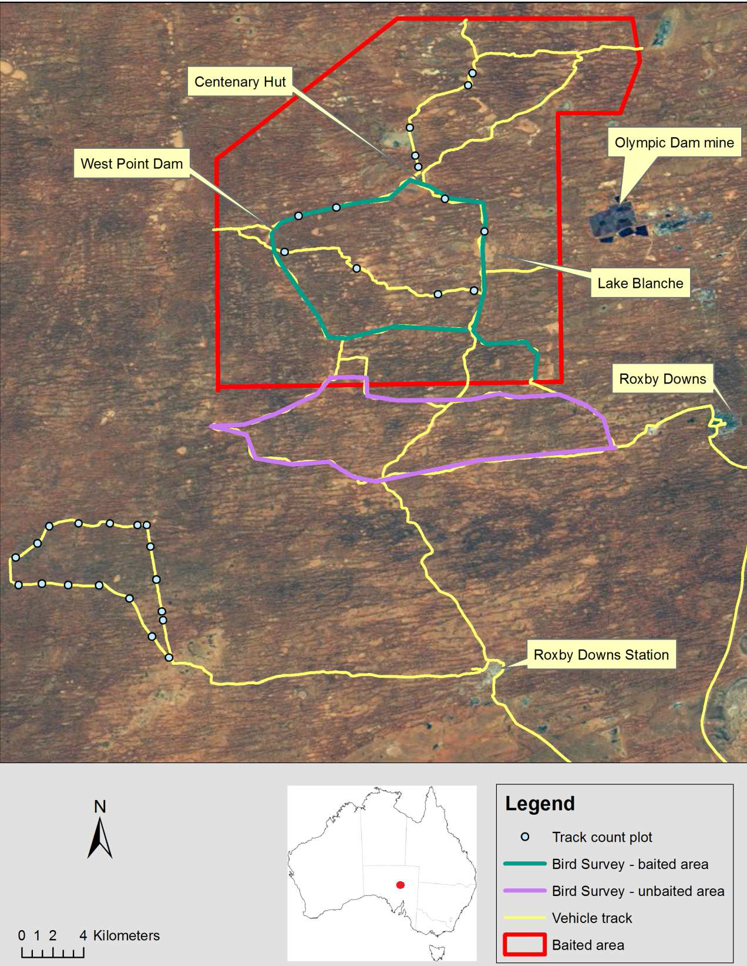

**Figure 1. Location of site and regional context.**

## Methods

### Project timing

The field study was undertaken between May 19 and August 12, 2013. Sustained wet weather required that the field trial be suspended during the period of 1 to 20 June.

### Field study

* + 1. **Site occupancy**

Automated cameras were installed at 68 locations to assess the presence of feral cats within the study area prior to and following baiting (Figure 2). An automated camera site was established within each 1 km2 grid cell that contacted an established vehicle track. The actual location was determined using a semi-randomised process in which a random three-digit X and Y axis location was generated from the program ‘R’ (R Development Core Team 2012). These figures were then fitted over each of the 81 nominated cells. Thirteen cameras proved to be faulty which had the effect of limiting the number of units established in the north-western corner of the site.

At each site, a camera was mounted on a timber stake at a height of 200 - 300 mm above ground. Cameras were oriented to face south and the surrounding vegetation was trimmed to minimise false detections caused by moving vegetation (Figure 3a). We used three camera types: Reconyx RM45 (16 units), Reconyx Rapidfire semi-covert LED HC500 (12 units), Reconyx Covert HC600 (40 units) (Reconyx, Wisconsin, USA). At the time of installation, all cameras were test-fired to confirm functionality and correctness of aim. A series of set-up photos was taken in which a white board with the location details and date was held in front of the camera to create a photographic record. Cameras remained operational for the duration of the study. All cameras were configured to record three photos at every motion detected with sensitivity settings on ‘high’ and no time- delay between detections.

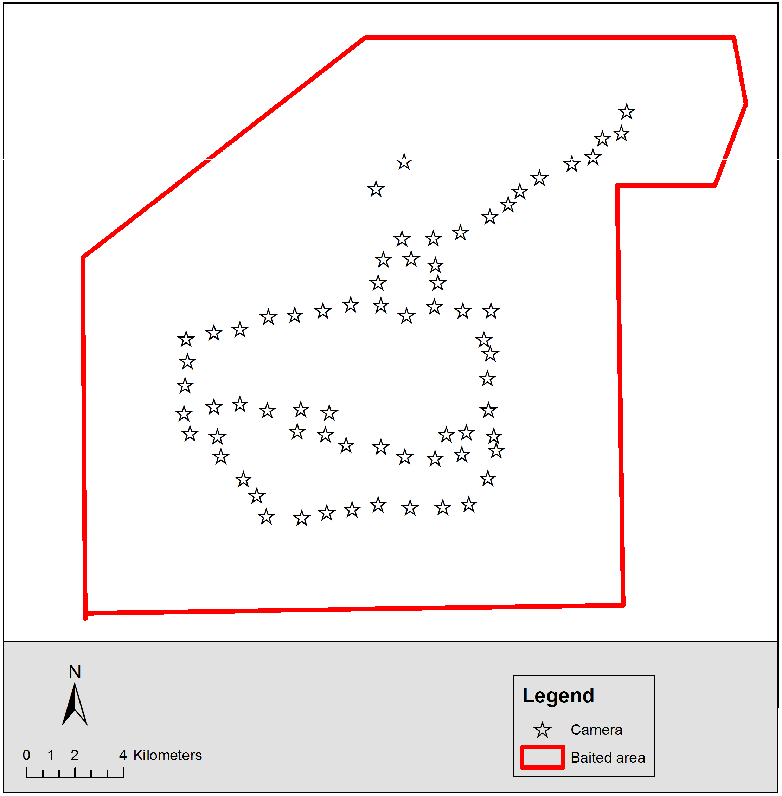

**Figure 2. Location of automated cameras used to assess site occupancy.**

Visual and olfactory lures were present for a period of 23 - 29 nights during the pre- and post- baiting monitoring periods (Figure 3b). A vial containing 15 mm of ‘Catastrophic’ scent lure (Outfoxed Pest Control, Victoria) in an oil suspension, was taped to a stake placed 3 m in front of the camera. Three turkey feathers (dyed black or white) were fixed to the top of the vial. A 300 mm length of tinsel was fixed to the top of the stake in a position where it was not within the camera’s field of view. The landform of each site was classified into one of four categories: dune, plain, swale or rocky hill.

All photographic images were reviewed with detections of each species recorded on a separate MS Excel worksheet indicating occupancy of that species at that site within a specified ‘camera day’. Each ‘camera day’ was measured from midday to midday so that evening was recorded as one period. A site was considered ‘occupied’ if one (or more) detections were recorded at that site. No greater weighting was given to sites where multiple detections during the same day were recorded,

i.e. the species was either present or absent.

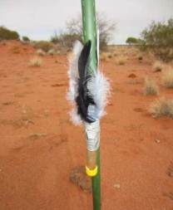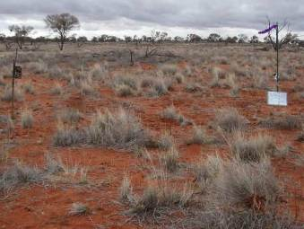

**Figure 3. (a) Typical camera site layout. (b) Visual and scent lures in position.**

These data were analysed using a dynamic occupancy model (MacKenzie *et al*. 2003; MacKenzie *et al*. 2006). This approach allows for the occupancy rate to change from one period to another. In this case, the periods of interest were when the lure was available during pre- and post-baiting survey periods. Three models were generated for each group of interest to take account of any possible variation in detection due to the camera used and/or the baiting. The model with the lowest Akaike Information Criterion (AIC) was selected and its estimates used in the analysis. The analysis was conducted using *R 3.0.1* (R Development Core Team, 2012) and the package *unmarked 0.10-2* (Fiske and Chandler, 2011). Confidence intervals for the post-baiting occupancy rates were estimated via bootstrapping. The goodness-of-fit for the model was tested using a χ2 statistic compared to a bootstrapped χ2 distribution. The terms ‘extinction’ and ‘colonisation’ are used in this analysis. Extinction refers to those sites in which the species was detected in the pre- bait but not the post-bait monitoring periods. Colonisation refers to the converse of this situation.

* + 1. **Trapping and radio-telemetry of feral cats**

Trapping was based on the procedures described in Sharp and Saunders (2004). The traps used were rubber-padded leghold traps (Duke #1.5 and #3, West Point, USA) that had been modified with a stronger base plate and additional swivels, and were waxed and dyed by Outfoxed Pest Control (Victoria). Seventy-six trap sets (consisting of two traps set as pairs in a ‘walk-through’

configuration) were located along vehicle tracks with a 100–500 m separation (Figure 4). Ten additional trap sets were installed in off-track locations. Traps were not placed within 2 km of the edge of the study area in an attempt to minimise the capture of cats which were likely to spend time outside the baited area. Cat faeces and urine sourced from domestic cats were used as the scent lure at all trap sets except in one case. For this exceptional case, a cat was observed feeding on a trapped European rabbit (*Oryctolagus cuniculus*) during the morning trap check on 26 June. This trap site was re-established leaving the rabbit secured in one trap as a food lure. The cat was recovered from the other trap approximately four hours later. Audio lures, known as the Feline Audio Phonic (FAP – Westcare, Nedlands, Western Australia), were operated on alternate nights at all trap sites.

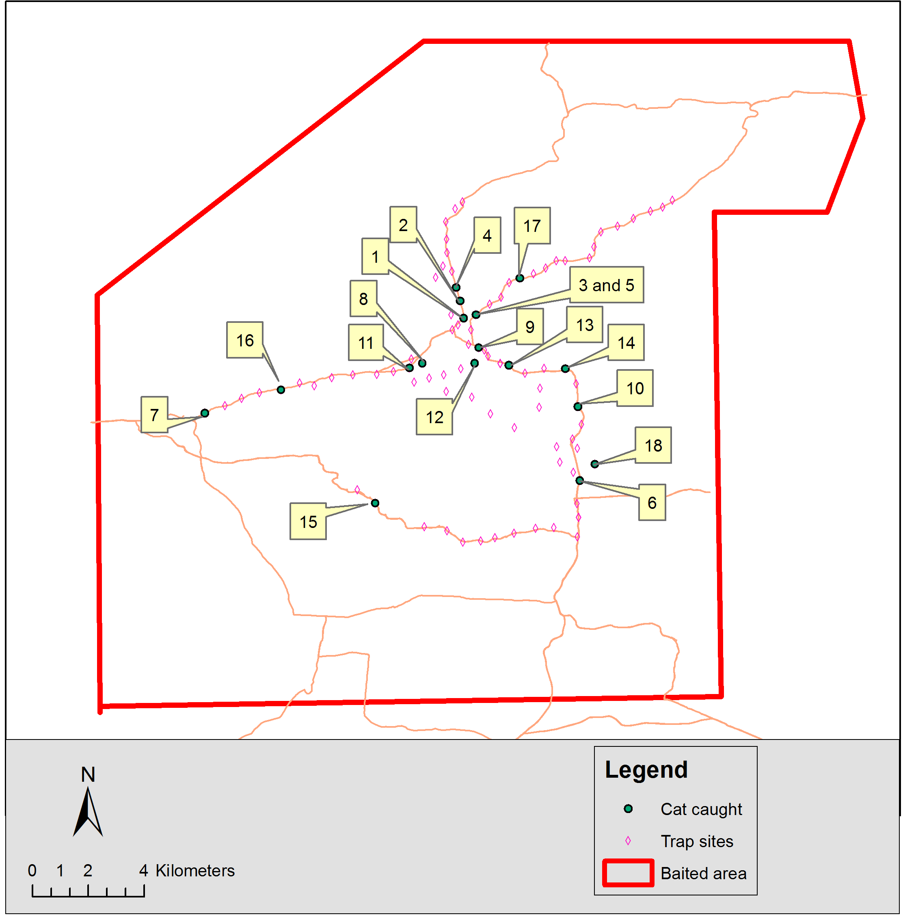

**Figure 4. Trap locations within the site. The numbered label indicates where feral cats were captured.**

Trapped feral cats were restrained with a catch pole and covered with a blanket. The cats were then released from the trap and transferred into a hessian sack. The neck of the sack was secured with a cable tie and then placed into vegetative cover and left until all traps had been cleared. On return to the trap site, cats were lightly sedated (Domitor®, Pfizer Animal Health) to allow a radio- transmitting collar / GPS datalogger to be fitted. The sex and body mass of animals were recorded.

The trapped foot was massaged by hand with Rectinol® cream to promote blood flow and any superficial injuries were treated with Cetrigen® antiseptic spray.

Radio-tracking collars sourced from three different suppliers were used in this study:

* Sirtrack Ltd (NZ) — One GPS datalogger / VHF 150 MHz collar. This collar weighed 132 g and was fitted with an automated collar drop-off timed for 0100 hrs on 30 July (local time) (Figure 5a).
* Holohil Systems (Canada) — Three VHF collars transmitting at 152 MHz. These collars were modified to include an IGotU GPS logger and had a total mass of 80 g. These were configured to automatically start recording a GPS location every 60 minutes on the day following release.
* Telemetry Solutions (USA) — Fourteen GPS datalogger / VHF 150 and 151 MHz collars.

These collars had a mass of 100 g and included the necessary hardware to enable remote download of the GPS data.

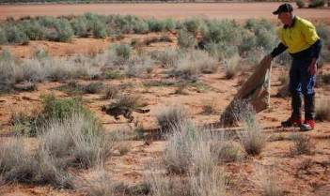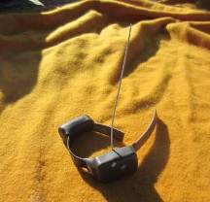

**Figure 5. (a) Holohil VHF collar with iGotU GPS datalogger. (b) Release of cat #6.**

All collars included a mortality sensor that activated if the cat did not move for10 hours.

Cats were injected with AntiSedan® (Pfizer Animal Health) as per label recommendation to reverse the sedation and were then released at the point of capture (Figure 5b).

All non-target species trapped were euthanased. Canids were restrained with a noose pole and then euthanased by head shot with a .22 rifle. Rabbits were removed from the trap and cervically dislocated. Carcasses were provided to the Arid Recovery Project for later study.

* + 1. **Track counts**

Fourteen 200 m sections of sandy track within the baited area were inspected daily for six consecutive days with counts made of the presence or absence of footprints of mammal species (cat, rabbit, macropod (red kangaroo *Macropus rufus* and euro *Macropus robustus*), wild dog/dingo *Canis familiaris* and fox). Plots were located on vehicle tracks that were composed of a suitably soft substrate (i.e. sand) and were separated from other plots by a minimum of 500 m (Figure 1). These conditions led to uneven geographic distribution of plots within the site.

Each section was walked by a member of the field crew skilled in print identification and the presence or absence of each species on each plot per day was recorded. The tracks were then smudged using looped chains towed behind a vehicle (Figure 6). A transect of 18 x 200 m sections was prepared in a similar manner in an area located over 10 km from the baited area to be used as

an untreated control replicate. Results from the track counts were derived from the averaged daily counts with standard errors on the plots.

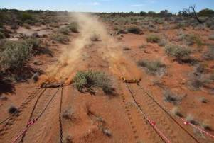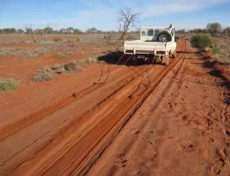

**Figure 6. Apparatus used to smudge tracks after daily counts.**

* + 1. **Non-target fauna surveys**

Surveys of bird species observed on site were undertaken to determine the impact of the baiting on these non-target fauna. These surveys were undertaken over nine sequential days prior to baiting (23 to 31 May) and following baiting (30 July to 7 August). The transect for the non-baited bird counts included a 2 km section of track that was within the baited area (Figure 1). This was unavoidable given the available tracks at the site and the requirement to survey both transects each day. Three surveys were conducted during each monitoring period, comprising:

* Counts of individual birds that were considered to be ‘potential bait consumers’ (i.e. raptors, corvids, etc) as seen from a vehicle driven at ~30 km/h along a 42 km transect through the study area. The same method was used to obtain a similar count over a 50 km transect in a bait- free ‘control’ area located in similar topography and vegetation. The start/finish locations were alternated daily to allow for variations in bird behaviour that occur throughout the day (Figure 7). Data from these surveys are presented as number of birds observed per kilometre searched.
* A skilled observer identified all birds visually or by vocalisation during a 5 minute period over a ~2 ha area. These surveys took place at fixed locations spaced at 3 km intervals along the driven transect with the vehicle switched off and the observer standing on the tray of the vehicle. Data from this survey is not presented in this report but will be provided to local agencies such as the Arid Recovery Project and the South Australian Museum.
* A species list was generated for all bird species observed opportunistically during the study.
  + 1. **Weather**

The Bureau of Meteorology maintains a weather recording station at the Olympic Dam airport (site number 016096) and publishes data from this station online. This station is approximately 16 km from Centenary Hut which is located in the centre of the baited area. Meteorological data referred to in this report is from the perspective of its impact on bait attractiveness, and activity of cats and non-target species. Rain affected the conduct of the trial by limiting vehicle access to the site and led to some work, such as track drags, not being completed to the intended extent.

* + 1. **Baiting**

Meat attractants were manufactured by a commercial sausage factory (Gamm Foods Pty Ltd, Melbourne, Australia) during April 2013 using a recipe modified from that used to prepare Eradicat® baits. It comprised 70% minced kangaroo meat, 20% chicken fat, and 10% digest and flavour enhancers (Australian Patent No. 781829). The modifications included (i) addition of a preservative (sodium nitrite - Kur-Kwik), (ii) pH adjustment of the meat emulsion buffered to 7.5 using sodium carbonate (Scientec 2012) and (iii) manufacture as a skinless sausage (Ćevapi) dried to ~60% of the initial wet weight at room temperature under airflow provided by a commercial air conditioner. Once dried sufficiently, baits were bagged, stored frozen in domestic chest freezers and then transported to the field site.

The toxic doses, termed the Hard Shelled Delivery Vehicles (HSDV) were manufactured by Scientec Research (Warrandyte, Victoria). Randomly selected HSDVs were subjected to quality assurance testing that assessed the dosing consistency as well as shell hardness and the subsequent dispersion of the polymer encapsulation (Scientec 2013). The HSDVs were packed in plastic bags and stored and transported in a locked refrigerated cabinet.

Attractants were thawed to permit the manual insertion of the HSDV, i.e. the encapsulated para- aminopropiophenone (PAPP). The pellet contained a formulation of approximately 78 mg PAPP and included a trace amount of Rhodamine B dye (Figure 7a; Scientec 2013). A trochar device was inserted into each attractant, the plunger withdrawn and a HSDV introduced. The plunger was then replaced and used to push the HSDV into the core of the attractant. The trochar was withdrawn from the bait and gentle pressure applied to close the entry point. Dosed attractants (Curiosity® baits) were then weighed into batches of 2.5 kg (approximately 100 baits) and then placed into onion bags. The finished bags were then stored in a freezer. There was some variation in the degree of the curing / dryness of attractants as supplied by the factory. Attractants that were not sufficiently cured were placed in the sun to allow further drying prior to insertion of the HSDV.

Fifty randomly selected Curiosity® baits were placed in a metal cage within the baited area on 3 July. Five baits were withdrawn from this cage on 7 and 8 July and assessed for attractiveness, palatability (i.e. odour and degree of desiccation) and the condition of the HSDV was ascertained after incising the bait with a scalpel. Further inspections were not undertaken after this date due to the unfavourable results (i.e. premature leakage observed in each sample) from these inspections.

All baits were removed from the freezer on 9 July and allowed to thaw overnight. Baits were transported to the Andamooka airstrip on the morning of 10 July and arranged on racks such that they would be in full sun (Figure 7b). This completed the thawing process and allowed the aromatic chicken fats to leach onto the surface of the sausage. Baits were lightly sprayed with a residual insecticide (Coopex®, Bayer Crop Science, Australia) to reduce ant activity.

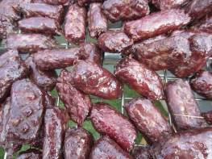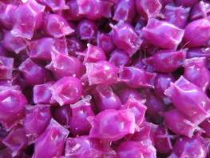

**Figure 7. (a) Detail of PAPP / Rhodamine B pellets. (b) Baits sweating when thawed.**

Baits were loaded into a Cessna 210 single engine aircraft (Opal Air, South Australia). This aircraft is fitted with computerised, GPS-linked equipment to semi-automate the bait dropping process (Figure 8a, b). A carousel with eight segments powered by a stepper motor revolves above a chute that exited the aircraft. Rotation of the carousel was linked to pre-determined waypoints

(i.e. drop locations) and aircraft location. Baits were loaded into each segment of the carousel. A light detector fixed within the bait exit chute logged the location of the aircraft as baits passed through the chute. An independent GPS device was fitted to the aircraft to record the flight track.

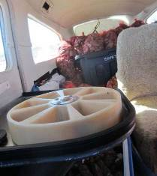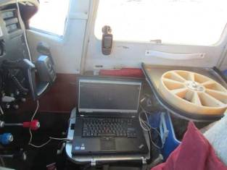

**Figure 8. (a) Inside the aircraft: carousel, computer and independent GPS. (b) Baits were stored alongside and behind the bombardier.**

Two flights were required to complete the application of ~22000 baits across the 430 km2 site. Baits were dropped at a rate of 50 per km2 between 1000 and 1800 hours. The aircraft operated at approximately 130 knots and a height of 500 ft flying east-west transects separated at 500 m intervals. The bombardier was instructed to load a group of five baits into each segment of the carousel. The carousel then revolved in accordance with the pre-determined waypoints spaced 200 m along each transect. A group of 5 baits was released every ~3 seconds. The carousel rotation mechanism was ‘locked’ when the aircraft was outside of the baited area, preventing the release of baits.

The dry bed of Lake Blanche was searched for baits on the morning of 11 July and the location of each bait found was recorded using a GPS device. This data was mapped to determine the typical spread of baits across the study site.

* + 1. **Monitoring of radio-collared cats**

Radio-telemetry techniques were used to determine the approximate location and status (alive or dead) of collared cats. The pulse rate of the transmitted tones on the collars doubled if the collar had remained motionless for 10 hours (i.e. the cat was dead or the collar had dropped off). Hand- held Yagi and vehicle-mounted omni-directional antennae connected to VHF receivers, (Australis 26K (Titley Scientific, Australia) and R1000 (Communication Specialists, USA), were used to determine the cat’s status. Hills within the baited area were accessed daily during the study for purposes of remotely determining the status (alive / dead) of cats using the radio collars. A record was kept of the cats detected and their approximate location.

On 17 July the GPS data were downloaded remotely from the live cats that that had been fitted with the Telemetry Solutions collars. Radio-telemetry was used to approach the cat (to <50 m) whereupon the UHF modem could undertake the data transfer to a laptop computer.

The Sirtrack collar fitted to cat 17 was configured to automatically drop-off at 0100 hrs (local time) on 30 July. This time was selected as it was considered that the cat would be more likely to be active rather than below ground in a rabbit warren that would act to reduce detection of the VHF transmission.

The data from all of the GPS datalogger collars was downloaded at the conclusion of the study and then filtered to remove all points where the collar failed to collect a location (i.e. cat may have been in an enclosed den site), or had a horizontal dilution of precision value greater than 5.0, or was a two-dimensional fix. Filtered data were projected and manipulated in Arcview3.3 (ESRI, Redlands, USA) and home range analysis conducted using the Home Range Extension tool (Rodgers and Carr 1998).

* + 1. **Post-mortem examination**

Radio-telemetry techniques were used to locate cats when their collar had switched to mortality mode. The carcass was photographed in position and immediate surrounds searched for evidence of cause of death. Vomit, defecation, cyanosed soft tissues in the mouth, and presence of Rhodamine B dye indicated that death was as a result of consuming Curiosity® bait(s). An estimate of the number of baits found in the stomach was made during a subsequent examination. Carcasses were retained and stored frozen.

* + 1. **Recovery of surviving collared cats**

Cats that did not die as a direct result of consuming a Curiosity® bait were recovered between 27- 29 days after baiting using VHF-guided hunting. Collared cats were pursued using VHF tracking techniques until they could be approached and shot or had sought refuge in a rabbit warren. These warrens were fumigated with phosphine gas tablets (Apparent Pty. Ltd., Melbourne) and excavated the following day to recover the cat / collar.

Facial whiskers were plucked from each of the recovered cats where possible and were subsequently cleaned prior to mounting on microscope slides. Each sample was examined using techniques described in Fisher (1998) and Fisher *et al*. (1999) for the presence of Rhodamine B dye that would indicate that a Curiosity® pellet had been ingested. A microscope (Nikon Ti Eclipse, USA) fitted with a TRITC filter was used to view the whiskers samples at x2 and x4 magnification.

## Results

### Baiting

* + 1. **Weather**

The weather was characteristic for the region, with cool weather during May – July and daytime temperatures increasing into August, albeit there was unseasonal rainfall recorded over the region during late May (11 mm) and early June (56 mm). The weather, on and after 10 July, was generally suitable for baiting although 7.6 mm rain was recorded during this period. This did not appear to reduce the attractiveness of the baits (Table 1).

**Table 1. Summary of weather observations at Olympic Dam Airport, 10 – 20 July 2013**.

|  |  |  |  |  |
| --- | --- | --- | --- | --- |
| **Date** | **Min. temp. °C** | **Max. temp. °C** | **Rainfall mm** | **Relative humidity %** |
| 10 July | 1.5 | 18.2 | 0.0 | 69 |
| 11 July | 10.3 | 20.9 | 0.0 | 58 |
| 12 July | 13.0 | 24.6 | 0.0 | 78 |
| 13 July | 14.8 | 24.7 | 0.0 | 59 |
| 14 July | 7.6 | 20.4 | 1.0 | 97 |
| 15 July | 8.8 | 17.7 | 0.2 | - |
| 16 July | 2.3 | 19.6 | 0.0 | - |
| 17 July | 9.6 | 23.8 | 0.0 | 80 |
| 18 July | 10.3 | 18.0 | 6.2 | 78 |
| 19 July | 8.8 | 17.1 | 0.2 | 96 |
| 20 July | 7.4 | 15.1 | 0.0 | 93 |

* + 1. **Baits**

The manual loading of the ~22,000 HSDVs into the attractants took nine ‘person-days’ to complete because this task could only be undertaken in the warmer part of the day when baits had thawed.

Five randomly chosen Curiosity® baits were withdrawn from the test cage on 8 July and inspected after they had been subject to five days of ‘exposure’ to ambient weather at the study site. The HSDV in these baits had leaked as evidenced by the Rhodamine B dye staining the meat surrounding the pellet. The pellets themselves remained firm and it was determined that the point of leakage had been from the end seals.

A similar number of baits were also inspected on 10 July prior to loading onto the aircraft after being removed from the freezer ~12 hours earlier. The HSDVs in these baits had not leaked (Figure 9a). The baits were observed to be exuding chicken fat (i.e. sweating) within 20 minutes when placed on the racks at Andamooka. The appearance and odour of baits was considered to be ‘attractive’ and quite distinct from the baits used during the 2012 study in Karijini National Park (Johnston *et al.* 2013).

Opal Air provided data that indicated the location of the aircraft when baits were dropped (Figure 10). This data indicates many ‘holes’ in the bait pattern which is reportedly a consequence of a failure of the bait-drop logging equipment, rather than actually reflecting unbaited areas (L. Wright, pers. comm.).

Baits found on the dry surface of Lake Blanche were in good condition (Figure 9b) after the bait drop and were observed to desiccate slowly over subsequent days. Baits remained attractive to cats for at least nine days after application, as evidenced by the recovery of two dead cats (#2 and #11) on July 19.

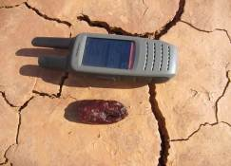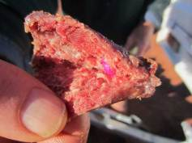

**Figure 9. (a) No leakage of toxicant observed in baits prior to loading in aircraft. (b) Bait located on Lake Blanche.**

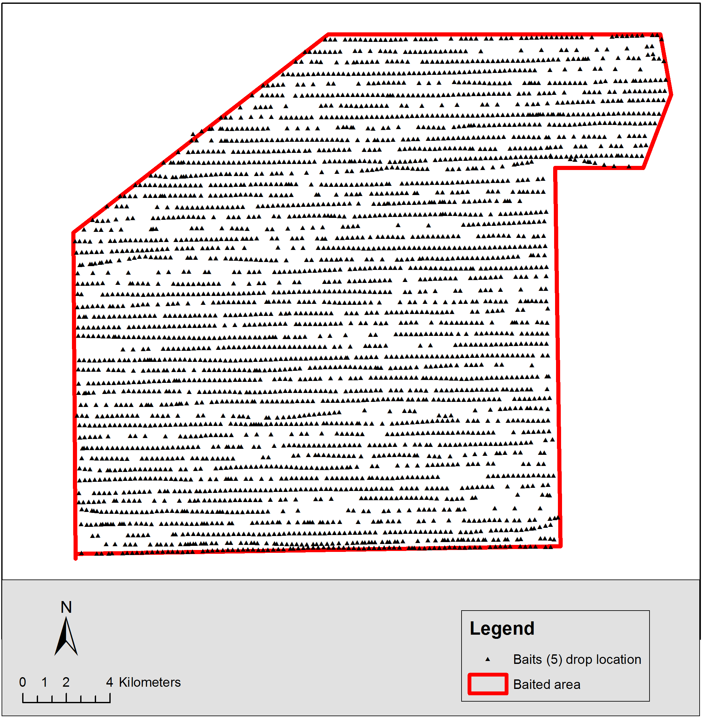

**Figure 10. Map showing aerial distribution of Curiosity® baits across the study site.**

* + 1. **Assessment of bait spread**

Forty-seven baits from 13 groups were located on Lake Blanche during the search conducted on 11 June (Figure 11). The number of baits found per ‘group of 5’ was variable and ranged from 1 to 6. There were 6 groups in which all five baits were located. Interpretation of the aircraft track log indicates that both of these transects were flown in a westerly heading. Baits were an average 160 m (range: 103 – 223 m) from the location where they left the aircraft. The area over which these groups were located averaged 833 m2 (range: 265 – 1502 m2). One group comprised six baits while at another area no baits were located in the vicinity of where the aircraft bait-drop logger indicated that there should be a group.

Two other baits were located later in the study as crew were walking across the site. The location of these baits correlated with the recorded flight track and drop locations from the aircraft.

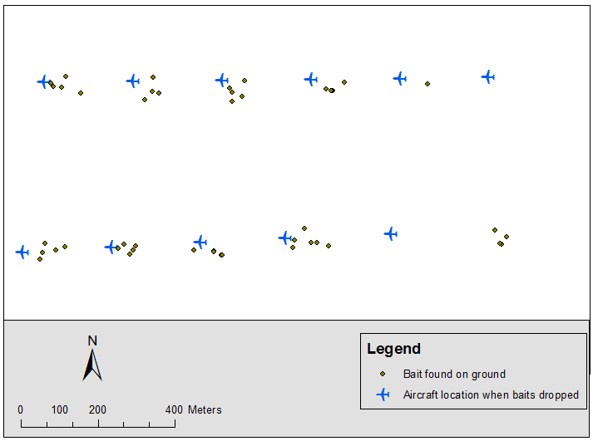

**Figure 11. Measured results of bait spread on Lake Blanche.**

### Collared Feral Cats

Eighteen feral cats were trapped over 613 trap-set nights (i.e. the number of sets active per night, as distinguished from the number of traps) resulting in a 3% rate of trap success. All cats trapped were fitted with collars (Table 2).

All eighteen cats were known to be alive and within the study area on 8 July 2013 (i.e. two days before baiting).

One wild dog, three foxes and three rabbits were also caught during the trapping phase of the project.

**Table 2. Details and fate of feral cats trapped during this study.**

|  |  |  |  |
| --- | --- | --- | --- |
| **Cat ID** | **Date** | **Trap Location** | **Fate and body mass.** |
| 1. 4.3kg ♂ Tabby | 22/6/13 | 30° 24.860 136° 43.322 | Survived baiting. Fumigated in |
|  |  |  | warren (6 August) 5.2kg. |
| 2. 3.4kg ♀ Tabby | 23/6/13 | 30° 24.528 136° 23.251 | Poisoned by Curiosity® bait (20 |
|  |  |  | July) 3.1kg |
| 3. 4.9kg ♂ Tabby | 24/6/13 | 30° 24.795 136° 43.547 | Poisoned by Curiosity® bait (12 July) 4.1kg |
| 4. 4.3kg ♂ Tabby | 24/6/13 | 30° 24.268 136° 43.173 | Survived baiting. Fumigated in warren (6 August) 4.6kg |
| 5. 5.0kg ♂ Tabby | 25/6/13 | 30° 24.794 136° 43.550 | Survived baiting. Fumigated in warren (7 August) 5.6kg |
| 6. 2.2kg ♀ Tabby | 25/6/13 | 30° 28.009 136° 45.022 | Poisoned by Curiosity® bait (12 July) 1.6kg |
| 7. 3.0kg ♀ Tabby | 25/6/13 | 30° 26.690 136° 38.315 | Survived baiting. Fumigated in warren (7 August). 3.5kg. |
| 8. 3.5kg ♀ Tabby | 25/6/13 | 30° 25.727 136° 42.517 | Poisoned by Curiosity® bait (15 July) 3.1kg. |
| 9. 2.5kg ♀ Tabby | 26/6/13 | 30° 25.428 136° 43 599 | Poisoned by Curiosity® bait (14 July) 2.4kg |
| 10. 4.4kg ♂ Black | 26/6/13 | 30° 26.569 136° 45.524 | Poisoned by Curiosity® bait (12 July) 4.0kg |
| 11. 3.4kg ♂ Tabby | 27/6/13 | 30° 25.824 136° 42.254 | Poisoned by Curiosity® bait (20 July) 3.5kg |
| 12. 5.1kg ♂ Black | 27/6/13 | 30° 25.726 136° 43.527 | Poisoned by Curiosity® bait (12 July) 5.2kg |
| 13. 2.7kg ♂ Tabby | 27/6/13 | 30° 25.766 136° 44.190 | Unknown. Last detected alive on 8 July. |
| 14. 3.0kg ♀ Tabby | 27/6/13 | 30° 25.842 136° 45.277 | Survived baiting. Fumigated in warren (7 August) 3.3kg |
| 15. 3.7kg ♂ Tabby | 27/6/13 | 30° 28.442 136° 41.597 | Poisoned by Curiosity® bait (14 July) 2.8kg |
| 16. 5.0kg ♂ Tabby | 27/6/13 | 30° 26.238 136° 39.785 | Survived baiting. Shot 7 August. 5.4kg |
| 17. 3.7kg ♀ Tabby | 28/6/13 | 30° 24.086 136° 44.413 | Survived baiting. Collar dropped off 31 July. Unknown weight. |
| 18. 3.5kg ♂ Tabby | 29/6/13 | 30° 27.705 136° 45.853 | Poisoned by Curiosity® bait (13 July) incomplete body recovered. |

GPS location data were retrieved from seventeen collared cats and are summarised in Table 3. The sampling schedule for each collar varied according to the date of capture. Collars fitted to cats

caught early in the trapping program were programmed for less frequent sampling to prolong the battery life. Cat 13 was detected as ‘alive’ two days prior to baiting but was not located following baiting and thus no data were recovered from the collar fitted to this cat.

**Table 3. Details of location sampling programmed into GPS datalogger collars.** Manufacturers are indicated as Telemetry Solutions (TS), Holohil (H) and Sirtrack (S).

**Cat ID Collar**

**frequency and supplier**

**Date GPS sampling**

**routine**

**Total no. of locations**

1 151.800 TS 22 June – 2 July

3 July – 3 August

60 mins

15 mins

227

3072

2 151.690 TS 23 June – 2 July

3 July – 20 July

60 mins

15 mins

230

1719

3 150.140 TS 24 June – 2 July

3 July – 12 July

60 mins

15 mins

208

937

4 150.360 TS 24 June – 2 July

3 July – 3 August

60 mins

15 mins

206

3072

5 150.460 TS 25 June – 2 July

3 July – 10 August

60 mins

15 mins

182

3699

6 151.650 TS 25 June – 2 July

3 July – 12 July

60 mins

15 mins

181

943

7 151.600 TS 26 June – 2 July

3 July – 10 August

60 mins

15 mins

158

3697

8 150.320 TS 25 June – 2 July

3 July – 15 July

60 mins

15 mins

180

1218

9 151.820 TS 26 June – 2 July

3 July – 14 July

60 mins

15 mins

155

1131

10 150.440 TS 26 June – 2 July

3 July – 12 July

60 mins

15 mins

154

942

11 150.780 TS 27 June – 2 July

3 July – 20 July

60 mins

15 mins

134

1685

12 150.420 TS 27 June – 2 July

3 July – 12 July

60 mins

15 mins

111

933

13 150.260 TS 27 June – 2 July

3 July - ?

60 mins

15 mins

Nil Nil

**Cat ID Collar**

**frequency and supplier**

**Date GPS sampling routine**

**Total no. of locations**

14 150.480 TS 27 June – 2 July

3 July – 7 August

60 mins

1. mins

132

3400

15 152.220 H 28 June – 14 July 60 mins 282

1. 152.279 H 28 June – 7 August 60 mins 2652
2. 150.739 S 28 June – 2 July

3 July – 30 July

60 mins

15 mins

34

2171

18 152.321 H 30 June – 13 July 60 mins 463

Home ranges were determined for the 17 cats from the GPS data gathered during the study period. The minimum convex polygons (MCP) encompassing 95% of the GPS data points averaged 5.1 km2 (range: 2.1 – 10.5) for male and 4.1 km2 (range: 2.0 – 11.2) for female cats. There was substantial overlap in the home ranges of cats observed, notably in the area surrounding Centenary Hut (Figure 12).

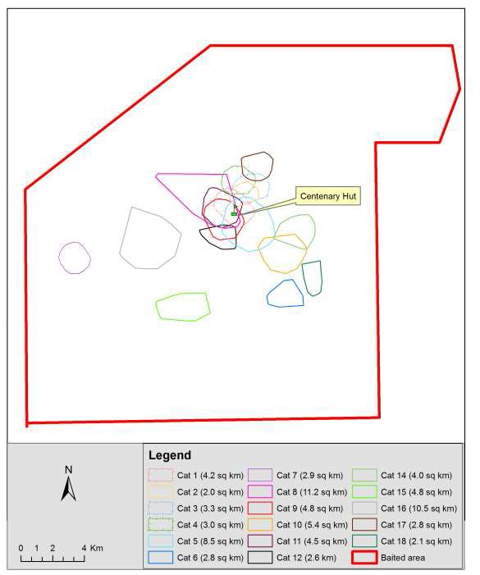

**Figure 12. Minimum convex polygons (MCP95%) for feral cats in this study. The area of each polygon is indicated in the legend.**

Ten cats were confirmed as having died as a result of consuming Curiosity® bait(s) as evidenced by cyanosed soft tissues in the mouth and presence of bait(s) in the stomach. The GPS dataloggers indicated that these cats ranged over areas of varying size in the period between bait application (nominally 1800 hrs 10 July) and the time that they consumed bait(s) and their subsequent death (Figure 13). These data include a period when the cat was dead but due to the error associated with these GPS devices it was not possible to determine a precise time of death.

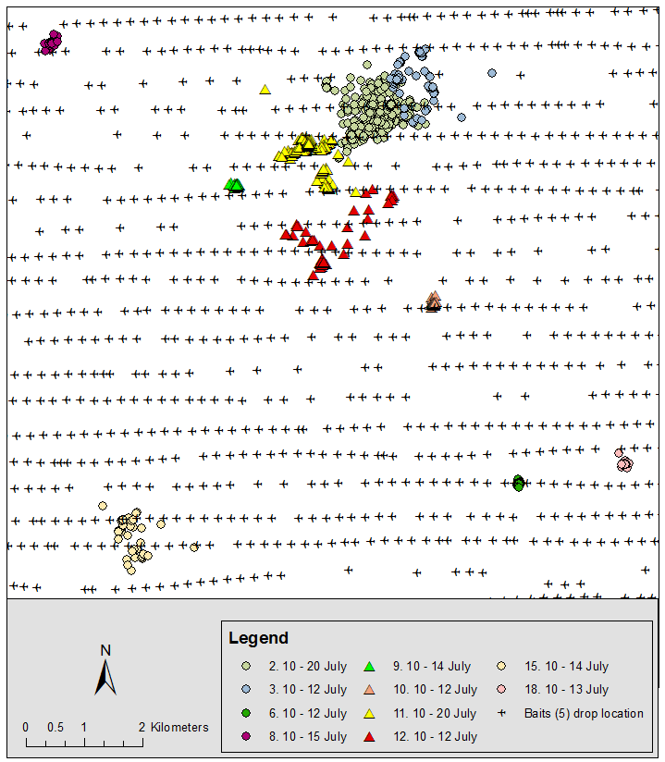

**Figure 13. Variable activity observed in the ranging behaviour of cats that died following consumption of Curiosity**® **bait in the period between baiting and their death**.

### Post-mortem investigation

The digestive tracts of all cats detected as ‘dead’ subsequent to baiting were inspected following recovery of the body to confirm that cats had died following consumption of Curiosity® bait(s).

Other supporting evidence was collected at the location where the body was recovered that would indicate that the cat had died from PAPP toxicoses, (e.g. vomit, defecation, cyanosed gum tissue, etc). The presence of Rhodamine B dye provided a readily identifiable marker along with the presence of bait material (Figure 14). It was observed that cats had generally consumed multiple baits and in some cases also had other food items in their stomach (Table 4).

**Table 4. Contents of stomachs from feral cats poisoned with Curiosity® bait(s).**

##### Cat ID Vomit at site of death (yes/ no)

**Estimated no. of Curiosity**® **baits consumed.**

**Other material consumed**

1. Yes 1 Bearded dragon (*Pogona viticeps)*
2. Yes 3 Rabbit

6 No 4 -

1. No 4 -
2. No 2 Reptile
3. Yes 2 -
4. No 3 Rabbit
5. No 5 -

15 No 1 -

18 No 1 Bird

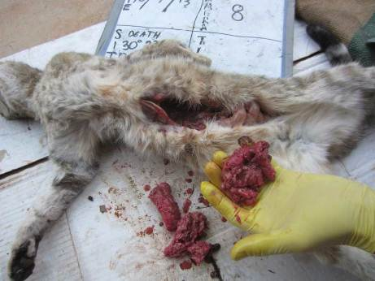

**Figure 14. Post-mortem examination of cat 8. Note the Rhodamine B dye stain and presence of multiple baits.**

The seven cats that did not die from bait consumption are assumed to have had numerous opportunities to encounter baits as they crossed bait transects and remained within the baited area throughout the study (Figure 15).

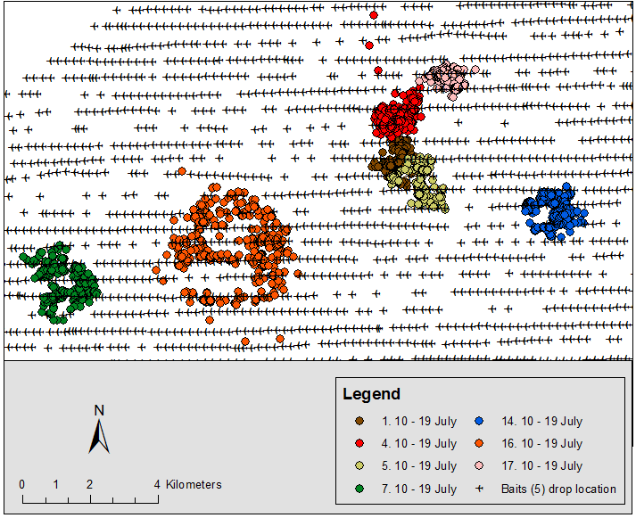

**Figure 15. Activity of collared cats that were not poisoned during the period 10 – 19 July.**

### Whisker analysis

Whiskers taken from five of the six cats recovered by hunting were examined under fluorescence microscope. No whiskers were recoverable from the remaining cat. A single Rhodamine B mark was evident in the samples taken from Cat 4, indicating exposure to a bait (Figure 16). No marking was detected in any of the remaining cats.

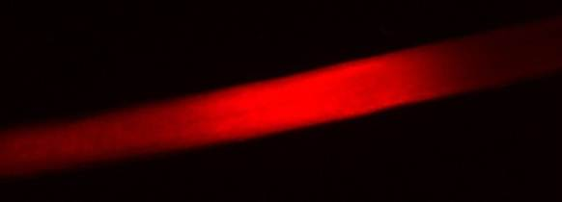

**Figure 16. Rhodamine B dye mark in whisker of Cat 4 (magnification x4)**.

### Track Counts

There was no observed change in the feral cat (or fox) activity detected at the sections of monitored track plots, nor in the fox detections. However, the amount of dingo activity was greatly reduced during the post-bait monitoring period. Activity of rabbits and macropods were not expected to be directly affected by the baiting program and were observed to be similar prior to and following baiting. Data for the counts in the non-baited area are not shown given the incomplete data set.

**Table 5. Summary of counts of species detected on 14 monitor plots in the baited area.**

**Mean and (*StDev)***

|  |  |  |
| --- | --- | --- |
|  | **Pre –bait** | **Post-bait** |
| Feral cat | 3.8 (*1.7)* | 4 (*1.3)* |
| Rabbit | 11.7 (*2)* | 12.7 (*1)* |
| Macropod | 4.3 (*2.1)* | 7.2 (*1.5)* |
| Red Fox | 0.7 (*1)* | 0.8 (*1.3)* |
| Wild dog / dingo | 5.2 (*2.8)* | 1 (*0.6)* |

### Site occupancy

The occupancy model with the lowest AIC had constant occupancy and detection probability (Table 6), with the next best model having a ∆AIC> 4. It was therefore concluded that camera type and baiting did not affect detection rates for cats and that landform did not influence occupancy. This does not mean that baiting did not have an effect on occupancy rates *per se*. Occupancy rates from the pre-to post-baiting periods were affected by the local extinction and colonisation rates. The estimated occupancy rates pre- and post-baiting are given in Table 7 and displayed in Figure 17.

**Table6:Feralcatmodellingcomparisonsfromautomated camera occupancy analysis.**

|  |  |  |
| --- | --- | --- |
| **Model** | **AIC** | **∆AIC** |
| ψ(.)p(.) | 887.32 | 0.0 |
| ψ(.)p(Camera) | 892.92 | 5.6 |
| ψ(.)p(Camera+Baiting) | 894.13 | 6.8 |
| ψ(Landform)p(Camera) | 898.92 | 11.6 |
| ψ(Landform)p(Camera+Baiting) | 900.13 | 12.8 |
| ψ(.)p(Baiting) | 903.26 | 15.9 |
| ψ(Landform)p(.) | 908.44 | 21.1 |
| ψ(Landform)p(Baiting) | 909.26 | 21.9 |

Feral cats were estimated to have an occupancy rate at camera sites of 71.0% (range: 54.9 - 83.1%) during the pre-baiting monitor period. This occupancy rate decreased to an estimated 32.9% (range: 18.2 - 47.7%) during the post-baiting monitor period, giving a decline of 52.8% (-73.2- 30.0%), (Table 7).

**Table 7: Summary statistics for the model with the most support. The confidence interval (CI)**

**for the growth rate was calculated by parametric bootstrapping.**

|  |  |  |  |
| --- | --- | --- | --- |
|  | **Estimate** | **95% CI**  **Lower** | **Upper** |
| Detection (%) | 5.7 | 4.5 | 7.1 |
| Occupancy (%) |  |  |  |
| Pre-baiting | 71.0 | 54.9 | 83.1 |
| Post-baiting | 32.9 | 18.2 | 47.7 |
| Local Colonisation (%) | 0.1 | 0.0 | 100.0 |
| Local Extinction (%) | 53.9 | 34.8 | 72.0 |
| Growth Rate (%) | -52.8 | -73.2 | -30.0 |
| Goodness-of-fit | 0.441 |  |  |

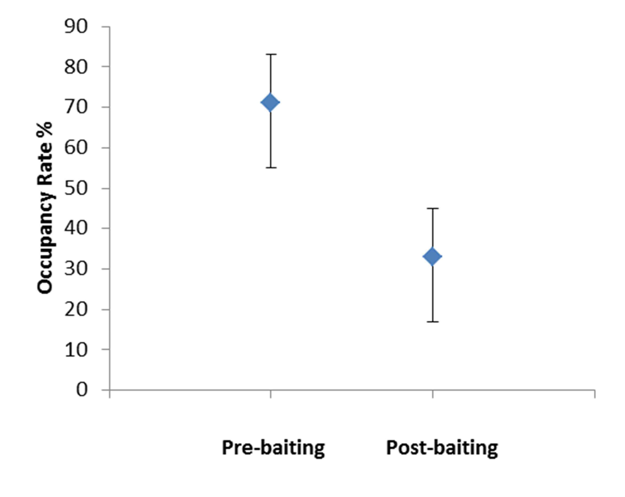

**Figure 17: Plot of the estimated occupancy rates pre- and post-baiting for feral cats**.

### Non-target species

Canids were infrequently detected at automated camera sites. Foxes were photographed on a total of 22 occasions (18 pre-bait and 4 post-bait) and wild dog / dingoes were photographed 4 times only during the post-bait monitor period.

Data from the counts of carnivorous birds are summarised in Table 8 and reflect a generalised low abundance of this guild within the site during the period of the study. The most common species observed was the Wedge-tailed Eagle (*Aquila audax*), which was abundant during both survey periods.

Emus (*Dromaius novaehollandiae*) were not observed during the ‘carnivore’ counts but the same number of birds were seen in the same localised areas prior to and following baiting (i.e. a group of 4 birds at the southern entry to the site and an individual bird near Centenary Hut).

Counts of corvids, including both Australian Raven (*Corvus coronoides*) and Little Crow (*Corvus bennetti*) were declined by 50% in the post-baiting monitor period.

Summaries of the data generated in the other bird surveys are provided in the Appendix.

**Table 8. Counts of carnivorous birds on transects inside and outside the baited area.**

##### Bait area transect Unbaited area transect Total count over 9 surveys / (total count per km along transect)

**Pre-bait Post-bait Pre-bait Post-bait**

Australian Magpie

*Gymnorhina tibicen* Brown Falcon *Falco berigora* Corvids

*Corvus* spp.

Grey Butcherbird *Cracticus torquatus* Nankeen Kestrel *Falco cenchroides*

Wedge-tailed Eagle

*Aquila audax*

18

(0.4)

1

(0)

37

(0.9)

1

(0)

8

(0.2)

30

(0.7)

11

(0.3)

3

(0.1)

16

(0.4)

0

(0)

3

(0.1)

31

(0.7)

23

(0.5)

1

(0)

25

(0.5)

5

(0.1)

4

(0.1)

17

(0.3)

15

(0.3)

5

(0.1)

24

(0.4)

6

(0.12)

5

(0.1)

13

(0.26)

It was not possible to provide an accurate estimate of the proportion of the baits consumed by non- target species. Invertebrates such as ants are expected to consume many baits (Figure 18).

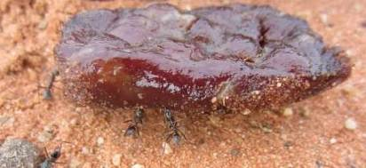

**Figure 18. Invertebrates were observed consuming baits**.

Carnivorous birds are also likely to locate and consume baits. A pair of Australian Raven was observed investigating a bait after its location on Lake Blanche had been mapped on 11 July (L. Bould, pers. obs). Inspection of this location the following day revealed that the bait was missing but the HSDV had been rejected (Figure 19). Bird faeces were present at this site. It is also possible that birds consumed other baits not found during the search of the lake bed.

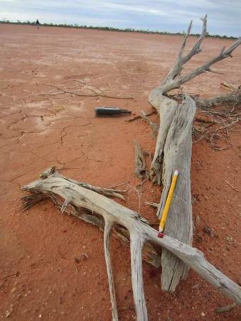

**Figure 19. A HSDV found on Lake Blanche following probable bait consumption by bird.**

While no index or formal measure of reptile activity was attempted in this study, incidental observations indicated that there was little reptile activity during July and early August. The reptiles that were observed were mostly Shingleback lizards (known locally as Sleepy lizards) (*Tiliqua rugosa*) with a mulga snake (*Pseudechis australis*) being the only other reptile sighted. Following baiting, Shinglebacks were routinely encountered and photographed (Figure 20) with the intention of conducting a rudimentary field survey for possible bait consumption by looking for Rhodamine B dye staining in their mouth. There was no evidence of Rhodamine B staining observed in the mouths of these animals. Four Central Bearded Dragons (*Pogona viticeps*) were observed on separate occasions during early August as the daytime temperatures increased. No goannas were observed during the study.

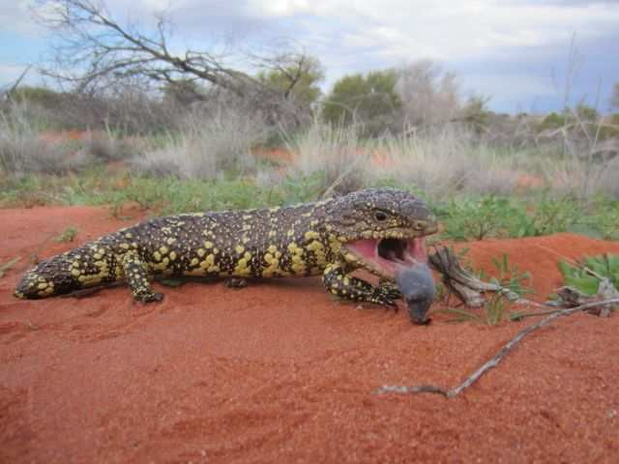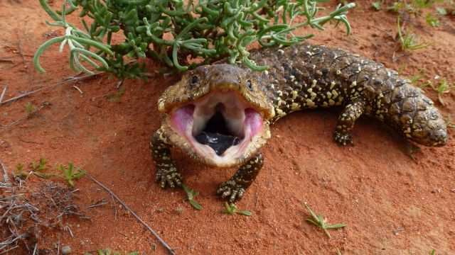

**Figure 20. Shingleback lizards were commonly seen as the daily temperatures increased.**

## Discussion

This study assessed the efficacy of the Curiosity® bait for controlling a feral cat population in the semi-arid zone by measuring feral cat survival and activity prior to and following aerial application of those baits. A secondary objective was to determine whether the baiting program had a negative impact on other wildlife species that inhabited the study site. The baiting program reduced the cat population as indicated by the death of 58% of the radio-collared individuals. This was corroborated by the estimated 52% reduction in occupancy of sites monitored by automated cameras.

Eighteen adult cats were trapped within the core of the baited area which represented a robust study population. All cats trapped were suitable for inclusion in the study given that their body mass was >2.0 kg and none had sustained any trap-related injury. The collared cats were all known to be alive and within the baited area prior to the application of baits. However, one cat (#13, Male

2.7 kg) was not detected after baiting despite considerable searching. Adjoining areas to the south, south-east and east of the site, including the Roxby Downs landfill, were also searched. Feral cats in previous studies in this area have undertaken long-range movements that included activity at the landfill site (Moseby *et al.* 2009; P. Paisley, pers. comm). Several explanations for the ‘loss’ of animal / collar #13 are possible, including: a) failure or damage to the VHF transmitter hardware in the collar, b) the animal died as a result of bait consumption in a location with either poor radio- frequency propagation or the transmitter could potentially have been damaged by a predator scavenging the carcass, c) the animal undertook a long-distance movement and was not detected at this new location. Moseby *et al*. (2009) previously observed long distance movements over 24 hr periods in male cats in this area including a ~3.5 kg male cat that covered >45 km in 2 days.

Ten of these seventeen (58%) collared feral cats died following consumption of Curiosity® bait(s) with one cat subsequently found to have consumed a bait and survived. Bait consumption was confirmed at the site of death by physiological indicators, i.e. cyanosed tissue, and also during a post-mortem investigation that located Curiosity® bait(s) in the stomach. Of these poisoned cats, seven had lost weight over the period between trapping and baiting (mean reduction of 485 g), two had slightly heavier body mass (+ 100 g) and the body of the remaining cat had been scavenged prior to recovery precluding an accurate measurement. Possible explanations for the survival of the

4.3 kg male cat include insufficient consumption of a toxicant, caused by either leakage from the HSDV or vomiting during toxicosis. It is not possible to determine which is the most likely scenario. Pen studies have demonstrated that emesis during PAPP toxicoses can result in survival of feral cats in pen studies (Scientec, 2007). Similarly, premature failure of the polymer encapsulation of the HSDV has led to survival of cats (Robinson *et al*. submitted). The GPS data for cat 4 did not indicate any sustained period of immobility that could indicate a recovery from toxicoses during the post-baiting period. Regardless, the cat was in good condition when killed at the end of the trial reflecting that the exposure to PAPP had not compromised the cat’s ability to survive. It is reasonable to assume that this cat would have been poisoned if Eradicat® baits had been used rather than Curiosity® due to the different mode of action associated with 1080 toxicosis.

The observed decrease in occupancy in the post-baiting monitor period showed a significant local decline in the feral cat population. The olfactory lure was observed to retain the smell, volume and consistency at the culmination of each monitor period. Similarly, rain did not damage the condition of the feathers. The removal of lures between the monitoring periods was undertaken to retain the ‘novelty’ and interest of these devices. It was evident that the camera itself was detected by feral cats and other species, with reference to the infra-red illumination and noise associated with their use.

Cameras were located at semi-randomised locations in the landscape in sites within 1 km of a vehicle track. This method was chosen as cats do not make extensive use of formed tracks (Bengsen *et al.* 2011) and it also facilitated efficient servicing of cameras. Landform was not a factor that influenced occupancy of feral cats in this study although previous studies in the region have found cat activity to be greater in dune habitats than other landforms (Moseby *et al*. 2009; Moseby *et al*. 2011).

The results from the track count indices were compromised in two ways. Firstly, there were a low number of plots in the baited area and secondly, insufficient data were collected in the unbaited area to reach any useful comparisons with the baited area. Water-logged tracks reduced the number of plots that were prepared in the baited area. Access and preparation of plots in the unbaited area was also delayed by several days. Data were subsequently collected over three days before rainfall forced closure of both sites. Access to these unbaited plots was not possible during the post-bait monitor period due to military activity.

The GPS data for four cats that were poisoned indicates that their activity was restricted to small areas (mean: 1.9 ha, range 1.0 – 3.5 ha) in the days following 10 July but they did not appear to cross a bait transect. Three of these collars were programmed to log a GPS location every fifteen minutes. While this complicates identification of timing associated with bait encounter, the fact that baits were recovered from their stomachs indicates that they were poisoned by a Curiosity® bait.

Eleven cats were trapped and remained active within a 2 km radius of Centenary Hut. This area had an abundance of food resources to support this population of cats. The landscape at this location includes a rocky hill, cane grass swamp, sand dunes and a dam with permanent water. Despite the apparent resources, Curiosity® baits were responsible for the death of six of these cats. Two of these cats consumed baits that had been on the ground for nine days. Four of the seven collared feral cats that were not poisoned were resident in this area and it is probable that they were also detected on the track count surveys contributing to the ‘nil change’ in this index. Another of the non-poisoned cats inhabited an area with a dam so it is probable that this ‘resource’ supports increased abundance of prey items and reduced likelihood of bait consumption even if encountered.

All of the ‘not poisoned’ cats remained within the baited area and should have encountered baits on numerous occasions. It is therefore apparent that these cats were able to locate sufficient alternative food to sustain them as each cat had an increased body weight (mean 500 g) at the conclusion of the study. In terms of food resources, rabbits are known to be a dietary staple of feral cats throughout this region, and Australia more broadly (Coman and Brunner 1972; Liberg 1984; Read and Bowen 2001). There had been no rabbit control undertaken at the site prior to the study and this contributed to the ready availability of both food and shelter (i.e. warrens) for feral cats. The unseasonal wet weather experienced during this study is expected to have further supported prey populations, particularly juvenile rabbits. Rabbit kittens were first photographed by automated cameras on 31 May. Rabbits were apparently abundant throughout the site during all stages of the study given the combined data from automated cameras and field observations. However, this abundance cannot be quantified as formalised surveys were not undertaken.

The bait mapping exercise conducted on Lake Blanche indicated that the baits were located an average of 160 m from where the baits left the aircraft and that the group of baits landed within areas averaging 833 m2. This data represents a valid ‘random’ sample of the typical ground spread of baits as the aircraft crew were not advised about this aspect of the study. However, it is expected that the ground spread of baits varies in relation to aircraft speed and wind direction. In this study it was only possible to measure the pattern of bait spread when the aircraft was flying west.

There are several possible explanations for our inability to detect all dropped baits on Lake Blanche: a) <5 baits were dropped from the aircraft per group, b) baits had been consumed prior to the survey, and c) baits were not detected during the survey. Each of these alternatives is equally plausible given that the pace required to reload the carousel with baits could lead to an inaccurate number being loaded. Baits may also have been removed prior to our search or additionally not have been detected as a result of their being amongst the rocks that peppered the lake surface. The automated logging device in the aircraft only recorded one object dropping per drop location, rather than a cluster of five objects. Additionally, the many gaps visible in the data log of the bait drop indicate that the system frequently failed to record the passage of baits through the system. All transects show missed bait-drop locations, reflecting a requirement for the aircraft operator to improve the design of the hardware fitted to the aircraft. A similar loss-of-data situation occurred to a previous user of this equipment when baiting for wild dogs (P. Bird, pers. comm). Reliable logging equipment is required to provide confidence that baits were actually dropped within the desired area and also that baits were not dropped outside of it.

Previous attempts to reduce populations of feral cats using both aerial and ground laid poison baits in this region are well documented (Moseby *et al.* 2009; Moseby *et al.* 2011; Moseby and Hill 2011) over a five year period. These studies also measured cat detections on track plots and survival of radio-collared individuals to assess efficacy of aerially delivered Eradicat® baits. The bait densities deployed, at either 10 and 25 baits per km2 were lower than used in the present study and were not found to lead to significant reductions in the cat population when compared to paired unbaited areas. Cost of baits and increased hazard to non-target species were cited as the main reasons for the bait densities used in these previous studies. The unit cost of Curiosity® baits used in the present study is currently limited by commercial confidentiality and is irrelevant to the anticipated costs for the product following registration.

Use of the encapsulated toxicant (i.e. the HSDV) has been demonstrated to reduce exposure of non-target species to the toxicant (Marks *et al.* 2006; F. Gigliotti, pers comm; M. Johnston, unpublished data). Baiting efficiency could potentially be improved further by adjusting the procedures for dropping baits with respect to dropping less baits more often along each flight transect, for example 2 baits/ 100 m compared to the 5 baits /200 m as used in this study. This would achieve greater spread of baits without requiring additional aircraft time. This would also slightly reduce the bait density and therefore the number of baits required. The observed rate of multiple bait consumption seen in this and previous studies (Johnston et al. 2010b; Johnston 2012) suggests that if cats encounter one bait, then they are likely to consume the ‘group’ of baits. Optimising the opportunity for bait encounter by more evenly dispersing baits along the flight transects, and/or reducing the bait density, deserves further investigation.

Achieving bait consumption by cats is reliant on delivery of an attractive and palatable bait at a point in time when cats are likely to consume baits and in a pattern that facilitates rapid encounter with the bait. Flight transects were prepared such that the aircraft would fly parallel (east-west) to the dune system following previous work that indicated that feral cats appear to prefer this habitat type (Moseby *et al.* 2009). Factors such as bait consumption, competition or spoiling by other species (canids, reptiles, birds, ants) act to reduce the effective bait availability to cats. Feral cats have a preference for live prey over the consumption of scavenged food (such as Curiosity® baits) so poison baiting will achieve best efficacy when prey availability is low (Bradshaw 1992). Delivery of attractive baits during a period of high prey availability is unlikely to lead to a successful feral cat control program due to behavioural factors associated with known and / or preferred food items (Algar *et al*. 2007; Moseby *et al.* 2009; Johnston *et al*. 2010).

The meat attractants used in this study were sourced from a different supplier than used in previous field evaluations of the Curiosity® bait. The main difference with respect to attractant preparation was the ‘skinless sausage’ method of manufacture which resulted in baits that resembled ćevapi (Scientec Research 2013). The absence of the sausage casing is thought to have contributed to the excellent ‘sweating’ of the chicken fat component observed across all batches of the baits used. The baits had a pleasant odour compared to those used in previous studies (Johnston *et al.* 2013). The addition of a preservative and the cooler ambient drying temperature reduced the putrefaction of baits observed in Johnston *et al.* 2013. A minority of baits required further curing at the field site due to insufficient drying at the factory. This additional curing was undertaken by placing the baits on a rack in the sun until sufficiently dry. However, the manual loading of HSDVs into the attractants was time-consuming and will require a degree of automation for operational use of the Curiosity® baits into the future. Examination of baits on Lake Blanche

indicated that the skinless sausages were sufficiently robust to avoid sustaining any damage upon hitting the lake surface.

The bird counts demonstrated a relative paucity of carnivorous birds throughout the site during this study although the abundance and diversity of species in this region is subject to considerable variation in abundance and diversity (Read *et al*. 2000). A 50% decrease in the number of corvids was observed but it is not possible to determine whether this can be linked to consumption of baits by these birds. Captive trials with wild Australian Ravens has demonstrated active rejection of the HSDV when presented with Curiosity® baits (F. Gigliotti, pers. comm) and similar rejection of devices has been observed by Avery *et al.*(2004).

The bird surveys were an imperfect measure of the potential for impact on non-target species due to, by way of example, the ability of birds to move long distances with respect to the size of the areas surveyed. Decreases in counts may be explained by scenarios that include the death of individual birds but may equally simply be the result of non-detection that day, or their having moved out of the study site. Monitoring statistically robust numbers of individual birds was beyond the scope of this study. Wedge-tailed Eagles were commonly seen throughout the site while observations of small and medium sized raptor species were infrequent. There was no Rhodamine B dye seen in the few bird carcasses that were located during the study. Similarly, Rhodamine B stained faeces were not found during inspections of Wedge-tailed Eagle roosts, nests and perches. Smaller raptor species such as Brown Falcons and Nankeen Kestrel were not counted in sufficient numbers during either monitor period to make a robust assessment of any change in population. Black kites were commonly seen flying over the Roxby Downs community but were not recorded on either of the bird survey transects and rarely as incidental observations. Observations of other carnivorous birds such as Australian Magpie, Little Crow and Australian Raven were also relatively infrequent. It is suspected that a corvid was responsible for the rejected HSDV found on Lake Blanche given that a pair of birds was observed watching our ‘bait search’.

Dedicated counts for other non-target species such as reptiles were not conducted due to this guild being generally inactive during the study period. The reptiles observed were mainly Shingleback lizards, with this species becoming increasingly active in early August as daytime temperatures increased. There was no evidence of Rhodamine B dye visible in the mouthparts of these animals.

Foxes and wild dogs/dingoes were present in the site but were infrequently detected at automated camera sites. Fox detections were predominantly in the pre-baiting monitor period and all (4) detections of wild dogs / dingoes occurred during the post-baiting period. Three foxes and one wild dog / dingo were trapped and euthanased prior to baiting which further reduced their populations. The detections of dingoes at track count plots dropped by 80% after baiting. However, it is not possible to determine whether this reflects a real reduction in dog population achieved through baiting or whether the dingoes simply did not use the monitored section of track during the survey period. The study was conducted south of the ‘dog fence’ where land managers are required to control dingoes.

This field study demonstrated the efficacy of the Curiosity® bait in reducing the population of feral cats at a semi-arid site. Improving the longevity of the HSDV remains the most pressing of technical hurdles to be overcome with this product. Development of hardware, or adaptation of existing hardware, to improve the efficiency of the process of loading HSDVs into attractants will be required prior to commercial use of this bait. Minor adjustments to processes and hardware by external suppliers, such as attractant production and improved logging of bait drops, will lead to a

better product. There is limited scope to adjust the density and pattern used when distributing baits, but small changes may lead to improved cost efficiency. Environmental factors such as rain and prey availability cannot be controlled and have contributed to the variable success achieved in previous studies in the development and field evaluation of the Curiosity® bait. It is recommended that land managers be informed of the impact that these factors will have on any proposed cat baiting programs, and be provided with suggestions as to how to best determine when, or when not, to bait.

## References

Abbott, I. and Burbidge, A.A. (1995) The occurrence of mammal species on the islands of Australia: a summary of existing knowledge*. CALMScience* **1***,* 259*–*324*.*

Algar D, Angus G.J., Williams M.R., Mellican A.E. (2007). Influence of bait type, weather and prey abundance on bait uptake by feral cats (*Felis catus*) on Peron Peninsula, Western Australia. *Conservation Science Western Australia* **6(1)**, pp. 109–149

Avery, M.L., Tillman, E.A. and Savarie, P.J. (2004) Responses of captive fish crows (*Corvus ossifragus*) to acetaminophen baits and bait stations for brown tree snake (*Boiga irregularis*) control on Guam. *Bird Behaviour* **16**: 1–6.

Bengsen, A., Butler, J. and Masters, P. (2011) Estimating and indexing feral cat population abundances using camera traps. *Wildlife Research* **38:** 732–739.

Bradshaw, J.W.S. (1992) The behaviour of the domestic cat. CAB International. United Kingdom. Bureau of Meterology (2012) Climate statistics for Australian locations: Olympic Dam

Aerodrome, South Australia. Website accessed September 2013,

[www.bom.gov.au/climate/averages/tables/cw_016096.shtml](http://www.bom.gov.au/climate/averages/tables/cw_016096.shtml)

Christidis, L. & Boles, W. (2008). *Systematics and Taxonomy of Australian birds*. CSIRO Publishing. Australia.

Coman, B. J., and Brunner, H. (1972). Food habits of the feral house cat in Victoria. *The Journal of Wildlife Management* **36**: 848-853.

DEWHA (2008) Background document for the threat abatement plan for predation by feral cats, Department of Environment, Water, Heritage and the Arts, Canberra.

Dickman, C. (1996) Overview of the impacts of feral cats on Australian native fauna. Australian Nature Conservation Agency. Canberra.

Fisher, P. (1998) Rhodamine B as a marker for the assessment of non-toxic bait uptake by animals.

Report Series Number 4. Vertebrate Pest Research Department, Department of Natural Resources and Environment, Victoria.

Fisher, P., Algar, D. and Sinagra, J. (1999). Use of Rhodamine B as a systemic bait marker for feral cats (*Felis catus*). *Wildlife Research* **26**: 281–285.

Fiske, I.J. and Chandler, R.B., (2011). Unmarked: An R package for fitting hierarchical models of wildlife occurrence and abundance. *Journal of Statistical Software* **43,** 1–23.

Hetherington, C.A., Algar, D., Mills, H., and Bencini, R. (2007) Increasing the target-specificity of ERADICAT® for feral cat (*Felis catus*) control by encapsulating a toxicant. *Wildlife Research*, **34**, 467–471.

Johnston, M. (2012) Field assessment of the Curiosity® bait for management of feral cats after fire at Wilsons Promontory National Park: Black Saturday Victoria 2009 - Natural values fire recovery program. Department of Sustainability and Environment, Heidelberg, Victoria.

Johnston, M., Algar, D., Hamilton, N. and Lindeman, M. (2010a) A bait efficacy trial for the management of feral cats on Christmas Island. Arthur Rylah Institute for Environmental Research Technical Series No. 200. Department of Sustainability and Environment.

Johnston, M., Algar, D., Onus, M., Hamilton, N., Hilmer, S., Withnell, B. and Koch, K. (2010b) A bait efficacy trial for the management of feral cats on Dirk Hartog Island. Arthur Rylah Institute for Environmental Research Technical Series No. 205. Department of Sustainability and Environment.

Johnston, M., Algar, D., O’Donoghue, M. and Morris, J. (2011) Field efficacy of the Curiosity® feral cat bait on three Australian islands. In: Veitch, C.R.; Clout, M.N. and Towns, D.R. (eds.). 2011. *Island Invasives: Eradication and Management*, pp. 182–187. IUCN, Gland, Switzerland.

Johnston, M., Gigliotti, F., O’Donoghue, M., Holdsworth, Robinson, S., Herrod, A. and Eklom, K. (2012) Field assessment of the Curiosity® bait for management of feral cats in the semi- arid zone (Flinders Ranges National Park). Arthur Rylah Institute for Environmental Research Technical Series No. 234. Department of Sustainability and Environment.

Johnston, M., O’Donoghue, M., Holdsworth, M., Robinson, S., Herrod, A., Eklom, K., Gigliotti, F., Bould, L. and Little, N. (2013) Field assessment of the Curiosity® bait for managing feral cats in the Pilbara. Arthur Rylah Institute for Environmental Research Technical Series No. 245. Department of Sustainability and Environment.

#### Liberg, O. (1984). Food habits and prey impact by feral and house-based domestic cats in a rural area in southern Sweden*. Journal of Mammalogy* **65**: 424-432.

MacKenzie, D.I., Nichols, J.D., Hines, J.E., Knutson, M.G. and Franklin, A.B. (2003) Estimating site occupancy, colonization, and local extinction when a species is detected imperfectly. *Ecology*, **84**: 2200–2207.

MacKenzie, D.I., Nicols, J.D., Royle, J.A., Pollock, K.H., Bailey, L.L. and Hines,J.E. (2006)

*Occupancy Estimation and Modeling*. Elsevier, San Diego, California, USA.

Marks, C.A., Johnston, M.J., Fisher, P.M., Pontin, K. and Shaw, M. (2006) Differential particle size ingestion: promoting target-specific baiting of feral cats. *Journal of Wildlife Management* **70**: 1119–1124.

Moseby, K.E., Stott, J., and Crisp, H. (2009) Movement patterns of feral predators in an arid environment – implications for control through poison baiting. *Wildlife Research* **36:** 422– 435.

Moseby, K.E., and Hill, B.M. (2011) The use of poison baits to control feral cats and red foxes in arid South Australia I. Aerial baiting trials. *Wildlife Research* **38:** 338–349.

Moseby, K.E., Read, J.L., Galbraith, B., Munro, N., Newport, J., and Hill, B. M. (2011) The use of poison baits to control feral cats and red foxes in arid South Australia II. Bait type, placement, lures and non-target uptake. *Wildlife Research* **38:** 350–358.

Murphy, E.C., Eason, C.T., Hix, S. and MacMorran, D.B. (2007) Developing a new toxin for potential control of feral cats, stoats and wild dogs in New Zealand. In: Witmer,G.W., Pitt,W.C. and Fagerstone,K.A.(eds.).*Managing Vertebrate Invasive Species:Proceedings of an International Symposium* (eds.). USDA/APHIS/WS, National Wildlife Research Centre, Fort Collins, CO. pp. 469–473.

R Development Core Team, (2012) *R: A Language and Environment for Statistical Computing.* R Foundation for Statistical Computing, Vienna.

Read, J.L., Ebdon, F.R. and Donohoe, P. (2000) The terrestrial birds of the Roxby Downs Area: A ten year history. *South Australian Ornithologist* **33:** 71-83.

Read, J. and Bowen, Z. (2001) Population dynamics, diet and aspects of the biology of feral cats and foxes in arid South Australia. *Wildlife Research* **28:** 195–203.

Robinson, S., Gadd, L., Johnston, M. and Pauza, M. (submitted) Long term protection of important seabird colonies on Tasman Island through eradication of cats. New Zealand Journal of Ecology.

Rodgers, A.R., and A.P. Carr. (1998) HRE: The Home Range Extension for ArcView. Ontario Ministry of Natural Resources, Centre for Northern Forest Ecosystem Research, Thunder Bay, Ontario, Canada.

Savarie, P.J., Ping Pan, H., Hayes, D.J., Roberts, J.D., Dasch, G.L., Felton, R. and Schafer, E.W. Jr. (1983) Comparative acute oral toxicity of *para*aminopropiophenone. *Bulletin of Environmental Contamination and Toxicology* **30**, 122–126.

Scawin, J.W., Swanston, D.W.and Marrs, T.C. (1984) The acute oral and intravenous toxicity of p- aminopropiophenone (PAPP) to laboratory rodents. *Toxicology Letters* **23**: 359–365.

Scientec (2007) Scientec Report 751. Formulation Efficacy Studies (Pt XVII). Unpublished report.

Scientec, Warrandyte, Victoria.

Scientec (2013) Scientec Report 944. Formulation Efficacy Studies (Pt XXXIIX) PAPP-HSDV and Curiosity® Attractant Manufacture for the Roxby Downs Field Trial. Unpublished report. Scientec, Warrandyte, Victoria.

Sharp, T. and Saunders, G. (2004) Development of a model code of practice and standard operating procedures for the humane capture, handling or destruction of feral animals in Australia. Report to the Australian Government Department of Environment and Heritage.

## Appendix 1

This list includes bird species observed during survey transects as well as incidental observations throughout the baited area during each monitor period by competent bird observers. The naming convention of bird species follows Christidis and Boles (2008).

**Table 9. List of bird species observed within the baited area.**

|  |  |  |
| --- | --- | --- |
| **Species** | **Pre-bait** | **Post-bait** |
| Emu *Dromaius novaehollandiae* |  |  |
| Australian Wood Duck *Chenonetta jubata* |  |  |
| Pink-eared Duck *Malacorhyncus membraneaceus* |  |  |
| Grey Teal *Anas gracilis* |  |  |
| Blue-billed Duck *Oxyura australis* |  |  |
| Australasian Grebe *Tachybaptus novaehollandieae* |  |  |
| Rock Dove *Columba livia* |  |  |
| Common Bronzewing *phapschalcoptera* |  |  |
| Flock Bronzewing *phapshistrionica* |  |  |
| Crested Pigeon *Ocyphaps lophotes* |  |  |
| Black Kite *Milvus migrans* |  |  |
| Wedge-tailed Eagle *Aquila audax* |  |  |
| Nankeen Kestrel *Falco cenchroides* |  |  |
| Australian Hobby *Falco longipennis* |  |  |
| Brown Falcon *Falco berigora* |  |  |
| Black-tailed Native Hen *Tribonyx ventralis* |  |  |
| Eurasian Coot *Fulica atra* |  |  |
| Banded Lapwing *Vanellus tricolor* |  |  |
| Inland Doterell *Charadrius australis* |  |  |
| Black-fronted Dotterel *Elseyornis melanops* |  |  |
| Red-kneed Dotterel *Erythrogonys cinctus* |  |  |
| Galah *Eolophus roseicapillus* |  |  |
| Little Corella *Cacatuas anguinea* |  |  |
| Cockatiel *Nymphicus hollandicus* |  |  |
| Blue Bonnet *Northiella haematogaster* |  |  |
| Mulga Parrot *Psephotus varius* |  |  |
| Bourke’s Parrot *Neopsephotus bourkii* |  |  |
| Horsfield’s Bronze Cuckoo *Chalcites basalis* |  |  |
| Pallid Cuckoo *Cacomantis pallidus* |  |  |
| Red-backed Kingfisher *Todiramphus pyrrhopygius* |  |  |
| Rainbow Bee Eater *Merops ornatus* |  |  |
| Splendid Fairy-wren *Malurus cyaneus* |  |  |
| White-winged Fairy-wren *Malurus leucopterus* |  |  |
| Variegated Fairy-wren *Malurus lamberti* |  |  |

|  |  |  |
| --- | --- | --- |
| **Species** | **Pre-bait** | **Post-bait** |
| Yellow-rumped Thornbill *Acanthiza chrsorrhoa* |  |  |
| Chestnut-rumped Thornbill *Acanthiza uropygialis* |  |  |
| Southern Whiteface *Aphelocephala leucopsis* |  |  |
| Pied Honeyeater *Certhionyx variegatus* |  |  |
| Singing Honeyeater *Lichenostomus virescens* |  |  |
| White-plumed Honeyeater *Lichenostomus penicillatus* |  |  |
| Yellow-throated Miner *Manorina flavigula* |  |  |
| Spiny-cheeked Honeyeater *Acanthagenys rufogularis* |  |  |
| Orange Chat *Epthianura aurifrons* |  |  |
| White-browed Babbler *Pomatostomus superciliosus* |  |  |
| Chirruping Wedgebill *Psophodes cristatus* |  |  |
| Cinnamon Quail-thrush *Cinclosoma cinnamomeum* |  |  |
| Varied Sittella *Daphoenositta chrysoptera* |  |  |
| Black-faced Cuckoo shrike *Coracina novaehollandiae* |  |  |
| White-winged Triller *Lalage suerii* |  |  |
| Grey Shrike-thrush *Colluricincla harmonica* |  |  |
| Crested Bellbird *Oreoica gutturalis* |  |  |
| Masked Woodswallow *Armatus personatus* |  |  |
| White-browed Woodswallow *Armatus superciliosus* |  |  |
| Black-faced Woodswallow *Armatus cinerus* |  |  |
| Grey Butcherbird *Cracticus mentalis* |  |  |
| Australian Magpie *Gymnorhina tibicen* |  |  |
| Willie Wagtail *Rhipidura leucophrys* |  |  |
| Australian Raven *Corvus coronoides* |  |  |
| Little Crow *Corvus bennetti* |  |  |
| Magpie Lark *Grallinna cyanoleuca* |  |  |
| Red-capped Robin *Petroica goodenovii* |  |  |
| Rufous Songlark *Cincloramphus mathewsi* |  |  |
| Brown Songlark *Cincloramphus cruralis* |  |  |
| White-backed Swallow *Cheramoeca leucosterna* |  |  |
| Welcome Swallow *Hirundo neoxena* |  |  |
| Mistletoebird *Dicaeum hirundinaceum* |  |  |
| Zebra Finch *Taeniopygia bichenovii* |  |  |
| Australian Pipit *Anthus novaeseelandiae* |  |  |



**ISSN 1835-3827 (print)**

**ISSN 1835-3835 (online)**

**ISBN 978-1-74326-747-9 (print)**

**ISBN 978-1-74326-755-4 (online)**