Currawinya Lakes Ramsar Site / Currawinya National Park

Ramsar Management Summary 2014

Prepared by: Marine Resource Management Unit, Queensland Parks and Wildlife Service, Department of National Parks, Recreation, Sport and Racing

© State of Queensland, 2014.

The Queensland Government supports and encourages the dissemination and exchange of its information. The copyright in this publication is licensed under a Creative Commons Attribution 3.0 Australia (CC BY) licence.



Under this licence you are free, without having to seek our permission, to use this publication in accordance with the licence terms.

You must keep intact the copyright notice and attribute the State of Queensland as the source of the publication.

For more information on this licence, visit <http://creativecommons.org/licenses/by/3.0/au/deed.en>

Disclaimer

This document has been prepared with all due diligence and care, based on the best available information at the time of publication. The department holds no responsibility for any errors or omissions within this document. Any decisions made by other parties based on this document are solely the responsibility of those parties. Information contained in this document is from a number of sources and, as such, does not necessarily represent government or departmental policy.

If you need to access this document in a language other than English, please call the Translating and Interpreting Service (TIS National) on 131 450 and ask them to telephone Library Services on +61 7 3170 5470.

This publication can be made available in an alternative format (e.g. large print or audiotape) on request for people with vision impairment; phone +61 7 3170 5470 or email <library@nprsr.qld.gov.au>.

Citation

NPRSR. 2014. Currawinya Lakes Ramsar Site / Currawinya National Park: Ramsar Management Summary 2014. Brisbane: Department of National Parks, Recreation, Sport and Racing Government.

Acknowledgements

We would like to acknowledge the funding provided by the Australian Government under the Queensland Wetlands Program and the valuable input and assistance of staff of the Queensland Wetlands Program, Department of Environment and Heritage Protection.

November 2014

Contents

Purpose of this document 4

Management objective 4

Protected area values, management plans and other information 4

Size and location of the site 5

Internationally important values of the Ramsar site 7

General characteristics of the Currawinya Lakes Ramsar site 9

Wetlands on the site 9

Critical components, processes and services/benefits provided by the wetlands 13

Key threats identified to ecological character 20

Management of protected areas associated with the Currawinya Lakes Ramsar site 21

Knowledge gaps 25

Monitoring recommendations 26

Communication, education and awareness for the Ramsar site 28

References 30

Appendix 1 - State-wide principles for wetland planning and management on protected areas and other lands managed by QPWS 31

Appendix 2 - Endangered and of concern regional ecosystems associated with wetlands on Currawinya National Park 45

# Purpose of this document

Queensland has five sites listed under the international Convention on Wetlands of International importance especially as Waterfowl Habitat (Ramsar Convention) — Bowling Green Bay, Shoalwater and Corio Bays, Great Sandy Strait, Moreton Bay and Currawinya Lakes. The Convention is an international treaty. The aim of the treaty is to halt the world wide loss of wetlands and conserve those that remain through wise use and management. Ramsar wetlands are recognised under the Commonwealth Environment Protection and Biodiversity Conservation Act 1999 (EPBC Act) and principles for their management are outlined in Schedule 6 of the Act.

As a signatory to the Ramsar Convention, Australia has several obligations which include promoting the wise use[1] of wetlands and notifying the Convention Secretariat of changes to the ecological character[2] of listed Ramsar sites. It is these aspects that must be considered when managing Queensland protected areas[3] that contain a Ramsar site.

The purpose of a Ramsar Management Summary (RMS) is to provide information and guidance for land managers responsible for the management of Ramsar sites. This information is derived primarily from the draft Ecological Character Description[4] (ECD) and the Ramsar Information Sheet[5] (RIS), developed for each site.

The focus of this document is the wetland values and management of the Currawinya Lakes Ramsar site. However, it should not be used in isolation. For more information about the values of the wetlands, the RIS should be consulted. For further information on terrestrial ecosystems, species and their management, the statutory Currawinya National Park (NP) management plan (QPWS 2001), recognised under the Nature Conservation Act 1992 (NCA), and Currawinya NP management statement (QPWS 2011) should be consulted — or any future management instrument for the area. The RMS and management plan and statement should be used in conjunction with the State-wide principles for wetland planning and management on protected areas and other lands managed by Queensland Parks and Wildlife Service (QPWS) (QPWS 2013) (Appendix 1).

# Management objective

To maintain the ecological character of the Currawinya Lakes Ramsar site through informed and appropriate management practices.

# Protected area values, management plans and other information

Currawinya NP was gazetted on 11 May 1991 to protect the integrity and function of its wetlands, as well as the important habitats it provides for migratory bird species. It protects threatened and representative mulga ecosystems and wildlife; and significant Indigenous and non-Indigenous cultural heritage sites.

The management plan for Currawinya NP, which describes the natural values, threats and management intent of the park and recognises Ramsar management principles, was approved by Governor in Council in 2001. At this time the Ramsar site covered the entire national park but in 2008 a 3,570ha addition to the north-west corner of the national park was made, which enhanced the protection of the wetlands.

Therefore, the Ramsar site currently covers approximately 97% of the national park although significant wetland values are recognised over the entire national park. Future consideration may be given to modifying the boundary of the Ramsar site to align with the national park boundary.

# Size and location of the site

The Ramsar site/national park occurs on the border of Queensland and New South Wales near Hungerford, 170 km southwest of Cunnamulla (Figure 1).

|  |  |
| --- | --- |
| Size of Ramsar site | 151, 300 ha[6] |
| Size of National Park[7] | 154, 870 ha[8] (151,300 ha in 1991) |
| Bioregion | Mulga Lands |
| QPWS Region | Western |
| QPWS Management Unit | Southern Mulga |
| Catchment | Paroo River |
| Drainage Division | Murray Darling Basin |

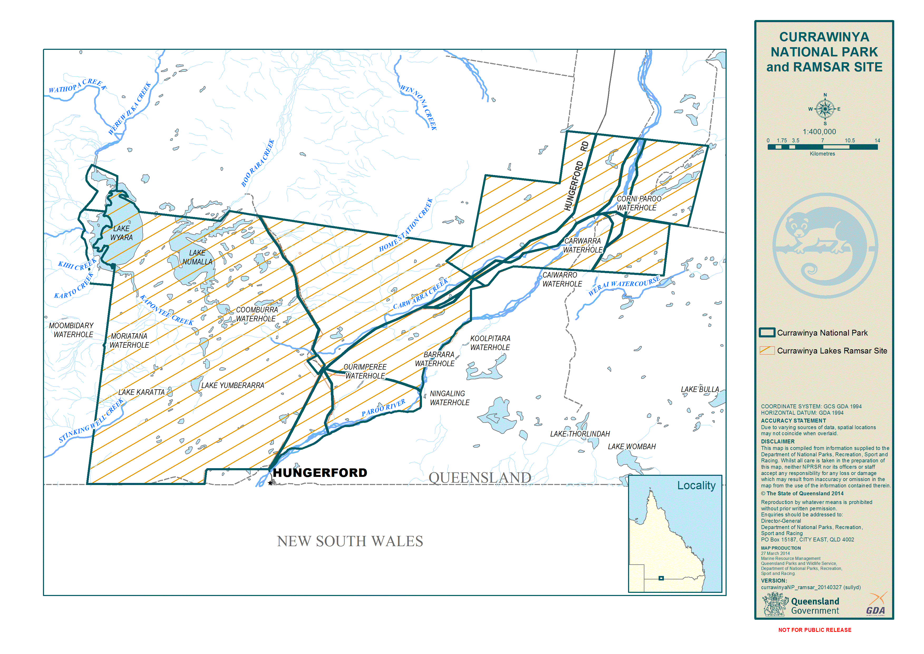

Figure 1. Map showing Currawinya National Park and the Currawinya Lakes Ramsar Site

# Internationally important values of the Ramsar site

Currawinya Lakes was listed as a Ramsar site in 1996 for its outstanding wetland values and features. It fulfilled all six of the nomination criteria available at the time (Table 1). In some cases the justification provided applies to multiple criteria.

In 2009, the draft ECD stated that the site’s ecological character has been maintained since being listed as a Ramsar site in 1996.

Table 1. Nomination criteria and justification for listing for the Currawinya Lakes Ramsar site

| Nomination criteria | | Justification |
| --- | --- | --- |
| Criterion 1 | Contains a representative, rare, or unique example of a natural or near-natural wetland type found within the appropriate biogeographic region | * The site contains one of the richest and most diverse samples of wetlands in inland Australia. * These wetlands are relatively natural (unmodified), and include those with a range of saline, freshwater, lacustrine (lake) and palustrine (swamp) attributes. The site also includes the rare wetland type, Great Artesian Basin Springs. The ecological community associated with these springs is listed as endangered under the EPBC Act. * The wetlands occur in the Mulga Lands Bioregion, which was poorly conserved until areas were selected as part of the protected area estate — Currawinya National Park was one of the first parks in the Mulga Lands, containing typical vegetation of this bioregion. |
| Criterion 2 | Supports vulnerable, endangered, or critically endangered species or threatened ecological communities (listed nationally or under international frameworks) | * The site contains Great Artesian Basin Springs. The community of native species associated with these springs is listed as an endangered ecological community under the EPBC Act. * The site supports the nationally and State threatened plant species Sclerolaena walkeri (regal pumpkin burr) — listed as vulnerable under both the NCA and EPBC Acts. * The nationally threatened bird species Rostratula benghalensis (painted snipe) — listed as vulnerable under both the NCA and EPBC Act has been recorded at the site. The fish Bidyanus bidyanus (silver perch) has also been observed on the site and is listed as critically endangered under the EPBC Act. |
| Criterion 3 | Supports populations of plant and/or animal species important for maintaining the biological diversity of a particular biogeographic region | * The diverse wetland types and range of habitats they provide are critical in supporting the high diversity of native wildlife associated with the bioregion — of particular note is the abundance and diversity of waterbird[9] species supported by Lake Wyara, Lake Numalla, the smaller lakes and floodplain wetlands. No other wetlands in arid or southern Australia are thought to support such high numbers of waterbirds consistently as Currawinya Lakes. * Over 200 bird species, 17 amphibian species, 24 mammal species and 58 reptile species have been recorded at the site. * The site also supports eight native fish species from seven families. This represents almost the entire known fish diversity of the Paroo River catchment. Poorly known within the bioregion are Bidyanus bidyanus (silver perch) which have been recorded at the site. * Permanent waterbodies, which provide a refuge at times of drought, play a vital role in maintaining biodiversity. |
| Criterion 4 | Supports plant and/or animal species at a critical stage in their life cycles, or provides refuge during adverse conditions | * The site provides habitat for waterbirds for feeding and breeding. The size and storage capacity of the lakes at Currawinya make it an important habitat at large regional scales. * Islands within Lake Wyara are particularly important for colonial breeding waterbirds such as Pelecanus conspicillatus (Australian pelican), up to 20,000 pairs, Cygnus atratus (black swan), Hydroprogne caspia (Caspian tern), Recurvirostra novaehollandiae (red-necked avocet), Chroicocephalus novaehollandiae (silver gull) and Phalocrocorax spp. (cormorants). * Permanent lakes and waterholes provide a refuge for amphibians, fish, reptiles and birds during times of drought. * The Currawinya Lakes form part of an inland route for migratory shorebirds, with Currawinya National Park being a listed site within the East Asian-Australasian Flyway Site Network. Species listed under the Convention on the Conservation of Migratory Species of Wild Animals, Japan-Australia Migratory Bird Agreement (JAMBA), China-Australia Migratory Bird Agreement (CAMBA) or Republic of Korea-Australia Migratory Bird Agreement (RoKAMBA) have also been recorded at the site. |
| Criterion 5 | Regularly supports 20,000 or more waterbirds | * The site, and in particular Lake Numalla and Lake Wyara, supports abundant populations of waterbirds, with counts in excess of 100,000 recorded. On occasions, more than 250,000 individuals have been recorded through aerial and ground surveys. |
| Criterion 6 | Regularly supports one per cent of the individuals in a population of one species or subspecies of waterbird | * The one percent population threshold has been exceeded for at least ten waterbird species: * pink-eared duck (Malacorhynchus membranaceus) * Eurasian coot (Fulica atra) * black swan (Cygnus atratus) * freckled duck (Stictonetta naevosa) * grey teal (Anas gracilis) * sharp-tailed sandpiper (Calidris acuminata) * hardhead (Aythya australis) * Australasian shoveler (Anas rhynchotis) * banded stilt (Cladorhynchus leucocephalus) * red-necked avocet (Recurvirostra novaehollandiae). |

# General characteristics of the Currawinya Lakes Ramsar site

* Contains diverse wetland types (freshwater and saline lakes, riverine channels and waterholes, ephemeral lakes, saltpans, claypans, swamps, and freshwater springs) — these have resulted from the unique geomorphology and hydrological features of the area.
* Natural hydrology of the area is considered to be the most important underlying process in maintaining wetland diversity and integrity — with the frequency, duration, size, rates of flow and timing of floods critical components.
* Demonstrates a high degree of natural variation in response to unpredictable rainfall and flooding, this being a characteristic of the semi-arid zone it occurs in.
* Paroo River system plays an important role in the flow of water throughout this landscape. The system is largely unregulated with no significant dams or weirs in the region.
* Outstanding and significant habitat for a range of important fauna species, in particular general and breeding habitat for waterbirds (including some migratory species listed under international agreements i.e. JAMBA, CAMBA and RoKAMBA).
* Contains spring wetlands fed by the Great Artesian Basin (Regional Ecosystem 6.3.23) with a Biodiversity Status and Vegetation Management Act 1999 status of endangered. The community associated with the springs is also listed as an endangered ecological community under the EPBC Act.
* Lakes, waterholes, rivers and springs are of cultural significance to Indigenous people of the area, having ceremonial and spiritual importance. A native title claim is currently active over the park and awaits determination (Budjiti People Claim No: QC07/002; Federal Court No: QUD53/07).
* Visitors are able to undertake a number of nature-based, low-impact, recreational activities associated with the wetlands. Activities such as swimming, canoeing and kayaking are permitted on Lake Numalla, but no motorised vessels are permitted on any of the lakes. Fishing is permitted in some parts of Lake Numalla and in the Paroo River.
* The site is well-studied and continues to be an important site for conducting research on: wetlands; their water levels and sedimentation rates; climate effects; archaeology, pest species management and waterbird use.
* Properties surrounding the Currawinya Lakes area are well-timbered leasehold land used for cattle and sheep grazing.

# Wetlands on the site

The nine following wetland types, according to the Ramsar classification system, occur on the site (Table 2; Figure 2):

Table 2. Ramsar wetland types on the Currawinya site

| Ramsar wetland classification | Location on Currawinya NP |
| --- | --- |
| Type N — seasonal/intermittent /irregular rivers/streams/creeks | River channel (e.g. Paroo River) and waterholes (Corni Paroo, Kyearing, Caiwarro and Carwarra), located on the floodplain[10] on the eastern part of the site. |
| Type O —permanent freshwater lakes (over 8ha) | Permanent freshwater lakes (such as Lake Numalla) and Lake Yumberrara). Lake Numalla is of particular importance for feeding waterbirds and also provides a refuge for aquatic invertebrates, fish and turtles.  Water in Lake Numalla becomes saline as drying occurs. The lake dries very infrequently (approximately once every 20 years[11]). |
| Type P — seasonal/intermittent freshwater lakes (over 8ha) | Smaller, semi- permanent lakes such as Kaponyee, Yumberarra, and Karatta. These are affected by water levels in the local catchment and the Paroo River during extreme flood events.  The lakes become more saline as they evaporate. |
| Type Q — permanent saline/brackish/alkaline lakes | Permanent salt lake (e.g. Lake Wyara). The lake fills approximately every seven years and retains water for 1-1.5 years[12].  Lake Wyara is primarily a closed lake system, only affected by extreme flood overflow (from the Paroo River). Small tributaries (e.g. Werewilka Creek) enter the lake from the northwest and it is fed by a separate catchment from Lake Numalla. It is an important breeding site for waterbirds (e.g. pelicans and black swans). |
| Type R — seasonal/intermittent saline/brackish/alkaline lakes and flats | Smaller, semi- permanent lakes such as Kaponyee, Yumberarra, and Karatta. These are affected by water levels in the local catchment and the Paroo River during extreme flood events.  The lakes become more saline as they evaporate. |
| Type Sp — permanent  Type Ss — seasonal/intermittent saline/brackish/alkaline marshes/pools | Various palustrine swamps associated with the central area and the broader Paroo River floodplain to the north east. |
| Type Ts — seasonal/intermittent freshwater marshes/pools on inorganic soils | Claypans occur in the central floodplain area. They are dependent on major flood and local rainfall events. |
| Type Y — freshwater springs | Great Artesian Basin spring wetlands. More than 70 springs in five broad groups have been identified, mostly in the Hoods Range area to the east of Lake Numalla, with isolated springs in low dunefields to the east and south of Lake Numalla. All spring groups except one contain both active and inactive mounded and non-mounded (water) springs. |

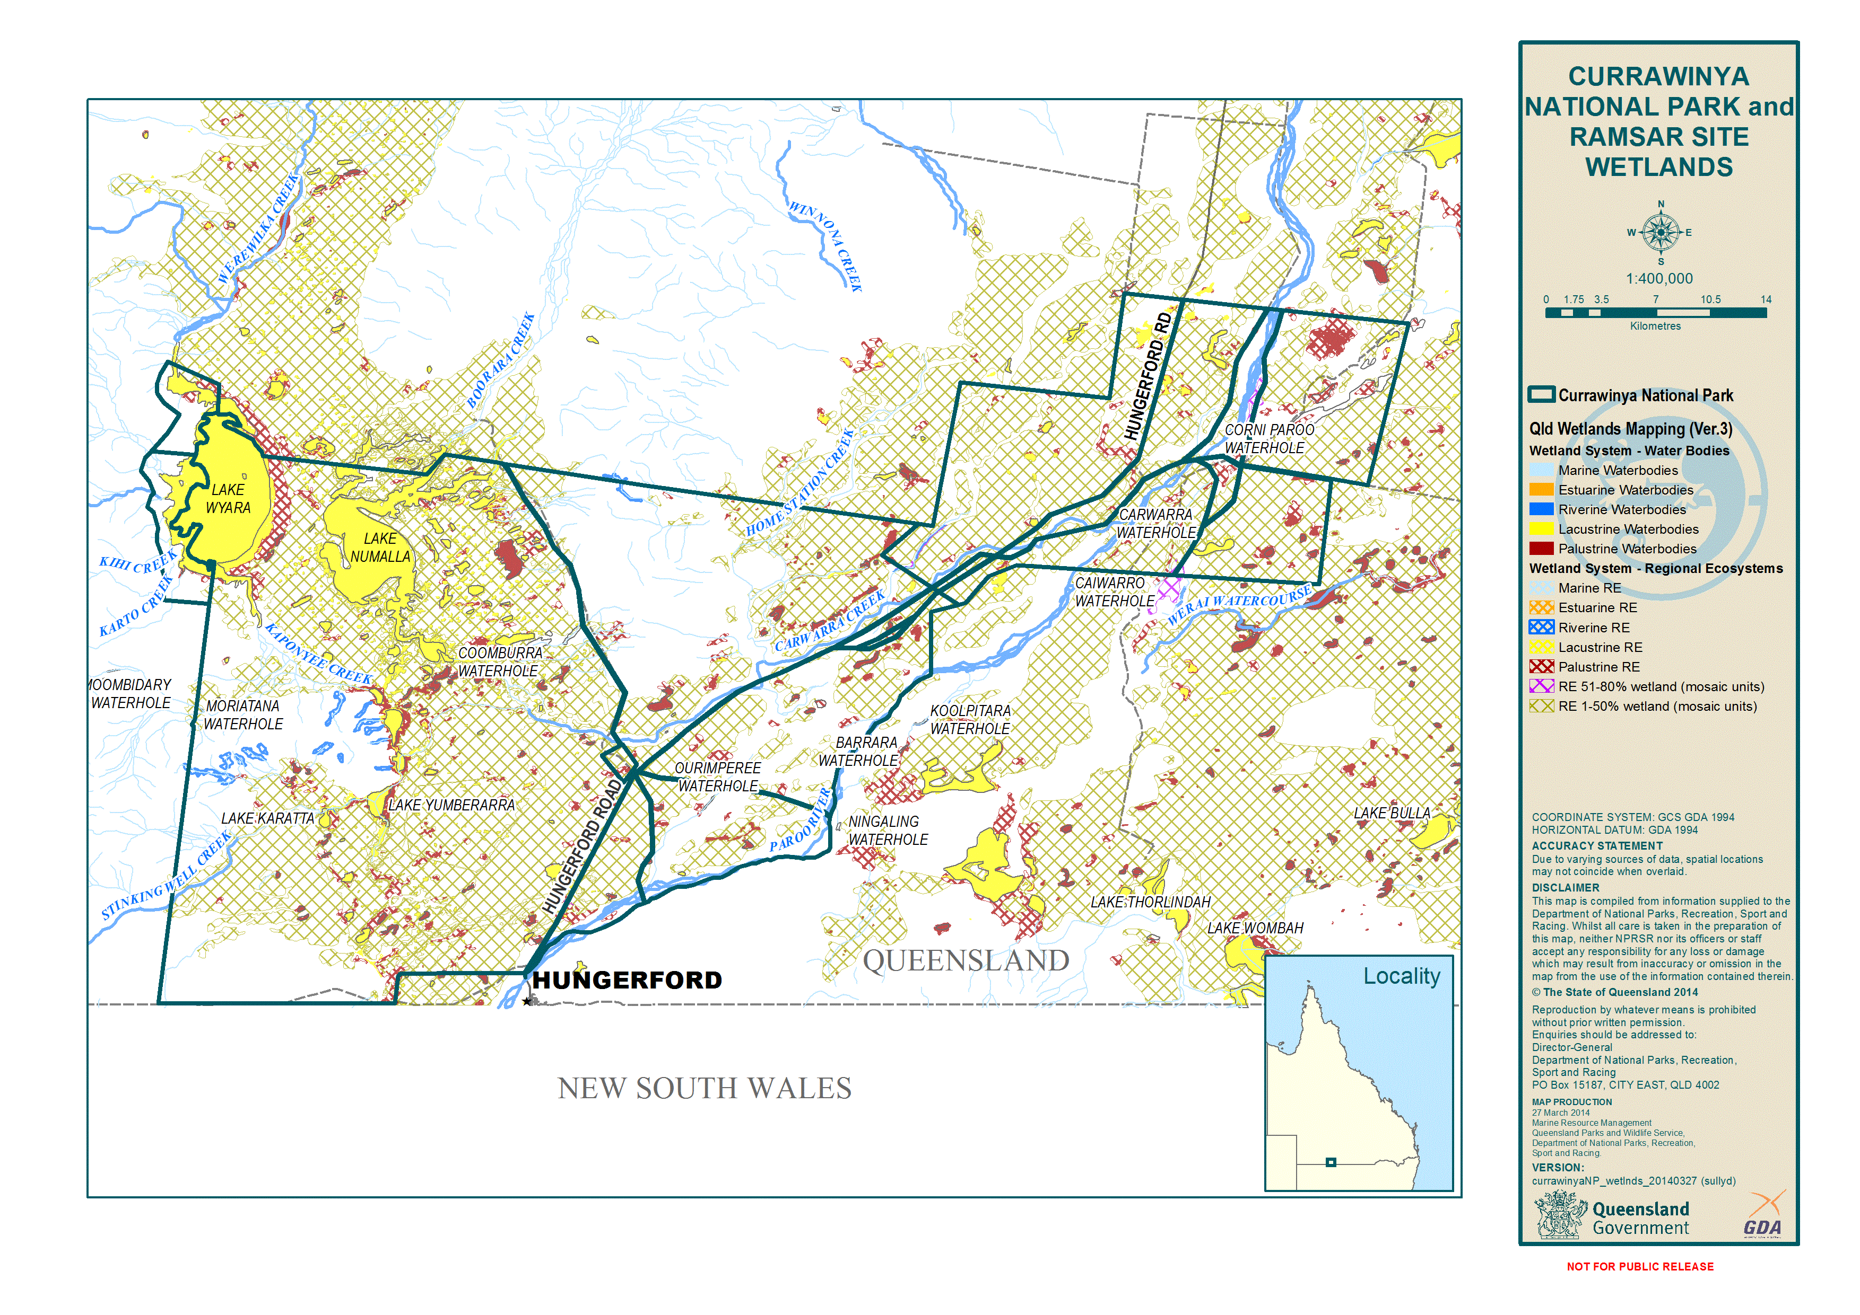

Figure 2. Wetland types mapped in Currawinya National Park

# Critical components, processes and services/benefits provided by the wetlands

The National Framework and Guidance for Describing the Ecological Character of Australian Wetlands defines the ecological character of a wetland as the combination of ecosystem components, processes, and benefits and services that characterise the wetland at a given point in time.

Components are defined as the physical, chemical and biological parts or features of a wetland. Examples include physical form (e.g. wetland type, geomorphology), wetland soils (e.g. profiles, permeability, physico-chemical properties), water quality (e.g. physico-chemical properties such as salinity, pH) and biota (e.g. flora, fauna and habitats).

Processes include all those processes that occur between organisms and within and between populations and communities, including interactions with the nonliving environment, which result in existing ecosystems and that bring about changes in ecosystems over time. Ecosystem services refer to the benefits that people receive or obtain from an ecosystem. In its broadest sense they can be thought of as key values provided by the wetlands.

For the Currawinya Lakes Ramsar site seven supporting services and two cultural services have been identified. These are shown in Tables 3 and 4, along with the habitats, processes and Ramsar criteria associated with each critical service. Cultural Criteria are recognised under the Ramsar convention (Resolution IX.21).

Conceptual models identifying the critical components, processes and services for the Currawinya Lakes Ramsar site can be found in Figures 3- 6.

Table 3. Supporting critical services/benefits on the Currawinya site

| Supporting critical service/benefit (1-7) | | Habitats associated with the Critical Service/Benefit | Processes underlying the Critical Service/Benefit | Associated Ramsar nomination criteria[13] |
| --- | --- | --- | --- | --- |
| 1 | Unique diversity of habitats with many different wetland types represented in a ‘natural’ (unmodified) form | * All wetland areas (i.e. excluding terrestrial areas — see wetland mapping for the site) | * Climatic * Hydrological regime * Geomorphologic processes such as natural sedimentation and aeolian[14] processes * Water quality and nutrient cycling * Biological processes | Criterion 1 |
| 2 | Wildlife refuge in drought conditions for amphibians, fish, reptiles and birds | * Permanent and nearly permanent lakes and waterholes | * Climatic * Hydrological regime * Geomorphologic processes such as natural sedimentation and aeolian processes * Water quality and nutrient cycling * Biological processes | Criterion 4 |
| 3 | Supports waterbird diversity, abundance and habitat | * Lake Wyara, Lake Numalla, the smaller lakes (e.g. Kaponyee, Yumberarra and Karatta) and floodplain wetlands | * Frequency, timing, size, rate of low and duration of inundation * Nutrient cycling | Criteria 3, 4 and 5 |
| 4 | Supports threatened wetland fauna | * Habitat for the painted snipe and silver perch includes: Lake Wyara, Lake Numalla, smaller lakes, waterholes and river channels, floodplain wetlands and vegetation communities | * Frequency, timing, size, rate of flow and duration of inundation | Criteria 2,3, 4 and 5 |
| 5 | Supports a notable diversity of native wetland fauna of the bioregion | * Lake Wyara, Lake Numalla, the smaller lakes, floodplain wetlands, and other terrestrial habitats | * Frequency, timing, size, rate of flow and duration of inundation * Biological Processes (e.g. extent of pest species) | Criterion 3 |
| 6 | Supports a threatened ecological community or Communities | * Great Artesian Basin Springs - each individual spring varies in shape, water flow, topographic and geographic location. | * Groundwater hydrology - occur where groundwater discharges naturally at margins or fault lines of the Great Artesian Basin. * Hydrogeological processes * Rainfall and recharge rates | Criteria 1 and 2 |
| 7 | Supports threatened plant species | * Sclerolaena walkeri occurs in and around saltpans and herblands | * Climatic (annual rainfall, consistency of seasons, annual temperature patterns) * Hydrology and flood inundation | Criteria 2, 3 and 4 |

Table 4. Cultural critical services/benefits

| Cultural critical service/benefit | | Habitats associated with the Critical Service/Benefit | Processes underlying the Critical Service/Benefit | Reasons for inclusion as a critical service/benefit |
| --- | --- | --- | --- | --- |
| 1 | Contains Indigenous cultural heritage values | The entire site but in particular:   * spring areas * Paroo River and its waterholes (such as the Corni Paroo) * the major lakes (Lake Wyara and Lake Numalla) | * Climatic * Hydrological regime * Geomorphologic processes such as natural Sedimentation and aeolian processes * Water quality * Biological processes | This site demonstrates:   * the application of traditional knowledge and methods of management that maintain ecological character * exceptional cultural traditions or records of former civilisations that have influenced the ecological character * non-material values such as sacred and ceremonial sites and their existence is linked with the maintenance of ecological character. |
| 2 | Provides for education and research on wetlands | All wetlands on the site | * As above | * Its diverse wetlands and unique setting. |

Figure 3. Conceptual model of critical services, components and processesFlow diagram of ecosystem, environmental and cultural interactions of the Ramsar site. of Currawinya Lakes Ramsar site (BMT WBM 2009). 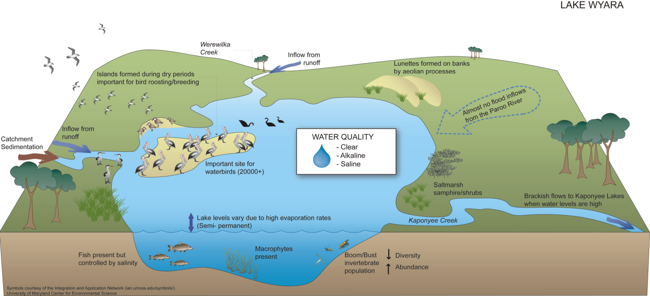

Figure 4. Conceptual model of Lake Wyara (BMT WBM 2009)

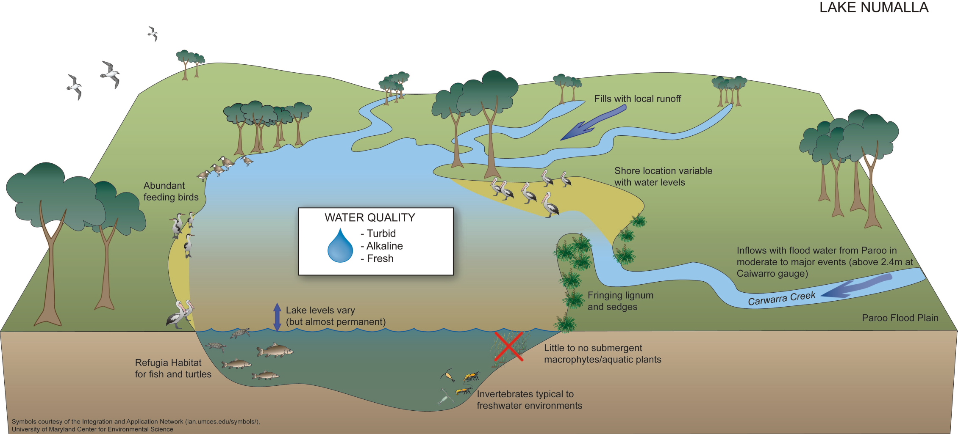

Figure 5. Conceptual model of Lake Numalla (BMT WBM 2009)

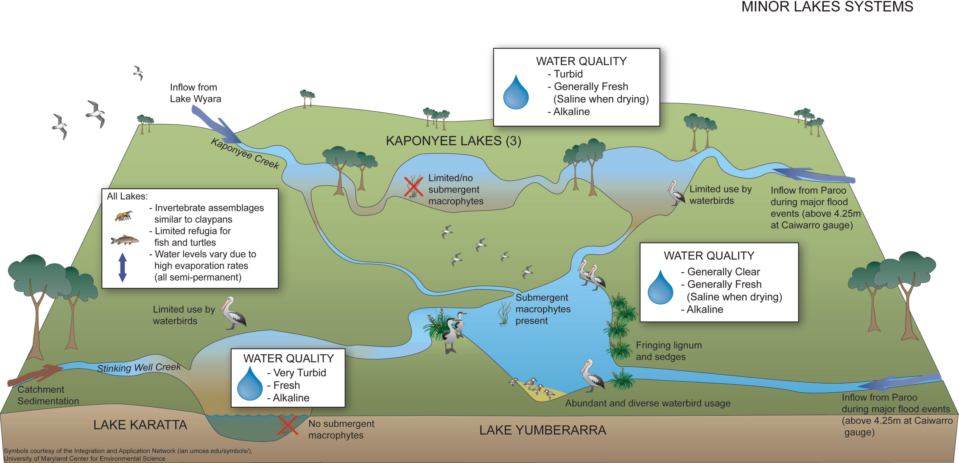

Figure 6. Conceptual model of minor lakes systems (BMT WBM 2009)

# Key threats identified to ecological character

According to the draft Currawinya ECD, the ecological character of the Currawinya Lakes Ramsar site has been maintained since being listed in 1996. However, the following broad scale medium to long term threats to the ecological character of the site have been identified in the draft ECD (Table 5).

Table 5. Possible medium to long term threats to the Currawinya Lakes Ramsar site

|  |  |  |
| --- | --- | --- |
| Threat | Risk | |
| A change to its protected area status and water flow regime | Low | * The site is currently provided a high level of protection due to its status as a national park under the NCA, and the largely natural flow regime occurring in the Paroo River. |
| Sedimentation rates in Lake Wyara and Lake Karatta | Unknown | * Sedimentation rates could impact bird breeding areas and activities. For example when water levels are low, bird breeding islands within Lake Wyara become connected to the lake shoreline allowing predators (foxes, pigs) easier access to important bird breeding areas. * Sedimentation in Lake Karatta has already resulted in an altered shape and depth of the site. However, it continues to act as a sediment basin, reducing the amount of sediment entering Lake Yumberrara. * The draft ECD suggests that a more targeted survey is required to determine the real risk and extent of this threat. |
| Climate change | Unknown | * Modelling scenarios by the CSIRO[15] for wet and dry extreme events indicate that there could be significant impacts on the Currawinya Lakes Ramsar site wetlands. This could include an increase in the frequency of large flood events (i.e. frequency and volume of inundation and reduced salinity) or extended periods of drying (resulting in hypersaline conditions). |
| Non-native fish | Unknown | * Damage to aquatic ecosystems could occur if high abundance of non-native fish (e.g. carp, goldfish and Gambusia) negatively impact native fish. * The draft ECD suggests that monitoring of non-native fish is warranted; and maintaining the natural flow regime of the Paroo River is vital in maintaining conditions in which native fish can flourish. |

Other threats that are on-going management issues for the site include invasive pests (goats, pigs, cats, foxes), visitor access and environmental weeds. Management approaches are set out in the Currawinya NP management plan (2001).

Any future activities or development that may affect Currawinya Lakes’ Ramsar values and other matters of national environmental significance must be referred under the EPBC Act for assessment.

# Management of protected areas associated with the Currawinya Lakes Ramsar site

The Currawinya Lakes Ramsar site currently covers approximately 97% of the Currawinya National Park. Therefore, management of the wetlands within Currawinya National Park should, wherever possible, be consistent with Ramsar management principles, and existing State and Commonwealth legislation, and policies and agreements relevant to the management of Ramsar sites (e.g. species of conservation concern and ecosystems, Matters of National Environmental Significance[16]).

In terms of the wetlands, particular consideration should be made to:

* The Ramsar management principles (Table 7) and Ramsar wise-use principles[17]; and
* International treaties[18] for listed migratory bird species that may be associated with wetlands (e.g. JAMBA, CAMBA and RoKAMBA).
* The Currawinya National Park being listed on the East Asian – Australasian Flyway (EAAF), as an important site along the inland flyway.

Table 7. Ramsar Management Principles[19]

|  |  |
| --- | --- |
| Management Principle | Description |
| 1 | Describe and maintain the ecological character[20] of the wetland |
| 2 | To formulate and implement planning that promotes conservation of the wetland and wise and sustainable use of the wetland for the benefit of humanity in a way that is compatible with maintenance of the natural properties of the ecosystem |
| 3 | Wetland management should provide for public consultation on decisions and actions that may have a significant impact on the wetland |
| 4 | Wetland management should make special provision, if appropriate for the involvement of people who: (a) have a particular interest in the wetland; and (b) may be affected by the management of the wetland |
| 5 | Wetland management should provide for continuing community and technical input |

Furthermore, as outlined in Schedule 6 of the Environment Protection and Biodiversity Conservation Regulations 2000, management planning should be done in accordance with the following:

* At least one management plan should be prepared for each declared Ramsar wetland.
* A management plan for a declared Ramsar wetland should:

(a) describe its ecological character

(b) state the characteristics that make it a wetland of international importance under the Ramsar Convention

(c) state what must be done to maintain its ecological character

(d) promote its conservation and sustainable use for the benefit of humanity in a way that is compatible with maintenance of the natural properties of the ecosystem

(e) state mechanisms to deal with the impacts of actions that individually or cumulatively endanger its ecological character, including risks arising from

(i) physical loss, modification or encroachment on the wetland; or

(ii) loss of biodiversity; or

(iii) pollution and nutrient input; or

(iv) changes to water regimes; or

(v) utilisation of resources; or

(vi) introduction of invasive species; and

(f) state whether the wetland needs restoration or rehabilitation

(g) if restoration or rehabilitation is needed — explain how the plan provides for restoration or rehabilitation

(h) provide for continuing monitoring and reporting on the state of its ecological character

(i) be based on an integrated catchment management approach

(j) include adequate processes for public consultation on the elements of the plan

(k) be reviewed at intervals of not more than 7 years.

A number of management actions (Table 8a and 8b) that relate to wetland or Ramsar management have been identified in existing QPWS documents for Currawinya National Park[21]. Broader management considerations such as pests, fire and visitor impacts, which can also impact on the wetlands are not included in this RMS. It should be noted that the ability of QPWS to implement these management actions is dependent on the availability of resources.

Table 8a. Management actions outlined in the Currawinya Management Plan 2001[22]

| Desired Outcome | Actions and Guidelines relevant to Ramsar wetlands |
| --- | --- |
| Native animals[23]:   * The diversity of animal species and populations of noteworthy animal species are maintained. * The habitats of all species, especially those with specific habitat requirements (such as feeding areas for migratory waders and breeding sites for the near threatened freckled duck), are protected. | * Visitor activities in sensitive areas will be strictly regulated (e.g. access to the lakes area will be restricted during peak waterbird breeding seasons). Staff access to certain areas (e.g. pelican rookeries) may also be restricted unless prior approval has been obtained from the District Manager, Charleville. * Noteworthy, i.e. near threatened and threatened native animals, will be researched and/or monitored in order to develop a better appreciation of their biology, habitat requirements, and breeding and migratory patterns. * Locations where noteworthy species have been recorded will be monitored regularly to ensure minimal disturbance to populations and associated habitats, particularly through the impacts of introduced species and human interference. * Park staff will liaise with researchers and the Queensland Museum to benefit from studies involving native animal species found within the park, and will promote research into understanding the ecological requirements and vulnerability of recognised endemic, near threatened, threatened and introduced species recorded in the park. * Park staff will liaise with appropriate research institutions and specialists to establish a broad information base and network of contacts to monitor the security of nomadic and migratory species. * Any action which has, will have, or is likely to have a significant impact on a Matter of National Environmental Significance (including a Ramsar wetland, listed threatened species and ecological communities and/or listed migratory species) should be referred to the Environment Minister to determine whether the action is subject to the Environment Protection and Biodiversity Conservation Act 1999. * Before the development of any new infrastructure, the site and its surrounds will be surveyed to identify any potential threats (e.g. water pollution, visitor access to critical habitat) to noteworthy native animal species. * Populations of noteworthy species will be retained by investigating their habitat utilisation/requirements and formulating management strategies which will promote populations and habitats (e.g. suitable fire regimes). |
| Landscape, soil, wetland and catchment protection:   * The natural scenic qualities of the park’s environment are maintained. * Degraded areas of the park are rehabilitated and further impacts in these areas have been limited. * The park is protected from the negative impacts of upstream catchment management practices and off-park land use practices. * Soil erosion and compaction damage in the national park are minimal. * The components, process and services/benefits (i.e. the site’s ecological character) of the park’s wetland systems are maintained. | * Natural hydrological processes will be permitted to continue throughout the park with a minimum of interference. * Existing soil erosion problems will be identified and, where possible, countered, using measures such as the diversion of runoff, controlling access, revegetation with local plant species, and stock/feral animal control. Flood frequency will be considered when selecting appropriate erosion control measures along watercourses. * Erosion control and rehabilitation measures will be included as part of any park developments. Accordingly, Recreation Zones will, where possible, be located on more stable soils. * Any action which has, will have, or is likely to have a significant impact on the ecological character of the Currawinya Lakes Ramsar site should be referred under the Environment Protection and Biodiversity Conservation Act 1999. In relation to lakes and wetland systems, consideration to be given to: access to and use of sites, impacts on birdlife and other native animals, impacts on the lake edge native plants, reclamation plans for degraded sites, initiating an education program to raise awareness of the significance of maintaining the integrity of the wetlands systems. * Further research and monitoring of the wetland systems will be encouraged and supported. * Any form of degradation of the park’s wetland systems attributable to human causes will be countered by changes to permitted use levels, increased patrols or other actions considered necessary. * Vehicular access will be restricted to stable areas. All tracks will be appropriately maintained, with particular emphasis given to drainage and appropriate siting of any new sections of track. * Park management staff will liaise with neighbouring landholders on conservation measures to protect the integrity of the park’s wetland systems. * Sedimentation within the wetland systems will be monitored and minimised where it is of non-natural causes. * Methods of trapping sediment will be investigated to alleviate sedimentation caused by road runoff. * An appropriate monitoring program for the assessment of water quality in the park will be developed. * Park staff will maintain knowledge of current and proposed land management practices in the larger catchment which can impact on the wetlands within the park and further downstream (e.g. water quality and flow rate, creek integrity and soil stability). |
| Resource harvesting:   * Sources of underground and surface water have been assessed and are being used appropriately. | * Avoid any actions which have the potential to significantly pollute watertables. * Monitor water quality, for consumption and environmental purposes, through standardised procedures for collection, recording and analysing of data established by the Queensland Government. * Progressively regulate underground water supplies and, where possible, use such facilities during park management activities such as firefighting and road construction. * Undertake research into the impacts that the control of water sources will have on native and introduced plant and animal species. * Any action which has, will have, or is likely to have a significant impact on a Matter of National Environmental Significance (e.g. Ramsar Wetland, listed threatened species and ecological communities, listed migratory species) should be referred under the Environment Protection and Biodiversity Conservation Act 1999. |

Table 8b. Management actions outlined in the Currawinya Management Statement 2011[24]

|  |  |
| --- | --- |
| Desired Outcome | Actions and Guidelines relevant to Ramsar wetlands (Action number) |
| Species and ecosystems of conservation significance:   * Protect the integrity and maintain ecological processes within wetland systems. * Monitor sensitive habitats and threatened species, and ensure their requirements are reflected in management programs. | * Management actions will be in accordance with Ramsar management principles (A1). * Encourage research into and monitor the distribution, abundance and habitat condition of species of conservation significance and use findings to adapt park management where appropriate (A3). * Actions from recovery plans (species or ecological communities) will be implemented where possible (A4). * Place a high priority on relationships with organisations associated with existing programs related to the conservation of significant species and ecosystems including Artesian spring wetlands (RE 6.3.23) and waterbirds – see Appendix 2. |

# Knowledge gaps

Key information gaps identified in the draft ECD for Currawinya Lakes Ramsar site are as follows:

* Resolution of different wetland typologies such that indicator/reference sites for each main wetland type can be assigned and monitored over time.
* Empirical data concerning the extent to which Paroo waterholes and more permanent lakes, such as Lake Numalla and Lake Yumberarra, provide refuge for aquatic vertebrates.
* Up-to-date systematic collection of data (since 1998) on patterns of waterbird usage in the major lake systems particularly as a drought refuge.
* Up-to-date systematic data collection (since 1998) on use of the site by the freckled duck.
* Targeted surveys in relation to the painted snipe and grey snake (data collected to date has been from broader fauna surveys).
* Systematic or regular data collection regarding vertebrate fauna (other than waterbirds).
* In the context of the artesian springs, information or data from which to assess the potential positive impact of bore capping.
* Targeted surveys for threatened plant species.
* In the context of cultural heritage services, information available regarding:

- spatially definable sites of cultural heritage significance;

- extent of current knowledge systems and identification of these systems associated with wetland types; and

- extent of traditional management systems/practices being implemented that may have an impact on the ecological character of the wetland.

* Greater verification of field observations about the frequency and duration of inundation at the major lakes and waterholes from Paroo River in-flows.
* The relationship between ecological communities, hydrology and water quality in the major lakes systems at full, half full and near empty levels such that longer term trends on hydrology and water quality from climate change can be assessed.
* The extent, rate and implications of sedimentation in Lake Wyara, with specific consideration of impact on bird breeding islands.
* Implications of climate change on the hydrology and ecology of the site.

# Monitoring recommendations

The draft ECD proposes monitoring recommendations (Table 9). These recommendations recognise the limitation of physical and financial resources. The recommendations may have to be adopted by agencies outside of or in partnership with QPWS and may be dependent on available resources and state wide priorities.

A comprehensive monitoring plan for the Ramsar site is provided in Appendix B of the draft ECD. The activities outlined cover:

* Lake and water ecology, hydrology and water quality (Theme 1)
* Sedimentation and breeding birds in Lake Wyara (Theme 2)
* Wetland reference sites for waterbirds, threatened flora and fauna surveys (Theme 3).

Table 9. Monitoring priorities for the Currawinya Lakes Ramsar site[25]

| Ramsar monitoring objectives | Recommended monitoring activities | Reason for monitoring |
| --- | --- | --- |
| Detecting change in ecological character | * Periodic observation of wetland features (e.g. water levels, changes in topography, drainage and flow paths, flora assemblages including weed presence, wildlife surveys). * Water quality/condition measurements in the major water-bodies (e.g. salinity, pH, dissolved oxygen and turbidity). * Sampling of fish and invertebrates periodically (e.g. every 5-10 years). * Targeted survey of threatened flora and fauna (e.g. every 5-10 years). * Periodic counts of breeding and feeding waterbirds with a particular focus on those listed under Ramsar Criterion 6 (i.e. pink-eared duck; Eurasian coot; black swan; freckled duck; grey teal; sharp-tailed sandpiper; hardhead; Australasian shoveler; banded stilt; red-necked avocet). | Baseline monitoring to facilitate determining whether an observed change is within natural limits or not. |
| Flood flows and water quality | * Installation of flood gauge at Lake Numalla — to determine flow volumes and river heights. * Installation of graduated poles in minor lakes (Yumberarra, Karatta and Kaponyee) — to observe depth changes. * Salinity, Turbidity, pH, and dissolved oxygen measurements for lakes at full, half and near empty levels (Wyara, Numalla, Yumberarra, Karrata, Kaponyee and permanent waterholes). * Examine community structure and condition indicators:   - macroinvertebrate composition and abundance;  - Ruppia sp. and other macrophyte sampling (in Lake Wyara and Yumberarra);  - fish and turtle (species, size classes and abundance) | Maintenance of hydrological processes, and flood inflows from the Paroo River system are fundamental to all critical services and habitats. |
| Sedimentation in Lake Wyara | * Sediment core sampling in the western part of the lake, at the mouth of inlets. * Installation of graduated poles near the bird breeding island (to assist depth observations). * Conduct bird surveys on the bird breeding island and correlate them with water levels over time. | To determine the impact of the extent and rate of sedimentation on bird breeding islands within Lake Wyara. |
| Presence and trends in non-native fish | * Monitoring of fish populations, and the ratio between native and non-native species. * Monitor effects of predation by waterbirds on non-native fish. | To ascertain the potential damage/health of aquatic ecosystems; and determine the effect of non-native fish on waterbirds. |

# Communication, education and awareness for the Ramsar site

Where possible the following considerations and key messages related to the Currawinya Lakes Ramsar site should be reflected and integrated in the public contact and interpretive material prepared for Currawinya National Park (e.g. web information, brochures, factsheets, signs).

1. That Currawinya Lakes is a Wetland of International Importance, listed under the Ramsar Convention.
2. The uniqueness of the area, and the diversity and naturalness of the wetlands and habitats provided within the national park and associated Ramsar site.
3. The importance of the natural hydrological regime in maintaining the wetlands and their associated Ramsar values.
4. The scientific research and educational significance and opportunities provided by the site/national park.
5. The importance and functioning of the site/national park as a refuge for birds and other wildlife during times of drought, and as habitat for migratory birds.

In addition, the following principles in relation to communication, education and awareness messages for wetlands are recommended[26].

a. Ensure tourism or recreational activities in or in proximity to wetlands do not detract from the Ramsar wetland values, or inappropriately disturb wetland-dependant wildlife. For example:

* When developing strategies and actions relating to tourism and visitor use and management, this should be reflected in the designation of management zones and the visitor capacity allowed in the wetland and its surrounds.
* Where sensitive or threatened wetland values occur at Ramsar sites or other conservation significant wetlands (e.g. disturbance of migratory birds), the management zone status should be based on the conservation of natural values.

b. Develop community and landholder awareness of, and respect for, the values and benefits of wetlands; and involve them in their management. For example:

* Ensure people who have a particular interest in the wetland or who may be affected by wetland management are consulted during the development of management plans for areas containing Ramsar sites, particularly where these provide a hydrological or ecological connectivity in the landscape.
* Ramsar wetlands should be included in interpretive information for an area, as well as any interpretation section of a management plan. Interpretive information (including information available on the Department of National Parks, Recreation, Sport and Racing (NPRSR) website, on signs or in brochures) and actions within management plans should enhance tourism and visitor experiences, knowledge and appreciation of the wetlands.
* Management plans should support opportunities to develop partnerships with organisations and that will foster education and research into wetlands.

c. Consider the establishment and operation of strategically located wetlands interpretation and education centres.

* Interpretive material (including information available on the NPRSR website, on signs or in brochures) for QPWS managed areas containing Ramsar wetlands should highlight the significance, value and benefits of the wetlands to enhance tourism and visitor experiences, and knowledge and appreciation of the site.

# References

Australian Government 2013, Australian Ramsar Wetlands, Australian Government, Department of Sustainability, Environment, Water, Population and Communities, <http://www.environment.gov.au/cgi-bin/wetlands/ramsardetails.pl?refcode=43> , viewed February 2013.

Australian Government 1999, Currawinya: Information Sheet on Ramsar Wetlands, Australian Government, Department of Sustainability, Environment, Water, Population and Communities. <http://www.environment.gov.au/water/topics/wetlands/database/pubs/43-ris.pdf> , viewed February 2013.

BMT WBM 2009, Draft Ecological Character Description of the Currawinya Lakes Ramsar Site, prepared for the Queensland Government, Environmental Protection Agency, Brisbane, Australia.

QPWS 2001, Currawinya National Park Management Plan, Queensland Government, Queensland Parks and Wildlife Service, Brisbane, Australia.

QPWS 2011, Currawinya National Park Management Statement, Queensland Government, Queensland Parks and Wildlife Service, Brisbane, Australia.

QPWS 2013, QPWS Guideline: State-wide principles for wetland planning and management on protected areas and other lands managed by QPWS, Queensland Government, Queensland Parks and Wildlife Service, Brisbane, Australia.

# Appendix 1 - State-wide principles for wetland planning and management on protected areas and other lands managed by QPWS

# Appendix 2 - Endangered and of concern regional ecosystems associated with wetlands on Currawinya National Park

|  |  |  |  |
| --- | --- | --- | --- |
| Regional ecosystem (RE) number | Description | Biodiversity status* | Wetland type associated with RE** |
| 6.3.1 | Eucalyptus camaldulensis woodland | Of concern | Riverine wetland or fringing riverine wetland |
| 6.3.3 | E. camaldulensis +- E. coolabah +- E. populnea +- Acacia stenophylla woodland | Of concern |
| 6.3.8 | E. largiflorens +- A. cambagei woodland | Of concern | Palustrine wetland (e.g. vegetated swamp). |
| 6.3.10 | Halosarcia spp. open succulent shrubland on alluvium | Of concern |
| 6.3.11 | Eleocharis pallens +- short grasses +- Eragrostis australasica open forb land. | Of concern |
| 6.3.23 | Springs on recent alluvia, ancient alluvia and fine-grained sedimentary rock | Endangered |

* The Biodiversity Status: used by the Queensland Government for a range of planning and management applications (including protected area management planning) — it is based on an assessment of the condition of remnant vegetation and associated threats.

** Wetland type: the wetland type (descriptor) associated with an individual RE.

1. Wise use - the maintenance of their ecological character, achieved through the implementation of ecosystem approaches, within the context of sustainable development.
2. Ecological character —the combination of ecosystem components, processes, benefits, and services that characterise a wetland.
3. Protected area **—** refers to the classes of protected areas defined under the *Nature Conservation Act 1992*, managed by QPWS; and including national parks, conservation parks and resources reserves.
4. Ecological Character Description of Currawinya Lakes Ramsar site (final report) — draft 2009
5. Ramsar Information Sheet (RIS)— http://www.environment.gov.au/water/topics/wetlands/database/pubs/43-ris.pdf
6. Ramsar area at date of listing (11 March 1996)
7. Declared under the Nature Conservation Act 1992 (NCA)
8. Includes a 3,570 ha extension to the north west corner of the park in 2008
9. Waterbirds — describes a large and varied group of birds that are ecologically tied to bodies of water for some part of their lifecycle. Waterbirds may be migratory or non-migratory (resident). They come from the six major orders: Aniseriformes, Podicipediformes, Pelecaniformes, Ciconiiformes, Gruiformes, and Charadrifformes.
10. Floodplains are not considered a wetland type under the Ramsar classification system. However, floodplains in the eastern portion of the site contribute to the hydrology of the site during flood events.
11. According to Timms, B.V (2006). The geomorphology and hydrology of saline lakes of the Middle Paroo, arid- zone Australia. *Proceedings of the Linnean Society of New South Wales* 127: 157-174.
12. According to Timms, B.V (2006). The geomorphology and hydrology of saline lakes of the Middle Paroo, arid- zone Australia. *Proceedings of the Linnean Society of New South Wales* 127: 157-174.
13. Refer to Table 1
14. Aeolian refers to winds ability to shape the earth through erosion and the deposition of materials.
15. CSIRO (2007). Water availability in the Paroo. A report to the Australian Government from the CSIRO Murray-Darling Sustainable yields project. Canberra.
16. Matters of national environmental significance (NES) are recognised under the Environment Protection and Biodiversity Conservation Act 1999. They include: Ramsar wetlands; migratory species listed under international treaties; the Great Barrier Reef Marine Park; EPBC Act listed threatened species and ecological communities; Commonwealth marine areas; world heritage properties; national heritage places; and nuclear actions.
17. The wise use of wetlands is defined by the Ramsar Convention as "the maintenance of their ecological character, achieved through the implementation of ecosystem approaches, within the context of sustainable development" <http://www.ramsar.org/pdf/lib/lib_handbooks2006_e01.pdf>.
18. These are treaties between the Australian Government and governments of other countries that aim to protect and conserve migratory bird species and their habitats.
19. Ramsar management principles are outlined in Schedule 6 of the *Environment Protection and Biodiversity Conservation Regulations 2000.*
20. Ecological character: the combination of ecosystem components, processes, benefits, and services that characterise the wetland.
21. Currawinya National Park Management Plan 2001; Currawinya National Park Management Statement 2011.
22. Desired outcomes and actions taken directly from the Currawinya National Park Management Plan 2001.
23. Native in this context is also includes migratory birds that inhabit the site that are not technically native animals.
24. Desired outcomes and actions taken directly from the Currawinya National Park Management Statement 2011.
25. Monitoring priorities as recommended in the Currawinya Lakes Ramsar site draft ECD.
26. Communication, education and awareness messages based on the QPWS guideline “State-wide principles for wetland planning and management on protected areas and other lands managed by Queensland Parks and Wildlife Service (QPWS)”(Attachment 1: Principles 10-12)