Data on exports of Australian wastes 2018-19

1 November 2019 (version 2)

Joe Pickin and Jenny Trinh[1]

This analysis examines exports of waste-derived materials from Australia to all countries in 2018-19. The export tonnages and values reported are Australian Border Force data obtained via the Australian Bureau of Statistics. Nearly all the materials discussed are recovered from our waste streams for recycling or energy recovery, but a small portion is hazardous waste sent for treatment. This document uses the terms ‘wastes’ and ‘waste-derived’ to include all these materials.

Background

Exports of waste-derived materials came to public prominence after China made a series of announcements in 2017 and 2018 that restricted the import of certain materials if contaminated above a threshold contamination rate of 0.5%, and established a staged ban for 32 material types. The first wave of the bans took effect from 31 December 2018, covering 16 material codes that were previously restricted. Another 16 materials are expected to be banned from 31 December 2019.

Following China’s lead, several Asian countries subsequently ramped up import regulations for waste-derived materials. India and Taiwan introduced bans on the import of waste-derived plastics; Malaysia and Thailand are expected to do so from 2021; and Vietnam from 2025. Inspections of imported waste-derived materials have also increased in a number of countries. Recent reports suggest 210 tonnes of contaminated waste exports from Australia are to be returned.

The restrictions have had global consequences, reducing prices for recycled plastics, paper and cardboard and causing market blockages, stockpiling and some instability in the provision of domestic collection services. This is being referred to as the recycling crisis.

Annual trends in exports of waste-derived materials

Figure 1 displays the tonnage of exports of wastes to all destinations over a 12-year period from 2006-07 to 2018-19. The recycling crisis cannot be easily seen in the tonnage quantities shown in this chart – total quantities increased in all recent years and reached 4.44 Mt in 2018-19, which was 0.15 Mt (0.3%) higher than in 2017-18. However, most of the recent increase was in scrap metals, which were at their second highest level in the 12-year timeframe. Metals have not been greatly affected by the recycling crisis. Exported quantities of scrap plastics and paper and cardboard peaked in 2015-16. In 2018-19, paper and cardboard quantities were 27% below that peak and plastics 7% lower.

Figure 2 shows exports of waste to China[2] only over the same timeframe. Here, the effect of the restrictions on plastics, paper and cardboard and, to a lesser extent metals, is readily apparent.

Figure 3 shows the value of Australian exports of waste-derived materials over the same timeframe. The total value rose strongly from 2015-16 to reach $3.19 billion in 2018-19. This is $A347 million (12%) higher than the previous year, and is despite a 7.8% fall in the average value of the Australian dollar against the US dollar, in which currency most trades occur. Scrap metals represented 68% of the value of 2018-19 exports. Between 2015-16 and 2018-19 the value of exports of scrap plastics fell by 38% and paper and cardboard by 5%. There were strong increases in the value of exported hazardous wastes (mainly metal processing wastes) and ‘other’ wastes (mainly organics).

Figure 1 Exports of waste from Australia by financial year and type, 2006-07 to 2018-19 (millions of tonnes)

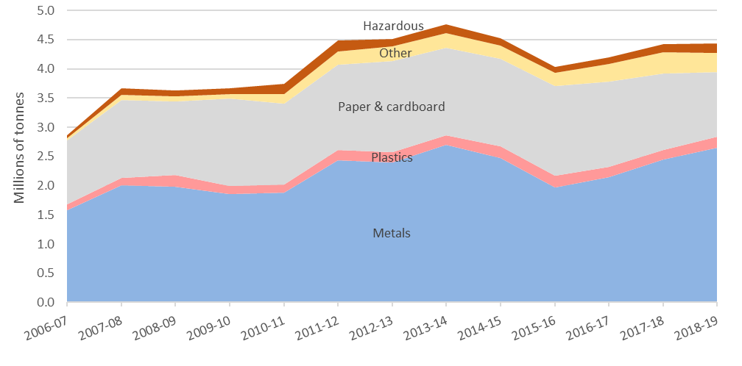

Figure 2 Exports of waste from Australia to China by financial year and type (millions of tonnes)

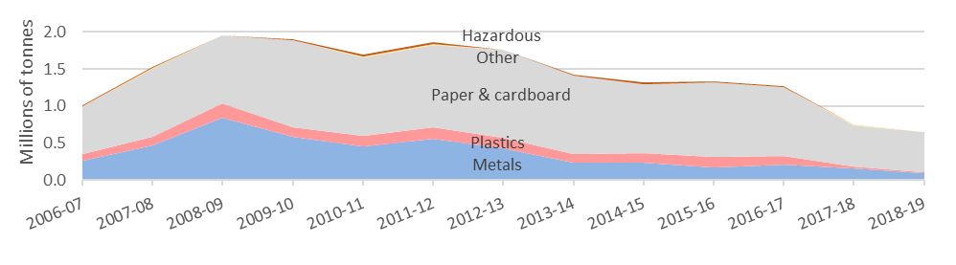

Figure 3 Value of exports of waste from Australia by financial year and type (billions of dollars)

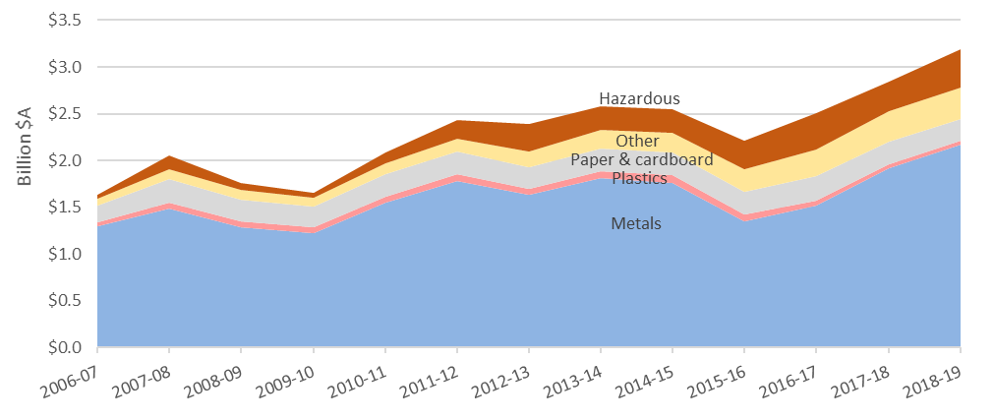

Figure 4 examines the trend in exports of paper and cardboard over the past five years. It distinguishes exports to China (on the left) from those to other destinations (on the right) and shows material grade. The figure shows a large fall in the exports of low-grade unsorted materials – which are mainly from domestic recycling – to China, but diversion of much of this quantity to other destinations (mainly India, Thailand and Indonesia). Exports of both mechanically pulped papers (newsprint) and bleached chemical (office paper) declined to all destinations. Unbleached kraft (old corrugated containers) is little changed.

Figure 4 Exports of scrap paper and cardboard from Australia to China and other destinations by financial year (thousands of tonnes)

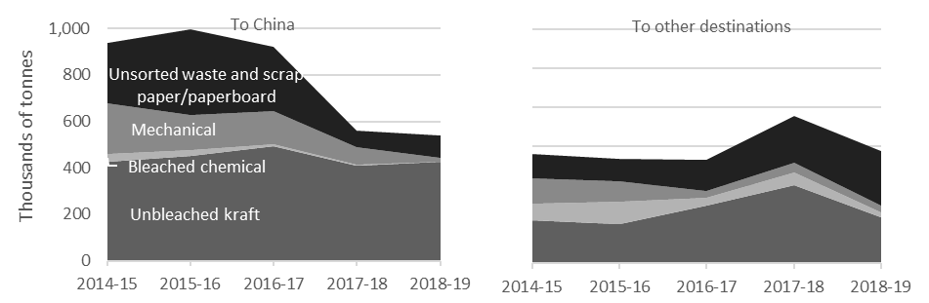

The material type most affected by the recycling crisis is scrap plastics. Figure 5 examines the trend in exports of plastics over the past five years, displaying exports to China on the left and to other destinations on the right, and showing the export grades. The largest export grade is mixed plastics (unsorted mixed materials from domestic recycling collections) followed by polymers of ethylene (PET and HDPE). China was the largest market for these materials until 2016-17. Subsequently, quantities to China plummeted but were diverted to other Asian destinations, mainly Indonesia and Malaysia. The quantities of waste-derived plastics exported in 2018-19 were 18% higher than the year before but still 7% lower than the quantity in 2014-15.

Figure 5 Exports of waste plastic from Australia to China and other destinations by financial year (thousands of tonnes)

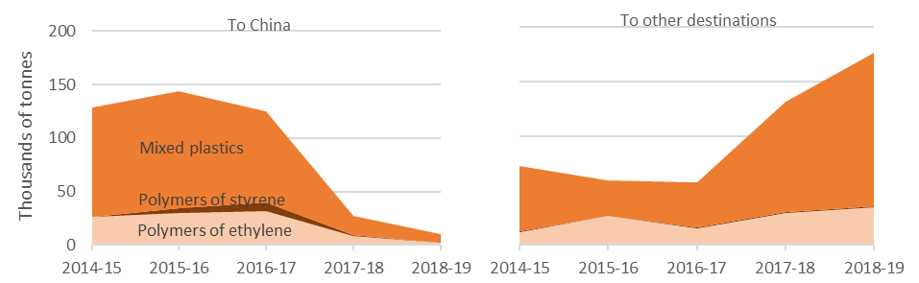

Figure 6 shows exports of all waste-derived materials by destination over the past five years, ranking the six destinations that received the most materials in 2018-19.

China was the top ranked destination in the first four years but was overtaken in 2018-19 by Vietnam and Indonesia. All the countries listed other than China saw increases in volumes over the five-year timeframe, suggesting that materials formerly sent to China were dispersed across these countries.

Figure Exports of waste from Australia by financial year, showing the top six recipient destinations (millions of tonnes)

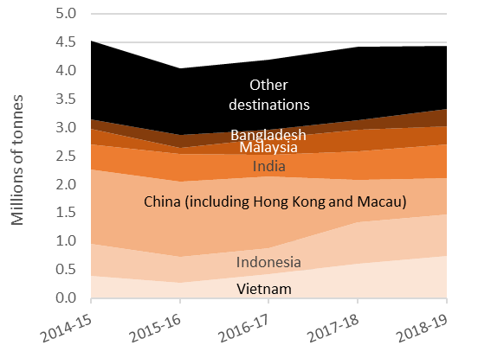

2018-19 in focus

Figure 7 shows monthly exports of waste-derived materials by category. The figure contains two charts with different vertical axes so that the pattern for each material can be readily seen.

Starting with the chart to the left, metals quantities were the most variable, due to uneven quantities of the ferrous scrap and mixed metal waste grades. The top destinations – Vietnam, Indonesia and India – received 1.15 million tonnes (58%) over the year. Monthly exports of scrap paper and cardboard remained level in 2018-19. China was the biggest recipient, accepting 540,400 tonnes (48%). Plastics also remained consistent. Indonesia and Malaysia were the top recipients at 118,000 tonnes (63%) over the year.

The chart to the right shows hazardous and other waste exports. The hazardous category, comprising mainly metal processing wastes and end-of-life tyres, remained relatively stable. The ‘other’ category varied widely, mainly due to varied quantities of organics. This category also includes glass and textiles.

Figure 7 Monthly trend of total exports by material, 2018-19 (thousands of tonnes)

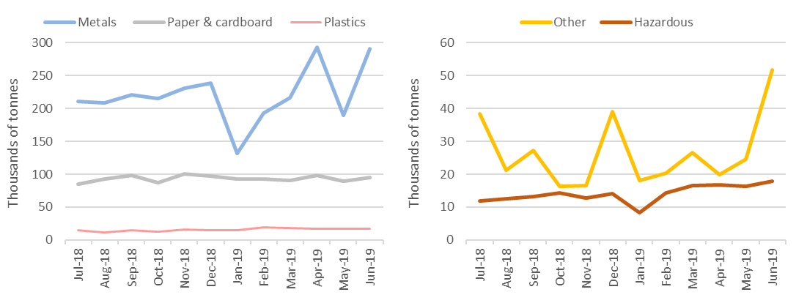

Figure 8 shows exports from Australia in 2018-19 by month, again ranking the six destinations receiving the most materials in the year (ranked from the bottom). Vietnam was our biggest export destination, mainly due to receiving large quantities of scrap metals.

Figure 8 Exports of waste from Australia by destination and month, 2018-19 (thousands of tonnes)

Australia’s 2018-19 exports of waste-derived materials were exported from ports in the jurisdictions shown in Figure 9. The fact that material was exported from a jurisdiction does not necessarily mean it was generated within that jurisdiction – it may have been transported from interstate. In 2018-19 Queensland exported the most metals, Victoria the most paper and cardboard and NSW the most plastics.

Figure 9 Australian 2018-19 waste exports by jurisdiction of origin (thousands of tonnes)

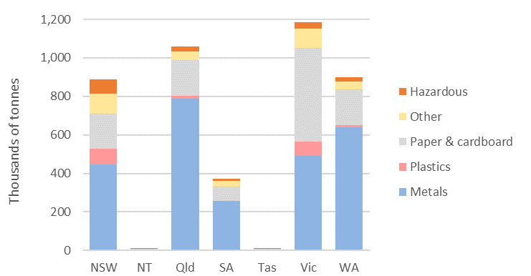

Figure 10 presents monthly trends in the unit prices of key waste-derived material exports over 2018-19. Comparing the start and end of the year, average prices for metals declined by 25%; paper and cardboard by 19%; and plastics by 7%. However, 2018-19 average prices for metals and paper and cardboard exceed those for 2017-18. Plastics, on the other hand, were 14% lower, mainly due to falling prices for mixed plastics.

Figure Comparison of unit prices by material, July -June 2018-19 ($/tonne)

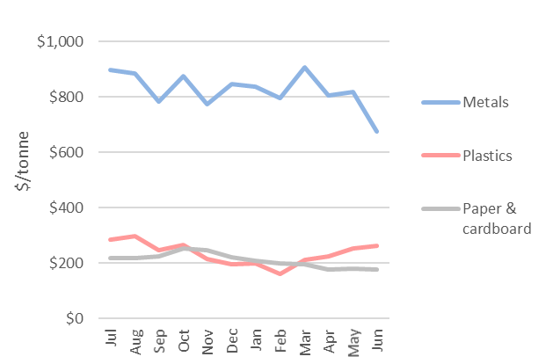

June 2019 in focus

In June, Australia exported about 473,000 tonnes of waste-derived materials with a reported value of A$272 million. Compared with May, this is a 41% increase in quantity and a 10% increase in the value. Bangladesh was the top receiver of waste-derived exports for the month, receiving mostly scrap metals. Vietnam ranked second highest followed by Malaysia. Waste exports increased across each material type. The largest increase was in scrap metals (53%). Plastics exports increased slightly by 2%, paper and cardboard by 7%, hazardous waste by 10%. Exports of ‘other wastes’ increased sharply mainly due to higher exports of organic materials.

Context – Australian waste exports compared with overall waste flows

The most recent published national data (2016-17) had Australia generating 67 million tonnes (Mt) of waste, sending 55% (37 Mt) to recycling, 3% to energy recovery and nearly all the remainder to disposal in landfill and incineration. In 2018-19 Australia exported 4.44 Mt of waste-derived materials, representing about 12% of national recycling and 7% of national waste generation. Table 1 compares quantities recycling in Australia with exports of waste materials, noting that nearly all exports are destined for recycling or energy recovery. The hazardous and ‘other’ categories are combined because the proportions of both are low.

The table suggests that 2018-19 exports encompassed most recovered metals and plastics and a third of recovered paper and cardboard. Nearly all other recovered materials were recycled in Australia. These encompass a wide range of materials but the majority of the tonnes were demolition materials, organic wastes and fly ash from coal-fired power stations. Only about 12% of materials collected for recycling were exported.

Table 1 Data comparing Australian exports and overall recycling of wastes

|  |  |  |  |  |  |  |
| --- | --- | --- | --- | --- | --- | --- |
| Waste material type | Recycled in 2016-171 | Exported in 2018-19 | | | Exported to China in  2018-19 | |
| ***(thousands of tonnes)*** | ***(thousands of tonnes)*** | ***(millions of dollars of value)*** | ***(percent of 2016-17 recycling)*** | ***(thousands of tonnes)*** | ***(percent of all exports)*** |
| Metals | 4,982 | 2,643 | $2,166m | 53% | 92 | 3% |
| Paper & cardboard | 3,361 | 1,118 | $235m | 33% | 540 | 48% |
| Plastics | 306 | 187 | $43m | 61% | 10 | 6% |
| Other, incl. hazardous | 28,381 | 488 | $744m | 2% | 3 | 1% |
| **All wastes** | **37,030** | 4,436 | $3,188m | 12% | 646 | 15% |

*Notes:*

*1 The most recent published national data set (2016-17), taken from the* [National Waste Report 201](http://www.environment.gov.au/protection/waste-resource-recovery/national-waste-reports/national-waste-report-2018)8. *Comprises materials entering recycling processes.*

Australian waste export bans

On 9 August 2019 the Council of Australian Governments agreed Australia should establish a timetable to ban the export of waste plastic, paper, glass and tyres, while building Australia’s capacity to generate high value recycled commodities and associated demand. Government leaders tasked Environment Ministers to advise on a proposed timetable and response strategy. The relevant export codes and reported 2018-19 tonnages and values are given in Table 2. Should the COAG export bans apply to all waste-derived glass, paper and cardboard, plastics and tyres, this would impact about 1.4 million tonnes with a value of $291 million, based on exports during 2018-19.

Table 2018-19 exports of waste-derived materials assumed to be subject to the proposed Australian export bans (reported quantity and value)

|  |  |  |  |  |  |
| --- | --- | --- | --- | --- | --- |
| Material | AHECC code | Description | Quantity (thousands of tonnes) | | Value (thousands of dollars) |
| Glass1 | 70010000 | Cullet and other waste and scrap of glass; glass in the mass | | 16 | $716 |
| Paper & cardb’d | 47071000 | Recovered (waste and scrap), unbleached, kraft paper or paperboard or corrugated paper or paperboard | | 661 | $135,403 |
| 47079000 | Waste and scrap paper or paperboard (incl. unsorted waste & scrap) (excl. unbleached kraft or corrugated (470710); that made mainly from bleached chemical pulp, not coloured in the mass; or made mainly of mechanical pulp) | | 378 | $74,972 |
| 47073000 | Recovered (waste and scrap) paper or paperboard, made mainly of mechanical pulp (for example, newspapers, journals and similar printed matter) | | 54 | $17,696 |
| 47072000 | Recovered (waste and scrap) paper or paperboard, made mainly of bleached chemical pulp, not coloured in the mass | | 26 | $7,038 |
| 47062000 | Pulps of fibres derived from recovered (waste and scrap) paper or paperboard | | 0.01 | $11 |
| Plastics | 39159092 | Waste, parings and scrap, of plastics (excl. those of polymers of ethylene, styrene or vinyl chloride)2 | | 150 | $31,349 |
| 39151000 | Waste, parings and scrap, of polymers of ethylene2 | | 36 | $11,374 |
| 39152000 | Waste, parings and scrap, of polymers of styrene2 | | 1.2 | $680 |
| 39153000 | Waste, parings and scrap, of polymers of vinyl chloride2 | | 0.1 | $35 |
| Tyres3 | 40040000 | Waste, parings and scrap of rubber (excl. of hard rubber) and powders and granules obtained therefrom | | 85 | $3,644 |
| 401220004 | Used pneumatic rubber tyres, whether or not subject to recutting or regrooving | | 17 | $7,829 |

1 Included in this report in the waste category ‘other’

2 Excluding those of a single thermoplastic material, transformed into primary forms

3 Included in this report in the waste category ‘hazardous’

4 This code is assumed to comprise 98% waste-derived. Other codes are assumed to be 100% waste-derived.

Analysis

The disruption to domestic recycling caused by Asian restrictions on imports of waste-derived materials continues, as demonstrated by the recent problems at SKM Recycling in Victoria. Scrap plastics, paper and cardboard are the most affected materials, especially lower grade mixed products. The exported tonnes of scrap plastics nevertheless increased in 2018-19 as alternative markets were identified, but some of these destinations are now tightening their requirements (see Table 3).

Exports of scrap plastics and scrap paper and cardboard both peaked in 2015-16. Since then, tonnages of exported plastics are down about 7% but their value is down 38%. In contrast, paper and cardboard tonnages are down about 27% but their value is down only 5%, suggesting some substitution of higher-grade materials in export markets with lower-grade product presumably being used onshore. Considerable quantities of scrap paper and cardboard continue to be exported to China, leading to a stabilisation of waste exports to China since the major falls in 2017-18.

Table Status of waste import restrictions

|  |  |  |  |  |  |  |
| --- | --- | --- | --- | --- | --- | --- |
| Country | Scope of restrictions | Announced & implemented | Associated exports (tonnes) | | | Impact and uncertainties |
| **Types** | **2017-18** | **2018-19** |
| China  (incl. Hong Kong and Macao) | Restricted the import of certain materials covering specific commodity codes, mainly by specifying a threshold contamination rate of 0.5%[3].  A ban (issued in April 2018) on the import of 32 varieties of solid waste codes which were previously restricted. 16 of these are banned from 31 December and the other 16 to take effect from 31 December 2019[4]. A recent revision suggests these bans may be replaced by material standards[5].  Further restrictions on metals imports flagged in Dec. 18[6] | Ann.: Jul & Nov-17, Apr-18.  Impl.: Jan & Mar-18, Dec-18, Dec-19 | Plastic, paper, metals, other | 744,300 (62,000/month) | 645,200 (53,800/month) | Apparent impact evident for plastics (-60%) and metals (-40%) export from Australia. |
| India | Import of scrap plastics banned from August 2019[7]. Also covers areas that were previously exempt under the 2016 ban such as special economic zones (SEZ) and export-oriented units (EOU)[8]. Excludes electrical/electronic assemblies or components that are defective which can be imported within a year of export. | Ann.: Mar-19  Impl.: Mar-19, Aug-19 for importers currently exempt under SEZs and EOUs. | Plastic | 800 (70/month) | 700 (60/ month) | No impact apparent. |
| Indonesia | All imported scrap paper must be inspected, similar to steel and plastic. A maximum 0.5% contamination rate applies, however there are plans to adopt the Institute of Scrap Recycling Industries specifications for recovered paper imports, that is 1-2% for prohibitive materials and 3-4% for outthrows[9][10][11]. Illegally imported plastic waste to be returned back to exporters[12]. In July 2019, reportedly rejected eight containers (210 tonnes) of ‘contaminated’ paper and plastic material from Australia. | Ann.: Apr-19  Impl.: Apr-19 | Paper, plastic | 326,700 (27,200/month) | 221,800 (18,500/month) | Apparent impact evident for paper and cardboard export from Australia (-46%). |
| Malaysia | Import permits revoked from 114 factories that process imported plastic waste[13],[14]. Import of non-recyclable plastic waste to be banned[15]. Contaminated, mislabelled or illegally imported plastic waste loads to be sent back to source[16] [17]. | Jul-18. | Plastic | 49,800 (4,200/month) | 55,400 (4,600/month) | No impact apparent |
| Philippines | Expected to release an administrative order that places temporary (three-month) ban all waste imports including scrap metals, plastics, e-waste, used oil and fly ash. | Ann,: Aug 19  Impl. date to be confirmed | All | 4,500 (375/month) | 26,000 (2,200/month) | Impact uncertain. |
| Taiwan | Import of plastic waste is banned. Exceptions are made to licensed local firms that import plastic waste originating from their own overseas production processes or are a single material, but not from original production processes[18]. Paper imports restricted to only kraft paper, corrugated paper or cardboard that is not bleached or mixed with other wastes[19]. Import of waste newspapers and magazines banned. | Ann.: Aug-18  Impl.: Oct-18 | Plastic, paper | 10,600 (900/month) | 17,800 (1,500/month) | No impact apparent. |
| Thailand | Revoked a broad plastic scrap import allowance, meaning plastic waste and scrap is banned from import by 2021[20],[21],[22]. Looking to ban e‑waste imports within 2 years14 including 432 types of e-waste within six months[23]. | Both ann. Aug-18, plastic impl. Aug-18, e-waste partial ban in six months and full ban within 2 years. | Plastic | 26,800 (2,200/month) | 11,200 (900/ month) | Apparent impact evident (-58% plastic export from Australia). Gov’t announcement available in Thai only. |
| Vietnam | Tighter controls over imports of plastic, paper and metals. Only accepted if importers can prove that their shipment meets the specified environmental standards and there is capacity in the country to process the materials[24]. No new licences issued for waste imports14. Plastic scrap imports to be banned by 2025[25].  Under the new national standard QCVN 32: 2019/BTNMT, import of e-waste plastics (e.g. cases of TVs and computers) would be forbidden[26].  From 22 February 2019, all imports through road and railway border gates are banned[27].  Import of mixed metal waste (containing any plastic, paper, other non-metallic metals) now understood to be restricted. Composition of metal waste needs to be 99% metal to be allowed in[28]. | Ann. in Aug-18, appears to be implemented.  Mixed metal waste restricted from October 2018. | Plastic, paper, metals | 600,700 (50,000/month) | 773,500 (61,100/month) | Apparent impact evident for plastic exports from Australia (-78%).  Environmental standards used to determine when shipments are acceptable or when the ban on e-waste plastic imports would take effect unavailable in English. |

1. Inquiries to [joe.pickin@blueenvironment.com.au](mailto:joe.pickin@blueenvironment.com.au)
2. Including Hong Kong and Macao.
3. Blue Environment (2018) [Data on exports of recyclables from Australia to China](https://blueenvironment.com.au/wp-content/uploads/2018/05/Exports-of-recyclables-from-Aust-to-China-v2.pdf)
4. Ministry of Commerce, State Development & Reform Commission (incl. former State Development Planning Commission), General Administration of Customs (2018) *Announcement No. 6 [2018] of the Ministry of Ecology and Environment, the Ministry of Commerce, the National Development and Reform Commission and the General Administration of Customs*
5. Recycling Today, 23/7/19, <https://www.recyclingtodayglobal.com/article/china-import-scrap-policy-update>
6. Reuters, 28/12/18,[China to restrict imports of scrap steel, aluminium from July](https://www.reuters.com/article/us-china-environment-waste/china-to-restrict-imports-of-scrap-steel-aluminum-from-july-idUSKCN1OS02X)
7. Business Today, 24/6/19, [India bans import of plastic waste from August this year to curb pollution](https://www.businesstoday.in/current/policy/india-bans-import-of-plastic-waste-from-august-this-year-to-curb-pollution/story/358778.html)
8. Ministry of Environment, Forest and Climate Change (2019)[Amendment in Hazardous Waste (Management & Transboundary Movement Rules, 2016)](http://pib.nic.in/PressReleseDetail.aspx?PRID=1567682)
9. recycling today, 15/08/2019, [ISRI learn of Indonesia’s plans to severely restrict prohibitives in recovered fibre imports](https://www.recyclingtoday.com/article/indonesia-recovered-paper-import-inspections/)
10. Sydney Morning Herald, 9/7/19, [Eight more containers of 'toxic' rubbish to be sent back to Australia](https://www.smh.com.au/world/asia/eight-more-containers-of-toxic-rubbish-to-be-sent-back-to-australia-20190709-p525kb.html)
11. Waste Management Review, 2/4/19, [Indonesia announces 100 per cent paper inspection rate](http://wastemanagementreview.com.au/indonesia-100-per-cent-paper-inspection-rate/)
12. VOA news ,14/6/19, [Indonesia vows to send back illegal plastic waste](https://www.voanews.com/east-asia/indonesia-vows-send-back-illegal-plastic-waste)
13. FMT News, 24/7/18, [Permits to import plastic waste for 114 factories revoked](https://www.freemalaysiatoday.com/category/nation/2018/07/24/permits-to-import-plastic-waste-for-114-factories-revoked/)
14. Waste Management Review, 19/12/18, [Malaysia, Thailand and Vietnam waste imports crackdown](http://wastemanagementreview.com.au/battling-sovereign-risk/)
15. The Star Online, 17/10/18, [*Govt to ban import of all non-recyclable waste*](https://www.thestar.com.my/news/nation/2018/10/17/govt-to-ban-import-of-all-nonrecyclable-waste/)
16. The Australian, 21/6/19,[Australia would vet any waste returns, says Ley](https://www.theaustralian.com.au/nation/world/australia-would-vet-any-waste-returns-says-ley/news-story/96aaa8c05908bca11579908f128cf40e)
17. Malaymail (2019) [Yeo Bee Yin moots RM1,500 charge per shipping container to cut illegal imported plastic waste](https://www.malaymail.com/news/malaysia/2019/05/31/yeo-bee-yin-moots-rm1500-charge-per-shipping-container-to-cut-illegal-impor/1758091)
18. Taipei Times, 2/10/18, [New waste plastic, paper import rules to take effect](http://www.taipeitimes.com/News/taiwan/archives/2018/10/02/2003701576)
19. Taipei Times, 14/8/19, [Rules proposed to curb imports of waste](http://www.taipeitimes.com/News/taiwan/archives/2018/08/14/2003698509)
20. *The Nation,* 9/8/18*,* [Import of plastic waste banned](http://www.nationmultimedia.com/detail/national/30351792)
21. CIWM, 19/10/18, [*Thailand set to ban plastic waste imports by 2021*](https://ciwm-journal.co.uk/thailand-set-to-ban-plastic-waste-imports-by-2021/)
22. [Government Gazette Thailand](http://www.ratchakitcha.soc.go.th/DATA/PDF/2561/E/188/T15.PDF) (2018)
23. Reuters, 16/8/19, [Thailand to ban imports of high tech trash, plastic waste](https://www.reuters.com/article/us-thailand-environment-waste/thailand-to-ban-imports-of-high-tech-trash-plastic-waste-idUSKBN1L10QW)
24. Vietnam Briefing, 22/8/18, [Vietnam to Restrict Surging Scrap Imports](http://www.vietnam-briefing.com/news/vietnam-to-restrict-surging-scrap-imports.html/)
25. VN Express International, 27/3/19, [Vietnam to end plastic scrap imports from 2025](https://e.vnexpress.net/news/business/economy/vietnam-to-end-plastic-scrap-imports-from-2025-3900351.html)
26. Ministry of Natural Resources and Environment of the Socialist Republic of Vietnam, 31/10/18, [Vietnam to ban imports of plastic from used electronics](http://www9.monre.gov.vn/wps/portal/news/!ut/p/c5/dclJDoIwFADQE5n_RYawbJAZFWgh2A0hJJpCw6AVlNPrBcxbPuDwMzSLuDdKjEMjoQJu1o5PAt1KEP2SmEgozS6hFWnoI1yBW38_1oFBhXpNOxxfCZ3ijS5v1uLDrljebZl2VlkgJl54M5tzPeafmzSignihK4-OduoIKrv09mva9lxU0phZvxaHUHVuELqZk-6eooepb8gXeJcnsw!!/)
27. VietnamPlus, 12/1/19, [Scrap imports through road, railway border gates to be banned](https://en.vietnamplus.vn/scrap-imports-through-road-railway-border-gates-to-be-banned/145041.vnp)
28. S&P Global Platts, 20/2/19, [Vietnam’s Jan scrap imports plunge amid stricter government rules](https://www.spglobal.com/platts/en/market-insights/latest-news/metals/022019-vietnams-jan-scrap-imports-plunge-amid-stricter-government-rules)