Exports of Australian waste-derived products and wastes in 2019-20

26 October 2020, Joe Pickin and Sally Donovan[1]

Blue Environment is commissioned by the Department of Agriculture, Water and the Environment to analyse and report on monthly exports of waste-derived products (e.g. recycled plastic chip) and materials that are still wastes. The data is provided by the Australian Bureau of Statistics[2], and comprises monthly data covering the previous six months, including any updates to previously reported data. On a tonnage basis, nearly all these exports are materials recovered from waste streams for recycling or energy recovery[3], but a small portion is hazardous waste sent for treatment.

# Summary

In 2019-20, Australia exported 4.22 million tonnes (Mt) of waste-derived products and wastes with a reported value of $2.90 billion[4]. This represents a fall of 5% in tonnage and 7% in value compared with 2018‑19. Exports of the main categories of material declined, except for scrap glass and materials classified as ‘other’. The impact of the Asian restrictions of imports of waste-derived products is clearly apparent in the data for plastics and paper and cardboard.

About 1.29 Mt of glass, paper, plastics and tyres codes were exported, down from 1.43 Mt in 2018‑19. Export bans will apply to these materials if not processed into a value-added material. An estimated 612 kt are potentially affected.

# Annual trends in exports of waste-derived materials

Figure 1 displays the tonnage of exports of waste-derived materials and waste to all destinations over the 14-year period from 2006‑07 to 2019-20. Scrap metals were the largest component, accounting for between 50% and 60% throughout the period. In 2019-20, metals were at 2.54 Mt, 60% of the total and 93 thousand tonnes (kt) less than 2018-19. The second largest category was scrap paper and cardboard, of which 1.07 Mt were exported (25% of the total) in 2019‑20 – these exports have fallen steadily from their 2015-16 peak, including a 4% drop during 2019‑20. Import restrictions in Asia are the likely main cause.

The remaining components are all small compared with metals and paper and cardboard, and combined made up 15% of total waste exports. The category ‘other’, which is largely organic wastes, grew throughout the data period and reached 324 kt (8% of the total) in 2019‑20. Scrap plastics fell 40% from 2018-19 to a 2019-20 total of 113 kt, the lowest amount since 2006-07. Again, the Asian import restrictions are considered the main cause. Exports of end-of-life tyres were 85 kt, a 26% drop from the previous year. Most of this fall occurred late in the year and may be related to coronavirus (COVID-19) issues in India. Exports of hazardous materials fell to 60 kt from 67 kt in the previous year. Scrap glass exports increased 61% over the previous year to reach 26 kt, a similar level to 2017-18.

In March 2020, the former Council of Australian Governments (COAG) agreed to a timetable for implementing bans on exporting waste glass, paper, plastics and tyres not processed into a value-added material. Figure 2 shows exports of these combined materials have declined consistently since 2015-16.

Figure 1 Exports of waste from Australia by financial year and type, 2006-07 to 2019-20 (Mt)

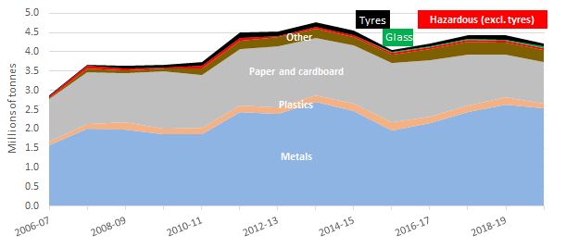

Figure 2 Exports of waste glass, paper, plastics and tyres, 2006-07 to 2019-20 (Mt)

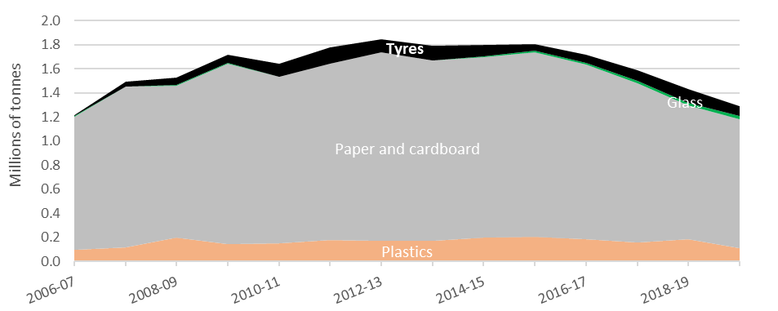

Figure 3 shows the reported dollar value of exports over 2006‑07 to 2019‑20. Total value declined by 5% in 2019-20 compared to 2018‑19. Scrap metals represented 67% of the value. Hazardous waste was 17% of value despite being only 1.4% of tonnage. The reported unit value of hazardous waste was $791 per tonne in 2006-07, but rose to $8,000 in 2012-13, the highest value since 2012-13[5]. Paper and cardboard represented only 6% of the value despite accounting for 25% of total tonnage.

Figure 3 Value of exports of waste from Australia by financial year and type (billions of dollars)

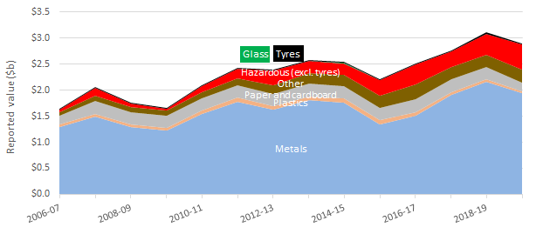

Figures 4 and 5 illustrate how the import restrictions imposed by China and other Asian countries (see Table 3) have affected the key exports of paper and cardboard and plastics. Figure 4 shows exports of paper and cardboard by grade since 2014-15, distinguishing exports to China (on the left) from those to other destinations (on the right). Exports of low-grade unsorted materials – mainly from domestic recycling – to China fell from 2015-16 and plummeted in 2017-18 due to that country’s import restrictions. Much of this material was diverted to other destinations (mainly India, Thailand and Indonesia). Exports of both mechanically pulped papers (newsprint) and bleached chemical (office paper) declined to all destinations. Exports of unbleached kraft (old corrugated containers) changed little.

Figure 4 Exports of scrap paper and cardboard from Australia to China and other destinations by financial year (kt)

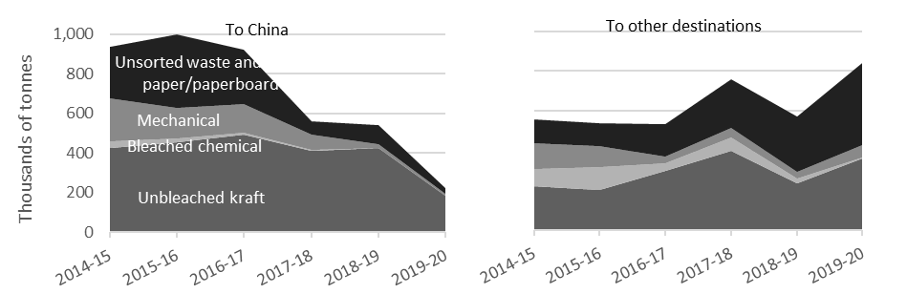

Figure 5 similarly shows exports of plastics since 2014-15. The largest export grade is mixed plastics (unsorted mixed materials, mainly from domestic recycling collections) followed by polymers of ethylene (PET and HDPE). China was the largest market for these materials until 2016-17, at which point exports to China collapsed due to its import restrictions. However, there was a large corresponding rise in exports to other Asian destinations, mainly Indonesia and Malaysia. During 2019-20, exports of unsorted mixed materials to these other destinations fell by 50% as these countries also introduced and began to enforce their own import restrictions. Exports of ethylene polymers appear to have been unaffected.

Figure 5 Exports of waste plastic from Australia to China and other destinations by financial year (kt)

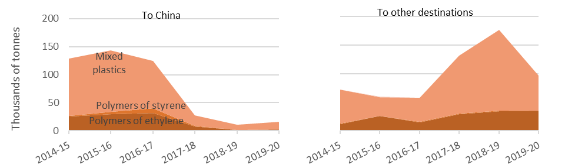

Figure 6 shows exports of all waste-derived materials by destination over the past five years, ranking the six destinations that received the most materials in 2019-20. China was the top ranked destination until 2016-17 when it received 1.26 Mt and 30% of Australia’s waste exports, but subsequently dropped dramatically. Exports to Indonesia, India and Vietnam grew from 1.25 Mt in 2016‑17 to 2.05 Mt in 2018‑19, indicating they received materials displaced from China. In 2019‑20, exports to Vietnam and Indonesia declined as they also brought in import restrictions (see details in Table 3).

Exports of metals to Bangladesh increased from 171 kt in 2014‑15 to 622 kt in 2019‑20.

Figure 6 Exports of waste from Australia by financial year, showing the top six destinations (Mt)

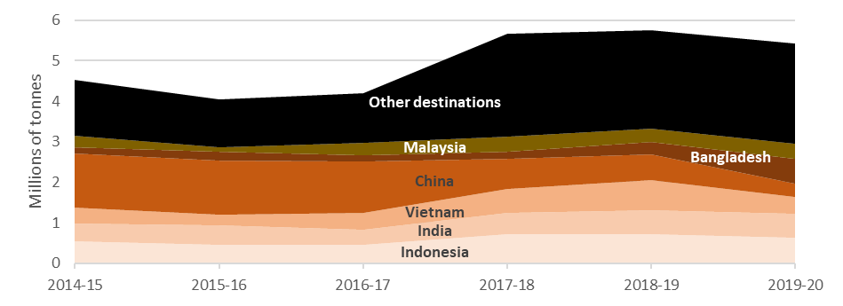

# 2019-20 in focus

|  |  |
| --- | --- |
| Figure 7 shows monthly exports of waste-derived materials by category from July 2019 to June 2020. Materials with similar export ranges are presented together for clarity.  Metals exports varied due to uneven quantities of ferrous scrap, which makes up half the total, and mixed metal waste grades. Of the 2.54 Mt exported, Bangladesh, Vietnam, India and Indonesia received 64%.  Monthly exports of scrap paper and cardboard were stable in 2019-20. Of 1.07 Mt exported, Indonesia accepted 314 kt (29%) followed by China at 224 kt (21%).  Exports of materials in the waste category ‘other’ ranged from 13 to 43 kt per month.  Exports of plastics fluctuated, but continued a declining trend from a 19 kt peak in February 2019. The major destinations were Malaysia (43%) followed by China (14%) and Indonesia (10%). | Figure 7 Monthly exports by material, July 2019 to June 2020 (kt) |
| Paper & cardboard  Other  Metals  Hazardous  Tyres  Tyres  Hazardous  Plastics  Glass |

Monthly exports of waste tyres fell throughout the year. The main recipients in 2019-20 were India (47%) and Malaysia (28%).

The hazardous category, comprising mainly metal processing wastes, ended the year with reported monthly values similar to the start (5.7 kt compared with 5.9 kt).

Compared with the other categories, glass exports were relatively low throughout the year. A strong peak in early 2020 was followed by a drop back to just eight tonnes in June.

Figure 8 shows exports from Australia between July 2018 and June 2020, ranking the six destinations receiving the most materials (ranked from the bottom). Indonesia was our biggest export destination, receiving mainly scrap metals and paper and cardboard. For 2019-20 only, the ranking is similar except that Bangladesh jumps to second place.

Figure 8 Exports of waste from Australia by destination and month, July 2017-June 20 (kt)

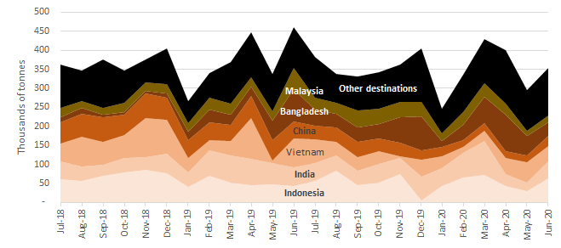

|  |  |
| --- | --- |
| Australia’s 2019-20 exports of waste-derived materials were from the jurisdictions shown in Figure 9. Victoria exported the most overall, at 1.1 Mt or 26%. Queensland, NSW and WA were also large exporters.  Victoria exported the most paper and cardboard (416 kt), plastics (53 kt) and tyres (30 kt). Queensland exported the most metals (776 kt). NSW exported the most hazardous materials (33 kt) and glass (22 kt). | Figure 9 Australian 2019-20 waste exports by jurisdiction of origin (kt) |
|  |

Figure 10 presents monthly trends in the reported unit values of key waste-derived material exports from July 2017 to June 2020. Average metals values have oscillated between $588 and $998/t but have been at the low end in the last three months. Average paper and cardboard values were relatively consistent. The reported value of plastics has largely remained in the $200-$300/t range. Reported values of end-of-life tyres have been volatile but appear to be rising, likely to be associated with the Indian restrictions on low value whole-tyre product. The reported value of scrap glass has been mostly consistent and low. The steep spike in June 2020 is not significant given it applies to only eight tonnes exported in that month.

Figure 10 Comparison of average unit prices by material, July 2019 -June 2020 ($/tonne)

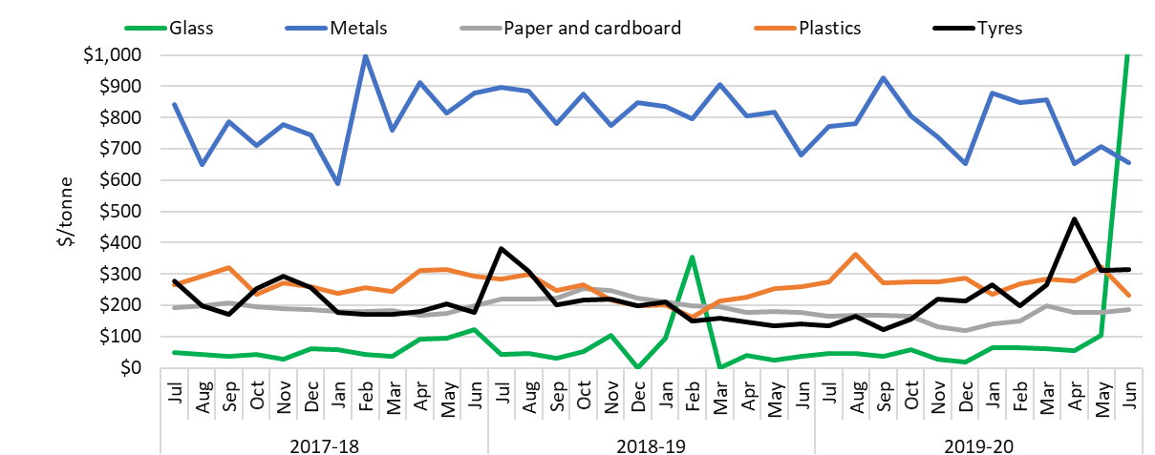

# June 2020 in focus

In June 2020, Australia exported about 354 kt of waste-derived materials with a reported value of $234 million. Compared with May 2020, this is a 20% increase in quantity (60 kt) and a 23% increase in the value ($44 million). Indonesia was the top receiver of waste-derived exports for the month, receiving a mix of paper and cardboard (54%, 34 kt) and metals (41%, 26 kt). India ranked second highest, followed by Vietnam. Waste exports for glass fell to just eight tonnes, suggesting the impending export ban is starting to have an impact. Tyres and materials in the ‘other’ waste category also declined slightly. Exports of all other materials increased. The largest tonnage increase was in scrap metals, from 174 to 213 kt. The largest percentage increases were plastics (47%) and paper and cardboard (36%).

# Context – Australian waste exports compared with overall waste flows

The *National Waste Report 2020* (unpublished at the time of writing) has Australia generating 74 Mt of waste in 2018-19 and recycling or recovering energy from 60% (43 Mt). The 2019‑20 export total of 4.2 Mt of waste-derived materials therefore represents about 10% of national recovery and 6% of national waste generation. Table 1 compares recovered quantities with waste exports, noting that nearly all exports are intended for recovery. The hazardous and ‘other’ categories are combined because the proportions of both are low. Values are rounded to no more than three significant figures

The table suggests that 2019-20 exports accounted for half of recovered metals and about a third of plastics and paper and cardboard. Nearly all other recovered materials were recovered in Australia. These encompass a wide range of materials, but most of the tonnes were masonry materials, organic wastes and fly ash from coal-fired power stations.

Table 1 Data comparing Australian exports and overall recovery of wastes

|  |  |  |  |  |
| --- | --- | --- | --- | --- |
| Waste material type | Recovery in 2018-191 | Exported in 2019-20 | | |
| ***(kt)*** | ***(kt)*** | ***($m value)*** | ***(% of 2018‑19 recovery)*** |
| Metals | 5,040 | 2,544 | $1,950 | 51% |
| Paper and cardboard | 3,530 | 1,066 | $173 | 30% |
| Plastics | 393 | 113 | $31.3 | 29% |
| Glass | 688 | 26 | $1.4 | 4% |
| Tyres | 316 | 85 | $17.7 | 27% |
| Other, incl. hazardous | 33,700 | 383 | $727 | 1% |
| **All wastes** | **43,500** | **4,218** | **$2,900** | **10%** |

*Note 1 Comprises materials entering recovery processes. Excludes energy recovery via landfill gas.*

# Australian waste export bans

In March 2020, the former COAG agreed to a timetable for implementing bans on exporting waste glass, paper, plastics and tyres not processed into a value-added material. The relevant export codes and reported 2019-20 tonnages and values are given in Table 2. A total of 1.29 Mt with a value of $223 million were exported under these codes. An estimated 613 kt are potentially affected by the bans.

Table 2 2019-20 exports of waste-derived materials subject to the Australian export bans (reported quantity and value)

| Material | Ban date | AHECC code | AHECC description | 2019-20 exports in this code (rounded tonnes) | | Estimated % banned unless further processed[6] | 2019-20 value of exports in this code ($million) |
| --- | --- | --- | --- | --- | --- | --- | --- |
| Glass | Jan 2021 | 70010000 | Cullet and other waste and scrap of glass; glass in the mass | | 26,000 | 100% [7] | 1.37 |
| Paper and cardboard | Jul 2024 | 47071000 | Recovered (waste and scrap), unbleached, kraft paper or paperboard or corrugated paper or paperboard | | 548,000 | 0% | 76.9 |
| 47072000 | Recovered (waste and scrap) paper or paperboard, made mainly of bleached chemical pulp, not coloured in the mass | | 3,700 | 0% | 1.07 |
| 47073000 | Recovered (waste and scrap) paper or paperboard, made mainly of mechanical pulp (e.g. newspapers and journals) | | 69,000 | 0% | 7.94 |
| 47079000 | Waste and scrap paper or paperboard (incl. unsorted waste & scrap) (excl. unbleached kraft or corrugated (470710); that made mainly from bleached chemical pulp, not coloured in the mass; or made mainly of mechanical pulp) | | 445,000 | 100% [8] | 86.5 |
| Plastics | Jul 2022 | 39151000 | Waste, parings and scrap, of polymers of ethylene | | 37,000 | 100% [9] | 11.9 |
| 39152000 | Waste, parings and scrap, of polymers of styrene | | 500 | 100% 9 | 0.15 |
| 39153000 | Waste, parings and scrap, of polymers of vinyl chloride | | 44 | 100% 9 | 0.01 |
| Jul 2021 | 39159092 | Waste, parings and scrap, of plastics (excl. those of polymers of ethylene, styrene or vinyl chloride) | | 75,000 | 83% | 19.3 |
| Whole tyres | Dec 2021 | 40040000 | Waste, parings and scrap of rubber (excl. of hard rubber) and powders and granules obtained therefrom | | 58,000 | 44% [10] | 2.40 |
| 40122000 | Used pneumatic rubber tyres, whether or not subject to recutting or regrooving | | 16,000 | 96% 10 | 7.04 |
| 40129000 | Solid or cushion rubber tyres, rubber tyre treads (incl. Interchangeable tyre treads) and rubber tyre flaps | | 11,000 | 6% 10 | 8.31 |

# Analysis and comment

As with the previous two financial years, 2019-20 saw some major changes in the tonnage flows, destinations and reported value of Australian exports of waste-derived products and waste. There are disparate stories for the different materials.

Markets for scrap plastics have been strongly affected by Asian import restrictions imposed due to concerns about the quality of materials received and the management of residuals. The initial Chinese restrictions displaced materials to Indonesia, Malaysia and other countries during 2017‑18 and 2018‑19. In 2019‑20, exports to all these alternative destinations also fell, mainly, it appears, because of their own import restrictions (see Table 3). The grade most affected by these changes is mixed plastics, for which exports fell 50%. The smaller export quantities of single polymer grades remained strong during 2019‑20.

Scrap paper and cardboard exports have also been reshaped by Asian restrictions. Again, exports to China were displaced and, again, there has been an overall decline, but to a lesser extent than plastics. Also, unlike plastics, particular grades of paper and cardboard – bleached kraft (office paper) and mechanical (newsprint) – suffered the largest declines in 2019-20. Exports of unbleached kraft (old corrugated containers) remained strong, with China and Indonesia the two major destinations. Exports of mixed grades grew to their highest level since 2015-16, going mainly to Indonesia, India and Thailand.

End-of-life tyre exports fell during 2019-20, apparently associated with Indian restrictions linked to the COVID pandemic. Miscoding of these exports apparent in Australian Border Force data suggests less confidence can be placed on this apparent trend than other materials.

Exports of scrap glass maintained a long-term rise and in 2019‑20 reached their highest level across the 14-year timeframe, but declined steadily towards the end of the year. This followed the announcement of an impending Australian export ban.

In contrast to these falling export quantities, exports of scrap metals grew to their third-highest rate in the timeframe and exports of hazardous and ‘other’ wastes (mainly organics) continued to be robust.

# The current status of waste import restrictions

Following China’s lead, various Asian countries have flagged or implemented restrictions on the import of waste-derived products and wastes. These are described in Table 3 for the top 10 countries receiving waste exports from Australia. The information presented has been compiled based on publicly available sources, sometimes translated from languages other than English.

Table 3 Status of waste import restrictions

|  |  |  |  |  |  |  |
| --- | --- | --- | --- | --- | --- | --- |
| Country | Scope of restrictions | Announced & implemented | Associated exports (tonnes) | | | Impact and uncertainties |
| **Types** | **2018-19** | **May 20** |
| Indonesia | On 27 May 2020 Indonesia published a decree setting a 2% contamination limit for imports of plastic and paper waste[11]. It also announced a task force to develop a road map over the next 6 months to accelerate the availability of domestic raw materials for paper and plastic industry, including a staged reduction of import quotas. By 1st October 2020 companies exporting waste to Indonesia will need to have pre-registered with the Indonesian embassy[12]. Scrap imports to be restricted to arrive at eight ports only. Illegally imported plastic waste to be returned to exporters[13]. Reportedly rejected eight containers of ‘contaminated’ paper and plastic material in July 2019. In September 2019, it announced it would send 100 containers of contaminated material (particularly plastics) back to Australia, but to date only a small number have been returned[14]. Decided in Feb 2020 to ease the rules on metal scrap imports due to shortages[15]. | Ann.: Apr-19  Imp.: Nov-19 | Plastics, paper and cardboard, metals, glass, hazardous waste, tyres, other. | 725,700  (60,500 per  month) | 35,000 | Impact uncertain. |
| India | Import of scrap plastics banned from August 2019[16]. Also covers areas previously exempt under the 2016 ban such as special economic zones (SEZ) and export-oriented units (EOU)[17]. Excludes electrical/electronic assemblies or components that are defective which can be imported within a year of export. A six-month extension has been granted to three SEZs which allows plastic scrap to be imported until May 31 2020[18]. India set a contamination limit of 1% for recovered paper years ago. It now intends to enforce this by randomly inspecting 5 mixed paper bales per container[19].  India’s Central Pollution Control Board has been reviewing the pyrolysis industry and has ordered the closure of 270 plants that were not compliant with environmental regulations[20]. It is expected this will lead to a subsequent restriction on the import of waste tyres in the near future[21]. | Ann.: Mar-19  Imp.: Mar-19, Aug-19 for importers currently exempt under SEZs and EOUs. | Plastics, tyres | 52,500  (4,300 per month) | 1,700 | Impact uncertain. |
| Vietnam | Tighter controls over imports of plastic, paper and metals. Accepted only if importers prove their shipment meets specified environmental standards and there is capacity to process the materials[22]. No new licences issued for waste imports[23]. Plastic scrap imports to be banned by 2025[24]. Under new national standard QCVN 32: 2019/BTNMT, import of e-waste plastics (e.g. cases of TVs and computers) would be forbidden[25]. From 22 February 2019, all imports through road and railway border gates banned[26]. Import of mixed metal waste (containing any plastic, paper, other non-metallic metals) now understood to be restricted. Composition of metal waste needs to be 99% metal to be allowed in[27]. | Ann. in Aug-18 apparently implemented.  Mixed metal waste restricted from Oct 2018. | Plastics, paper and cardboard, metals | 732,600  (61,100 per month) | 53,000 | Has apparently affected imports of scrap plastic and metal from Australia.  Environmental reference standards are unavailable in English. |
| China | Declared restrictions and then, in April 2018, a ban on 32 types of waste-derived products[28]. From 1 July 2019, import restrictions were placed on eight solid waste codes pertaining to metals[29]. In the meantime, China continues to issue permits for imports of waste fibre and will allow 4.5 million tonnes to be imported in 2019-20. Quotas are still being issued for metals[30],[31]. China was reported to have enshrined in law its intention to stop all imports of waste with the aim of full implementation by the end of 2020[32]. However, more recent reports indicate they may be rethinking the blanket ban and exempting feedstocks that some industries rely on[33] | Ann.: Jul & Nov-17, Apr-18, Jul-19, Dec-19, Jan-20  Imp.: Jan & Mar-18, Dec-18, Dec-19 | Plastics, paper and cardboard, metals, other | 643,000  (53,600 per month) | 18,000 | Impact evident (2016-17 exports averaged 105,300/month and averaged 62,000/month in 2017-18). |
| Bangladesh | No import bans apparent. Received mainly metals from Australia (not subject to bans). |  |  |  | 0 | None |
| Malaysia | Import permits revoked from 114 factories that process imported plastic waste23, [34]. Import of non-recyclable plastic waste to be banned by 2021[35]. Contaminated, mislabelled or illegally imported plastic waste loads to be sent back to source[36] [37]. Malaysia has continued returning contaminated containers of plastic waste to countries of origin with 150 returned and another 110 to be sent back by midyear. Enforcement at ports has improved and over 200 illegal plastic recycling facilities closed down in a bid to crackdown on illegal waste imports[38]. | Jul-18. | Plastics | 55,200  (4,600 per month) | 2,400 | No impact apparent. |
| Thailand | Revoked a broad plastic scrap import allowance, meaning plastic waste and scrap is banned from import by 2021[39],[40],[41]. Looking to ban e‑waste imports within 2 years23. In January 2020, a new subcommittee was set up to ensure the proposed bans can be achieved, and will not be prevented by loopholes[42]. | Ann. Aug-18, plastic imp. Aug-18, e-waste <2 yrs. | Plastics | 11,200  (900 per month) | 370 | No impact apparent Announcement available in Thai only. |
| Korea, Republic of | Announced on 17 February 2020 that it plans to reduce wastepaper imports. On 30 June 2020 announced a ban on imports of PET, PE, PP and PS with immediate effect.[43] | Ann.: Feb-20 | Paper, plastic bottles | 13,200  (1,100 per month) | 190 |  |
| Taiwan | Import of plastic waste is banned. Exceptions are made to licensed local firms that import plastic waste originating from their own overseas production processes or are a single material, but not from original production processes[44]. Paper imports restricted to only deinked paper, kraft paper, corrugated paper or cardboard that is not bleached. Import of waste newspapers and magazines banned. | Ann.: Aug-18  Imp.: Oct-18 | Plastics, paper and cardboard | 17,700  (1,500 per month) | 810 | No impact apparent. |
| Pakistan | No import bans apparent[45]. Received mainly metals from Australia (not subject to bans). |  |  |  | 0 | No impact apparent |

1. Inquiries to [joe.pickin@blueenvironment.com.au](mailto:joe.pickin@blueenvironment.com.au)
2. Data in these summaries is sourced from the Australian Bureau of Statistics and is originally entered by exporters or their agents. It cannot be guaranteed that exporters use the correct codes or values for their exports, so this data should be used with caution. Data may be revised for up to six months after initial publication as customs declarations are amended by individual traders. Due to these revisions, there may be discrepancies between this and preceding reports.
3. Some of these recovered materials contain a proportion of contamination (or ‘off-spec’ content) that needs to be extracted before the material can be used.
4. Dollar values refer to Australian dollars.
5. Copper containing slag, ash and residues has an anomalously high reported value of over $500/kg in some of the data. The value of pure copper is under $10/kg.
6. In a review of 2018-19 Australian Border Force (ABF) data, these proportions appeared to fit the ban definition. Similar proportions were applied in Figure 2 of the [Phasing out exports of waste plastic, paper, glass and tyres](https://www.coag.gov.au/sites/default/files/communique/phasing-out-waste-exports-response-strategy.pdf) response strategy.
7. It is believed that most or all of this product is derived from municipal recycling collections.
8. May be an over-estimate as significant miscoding is apparent in the data.
9. Assumes no material was sorted and processed to the extent that will be required for future export.
10. 2018-19 ABF data on tyres exports differed from the equivalent ABS data, and neither were consistent with industry-reported export quantities.
11. Minister of Trade, Minister of Environment and Forestry, Minister of Trade Industry and Head of State Policy, Republic of Indonesia (May 2020), [Implementation of import of non hazardous and toxic material waste as raw material industry](https://images.magnetmail.net/images/clients/ISRIID/attach/ENIndonesiaGovtJointDecreeonRPimportsEN.pdf)
12. Recycling Today (30 July 2020) [Indonesian embassy releases procedures for US exporters of scrap to the country](https://www.recyclingtoday.com/article/legislation--regulations-international-august-2020/)
13. VOA news (2019) [Indonesia vows to send back illegal plastic waste](https://www.voanews.com/east-asia/indonesia-vows-send-back-illegal-plastic-waste)
14. Inside Indonesia (2020) [Buried under the weight of the recycling crisis](https://www.insideindonesia.org/buried-under-the-weight-of-indonesia-s-recycling-crisis)
15. Indonesia will ease rules on scrap metal imports, <https://www.wastetodaymagazine.com/article/indonesia-will-ease-rules-on-import-of-scrap-metal/>
16. Business Today, (24 June 2019) [India bans import of plastic waste from August this year to curb pollution](https://www.businesstoday.in/current/policy/india-bans-import-of-plastic-waste-from-august-this-year-to-curb-pollution/story/358778.html)
17. Ministry of Environment, Forest and Climate Change (2019)[Amendment in Hazardous Waste (Management & Transboundary Movement Rules, 2016)](http://pib.nic.in/PressReleseDetail.aspx?PRID=1567682)
18. Business Standard, (2 December 2019) [Govt grants six month extension to plastic scrap imports in three SEZs](https://www.business-standard.com/article/economy-policy/govt-grants-six-month-extension-to-plastic-scrap-imports-in-three-sezs-119112900554_1.html)
19. Waste Dive, (15 January 2020), [India to enforce 1% contamination rate on paper imports, conduct random inspections](https://www.wastedive.com/news/india-enforce-contamination-rate-inspections-paper-imports/570427/)
20. India legal, (6 January 2020), [NGT calls for review of CPCB’s report on pyrolysis units](https://www.indialegallive.com/national-green-tribunal/ngt-calls-for-review-of-cpcbs-report-on-pyrolysis-units-81315).
21. Tyre and Rubber recycling, (22 September 2019), [Near total ban on waste tyre imports imminent in India](https://www.tyreandrubberrecycling.com/latest-news/posts/2019/september/indian-ban-imminent/)
22. Vietnam Briefing (2018) [Vietnam to Restrict Surging Scrap Imports](http://www.vietnam-briefing.com/news/vietnam-to-restrict-surging-scrap-imports.html/)
23. Waste Management Review (2018) [Malaysia, Thailand and Vietnam waste imports crackdown](http://wastemanagementreview.com.au/battling-sovereign-risk/)
24. VN Express International (2019) *Vietnam to end plastic scrap imports from 2025*
25. Ministry of Natural Resources and Environment of the Socialist Republic of Vietnam (2018) [Vietnam to ban imports of plastic from used electronics](http://www9.monre.gov.vn/wps/portal/news/!ut/p/c5/dclJDoIwFADQE5n_RYawbJAZFWgh2A0hJJpCw6AVlNPrBcxbPuDwMzSLuDdKjEMjoQJu1o5PAt1KEP2SmEgozS6hFWnoI1yBW38_1oFBhXpNOxxfCZ3ijS5v1uLDrljebZl2VlkgJl54M5tzPeafmzSignihK4-OduoIKrv09mva9lxU0phZvxaHUHVuELqZk-6eooepb8gXeJcnsw!!/)
26. VietnamPlus (2019) [Scrap imports through road, railway border gates to be banned](https://en.vietnamplus.vn/scrap-imports-through-road-railway-border-gates-to-be-banned/145041.vnp), Ministry of Information and Communications
27. S&P Global Platts (2019) [Vietnam’s Jan scrap imports plunge amid stricter government rules](https://www.spglobal.com/platts/en/market-insights/latest-news/metals/022019-vietnams-jan-scrap-imports-plunge-amid-stricter-government-rules)
28. Ministry of Commerce, State Development & Reform Commission (incl. former State Development Planning Commission), General Administration of Customs (2018) *Announcement No. 6 [2018] of the Ministry of Ecology and Environment, the Ministry of Commerce, the National Development and Reform Commission and the General Administration of Customs*
29. Ministry of Ecology and Environment of the People’s Republic of China (2018) [Announcement on adjusting the catalogue of imported waste management](http://www.mee.gov.cn/xxgk2018/xxgk/xxgk01/201812/t20181227_687488.html)
30. Bureau of International Recycling (8 January 2020) [Chinese quotas for waste & scrap imports: full list of 2nd batch 2020](https://www.bir.org/news-press/news/item/1000000055-chinese-quotas-for-waste-scrap-imports-full-list-of-2nd-batch-2020)
31. Recycling Today (10 January 2020) [China issues second batch of scrap import quotas](https://www.recyclingtoday.com/article/sennebogen-scrap-recycling-lake-pleasant-michigan/)
32. Resource Recycling (5 May 2020) [China moves closer to complete import ban](https://resource-recycling.com/recycling/2020/05/05/china-moves-closer-to-complete-import-ban/)
33. Bloomberg (30 July 2020) [China finally makes its peace with ‘foreign garbage’](https://www.bloomberg.com/opinion/articles/2020-07-30/china-finally-makes-its-peace-with-foreign-garbage)
34. FMT News (2018) [Permits to import plastic waste for 114 factories revoked](https://www.freemalaysiatoday.com/category/nation/2018/07/24/permits-to-import-plastic-waste-for-114-factories-revoked/)
35. The Star Online (2018) [*Govt to ban import of all non-recyclable waste*](https://www.thestar.com.my/news/nation/2018/10/17/govt-to-ban-import-of-all-nonrecyclable-waste/)
36. The Australian (2019)[Australia would vet any waste returns, says Ley](https://www.theaustralian.com.au/nation/world/australia-would-vet-any-waste-returns-says-ley/news-story/96aaa8c05908bca11579908f128cf40e)
37. Malaymail (2019) [Yeo Bee Yin moots RM1,500 charge per shipping container to cut illegal imported plastic waste](https://www.malaymail.com/news/malaysia/2019/05/31/yeo-bee-yin-moots-rm1500-charge-per-shipping-container-to-cut-illegal-impor/1758091)
38. EcoWatch (21 January 2020) [Malaysia sends plastic waste back to 13 wealthy countries, says it won’t be ‘the rubbish dump of the world’](https://www.ecowatch.com/malaysia-plastic-waste-2644881004.html).
39. *The Nation (2018)* [Import of plastic waste banned](http://www.nationmultimedia.com/detail/national/30351792)
40. CIWM (2018) [*Thailand set to ban plastic waste imports by 2021*](https://ciwm-journal.co.uk/thailand-set-to-ban-plastic-waste-imports-by-2021/)
41. [Government Gazette Thailand](http://www.ratchakitcha.soc.go.th/DATA/PDF/2561/E/188/T15.PDF) (2018)
42. Bangkok Post (2020) [Waste plastic imports ‘to be banned’](https://www.bangkokpost.com/thailand/general/1846429/waste-plastic-imports-to-be-banned)
43. The Korea Times (2020) [Plastic waste imports banned in Korea amid mounting local trash](https://www.koreatimes.co.kr/www/nation/2020/06/371_292052.html)
44. Taipei Times (2018) [New waste plastic, paper import rules to take effect](http://www.taipeitimes.com/News/taiwan/archives/2018/10/02/2003701576)
45. Pakistan Today (2020) [Import of hazardous plastic scrap surges to 65,000 tonnes](https://profit.pakistantoday.com.pk/2020/05/21/import-of-hazardous-plastic-scrap-surges-to-65000-tonnes/)