ANZECC BEST PRACTICE/BENCHMARKING PROGRAM

National Data Standards on Protected Areas
Volume 2

1996

ACKNOWLEDGEMENTS

Project Management

- Russell Mason, Manager Visitor Research, National Parks Service, Victoria;
- Rod Gowans, Manager, Parks & Reserves, National Parks Service, Victoria.

Project Development

- Dr Norm McIntyre, Centre for Leisure Research, Griffith University, Queensland.

Project Assistant

- Richard Mills, Beth Plowman and Esther Sun, Centre for Leisure Research, Griffith University.

Steering Group Members

- Hillary Sullivan, Protected Areas Unit of the Australian Nature Conservation Agency, Canberra;
- Meg Bishop, Manager Interpretation, ACT Parks and Conservation;
- Tim Bond, Senior Nature Reserves Planner, SA Department of Environment and Natural Resources;
- Brendon Clough, NZ Department of Conservation, Nelson;
- Bob Hoey, Qld. Department of Environment;
- Luisa Liddicoat, Vistat Coordinator, Department of Conservation and Land Management, Western Australia;
- Alison Ramsay, Recreation Planner, NSW Parks and Wildlife Service;
- Sue Rundle, Planning Statistics Officer, Parks and Wildlife Service, Tasmania;
- Libby Sterling, Visitor Monitoring Officer, NT Parks and Wildlife Commission.
- Commercial and other Agencies
- Leigh Bignall, Warner Brothers, Movieworld and Jenni Wight, Dreamworld; Lynda Peacock, Australian
- Resorts and Damien Hampton, AGB McNair (QTTC);
- Per Nilsen and Greg Danchuck of Parks Canada; Bryan Dick, Ministry of Lands and Parks, British Columbia and Bruce Van Staalduineu of Ontario Provincial Parks;
- Tim Gardner and Margaret Jacobs of Forestry Tasmania and Brett Wearing of the Department of Forestry, Queensland;
- Ernst Holland of Jenolan Caves Trust.

Delphi Group

- Professor Paul Eagles, Department of Recreation and Leisure, University of Waterloo, Ontario, Canada;
- Dr. Gary Howat, School of Environmental and Recreation Management, University of South Australia;
- Dr. Jay Beaman, Director, Auctor Consulting Associates, Ltd. and Adjunct Professor, Colorado State, Lakehead and Waterloo Universities;
- Dino Zanon of Melbourne Parks & Waterways;
- Dr Graham Cuskelly, School of Leisure Studies, Griffith University;
- Dr. Chris Auld, School of Leisure Studies, Griffith University.

TABLE OF CONTENTS

1. Introduction 4

2. Summary and recommendations 5

3. Data collection process 7

4. Definitions 8

5. Development of best practice model 10

6. Results 22

7. System flexibility and standardisation 33

8. Conclusions 34

1. INTRODUCTION

Many protected areas, already popular with local communities, have become a focus of visits by interstate and international tourists. Estimates in increases in visitor numbers lie in the range of 4% per annum in remote protected areas, 16% to 17% in near urban parks and up to 20% in high profile World Heritage Areas (McIntyre, 1995). These increases in numbers are driven by many factors not least of all major promotion of the Australian natural environment by State and Commonwealth tourist agencies.

Management of protected areas suffers because of a lack of reliable data on visitors:

- to guide the provision and location of services;
- to provide estimations of carrying capacities;
- to assess performance and
- to enable the analysis of the contribution of protected areas to local, regional and national economies.

When data on visitors is collected, it is usually limited to visitor numbers (car counts, spot counts at popular localities etc.) and neglects to provide information on visitor characteristics and attitudes. Data on visitor characteristics and attitudes often suffer from issues related to sampling (population, season, time), lack of comparability in terms of measures (instrument design, definition) and transferability (within a State and between States).

The collection of reliable visitor data in protected areas is not an easy task given that many of them are remote, have multiple entry and exit points, enclose communities of various sizes and depend on self-registration for permits and fee payment etc. Most of the States and many other countries share these same problems and a search for 'best practice' within the Australian context can provide a first step towards the continuous process of improvement in visitor monitoring and management.

2. SUMMARY AND RECOMMENDATIONS

Summary

This study sought to collect data on current practice in the collection and management of visitor data throughout the protected area system in Australia and New Zealand. Further, data was collected from a variety of other organisations both in Australia and overseas which shared the need to collect data on visitors. These included theme parks, urban parks, tourism organisations, State Forests and overseas protected agencies.

A model of best practice in collecting and managing visitor data has been developed based on the information received from this diverse group of agencies. The model was applied to rate most common practice and average practice for inter organisation comparisons to reveal opportunities and constraints in current practices.

The study has revealed a high level of practice in many individual agencies and organisations which provide a fund of detailed implementation information for future study in improving practice in protected areas.

Based on the analysis of the data collected this study presents a number of recommendations for consideration by the ANZECC Benchmarking Committee.

Recommendations

Best Practice Criteria

- the best practice criteria and ratings be endorsed as appropriate targets for the development of visitor use monitoring systems within high-use protected areas;
- each agency consider the diversity of the protected areas within their system and develop proposals as to the combinations and levels of practices which would be acceptable across the spectrum of protected area types;
- standardisation be sought with regard to acceptable systems of collecting and managing visitor data across the diversity of the protected area estate in Australia.

Visitor Use Measures

- three measures would seem to be appropriate in assessing visitor use namely person-entry, person-visit and person visit-day. In high use protected areas all three measures should be used to provide an estimate of variation in workload on an annual and seasonal basis. In more lightly visited parks, person-entry measures based on traffic counters and/or fee registration and/or ranger observation may be more appropriate;
- these three measures should form the basis of a standardised system of assessing visitor numbers to protected agencies throughout Australia;
- where visitor numbers are quoted an indication of the basis on which they have been derived, based on the best practice criteria, should be available;
- the use of a standard self-registration and/or permit with key visitor characteristics across all protected area agencies should be explored;
- a standard ranger observation protocol be developed for use across the protected area estate;

Visitor Satisfaction Measures

- measurement of satisfaction (performance) should be developed as phase 2 of a two phase data collection process. The first phase of such a system is a good understanding of the numbers of visitors and their basic characteristics (i.e. visitor use data). This is an essential prerequisite, as success of the Phase 2 performance data collection depends on representativeness of the visitor sample;
- appropriate segmentation of visitor populations should form the basis of sampling visitor satisfaction;
- the areas of frequency of assessment and integration into management of visitor satisfaction data and sample selection need to be addressed;
- the efficiency of the current practices for the measurement of visitor satisfaction in Type 2 protected areas should be examined.

Analysis and Reporting

- standardisation of analysis and reporting of base visitor use data across the protected area estate in Australia should be a priority;

Management

- automation of data collection should be a priority in protected areas, especially in the use of automatic counters and fee collection;
- it is critical that visitor use and satisfaction and economic data be structured to be useful in decision-making i.e. it must be available quickly, easily used (available on a PC at the office on the internet and intranet within the protected area system) and designed to meet the needs of a diversity of users and uses e.g. planners, public relations, ministerials, comparisons and further analyses;
- the level at and means by which revenue generation from the expanding role of services provided by protected agencies is integrated into management requires further consideration in light of the need to demonstrate the economic contribution of protected areas to community wealth.

3 DATA COLLECTION PROCESS

The Centre for Leisure Research at Griffith University was appointed by the Department of Natural Resources and Environment, Victoria and the Australian Nature Conservation Agency (ANCA) on March 22 1996 to undertake the "National Data Standards on Protected Areas Visitation" Study.

Preparation of the Summary Data Base for Protected Area Agencies and Benchmark Case Studies

The first stage of this process was to compile a data base on current practice in collecting visitor data in the three areas of visitor use, characteristics and satisfaction. An initial survey of the Protected Area Agencies in Australia and New Zealand provided a preliminary indication of the diversity of visitor data collection processes currently utilised.

A data base in Microsoft Excel (ver. 5) was compiled. The development of the data base was iterative in that, the visitor data collection processes encoded were developed progressively as information from each of the agencies was received.

At this stage, a Draft Report (McIntyre, 1996) was presented at an ANZECC meeting in the Blue Mountains (April 12, 1996). Feedback on the report provided a basis for the second stage of the study. This same report was distributed to Professor Paul Eagles (University of Waterloo, Canada) and Dr. Gary Howat (University of South Australia) for comment. Their comments are incorporated in this final report.

On the basis of the preliminary data base, a comprehensive questionnaire was designed seeking further detailed information on visitor data collection processes. This questionnaire comprised a series of tables listing the various processes used to collect visitor data and requested the agency to indicate those they used currently (Appendix 1). All nine protected area agencies within Australia and New Zealand provided responses.

The second stage of the data gathering process involved the collection of similar data from overseas protected area agencies, particularly Canada, which has been a world leader in this field and from other agencies and commercial operations which shared similar needs for data on visitors e.g. Melbourne Parks & Waterways, theme parks, State Forest Departments and tourist resorts. A total of eleven (11) other organisations both within Australia and overseas were contacted for information on their visitor data collection processes. Those within South-East Queensland were interviewed on site and all others were sent copies of the same questionnaire distributed to the protected area agencies.

4. DEFINITIONS

Visitor Numbers

A central consideration in the development of a national data base on protected areas is the question of what is used to estimate attendance at protected areas. This may be seen as a definitional problem and might seem to be resolved simply by decree. For attendance figures to be useful, they must relate in some way to protected area functions, particularly, workload and yet make sense when accumulated at a national level or transferred from one agency to another. The relationship between workload and visitor numbers is complex and not readily demonstrated but can be approximated by a combination of absolute numbers of visitors and duration of stay.

A survey of the main 'visitor' definitions used in protected area agencies in Australia was undertaken as part of this brief.

Representative examples of the major definitions referring to visitors are listed below:

Visitor:
- a person who visits a park on a recreational or educational basis. Not intended to include persons visiting for business, through traffic or others who do not use the park for the mandated purpose;

- a person staying within a region within which the park/reserve is located and who visits the park/reserve for the purposes of leisure/recreation/education;

- anyone visiting a park/protected area for the purposes of tourism/recreation;

Visit:
- an entry to a park/protected area by a visitor;
- trips to the park/reserve;
- people/visitor traffic. A variable indicating the number of persons past a point (usually the entrance). No assumption as to length of stay. Derived from car-counter data.

Length of Stay:
- most parks/protected areas have day-use areas. Some have campsites and campers are recorded as camper nights;
- usually asked in regard to half-day or less, full day, one night, two-three nights and four or more nights;

Day Visitors:
- persons making a day visit i.e. not staying overnight.

A review of these definitions indicated that both parameters of absolute numbers and duration of visit are commonly used. Further, at least in some cases, a distinction is also made between those who visit the protected area for 'educational/recreational purposes' and those who just pass through or are there on other business. This analysis suggests that three major patterns of visitor behaviour are recognised: a visitor passes through the protected area to somewhere else; a visitor stops for a short time to use the facilities, participate in the programmes provided by the agency or be involved in an activity; a visitor stays in the area for a significantly longer time to participate in a series of activities and camp or use overnight accommodation.
Beaman and Stanley (1991) in a study of visitor numbers data collected by Parks Canada came to a similar conclusion and further suggested that no ONE of these measures can accurately display the diversity of 'visitor behaviour' that occurs across a protected area estate. They suggest that 'the search for a single number to describe performance (in terms of visitor numbers) .... is somewhat akin to the search for the holy grail: the biggest myth is that it exists at all' (p.3).

In essence, Beaman and Stanley suggest that four, in a very real sense unrelated, measures of attendance are necessary to accurately reflect both workload and performance across a protected area agency.

These measures incorporate both purpose and duration of visit:

the person entry: this occurs whenever a person enters a protected area for any purpose;

the person visit: this occurs when a person visits a protected area for the first time on any given day or on the first day of the stay for the purpose of participating in protected area related activities;

the person visit-day: occurs when a person stays in a protected area for a day or part-day: each day the person stays counts as an additional person-visit-day.

the person visit-hour: this is used for visits to protected areas where the person cannot stay overnight but where different lengths of stay, ranging from minutes to hours can be significant to management.

An in-depth analysis of these various measures by Beaman and Stanley suggested that person-entry, person-visit and person visit-day would all be necessary to accurately define the patterns of visitor numbers in national parks in Canada. The person visit-hour they considered specific to historic sites and they did not include it further in the overall discussion. The relevance of this latter measure to Australian protected area agencies merits further consideration e,g, in a protected area like Uluru/Kata Tjuta National Park.

This brief analysis suggests that the concepts of trip purpose and duration are already recognised in Australian agencies as being useful measures of attendance. Consistent definitional criteria for these parameters, however, appear to be lacking, as is the realisation that a number of measures is required for accurate assessment of performance. The study by Beaman and Stanley provides a defensible argument for the general adoption of the three proposed attendance measures across the protected areas in Australia (the paper by Jay Beaman and Dick Stanley of the Canadian Parks Service Socio-Economic Branch is provided for information and consideration: Appendix 8).

Park Type Definitions

Protected areas vary in their physical characteristics in terms of visitor numbers, seasonality of visitation, access, distance from centres of population, staffing, entrance exit controls etc. These characteristics severally and jointly will make difficult the development of a standardised system suitable for all types of protected areas.

Despite this wide variability in character, it might well be possible to 'cluster' protected areas into a small number of similar groups based on a combination of relevant criteria e.g. visitor numbers, staffing and entrance/exit control and on this basis develop a series of data collection and management strategies which accommodates the individual but not necessarily unique characteristics of each protected area.

The first stage of this process was implemented through the recognition of two main types of protected areas:

High Visitation Level Parks (Type 1)
Those parks which account for approximately 90% of all park visits;

Low Visitation Level Parks: (Type 2)
Those parks which account for 10% of all park visits.

5. DEVELOPMENT OF BEST PRACTICE MODEL

Best Practice Criteria

The Best Practice Criteria were developed from a combination of general data collection and management principles, a broad understanding of the characteristics of protected areas and their operations, accepted calibration methods for mechanical counters, fee mechanisms and principles of information management.

The overall aim of a Visitor Data Management System is to provide reliable data which can be analysed and made available to inform decision making at all levels in a protected area agency. On this basis, a list of Best Practice Criteria for such a system were developed.
The Visitor Data Management System should have the following general characteristics:

It should provide data that is:

- compatible with other sources at state and national level e.g. tourism data; ABS data;
- able to be aggregated at regional, agency and national levels;
- available at all levels within a protected area agency.

Adopt methods that:

- are acceptable to staff;
- are able to be integrated into protected area operations;
- are automated;
- minimise impact on visitors;
- improve customer consciousness;
- use standardised terminology.

In addition, the data COLLECTION process should:

- aim to quantify appropriate market segments within the visitor population and use these as a basis for collection of information on visitor satisfaction and specific management issues;
- be sensitive to the individual characteristics of the protected area
- optimise the frequency of data collection;
- optimise the return rate of surveys;

Be sufficiently flexible:

- to evolve as needs and data requirements change;
- to accommodate a variety of methods of data collection

The methods of ANALYSIS, PRESENTATION and STORAGE should:

- use appropriate and compatible computer hardware and software for analysis and storage of data which includes standardised reporting functions (tables, graphs, summary statistics etc.);
- provide secure long-term data storage and retrieval and the information derived from visitor data should be readily integrated into the MANAGEMENT DECISION MAKING PROCESS and should:
- be available in a time frame that enhances decision making;
- be effective in problem recognition and resolution;
- be in a form that is accessible at the various levels of decision making i.e. system, strategic and operational;
- be linked to management procedures and policy development.

The criteria were distributed to the Delphi Group (Dr. Gary Howat - University of South Australia; Professor Paul Eagles - University of Waterloo, Canada; Mr. Dino Zanon - Melbourne Parks and Waterways; Dr. Graham Cuskelly and Dr. Chris Auld - Griffith University) for comment and have been discussed by members of the ANZECC Steering Committee. Modifications as suggested by both these groups have been incorporated in this final report.

Best Practice Model

The criteria derived above were used to rate the various sub-processes provided by the agencies on a 5-point scale within the three broad categories of Data Collection/Return, Data Input, Analysis and Storage and Information Input into Management. The rankings used in the Best Practice Model were derived from a combination of Australian, industry and overseas practice.

A number of assumptions underlie the scalar quantities that have been attached to the various sub-processes. Where appropriate, the guiding assumption is included under each practice. A major underlying assumption is that the highest score represents 'best practice' in a protected area that has a high visitation, adequate staffing and relatively controlled access. The fact that many protected areas deviate from this 'ideal' indicates the need for flexibility in the system of managing visitor data. Such flexibility necessitated the development of a Best Practice Model that incorporated a broad spectrum of processes which could be mixed in various combinations to provide the necessary match between the processes and scale of data gathering and management purposes.
VISITOR SATISFACTION (VS)

VSCollection/Frequency
Assumption: data collection on a continuous basis optimises frequency of data input, improves integration with protected area operations and enhances understanding of the visitor and increases sensitivity to visitor needs.

VS-CF | 5 | continuous
 | 4 | peak/shoulder- off-peak
 | 3 | peak- off-peak
 | 2 | annual
 | 1 | occasional

VSCMethod
Assumption: Control of distribution of surveys by trained independent research staff enhances representativeness of the visitor sample and enhances customer consciousness.

VS-CM | 5 | direct handout - independent surveyors
 | 4 | direct handout - rangers
 | 3 | office/entrance station
 | 2 | placement cars/tents
 | 2 | voluntary pick-up
 | 1 | comments (vis.book/ to rangers)

VSCSelection
Assumption: a random process of selection within 'recognised groups' (market segments) which are chosen on the basis of experience based characteristics provides the best available information to target management responses and initiatives.

VS-CS | 5 | segments (demo & experiential) probability
 | 4 | segments (demo) probability
 | 3 | probability
 | 3 | selected targeted (activity groups)
 | 2 | selected (non-prob)
 | 1 | convenience

VSCReturn
Assumption: a variety of processes for return or the use of a short interview schedule enhances return rate and minimises impact on visitors.

VS-CR | 5 | on-site/drop-box/mail-back (combination)
 | 5 | direct hand out on-site(short interview)
 | 4 | entry/exit (collection)
 | 3 | drop-box/mail-back (incentive)
 | 2 | drop-box /mail-back
 | 1 | exit drop box

VSAnalysisMethod
Assumption: automated data read in and a standardised computer-based system for data analysis and routine reporting provides the most efficient means of translating raw data into management useful information, enhances acceptability by staff and integration with protected area operations, and enhances usefulness of information

VS-AM | 5 | Automated data read-in combined with a standard software and report system
 | 4 | standard software and report
 | 4 | standard software
 | 3 | non-standard software
 | 2 | manual
 | 1 | no standard procedure

VSMan/cycleFreq
Assumption: automated data input from visitor contact point to computerised data base at protected area level and central agency headquarters optimises 'real time' management of visitor issues, improves customer consciousness and enhances acceptability by staff.

VS-MF | 5 | on-line and continuous
 | 4 | monthly
 | 4 | peak/shoulder/off-peak
 | 3 | six-monthly
 | 2 | annual
 | 1 | management plan cycle
 | 1 | as needed

VSMDecision Making
Assumption: visible integration of visitor information into management at all levels in the protected area system enhances policy development, guides operational priorities, increases sensitivity to visitors and promotes commitment by staff to the data collection process.

VS-MD | 5 | at all levels within the agency
 | 5 | operational/strategic (system-wide)
 | 4 | operational/strategic (protected area level)
 | 3 | budget (system-wide)
 | 3 | budget (protected area level)
 | 2 | management planning cycle
 | 1 | issue specific
 | 1 | not consistently used in decision making

VISITOR NUMBERS (VN)

Automatic Counters (VNC)
VNCFreq
Assumption: data collection on a continuous basis optimises frequency of data input, improves integration with protected area operations and enhances understanding of the visitor and increases sensitivity to visitor needs.

VN-CF | 5 | continuous
 | 4 | peak/shoulder-off-peak
 | 3 | peak-off-peak
 | 2 | annual
 | 1 | occasional

VNCMethod
Assumption: periodic and regularly updated calibration of vehicle and other counters provides the most reliable method of estimating visitor numbers from mechanical counters.

VN-CM | 5 | calibration (vis + veh/t + conv + seas)
 | 4 | calibration (vis + veh/t + conv)
 | 3 | calibration (veh/t + conversion)
 | 2 | calibration (all + conversion)
 | 1 | no calibration

VNCCollection/return
Assumption: direct automatic computer-based accumulation of data from counters at a central point is the most reliable method of data entry and enhances staff acceptability.

VN-CC | 5 | automated entry
 | 4 | manual -daily patrol
 | 4 | manual - weekly patrol
 | 2 | manual - convenience
 | 1 | other

VNCAnalysisMethod
Assumption: automated data read in and a standardised computer-based system for data analysis and routine reporting provides the most efficient means of translating raw data into management useful information, enhances acceptability by staff and integration with protected area operations, and facilitates usefulness of information

VN-CA | 5 | Automated data read-in combined with a standard software and report system
 | 5 | standard software and report
 | 4 | standard software
 | 3 | non-standard software
 | 2 | manual
 | 1 | no standard procedure

VNCMan/cycleFreq
Assumption: automated data input from visitor contact point to computerised data base at protected area level and central agency headquarters optimises 'real time' management of visitor issues, improves customer consciousness and enhances acceptability by staff.

VN-CMF | 5 | on-line and continuous
 | 4 | monthly
 | 4 | peak/shoulder/off-peak
 | 3 | six-monthly
 | 2 | annual
 | 1 | management plan cycle
 | 1 | as needed

VNCMDecision Making
Assumption: visible integration of visitor information into management at all levels in the protected area system enhances policy development., guides operational priorities, increases sensitivity to visitors and promotes commitment by staff to the data collection process.

VN-CMD | 5 | at all levels within the agency
 | 5 | operational/strategic (system-wide)
 | 4 | operational/strategic (protected area level)
 | 3 | budget (system-wide)
 | 3 | budget (protected area level)
 | 2 | management planning cycle
 | 1 | issue specific
 | 1 | not consistently used in decision making

Ranger Observations (VNO)
Assumption: data collection on a continuous basis optimises frequency of data input, improves integration with protected area operations and enhances understanding of the visitor and increases sensitivity to visitor needs.

VNRanger Observations Freq | 5 | continuous (weekly/monthly)
 | 4 | peak/shoulder/off-peak
 | 3 | peak/off-peak
 | 2 | annual
 | 1 | occasional

VNOData
Assumption: a systematic data collection which includes visitor numbers (nos), group sizes, gender, etc. (char) and activities being undertaken (act) using prepared data sheets provides the most reliable means of data collection, improves customer consciousness and enhances integration into protected area operations.

VN-OD | 5 | systematic observation (nos/char/act)
 | 4 | systematic observation (nos/act)
 | 3 | informal (nos/char/act)
 | 2 | informal (nos/act)
 | 1 | informal (nos)

VNOAnalysisMethod
Assumption: a standardised computer-based system for data entry and routine reporting provides an efficient means of translating raw data into management useful information, enhances acceptability by staff and integration with protected area operations, and facilitates usefulness of information;

VN-OAM | 5 | standard software and report
 | 4 | standard software
 | 3 | non-standard software
 | 2 | manual
 | 1 | no standard procedure

VNOMan/cycleFreq
Assumption: automated data input from visitor contact point to computerised data base at protected area level and central agency headquarters optimises 'real time' management of visitor issues, improves customer consciousness and enhances acceptability by staff.

VN-OMF | 5 | on-line and continuous
 | 4 | monthly
 | 4 | peak/shoulder/off-peak
 | 3 | six-monthly
 | 2 | annual
 | 1 | management plan cycle
 | 1 | as needed

VNOMDecision Making
Assumption: visible integration of visitor information into management at all levels in the protected area system enhances policy development., guides operational priorities, increases sensitivity to visitors and promotes commitment by staff to the data collection process.

VN-OMD | 5 | at all levels within the agency
 | 5 | operational/strategic (system-wide)
 | 4 | operational/strategic (protected area level
 | 3 | budget (system-wide)
 | 3 | budget (protected area level)
 | 2 | management planning cycle
 | 1 | issue specific
 | 1 | not consistently used in decision making

Visitor Fees (VNF)

A complex variety of fees for service are administered in a modern protected area including merchandising, food sales, accommodation as well as the more traditional entry and camping fees. However, in the assessment of visitor numbers within protected areas, the transactions most commonly used are entrance fees, camping permits, commercial operator returns and commercial accommodation charges.

VNFeesCollection
Assumption: direct control is seen as the most reliable means of comprehensive fee collection and hence, reliable estimate of total visitor numbers e.g. camping fees which allow pre-booking and payment at visitor centre and/or controlled entrance stations combined with entrance fees in similarly controlled situations can provide comprehensive estimates of visitor numbers. This provides maximum flexibility for clients and enhances likelihood of compliance;

VNFC | 5 | direct control (pre-booking and vis.c./entry camping and entrance fees);
 | 4 | on-site collection
 | 4 | commercial operator/franchise returns
 | 3 | self-registration + ranger patrol
 | 2 | self-registration + honesty system
 | 1 | other fees

VNFData
Assumption: a conversion system which converts $ collected into visitor numbers by taking account of visitor characteristics (cal) as it relates to fees paid (children, concessions, annual passes, residents) and takes into account estimates of compliance, provides the most reliable method of relating income to visitor use.

VN-FD | 5 | fees($) + cal(nos/char) + compl.
 | 4 | fees($) + cal(nos) + compliance
 | 3 | fees($) + calib(nos/char)
 | 2 | fees($) + calib(nos)
 | 1 | fees($)

VNFAnalysisMethod
Assumption: Direct cash register entry with data read-in to a computer combined with a standard software and report system for data analysis and routine reporting provides the most efficient means of translating raw data into management useful information, enhances acceptability by staff and integration with protected area operations.

VN-FA | 5 | automated
 | 4 | standard software
 | 3 | non-standard software
 | 2 | manual
 | 1 | no standard procedure

VNFMan/cycleFreq
Assumption: automated data input from visitor contact point to computerised data base at protected area level and central agency headquarters optimises 'real time' management of visitor issues, improves customer consciousness and enhances acceptability by staff.

VN-FMF | 5 | on-line and continuous
 | 4 | monthly
 | 4 | peak/shoulder/off-peak
 | 3 | six-monthly
 | 2 | annual
 | 1 | management plan cycle
 | 1 | as needed

VNFMDecision Making
Assumption: visible integration of visitor information into management at all levels in the protected area system enhances policy development., guides operational priorities, increases sensitivity to visitors and promotes commitment by staff to the data collection process.

VN-FMD | 5 | at all levels within the agency
 | 5 | operational/strategic (system-wide)
 | 4 | operational/strategic (protected area level)
 | 3 | budget (system-wide)
 | 3 | budget (protected area level)
 | 2 | management planning cycle
 | 1 | issue specific
 | 1 | not consistently used in decision making

The criteria and ratings indicated in this report have been substantially modified from those presented in the interim report (12 April 1996) as a result of consultation with both the Delphi group and the Steering Committee.

Best Practice Processes

Figures 1, 2 and 3 summarise the proposed Best Practice Process as derived from the Best Practice Model (i.e. sub-processes rated as 5 in the Model). Figure 1 illustrates in flow-chart form the processes suggested as representing best practice in the measurement of visitor satisfaction using a survey methodology. Figure 2 details these same processes for the assessment of visitor numbers using automatic counters (vehicle), fees and ranger observation. Figure 3 details the integration of satisfaction measures and visitor number assessments into the management decision process.

The assessment of visitor satisfaction or, indeed, any measure of visitor opinion, is viewed as a two-stage process. The initial stage is an estimation of visitor numbers which provides the basis for appropriate sampling of visitor opinion on the issue in question. A central consideration in this assessment is the derivation of appropriate visitor segments either on the basis of pre-segmentation (e.g. activity groups) or on some derived variable of interest (post-segmentation into 'experience' groups e.g. 'nature lovers'). For the purposes of illustration the major proposed visitor number segments (Person-entry, visit and visit day) are used in Figures 1 through 3.

A second characteristic of the proposed best practice is the use of 'automation' for data entry and analysis. The increasing availability of desk-top computers, internet systems, automated survey readers, sophisticated point-of-sale systems etc. can remove much of the routine tasks from the data management process, enhance the real-time availability of information at all levels and allow managers to become increasingly sophisticated and creative in the use of information in managing protected areas.

While Figures 1 and 2 are self-explanatory, two specific aspects of Figure 3 require some elaboration. The first is the use of the idea of 'Seasonally Adjusted Visitor Numbers'. This draws on the concept of 'seasonally adjusted employment figures' and indicates the need to take into account variations in the calendar from year to year and the effect on park visitor numbers of 'floating holidays' (e.g. Easter weekend) and 'special events' (weather, environment days etc.) (Beaman and Thompson Pers. Comm.). For example, variations in the numbers of weekends in a month from year to year can cause as much as 20% change in visitor numbers in any one month. Thus the use of raw figures can be deceptive when examining trends in visitor numbers over a period of years. On the positive side, the use of 'seasonally adjusted figures' can also reveal the effects of specific promotional events on visitor numbers and hence cost effectiveness.

The second point relates to the use of the '20% rule'. Experience in Parks Canada (Beaman, pers. comm.) indicates that the use of such a criterion in assessing the significance of changes in visitor numbers provides an appropriately sensitive indicator of the need for management response.

Figure 1: Collection of Visitor Satisfaction Data
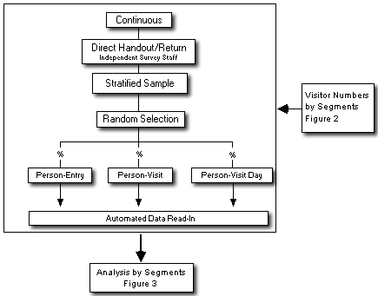

Figure 2: Collection of Data on Visitor Numbers
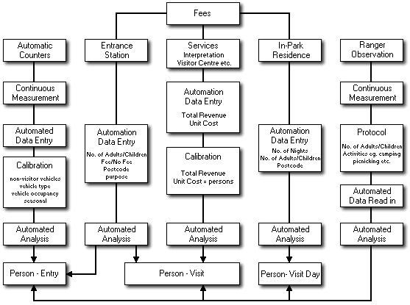

Figure 3: Integrated Visitor Monitoring Process
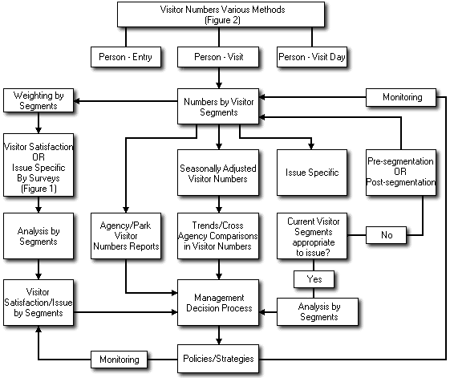

6. RESULTS

Examination of the final data base compiled from the Australia-wide protected area data collection process enables an indication of the extent to which various practices are used currently and makes possible an assessment of the most common means of collecting and managing Visitor Satisfaction and Visitor Use data. The extension of the data base to include selected commercial ventures, urban parks, State Forest Agencies and overseas protected areas enabled the comparison of current practice in Australian protected area agencies across a wider variety of organisations with similar purpose.

The discussion that follows necessarily simplifies the complex mix of processes that would be used within an agency or organisation to create a system for collecting visitor data and the close links between the structure of that system and the reasons for data collection. Given this simplification, each of the major processes e.g. 'Data Collection (Frequency and Timing)' is analysed as a separate entity rather than as a component of a total integrated system.

Two approaches to analysis were taken in the following discussion. In the first instance, an indication of most common practice was developed by simply noting the most frequently used practices. Secondly, the proposed 'best practice' process model was applied to the agencies and organisations i.e. only the highest rated practice for each agency is counted and a score out of five for each of the major sub-processes is calculated; a mean rating of current performance chart was then compiled e.g. Figure 4.

Measuring Visitor Satisfaction through Survey Methods

Appendix 4 (Tables 1 and 2) shows the range of processes and the frequency with which they are used in assessing Visitor Satisfaction and Experiences in Type 1 protected areas (high visitor numbers) and tables 3 and 4 those for Type 2 protected areas (low visitor numbers) throughout Australia. Tables 5, 6, 7 and 8 in Appendix 4 illustrate the same data for overseas agencies and other Australian organisations. The data indicates that 'best practice' does exist within some agencies in Australia and overseas which provides potential sources of case studies for detailed analysis.

Australian Protected Areas

A brief review of Tables 1 through 4 in Appendix 4 indicates that all Australian protected area agencies are involved to varying degrees in the collection of data on visitor satisfaction with facilities and services and experiences. As the data was collected on an agency wide basis a wide variety of processes is evident even within the one agency.

A composite pen picture of the way in which visitor satisfaction with 'Facilities and Services' is most frequently assessed at the present time indicates that:

data is collected 'occasionally' by 'direct handout by rangers' (although, almost equal use of visitor comments is evident) to a 'convenience' sample of visitors who mostly receive and return a short interview schedule. Most commonly 'no standard procedure' is used for data management and the information integrated into management mainly on an 'as needed basis' in the 'management planning cycle' or in an 'issue specific' context.

Comparison between the practices most commonly used in Type 1 and Type 2 areas indicates little difference in data collection in the two situations.

A mean rating of current performance chart was compiled for the Australian agencies (Figure 4). The results indicate that performance is high with regard to handout and collection of surveys i.e. mostly direct handout and return of short survey questionnaires. However, the frequency with which such surveys are undertaken, the method of selection of respondents and the processes for analysis are all relatively low. The frequency of integration into management which is also low, reflects the 'occasional' nature of the data collection. While, in general the ratings of the processes are lower in Type 1 than in Type 2 protected areas, the overall pattern is very similar, indicating that agencies are perhaps making little distinction between the two areas in terms of the allocation of resources to data collection.

Figure 4: Best Practice Ratings for Satisfaction Assessment Practices in Type 1 & 2 Protected Areas
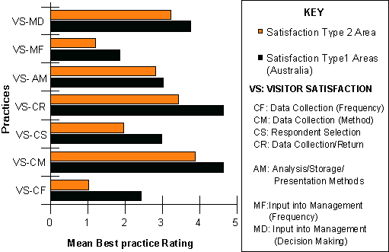

Comparisons between Australian Protected Area Agencies and Australian Commercial Ventures

A number of Australian commercial companies were approached to provide information on the processes used to collect visitor data. These companies included theme parks, resorts and a State tourism body (5 in total). Refer to Appendix 4 (Tables 5-8) for the summary data base for these companies. The best practice criteria were applied to compile 'mean best practice ratings' in the same manner as with the protected areas. These ratings were plotted with those from Australian Type 1 protected areas to produce Figure 5.

Overall, the most significant differences in mean process ratings appear to lie in the areas of frequency of data collection and integration into management, reflecting the high commitment in commercial enterprises to be aware of and responsive to variation in client demand. In this regard, a common feature in those commercial ventures interviewed in-depth was a high commitment to strategies such as 'importance/performance measures' and SERVQUAL assessments. An equally high commitment was evident in the use of data within the organisations indicated by the production of 'user friendly' reports and monthly section managers meetings to discuss performance. While there were personnel specifically designated with responsibilities for visitor data collection and distribution in each organisation, the questionnaire and the 'research' designs were developed by commercial consultants.

Figure 5: Best Practice Ratings for Satisfaction Assessment Practices in Type 1 Protected Areas and Commercial Ventures
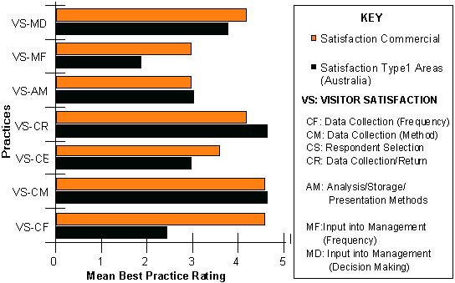

Comparisons between Australian and Overseas Protected Area Agencies

A small number of overseas protected area agencies (Parks Canada, British Columbia (BC) Parks and the Department of Conservation, New Zealand) were contacted to provide similar information as their Australian counterparts. Refer to Appendix 4 (Tables 5-8) for the summary data base for these protected area agencies. The best practice criteria were applied to compile 'mean best practice ratings' in the same manner as with the Australian protected areas.

These ratings were plotted for Type 1 and Type 2 protected areas in the overseas sample to produce Figure 6. A comparison between the plots shown in Figure 6 and those for Australian protected areas (Figure 4) reveals significantly lower mean ratings and hence, practice, for Type 2 as compared to Type 1 protected areas in the case of the overseas agencies. This implies a higher standard of data collection processes in high use than in low use protected areas and perhaps reflects an appropriate and considered allocation of resources.

Figure 6: Best Practice Ratings for Satisfaction Assessment Practices in Type 1& 2 Overseas Protected Areas
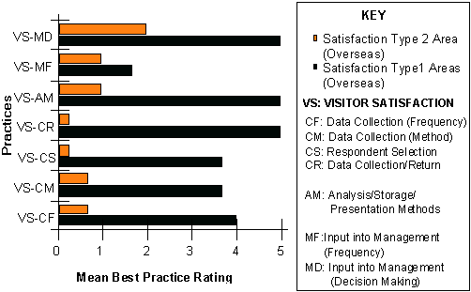

Figure 7 illustrates the mean best practice ratings for Type 1 protected areas in Australia and overseas. It is evident that data is collected more frequently and from a more representative sample in the overseas agencies and although there is less frequent input into the management process than in Australia, the information appears to be more available at all levels of management. The high ratings for data return and analysis represent the higher investment in automation which is evident in the Canadian system particularly.

Comparisons between Protected Area and Other Agencies in Australia

Figure 8 shows the best practice ratings for a metropolitan park system in Australia as compared to the mean ratings for Australian protected area agencies. The overall pattern of ratings indicates that the average protected area performance is lower than the metropolitan system in all but one area (sampling- convenience sampling is used).

Summary

The data base from protected areas in Australia was examined in terms of 'most common practice' and 'mean best practice ratings'. The former revealed that 'practice' generally rates quite low on best performance criteria (mean rating of all processes 2.1 ). Average performance was higher overall than the most common, however, frequency of administration, sampling and frequency of integration into management were rated low. This general statement is mitigated to some extent by the observation that 'best practice' does exist in both protected areas and commercial ventures in Australia and in overseas agencies, all of which provide potential for further study.

Comparisons of average performance were conducted with commercial ventures, overseas protected areas and other 'park' agencies. Average performance of Australian protected areas in the individual practices was generally lower than in the other organisations. Key deficiencies lay in frequency of administration and use in management.

Figure 7: Best Practice Ratings for Satisfaction Assessment Practices in Type 1 Protected Area Agencies in Australia and Overseas
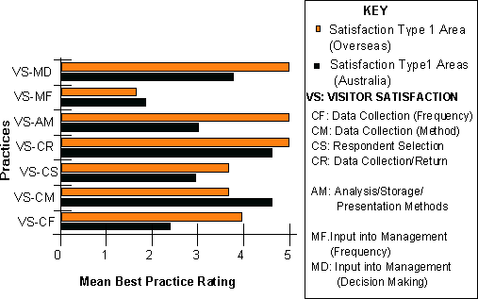
Figure 8: Best Practice Ratings for Visitor Satisfaction Assessment in Type 1 Protected Areas and Melbourne Parks & Waterways
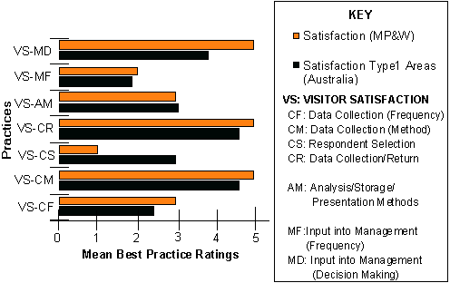

Overseas protected agencies undertook surveys more frequently and had more highly automated data entry and analysis systems than was typical in Australia. It was also evident that practice performance varied markedly with park type in overseas agencies but was quite uniform across types in Australian protected areas.

Measurement of Visitor Use by Automatic Counters

A similar approach was used to analyse the data from counters as from satisfaction i.e. most common practice and mean best practice ratings -were analysed within and across organisations. Traffic counters were the most commonly used automatic counting devices in Australian protected areas, although some limited use is made of 'people counters' in visitor centres and along walking tracks. The commercial organisations contacted did not use such devices, hence comparisons are entirely within protected area or park agencies.

Appendix 5 (Tables 1 and 2) shows the range of processes and the frequency with which they are used in assessing Visitor Use by automatic (traffic) counters in Type 1 and Type 2 protected areas and Tables 3 and 4 shows the same data for overseas agencies and other Australian organisations. The data again indicates high levels of practice in several Australian protected areas. A detailed plan for the use of traffic counters on an agency-wide basis was provided by CALM and is included in Appendix 8 (Haynes, de Braganca, Mulholland and Sharp; undated).

Australian Protected Areas

A composite pen picture of the way in which visitor use by automatic (traffic) counter is most frequently assessed in Type 1 protected areas at the present time indicates the following practice:

continuous reading using full calibration (non-visitor traffic, vehicle type and conversion), read manually on a weekly patrol, analysed by standard software and report with monthly and annual entry to mainly operational and strategic management.

Practice in Type 2 protected areas reflects a use more consistent with a monitoring function with continuous and occasional measurement being used with equal frequency. Calibration is limited to conversion to visitor numbers or simple counts. The same systems are used for collection and analysis and reporting, although the information is used less frequently (annual) and in issue specific contexts as well as operational and strategic management.
An analysis of mean best practice rankings (Figure 9) exhibits a similar practice to that discussed above.

In the case of automatic (traffic) counters, a process appears to have evolved which links data collection with management information needs, in that a distinction is evident between the resources allocated to data collection and management and the type of protected area.

Comparisons between Australian and Overseas Protected Area Agencies

Figure 8 depicts the mean ratings in Type 1 Australian and overseas protected area agencies in the collection and management of visitor use data. Indications are that the mean level of practice is higher in overseas than in Australian agencies in all but one area (calibration).

In Type 2 areas, of the three agencies surveyed one does not collect such data at all in Type 2 areas; another collects data continuously but does not appear to use any consistent methods for analysis and management although the data is integrated into management on an annual basis; the third basically follows the Australian pattern in that, it utilises the same frequency and processes for data collection as for Type 1 areas but analyses are reduced, as is frequency and management level at which the data is used.

Figure 9: Best Practice Ratings for Visitor Use Assessment by Automatic Counter in Type 1 & 2 Protected Areas
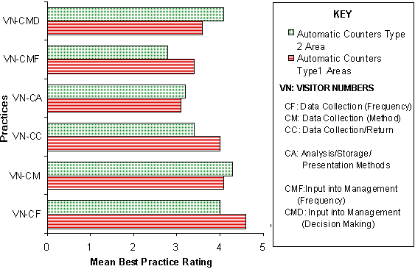
Figure 10: Best Practice Ratings for Visitor Use Assessment by Automatic Counters in Type 1 Protected Areas in Australia and Overseas
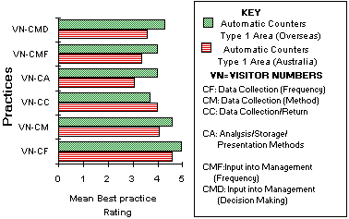
Comparisons between Protected Area and Other Agencies in Australia

Figure 11 indicates that the level of practice in Melbourne Parks & Waterways is higher than the mean Type 1 protected area in all but the calibration practice, where only a conversion factor is applied to change axle counts to numbers of visitors.

Figure 11: Best Practice Ratings for Visitor Use Assessment by Automatic Counters in Type 1 Protected Areas and Melbourne Parks & Waterways
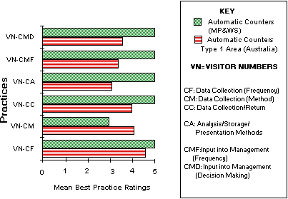
Summary

The average level of practice in the collection and management of automatic counter data within protected areas in Australia is high (Mean rating 3.8) although lower generally than both overseas and metropolitan park practice except in the more stringent calibration used in the Australian protected area context. Practice in Type 2 protected areas appears to reflect a consistently lower level of practice consistent with management needs for information from this type of area.

Measuring Visitor Use through Ranger Observation

Appendix 6 (Tables 1 and 2) shows the range of processes and the frequency with which they are used in assessing Visitor Use by Ranger Observation in Type 1 and Type 2 protected areas and Tables 3 and 4 shows the same data for overseas agencies and other Australian organisations.

Australian Protected Areas

It is evident from Tables 1 and 2 that all agencies use ranger observation to some extent within protected areas. There is little difference between practice in Type 1 and Type 2 areas and most common practice in the use of observation in Australian protected areas may be summed up as follows:

occasional informal observation of numbers and activities using no standard procedure for analysis or presentation integrated into management as needed on an issue specific basis.
The high overall consistency in practice across the agencies means that mean and most common practice are quite similar (Figure 12).

Comparisons between Australian and Overseas Protected Area Agencies

Ranger observation was used by two out of the three overseas protected areas surveyed.
In one case, ranger observation of numbers of visitors was used occasionally on an informal basis, no standard procedure was used for data entry or reporting and the information was used in management planning or as needed on an issue specific basis. The other agency, used a continuous process involving an observation checklist with a standard software and reporting system. Data was integrated into management on a monthly basis and used at all levels in the agency.

Summary

Ranger observation is used by all Australian agencies and by two out of the three overseas agencies. Practice was dominated by informality in both data collection and management.

Figure 12: Best Practice Ratings for Visitor Use Assessment by Ranger Observation in Type 1 & 2 Protected Areas
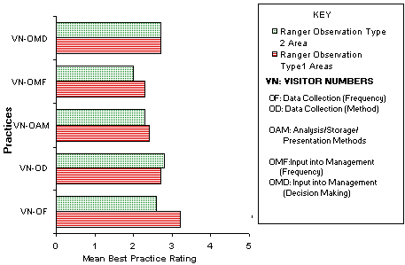

Measuring Visitor Use through Fee Collection

A complex variety of fees for service are administered in a modern protected area including merchandising, food sales, accommodation as well as, the more traditional entry and camping fees. However, in the assessment of visitor numbers within protected areas the transactions most commonly used are entrance fees, camping permits, commercial operator returns and commercial accommodation charges.

Appendix 6 (Tables 1 and 2) shows the range of processes and the frequency with which they are used in assessing Visitor Use by Fee Collection in Type 1 and Type 2 protected areas and Tables 3 and 4 shows the same data for overseas agencies and other Australian organisations.

Australian Protected Agencies

Eight agencies collect fees of some kind and use them in estimates of visitor numbers. A review of the most common practices indicates that:

Fees are mostly collected directly at entrance stations, visitor centres, and there is an even division between direct use of dollars as indicators and using a high level of calibration (numbers/characteristics and compliance estimates) to estimate actual visitor numbers. No one procedural practice for analysis and presentation could be seen to be prevalent. Information is used as needed mainly at the operational and strategic level.

In general the practices in Type 2 areas are scaled down with ranger collection and self-registration dominant, minimal calibration (numbers) and manual, unstandardised analysis and reporting. There is more emphasis on information integration on an 'as needed' basis principally in an issue specific context.

Figure 13 shows the mean best practice ratings for assessment of visitor use by fee collection for Type 1 and Type 2 protected areas in Australia. The generally high levels of fee collection and management practice is consistent with audit requirements. Relatively high levels of calibration and integration into management are evident in Type 1 areas.

Comparisons between Australian Protected Area Agencies and Australian Commercial Ventures

The dominant means of visitor use data collection and management in commercial ventures is through fee collection and a high level of sophistication and control is demonstrated by the practice of such organisations (Figure 14). A detailed description of the "Theme Park Management System (Data 3, Gold Coast, Queensland) is provided in Appendix 8. It is evident in all areas of practice that commercial ventures because of the close control on entry exceed the standards in protected areas.

Figure 13: Best Practice Ratings for Visitor Use Assessment by Fee Collection in Type 1 & 2 Protected Areas
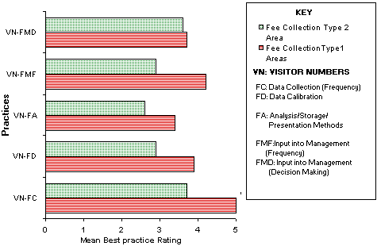

Figure 14: Best Practice Ratings for Visitor Use Assessment by Fee Collection in Type 1 Protected Areas and Commercial Venues
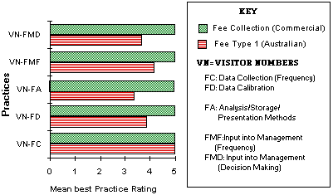
Comparisons between Australian and Overseas Protected Area Agencies

Australian agencies demonstrate comparable average practice in visitor assessment by fee collection in Type 1 protected areas with those overseas agencies surveyed (Figure 15). In the area of calibration, Australian practice exceeds that of overseas agencies. In Type 2 protected areas Australian practice exceeds that of the overseas agencies (Figure 16).

Summary

Fee collection is widely used both in Australia and overseas as a means of assessing visitor use. The average practice of Australian protected area agencies is lower than that of commercial enterprise and comparable with practice in overseas protected areas. In both overseas and Australian Type 2 protected areas the practice is lower than in Type 1 areas. However, Australian practice is significantly higher than overseas in the Type 2 areas and higher overall with regard to the conversion of fees ($) into visitor numbers. A deficiency is perhaps evident in the level at which revenue collection from protected areas is integrated into management. Few agencies integrate at the policy and strategic level where increasingly the economic contribution of protected areas to the community needs to be recognised.

7. SYSTEM FLEXIBILITY AND STANDARDISATION

Protected areas vary in their physical characteristics in terms of visitor numbers, seasonality of visitation, access, distance from centres of population, staffing, entrance exit controls; to name but a few. These characteristics singly and in combination will make difficult the development of a standardised system suitable for all types of protected areas. What might be 'best practice' in one protected area may be quite inefficient in another.

Despite this wide variability in character, it might well be possible to 'cluster' protected areas into a small number of similar groups based on a combination of relevant criteria e.g. visitor numbers, staffing and entrance/exit control and on this basis develop a series of data collection and management strategies which accommodates the individual but not necessarily unique characteristics of each protected area.

If this approach is seen to have some merit, Protected Area Agency representatives could:

- develop and agree on an appropriate mix of criteria;
- apply these to each of the State's Protected Area Systems and
- compile a data base of protected area clusters with their classification characteristics and current visitor data collection processes.

The first stage of this process was implemented through the recognition of Type 1 and Type 2 protected areas for the purposes of data collection in this study. Beaman and Stanley (undated) used a more sophisticated classification based on three measures of visitor use and demonstrated the utility of this approach in segmenting national parks within the Parks Canada system (Appendix 8).

Figure 15: Best Practice Ratings for Visitor Use Assessment by Fee Collection in Overseas and Australian Type 1 Protected Areas
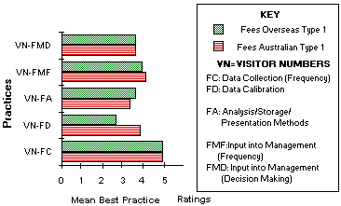

Figure 16: Best Practice Ratings for Visitor Use Assessment by Fee Collection in Overseas and Australian Type 2 Protected Areas
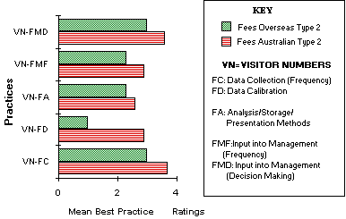
8. CONCLUSION

A data base has been compiled based on the returns from Australian protected area agencies and other selected Australian and overseas organisations including protected areas, commercial ventures and a metropolitan park system. A set of practices common to all the organisations were scaled using proposed best practice criteria and a series of comparisons were drawn between the various organisations surveyed.

Key Observations from the Data Analyses

- there is wide variation in terminology and measurement targets in visitor use and satisfaction data collection evident in the Australian protected area agencies. Despite this variation, a pattern, based on user characteristics in terms of duration and purpose of visit, is evident in the definitions provided;
- high levels of practice exist in individual Australian agencies in all areas of the collection and management of visitor data. There is therefore a wealth of practice which is available to raise standards generally within Australia;
- in the area of measurement of visitor satisfaction:
- Australian practice is very variable, with some very high levels of practice in individual agencies but both most common and average practice is below that of commercial enterprises and overseas protected areas;
- the main areas of weakness in the Australian protected areas lies in the frequency of assessment of satisfaction, with the representativeness of the sample and integration into management;
- on average Australian protected area agencies seem to make little distinction between Type 1 areas (high visitor numbers) and Type 2 areas (low visitor numbers) in terms of effort in the measurement of visitor satisfaction. This is arguably a misallocation of resources;
- visitor use is assessed in three ways:
- by automatic, mainly traffic, counters, ranger observation and fee collection. Normally, some combination of all of these characterises the Australian situation;
- practice in the use of traffic counters is generally high but lower than in overseas and metropolitan park practice except in the case of calibration. Use in Type 2 areas is consistent with a low level monitoring function;
- practice in the use of ranger observation is lower than either automatic counters or fee collection.
- practice in the use of fee collection in Australian agencies is high and broadly similar to that in overseas agencies but lower than in commercial ventures;
- the wide diversity of protected agencies makes difficult the development of one vision of best practice and thus the practices used in any protected area must be closely linked to the role that visitor data will play in management function.

