WA INTERIM RECOVERY PLAN NO. 234

NORSEMAN PEA

(DAVIESIA MICROCARPA)

RECOVERY PLAN

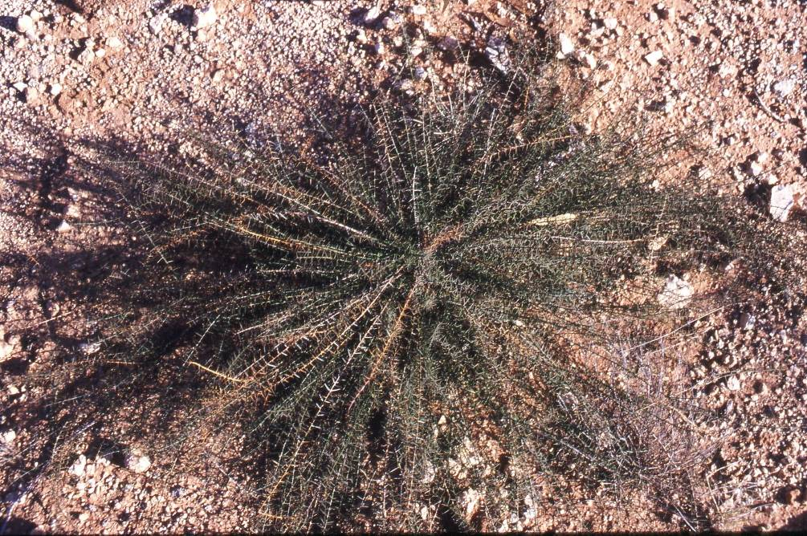
Photo: Ryan Butler

Department of Environment and Conservation
Kensington

 |  | 
FOREWORD

Recovery Plans (RPs) and Interim Recovery Plans (IRPs) are developed within the framework laid down in Department of Conservation and Land Management (CALM) Policy Statements Nos. 44 and 50. Note: the Department of CALM formally became the Department of Environment and Conservation (DEC) in July 2006.

Plans outline the recovery actions that are required to urgently address those threatening processes most affecting the ongoing survival of threatened taxa or ecological communities, and begin the recovery process.

DEC is committed to ensuring that Threatened taxa are conserved through the preparation and implementation of plans and by ensuring that conservation action commences as soon as possible.

This plan will remain in force until withdrawn or replaced. It is intended that, if the taxon is still ranked Critically Endangered (against IUCN criteria) this plan will be reviewed after five years and the need for further recovery actions assessed.

This plan was given regional approval on 17 October 2004 and was approved by the Director of Nature Conservation on 5 December 2004. The provision of funds identified in this plan is dependent on budgetary and other constraints affecting DEC, as well as the need to address other priorities.

This plan was written and endorsed as an IRP in Western Australia, and it is also the National Recovery Plan for this species as listed under the Commonwealth Environment Protection and Biodiversity Conservation Act 1999.

Information in this plan was accurate at March 2010.

PLAN PREPARATION

This plan was prepared by Ryan Butler¹, Mike Fitzgerald² and Andrew Brown³

¹Conservation Officer (Flora), Esperance District, DEC, PO Box 234, Esperance WA 6450
²Nature Conservation Coordinator, Esperance District, DEC, PO Box 234, Esperance WA 6450
³Coordinator Threatened Flora, DEC, Locked Bag 104, Bentley DC 6983.

ACKNOWLEDGMENTS

The following people have provided assistance and advice in the preparation of this Interim Recovery Plan:

Barbara Archer Amateur botanist and specimen collector, Norseman.
Anne Cochrane Manager, Western Australia’s Threatened Flora Seed Centre
Mike Crisp Australian National University
Bernie Haberley Former Esperance District Wildlife Officer

Thanks to the staff of the W.A. Herbarium for providing access to Herbarium databases and specimen information, and DEC Species and Communities Branch for assistance.

CITATION

This plan should be cited as:

Department of Environment and Conservation (2004) Daviesia microcarpa Interim Recovery Plan 2004-2009. Interim Recovery Plan No. 234. Department of Environment and Conservation, Western Australia.
SUMMARY

Scientific Name: | Daviesia microcarpa | Common Name: | Norseman Pea
Family: | PAPILIONACEAE | Flowering Period: | August - September
Dept Region: | South Coast | Dept District: | Esperance
Shire: | Dundas | Recovery Team: | Esperance District Threatened Flora Recovery Team (EDTFRT)

Illustrations and/or further information: Brown, A., Thomson-Dans, C. and Marchant, N. (Eds). (1998) Western Australia’s Threatened Flora. Department of Conservation and Land Management, Western Australia; Hopper, S. D. et al. Western Australia’s Endangered Flora (1990); Mattiske, E. M. and Associates, Assessment of Three Gazetted Rare Plants (1994); Crisp, M. D. Contributions Towards a Revision of Daviesia (Fabaceae: Mirbelieae) III A Synopsis of the Genus (1995); Schwarten, T. The Biology and Ecology of Threatened Daviesia Species in Western Australia (1995); Coates, D. and Craig, G. Wildlife Management Program 21 (1991).
Current status: Daviesia microcarpa was declared as Rare Flora in September 1987 and is ranked as Critically Endangered (CR) in Western Australia against World Conservation Union (IUCN, 2001) criteria B1ab (i, iii, iv, v)+2ab (i, iii, v); C1; C2a (i); D due to the severe fragmentation of populations and continuing decline in the area, extent and quality of habitat and the number of mature individuals. The main threats are road maintenance, inappropriate fire regimes, lack of appropriate disturbance, weeds and poor recruitment.
Description: Daviesia microcarpa is a sprawling shrub to 40 cm high and 1 m wide, with 8-20 mm long needle-like phyllodes spirally arranged on tangled stems. The flowers, which are produced from August to September, are found towards the end of each stem. Each flower has a standard c. 4 mm long and 5 mm broad that is orange in colour with pinkish red veins. The wings are pinkish red with orange tips and the keel is pale orange pink. The flowers and pods (4-4.5 mm long) distinguish Daviesia microcarpa from nearly all its relatives as they are amongst the smallest in the genus (Crisp 1985). Daviesia microcarpa was formally described by M.D. Crisp in 1995.
Habitat requirements: D. Whibley made the first known collection of Daviesia microcarpa in 1974. There is currently 1 extant population containing 39 plants east of Norseman where plants grow in disturbed low mallee heath over spinifex scrub in loamy red-brown soil with calcrete nodules, usually beside or in watercourses and 1 population of 13 plants near Southern Cross which is not thought to be natural (A. Brown¹ pers. comm. 2003).
Habitat critical to the survival of the species, and important populations: The habitat critical to the survival of Daviesia microcarpa comprises the area of occupancy of the known populations; similar habitat within 200 metres of known populations; corridors of remnant vegetation that link populations and additional nearby occurrences of similar habitat that do not currently contain the species but may have done so and may be used for translocations. This taxon is listed as Critically Endangered and it is therefore considered that all known habitat for wild and future translocated populations is critical habitat and that all populations, including translocated populations, are important populations.
Benefits to other species/ecological communities: Recovery actions implemented to improve the quality or security of the habitat of Daviesia microcarpa will also improve the status of remnant vegetation in which it is located.
International Obligations: This plan is fully consistent with the aims and recommendations of the Convention on Biological Diversity, ratified by Australia in June 1993, and will assist in implementing Australia’s responsibilities under that Convention. Daviesia microcarpa is not specifically listed under any international treaty and therefore this plan does not affect Australia’s obligations under any other international agreements.
Role and interests of indigenous people: According to the Department of Indigenous Affairs Aboriginal Heritage Sites Register, no sites are known near Daviesia microcarpa populations. Input and involvement has been sought from Aboriginal groups that may have an active interest in the areas that are habitat for D. microcarpa, and this is discussed in the recovery actions.
Affected interests: Populations occur on Main Roads Western Australia (MRWA) land, mining lease and on a pipeline reserve.
Social and economic impact: There is potential for some impact as Populations occur on MRWA land, mining leases and a water/common reserve. Recovery actions refer to continued liaison between stakeholders with regard to these areas.
Evaluation of the Plans Performance: The Department of Environment and Conservation (DEC), in conjunction with the EDTFRT, will evaluate the performance of this plan. In addition to annual reporting on progress with listed actions and comparison against the criteria for success and failure, the plan is to be reviewed within five years of its implementation.
Existing Recovery Actions: The following recovery actions have been or are currently being implemented –
- Land managers and adjacent landowners have been made aware of the location and threatened status of the species.
- Approximately 12,600 seeds collected from sub-populations 1b & 1c between 1993 and 2001 are stored in DEC Threatened Flora Seed Centre at –18°C.
- In 2002, 600 seeds were used in a translocation planted in the same gravel pit as sub-population 1c.
- Sub-population 1b has markers installed and sub-population 1c has been fenced.
- The EDTFRT and staff from DEC Esperance District are overseeing the implementation of this plan and will include information on progress in an annual report to DEC's Corporate Executive and funding bodies.
- Staff from DEC Esperance District regularly monitor populations of the species.
Recovery Plan Objective: The objective of this Recovery Plan is to abate identified threats and maintain viable in situ populations of Daviesia microcarpa in order to conserve the wild genetic stock of the species.
Recovery criteria
Criteria for success: The number of individuals within populations and/or the number of populations have increased by ten percent or more over the period of the plan’s adoption under the EPBC Act.
Criteria for failure: The number of individuals within populations and/or the number of populations have decreased by ten percent or more over the period of the plan’s adoption under the EPBC Act.

Recovery actions:

- Coordinate recovery actions | - Collect tissue culture and cutting material
- Map habitat critical to the survival of Daviesia microcarpa | - Conduct further translocations
- Monitor populations | - Develop and implement a fire management strategy
- Conduct further surveys | - Obtain biological and ecological information
- Conduct fire and disturbance trials | - Produce and distribute media materials and undertake educational presentation
- Liaise with landowners and land managers | - Review the plan and assess the need for further recovery actions.
__________________________
¹ Andrew Brown (WATSCU)
Daviesia microcarpa
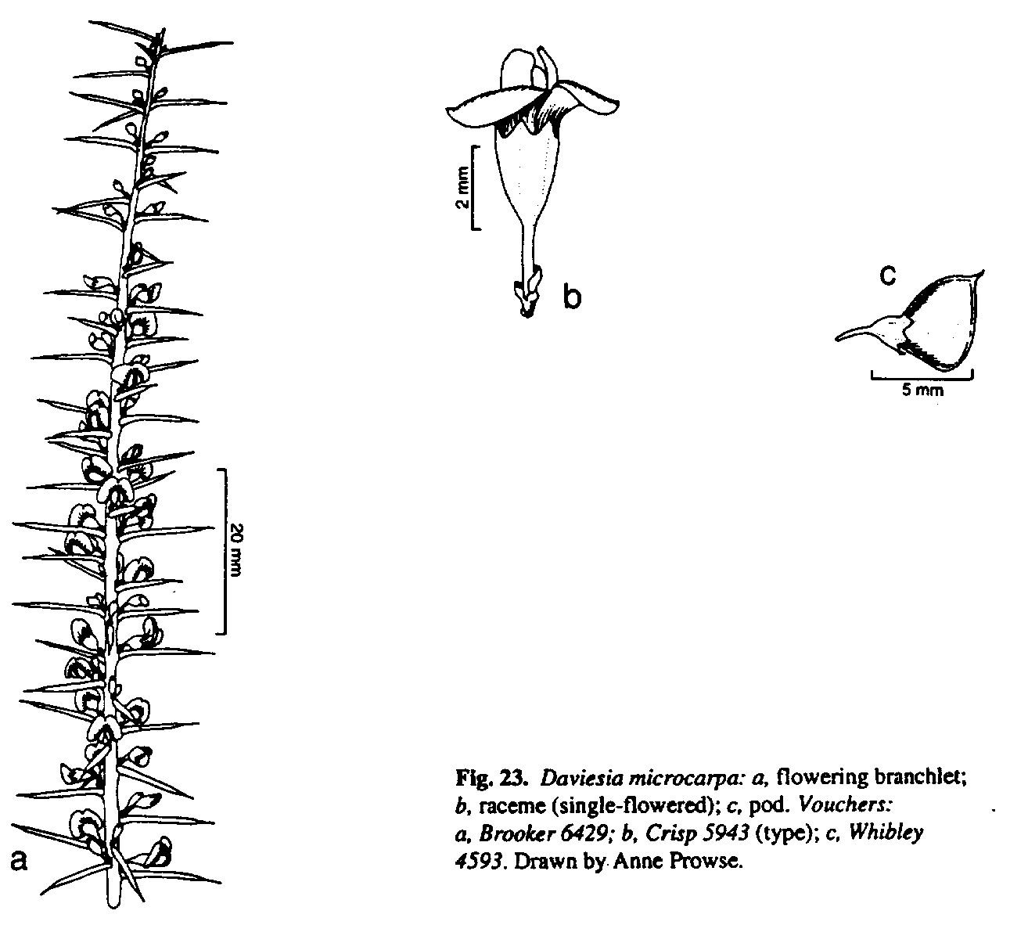Anne Prowse

Distribution of Daviesia microcarpa
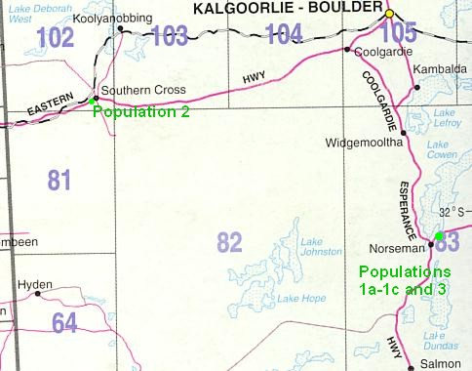
1. BACKGROUND

History
The first known collection of Daviesia microcarpa was made in 1974 by D. Whibley of the State Herbarium of South Australia who located plants in a disturbed area on a roadside ditch north-east of Norseman on the Eyre Highway (sub-population 1a). M.D. Crisp and M.I.H. Brooker made further collections from the same area in February and September 1979 and August 1979 respectively. During the latter half of 1984, Main Roads Western Australia (MRWA) graded the road reserve and it was believed that the sub-population was destroyed at that time. However, in March 1985 an unconfirmed report of thirteen plants was made from the same site by P. Collins from the Department of Fisheries and Wildlife. It is believed that soil disturbance during MRWA maintenance in 1984 stimulated the germination of soil-stored seed, resulting in the thirteen plants recorded in 1985. This was the last sighting of the species until 1992.
In 1990 MRWA was denied permission to disturb the area containing Daviesia microcarpa in preparation for the upgrading and realignment of the Norseman section of the Eyre Highway until the conservation status of the species was known. To obtain this information, Engineering consultants Halpern Glick Maunsell Pty Ltd were commissioned by MRWA to prepare an Environmental Assessment and Management Plan (EAMP), including a biological survey for Daviesia microcarpa. No plants were found during surveys conducted by them in 1991 and 1992.
The former department of CALM commissioned Mattiske Consulting Pty Ltd in 1992 to conduct further surveys for the species. Eighteen plants were found, of which two were dead (sub-population 1b). This subpopulation was located approximately 500 m north-east along the Eyre Highway from the original location of the species and was believed to have been graded four or five years prior to 1992. Extensive surveys for the species in other areas failed to locate more plants.
On 10th November 1994 MRWA was granted permission to conduct works in the area of sub-population 1a as extant plants no longer existed there.
Road works for the realignment of the Eyre Highway commenced late 1995. In May 1996 the site was surveyed by A. Brown, E. Holland and F. Bunny from the former CALM Threatened Species and Communities Unit (WATSCU). The area had been fenced and flagged by MRWA as per the recommended guidelines in the EAMP and fifteen live plants (plus one dead plant) were recorded. The embankment of the new road was, however, extremely close to the edge of the sub-population and several trees within the fenced area had been cut down. Also, several Declared Rare Flora (DRF) markers had been removed.
The site was again surveyed by A. Brown in September 1996. The DRF markers had still not been re erected and a culvert had been positioned through the road into the middle of the sub-population. In the process of building the culvert two plants had been buried, one of which was thought to be unlikely to survive. It also appeared likely that water would drain through the culvert into the low lying area of the sub-population, possibly causing flooding and siltation.
In 1997 CALM staff conducted a survey in the area of population 1b and a second site where topsoil from the road realignment had been placed. No plants were observed at the topsoil site. However, subpopulation 1b appeared to be stable. After this survey MRWA erected small pine bollards and DRF markers at subpopulation 1b.
In 2001, plants were located in three new areas. These included an additional 15 plants (subpopulation 1c) found by Croesus Mining’s K. Tanner approximately 200m NW of subpopulation 1b in a rehabilitated gravel borrow pit, a new population (population 2) found the same year near Southern Cross by Mattiske Consulting Pty Ltd and a site containing 2 plants (population 3) found by B. Archer east of sub-population 1b. During a survey in 2002 by CALM staff a total of 49 plants were counted in subpopulation 1c and 10 plants at 1b. At the same time as the 2002 survey, a translocation was conducted in the gravel pit containing sub-population 1c. Some 500 seeds were planted in rows and another 100 seeds scattered around the gravel pit. The gravel pit was then fenced to reduce the potential for subsequent seedlings to be grazed. To date (2004), there has been no evidence of germination.
During surveys of Norseman populations in 2003 by R. Butler and W. Williams (DEC, Esperance) it was found that the 2 plants at population 3 had died, and there were just 7 extant plants in sub-population 1b and 32 plants in sub-population 1c. Plants in the Southern Cross population (population 2) had also died but a further 13 plants germinated in 2009.
Description
Daviesia microcarpa is a sprawling shrub to 40 cm high and 1 m wide, with 8-20 mm long needle-like phyllodes spirally arranged on tangled stems. The flowers, which are produced from August to September, are found towards the end of each stem. Each flower has a standard c. 4 mm long and 5 mm broad that is orange in colour with pinkish red veins. The wings are pinkish red with orange tips and the keel is pale orange pink. The flowers and pods (4-4.5 mm long) distinguish Daviesia microcarpa from nearly its relatives as they are amongst the smallest in the genus (Crisp 1985).
Daviesia microcarpa was formally described by M.D. Crisp in 1995.
Distribution and habitat
Daviesia microcarpa is currently known from two extant populations, one population of 39 plants to the east of Norseman and one near Southern Cross containing 13 plants. A third population near Norseman is now believed to be extinct.
Habitat consists of Eucalyptus oleosa var. oleosa over Melaleuca pungens, Allocasuarina helmsii, Acacia hemiteles and Westringia dampieri over grasses of Aristida contorta and Triodia sp. in dry red-brown loamy clay with calcrete nodules.
A full list of associated species is included in Appendix one.
Biology and ecology
Daviesia is the second most diverse genus of pea-flowered legumes in Australia with 135 known species and subspecies. Like many other Daviesia species, D. microcarpa is considered a relatively short-lived disturbance opportunist with germination of soil-stored seed known to be stimulated by fire and habitat disturbance, such as occurs during grading (Crisp 1983).
It is recognised from previous work on threatened species of Daviesia (Schwarten 1995) that some species have high incidences of flower and fruit abortion with a low seed set. However, Daviesia microcarpa has been noted to usually have a high seed set suggesting active pollinators.
In 2002, DNA analysis of the genus Daviesia was carried out by Mike Crisp at The Australian National University. It was found that the Daviesia microcarpa is very distant and distinct both genetically and evolutionary from all other Daviesia species (M.D. Crisp² pers comm. 2002).
Seed collected in 1993 by DEC’s Threatened Flora Seed Centre (TFSC) had a 94% germination rate (A.Cochrane3 pers comm. 1995).
________________________
² Mike Crisp (Australian National University)
³Anne Cochrane (Western Australian Herbarium)

Threatening processes
A naturally restricted geographical range combined with a lack of suitable disturbance (soil disturbance or fire) may be the cause of the rarity of the species. A short life span and poor germination of soil stored seed may also be contributing to the low numbers of extant plants. Continuing threats include:
- Senescence is resulting in the deaths of old plants that are not being replaced through natural recruitment.
- Altered hydrology as a result of the MRWA highway realignment undertaken in 1996 may lead to continuing deaths of adult plants in population 1b and poor or no recruitment.
- Lack of suitable disturbance has resulted in no recruitment at populations 1a, 1b, 2 and 3.
- Inappropriate fire regimes during the reproductive phase of Daviesia microcarpa (i.e. flowering, pollination, seed development and seed dispersal) may result in low/nil seedling recruitment. High fire frequency may also lead to the degradation of the habitat of Daviesia microcarpa due to a depletion of soil seed banks and a temporary increase in the availability of nutrients for weed establishment (Panetta and Hopkins 1991). Irregular summer fire may be an important part of the life cycle of this species and be necessary for regeneration.
- Drought appears to have had an affect on all of the populations. Many of the mature plants and smaller seedlings have shown signs of stress in the past 2 years (2002/03) and some have not recovered.

Table 1: Summary of population information
Pop no & location | Land status | No of plants | Condition | Threats
- ENE of Norseman | Road Reserve, MRWA | 1985, 13  2003, 0 | Extinct | Road works, inappropriate fire
- ENE of Norseman | Road Reserve, MRWA | 1996, 15  1997, 12  1998, 11  2002, 10  2003, 7  2009, 5 | Poor | Road works, flooding, inappropriate fire
- ENE of Norseman | Rehabilitated borrow pit | 2002, 49  2003, 32  2009, 34 | Healthy | Grazing
2. Southern Cross | Mining Lease | 2001, 7  2003, 0  2009, 13 | Extinct | Track maintenance, inappropriate fire
3. ENE of Norseman | Dewatering pipeline | 2001, 2  2003, 0  2009, 0 | Extinct | Road works, pipeline maintenance work

Habitat critical to the survival of the species, and important populations

Habitat Critical to the survival of the species is habitat identified as being critical to the survival of a listed threatened species or listed threatened ecological community. The area of occupancy of currently known Daviesia microcarpa populations has been mapped. However, areas of habitat critical outside known populations has not yet been mapped.

The habitat critical for the survival of Daviesia microcarpa comprises:
- the area of occupancy of known populations.
- areas of similar habitat within 200 metres of known populations, i.e. low, open mallee over spinifex scrub in gravelly, dry red-brown loamy clay with calcrete nodules which has been disturbed (these provide potential habitat for natural range extension).
- corridors of remnant vegetation that link populations (these are necessary to allow pollinators to move between populations and are usually road and rail verges).
- the local catchment area (the species may be transported by local surface and ground water hydrology).
- additional occurrences of similar habitat that do not currently contain the species but may have done so in the past (these represents possible translocation sites).

This species is listed as Critically Endangered and it is therefore considered that all known habitat for wild and any future translocated populations is habitat critical for their survival and that all populations are important populations.

Benefits to other species/ecological communities

Recovery actions implemented to improve the quality or security of the habitat of Daviesia microcarpa will also improve the status of remnant vegetation in which it is located.

International Obligations

This plan is fully consistent with the aims and recommendations of the Convention on Biological Diversity, ratified by Australia in June 1993, and will assist in implementing Australia’s responsibilities under that Convention. The taxon is not listed under any specific international treaty, however, and therefore this plan does not affect Australia’s obligations under any other international agreements.

Role and interests of indigenous people

According to the Department of Indigenous Affairs Aboriginal Heritage Sites Register, no sites have been discovered near any Daviesia microcarpa population. However, input and involvement has been sought from Aboriginal groups that may have an active interest in the areas that comprise habitat for D. microcarpa, and this is discussed in the recovery actions.

Affected interests

Known populations occur on Main Roads Western Australia (MRWA) land, Mining lease and pipeline reserve.

Social and economic impacts

The implementation of this recovery plan has the potential to have some social and economic impact as populations of Daviesia microcarpa occur on MRWA road reserve, mining leases and a water/common reserve. Recovery actions refer to continued liaison between stakeholders with regard to these areas.

Guide for decision-makers

Section 1 provides details of current and possible future threats. Developments in the immediate vicinity of the populations or within the defined critical habitat of Daviesia microcarpa require assessment for the potential for a significant level of impact. No developments should be approved unless the proponents can demonstrate that they will not have a detrimental impact on the taxon or its habitat or potential habitat or the local surface and ground water hydrology.

Evaluation of the Plans Performance

DEC, in conjunction with the EDTFRT will evaluate the performance of this recovery plan. In addition to annual reporting on progress against the criteria for success and failure, the plan is to be reviewed within five years of its implementation. Any changes to management / recovery actions made in response to monitoring results will be documented accordingly.

2. RECOVERY OBJECTIVE AND CRITERIA
Objective
The objective of this Interim Recovery Plan is to abate identified threats and maintain viable in situ populations to ensure the long term preservation of the species in the wild.
Criteria
Criteria for success: The number of individuals within populations and/or the number of populations have increased by ten percent or more over the period of the plan’s adoption under the EPBC Act.

Criteria for failure: The number of individuals within populations and/or the number of populations have decreased by ten percent or more over the period of the plan’s adoption under the EPBC Act.

- RECOVERY ACTIONS
Existing and completed recovery actions
The DEC TFSC has a total of approximately 12,600 seeds in storage from six collections. Tests of the 1993 collection gave a 94 % germination rate.
The following sites were surveyed by Mattiske Consulting Pty Ltd in 1992:
- North and south of Eyre Highway near sub-population 1b, in recently burnt/regenerating area.
- Numerous tracks in the Jimberlana Hill area.
- Calcrete pits in the Jimberlana Hill area.
- Calcrete pits north east of sub-population 1b, north of the Eyre Highway.
- Unnamed road north east of sub-population 1b, south of the Eyre Highway.
In late 1995 road works along the Eyre Highway commenced and sub-population 1b was fenced and flagged. In January 1996, half of the area where sub-population 1a had occurred (plants last seen 1985) was cleared (Haberley4 pers comm. 1996). The topsoil from this location was spread over a disused gravel scrape in the hope that soil stored seed might germinate. To date, no germination has been observed.
Since 2001, monitoring of the sites has been routinely undertaken by DEC Esperance District staff and includes stereo aerial photography interpretation of the existing sites. The information gathered was used to survey for new populations in the surrounding area.
In 2002 a translocation was conducted into the gravel pit containing sub-population 1c with some 500 seeds planted in rows and another 100 seeds scattered around the pit. The rows were split into five groups of four. Each of these four rows consisted of a different treatment method. Treatments included nicking seed, placing in boiling water, scratching seed dirt and a control line with no treatment. The five rows contained five replications of these treatments. To date there has been no evidence of any germination.
A Threatened Flora Recovery Team was established for DEC Esperance District in 2002. This team is overseeing the implementation of this plan and reports annually to DEC Corporative Executive.
Future recovery actions
Where populations occur on lands other than those managed by DEC, permission has been or will be sought from appropriate land managers prior to recovery actions being undertaken. The following recovery actions are roughly in order of descending priority; however this should not constrain addressing lower priority recovery actions if funding is available and other opportunities arise.

1. Coordinate recovery actions

The EDTFRT is coordinating recovery actions for Daviesia microcarpa and will include information on progress in their annual report to DEC Corporate Executive and funding bodies.

Action: Coordinate recovery actions
Responsibility: DEC (Esperance District) through the EDTFRT
Cost: $4,000 per year

2. Map Habitat critical to survival of the species

It is a requirement of the EPBC Act that spatial data relating to habitat critical to the survival of a species be determined. Although this habitat is described in Section 1, it has not yet been fully mapped and this will be redressed under this action. If any additional populations are located habitat critical to their survival will also be determined and mapped for them.

Action: Map habitat critical to the survival of Daviesia microcarpa
Responsibility: DEC (Esperance District, Species and Communities Branch (SCB)) through the EDTFRT
Cost: $2,000 in the first year.

3. Monitor populations
Monitoring of factors such as weed encroachment, habitat degradation, sub-population stability (expanding or declining), seed production, recruitment and longevity is prescribed.
All sub-populations will be inspected annually as a requirement under CALM Policy Statement Nos. 9 Conservation of Threatened Flora in the Wild and No 28 Reporting Monitoring and Re-evaluation of Ecosystems and Ecosystem Management.
Action: Monitor sites
Responsibility: DEC (Esperance District, SCB) through the EDTFRT
Cost: $1500 per year

4. Conduct further surveys

Daviesia microcarpa has been extensively surveyed for by DEC staff and consultants in recent years. However, it is recommended that surveying for the species in other suitable habitats is continued on a systematic basis, particularly during its flowering period (August-September) and following disturbances such as fire and grading. Volunteers from the local community and wildflower societies and naturalist clubs from Perth could be involved in surveys supervised by DEC staff. One area recommended for further surveying is Dundas Nature Reserve ↑36957, vested in the Conservation Commission of Western Australia (CCWA) for the conservation of flora and fauna.

Action: Conduct further surveys
Responsibility: DEC (Esperance District, SCB) through the EDTFRT
Cost: $4000 per year.
5. Conduct fire and soil disturbance trials

It is recommended that management burning and soil disturbance be trialled on a further two occasions to determine the effectiveness of different regimes in encouraging recruitment. The trial of both fire and soil disturbance would ascertain which is most effective. This research should assist to determine:
- The size and viability of the soil seed bank.
- The seed germination requirements of Daviesia microcarpa.
- The role of disturbance in regeneration and recruitment.
- Response of Daviesia microcarpa and its habitat to fire.
Care, however, should be taken as these processes inherently carry a significant risk of depletion of soil seed bank reserves. The construction of firebreaks around burn plots is recommended.
Action: Conduct fire and soil disturbance Trials
Responsibility: DEC (Esperance District) through the EDTFRT
Cost: $6300 in the first and third years for trial implementation, and $1,700 in other years for monitoring.

- Liaise with landowners and land managers

Continued liaison between DEC Esperance District and MRWA is required to ensure the following actions are undertaken:
- Monitoring of the area where top soil that potentially contains Daviesia microcarpa seed from the extinct sub-population 1a was spread to detect any germination.
- Ensuring that there is minimal disturbance to sub-population 1b.
- Controlling weed species invading habitat of populations due to disturbance from roadworks (spraying in the vicinity of sub-population 1a and 1b would require permission from DEC).
If more plants are found, either through surveys for new populations or due to the actions detailed above, staff from the DEC Esperance District will continue liaison with landowners and managers to ensure that populations are not accidentally damaged or destroyed. Ways and means of improving the security of populations and their habitat will also be investigated.

Action: Liaise with landowners and land managers
Responsibility: DEC (Esperance District) through the EDTFRT
Cost: $1,800 per year

Collect tissue culture and cutting material

Adequate seed is currently in storage at the DEC TFSC. However, recovery of the species may require other ex situ conservation techniques. These can involve living collections from cutting or other source material, or storage of tissue culture material. If resources are limited these techniques will need to be carefully prioritised in relation to in situ conservation. This will be coordinated by the Esperance District Threatened Flora Recovery Team (EDTFRT).

Preservation of germplasm is essential to guard against extinction if wild populations are lost. Such collections are also needed to propagate plants for translocations

Action: Collect seed and cutting material if and when required

Responsibility: EDTFRT, DEC (Threatened Flora Seed Centre (TFSC), Esperance District, SCB
Cost: $1,200 per trip in third and fifth years

8. Conduct further translocations

Surveys for possible future translocation sites have taken place with two borrow pits identified as potential sites. Two translocations were planned but due to funding constraints only one was carried out. Provided funding becomes available this will be carried out in the second and third years. All translocation proposals require endorsement by the Director of Nature Conservation.

Action: Conduct further translocations.
Responsibility: EDTFRT, DEC (Esperance District, SCB) through the EDTFRT
Cost: $4,500 in the second and third years.

9. Develop and implement a fire management strategy

Although the affects of fire on Daviesia microcarpa has not been documented it is likely that the species responds well to occasional fire for recruitment. However, frequent fire may prevent the accumulation of sufficient soil-stored seed for recruitment to occur. Fire should therefore be prevented from occurring in the area of populations except where it is being used experimentally as a recovery tool and until such time as research results indicate a suitable regime. A fire management strategy will be developed to determine fire control measures and fire frequency.

Action: Develop and implement a fire management strategy
Responsibility: DEC (Esperance District) through the EDTFRT
Cost: $2,600 in first year and $1,000 in subsequent years.

10. Obtain biological and ecological information

Improved knowledge of the biology and ecology of Daviesia microcarpa will provide a better scientific basis for its management in the wild and will include:

- Determining the reproductive methodology, phenology and seasonal growth of the species.
- Investigating the population genetic structure, levels of genetic diversity and minimum viable population size.
- Longevity of plants, and time taken to reach maturity.

Action: Obtain biological and ecological information
Responsibility: DEC (SCB, Esperance District) through the EDTFRT
Cost: $6000 for each year.

11. Produce and distribute media materials and undertake educational presentation
The initiatives previously undertaken to promote an awareness of Daviesia microcarpa among relevant DEC staff, the Shire of Dundas and MRWA will continue. The production of more vehicle stickers, drink holders and colour posters will also be necessary. Vehicle stickers and drink holders illustrate a rare flora marker and provide a contact telephone number if one is encountered. Posters illustrate and provide information on the species.
The importance of biodiversity conservation and the preservation of critically endangered species need to be promoted to the general public. However, it is recommended that the exact location of Daviesia microcarpa remains confidential. Consideration should therefore be given to undertaking presentation of a threatened flora educational package to Shire employees, local groups, Bushrangers and interested individuals. Formal links with local groups, Bushrangers and interested individuals should also be encouraged. Such activities may lead to the discovery of new populations of the species.
Action: Produce and distribute media materials and undertake educational presentation.
Responsibility: DEC (Esperance District, SCB) through the EDTFRT
Cost: $1800 in the first two years.

12. Review the plan and assess the need for further recovery actions

If Daviesia microcarpa is still ranked as Critically Endangered (WA) at the end of the five-year term of this plan, the plan will be reviewed and the need for further recovery actions assessed

Action: Review the plan and assess the need for further recovery actions
Responsibility: DEC (SCB, Esperance District) through the EDTFRT
Cost: $8,000 in the fifth year (if required).

Summary of recovery actions

Total DEC: $31,100

Total Other: $16,000

Total External Funding: $72,700
TOTAL COSTS: $119,800

Recovery Actions | Priority | Responsibility | Completion date
Coordinate recovery actions | High | EDTFRT, DEC (Esperance District) | Ongoing
Map habitat critical to the survival of Daviesia microcarpa | High | DEC (Esperance District) through the EDTFRT | Year 1/2
Monitor populations | High | DEC (Esperance District) through the EDTFRT | Ongoing
Conduct further surveys | High | DEC (Esperance District, SCB) through the EDTFRT | August-September annually
Conduct fire and Disturbance trials | High | DEC (Esperance District) through the EDTFRT | Ongoing
Liaise with landowners and land managers | High | DEC (Esperance District) through the EDTFRT | Ongoing
Collect tissue culture and cutting material | Medium | DEC (Esperance District, SCB, TFSC) through the EDTFRT | Done 1993, 1995, 2001, next October - November 2006
Conduct further translocations | Medium | DEC (Esperance District, SCB) through the EDTFRT | Done 2002, 2006
Develop and implement a fire management strategy | Medium | DEC (Esperance District, SCB) through the EDTFRT | Year 2
Obtain biological and ecological information | Medium | DEC (Esperance District, SCB) through the EDTFRT | Ongoing
Conduct information dissemination | Low | DEC (Esperance District, SCB) through the EDTFRT | Ongoing
Review the plan and assess the need for further recovery actions | Low | DEC (Esperance District, SCB) through the EDTFRT | Year 5

4. TERM OF PLAN
Western Australia
This plan will operate from December 2004 to November 2009 but will remain in force until withdrawn or replaced. If the taxon is still ranked by the WA Government as Critically Endangered (IUCN 2001) after five years, this plan will be reviewed and, if necessary, further recovery actions put in place. The information in this plan was updated in March 2010

Commonwealth
In accordance with the provisions of the Commonwealth Environment Protection and Biodiversity Conservation Act 1999 (EPBC Act) this adopted recovery plan will remain in force until revoked.

The recovery plan must be reviewed at intervals of not longer than 5 years.

5. REFERENCES

Brown, A., Thomson-Dans, C. and Marchant, N. (Eds). (1998) Western Australia’s Threatened Flora. Department of Conservation and Land Management, Western Australia.
CALM (1988). Policy Statement No. 28 Reporting Monitoring and Re-evaluation of Ecosystems and Ecosystem Management. Department of Conservation and Land Management, Perth.
CALM (1992). Policy Statement No. 9 Conservation of Threatened Flora in the Wild. Department of Conservation and Land Management, Perth.
CALM (1992). Policy Statement No. 44 Wildlife Management Programs Department of Conservation and Land Management, Perth.
CALM (1994). Policy Statement No. 50 Setting Priorities for the Conservation of Western Australia’s Threatened Flora and Fauna. Department of Conservation and Land Management, Perth.
CALM (1995). Policy Statement No. 29 Translocation of Threatened Flora and Fauna Department of Conservation and Land Management, Perth.
Crisp, M.D. (1983). Conservation of the Genus Daviesia. A report to the World Wildlife Fund Australia. Australian National Botanic Gardens, Canberra.
Crisp, M.D. (1985). Conservation of the Genus Daviesia. Australian National Botanic Gardens Occasional Publication No. 6, Canberra.
Crisp, M.D. (1995). Contributions towards a revision of Daviesia (Fabaceae: Mirbelieae). III. A synopsis of the genus. Australian Systematic Botany 8, 1155-1249.
Hopper, S.D., Van Leeuwen, S., Brown, A.P., and Patrick, S.J. (1990). Western Australia’s Endangered Flora. Department of Conservation and Land Management, Perth.
Main Roads Western Australia (1992). Environmental Assessment and Management Plan. Eyre Highway Norseman Section SLK0.00 To SLK45.00. Prepared by Halpern Glick Maunsell Pty Ltd.
Mattiske E.M and Associates (1994). Assessment of Three Gazetted Rare Plants. Department of Conservation and Land Management, Perth.
Schwarten T. (1995) The Biology and Ecology of Threatened Daviesia Species in Western Australia. Kings Park and Botanic Garden, Perth.

6. TAXONOMIC DESCRIPTION

Crisp M. D. (1995). Contributions towards a revision of Daviesia (Fabaceae: Mirbelieae). III. A synopsis of the genus. Australian Systematic Botany 8, 1155-1249.

