# Corporate Plan 2020–21

Department of Agriculture, Water and the Environment

# 

© Commonwealth of Australia 2020

**Ownership of intellectual property rights**

Unless otherwise noted, copyright (and any other intellectual property rights) in this publication is owned by the Commonwealth of Australia (referred to as the Commonwealth).

**Creative Commons licence**

All material in this publication is licensed under a [Creative Commons Attribution 4.0 International Licence](https://creativecommons.org/licenses/by/4.0/legalcode) except content supplied by third parties, logos and the Commonwealth Coat of Arms.

Inquiries about the licence and any use of this document should be emailed to [copyright@awe.gov.au](mailto:copyright@awe.gov.au).



**Cataloguing data**

This publication (and any material sourced from it) should be attributed as: Department of Agriculture, Water and the Environment 2020, Corporate Plan 2020–21, Department of Agriculture, Water and the Environment, Canberra, August. CC BY 4.0.

ISBN 978-1-76003-304-0

This publication is available at [awe.gov.au/about/reporting/corporate-plan](https://www.awe.gov.au/about/reporting/corporate-plan).

Department of Agriculture, Water and the Environment

GPO Box 858 Canberra ACT 2601

Telephone 1800 900 090 or 1800 803 772

Web [awe.gov.au](http://agriculture.gov.au/)

The Australian Government acting through the Department of Agriculture, Water and the Environment has exercised due care and skill in preparing and compiling the information and data in this publication. Notwithstanding, the Department of Agriculture, Water and the Environment, its employees and advisers disclaim all liability, including liability for negligence and for any loss, damage, injury, expense or cost incurred by any person as a result of accessing, using or relying on any of the information or data in this publication to the maximum extent permitted by law.

**Photo credits**

(Page v) Petroglyphs (rock engravings) in a cave of Mount Augustus National Park, Western Australia © Nick Rains

(Page 2) Mildura Vineyards, Mildura, Victoria © Kerry Cameron

(Page 5) Calves rumbling © Laura Olsson

(Page 5) Water flowing at the Grotto located close to Kununurra, Western Australia © Patrick Goda

(Page 6) Yellow-Footed Rock Wallaby © Noel Green

(Page 9) Out of the Ashes © Cath Hill

(Page 12) Sydney recruitment shoot, biosecurity officer, inspection, mailroom, x-ray © Sheldon Davies

(Page 15) Around Mawson, Mawson Station Antarctica © Matt Williams

(Page 17) National Landcare Programme-Volunteers at Lake Claremont, Western Australia © Tony McDonough

(Page 20) Flooded Lake Menindee, Menindee, New South Wales © Koenraad Van Landeghem

(Page 23) Docks, Melbourne, Victoria © Glenn Hester

(Page 25) An ecologist fitting a LiDAR sensor to a drone for vegetation surveys, Kakadu National Park, Northern Territory © Mitchel Rudge

(Page 27) Mawson, Mawson Station Antarctica © Chris Wilson

## Foreword

It is with great pride that I present the inaugural corporate plan for the Department of Agriculture, Water and the Environment.

The Corporate Plan 2020–21 is our primary planning document. It sets the pathway for our strategic direction and performance for the next 4 years.

This plan represents a concrete program for us to deliver on the government's intent of bringing together the portfolio and achieving outcomes for the nation. This marks a new era in the holistic management of Australia's agricultural land, water and other natural resources, environment and heritage.

We believe that we are well placed to provide comprehensive support to our ministers, and high-quality program and regulatory services to our many and diverse clients.

We have a diverse workforce, with a broad spectrum of skills and specialisations. Strengthening our workforce capability is a key priority, particularly as we continue to build a collaborative and cohesive culture.

Our operating context is increasingly complex, both in Australia and across the world. As a new department, we have already demonstrated our resilience and adaptability – qualities often displayed by the communities and businesses that we serve.

The 2019–20 Black Summer bushfires burnt through large areas of eastern and southern Australia, devastating native wildlife and their habitats, and some agricultural areas. Following these catastrophic fires, COVID-19 emerged as a global threat. The pandemic has significantly affected our areas of responsibility and workforce.

I recognise that we are on the frontline of many significant challenges. I look forward to continuing to deliver results for the government and the community on issues that are important now, and important for Australia's long-term future.

### Statement of preparation

As the Accountable Authority of the Department of Agriculture, Water and the Environment, I present the Corporate Plan 2020–21, which covers the period 2020–21 to 2023–24, as required under paragraph 35(1)(b) of the Public Governance, Performance and Accountability Act 2013.

Andrew Metcalfe AO

Secretary

Department of Agriculture, Water and the Environment

Contents

Foreword iii

Statement of preparation iii

Our planning framework 1

Our purpose and objectives 3

Our strategic priorities 4

Our operating context 7

Our risk oversight and management 10

Our strategic risks 10

Risk mitigation strategies 11

Building a positive risk culture 11

Our portfolio 13

Our people 14

Our locations 15

Our partners 17

Our capabilities 21

Workforce 22

Values and behaviours 22

Safe and healthy workplace 23

Integrity 23

Cross-cutting science and research 24

Technology 25

Regulatory maturity 25

Our performance information 28

Purpose 28

Objectives 28

Objectives and performance criteria 29

Performance criteria and measures 30



## Our planning framework

Our Corporate Plan 2020–21 is the primary planning document for the Department of Agriculture, Water and the Environment. This plan sets the framework against which our divisional business plans and performance frameworks are aligned (Figure 1).

Our planning framework aligns the activities we undertake to ensure we are working in a coordinated and structured way to achieve our purpose. Establishing and maintaining a robust planning framework allows us to effectively monitor our achievements, identify our risks and respond to changes to our operating context.

Figure 1 Our planning framework

Our planning framework: 
Portfolio Budget Statements, followed by the Corporate Plan and enabling frameworks, including: Enterprise Agreement, Corporate Strategies and policies, and governance. This flows through to Divisional business plans and individual agreements. Finally, the Annual report which provides a statement of the department’s performance for the year. 


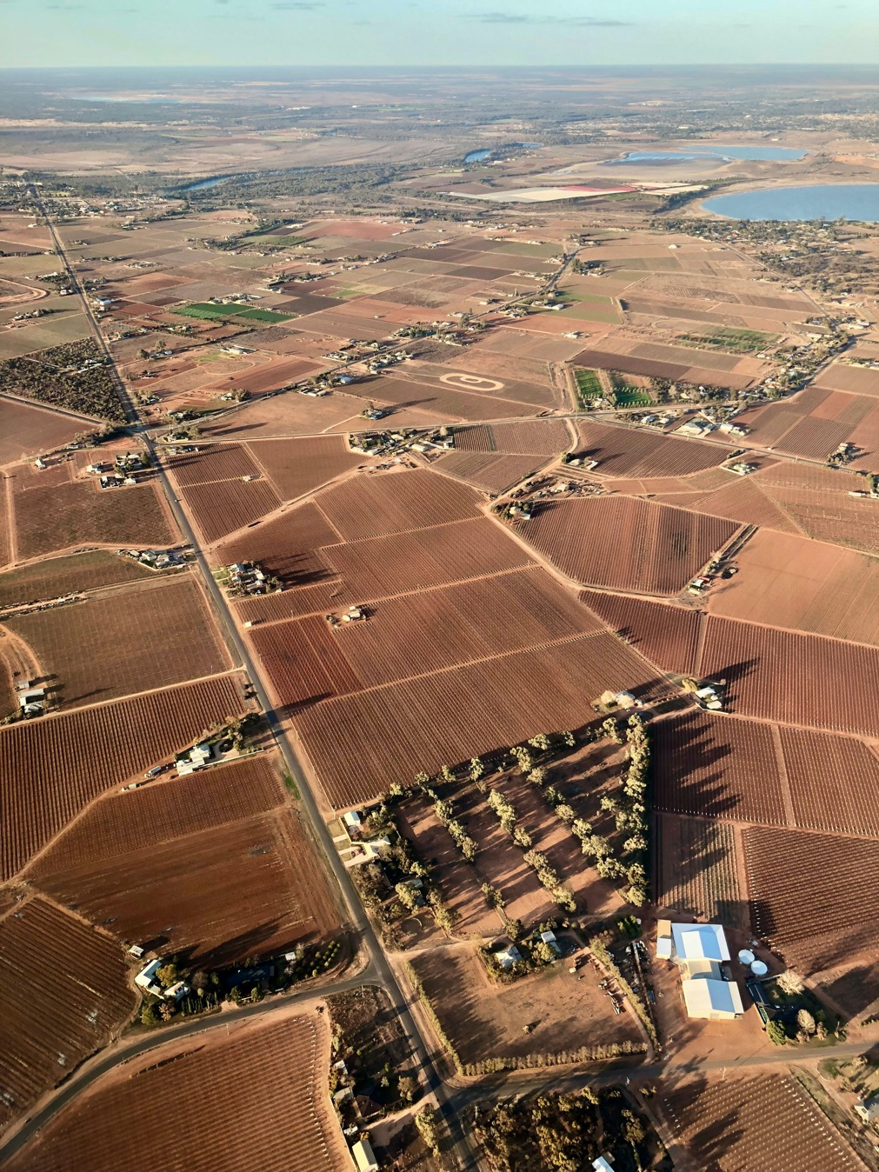

## Our purpose and objectives

The department has consulted with government, stakeholders and staff to develop our purpose, which is supported by 5 objectives (Figure 2).

Our **purpose** captures what we do and how we do it:

Partnering and regulating to enhance Australia's agriculture, unique environment and heritage, and water resources.

Our work and the decisions that we make should have lasting benefits for generations to come. Our purpose provides the foundation for all the work that we do, everyday.

Our **objectives** cover the breadth of our responsibilities and link to our budget outcome statements. Collectively, they identify who benefits from our activities, what success looks like and, as part of our performance framework, how it will be measured. Our strategic priorities are core activities that are central to achieving our objectives.

Figure 2 Purpose and objectivesOur Objectives.
• Agriculture: assist industry to grow to a $100 billion agricultural sector by 2030.
• Environment and heritage: support stewardship and sustainable management to enhance Australia's environment and our unique heritage.
• Biosecurity: manage biosecurity risks to Australian agriculture, the environment and our way of life.
• Antarctic: advance Australia's strategic, scientific and environmental interests in the Antarctic and the Southern Ocean.
• Water resources: Support the sustainable management and productive use of Australia's water resources.


## Our strategic priorities

Our priorities are the key activities that we will deliver across the next 4 years (Figure 3). Our delivery against these priorities will significantly contribute to achieving our purpose and objectives. In setting these priorities, we have identified and reflected on the issues that affect our stakeholders and the agenda set by government. We acknowledge the importance of ongoing engagement with our stakeholders, the need to constantly scan our operating context, and the need to be agile in responding to emerging priorities.

Maintaining and improving conditions for our primary producers is key to their success. Continuing to grow trade opportunities, improving regulation and regulatory processes, and supporting science and innovation is core to ensuring our agricultural sector develops over the coming decade and reaches its goal of $100 billion by 2030. Recovery from COVID-19 will be a long-term focus for government, industry and the community.

Our environment faces a range of threats and challenges from catastrophic events like the Black Summer bushfires and from ongoing threats to biodiversity and ecosystems. We have supported the commitment of funds towards the recovery of our unique native wildlife and their habitat from the impacts of the bushfires. We are also working across government to provide support to affected farmers, fishers and foresters, along with rural, regional and urban communities. We are committed to the sustained effort that will be needed to support bushfire-affected areas.

Climate science and adaptation is critical in building the nation's environmental resilience.

Figure 3 Our strategic priorities: delivering on government and ministerial priorities

Delivering on government and ministerial priorities:
• Improve market access and with our partners maximise opportunities for agricultural exports
• Transform the exports regulatory system 
• Foster collaboration in research and development to drive uptake of innovative practices in the agricultural sector 
• Deliver policies and programs to support profitable and resilient agri-business 
• Support economic recovery post COVID-19 across industry 
• Improve the status of threatened species and ecosystems, including in the wake of bushfires
• Reform the E P B C Act to drive economic recovery post COVID-19 and strong environmental outcomes 
• Provide national leadership to effectively manage Australia’s waste
• Conserve and maintain Australia’s unique heritage
• Partner with Murray-Darling Basin states to implement the Basin Plan and manage basin water resources in the national interest
• Maintain and strengthen our biosecurity system working with our partners and through innovation and business transformation
• Maintain Australian leadership in Antarctica and the Southern Ocean 
• Improve regulatory efficiency, effectiveness and maturity including through deregulation 
• Manage our national parks, gardens and marine parks in partnership with traditional owners, communities and businesses


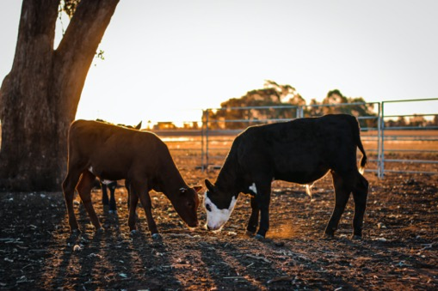Our ministers have given their commitment to lead advancements on waste management across the country through a National Waste Policy Action Plan. The Council of Australian Governments has also agreed to ban the export of waste plastic, paper, glass and tyres, with the ban to be phased in from January 2021.

We continue work to strengthen and mature our approach to environmental regulation, implementing policies and practices to support greater consistency in decision-making and improved compliance under the Environment Protection and Biodiversity Conservation Act 1999 (EPBC Act). The current independent statutory review of the EPBC Act will provide a basis for legislative reform to streamline environmental regulation and maintain strong environmental standards of protection.

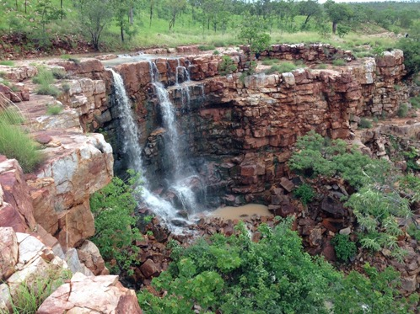Our heritage is an important part of our national identity, not just as something we look back on, but as something we carry forward into the future. We will work actively to ensure the protection of our national and world heritage places that tell the stories of our history, our unique Indigenous heritage and the exceptional environment of our continent and its surrounding waters.

We provide national leadership to ensure water resources are managed sustainably, with particular focus on our partnerships in the Murray–Darling Basin. We will continue to respond to those issues of importance to our stakeholders and our ministers as we pursue our purpose.



## Our operating context

Our operating context is dynamic, evolving and global in nature. We support delivery of the Australian Government's policy agenda across the important and interrelated areas of agriculture, the environment and heritage, and water resources. Our functions are critical to our country's prosperity and to maintaining the quality of life that Australians currently enjoy.

On 1 February 2020 the government brought together the areas of agriculture, the environment and heritage, and water under one department. To realise the potential of our new department, our advice to government must be contemporary and evidence-based, drawing on the knowledge of experts – both within and outside the department. We must also demonstrate a deep understanding of the issues that our stakeholders face. We will consider policy impacts across our responsibilities and identify opportunities to maximise outcomes from our work.

The COVID-19 pandemic continues to have a global impact on people's health, the foundations of national economies, trade and the movement of people across borders. In the context of our work, the pandemic has had a profound effect on our areas of policy responsibility, our program delivery and on our workforce.

Over the course of the pandemic, we have continued to play a crucial role in supporting the agricultural sector to maintain domestic food security and to supply Australian-produced food to our trading partners. Australia's food supply chain remains strong – all jurisdictions recognise food and fibre production as critical to maintaining our domestic food security. We are supporting exporters to find new markets, maintain existing markets and minimise disruptions to their export activities through investing in strong relationships with our trading partners. In the face of an ongoing pandemic, helping industry reach the target of $100 billion in agricultural output by 2030 will require a strong partnership between government and industry. It will also require hard choices to be made that lift farm productivity, increase the value of our produce and keep Australian exports competitive.

We have remained focused on delivering our core responsibilities during the pandemic. Our response to COVID-19 has required resources to be allocated to key activities in response to the immediate and evolving impacts of the pandemic, but that we also continue to provide critical services. We have established dedicated taskforces to guide and assist staff to work safely and effectively from our national office network, in the field and from their homes. We have responded quickly to the changing workload at the border and worked to redeploy key regulatory staff from airports into areas that have had a growth in activity, such as in international mail centres. We have also assisted Services Australia, the Department of Health, Austrade and the National COVID-19 Commission Advisory Board. We are trialling innovative approaches to delivering our responsibilities, including increasing our use of technology to undertake activities remotely. We have also sought to manage the risk posed by COVID-19 in our high-risk operating context – for example, we have significantly reduced the number of expeditioners to Antarctica this season.

We recognise the importance of preparing for a post-COVID world and the need for policies and programs that support our agricultural and environment-related tourism industries to rapidly recover and to take advantage of new opportunities. We understand that many of the businesses we interact with are operating in a fast changing and highly competitive global business setting. As a key partner in their success, we recognise our responsibility to improve their experience. We are working to transform and streamline our processes, including the delivery of our regulatory responsibilities. We are also modernising our information and communications technology (ICT) systems to provide a seamless experience for businesses engaging with us.

A changing climate, changes in land use, invasive species and extreme events such as bushfires, drought and floods have also had devastating impacts on Australia's agriculture, water resources and unique environment, particularly our biodiversity.

The 2019–20 Black Summer bushfires had significant and unprecedented impacts across Australia. More than 10.3 million hectares was burnt, and the impact on our native animal and plant species has been catastrophic. We are actively involved in recovery efforts and are providing funds to aid the recovery of our unique native wildlife and their habitat. We will also support the sustained effort needed across bushfire-affected areas, including World and National Heritage places, to prevent extinction and limit the decline of native animal and plant species. In support of recovery efforts, we continue to recognise Aboriginal and Torres Strait Islander peoples and their connection to land, sea and community in our response.

The bushfires also affected some of the nation's most productive agricultural areas (more than 1.4 million hectares of agricultural land) – regions heavy in horticulture, apiculture, wine, red meat and dairy. The overall impact on national agricultural production and exports has been limited, but localised impacts have been severe and, for businesses and regions directly involved, the stock losses and infrastructure damage were significant. The forestry sector was also heavily impacted by the fires. Around 130,000 hectares of plantation forest and 2 million hectares of productive native forest were affected, which represents 6.7% of national plantation forest and 20% of national productive native forest.

Drought is an enduring feature of the Australian landscape. It has economic, environmental and social impacts on farmers and communities. The beginning of 2020 has seen some respite from drought in parts of Australia and the Bureau of Meteorology is forecasting a more positive climate outlook for most of the country for the remainder of 2020. To build economic, environmental and social resilience to drought, the $5 billion Future Drought Fund has been introduced. Supporting effective adaptation to a changing climate will be critical to helping the agricultural sector achieve its ambition of reaching a value of $100 billion by 2030.

As a country, we also face major challenges in ensuring sustainable water supply in the face of increased climate variability and rising demand for water. Australia is now 8 years into the 12‑year reform of water management in the Murray–Darling Basin. The pace and extent of water reform over the past decade has left many stakeholders fatigued and disenfranchised. Recent drought, bushfire, flooding, fish death events, as well as COVID-19, have all contributed to additional community stress.

As we continue to mature as a department, we will maintain our core focus on strengthening our leadership capabilities, building our strategic policy skills, becoming more digitally enabled, growing our data and scientific capabilities, and meaningfully engaging with our stakeholders to better inform and direct our work.

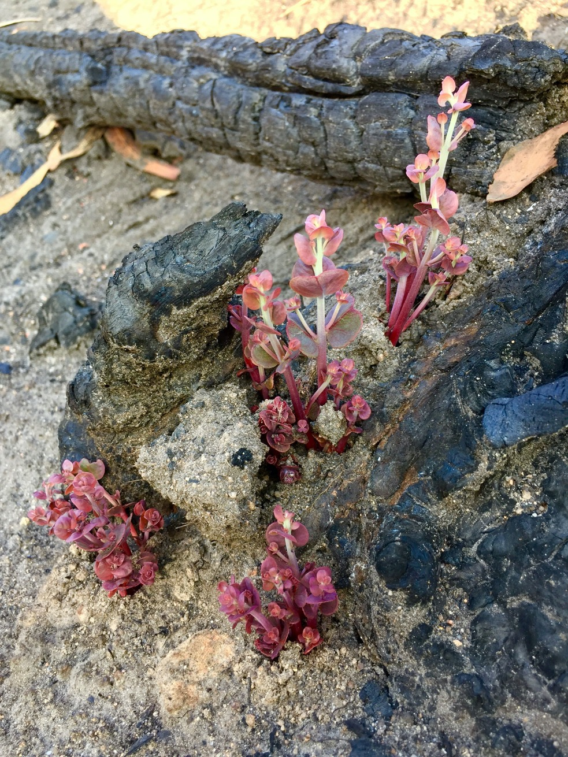

## Our risk oversight and management

The department has a diverse range of responsibilities and operates in an increasingly complex and rapidly changing environment. We face a range of risks that reflect our responsibilities as a policy adviser, researcher, program administrator, market access negotiator and regulator. To better understand and respond to risk, we integrate risk management with governance, planning and performance management processes in all areas of our department.

It is not possible, nor necessarily desirable, to eliminate all risks inherent in our work. We, therefore, identify and implement pragmatic risk management practices that include appropriate and informed risk-taking as part of our everyday decision-making processes. We embed sound risk management practices in our business to ensure risk awareness, identification and mitigation.

Our Enterprise Risk Management Framework and Policy are administered in line with the requirements of the Commonwealth Risk Management Policy.

### Our strategic risks

Our strategic risks are those that, if realised, would materially affect our ability to achieve our purpose and objectives (Figure 4).

Figure 4 Our strategic risks

Key strategic risks for the department will arise if we do not:
• ensure that our resources and capabilities are focused on delivering the government's priorities
• implement our regulatory responsibilities and our programs to deliver both protection and growth
• use expertise and meaningful stakeholder relationships to provide future-focused policy options and advice
• manage the unique health and safety hazards presented by our diverse operations in challenging locations
• continue to invest in our systems and technology to deliver quality digital services
• drive integration and efficiencies to realise the benefits of the new organisation.


### Risk mitigation strategies

We have established a series of tailored controls to reduce the likelihood of these risks occurring. These mitigations draw support from across the department to ensure that the risks are effectively managed. These controls include:

* **Ongoing oversight by the secretary and the Executive Board** – The department's executive maintains visibility and oversight of strategic risks and the ongoing efficacy of their management through regular risk reporting to the Executive Board. Strategic risk owners are required to coordinate management and mitigation activities undertaken across the department, as well as report any changes in risk profile.
* **Application of risk management and monitoring approaches** – The chief risk officer oversees the department's Enterprise Risk Management Framework and supporting policy and systems. The chief risk officer is responsible for building a positive risk culture and supporting the department to maintain sound processes to appropriately identify and manage risk.
* **Regular reporting to the executive** – Each division will report to the executive on its progress in managing and mitigating risks as part of the divisional performance review process. Where a division becomes aware of factors that heighten the risk above the department's set tolerances, risk owners are required to escalate these factors to the executive as a priority.
* **Auditing and review** – External audits and reviews, along with the department's internal audit program, provide insights into the effectiveness of risk identification and management activities. We are committed to ensuring that areas identified for improvement are promptly actioned.

### Building a positive risk culture

Risk management is the responsibility of all staff and we encourage staff to openly discuss risk and incorporate risk management into their day-to-day work.

Positive engagement with risk balances threats with opportunities and allows us to recognise both the importance of controls and the need to realise opportunities for efficiency, innovation and continuous improvement. Our Enterprise Risk Management Framework sets out expectations and requirements to guide staff in identifying and managing risks.

We promote a positive risk culture to guide innovation, manage threats, harness opportunities and empower staff to make informed decisions. This is carried out through a variety of channels, for example through workshops and regular communication from the chief risk officer, that encourage staff participation at all levels. In addition, we are an active participant in whole-of-government risk management initiatives.

We have appointed a chief risk officer at the first assistant secretary level to support the secretary in promoting positive engagement with risk. Through a comprehensive program of work, the chief risk officer is visible across the department and plays a key role in building positive, engaged and proactive risk management practices.

The chief risk officer engages key senior executives, committees and boards to gain oversight of cross-cutting emerging risks, issues and risk management approaches.

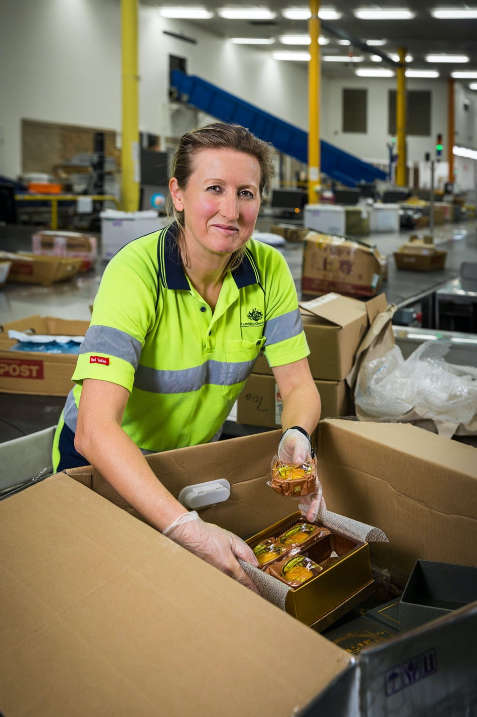

## Our portfolio

We partner and cooperate with a range of environmental organisations and agricultural industries to deliver on the priorities of our ministers and the government. We cooperate across key areas, including agriculture, water, environment, heritage, forestry and fisheries management. Our portfolio includes agencies and rural research and development corporations that deliver targeted services (Figure 5).

Figure 5 Our portfolio

The department’s ministers: 

Minister for Agriculture, Drought and Emergency Management - The Honourable David Littleproud MP.
Minister for Resources, Water and Northern Australia - The Honourable Keith Pitt MP.
Minister for the Environment - The Honourable Sussan Ley MP.
Assistant Minister for Forestry and Fisheries - Senator the Honourable Jonathon Duniam.
Assistant Minister for Waste Reduction and Environmental Management - The Honourable Trevor Evans MP.

Agencies:

Australian Fisheries Management Authority, Australian Pesticides and Veterinary Medicines Authority, Regional Investment Corporation, Murray-Darling Basin Authority, Sydney Harbour Federation Trust, Director of National Parks, Great Barrier Reef Marine Park Authority, and Bureau of Meteorology.

Rural research and development corporations:

Cotton Research and Development Corporation, Fisheries Research and Development Corporation, Grains Research and Development Corporation, AgriFutures Australia and Wine Australia.


## Our people

Our talented and experienced staff are our greatest asset (Figure 6). We are inspectors, policy and assessment officers, program administrators, biosecurity and compliance officers, investigators, veterinarians, scientists, researchers, economists, accountants, legal advisors, ICT specialists, data analysts, expeditioners, food safety meat assessors, auditors and park managers and more.

We work to conserve our heritage – our spirit and ingenuity, our historic buildings and our unique, living landscapes. We manage our water resources wisely for the most productive and sustainable outcomes. We strive for a healthy environment, which leads to healthy communities, and we help build and grow Australia's primary industries.

Figure 6 Our people

*We have approximately 7000 employees in our department.
This is made up of 5473 full time employees, 1273 part time employees and 500 casual employees.
53% of our workforce self-identify as female, 48% of EL2 and above self-identify as female, 5% of employees self-identify as Aboriginal or Torres Strait Islander, 2% of our employees self-identify as having a disability, 5% employees self-identify as being from non-English speaking background. 
The department has been awarded as an Australian Workplace Equality Index gold employer for its effort in building a diverse and inclusive workplace that represents the community.  
Note: An employee has a non-English speaking background (NESB1) if they arrived in Australia after the age of 5 and their first language is a language other than English (APSC 2019). The Australian Workplace Equality Index provides a national benchmark on LGBTQ workplace inclusion in Australia.
Source: Aurion and SAP 30 June 2020.
*

## Our locations

We have a presence across Australia and around the world (Figure 7). Our staff work across our network of locations to achieve our purpose and objectives, while effectively managing our highest risks.

Our staff work in a diverse range of settings – in national parks, Antarctica, shipping ports and airports, mail centres, quarantine facilities, laboratories, abattoirs and offices in remote and regional centres, rural communities and cities. Around half of our staff are located outside Canberra.

Our network of agricultural counsellors, based in key trade locations around the world, promote Australia's agricultural interests, negotiate market access and contribute to growth in the agricultural sector.

Funded through Australia's aid program, we have staff located in Papua New Guinea to help protect the heritage and environmental values of the Kokoda Track and in the Pacific to help reduce the amount of plastic litter on beaches and in inshore coastal environments.

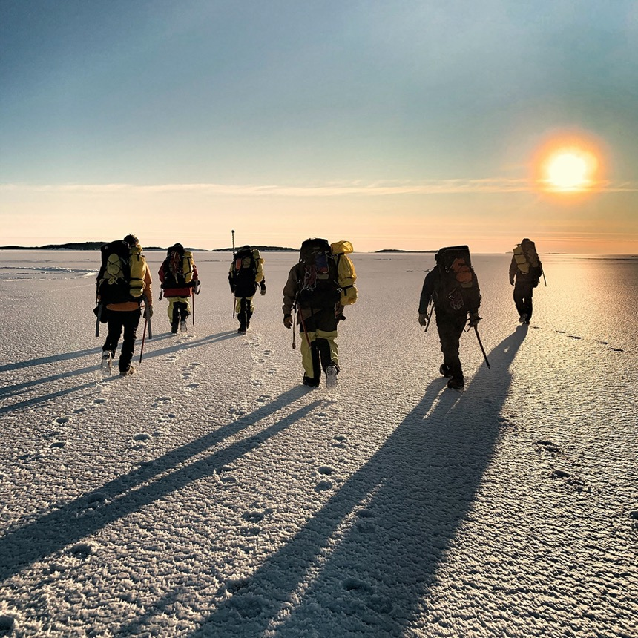

Figure 7 Department of Agriculture, Water and the Environment locations

In Australia our department is made up of 182 locations, these include 51 major cities, 131 regional and remote areas which include external territories such as Coco Island, Christmas Island and Norfolk Island.
The department is also based in 17 locations outside of Australia.
Our Antarctic deployment is made up of four location in and around Antarctica.   
Note: Location data is based on actual placements as at 30 June 2020


## Our partners

Our stakeholders include diverse organisations and contributors (Figure 8). We partner with, collaborate with, connect with, engage and regulate our stakeholders to help us achieve our purpose and objectives.

We work with industry peak bodies to better understand the issues facing our industry stakeholders to improve the quality of our policy advice and program delivery. We consult with environmental non-government organisations to learn about issues of importance to their members. We work directly with the Australian community through targeted funding and grants.

We are taking an active role in building more multi-stakeholder partnerships to achieve our objectives. We partner with Aboriginal and Torres Strait Islander peoples to manage country. The National Landcare Program is a longstanding partnership between governments, primary producers, environmentalists and the community to promote sustainable land management. Through partnerships, we bring together the unique strengths and resources of our partners to achieve more than each partner could achieve acting alone.

Government and industry-owned research and development corporations are integral to the pursuit of innovation to enable an efficient, productive and sustainable agricultural sector. We continue to support their efforts.

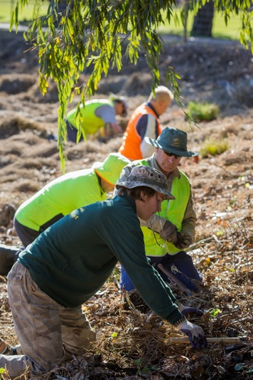Our collaboration across government ensures that we are working holistically and leveraging off existing efforts and policies to achieve our outcomes in the most efficient manner. We work with the Department of Foreign Affairs and Trade, Austrade, state and territory governments, producers, exporters and trading partners to achieve the best market access outcomes for Australian agriculture. We work through Services Australia, the Regional Investment Corporation and the Rural Financial Counselling Service to provide assistance and support to farmers and rural communities. Our biosecurity staff work on behalf of the Department of Health to carry out health screening of international passengers and to ensure imported goods meet Australia's food safety standards.

We also support our portfolio agencies to achieve their objectives and to deliver improved outcomes for the agricultural sector, our unique environment and heritage and to better balance the use of Australia's precious water resources.

Examples of our approaches to cooperation are:

Partner

The **National Environmental Science Program's** Northern Hub and its partners, the CSIRO and the North Australian Indigenous Land and Sea Management Alliance, launched Our Knowledge Our Way in caring for Country: Indigenous-led approaches to strengthening and sharing our knowledge for land and sea management. Best Practice Guidelines from Australian experiences. With over 100 Indigenous contributors, the Indigenous-led and authored guidelines are based on the principle that 'Indigenous people must decide what is best practice in working with our knowledge' and drew on 23 partnership case studies from across Australia.

Connect

The **National Biosecurity Committee** (NBC) provides advice to the Agriculture Senior Officials Committee on national biosecurity and on progress in implementing the Intergovernmental Agreement on Biosecurity. The secretary of the department chairs the NBC as a member of the Agricultural Senior Officials Committee. Membership comprises senior officials from the Australian, state and territory primary industry and environment agencies. Jurisdictions may have up to 2 representatives.

Collaborate

Through the Regional Land Partnerships program, the department is working with 50 **Regional Natural Resource Management organisations** to deliver natural resource management outcomes across the country. These organisations are working with local communities to deliver on-ground projects that improve our environment and promote sustainable agriculture.

Engage

In March 2020 we appointed a **senior industry engagement officer** to help agricultural, fisheries and forestry industries navigate the COVID-19 pandemic and to build links between government and industry. This targeted engagement with industry, states and territories has built connection, understanding and responsiveness during changing and challenging times.

Figure 8 Our stakeholders

Our stakeholders:
Examples include industry, community, Indigenous Australians, non-government organisations, academia, oversight including Auditor-General, Commonwealth agencies, state, territory and local government and international partners. Note: this list is indicative and not all stakeholders have been included.




## Our capabilities

As a new department, we are reviewing and investing in our capabilities to ensure we have the right balance and combination of skills, expertise and knowledge to deliver on our purpose.

We have identified core capability priorities that reflect critical organisational activities, plans and processes (Figure 9).

Figure 9 Our capability priorities

Departmental capability priorities:
• Provide excellent advice and support to ministers and the government
• Build an integrated, inclusive and high performing culture aligned with broader APS reforms
• Maintain and improve our workplace health and safety
• Develop and promote digital and innovative delivery of services
• Actively pursue ways to better connect with and understand our stakeholders, partners and communities
• Maintain and strengthen strong working relationships with Indigenous Australians
• Improve our ability to capture, analyse, manage and share data and information to better inform our decisions
• Increase our cross-cutting science information and research activity and capability
• Build agility in our organisation to manage change and respond quickly and effectively to emerging issues
• Support and partner with our portfolio agencies.


### Workforce

Effectively managing and supporting our workforce is critical to the success and wellbeing of our department. We are building the capability of our people through integrated strategies, policies and guidance, and a range of people-focused initiatives. Initiatives include:

* Our People Strategy will incorporate our capability framework, leadership strategy and learning and development strategy. It will be designed to ensure our people understand what is expected of them and have the tools to effectively perform their roles and continue to develop.
* Our Inclusion Strategy will help embed inclusion in all that we do to ensure every employee can contribute and bring their authentic self to work.
* Our Reconciliation Action Plan 2021–24 will help us to better understand, recognise, celebrate, value and respect Aboriginal and Torres Strait Islander peoples, their culture and communities, and the valuable contribution that our Indigenous staff bring to our department.

We will continue to explore new, flexible and varied ways of working to support the delivery of our broad responsibilities and provide a working environment that responds to the diverse needs of our skilled and knowledgeable workforce.

The workforce initiatives we implement will help us to identify the current and future roles required within the department and the capability requirements of our staff. They will also help us to address any workforce gaps.

We will continuously review, target and enhance our systems, policies and processes to reflect our dynamic and diverse workforce and priorities. We will also continue to drive organisational transformation, supported by our change management actions.

### Values and behaviours

We will continue to align our behaviour and actions with the Australian Public Service Values in delivering our significant and diverse portfolio of work for the Australian community.

We are committed to establishing core department-specific values and behaviours that reflect the uniqueness of our department, our work, our priorities and our people.

Our people are at the heart of all that we do and, in developing our values and behaviours, we will provide them with the opportunity to contribute to the way we describe, demonstrate and measure those values and our commitment to enshrining our values in all we do.

### Safe and healthy workplace

The health, safety and wellbeing of our staff is a key priority. Our safety focus helps to ensure that our diverse range of workplaces – including our Antarctic stations, mail centres, airports, laboratories and office-based locations – are healthy, safety-conscious and inclusive of all our people across our vast domestic and international footprint. We are committed to:

* prioritising the health and safety of our people as we respond to the evolving COVID-19 pandemic and ensuring our workplaces are healthy and safe during any future health crisis
* actively protecting and enhancing the health and wellbeing of our people through the embedding of a robust and fit-for-purpose enterprise safety management system, governance structure and information system
* maintaining, enhancing and promoting a safety culture that is inclusive, supportive and free from harassment, discrimination and bullying
* embedding dynamic, relevant and responsive risk identification processes and controls to minimise any health, safety and wellbeing impacts on our people.

### Integrity

Integrity is fundamental to all that we do. This is particularly the case for our diverse range of regulatory functions. We support a pro-integrity culture through maintaining high standards of professionalism, accountability and ethical behaviour. Through the reinforcement of this culture, we aim to build performance and effectively manage our risk.

We are:

* embedding robust integrity practice through our integrity framework
* educating our staff about fraud and corruption risks to them and to the department, while identifying and effectively controlling integrity risk across our department
* promoting our pro-integrity culture, where our people understand the importance of personal responsibility and behaving with integrity, and our zero-tolerance approach to breaches of integrity and ethical requirements.

### Cross-cutting science and research

We are committed to investing in science to inform the work that we do to achieve our purpose. Science and research feeds into every aspect of our work and is a core capability for our department. Integrating best-available science into our business ensures we strengthen our credibility and integrity.

Some examples of the specialised science and research capability in our department include:

The **Supervising Scientist Branch** provides the scientific oversight of uranium mining in the Alligator Rivers Region of the Northern Territory. The Environmental Research Institute of the Supervising Scientist undertakes world-leading research to understand the effects of uranium mining on Kakadu National Park.

The **Australian Bureau of Agricultural and Resource Economics and Sciences** **(ABARES)** provides independent data, research, analysis and advice that informs public and private decisions affecting Australian agriculture, fisheries and forestry.

The **National Environmental Science Program** is Australia's flagship program for applied science, which delivers practical management options to support the Australian community. The program also delivers fundamental climate services, including future scenario development to help government, industry and the broader community build climate resilience into their decision-making.

The **Geospatial and Information Analytics Branch** aims to strengthen the environmental information and science evidence base accessible to the department. We do this by bringing together departmental priorities for environmental information and research, and adding value to high-priority activities of the department by providing science and research, environmental and spatial information products, advice, analysis and tools.

The **Office of Water Science** is leading the Australian Government's efforts to improve our understanding of the water-related impacts of coal seam gas and large coal mining development. The office provides secretariat and technical support to the Independent Expert Scientific Committee, which advises Australian Government regulators on proposals.

The **Operational Science and Surveillance (OSS)** function within the Biosecurity Operations Group provides scientific advice and innovation across a range of operational and policy areas in the department. OSS staff provide diagnostics and risk assessment advice for pests and diseases that are detected at first points of entry and post-entry quarantine, and provide guidance on treatments and other risk mitigation measures. The team make thousands of identifications of insects, seeds and plant pathogens each year that are crucial for analysing and understanding border interception trends that inform biosecurity policy.

The Australian Government's investment in **Antarctic capability** better equips us to revitalise our science program and build greater collaboration and resource sharing with other nations active in East Antarctica. Through strong and effective international engagement we are able to build and maintain our relationships with other Antarctic Treaty nations and, in turn, strengthen the Antarctic Treaty system and our influence in it.

Our department is one of Australia's largest employers of **veterinarians**. They are critical to Australia's biosecurity and export systems by protecting the health of our animals, people and environment from animal pests and diseases.

### Technology

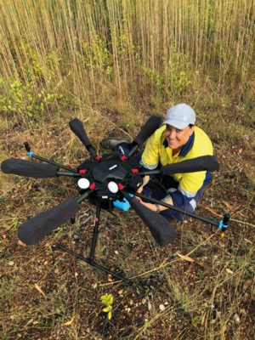Our new ICT Strategy will set a clear direction for managing ICT services across the department to ensure that we have the appropriate systems and services in place to operate effectively and to support our staff and stakeholders, including regulated entities, now and into the future.

Our vision is to provide scalable, flexible, sustainable and secure ICT services that are fit-for-purpose and that can adapt quickly to a diverse and rapidly evolving operating context, including growing expectations of those that we partner with and regulate. Over the next 4 years, our priorities are to:

* provide modern, reliable and secure digital services to our staff and stakeholders
* govern, develop and deliver ICT services for maximum business impact
* enable the department's digital transformation.

Future ICT operating, sourcing and technology models are being developed to support implementation of the strategy. These models will inform which technology investments we prioritise and how we procure and deliver our ICT services.

### Regulatory maturity

Building our regulatory maturity is a key focus for us. We are designing a new Regulatory Practice Framework that will set out how we intend to strengthen and mature our performance as a regulator and how we will improve the way we partner with our stakeholders and deliver regulated activities.

In 2020–21 we will finalise our Regulatory Practice Statement in consultation with our stakeholders. The statement will include a set of clear regulatory practice principles to guide our expectations of ourselves as regulators. We are addressing key recommendations from external reviews on improving the way we regulate live animal exports and make decisions on environmental approvals. We will determine how these improvements can be integrated into our Regulatory Practice Framework to support our regulatory systems.

Our Regulatory Practice Committee and regulatory leaders drive improvements across our regulatory functions of the department, including through:

* developing our regulatory staff and improving transparency and accountability in decision-making
* improving how we manage regulatory risks and building our analysis, intelligence and risk profiling capability
* improving how we communicate and engage with our regulatory professionals, regulated communities and our stakeholders
* promoting compliance of regulated entities with regulatory requirements and our response to non-compliance
* improving the assurance and integrity of our regulatory practices
* providing meaningful performance monitoring and reporting of our regulatory performance.

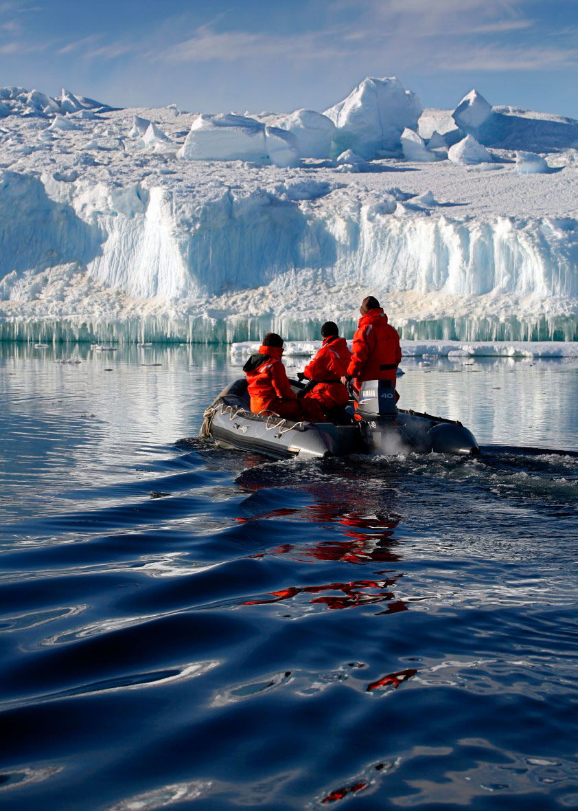

## Our performance information

Our performance information describes how we intend to measure our success in achieving our purpose. Our performance is reported in our annual report. We measure and report on our performance to track progress against our purpose and objectives. In doing so we demonstrate accountability to our ministers and the Australian Government and, through them, to the Parliament, the Australian public and our stakeholders.

### Purpose

Partnering and regulating to enhance Australia's agriculture, unique environment and heritage, and water resources.

### Objectives

The department measures specific outcomes that in combination are key performance indicators that show we are on track to achieve our objectives. The achievement of our objectives ensures that our work supports the department in achieving its purpose.

|  |  |  |  |  |
| --- | --- | --- | --- | --- |
| **Agriculture** | **Environment and Heritage** | **Biosecurity** | **Water Resources** | **Antarctic** |
| Assist industry to grow to a $100 billion agricultural sector by 2030 | Support stewardship and sustainable management to enhance Australia's environment and our unique heritage | Manage biosecurity risks to Australian agriculture, the environment and our way of life | Support the sustainable management and productive use of Australia's water resources | Advance Australia's strategic, scientific and environmental interests in the Antarctic and the Southern Ocean |

### Objectives and performance criteria

|  |  |  |  |
| --- | --- | --- | --- |
| **Agriculture – Assist industry to grow to a $100 billion agricultural sector by 2030** | | | |
| Increase, improve and maintain markets | Encourage and reduce risks to agricultural productivity | Forecasting and strategic intelligence | The efficient collection and distribution of levies to fund rural research and development |

|  |  |  |  |  |  |
| --- | --- | --- | --- | --- | --- |
| **Environment and Heritage – Support stewardship and sustainable management to enhance Australia's environment and our unique heritage** | | | | | |
| Ecosystem diversity, extent and function are maintained or improved | Species diversity, range and abundance are maintained or improved | Heritage is recognised and protected | Development is ecologically sustainable and impacts to the environment and human health are managed | Produce scientific research on the environment and resource development | Provide national leadership to effectively manage Australia's waste |

|  |  |
| --- | --- |
| **Biosecurity – Manage biosecurity risks to Australian agriculture, the environment and our way of life** | |
| The national biosecurity system meets the agreed national goals and objectives of the Intergovernmental Agreement on Biosecurity | Regulation, partnerships and service delivery manage biosecurity risk |

|  |  |
| --- | --- |
| **Water Resources – Support the sustainable management and productive use of Australia's water resources** | |
| Support sustainable use and maintenance of high-quality water resources | Water quality and flows, and ecosystem health are maintained or improved |

|  |
| --- |
| **Antarctic – Advance Australia's strategic, scientific and environmental interests in the Antarctic and the Southern Ocean** |
| Strengthen Australia's leadership in Antarctica and the Southern Ocean, by conducting world-leading science, promoting environmental best practice, and developing economic, educational and collaborative opportunities |

### Performance criteria and measures

#### Agriculture objective

**Assist industry to grow to a $100 billion agricultural sector by 2030**

|  |  |  |  |  |
| --- | --- | --- | --- | --- |
| **Performance criteria** | **2020–21 measure** | **2021–22 measure** | **2022–23 measure** | **2023–24 measure** |
| Increase, improve and maintain markets | Growth in agricultural commodity exports in markets for which the department has negotiated improved market access exceeds average export growth | As per 2020–21 | | |
| Number of disruptions to existing export markets resolved through the department's negotiation and advocacy work | As per 2020–21 | | |
| **Context:** The department works to provide opportunities for primary producers to export their commodities. We are involved in negotiations with other countries to establish trade agreements, and we work with trading partners to establish and amend protocols to ensure that Australian agricultural exports meet importing country requirements.  With these arrangements in place, the value of agricultural commodity exports is subject to factors that are outside the department's control. These include the effect of the climate on production conditions, changes in the global economy affecting currency movements, consumer demand and commodity prices, and the business decisions of primary producers and exporters.  Arrangements to increase, improve and maintain markets are also implemented over the medium to long term. As a result, there is a lag between the department's activities to open or improve market access, the commencement of trade in those markets and the results in terms of increased export values.  The department's objective is to gain, improve, maintain and restore access to international markets for primary producers. | | | |

|  |  |  |  |  |
| --- | --- | --- | --- | --- |
| **Performance criteria** | **2020–21 measure** | **2021–22 measure** | **2022–23 measure** | **2023–24 measure** |
| Encourage and reduce risks to agricultural productivity | Average annual productivity growth for the past 10 years is equal to or exceeds average annual market sector productivity growth over the same period | As per 2020–21 | | |
| **Context:** The department works to provide a policy and regulatory environment in which primary producers can build their productivity. We also support research, development and extension to promote innovation in agriculture and in agribusiness management. We partner with states and industry to support Australia's favourable biosecurity and food safety status.  Within this environment, agricultural productivity is subject to factors that are outside the department's control. These include the effect of the climate on production conditions. Factors that are partly within the department's control are business decisions by primary producers, which can be influenced by policies, information on risks like climate change, and programs.  The outcomes from research and development and from business decisions are delivered over the medium to long term. As a result, there is a lag between the department's activities and the results in terms of increased productivity.  The department is supporting the government's agenda to modernise the agricultural innovation system and drive a step-change in productivity growth. This includes partnering with the rural research and development corporations to strengthen coordination and collaboration, increase private sector investment into the system and achieve greater uptake of innovation. | | | |

|  |  |  |  |  |
| --- | --- | --- | --- | --- |
| **Performance criteria** | **2020–21 measure** | **2021–22 measure** | **2022–23 measure** | **2023–24 measure** |
| Forecasting and strategic intelligence | Outcomes are consistent with forecasts, allowing for unforeseeable events | As per 2020–21 | | |
| **Context:** The department's forecasting and strategic intelligence activities provide data and advice to inform primary producers and industries, and to support our policy work, program development and regulatory activities.  This function will be measured by comparing the department's economic and scientific forecasts and predictions to actual results over time.  Results in commodities forecasting may be affected by factors including significant weather events, pest and disease incursions, changes in the global economy affecting currency movements, consumer demand and commodity price and the business decisions of primary producers. | | | |

|  |  |  |  |  |
| --- | --- | --- | --- | --- |
| **Performance criteria** | **2020–21 measure** | **2021–22 measure** | **2022–23 measure** | **2023–24 measure** |
| The efficient collection and distribution of levies to fund rural research and development | Levy collection processes cost no more than 1.2% of levies disbursed | As per 2020–21 | | |
| Inspections of levy agent records cover at least 20% of levy revenue over a 3-year rolling average | As per 2020–21 | | |
| **Context:** The department is responsible for collecting industry levies and providing them to rural research and development corporations to fund their work. There are currently 113 levies on 77 commodities and we disburse levies to 18 recipient bodies.  The department supports the integrity of the levies system through a risk-based compliance program. We publish semi-annual reports for stakeholders, to provide an overview of the administration of the levies scheme, including collection costs and charges, and the disbursement of levies.  The department is working to modernise and streamline the agricultural levies legislative framework. This project will reduce complexity and duplication in the legislation and improve the transparency and usability of the legislation for industry and government. | | | |

#### Environment and Heritage objective

**Support stewardship and sustainable management to enhance Australia's environment and our unique heritage**

|  |  |  |  |  |
| --- | --- | --- | --- | --- |
| **Performance criteria** | **2020–21 measure** | **2021–22 measure** | **2022–23 measure** | **2023–24 measure** |
| Ecosystem diversity, extent and function are maintained or improved | A reduction in nutrient, sediment and pesticide loads consistent with meeting targets in the Reef 2050 Water Quality Improvement Plan | As per 2020–21 | | |
| **Context:** Great Barrier Reef ecosystems continue to be in poor condition largely due to climate change impacts such as the 2016, 2017 and 2019 coral bleaching events and the collective impact of run-off associated with past and ongoing agricultural land use, coastal development activities and extreme weather events. Improving water quality contributes to the Reef's resilience. Measuring the nutrient and sediment loads gives us an indication of the impact on water quality on the Reef.  NB: Water quality targets in the Reef 2050 Water Quality Improvement Plan include:   * 60% reduction in anthropogenic end-of-catchment dissolved inorganic nitrogen loads (by 2025) * 20% reduction in anthropogenic end-of-catchment particulate nutrient loads (by 2025) * 25% reduction in anthropogenic end-of-catchment fine sediments loads (by 2025). | | | |
| Habitat condition within major vegetation groups improves relative to baseline | As per 2020–21 | | |
| Habitat connectivity within major vegetation groups improves relative to baseline | As per 2020–21 | | |
| Extent of major vegetation groups is maintained | As per 2020–21 | | |
| Terrestrial and inland water in protected areas – targets to be specified following agreement of the post-2020 agenda under the Convention on Biological Diversity | N/A | | |
| **Context:** Tracking change in the condition, connectivity and extent of habitats is important to determine the effectiveness of policy, regulatory, adaptation and program interventions to improve native ecosystems, and the species they support. Reporting on these related indices against the 33 National Vegetation Information System major vegetation groups provides a logical sub-national breakdown and relates to long-established approaches to reporting in the State of the Environment reports and elsewhere.  While Australian Government policy, regulatory and program interventions should influence performance against these criteria, changes in condition, connectivity and extent of habitats will be influenced by a range of other factors, including state and territory government interventions and other stakeholder actions, as well as natural variation and random events.  Australia is committed to implementing its obligations under the Convention on Biological Diversity (CBD) in accordance with national priorities. Australia's Aichi Biodiversity Targets under the CBD include protecting terrestrial areas and inland waters. Reporting on this target gives an indication of national action taken to improve the extent of protected ecosystems. | | | |

|  |  |  |  |  |
| --- | --- | --- | --- | --- |
| **Performance criteria** | **2020–21 measure** | **2021–22 measure** | **2022–23 measure** | **2023–24 measure** |
| Species diversity, range and abundance are maintained or improved | Threatened Bird Index improves relative to 2019–20 baseline | As per 2020–21 | | |
| Percentage of threatened species identified as priorities for action and investment showing improvements in their trajectory (100%) | As per 2020–21 | | |
| Percentage of natural resource management projects that demonstrate an improvement in environmental outcomes relative to the established project baseline (100%) | As per 2020–21 | | |
| NB: Reporting against the 2020–21 performance criterion will be undertaken in line with reporting against the Threatened Species Strategy Year 5 targets. The strategy targets are set for 30 June 2020, and assessment and reporting will occur in 2020–21. | | | |
| **Context:**  Threatened Bird Index  The Threatened Bird Index provides an annual indicator of the change in threatened bird populations for approximately 28% of Australia's threatened bird species for which data are available. The Threatened Bird Index may include additional species over time as monitoring improves. Threatened species indices are being developed for mammals and plants and may be included as performance criteria in the future. The Threatened Bird Index was developed by the National Environmental Science Program's Threatened Species Recovery Hub.  While Australian Government policy, regulatory and program interventions should influence performance against this criterion, changes in the Threatened Bird Index will be influenced by a range of other factors, including state and territory government interventions and other stakeholder actions, as well as natural variation and random events.  Threatened species trajectories  The Threatened Species Strategy included a target to improve the trajectory of 20 mammals, 21 birds and 30 plants by June 2020. Improvements in the trajectories of priority threatened species will demonstrate the effectiveness of the government's investments in priority species and action areas and its partnerships with communities and state and territory governments to address species decline and support recovery. Improvements in the trajectory of a species will be assessed by comparing its estimated trajectory from 2005 to 2015 with its estimated trajectory from 2015 to 2020. Trajectory assessment will be reported on in 2020–21. This performance criterion may apply to other species in the future, as additional priorities for action and investment are identified.  This criterion is a sub-component of targets under the Threatened Species Strategy, which also includes targets to tackle feral cats and their impacts, improve recovery practices and protect Australia's plants through activities such as seedbanking.  Projects with improved environmental outcomes  The department's component of the Regional Land Partnerships program aims to achieve benefits for Wetlands of International Importance listed under the Ramsar Convention, threatened species, World Heritage properties and threatened ecological communities. Each project funded under the program is required to collect baseline information against which changes in environmental condition can be tracked over the 5-year life of the project. Indicators will vary but will include such things as vegetation condition or changes in the trajectory of a threatened species. Projects commenced in 2018–19 and will report on progress towards meeting long-term outcomes in 2021 and 2023. This reporting will enable the Australian Government to demonstrate the effectiveness of its investments in achieving environmental outcomes and will support adaptive management.  This performance criterion currently applies to projects funded through the Regional Land Partnerships program but may be applied to additional programs in the future that operate under a similar monitoring, evaluation, reporting and improvement framework. | | | |

|  |  |  |  |  |
| --- | --- | --- | --- | --- |
| **Performance criteria** | **2020–21 measure** | **2021–22 measure** | **2022–23 measure** | **2023–24 measure** |
| Heritage is recognised and protected | Percentage of World Heritage listed properties being managed under management plans that are consistent with the management principles in the EPBC Regulations (100%) | As per 2020–21 | | |
| Increase in percentage from previous year of National Heritage listed properties being managed under management plans that are consistent with the management principles in the EPBC Regulations | As per 2020–21 | | |
| Number of times water quality in the Alligator Rivers Region exceeds statutory limits (0) | As per 2020–21 | | |
| Track changes against baseline dissimilarity values for biological communities in the Alligator Rivers Region | As per 2020–21 | | |
| **Context:** Management plans consistent with the EPBC Regulations provide a foundation for effective management of World Heritage and National Heritage listed properties. Measuring these performance criteria will support the effective management and protection of matters of national environmental significance. The department works with property managers to provide guidance on issues such as the effects of climate change and approaches for effective adaptation.  The department's role, through the Supervising Scientist, is to ensure that people and the environment of the Alligator Rivers Region remain protected from the effects of uranium mining. This region includes the World Heritage listed Kakadu National Park. | | | |

| **Performance criteria** | **2020–21 measure** | **2021–22 measure** | **2022–23 measure** | **2023–24 measure** |
| --- | --- | --- | --- | --- |
| Development is ecologically sustainable and impacts to the environment and human health are managed | Reduction against baseline of non-compliant projects causing environmental harm | As per 2020–21 | | |
| **Context:** The department is responsible for ensuring our regulatory systems are effective and efficient and that they deliver the benefit to the community that the government and Parliament intended. The department identifies annual compliance priorities that are set out in our compliance plan. This performance criterion will measure our compliance activities in relation to ecologically sustainable development. | | | |
| Number of departments mapping climate risks and implementing climate risk strategies | As per 2020–21 | | |
| **Context:** The department works across government and with state and territory governments to coordinate climate adaptation policies and action. This includes providing support (in the form of information and guidance), and partnering with agencies to develop effective policy responses. Governance mechanisms for this work include the Australian Government Disaster and Climate Resilience Reference Group which includes all Australian Government departments, and the Adaptation Working Group which includes representatives of all states and territories. This measure reflects the shared nature of adaptation and climate risk management and the need to work with all departments to integrate climate risks in their work. | | | |
| Statutory timeframes are met 100% of the time for EPBC Act referral, assessment and approval decisions and the backlog of decisions is cleared. | As per 2020–21 | | |
| **Context:** This target reflects the requirement that decisions and activities required by legislation are made within statutory timeframes to demonstrate regulation to identify, conserve and protect our biodiversity and heritage is effective and efficient. | | | |
| Annual radiation dose to the public remains below 1 mSv | As per 2020–21 | | |
| **Context:** The department's role, through the Supervising Scientist, is to ensure that people and the environment remain protected from the effects of uranium mining. This includes in the Alligator Rivers Region, which is recognised for its significant heritage values.  Radiological data are collected and assessed to ensure that environmental management systems are effective and appropriate for preventing impacts to human health. | | | |

|  |  |  |  |  |
| --- | --- | --- | --- | --- |
| **Performance criteria** | **2020–21 measure** | **2021–22 measure** | **2022–23 measure** | **2023–24 measure** |
| Produce scientific research on the environment and resource development | Completed NESP projects inform policy, adaptation, or management action, with a target of at least one user in all cases (100%)  NB: Projects include those from all 6 hubs and emerging priorities funding | As per 2020–21 | | |
| First phase national land and waste accounts and experimental ecosystem accounts are reviewed and refined based on consultation and testing for policy suitability  Scoping, design and development of second phase accounts has commenced | Continued expansion and refinement of national environmental-economic accounts | | |
| Impact and risk analysis reports for Geological Bioregional Assessment regions published | N/A | | |
| **Context:** The primary purpose of NESP is to deliver collaborative, practical and applied research to inform decision-making and on-ground action.  The production of core national environmental-economic accounts will support evidence-based decisions by tracking stocks and flows in important environmental assets, and by allowing the interactions between the environment and the economy to be observed and better understood.  The department is responsible for the coordination of climate science through the National Climate Science Advisory Group which includes representatives of the key science agencies across government, academia and users of climate science information.  Geological and bioregional assessments directly inform strategic assessments under the EPBC Act, resulting in regulatory efficiency and regional-scale approvals that facilitate new gas to the East Coast Gas Market. | | | |

|  |  |  |  |  |
| --- | --- | --- | --- | --- |
| **Performance criteria** | **2020–21 measure** | **2021–22 measure** | **2022–23 measure** | **2023–24 measure** |
| Provide national leadership to effectively manage Australia's waste | Add to the list of priority chemicals and waste for which baselines are established | An improvement relative to baseline; to be measured and reflected in the annual report | | |
| Australian targets for Montreal protocol  2020 HFC Import limits – 7.25 million tonnes CO2e  2020 HCFC import limits – 2.5 ODP tonnes  2020 Methyl bromide Import limits – 28.98 metric tonnes | 2021 HFC Import limits – 7.25 million tonnes CO2e  2021 HCFC import limits - 2.5 ODP tonnes  2021 Methyl bromide Import limits – 28.98 metric tonnes | 2022 HFC Import limits – 6.25 million tonnes CO2e  2022 HCFC import limits – 2.5 ODP tonnes  2022 Methyl bromide Import limits – to be decided | 2023 HFC Import limits – 6.25 million tonnes CO2e  2023 HCFC import limits – 2.5 ODP tonnes  2023 Methyl bromide Import limits – to be decided |
| The National Television Computer and Recycling Scheme's (NTCRS) annual target for recycling is met (68%) | NTCRS target  achieves a recycling rate of 70% | NTCRS target  achieves a recycling rate of 72% | NTCRS target  achieves a recycling rate of 74% |
| **Context:** Some chemicals and wastes can cause environmental damage if not managed. Once released into the environment, they can cause harm to animals such as fish, birds and insects, as well as to soil microbes and plants. They can also have flow on effects for human health.  The success of regulatory interventions or standards-setting in reducing exposure to chemicals and waste can be established by measuring the amounts of these substances in the environment over time. Responsibility for managing chemicals and wastes is complex and some components rest with multiple Commonwealth, state, territory and local government agencies. While not having primary responsibility, the department has a role for assessment and management of chemicals and some wastes through a range of roles, including as the lead Australian agency for international agreements to reduce or eliminate some chemicals; and as the lead agency for some national product stewardship schemes.  Australia's key policy to reduce emissions of ozone depleting chemicals and synthetic greenhouse gas is to gradually reduce the amount of these chemicals permitted to be imported, through controls under the *Ozone Protection and Synthetic Greenhouse Gas Management Act 1989*. The gradual reduction is an obligation under the Montreal Protocol on Substances that Deplete the Ozone Layer.  The National Television and Computer Recycling Scheme was established in 2011 to provide Australian households and small businesses with access to free industry-funded collection and recycling services for televisions and computers, including printers, computer parts and peripherals. The Product Stewardship (Televisions and Computers) Regulations 2011 provide the legislative framework for the scheme. | | | |
| Unprocessed waste glass in a whole or broken state banned from waste export from 1 January 2021 | Mixed waste plastics that are not of a single resin/polymer type banned from export from 1 July 2021  Whole waste tyres banned from export from 1 December 2021 | Single resin/polymer waste plastics that have not been reprocessed banned from export from 1 July 2022 | Mixed and unsorted waste paper and cardboard will be banned from waste export from 1 July 2024.  All waste bans in effect by 1 July 2024 |
| **Context:** The Council of Australian Governments has agreed to the timetable and definitions to ban waste plastic, paper, glass and tyres. The COAG waste export ban is the first step in taking responsibility for our own waste and using this resource to create jobs, spark innovation, and deliver strong environmental outcomes. | | | |
| Deliver department-led actions (17 actions) | Deliver department-led actions (4 actions) | Deliver department-led actions (2 actions) | Deliver any remaining department-led actions; assess performance against NWPAP Targets |
| **Context:** The department is the lead Australian Government agency for the implementation of the National Waste Policy and its associated Action Plan. Responsibility for delivering on the Action Plan's 7 targets and 80 actions is shared across Australian Government, state, territory and local governments, the industry and business sectors, and non-government organisations. | | | |
| National Standard framework established in Commonwealth legislation | Scheduling of priority chemicals of concern, in accordance with implementation plan (to be established) | | |
| **Context:** Environment ministers from the Australian Government and all states and territories met in July 2015 and agreed to establish a National Standard for the environmental risk management of industrial chemicals. The National Standard will improve the regulation of industrial chemicals, enabling a more consistent, efficient and effective approach to environmental risk management of industrial chemicals across all jurisdictions. | | | |
| National Pollutant Inventory data published by 31 March each year | As per 2020–21 | | |
| **Context:** National Pollutant Inventory is a National Environment Protection Measure under the *National Environment Protection Council Act 1994* and fulfils Australia's international obligation under the 1996 OECD Recommendation of the Council on Implementing Pollutant Release and Transfer Registers. | | | |

#### Biosecurity objective

**Manage biosecurity risks to Australian agriculture, the environment and our way of life**

|  |  |  |  |  |
| --- | --- | --- | --- | --- |
| **Performance criteria** | **2020–21 measure** | **2021–22 measure** | **2022–23 measure** | **2023–24 measure** |
| The national biosecurity system meets the agreed national goals and objectives of the Intergovernmental Agreement on Biosecurity | Performance measures are developed to assess the effectiveness of the national biosecurity system | Performance baseline established | Performance measures trend positively | |
| **Context:** The Intergovernmental Agreement on biosecurity seeks to strengthen Australia's biosecurity system through enhanced national collaboration among Australian governments. Signatories agreed to the development of a set of national performance measures. The performance measures will continue to develop and evolve over time. | | | |

|  |  |  |  |  |
| --- | --- | --- | --- | --- |
| **Performance criteria** | **2020–21 measure** | **2021–22 measure** | **2022–23 measure** | **2023–24 measure** |
| Regulation, partnerships and service delivery manage biosecurity risk | Rates of compliance with regulations administered by the department are maintained or improved | As per 2020–21 | | |
| Agreed regulatory performance timeframes are met | As per 2020–21 | | |
| **Context:** This is a composite measure, using indicators for a range of areas where the department is responsible for regulatory compliance.  This is a composite measure reporting our performance against service level standards.  The department's service standards have been developed to ensure we are delivering our regulatory activities within agreed timeframes. The standards describe how individuals and businesses can expect requests for information or regulatory activities to be progressed by the department. These include:   * requests for general information * import regulatory activities, including inspections, treatments of cargo, and the assessment of applications * export regulatory activities, including inspections and assessment of applications * live animal export regulatory activities, including inspections, assessment of applications, registrations and audits.   The service standards outline obligations of individuals and businesses to help us provide information and regulatory activities in a timely way. Performance results may be affected by the ability of individuals and businesses to provide necessary information or meet other requirements. | | | |

#### Water Resources objective

**Support the sustainable management and productive use of Australia's water resources**

| **Performance criteria** | **2020–21 measure** | **2021–22 measure** | **2022–23 measure** | **2023–24 measure** |
| --- | --- | --- | --- | --- |
| Support sustainable use and maintenance of high-quality water resources | Number of water resource plans (WRPs) accredited under Commonwealth law  33 of 33 WRPs accredited  (or 100%) | Accreditation complete address amendments as they arise | | |
| **Context:** The Murray–Darling Basin Plan sets out a requirement for Basin state and territory governments to develop WRPs. These plans are assessed by the MDBA and accredited by the Australian Government minister responsible for water. The WRPs give legal effect to sustainable diversion limits and strengthens protections for environmental water, protecting the Australian Government's investment in environmental water recovery. These instruments may be amended with new information or associated legislative changes. | | | |
| Maintaining Basin jurisdiction cooperation and coordination to implement the Basin Plan | Participation at all scheduled Basin Officials Committee and Ministerial Council meetings | | |
| **Context:** The Ministerial Council and Basin Officials Committee are responsible under the *Water Act 2007* for overseeing implementation of the Basin Plan. They also oversee the operation of water management and delivery in the southern Basin under the Murray–Darling Basin Agreement. Strategic plans and key actions arising from meetings drive the work program, consistent with the legislative framework and timelines. | | | |
| Track engagement with key stakeholders (industry, environment, local government) | Number of meetings held across sectors | | |
| **Context:** Ensuring policy development and program/project delivery are informed by the views of stakeholders across Australia is essential for water resource management. | | | |
| Improved progress towards delivering the Murray–Darling Basin Plan (Bridging the Gap, Water Efficiency Program, Supply and constraint measures): | | | |
| 47 GL recovery remaining to bridge the gap | 20 GL | A further 27 GL recovered | Complete |
| Number of large water efficiency measure projects (>$2million) contracted | 20 projects | under 20 projects | 10 projects |
| WESA funding contracted | $700 million | $420 million | $280 million |
| Establishment of NPA and associated milestones for Phase 2 implementation of supply and constraint measures – 17 of 36 supply measures implemented | 19 of 36 supply measures implemented | 21 of 36 supply measures implemented | 36 of 36 supply measures implemented |
| **Context:** Bridging the Gap water recoveries – approximately 47 GL of further water recovery is required to meet the gap bridging target.  The Water Efficiency Program will deliver funding to upgrade water infrastructure in the Murray–Darling Basin. Around $1.4 billion remains available in the Water for the Environment Special Account to improve water efficiency and deliver 450 GL of water for the environment by 2024.  Supply measures provide greater flexibility in meeting sustainable diversion limits by allowing equivalent environmental outcomes of the Basin Plan to be achieved through more efficient use of environmental water. Basin States are required to deliver 36 projects with an environmentally equivalent value of 605 GL. The Australian Government is the responsible funding partner through NPAs. | | | |
| Undertake statutory review of WELS scheme and track implementation of review recommendations | Implement recommendations from the review | N/A | N/A |
| **Context:** The Water Efficiency Labelling and Standards (WELS) scheme provides information for purchasers of water-use and water-saving products: dishwashers, clothes washing machines, taps, showers, lavatories, urinals and flow controllers. To be legally supplied, these products must meet the performance and testing requirements of the WELS standard (AS/NZS 6400:2016 Water Efficient Products – Rating and Labelling) and must be registered and labelled correctly. The Australian Government administers the scheme on behalf of all state and territory governments. | | | |
| Release Ministerial Forum response to the Lake Eyre Basin Intergovernmental Agreement review. | Implement recommendations from the Agreement review | N/A | N/A |
| **Context:** The Lake Eyre Basin Intergovernmental Agreement (Agreement) was established between the Commonwealth, Queensland, South Australia and Northern Territory to enable jurisdictions to coordinate the management of cross-border Lake Eyre Basin water and related natural resource matters.  The Agreement requires that the Ministerial Forum undertake a review of the IGA after the fifth anniversary of the effective date of the Agreement, and thereafter on a 10-yearly basis to assess the extent to which the objectives of the Agreement have been achieved. | | | |
| Progress high priority areas of water for cities and towns, water for Indigenous Australians and climate change with jurisdictions | Renewal of the National Water Initiative (NWI) in relation to the high priority areas | All Australian jurisdictions execute new NWI | N/A |
| **Context:** The Productivity Commission's report on national water reform released by the Australian Government in 2018 found further work to do to complete unfinished business from the NWI. Governments have agreed to take a modular approach to a renewal of the NWI by focusing on the highest priority areas of water for cities and towns, water for Indigenous Australians and climate change. | | | |
| Establishment of the Great Artesian Basin Stakeholder Advisory Committee and track participation and number of meetings | Participation at all scheduled meetings | | |
| **Context:** The signing of the Heads of Agreement for the Great Artesian Basin Strategic Management Plan in July 2020 concludes the work of the Great Artesian Basin Coordinating Committee and provides the authority for the establishment of the replacement Great Artesian Basin Stakeholder Advisory Committee.  The new committee is a skills-based advisory body and will support the delivery of the updated Plan and provide Basin ministers with advice on whole of Basin matters. The committee will consist of a maximum of 14 members (including a Chair). The appointment of both the chair and members of the committee will require agreement by Basin ministers. | | | |

|  |  |  |  |  |
| --- | --- | --- | --- | --- |
| **Performance criteria** | **2020–21 measure** | **2021–22 measure** | **2022–23 measure** | **2023–24 measure** |
| Water quality and flows, and ecosystem health are maintained or improved | The restoration of the hydrological regime which includes relevant flow components set out in the Basin Plan (section 8.51(1)(b)) | As per 2020–21 | | |
| Hydrological connectivity between the river and floodplain and between hydrologically connected valleys | As per 2020–21 | | |
| Murray–Darling Basin salt export: volume of flow and salt load (tonnes) over the Lower Lakes barrages | As per 2020–21 | | |
| **Context:** The target is to assess whether the Australian Government's management of environmental water achieves expected water flow and connectivity outcomes that underpin ecosystem functions of water-dependent systems. | | | |
| Ramsar Information Sheet updates completed for 8 additional Ramsar sites | As per 2020–21 | | |
| **Context:** This target will demonstrate that sound information is available to inform decisions relating to Ramsar site management (including management of threats, decisions on developments referred under the EPBC Act, and management of environmental watering), helping to maintain and enhance the ecological character of Ramsar sites. | | | |

#### Antarctic objective

**Advance Australia's strategic, scientific and environmental interests in the Antarctic and the Southern Ocean**

|  |  |  |  |  |
| --- | --- | --- | --- | --- |
| **Performance criteria** | **2020–21 measure** | **2021–22 measure** | **2022–23 measure** | **2023–24 measure** |
| Strengthen Australia's leadership in Antarctica and the Southern Ocean, by conducting world-leading science, promoting environmental best practice, and developing economic, educational and collaborative opportunities | Measure progress against 20 Year Action Plan | As per 2020–21 | | |
| Number of institutions collaborating in the Australian Antarctic Program (target: average of at least 100 over previous 5 years) | As per 2020–21 | | |
| Number of scientific publications published in peer-reviewed journals (target: average of at least 100 over previous 5 years) | As per 2020–21 | | |
| **Context:** This target measures performance against the public commitments set out in the Australian Antarctic Strategy and 20 Year Action Plan, which seek to protect Australia's national Antarctic interests. The Australian Antarctic Division leads Australia's science program in Antarctica including world leading research to investigate the role of Antarctica and the Southern Ocean in the global climate system.  This target demonstrates international collaboration and research leadership in the Australian Antarctic Program, underpinning Australia's role in the Antarctic Treaty System. | | | |