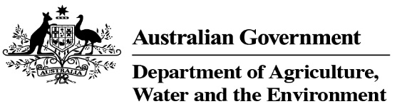

# Corporate Plan 2021–22

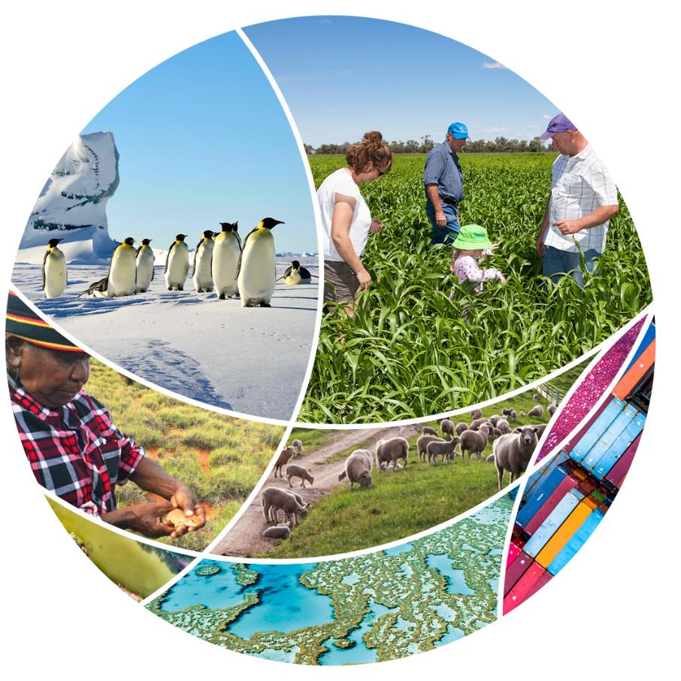

© Commonwealth of Australia 2021

**Ownership of intellectual property rights**

Unless otherwise noted, copyright (and any other intellectual property rights) in this publication is owned by the Commonwealth of Australia (referred to as the Commonwealth).

**Creative Commons licence**

All material in this publication is licensed under a Creative Commons Attribution 4.0 International Licence except content supplied by third parties, logos and the Commonwealth Coat of Arms.

Inquiries about the licence and any use of this document should be emailed to [copyright@awe.gov.au](mailto:copyright@awe.gov.au).



**Cataloguing data**

This publication (and any material sourced from it) should be attributed as: *Corporate Plan 2021–22*, Department of Agriculture, Water and the Environment, Canberra, August 2021. CC BY 4.0.

ISBN 978-1-76003-451-1

This publication is available at [awe.gov.au/about/reporting/corporate-plan](https://www.awe.gov.au/about/reporting/corporate-plan).

Department of Agriculture, Water and the Environment

GPO Box 858 Canberra ACT 2601

Telephone 1800 900 090

Web [awe.gov.au](https://www.awe.gov.au/)

**Disclaimer**

The Australian Government acting through the Department of Agriculture, Water and the Environment has exercised due care and skill in preparing and compiling the information and data in this publication. Notwithstanding, the Department of Agriculture, Water and the Environment, its employees and advisers disclaim all liability, including liability for negligence and for any loss, damage, injury, expense or cost incurred by any person as a result of accessing, using or relying on any of the information or data in this publication to the maximum extent permitted by law.

## Foreword

Our purpose is captured in this simple statement: *Enhancing Australia’s agriculture, environment, heritage, and water resources, through regulation and partnership*. For today and into the future.

With $900 million in new funding for us to administer over the next 5 years, we’re focused on a large program of activity and delivery throughout 2021–22; as well as administering our many long-term programs and responsibilities.

To ensure we achieve our purpose, we’re setting up our workforce to be future ready – developing, integrating, and applying world-class science, technology, data, economics, legal and digital capabilities to continually improve how we serve our stakeholders.

However, we can’t achieve these wide goals in isolation. To deliver for government and the community, we’re drawing on a range of partnerships to achieve the best possible outcomes in agriculture, biosecurity, water and environmental and heritage policy and practice. A particular priority is building on our engagement and partnership with Traditional Owners across our shared interests, in order to deliver on our collective responsibilities and work towards our longer-term aspirations.

With this commitment in mind, I’m pleased to release our *Corporate Plan 2021–22*.

This is our primary planning document and forms part of our annual strategic planning process. It sets the pathway for our strategic direction and performance and outlines how we intend to deliver against our purpose over the next 4 years (2021–22 to 2024–25).

I’m proud to lead our professional and diverse workforce, who continue to achieve great outcomes in this most demanding of times. This includes strengthening our biosecurity systems, helping our agricultural industries grow towards their $100 billion 2030 target, advancing our scientific knowledge in Antarctica, ensuring that our national parks remain open and safe and respect culture, supporting the sustainable management and use of our water resources, continuing efforts to recover those plants, animals and ecological communities most at risk, and protecting our natural, historic and Indigenous heritage. Our staff are on the frontline of helping Australia respond and start to recover from natural disasters and the COVID-19 pandemic; working in partnership with our communities, Traditional Owners, other government agencies, academia and industry.

We’re approaching our work with a strong sense of purpose, strong and positive values, and a focus on getting things done, to ensure we contribute positively to Australia and its future.

### Statement of preparation

As the accountable authority of the Department of Agriculture, Water and the Environment, I present the *Corporate Plan 2021–22*. This plan covers the reporting periods from 2021–22 to 2024–25, as required under paragraph 35(1)(b) of the *Public Governance, Performance and Accountability Act 2013*.

**Andrew Metcalfe AO**

Secretary

Department of Agriculture, Water and the Environment

Contents

[Foreword 3](#_Toc79585738)

[Statement of preparation 3](#_Toc79585738)

[About us 3](#_Toc79585738)

[Our purpose 3](#_Toc79585738)

[Our portfolio 3](#_Toc79585738)

[Our work 4](#_Toc79585738)

[Our people and locations 5](#_Toc79585738)

[Our values and principles 8](#_Toc79585738)

[Our objectives 9](#_Toc79585738)

[Our operating environment 10](#_Toc79585738)

[Partnering for better outcomes 10](#_Toc79585738)

[Responding to COVID‑19 10](#_Toc79585738)

[Changing global markets 10](#_Toc79585738)

[Technology and innovation 11](#_Toc79585738)

[Climate resilience 11](#_Toc79585738)

[Our strategic priorities 13](#_Toc79585738)

[Supporting our primary industries 14](#_Toc79585738)

[Improving how we regulate 14](#_Toc79585738)

[Strengthening biosecurity 14](#_Toc79585738)

[Protecting our environment and heritage 15](#_Toc79585738)

[Managing water and waste 15](#_Toc79585738)

[Enhancing our capabilities 17](#_Toc79585738)

[People, culture and leadership 17](#_Toc79585738)

[Partnerships and stakeholder engagement 18](#_Toc79585738)

[Cross-cutting science, innovation and research 20](#_Toc79585738)

[Technology and digital transformation 21](#_Toc79585738)

[Regulatory maturity 21](#_Toc79585738)

[Managing risk 22](#_Toc79585738)

[Strategic risks 22](#_Toc79585738)

[Risk mitigation strategies 22](#_Toc79585738)

[Building a positive risk culture 23](#_Toc79585738)

[Our performance measures 24](#_Toc79585738)

[New performance framework 24](#_Toc79585738)

[Regulator performance reporting 25](#_Toc79585738)

[Objectives, performance criteria and measures 25](#_Toc79585738)

## About us

### Our purpose

Our purpose is enhancing Australia’s agriculture, environment, heritage and water resources through regulation and partnership.

### Our portfolio

We support 3 ministers and 2 assistant ministers. They each have responsibility for distinct parts of our portfolio. We are at the centre of a diverse group of government agencies, statutory and non-statutory bodies, independent advisers and industry representatives (see Figure 1).

Figure 1 Our portfolio

The department’s ministers: Minister for Agriculture, Drought and Emergency Management: The Honourable David Littleproud MP.
Minister for Resources, Water and Northern Australia: The Honourable Keith Pitt MP. Minister for the Environment: The Honourable Sussan Ley MP. Assistant Minister for Forestry and Fisheries and for Industry Development: Senator the Honourable Jonathon Duniam. Assistant Minister for Waste Reduction and Environmental Management: The Honourable Trevor Evans MP. Agencies: Australian Fisheries Management Authority, Australian Pesticides and Veterinary Medicines Authority, Regional Investment Corporation, Murray-Darling Basin Authority, Sydney Harbour Federation Trust, Director of National Parks, Great Barrier Reef Marine Park Authority, and Bureau of Meteorology. Rural research and development corporations: Cotton Research and Development Corporation, Fisheries Research and Development Corporation, Grains Research and Development Corporation, AgriFutures Australia and Wine Australia.


Note: The department does not have any subsidiaries.

### Our work

#### Agriculture

Agriculture accounts for 58% of Australian land use. Our policies and programs help to deliver a productive, competitive and sustainable agricultural sector.

Our work encourages agricultural productivity and maintains and improves market access for primary producers. We promote agricultural stewardship to recognise farmers for their efforts in delivering biodiversity. We support sustainable, high-quality natural resources to benefit producers and the community.

Even in years of drought, Australia produces more food than Australians consume. On average, Australia exports about 70% of its farm production. We maintain, expand and secure new markets for Australia’s agricultural exports. We support and regulate Australia’s agricultural trade with the rest of the world. We are using technology to transform the way we deliver export regulation.

#### Environment and heritage

We play a pivotal role in protecting and sustaining Australia’s environment, which is one of the most biodiverse in the world. About 80% of Australia’s plants and 90% of its animals are found nowhere else on Earth. We work cooperatively with state and territory governments, First Nations peoples, a range of organisations and private landholders to manage the [National Reserve System](https://www.environment.gov.au/land/nrs), which is Australia’s network of terrestrial protected areas.

We deliver policies and programs to protect our environment, including undertaking environmental assessments, implementing our national waste policy, and protecting our marine reserves, including the Great Barrier Reef. We are responsible for vast marine protected areas and manage 58 Commonwealth Marine Parks, encompassing 2.8 million square kilometres, which is 31% of Australian waters.

Australia has a rich and diverse heritage of natural, historic and Indigenous values. We work in partnership with other governments, First Nations peoples and the community to see that Australia’s significant heritage places are recognised and managed to ensure their long-term protection.

#### Water resources

We lead water reform across the country and promote the sustainable, efficient and productive management and use of our water resources. We develop policies and provide advice to help farmers and rural communities deal with drought.

#### Biosecurity

Biosecurity is critical to preventing, responding to and recovering from the pests and diseases that threaten our economy and environment. On average each year, around 2.5 million shipping containers, 19,000 commercial vessels and 144 million mail items arrive in Australia. We work with importers, exporters, producers, supply chain and logistics businesses, and the community to protect Australia from biosecurity risks.

We work with the states, territories and other stakeholders on emergency response plans. These aim to minimise the impact of pests, disease and contaminants on agriculture, the environment and people’s health.

[Commonwealth Biosecurity 2030](https://www.agriculture.gov.au/biosecurity/commonwealth-biosecurity-2030) is our roadmap to build a stronger, smarter biosecurity system. Our ongoing biosecurity efforts focus on strengthening our partnerships, investing in our critical frontline resources and people, and modernising ICT systems, technology and data analytics.

#### Antarctic

Australia’s Antarctic Science Program is one of our most iconic and enduring national endeavours. The Australian Antarctic Territory covers nearly 5.9 million square kilometres, which is about 42% of Antarctica.

Australia operates 4 permanent research stations: Mawson, Davis and Casey stations in Antarctica, and Macquarie Island station in the sub-Antarctic region. We are committed to providing the facilities and logistics that will enable Antarctic scientists to focus on answering critical questions of global significance for decades to come.

The government is investing $2.8 billion to ensure our Antarctic presence and science research program benefits future generations. This includes the acquisition of a new world-class icebreaker ship, RSV *Nuyina*, restoring our inland traverse capability, preliminary work to develop year-round aviation access, and revitalising Australia’s Antarctic science infrastructure, starting with our southernmost research facility, Davis station.

### Our people and locations

Our people have a wealth of experience, expertise and knowledge. Our skills and capabilities are as diverse as our portfolio. We are inspectors, policy and assessment officers, program administrators, biosecurity and compliance officers, investigators, veterinarians, scientists, researchers, park managers and rangers, economists, accountants, legal practitioners, information communication technology (ICT) specialists, data analysts, expeditioners, food safety meat assessors, auditors and more.

We work with others to ensure Australia’s land, water and heritage are well-managed, protected and productive for today and the future. We partner with government, industry and community groups to conserve Australia’s heritage and its unique landscapes.

We work in diverse settings: in national parks, Antarctica, shipping ports, airports, mail centres, quarantine facilities, laboratories, abattoirs and offices. About half of our people are located outside Canberra in remote and regional centres, rural communities and cities.

Our people overseas maintain relationships with international organisations and trading partners. Our agricultural counsellors are in key trade locations around the world. They promote Australia's agricultural interests, negotiate market access and contribute to growth in the agricultural sector.

Our experience, expertise and knowledge help us to be ready for any challenge. They ensure our advice and activities meet the current and future needs and expectations of our government, industry and community stakeholders.

Figure 2 Our people on 30 June 2021

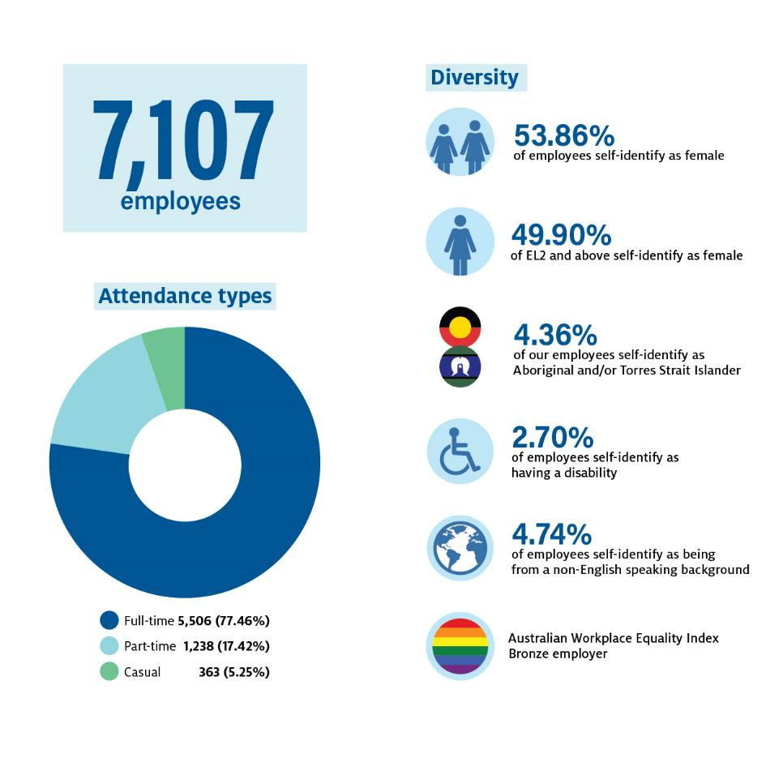

Note: An employee has a non-English speaking background if they arrived in Australia after the age of 5 and their first language is a language other than English. The [Australian Workplace Equality Index](https://www.pid-awei.com.au/) provides a national benchmark on lesbian, gay, bisexual, transgender and queer or questioning workplace inclusion in Australia. Source: Aurion and SAP.

Figure 3 Our locations on 30 June 2021

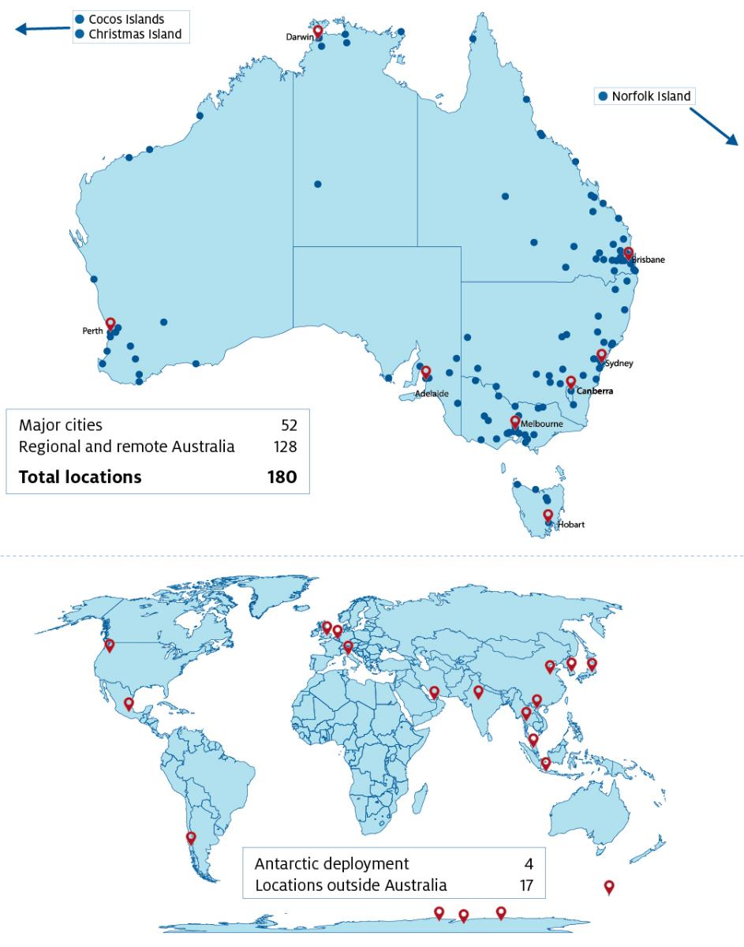

Note: Not all international locations are displayed due to the image size.

### Our values and principles

Our values and principles underpin everything we do.

We are part of the Australian Public Service (APS) and adhere to the APS Values of impartial, committed to service, accountable, respectful, ethical.

We support the APS Values through Our Core 4 values. These provide a shared understanding of how we work together and how we work with our stakeholders and partners. They help us to achieve our purpose, objectives and priorities.

Our Core 4 values (Figure 4) are:

* **Working together.** We collaborate and share information. We actively look for opportunities to connect across the department and with our stakeholders, partners and the community. We look after each other, support each other and work as a team.
* **Courage.** We look for opportunities to innovate. We try new things and engage with risk. We call out unacceptable behaviour. We own up to and learn from our mistakes.
* **Diversity.** We are diverse in who we are and the work we do. We listen to and draw on the experience, expertise and knowledge of others. We are inclusive. We acknowledge and respect diverse cultures and backgrounds.
* **Excellence.** We work to the best of our ability. We accept personal responsibility for our work. We use data and research to make well-informed decisions.

The principles of safety and integrity underpin Our Core 4. Figure 4 and Figure 5 highlight the importance of values and principles in our workplace.

Figure 4 Our Core 4

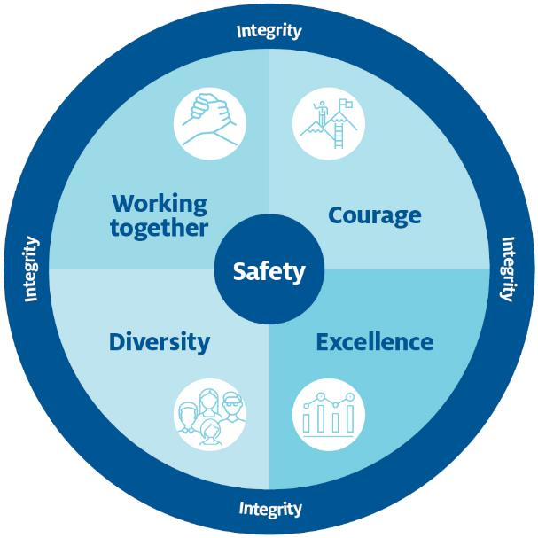

### Our objectives

Our purpose, objectives, values and principles are a clear statement about who we are and what we are here to do. Our 6 objectives are our key areas of focus and the foundation for our strategic priorities.

The supporting performance measures for each objective are in the Our performance measures section of this plan.

Figure 5 Our purpose, objectives and values

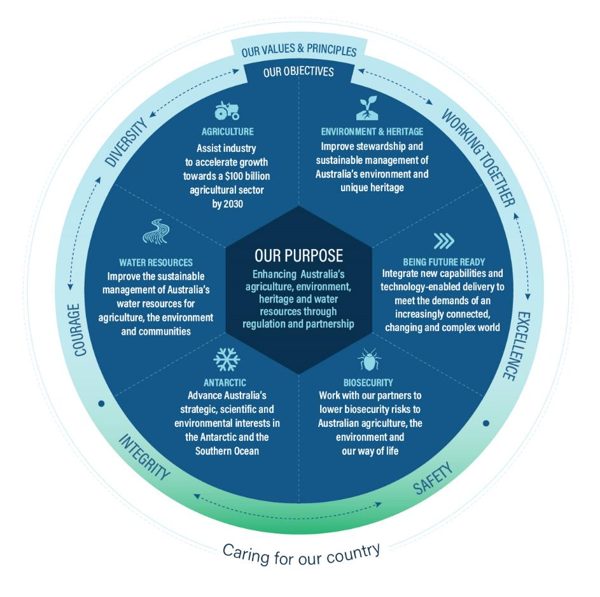

## Our operating environment

Our operating environment has complex challenges and opportunities. Changing global markets and consumer preferences, increasing international competition, technological disruption, climate and water-related risk, and global shocks such as the COVID‑19 pandemic affect our people, communities, agriculture, the environment and the economy.

### Partnering for better outcomes

We recognise the importance of partnering with other organisations to help us meet these challenges. We work with agencies across Australian, state and territory governments. We also work with industry, academia, non-government organisations and communities.

For example, our science and research partners, CSIRO and Charles Sturt University, boost our scientific and technical expertise. Our strategic consulting services partner, PwC, helps with strategic initiatives to transform the way we work. We work with regional natural resource management organisations to better protect our land and seascapes.

Further examples of our partnering approach are in Enhancing our capabilities.

### Responding to COVID‑19

We remain at the forefront of the ongoing response to COVID 19. We continue to provide border clearance processes and regulatory services to Australian exporting industries, at times in high-risk environments. Our biosecurity officers board all international flights to provide COVID‑19 health measures, and administer human health functions when required.

We are part of whole-of-government working groups for safe travel zones and arrangements for quarantine-free international arrivals. With the Department of Health, we ensure consignments of imported therapeutics, such as COVID‑19 vaccines, meet biosecurity requirements.

Agriculture is critical to Australia’s economic recovery. In 2020–21 the gross value of the agricultural, fisheries and forestry sectors reached $71.7 billion. To help maintain this growth, we are providing continued support for Australian agri-food exporters to expand and diversify their export markets.

We continue to work with other government departments on meeting agricultural workforce needs through the Pacific Labour Scheme and Seasonal Worker Programme.

### Changing global markets

China remains our biggest agricultural trading partner, despite geopolitical shifts and trade tensions.

We continue to build and deepen export market opportunities for Australian primary producers. We have met our counterparts in the European Union, India, Indonesia, Japan, Malaysia, New Zealand, South Korea and the United Kingdom to improve market access for our producers and ease regulatory burdens.

At the 7th Australia–Japan High Level Dialogue of February 2021 we reached agreement to progress a Statement of Intent on Agri-Food Value Chains with our second biggest agricultural trading partner. When finalised this will solidify the commitment of both countries to work together on supply chain resilience, export modernisation and future food systems.

The Australian Government has achieved in principle agreement for a free trade agreement between Australia and the United Kingdom. When finalised this agreement will further expand agricultural trade opportunities for Australian industries.

Changes in global trade are increasing pressure on Australia’s biosecurity system. Global trade routes are shifting. This creates new and complex biosecurity risk pathways. Higher volumes and complexity of trade lead to more detections at the border. We continue to invest in screening and detection technologies, intelligence and information, and risk management systems to protect Australia from biosecurity threats.

There is a significant shift in global expectations for the transport, processing and re-use of waste materials. This illustrates the importance of Australia’s world-first waste export ban. We are working across government and industry to support transformation of the waste and recycling sectors. This will help Australia take responsibility for its own waste.

### Technology and innovation

We are strongly committed to using digital services and providing user-centred service delivery in line with industry and community expectations.

As noted in [The future of agricultural technologies report](https://acola.org/hs6-future-agricultural-technologies/), emerging technology presents opportunities. It can improve efficiency and profitability of production, develop novel industries and markets, and contribute to social and environmental values. The report examined the future impact of 9 technologies on the agriculture sector, including the internet of things, robotics, machine learning, biotechnology, and distributed ledger technology.

We are investing in many of these technologies. An advanced blockchain traceability system will digitise end-to-end traceability in horticulture. We are using 3D X-rays to detect biosecurity risk material and smuggled wildlife at airports and mail centres. We use drones for myriad purposes and they are likely to become a foundational scientific capability. They help us monitor wildlife and vegetation conditions, and monitor compliance activities such as land clearing. We have appointed a Chief Remote Pilot and a Drone Compliance and Policy Officer, and we are creating a drone management framework.

The Australian Government is investing $86 million through the Future Drought Fund to establish [8 drought resilience adoption and innovation hubs](https://www.agriculture.gov.au/ag-farm-food/drought/future-drought-fund/research-adoption-program). These will create a regional focus for research and accelerate the uptake of new technologies by farmers.

### Climate resilience

Extreme weather is increasing in intensity and frequency. Climate forecasting and disaster preparedness are integral to our responsiblities. We help governments, industry, businesses and communities to anticipate and manage the risks associated with climate change.

As a single trusted source for climate and disaster risk advice, the new [Australian Climate Service](https://www.acs.gov.au/) will provide a strong foundation for us to support future climate resilience action. This new service will consolidate data from scientists and climate research institutions. It will contribute to an environmental road map that supports planning for infrastructure, housing, power, telecommunications, and water. The service complements our [National Environmental Science Program](https://www.environment.gov.au/science/nesp), our [Reef Restoration and Adaptation Program](https://gbrrestoration.org/), and our refreshed [National Climate Resilience and Adaptation Strategy](https://www.environment.gov.au/climate-change/adaptation/strategy).

Our country needs to ensure sustainable water supply in the face of increased climate variability and rising demand for water. Water is critical to the environment, to the wellbeing of communities and to agriculture, which accounts for 59% of water extractions.

We support the sustainable management and productive use of Australia’s water resources. We continue to work on improving the health of rivers and freshwater systems. We provide national leadership for implementing the Murray–Darling Basin Plan. We are part of the collaborative national efforts to upgrade water modelling capability and develop phased reform of water markets in the Basin.

## Our strategic priorities

Our strategic priorities are the key activities we will deliver across the next 4 years (Figure 6). Delivery of these priorities will contribute to achieving our purpose and objectives.

In setting our priorities, we reflected on issues that affect our industries, communities and stakeholders. We considered the Australian Government's agenda. To achieve our priorites, we acknowledge the ongoing importance of stakeholder engagement, working with our partners, scanning our operating context, and agility in responding to emerging priorities.

Figure 6 Our strategic priorities

* improve market access and, with our partners, maximise opportunities for agricultural exports
* transform the export regulatory system
* foster collaboration in research and development to drive uptake of innovative practices in the agricultural sector
* deliver policies and programs to support profitable and resilient agribusiness
* support economic recovery post-COVID-19 across industry
* improve the status of threatened species and ecosystems
* administer and reform the *Environment Protection and Biodiversity Conservation Act 1999* to drive economic recovery post-COVID-19 and strong environment and heritage outcomes
* provide national leadership to effectively manage Australia’s waste
* conserve and maintain Australia’s unique heritage
* partner with Murray–Darling Basin states to implement the Basin Plan and manage Basin water resources in the national interest
* maintain and strengthen our biosecurity system by working with our partners and through innovation and business transformation
* maintain Australian leadership in Antarctica and the Southern Ocean
* improve regulatory efficiency, effectiveness and maturity, including through deregulation
* protect, conserve and enhance the value of Commonwealth marine and terrestrial parks and gardens for the use and wellbeing of all Australians
* deliver substantial actions to build climate adaptation and resilience in the economy, community and environment.

### Supporting our primary industries

Recovery from the COVID‑19 pandemic is a long-term focus for government, industry and the community. [Delivering Ag2030](https://www.agriculture.gov.au/ag-farm-food/ag2030) contributes to the government’s efforts to get Australians back into jobs and revitalise the regions. It will also help Australian farmers, fishers and foresters achieve their vision of a $100 billion agricultural sector by 2030.

We are supporting this vision by encouraging better land management, improving regulatory processes, tackling emerging trade challenges and supporting industry resilience. We are promoting science and innovation, which is enhanced through the creation of [Agricultural Innovation Australia](https://www.aginnovationaustralia.com.au/).

Soil supports every Australian. The [National Soil Strategy](https://www.agriculture.gov.au/ag-farm-food/natural-resources/soils) sets out how Australia should value, manage and improve its soil. The 2-year National Soil Monitoring and Incentives Pilot Program will improve our understanding of Australia’s soil condition and how to better manage it. The pilot will assess the impact of land management practices, assist farmers to improve their productivity and profitability, and support them to participate in the Emissions Reduction Fund.

The $328 million Busting Congestion for Agricultural Exporters package funds reform for Australian agricultural sectors. We aim to reduce unnecessary red tape, get products to export markets faster and support jobs in rural and remote Australia. The package will modernise Australia’s regulatory approach. It will provide best-practice systems and enable us, as the agricultural export regulator, to undertake assurance more efficiently.

### Improving how we regulate

Good regulation is important. We are accountable to the public in how we regulate and we recognise the need to reduce red tape and streamline regulation. We have 12 regulatory systems and administer more than 120 pieces of legislation. Our [Regulatory Practice Statement](https://www.awe.gov.au/about/commitment/regulator-practice) outlines our commitment to regulate in accordance with principles of better practice and sets an aspiration for each of our regulatory systems to work towards. The regulatory maturity section of Enhancing our capabilities has more detail on our Regulatory Practice Statement.

We will mature the practice of each of our regulatory systems. Our Regulatory Practice Committee and regulatory leaders will drive improvements across our regulatory functions. We will progress reforms to address issues identified by independent reviewers, and issues emerging in the evolving markets and industries we regulate. We will continue to clearly outline our approach to managing compliance, with a focus on enabling voluntary compliance.

We will continue implementing the $6.4 million Excellence in Professional Regulation training pilot, in partnership with the Australian Public Service Commission. This training will enhance the capability and performance of agricultural export regulators and upskill other APS regulators.

### Strengthening biosecurity

Australia’s biosecurity system protects $5.7 trillion in environmental assets; $50 billion in inbound tourism; $71 billion in agriculture, fisheries and forestry production; $51 billion in agricultural exports; and 1.6 million jobs across the agriculture supply chain.

To ensure Australia stays ahead of biosecurity threats, we have launched [Commonwealth Biosecurity 2030](https://www.agriculture.gov.au/biosecurity/commonwealth-biosecurity-2030). This is a roadmap to a stronger, smarter biosecurity system. We will use our stakeholder networks to guide annual action plans and develop a national biosecurity strategy.

### Protecting our environment and heritage

Our heritage is important to Australia’s national identity. It is not just something we look back on, but something we carry into the future. We will work to protect the national and world heritage places that tell stories of our history, our Indigenous heritage and the exceptional environment of our continent and its surrounding waters.

Through Parks Australia, we manage national parks, gardens and marine parks in partnership with Traditional Owners, communities and business. The COVID‑19 pandemic affected tourism and we are investing in upgrades and new infrastructure to boost visitation. Funding for Uluru‑Kata Tjuta, Kakadu and Booderee national parks, Christmas Island, and the Australian National Botanic Gardens will help tourism businesses and the economy.

The environment, ecosystems and biodiversity continue to be affected by catastrophic events such as the 2019–20 Black Summer bushfires, the New South Wales floods and the associated mouse plague. In response, we have developed the [Threatened Species Strategy 2021–2031](https://www.environment.gov.au/biodiversity/threatened/publications/threatened-species-strategy-2021-2031), a 10-year blueprint for protecting Australia’s biodiversity. It was created with environmental scientists, threatened species experts, environmental groups, landholders and Traditional Owners. The strategy draws on lessons from the Black Summer bushfires. It sets a vision to drive practical on-ground action for the recovery of threatened species and ecological communities. It establishes principles for identifying priority threatened species. It provides plans for deploying monitoring technologies, such as drones and environmental DNA.

Climate science and adaptation is critical in building environmental resilience. We will consult widely to refresh the [National Climate Resilience and Adaptation Strategy](https://www.environment.gov.au/climate-change/adaptation/strategy). We will release the new strategy in the second half of 2021.

The climate and the health of the planet’s oceans are inextricably linked. The Australian Government is investing $100 million to protect oceans and coastal environments. This is a major contribution to domestic and international efforts to build healthier oceans and combat climate change. We will deliver initiatives to protect marine life and boost blue carbon ecosystems that draw carbon out of the atmosphere.

We will progress environmental law reform in response to the [Independent Review](https://epbcactreview.environment.gov.au/) of the *Environment Protection and Biodiversity Conservation Act 1999*. This will include new national environmental standards, streamlining approval processes with state and territory governments, rigorous assurance monitoring for bilateral agreements, and improving Indigenous cultural heritage protection.

### Managing water and waste

Sustainable water supply underpins Australia’s environment, agriculture and the wellbeing of our communities. We take an adaptive, evidence-based approach to policymaking for Australia’s largest river system, the Murray–Darling Basin. We seek to align Basin management with nationally agreed strategies and frameworks, including the [National Water Initiative](https://www.agriculture.gov.au/water/policy/nwi). We have a similar approach for the [Great Artesian Basin Strategic Management Plan](https://www.agriculture.gov.au/water/national/great-artesian-basin/strategic-management-plan).

Actions to drive a billion-dollar transformation of Australia’s waste and recycling industry by 2030 continue under the [National Waste Policy Action Plan 2019](https://www.environment.gov.au/protection/waste/publications/national-waste-policy-action-plan). Each year Australia sends 27 million tonnes of waste to landfill. This costs the economy about $20 billion each year.

We are implementing the world’s first ban on the export of unprocessed waste. This includes building a domestic resource recovery industry so Australia can take care of its waste. Each 10,000 tonnes of waste that is recycled will reduce pollution and create 6.4 new local jobs.

We are driving product stewardship and partnering with industry to increase recycling, tackle food and organic waste, and support better waste management. The $67 million [Food Waste for Healthy Soils Fund](https://www.environment.gov.au/protection/waste/food-waste/food-waste-for-healthy-soils-fund) is supporting the diversion of about 3.4 million tonnes of food and garden waste from landfill to productive use as nutrient rich compost and soil enhancers.

Under the first [National Plastics Plan](http://www.environment.gov.au/protection/waste/plastics-and-packaging/national-plastics-plan), we are working with governments, industry and households on a whole-of-lifecycle approach to plastic. This includes phasing out problematic plastics, increasing Australia’s recycling capacity, stimulating demand for recycled content, and preventing plastics from leaking into the environment.

We are driving national reforms to better manage risks to the environment from chemicals. This includes ongoing work to implement the [Industrial Chemicals Environmental Management Standard](https://www.environment.gov.au/protection/chemicals-management/national-standard).

## Enhancing our capabilities

We are on a journey to transform the way we work. We continue to adapt to a dynamic operating environment and strengthen the capability of our workforce. We are building our future capacity to support Australians and the Australian Government in our critical areas of responsibility.

We regularly review and invest in our capabilities to ensure we have the right balance and combination of skills, expertise and knowledge to deliver on our purpose and objectives. Figure 7 highlights the core capabilities we are investing in.

Figure 7 Our capability priorities for a future-ready workforce

As part of our Future Department Blueprint, we will realise our potential by enhancing core capabilities across our department through:

* building a safe, diverse, inclusive and high-performing culture united by our purpose and values
* building innovation, digital and technology skills to confidently deliver great services
* harnessing data and analytics to inform decision-making
* pursuing ways to better connect with our stakeholders, partners, portfolio agencies and communities
* strengthening our cross-cutting science, information and research activities
* improving financial discipline and sustainability to maximise outcomes from regulation, policy, programs and service delivery
* strengthening our ability to deliver informed, influential, integrated and innovative policies
* Building world leading regulation of our agricultural, environmental, heritage and water resources.

In developing and realising these core capabilities we will also continue to:

* provide excellent advice and support to ministers and government
* collaborate across government to capture, analyse and apply intelligence
* respect and engage with Aboriginal and Torres Strait Islander peoples, their culture, history and ongoing connection to the land, sea and community.

Our Future Department Blueprint provides greater detail on how we are transforming our capabilities to meet the demands of an increasingly connected, changing and complex world.

### People, culture and leadership

Effective leadership and a positive culture help our workforce to thrive. We continue to integrate people strategies, policies, guidance and initiatives to build the capability of our people.

Our Core 4 values and principles are specific to our department and aligned to the APS Values. They underpin our culture and reflect how we work together. We embrace courage, excellence and diversity while maintaining integrity and ensuring the safety of our workers and visitors.

Integrity-based behaviour and decision-making is fundamental to the way we operate, particularly in our regulatory roles. Through our integrity framework, we identify integrity risks and effective controls. We educate our people about fraud and corruption. We embrace and promote a pro-integrity culture that is ethical, fair and appropriate, by maintaining high standards of professionalism, accountability and ethical behaviour.

Our *Workforce Strategy and Action Plan 2021–2025* identifies the capabilities we need to achieve our purpose and objectives. It will guide development of a workforce with the right skills and employment types in the right locations, and managed within our budget. We have 7 priority areas:

* People-centric systems: integrating human resources systems and data for enhanced reporting and planning.
* Workforce needs: improving strategic and tactical workforce planning to help manage enterprise and workforce risk.
* Surge and mobility capacity: using lessons from the COVID-19 pandemic to ensure we are ready to respond to rapid changes in our operating environment.
* Holistic workforce capability: developing a comprehensive capability framework and a talent and succession management strategy to support future workforce requirements.
* Organisational design: building an organisational design capability, including a policy and framework for establishments and organisational design.
* Varied workforce model: enhancing workplace flexibility, developing new recruitment strategies and expanding partnerships with businesses, universities and other organisations.
* Work health and safety: improving systems for the mental and physical health and safety of our people across our diverse range of workplaces. This includes pandemic responses and embedding dynamic risk identification and control practices to minimise health, safety and wellbeing impacts.

We continue to embed inclusion in all that we do. Our Diversity and Inclusion Strategy encourages every person to contribute and bring their authentic self to work. Our Mental Health and Wellbeing Strategy will enable people to thrive in our workplaces and throughout their careers with us.

Our [Reconciliation Action Plan 2021–24](https://www.awe.gov.au/about/reporting/reconciliation-action-plan) will help us to understand, recognise, celebrate, value and respect Aboriginal and Torres Strait Islander peoples, their culture and communities. We continue to value the contribution that our Indigenous staff bring to our department.

### Partnerships and stakeholder engagement

We work with and through other organisations to achieve our purpose and objectives.

Our stakeholders and partners (Figure 8) include other government agencies, industry peak bodies, universities and research organisations, farmers and other primary producers, industry and the community. We work across government to capture, analyse and apply intelligence that will enhance delivery of our services. We actively pursue ways to better connect with our stakeholders, partners and communities.

Figure 8 Our stakeholders and partners

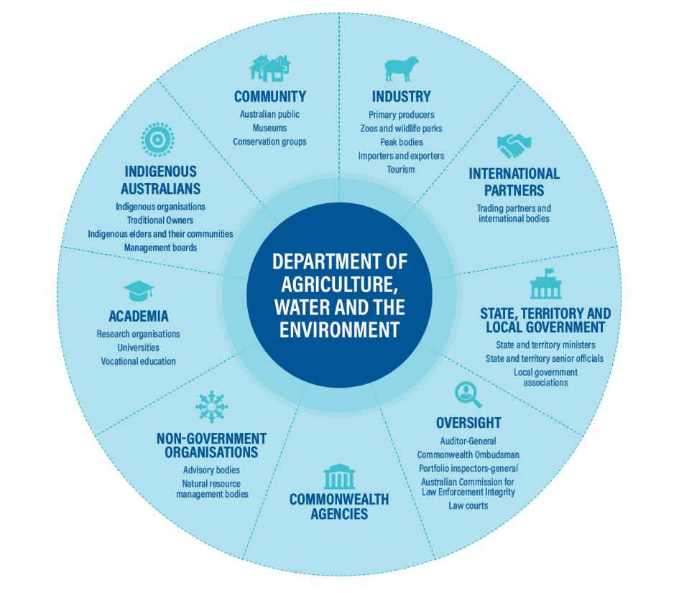

Note: This is an indicative list. It does not include all stakeholders and partners.

Snapshot: How we collaborate

Cross-government collaboration

Xylella fastidiosa is a bacterial disease. It is a significant emerging plant disease threat for the world. We hosted the first online forum to review progress of the [National Xylella Action Plan 2019–2029](https://www.agriculture.gov.au/pests-diseases-weeds/plant/national-action-plans). The plan focuses on preventing Xylella from entering Australia, rapidly detecting it if it does enter, and mounting an effective emergency response. The forum included industry, state and territory governments and other Australian Government departments.

International leadership

Australia is one of 12 original parties to the Antarctic Treaty. The treaty system is a set of legally binding agreements that govern international activities in Antarctica and its surrounding seas. Through the treaty, Australia has worked with other countries for more than 50 years to carry out scientific investigation and protect Antarctica’s unique environment.

Indigenous partnerships

A lot of our work is about caring for country. This work is anchored in partnerships with our Indigenous staff, First Nations communities and Indigenous ranger groups. The Indigenous Ranger Biosecurity Program providesrangers with skills and support to use their knowledge of country and conservation to carry out biosecurity work along 10,000 kilometres of coastline in northern Australia.

Industry collaboration

Bee pollination supports crop industries and food security. Strong biosecurity measures protect the health of bees. The National Bee Pest Surveillance Program is jointly funded by the department, the Australian Honeybee Industry Council, Hort Innovation and Grain Producers Australia. We are working with these partners to build diagnostic skills in laboratories to support preparedness and response for bee viruses.

Research partnerships

We have strategic partnerships with Charles Sturt University and the CSIRO to boost our scientific and technical capabilities, support service delivery and expand our engagement into regional and rural communities. We are exploring opportunities for collaboration in biosecurity, agricultural innovation, biodiversity conservation, climate adaptation, soils, public engagement and digital modernisation.

We collaborated with the University of Melbourne’s Centre of Excellence for Biosecurity Risk Analysis to put a dollar value on Australia’s biosecurity system. When modelled over 50 years, the estimated value of the biosecurity system is $314 billion. It protected assets valued at more than $5.7 trillion over the same period. The model demonstrates the benefits of government investment in biosecurity.

### Cross-cutting science, innovation and research

We are leaders in using science to solve problems. Science and research are core capabilities that feed every aspect of our work. We produce, commission and apply science to policies and regulatory decisions. We find innovative solutions to improve Australia’s agriculture, environment and heritage, and water resources.

Since 1945, our Australian Bureau of Agricultural and Resource Economics and Sciences (ABARES) has provided independent data, research, analysis and advice. This informs public and private decisions affecting Australian agriculture, fisheries and forestry.

Our National Environmental Science Program is Australia's flagship program for applied science in environment and climate research. It develops future scenarios to help government, industry and the community build climate resilience into decision-making.

Our science leadership is based on the scientific capability of our people; our partnerships with research institutions, innovators and First Nations peoples; and our willingness to share knowledge, expertise and findings.

We are committed to investing in science as it informs the work we do to achieve our purpose. Our [Science Strategic Action Plan](https://www.agriculture.gov.au/ag-farm-food/innovation/science-strategy) guides the delivery and application of science and science capabilities. It also directs how and where we can drive and shape opportunities that benefit us and the broader community.

### Technology and digital transformation

Enhancing our ICT services will help us achieve our purpose and objectives. Our ICT vision is to provide scalable, flexible, sustainable and secure services that enable and enhance our activities.

A mature and contemporary digital service needs ICT that delivers a seamless, integrated service experience to our people, clients and stakeholders. The attributes that enable this are:

* Digital by default: secure, scalable, agile, cloud-based services; mobile access to all ICT services in one place and on any device.
* 24/7 operations: access to services anywhere and at any time, with processing of requests without delay across international time zones.
* Rules-driven: context-aware, event-driven workflows tailored to suit changing profiles and requirements; decision automation and clearly-defined decision trees for pre-determined responses and actions.
* Single view of client: visibility of all information about previous and current interactions between a client, establishment or authorised officer and the department.
* Advanced analytics: evidence, insights and actionable guidance based on internal and external data.

To achieve our ICT vision, we are improving the way we govern and deliver our ICT services. Our *ICT Strategy 2020 to 2024* will position us to support the department’s digital transformation.

### Regulatory maturity

To strengthen our regulatory functions and achieve our objectives, we have a new [Regulatory Practice Statement](https://www.awe.gov.au/about/commitment/regulator-practice). This signals our commitment to improve business systems and tools, invest in our people and make it easier for regulated entities to understand and comply with regulations.

The statement is a strategic document that underpins our regulatory functions and guides our regulatory services. We have a diverse workforce, with a broad spectrum of skills and specialisations. The statement will guide the adoption of a common approach, a strong regulatory culture and mature practice. It includes clear regulatory practice principles to help us make decisions, improve the way we engage with stakeholders and deliver quality services.

## Managing risk

Our diverse work in a complex and changing operating environment means we need to manage multiple risks. These range from trade tariffs and climate risk to digital disruption and worker health and safety. To better understand and respond to risk, we integrate risk management with governance, planning and performance management.

Our Chief Risk Officer is responsible for strengthening our risk management capability and maturity, and for driving a positive risk culture.

We take a pragmatic and consistent approach to managing risks. This promotes appropriate and informed risk-taking as part of everyday decision-making.

Our Enterprise Risk Management Framework and Policy provides our risk management approach. It aligns with the Commonwealth Risk Management Policy and the *Public Governance, Performance and Accountability Act 2013*. Our framework describes expectations and requirements. It guides our people in identifying and managing risks.

### Strategic risks

Our strategic risks are those that, if realised, would materially affect our ability to achieve our purpose and objectives (Figure 9).

Figure  Our strategic risks

* failure to respond to megatrends or global developments in the design and execution of our programs and policies
* failure to harness our resources and capabilities to deliver government priorities
* failure to implement regulatory responsibilities and programs to deliver protection and growth
* our expertise and stakeholder relationships do not position us to provide future-focused policy options and advice
* failure to manage the unique health and safety hazards presented by our diverse operations in challenging locations
* failure to invest in systems and technology to deliver quality digital services.

### Risk mitigation strategies

We have established controls to reduce the likelihood of our strategic risks occurring, to minimise the potential consequences where able, and to ensure risks are effectively monitored, reported and managed. This section describes our controls.

#### Ongoing oversight

Our Executive Board maintains visibility and oversight of strategic risks, and the ongoing efficacy of their management, through regular risk reports from the Chief Risk Officer. Strategic risk owners are required to coordinate management and mitigation activities across the department, and to report any changes in risk profile.

#### Application of risk management and monitoring approaches

In line with the Commonwealth Risk Management Policy, we define our approach to risk management through our Enterprise Risk Management Framework and Policy. This ensures we take a consistent, integrated and proactive approach to managing strategic risks, in accordance with our risk appetite and tolerance statements.

We encourage and support our people and our stakeholders to continually identify, assess and monitor current and emerging risks. We provide support and guidance for our people to measure the performance and effectiveness of risk mitigation measures. This ensures the measures remain fit-for-purpose and we can identify opportunities for improvement.

#### Regular reporting to the executive

The Chief Risk Officer reports to the Executive Board and Portfolio Audit Committee on the ongoing management of our strategic risks, the maturity of risk identification and management practices, and emerging cross-cutting risks and issues that are shaping our strategic risk profile.

Along with the Chief Risk Officer’s quarterly reports to the Executive Board and Portfolio Audit Committee, each division also reports to the senior executive twice a year on its progress in managing and mitigating risks, as part of the executive performance review process.

Risk owners are required to manage risks in line with our risk appetite and tolerance. This is defined in our Enterprise Risk Management Framework and Policy.

#### **Strategic policies, programs and procedures**

To provide assurance that we can achieve our purpose and objectives and manage strategic risks, we continue to develop, enhance and manage both existing and future strategic policies, programs and procedures.

Our strategic controls provide effective risk mitigation to manage our health and safety hazards, resources and capabilities. These controls also ensure we implement and manage our regulatory responsibilities and programs effectively and in line with government expectations.

#### **Auditing and review**

External audits, internal audits, benchmarking programs and reviews provide insights into the effectiveness of risk identification and management activities. We are committed to ensuring prompt action in areas identified for improvement.

### Building a positive risk culture

We promote a positive risk culture to guide innovation, manage threats, harness opportunities and empower our people to make informed, risk-based decisions.

Risk management is the responsibility of all our people. We encourage them to incorporate consideration of risk into their day-to-day work. Proactively managing risk balances threats with opportunities. It allows us to recognise the importance of controls while realising opportunities for efficiency, innovation and continuous improvement.

## Our performance measures

### New performance framework

This year we have developed a new framework to measure our performance against our purpose, objectives and priorities. This framework (Figure 10) will improve consistency across performance measures. It will align the activities we deliver against our objectives.

Figure  Enterprise performance framework

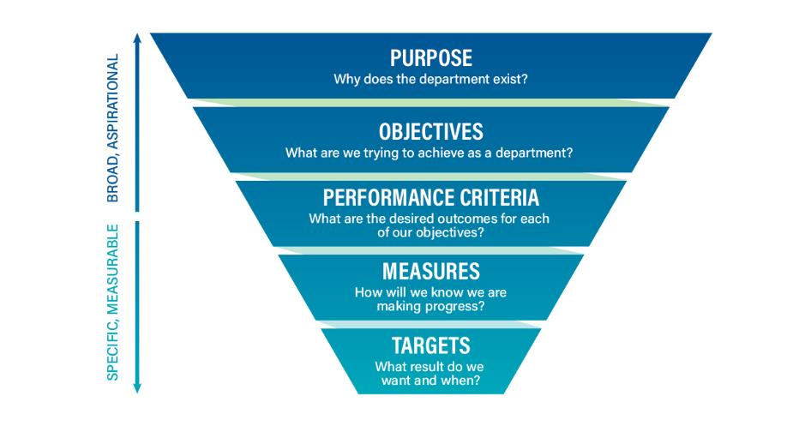

The framework levels are connected as follows:

* Our purpose captures what we do and how.
* Our objectives express our key focus areas, and how these will achieve our purpose. The objectives link to Portfolio Budget Statements and identify what success looks like.
* Our performance criteria specify the benchmark for success under each objective. They provide the desired outcomes for each objective and are the basis for measuring performance. We used program logic models to help business areas develop new or improved performance criteria, measures and targets for each objective.
* Measures indicate progress towards the performance criteria and objectives. Measures indicate the dimension of performance: output, effectiveness or efficiency. Some measures have replaced or revised measures currently published in our *Portfolio Budget Statements 2021–22*. We report on performance measures in our annual report.
* Targets are the milestones that indicate success or progress in a measure in a given time frame. They inform short-term management decisions and support discussions on the effectiveness of strategy.

We continue to improve the performance framework. Our Performance Framework 2021–22 provides more information about the way we measure our performance.

### Regulator performance reporting

We support the Australian Government’s [Deregulation Agenda](https://deregulation.pmc.gov.au/) and are committed to providing relevant and appropriate information on the performance of our regulatory functions.

In 2021–22 reporting of performance information will occur under the Department of the Prime Minister and Cabinet’s Regulator Performance Framework for the last time. Australian Government regulators are transitioning to new regulator performance reporting arrangements under the *Public Governance, Performance and Accountability Act 2013*. Regulator performance reporting will be part of our annual report from 2022–23.

### Objectives, performance criteria and measures

This section provides the performance criteria for each of our objectives.

#### Agriculture

**Objective:** Assist industry to accelerate growth toward a $100 billion agriculturale sector by 2030.

##### Performance criterion: Agricultural policy and innovation supports sector productivity and sustainability.

|  |  |
| --- | --- |
| Measure | Greater growth in average agriculture, forestry and fishing sector productivity for the past 10 years compared to average annual market sector productivity growth over the same period. (Effectiveness) |
| Target | **2021–22**: ≥0% difference over past 10 years.  **2022–23**: As for 2021–22.  **2023–24**: As for 2021–22.  **2024–25**: As for 2021–22. |
| Context | We work to provide a policy and regulatory environment in which primary producers can build their productivity. We support research and development to promote innovation in agriculture and in agribusiness management.  We implement arrangements to increase, improve and maintain markets over the medium to long term. As a result, there is a lag between our activities and the results in terms of increased export values.  Agricultural productivity is often susceptible to significant volatility because of seasonal conditions. We use Total Factor Productivity as the measure of productivity. It is calculated on a value-added basis. |
| Measure | Equal or reduced cost of levy collection processes compared with levies disbursed. (Efficiency) |
| Target | **2021–22**: Cost ≤1.2% of levies disbursed.  **2022–23**: As for 2021–22.  **2023–24**: As for 2021–22.  **2024–25**: As for 2021–22. |
| Context | We are responsible for collecting industry levies and providing them to rural research and development corporations to fund their work. This is a measure of the efficiency of our agricultural levy collection processes. Decreases will reflect lower costs in collection processes and greater efficiency.  We calculate the percentage by dividing the total cost-recovery charge by the total levy/charge disbursed for that financial year. It does not include Commonwealth matching payments. |
| Measure | Lead and report on the implementation of Australian, state and territory government obligations under the National Drought Agreement. (Output) |
| Target | **2021–22**: Annual report complete within 6 months of the end of each financial year.  **2022–23**: As for 2021–22.  **2023–24**: As for 2021–22.  **2024–25**: As for 2021–22. |
| Context | The National Drought Agreement sets out a joint approach by the Australian, state and territory governments to support farming businesses and communities to prepare for and respond to drought.  Responsibility for drought policy was transferred to us from the National Recovery and Resilience Agency in the *Portfolio Budget Statements 2021–22*. |

##### Performance criterion: Agricultural export markets are increased, improved and maintained.

|  |  |
| --- | --- |
| Measure | Value of potential trade achieved through new and improved market access arrangements. (Effectiveness) |
| Target | **2021–22**: Improvement in market value achieved (above zero).  **2022–23**: As for 2021–22.  **2023–24**: As for 2021–22.  **2024–25**: As for 2021–22. |
| Context | We work to provide opportunities for primary producers to export their commodities. The Australian Government is involved in negotiations with other countries to establish trade agreements. We work with trading partners to establish and amend protocols to ensure that Australian agricultural exports meet importing country requirements.  This is a measure of the effect of our market access activities on trade outcomes. |
| Measure | Value of potential exports facilitated through dispute resolution. (Effectiveness) |
| Target | **2021–22**: Improvement in value of potential exports facilitated through dispute resolution.  **2022–23**: As for 2021–22.  **2023–24**: As for 2021–22.  **2024–25**: As for 2021–22. |
| Context | This is a measure of the effectiveness of our work to resolve trade disputes and its effect on the value of potential exports facilitated. The measure captures the work of our international counsellor network. |

##### Performance criterion: Export regulatory activity is streamlined and effective.

|  |  |
| --- | --- |
| Measure | Decrease in number of point of entry failures from agricultural exports. (Effectiveness) |
| Target | **2021–22**: <0% difference in number of point of entry failures from baseline (2020–21).  **2022–23**: As for 2021–22.  **2023–24**: As for 2021–22.  **2024–25**: As for 2021–22. |
| Target | **2021–22**: <0% difference in overall certification failures from baseline (2020–21).  **2022–23**: As for 2021–22.  **2023–24**: As for 2021–22.  **2024–25**: As for 2021–22. |
| Context | We provide export controls and assistance for agricultural, fisheries and forestry exporters to meet importing country requirements for their commodities. This is a proxy measure of our regulatory effectiveness. Fewer point of entry failures reflects greater compliance by exporters with regulatory standards. |
| Measure | Reduction of $21.4 million in the department’s regulatory costs for agricultural exporters by 2024. (Effectiveness) |
| Target | **2021–22**: Reduction of $12.7 million in cost recovery expense.  **2022–23**: To be developed.  **2023–24**: To be developed.  **2024–25**: n/a. |
| Context | This measures core outcomes of the government’s package of reforms for Australian agricultural exporters. We seek to make it faster and cheaper for farmers to get their product to market. Reducing regulatory costs and costs of compliance contributes to this goal. |
| Measure | Reduction in costs of compliance burden for agricultural exporters. (Efficiency) |
| Target | **2021–22**: Target will be developed based on 2021–22 values to form a baseline as this is a new measure.  **2022–23**: To be developed.  **2023–24**: To be developed.  **2024–25**: To be developed. |
| Context | These are core outcomes of the government’s package of reforms for Australian agricultural exporters. We seek to make it faster and cheaper for farmers to get their product to market. Reducing regulatory costs and costs of compliance contribute to this goal. |

##### Performance criterion: Australian farmers and communities are supported through hardship and are prepared for business risk, including drought.

|  |  |
| --- | --- |
| Measure | Increase in the proportion of farmers who are actively planning for business risk, including drought, and have confidence in their ability to achieve desired outcomes on their farm. (Effectiveness) |
| Target | **2021–22**: >75% of farmers have a farm plan with business objectives.  **2022–23**: As for 2021–22.  **2023–24**: As for 2021–22.  **2024–25**: As for 2021–22. |
| Target | **2021–22**: >75% of farmers have a farm plan with strategies for dealing with drought and other risks that could affect their farm.  **2022–23**: As for 2021–22.  **2023–24**: As for 2021–22.  **2024–25**: As for 2021–22. |
| Context | The Australian Government is accountable for ensuring the Future Drought Fund supports genuine improvements in drought preparedness and resilience.  The measure aligns with the Monitoring, Evaluation and Learning Framework, which outlines the approach to monitoring and evaluating the fund and its programs, supports measurement of the fund’s progress and achievements over time, and helps identify improvements for the programs in the future. |

#### Environment and heritage

Objective: Improve stewardship and sustainable management of Australia’s environment and unique heritage.

##### Performance criterion: Ecosystem diversity, extent and function are maintained or improved.

|  |  |
| --- | --- |
| Measure | Percentage improvement in 5 to 10-year rolling average of:   * habitat condition assessment scores across major vegetation groups, after any relevant offsets * National Connectivity Index scores across major vegetation groups, after any relevant offsets * remaining area of major vegetation groups as a percentage of pre-1750 levels, after any relevant offsets. (Effectiveness) |
| Target | **2021–22**: Maintained or improved (≥0%).  **2022–23**: As for 2021–22.  **2023–24**: As for 2021–22.  **2024–25**: As for 2021–22. |
| Context | Tracking change in the condition, connectivity and extent of habitats is important to determine the effectiveness of policy, regulatory and program interventions to improve native ecosystems, and the species they support. The 3 elements of this measure capture the full picture of habitat status, which is a proxy indicator of biodiversity.  While Australian Government policy, regulatory and program interventions should influence performance against these criteria, changes in condition, connectivity and extent of habitats are influenced by other factors, such as state and territory government interventions, stakeholder actions, natural variation, and random events. |
| Measure | Reporting on Australia’s responsibilities under the Ramsar Convention is informed by the states working collaboratively with the department to provide completed updates for Ramsar Information Sheets. (Output) |
| Target | **2021–22**: 8 additional Ramsar information sheets completed by June 2022.  **2022–23**: 8 additional Ramsar information sheets completed by June 2023.  **2023–24**: 8 additional Ramsar information sheets completed by June 2024.  **2024–25**: 8 additional Ramsar information sheets completed by June 2025. |
| Context | Ramsar information sheets are the culmination of significant work to protect and conserve internationally important wetlands. They provide information to inform decisions about managing Ramsar sites. There are more than 60 information sheets – one for each wetland – which require regular update. We aim to update 8 per year, given current resources and requirements. |
| Measure | Delivery of the National Soil Strategy. (Effectiveness) |
| Target | **2021–22**: Review of historical soil data. Delivery of soil testing rebates. Development of a federated soil data platform.  **2022–23**: Completion of the National Soil Monitoring and Incentives Pilot Program by 2023.  **2023–24**: n/a.  **2024–25**: n/a. |
| Context | The National Soil Strategy sets out how Australia will value, manage and improve its soil for the next 20 years. The strategy highlights 3 overarching goals:   * prioritise soil health * empower soil innovation and stewards * strengthen soil knowledge and capability.   Actions to address these goals will ensure that soil continues to contribute to agricultural productivity, environmental sustainability and economic growth. |

##### Performance criterion: Species diversity, range and abundance are maintained or improved.

|  |  |
| --- | --- |
| Measure | Stability or improvement in the 5-year rolling trajectory of the Threatened Species Main Index. (Effectiveness) |
| Target | **2021–22**: Maintained or improved trajectory (≥0).  **2022–23**: As for 2021–22.  **2023–24**: As for 2021–22.  **2024–25**: As for 2021–22. |
| Context | This is a measure of the effectiveness of the Australian Government’s investment in priority species, and of its partnerships with other governments and the community to address species decline and support recovery.  The trajectory of threatened species is a leading indicator of biodiversity loss. Given the trends, targets are about slowing loss rather than reversing it.  The trajectory is the slope of the curve over time compared to the slope over a longer term.  The long-term nature of changes in the main index is represented with a multi-year rolling average.  The indices aim to aggregate all species. The trajectory of priority species (referred to as 'target' or 'strategy' species) is the main driver of changes to the overall index. |
| Measure | Percentage of natural resource management projects that demonstrate an improvement in environmental outcomes relative to the established project baseline. (Effectiveness) |
| Target | **2021–22**: n/a.  **2022–23**: 100%.  **2023–24**: n/a.  **2024–25**: n/a. |
| Context | We provide national leadership for the delivery of natural resource management projects through environment and sustainable agriculture programs.  This is an indicator of the impact of joint efforts across the department. Projects reported against this measure for 2020–21 and are due to report again in July 2023. |
| Measure | Percentage of *Environmental Protection and Biodiversity Act 1999* referral, assessment, and approval decisions that meet statutory timeframes. (Output) |
| Target | **2021–22**: 100%.  **2022–23**: As for 2021–22.  **2023–24**: As for 2021–22.  **2024–25**: As for 2021–22. |
| Context | This is a measure of our direct involvement in the implementation of the Act aside from reform. Assuming the referrals, assessments and approvals system set out in the Act are effective, our main responsibility is to ensure that this is carried out within the legislated time frames. |

##### Performance criterion: Our natural, historic, and Indigenous heritage places are protected and sustainably managed for future generations.

|  |  |
| --- | --- |
| Measure | Percentage of World Heritage listed properties with management plans that are consistent with the principles in the Environment Protection and Biodiversity Conservation Regulations. (Output)  Percentage of National Heritage listed properties with management plans that are consistent with the principles in the Environment Protection and Biodiversity Conservation Regulations. (Output) |
| Target | **2021–22**: 100%.  **2022–23**: As for 2021–22.  **2023–24**: As for 2021–22.  **2024–25**: As for 2021–22. |
| Context | Management plans consistent with the Regulations provide a foundation for effective management of World Heritage and National Heritage listed properties.  Measurement supports the effective management and protection of matters of national environmental significance.  We work with property managers to provide guidance on issues such as the effects of climate change and approaches for effective adaptation. |
| Measure | Deliver a sustainable ocean economy strategy and all elements of the Oceans Leadership Package. (Output) |
| Target | **2021–22**: Commence development of the ocean economy strategy.  **2022–23**: To be developed.  **2023–24**: To be developed.  **2024–25**: Delivery of the strategy by 2025. |
| Context | The package spans 4 key areas of Australia’s oceans management:   * implementing on-ground actions to support Australian Marine Parks * expand the Indigenous Protected Areas into Sea Country * restore blue carbon ecosystems * protect iconic marine species. |

##### Performance criterion: Provide national leadership to effectively manage Australia's waste.

|  |  |
| --- | --- |
| Measure | Reduction in kilograms of waste per capita generated in Australia every year from 2,700 kg to 2,400 kg per person by 2030. (Effectiveness) |
| Target | **2021–22**: n/a.  **2022–23**: n/a.  **2023–24**: n/a.  **2024–25**: 2,600 kg per person by 2025. |
| Context | Waste volume is an indicator of environmental pressures and waste reduction is one of the key outcomes of the National Waste Policy Action Plan.  We provide national leadership to coordinate states, territories and other stakeholders to achieve this outcome. We are also responsible for leading a number of actions under the action plan.  The National Waste Policy has other key outcomes: recycling targets, resource recovery targets, harmful substance use targets, and waste information goals. Each of these is important, but waste volume has been selected as the headline figure. |
| Measure | The recycling rate for televisions and computers increases to 80% by 2026–27. (Effectiveness) |
| Target | **2021–22**: 70% recycled by June 2022.  **2022–23**: 72% recycled by June 2023.  **2023–24**: 74% recycled by June 2024.  **2024–25**: 76% recycled by June 2025. |
| Context | The National Television and Computer Recycling Scheme supports Australians with industry-funded collection and recycling services. The recycling rate determines the effectiveness of the scheme in removing hazardous materials from landfill and recovering valuable elements used in electronics manufacturing. |

##### Performance criterion: The condition and value of Australia’s environment is accounted for and this information is available to decision makers.

|  |  |
| --- | --- |
| Measure | Progress implementation of the National Strategy for Environmental-Economic Accounting and delivery of the legislative requirement to report on the national state of the environment. (Output) |
| Target | **2021–22**: Continual improvement of the National Land Account.  **2022–23**: As for 2021–22.  **2023–24**: As for 2021–22.  **2024–25**: As for 2021–22. |
| Target | **2021–22**: At least one regional pilot account is progressed by 30 June 2022.  **2022–23**: n/a.  **2023–24**: n/a.  **2024–25**: n/a. |
| Target | **2021–22**: Deliver the National State of the Environment Report.  **2022–23**: n/a.  **2023–24**: n/a.  **2024–25**: n/a. |
| Context | We are responsible for leading the implementation of the *Environmental Economic Accounting: A common national approach strategy and action plan*.  Environmental economic accounting helps people understand the condition of their environment and its relationship to the economy. Australia’s environment contributes to the economy through the provision of clean water and air, fresh food, fibre, mineral resources, timber and a place for recreation.  We are supporting the preparation of the next national State of the Environment Report. The Australian Government conducts a comprehensive review of the state of the Australian environment every 5 years. The next report is due to be released in early 2022. |

##### Performance criterion: Australia’s environment, people, governments and industries are adapting to the impacts of a changing climate.

|  |  |
| --- | --- |
| Measure | Delivery of the National Climate Resilience and Adaptation Strategy. (Output) |
| Target | **2021–22**: Delivery prior to the United Nations Climate Change Conference of Parties (COP26) in November 2021.  **2022–23**: n/a.  **2023–24**: n/a.  **2024–25**: n/a. |
| Context | The National Climate Resilience and Adaptation Strategy was first released in 2015 and is due for renewal in 2021–22. |

##### Performance criterion: Reform of policy and regulation is efficient and effective in driving environmental outcomes.

|  |  |
| --- | --- |
| Measure | Approval bilateral agreements are in place, underpinned by national environmental standards and supported by strong assurance. (Output) |
| Target | **2021–22**: National environmental standards for matters of national environmental significance are in place by September 2021.  **2022–23**: n/a.  **2023–24**: n/a.  **2024–25**: n/a. |
| Target | **2021–22**: Environmental Assurance Commissioner is established by December 2021 and prior to approval of bilateral agreements.  **2022–23**: n/a.  **2023–24**: n/a.  **2024–25**: n/a. |
| Target | **2021–22**: Minister signs 2 approval bilateral agreements by December 2021.  **2022–23**: n/a.  **2023–24**: n/a.  **2024–25**: n/a. |
| Context | The Environment Protection and Biodiversity Conservation Act 1999 is the central piece of legislation to protect and manage Australia’s natural environment. We are responsible for implementing government environmental reforms following the independent review of the EPBC Act. Our targets for 2021–22 are outputs to be delivered subject to the passage of legislation by the Australian Parliament. |

#### Biosecurity

Objective: Work with our partners to lower biosecurity risks to Australian agriculture, the environment and our way of life.

##### Performance criterion: Reduced likelihood of exotic pests and diseases entering and becoming established or spreading in Australia.

|  |  |
| --- | --- |
| Measure | Reduction in risk from targeted priority pests due to biosecurity measures implemented by the department. (Effectiveness) |
| Target | **2021–22**: African swine fever: Risk-based interventions in mail and traveller pathways including interception rates of pork products.  **2022–23**: As for 2021–22.  **2023–24**: As for 2021–22.  **2024–25**: As for 2021–22. |
| Target | **2021–22**: Brown marmorated stink bug: Reduced proportion of live insects intercepted due to departmental measures.  **2022–23**: As for 2021–22.  **2023–24**: As for 2021–22.  **2024–25**: As for 2021–22. |
| Target | **2021–22**: Hitchhiker pests including khapra beetle: A comprehensive risk-based intervention method including a reduced number of live insects intercepted at the border in high-risk commodities.  **2022–23**: As for 2021–22.  **2023–24**: As for 2021–22.  **2024–25**: As for 2021–22. |
| Context | This is a proxy measure for the effectiveness of our offshore biosecurity interventions to reduce risks from target pests. We have identified these 3 pests as priority pests.  Treatments for biosecurity purposes are part of managing the risk of introduction of exotic pests and diseases. It is important that treatment providers in other countries (offshore) understand and follow our requirements to effectively treat consignments for import into Australia.  Offshore fumigation requirements in high-risk countries should reduce the risk in risk commodities. A comprehensive risk-based approach to targeting containers for hitchhiker pests will significantly decrease the biosecurity risk.  It is likely that interceptions will increase before they are reduced over the longer term. |

##### Performance criterion: Greater shared responsibility across the Australian community and business sectors through improved awareness and understanding.

|  |  |
| --- | --- |
| Measure | Increased public engagement with biosecurity information. (Output) |
| Target | **2021–22**: Establish baseline.  **2022–23**: To be developed.  **2023–24**: To be developed  **2024–25**: To be developed. |
| Context | This measure is aligned to *Commonwealth Biosecurity 2030*, specifically the strategic action of ‘Generate greater shared responsibility through improved awareness and understanding’.  We seek to enhance engagement, awareness and understanding of biosecurity risks across the Australian community and business sectors. |

##### Performance criterion: Regulation, incident management and service delivery management of biosecurity outcomes.

|  |  |
| --- | --- |
| Measure | Reduced levels of non-compliance with regulations administered by the department. (Effectiveness) |
| Target | **2021–22**: High-value cargo non‑compliance rate.  **2022–23**: As for 2021–22.  **2023–24**: As for 2021–22.  **2024–25**: As for 2021–22. |
| Target | **2021–22**: Approved Arrangements non‑compliance rate.  **2022–23**: As for 2021–22.  **2023–24**: As for 2021–22.  **2024–25**: As for 2021–22. |
| Target | **2021–22**: Post-intervention non-compliance rate for international travellers.  **2022–23**: As for 2021–22.  **2023–24**: As for 2021–22.  **2024–25**: As for 2021–22. |
| Context | We work to advise and raise awareness of the requirements of regulations. We conduct activities, such as inspections, application checks and audits, to ensure compliance with requirements. Reducing rates of non-compliance will reflect improved regulatory functions.  We maintain high-quality non-compliance data on 3 areas. The targets are structured around reducing non-compliance in these areas. |
| Measure | Increased responsiveness to post border-detections. (Effectiveness) |
| Target | **2021–22**: Incidents are managed in a timely way to decrease the risk to the environment.  **2022–23**: As for 2021–22.  **2023–24**: As for 2021–22.  **2024–25**: As for 2021–22. |
| Context | We collaborate with state and territory governments to coordinate national resources, operational and technical support and information for the public during pest and disease outbreaks. This is a measure of our responsiveness to biosecurity detections. |
| Measure | Biosecurity service standards are delivered. (Effectiveness) |
| Target | **2021–22**: Service standards are met or exceeded.  **2022–23**: As for 2021–22.  **2023–24**: As for 2021–22.  **2024–25**: As for 2021–22. |
| Context | We use internally tracked service standards for a range of our regulatory functions. This measure is an aggregate for meeting all service standards. It will be further broken down by individual service standard upon reporting. |

##### Performance criterion: The national biosecurity system is strong, future-oriented and efficient through advancement of partnerships, technology and innovation.

|  |  |
| --- | --- |
| Measure | Number of formal arrangements in place with near neighbours in the Indo-Pacific region. (Output) |
| Target | **2021–22**: Establish baseline.  **2022–23**: To be developed.  **2023–24**: To be developed.  **2024–25**: To be developed. |
| Context | This measure is aligned to *Commonwealth Biosecurity 2030*, specifically the strategic action of ‘Increase partnership activities with our near-neighbours to build their risk management capability and continue our engagement with key international bodies’.  We will collaborate with the Department of Foreign Affairs and Trade to work with Pacific Island countries on bilateral biosecurity partnerships. |
| Measure | Number and extent of biosecurity preparedness exercises completed. (Output) |
| Target | **2021–22**: Establish baseline.  **2022–23**: Increased number or scope of exercises conducted year on year.  **2023–24**: As for 2022–23.  **2024–25**: As for 2022–23. |
| Context | This measure is aligned to *Commonwealth Biosecurity 2030*, specifically the strategic action of ‘Lift our national preparedness, response and resilience to exotic pest and disease incursions’.  We work with state and territory governments and other stakeholders to develop and test emergency response plans and arrangements. Preparedness exercises aim to test the readiness of the national biosecurity system to respond to a significant incursion. |

#### Water resources

Objective: Improve the sustainable management of Australia’s water resources for agriculture, the environment and communities.

##### Performance criterion: Sector stewardship drives improved water development outcomes.

|  |  |
| --- | --- |
| Measure | The Water Efficiency Labelling and Standards (WELS) scheme is improved. (Effectiveness) |
| Target | **2021–22**: Joint government response to WELS independent review agreed by July 2022.  **2022–23**: n/a.  **2023–24**: n/a.  **2024–25**: n/a. |
| Context | The national WELS scheme helps Australians to save water by promoting more water efficient household products such as taps, toilets, urinals, flow controllers, showers, dishwashers and washing machines. We administer the WELS scheme on behalf of the Australian, state and territory governments.  Although this target is an output, future development of this measure will focus on outcomes. |
| Measure | Improve national leadership of the Great Artesian Basin. (Output) |
| Target | **2021–22**: Great Artesian Basin Stakeholder Advisory Committee formed by December 2021.  **2022–23**: n/a.  **2023–24**: n/a.  **2024–25**: n/a. |
| Context | The Great Artesian Basin Strategic Management Plan provides a national framework for the effective management of the underground aquifer that supports parts of New South Wales, Queensland, South Australia and part of the Northern Territory.  Key outcomes include reduction of unregistered and unrestricted bores to protect the integrity of the aquifer. |
| Measure | Improve national leadership of the Lake Eyre Basin. (Output) |
| Target | **2021–22**: By December 2021, develop:   * Lake Eyre Basin Vision Statement Strategic Plan * Monitoring and evaluation framework * Revised governance model.   **2022–23**: n/a.  **2023–24**: n/a.  **2024–25**: n/a. |
| Context | The Lake Eyre Basin is in good health but must be protected against threats from mining infrastructure and works, vegetation clearing, over-grazing, erosion, pests and weeds and other human damage.  Monitoring impacts and the health of the Lake Eyre Basin and creating clarity around jurisdictional roles and responsibilities will help ensure the health of the Lake Eyre Basin. |

##### Performance criterion: Water-dependent ecosystems in the Murray–Darling Basin are protected and restored.

|  |  |
| --- | --- |
| Measure | Increase in the volume of water recovered to for environmental purposes in the Murray–Darling Basin to meet Basin Plan targets. (Effectiveness) |
| Target | **2021–22**: Bridging the Gap water recovery: +20 GL recovered.  **2022–23**: Bridging the Gap water recovery: +26 GL recovered.  **2023–24**: Bridging the Gap water recovery complete.  **2024–25**: n/a |
| Target | **2021–22**: Progress towards the recovery of 450 GL of additional water.  **2022–23**: Progress towards the recovery of 450 GL of additional water.  **2023–24**: 450 GL of additional water to enhance the environmental outcomes achieved by the Basin Plan recovered by 30 June 2024.  **2024–25**: n/a. |
| Context | Much of our work under the Murray–Darling Basin Plan relates to supporting the recovery of water. This maintains river health and associated impacts such as biodiversity and water quality.   * Bridging the Gap. Almost all of the 2,075 GL Bridging the Gap target has been recovered, with only 46 GL remaining as of 31 March 2021. * Additional 450 GL. Under the Basin Plan, the Sustainable Diversion Limit Adjustment Mechanism requires the development of efficiency measures to recovery an additional 450 GL a year by 30 June 2024. A number of pressures on community and the environment, particularly drought, has slowed progress against the additional 450 GL target. |
| Measure | The application of environmental water delivers ecological benefit in accordance with the Murray–Darling Basin Plan. (Effectiveness) |
| Target | **2021–22**: The Commonwealth Environmental Water Office is assessed as delivering positive benefits.  **2022–23**: As for 2021–22.  **2023–24**: As for 2021–22.  **2024–25**: As for 2021–22. |
| Context | We work through the Commonwealth Environmental Water Office to deliver water for the environment in the Murray–Darling Basin. The delivery of environmental water is used to help keep rivers healthy so they can continue to sustain healthy communities.  Long‑term intervention monitoring reports provide a detailed and nuanced view of our performance across many individual metrics and account for external impacts. |
| Measure | Environmental water flows support connection between the river and floodplain, and between hydrologically connected valleys in the Murray–Darling Basin. (Effectiveness) |
| Target | **2021–22**: Flows maintain or improve ecosystem health.  **2022–23**: As for 2021–22.  **2023–24**: As for 2021–22.  **2024–25**: As for 2021–22. |
| Context | Environmental water flows are one of the direct levers that we can influence to affect change in the various other environmental outcome measures of the Long-Term Intervention Monitoring Project.  Increasing the volume of flows over modelled baselines allows a greater percentage of the river to remain inundated for longer periods in the year, producing benefits for river and floodplain health. |
| Measure | Percentage of Basin jurisdictions assessed as meeting all applicable 2021–22 milestones under the Federation Funding Agreement – Environment relating to water reform in the Murray–Darling Basin. (Output) |
| Target | **2021–22**: 100% of relevant milestones met by June 2022.  **2022–23**: n/a.  **2023–24**: n/a.  **2024–25**: n/a. |
| Context | The Murray–Darling Basin Plan is largely delivered by state governments and the ACT Government. We have a role in facilitating effective management of the Basin under the Basin Plan and associated plans and legislation.  The Basin jurisdiction commitments are captured under the Federation Funding Agreement – Environment. They impact environmental, agricultural, economic, and social and cultural outcomes of national importance. |

#### Antarctic

Objective: Advance Australia’s strategic, scientific and environmental interests in the Antarctic and the Southern Ocean.

##### Performance criterion: Australian science and operations in Antarctica are world-leading and promote environmental best practice.

|  |  |
| --- | --- |
| Measure | Increased compliance with legislation protecting Australian Antarctic Territory and Territory of Heard Island and McDonald Islands. (Output) |
| Target | **2021–22**: Australian Antarctic Division and its contractors act on 100% of breaches.  **2022–23**: As for 2021–22.  **2023–24**: As for 2021–22.  **2024–25**: As for 2021–22. |
| Target | **2021–22**: 100% of Australian Antarctic Program activities conducted in Antarctica have prior environmental authorisation.  **2022–23**: As for 2021–22.  **2023–24**: As for 2021–22.  **2024–25**: As for 2021–22. |
| Context | Our Australian Antarctic Division delivers Australia’s commitment to conserving the Antarctic environment, as well as protecting and managing the Territory of Heard Island and McDonald Islands. We also deliver Australia’s scientific research and operations in Antarctica and the Southern Ocean.  This is a measure of our regulatory performance in protecting the Antarctic environment and of our own compliance with these requirements. |

#### Being future ready

**Objective:** Integrate new capabilities and technology-enabled delivery to meet the demands of an increasingly connected, changing and complex world.

##### Performance criterion: Our people are engaged.

|  |  |
| --- | --- |
| Measure | Employee engagement. (Effectiveness) |
| Target | **2021–22**: Stability or increase.  **2022–23**: As for 2021–22.  **2023–24**: As for 2021–22.  **2024–25**: As for 2021–22. |
| Context | Employee engagement describes commitment to the department and to achieving departmental goals. Employee engagement is linked to positive outcomes at various levels within the department and is a key focus for us. |
| Measure | Our people are agile, responsive, and open to new ways of working. (Effectiveness) |
| Target | **2021–22**: Increase our adaptability to new ways of working.  **2022–23**: As for 2021–22.  **2023–24**: As for 2021–22.  **2024–25**: As for 2021–22. |
| Context | Adaptability describes the ability of our people to embrace new ways of working to effectively respond to our dynamic operating environment. Strengthening the adaptability and agility of our people is a key focus in building our capabilities. |

##### Performance criterion: Our ICT infrastructure supports the department to be future ready.

|  |  |
| --- | --- |
| Measure | Our technology infrastructure, architecture and business processes support modern service delivery and enable stakeholders to more easily interact with us. (Effectiveness) |
| Target | **2021–22**: Establish baseline to enhance service level standards for ICT downtime/unplanned outages.  **2022–23**: As for 2021–22.  **2023–24**: As for 2021–22.  **2024–25**: As for 2021–22. |
| Target | **2021–22**: Reduce volume of incidents within Information Systems Division control (by incident type).  **2022–23**: As for 2021–22.  **2023–24**: As for 2021–22.  **2024–25**: As for 2021–22. |
| Target | **2021–22**: Define and deliver priorities under our *ICT Strategy 2020 to 2024*.  **2022–23**: n/a.  **2023–24**: n/a.  **2024–25**: n/a. |
| Context | The ongoing development of ICT services is a priority. By creating service level standards and monitoring progress we aim to provide our people with the tools they need and provide a positive user experience for stakeholders. |