DCCC Meeting 89 – 9 August 2021

Agenda Item 4.1a

Review of the Imported Food Control Act 1992

PURPOSE
This is an information only paper for DCCC members to note the department’s intention to undertake a comprehensive review of the Imported Food Control Act 1992 (IFC Act 1992).

KEY POINTS
From September 2021, the department will commence project planning for a comprehensive review of the IFC Act. This work will be led by the Biosecurity Strategy and Reform Division with input from the Biosecurity Operations Division.
The department will engage with all key consumer, government and industry stakeholders. Feedback from this engagement will be used to inform policy options within a consultation regulatory impact statement.

BACKGROUND
The Imported Food Control Act 1992 (IFC Act) provides the department with the legislative framework for the inspection and control of imported food using a risk-based border inspection program, the Imported Food Inspection Scheme (IFIS).
The IFIS provides a system for inspecting imported food to check it meets Australian public health and safety requirements and to verify it complies with the Australia New Zealand Food Standards Code.
As Australia produces a surplus of food, export markets are essential for the profitability of many domestic businesses. To retain these exports markets, Australia needs to allow imports.
The IFIS supports Australia’s agricultural interests by providing a ‘level playing field’ whereby imported products must meet the same standards as domestically produced foods. Without an effective IFIS the competitiveness of domestic agri-food system is compromised.
The Act has not undergone a comprehensive review since it was introduced. While the IFC Act has been amended over time, the legislation can no longer support significant changes to keep pace with emerging challenges.
While amendments to the IFC Act were made in 2018 to improve the ability to respond to food safety incidents in response to the 2015 outbreak of hepatitis A, advice from legislative drafters at the time was that a new legislative framework needs to be considered as the current IFC Act would not support any further significant amendments.
A new Act will aim ensure the challenges with managing imported food safety risks can be achieved into the future and unnecessary costs to importing businesses and the department can be minimised.
A comprehensive review of the IFC Act and subsequent resetting of the regulations could strengthen Australia’s import system and lead to more efficient and effective administration of import legislation.

All stakeholders (including consumers, industry and the department) will benefit from having an imported food inspection system that reflects international best practice; that can better target food for inspection based on risk, and that doesn’t result in unnecessary border inspections and delays.

CLEARED BY
Vikki Fischer, Assistant Secretary, Pathway Policy – Travellers, Mail and Imported Food

DCCC Meeting 89 – 9 August 2021

Agenda Item 4.1b

Trial of virtual label/visual inspections under the Imported Food Inspection Scheme

PURPOSE
This is an information only paper for DCCC members to note the results of a trial of virtual label/visual inspections under the Imported Food Inspections Scheme (IFIS). Virtual inspections are now an option for certain surveillance foods.

KEY POINTS
Following a successful trial of virtual inspections of low risk imported food in 2020, the department is now offering these inspections to all importers. An Imported Food Notice - IFN 03-21 - Imported Food virtual inspections - Department of Agriculture was issued on 5 July 2021 to advise importers (and brokers acting on behalf of importers) to express interest if they wish to utilise these inspections.
Interested importers, and brokers acting on behalf of importers, are sent information on the requirements that must be met to undertake virtual inspections, including instructions on how to book a connectivity test with the department. Those that meet all the requirements can then book virtual inspections.
Food eligible for virtual label and visual inspections are surveillance foods considered to be low risk. These are those not subject to analytical testing or a holding order and are not formulated supplementary sports foods.
Virtual inspections are voluntary and physical inspections can still be booked.
The department is currently looking to extend virtual inspections to certain other inspections.

BACKGROUND
The Australian government established a ‘Supermarket Taskforce’ to investigate options to expedite the clearance of grocery imports at the border during the COVID-19 pandemic. An outcome from this taskforce was a commitment from the Department of Agriculture, Water and the Environment (the department) to implement a virtual inspection trial, to conduct label and visual inspections in real time of surveillance food under the IFIS. The trial enabled inspections to continue during the pandemic and to test the feasibility of using virtual inspections as a permanent option for industry.
The trial was developed by the department in collaboration with industry representatives from the ‘supermarket taskforce’, primarily the major supermarkets and members of the Food and Beverage Importer's Association. The department limited the number of participants to allow effective management of the trial.
The trial commenced on 4 May 2020 and ended on 31 December 2020. Food in scope of the trial included low risk food referred for label and visual inspection. There was a total of 33 virtual inspections conducted. In total, 29 of the 33 virtual inspections passed inspection, a success rate of 87%.
The main benefits of the trial noted by importers included reduced delays in booking an inspection during peak periods and reduced risk of infection during the pandemic as there was no need for a departmental officer to visit the premises.
The short-term benefits for the department were less exposure risk for departmental officers during the pandemic and more flexibility to utilise officers working away from the office or located in other regions.
In the longer term, virtual inspections provide many efficiencies for the department due to increased workforce flexibility and allocation of time for officers to conduct these inspections, as no travel time is needed. These efficiencies benefit industry as the increase to workforce capacity reduces inspection delays.

CLEARED BY
Vikki Fischer, Assistant Secretary, Pathway Policy – Travellers, Mail and Imported Food

DCCC Meeting 89 – 9 August 2021

Agenda Item 4.1c

Cargo Operational Reforms

PURPOSE
This is an information only paper for DCCC members to note some of the cargo operational reform initiatives underway across the department.

KEY POINTS
In February 2021 the department hosted two roundtables with a broad cross section of the imports industry to discuss delays in the delivery of biosecurity services at the border, and potential opportunities for co-designed operational reform.
Attendees noted there had been an unprecedented increase in demand for these services in the past twelve months and were keen to work with the department to co-design a more robust biosecurity system.
Since the roundtables, the department has met with industry representatives on ways to relieve immediate pressure at the border and ensure a less congested and costly biosecurity system. Some of these initiatives are outlined below, together with initiatives already underway.

Cargo Operational Reforms

Proof of concept (POC) trial of new third-party arrangements for imported cargo
Under the Government’s Deregulation Agenda, a trial program has been established to test if equal or better biosecurity outcomes could be achieved using existing importer assurance to manage biosecurity risk across their supply chains. Four pilots are being progressed with individual importers under the POC trial.
Each pilot is being co-designed with the importer and will run in parallel to existing biosecurity requirements. The co-design process includes detailed mapping of the importer’s systems, data and supply chain assurance mechanisms against biosecurity controls and risk trigger points. Consideration is also being given to trade related or other regulatory controls the importer may be required to meet.
The first pilot is underway, with subsequent pilots rolling out across August and September. It is expected these initial pilots will be completed by the end of 2021, with further pilots conducted as we progress.
If the pilots are successful, they may lead to the development of `green lane’ channels for highly compliant importing entities, reducing border clearance congestion for other importers, lower regulatory costs, and will free up biosecurity resources for higher priority activities. Access to industry data will also elevate the department’s regulatory performance by enabling biosecurity risks to be identified and dealt with before goods leave their point of origin.

Biosecurity Portal
The Biosecurity Portal will initially be trialed with a small number of industry participants from September. Initial functionality will enable importers or their agents to schedule and cancel inspection bookings without needing to speak to a booking officer. It will also address a key industry pain point by allowing users to see all their requests in the one place, potentially saving them time and money.

Virtual inspections
Following the success of the trial of virtual label/visual inspections under the Imported Food Inspection Scheme, virtual inspections are now a permanent option for low-risk surveillance foods.
We are currently exploring how best to extend this to certain other types of inspections and the use of different streaming devices. In some cases, this is an iterum step pending authorisation of industry personnel undertake low-risk inspection activity.

Trialing technologies to improve detection rates
The department is supporting two businesses in trialing different technologies to improve pest and disease detection rates on or in shipping containers. This includes cameras attached to port crane gantries supported by hyperspectral imaging and deep learning techniques to screen containers during standard ship to shore movements, and mobile application tools to identify and record internal container findings.
DP World is contributing to the trials which are operating at the Ports of Sydney and Brisbane.
If the concepts prove viable, this would enable all arriving shipping containers to be screened in real time and for decisions to be made remotely on the need for further intervention. Shippers, stevedores and port authorities will also benefit as the scanning process will be able to identify damaged containers.

Streamlining document assessment through world first automation technology and system enhancements
The department has worked with a third party to develop a world first technology to deliver an automation solution that will support biosecurity officers assess import documentation. This involves a combined suite of technologies and custom-built algorithms able to handle the volume and complexity of documentation provided to the department for assessment purposes (noting we receive and manually assess over 6 million documents a year).
We are aiming to fully automate the Minimum Documentation (Min Docs) assessment component, which is a highly manual and resource intensive part of the import document assessment process. This will help us manage the increased volumes and will enable our staff to focus on the higher risk parts of the assessment process. The addition of ‘Bots’ or ‘Digital Workers’ will speed up the assessment process and reduce delays where documents are lodged in accordance with the Min Docs policy and import conditions. We expect to implement the automation into Min Docs toward the end of this calendar year.
We are also using the same type of automation solution to streamline the ICS screening process for biosecurity officers processing Self Assessed Clearances (SACs). We are aiming to automate some highly manual screening processes currently undertaken in the ICS by our biosecurity officers. This automation solution provides greater visibility of current and emerging biosecurity risks as well as time efficiencies in processing SACs.
The department is also undertaking enhancements to COLS that will provide the ability for better queue management that does not rely on manual processes. This change is required as a result of the significant increase in broker/importer late lodgements (61% increase in LRNs being lodged within 12 hours of arrival). This has in effect made it impossible for our workforce to assess and turn around the high volumes of what is therefore classified as ‘urgent’ cargo within the service standards. The enhancements seek to enable the identification of legitimate urgent cargo vs non legitimate, and subsequent prioritisation in the assessment queue (and reflection in service standard calculations).

CLEARED BY
Leanne Herrick, Principal Director, Industry Partnerships and Engagement, following input from relevant business leads.

ATTACHMENT
Placemat - Reforms for Imported Cargo with timeframes

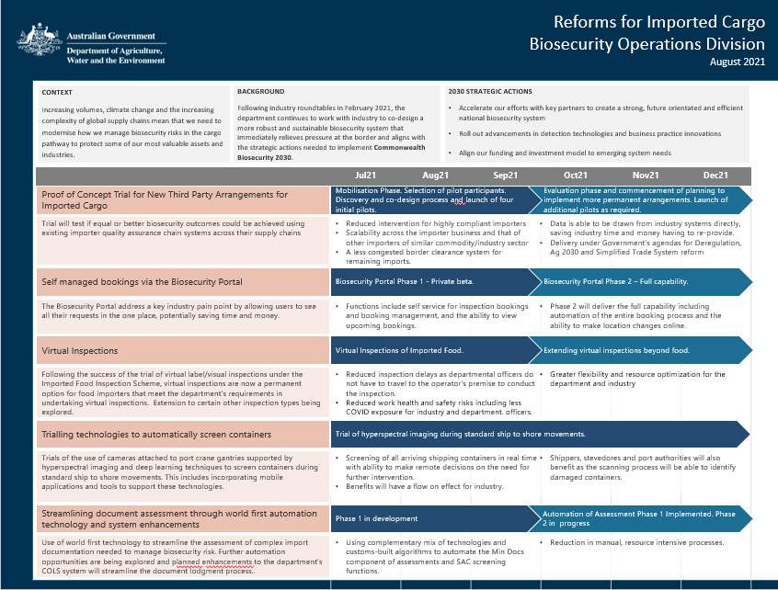

DCCC Meeting 89 – 9 August 2021

Agenda Item 4.2a

Brown Marmorated Stink Bug (BMSB) Response

PURPOSE
This is an information only paper for DCCC members to note the 2020-21 BMSB Season outcomes and the requirements for the upcoming 2021-22 BMSB Season.

KEY POINTS

2020-21 BMSB Season
This season saw a decrease in the number of live detections at Biosecurity entry points, indicating the biosecurity policy continues to be successful in minimising the risk posed by BMSB. Of concern is increasing detections in the post border environment from pathway supply chains not currently targeted (air cargo and mail) by the current seasonal measures.
Of the total live detections:
- 18 were made on targeted pathways (Sea Cargo),
- five from native range countries (native range countries e.g., China is not subject to BMSB measures),
- Nine on non-targeted pathways such as Air Cargo (five), Mail (three), and Unknown (one).
 |  | 19/20 Season  Until 4 June 20 | 20/21 Season  Until 2 June 21
Detection Point | Condition | Number of detections
Biosecurity Intervention Point | Alive | 25 | 17
 | Dead | 183 | 187
Post Biosecurity | Alive | 4 | 15
 | Dead | 14 | 13
Total Detections |  | 226 | 232

Highlights
- 12,552 containers were declared in SeaPest compared to 10,648 (15% increase from last season),
- 8,194 containers were automatically managed by the SeaPest system this season compared to 5,055 last season (40% increase),
- 50,971 (13% of total lodgements) consignments were referred for assessment by biosecurity compared to 46,875 (14%) last year,
- 25,642 AEPCOMM lodgements compared to 17,443 (31% increase) and an overall 13% increase against referrals,
- 73,149 consignments (53% of all consignment) were treated offshore and released via the Integrated Cargo System without the need for further biosecurity intervention. Less than 45% were treated offshore last season.

Vessels
- 320 voyages made by 171 roll-on roll-off (RoRo) vessels (compared to 276 voyages by 156 RoRo vessels last year),
- 244 voyages were made by vessels on the Vessel Seasonal Pest Scheme (VSPS) (compared to 64 last year),
- Six shipping lines qualified to participate in the VSPS this season,
- 198 Seasonal Pest Inspections were conducted compared to 260 last year,
- Live BMSB were detected by crew or biosecurity officers on arrival on five vessels compared to 10 last year,
- No vessels were directed to leave Australian waters compared to two last year.

Offshore Treatments
In conjunction with New Zealand Ministry for Primary Industries (NZ MPI), the department continued the Offshore BMSB Treatment Providers Scheme.
- A total of 235 treatment providers from 25 countries were registered and approved to perform authorised offshore BMSB treatments,
- 82,977 BMSB treatment certificates from offshore treatment providers were lodged with the department compared to 72,732 last season (13% increase),
- Six offshore treatment providers were suspended for non-compliance within the scheme.

Safeguarding
The department approved seven entities for Safeguarding Arrangements. Safeguarding provides an alternative clearance option for goods subject to BMSB measures. This scheme will continue for the 2021-22 season and the department encourages those companies who are able to meet criteria to safeguard their supply chains against hitchhiker pests to apply.

Issues identified during the 2020-21 season
- 54 consignments were exported during the season for being non-compliant with the BMSB measures – predominately break bulk (including open tops and flat racks) arriving untreated or exceeding the 120 hours post treatment window,
- We are aware of concerns raised regarding inspection times for consignments subject to BMSB verifications. The verification regime is an important control measure in identifying and managing biosecurity risks including ensuring that BMSB measures are adequately identifying BMSB risks.

2021-22 BMSB Season
The BMSB seasonal measures will again apply to goods shipped between 1 September 2021 and 30 April 2022 (inclusive) and to vessels that berth, load, or tranship from target risk countries within the same period.
The measures are the same as last season. Further details can be found at https://www.agriculture.gov.au/import/before/brown-marmorated-stink-bugs.
Poland has been added to the target risk country list, taking the total BMSB target risk countries to 38 (including Japan, for heightened vessel surveillance only).
Malta has been added to the emerging countries list and may be selected for random onshore inspections.
Department will conduct limited verification activity across air cargo consignments from Italy and USA for the period September to November. The details are still being worked out and further industry notices will be published once the process has been finalised.
Treatment providers on the Offshore Treatment Provider scheme must re-register for the new BMSB season. Registration is open for all prospective offshore treatment providers to register or re-register. Details of approved offshore treatment providers may be found at: https://www.agriculture.gov.au/import/before/brown-marmorated-stink-bugs/offshore-bmsb-treatment-providers-scheme/approved-list.

CLEARED BY
Barbara Cooper, Assistant Secretary, Pathway Policy – Cargo and Conveyances

DCCC Meeting 89 – 9 August 2021

Agenda Item 4.2b

Khapra Beetle Response

PURPOSE
This is an information only paper for DCCC members to note the status of the implementation of the urgent actions to address the risk of khapra beetle (Trogoderma granarium).

KEY POINTS
We are implementing urgent actions to address the risk of khapra beetle entering Australia. These actions are being implemented in phases and have resulted in changes to import conditions for plant products and sea containers. The actions are being supported by a $14.5 million investment to safeguard Australia against this significant pest.
In 2020, a ban on high-risk plant products (a host of khapra beetle) within unaccompanied personal effects and low value freight was implemented under Phase 1 of the urgent actions. Phase 2 was also implemented which banned high-risk plant products within accompanied baggage, via international travellers or mail articles.
In 2021, the first part of Phase 6A introducing requirements for sea containers was implemented on 12 April. This introduced mandatory offshore treatment for sea containers packed with high-risk plant products in a khapra beetle target risk country. On 12 July, we commenced the second part of Phase 6A. This extended mandatory offshore treatment to sea containers packed with all types of goods in a khapra beetle target risk country that will be unpacked in a rural grain growing area of Australia.
A diagram outlining the actions is at Attachment A.
Below is a quick summary since the implementation of Phase 6A:
- 710 consignments have been subject to measures to date
  - 114 processed through Automatic Entry Processing for Commodities (AEPCOMM)
- 97% of treatments have been conducted using methyl bromide
- 76% of entries processed by the department are compliant, and this continues to improve over time:
  - Common non-compliance includes:
    - Sea container not treated (for example, goods treated but not the container)
    - Sea container treated incorrectly (incorrect treatment rate or fumigation not performed under sheet)
    - Non-compliant documentation (treatment certificates missing information)
- 74% of treatment have been conducted by either Australian Fumigation Accreditation Scheme (AFAS) or Offshore Brown Marmorated Stink Bug (BMSB) Treatment Providers
  - 89% of treatments conducted by registered providers are compliant
  - 36% of treatment conducted by non-registered providers are compliant
To continue to improve compliance rates, where possible we have been directly contacting treatment providers to provide feedback on treatment practices. We are also continuing to refine instructional and guidance material and are holding virtual treatment provider information sessions (more information on these to be announced soon).
We continue to encourage importers to use registered treatment providers where possible, and further prompt importers to work with their supply chains to encourage non-registered providers to contact us at offshoretreatments@awe.gov.au
In September 2021 we will implement Phase 3 of the urgent actions which will target high-risk plant products. Mandatory offshore treatment and phytosanitary certification will be required for high-risk plant products exported from a khapra beetle target risk country. For high-risk plant products exported from all other countries, only phytosanitary certification will be required.
In late September we are also planning on implementing the next phase of the sea container urgent actions under Phase 6B. This will introduce measures to a broader range of containers (all high-risk containers). Note: gaining data on all high-risk containers is proving to be difficult. We have reached out to Shipping Australia to seek nominations for shipping lines to participate in a workshop during the week commencing 16 August 2021 to discuss ways to obtain container movement history required to support the implementation of the 6B measures.
For your interest, to support the implementation of the khapra beetle urgent actions, we have developed two short videos to communicate:
- the risks khapra beetle poses to Australia
- how to identify khapra beetle
- the importance of sea container cleanliness
- how to maintain sea container cleanliness.
We invite you to watch and share the content with your contacts. You can watch the videos via our urgent actions and sea container webpages.
Further information on the urgent actions is available on our website:
https://www.agriculture.gov.au/pests-diseases-weeds/plant/khapra-beetle/urgent-actions
Industry are advised to communicate the khapra beetle requirements with their contacts/stakeholders and encourage:
- Importers to use registered treatment providers where possible and
- Unregistered treatment providers to contact us at offshoretreatments@awe.gov.au.

CLEARED BY
Rama Karri, Director, Hitchhiker Working Group

ATTACHMENT/S
Khapra beetle urgent action phases (PDF)

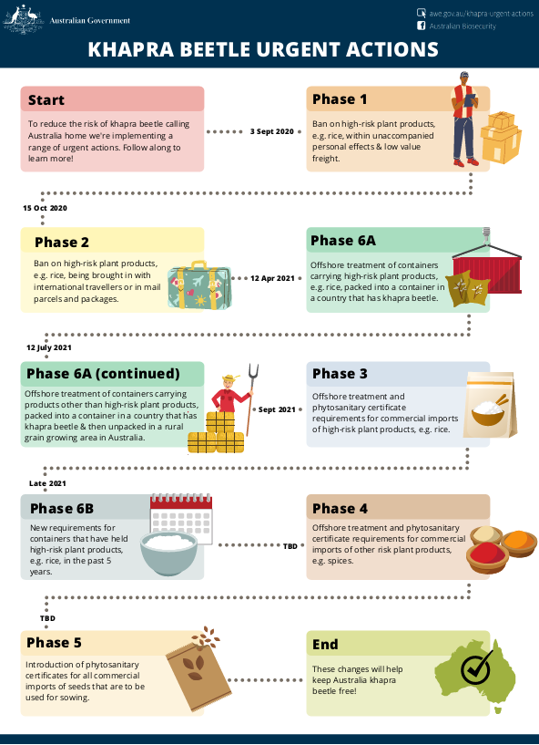

DCCC Meeting 89 – 9 August 2021

Agenda Item 4.2c
Recognised Offshore Cleaning and Pre-Inspection Scheme (Used Vehicles)

PURPOSE
This is an information only paper for DCCC members to note measures implemented by the department to manage risks offshore for used vehicles being exported from Japan.

KEY POINTS
A decision by an offshore cleaning provider in December 2020 to reduce the number of vehicles cleaned and pre-inspected through their facilities contributed to increased demand for bookings, assessments, and inspections for these goods on arrival.
Whilst the issues experienced by this provider are now resolved and volumes being cleaned and pre-inspected offshore are approaching pre-reduction levels, the department has implemented an alternative recognition process, which focuses on gaining assurance onshore, to facilitate the onboarding of new offshore cleaning providers. This has been instigated in part due to travel restrictions associated with COVID-19.
The model is reliant on desktop audits (phase one), virtual audits conducted via Microsoft Teams (phase two) and then onshore verification (phase three) to demonstrate an ability for a service provider to become, and remain, compliant.
Three companies, which manage a combined total of seven facilities, are currently undertaking onshore assessment, via inspections under phase three. If successful, this will increase the number of available offshore cleaning and pre-inspection facilities in Japan from 10 to 17.
The department is also considering how to align this offshore program with other departmental-led programs and policies relating to offshore treatment. This may reduce further intervention with used vehicles cleaned offshore into the future.
In addition to the above, the department is working with offshore cleaning facilities for the offshore management of used vehicles being imported from Japan.

CLEARED BY
Barbara Cooper, Assistant Secretary, Policy Pathways – Cargo and Conveyances

DCCC Meeting 89 – 9 August 2021

Agenda Item 4.2d

Gateway clearances for sea cargo

PURPOSE
This is an information only paper for DCCC members to note the proposed implementation for Gateway Clearances for sea cargo.

BACKGROUND
To date, the Australian Border Force (ABF) has required cleared sea cargo to be moved to the Port of Destination identified on the Sea Cargo Report before it can be released from customs control. Where the Port of Destination, e.g., Adelaide, is different to the Port of Discharge, e.g., Melbourne, logistics providers must transport even cleared cargo between these two ports under customs control.
Following industry representations regarding risks of congestion and supply chain issues at ports of discharge magnified by COVID-19, the ABF has implemented procedures to allow sea cargo to be released from the Port of Discharge, regardless of the cargo’s final delivery address. This is called ‘Gateway Clearance’.
The ABF will implement Gateway Clearance from 1 October 2021 by changing the definition of Port Code Destination and Destination Port Code in all cargo report, import declaration and self-assessed clearance declaration Approved Statements. This change will allow industry, in conjunction with importers, to identify the same port as the Port of Destination and Port of Discharge in the Integrated Cargo System (ICS), thus allowing goods to enter home consumption from that port. Further onward movements of the sea cargo to its final Australian destination can be done outside of customs control (i.e., without underbond movement).
It is important to note that amendments made to the Port of Destination field on the import declaration (N10, N30 and hard-copy forms) do not influence the port where the goods will be released or change ABF requirements to move goods under customs control to the Port of Destination.
Where a cargo reporter reports different ports as the Port of Discharge and Port of Destination, the consignment will be required to move, under customs control (underbond movement), to either a licensed premise or s.15 port in the Port of Destination.
Gateway Clearance is a deregulatory measure that also supports the integrity of cargo clearance:
- It will allow importers to avoid underbond movements from a Port of Discharge to a Port of Destination (where these are different).
- Reducing underbond movements for sea cargo is beneficial to both industry (for quicker release) and the Government (container security and reduced biosecurity risk).
Based on 2020 figures, the ABF expects the implementation of Gateway Clearance to see approximately 100,000 consignments no longer requiring underbond movements.
The department strongly supports the implementation of Gateway Clearances which will allow importers to have their goods inspected for biosecurity purposes at the discharge location and reduce instances of land-bridging.
The ICS user dictionary will soon be updated with the new information required for ‘Port of Destination’ in the applicable reports. Third party software providers are advised to update their definitions as soon as practicable.
The ABF will issue an Australian Customs Notice, and other public information resources, to explain how industry can access this trade facilitative reform closer to 1 October 2021.

CLEARED BY
Barbara Cooper, Assistant Secretary, Policy Pathways – Cargo and Conveyances

DCCC Meeting 89 – 9 August 2021

Agenda Item 4.3a

Non-Compliance Report

PURPOSE
This is an information only paper for DCCC members to note the non-compliance report for financial year 2020 to 2021.

KEY POINTS
The attached non-compliance report provides an overview on activities and assessments conducted by the department.

CLEARED BY
Assistant Secretary, Enforcement, Compliance and Enforcement

ATTACHMENTS
Non-Compliance Report Financial Year 2020 to 2021

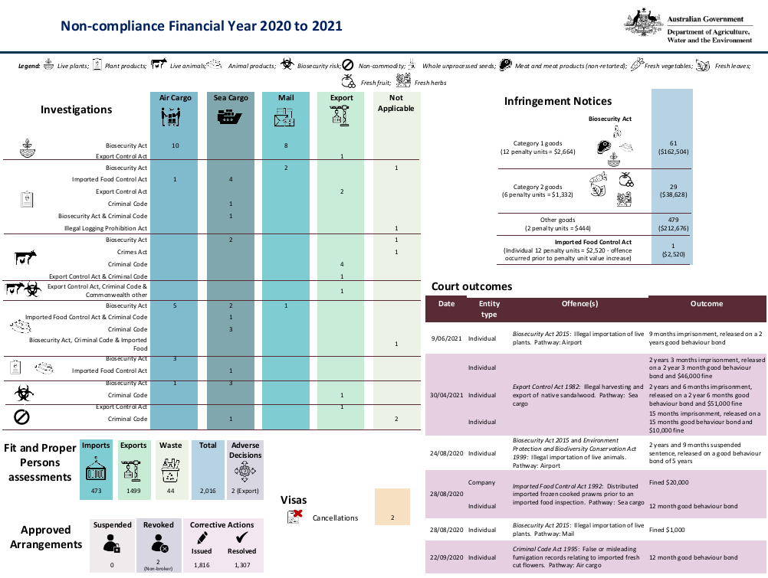

DCCC Meeting 89 – 9 August 2021

Agenda Item 4.3b

Legislative Amendments

PURPOSE
This is an information only paper for DCCC members to note legislative amendments.

KEY POINTS
The attached document provides an update on legislative amendments that have been made to civil and regulatory sanctions.

CLEARED BY
Assistant Secretary, Enforcement, Compliance and Enforcement

ATTACHMENTS
Legislative Amendments 2021: Civil and Regulatory Sanctions

