DCCC Meeting 90 – 25 November 2021

Agenda Item 2.2

National Biosecurity Strategy

PURPOSE
To seek views and suggested priorities from members of the Department of Agriculture, Water and the Environment’s Cargo Consultative Committee (DCCC) for inclusion in a national biosecurity strategy.

KEY POINTS

Australia’s first national biosecurity strategy is currently being developed, with an early draft expected to be released in early 2022.

It is intended the national biosecurity strategy will:
- provide a strategic direction for Australia’s national biosecurity system to 2030
- articulate a collective national vision, objectives and outcomes
- provide a means to drive coordinated reform and investment
- support nation-wide engagement on biosecurity
- include an implementation approach, focusing on co-design of actions and next steps with biosecurity partners
- be a vehicle to build on – and bring together – key strategic biosecurity documents, such as Commonwealth Biosecurity 2030, state and territory strategies, and industry strategies.

Initial consultation on the strategy design is underway, focusing on priorities and key themes. Further information is provided at Attachment A.

We would like to hear from DCCC members their priorities for a national biosecurity strategy. Submissions through Have Your Say as part of the initial consultation phase close on 26 November. The National Biosecurity Strategy Project Team is also happy to arrange bilateral discussions with member organisations.

Some early views we are hearing from stakeholders include:

Stakeholders recognise the importance of a national biosecurity strategy and want to be involved throughout its development.

The process to develop the strategy is as important as the final document.

They would like to see the strategy set out the areas we will be focusing on nationally to help guide our collective work together– and not just the work of governments - with all stakeholders able to see themselves in the strategy’s agenda.

There is a strong desire for a strategy that can be delivered upon – with tangible, achievable outcomes and supported by a proper implementation framework.

They would like more cohesion nationally and greater connectivity of elements within the system.

System investment and funding (across government and non-government) needs to be a part of the conversation.

BACKGROUND
- In June 2021 agriculture ministers agreed to develop a national biosecurity strategy.
  - The national biosecurity strategy was also a commitment in Commonwealth Biosecurity 2030.
- The National Biosecurity Committee (NBC) is leading this work.
  - The NBC provides advice to the Agriculture Senior Officials Committee on national biosecurity and is comprised of state, territory and Commonwealth government officials and peak body observers.

The NBC has formed a working group (chaired by the Commonwealth and consisting of state and territory representatives as well as Animal Health Australia and Plant Health Australia) to drive this work.

The working group, alongside a small departmental project team and PwC form an integrated delivery team for the strategy’s development.

The NBC has also established a stakeholder reference group to provide expert advice and input throughout the strategy’s development. The members of the reference group are:

Australian Banana Growers’ Council

CSIRO

Freight and Trade Alliance

Invasive Species Council

National Farmers’ Federation

Rural Research and Development Corporations representative - Australian Pork Limited

Seafood Industry Australia

Torres Strait Regional Authority.

CLEARED BY
Jo Laduzko, Assistant Secretary Biosecurity Response and Reform

ATTACHMENTS
Attachment A: National biosecurity strategy - initial consultation material

DCCC 90 – 25 November 2021
Agenda Item 2.3
Advice on non-compliant behaviours

PURPOSE
To seek views and suggestions from members of the Department of Agriculture, Water and the Environment’s Cargo Consultative Committee (DCCC) for a non-compliant behavior report for industry.

RECOMMENDATIONS
That DCCC members discuss and provide feedback on the desired content and structure of a non-compliant behaviours report.

KEY POINTS
Through the department’s ongoing discussions with industry, the department has been asked to provide examples of non-compliance in the documentation assessment and inspections space.
The department has commenced work on a report for industry to capture non-compliance behaviours.
Member views are sought on the preferred design and content of this report, including:
- the level of detail to ensure a meaningful product that is not onerous to produce, noting information would be de-identified for reasons of privacy and confidentiality.
- how the information could be used to inform and educate industry on the impacts of these behaviours
- actions industry groups could take to address non-compliant behaviour
- the frequency of the report (issuance on a quarterly basis should provide the necessary insight and trend analysis).
The information would be indicative and not a reflection of all non-compliant behaviours. As an example, instances of non-compliance that are subject to enforcement action would not be included.
Members are also asked to consider how industry can partner with the department to build good intelligence holdings and counter measures to address non-compliance.

Background
Non-compliance behaviour includes but is not limited to:
- downgrading of Community Protection (CP) questions in the Integrated Cargo System (ICS)
- misdeclaration of tariffs and goods or importer details to bypass rural tailgate, imported food or other inspections
- submission fraudulent and falsely modified documents.

- non-adherence to minimum documentary and import declaration requirements policy, and/or inspection, treatment and export/destroy directions.

Poor brokerage administration practices and errors can also result in diversion of resources from documentation assessment and inspection activity including processing of booking requests. Common scenarios include:

- submission of excess documentation resulting in departmental officers having to sift through endless pages of paperwork to find what is relevant
- lodgment of documents within two business days or less from the goods arriving at the discharge port, with pressure then being placed on departmental officers to clear goods, at times to the detriment of importers/brokers who lodge early
- calls to the department on the status of lodged documents, rather than using the COLS self-service status checker.

CLEARED BY
Leanne Herrick, Principal Director, Industry Partnerships and Engagement, with input from relevant business leads

DCCC Meeting 90 – November 2021

Agenda Item 4.1a

Work to deliver the nine strategic actions under Commonwealth Biosecurity 2030

PURPOSE
This is an information only paper for DCCC members to note the work to progress a public facing implementation plan that will report on progress of the work to deliver the nine strategic actions under the Commonwealth Biosecurity 2030 strategy.

KEY POINTS
The Commonwealth Biosecurity 2030 strategy was released in May 2021 and is the Australian Government’s roadmap to build a stronger, smarter biosecurity system through to 2030.
Our roadmap will help ensure our biosecurity system continues to protect us from current and future threats by focusing on better regulation and partnerships, smarter border clearance processes, improved use of technology, and ensuring our funding and investment model is sustainable in the long-term. Our goal for the biosecurity system will be realised by implementing nine strategic actions. These are:
- Accelerate our efforts with key partners to create a strong, future orientated and efficient national biosecurity system
- Expand offshore assurance arrangements and overseas supply chain integration
- Increase partnership activities with our near-neighbours to build their risk management capability and continue our engagement with key international bodies
- Invest in a skilled and responsive workforce supported by improved regulatory tools and information
- Roll out advancements in detection technologies and business practice innovations
- Generate greater shared responsibility through improved awareness and understanding
- Increase offshore intelligence, research and data sourcing to support risk-based interventions, preparedness and response
- Lift our national preparedness, response and resilience to exotic pest and disease incursions
- Align our funding and investment model to emerging system needs
The Department of Agriculture, Water and the Environment (department) is undertaking a significant amount of work and investing in a range of new initiatives and technologies designed to offer operational efficiencies whilst helping industry prepare for the biosecurity challenges that lay ahead.
In line with the department’s commitment to consult with key partners, we welcome DCCC member views or feedback ahead on the department’s first annual action plan. The action plan is currently being developed and will include a snapshot of projects that will set the groundwork in achieving our goal of a risk-based biosecurity system to protect against current and future threats.

CLEARED BY
Leanne Herrick, Principal Director, Industry Partnerships and Engagement, following input from relevant business leads.

DCCC Meeting 90 – 25 November 2021

Agenda Item 4.1b

Cargo Operational Reforms and Innovation Initiatives

PURPOSE
This is an information only paper for DCCC members to note some of the cargo operational reform initiatives and broader innovation initiatives underway across the department.

KEY POINTS
The department has been exploring ways to improve assessment and inspection services at the border to ensure a less congested and costly biosecurity system.
Updates on key initiatives that relate to cargo operations are outlined below and in Attachment A
A number of innovation initiatives are also currently being undertaken by the department to assist it meet current and future challenges. Several programs have been established to achieve this goal and are outlined in Attachment B.

Cargo Operational Reforms

Proof of concept (POC) trial of new arrangements for imported cargo
As part of the Australian Government’s Deregulation Agenda, the department established a proof-of-concept trial to test if equal or better biosecurity outcomes could be achieved by using existing importer assurance systems to manage biosecurity risk across their supply chains.
A series of pilots are being conducted in collaboration with selected import businesses.
A targeted outreach program was also undertaken with companies not selected for a pilot and delivered additional insights into business import experiences. This also led to the program being extending to include 3 additional pilots to cover other industry sectors/supply chains.
The trial is expected to run until May 2022. Further information on this trial will be provided at Agenda item 2.4.

Biosecurity Portal
Phase 1 functionality will enable importers or their agents to schedule and manage inspection bookings without needing to speak to a booking officer. It will also address a key industry pain point by allowing users to see all their requests in the one place, potentially saving them time and money.
Phase 2 will automate the booking processes providing quicker turnaround of booking requests and introduce additional self-service functionality reducing wait times and effort.

Virtual inspections
Following the success of the trial of virtual label/visual inspections under the Imported Food Inspection Scheme, virtual inspections are now a permanent option for low-risk surveillance foods.
We are currently exploring how best to extend this to certain other types of inspections and the use of different streaming devices. In some cases, this may be an interim step pending authorisation of industry personnel to undertake low-risk inspection activity on behalf of the department.

Verification trials for cameras to detect biosecurity risks
The department continues to work with two separate companies on two projects to automate screening of shipping containers.
The first is a system based on standard high-resolution, optical (RGB – red, green blue) cameras. During the proof-of-concept stage, the project determined minimum camera number, positioning and synchronisation to capture suitable images from the surfaces of the containers as they move from ship to shore. The project investigated suitable data transfer and storage and options for system integration between the scanning system and departmental and stevedore systems. It also developed a detection algorithm involving machine learning.
- The next phase of this project will investigate the accuracy and potential refinement of the algorithm and outstanding technical, operational and regulatory issues that would enable the new system to be implemented on a larger scale or nationally. Cameras, initially installed on a quay crane in the Port of Brisbane, will be extended to up to five cranes. All containers processed by these cranes will be scanned, and a sample of containers manually inspected. Images of identified pest specimens collected during the manual inspections will be used to further develop the algorithm and potentially assist in automatic identification of invertebrates to order, or family taxonomic rank.
The second project is to extend a biosecurity risk detection system based on hyperspectral cameras which, combined with a machine learning algorithm, is detecting and classifying soil, plant and animal material on a pixel-by-pixel basis with very high accuracy (>99%) to detect very small pests or seeds or parts thereof at short distance.
The extension is to create a handheld surveillance and inspection tool based on the camera and algorithm already developed. Such a tool could help officers detect small insects such as ants, termites or khapra beetle in places that are difficult to inspect and may also be suitable for the inspection of goods with difficult-to-see/dark areas (e.g., in machines and vehicles) or where pests may be present that are difficult to distinguish from the commodity (e.g., khapra larvae in brown rice or wheat, and mosquito eggs in tyres).
The ongoing project will trial the ability of the tool to distinguish between dead and live insect larvae, eggs and soft-skinned adults; to detect mosquito eggs and larvae in water; and to produce an RGB image to enable a biosecurity officer to visually assess/identify the organism detected by the device.

Streamlining document assessment through world first automation technology and system enhancements
The department has worked with a third party to develop technology and world firs algorithms to deliver an automation solution that will support biosecurity officers assess import documentation. This involves a combined suite of technologies and custom built algorithms able to handle the volume and complexity of documentation provided to the department for assessment purposes (noting we receive and manually assess over 6 million documents a year).
We are aiming to fully automate the Minimum Documentation (Min Docs) assessment component, which is a highly manual and resource intensive part of the import document assessment process. This will help us manage the increased volumes and will enable our staff to focus on the higher risk parts of the assessment process. The addition of ‘Bots’ or ‘Digital Workers’ will speed up the assessment process and reduce delays where documents are lodged in accordance with the Min Docs policy and import conditions. We expect to implement the automation into Min Docs toward the end of this calendar year.
We are also using the same type of automation solution to streamline the ICS screening process for biosecurity officers processing Self Assessed Clearances (SACs). We are aiming to automate some highly manual screening processes currently undertaken in the ICS by our biosecurity officers. This automation solution provides greater visibility of current and emerging biosecurity risks as well as time efficiencies in processing SACs.
The department is also undertaking enhancements to COLS that will provide the ability for better queue management that does not rely on manual processes. This change is required as a result of the significant increase in broker/importer lodgements being submitted in 12 hours or less of arrival. This has in effect made it impossible for our workforce to assess and turn around the high volumes of what is therefore classified as ‘urgent’ cargo within the service standards. The enhancements seek to enable the identification of legitimate urgent cargo, and subsequent prioritisation in the assessment queue.

Innovation Initiatives

Pre-screening of passenger baggage
This project is a multi-stream proof-of-concept that will use x-ray images and biosecurity algorithms to screen aircraft passengers’ bags prior to collection on arrival. Key outcomes are an improved passenger experience and a faster, more streamlined clearance process for passenger baggage.
- Onshore pre-screening - stream 1 of the project tests onshore operations by screening hold baggage after arrival but before the passenger collects their baggage. As bags are unloaded onto the baggage handling system, they will be scanned by the 3D x-ray unit. X-ray images will be sent to a control room where a biosecurity officer will assess the contents for biosecurity risk. Bag tracking technology will be applied to link individual bags to scanned images and to assign a biosecurity status to the bag.
- Offshore pre-screening (Trans-Tasman) - The department is working with New Zealand Aviation Security to test the offshore stream of the proof of concept. Outbound baggage from aviation security screening (2D) in New Zealand will be risk assessed on inbound passengers’ hold baggage whilst in flight. Auto detection algorithms will be applied to these images to assist in making a biosecurity decision. Bags containing risk items will be electronically tagged for further inspection.
In-principle agreement has been provided by two airports to partner in the delivery of this proof of concept with formal arrangements and project schedules to be finalised in the coming weeks.

Biosecurity Algorithms, Software and Networking
Discussions are underway with the department’s Cyber Engagement and Testing team to identify any potential cyber security issues with moving to cloud-based systems. A risk assessment process is currently underway. In addition, the Legal Division has been engaged to ensure permissions, privacy and regulatory aspects are considered to support the transfer of images.
Algorithm Development
- Rapiscan Systems: continuation of 3D x-ray biosecurity algorithm development (fruit, meat, seafood, plant/vegetable and wildlife) and 2D x-ray biosecurity algorithm development for meat detection. Melbourne University is undertaking independent analysis and validation.
- Smith’s Detection: develop proof of concept algorithm development for 2D meat detection.

Image Transfer and Access
- Rapiscan are in the process of acceptance testing and deploying ScanOS, their new cloud-based system which will enable remote screening, image transfer and the overlaying of detection algorithms.
- Smiths are proposing to use their existing cloud-based system iCMore for image transfer of Trans-Tasman baggage. Smith’s EDX-2 x-ray equipment is owned and operated by NZ AVSEC.

Seed Detection
This innovation project is exploring alternative technologies using low energy, high resolution x-rays and is currently moving into its final phase.
- Current high energy 2D or 3D x-ray technology deployed in mail centres is not effective in detecting smaller items such as seeds that have a less dense molecular structure. The x-ray beams are not able to fully penetrate the item resulting in no image being produced. Phase 1 of the project tested a prototype on a stand-alone unit as a proof of concept. This phase has been completed and was successful.
- Phase 2 was to prove the concept of auto-detection of seed packets and their contents using video cameras, low energy x-ray and computer algorithms on a moving conveyor system. The department and Rapiscan undertook validation testing to determine true and false positive/negative detection rates. Scanning of various granular powders was also conducted to evaluate the image quality and determine whether there is potential for the technology to be utilised by other government agencies. This phase was successfully completed, and the project has now moved to Phase 3.
- Phase 3 will involve a redesign of the unit, and research, design and development of a bespoke materials handling solution. Final design and implementation of solution will incorporate the unit into a live operational environment.

COVID-19 Detector Dog Feasibility Project
Since April 2020, the department has been working with Adelaide University and the ABF to monitor international research and progress of trials to test the feasibility of dogs to detect COVID-19. The project seeks to determine the viability of using detector dogs to identify COVID-19 infected persons through changes in their body odour. The dogs are not currently directly searching passengers, they instead search sweat samples presented on cotton swabs in a separate area away from passengers.
The department has committed an experienced Adelaide based detector dog handler to assist in the training and deployment of project dogs and contributed to controlled trials at the Brisbane National Training Centre. Operational trials at Sydney and Adelaide International airports provided inconclusive results due to a variety of factors primarily due to sample availability and the method to collect these.
Controlled trials focused on assessing the sensitivity and specificity of the dogs. Sensitivity relates to the capacity of the dogs to accurately discriminate against COVID-19 infected persons while specificity relates the capacity of dogs to accurately discriminate against non-infected persons. results of these controlled trials encouraging with most dogs proving comparable sensitivity to COVID-19 as polymerase chain reaction (PCR) testing.
Ongoing training and deployment of detector dogs requires ready access to suitable target material. Research is underway on multiple fronts investigating the ability to manufacture a suitable training aid to reduce the reliance on live samples from infected patients. Engagement with state and territory health agencies to identify further in field trial scenarios continues and a final report date is unlikely until these are explored and questions around training aid availability have been answered.

National eDNA Testing Program
The department has been researching innovative molecular environmental DNA (eDNA) and point-of-care molecular testing technologies for the last decade with the aim of operationalising scientifically robust, efficient technologies for environmental and biosecurity risk management and other compliance and control purposes.
The department is progressing key cross-sectoral projects to achieve its goal of national eDNA testing competency, capacity, and capability:
- National eDNA Test Validation Guidelines & eDNA Test Validation Reports
- National Environmental DNA Test Protocols & NETP Guide for Authors
- The department/NATA Memorandum of Understanding Schedule 5. Laboratory Accreditation for eDNA testing
- Establishment of a National eDNA Reference Centre & eDNA Collaboration Centre Network
- National eDNA Proficiency Testing Scheme
- Research: Biosecurity molecular screening using eDNA and Point-of-Care technology, & the department eDNA Research Planning Guidelines
- DNA Barcode Reference Library & Data Analytics
- Establishment of the department’s eDNA Expert Reference Group
- eDNA Implementation: Policy & Testing Options Guidelines
Since 2019, the department has funded the research and development via its Biosecurity Innovation Program of over thirty eDNA assays to detect target species of environmental and biosecurity concern. The outcome of this work has proven the potential of eDNA technology as a biosecurity screening tool for use in the field or laboratories as appropriate. The department has also provided funding for the Khapra beetle Surge Trial (two years) to understand the prevalence of khapra beetle in imported goods, and the Hitchhiker Action Plan (four years) for the research and development of eDNA assays targeting priority hitchhiker pests. An additional thirty tests for high-priority pests will be developed under the Hitchhiker Action Plan.
The National eDNA Testing Program will deliver the underpinning infrastructure, governance and policy framework, and implement eDNA testing at border and post-border locations across Australia and at critical pre-border control points. The nine projects currently funded by the Commonwealth are at various stages of progression. Establishment of the National eDNA Testing program is on-track for completion in the 2022-23 financial year.

CLEARED BY
Leanne Herrick, Principal Director, Industry Partnerships and Engagement, following input from relevant business leads.

ATTACHMENT
Attachment A – Cargo Operational Reforms
Attachment B – Innovation Initiatives

Attachment A – Cargo Operational Reforms
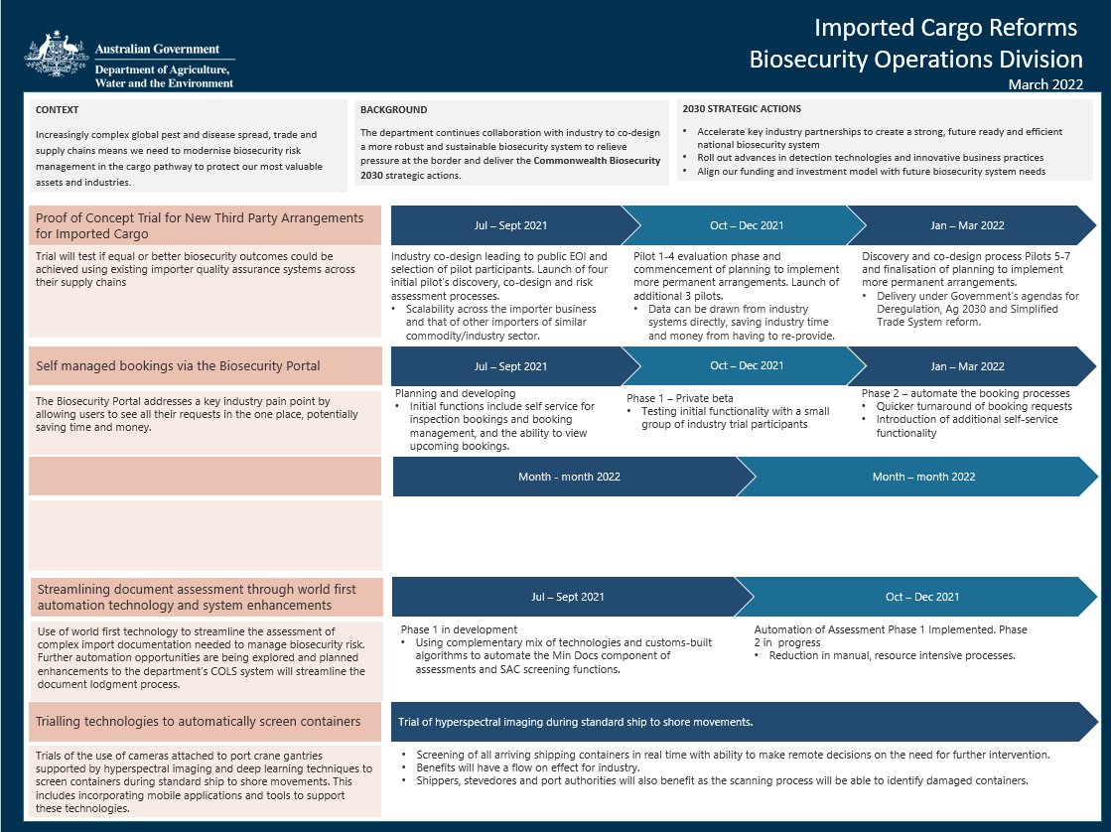

Attachment A – Cargo Operational Reforms cont.…
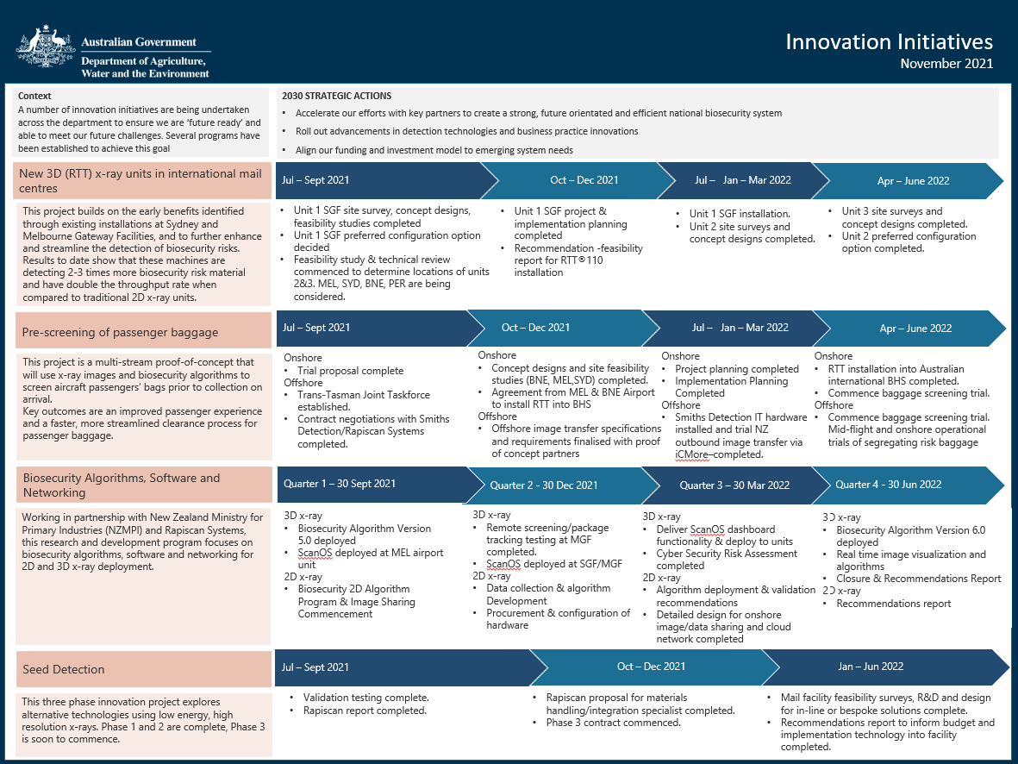

Attachment B – Innovation Initiatives
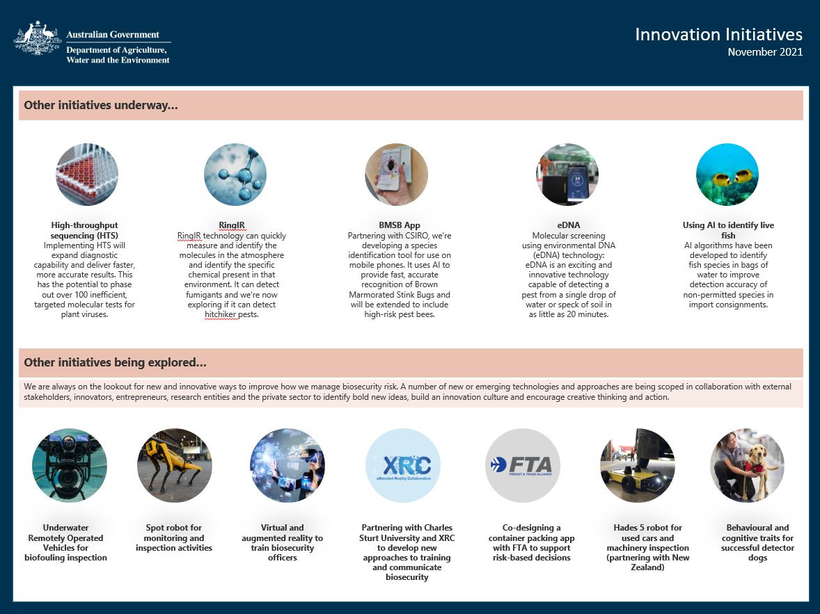

DCCC Meeting 90 – 25 November 2021

Agenda Item 4.1c

Simplified Trade System Reform

PURPOSE
This is an information only paper for DCCC members to note the progress of initiatives and activities relating to the Australian Government’s Simplified Trade System (STS) reform agenda.

KEY POINTS
The STS reform agenda seeks to simplify Australia’s international trade regulations and to reduce costs and administrative burden of cross-border trade.
The STS reform agenda:
- contributes to the Government’s Deregulation Agenda and Digital Technology Strategy
- complements existing reform and investment programs across Government, including the Commonwealth Biosecurity 2030 roadmap and Busting Congestion for Agricultural Exporters.
- will contribute to the delivery of a simplified, tell-us-once digital model for Government-business interaction on Australian import and export movements, and reduce unnecessary costs for business.
The department has been actively engaging with the STS Taskforce to progress deliverables and key initiatives under the reform agenda.

STS Taskforce deliverables

Mapping the end-user experience end-to-end trade journey process for imports and exports
These have been developed in consultation with industry including importers, exporters and third-party providers. Previous journey mapping conducted by the department was provided to the Taskforce to assist them in this activity.
Research interviews with businesses that import and/or export were conducted by the STS Taskforce in September-October. Representatives of both the department and the Australian Border Force were invited to attend as observers.
The department has been provided with the highlights of these research interviews for consideration and validation.
The Taskforce’s journey maps will also be shared with the department for input and validation early December 2021.
This work will be informed by the review of cross-border trade regulations to help identify pain points and opportunities to be considered under the STS agenda.
The department is also working to ensure its own reform initiatives align with the STS agenda.

Mapping of IT systems involved in cross-border trade
The STS Taskforce has prepared a draft ICT scoping study on the strength of the research insights. Early research of this study reveals there is significant opportunity to improve outcomes for both businesses and agencies. The department is providing input into this research which is still underway.

Review of cross-border trade regulations
The department is also considering a draft regulatory process map prepared by the STS Taskforce, based on public facing material and information provided by industry.
The department is providing input to this mapping, with the expectation this will be used by the STS Taskforce in their deliberations.

Proposed New Cargo Intervention Model
The department is working closely with the ABF to develop a streamlined cargo intervention model that will improve the screening of containerised air and sea cargo and increase the detection of non-compliant goods at the border. This work is also looking to remove duplication between the department and DAWE where possible.
Initial industry consultation on the model was undertaken by the ABF and the department in October 2021. Consultation is continuing and is being used to inform the future intervention model and development of a trial with industry.
This work will be used form a proposal for government to consider, and if supported, both departments will engage with industry in both the air and sea cargo environment.
This work complements existing initiatives and trials underway to test new screening and detection technology.

BACKGROUND
STS was announced by the Australian Government in the second half of 2020 as a significate micro economic reform package, seeking to modernise and streamline legislation and regulation for cross border trade; harmonise systems; ensure better harnessing of data; use of new, emerging and better technology; and enhancing our economic resilience.
A separate Taskforce was established operating under Austrade to deliver the reform agenda.
At the previous DCCC meeting in August 2021, the STS Taskforce provided an update on the overview of the taskforce’s objectives, and key deliverables for the next 12 months, including:
- Providing government with some options to deliver and design a tell-us-once digital service for exporters and importers.
- Undertaking a comprehensive review of all cross-border trade regulations to look at opportunities to streamline and simplify, drawing on work already done in this space, noting DAWE has done a number of reviews that can be leveraged.
- Mapping the end-to-end trade journey process for imports and exporters.
- Looking at mapping all the IT systems that are involved in cross-border trade.

CLEARED BY
Leanne Herrick, Principal Director, Industry Partnerships and Engagement

DCCC Meeting 90 – 25 November 2021

Agenda Item 4.2a

BMSB response

PURPOSE
This is an information only paper for DCCC members to note the status of the 2021-22 Brown marmorated stink bug (BMSB) Season.

KEY POINTS
BMSB detections are currently on par with last season. However, we have not seen the live detections in the air cargo pathway that we have seen in the past two BMSB seasons.
The live detection we have this season was in the mail pathway, on non-target risk goods from Hungary.
Detections of dead BMSB remain similar. We have had two detections in cargo and 16 in vessels. Early vessel detections appear to be from previous voyages as BMSB were long dead, however more recent detections were of recently dead BMSB.
 |  | 20/21 Season | 21/22 Season
 |  | Until 9 Nov 20 | Until 9 Nov 21
Detection Point | Condition | Number of detections
Biosecurity Intervention Point | Alive | 0 | 1
 | Dead | 16 | 18
Post Biosecurity | Alive | 2 | 0
 | Dead | 1 | 0
Total Detections |  | 19 | 19

Non-compliant consignments
- We have directed seven consignments for export due to arriving untreated or treated but exported greater than 120hrs post treatment. The breakdown is as follows:
- Four break bulk consignments (including flat rack and OT containers) have arrived untreated
- Two consignments shipped from Western United States of America missed 120hr post treatment export.
- One consignment shipped from Europe missed 120hr post treatment export requirement.
Safeguarding
- The department has approved 14 entities onto the Safeguarding Arrangement this season. That is double the number approved for the 2020-21 BMSB season.

CLEARED BY
Barbara Cooper, Assistant Secretary, Pathway Policy – Cargo and Conveyances

DCCC Meeting 90 – 25 November 2021

Agenda Item 4.2b

Khapra beetle response

PURPOSE
This is an information only paper for DCCC members to note the status of the implementation of the urgent actions to address the risk of khapra beetle (Trogoderma granarium) entering Australia.

KEY POINTS
We are implementing urgent actions to address the risk of khapra beetle entering Australia. The urgent actions are being implemented in phases and will result in changes to import conditions for plant products and sea containers. The urgent actions are being supported by a $14.5 million investment to safeguard Australia against this significant pest.
We have implemented:
- Phase 1 (September 2020): a ban on high-risk plant products (a host of khapra beetle) within unaccompanied personal effects and low value freight.
- Phase 2 (October 2020): a ban on high-risk plant products within accompanied baggage, via international travellers or mail articles.
- Phase 6A (April and July 2021): mandatory offshore treatment for sea containers packed with:
- high-risk plant products in a khapra beetle target risk country
- all types of goods in a khapra beetle target risk country that will be unpacked in a rural grain growing area of Australia.
- Phase 3 (September 2021): mandatory offshore treatment and phytosanitary certification for high-risk plant products exported from a khapra beetle target risk country and phytosanitary certification for high-risk plant products exported from all other countries.
As of October 2021:
- 2,201 consignments have been subject to Phase 6A measures
  - 179 processed through Automatic Entry Processing for Commodities (AEPCOMM).
- 97% of treatments have been conducted using methyl bromide.
- 83% of entries processed by the department are compliant (increase from 77% in reported to the DCC in August).
  - Common non-compliance continues to include:
    - Sea container not treated (for example, goods treated but not the container)
    - Sea container treated incorrectly (incorrect treatment rate or fumigation not performed under sheet).
  - Non-compliant documentation (treatment certificates missing information).
- 61% of treatments have been conducted by either Australian Fumigation Accreditation Scheme (AFAS) or Offshore Brown Marmorated Stink Bug (BMSB) Treatment Providers
  - 85% of treatments conducted by registered providers are compliant
  - 40% of treatments conducted by unregistered provider are compliant.
On 15 December 2021, additional measures under Phase 6A will commence. We are planning on extending the mandatory offshore treatment requirements to sea containers packed with all types of goods in a khapra beetle target risk country that will be unpacked in a rural nut growing area of Australia. The postcodes for rural nut growing areas of Australia are: 4569, 4517, 4518, 4858 and 4560. For split postcodes, measures will apply to the rural areas of the postcode only.
In early 2022, we are planning on implementing the next phase of the sea container urgent actions under Phase 6B, subject to access to the required data. This will introduce measures to a broader range of containers (all high-risk containers). The department will consult with the DCCC members on implementation options (including timeframes) prior to implementing 6B measures.
We are also planning on implementing Phase 4 and 5 of the urgent actions in early 2022. Phase 4 will introduce revised phytosanitary certification requirements for other-risk plant products exported from all countries and arriving via certain pathways. Phase 5 will introduce phytosanitary certification requirements for seeds for sowing exported from all countries and arriving via all arrival modes.
Further information on the urgent actions is available on our website:
https://www.awe.gov.au/biosecurity-trade/pests-diseases-weeds/plant/khapra-beetle/urgent-actions
We would appreciate your assistance communicating the khapra beetle requirements with your contacts/stakeholders and encouraging:
- importers to use registered treatment providers where possible
- unregistered treatment providers to contact us at offshoretreatments@awe.gov.au.

BACKGROUND
- Changing global demands, growing passenger and trade volumes, increasing imports from a growing number of countries, population expansion and climate change mean that biosecurity risk is growing.
- Australia has a robust biosecurity system that reduces the risks posed by exotic pests and diseases, as well as established procedures to manage interceptions when they do occur.
  - Biosecurity threats are effectively managed using a risk-based approach.
  - Biosecurity risks are managed offshore, at the border, and within Australia at the point where intervention is most effective.
- Khapra beetle is Australia’s number two National Priority Plant Pest (2019).
  - Khapra beetle is not present in Australia and poses a major threat to Australia’s grains, rice and nut industries as a serious storage pest and potential impacts on international trade.
  - If khapra beetle was to establish in Australia it would have significant economic consequences. An incursion could cost Australia $15.5 billion over 20 years through revenue losses arising from damaged grain in storage and exports.
- We are undertaking further analysis of global trade patterns to gain a better understanding as to why these interceptions are taking place.
- Australia has committed $96.9 million over 4 years (2021 to 2024) towards the Hitchhiker Pest Program which will build a stronger biosecurity system to protect Australia from hitchhiker pests in sea containers and goods. A key deliverable of this project amongst other things is enhanced data capture, modelling, and analytics to accurately profile and target imported sea containers and cargoes that pose a risk of hitchhikers including khapra beetle.
  - The Hitchhiker Pest Program will schedule a separate meeting with DCCC members to discuss progress of work under this program.

CLEARED BY
Sarah Bruce, Principal Director, Hitchhiker Working Group

ATTACHMENTS
Khapra beetle urgent actions phases (PDF)

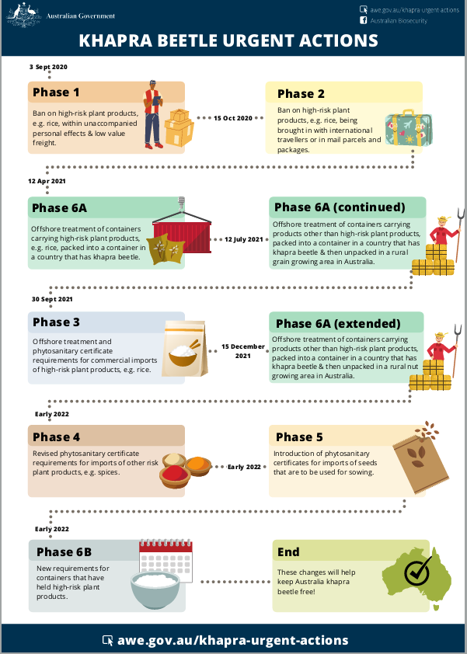

DCCC Meeting 90 – 25 November 2021

Agenda Item 4.3a

Compliance Activities Snapshot

PURPOSE
This is an information only paper for DCCC members to note the Compliance Activities Snapshot for Quarter 1 of the 2021-2022 financial year.

KEY POINTS
The Compliance Activities Snapshot (Attachment A) provides an overview of activities and assessments conducted by the department from 1 July 2021 to 30 September 2021.

CLEARED BY
Anna Brezzo, Assistant Secretary, Enforcement, Compliance and Enforcement

ATTACHMENTS
Compliance Activities Snapshot – First Quarter Statistics - Financial Year 2021 – 2022

Attachment - Compliance Activities Snapshot – First Quarter Statistics - Financial Year 2021 – 2022

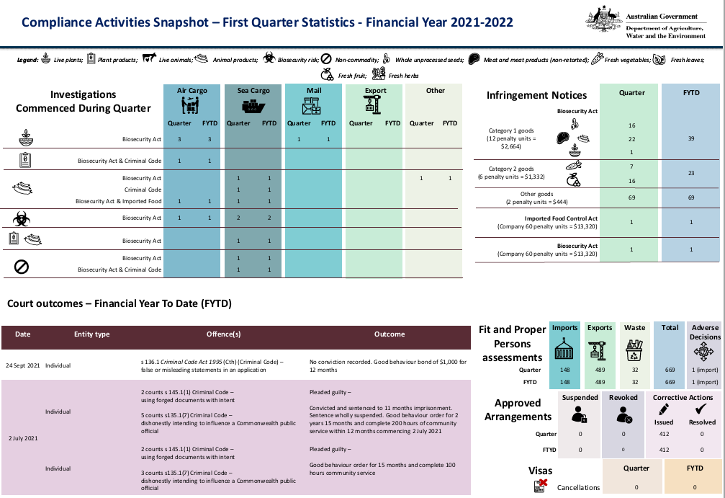

DCCC Meeting 90 – 25 November 2021

Agenda Item 4.3b

Legislative Amendments

PURPOSE
This is an information only paper for DCCC members to note legislative amendments.

KEY POINTS
The attached document provides an update on legislative amendments that have been made to civil and regulatory sanctions.

CLEARED BY
Anna Brezzo, Assistant Secretary, Enforcement, Compliance and Enforcement

ATTACHMENTS
Legislative Amendments 2021: Civil and Regulatory Sanctions

Attachment - Legislative Amendments 2021: Civil and Regulatory Sanctions
