

DCCC information paper suitable for sharing   
**DCCC Meeting 91 – 7 March 2022**

**Agenda Item 3.1**

**National Biosecurity Strategy**

**For DISCUSSION**

**PURPOSE**

To seek the views of DCCC members on the national biosecurity strategy consultation draft.

**KEY POINTS**

The national biosecurity strategy consultation draft (Attachment A) was released for public comment on 21

February 2022 through the national biosecurity strategy Have Your Say page, with comments closing on 18 March 2022.

While Australia has a strong and mature biosecurity system, biosecurity risks are continuing to rise in volume and complexity. To address these risks, we must continue to evolve our system and act on our opportunities for change. This requires effort across a diverse range of government and non-government stakeholders.

Whilst there are significant efforts already underway across the system, it is intended the national biosecurity strategy will provide a strategic direction for Australia’s national biosecurity system and provide a means to drive coordinated reform and investment, to address these growing risks and challenges.

The national biosecurity strategy will not replace or supplant existing strategies, but rather build on and complement existing strategies and work underway, including *Commonwealth Biosecurity 2030*.

***Consultation draft content***

The consultation draft was developed drawing on stakeholder feedback and insights from consultation conducted in late 2021. It includes:

* a proposed vision and purpose for the national biosecurity system
* an overview of the key biosecurity threats and opportunities facing Australia
* six priority areas with initial strategic actions
* an approach to implementation
* consultation questions to guide stakeholders in providing feedback.

The proposed priority areas and initial actions reflect feedback received through the initial consultation phase last year:

* **Shared biosecurity culture** - ensuring all Australians understand what biosecurity is and are empowered to act to support our system.

UNCLASSIFIED

Page 1 of 2

DCCC information paper suitable for sharing

* **Stronger partnerships** - strengthening and expanding partnerships with all stakeholders to leverage our different expertise, resources and knowledge and clearly articulate our roles to support better biosecurity outcomes.
* **Highly skilled workforce** - developing and sustaining the pipeline of biosecurity skills needed for the future, both within government, industry and community.
* **Coordinated preparedness and response** - enhancing our preparedness through improved coordination, regional planning, increased collaboration and faster information and data sharing to support system resilience and adaptability.
* **Sustainable investment** - developing long-term sustainable funding and investment approaches that support the system’s needs and are efficient, equitable, adaptable and transparent.
* **Integration supported by technology, research and data** – leveraging current and emerging technology, research and data to facilitate timely, informed and risk-based decision-making, while also continuing to deliver our research priorities.

The consultation draft is not the full and final strategy. For example, the consultation draft outlines only a high-level approach to implementation at this stage.

Stakeholder feedback on the consultation draft will inform the actions to include in the final strategy and how the strategy should be implemented and monitored. This includes how stakeholders should be involved in action plan development and implementation planning.

We would like to hear from DCCC members their views on the consultation draft. Submissions can be made through Have Your Say until 18 March. The National Biosecurity Strategy Project Team ([nationalbiosecuritystrategy@awe.gov.au](mailto:nationalbiosecuritystrategy@awe.gov.au)) is also happy to arrange bilateral discussions with member organisations.

**BACKGROUND**

* In June 2021 agriculture ministers agreed to develop a national biosecurity strategy.
* The national biosecurity strategy was also a commitment in *Commonwealth Biosecurity 2030*.
* The National Biosecurity Committee (NBC) is leading this work.
* The NBC provides advice to the Agriculture Senior Officials Committee on national biosecurity and is comprised of state, territory and Commonwealth government officials and peak body observers.
* The NBC has also established a stakeholder reference group to provide expert advice and input throughout the strategy’s development.

**CLEARED BY**

J*o Laduzko, Assistant Secretary, Biosecurity Response and Reform, Biosecurity Strategy and Reform Division*

**ATTACHMENT**

A: National biosecurity strategy consultation draft

UNCLASSIFIED

Page 2 of 2

**CONSULTATION DRAFT**



February 2022

NATIONAL BIOSECURITY

STRATEGY

Connected

Resilient

Shared

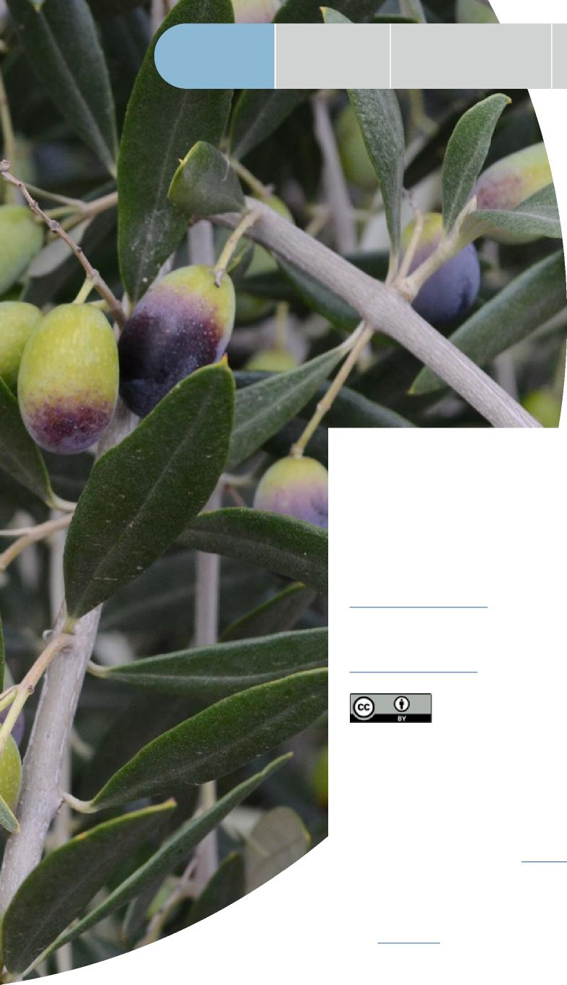

|  |  |  |
| --- | --- | --- |
| Why Australia | How our biosecurity | Changing biosecurity |
| needs biosecurity | system works | environment |

Executive Summary

Purpose

© Commonwealth of Australia 2022

**Ownership of intellectual property rights**

Unless otherwise noted, copyright (and any other intellectual property rights) in this publication is owned by the Commonwealth of Australia (referred to as the Commonwealth).

**Creative Commons licence**

All material in this publication is licensed under a [Creative Commons Attribution](https://creativecommons.org/licenses/by/4.0/legalcode)  [4.0 International Licence](https://creativecommons.org/licenses/by/4.0/legalcode) except content supplied by third parties, logos and the Commonwealth Coat of Arms.

Inquiries about the licence and any use of this document should be emailed to [copyright@awe.gov.au](mailto:copyright%40awe.gov.au?subject=)

**Cataloguing data**

This publication (and any material sourced from it) should be attributed as: *National Biosecurity Strategy – Consultation draft*, Department of Agriculture, Water and the Environment, Canberra, February. CC BY 4.0

ISBN 978-1-76003-529-7

This publication is available at [haveyoursay.awe.gov.au/national-biosecurity-strategy](http://haveyoursay.awe.gov.au/national-biosecurity-strategy%20)

Department of Agriculture, Water and the Environment

GPO Box 858 Canberra ACT 2601

Telephone 1800 900 090

Web [awe.gov.au](http://awe.gov.au)

**Disclaimer**

The Australian Government acting through the Department of Agriculture, Water and the Environment has exercised due care and skill in preparing and compiling the information and data in this publication. Notwithstanding, the Department of Agriculture, Water and the Environment, its employees and advisers disclaim all liability, including liability for negligence and for any loss, damage, injury, expense or cost incurred by any person as a result of accessing, using or relying on any of the information or data in this publication to the maximum extent permitted by law.

**Acknowledgement of Country**

We acknowledge the Traditional Custodians of Australia and their continuing connection to land and sea, waters, environment and community. We pay our respects to the Traditional Custodians of the lands we live and work on, their culture, and their Elders past and present.

2 CONSULTATION DRAFT

|  |  |  |
| --- | --- | --- |
| Our opportunities for | It’s time to evolve how | Driving |
| meaningful change | we work together | collaborative action |



Appendix

|  |  |
| --- | --- |
|  | Purpose of the  consultation draft  Help to set the direction of our biosecurity system with your feedback on the consultation draft of the National Biosecurity Strategy. |

We’ve been working with biosecurity stakeholders to develop this consultation draft of the National Biosecurity Strategy.

It captures the views we’ve heard so far from industry, environmental groups, researchers, the community and government stakeholders about how our biosecurity system needs to evolve.

We’re now seeking feedback on the consultation draft.

We want to hear from you on the future direction

of Australia’s biosecurity system, the ideas we’ve included in the consultation draft and how we should work together to implement the final strategy. We’ve included some questions at the end of this document to help guide your feedback.

Your input is vital to ensure that the national strategy reflects the role all Australians can and should play within our biosecurity system.

The final strategy will be presented to all Australian ministers responsible for biosecurity in 2022.

WHO ARE WE?

We are the National Biosecurity Committee (NBC) – senior biosecurity officials from all Australian governments. NBC provides advice to the Agriculture Senior Officials Committee (AGSOC) which supports ministers responsible for primary industries.

We’ve worked with stakeholders to develop this consultation draft, including Plant Health Australia and Animal Health Australia, and have been supported by a reference group of system stakeholders.

SHARE YOUR FEEDBACK

We invite you to participate in the development of the national strategy and share your feedback.

Visit National Biosecurity Strategy Have Your Say: <https://haveyoursay.awe.gov.au/national-biosecurity-strategy>

If you have any questions, please email [nationalbiosecuritystrategy@awe.gov.au](mailto:nationalbiosecuritystrategy%40awe.gov.au?subject=)

NATIONAL BIOSECURITY STRATEGY REFERENCE GROUP

Australian Banana Growers’ Council

CSIRO

Freight and Trade Alliance

Invasive Species Council

National Farmers’ Federation

Seafood Industry Australia

Torres Strait Regional Authority

Rural Research and Development Corporations representative – Australian Pork Limited

CONSULTATION DRAFT 3

|  |  |  |  |
| --- | --- | --- | --- |
| Executive | Why Australia | How our biosecurity | Changing biosecurity |
| Summary | needs biosecurity | system works | environment |



Purpose



Purpose of the National Biosecurity Strategy





**WHAT IS THE**

**NATIONAL BIOSECURITY**

**STRATEGY?**

The biosecurity risks facing us are becoming increasingly complex and harder to manage. In this challenging and changing environment, we need to continually evolve our system to ensure our biosecurity remains strong.

The National Biosecurity Strategy will guide this evolution.

Our national system is greater than the sum of its individual parts. It’s a multilayered, interconnected network of people, critical infrastructure and technology, partnerships, processes and regulatory activities that function cohesively overseas, at our border and within Australia to protect our national interests.

We will build from this solid foundation, uniting behind a collective vision and purpose in the national strategy to enhance the significant capability within our biosecurity system.

We all have a valuable role to play in supporting our biosecurity. The national strategy will help us to work more effectively together, by driving improved collaboration, innovation and awareness at local, regional, national and international levels.

It will outline the future biosecurity environment and detail the current challenges and barriers we face. To help us overcome these challenges, it will also set the approach for how we can best work together to develop and implement action plans and monitor our progress.

The national strategy’s scope will include consideration of exotic and established exotic pests, weeds, and diseases, but will not extend to endemic species or human biosecurity.

It will be informed by, and will build on, the considerable efforts already being undertaken by the Australian, state and territory governments, industry, Indigenous Australians, environmental groups and the community. The national strategy will be developed in consultation with these stakeholders, overseen by the NBC.

The national strategy will be a living document that will be reviewed every 5 years or sooner if there is a significant change to the risks, challenges or opportunities facing us.

4 CONSULTATION DRAFT

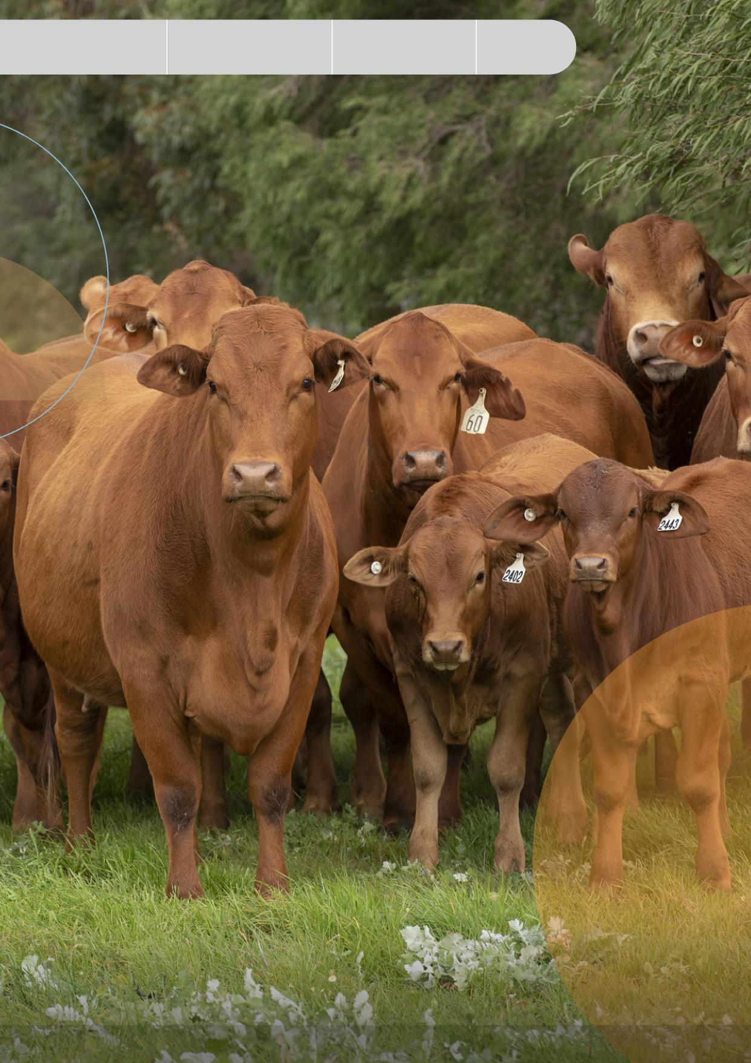

|  |  |  |
| --- | --- | --- |
| Our opportunities for | It’s time to evolve how | Driving |
| meaningful change | we work together | collaborative action |

Image: *© State of Western Australia (Department of Primary Industries and Regional Development, WA)*

Appendix

CONSULTATION DRAFT 5



Purpose

|  |  |  |  |
| --- | --- | --- | --- |
| Executive | Why Australia | How our biosecurity | Changing biosecurity |
| Summary | needs biosecurity | system works | environment |

**EXECUTIVE SUMMARY**

**EVOLVING AUSTRALIA’S**

**BIOSECURITY SYSTEM**

Our land, air, seas and waterways are deeply interwoven with our way of life – our people, environment and economy – which is why our biosecurity system is so valuable. It’s what protects us and the communities we live in from the harmful impacts of exotic and established exotic pests, weeds and diseases.

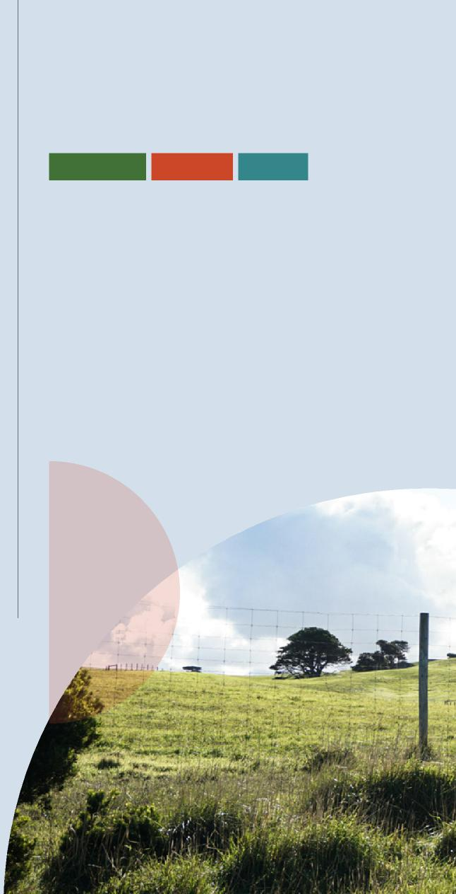

Shared

Resilient

Connected

**OUR VISION**

FOR AUSTRALIA’S FUTURE BIOSECURITY SYSTEM

A biosecurity system that protects Australia’s way of life.

**SHARED PURPOSE**

BRINGING US TOGETHER

A risk-based system underpinned by science that protects Australia’s people, our environment and economy from the biosecurity threats of today and tomorrow.

Even a single biosecurity outbreak can have potentially devastating, costly and far-reaching impacts for Australia.

While our biosecurity system has served us well, we face growing and more complex biosecurity risks driven by factors such as climate change, shifting and unpredictable trade and travel patterns and changes in land use. More than ever before, we are facing multiple risks, on multiple fronts, at the same time.

To ensure we continue to meet the challenges of today and tomorrow, we must act now and evolve how we work together.

6 CONSULTATION DRAFT



|  |  |  |
| --- | --- | --- |
| Our opportunities for | It’s time to evolve how | Driving |
| meaningful change | we work together | collaborative action |

Appendix

**6 PRIORITY AREAS**

TO EVOLVE OUR SYSTEM

To achieve our vision and purpose, we will act in 6 priority   
areas. Our 6 priority areas have guided the development of   
initial actions and will help us to focus our effort in the areas   
with the biggest impact.



Shared biosecurity culture

We will enhance our **culture of biosecurity action** so everyone understands its importance and plays their part.

Highly skilled   
workforce

We will develop and sustain a **highly skilled workforce** to ensure we have the right capability, in the right place, at the right time.

Sustainable   
investment

We will ensure **funding and investment** is sufficient, co-funded, transparent, and sustainable for the long term.



Stronger

partnerships

We will strengthen and expand **partnerships and networks** between all stakeholders at local, regional, national and international levels.

Coordinated   
preparedness   
and response

We will boost our system’s **adaptability and its capacity** to detect, prevent, manage, respond to and recover from outbreaks.

Integration supported by technology, research and data

We will create a more **connected, efficient and science-based** system to facilitate more timely, informed and risk-based decisions.

CONSULTATION DRAFT 7



|  |  |  |  |
| --- | --- | --- | --- |
| Executive | Why Australia | How our biosecurity | Changing biosecurity |
| Summary | needs biosecurity | system works | environment |

Purpose

**WE WILL**

**TAKE ACTION**

IN OUR 6 PRIORITY AREAS

Shared biosecurity culture

Build on and develop national education and awareness programs

Encourage positive biosecurity behaviours and incentivise compliance

Revitalise national communication and engagement mechanisms

Determine opportunities to embed biosecurity considerations into decision-making and risk planning.

Coordinated preparedness and response

Undertake and promote regular national preparedness exercises

Advance regionally based planning activities

Continually review and update risk information to inform priorities

Actively embed continuous learning

Strengthen traceability arrangements

Enhance our national surveillance arrangements

Evolve our national information management frameworks.

Stronger partnerships

Enhance partnerships and engagement with Indigenous Australians

Collaboratively review and refine roles and responsibilities

Review governance arrangements to ensure they include relevant stakeholders

Identify opportunities for industry and community involvement in peak decision-making bodies

Strengthen the involvement of environmental agencies

Deepen international partnerships

Work together to help shape global biosecurity standards, rules and conditions.

8 CONSULTATION DRAFT



|  |  |  |
| --- | --- | --- |
| Our opportunities for | It’s time to evolve how | Driving |
| meaningful change | we work together | collaborative action |

Highly skilled workforce

Identify current and future skills needs in key areas

Develop a workforce strategy to build, retain and deploy capability

Build on and expand existing cooperative arrangements

Strengthen professional development programs.

Integration supported by technology, research and data

Continue to invest in and rollout transformative technologies to digitise and automate processes

Increase stakeholder coordination to prioritise, drive and deliver national research outcomes

Actively share data and research widely

Enhance the accessibility and use of surveillance and interception data

Further support innovations to build science and research capacity.

**OUR WAY FORWARD**

DRIVING COLLABORATIVE ACTION

Following finalisation of the national strategy, we will continue to work together to drive its implementation by developing action plans, monitoring our progress and adapting where needed to continually improve our system. The NBC will oversee the national strategy’s implementation, working collaboratively with all stakeholders.

Through public consultation, we are keen to hear your views on the actions included in the consultation draft, any additional actions we should take, as well as your feedback on how implementation planning should occur.

CONSULTATION DRAFT 9

More than 30 actions across our 6 priority areas have been proposed in this consultation draft. These initial actions will be built upon and refined through public consultation to ensure they capture the collective efforts needed to implement our national strategy.

As we all share in the success of our biosecurity system, we all must play an important role in ensuring it remains strong and continues to protect our national interests.

Appendix

Sustainable investment

Work together to identify funding needs and determine priorities

Strengthen frameworks to agree and deliver priority investments

Advance co-funding and investment strategies with stakeholders

Increase the transparency of biosecurity funding

Complete a system performance and evaluation framework.



Purpose

|  |  |  |  |
| --- | --- | --- | --- |
| Executive | Why Australia | How our biosecurity | Changing biosecurity |
| Summary | needs biosecurity | system works | environment |

**WHAT IS**

**BIOSECURITY** THE REACH AND IMPACT OF

OUR BIOSECURITY SYSTEM

Australia is free from many harmful pests, weeds and diseases found elsewhere in the world. Our animal, plant, human and environmental health outcomes rely on strong biosecurity – that is, the controls and measures to manage the risk of

these pests, weeds and diseases entering, emerging, establishing or spreading within Australia.

**SCALE OF BIOSECURITY ACTIVITY ACROSS AUSTRALIA**

**115m**

mail items received (letter articles, packages and parcels) on average each year over five years

(2016-17 to 2020-21)

**2.6m**

shipping containers arrived in Australia (2020-21)

**OVER**

**15,200**

inspections were conducted on international vessels (2020-21)

**ALMOST**

**4,500**

post border detections were recorded (2020-21)

10 CONSULTATION DRAFT

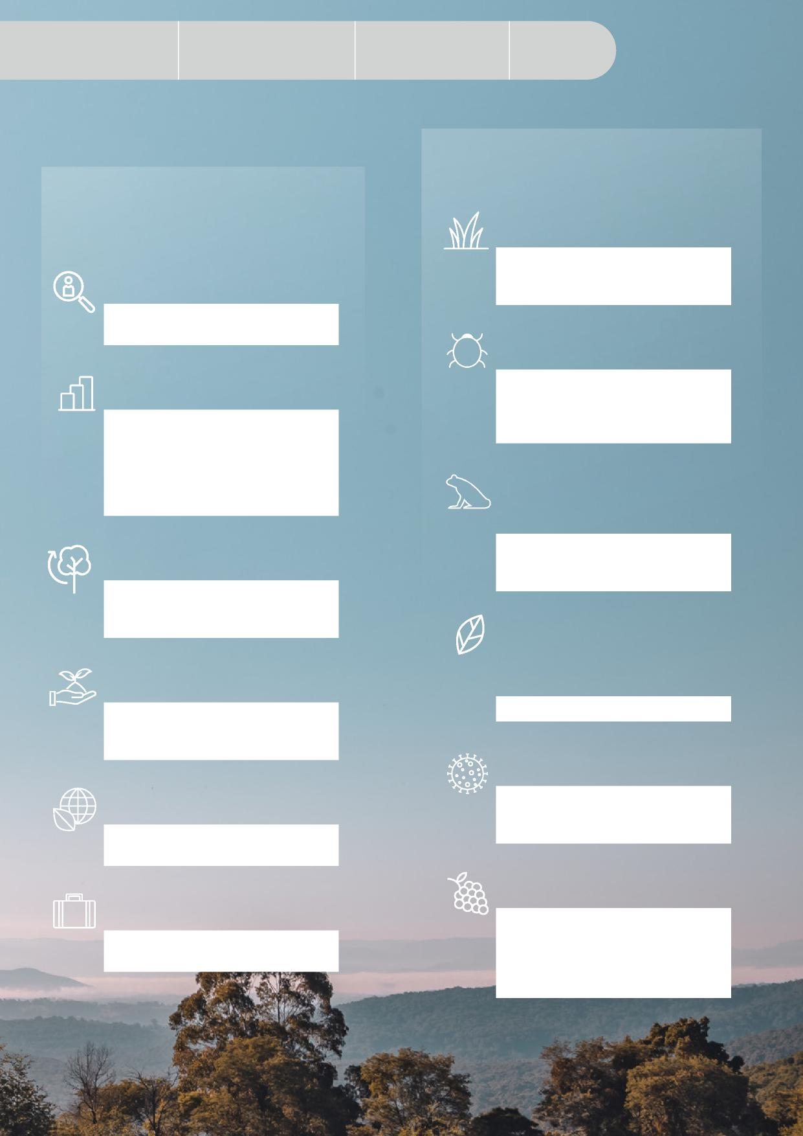

Appendix

|  |  |  |
| --- | --- | --- |
| Our opportunities for | It’s time to evolve how | Driving |
| meaningful change | we work together | collaborative action |

**SAFEGUARDING AUSTRALIA’S INDUSTRIES, ENVIRONMENT, LIVELIHOODS AND WAY OF LIFE**

**ACTUAL AND POTENTIAL IMPACTS OF OUTBREAKS AND INCURSIONS**

**$5b**

**1.6m**

annual cost to Australia for weed control measures and lost production (2018 estimate)

jobs across the agricultural supply chain

**$1.3b**

**$251.5b**

potential cost to our producers and consumers of pollination-dependent crops over 30 years in the event of a varroa mite incursion (2012 estimate)

total flow of benefits arising from assets vulnerable to biosecurity hazards, including infrastructure, agriculture, forestry and seafood industries and companion animals (2021 estimate)

**500**

**FROG SPECIES**

**$5.7t**

in population decline in part due to the devastating wildlife disease chytridiomycosis

in environmental assets over 50 years in present value terms (2020 estimate)

**MORE THAN**

**380**

**NATIVE SPECIES**

**$73.5b**

in gross value of agricultural, forestry and seafood production (2020-21 estimate)

at risk of being infected by myrtle rust

**$49.3-$51.8b**

**$52.3b**

over 10 years in present value terms in the event of a foot and mouth disease outbreak (2013 estimate)

in agricultural, forestry and seafood exports (2020-21 estimate)

**$50.4b**

**$7.8-11.1b**

direct tourism contribution to Australia’s GDP (2019-20 estimate)

potential cost to Australian

horticultural industries over 50 years in present value terms if a worst-case *Xylella fastidiosa* incursion occurred (2021 estimate)

CONSULTATION DRAFT 11



|  |  |  |
| --- | --- | --- |
| Why Australia | How our biosecurity | Changing biosecurity |
| needs biosecurity | system works | environment |

Executive Summary

Purpose

Why Australia needs biosecurity



We all enjoy the benefits of biosecurity. It’s what protects our unique natural environment, enables us to generate high-quality primary produce, provides access to key export markets and supports our trusted international reputation with our trading partners.

Image: *Getty Images/iStockphoto*

As the risk landscape rapidly changes, our natural and productive ecosystems are becoming increasingly vulnerable to biosecurity risks. These

risks can devastate our native plants and animals, impact our agricultural, seafood and forestry industries and compromise our clean air, water and land.

Even though our biosecurity system has served us well, we face the challenge of managing a range of growing and changing threats. We can’t reduce our biosecurity risk to zero and even a single outbreak has the potential to affect our prosperity, environment, national security, ability to trade and way of life.

12 CONSULTATION DRAFT

**Biosecurity outbreaks can potentially lead to:**

– devastating impacts to agricultural and horticultural industries and their supply chains through lower yields or damage to crops, produce, livestock or fisheries, as well as increased costs in protection, response or ongoing management activities. These costs are often passed onto customers.

– damage to our unique natural environment and ecosystems, plants and animals.

– an inability for Australian primary producers to access export markets, as well as possible reputational damage to our premium, high-quality produce.

– detrimental impacts to areas of nationally significant land and sea Country that have important cultural and heritage value to Indigenous Australians and the wider community.

– delays in access to essential produce due to supply chain disruptions and the impact of biosecurity response activities on stock levels or distribution channels.

– negative impacts on our urban amenity, way of life and human health.

A strong, resilient and adaptable biosecurity system is critical to ensure we manage these increasingly complex risks.

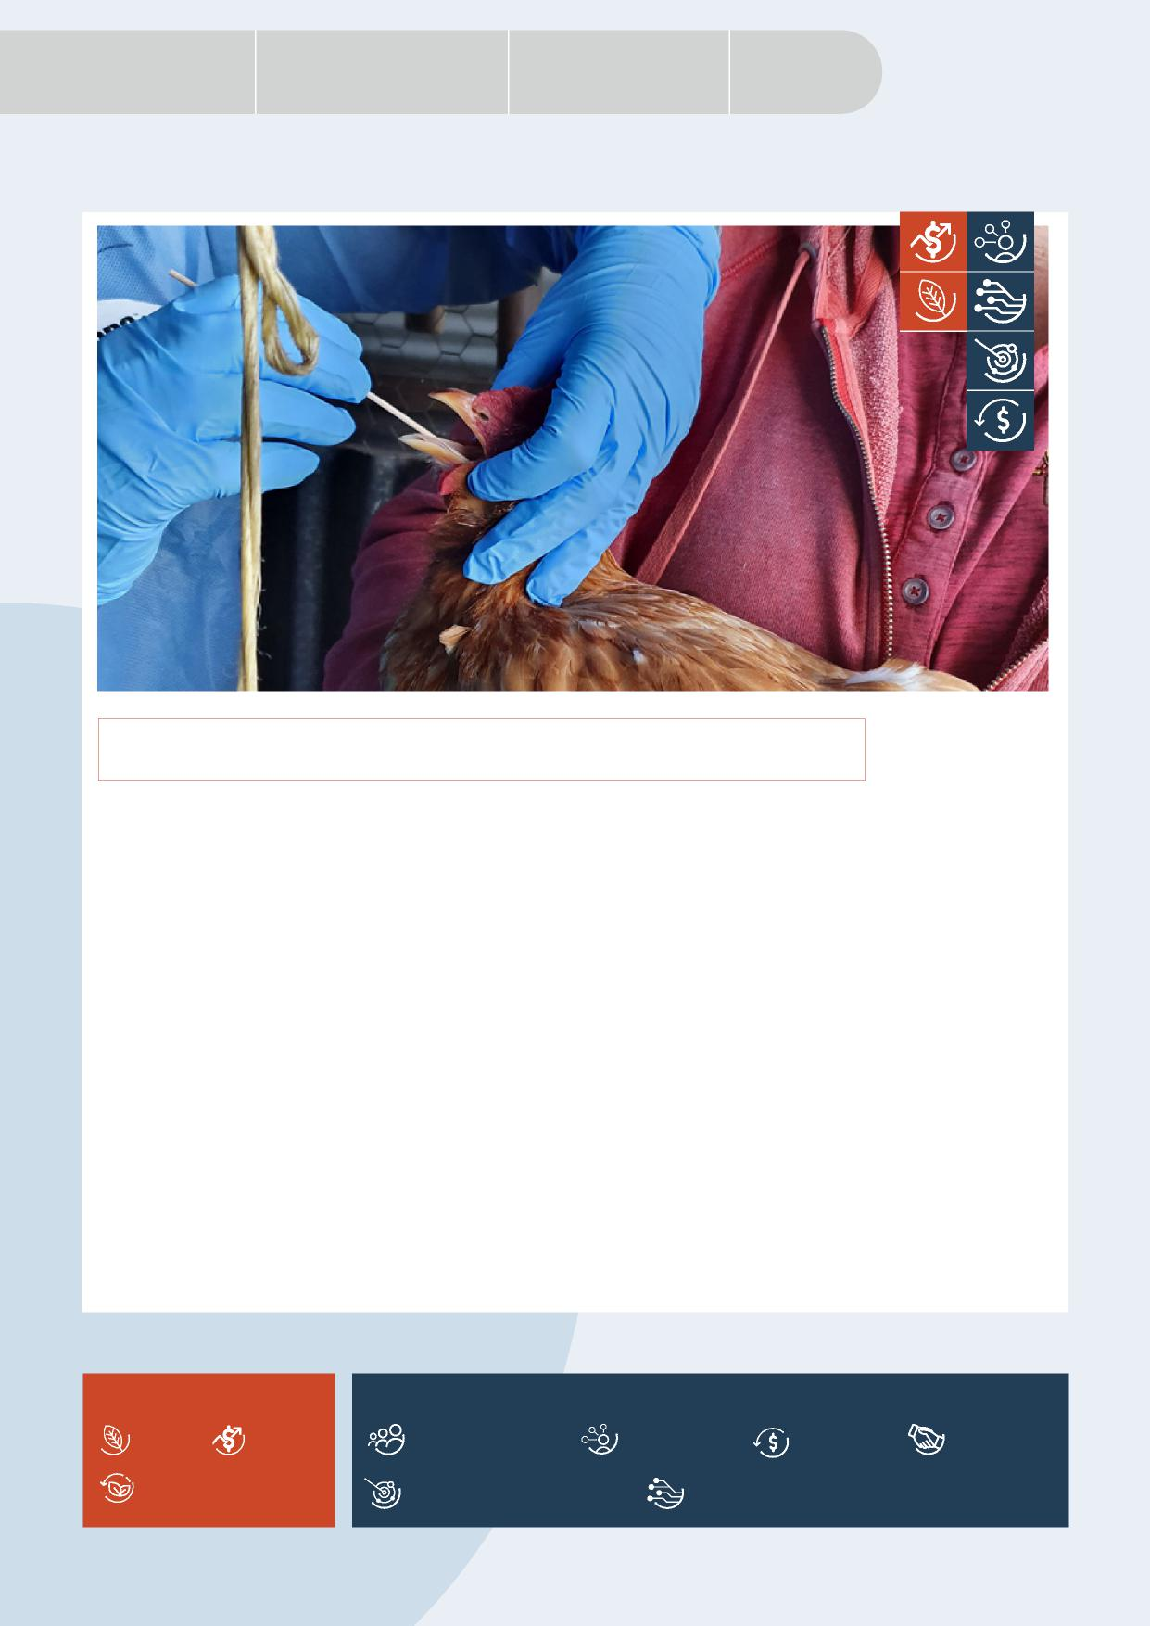

Appendix

|  |  |  |
| --- | --- | --- |
| Our opportunities for | It’s time to evolve how | Driving |
| meaningful change | we work together | collaborative action |

**HIGHLY PATHOGENIC AVIAN INFLUENZA**

Highly pathogenic avian influenza (AI), also known as bird flu, is a highly contagious viral infection of birds, and can cause severe symptoms and sudden death in poultry. It is generally introduced by infected migratory birds and can be particularly disruptive to chicken, duck, emu and turkey farms, requiring the culling of infected flocks.

A single outbreak of AI could have significant economic impacts and restrict market access for Australian poultry products. Some forms of AI can also have human health impacts, causing influenza in exposed humans.

The Australian, state and territory governments, together with the egg and poultry meat industries, have rapid and effective emergency response plans in place to manage potential outbreaks.

These arrangements were tested in 2020 during the height of Victoria’s COVID-19 related lockdowns when an outbreak of AI occurred on six farms. It triggered one of Australia’s largest biosecurity emergency responses and demonstrated the critical importance of our people, technology and preparedness arrangements.

The eradication work ran for 9 months with over 340 people involved and included almost 1,400 surveillance visits, as well as significant diagnostic and laboratory testing, at an estimated total cost of $22 million. This cost was a fraction of the potential losses facing industry if the outbreak had spread further.

Highly pathogenic AI was successfully eradicated from all affected farms in February 2021 and Australia formally regained its AI (notifiable) free status.

**KEY** – IMPACTS

**KEY** – PRIORITIES

Amenity Economy

Sustainable investment

Highly skilled workforce

Shared biosecurity culture

Stronger partnerships

Environment

Integration supported by technology, research and data

Coordinated preparedness and response

CONSULTATION DRAFT 13

|  |  |  |  |
| --- | --- | --- | --- |
| Executive | Why Australia | How our biosecurity | Changing biosecurity |
| Summary | needs biosecurity | system works | environment |



Purpose



How our biosecurity system works

Australia’s biosecurity system is multilayered with activities undertaken overseas, at and within our borders. Our system relies heavily on all stakeholders, from governments, industry and research partners, agricultural and environmental groups, Indigenous communities and individuals.

**Without strong partnerships at all levels, we can’t have a strong biosecurity system.**

**OVERSEAS**

The Australian Government and importers work with overseas counterparts   
to identify and mitigate biosecurity risks before they reach our border, while   
also undertaking capacity building activities, including in the Indo-Pacific region,   
to further our biosecurity, trade, security and national interests. Officials facilitate   
trade in line with our international obligations, apply import conditions and   
controls, and engage in risk and intelligence gathering, analysis and horizon   
scanning. Our overseas partners and industry provide vital intelligence on risks   
and traceability of products to support this work.

**AT OUR BORDER**

Robust surveillance and quarantine processes are in place to detect and intercept risks at our national border before they can do us harm. The Australian Government operates border controls, including screening, assessment, inspections and quarantine processes, to support this effort. Travellers have a role to play through their awareness of the importance of biosecurity and declaring goods if required. Industry also helps to protect us by having systems in place to proactively manage risks, apply treatments where needed and participate in surveillance activities.

**WITHIN AUSTRALIA**

Industry partners, Natural Resource Management organisations, environmental groups, local governments and the wider community work at regional and local levels to plan for, detect and respond to outbreaks and manage and eradicate pests, weeds and diseases. The Australian, state and territory governments lead regulatory activities and support their biosecurity partners to manage or eradicate outbreaks. All system participants work together on the ground to reduce the impact and chance of further spread within and across borders. Research organisations work to enhance our understanding of biosecurity risks and examine new approaches to improve our system in areas like diagnostics, containment and treatments.

14 CONSULTATION DRAFT

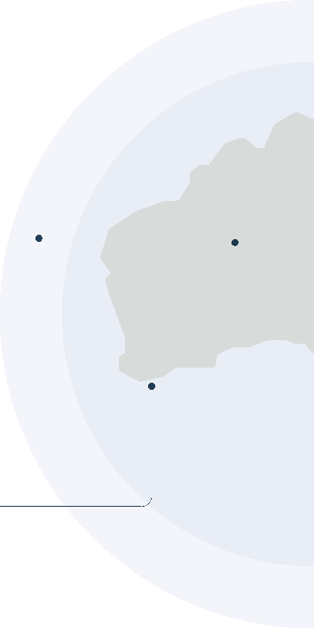



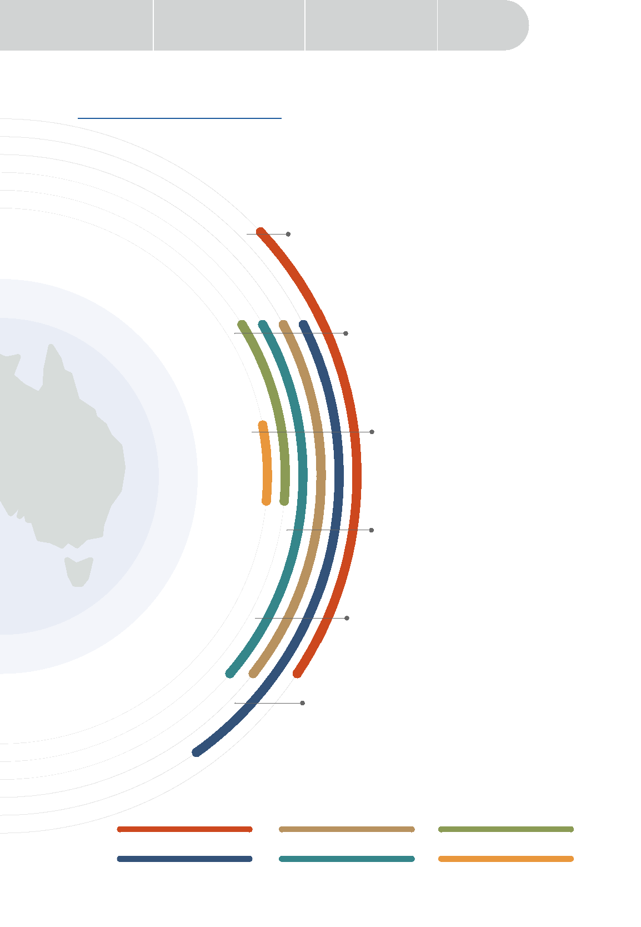

State, territory and local governments

Representative bodies

(e.g. industry, environmental, natural resource management and community groups)

|  |  |  |
| --- | --- | --- |
| Our opportunities for | It’s time to evolve how | Driving |
| meaningful change | we work together | collaborative action |

PRIMARY RESPONSIBILITIES

Industry

CONSULTATION DRAFT 15

AUSTRALIA’S BIOSECURITY SYSTEM

The [National Biosecurity Statement](https://www.awe.gov.au/sites/default/files/sitecollectiondocuments/biosecurity/national-biosecurity-statement.pdf) mapped the roles we play within the biosecurity system as illustrated below. The national strategy will build from this strong foundation. Through the consultation phase, we want to hear your feedback to ensure that everyone’s roles are clear and reflect the future needs of our system.

**Domestic regulatory functions**

Managing biosecurity within Australia’s border. Includes undertaking enforcement actions, regulatory interventions, emergency responses and negotiating and facilitating domestic trade.

**Federal regulatory functions**

Managing matters relating to the movement of people and goods at the national border. Regulating biosecurity controls to facilitate trade and market access, and fulfiling international convention obligations, including monitoring and reporting pest and disease status and protecting biodiversity.

**Leadership and coordination**

Providing leadership and coordination to proactively manage

biosecurity risk reduction and analysis. Includes developing partnerships with biosecurity participants and fostering biosecurity awareness.

**Research and capacity building**

Maintaining capacity to prepare for, detect and respond to pests, weeds and diseases, and the management of those already established. Includes support for research and

innovation to underpin Australia’s science-based

approach to biosecurity.

**Awareness and information**

Raising awareness and understanding of the biosecurity

system and everyone’s roles and responsibilities. Including publishing information about Australia’s biosecurity system and responsibility for emergency response communications.

**On the ground**

Performing tasks for everyday management of biosecurity risks. Includes surveillance, complying with biosecurity obligations and managing pests, weeds and diseases. Contributing to the protection of the Australian environment and economy through practical biosecurity measures.

Australian Government

Research organisations

Individuals, businesses and communities

Appendix

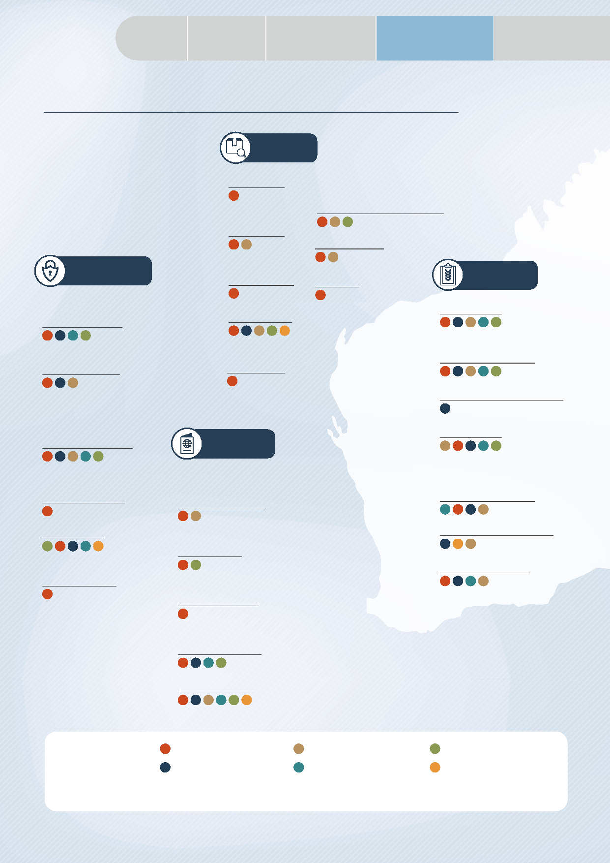

Purpose

|  |  |  |  |
| --- | --- | --- | --- |
| Executive | Why Australia | How our biosecurity | Changing biosecurity |
| Summary | needs biosecurity | system works | environment |

**OUR BIOSECURITY SYSTEM IN ACTION**

**Screen**

**Inspections**

**Storage / destruction**

Approved arrangements for storage / destruction of goods

**Post entry quarantine**

**Treatments**

**Anticipate**

**International mail screening**

**Screening**

**Prepare**

**Environmental scanning**

**Risk analysis**

**Diagnostics**

**Offshore surveillance**

**Contingency planning & training**

**Border assessments**

**Domestic border assessment**

**Collaboration / Programs**

with offshore industry and authorities

**Traceability**

**Prevent**

**Import risk analysis / review of import conditions**

**Response plans**

(e.g. Deeds, PlantPlan & AusVetPlan)

**Offshore treatments /verification and certification**

**Modelling**

**On-farm biosecurity plans**

**International arrangements**

**OIE notifiable disease lists**

**Simulation exercises**

**Import conditions / permits**

**Capability building in neighbours**

**Partnerships**

**PRIMARY**

**RESPONSIBILITIES**

Research organisations

Individuals, businesses and communities

Australian Government

State, territory and local governments

Industry

Representative bodies

(e.g. industry, environmental, natural resource management and community groups)

16 CONSULTATION DRAFT

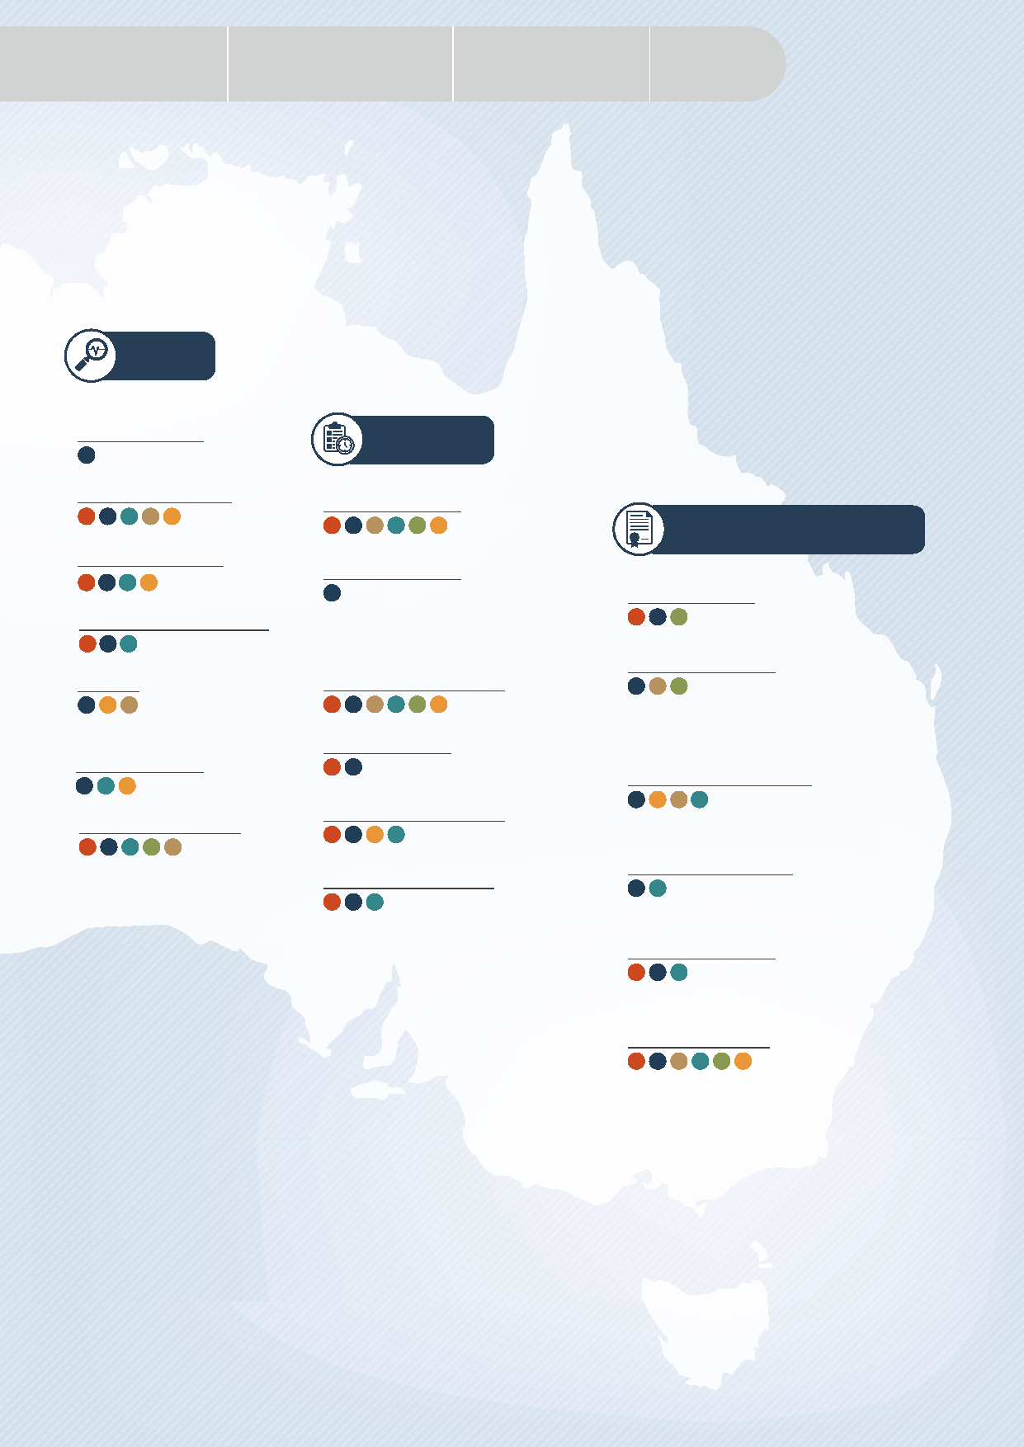

Appendix

|  |  |  |
| --- | --- | --- |
| Our opportunities for | It’s time to evolve how | Driving |
| meaningful change | we work together | collaborative action |

**Detect**

**Domestic border inspections**

**Respond**

**Onshore surveillance**

**Awareness raising**

**Recover and/or Adapt**

**Indigenous Rangers**

**Initial investigation**

**Proof of freedom**

**Sentinel herds / plantings**

**Domestic quarantine**

**Tracing**

**Emergency responses**

(e.g. property quarantines and protocols)

**Community weed identification**

**Pest risk analysis**

**Community / industry led programs**

(e.g. weed management)

**Diagnostics**

**Response plan activation**

**Community engagement**

**Certification schemes** for product movement

**Technical / financial recovery support**

**Business continuity planning**

Biosecurity activity categories sourced from Centre of Excellence for Biosecurity Risk Analysis (CEBRA), Year 1 Report: Valuing Australia’s Biosecurity System, Project 1607A – Milestone 6, 28 November 2017, University of Melbourne.

CONSULTATION DRAFT 17

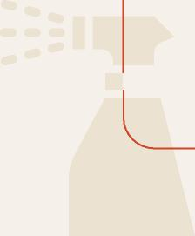

|  |  |  |  |
| --- | --- | --- | --- |
| Executive | Why Australia | How our biosecurity | Changing biosecurity |
| Summary | needs biosecurity | system works | environment |



Purpose

KHAPRA BEETLE

**BIOSECURITY OUTBREAKS CAN HAVE FAR-REACHING IMPACTS**

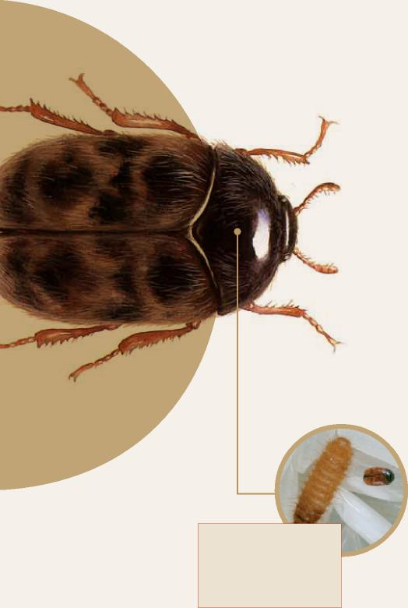

THE KHAPRA BEETLE IS SMALLER THAN A GRAIN OF RICE

KHAPRA BEETLE COULD COST AUSTRALIA

**$15.5B OVER 20 YEARS**

IF IT BECAME ESTABLISHED   
(2014 ESTIMATE)

**In 2020-21, responses to 20 interceptions**

**of the khapra beetle (*Trogoderma granarium*)**

**were managed across Australia.**

Changes in global trade patterns, such as increased volumes of goods, container movements and declining container hygiene are some of the drivers of recent increases in khapra beetle interceptions.

**AFFECTED CUSTOMERS HAD THEIR PURCHASES REPLACED, AND THE GOODS WERE FUMIGATED**

The incident affected around 300 retail customers across Australia who had their homes and cars inspected and treated with insecticides, with some of their food and pet food collected for destruction. This response prevented the pest from establishing in Australia which could have been severely damaging to our domestic grain producers.









18 CONSULTATION DRAFT





|  |  |  |
| --- | --- | --- |
| Our opportunities for | It’s time to evolve how | Driving |
| meaningful change | we work together | collaborative action |

Appendix





**KHAPRA BEETLE**



Smaller than a grain of rice, khapra beetle is a serious pest that can contaminate stored grains, rice, oilseeds and dried foodstuffs. It is not established in Australia. Khapra beetle can cause losses of up to 75% from direct feeding. Infested produce also becomes contaminated with beetles, cast skins and hairs from larvae, which can pose a health risk and are difficult to remove from storage structures and transport vessels.

If it were to establish itself here, many of our trading partners would refuse to buy our stored produce, particularly grains. Given Australia exports 65 to 75% of the grain we grow to more than 50 countries, this could cause significant economic losses.

Responding to a khapra beetle (or another exotic pest, weed or disease) outbreak can have wide ranging impacts across the supply chain.

AUSTRALIA EXPORTS

65-75%

OF THE GRAIN WE GROW

EXPORTING

TO MORE THAN

50

COUNTRIES



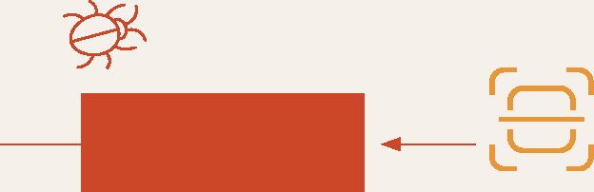

**IMMEDIATE ACTION WAS TAKEN ACROSS OUR BIOSECURITY SYSTEM**

**OCTOBER 2020**

**A DETECTION IN   
IMPORTED GOODS**

The retailer worked closely with the Australian Government to remove the goods that were in this consignment from sale across Australia. It secured those goods that had made their way through the supply chain – from the port to the warehouse, to the distributor, to retailers and to customers’ homes.



The Australian, state and territory governments began investigating and managing a detection of khapra beetle in a container of goods imported by a large retailer. This detection was initially reported by a member of the public who found khapra beetle in packaging material and notified biosecurity officials.



**FURTHER BIOSECURITY MEASURES WERE IMPLEMENTED**

Additional urgent measures were developed by the   
Australian Government in consultation with industry to   
better safeguard our agricultural sector and economy.   
This included stricter import conditions for high-risk   
goods and changes to container management. State   
and territory governments continue to undertake   
further monitoring and surveillance activities.

CONSULTATION DRAFT 19

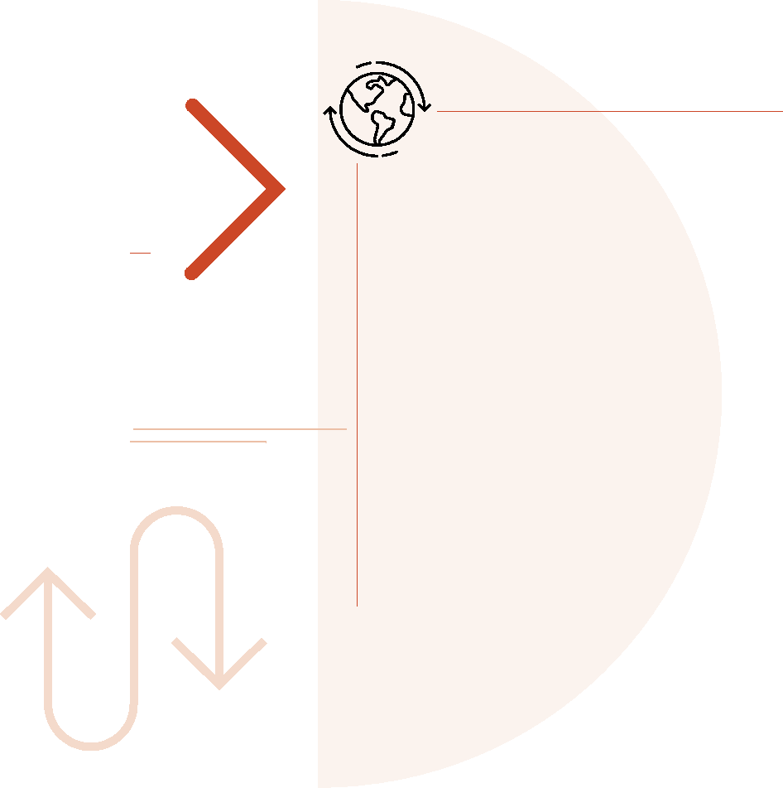

|  |  |  |  |
| --- | --- | --- | --- |
| Executive | Why Australia | How our biosecurity | Changing biosecurity |
| Summary | needs biosecurity | system works | environment |



Purpose

We are facing a

changing biosecurity environment

Managing biosecurity risks is becoming more complicated. We face a range of compounding risks on multiple fronts, including from our near north.



**CHANGING**

**> CLIMATE CHANGE**

**OR INCREASING**

**BIOSECURITY**

**RISKS**

is impacting the global environment. It is altering the habitat, range and distribution of many pests, weeds and diseases, as well as increasing their ability to spread and establish in new areas. These exotic species are also reducing the ability of our precious natural ecosystems to cope with changing climatic conditions.

For example, the buffalo fly, a harmful parasite that can irritate beef cattle, interrupt feeding and cause sores, is already present in Australia’s north and has been moving further south as the climate changes. It is predicted that it will establish itself in South Australia and Western Australia by 2030. As climate change increasingly affects global plant and animal habitats, it will also have flow-on impacts for biosecurity risks associated with changes in trade and travel patterns.

20 CONSULTATION DRAFT



|  |  |  |
| --- | --- | --- |
| Our opportunities for | It’s time to evolve how | Driving |
| meaningful change | we work together | collaborative action |



Appendix





**> DECREASING**



**BIODIVERSITY**

driven by invasive species, climate change and changing land uses weakens the resilience of our ecosystems to future outbreaks. It is estimated that 8 out of 10 land-based threatened species are at risk due to invasive species. This is a growing problem in Australia. For example, around 20 new weed species are unintentionally introduced or become unmanaged populations each year, displacing native plant life and changing entire ecosystems, while creating fuel for bushfires and choking our waterways.

Additionally, decreasing levels of crop genetic diversity in parts of the agricultural sector, such as in Australia’s banana industry, which is 95% Cavendish bananas, expose Australia to higher levels of risk in the event of a pest, weed or disease outbreak.

**> SHIFTING TRADE AND TRAVEL PATTERNS**

have seen Australia’s supply chains, trading partners and demand for goods continuously evolve and increase in complexity. This is changing the biosecurity risks reaching our international and domestic borders and impacting how we work with trading partners and each other.

Increased movement of people, equipment and goods increase biosecurity risks by providing more opportunities for pests, weeds and diseases to spread. Within Australia, interstate road freight is predicted to increase by 1.7% every year until 2030. Additionally, predicted increases in trade and vessel movements will result in a greater likelihood of the introduction of marine pests like tunicate didemnum (*Didemnum vexillum*) – sometimes known as ‘sea vomit’ – which poses a serious threat to our cultured shellfish industries and our ability to export seafood.

|  |  |  |
| --- | --- | --- |
|  |  |  |
| **> CHANGING LAND USES** | |

|  |  |
| --- | --- |
|  | are altering the interface between urban and non-urban areas and the environment. As our population grows and spreads, it brings people closer to wildlife, natural habitats and agricultural areas, potentially increasing biosecurity risks. Recent COVID-19 restrictions have accelerated this change in some areas, acting as a driver for Australians to relocate from our cities to regional centres in search of a different lifestyle.  As cities grow and peri-urban environments change, the risk of the introduction and spread of pests, weeds and diseases may increase. These changes to our urban and natural environment will also expose new people to biosecurity who may have limited awareness of its importance. |

CONSULTATION DRAFT 21

|  |  |  |  |
| --- | --- | --- | --- |
| Executive | Why Australia | How our biosecurity | Changing biosecurity |
| Summary | needs biosecurity | system works | environment |



Purpose





**>ILLEGAL ACTIVITY**

has increased in recent years, leading to a higher risk of biosecurity threats. The growth and increasing complexity of trade and online shopping – exacerbated by the COVID-19 pandemic – has inadvertently opened new pathways for illegal plants and animals to reach Australia, impacting biosecurity risks. The increasingly lucrative illegal trade in plants and animals was valued at US$7-23 billion per year globally in 2016.

Additionally, increasing illegal fishing practices heighten the risk of exotic marine animals invading Australian waters, with poorly maintained vessels often harbouring marine pests on their infrastructure above and below the waterline.

**> INCREASING**

**BIOSECURITY RISKS OVERSEAS**

including in our region, make us more   
susceptible to pests, weeds and diseases   
entering Australia. We have kept out many   
high-risk animal diseases such as rabies, lumpy   
skin disease and African swine fever. However,   
geographically some of these diseases are only   
5km from Australian shores. Climate change is   
altering the movement patterns of some species   
within the region, and increasing arrival risks   
through natural pathways like wind and tide.

Australia’s vast northern coastline is the   
frontline for many of these risks, with modern   
biosecurity infrastructure, trained people   
and strong surveillance activities critical   
to protecting our nation. Pests such as fall   
armyworm, citrus canker, fruit flies and rust   
species can be wind borne, making them harder   
to track and limiting risk management options.

|  |  |
| --- | --- |
|  | **>THE COVID-19 PANDEMIC** |

has disrupted supply chains and the movement of goods and people through travel restrictions. While these changes are temporary, they are likely to have created permanent changes in behaviour and supply chain pathways. For example, many Australians have moved to online shopping with businesses that are often based in other states or countries. Additionally, retailers have looked to change or diversify suppliers to improve the reliability and resilience of their supply chains. Higher trade volumes and new pathways have changed and increased the risk of threats reaching our shores.



22 CONSULTATION DRAFT



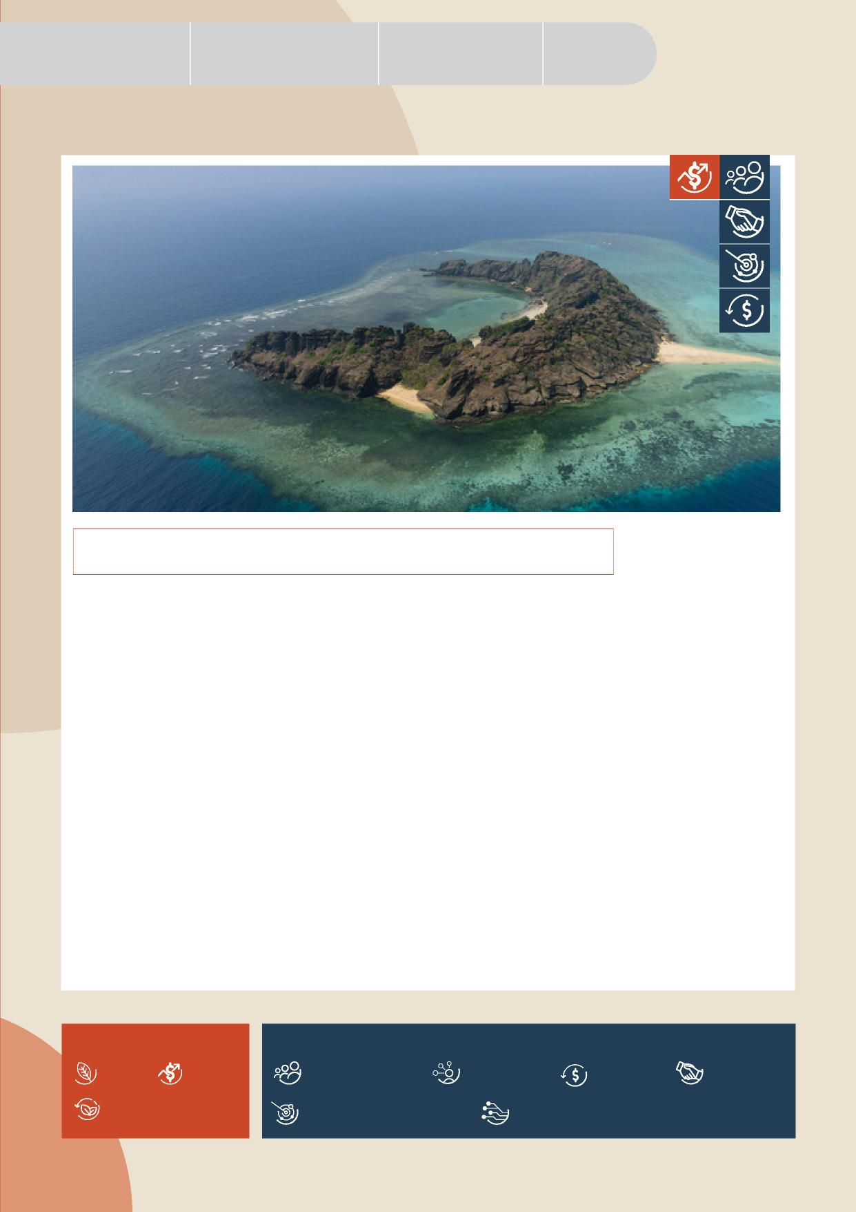

Appendix

|  |  |  |
| --- | --- | --- |
| Our opportunities for | It’s time to evolve how | Driving |
| meaningful change | we work together | collaborative action |

**BIOSECURITY IN THE TORRES STRAIT**

Pests like exotic fruit flies can enter Australia from our near neighbours, by wind or through human-mediated pathways, such as people or vessel movements. Exotic fruit flies and other wind-borne exotic pests could have devastating impacts on Australia’s $12 billion horticultural industries, with fruit flies recognised as the world’s most destructive fruit pests.

Targeted prevention and seasonal eradication activities focused in the Torres Strait are the first and best line of defence against these threats entering Australia.

Since 1996, an eradication program has been in place to manage seasonal fruit fly incursions in the Torres Strait, supported by strong relationships, collaboration and knowledge sharing between Indigenous communities and Traditional Owners, all levels of government, industry bodies and community groups.

The National Exotic Fruit Fly in Torres Strait Eradication Program was established in 2015 under the Emergency Plant Pest Response Deed to monitor and eradicate seasonal detections of exotic Oriental fruit fly (*Bactrocera dorsalis*), melon fly (*Zeugodacus cucurbitae*), and New Guinea fruit fly (*Bactrocera trivialis*), before they can establish in Australia. The program is led by the Queensland Government, with support from the Australian Government.

The program includes a range of activities, such as trapping, male annihilation (“blocking”) and bait spraying, some of which are supported by Indigenous Rangers from the Torres Strait Regional Authority (TSRA). The ongoing engagement of the TSRA enhances the success of the program and provides employment and training opportunities within remote Torres Strait communities.

**KEY** – IMPACTS

**KEY** – PRIORITIES

Amenity Economy

Sustainable investment

Highly skilled workforce

Shared biosecurity culture

Stronger partnerships

Environment

Integration supported by technology, research and data

Coordinated preparedness and response

CONSULTATION DRAFT 23

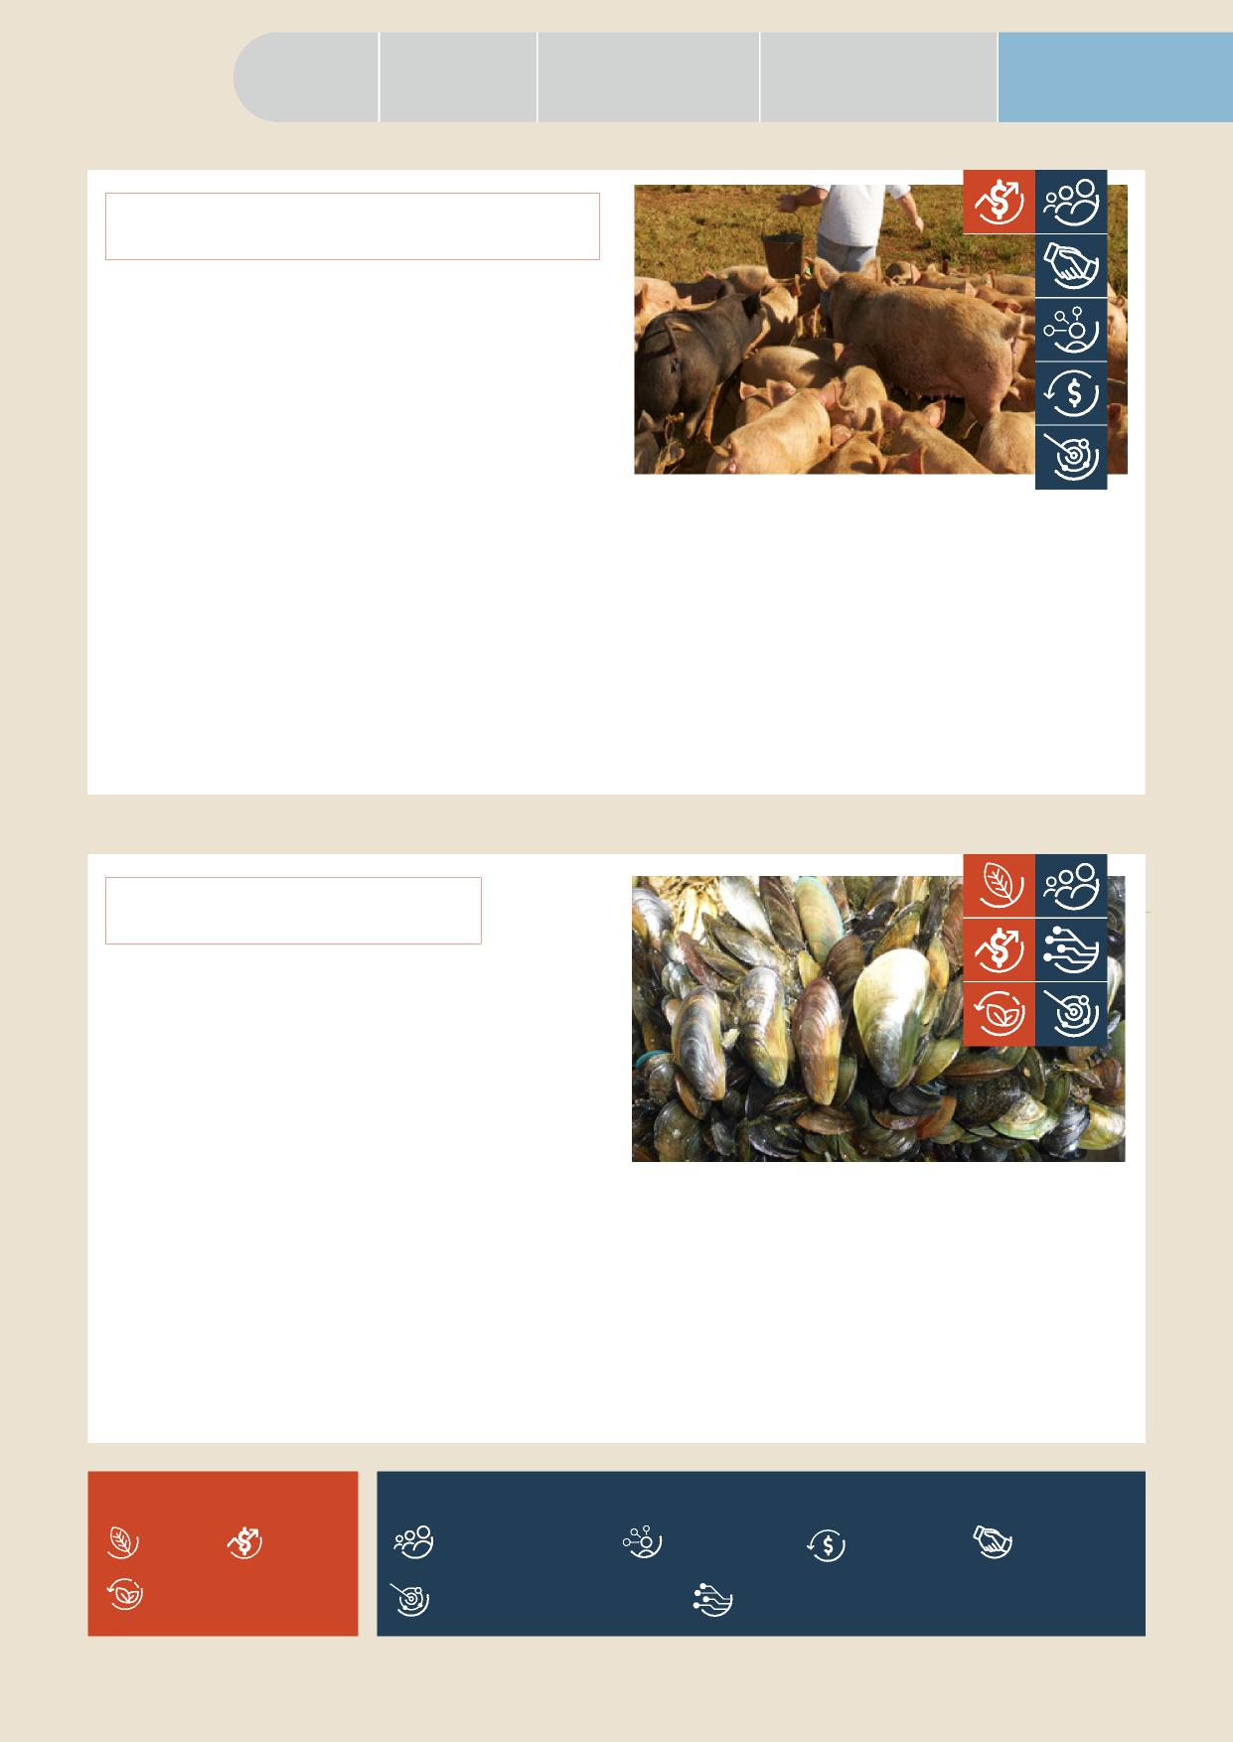

Purpose

|  |  |  |  |
| --- | --- | --- | --- |
| Executive | Why Australia | How our biosecurity | Changing biosecurity |
| Summary | needs biosecurity | system works | environment |

**AFRICAN SWINE FEVER**

African swine fever (ASF) is a contagious viral disease that infects domestic and wild pigs and is not present in Australia. The disease leads to death in approximately 80% of affected pigs and there is currently no vaccine. A multi-state incursion could cost the local pork industry, the majority of which is made up of small-scale family businesses, up to $2 billion over five years (2019 estimate) and would impact export market access for Australian pork products.

ASF is established in Asia and parts of Europe and continues to spread around the world. During 2019 and 2020, it was found in our northern neighbours Timor-Leste and Papua New Guinea and the disease continues to impact both countries today. The close proximity of ASF to our border represents a significant biosecurity risk for Australia. To support the efforts of our neighbours to manage and slow the spread of the disease, in early 2022 the Australian Government announced it would provide aid funding to Timor-Leste

and Papua New Guinea as part of an ASF biosecurity response package. This funding is designed to help our near neighbours to manage and respond to ASF outbreaks and strengthen the overall biosecurity capacity of our region.

Within Australia, dedicated funding to support surveillance and diagnostic activities is in place, which is complemented by the cooperative preparedness activities of governments, industry and producers to enhance on-farm biosecurity.

**CHARRU MUSSEL**

The charru mussel (*Mytella strigata*) is an exotic marine pest not present in Australia that is spread through international shipping and threatens Australia’s unique marine ecosystems and economy. The mussel forms dense clusters that outcompete native marine species, impact aquaculture production, damage infrastructure and foul vessels.

Native to the waters of South and Central America, the charru mussel has spread rapidly through North America and Asia. Like many marine pests, charru mussels can hitch a ride on boats and ships, either as biofouling or as larvae in a ship’s ballast water. Charru mussels have been detected on vessels heading to Australia but have been successfully eradicated.

A combination of national regulations and surveillance activities are used to keep this pest out of Australian waters. As a further line of defence to prevent the

introduction of this or other marine pests, surveillance programs are also run by Australian, state and territory governments around the country. Innovative tools like underwater drones and analysis of environmental DNA are used to support these activities. National education and engagement activities are employed to engage communities and users of Australia’s vast coastline and marine environments in biosecurity.

**KEY – IMPACTS**

**KEY – PRIORITIES**

Amenity Economy

Sustainable investment

Highly skilled workforce

Shared biosecurity culture

Stronger partnerships

Environment

Integration supported by technology, research and data

Coordinated preparedness and response

24 CONSULTATION DRAFT

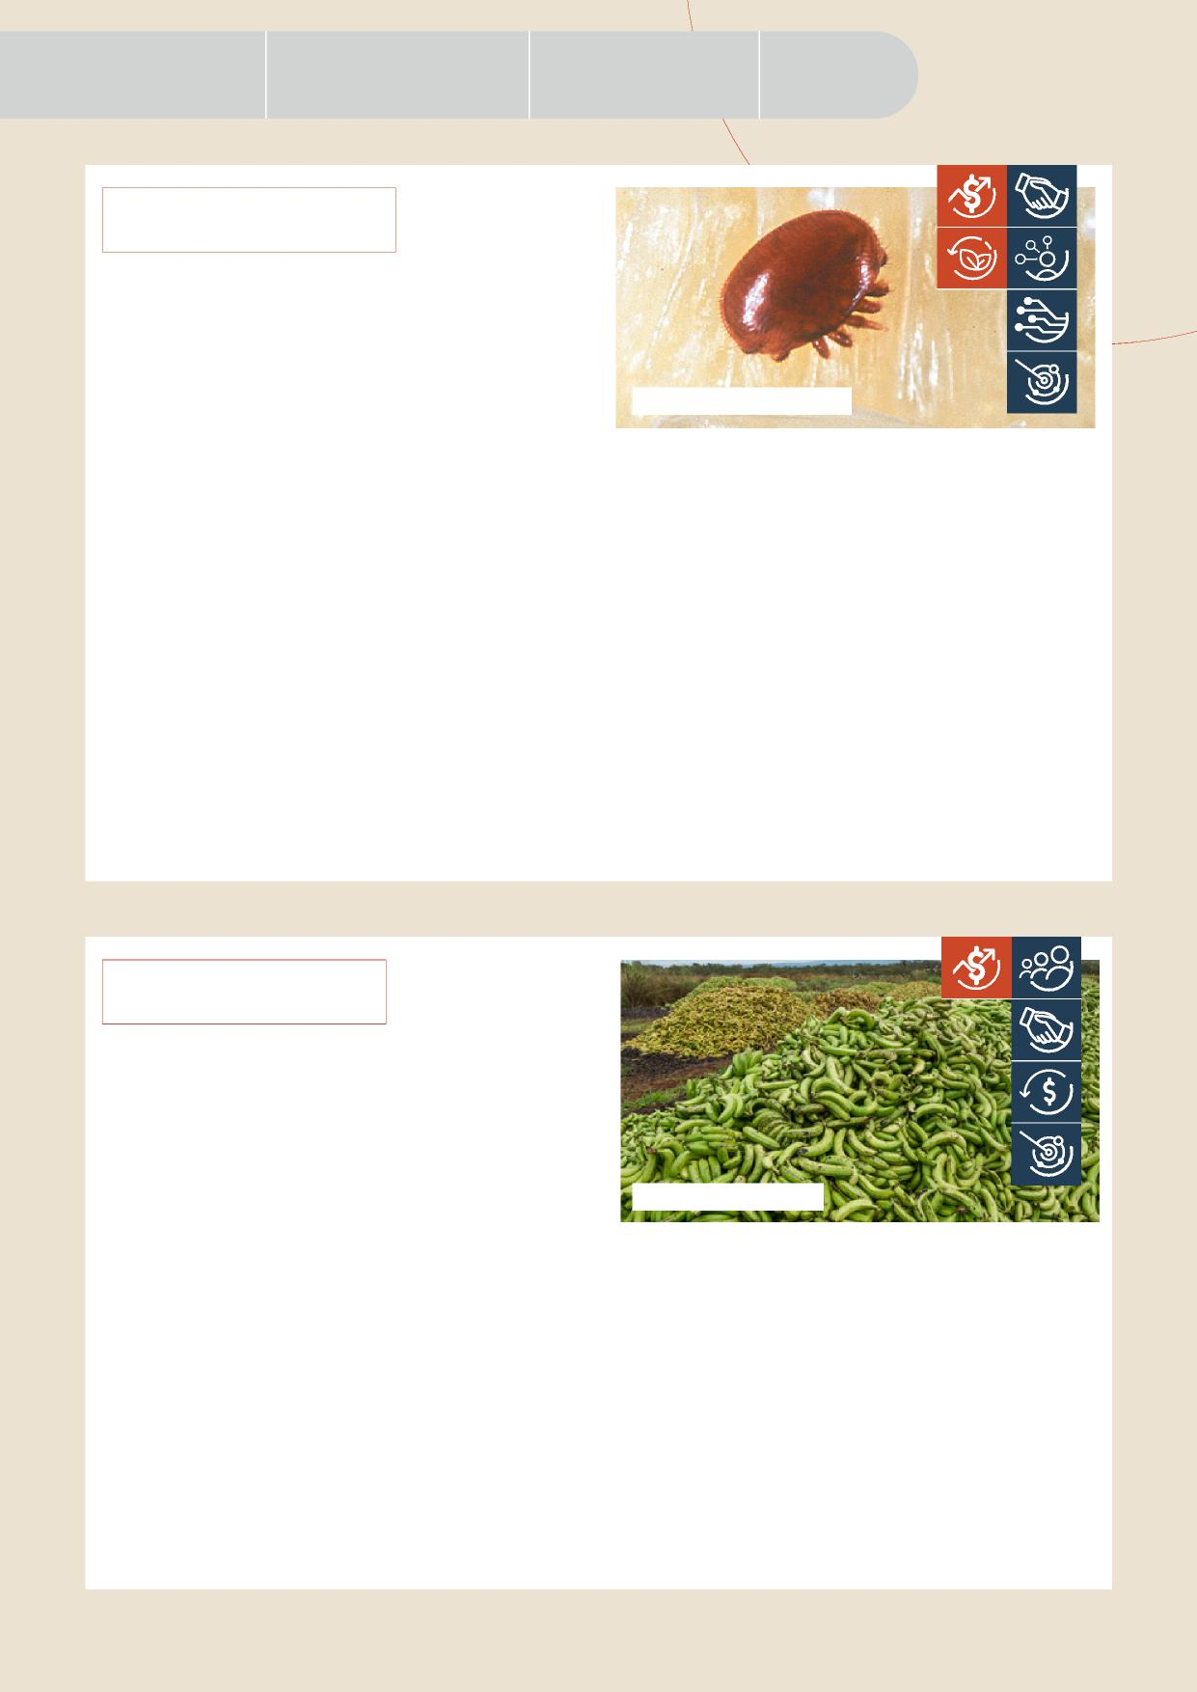

Appendix

|  |  |  |
| --- | --- | --- |
| Our opportunities for | It’s time to evolve how | Driving |
| meaningful change | we work together | collaborative action |

**VARROA MITE**

Internal and external mites of bees, including varroa mite (*Varroa destructor* and *Varroa jacobsoni*) are National Priority Plant Pests. Varroa mite, particularly *Varroa destructor*, weakens and eventually kills European honeybees (*Apis mellifera*). An outbreak could have significant repercussions for our economy, potentially costing producers and consumers of pollination-dependent crops – like almonds and pears – $1.3 billion over 30 years (2012 estimate).

Australia is currently the only inhabited continent to successfully prevent the pest from establishing itself. While varroa mites have been detected on recently arrived bee swarms several times at ports across Australia, such as at the Port of Townville (2016, 2019, 2020 – *Varroa jacobsoni*) and the Port of Melbourne (2018 – *Varroa destructor*), each time the swarms and the mites have been successfully eradicated or destroyed on entry. This success is down to our strong partnerships, robust surveillance methods and coordinated preparedness activities across the system.

Image: *Varroa destructor*

The National Varroa Mite Eradication Program was established in 2016 after varroa mite (*Varroa jacobsoni*)

was detected in Townsville. The program is co-funded by industry, including the Australian Honey Bee Industry Council, the state and territory governments and the Australian Government under national response arrangements. It funds important surveillance activities like GPS tracking, community awareness campaigns and extensive inspections of bees and their colonies, including the examination by entomologists of around 880,000 honeybee wings in 2019-20 alone. *Varroa jacobsoni* was declared eradicated in 2021 following the success of the program.

Across Australia, the close collaboration of

governments, industry and the community has allowed for the rapid and transparent sharing of resources and information to effectively prepare for and eradicate the pest.

**PANAMA TR4**

Panama disease Tropical Race 4 (TR4) is a National Priority Plant Pest that affects bananas and is present in parts of Australia. The pest blocks the tissues that carry water and nutrients in banana plants, eventually killing them. Without management, it could devastate Australia’s banana industry. Panama TR4 can live in soil for decades without a host and is spread easily in contaminated soil, plant material and water. There is currently no cure for the disease and our only defence is to implement effective separation and decontamination processes. The success of these prevention and management measures relies on strong partnerships and awareness of system stakeholders, as well as sustainable funding to support ongoing activities.

The Panama TR4 Program is a joint initiative between the Queensland Government and the Australian Banana Growers’ Council (ABGC) to control and contain the disease. Since the region’s first detection in 2015, the program has focused on early detection through surveillance on commercial banana farms in

Far North Queensland and compliance activities

Image: *Kerry Trapnell*

on known infested properties. The program also seeks to generate community support for efforts to protect against the disease through communications and engagement activities.

With the ABGC co-funding the Panama TR4 Program since 2019, a management board of equal government and industry representation has been established to govern and deliver the program’s strategic direction until mid-2023. Beyond July 2023, industry will take leadership of disease management. Continued success will require us to harness the potential of our shared biosecurity culture, supported by broad community engagement and awareness activities.

CONSULTATION DRAFT 25

|  |  |  |  |
| --- | --- | --- | --- |
| Executive | Why Australia | How our biosecurity | Changing biosecurity |
| Summary | needs biosecurity | system works | environment |



Purpose

|  |  |
| --- | --- |
|  | Our opportunities for  meaningful change |

To meet the biosecurity risks of today and arm ourselves for the new and increasing risks coming our way, we must continue to evolve our system and act on our opportunities for meaningful change.

This requires us to go beyond scaling our current efforts to enhance how we work together and leverage opportunities for improvement.

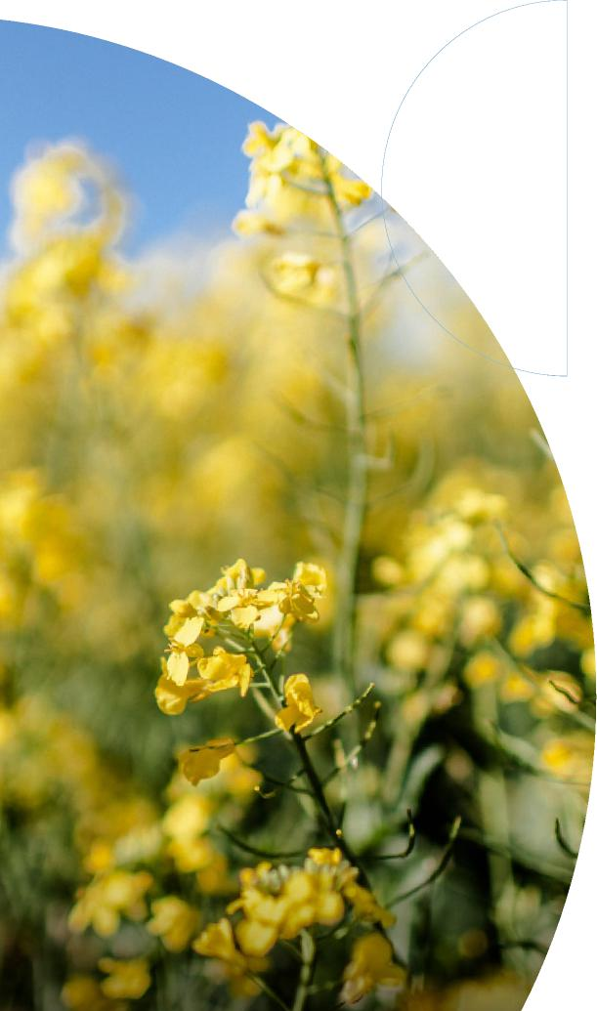

26 CONSULTATION DRAFT

**Engaging everyone in the biosecurity system** is a fundamental opportunity to create a stronger system that is action-oriented and raises awareness of risks, shared benefits, and outcomes. This will rely on a greater understanding and valuing of biosecurity, as well as behavioural change across the entire system. The National Biosecurity Statement, developed in 2018, provides a solid starting point for the sharing of ownership across the biosecurity system. Additionally, enhancing our engagement with international organisations and trading partners on biosecurity has the potential to help us mitigate risks before they reach our shores. We have a significant opportunity to build upon previous efforts to connect, motivate, include and empower a broader range of stakeholders.

**Opportunities in the north** exist to support and enhance existing biosecurity efforts. The north of Australia is at high risk of threats entering via natural pathways and is home to some of our key primary production and tourism growth areas. The Northern Australia Biosecurity Strategy provides a platform for us to focus our efforts on high priority activities, which include expanding our Indigenous Ranger programs and capacity, increasing surveillance and diagnostic capabilities, addressing regional skills needs in key areas and improved data collection for wider use.

**A more flexible, improved risk-based regulatory system** is needed to drive more efficient processes through targeted and adaptable regulatory frameworks that provide benefits to all stakeholders. We have significant opportunities to facilitate data sharing and operationalise real time innovations in technology to support faster risk-based decision-making and traceability. Co-regulation with industry can also provide material benefits to all stakeholders in managing risk and streamlining processes when they are carefully designed and supported by harmonised compliance frameworks.

**Enhanced collaboration at regional and**

**local levels** through on the ground coordination and locally driven solutions could support better biosecurity outcomes. In addition to the potential to improve collaboration amongst the state and territory governments, and with the Australian Government, opportunities exist for diverse stakeholder groups, including Natural Resource Management organisations, to work more closely together at regional and local levels. This collaboration will help to implement biosecurity priorities matched to regional needs, collect data and measure results consistently, coordinate mutually beneficial activities, and maintain open and continuous communication.



**Additional skills and quality infrastructure** are required to support a more responsive biosecurity system. Our system is currently supported by a skilled workforce with deep and diverse technical expertise, but there are capacity constraints and recruitment challenges, especially in a range of specialist capabilities. The skills of our people and the infrastructure that supports them are the foundations of our system. We will only realise the benefits of new approaches and innovative technologies, like High-Throughput Sequencing and eDNA, if we have the skilled people and the supporting infrastructure necessary to operationalise them. The national strategy presents an enormous opportunity to plan for the skills and critical infrastructure we need going forward.

|  |  |  |
| --- | --- | --- |
| Our opportunities for | It’s time to evolve how | Driving |
| meaningful change | we work together | collaborative action |

Appendix

**Funding and investment** is currently sourced from all levels of government, industry and the community through a variety of models, reducing transparency of system-wide investment. Funding has been under recent strain, due to the evolving risk environment and growing demand for resourcing. We have the opportunity to work together across government, industry and the community to assess and reset our funding and investment frameworks to ensure they are fit for purpose, sustainable in the longer term and that all biosecurity participants contribute equitably.

**Understanding the changing risk environment** and enhancing the way we share threat information is critical to maintaining a strong system. Biosecurity risks are constantly evolving and as threats change, our risk profile changes. We have the opportunity to better share risk information and threat assessments with a wider range of biosecurity stakeholders to improve their understanding of the changing environment, support preparedness activities and investment and research prioritisation.

CONSULTATION DRAFT 27



Purpose

Executive Summary

|  |  |  |
| --- | --- | --- |
| Why Australia | How our biosecurity | Changing biosecurity |
| needs biosecurity | system works | environment |

It’s time to evolve how we work together

The only way we can build an even stronger biosecurity system is to evolve how we work together.

Australia’s biosecurity is underpinned by the 2019 Intergovernmental Agreement on Biosecurity, which provides a strong foundation to focus our collective efforts and supports wide-ranging partnerships.

However, as the challenges facing biosecurity continue to build, we need a renewed focus on enhancing national capacity and capability going forward.

28 CONSULTATION DRAFT

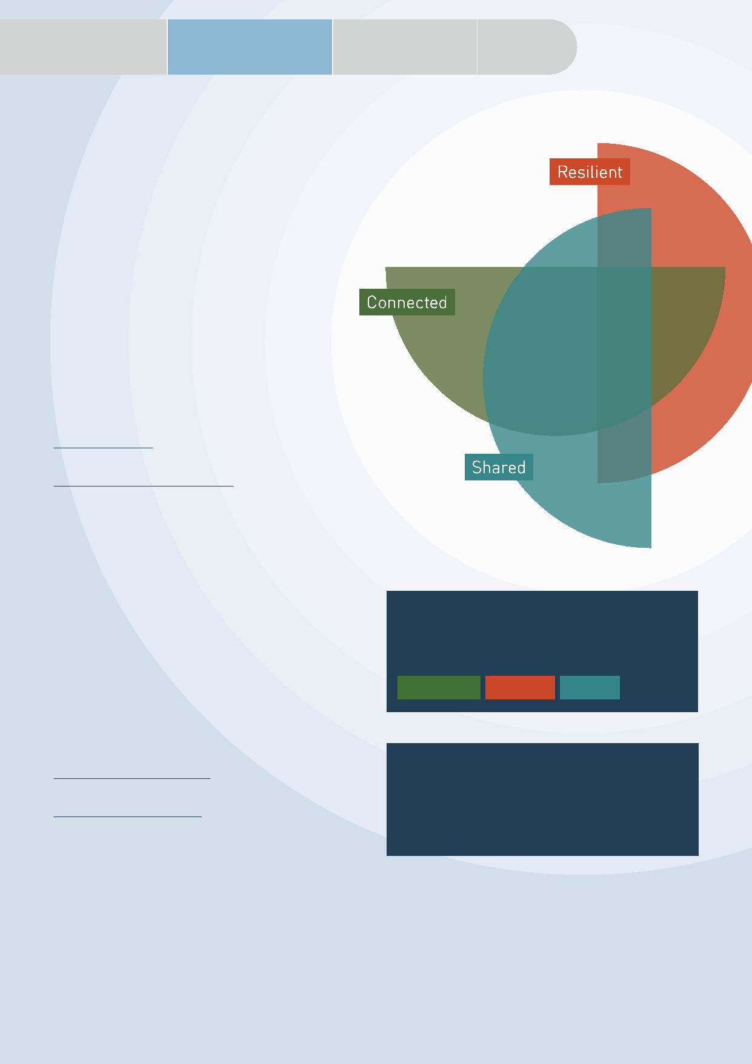

Appendix

|  |  |  |
| --- | --- | --- |
| Our opportunities for | It’s time to evolve how | Driving |
| meaningful change | we work together | collaborative action |

**WHERE**

**WE’RE GOING**

In the future, we will more efficiently and effectively manage biosecurity risks.

Key to our success will be the adaptability and sustainability of our preparedness, surveillance, response, management and recovery systems, combined with a collaborative culture that encourages action and embeds continuous learning.

Everyone will know why biosecurity is important, care about it, understand their role and how they should play their part to ensure that our biosecurity remains strong.

VISION

A biosecurity system that protects Australia’s way of life.

Connected

Shared

Resilient

**HOW WE’LL**

SHARED PURPOSE

**GET THERE**

A risk-based system underpinned by science that protects Australia’s people, our environment and economy from the biosecurity threats of today and tomorrow.

We will work together to act in 6 priority areas. These priorities will guide our efforts so that we have the biggest impact and remain on track as we move into implementation planning.

CONSULTATION DRAFT 29

|  |  |  |  |
| --- | --- | --- | --- |
| Executive | Why Australia | How our biosecurity | Changing biosecurity |
| Summary | needs biosecurity | system works | environment |





Purpose

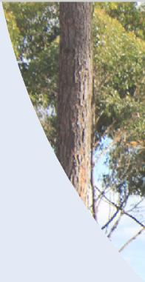

**PRIORITIES AND ACTIONS**

**TO REALISE OUR VISION**

Enhancing our capabilities and embedding advancements in technology and research will be key enablers of the national strategy. However, improving our system will also rely heavily on strengthening our biosecurity culture – the way we think, behave and work together – to promote awareness and drive coordinated action across the nation.

The initial actions for our 6 priority areas have been crafted to support our vision and purpose. Our next step will be to refine and build upon these actions during consultation and implementation.

**WE WILL TAKE ACTION IN 6 PRIORITY AREAS:**

|  |  |
| --- | --- |
|  |  |
| **Shared biosecurity culture** |
|  |

We will ensure all Australians understand what biosecurity is and are empowered to act to support our system. We will create a culture of biosecurity action in which we all care about biosecurity as we all enjoy the benefits that effective biosecurity brings and potentially suffer the consequences of our system’s failures.

30 CONSULTATION DRAFT

**Initial actions:**

– Build on and develop national education and awareness programs – including introducing biosecurity into curricula – to deepen understanding of, and commitment to, biosecurity and encourage community and industry stewardship in the system.

– Progress innovative approaches to encourage positive biosecurity behaviours and incentivise compliance, including through the leveraging of community and other networks and exploring new channels of engagement.

– Revitalise and further collaborate through

national communication and engagement mechanisms,

as well as relevant fora and symposia, to encourage greater knowledge sharing, build trust and increase transparency.

– Determine opportunities to embed consideration of biosecurity into all

levels of government, community, industry and other stakeholders’ broader decision-making and risk and business continuity planning.

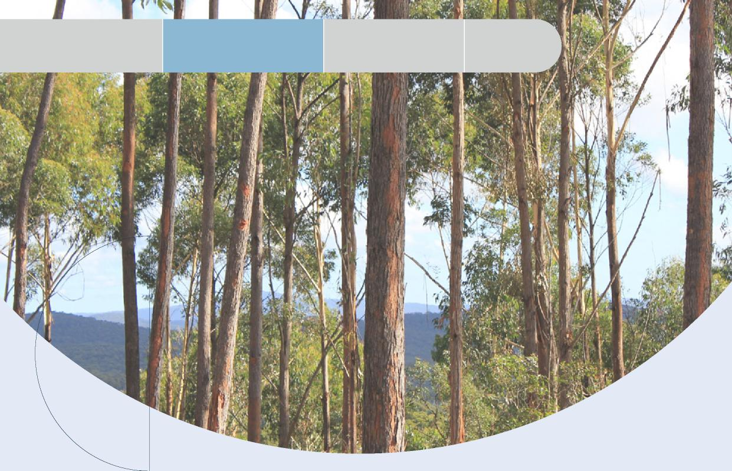

Our opportunities for meaningful change

It’s time to evolve how we work together

Driving

collaborative action

Appendix

|  |  |
| --- | --- |
|  |  |
| Stronger partnerships |
|  |

|  |  |
| --- | --- |
| We will strengthen and expand partnerships with all stakeholders at local, regional, national and international levels to leverage our different expertise, resources and knowledge for greater impact and to | support better biosecurity outcomes. Underpinning these partnerships will be mutual trust, formal recognition, transparency and a clear understanding of the importance of everyone’s role. |

CONSULTATION DRAFT 31

**Initial actions:**

– Enhance partnerships and engagement with Indigenous Australians to ensure Indigenous interests are considered and to provide for participation in the design and delivery of biosecurity outcomes and initiatives.

– Work with biosecurity stakeholders to review and refine roles and responsibilities, providing flexibility to adapt as the system evolves.

– Review governance arrangements to ensure that they include relevant stakeholders in the

design, development and implementation of national policies, programs and regulatory arrangements.

– Strengthen the involvement of environmental agencies across the biosecurity system.

– Identify opportunities for industry and community involvement in peak decision-making bodies.

– Deepen international partnerships, including in the Indo-Pacific, to increase engagement, harmonisation and information and intelligence sharing on national priority pests, weeds and diseases.

– Work together to help shape global biosecurity standards, rules and conditions to support strong biosecurity in Australia.



Purpose

|  |  |  |  |
| --- | --- | --- | --- |
| Executive | Why Australia | How our biosecurity | Changing biosecurity |
| Summary | needs biosecurity | system works | environment |

|  |  |
| --- | --- |
|  |  |
| Highly skilled workforce |
|  |

We will develop and sustain the pipeline of biosecurity can be deployed when and where they are needed,

skills needed for the future, within government, and that they have the right skills by providing

industry and community. We will ensure our people targeted education and training.

**Initial actions:**

– Investigate national skills to identify current and future needs in key areas, such as science, data, new technologies and regulatory capabilities, considering the findings of existing industry and government workforce strategies.

– Develop a national biosecurity workforce strategy to build, develop, retain and deploy

capability across the system, including surge support for responses, taking into account regional needs across Australia.

– Build on and expand existing cooperative arrangements to leverage the expertise and capability of biosecurity stakeholders to support system needs where there are mutual benefits.

– Strengthen professional development programs and exchanges between biosecurity stakeholders to facilitate knowledge and information sharing and improve skills.

|  |  |
| --- | --- |
|  |  |
| Coordinated preparedness and response |
|  |

We will enhance our preparedness through improved coordination, regional planning, increased collaboration and faster information and data sharing to support our system’s resilience and adaptability.

32 CONSULTATION DRAFT

**Initial actions:**

– Undertake and promote regular national preparedness exercises with biosecurity stakeholders to test and improve our collective readiness and increase public awareness of significant biosecurity threats.

– Advance regionally based planning activities to better align effort, integrate biosecurity practices and facilitate greater education and awareness opportunities.

– Continually review and update risk information, including through regular strategic threat assessments, to inform priorities and share this with stakeholders.

– Actively embed continuous learning supported by enhanced post-incident review and evaluation practices.

– Strengthen traceability arrangements to support improved biosecurity outcomes.

– Enhance our national surveillance arrangements to ensure they are robust given the changing threat environment, drawing on the expertise and capabilities of biosecurity stakeholders.

– Evolve our national information management frameworks to ensure they are fit for purpose, interoperable and promote seamless information exchange.

|  |  |  |
| --- | --- | --- |
| Our opportunities for | It’s time to evolve how | Driving |
| meaningful change | we work together | collaborative action |



Appendix

|  |  |
| --- | --- |
|  |  |
| **Sustainable investment** |
|  |

We will develop long-term sustainable biosecurity funding and investment approaches that recognise the value of government, industry and the community

investing in biosecurity to support the system’s growing needs. We will ensure these approaches are efficient, equitable, adaptable and transparent.

**Initial actions:**

– Work together to identify funding needs and determine priorities, including critical assets, infrastructure and research priorities.

– Strengthen frameworks to agree and deliver priority investments having regard to the level of risk and benefits from activities and to increase efficiency by reducing duplicative investments and processes.

– Advance co-funding and investment strategies with stakeholders, including models that consider key risk creators and system beneficiaries in an equitable manner.

– Increase the transparency of biosecurity funding to support improved accountability.

– Complete the development and implementation of a system performance and evaluation framework to inform future investment decisions.

|  |  |
| --- | --- |
|  |  |
| **Integration supported by technology, research and data** |
|  |

We will create a more connected and efficient system in which we better leverage technology, research and data to facilitate more timely, informed and risk-based decisions. We will continue to deliver our

biosecurity research priorities and develop, share and embed new technologies in areas such as traceability, surveillance, screening, data analytics, treatments and diagnostics.

**Initial actions:**

– Continue to invest in and rollout transformative technologies to digitise and automate processes, and support rapid and accurate detection, identification and response.

– Increase coordination and engagement with biosecurity stakeholders, including research and development bodies, to prioritise, drive and deliver national research outcomes.

– Actively share data and research to streamline research efforts and facilitate adoption of outcomes.

– Enhance the accessibility and use of surveillance and interception data to support effective decision-making by all stakeholders.

– Further support innovations to build science and research capacity in areas such as assessing pathway risks and species identification.

CONSULTATION DRAFT 33



Purpose

Executive Summary

Why Australia needs biosecurity

How our biosecurity system works

Changing biosecurity environment



Our way forward: Driving collaborative action

Our national strategy will set the future vision and priorities for the biosecurity system; however, it will only be realised through action from all of us.

More than 30 actions across our 6 priority areas have been included in this consultation draft for your feedback. These initial actions will be built upon and refined through public consultation to ensure that they capture the actions needed to implement the national strategy. We want to hear your views, as well as any other ideas you have on the collective efforts needed to evolve our system.

Following the strategy’s finalisation, we will work together to

develop action plans which will provide a pathway for implementation.

Our action plans will be monitored regularly to keep us on track

and ensure that we adapt where needed and remain focused on the

continual improvement of our system.

While implementation will be overseen by the NBC, it will be a consultative process that includes all stakeholders and takes into account local and regional priorities. To help us develop this process, we want your feedback as part of the public consultation phase on how you think implementation planning should occur.

34 CONSULTATION DRAFT

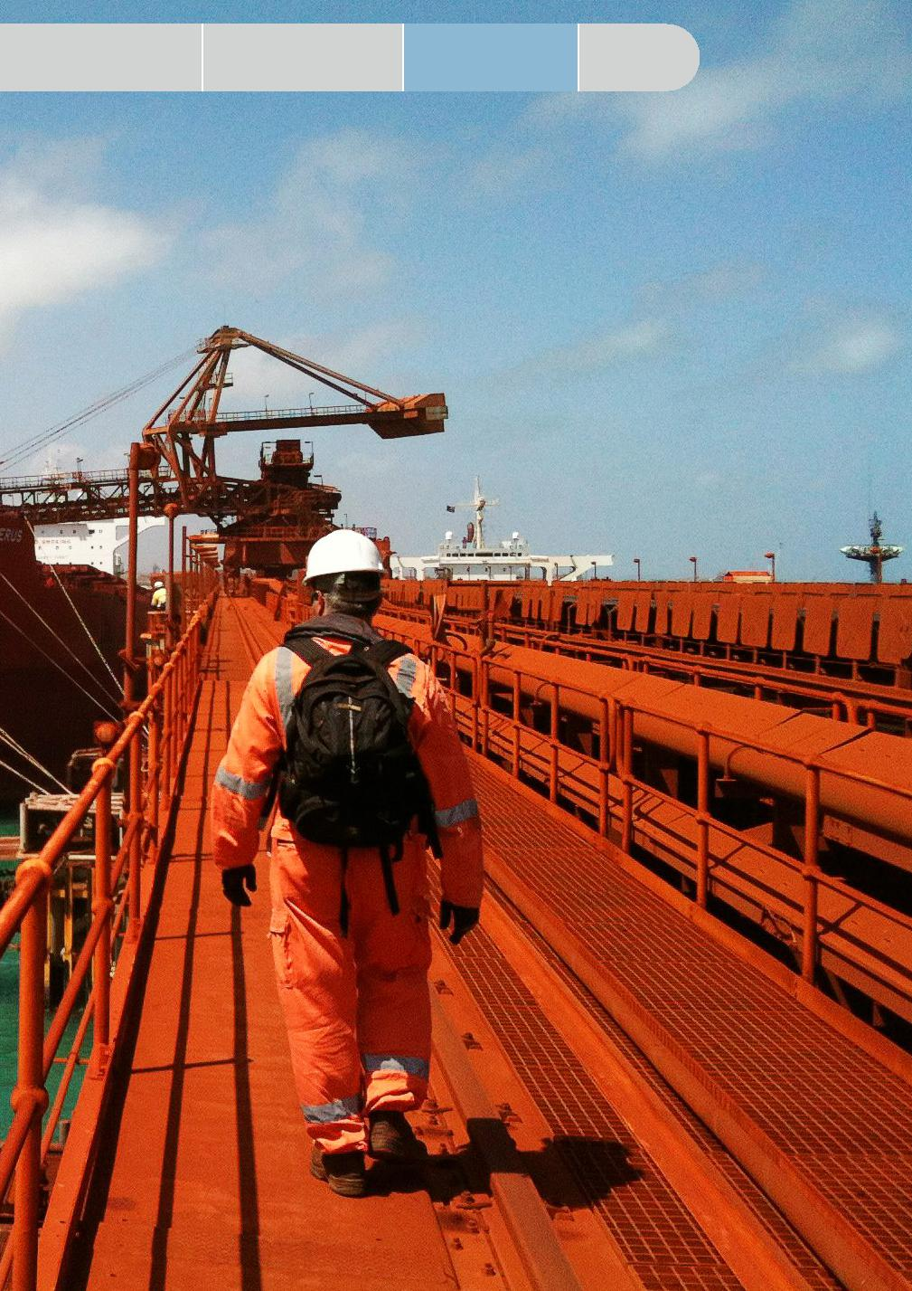

Driving

collaborative action

It’s time to evolve how we work together

Our opportunities for meaningful change

Appendix

CONSULTATION DRAFT 35



Changing biosecurity environment

|  |  |  |  |
| --- | --- | --- | --- |
|  | Executive | Why Australia | How our biosecurity |
| Purpose | Summary | needs biosecurity | system works |

36 CONSULTATION DRAFT

|  |  |  |
| --- | --- | --- |
| Our opportunities for | It’s time to evolve how | Driving |
| meaningful change | we work together | collaborative action |



Appendix

Questions on the National Biosecurity Strategy consultation draft

We are keen to receive your feedback on the consultation draft of the National Biosecurity Strategy.

The questions below cover key areas of the draft to help guide your input, but you can comment on any aspect of it that you like.

Provide your feedback through to National Biosecurity Strategy Have Your Say – <https://haveyoursay.awe.gov.au/national-biosecurity-strategy>

If you have any questions, please [email](mailto:email_nationalbiosecuritystrategy@awe.gov.au) nationalbiosecuritystrategy@awe.gov.au

A collaborative process will be established following the finalisation of the national strategy to consider additional actions in the 6 priority areas and develop action plans:

1. **ACTIONS**

– What are your views on the proposed initial actions?

– What other actions should be included to deliver our 6 priority areas, address biosecurity risks and capitalise on our opportunities for change?

– How can you contribute to achieving our 6 priority areas?

1. **IMPLEMENTATION AND   
   REVIEW**

– What mechanisms should be established to ensure stakeholders are involved in the further development of actions and implementation planning?

– How regularly should the strategy be reviewed?

– How should we monitor and evaluate the success of the national strategy and implementation plans?

1. **BIOSECURITY RISKS AND OPPORTUNITIES**

– Are there any key risks and opportunities not captured in the consultation draft?

– Do any of the biosecurity risks or opportunities outlined in the consultation draft have additional implications for our 6 priority areas?

1. **SCOPE OF THE STRATEGY**

– Do the proposed vision and purpose reflect what we want to achieve and how we want to evolve our system into the future?

– Are our 6 priority areas where we should focus   
our efforts in the future? Is anything missing?

1. **ROLES WITHIN THE BIOSECURITY SYSTEM**

– Can you see your current role within the

bio security system reflected in the consultation

draft?

– Do you think the ‘How our biosecurity system works’ diagram (page 15) reflects your role and responsibilities in the biosecurity system? If not, what amendments should be made?

– How do you see your own and others’ roles changing into the future?



CONSULTATION DRAFT 37

|  |  |  |  |
| --- | --- | --- | --- |
| Executive | Why Australia | How our biosecurity | Changing biosecurity |
| Summary | needs biosecurity | system works | environment |



Purpose

|  |  |
| --- | --- |
|  | Appendix |



OUR BIOSECURITY SYSTEM ARCHITECTURE

Our system is supported by a mature and dynamic architecture of agreements, arrangements, deeds and statements between governments, plant and animal industries, environmental groups and research organisations. This is complemented by reviews undertaken by the Inspector-General of Biosecurity, CSIRO and other stakeholders.

Australia is also a signatory to a range of international biosecurity, trade, health and environmental agreements, including measures outlined by the World Trade Organization, International Plant Protection Convention, World Organization for Animal Health and the World Health Organization.

**The Intergovernmental Agreement on Biosecurity (IGAB)** sets out commitments for governments, outlines agreed national goals and objectives and clarifies roles and responsibilities.

The IGAB also establishes the NBC. The NBC provides advice to the AGSOC on national biosecurity issues, and progresses the implementation of the IGAB. AGSOC reports to ministers responsible for primary industries.

The NBC is responsible for managing a national, strategic approach to biosecurity risks that could impact agricultural production, the environment, community wellbeing and urban amenity.

The NBC is supported by several sectoral committees – the Animal Health Committee, Environment and Invasives Committee, Marine Pest Sectoral Committee and Plant Health Committee – and the National Biosecurity Community Engagement Network, as well as ongoing expert groups and short-term, task-specific groups.

**Formal emergency preparedness and response agreements** establish arrangements for responding to exotic pests, weeds and diseases that are detected within Australia and have the potential to impact animal, plant or human health, or the environment. These agreements are the:

– Emergency Animal Disease Response Agreement (EADRA)

– Emergency Plant Pest Response Deed (EPPRD), and

– National Environmental Biosecurity Response Agreement.

These arrangements are formal agreements between governments and (where relevant) industry signatories, and as appropriate, Animal Health Australia (AHA) and Plant Health Australia (PHA).

The arrangements cover the management and funding of responses to biosecurity outbreaks, or where a pest, weed or disease primarily impacts the environment and/or social amenity (where the response is for the public good).

AHA and PHA are the custodians of the EADRA and EPPRD respectively and are national coordinators of key government-industry biosecurity partnerships in the areas of animal and plant health, producing and inputting into strategies and plans to guide these efforts. AHA and PHA facilitate a national approach to enhancing Australia’s animal and plant biosecurity systems, through awareness, preparedness and emergency response management.

**The National Biosecurity Statement** was finalised in 2018 and outlines national biosecurity goals, roles and responsibilities and principles for managing biosecurity risk. The national strategy will build from this strong foundation.



38 CONSULTATION DRAFT

|  |  |  |
| --- | --- | --- |
| Our opportunities for | It’s time to evolve how | Driving |
| meaningful change | we work together | collaborative action |



Appendix

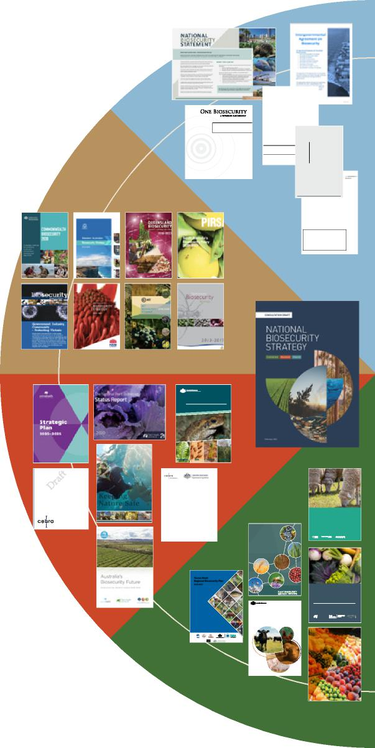

**OverviewofACERA/CEBRAProjects** *Asummaryofprojectoutputsandoutcomes*

EdithArndt1,AndrewRobinson1,andMarkBurgman2

1Centreof Excellence for Biosecurity Risk Analysis, University of Mel­bourne

2CentreforEnvironmentalPolicy,ImperialCollegeLondon

October20,2018

Centre of Excellence for Biosecurity Risk Analysis

**Keeping 2012**

JUNE

**Nature Safe**

**A proposal for the establishment of Environment Health Australia, a national body dedicated to environmental biosecurity.**

**Developing models for the spread   
and management of   
National Priority Plant Pests**

**Technical Report for CEBRA project 170606**

Dr Richard Bradhurst1 Dr Mark Stanaway2 James Milner2 Professor Tom Kompas1

1Centre of Excellence for Biosecurity Risk Analysis, University of Melbourne 2Plant Health Policy Branch, Department of Agriculture

**28 February 2020**

Huanglongbing (citru sgreeinng) rTamp ants Xylella on grapevine Dtuch elm disease

**Inspector-General of Biosecurity**

Environmental biosecurity risk management in Australia

**Torres Strait**

**Regional Biosecurity Plan 2018-2023**

BEALE | FAIRBROTHER | INGLIS | TREBECK 30 SEPTEMBER 2008

REVIEW REPORT NO. 2018–19/04

The Independent Review of Australia’s Quarantine and Biosecurity Arrangements Report to the Australian Government

Asian black-spined toad

**ANIMALPLAN**

202 2 to 2 027 Australia’s National Action Plan for Terrestrial Agricultural Animal Health

Plant Biosecurity Research Initiative Strategy 2018-2023

**GOVERNMENT AND LIVESTOCK INDUS IN RESPECT OF EMERGENCY ANIMA**

**VERSION No. 20/01-**

**AUSTRALIAN ANIMAL HEALTH COUNCIL LIMITED**

**COMMONWEALTH OF AUSTRALIA**

**THE STATE OF QUEENSLAND**

**THE STATE OF NEW SOUTH WALES**

**THE STATE OF VICTORIA THE STATE OF SOUTH AUSTRALIA**

**THE STATE OF TASMANIA**

**THE STATE OF WESTERN AUSTRALIA**

**THE NORTHERN TERRITORY OF AUSTRALIA THE AUSTRALIAN CAPITAL TERRITORY AUSTRALIAN CHICKEN MEAT FEDERATION INC. AUSTRALIAN DUCK MEAT ASSOCIATION INC. AUSTRALIAN EGGS LIMITED AUSTRALIAN DAIRY FARMERS LIMITED CATTLE COUNCIL OF AUSTRALIA INC. AUSTRALIAN PORK LIMITED**

**SHEEP PRODUCERS AUSTRA WOOLPRODUCERS AUSTRA AUSTRALIAN LOT FEEDERS’ AS GOAT INDUSTRY COUNCIL O RACING AUSTRALIA LI HARNESS RACING AUST AUSTRALIAN HORSE INDUS EQUESTRIAN AUSTRALIA**

@ Agriculture Victoria

Version1.1 National Environmental Biosecurity Response Agreement–pa ge 1

**This version of the Government and Plant Industry Cost Sharing Deed in respect of   
Emergency Plant Pest Responses is current as at   
21September,2021   
You should note that this Deed can be varied with the approval of al the Parties (see clause   
17). Please contact Plant Health Australia to confirm whether this document is the most   
current version before relying on the information contained.**

**Mailing Address: Level 1,1 Phipps Close**

**DEAKIN, ACT 2600**

Phone: +61 2 6215 7700

Email: [epprd@phau.com.au](mailto:epprd@phau.com.au)

**Government and Plant Industry Cost Sharing Deed in respect of Emergency Plant Pest Responses**

National

**EED** Environmental

**S** Biosecurity Response

Agreement

**NATIONAL SHEEP INDUSTRY BIOSECURITY STRATEGY**

2019–2024

**Biosecurity Plan** for the Vegetable Industry

A shared responsibility between government and industry

Version 3.0 May 2018

**NATIONAL FRUIT FLY STRATEGY**

2020-25

Plant Health **AUSTRALIA**

Lawyers

Maddocks House Level 1, 40 Macquarie Street Barton ACT 260 0 Australia

Telephone 61 2 6120 4800 Facsimile 61 26230 1479 [info@maddocks.com.au](mailto:info@maddocks.com.au) [www.maddocks.com.au](http://www.maddocks.com.au)

**Government strategies**

The Australian, state and territory, and local governments have published a range of strategies, roadmaps and reviews that outline the goals, objectives, priorities and frameworks for the biosecurity system within their jurisdiction.

Research organisations and environmental groups are instrumental in the protection and continual enhancement of our biosecurity system. Research organisations develop strategies, research and position papers, and strategic actions that explore and inform initiatives and outline innovative approaches in science, research and collaboration.

Environmental groups, such as regional Natural Resource Management organisations, play a critical role in environmental biosecurity, regional planning, natural resource management and policy advocacy. Indigenous Australians undertake important surveillance activities and management of Country. Surveillance activities are also enhanced by citizen science initiatives which support education, collaboration and capacity building.

**Industry strategies and position papers**

Industry peak bodies who understand and acknowledge the shared benefits of a strong and resilient biosecurity system are consistent advocates for its improvement. Most importantly they publish, in consultation with their members, an array of ambitious and considered strategies and position papers that seek to make a case for reform, action and investment.

System stakeholders work together on a range of holistic plans and strategies, such as Animalplan 2022 to 2027, which has recently been developed through collaboration between relevant animal health stakeholders from government, industry, research and other sectors as Australia’s first national action plan to strengthen our animal health system.



**Peak research organisations and environmental biosecurity stakeholder publications**

CONSULTATION DRAFT 39

DCCC information paper suitable for sharing

**DCCC Meeting 91 – 7 March 2022**

**Agenda Item 3.2**

**Industry behaviour and compliance report**

**For DISCUSSION**

**PURPOSE**

To seek further feedback from DCCC members on the development of an industry behavior and compliance report.

**RECOMMENDATIONS**

That DCCC members:

**Discuss** and agree the key metrics, data types and format for inclusion in the report.

**Discuss** opportunities for greater industry/government data sharing.

**KEY POINTS**

Members have requested the department provide regular reports on the types of non-compliant behaviour across the cargo pathway to enable them to better understand that behaviour and assist the department to address it.

This work is progressing and as a starting point, is expected to capture metrics and insights outlined in Attachment A.

. Service standard results for the period 1 October to 31 December 2021 are at Agenda item 5.2d. Non-compliant behaviours have contributed at times to some service standards not being met.

. At future meetings, we will look to provide data on entry processing for FID referrals.

Members are asked to advise other metrics that should be captured and discuss opportunities for more regular and tailored data exchange.

**CLEARED BY**

*Leanne Herrick, Principal Director, Industry Partnership and Engagement*, *following input from relevant business leads.*

UNCLASSIFIED Page 1 of 2

DCCC information paper suitable for sharing

Mtg 91 Item 3.2 - Attachment A

**Draft Schematic for industry behaviour and compliance report**

|  |  |
| --- | --- |
| **Behaviours**  *This includes acts that aren’t necessarily non-compliant, but  rather undesirable as they can impact resourcing and the  delivery of service to other clients.* | **Compliance**  *This includes acts whereby legislation, import conditions or policies that support the management of biosecurity risk are met or not met.* |
| Request for reassessment of documentation resulting in the same outcome | Submission of insufficient or incorrect  documentation for assessment |
| Short-notice cancellation or no-show for afterhours appointments (assessments & inspections) | Failed inspections for biosecurity |
| Inspection appointment cancellations or re- schedule at short notice | Failed inspections for imported food |
| Consignments not ready at the time of inspection | Failed surveillance activity such as CCV |
| Unacceptable behavior over the phone | Outstanding entries |
|  | Sea container not treated (for example, goods treated but not the container) |

UNCLASSIFIED Page 2 of 2



DCCC paper suitable for sharing   
**DCCC Meeting 91 – 7 March 2022**

**Agenda Item 5.1a**

**Proof of concept trial of new industry arrangements for imported cargo**

**For INFORMATION**

**PURPOSE**

To update DCCC members on the progress of the trial, the insights identified to date and how they are being leveraged to design a new arrangement for imported cargo.

**KEY POINTS**

Expected to be completed in June 2022, the trial has been seeking to identify whether importer commercial assurance controls could be used to manage biosecurity risk.

Seven pilots are underway with importers across different supply chains, industry sectors and cargo entry channels.

The trial is demonstrating a compelling case for the establishment of a `trust-based’ biosecurity relationship model, not dissimilar to the ABF’s trusted trader program.

Observations to date include:

* Pilot participants invest considerable time and money to ensure biosecurity and imported food requirements are met to avoid delays at the border and satisfy customers who rely on the protection these safety nets provide.
* The current transactional biosecurity management model does not always recognise this effort, or the importer’s past compliance, with consignments often treated the same each time.
* Participant assurance controls are well established and documented and could be leveraged to manage biosecurity risk.
* Trial model is scalable and agile enough to apply to different business models and supply chains.
* Capacity exists for the department to directly source industry supply chain data, saving importers time and money from having to prepare and provide this information to the department.
* Importers are choosing to make further changes to embed biosecurity management within their business and improve end-to-end resilience.

These insights are informing the design of new `green lane’ styled arrangements that will see consignments from participating importers largely bypass traditional biosecurity clearance processes.

UNCLASSIFIED

Page 1 of 3

DCCC paper suitable for sharing

The arrangements will benefit other businesses by reducing congestion at the border and generating greater capacity for the department to manage areas of higher risk and meet service demands.

**IMPLEMENTATION OF NEW GREEN LANE ARRANGEMENTS**

Despite scheduling slippages due to importer business disruptions from COVID-19, the trial is well underway with the two pilots now complete, and another expected to finish shortly. The remaining four pilots are expected to be completed by May 2022.

Work to operationalize the new arrangements is continuing. This includes identifying and removing system or process barriers to implementation and minimizing the risk of cross over with other programs.

The arrangements will be for the supply chain assessed and subject to a level of ongoing assurance and verification activity.

Participating importers will be required to meet all current import conditions, and hold appropriate import documentation for consignments, but not to lodge those documents in COLS.

The department anticipates that successful industry trial participants will transition to the new arrangements by the second quarter of 2022.

Further information on the application and assessment process will be released in the coming months, with the program expected to open to other importers from July 2022.

The department will continue to consult with industry as the program is rolled out.

While this type of arrangement will be open to all importers, it will not suit all businesses as it requires the importer to have sufficient visibility and control over their supply chains.

**BACKGROUND**

Following an open expression of interest process, the companies chosen to participate in pilots under this proof-of-concept trial were:

* KMART Australia Pty Ltd
* FTA Food Solutions Pty Ltd
* Becton Dickinson Australia
* Stora Enso Australia Pty Ltd (Wood Products).

Three additional pilots are now underway with:

* John Deere Pty Ltd
* Ball Australia Pty Ltd
* Amazon Australia Pty Ltd.

If successful, the trial will lead to the establishment of new arrangements that will:

* reduce regulatory intervention and costs for highly compliant importers who already invest heavily in commercial quality assurance arrangements
* allow for biosecurity risks to be identified and mitigated early in supply chain, before goods are shipped to Australia

UNCLASSIFIED

Page 2 of 3

DCCC paper suitable for sharing

* lessen border congestion, providing downstream benefits for other importers and the wider community, helping to drive business growth and job creation
* enable departmental resources to be redirected to areas of greater need.

Each pilot is being designed with the companies based on detailed mapping of their systems, data and supply chain assurance mechanisms against biosecurity controls and risk trigger points. This activity captures the people, regulations, systems, and processes involved from product selection to export and logistics on arrival in Australia, including for both commodity and non-commodity risks. Other government and industry accreditations held by each importer are also considered, as well as non-biosecurity related regulatory controls or industry standards they are required to meet.

The pilots are being run in parallel to current biosecurity arrangements and sector specific arrangements being trialled. Non-commercial and self-assessed clearance cargo (<$1000) is out of scope.

While the pilots were progressing, the department continued to engage with the importers that applied but were not selected for a pilot. This engagement led to the trial being extended and the number of pilots increased for a broader coverage of supply chain models.

This initiative is delivering on our Commonwealth Biosecurity 2030 plan by partnering with industry to inform border operations and strengthen our biosecurity system.

**CLEARED BY**

*Leanne Herrick, Industry Partnerships and Engagement Branch, Biosecurity Operations Division*

UNCLASSIFIED

Page 3 of 3



DCCC paper suitable for sharing   
**DCCC Meeting 91 – 7 March 2022**

**Agenda Item 5.1b**

**Update on Commonwealth Biosecurity 2030**

**For INFORMATION**

**PURPOSE**

To update DCCC members on the work underway to progress the first annual action to deliver against the nine strategic actions under the Commonwealth Biosecurity 2030 strategy.

**KEY POINTS**

The Commonwealth Biosecurity 2030 strategy (CB2030), released in May 2021, is the Australian

Government’s roadmap to build a stronger, smarter biosecurity system through to 2030. The department has committed to releasing an action plan each year to guide delivery against the roadmap.

The draft plan, which the department expects to release shortly via our website, sets out:

* changes in our strategic and operating environment
* key stakeholder engagement and reflections on CB2030
* snapshots of projects/achievements key to realising the CB2030 goal
* the next phase of focused implementation efforts, and
* an overview of resolution of independent reviewer actions.

The focused implementation efforts for this year keep us tracking towards realising our goal of a risk-based biosecurity system that effectively, efficiently and sustainably protects Australia’s health, economic, environmental and national security interests against the threats of today and tomorrow, consistent with our Appropriate Level of Protection. This year’s planned efforts are building out from the 16 initial steps outlined in the roadmap and/or have been informed by feedback from key biosecurity partners through various channels, including fora such as the DCCC and the Biosecurity Futures group.

To support greater transparency around the department’s efforts, the plan will also include an

achievement stock-take across the 16 initial steps outlined in the roadmap towards the nine strategic actions. Two actions have been completed in full and all other actions are well underway.

In line with the department’s commitment to consult with key partners, we welcome further DCCC member views or feedback on the department’s first annual action plan ahead of its finalisation.

**CLEARED BY**

*Jo Laduzko, Assistant Secretary Response and Reform Branch, Biosecurity Strategy and Reform Division*

UNCLASSIFIED

Page 1 of 1



DCCC information paper suitable for sharing

**DCCC Meeting 91 – 7 March 2022**

**Agenda Item 5.1c**

**Cargo Operational Reforms and Biosecurity Innovation Initiatives**

**For INFORMATION**

**PURPOSE**

To update DCCC members on the cargo operational reforms and initiatives underway to modernise border operations and services, decrease border congestion, and ensure the biosecurity system is future ready.

**KEY POINTS**

A high-level snapshot of current reforms and innovation initiatives is provided in **Attachment A.**

The department will continue to provide updates to the DCCC on progress of these and future activity, with more detailed papers/presentations provided where initiatives reach significant milestones, or as specifically requested by members.

The suite of reforms aligns with strategic actions under the department’s 2021 Future Blueprint, the Commonwealth Biosecurity 2030 Roadmap, and the Government’s Simplified Trade System, Deregulation and Digital Transformation Agendas. Some activity is in direct response to recommendations by the Inspector General of Biosecurity and the Australian National Audit Office.

**CLEARED BY**

*Leanne Herrick, Principal Director, Industry Partnership and Engagement*, *following input from relevant business leads.*

**ATTACHMENT**

A: Cargo Operational Reforms and Innovation Initiatives

DCCC paper suitable for sharing   
**DCCC Meeting 91 – 7 March 2022**

**Agenda Item 5.1d**

**Biosecurity Portal**

**For INFORMATION**

**PURPOSE**

To update DCCC members on the progress on the development of the Biosecurity Portal.

**KEY POINTS**

The Biosecurity Portal is progressively being deployed to industry between March and June 2022. Additional self-service functionality and automation processes are in development.

**BACKGROUND**

The department’s Client and Workload Management (CWLM) program, of which the Biosecurity Portal is a part of, aims to improve the allocation of biosecurity officers to inspections and provide self-service capability to clients.

The program consists of the Scheduling and Workload Management System (SWMS) and the Field Service Mobile App used by our bookings teams and Biosecurity officers (currently deployed in QLD, SA and NT) and now the Biosecurity Portal.

The Biosecurity Portal will initially allow importers, approved arrangements and brokers to book, view, manage and cancel import inspections online. Over the next 3-4 months additional self-service functionality will be delivered including the ability for industry to view AIMS directions and further streamlining and automating of inspection booking processes to speed up the booking confirmation for clients.

The Biosecurity Portal has been in private beta (limited release) since October 2021 with four (clients)

participating in Queensland and South Australia. The purpose of the private beta is to test the functionality and capability of the portal as well as to identify further enhancements.

Private beta has recently been expanded to an early adopter program. Industry members have been invited to continue to test the portal and targeted webinars have been held outlining the process.

**IMPLEMENTATION**

Progressed deployment of the Biosecurity Portal is planned between March and June 2022 and will be supported through:

* Active engagement with industry associations
* Industry Advice Notices
* Website, FAQs, user guide
* Dedicated contact centre to support client onboarding and navigation/technical queries
* Webinars

**CLEARED BY**

*Dennis Foden, ICT Reform Director, Border System and Planning Branch/BOD*

UNCLASSIFIED Page 1 of 1



DCCC information paper suitable for sharing

**DCCC Meeting 91 – 7 March 2021**

**Agenda Item 5.1e**

**Simplified Trade System**

**For INFORMATION**

**PURPOSE**

To update DCCC members on the 2021-22 mid-year economic and fiscal outlook (MYEFO) budget measures under the Simplified Trade System (STS) Reform Agenda.

**KEY POINTS**

In 2021, the Government established an STS Taskforce to progress broad reform of trade regulation and ICT systems to make cross-border trade easier for Australian business.

To achieve this, the Taskforce has been collaborating with Australian import and export businesses, associated industries, and government agencies on a range of initiatives including a ‘tell-us-once’ digital model for Government-business interaction.

Several initiatives being led by agencies including DAWE have now been integrated with this work to deliver better outcomes for both business and government.

On 16 December 2021, the Government announced additional funding of $137 million over four years to support these reforms. A summary of the measures funded is at **Attachment A**.

Industry submissions in response to the Taskforce’s public consultation paper are expected to be published early March 2022, where agreed for public release.

Updates on STS initiatives, including delivery timeframes, will be provided at future DCCC meetings.

**CLEARED BY**

*Leanne Herrick, Principal Director, Industry Partnership and Engagement*

**ATTACHMENT**

A: STS 2021-22 MYEFO measures

UNCLASSIFIED Page 1 of 1



**Simplified Trade System (STS): making cross-border trade easier for Australian businesses**

**2021-22 Mid-Year Economic and Fiscal Outlook (MYEFO) measures**

**Context**

As part of its STS agenda, the Government has announced a further whole-of-government package of measures to

make it easier and less costly for Australian businesses to import and export goods.

The Government has committed an additional **$137 million** over four years to improve user experience for

businesses, simplify regulatory processes, better align processes across government agencies, and enhance data collection and sharing.

**Measures summary**

The MYEFO STS package includes **9** measures:

|  |  |  |
| --- | --- | --- |
| **No.** | **Measure description** | **Lead agency** |
|  | A **biosecurity portal** that will allow businesses to book biosecurity inspections online and manage changes to these bookings. | Department of Agriculture, Water and the Environment (DAWE) |
|  | A **digital verification platform** that will enable the creation and use of trusted digital trade documents, and collaboration with industry and international partner countries. | Australian Border Force (ABF) |
|  | **Improvements to customs processes** including providing business with real time notifications on the operational status of the Integrated Cargo System. | ABF |
|  | An **agricultural traceability and credentials ‘ecosystem’** that will harmonise traceability standards and data, maximising exporters’ ability to meet market demands and receive premium prices for their quality produce. | DAWE |
|  | Advancing **reform of biosecurity processing systems** to modernise biosecurity systems to allow faster and more targeted biosecurity clearance processes. | DAWE |
|  | **Improving cross-border trade alignment** by aligning accreditation and authorisation schemes across government. | STS Implementation Taskforce (STS Taskforce) |
|  | Digitising and improving **shipping information management** that will allow arriving ships to submit information through a single digital portal. | Department of Infrastructure, Transport, Regional Development and Communications |
|  | Preliminary work to allow agencies to **standardise and share cross-border trade data** by default. | STS Taskforce |
|  | **Additional STS Taskforce resourcing** to better align whole-of- government future cross-border trade reforms on accessing information for businesses, and for trade clearance services funding. | STS Taskforce |

**Implementation**

The STS Taskforce is coordinating these improvements across government. The STS Taskforce is working closely with Australian Government departments to ensure that reforms are implemented from a whole-of-government perspective to deliver the best outcomes for businesses.

**Questions**

Any questions on these measures can be directed to the STS Taskforce [at](mailto:at_info@simplifiedtrade.gov.au) info@simplifiedtrade.gov.au

December 2021 1



DCCC paper suitable for sharing   
**DCCC Meeting 91 – 7 March 2022**

**Agenda Item 5.2a**

**BMSB response**

**For INFORMATION**

**PURPOSE**

To update DCCC members on the status of the 2021-22 Brown marmorated stink bug (BMSB) Season.

**KEY POINTS   
Detections**

|  |  |  |  |
| --- | --- | --- | --- |
|  |  | **20-21 Season**  **Until 4 Feb  2021** | **21-22 Season**  **Until 4 Feb  2022** |
| **Detection Point** | Condition | Number of detections | |
| **Biosecurity Intervention Point** | Alive | 14 | 11 |
| Dead | 111 | 70 |
| **Post Biosecurity** | Alive | 13 | 3 |
| Dead | 6 | 4 |
| **Total Detections** | | 144 | 88 |

The detections of live BMSB post biosecurity intervention have seen a significant drop compared to last

season. This is partly attributable to not having detections in mail or air cargo pathways this season which made up eight of the 13 live detections last season.

One of the live post biosecurity intervention point detections this season was a significant detection of live BMSB found in a consignment of stone from China.

While most detections of BMSB on Chinese origin goods are low in numbers of bugs, this detection was significant in the number of BMSB found. During a post treatment partial inspection of some of the pallets the number of BMSB found were in the hundreds, leading the department to believe throughout the consignment there were a significant number of BMSB.

**Non-compliant consignments**

We have directed 38 consignments subject to mandatory offshore treatment for export on arrival due to arriving untreated or arriving outside of the 120-hour post treatment window. The breakdown is as follows:

* 24 break bulk consignments (including flat rack and OT containers) have arrived untreated
* 14 consignments have arrived having missed the 120-hour post treatment window for export or spending longer than 120 hours transhipping through a target risk country.

The noncompliance rate is less than 1% of break bulk (flat rack and open top containers).

The 120hr post treatment window requirement ceased for goods treated from 1 December 2021. Goods treated after this date are no longer subject to the post treatment window due to the unlikeliness of reinfestation.

UNCLASSIFIED

Page 1 of 2

DCCC paper suitable for sharing

We are reviewing the 120-hour post treatment export requirement to determine if there are adjustments that may be made to the policy that will allow us to meet biosecurity risk concerns and not create further impediments to an importer who has attempted to meet import conditions but failed due to events outside of their control.

**China - Emerging risk country concern**

The significant detection of BMSB in a consignment from China has the Department reconsidering if the BMSB risk of China is greater than we currently believe.

To determine if the BMSB risk from China is changing, the department will treat China as an emerging risk country for the remainder of the BMSB season and conduct verification inspections on targeted risk goods shipped as FCL/FCX from China.

The department is redirecting resources from other BMSB verification inspection activities on current list of emerging risk countries and risk goods to conduct verification inspections on Chinese origin goods. This is to ensure there is no additional pressure on resources required by the department to conduct the new inspections and no additional delays to be experienced by importers through increasing levels of intervention.

**CLEARED BY**

*Barbara Cooper, Assistant Secretary, Pathway Policy – Cargo and Conveyances*

UNCLASSIFIED

Page 2 of 2



DCCC paper suitable for sharing   
**DCCC Meeting 91 – 7 March 2022**

**Agenda Item 5.2b**

**Khapra beetle response**

**For INFORMATION**

**PURPOSE**

To update DCCC members on the status of the implementation of the urgent actions to address the risk of khapra beetle (*Trogoderma granarium*) entering Australia.

**KEY POINTS**

We are implementing urgent actions to address the risk of khapra beetle entering Australia. The urgent actions are being implemented in phases and will result in changes to import conditions for plant products and sea containers. The urgent actions are being supported by a $14.5 million investment to safeguard Australia against this significant pest.

We have implemented:

* **Phase 1** (September 2020): a ban on high-risk plant products (a host of khapra beetle) within unaccompanied personal effects and low value freight.
* **Phase 2** (October 2020): a ban on high-risk plant products within accompanied baggage, via international travellers or mail articles.
* **Phase 6A** (April and July 2021): mandatory offshore treatment for sea containers packed with:
* 6a.i high-risk plant products exported from a khapra beetle target risk country
* 6a.ii all types of goods in a khapra beetle target risk country that will be unpacked in a rural grain growing area of Australia
* 6a.ii measures were extended to rural nut growing areas of Australia in December 2021.
* **Phase 3** (September 2021): mandatory offshore treatment and phytosanitary certification for high-risk plant products exported from a khapra beetle target risk country and phytosanitary certification for high-risk plant products exported from all other countries.

As of February 2022, a sample of 2329 entries were taken of phase 6a.i and phase 3:

* 93% of treatments have been conducted using methyl bromide.
* None of the sample had been treated with heat
* 85% of entries processed by the department were compliant (an increase from 77% in the report to the DCCC in August and increase of 2% since November).
* Common non-compliances continue to include:
* Sea container not treated (for example, goods treated but not the container)
* Incorrect treatment schedule applied to non-compliant documentation (treatment certificates missing information).
* 81% of treatments have been conducted by either Australian Fumigation Accreditation Scheme (AFAS) or Offshore Brown Marmorated Stink Bug (BMSB) Treatment Providers (a 20% increase since November)
* 93% of treatments conducted by registered providers are compliant (Nov figure 85%)
* 52% of treatments conducted by unregistered providers are compliant. (Nov figure 40%)

UNCLASSIFIED

Page 1 of 2

DCCC paper suitable for sharing

On 28 April 2022, Phases 4 and 5 of the urgent actions will be implemented. Phase 4 will introduce revised phytosanitary certification requirements for other-risk plant products exported from all countries and arriving via certain pathways. Phase 5 will introduce phytosanitary certification requirements for seeds for sowing exported from all countries and arriving via all arrival modes.

We are also planning on implementing the next phase of the sea container urgent actions under Phase 6B in late 2022, subject to access to the required data. This will introduce measures to a broader range of containers (other high-risk containers). The department will consult with the DCCC members on implementation options (including timeframes) prior to implementing 6B measures.

Further information on the urgent actions is available on our website:

<https://www.awe.gov.au/biosecurity-trade/pests-diseases-weeds/plant/khapra-beetle/urgent-actions>

We would appreciate your assistance communicating the khapra beetle requirements with your contacts/stakeholders and encouraging:

* importers to use registered treatment providers where possible
* unregistered treatment providers to contact us [at](mailto:at_offshoretreatments@awe.gov.au) offshoretreatments@awe.gov.au.

**BACKGROUND**

* Changing global demands, growing passenger and trade volumes, increasing imports from a growing number of countries, population expansion and climate change mean that biosecurity risk is growing.
* Australia has a robust biosecurity system that reduces the risks posed by exotic pests and diseases, as well as established procedures to manage interceptions when they do occur.
* Biosecurity threats are effectively managed using a risk-based approach.
* Biosecurity risks are managed offshore, at the border, and within Australia at the point where intervention is most effective.
* Khapra beetle is Australia’s number two National Priority Plant Pest (2019).
* Khapra beetle is not present in Australia and poses a major threat to Australia’s grains, rice and nut industries as a serious storage pest and potential impacts on international trade.
* If khapra beetle was to establish in Australia it would have significant economic consequences. An incursion could cost Australia $15.5 billion over 20 years through revenue losses arising from damaged grain in storage and exports.
* Australia has committed $96.9 million over 4 years (2021 to 2024) towards the Hitchhiker Pest Program which will build a stronger biosecurity system to protect Australia from hitchhiker pests in sea containers and goods. A key deliverable of this project amongst other things is enhanced data capture, modelling, and analytics to accurately profile and target imported sea containers and cargoes that pose a risk of hitchhikers including khapra beetle.

**CLEARED BY**

*Sarah Bruce, Principal Director, Hitchhiker Working Group*

**ATTACHMENT**

A: Khapra beetle urgent actions phases

UNCLASSIFIED

Page 2 of 2

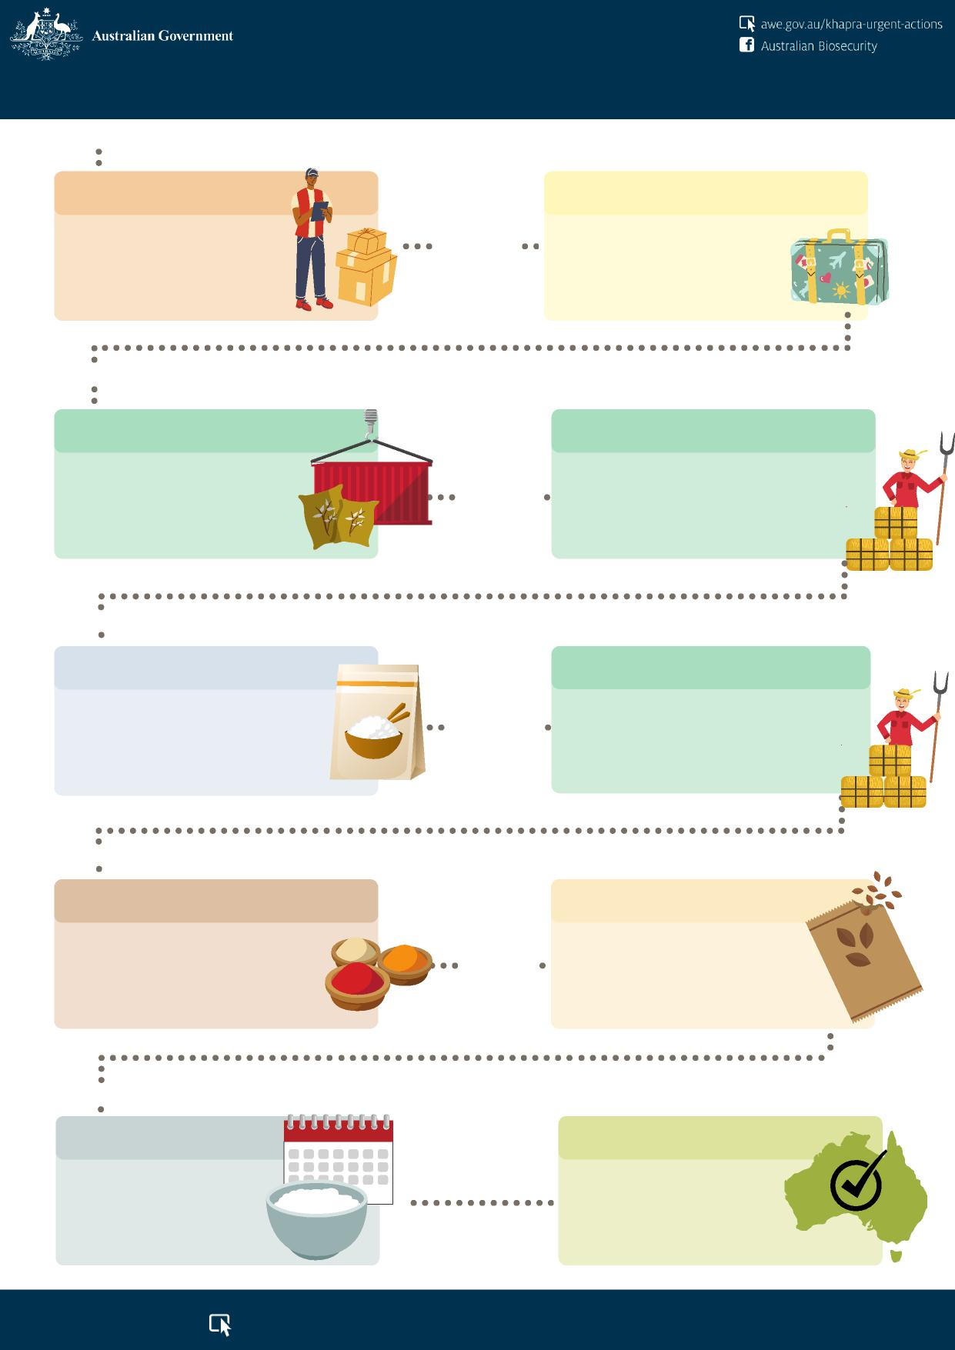

**3 Sept 2020**

**15 Oct 2020**

Ban on high-risk plant products, e.g. rice, within unaccompanied personal effects & low value freight.

**Phase 1**

Ban on high-risk plant products, e.g. rice, being brought in with international travellers or in mail parcels and packages.

**Phase 2**

**KHAPRA BEETLE URGENT ACTIONS**

**12 Apr 2021**

**12 July 2021**

Offshore treatment of containers carrying high-risk plant products, e.g. rice, packed into a container in a country that has khapra beetle.

**Phase 6A**

Offshore treatment of containers carrying products other than high-risk plant products, packed into a container in a country that has khapra beetle & then unpacked in a rural grain growing area in Australia.

**Phase 6A (continued)**

**30 Sept 2021**

Offshore treatment and phytosanitary certificate requirements for commercial imports of high-risk plant products, e.g. rice.

**Phase 3**

**15 December**

**2021**

Offshore treatment of containers carrying products other than high-risk plant products, packed into a container in a country that has khapra beetle & then unpacked in a rural nut growing area in Australia.

**Phase 6A (extended)**

**28 April 2022**

**28 April**

**2022**

Revised phytosanitary certificate requirements for imports of other risk plant products, e.g. spices.

**Phase 4**

Introduction of phytosanitary certificates for imports of seeds that are to be used for sowing.

**Phase 5**

**Late 2022**

**End**

New requirements for containers that have held high-risk plant products.

**Phase 6B**

These changes will help keep Australia khapra beetle free!

[**awe.gov.au/khapra-urgent-actions**](http://awe.gov.au/khapra-urgent-actions)



DCCC paper suitable for sharing   
**DCCC Meeting 91 – 7 March 2022**

**Agenda Item 5.2c**

**DAWE International activities**

**For INFORMATION**

**PURPOSE**

To provide DCCC members with information about the department’s international biosecurity management activities intended to mitigate biosecurity risk across trade and travel supply chains before it reaches our borders.

**Key Points**

**International engagement**

The department’s strategic engagement activities build international, regional and bi-lateral relationships to influence trade policy, standards and rule settings; meet our international obligations; maintain Australia’s favorable Plant and Animal health status; and build capability in near neighbors.

International efforts range from actions to create new and maintain existing markets (including a network of agricultural counsellers in key trade locations), foster the sustainable management of forests globally, to those aimed at protecting our environment, agricultural industries and quality of life from the impacts of harmful exotic pests and disease.

The focus of this paper is on biosecurity and food related activities and engagement.

International fora include (but is not limited to):

* International Plant Protection Convention (IPPC) and its governing body, the Commission on Phytosanitary Measures (CPM)
* World Organization of Animal Health (OIE) – Chair, Mark Schipp, Australian Chief Veterinary Officer
* Codex Alimentarius Commission (CODEX)
* International Maritime Organization (IMO)
* International Regional Organisation for Plant and Animal Health (OIRSA)
* Pacific Agreement on Closer Economic Relations
* World Trade Organisation (WTO)
* Organisation of Economic Cooperation Development (OECD).

**Capability building in near neighbours (systems, education, technical, surveillance)**

The department undertakes a range of activities to build capability in the region and work with near

neighbors to achieve mutually beneficial biosecurity outcomes. This includes:

* **Pacific partnerships**

o Operationalising Australia's Pacific Agreement on Closer Economic Relations Plus (PACER Plus) to facilitate trade with Pacific Island countries, including Papua New Guinea, Fiji, Solomon Islands, Vanuatu, Tonga, Samoa, and Timor-Leste, and will also involve other pacific island countries.

* **Data and systems**

UNCLASSIFIED Page 1 of 4

DCCC paper suitable for sharing

* Progressing upgrades to support the Pacific Island Pest List Database to become the trusted source of data on plant pests, hosts and distribution, and meet international reporting obligations under the IPPC.
* **Education**
* An education, awareness and training program focused on operational aspects on cleaning containers and maintaining the integrity of clean containers.
* **Technical**
* Designing biosecurity preparedness, response and surveillance plans and programs with Timor-   
  Leste and Papua New Guinea, including diagnostic platforms for emerging animal diseases
* Frameworks and systems to mitigate the risk of future pandemics.

**Cross-jurisdiction biosecurity collaboration**

* **International Cargo Cooperative Biosecurity Arrangement (ICCBA)**
* This voluntary, non-binding multilateral arrangement provides a platform for biosecurity agencies to collaborate on biosecurity initiatives. It includes representation from 14 agencies (a further 8 agencies investigating membership).
* The ICCBA aims to provide rigor around the operational implementation and management of biosecurity policies developed by bodies such as the International Plant Protection Convention. Current interests are in developing treatment methodologies and their verification with potential to expand to inspection and biosecurity assurance activities.
* **Quarantine Regulators Meeting**
* Established in 2008 the annual Quarantine Regulators Meeting (QRM) connects government agencies responsible for, or involved in, biosecurity and border management.
* Participation is open to all biosecurity agencies. QRMs have attracted representation from more than 20 agencies from South-East and South Asia, the Americas and Pacific. QRMs support harmonising biosecurity border management, trade facilitation and capacity building.
* **Australia and New Zealand Biosecurity Cooperation**
* Established by Australian and New Zealand ministers in 1999 under the terms of the Australia New Zealand Closer Economic Relations Trade Agreement.
* The Australia and New Zealand Biosecurity Cooperation (ANZBC) provides the impetus and direction for harmonising animal and plant health measures affecting trade between the two countries. To this end, Australia and New Zealand have committed where possible to
* recognise each other’s systems to manage biosecurity risk (e.g. verification and certification processes) and facilitate trans-Tasman trade
* remove unnecessary trans-Tasman biosecurity controls (e.g. trans-Tasman passenger requirements)
* jointly explore advances in screening and detection technologies, and
* implement a consistent approach to biosecurity risk assessment and management of imports from third countries.
* Three working groups operate under the ANZBC – the Animal Technical Working Group, Plant Technical Working Group and an Operational Technical Working Group.
* **Sea Container Task Force (SCTF)**
* Established in 2017 to facilitate implementation of the CPM’s Complimentary Action Plan; promote the uptake of the CTU code (IMO/ILO/UNECE Code of Practice for Packing of Cargo Transport Units Code); and measure its success in minimising pest risks associated with the movement of sea containers in the global supply chain.
* This involved the department working with international industry bodies representing shipping lines, container manufacturers and owners, and shippers. The SCFT has now disbanded.
* **Hitchhiker pest measure**

UNCLASSIFIED Page 2 of 4

DCCC paper suitable for sharing

* Under the hitchhiker measure, Australia works with a range of national plant protection organisations to identify and establish collaborative opportunities for sea container risk management.

**Offshore accreditation Schemes**

* **Australian Fumigation Accreditation Scheme (AFAS)**
* Involves collaboration with overseas government agencies in Cambodia, Fiji, India, Indonesia, Lao, Malaysia, Peru, Philippines, Sri Lanka, PNG, Thailand and Vietnam to set treatment accreditation standards, registration for accreditation of fumigation companies and training for fumigators and regulatory officers.
* **Offshore BMSB treatment providers scheme**
* Sets out the minimum registration and compliance requirements for treatment providers conducting BMSB treatments on goods bound for Australia and/or New Zealand during the 2021­22 BMSB risk season. Joint scheme with the NZ Ministry for Primary Industries.
* Treatment providers who meet the scheme standards are added to the 2021-22 list of offshore BMSB treatment providers.
* **Motor Vehicle Inspection Program and Offshore Treatment Scheme**
* Established in 2009 to manage the biosecurity risk associated with new vehicles exported to Australia from Thailand, MVIP is a collaborative effort between industry, including the Australian Federal Chamber of Automotive Industries, the Thai Automotive Industry Association, and the governments of Thailand and Australia. MVIP works by training and accrediting industry personnel to inspect, clean and certify new vehicles are free from biosecurity risk material prior to export. The Thai Department of Agriculture provides regulatory oversight of this process in Thailand.
* A similar scheme exists for the offshore treatment and cleaning of used vehicles primarily from Japan.
* **Sea Container Hygiene System**
* Voluntary biosecurity agreement developed by industry in collaboration with New Zealand’s Ministry for Primary Industries. The agreement seeks to manage biosecurity risk associated with sea containers imported from Country Action list (CAL) countries at the port of loading.

**Supply chain assurance**

* **Food**
* Established in 2018, the Global Alliance on Food Crime (Global Alliance) forms a coalition of food regulation agencies from the United Kingdom, United States, New Zealand, Canada and Australia. The alliance shares information relating to food fraud and crime.
* **Plant**
* Involves audits and verification of pre-export treatment facilities and operational procedures.
* Similar activity for plant-based animal feed and ingredient manufacturing facilities in Malaysia, Papua New Guinea, Indonesia, Thailand, Turkey, China, India and the Solomon Islands; in the US and UK for nursery stock pathways; and in the US for cherry and stone fruit pathways.

**Vessel ballast water compliance**

* Ensuring a high level of industry compliance with the International Convention for the Control and Management of Ships’ Ballast Water and Sediments (BWM Convention) as ships transition to the use of new ballast water management technology in Australian ports.

UNCLASSIFIED Page 3 of 4

DCCC paper suitable for sharing

**BACKGROUND**

This paper has been developed to address an action item taken at DCCC meeting 88 on 31 March 2021 to provide a summary of work being undertaken by the department internationally.

**CLEARED BY**

*Leanne Herrick, Principal Director, Industry Partnership and Engagement*, *following input from relevant business leads.*

UNCLASSIFIED Page 4 of 4



DCCC paper suitable for sharing

**DCCC Meeting 91 – 7 March 2022**

**Agenda Item 5.3a**

**Compliance Activities Snapshot**

**For INFORMATION**

**PURPOSE**

To provide DCCC members with a snapshot of compliance activities for the first half of the 2021-2022 financial year.

**KEY POINTS**

The attached Compliance Activities Snapshot provides an overview of activities and assessments conducted by the department from 1 July 2021 to 31 December 2021.

**CLEARED BY**

*Holly Buckle, Assistant Secretary, Enforcement, Compliance and Enforcement*

**ATTACHMENT**

A: Compliance Activities Snapshot –Second Quarter Statistics - Financial Year 2021 – 2022

UNCLASSIFIED

Page 1 of 1

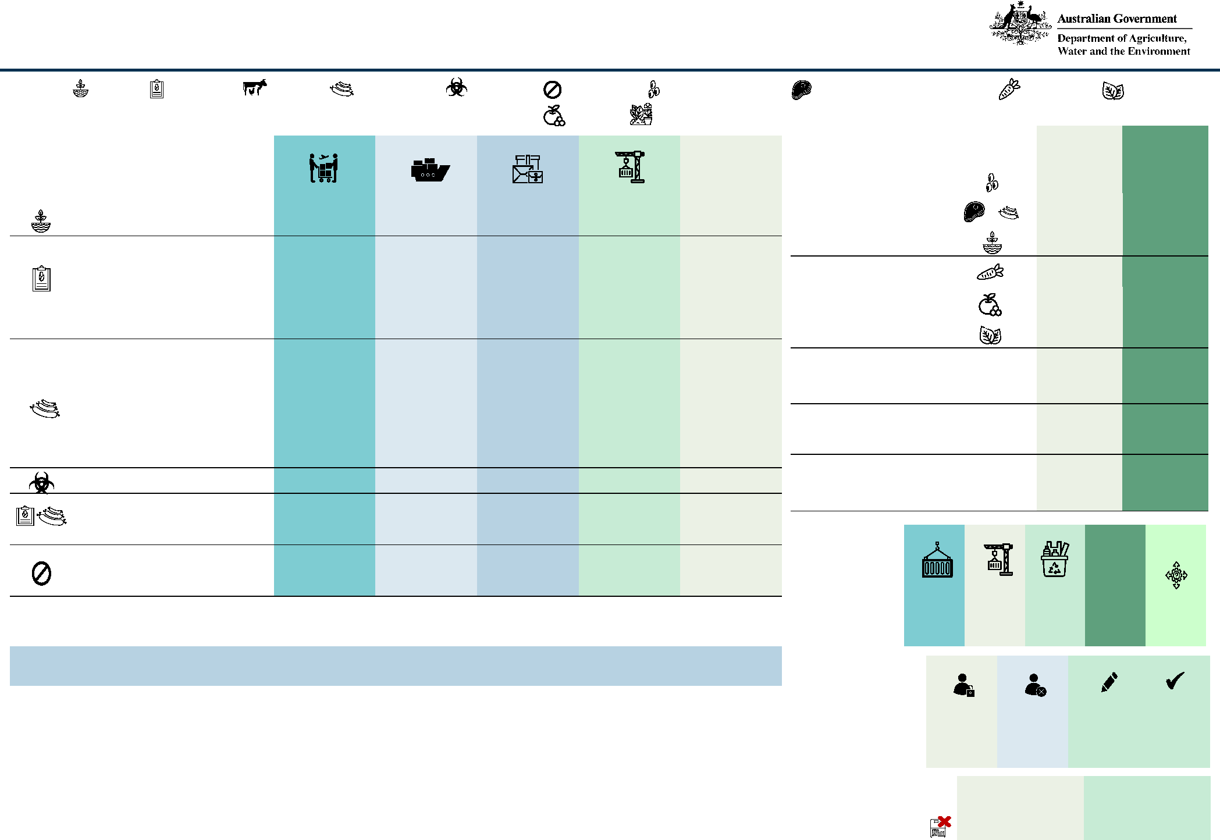

**Compliance Activities Snapshot – Second Quarter Statistics - Financial Year 2021-2022**

|  |  |  |  |  |  |  |  |  |  |  |  |
| --- | --- | --- | --- | --- | --- | --- | --- | --- | --- | --- | --- |
| **Investigations Commenced During the Quarter** | | **Air Cargo**  **QTR 2 FYTD** | | **Sea Cargo**  **QTR 2 FYTD** | | **Mail**  **QTR 2** | **FYTD** | **Export**  **QTR 2 FYTD** | | **Other**  **QTR 2 FYTD** | |
| Biosecurity Act | | 1 | 4 | - | - | 1 | 1 | - | - | - | - |
| Biosecurity Act | | - | - | - | - | 1 | - | - | - | - | - |
|  | Imported Food | - | - | 2 | 2 | - | - | - | - | - | - |
|  | Biosecurity Act & Imported Food | - | - | 1 | 1 | - | - | - | - | - | - |
| Biosecurity Act & Criminal Code | | - | 1 | - | - | - | - | - | - | - | - |
| Biosecurity Act | | 1 | - | 1 | 2 | - | - | - | - | 1 | 2 |
| Imported Food | | - | - | 1 | 1 | - | - | - | - | - | - |
| Exported Control Act | | - | - | - | - | - | - | 1 | 1 | - | - |
| Criminal Code | | - | - | - | 1 | - | - | - | - | - | - |
| Biosecurity Act & Imported Food | | - | 1 | - | 1 | - | - | - | - | - | - |
| Biosecurity Act | | 1 | 2 | - | 2 | - | - | - | - | - | - |
|  | Biosecurity Act | - | - | - | 1 | - | - | - | - | - | - |
|  | Criminal Code | - | - | 1 | 1 | - | - | - | - | - | - |
| Biosecurity Act | | - | - | - | 1 | - | - | - | - | - | - |
| Biosecurity Act & Criminal Code | | - | - | - | 1 | - | - | - | - | - | - |

**Court Outcomes**

|  |  |  |
| --- | --- | --- |
| **Infringement Notices**  **Biosecurity Act**  Category 1 goods  (12 penalty units =  $2,664) | **QTR 2**  7  43  2 | **FYTD**  91 |
| Category 2 goods  (6 penalty units = $1,332) | 2  22  3 | 50 |
| Other goods  (2 penalty units = $444) | 101 | 170 |
| Company  (60 penalty units = $13,320) | - | 1 |
| **Imported Food Control Act**  Company  (60 penalty units = $13,320) | - | 1 |

|  |  |  |  |  |
| --- | --- | --- | --- | --- |
| **Imports** | **Exports** | **Waste** | **Total** | **Adverse** |
|  |  |  |  | **Decisions** |
| 167 | 390 | 28 | 282 | 2 (import) |
| 315 | 879 | 60 | 951 | 3 (import) |

***Plant products; Live animals; Animal products; Biosecurity risk; Non-commodity; Whole unprocessed seeds; Meat and meat products (non-retorted); Fresh vegetables; Fresh leaves;***

***Legend: Live plants;***

***Fresh fruit; Fresh herbs***

|  |  |  |  |  |
| --- | --- | --- | --- | --- |
| **Date** | **Entity type** | **Offence(s)** | **Outcome** |  |
|  |  |  |  | **Approved** |
| 23 Nov 2021 | Individual | One (1) count s 67(3) *Quarantine Act 1908* | Pleaded guilty **Arrangements** | |
|  |  | - Aggravated illegal importation | - Sentenced to two (2) years imprisonment with  immediate release **QTR 2** | |
|  |  | One (1) count s 135.1(7) *Criminal Code* |  | |
|  |  | - Dishonestly intending to influence a | **FTYD** | |
|  |  | Commonwealth public official |  | |

|  |  |  |  |
| --- | --- | --- | --- |
| **Suspended** | **Revoked** | **Corrective Actions** | |
|  |  | **Issued** | **Resolved** |
| - | - | 14 | - |
| - | - | 426 | - |

**Visa Cancellations**

**QTR 2**

-

**FYTD**

-

**Fit and Proper Persons Assessments**

**QTR 2 FYTD**



DCCC paper suitable for sharing

**DCCC Meeting 91 – 7 March 2022**

**Agenda Item 5.3b**

**Legislative Amendments**

**For INFORMATION**

**PURPOSE**

To update DCCC members of amendments to legislation for civil and regulatory sanctions.

**KEY POINTS**

The attached document provides an update on legislative amendments to civil and regulatory sanctions.

**CLEARED BY**

*Holly Buckle, Assistant Secretary, Enforcement, Compliance and Enforcement*

**ATTACHMENT**

A: Legislative Amendments 2022: Civil and Regulatory Sanctions

UNCLASSIFIED

Page 1 of 1

***Biosecurity Amendment (Strengthening Penalties)***

***Act 2021***

* **From 30 June 2021, the penalties that a court may impose   
  under 28 civil penalty provisions and criminal offences under   
  the *Biosecurity Act 2015* have been significantly increased*.***
* **In some cases, they are more than eight times the current penalty to reflect the potential gains someone might obtain, or seek to obtain, by not complying with the law.**

***The Biosecurity Amendment (Enhanced Risk***

***Management) Bill 2021***

* **This Bill is likely to be debated by the Senate in March 2022.**
* **The Bill proposes increasing the penalties for 30 criminal offence and civil penalty provisions under Chapter 3 of the *Biosecurity Act 2015* that were not covered by the *Biosecurity Amendment (Strengthening Penalties) Act 2021*.**

**Visa Cancellations:**

**From 1 January 2021, the biosecurity-related visa cancellation ground in the *Migration Regulations 1994* applies to 18 subclasses of visa, including international students and holders of temporary work visas. Initially it only applied to 5 subclasses of visitor/transit visas.**

**Australian Border Force have cancelled 14 visas under this ground since 1 October 2019, 10 of the decisions relate to failure to declare pork or pork products.**

Civil and Regulatory Sanctions:

Legislative Amendments 2021 as at 10 Feb 2022

***Biosecurity (2021 Infringement Notices) Determination 2020* From 1 January 2021, biosecurity officers may issue a higher value infringement notice when travellers knowingly fail to declare high risk goods on arrival into Australia. The recently remade *Biosecurity (2022 Infringement Notices) Determination 2021* lists the classes of goods that are subject to 6 and 12 penalty unit infringement notices:**

* **Category 1 goods – 12 penalty units ($2,664)** – live plants, whole unprocessed seeds, meat and meat products (except retorted meat), raw or partially raw prawns, live animals (and remains of animals that have died in transit), bird or reptile eggs for hatching, and/or veterinary vaccines.
* **Category 2 goods – 6 penalty units ($1,332)** – fresh fruit, fresh vegetables, fresh fungi, fresh leaves and/or fresh herbs.
* If a traveller fails to declare goods not listed in the new determination, the infringement notice amount is **2 penalty**

**units ($444).**

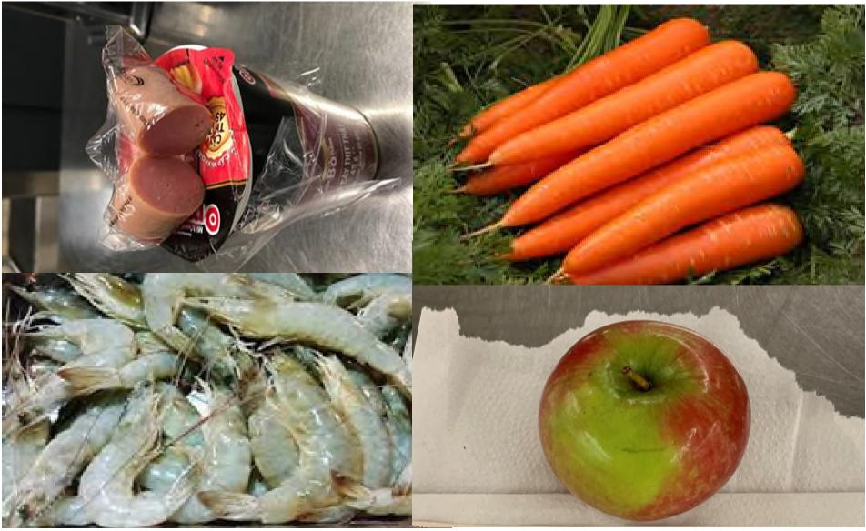



DCCC paper suitable for sharing   
**DCCC Meeting 91 – 7 March 2022**

**Agenda Item 5.4a**

**Biosecurity Cost Recovery Arrangement Financial Report**

**For INFORMATION**

**PURPOSE**

To update DCCC members on biosecurity cost recovery arrangement revenue, expenses and cost recovery reserve streams.

**KEY POINTS**

The Biosecurity Arrangement is tracking below budget with revenue down by $5.4 million compared to budget. This is primarily due to a reduction in fee-for-service activities being impacted by COVID-19 - third-party premises have been closed to our staff, or the unavailability of our own staff. As a result of this, we have revised downwards our January to June forecasts.

The Biosecurity Cost Recovery Team and operational areas continually monitor activity and will update forecasts as required if there are growing trends away from current volumes.

A review of the Cost Recovery Implementation Statement (CRIS) for biosecurity is well underway, however, DCCC members have not been provided with a paper for the Biosecurity Cost Recovery Review while costs and volumes are being considered. The department is expecting to consult with DCCC on the CRIS in coming months, pending the timing of the federal election.

**BACKGROUND**

The department has authority to recover certain costs from import industry participants for biosecurity activities that protect our export industries, our environment, and our way of life.

The Biosecurity Cost Recovery Arrangement reports the revenue raised and expenses incurred by the Department to assess and manage the biosecurity risks arising from people, goods, and conveyances (sea and aircraft) entering Australia. These activities also include assessing compliance of imported food with relevant food standards and public health and safety.

**CLEARED BY**

*Rachel Short, A/g Assistant Secretary, Funding and Revenue Branch, DAWE*

**ATTACHMENT**

A: Biosecurity Cost Recovery Arrangement Financial Reports at 31 December 21

For Official Use Only (FOUO)

Page 1 of 1

FOR OFFICIAL USE ONLY

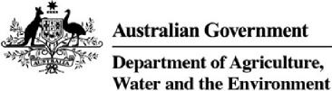

**Biosecurity Cost Recovery Arrangement**

Financial Performance for 2021–22

as at 31 December 2021

Finance Division



Page 1 of 8

FOR OFFICIAL USE ONLY

© Commonwealth of Australia 2021

Disclaimer:

The Australian Government acting through the Department of Agriculture, Water and the Environment has exercised due care and skill in preparing and compiling the information and data in this report. Notwithstanding, the Department of Agriculture, Water and the Environment, its employees and advisers disclaim all liability, including liability for negligence and for any loss, damage, injury, expense or cost incurred by any person as a result of accessing, using or relying on any of the information or data in this report to the maximum extent permitted by law

Page 2 of 8

FOR OFFICIAL USE ONLY

**The Biosecurity Arrangement**

The Department commenced partial cost recovery of selected biosecurity activities in 1979 and implemented full cost recovery from 1 January 1991. The Department’s biosecurity activities are provided to these key groups:

* **Importers** – inspection, assessment and management of the biosecurity risks associated with imported goods and packaging (including air and sea cargo, containers, international mail, food, live animals and plants). This also includes husbandry activities undertaken by the department, associated with the PEQ of live animals and plants prior to release into Australia (such as horses, dogs, cats, hatching eggs, birds, ruminants, bees, nursery stock and viable seeds).
* **Conveyance operators** – assessments and inspections of vessel and aircraft entering Australia to manage the risks posed by the vessel, contaminants on the vessel, human biosecurity risks, ballast water and biofouling on vessels, and aircraft disinsection (where non-compliant on arrival) and assessment of aircraft for release from biosecurity control.
* **Approved arrangement participants** – administering arrangements, managing compliance regimes, and setting standards for various third-party arrangements managed by the department, such as quarantine approved premises, compliance agreements and imported food compliance agreements.
* **Passengers** – assessment and management of biosecurity risks posed by baggage accompanying passengers. Activities such as inspection and assessment of baggage are only cost recovered when provided outside of designated international airports or seaports.

The Biosecurity Act 2015 is the primary biosecurity legislation in Australia. The Imported Food Control Act 1992 is the primary food importation legislation. Subordinate legislation (including regulations) and supporting policies affect the management of ballast water, approved arrangements and import risk analysis.

The Biosecurity Regulation 2016 provides fees for different biosecurity regulatory activities. Section 592 of the Biosecurity Act allow fees that may be charged in relation to activities carried out by, or on behalf of the Commonwealth, to be prescribed in regulations made under the Act.

The Imported Food Regulations 2019 provides fees for different chargeable services. Section 36 of the Imported Food Control Act allow fees that may be charged in relation to certain chargeable services, to be prescribed in regulations made under this Act.

Page 3 of 8

FOR OFFICIAL USE ONLY

**2021-22 Budget**

**Revenue assumptions**

Australia spent 2020-21 in lockdown, navigating its way through the pandemic, yet import activity exceeded our forecasts as consumer spending shifted to goods in place of services. The 2021-22 budget projected growth in anticipation of continuing higher import activity. However, our December forecast for 2021-22 recognises a decline in fee for service (FFS) revenue resulting from COVID-19 outbreaks and associated lockdowns impacting the delivery of frontline services. Using 2020-21 volume trends, full import declarations are expected to continue to increase, however, this will be offset by lower inspection and assessment activity.

**Expense budget**

The 2021-22 expense budget reflects the effort and resources required for the forecast regulatory activity volumes. The total expenses are an increase on the 2020-21 actual expenses, with the forecast including the additional effort to manage the risk posed by hitchhiker pests, as announced in the May 2021 Budget. Operational areas are allocated funding for regulatory activities based on forecast revenue volumes and departmental priorities as agreed by the Secretary and Deputy Secretaries of the Department.

An updated Biosecurity Cost Recovery Impact Statement (CRIS) for 2021-22 is expected to be released shortly showing the 2021-22 forecast revenue and expenses and the actual results for 2020-21. Table 1 below provides a summary of forecast and actual revenue and expense for 2021-22 and 2020-21.

**Full year forecast**

The full year forecast below is for a deficit of $12.1 million after taking into account known revenue and expense adjustments still to be processed in our finance system. The forecast expenses include $11.7 million to manage the risk of hitchhiker pests for which we have not increased prices. The over-recovery in 2020-21 is being used to fund this measure in 2021-22. A new CRIS is expected to be in place for 1 July 2022, which will include future year impacts for the hitchhiker measure.

**Table 1 Biosecurity arrangement forecasts and actuals for 2020-21 and forecasts for 2021–22**

|  |  |  |  |
| --- | --- | --- | --- |
| **Finance element** | **2020–21($)**  **Forecast** | **2020–21($)  Actuals** | **2021–22($) Forecast** |
| Revenue = X | 281,668,212 | 285,801,049 | 292,681,388 |
| Expenses = Y | 279,284,678 | 276,214,706 | 304,786,428 |
| **Balance = X – Y** | **2,383,534** | **9,586,343** | **- 12,105,040** |
| Remissions | -2,383,534 |  |  |
| Estimated opening cost recovery reserve balance 1 July | 36,318,932 | 25,492,390 | 35,078,733 |
| **Estimated closing cost recovery reserve balance 30 June** | **36,318,932** | **35,078,733** | **22,973,693** |

Page 4 of 8

FOR OFFICIAL USE ONLY

**December 2021 YTD performance for the Biosecurity Arrangement**

**Table 2 – Summary of the December 2021 YTD performance for the overall Biosecurity Arrangement**

|  |  |  |  |  |  |
| --- | --- | --- | --- | --- | --- |
| **Biosecurity Arrangement** | **Dec 2021-22 YTD** | | | | **Dec 2020-21** |
| **Actual** | **Budget** | **Variance** | | **Actual** |
| **$’000** | **$’000** | **$’000** | **%** | **$’000** |
| **Total Revenue** | **141,932** | **147,322** | **(5,390)** | **-4%** | **146,584** |
| **Total Expense** | **151,609** | **140,343** | **11,267** | **8%** | **138,005** |
| Employee Benefits | 98,792 | 94,170 | 4,622 | 5% | 93,673 |
| Operating Expenses | 40,078 | 35,810 | 4,268 | 12% | 30,030 |
| Asset Related Expenses | 12,740 | 10,363 | 2,377 | 23% | 14,302 |
| Other Expenses | - | - | ) | 0% | - |
| **Operating Surplus / (Deficit)** | **(9,677)** | **6,979** | **(16,657)** | **>100%** | **8,579** |

**Key points for the biosecurity arrangement**

The arrangement’s revenue variance of $5.4 million is primarily due to:

* Full Import Declarations (FIDs)
* Sea FIDs – below budget by $2.1 million
* Offset by Air FIDs – $2.6 million above budget
* Invoicing for approved arrangement annual registration charges delayed until February 22 – resulting in a temporary $2.9 million revenue shortfall.
* Fee for service revenue (inspection, audit, assessment, etc.) – down $3.2 million compared to budget, due to operational impacts of lockdowns noted earlier.

**1. Import clearance**

The combined volume of air and sea importation activities for December 2021 YTD is above budget (25,917 units or 1.2%), indicating no discernible increase or decrease in activity. However, there has been a persistent pattern of lower sea FIDs and higher air FIDs throughout the YTD. Both sea and air FIDs recorded their highest increase over budget in the month of November, leading up to Christmas.

**Table 3 – December 2021 YTD performance for Import Clearance**

|  |  |  |  |  |  |
| --- | --- | --- | --- | --- | --- |
| **Import Clearance Stream** | **Dec YTD 2021-22** | | | | **Dec 2020-21** |
| **Actual** | **Budget** | **Variance** | | **Actual** |
| **$’000** | **$’000** | **$’000** | **%** | **$’000** |
| **Total Revenue** | **122,573** | **127,556** | **(4,984)** | **-4%** | **128,223** |
| **Total Expense** | **127,909** | **120,596** | **7,313** | **6%** | **116,002** |
| Employee Benefits | **84,706** | **81,652** | **3,054** | **4%** | **80,975** |
| Operating Expenses | **31,659** | **29,501** | **2,158** | **7%** | **24,089** |
| Asset Related Expenses | **11,544** | **9,443** | **2,101** | **22%** | **10,938** |
| **Operating Surplus / (Deficit)** | **(5,336)** | **6,961** | **(12,297)** | **>100%** | **10,872** |

**Key points for the import clearance stream**

* FIDs volume – air 9.1% increase (100,589 units) and sea 2.0% decrease (19,289 units) on 2020–21, actuals as shown graphically in Figures 1 and 2 below.
* FIDs revenue – air $3.8 million increase and sea $0.9 million decrease on 2020–21 actuals
* Inspections (out-of-office) – 5.9% decrease (15,586 units or $0.9 million) on 2020–21 actuals
* Document assessment – 16.6% decrease (47,651 units or $1.4 million) on 2020–21 actuals

Page **5** of **8**

FOR OFFICIAL USE ONLY

Figure 1 – Air volume comparison for the last three financial years

FIDs - Air Volume

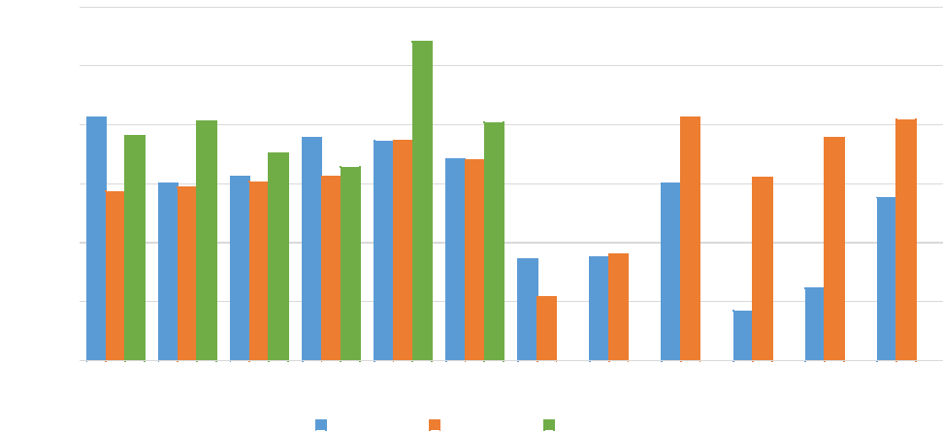

240,000

Jul Aug Sep Oct Nov Dec Jan Feb Mar Apr May Jun

2019-2020 2020-2021 2021-2022

220,000

200,000

180,000

160,000

140,000

120,000

Figure 2 – Sea volume comparison for the last three financial years

FIDs - Sea Volume

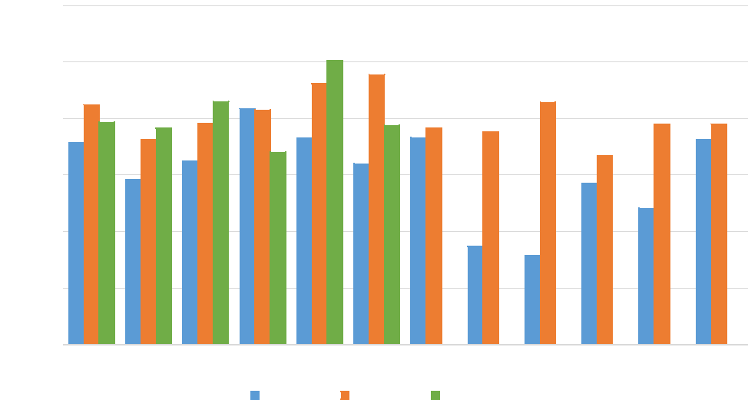

200,000

Jul Aug Sep Oct Nov Dec Jan Feb Mar Apr May Jun

2019-2020 2020-2021 2021-2022

180,000

160,000

140,000

120,000

100,000

80,000

Page 6 of 8

FOR OFFICIAL USE ONLY

**2. Seaports**

The number of cargo freighters YTD to 31 December 2021 increased compared to the same period last year. Volumes have remained relatively consistent each month for the first half of 2021-22 except for a significant drop in December 2021.

**Table 4 – December 2021 YTD performance for Seaports**

|  |  |  |  |  |  |
| --- | --- | --- | --- | --- | --- |
| **Seaports Stream** | **Dec YTD 2021-22** | | | | **Dec 2020-21** |
| **Actual** | **Budget** | **Variance** | | **Actual** |
| **$’000** | **$’000** | **$’000** | **%** | **$’000** |
| **Total Revenue** | **11,670** | **12,041** | **(371)** | **-3%** | **11,853** |
| **Total Expense** | **15,443** | **12,578** | **2,865** | **23%** | **12,475** |
| Employee Benefits | 10,418 | 8,981 | 1,437 | 16% | 8,537 |
| Operating Expenses | 4,190 | 2,895 | 1,295 | 45% | 2,368 |
| Asset Related Expenses | 834 | 702 | 133 | 19% | 1,570 |
| **Operating Surplus / (Deficit)** | **(3,773)** | **(537)** | **(3,237)** | **85.8%** | **(1,004)** |

**Key points for seaports**

* Vessel (≥25m) arrivals – an increase of 4.2% or 346 vessels on 2020-21 for December YTD, per Figure 3 below.
* Vessel arrivals (≥25m) in the month of December 2021 were down by 24 vessels on December 2020 and 131 less than December 2019 (a decrease of 10%), as illustrated by Figure 3

**Figure 3 – Vessel arrivals volume comparison for the last three financial years**

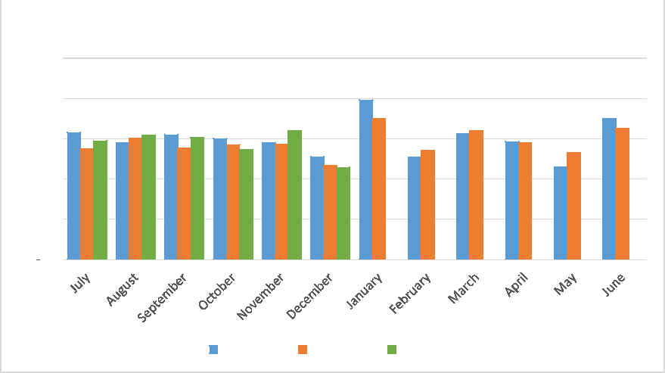

Vessels (25m or more) - Volumes

2,500

2,000

1,500

1,000

500

2019-2020 2020-2021 2021-2022

Page **7** of **8**

FOR OFFICIAL USE ONLY

**3. Post Entry Quarantine (PEQ) Facility, Mickleham**

PEQ overall December 2021 YTD revenue is below the 2021-22 budget by $35k or 0.5%. The December 2021 YTD revenue is higher than the 2020-21 actuals for the same period, indicating overall activity has increased this financial year. The Biosecurity Cost Recovery section will monitor this to see if any trends emerge that require updates to forecasts, in consultation with the PEQ management. The revenue position is not homogenous across the streams: in the non-horse (imports of cats, dogs, birds and hatching eggs) and plant streams, revenue is slightly below budget while revenue for the horse stream is currently greater than budget.

**Table 5 – December 2021 YTD performance for PEQ**

|  |  |  |  |  |  |
| --- | --- | --- | --- | --- | --- |
| **PEQ Stream** | **Dec YTD 2021-22** | | | | **Dec 2020-21** |
| **Actual** | **Budget** | **Variance** | | **Actual** |
| **$’000** | **$’000** | **$’000** | **%** | **$’000** |
| **Total Revenue** | **7,690** | **7,725** | **(35)** | **0%** | **6,514** |
| **Total Expense** | **8,258** | **7,170** | **1,088** | **15%** | **8,179** |
| Employee Benefits | 3,668 | 3,537 | 131 | 4% | 4,162 |
| Operating Expenses | 4,228 | 3,414 | 814 | 24% | 3,572 |
| Asset Related Expenses | 362 | 219 | 143 | 65% | 444 |
| **Operating Surplus / (Deficit)** | **(568)** | **555** | **(1,123)** | **>100%** | **(1,664)** |

**Key points for the PEQ**

* Cats – an increase of 12% or 84 animals and increased revenue of $101k, compared to 2020-21 December YTD.
* Dogs – an increase of 8% or 123 animals and increased revenue of $148k, compared to 2020-21 December YTD.
* Plants – an increase of 35% or 1002 plants (m2 per month) and increased revenue of $110k, compared to 2020-21 December YTD.
* Horses – an increase of 51% or 135 horses and increased revenue of $405k, compared to 2020-21 December YTD.
* Operational expenses remain high relative to other costs for the PEQ and are being examined as part of the review of the Biosecurity Cost Recovery Arrangement.

Page **8** of **8**