

DCCC information paper suitable for sharing   
**DCCC Meeting 92 – 13 July 2022**

**Agenda Item 6.1b**

**Cargo Operational Reforms and Biosecurity Innovation Initiatives**

**For INFORMATION**

**PURPOSE**

To update members on the reforms and initiatives underway to modernise cargo operations and services, decrease border congestion, and ensure the biosecurity system is more resilient and able to respond effectively to changing needs/risks.

**KEY POINTS**

A high-level snapshot of key reforms and innovation initiatives is provided in **Attachment A.**

Ongoing progress updates will be provided to the DCCC with more detailed papers/presentations provided where initiatives reach significant milestones, new initiatives come online, or are specifically requested by DCCC members.

The suite of reforms aligns with the department’s *Future Ready* Blueprint which sets out the capabilities we need to build by 2025 across 8 workstreams; the Commonwealth Biosecurity 2030 Roadmap; and proposed cross agency initiatives to simplify trade regulation and introduce digital services that offer improved user experiences for industry. Some activities are a direct response to recommendations of the Inspector General of Biosecurity and the Australian National Audit Office.

**CLEARED BY**

*Leanne Herrick, Principal Director, Industry Partnership and Engagement*, *following input from relevant business leads.*

**ATTACHMENT**

A: Cargo Operational Reforms and Innovation Initiatives

UNCLASSIFIED Page 1 of 1

|  |  |  |
| --- | --- | --- |
|  |  | Cargo Operational Reforms and innovations - Biosecurity Operations Division  July 2022 |
| **POLICY & SYSTEMS** |  |
|  |  |  |



June-July 2022 Aug-Sep 2022

* Four out of seven pilots completed.
* Ongoing work to design and implement new `green lane' arrangements post trial
* Successful pilot participants transition to new arrangements from July/August 2022
* Remaining successful pilots transition to new arrangements
* Application and assessment process finalised and arrangement   
  program opened to broader importer cohort from September.

June-July 2022 Aug-Sep 2022

* Progress AA system enhancements and variation to class 19 arrangements
* Industry participant engaged to progress private Beta Phase
* RTG automation work package to be completed
* Continued progression of AA system enhancements
* Expand private beta participants
* Open AA to all eligible industry participants

**Proof of Concept - New Third Party Arrangements for Imported Cargo**

To test whether equal or better biosecurity outcomes can be achieved by leveraging importer supply chain quality assurance systems

**Rural tailgate inspections**

New Approved Arrangement (Class 14.4) to allow industry to conduct tailgate inspections for containers destined for rural locations

**Port of Melbourne Led Trials**

Design of end-to-end solution/s to transform the way biosecurity outcomes are achieved at ports, using the Port of Melbourne (PoM) and break bulk cargo (new cars) as a test case.



June – Sep 2022

* DAFF/Industry co-design and trial of solutions to transform the clearance of new cars through PoM, including data collection and management, offshore treatment, automated screening of vehicles via a mobile gantry scanner and secondary inspections
* Trial scope determined and trials conducted from July.



June-July 2022

Aug-Sep 2022

* SAC automation live with defined declaration set
* Pilot completed for MinDocs automation
* At-volume document training to be completed
* Ongoing system enhancements including algorithm and user interface
* Additional users/assessment officers to be added
* Expansion of SAC automation
* Stage 2 - ICS API solution development and testing
* Full implementation of MinDocs automation
* All Assessment officers trained and using automated process
* Ongoing system enhancements for the solution

**Automated assessment of import documentation processes**



June-July 2022

Aug-Sep 2022

**Biosecurity Portal**

Self service online portal will enable industry to view and manage all biosecurity transactions - inspection bookings, cancellations and transaction status – in a centralised portal

* Deployment completed in QLD, SA, NT, NSW, ACT and WA
* Accessibility expanded to third parties (eg. Freight Forwarders)
* Improved navigation and automation of scheduling process
* Full national deployment expected by end of July
* API build commenced to enable connection with industry/third party software

Cargo Operational Reforms and innovations - Biosecurity Operations Division

July 2022

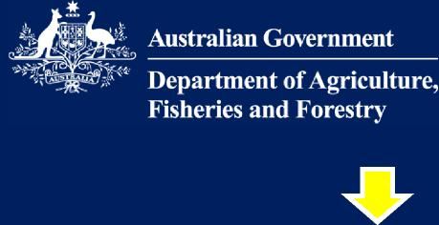

**TECHNOLOGY**

**Container screening cameras on cranes**

Use of automated hyperspectral cameras attached to port cranes, and supported by real time learning technology, to scan the external surfaces of arriving containers for biosecurity risk material



June-Dec 2022

* Additional trial commenced in June at DP World Brisbane Terminal further refine capability and verify the accuracy of captured images for CAL and non-CAL containers
* Trial to continue for 6 months.

**Air cargo facility 3D x-ray (RTTs)**

In collaboration with New Zealand and ABF, the air cargo facility 3D x-ray trial will screen and detect biosecurity risk items in air cargo.



June-July 2022

Aug-Sep 2022

* 3D X-ray (RTT) unit arrives in the country
* Site planning and design
* Installation for the 3D X-ray (RTT) unit commences

**Spot robot**

For use in monitoring and inspection activities

**BSMB App**

Partnering with CSIRO a species identification tool for use on

mobile phones. It uses AI to provide fast, accurate recognition of

Brown Marmorated Stink Bugs and will be extended to

include high-risk pest bees.



Aug-Sep 2022

* Final pilot evaluation report and pilot complete
* Develop scope for Stage 2 – Spot’s automation capability and additional payloads e.g. hyperspectral cameras



June - Sep 2022

* Further development to improve the application’s accuracy and incorporate the full range of Pentatomic bug species routinely intercepted at the border is continuing.
* The feasibility of using the same application to identify workers of high-risk pest bees is being developed.

Cargo Operational Reforms and Innovations - Biosecurity Operations Division

July 2022

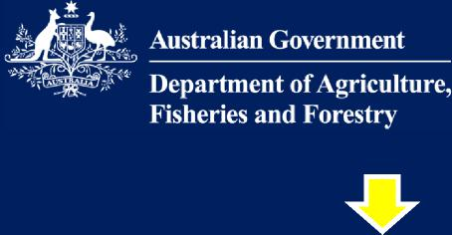

**INNOVATION**

June-July 2022 Aug-Sep 2022



**Hades-5Z robot for used cars and machinery**

Designed to traverse the under carriage of vehicles or any crawl space, providing a live view of the inspection with the ability to take snapshots and videos

* March: pilots conducted in Adelaide, Freemantle, Darwin and Brisbane.
* Pilot evaluation report drafted
* Pilot evaluation report finalised
* Pilot complete

**Underwater remotely operated vehicles (ROV) for biofouling inspection**

Oceanbotics SRV-8 ROV (Remotely Operated Vehicle) with imaging sonar that could enhance the department’s marine biosecurity inspection and risk assessment capability.

* Marine Biosecurity Unit staff to familiarise themselves with the unit
* Confirm pilot dates
* Undertake pilot
* Draft Pilot evaluation report



June-July 2022

Aug-Sep 2022



June-July 2022 Aug-Sep 2022

* Continued development of protype and testing at RingIR’s labs
* Field testing of fumigants prototype device
* Develop scope for next stage (if successful))

**RingIR (fumigants project)**

Portable prototype for detecting methyl bromide, sulfuryl fluoride and phosphine, as a potential replacement for the current Photo Ionization Devices or PIDs.

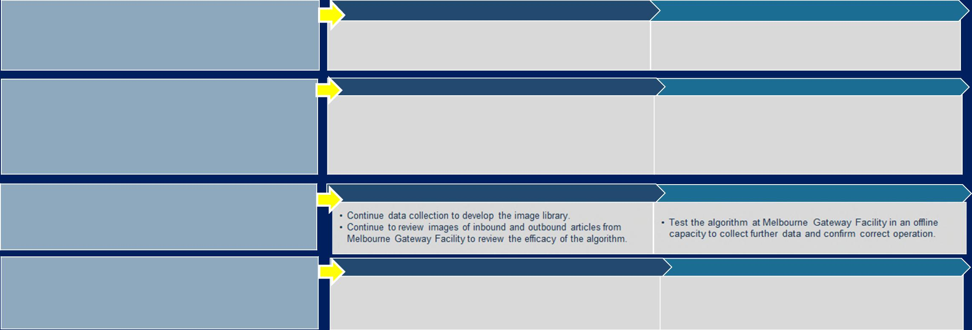

**RingIR (pests project)**

Expansion of the fumigants project to test whether the technology

detect hitchhiker pests in containers

June-July 2022

Aug-Sep 2022

* Khapra beetle container sampling (extends Khapra Beetle trial)
* Hitchhiker Action Plan, Container sampling and test development
* NATA Accreditation for the National eDNA Reference Centre
* Delivery of National Edna Test Validation Guidelines and National Edna Test Protocol Guider for Authors (incl NETP for Khapra Beetle)

**eDNA**

Molecular screening using environmental

DNA (eDNA) technology: is capable of detecting a pest from a

single drop of water or speck of soil in as little as 20 minutes.

* Full transfer of responsibilities to the National eDNA Reference Centre, including website development & first proficiency round.
* Expansion of the National eDNA Collaboration Centre network
* Commence talks with industry partners interested in working with Dept. and National eDNA Testing Program to provide vacuum samples from containers

June-July 2022 Aug-Sep 2022

* Develop pests prototype
* Testing at AgriBio’s labs commences
* Final report
* Develop scope for next stage (if successful

**Wildlife Automatic Detection Algorithm**

developing and implementing automated detection algorithms

to combat the illegal wildlife trade.

**Using AI to identify live fish**

Developing algorithms to identify fish species in bags of water to

detect non-permitted species in import consignments.

* Continuing to develop the model through image capture and labelling.
* Finalisation of analytics assessment and determining next steps

June-July 2022

June-July 2022 Aug-Sep 2022

* Further image capture, model development and testing
* Begin to establish the IT infrastructure and architecture to deploy the AI into an application for operational staff

Aug-Sep 2022



DCCC paper suitable for sharing

**DCCC Meeting 92 – 13 July 2022**

**Agenda Item 6.1c**

**Biosecurity Portal**

**For INFORMATION**

**PURPOSE**

This is an information only paper for DCCC members to note the progress on the development of the Biosecurity Portal.

**KEY POINTS**

* On 25 June 2022 new Biosecurity Portal features and enhancements were released to make it easier for industry to access the Portal.
* On 20 July 2022, the Victorian launch of the Biosecurity Portal will complete its nationwide coverage.
* From 1 October 2022, the Biosecurity Portal will be the only channel to request an import inspection. From this date, the department will not accept Request for Inspection forms via email, for most inspection types.

**BACKGROUND**

The Biosecurity Portal means inspections are at your fingertips with no manual forms; one central location saving time and providing more visibility through 24/7 access to directions and inspection bookings.

The Biosecurity Portal allows clients to lodge and manage requests for an import inspection at any time online.

**UPDATE TO PROGRESSIVE LAUNCH OF PORTAL**

The Biosecurity Portal has been launched in Qld, NT, SA, NSW, ACT and WA with 180 companies (as at 8 June) benefitting from the efficiencies of using the Portal. Usage of the Biosecurity Portal has been increasing steadily with around 20-30% of inspections being lodged via the portal.

Industry clients located in Victoria will be able to use the Biosecurity Portal from 20 July 2022.

The department has a dedicated team who are available to assist importers to access and use the

Biosecurity Portal. The team is contactable via email [at](mailto:at_biosecurityportal@awe.gov.au) biosecurityportal@awe.gov.au or

phone 1300 170 852.

**NEW FEATURES**

With each new version release new features and enhancements are added to the Portal to make it even easier to use.

In late June, a new version of the Portal was released including new features and enhancements:

* Freight forwarders and importers without an ABN will be able to access the Portal via a simplified registration process.
* Changes to Portal registration – cutover from existing MyGovID to Commonwealth mandated DTA authentication process.

UNCLASSIFIED Page 1 of 2

DCCC paper suitable for sharing

* Simplifying the inspection request process and selection of AIMS Directions information.
* Simplifying the selection of inspection types and improving the search functionality.
* Other bug fixes

**STREAMLINING INSPECTION REQUESTS**

From 1 October 2022 most requests for import inspections must be made via the Biosecurity Portal.

The Request for Inspection (RFI) form will continue to be accepted via email for limited exceptions. The Biosecurity Portal is not currently available for:

* Exporters
* Bookings on air waybill
* High volume specialist operators (HVSO) booking personal effects inspections
* Imported food virtual visual label inspections
* Bulk bookings/manned depots (recurring bookings only).   
  The above represent a small percentage of inspection requests.

The department is seeking assistance from industry to communicate the booking request process change. Industry associations will be provided with communication to distribute to their members.

**COMMUNICATION & ENGAGEMENT**

To complement the Biosecurity Portal, the department is improving the way we deliver our services to our industry clients. We continue to work with industry to co-design our new service model and enable industry to interact with us online through the Biosecurity Portal.

We anticipate that as our internal process changes, we will be able to schedule inspection bookings up to 50% faster. We can only realise these efficiencies if industry moves with us by embracing the Portal and taking actions to ensure they are ready for inspections at the time they are scheduled.

A workshop between the department and key industry representatives will be scheduled in July or August. This will be an opportunity to discuss the changes the department is making and discuss how we can work with industry to make the inspections booking process more efficient.

Communication and engagement with industry continues through:

* Active engagement with industry associations.
* Import Industry Advice Notices.
* Website, user guide, help guide and release notes for each new version of the Biosecurity Portal.
* Dedicated support centre to assist client onboarding and navigation/technical queries.
* Onboarding webinars.

**CLEARED BY**

*Andrew Patterson, Assistant Secretary, Pathway Operations – Cargo (ACT, NSW, QLD, NT)*

UNCLASSIFIED

Page 2 of 2



DCCC paper suitable for sharing   
**DCCC Meeting 92 – 13 July 2022**

**Agenda Item 6.1.d**

**Automation of document assessment**

**For INFORMATION**

**PURPOSE**

This is an information only paper for DCCC members to note the upcoming automation initiatives improving the import documentation assessment process.

**KEY POINTS**

Biosecurity Operations Division (BOD) has identified automation as a key focus area to help us effectively manage the increasing volumes of goods and therefore potential biosecurity risks coming into Australia.

As a result, we have established the Automation Centre of Excellence (ACE); a divisional, in-house capability that identifies and implements automation solutions into our biosecurity functions through leadership, expertise and best practice insights.

In conjunction with third party provider Gulanga Group Pty Ltd (Gulanga), and their technical partner Personar, we have already delivered five automation projects to improve business processes. Some of these are listed below under Completed Projects.

We are delivering significant additional automation initiatives, outlined below, that will benefit industry by removing manual, resource intensive processes; reduce delays where documents are lodged in line with the policy and import conditions; and provide faster release of rural tailgate consignments.

***Minimum documentary requirements (Min Docs) project***

We have worked with Gulanga and their delivery partners to develop a world first technology/

algorithm that has been custom-built to handle the volume and complexity of the millions of documents we receive each year for assessment purposes.

We assessed 399,359 commercial full import declarations (declared consignment value over $1,000) in the 2021 calendar year. In the current financial year, up to 30 April 2022, we have assessed 304,509

commercial full import declarations. Each consignment has multiple documents to assess.

We are automating the Min Docs requirements policy assessment component to manage the increasing

volume of documents that removes manual, resource intensive processes. This will also enable our staff to focus on the higher risk parts of the assessment process.

The addition of 'bots' or 'digital workers' speeds up the assessment process and reduces delays **where documents are lodged in accordance with the Min Docs policy and import conditions**. This has been implemented as a pilot, with expansion to occur through a phased approach. Full implementation is anticipated for **Q3 2022**.

This work will result in a capacity uplift in the document assessment process, improved regulatory compliance and increased opportunities for data-driven decision making. This will enhance our capacity to effectively manage the biosecurity system and manage increasing volumes of goods which are expected to continue into the future.

UNCLASSIFIED

Page 1 of 3

DCCC paper suitable for sharing

It must be reiterated that **timely turn-around times for industry receiving directions will be fully reliant on brokers and importers lodging documents in accordance with the Min Docs policy and import conditions**.

***Self-assessed clearances (SAC) project***

Australian Border Force allows high volume non-commercial cargo, valued less than $1,000 per shipment, to be assessed for biosecurity risk using a SAC declaration.

The associated screening workload is increasing dramatically.

* In the 2021 calendar year we screened 3,481,688 SAC declarations for biosecurity risk.
* This represents a 43 per cent increase on 2020.
* In this financial year, to 30 April 2022, we have screened 3,118,744 SAC declarations for biosecurity risk.
* This represents sustained high volumes since the beginning of the COVID 19 Pandemic.

The SAC automation project will enhance the effectiveness and transparency of the SAC screening and assessment function in this high-volume, fast-paced environment.

We have partnered with Gulanga to develop a solution that automates the screening workload. This solution deploys automation and machine learning technology to support officers performing biosecurity operations and improve regulatory outcomes.

Once completed, there are opportunities to expand this automation solution to continue supporting the SAC pathway, including automated decision making.

This SAC Automation went live in **early April 2022** with a defined declaration set and will continue to expand in scope.

***Other initiatives***

To support the upcoming Approved Arrangement class 14.4 for Rural Tailgate Inspections by Biosecurity Industry Participants, automation will undertake the necessary manual administrative work. This means the faster release of rural tail gate consignments for industry and the freeing up biosecurity officers for other activities. The project is currently in delivery and due for completion **August 2022**.

The existing scope of ‘Record of Fumigation automation’ will expand to include additional onshore biosecurity measures such as disposals. This significantly expanded scope will automate assessment of the majority of compliant onshore measures. The project is currently in delivery and due for completion **December 2022**.

***Completed projects***

BOD has automated the following functions to improve the biosecurity system:

1. **export and import in-transit cold treatment assessment** – automated assessment of temperature data logs received from shippers of goods treated in refrigerated shipping containers enroute to destination
2. **record of fumigation assessment** – automated calculation and requirement checks of the assessment of onshore fumigation treatments. This solution is currently being expanded (refer Other Initiatives section above)
3. **outstanding entries processing** – automation ensures that biosecurity directions are actioned within appropriate timeframes
4. **requests for permit (RFP) for exported plant products** – automation to assist officers in the assessments for RFP authorisation.

UNCLASSIFIED

Page 2 of 3

DCCC paper suitable for sharing

These measures provide capacity uplift and additional assurances to the regulatory processes through automation of detail-intensive data validation.

**CLEARED BY**

*Lee Cale, Cargo Pathway Operations (Vic, WA, SA, Tas) & PEQ/Biosecurity Operations Division*

UNCLASSIFIED

Page 3 of 3



DCCC paper suitable for sharing

**DCCC Meeting 92 – 13 July 2022**

**Agenda item 6.1e**

**ANAO/IGB review update**

**For INFORMATION**

**PURPOSE**

To update DCCC members on the department’s management processes for the handling of Inspector General of Biosecurity (IGB), Australian National Audit Office (ANAO) and other independent reviews into Australia’s biosecurity system.

**KEY POINTS**

* The Commonwealth’s biosecurity system is subject to regular reviews by independent bodies such as the IGB, ANAO and others.
* The Biosecurity Evaluation and Performance Coordination section (BEPC) within BSRD has a strategic oversight role across the Biosecurity and Compliance Group in responding and reporting to independent reviews into DAFF’s biosecurity system, including those conducted by the IGB and ANAO.
* Since the position of the Inspector General was formally established under the Act, a total of 17 reviews have been published where the department has received 216 recommendations. As at 1 July 2022, 82 recommendations remain open and in progress by the department.
* The ANAO has actioned two audits with a biosecurity focus; *Responding to Non-Compliance with Biosecurity Requirements;* where 8 recommendation topics are underway or in readiness to complete and a newly published audit *Human Biosecurity for International Air Travellers during COVID-19* with 3 recommendations.

**Background**

The IGB reviews perform an important accountability role in ensuring biosecurity regulation is appropriately administered and remains fit-for-purpose. The Australian National Audit Office (ANAO) supports accountability and transparency through independent reporting via performance audits reported to Parliament.

The tenure of the current IGB, Mr Rob Delane, is concluding on 24 July 2022. Dr Lloyd Klumpp will commence as the new IGB on 25 July 2022.

**CLEARED BY**

*Jo Laduzko, Assistant Secretary Response and Reform Branch, Biosecurity Strategy and Reform Division*

Page 1 | 1



DCCC paper suitable for sharing

**DCCC Meeting 92 – 13 July 2022**

**Agenda Item 6.2a**

**BMSB Season information**

**INFORMATION**

**PURPOSE**

This is an information only paper for DCCC members to note the end of the 2021-22 BMSB Season and to provide information on the plans for the upcoming 2022-23 BMSB Season.

**KEY POINTS**

The 2021-22 BMSB Season concluded on 1 May 2022. Key information and statistics relating to the season can be found on the Placemat at **Attachment A**.

In addition to the information found on the Placemat the following should be noted:

* 109 inspections have been completed as part of the BMSB verification inspection regime on goods exported from China implemented in February 2022.
* Of these inspections, there has been four consignments with biosecurity concerns all attributed to container/packaging concerns (i.e., live beetles on timber pallets, undeclared timber pallets and container contamination such as seed and rice). There have been no further detections of BMSB.
* Based on these findings there is no intention to add China to the list of BMSB countries at this time. The department will continue to monitor specific suppliers through Supplier Profiles.

The department is aware that ongoing sea container congestion from target risk country ports and in-transit ports means that for containers arriving from target risk countries, BMSB measures will be ongoing for the months to come with a possible long tail from the 2021-22 BMSB extending towards the 2022-23 BMSB season.

**2022-23 BMSB Season**

The department’s discussions with industry about the changes proposed for the 2022-23 BMSB season include:

* ways to improve the 120hr post treatment window to alleviate some of the issues found due to sea container congestion while still meeting our biosecurity requirements
* update and improve New, Unused, Not-Field Tested (NUFT) wording to provide clarity to internal and external stakeholders
* Moving to Inspect (unpack) verification directions instead of Seals Intact verification directions.

The department will continue to work with industry around proposed changes. Once finalised the changes will be published on our website as early as possible before the 2022-23 Season, with communication also via Import Industry Advice Notices.

**CLEARED BY**

*Joel Willis, A/g Assistant Secretary, Pathway Policy – Cargo & Conveyances*

**ATTACHMENT**

A: 2021-22 BMSB Season Placemat

UNCLASSIFIED

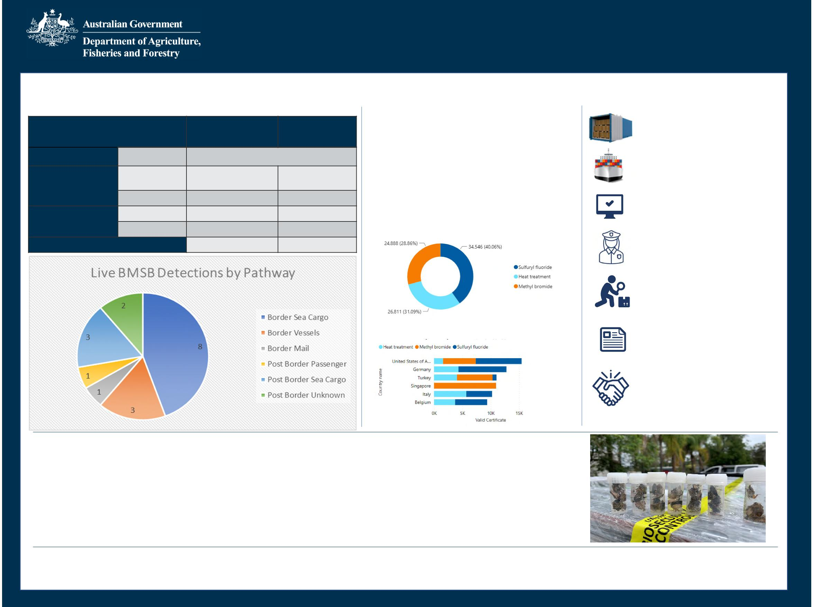

Biosecurity Operations Division

2021-22 BMSB Season

**3 June 2022**

The Brown Marmorated Stink Bug (BMSB) seasonal measures apply from goods shipped from 1 September to 30 April.

**BMSB Detections Offshore Treatments**

**Key Statistics**

|  |  |  |  |
| --- | --- | --- | --- |
|  | | **20-21 Season** | **21-22 Season** |
| **Detection Point** | **Condition** | **Number of detections** | |
| **Biosecurity**  **Intervention Point** | **Alive** | 17 | 12 |
| **Dead** | 187 | 134 |
| **Post Biosecurity** | **Alive** | 15 | 6 |
| **Dead** | 13 | 6 |
| **Total Detections** | | 232 | 158 |

**96,412** containers referred for BMSB concerns

**86,617** Valid treatment certificates lodged.

**228** Approved offshore treatment providers

**1** Offshore treatment provider suspended

**335** voyages by Roll-On Roll-Off vessels. **162** Seasonal Pest Inspections conducted

**61,315**

**10,799**

Containers treated offshore

Break Bulk units treated offshore

**77,096** containers and break bulk units Whitelisted. **2,620** referred for verification.

**Valid certificates by treatment type**

**62,729** Full Import Declarations (entries) referred for BMSB

**10,028** consignments with a BMSB profile directed for inspection

**Top 6 – Valid certificates by country**

**30,769** BMSB entries lodged through AEPCOMM (**17%** increase on 2021-22 Season)

**15** entities approved for the Safeguarding Arrangement scheme

**Non-compliance**

The department has directed **68** consignments for export due to arriving non-compliant to import conditions. This includes **46** break bulk, open top/flat rack consignments arriving untreated and **22** break bulk, open top /flat rack consignments arriving treated but exported to Australia outside of the 120 hour post treatment window.

The Goods Determination does not provide for exceptions or exemptions to mandatory offshore treatment requirements or give opportunity to allow for onshore treatment for consignment shipped in these methods. Goods failing to meet mandatory offshore treatment requirements are directed for export.

**BMSB Target risk countries:** Albania, Andorra, Armenia, Austria, Azerbaijan, Belgium, Bosnia and Herzegovina, Bulgaria, Canada, Croatia, Czechia, France, Georgia, Germany, Greece, Hungary, Italy, Kazakhstan, Kosovo, Liechtenstein, Luxembourg, Montenegro, Moldova, Netherlands, Poland, Portugal, Republic of North Macedonia, Romania, Russia, Serbia, Slovakia, Slovenia, Spain, Switzerland, Turkey, Ukraine, United States of America and Japan for heightened vessel surveillance only.



DCCC paper suitable for sharing

**DCCC Meeting 92 – 13 July 2022**

**Agenda Item 6.2b**

**Khapra beetle urgent actions**

**For INFORMATION**

**PURPOSE**

To update DCCC members on the status of the implementation of the urgent actions to address the risk of khapra beetle (*Trogoderma granarium*) entering Australia.

**KEY POINTS**

We are implementing urgent actions to address the risk of khapra beetle entering Australia. The urgent actions are being implemented in phases and will result in changes to import conditions for plant products and sea containers. The urgent actions are being supported by a $14.5 million investment to safeguard Australia against this significant pest.

What we have implemented already:

* **Phase 1** (September 2020): a ban on high-risk plant products (a host of khapra beetle) within unaccompanied personal effects and low value freight.
* **Phase 2** (October 2020): a ban on high-risk plant products within accompanied baggage, via international travellers or mail articles.
* **Phase 6A** (April and July 2021): mandatory offshore treatment for sea containers packed with:
* 6a.i high-risk plant products exported from a khapra beetle target risk country
* 6a.ii all types of goods in a khapra beetle target risk country that will be unpacked in a rural grain growing area of Australia
* 6a.ii measures were extended to rural nut growing areas of Australia in December 2021.
* **Phase 3** (September 2021): mandatory offshore treatment and phytosanitary certification for high-risk plant products exported from a khapra beetle target risk country and phytosanitary

certification for high-risk plant products exported from all other countries.

* **Phase 4** (April 2022): revised phytosanitary certification for other-risk plant products exported from all countries to verify freedom from Australia’s list of Trogoderma species of biosecurity concern.
* **Phase 5** (April 2022): introduced phytosanitary certification for seeds for sowing exported from all countries via all arrival modes to verify freedom from Australia’s list of Trogoderma species of biosecurity concern.

As of 27th May 2022, a sample of 3,293 entries were taken of phase 6a.i and phase 3:

* 98% of treatments have been conducted using methyl bromide.
* 2 consignments have been treated with heat
* 86% of entries processed by the department were compliant (an increase from 83% in the report to the DCCC in November 2021 and an increase of 1% since February 2022).
* Common non-compliances continue to include:
* Sea container not treated (for example, goods treated but not the container)
* Incorrect treatment schedule applied to non-compliant documentation (treatment certificates missing information).

UNCLASSIFIED

Page 1 of 2

DCCC paper suitable for sharing

* 81% of the sampled treatments have been conducted by either Australian Fumigation Accreditation Scheme (AFAS) or Offshore Brown Marmorated Stink Bug (BMSB) Treatment Providers (No change since February 2022)
* 93% of treatments conducted by registered providers are compliant (Feb 2022 figure 93%)
* 56% of treatments conducted by unregistered providers are compliant. (Feb 2022 figure 52%)

We are planning to implement the next phase of the sea container urgent actions under Phase 6B in late 2022. This will introduce measures to a broader range of containers (other high-risk containers). The department will consult with the DCCC members on implementation options (including timeframes) prior to implementing 6B measures.

Further information on the urgent actions is available on our website:

<https://www.awe.gov.au/biosecurity-trade/pests-diseases-weeds/plant/khapra-beetle/urgent-actions>

We would appreciate your assistance communicating the khapra beetle requirements with your contacts/stakeholders and encouraging:

* importers to use registered treatment providers where possible
* unregistered treatment providers to contact us [at](mailto:at_offshoretreatments@awe.gov.au) offshoretreatments@awe.gov.au.

**BACKGROUND**

* Changing global demands, growing passenger and trade volumes, increasing imports from a growing number of countries, population expansion and climate change mean that biosecurity risk is growing.
* Australia has a robust biosecurity system that reduces the risks posed by exotic pests and diseases, as well as established procedures to manage interceptions when they do occur.
* Biosecurity threats are effectively managed using a risk-based approach.
* Biosecurity risks are managed offshore, at the border, and within Australia at the point where intervention is most effective.
* Khapra beetle is Australia’s number two National Priority Plant Pest (2019).
* Khapra beetle is not present in Australia and poses a major threat to Australia’s grains, rice and nut industries as a serious storage pest and potential impacts on international trade.
* If khapra beetle was to establish in Australia it would have significant economic consequences. An incursion could cost Australia $15.5 billion over 20 years through revenue losses arising from damaged grain in storage and exports.
* Australia has committed $96.9 million over 4 years (2021 to 2024) towards the Hitchhiker Pest Program which will build a stronger biosecurity system to protect Australia from hitchhiker pests in sea containers and goods. A key deliverable of this project amongst other things is enhanced data capture, modelling, and analytics to accurately profile and target imported sea containers and cargoes that pose a risk of hitchhikers including khapra beetle.

**CLEARED BY**

*Sarah Bruce, Principal Director, Hitchhiker Working Group*

**ATTACHMENT**

A: Khapra beetle urgent actions phases

UNCLASSIFIED

Page 2 of 2

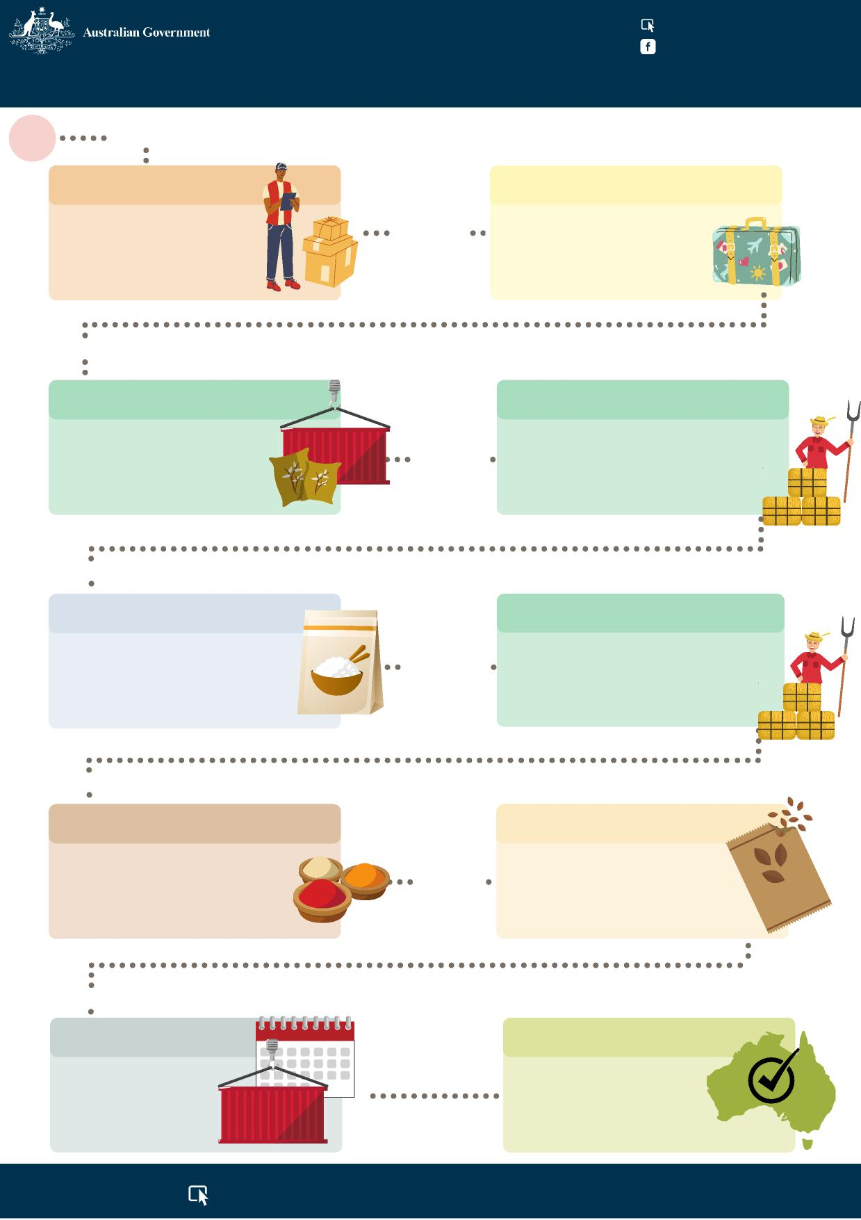

[agriculture.gov.au/khapra-urgent-actions](http://agriculture.gov.au/khapra-urgent-actions) Australian Biosecurity

**KHAPRA BEETLE URGENT ACTIONS**

**Start**

**3 Sept 2020**

**Phase 1**

**Phase 2**

Ban on high-risk plant products, e.g. rice, within unaccompanied personal effects & low value freight.

**15 Oct 2020**

Ban on high-risk plant products, e.g. rice, being brought in with international travellers or in mail parcels and packages.

**12 Apr 2021**

**Phase 6A**

**Phase 6A (continued)**

Offshore treatment of containers carrying high-risk plant products, e.g. rice, packed into a container in a country that has khapra beetle.

**12 July 2021**

Offshore treatment of containers carrying products other than high-risk plant products, packed into a container in a country that has khapra beetle & then unpacked in a rural grain growing area in Australia.

**30 Sept 2021**

**Phase 3**

**Phase 6A (extended)**

Offshore treatment and phytosanitary certificate requirements for commercial imports of high-risk plant products, e.g. rice.

**15 December**

**2021**

Offshore treatment of containers carrying products other than high-risk plant products, packed into a container in a country that has khapra beetle & then unpacked in a rural nut growing area in Australia.

**28 April 2022**

**Phase 4**

**Phase 5**

Revised phytosanitary certificate requirements for imports of other risk plant products, e.g. spices.

**28 April**

**2022**

Introduction of phytosanitary certificates for imports of seeds that are to be used for sowing.

**Date TBA**

**Phase 6B**

Introduction of

**End**

measures to a broader range of containers.

These changes will help keep Australia khapra beetle free!

[**agriculture.gov.au/khapra-urgent-actions**](http://agriculture.gov.au/khapra-urgent-actions)



DCCC paper suitable for sharing

**DCCC Meeting 92 – 13 July 2022**

**Agenda Item 6.3a**

**Compliance Activities Snapshot**

**For INFORMATION**

**PURPOSE**

This is an information only paper for DCCC members to provide a snapshot of compliance activities from 1 July 2021 – 31 March 2022.

**KEY POINTS**

The Compliance Activities Snapshot (**Attachment A**) provides an overview of activities and assessments conducted by the department from 1 July 2021 to 31 March 2022.

Further information on the compliance activities can be provided, where possible, to DCCC members upon request via the DCCC Secretariat.

**CLEARED BY**

A*nna Brezzo, Assistant Secretary, Enforcement, Compliance and Enforcement Division*

**ATTACHMENTS**

A: Compliance Activities Snapshot –Third Quarter Statistics - Financial Year 2021 – 2022

UNCLASSIFIED

Page 1 of 1

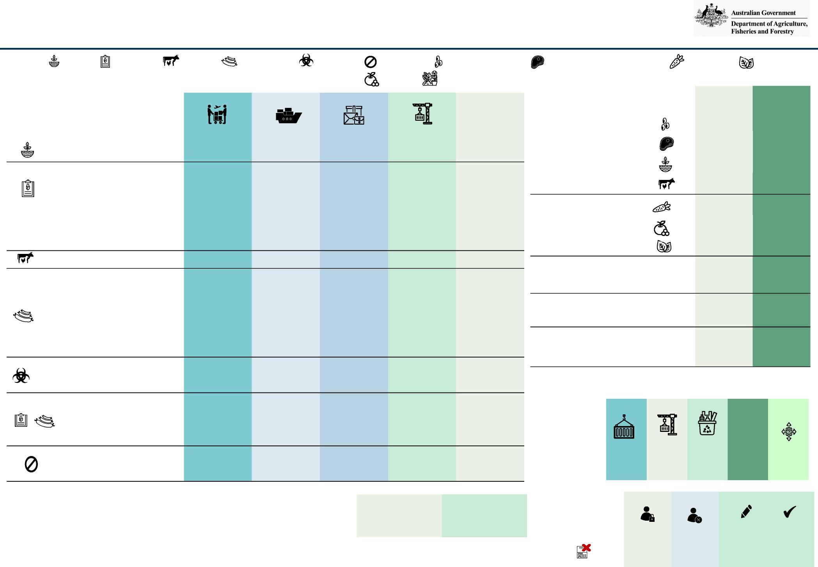

**Compliance Activities Snapshot – Third Quarter Statistics - Financial Year 2021-2022**

|  |  |  |  |  |  |  |  |  |  |  |  |
| --- | --- | --- | --- | --- | --- | --- | --- | --- | --- | --- | --- |
| **Investigations Commenced During the Quarter** | | **Air Cargo** | | **Sea Cargo** | | **Mail** |  | **Export** | | **Other** | |
|  | | **QTR 3** | **FYTD** | **QTR 3** | **FYTD** | **QTR 3** | **FYTD** | **QTR 3** | **FYTD** | **QTR 3** | **FYTD** |
| Biosecurity Act | | 2 | 6 | - | - | 1 | 3 | - | - | - | - |
| Biosecurity Act | | - | - | - | - | - | 1 | - | - | - | - |
|  | Imported Food | - | - | - | 2 | - | - | - | - | - | - |
|  | Biosecurity Act & Imported Food | - | - | - | 1 | - | - | - | - | - | - |
| Biosecurity Act & Criminal Code | | - | 1 | - | - | - | - | - | - | - | - |
| Export Control Act | | - | - | - | - | - | - | 1 | 1 | - | - |
| Biosecurity Act | | 1 | 1 | - | - | 1 | 1 | - | - | 1 | 1 |
| Biosecurity Act | | 2 | 4 | 1 | 3 | - | - | - | - | - | 2 |
| Imported Food | | - | - | - | 1 | - | - | - | - | - | - |
| Exported Control Act | | - | - | - | - | - | - | - | 1 | - | - |
| Criminal Code | | - | - | - | 1 | - | - | - | - | - | - |
| Biosecurity Act & Imported Food | | - | 1 | - | 1 | - | - | - | - | - | - |
| Biosecurity Act | | 2 | 4 | - | 2 | - | - | - | - | - | - |
| Criminal Code | | - | - | - | - | - | - | - | - | - | - |
| Biosecurity Act | | 2 | 2 | - | 1 | - | - | - | - | - | - |
|  | Criminal Code | - | - | - | 1 | - | - | - | - | - | - |
|  | Imported Food | - | - | 1 | 1 | - | - | - | - | - | - |
| Biosecurity Act | | - | - | - | 1 | - | - | - | - | - | - |
| Biosecurity Act & Criminal Code | | - | - | - | 1 | - | - | - | - | - | - |

*Plant products; Live animals; Animal products; Biosecurity risk; Non-commodity; Whole unprocessed seeds; Meat and meat products (non-retorted); Fresh vegetables; Fresh leaves;*

|  |  |  |
| --- | --- | --- |
| **Infringement Notices**  **Biosecurity Act**  Category 1 goods  12 penalty units = $2,664 | **QTR 3**  24  54  3  2 | **FYTD**  174 |
| Category 2 goods  6 penalty units = $1,332 | 8  35  6 | 99 |
| Other goods  2 penalty units = $444 | 153 | 323 |
| Company  60 penalty units = $13,320 | - | 1 |
| **Imported Food Control Act**  Company  60 penalty units = $13,320 | - | 1 |

***Legend:*** *Live plants;*

*Fresh fruit; Fresh herbs*

|  |  |  |  |  |
| --- | --- | --- | --- | --- |
| **Imports** | **Exports** | **Waste** | **Total** | **Adverse** |
|  |  |  |  | **Decisions** |
| 286 | 329 | 21 | 636 | - |
| 601 | 1,208 | 81 | 1,890 | 3 (import) |

|  |  |  |  |
| --- | --- | --- | --- |
| **Suspended** | **Revoked** | **Corrective Actions** | |
|  |  | **Issued** | **Resolved** |
| - | - | 309 | 254 |
| - | - | 735 | 254 |

**QTR 3**

**FTYD**

**Court Outcomes**

Nil court outcomes for Quarter 3

**Visa Cancellations**

**Approved Arrangements**

**FYTD**

2

**QTR 3**

2

**Fit and Proper Persons Assessments**

**QTR 3 FYTD**



DCCC paper suitable for sharing   
**DCCC Meeting 92 – 13 July 2022**

**Agenda Item 6.4a**

**Biosecurity Cost Recovery Arrangement Financial Report**

**For INFORMATION**

**PURPOSE**

This is an information only paper for DCCC members to note the April year-to-date results on the Biosecurity Cost Recovery Arrangement.

**KEY POINTS**

The Biosecurity Arrangement continues to perform below budget with revenue down by $5.96 million compared to budget. This is primarily due to a reduction in fee-for-service activities impacted by:

* COVID-19
* third-party premises have been closed to our staff
* unavailability of our own staff
* Growing complexity of imports
* changing risk profiles
* policy and process changes

We have further revised downwards our May and June forecasts for fee-for-service revenue. FIDs revenue is marginally below budget but expected to remain strong in May and June.

The review of the Cost Recovery Implementation Statement (CRIS) for biosecurity is continuing internally. The department will seek guidance from the new minister for Agriculture, Fisheries and Forestry on biosecurity matters, including cost recovery and sustainable funding and investment. These views will form part of our consultation with industry on the new CRIS.

**BACKGROUND**

The department has authority to recover certain costs from import industry participants for biosecurity activities that protect our export industries, our environment, and our way of life.

The Biosecurity Cost Recovery Arrangement reports the revenue raised and expenses incurred by the Department to assess and manage the biosecurity risks arising from people, goods, and conveyances (sea and aircraft) entering Australia. These activities also include assessing compliance of imported food with relevant food standards and public health and safety.

**CLEARED BY**

*Rachel Short, (A/g) Assistant Secretary, Funding and Revenue Branch, Finance Division*

**ATTACHMENTS**

A: Biosecurity Cost Recovery Arrangement Financial Reports on 30 April 22.

For Official Use Only (FOUO) Page 1 of 1

FOR OFFICIAL USE ONLY

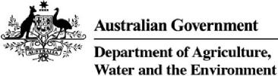

**Biosecurity Cost Recovery Arrangement**

Financial Performance for 2021–22

as at 30 April 2022

Finance Division



1

FOR OFFICIAL USE ONLY

© Commonwealth of Australia 2022

Disclaimer:

The Australian Government acting through the Department of Agriculture, Water and the Environment has exercised due care and skill in preparing and compiling the information and data in this report. Notwithstanding, the Department of Agriculture, Water and the Environment, its employees and advisers disclaim all liability, including liability for negligence and for any loss, damage, injury, expense or cost incurred by any person as a result of accessing, using or relying on any of the information or data in this report to the maximum extent permitted by law

2

FOR OFFICIAL USE ONLY

**The Biosecurity Arrangement**

The Department commenced partial cost recovery of selected biosecurity activities in 1979 and implemented full cost recovery from 1 January 1991. The Department’s biosecurity activities are provided to these key groups:

* **Importers** – inspection, assessment and management of the biosecurity risks associated with imported goods and packaging (including air and sea cargo, containers, international mail, food, live animals and plants). This also includes husbandry activities undertaken by the department, associated with the PEQ of live animals and plants prior to release into Australia (such as horses, dogs, cats, hatching eggs, birds, ruminants, bees, nursery stock and viable seeds).
* **Conveyance operators** – assessments and inspections of vessel and aircraft entering Australia to manage the risks posed by the vessel, contaminants on the vessel, human biosecurity risks, ballast water and biofouling on vessels, and aircraft disinsection (where non-compliant on arrival) and assessment of aircraft for release from biosecurity control.
* **Approved arrangement participants** – administering arrangements, managing compliance regimes, and setting standards for various third-party arrangements managed by the department, such as quarantine approved premises, compliance agreements and imported food compliance agreements.
* **Passengers** – assessment and management of biosecurity risks posed by baggage accompanying passengers. Activities such as inspection and assessment of baggage are only cost recovered when provided outside of designated international airports or seaports.

The Biosecurity Act 2015 is the primary biosecurity legislation in Australia. The Imported Food Control Act 1992 is the primary food importation legislation. Subordinate legislation (including regulations) and supporting policies affect the management of ballast water, approved arrangements and import risk analysis.

The Biosecurity Regulation 2016 provides fees for different biosecurity regulatory activities. Section 592 of the Biosecurity Act allow fees that may be charged in relation to activities carried out by, or on behalf of the Commonwealth, to be prescribed in regulations made under the Act.

The Imported Food Regulations 2019 provides fees for different chargeable services. Section 36 of the Imported Food Control Act allow fees that may be charged in relation to certain chargeable services, to be prescribed in regulations made under this Act.

3

FOR OFFICIAL USE ONLY

**2021-22 Budget**

**Revenue assumptions**

Australia spent 2020-21 in lockdown, navigating its way through the pandemic, yet import activity exceeded our forecasts as consumer spending shifted to goods in place of services. The 2021-22 budget projected growth in anticipation of continuing higher import activity. However, our April forecast for 2021-22 recognises a decline in fee for service (FFS) revenue resulting from COVID-19 outbreaks and associated lockdowns impacting the delivery of frontline services. Using 2020-21 volume trends, full import declarations are expected to continue to increase, however, this will be offset by lower inspection and assessment activity.

**Expense budget**

The 2021-22 expense budget reflects the effort and resources required for the forecast regulatory activity volumes. The total expenses are an increase on the 2020-21 actual expenses, with the forecast including the additional effort to manage the risk posed by hitchhiker pests, as announced in the May 2021 Budget. Operational areas are allocated funding for regulatory activities based on forecast revenue volumes and departmental priorities as agreed by the Secretary and Deputy Secretaries of the Department.

An updated Biosecurity Cost Recovery Impact Statement (CRIS) for 2021-22 was recently released showing the 2021-22 forecast revenue and expenses and the actual results for 2020-21. Table 1 below provides a summary of forecast and actual results for 2020-21 and forecast results for 2020-21.

**Full year forecast**

The full year forecast below is for a deficit of $12.8 million including $11.7 million to manage the risk of hitchhiker pests for which we have not increased prices. The over-recovery in 2020-21 is being used to fund this measure in 2021-22. A new CRIS is anticipated for release in 2023, which will include future year impacts for the hitchhiker measure.

**Table 1 Biosecurity arrangement forecasts and actuals for 2020-21 and forecasts for 2021–22**

4

|  |  |  |  |
| --- | --- | --- | --- |
| **Finance element** | **2020–21($)**  **Forecast** | **2020–21($) Actuals** | **2021–22($) Forecast** |
| Revenue = X | 281,668,212 | 285,801,049 | 282,565,359 |
| Expenses = Y | 279,284,678 | 276,214,706 | 295,414,346 |
| **Balance = X – Y** | **2,383,534** | **9,586,343** | **- 12,848,987** |
| Remissions | -2,383,534 |  |  |
| Estimated opening cost recovery reserve balance 1 July | 36,318,932 | 25,492,390 | 35,078,733 |
| **Estimated closing cost recovery reserve balance 30 June** | **36,318,932** | **35,078,733** | **22,229,746** |

FOR OFFICIAL USE ONLY

**April 2022 Year-to-date (YTD) performance for the Biosecurity Arrangement**

**Table 2 – Summary of the April 2022 YTD performance for the overall Biosecurity Arrangement**

|  |  |  |  |  |  |
| --- | --- | --- | --- | --- | --- |
| **Biosecurity Arrangement** | **Apr 2021-22 YTD** | | | | **Apr 2020-21** |
| **Actual** | **Budget** | **Variance** | | **Actual** |
| **$’000** | **$’000** | **$’000** | **%** | **$’000** |
| **Total Revenue** | **238,916** | **244,876** | **(5,961)** | **-2%** | **238,200** |
| **Total Expense** | **254,652** | **244,466** | **10,186** | **4%** | **221,637** |
| Employee Benefits | 162,359 | 157,247 | 5,112 | 3% | 153,739 |
| Operating Expenses | 72,143 | 67,665 | 4,621 | 7% | 47,294 |
| Asset Related Expenses | 20,150 | 19,553 | 597 | 3% | 20,603 |
| **Operating Surplus / (Deficit)** | **(15,736)** | **411** | **(16,146)** | **>100%** | **16,563** |

**Key points for the biosecurity arrangement**

The arrangement’s revenue variance of $6.0 million is primarily due to:

* Full Import Declarations (FIDs)
* Sea FIDs –$3.3 million below budget
* Offset by air FIDs – $2.8 million above budget
* Fee for service revenue (inspection, audit, assessment, etc.) – down $4.5 million compared to budget, due to covid-related impacts on operations and changes in the complexity of imports.

**1. Import clearance**

The combined volume of air and sea importation activities for April 2022 YTD is on budget (6,503 units), indicating no discernible increase or decrease in total activity. However, there has been a consistent pattern of lower sea FIDs and higher air FIDs throughout the year. As air FIDs have a lower value than sea FIDs, there is an overall reduction in revenue of approximately $0.5 million across the two charge points.

**Table 3 – April 2022 YTD performance for Import Clearance**

|  |  |  |  |  |  |
| --- | --- | --- | --- | --- | --- |
| **Import Clearance Stream** | **Apr 2021-22 YTD** | | | | **Apr 2020-21** |
| **Actual** | **Budget** | **Variance** | | **Actual** |
| **$’000** | **$’000** | **$’000** | **%** | **$’000** |
| **Total Revenue** | **205,654** | **212,356** | **(6,702)** | **-3.2%** | **206,988** |
| **Total Expense** | **215,283** | **210,081** | **5,202** | **2.5%** | **188,893** |
| Employee Benefits | 139,189 | 136,594 | 2,594 | 1.9% | 132,889 |
| Operating Expenses | 57,813 | 55,765 | 2,049 | 3.7% | 38,040 |
| Asset Related Expenses | 18,281 | 17,721 | 560 | 3.2% | 17,964 |
| **Operating Surplus / (Deficit)** | **(9,628)** | **2,275** | **(11,904)** | **>100%** | **18,095** |

**Key points for the import clearance stream**

* FIDs volume – air 9.2% increase (164,360 units) and sea 0.7% decrease (11,388 units) on 2020–21, actuals as shown graphically in Figures 1 and 2 below.
* FIDs revenue – air $6.2 million increase and sea $0.6 million decrease on 2020–21 actuals.
* Inspections (out-of-office) – 9.1% decrease (42,808 units or $2.1 million) on 2020–21 actuals.
* Document assessments – 11.9% decrease (56,918 units or $1.7 million) on 2020–21 actuals

5

FOR OFFICIAL USE ONLY

Figure 1 – Air volume comparison for the last three financial years

FIDs - Air Volume

Figure 2 – Sea volume comparison for the last three financial years

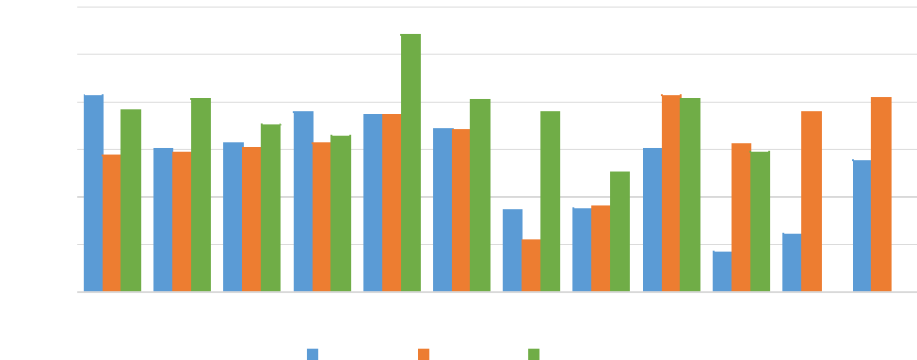

240,000

Jul Aug Sep Oct Nov Dec Jan Feb Mar Apr May Jun

2019-2020 2020-2021 2021-2022

220,000

200,000

180,000

160,000

140,000

120,000

FIDs - Sea Volume

200,000

|  |  |  |  |  |  |
| --- | --- | --- | --- | --- | --- |
| 180,000 160,000 140,000 120,000 100,000 80,000 |  |  |  |  |  |
|  |  |  |  |
|  |  |  |  |  |

Jul Aug Sep Oct Nov Dec Jan Feb Mar Apr May Jun

2019-2020 2020-2021 2021-2022



6

FOR OFFICIAL USE ONLY

**2. Seaports**

The number of cargo freighters YTD to 30 April 2022 increased compared to the same period last year. Volumes have remained relatively consistent each up to 30 April 2022, exception of a significant drops in vessel arrivals in February 2022.

**Table 4 – April 2022 YTD performance for Seaports**

|  |  |  |  |  |  |
| --- | --- | --- | --- | --- | --- |
| **Seaports Stream** | **Apr 2021-22 YTD** | | | | **Apr 2020-21** |
| **Actual** | **Budget** | **Variance** | | **Actual** |
| **$’000** | **$’000** | **$’000** | **%** | **$’000** |
| **Total Revenue** | **19,961** | **19,892** | **69** | **0%** | **20,126** |
| **Total Expense** | **25,845** | **21,762** | **4,083** | **19%** | **19,872** |
| Employee Benefits | 17,141 | 14,834 | 2,307 | 16% | 14,202 |
| Operating Expenses | 7,402 | 5,656 | 1,745 | 31% | 3,725 |
| Asset Related Expenses | 1,303 | 1,272 | 31 | 2% | 1,945 |
| **Operating Surplus / (Deficit)** | **(5,885)** | **(1,871)** | **(4,014)** | **>100%** | **254** |

**Key points for seaports**

* Vessel (≥25m) arrivals – an increase of 18.9% or 273 vessels on 2020-21 for April YTD, per Figure 3 below.
* The highest year-on-year growth in vessel arrivals (≥25m) was in November (11.9%) and lowest was in February (-21.3%).

**Figure 3 – Vessel arrivals volume comparison for the last three financial years**

Vessels (25m or more) - Volumes

2,500

|  |  |  |
| --- | --- | --- |
| 2,000  1,500  1,000  500 |  |  |
|  |  |



2019-2020 2020-2021 2021-2022



7

FOR OFFICIAL USE ONLY

**3. Post Entry Quarantine (PEQ) Facility, Mickleham**

PEQ combined April 2022 YTD revenue is above the 2021-22 budget by $672k or 5.3%. The April 2022 YTD revenue is higher than the 2020-21 actuals for the same period, indicating overall activity has increased this financial year. The revenue position is not homogenous across the streams: in the plant stream, revenue is slightly below budget while revenue for the horse and non-horse (imports of cats, dogs, birds and hatching eggs) streams are currently greater than budget.

**Table 5 – April 2022 YTD performance for PEQ**

|  |  |  |  |  |  |
| --- | --- | --- | --- | --- | --- |
| **PEQ Stream** | **Apr 2021-22 YTD** | | | | **Apr 2020-21** |
| **Actual** | **Budget** | **Variance** | | **Actual** |
| **$’000** | **$’000** | **$’000** | **%** | **$’000** |
| **Total Revenue** | **13,301** | **12,629** | **672** | **5%** | **11,092** |
| **Total Expense** | **13,524** | **12,623** | **901** | **7%** | **12,872** |
| Employee Benefits | 6,030 | 5,819 | 210 | 4% | 6,647 |
| Operating Expenses | 6,927 | 6,243 | 685 | 11% | 5,530 |
| Asset Related Expenses | 566 | 560 | 6 | 1% | 695 |
| **Operating Surplus / (Deficit)** | **(223)** | **6** | **(229)** | **>100%** | **(1,780)** |

**Key points for the PEQ**

* Cats – an increase of 30% or 350 animals and increased revenue of $419k, compared to 2020-21 April YTD.
* Dogs – an increase of 19% or 489 animals and increased revenue of $587k, compared to 2020-21 April YTD.
* Plants – an increase of 8% or 455 plants (m2 per month) and increased revenue of $50k, compared to 2020-21 April YTD.
* Horses – an increase of 37% or 180 horses and increased revenue of $540k, compared to 2020-21 April YTD.
* Operational expenses remain high relative to other costs for the PEQ and continue to be examined as part of the review of the Biosecurity Cost Recovery Arrangement.

8



DCCC paper suitable for sharing   
**DCCC Meeting 92 – 13 July 2022**

**Agenda Item 6.4b**

**Biosecurity Cost Recovery Arrangement Review Update**

**For INFORMATION**

**PURPOSE**

This is an information only paper for DCCC members to note progress of the review of the Biosecurity Cost Recovery Arrangement.

**KEY POINTS**

Work on the Biosecurity Cost Recovery Arrangement review has been delayed due to the election. The

department is waiting on guidance from the new government on a range of biosecurity matters, including cost recovery.

The department has been progressing the review work and still intends to consult widely on proposed

changes, with a new Cost Recovery Implementation Statement anticipated for release in 2023, following consultation with industry.

**BACKGROUND**

The department began a comprehensive review of the Biosecurity Cost Recovery Arrangement in July 2021 to realign costs and effort with current operations. The Arrangement was last comprehensively reviewed in 2015 in combination with the release of the Biosecurity Act 2015. Much has changed for the department and industry since then. The change of government is also impacting our review work and subsequently, consultation with industry has been slowed while we take the new government’s views into account.

The Biosecurity Cost Recovery Arrangement covers the department’s regulatory effort to assess and manage the biosecurity risks arising from people, goods, and conveyances (sea and aircraft) entering Australia. These activities also include assessing compliance of imported food with relevant food standards and public health and safety.

**CLEARED BY**

*Rachel Short, (A/g) Assistant Secretary, Funding and Revenue Branch, Finance Division*

For Official Use Only (FOUO) Page 1 of 1