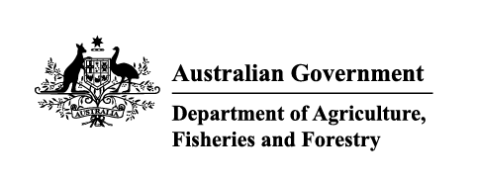

Instrument revoking a holding order under section 15(2) of the Imported Food Control Act 1992
The listed holding orders, having satisfied the circumstances under which the orders will be revoked, are revoked under section 15(2) of the Imported Food Control Act 1992 (the Act).
The circumstances being that the Secretary or delegate is satisfied that the basis for the order no longer applies.
Holding order number | Date revoked
19035 | 04/12/2025
19806 | 04/12/2025
19945 | 04/12/2025
19463 | 04/12/2025
13765 | 08/12/2025
18840 | 08/12/2025
15020 | 08/12/2025
18825 | 08/12/2025
18283 | 08/12/2025
18860 | 08/12/2025
17854 | 08/12/2025
17855 | 08/12/2025
18817 | 08/12/2025
15500 | 08/12/2025
18824 | 08/12/2025
18852 | 08/12/2025
18823 | 08/12/2025
18845 | 08/12/2025
18806 | 08/12/2025
18800 | 08/12/2025
18801 | 08/12/2025
18802 | 08/12/2025
18847 | 08/12/2025
18863 | 08/12/2025
17806 | 08/12/2025
INC23006 | 08/12/2025
18791 | 08/12/2025
18534 | 08/12/2025
18803 | 08/12/2025
18796 | 08/12/2025
18788 | 08/12/2025
18820 | 08/12/2025
INC23003 | 08/12/2025
18742 | 08/12/2025
18184 | 08/12/2025
18789 | 08/12/2025
19800 | 08/12/2025
18771 | 08/12/2025
18818 | 08/12/2025
18114 | 08/12/2025
18814 | 08/12/2025
18487 | 08/12/2025
18797 | 08/12/2025
18838 | 08/12/2025
18849 | 08/12/2025
18812 | 08/12/2025
18813 | 08/12/2025
18861 | 08/12/2025
20023 | 08/12/2025
19675 | 09/12/2025
19969 | 09/12/2025
18074 | 09/12/2025
19883 | 09/12/2025
20076 | 11/12/2025
19143 | 15/12/2025
18453 | 15/12/2025
19440 | 15/12/2025
19975 | 15/12/2025
19877 | 15/12/2025
19940 | 15/12/2025
16149 | 15/12/2025
19884 | 15/12/2025
18575 | 15/12/2025
20086 | 15/12/2025
20006 | 16/12/2025
10882 | 23/12/2025
20119 | 24/12/2025
19029 | 24/12/2025
20055 | 24/12/2025
19671 | 24/12/2025
19573 | 24/12/2025
19333 | 24/12/2025
Delegate position number | Date
100091 | 8/1/2026
Delegate of the secretary for the purposes of section 15(2) of the Act.

