Snapshot of world biofuels – December 2022
International government policies aimed at reducing greenhouse gas emissions and energy price volatility is driving biofuel demand. Australia is well-placed to provide key inputs to global biofuel production.

Global use of biofuels on the rise
- Over the past three decades, biofuels have become an increasingly important source of energy.
- Biofuel production has increased from 1.2 million barrels per day in 2011 to 1.8 million barrels per day in 2021 (an increase of 46%).
- In 2021, the USA, Brazil, Europe and Indonesia were the largest consumers of biofuel, accounting for 84% of global biofuel consumption.
- Over the next five years, the USA and Brazil will continue to lead global demand and production. Asia, particularly Indonesia, Malaysia and India, are expected to have the largest growth in demand.
Figure 1: World biofuel consumption
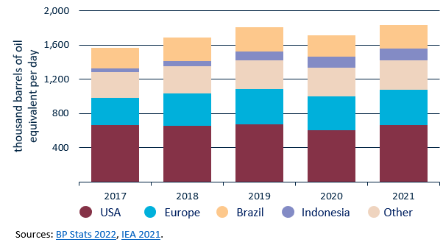
Figure 2: World feedstock crops for biofuel production
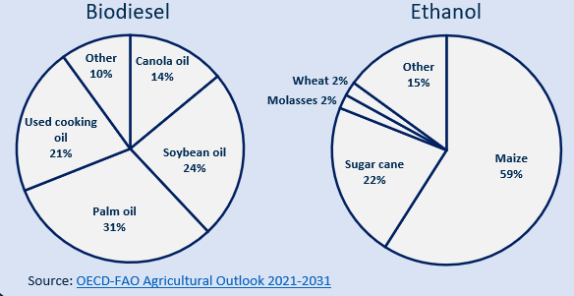

The role of agriculture in biofuel production
- Maize, sugar cane and oilseeds are the key feed stocks for biofuel production.
- The OECD-FAO estimate that between 2019 and 2021, 21% of world sugar cane production, 15% of world maize production and 12% of oilseed production was used to make biofuels.
- Other biofuel feedstocks include rice, coarse grains and cellulosic biomass (such as barley straw) for ethanol, while animal fats can be used for biodiesel.
- The majority of Australia’s $5.76b in canola seed exports in 2021-22 will be used to make biofuel in the EU.
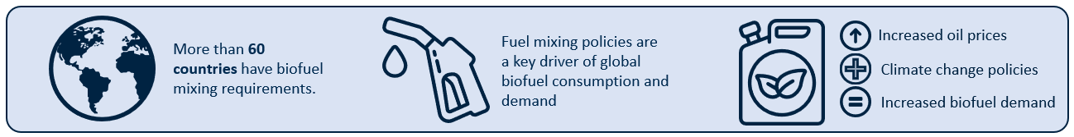
Figure 3: IEA and OECD-FAO projections for global biofuel demand
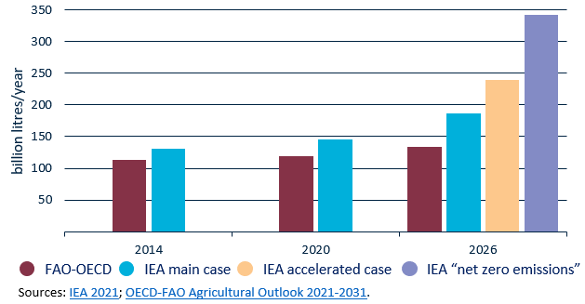
- The International Energy Agency (IEA) expects biofuel demand to grow from 146 billion litres/year in 2020 to between 186 and 342 billion litres/year in 2026 (an increase of 27%-134%).
- The magnitude of the increase will depend on whether countries meet their expressed policy goals of increasing biofuel use and the relative price of biofuels compared to oil.
- The OECD-FAO forecast more modest biofuel consumption growth than the IEA (134 billion litres of biofuel in 2026).

International biofuel policy impacts on Australian agriculture
- The EU intends to increase the use of biofuels and phase out the use of palm oil as a biofuel feedstock. This will increase the overall demand for biofuel feedstock, particularly feedstocks such as canola.
- India has proposed a target of 20% blending of ethanol in petrol, and 5% blending of biodiesel in diesel by 2030. India is unlikely to become an export market for Australian ethanol or by-products from raw sugar production.
- The diversion of Indian sugarcane away from sugar and towards ethanol production may have indirect benefits to Australian sugar exporters.

Australian biofuel production
- In 2021, Australia produced 180 million litres of fuel ethanol and 18 million litres of biodiesel.
- The main feedstock of Australia’s three ethanol producers are wheat starch and molasses (from sugarcane). The main biodiesel feedstocks are tallow and vegetable oil (used and virgin).
- Australia is the third largest sugarcane producer worldwide. Most excess bagasse is burnt to generate electricity, however, other countries have used its energy potential for biofuel.

