Publication details

**Title:**

**Catchment Scale Land Use of Australia – Commodities – Update December 2018 version 2**

**Alternate title:**

CLUMCv2 11/2019 dataset

**Date published:**

2019-11-26

**Abstract:**

Version 2 of the Catchment Scale Land Use of Australia – Commodities – Update December 2018 dataset was released on 26 November 2019. This dataset and map replaces those released on 19 February 2019. Version 2 incorporates the following changes:

* Removal of cattle meat features where it is not clear whether feedlots are cattle or sheep feedlots.
* Removal of broad aquaculture class and consistency applied to aquaculture commodities so that marron and yabbies are now classed as crustaceans and abalone as molluscs.
* An increase in the number of polygons in the Australian Capital Territory and Western Australia. Polygons for each commodity in these jurisdictions were combined as multi-part features rather than single part features leading an underestimation of the number of polygons at both the state and national levels.
* Inclusion of extra animal, grapes and olives features based on ALUM and Valuer General codes for South Australia, New South Wales, the Northern Territory and Victoria.
* Inclusion of alkaloid poppies in Tasmania based on ALUM codes.
* Inclusion of missing sugar features in New South Wales based on ALUM codes.
* Inclusion of missing vegetables and herbs features for Western Australia.
* Corrections where commodities have been assigned the wrong broad type (e.g. pistachios assigned to nuts) or commodity names were incorrect (e.g. pecan nuts to pecans).
* Removal of slithers and overlapping polygons.

This dataset is the second national compilation of catchment scale commodity data for Australia (CLUMC), current as at December 2018. It replaces the Catchment Scale Land Use of Australia – Commodities – September 2017. It has been compiled from vector land use datasets collected as part of state and territory mapping programs through the Australian Collaborative Land Use and Management Program (ACLUMP). It complements the Catchment Scale Land Use of Australia – Update December 2018 dataset (ABARES 2019). Agricultural commodities are assigned to the Australian Land Use and Management (ALUM) Classification version 8 (ABARES 2016) classes based on; perceived intervention to the landscape, growing conditions and management, the intended use of the commodity, consistency with national and international reporting frameworks and standards, such as National Plantation Inventory, industry guidelines, Australian Bureau of Statistics, harmonised trade codes and ABARES commodity reports, where possible.

Commodities data were produced as part of catchment scale land use mapping and primarily uses fine-scale satellite data and information collected in the field (ABARES 2011, 2015). Field validation was critical for mapping commodities. The date of mapping (2003 to 2018) and scale of mapping (1:5 000 to 1:250 000) vary, reflecting the source data, capture date and scale. It is important to note that the location of a commodity may change on an annual basis, depending on factors such as climate, markets or farming systems.

The following areas have been updated since the September 2017 version: Burdekin natural resource management (NRM) region in Queensland; the state of New South Wales; the state of Victoria; and the state of Western Australia.

Jurisdictions captured commodity data (where possible) for those areas most recently mapped in the Catchment scale land use of Australia – Update December 2018 (ABARES 2019) with a focus on horticultural and intensive animal industries. Other commodities which are tertiary classes of the ALUM classification (such as sugar cane, cotton, rice, olives and grapes) have been mapped by jurisdictions for some time and are included in this dataset.

Agricultural commodity level mapping is available for all of the Northern Territory, and is likely to be complete for the following commodities nationally (taking into consideration the date of mapping):

Crops - rice, sugar cane, cotton

Fruit – bananas (except Southern Queensland), avocados, mangoes, olives, grapes

Nuts – macadamias

Livestock – dairy cattle, pigs, poultry, horse studs, aquaculture.

Commodity information is selected from an agreed list of commodity names developed by ACLUMP partners. A commodity may be applied to one or many land use codes. For example the commodity ‘wheat’ is applied to class 3.3.1, ‘Cropping’ or 4.4.1, ‘Irrigated cropping’, while ‘cattle’ may be applied to any land use where cattle are observed including 2.1.0 ‘Grazing native vegetation’, 3.2.0 ‘Grazing modified pastures’, 4.2.0 ‘Grazing irrigated modified pastures’, 5.2.2 ‘Feedlots’ etc.

The commodity description is intended to add information to the catchment scale land use map which is not otherwise recorded in the ALUM Classification. Where there are several suitable commodity descriptions mappers are encouraged to record the most detailed description. For example when cattle breeds are known to be for milk production mappers would apply the commodity description ‘cattle dairy’ rather than just ‘cattle’.

This publication (and any material sourced from it) should be attributed as: ABARES 2019, Catchment Scale Land Use of Australia – Commodities – Update December 2018 version 2, ABARES, Canberra, November CC BY 4.0. <https://doi.org/10.25814/5c887edfb0bbb>

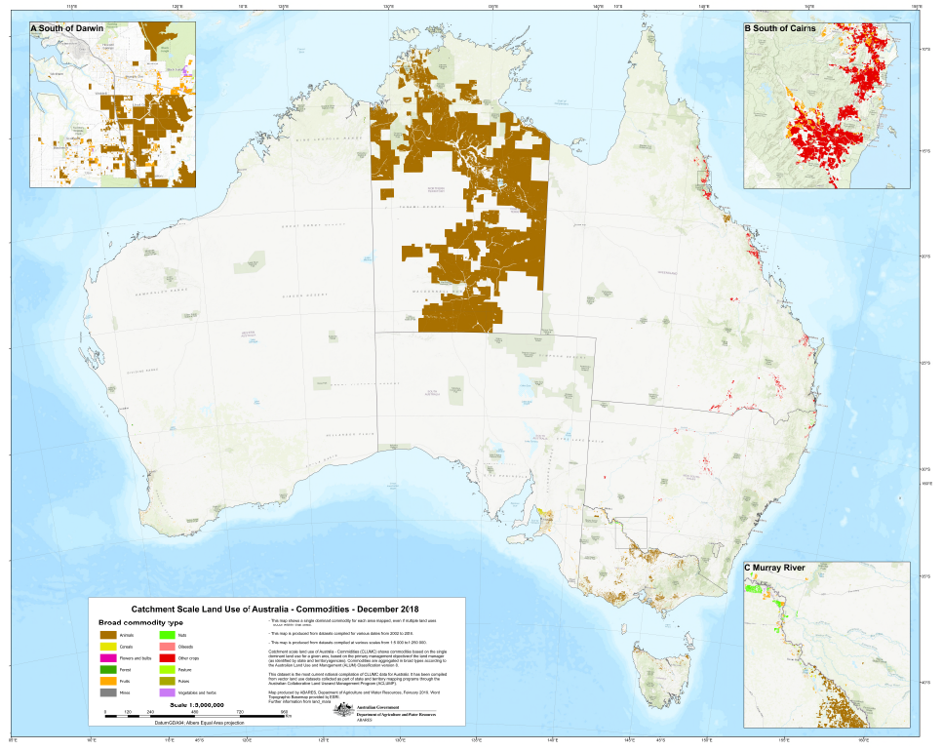

Descriptive information

**[Author(s)  
and/or Stakeholder(s):](http://data.daff.gov.au/anrdl/metadata_files/pb_mcas31s9abl_03111a01.xml" \l "Stakeholders)**

Acknowledgements: This dataset was produced by Australian Bureau of Agricultural and Resource Economics and Sciences (ABARES) within the Australian Government Department of Agriculture as part of the Australian Collaborative Land Use and Management Program (ACLUMP). ACLUMP, of which ABARES is a partner, is a consortium of Australian Government, and state and territory government partners that promotes the development of nationally consistent land use, land cover and land management practice information for Australia. Datasets were provided by: the New South Wales Office of Environment and Heritage; the Northern Territory Department of Environment and Natural Resources; the Queensland Department of Environment and Science; the South Australian Department of Environment and Water; the Tasmanian Department of Primary Industries, Parks, Water and Environment; the Victorian Department of Jobs, Precincts and Regions; and the Department of Primary Industries and Regional Development, Western Australia.

Constraints

**LEGAL CONSTRAINTS ASSOCIATED WITH THE MATERIAL**

**Limitation on the use of the material:**

The Australian Government acting through ABARES has exercised due care and skill in the preparation and compilation of the information and data set out in this publication. Notwithstanding, ABARES, its employees and advisers disclaim all liability, including liability for negligence, for any loss, damage, injury, expense or cost incurred by any person as a result of accessing, using or relying upon any of the information or data set out in this publication to the maximum extent permitted by law.

**Constraints on using the material:**

copyright

**Other constraints:**

Licence type:Copyright  
(c) Commonwealth of Australia 2019  
All material in this publication is licensed under a Creative Commons Attribution 4.0 Australia Licence, save for content supplied by third parties, logos and the Commonwealth Coat of Arms.

This publication (and any material sourced from it) should be attributed as: ABARES 2019, Catchment Scale Land Use of Australia – Commodities – Update December 2018 version 2, ABARES, Canberra, November CC BY 4.0. <https://doi.org/10.25814/5c887edfb0bbb>

Additional information about this material

**Purpose for which the material was obtained:**

This dataset provides the best available commodity level mapping information for Australia’s regions as at December 2018. It is used by the Department of Agriculture, state agencies and regional natural resource management groups to address issues such as agricultural productivity and sustainability, biosecurity, land use planning, natural disaster management and natural resource monitoring and investment. The data vary in currency (2003 to 2018) and scale (1:5 000 to 1:250 000).

**Progress status of this material:**

Completed

**Maintenance and Update Frequency:**

As needed

**KEYWORD(S)**

**ANZLIC Search Words:**

AGRICULTURE  
AGRICULTURE mapping  
LAND  
LAND survey  
LAND Use  
LAND Use maps  
LAND Use classification

**General Keywords:**

Australian Collaborative Land Use and Management Program (ACLUMP)

**TOPICS**

**ABARES Topic categories:**

Agriculture  
Land Use  
Environment and Natural Resource Management  
Models, Risk, Spatial Data and Datasets

**ISO topic categories:**

farming  
environment  
biota

**SPATIAL EXTENT(S)**

**Extent**

**Description of spatial extent:**

Australian Land

**Spatial bounding box included in:**

North: -8.20 degrees; South: -44.37 degrees; East: 157.23 degrees; West: 109.49 degrees.

**Extent**

**Description of spatial extent:**

Australian Land

**Spatial area included in:**

Australian Mainland  
Australia excluding external territories

**Projection:**

EPSG::3577

**Coordinate reference details: Well-Known Text:**

PROJCS["GDA94 / Australian Albers",GEOGCS["GDA94",DATUM["D_GDA_1994",SPHEROID["GRS_1980",6378137,298.257222101]],PRIMEM["Greenwich",0],UNIT["Degree",0.017453292519943295]],PROJECTION["Albers"],PARAMETER["standard_parallel_1",-18],PARAMETER["standard_parallel_2",-36],PARAMETER["latitude_of_origin",0],PARAMETER["central_meridian",132],PARAMETER["false_easting",0],PARAMETER["false_northing",0],UNIT["Meter",1]]

**RESPONSIBILITY FOR THIS MATERIAL**

**custodian**

Department of Agriculture: Australian Bureau of Agricultural and Resource Economics and Sciences  
Data Manager  
GPO Box 858  
CANBERRA CITY  
Australian Capital Territory 2601 AUSTRALIA  
Voice: +61 2 6272 3933

dataman@agriculture.gov.au

**publisher**

Department of Agriculture: Australian Bureau of Agricultural and Resource Economics and Sciences  
GPO Box 858  
CANBERRA CITY  
Australian Capital Territory 2601 AUSTRALIA  
Voice: +61 2 6272 3933

dataman@agriculture.gov.au

**go up to acknowledgements**

**CONTACT(S) WHEN INQUIRING ABOUT THIS MATERIAL**

**pointOfContact**

Department of Agriculture: Australian Bureau of Agricultural and Resource Economics and Sciences  
Data Manager  
GPO Box 858  
CANBERRA CITY  
Australian Capital Territory 2601 AUSTRALIA  
Voice: +61 2 6272 3933

dataman@agriculture.gov.au

**PROCESS USED TO GENERATE THIS MATERIAL**

**Lineage Statement**

**Lineage:**   
ABARES has produced this vector dataset from vector catchment scale land use data provided by state and territory agencies, as follows:

* Catchment Scale Land Use Mapping for the Australian Capital Territory 2012
* 2017 NSW Land Use v1.0
* Northern Territory Land Use Mapping 2016-17
* Land use mapping - Queensland current (March 2018)
* South Australia Land Use (ACLUMP) 2017
* Tasmanian Land Use 2015
* Victorian Land Use Information System (VLUIS) 2016-17
* Victorian Northern Irrigation Region 2016
* Catchment Scale Land Use Mapping for Western Australia 2018

Links to land use mapping datasets and metadata are available at the ACLUMP data download page at <http://www.agriculture.gov.au/abares/aclump/pages/land-use/data-download.aspx>.

Commodities data were extracted using the tertiary land use code or the commodity description where appropriate. The State and source year were added to the attribute table and the area of the polygon calculated in hectares. Finally the commodities was joined to a lookup table to include a broad classification of commodities.

**Positional Accuracy:**   
The scale of the source data varies from 1:5 000 to 1:250 000. See individual land use mapping dataset metadata for specific measures of accuracy.  
**Attribute Accuracy:**   
The methods for mapping and classifying commodities adhere to the standards outlined in ‘The Australian Land Use and Management Classification Version 8’ (ABARES 2016). Datasets mapped to version 7 of the ALUM Classification were converted to version 8 using a look-up table based on Appendix 1 (ABARES 2016).  
**Logical Consistency:**   
All input polygon datasets were checked for topological consistency.   
**Completeness:**   
Complete for Northern Territory. Complete for all relevant data provided.

Information about the product description

**Parties responsible for description**

**Description custodian**

Department of Agriculture: Australian Bureau of Agricultural and Resource Economics and Sciences  
Data Manager  
GPO Box 858  
CANBERRA CITY  
Australian Capital Territory 2601 AUSTRALIA  
Voice: +61 2 6272 3933

dataman@agriculture.gov.au

**Description publisher**

Department of Agriculture: Australian Bureau of Agricultural and Resource Economics and Sciences  
GPO Box 858  
CANBERRA CITY  
Australian Capital Territory 2601 AUSTRALIA  
Voice: +61 2 6272 3933

dataman@agriculture.gov.au

**Description originator**

Department of Agriculture: Australian Bureau of Agricultural and Resource Economics and Sciences : Land and Spatial Analytics  
GPO Box 858  
CANBERRA CITY  
Australian Capital Territory 2601 AUSTRALIA  
Voice: +61 2 6272 3933

dataman@agriculture.gov.au

Additional Metadata

**References**

ABARES 2011, *Guidelines for land use mapping in Australia: principles, procedures and definitions*, A technical handbook supporting the Australian Collaborative Land Use and Management Program, 4th edition, Australian Bureau of Agricultural and Resource Economics and Sciences, Canberra, available at [data.daff.gov.au/data/warehouse/pe_abares99001806/GuidelinesLandUseMappingLowRes2011.pdf](http://data.daff.gov.au/data/warehouse/pe_abares99001806/GuidelinesLandUseMappingLowRes2011.pdf%20).

ABARES 2015, *Addendum to the Guidelines for land use mapping in Australia: principles, procedures and definitions*, 4th edition, Australian Bureau of Agricultural and Resource Economics and Sciences, Canberra, available at [data.daff.gov.au/data/warehouse/pe_abares99001806/AddendumGuidelinesLandUseMapping2015_v1.0.0.pdf](http://data.daff.gov.au/data/warehouse/pe_abares99001806/AddendumGuidelinesLandUseMapping2015_v1.0.0.pdf).

ABARES 2016, *The Australian Land Use and Management Classification Version 8, Detailed*, Australian Bureau of Agricultural and Resource Economics and Sciences, Canberra, available at [agriculture.gov.au/abares/aclump/Documents/ALUMCv8_Handbook4ednPart2_UpdateOctober2016.pdf](http://www.agriculture.gov.au/abares/aclump/Documents/ALUMCv8_Handbook4ednPart2_UpdateOctober2016.pdf).

ABARES 2019, *Catchment Scale Land Use of Australia – Update December 2018*, Australian Bureau of Agricultural and Resource Economics and Sciences, Canberra, available at [agriculture.gov.au/abares/aclump/pages/land-use/data-download.aspx](http://www.agriculture.gov.au/abares/aclump/pages/land-use/data-download.aspx),