| Desiccation tolerance of river and floodplain mussels in the Murray–Darling Basin  Report to the Commonwealth Environmental Water Office |
| --- |

Published by the NSW Department of Primary Industries

Desiccation tolerance of river and floodplain mussels in the Murray-Darling Basin. Report to the Commonwealth Environmental Water Office. First published February 2022.

Citation

Wright, D., Thiem, J., Blackman, E., Beatty, S., Lymbery, A., Davis, S. (2022). Desiccation tolerance of river and floodplain mussels in the Murray-Darling Basin. NSW DPI Technical Report to the Commonwealth Environmental Water Office.

Funding

This project was commissioned and funded by the Commonwealth Environmental Water Office and was undertaken by the NSW Department of Primary Industries in collaboration with Murdoch University.

More information

[Daniel Wright, Jason Thiem & Elka Blackman / Department of Primary Industries / Narrandera Fisheries Centre;

Stephen Beatty & Alan Lymbery / Murdoch University / Perth, Western Australia;

Sam Davis / Department of Primary Industries/ Dubbo]

www.dpi.nsw.gov.au | www.murdoch.edu.au | www.awe.gov.au/water/cewo

Cover photo credit: Nicole McCasker, CSU.

© State of New South Wales through Regional NSW 2022. The information contained in this publication is based on knowledge and understanding at the time of writing (February 2022). However, because of advances in knowledge, users are reminded of the need to ensure that the information upon which they rely is up to date and to check the currency of the information with the appropriate officer of the Department of Regional NSW or the user’s independent adviser.

## Table of contents

Table of contents 2

List of tables 3

List of figures 4

Acknowledgements 6

Executive summary 7

Introduction 10

Literature review 11

Desiccation tolerance: a freshwater mussel research priority 11

Desiccation coping strategies 16

Previous desiccation research 17

Relevance to water managers 20

Methods 21

Sediment temperature field trial 21

Mussel desiccation laboratory trials 23

Results 26

Sediment temperature field trial 26

Mussel desiccation laboratory trials 29

Discussion 36

Interaction of water emersion and temperature 36

Differences between species in desiccation tolerance 37

Behavioural responses to water emersion 37

Management implications and recommendations 38

References 42

## List of tables

**Table 1** Numbers of total and IUCN assessed species by region. Data was obtained from Graf and Cummings (2021) and IUCN (2021). 13

**Table 2** Numbers of total, IUCN Red List assessed, IUCN Red List mapped species and desiccation tolerance studied species, as well as those species listed as threatened and data deficient by Superfamily. Data was obtained from Graf and Cummings (2021) for total species numbers, the IUCN (2021) for IUCN Redlist information and from this review of desiccation studies and associated species numbers (see references in next section). Note that only 5 of 30 (16%) freshwater mussel species in Australia have been mapped by the IUCN Red List. Proportions of assessed and mapped species are relative to total species numbers, while proportions of threatened and data deficient species are relative to species numbers assessed under the IUCN Red List. 15

**Table 3** Experimental equipment, mussel locations, and the temperatures and air humidity conditions used in desiccation tolerance trials for the Superfamilies and species studied. Note not all species are included from Bartsch et al. (2000) as desiccation tolerance could not be studied for some species over the experiment duration of 1 hour. 18

**Table 4** Parameters of equations for linear regressions between mean daily temperatures recorded by loggers in different sediment conditions and mean daily air temperature at a nearby NSW DPI weather station at Leeton. R2 and P values are also displayed. 28

**Table 5** Lethal times that 50% of mussels died (LT50) and 95% confidence intervals (CI) for river and floodplain mussels in simulated river drying conditions at 29, 32, 35, 38 and 41°C, with previous acclimation at 26°C. Confidence interval ratio test results for comparisons of LT50 estimates between mussel species are also provided at each temperature. 32

**Table 6** Lethal temperatures that 50% of mussels died (LT50) and 95% confidence intervals (CI) for river and floodplain mussels in simulated river drying conditions previously acclimated to 26°C at 1, 2, 4, 10, 20 and 30 day intervals. Confidence interval ratio test results for comparisons of LT50 estimates for between mussel species are also provided at each temporal interval. 34

**Table 7** Lethal temperatures that 50% of mussels died (LT50) and 95% confidence intervals (CI) for river mussels in simulated river drying conditions previously acclimated to 23 and 26°C at 1, 2, 4 and 10 day intervals. Confidence interval ratio test results for comparisons of LT50 estimates between acclimation temperature are also provided at each temporal interval. 35

## List of figures

**Figure 1** Framework for assessing freshwater mussel conservation status at a species level. This is based on threats (extrinsic factors) that influence animal- or population-level indicators (intrinsic factors) (reproduced from Ferreira-Rodríguez et al. 2019). Note that mussel desiccation and upper thermal tolerance studies assess risks posed by climate change and water habitat alteration which can affect all indicators. 11

**Figure 2** World map of the biogeographic realms where freshwater mussels occur (top), and the proportion of species assessed by the IUCN (2021) as threatened (critically endangered, endangered and vulnerable) or data deficient (bottom). See species numbers by region in Table 1. The biogeographic realm layer was obtained from the United Nations Environmental Programme (2004). 14

**Figure 3** Of the freshwater mussel species mapped by the IUCN Red List (see Table 2), world maps display the number of species by basin and the distribution of species within Superfamilies Unionoidea, Hyrioidea and Etherioidea by basin. Species distributions were obtained from the IUCN Red List (2021) and information on species superfamilies were obtained from Graf and Cummings (2021). The basins overlapping with species distributions were defined as main basins or Pfafstetter level 1 using the HydroBASINS system (Lehner and Grill 2013). 15

**Figure 4** Temperature, air relative humidity (RH) and sediment conditions used in laboratory desiccation tolerance trials for various freshwater mussel species. Yellow and blue colour indicates mussels belonging to Hyrioidea and Unionoidea Superfamilies respectively. Unk refers to instances where air humidity was not unknown. Mean temperature is used for trials where temperature varied. Points are slightly jittered apart to minimise overlaps. 17

**Figure 5** Maximum known survival times of freshwater mussel species subjected to desiccation conditions at 15–30 °C. Yellow and blue colour indicates mussels belonging to Hyrioidea and Unionoidea Superfamilies respectively. Note the x axis is on a log(*x*+1) scale. 20

**Figure 6** Map of the Murray-Darling Basin (grey shading), major Barwon-Darling, Murray and Murrumbidgee rivers within it (blue lines), NSW DPI Narrandera Fisheries Centre (NFC, circle) where the sediment temperature trial was conducted, and a nearby NSW DPI weather station at Leeton (triangle). State boundaries and major cities (squares) are also displayed. 21

**Figure 7** Schematic of the sediment temperature trial design where a range of sediment treatments (sun and shade light levels, wet and dry moisture levels, and clay and sand sediment types) were applied in 8 trays and temperature loggers were deployed at exposed surface and buried subsurface positions. Note that the schematic is not to scale, and that shade was provided via shade cloth and wet moisture levels were achieved using an irrigation system with an automated digital tap timer. 22

**Figure 8** Schematic of the freshwater mussel desiccation trials. Trial designs were adapted from Khan et al. (2020). 24

**Figure 9** Mean daily temperatures recorded by loggers (lines and symbols) from 13–28 January 2021 in a range of sediment conditions: dry (yellow) or wet (blue line), clay (circle) or sand (diamond symbol), buried (solid) or exposed (dashed line), shade (blue) or sun (yellow symbol). Logger recordings on 20–21 are not shown as the irrigation system for wet treatments malfunctioned. Mean daily air temperature from the NSW DPI Leeton weather station over the period is also shown (grey line). 27

**Figure 10** Hourly temperatures recorded by loggers (lines and symbols) from 13–28 January 2021 in a suite of sediment conditions: dry (yellow) or wet (blue line), clay (circle) or sand (diamond symbol), buried (solid) or exposed (dashed line), shade (blue) or sun (yellow symbol). Logger recordings on 20–21 are not shown as the irrigation system for wet treatments malfunctioned. Hourly air temperature from the NSW DPI Leeton weather station over the period is also shown (grey line). 27

**Figure 11** Mean daily air temperature plotted against temperatures recorded by loggers in various sediment conditions: dry (yellow) or wet (blue line), clay (circle) or sand (diamond symbol), buried (solid) or exposed (dashed line), shade (blue) or sun (yellow symbol). Yellow and blue lines represent linear regressions and grey lines indicate a 1:1 ratio between mean daily air temperature and mean daily logger temperature. Air temperatures were obtained from the NSW DPI Leeton weather station. 29

**Figure 12** Moisture content of sediment within containers which held mussels are shown for Trial 1 at day 0, 1, 4, 10, 20 and 40. Points indicate mean values of measurements from individual tanks and bars represent ranges. Points and bars are colour coded according to mean values. Note that values are not shown once no mussels were alive for several days in a treatment. 30

**Figure 13** Survival times of river and floodplain mussels under experimental desiccation conditions in Trial 1. Points represent mussel survival at each assessment in a replicate tank, with point shading indicating the number of replicates with an identical survival value (darker colour for more replicates with the same value). Lines show the two-parameter logistic regression curves and are colour-coded by temperature and 95% confidence intervals around lethal time LT50 values. 31

**Figure 14** Lethal temperatures that 50% of mussels died (LT50) and 95% confidence intervals for river and floodplain mussels at 1, 2, 4, 10, 20 and 40 days. The upper and lower temperatures at which mussels were held in simulated river drying conditions are shown as dashed horizontal lines. Note that points at the same time interval are dodged apart and the x axis in log(*x*+1) transformed. The colour of points refers to the corresponding lethal temperature LT50 value. 33

## 

## Acknowledgements

We thank Nerida Sloane and Hayley Behnke for their contributions to the project and the Commonwealth Environmental Water Office for funding under contract number 3600004096. Thanks also to the following DPI Fisheries staff for project and logistical support: Martin Asmus, Katherine Cheshire, Jonathon Doyle, Lachie Jess, Gary McLean, Matt McLellan, Nicholas O’Brien, Rohan Rehwinkel and Jackson Wilkes-Walburn. Discussions with Nicole McCasker and Hugh Jones were beneficial during this project.

## Executive summary

Freshwater mussels are an important component of aquatic communities in lowland rivers and play an essential role in ecosystem functioning; they provide a food resource for fish and other aquatic animals, are a biological filter that improves water quality, and can be used as an indicator of aquatic health. Globally, freshwater mussel populations have been impacted by water resource development, drought, and changes to climatic conditions, although little is known about their ecological requirements in some regions. Between 2017 and early 2020, extreme drought conditions and extreme summer temperatures in Australia’s Murray–Darling Basin are thought to have impacted the distribution, condition and survival of freshwater mussel populations. For example, large numbers of deceased mussels were observed in locations such as the Namoi and Barwon–Darling rivers, raising concerns of the potential risk for other populations in locations such as the Macquarie and Border rivers dying in drying pools. There are several knowledge gaps around the requirements of freshwater mussels in the Murray–Darling Basin. One of these gaps is the tolerance of different freshwater mussels to river drying at different temperatures, which is thought to contribute to significant declines in mussel populations. Although mussels may burrow into cooler sediment to better survive periods of drying, the desiccation tolerances likely differ between species. Quantifying critical ecological thresholds would enable predictive capacity to determine how drying events will impact the mortality and abundance of each mussel species, and can be used to inform the management of environmental water and river operations to better support mussel populations.

In this project, we aimed to 1) assess the relevant literature regarding global threats to freshwater mussels including desiccation during river drying as a result of river regulation and a changing climate, and 2) through a series of field and laboratory experiments investigate the potential sediment temperatures freshwater mussels experience during river drying events in the Murray–Darling Basin, 3) determine the desiccation tolerance of two Murray–Darling Basin freshwater mussel species (the river mussel *Alathyria jacksoni* and the floodplain mussel *Velesunio ambiguus*) in a study emulating field conditions (e.g. temperature, substrate, drying). Integrating these components will enable the formulation of recommendations on how to better support populations of different Murray–Darling Basin freshwater mussel species through river and environmental flow management.

Buried mussels were held in an experimental setup simulating river drying at a range of temperatures (29–41°C) for 76 days. Resistance to desiccation or river drying differed between species and was highly temperature-dependent. At 29°C, 50% of floodplain mussels survived for 58 days, significantly longer than river mussels, which had a 50% survival time of 14 days. As temperatures increased, survival times were markedly decreased and became more similar for both species; by 41°C the survival time for 50% of river and floodplain mussels was around one day. The differences in physiological tolerance of desiccation between mussel species probably reflect adaptations to different habitats. River mussels are found in the main channel of large, flowing rivers, while floodplain mussels are usually found in more ephemeral lentic environments.

Sediment temperatures at surface and buried locations were measured over a two-week period in summer for different soil types (sand and clay) which were either dry or wetted, and in either shade or full sun. Temperatures were not influenced by soil type but were always lower within the sediment than on the surface and were further reduced by soil moisture and shade. At an air temperature of 32°C, temperature at a depth of 2.5 cm in shaded, moist soil was only 24°C, compared to 38°C on the surface of dry soil in full sun. This suggests that a mussel species with a propensity to burrow and find moist sediment in shaded conditions will be able to survive prolonged drought periods, but that a species less likely to burrow and seek out moist shaded sediment will not.

The results of this study, and the general paucity of information regarding the current status of freshwater mussels in the MDB, lend themselves to several management and research recommendations:

**Management recommendation 1.** Identify any current critical source populations of *Alathyria jacksoni* and *Velesunio ambiguus*, quantify range reductions and map the spatial extent and vegetation types associated with these locations. This includes revisiting IUCN listing status. Identify and prioritise future colonisation sites and migration pathways of mussel fish-hosts on a catchment and basin scale.

**Management recommendation 2.** Both species of mussel, *Alathyria jacksoni* and *Velesunio ambiguus*, are extremely vulnerable to mortality during periods of emersion. Complete drying of habitat and subsequent exposure of either species, particularly for critical source populations, should be avoided at any time.

**Management recommendation 3.** During times of low water resource availability or extreme shortages, maintain very low flows, baseflows or refugia replenishment for the source populations of *Alathyria jacksoni* and *Velesunio ambiguus* identified in **Management recommendation 1**.

**Management recommendation 4.** If at risk of drying, habitatssupporting critical mussel source populations of *Velesunio ambiguus* should have any emersion and complete exposure events confined to the cooler months of the year when ambient temperatures are <30°C. Complete drying of these habitats should be conservatively managed during these months and extend for no longer than 20 days to avoid mass mortality events.

**Management recommendation 5.** Support specific watering targets for riparian and floodplain vegetation types associated with mussel habitat for source populations and priority recolonisation sites identified in **Management recommendation 1**, in both annual watering and long-term water plans to maintain and increase vegetation extent for temperature buffering and system productivity.

**Management recommendation 6.** Develop specific hydrographs to support critical life-history stages of mussels that relate to reproduction, dispersal and settlement opportunities (colonisation linked to **Management recommendation 1**) with synchronicity to fish host species hydrographs. Consider inclusion of specific ecological flow requirements for mussels in Long-Term Water Plans, where required.

**Research recommendation 1.** Examine the behavioural mechanisms both river and floodplain mussels use in response to river drying, including investigating their ability and the relevant timeframes required to undertake horizontal and vertical movements in response to receding water levels.

**Research recommendation 2.** Extend this current research to encompass the interactive effects of water emersion and temperature on multiple life-history stages of MDB mussels. Combined with the collection and modelling of sediment moisture content, water quality and temperature data under cease to flow conditions at several representative sites, this information could be used to provide prescriptive guidance to water managers regarding refugia longevity and maximum cease-to-flow durations.

**Research recommendation 3.** Investigate the sublethal effects of short-term emersion and associated desiccation on MDB mussels. Further, populations that have adapted to changing environmental conditions and have high levels of genetic diversity are more likely to overcome environmental stressors. This could be assessed in freshwater mussels at the population level using a combination of landscape genomics to identify adaptation in response to environmental factors and population genetics to identify patterns of genetic diversity and connectivity across the MDB.

## Introduction

Freshwater mussels provide a range of important ecosystem services in rivers including water filtering, nutrient cycling and providing food and habitat for other biota (Vaughn 2018). They have also provided an important food source and contributed to spiritual and cultural connections to water for many Indigenous peoples of the world (Noble et al. 2016), including Indigenous Australians (Balme 1995, Humphries 2007). Globally, freshwater mussels are affected by habitat destruction, climate change, pathogens, river regulation, changes to fish host populations, predation and introduced species (Lopes-Lima et al. 2018, Ferreira-Rodríguez et al. 2019). These threats have contributed to the extinction of 6% of freshwater mussel species and a further 32% considered to be critically endangered, endangered or vulnerable out of those assessed by the International Union for the Conservation of Nature (IUCN) Red List (IUCN 2021). While neither of the two species widely distributed through the Murray–Darling Basin (MDB) (the river mussel *Alathyria jacksoni* and the floodplain mussel *Velesunio ambiguus*) are currently listed as threatened (although it must be noted that *A. jacksoni* is listed as data deficient and *V. ambiguus* is not listed), recent extreme drought conditions and extreme summer temperatures from 2017–2020 are having noticeable impacts on freshwater mussel populations and may be disproportionately affecting certain species (Mallen-Cooper and Zampatti 2020, Sheldon et al. 2020).

A major gap in understanding the impacts of drought and extreme summer conditions on mussel populations in the MDB is how different mussel species cope with drying at extreme upper temperatures (Sheldon et al. 2020). Mussels can avoid desiccation (process of water content removal) during river habitat drying by travelling over land with their foot to move back into water. They also have the capacity to burrow down into cooler and potentially wetter sediment with their foot to minimise the effects of the desiccation. Once out of water, mussels must survive without food in a dormant state during which they are vulnerable to low humidity in air, low moisture content in sediment and high temperatures.

Freshwater mussels vary in their ability to move, burrow and survive desiccation (Gough et al. 2012, Mitchell et al. 2018). Out of the common freshwater mussels in the MDB we know that *A. jacksoni* is much more susceptible to desiccation compared to *V. ambiguus*. At 18°C, 50% of *A. jacksoni* are reported to die in 12 days compared with 280 days for 50% of *V. ambiguus* to perish (Walker 1981). What remains unknown is how desiccation tolerance times for these two species differ over a range of upper temperatures. Obtaining this information could enable water managers to assess freshwater mussel mortality risk during drought and extreme summer conditions. Appropriate management actions could then be implemented, such as tailoring the timing, volume and priority watering sites of both environmental and operational flows, to minimise the extent of river drying and its impacts on freshwater mussel populations.

In this report, we first present a global literature review on freshwater mussel desiccation tolerance studies. Second, we document new research into the desiccation tolerance of MDB freshwater mussel species. Specific research objectives were to: 1) investigate potential sediment temperatures freshwater mussels experience during river drying events, 2) determine the desiccation tolerance of two MDB freshwater mussels in a study emulating field conditions (e.g. temperature, substrate, drying), and 3) use the findings to make recommendations on how to better support populations of different MDB freshwater mussel species through river operations and environmental flow management, including within relevant plans (e.g. CEWO water use plans, Long Term Water Plans, Water Sharing Plans).

## Literature review

### Desiccation tolerance: a freshwater mussel research priority

Freshwater mussels (Order Unionoida) are a diverse group of bivalves, consisting of 3 superfamilies, 192 genera and 958 species (Graf and Cummings 2021). They are exposed to a plethora of threats that have led to extinction, increased risk of extinction and reductions in their abundance and distributional range (Lopes-Lima et al. 2018, Ferreira-Rodríguez et al. 2019) (Figure 1). Top research priorities for assessing freshwater mussel conservation status at a species level include determining desiccation and temperature tolerances to expose risks associated with climate change and water habitat alteration threats (Ferreira-Rodríguez *et al.* 2019) (Figure 1). These threats can affect mussel populations in variety of ways including reproduction, recruitment, population size and population distribution (Ferreira-Rodríguez et al. 2019) (Figure 1). Mass die-offs, reductions in species richness and local extinctions of freshwater mussels have resulted from river drying and high temperatures events linked to climate change and water habitat alteration (Golladay et al. 2004, Haag and Warren 2008). Such episodes are expected to worsen in terms of their frequency and intensity in future years under predicted climate change scenarios (Kundzewicz et al. 2008) and increasing river regulation in freshwater environments (Milliman et al. 2008). It is therefore critical that desiccation and upper thermal tolerances are studied and considered in freshwater mussel conservation and management.

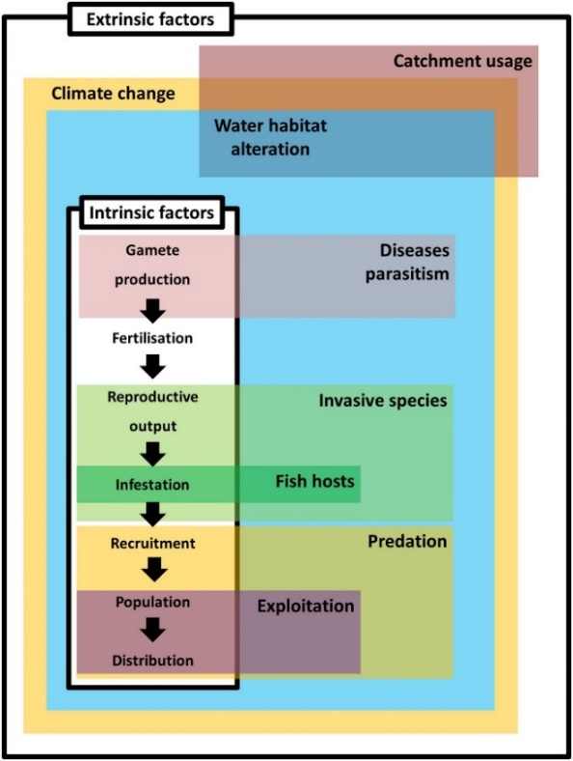

**Figure 1** Framework for assessing freshwater mussel conservation status at a species level. This is based on threats (extrinsic factors) that influence animal- or population-level indicators (intrinsic factors) (reproduced from Ferreira-Rodríguez et al. 2019). Note that mussel desiccation and upper thermal tolerance studies assess risks posed by climate change and water habitat alteration which can affect all indicators.

Of all 958 freshwater mussel species, only 540 (56%) have been assessed by the IUCN Red List for their conservation status (Tables 1 and 2) (Graf and Cummings 2021, IUCN 2021). Of the listed species, 32 (6%) have been assessed as extinct, 71 (13%) as critically endangered, 58 (11%) as endangered and 42 (8%) as vulnerable, with an additional 84 species (15%) considered data deficient (IUCN 2021) (Table 2). The proportion of threatened (critically endangered, endangered and vulnerable) freshwater mussel species (32%) falls above the average, with 28% of all species currently listed as threatened on the IUCN Red List (IUCN 2021).

Proportions of assessed, threatened and data deficient species under the IUCN Red List vary by region (Lopes-Lima et al. 2018) (Figure 2). With among the highest levels of species richness, the North American or Nearctic region has had most species assessed, with a high proportion of these listed as threatened and few species considered to be data deficient. By contrast, the Australasian region has low levels of species richness, but few species here have been assessed. Of the Australasian species assessed, a relatively small proportion are listed as threatened, however a high proportion of species are data deficient. Therefore, the number and proportion of threatened species in the Australasian region may be higher once more data allows definitive assessments for data deficient species and once more species are added to IUCN Red List (see Lopes-Lima et al. 2018).

Proportions of assessed, threatened and data deficient species under the IUCN Red List also differ between the three freshwater mussel Superfamilies (Table 2). With the fewest species, members of the Etherioidea Superfamily are all assessed under IUCN Red List, with half of them listed as threatened. The most diverse Superfamily, Unionoidea, has most species assessed by the IUCN Red List, of which 32% are threatened while 15% are considered data deficient. For the Hyrioidea Superfamily, the majority of species are yet to be assessed and of the small number of assessed species, 30% are threatened but 22% are data deficient. Hyrioidea mussel species are restricted to areas of Australasia and South America regions (Figure 3). Again, it is plausible that proportions and numbers of threatened species could be higher within Hyrioidea of Australasia and South America as more species are definitively assessed by the IUCN Red List.

These data highlight that status assessments for freshwater mussels in Australasia require urgent attention. This is particularly pertinent as most Australian rivers (but also Pacific Northwest and northern Canada, Mediterranean, African and Asian rivers) have experienced significant declines in river discharge in recent decades through climate change and river regulation (Milliman et al. 2008); a trend expected to continue in years to come (Hobday and Lough 2011). Indeed, Lopes-Lima et al. (2018) note natural system modification and agriculture among the top threats facing freshwater bivalves in Australasia due primarily to water diversion and extraction out of those listed on the IUCN Red List. Simultaneously, air temperatures across mainland Australia have increased (Lough and Hobday 2011) and are anticipated to increase further in future years via human-induced climate change which is impacting freshwater environments (Hobday and Lough 2011). These factors are contributing to extremes in summer drought conditions in Australia, such as those experienced in the Barwon–Darling River system of the MDB in 2018–2020 which resulted in freshwater mussel declines (Mallen-Cooper and Zampatti 2020, Sheldon et al. 2020). Desiccation and upper thermal tolerances of Australian freshwater mussels will be key research priorities to determining risks posed by these events (Ferreira-Rodríguez et al. 2019).

**Table 1** Numbers of total and IUCN assessed species by region. Data was obtained from Graf and Cummings (2021) and IUCN (2021).

|  |  |  |
| --- | --- | --- |
| Region (Biogeographic realm) | Total species | IUCN assessed species  (Proportion of total) |
| North America (Nearctic) | 302 | 244 (81%) |
| Central and South America (Neotropical) | 209 | 28 (13%) |
| Afrotropics (Afrotropical) | 81 | 77 (95%) |
| North Eurasia/East Asia (Palearctic/Indomalayan) | 354 | 202 (57%) |
| Australasia (Australasian) | 30 | 10 (33%) |
| **All** | **958** | **540** |

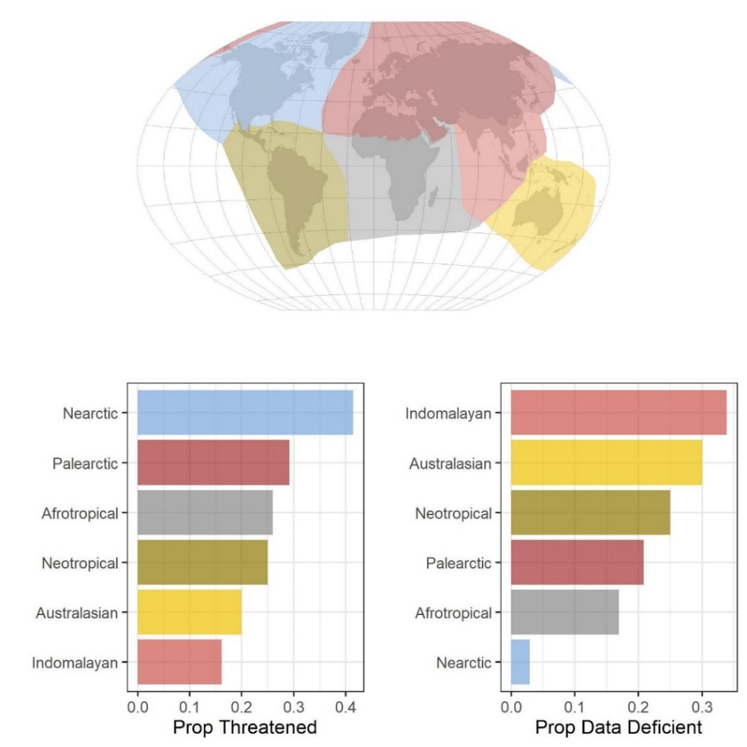

**Figure 2** World map of the biogeographic realms where freshwater mussels occur (top), and the proportion of species assessed by the IUCN (2021) as threatened (critically endangered, endangered and vulnerable) or data deficient (bottom). See species numbers by region in Table 1. The biogeographic realm layer was obtained from the United Nations Environmental Programme (2004).

**Table 2** Numbers of total, IUCN Red List assessed, IUCN Red List mapped species and desiccation tolerance studied species, as well as those species listed as threatened and data deficient by Superfamily. Data was obtained from Graf and Cummings (2021) for total species numbers, the IUCN (2021) for IUCN Redlist information and from this review of desiccation studies and associated species numbers (see references in next section). Note that only 5 of 30 (16%) freshwater mussel species in Australia have been mapped by the IUCN Red List. Proportions of assessed and mapped species are relative to total species numbers, while proportions of threatened and data deficient species are relative to species numbers assessed under the IUCN Red List.

|  |  |  |  |  |  |  |
| --- | --- | --- | --- | --- | --- | --- |
| Superfamily | Total species | Assessed species  (Prop. of total) | Mapped species  (Prop. of total) | Des-studied species (Prop. of total) | Threatened species  (Prop. of assessed) | Data Deficient species  (Prop. of assessed) |
| Unionoidea | 753 | 513 (68%) | 307 (41%) | 19 (2.5%) | 162 (32%) | 79 (15%) |
| Hyrioidea | 184 | 23 (13%) | 14 (8%) | 3 (1.6%) | 7 (30%) | 5 (22%) |
| Etherioidea | 4 | 4 (100%) | 4 (100%) | 0 (0%) | 2 (50%) | 0 (0%) |
| **All** | **958** | **540** | **325** | **22** | **171** | **84** |

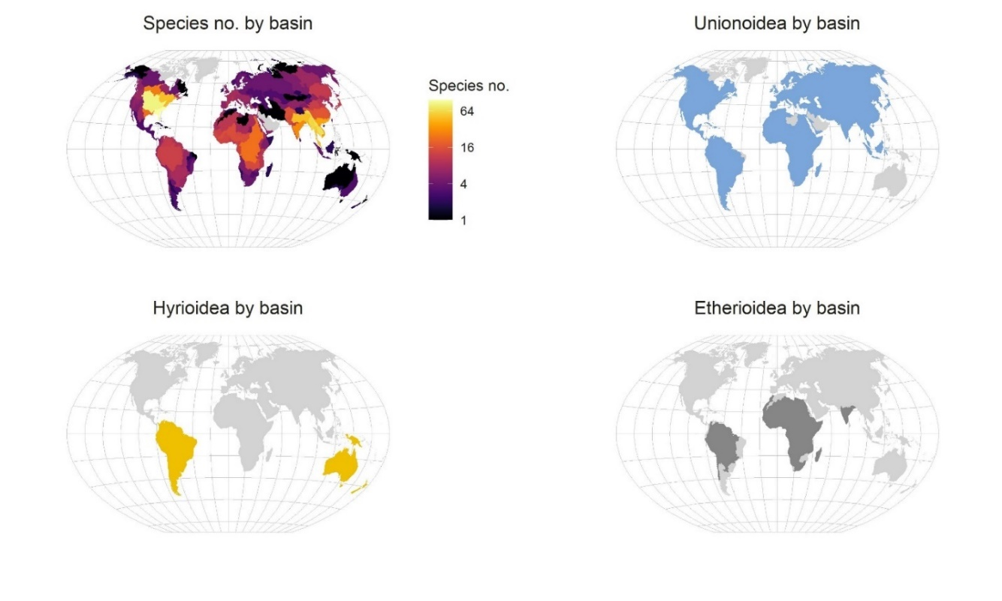

**Figure 3** Of the freshwater mussel species mapped by the IUCN Red List (see Table 2), world maps display the number of species by basin and the distribution of species within Superfamilies Unionoidea, Hyrioidea and Etherioidea by basin. Species distributions were obtained from the IUCN Red List (2021) and information on species superfamilies were obtained from Graf and Cummings (2021). The basins overlapping with species distributions were defined as main basins or Pfafstetter level 1 using the HydroBASINS system (Lehner and Grill 2013).

### Desiccation coping strategies

Freshwater mussel coping strategies to river drying events are wide ranging. A first defence is to move. Using their foot, mussels can traverse horizontally on land back into water or burrow down vertically into cooler and potentially more moist sediment where survival out of water may be more likely (Gough et al. 2012, Mitchell et al. 2018). Mussels more proficient at tracking receding water tend to be less tolerant of desiccation, while those that burrow tend to be more tolerant (Gough et al. 2012, Mitchell et al. 2018). Once stranded out of water, mussels can no longer feed and must survive in a state of aestivation. Gaping open their shells enables the exchange of gases across their epithelia for more efficient aerobic metabolism of energy stores and a sustained acid-base balance during desiccation (Byrne and McMahon 1994). But gaping has the unwanted consequence of shedding internal water, especially at low atmospheric humidity and high temperatures, risking mortality (Byrne and McMahon 1994). Keeping shells shut curtails water loss, however necessitates less efficient anaerobic metabolism and the build-up of by-products that upset acid-base balance which also risks death (Byrne and McMahon 1994). To survive long periods of desiccation, freshwater mussels must trade-off between metabolism efficiency, water loss and acid-base balance with gaping behaviour.

In freshwater mussels, gaping often involves mantle edge exposure behaviour (MEB), whereby the mantle edges are exposed and sealed together with mucus, while the siphon remains closed (Byrne and McMahon 1994). This avoids excessive aerial exposure of tissues. MEB varies considerably between freshwater mussel species. Those less tolerant to desiccation can have thin shell valves that do not provide a complete seal and frequently use MEB (Holland 1991, Byrne and McMahon 1994). More tolerant species tend to have thicker shell valves that tightly seal and display MEB sparingly (Holland 1991, Byrne and McMahon 1994). Tolerant mussel species have been observed keeping their valves fully sealed in the final half of desiccation periods and likely relying on anaerobic metabolism (Holland 1991). The freshwater mussel most tolerant of desiccation, *Uniomerus tetralasmus*, can survive >1.5 years out of water (Holland 1991).

High temperature, low air humidity and, when buried, low sediment moisture content reduce survival during periods of desiccation. High wind speed can further decrease survival of aerially exposed mussels through increased water loss (Ussery et al. 1998, Collas et al. 2021). Faster time to death at higher temperatures during desiccation is explained in two ways. First, a positive relationship between temperature and metabolism rate leads to quicker exhaustion of energy stores at high temperatures which are not replenished as no feeding occurs during desiccation. Second, at upper temperature extremes, organisms experience damage at a cellular level (Sørensen et al. 2013). Low air humidity and sediment moisture content increases water loss rates and shortens time to death (Byrne and McMahon 1994, Lymbery et al. 2021). Compounding the stress of high temperatures and low levels of moisture in the air or sediment is the tendency for mussels to decrease MEB, in theory to reduce water loss rates (Holland 1991, Byrne and McMahon 1994). This heightens the use of inefficient anaerobic metabolism and increases harmful by-products which impact acid-base balance.

### Previous desiccation research

Considerable research has focussed on desiccation tolerance of freshwater mussels, although only 22 of 958 species have been studied (Tables 2 and 3). Methods and drying conditions examined by researchers have differed widely. Studies have been conducted in both air and sediment, and across humidity and temperature ranges. In air, freshwater mussels in laboratory desiccation tolerance experiments have been subjected 0–100% relative humidity (RH) at temperatures of 15–35°C (difference of 20°C), and at 24% RH in air up to 40°C (Figure 4). In sediment, freshwater mussels under desiccation have been held at temperatures from 15–45°C. Of the 22 species studied for desiccation tolerance, 22 species were examined between 15–30°C, 10 species at >35°C and 3 species at >40°C. Interestingly, the 3 species within the Superfamily Hyrioidea have only been examined ≤22.6°C.

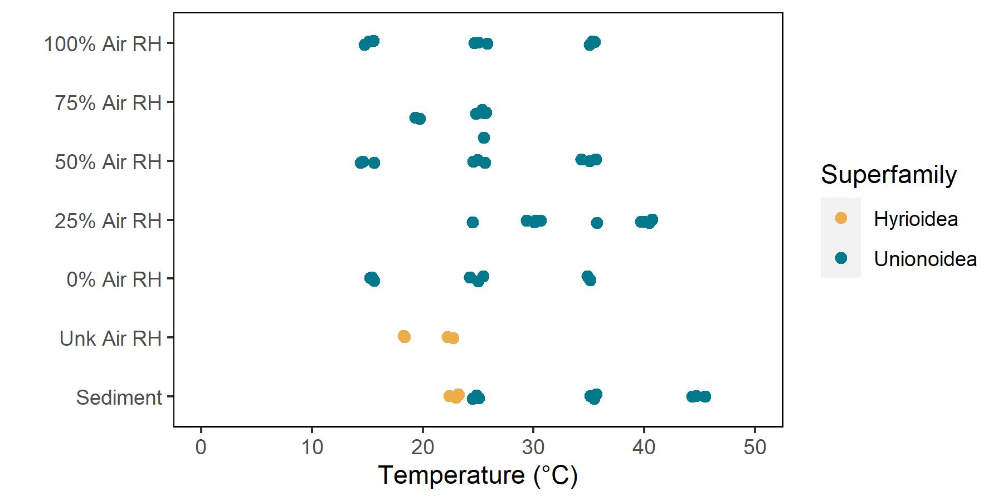

**Figure 4** Temperature, air relative humidity (RH) and sediment conditions used in laboratory desiccation tolerance trials for various freshwater mussel species. Yellow and blue colour indicates mussels belonging to Hyrioidea and Unionoidea Superfamilies respectively. Unk refers to instances where air humidity was not unknown. Mean temperature is used for trials where temperature varied. Points are slightly jittered apart to minimise overlaps.

Comparing desiccation tolerance between freshwater mussel species is difficult due to the different drying conditions used (see humidity and temperature ranges above). Attempts to do so should be interpreted cautiously. Based on the maximum known survival times in experiments at temperatures ranging from 15–30°C, albeit at varying RH and location (air or sediment), *Uniomerus tetralasmus* of the Superfamily Unionoidea has the longest desiccation survival time of 568 days (1.6 years) while the shortest time of 0.04 days (1 h) was displayed by *Eurynia dilatata* of Unionoidea (Figure 5). To date, it appears members of the Superfamily Hyrioidea may have longer desiccation survival times (range of 31–377 days, median of 62) than those of the Superfamily Unionoidea (range of 0.04–568 days, median of 6).

**Table 3** Experimental equipment, mussel locations, and the temperatures and air humidity conditions used in desiccation tolerance trials for the Superfamilies and species studied. Note not all species are included from Bartsch et al. (2000) as desiccation tolerance could not be studied for some species over the experiment duration of 1 hour.

|  |  |  |  |  |  |  |  |  |  |  |  |  |
| --- | --- | --- | --- | --- | --- | --- | --- | --- | --- | --- | --- | --- |
| Superfamily | Species | | Experimental equipment | | Mussel locations | | Temp. | | Air humidity | | Reference | |
| **Hyrioidea** | **Alathyria jacksoni** | | Lab bench | | Air | | 18°C | | Unknown | | (Walker 1981) | |
|  | **Velesunio ambiguus** | | Lab bench | | Air | | 18°C | | Unknown | | (Walker 1981) | |
|  | **Westralunio carteri** | | Sediment trays outside in shade or in direct sunlight | | Air/Sediment (Fully saturated, partially saturated sediment in sunlight and shade) | | Average of 23°C | | Unknown | | (Lymbery et al. 2021) | |
| **Unionoidea** | **Amblema pilcata** | | Incubators | | Air | | 30-40°C | | 24% | | (Mitchell et al. 2018) | |
|  | **Anodonta grandis** | | Incubators | | Air | | 15-35°C | | 0-100% | | (Holland 1991) | |
|  | **Cyclonais petrina** | | Incubators | | Air | | 30-40°C | | 24% | | (Mitchell et al. 2018) | |
|  | **Eurynia dilatata** | | Incubators | | Air | | 25°C | | 60% | | (Bartsch et al. 2000) | |
|  | **Inversidens brandtii** | | Incubators | | Air | | 25°C | | 71% | | (Nakano 2018) | |
|  | **Lampsilis bracteata** | | Incubators | | Air | | 30-40°C | | 24% | | (Mitchell et al. 2018) | |
|  | **Lampsilis straminea** | | Sediment containers within a water bath system | | Sediment (Fully saturated sediment) | | 25-35°C | | Unknown | | (Gough et al. 2012) | |
|  | **Lampsilis teres** | | Incubators | | Air | | 30-40°C | | 24% | | (Mitchell et al. 2018) | |
|  | **Lanceolaria grayii** | | Incubators | | Air | | 25°C | | 71% | | (Nakano 2018) | |
|  | **Nodularia douglasiae biwae** | | Incubators | | Air | | 25°C | | 71% | | (Nakano 2018) | |
|  | **Obovalia omiensis** | | Incubators | | Air | | 25°C | | 71% | | (Nakano 2018) | |
|  | **Popenaias popeii** | | Incubators | | Air | | 30-40°C | | 24% | | (Mitchell et al. 2018) | |
|  | | **Pronodularia japansis** | | Incubators | | Air | | 25°C | | 71% | | (Nakano 2018) | |
|  | **Pyganodon grandis** | | Sediment containers within a water bath system | | Sediment (Fully saturated sediment) | | 25-45°C | | Unknown | | (Gough et al. 2012) | |
|  | **Sinanodonta japonica** | | Incubators | | Air | | 25°C | | 71% | | (Nakano 2018) | |
|  | **Toxolasma parva** | | Incubators | | Air | | 15-35°C | | 0-100% | | (Holland 1991) | |
|  | **Unio pictorum** | | Incubators | | Air | | 20°C | | 68% | | (Collas et al. 2014) | |
|  | **Unio tumidus** | | Incubators | | Air | | 20°C | | 68% | | (Collas et al. 2014) | |
|  | **Uniomerus tetralasmus** | | Incubators | | Air | | 15-35°C | | 0-100% | | (Holland 1991) | |
|  |  | | Sediment containers within a water bath system | | Sediment (Fully saturated sediment) | | 25-45°C | | Unkown | | (Gough et al. 2012) | |

These data illustrate the high degree of variation in desiccation tolerance between species; confirmed in several studies using the same methods on multiple species. Disparate desiccation tolerances have been attributed to differences in behavioural responses (e.g. vertical burrowing and horizontal tracking movements), life history strategies or adaptations to specific habitats (Gough et al. 2012, Mitchell et al. 2018). Adaptation to habitats, for instance, would explain the more desiccation tolerant floodplain mussel (*V. ambiguus*) found in increasingly ephemeral habitats compared to the river mussel (*A. jacksoni*) (Walker 1981). Species-specific differences in desiccation tolerance reinforce the necessity to consider risks posed to all species in order to protect and conserve freshwater mussel communities.

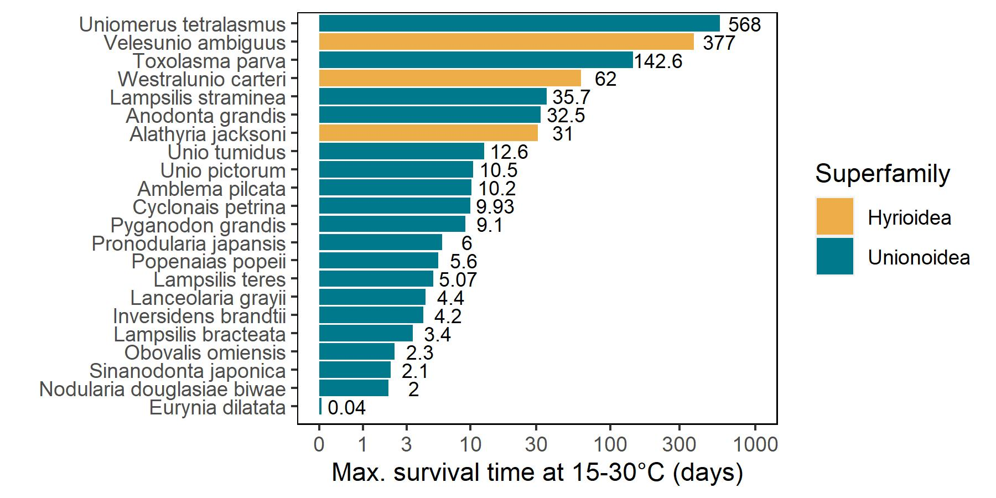

**Figure 5** Maximum known survival times of freshwater mussel species subjected to desiccation conditions at 15–30 °C. Yellow and blue colour indicates mussels belonging to Hyrioidea and Unionoidea Superfamilies respectively. Note the x axis is on a log(*x*+1) scale.

### Relevance to water managers

Desiccation and thermal tolerance studies of freshwater mussel populations can be of use not only for assessing the conservation status of freshwater mussel populations (Ferreira-Rodríguez et al. 2019), but also for guiding water management interventions such as environmental flows to protect them (Castelli et al. 2012, Maloney et al. 2012, Khan et al. 2020). For instance, in south-western USA, thermal tolerance studies in water have determined water temperature thresholds that risk freshwater mussel mortalities and the flows necessary to avoid mortalities to guide environmental water delivery (Khan et al. 2020). Thermal tolerance studies under desiccation scenarios may similarly be employed to develop thresholds that inform protective environmental and river operational flows.

A concern with developing thresholds is whether laboratory studies are relevant to natural conditions. For example, Walker (1981) only tested desiccation tolerance of *Alathyria jacksoni* and *Velesunio ambiguus* at 18°C, however these results are unlikely to translate well to mussels during summer periods when sediment temperatures are expected to be much higher (Gough et al. 2012). Similarly, mussels buried in moist sediment at the onset of desiccation will survive longer than those buried in dry sediment or exposed to low humidity conditions in air (Holland 1991, Lymbery et al. 2021). Therefore, laboratory studies that more closely resemble field conditions, for instance by burying mussels in initially wetted sediment (Gough et al. 2012, Lymbery et al. 2021) and allow adjustment of direct light exposure versus shade situations may achieve more realistic and relevant thresholds for water managers.

## Methods

### Sediment temperature field trial

We assessed summer sediment temperatures across a range of conditions in a field trial from 13–28 January 2021. This was performed within the grounds of Narrandera Fisheries Centre (34.78°S, 146.57°N) in New South Wales, Australia on the Murrumbidgee River in the southern region of the MDB (Figure 6).

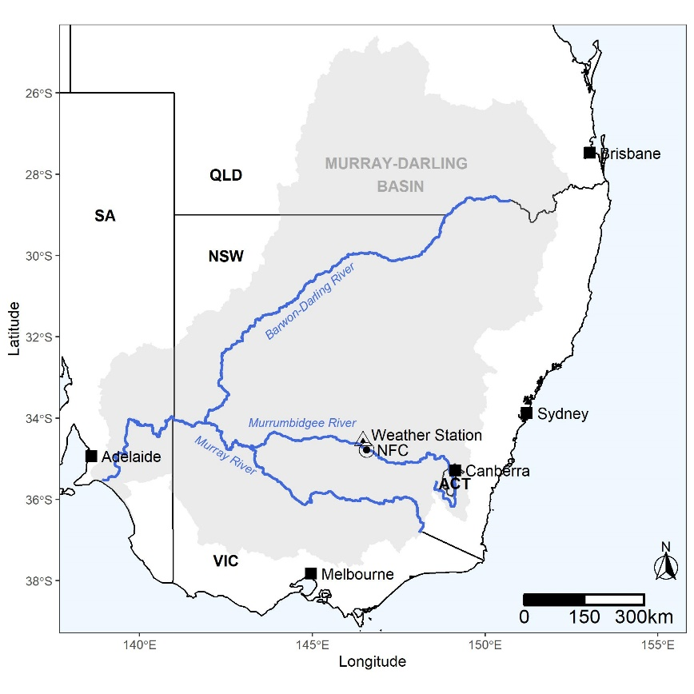

**Figure 6** Map of the Murray-Darling Basin (grey shading), major Barwon-Darling, Murray and Murrumbidgee rivers within it (blue lines), NSW DPI Narrandera Fisheries Centre (NFC, circle) where the sediment temperature trial was conducted, and a nearby NSW DPI weather station at Leeton (triangle). State boundaries and major cities (squares) are also displayed.

Two plots distanced 6 m apart were set up in an open and flat area, free from sources of shade (e.g. trees and buildings). We dug out enough soil to install plastic trays (163 x 413 x 652 mm) in a row of four at each of the two plots so tray tops were level with the surrounding soil. This ensured the surrounding soil buffered sediment temperatures, simulating natural conditions. The trays within plots were filled with either clay or sand sediment types in an alternating fashion. One plot was shaded with 70% UV light blocking shade cloth (Coolaroo, Braeside, VIC) covering 3.66 m2 at a height of 50 cm. This material provided considerable shade but still allowed rainfall to penetrate. Within each plot, half of the trays were irrigated for 10 min daily to full sediment saturation using an automatic digital tap timer (Holman Industries, Osborne Park, WA). Holes were drilled into all trays at the sediment surface so, in the event of rainfall or irrigation, excess water would drain from the top of the sediment. Treatments were applied in a way that every combination of sediment type, moisture type, and light type was administered (Figure 7). In each tray, sediment temperature was measured by 6 pendant waterproof temperature loggers (MX2201, HOBO, Onset Computer Corporation, Bourne MA, USA): 3 in an exposed position on the sediment surface and 3 at buried subsurface position (the top of the logger was 2.5 cm deep) similar to Gough et al. (2012). A total of 48 temperature loggers were used, and these recorded at an hourly interval.

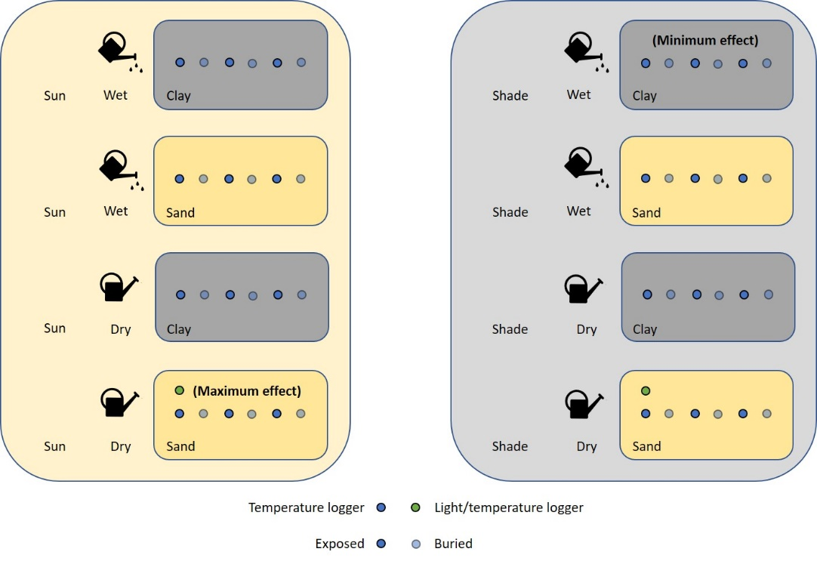

**Figure 7** Schematic of the sediment temperature trial design where a range of sediment treatments (sun and shade light levels, wet and dry moisture levels, and clay and sand sediment types) were applied in 8 trays and temperature loggers were deployed at exposed surface and buried subsurface positions. Note that the schematic is not to scale, and that shade was provided via shade cloth and wet moisture levels were achieved using an irrigation system with an automated digital tap timer.

At the start of the trial, after sediment in wet treatments was fully saturated, sediment moisture content (%) was recorded in all trays by weighing wet sediment samples, drying them at 65°C for 3 days and weighing the dry sediment sample. The following formula was used for calculations:

$$Sediment moisture content= \frac{Wet sediment weight \left(g\right)-Dry sediment weight (g)}{Dry sediment weight (g)} ×100$$

Sediment moisture content was calculated to be a mean of 2.4 ± SD 0.5, 3.5 ± 0.2, 21.1 ± 0.5 and 24.1 ± 6.3% in treatments with dry sand, dry clay, wet sand and wet clay. We also retrieved hourly air temperature recordings over the trial period from the nearby NSW DPI weather station at Leeton (34.56°S, 146.46°N) 25 km from Narrandera Fisheries Centre to compare with our sediment temperature recordings.

Linear regression models were used to determine relationships between mean daily air temperature and mean daily sediment temperatures over a range of sediment conditions. Due to significant rainfall from 26–28 January, sediment temperature data over this period was removed from analyses. Logger recordings on 20–21 January were also removed because the irrigation system for wet sediment treatments malfunctioned.

### Mussel desiccation laboratory trials

We determined the desiccation tolerance of river mussels and floodplain mussels in a laboratory trial within the tank room facilities at Narrandera Fisheries Centre. Floodplain mussels were obtained from a Mulwala canal offshoot spur (September 2020; -35.3866° S, 144.2489° E) and river mussels were collected from the Mulwala canal main channel (May 2021; -35.7771° S, 145.7552° E) a regulated distributary system connected to the Murray River in southern NSW. Species were identified using keys within the Australian Freshwater Molluscs interactive resource (Ponder et al. 2020). Both sites were less than 250 km from Narrandera. Mussels were transported in cooler boxes and on arrival to Narrandera Fisheries Centre were treated in a 15 g L-1 salt solution for 15 min in accordance with animal quarantine procedures. Afterwards, mussels were transferred to 3000 L holding tanks (separate tanks for different species) with constant flow and aeration with water from the Murrumbidgee River with temperatures fluctuating seasonally.

To confirm species identification, tissue samples were taken from 10 randomly selected individuals of each species. Samples were sent to the Australian Genome Research Facility for nucleic acid extraction and sequencing using Polymerase Chain Reaction (PCR). Sequences for a 710-bp region of the Cytochrome C Oxidase Subunit 1 (COI) gene were returned using the primers LCO1490 (5’ GGTCAACAAATCATAAAGATATTGG 3’) and HCO2198 (5’ TAAACTTCAGGGTGACCAAAAAATCA 3’) (Vrijenhoek 1994). These were trimmed for quality using Geneious Prime software (2021.1) with a confidence interval of 0.1. Quality sequences were then run on the National Centre for Biotechnology Information’s (NCBI) nucleotide Basic Local Alignment Search Tool (BLAST) with >96% query cover and >98.23% identity to morphologically identified species. Genetic assignment of river mussels and floodplain mussels was consistent with morphological identification.

#### 

#### Trial 1: Desiccation of river and floodplain mussels acclimated at 26°C

A first trial assessed desiccation tolerance of river and floodplain mussels which were previously acclimated at 26°C in water. In this trial, 90 river mussels and 90 floodplain mussels were moved from the holding tanks into 70 L experimental tanks in the tank room facility filled with 40 L of bore water with a flow rate of 4 L min-1 where oxygen remained above 8 mg L-1 in recirculating systems with biofilters. Densities were kept below 15 mussels per tank. Mussels were acclimated from the river water temperature in holding tanks to either a control temperature of 20°C (15 mussels of each species) or an acclimation temperature in experimental tanks of 26°C (75 mussels of each species). This temperature change was performed gradually over a five-day period at a rate of <3°C per day. Mussels were then held at control and acclimation temperatures for a further four days. Feeding occurred every second day during this 9-day period and involved adding Shellfish diet 1800 (ProAqua Pty Ltd, Queensland) at a volume equating to ~3% of mean shell-free dry weight. A 50% water change occurred after five days. These acclimation procedures were similar to Khan et al. (2020).

After the acclimation period, mussels were removed from tanks where they were measured for length and weight. They were then randomly assigned to three tanks within 1 control and 5 treatment groups: a 20°C in water control group (using the mussels acclimated to 20°C), and 29, 32, 35, 38 and 41°C desiccation treatment groups (using the mussels acclimated to 26°C) (Figure 8). Treatment desiccation temperatures covered the maximum daily mean temperatures recorded by loggers in buried dry sediment over summer 2020-21 in the sediment temperature trial (see results section). This equated to 5 floodplain mussels and 5 river mussels per tank and 15 mussels of each species per treatment group.

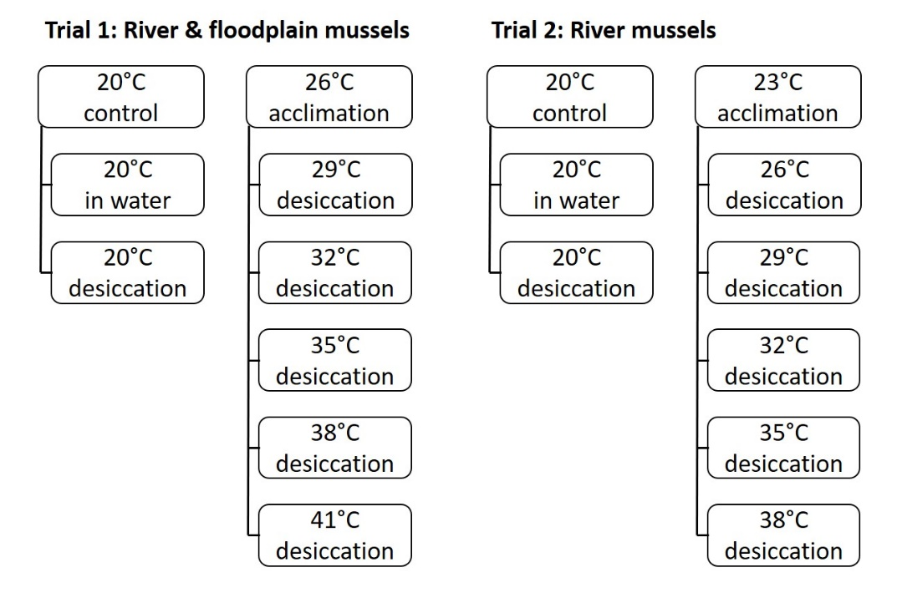

**Figure 8** Schematic of the freshwater mussel desiccation trials. Trial designs were adapted from Khan et al. (2020).

Mussels allocated to the in-water controls were returned to conditions outlined in the acclimation period, with river and floodplain mussels now kept together in tanks separated by placing each species in two weighted plastic containers per tank. Mussels allocated to desiccation controls and treatments were placed individually in 1 L plastic containers filled with fully saturated washed river sand at the beginning of the trial. No water entered containers after this point. Containers with mussels were filled with sand to the 800 mL mark and mussels were buried so the top of the mussel was in line with the sediment surface. Containers with mussels and sand were placed on aluminium stands in 70 L experimental tanks filled with 40 L of bore water flowing at 0.1 L min-1 providing a water bath. Each tank used as a water bath for desiccation (18 in total) was heated to the treatment temperature with a 300-W titanium heater (Schego) connected to temperature controller unit (DC Series, Aqua Logic) (Fresh by Design, New South Wales). This meant that each tank temperature was controlled independently and that a tank was a true replicate. Experimental desiccation conditions simulated a river drying event where sediment moisture content declined were similar to Gough et al. (2012).

Sediment temperatures were measured hourly in each tank throughout the experiment using pendant waterproof temperature loggers (MX2201, HOBO) buried in an additional container filled with saturated washed river sand at the start of the experiment (5 cm deep). Sediment moisture content was measured in each tank within a second additional container filled with saturated washed sediment at the experiment start and using methods described in the sediment temperature trial. This was performed at day 0 (as mussels were added to tanks), 1, 4, 10, 20 and 40. Mussel survival was checked daily until day 20 and then every second day until day 73, when both species had reached 50% mortality at all treatment levels. Mortality was deemed to have occurred if a mussel was gaping and did not respond to probing or if considerable water loss was observed underneath the mussel.

#### Trial 2: Desiccation of river mussels at 23°C

A second trial determined desiccation tolerance of only river mussels which were acclimated at 23°C in water beforehand. This trial was a repeat of trial 1, except only 90 river mussels were transferred to experimental tanks where they were acclimated to a control temperature of 20°C (15 mussels) or an acclimation temperature in experimental tanks of 23°C (75 mussels), and then mussels were added to three tanks within 7 treatment groups: 20°C in water and 20°C desiccation controls (using the mussels acclimated to 20°C), and 26, 29, 32, 35 and 38°C desiccation treatments (using the mussels acclimated to 26°C) (Figure 8). The design of the two trials allowed a comparison of river mussel desiccation between the two different acclimation temperatures and was comparable to trial designs used in Khan et al. (2020).

Lethal temperatures at which 50% of mussels died (LT50) under the experimental desiccation conditions were assessed at 1, 2, 4 and 10 days for river mussels previously acclimated to 23 and 26°C and at 1, 2, 4, 10, 20 and 30 days for river and floodplain mussels acclimated to 26°C. Lethal times that 50% of mussels died (LT50) under these conditions were also examined for river and floodplain mussels at 29, 32, 35, 38 and 41°C, which were previously acclimated to 26°C. These were determined from survival information using two-parameter logistic regression curves. LT50 comparisons were also performed between species and acclimation temperatures via the confidence interval ratio test (Wheeler et al. 2006). Briefly, ratios of LT50 estimates are compared with 1 and a 95% confident interval is determined around this ratio. If the confidence interval excludes 1, then the estimates are significantly different. Both regressions and confidence interval tests were conducted via the drc package within R software (v2.12.0) as in Khan et al. (2020).

## Results

### Sediment temperature field trial

The sediment trial from 13–28 January 2021, captured a hot dry summer period in the southern Murray–Darling Basin. However, significant rainfall (total of 49.4 mm) from 26–30 January led to the termination of the trial. Mean daily air temperature ranged from 18–32°C (Figure 9), although maximum daily air temperatures reached 40°C as indicated by visualisation of hourly temperatures (Figure 10).

Out of all conditions, sun-exposed surface loggers on dry sand or clay consistently recorded the highest temperatures, with mean daily temperatures ranging from 24–38°C (Figure 9) and substantial hourly extremes (Figure 10). Contrastingly, buried loggers in shaded wet sand or clay reliably measured the coolest temperatures, with mean daily temperatures between 15–23°C (Figure 9). Interestingly, sediment type did not have a major impact on sediment temperatures as indicated by largely comparable slopes in regression equations (Table 4). For loggers at the surface or buried in dry sediment, maximum mean daily temperatures ranged from 31.5–38.2°C (Figure 9). Light levels, moisture levels and logger positioning on or buried within the sediment had much stronger effects on sediment temperatures. Temperatures were found to vary most between sediment conditions during the hottest day recorded, when mean daily sediment temperatures ranged from 23–38°C or by 15°C (Figure 9).

The results of the sediment temperature trial are exemplified through visualisation of the measured treatment compared with a 1:1 ratio of air temperature (Figure 11). For example, mean daily wet sediment temperatures in the shade are consistently below corresponding mean daily air temperatures regardless of sediment type and buried or exposed. As air temperature increases a greater benefit is realised, particularly in the buried treatment. Wet treatments in full sun only provide a temperature benefit (i.e. measured temperature is below air temperature) when buried, and this increases with increasing mean daily air temperatures (Figure 11). There was no temperature benefit recorded from dry sediments, regardless of treatment (shading or full sun, buried or exposed), although shaded and buried treatments provided the greatest temperature benefit, respectively (Figure 11).

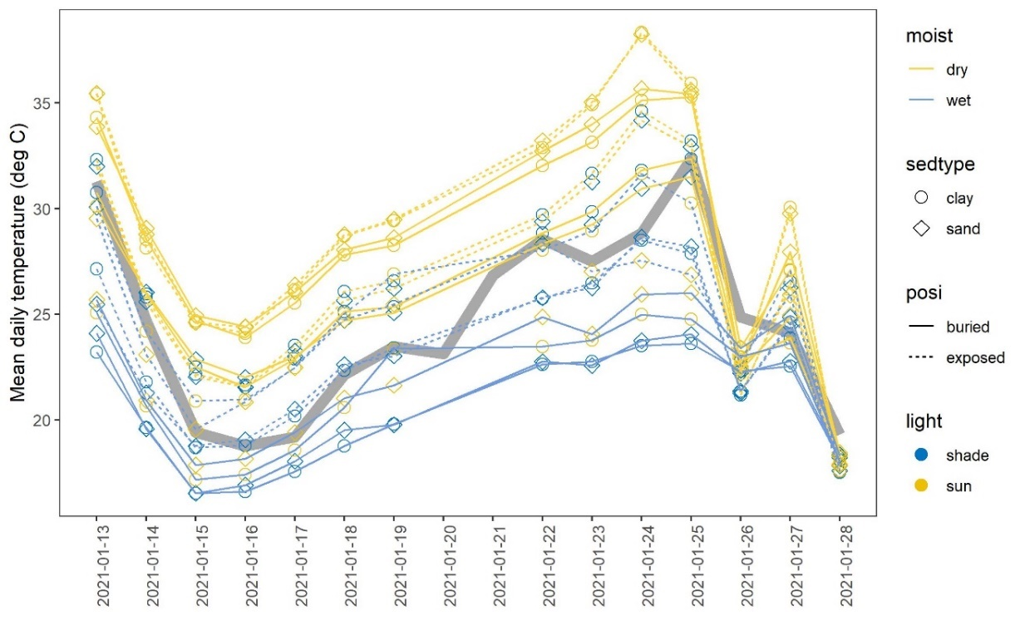

**Figure 9** Mean daily temperatures recorded by loggers (lines and symbols) from 13–28 January 2021 in a range of sediment conditions: dry (yellow) or wet (blue line), clay (circle) or sand (diamond symbol), buried (solid) or exposed (dashed line), shade (blue) or sun (yellow symbol). Logger recordings on 20–21 are not shown as the irrigation system for wet treatments malfunctioned. Mean daily air temperature from the NSW DPI Leeton weather station over the period is also shown (grey line).

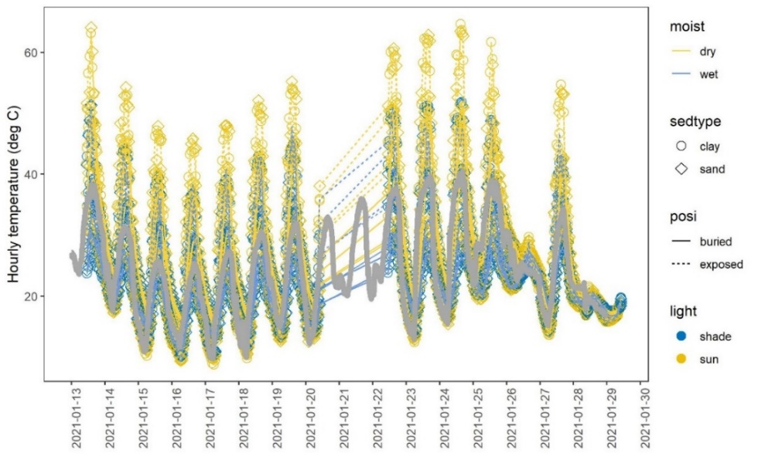

**Figure 10** Hourly temperatures recorded by loggers (lines and symbols) from 13–28 January 2021 in a suite of sediment conditions: dry (yellow) or wet (blue line), clay (circle) or sand (diamond symbol), buried (solid) or exposed (dashed line), shade (blue) or sun (yellow symbol). Logger recordings on 20–21 are not shown as the irrigation system for wet treatments malfunctioned. Hourly air temperature from the NSW DPI Leeton weather station over the period is also shown (grey line).

**Table 4** Parameters of equations for linear regressions between mean daily temperatures recorded by loggers in different sediment conditions and mean daily air temperature at a nearby NSW DPI weather station at Leeton. R2 and P values are also displayed.

|  |  |  |  |  |  |  |  |
| --- | --- | --- | --- | --- | --- | --- | --- |
| Moist | Light | Position | Sed type | Intercept | Slope | R2 | P value |
| Wet | Shade | Buried | Clay | 6.4 | 0.56 | 0.93 | < 0.0001 |
|  |  |  | Sand | 6.4 | 0.57 | 0.95 | < 0.0001 |
|  |  | Exposed | Clay | 6.2 | 0.70 | 0.89 | < 0.0001 |
|  |  |  | Sand | 7.3 | 0.65 | 0.83 | < 0.0001 |
|  | Sun | Buried | Clay | 7.4 | 0.57 | 0.86 | < 0.0001 |
|  |  |  | Sand | 6.9 | 0.62 | 0.93 | < 0.0001 |
|  |  | Exposed | Clay | 8.1 | 0.73 | 0.84 | < 0.0001 |
|  |  |  | Sand | 10 | 0.58 | 0.76 | < 0.0001 |
| Dry | Shade | Buried | Clay | 7.6 | 0.77 | 0.95 | < 0.0001 |
|  |  |  | Sand | 9.5 | 0.69 | 0.95 | < 0.0001 |
|  |  | Exposed | Clay | 5.8 | 0.88 | 0.89 | < 0.0001 |
|  |  |  | Sand | 5.8 | 0.87 | 0.89 | < 0.0001 |
|  | Sun | Buried | Clay | 8.7 | 0.84 | 0.93 | < 0.0001 |
|  |  |  | Sand | 9.5 | 0.83 | 0.92 | < 0.0001 |
|  |  | Exposed | Clay | 7.3 | 0.93 | 0.86 | < 0.0001 |
|  |  |  | Sand | 7.9 | 0.91 | 0.87 | < 0.0001 |

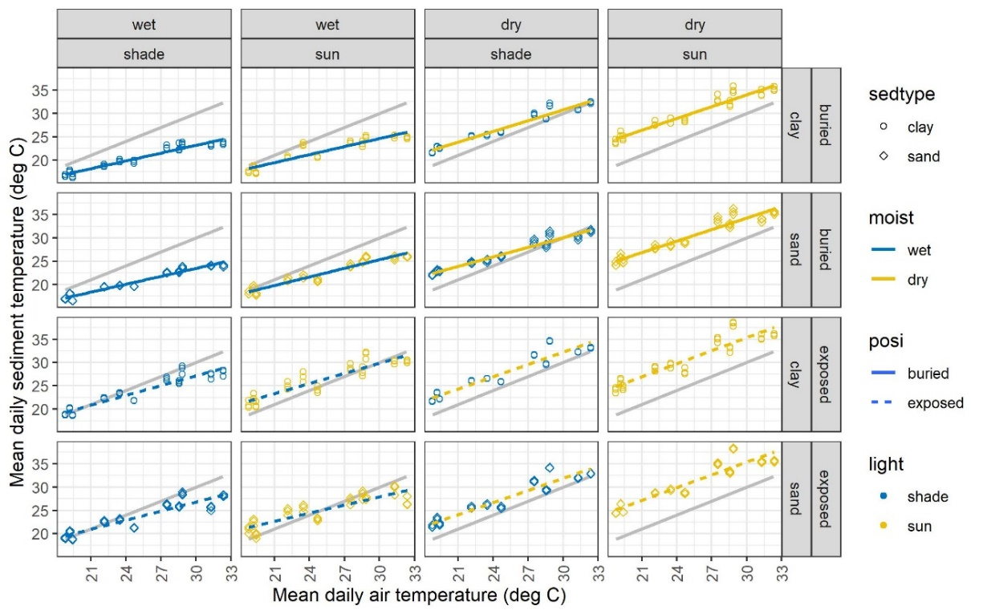

**Figure 11** Mean daily air temperature plotted against temperatures recorded by loggers in various sediment conditions: dry (yellow) or wet (blue line), clay (circle) or sand (diamond symbol), buried (solid) or exposed (dashed line), shade (blue) or sun (yellow symbol). Yellow and blue lines represent linear regressions and grey lines indicate a 1:1 ratio between mean daily air temperature and mean daily logger temperature. Air temperatures were obtained from the NSW DPI Leeton weather station.

### Mussel desiccation laboratory trials

#### Experimental conditions

Sediment containers housing experimental freshwater mussels sat within a water bath at a set temperature to simulate a river drying event under laboratory conditions. In trial 1, sediment temperatures within containers were within 1.55°C of treatment temperatures that water baths were set to. An exception to this was a 22 hr period on day 40-41 when sediment temperatures fell in high temperature treatments due to an electrical fault. Sediment moisture content started at a fully saturated state at the start of the experiment at values >5%. However, from this point on, moisture levels decreased and at a faster rate at higher temperatures (Figure 12). The lowest sediment moisture level recorded was 0.01%. By day 20 and 40, all sediment moisture content in all remaining treatments (29, 32 and 35°C) were at or below 0.06%.

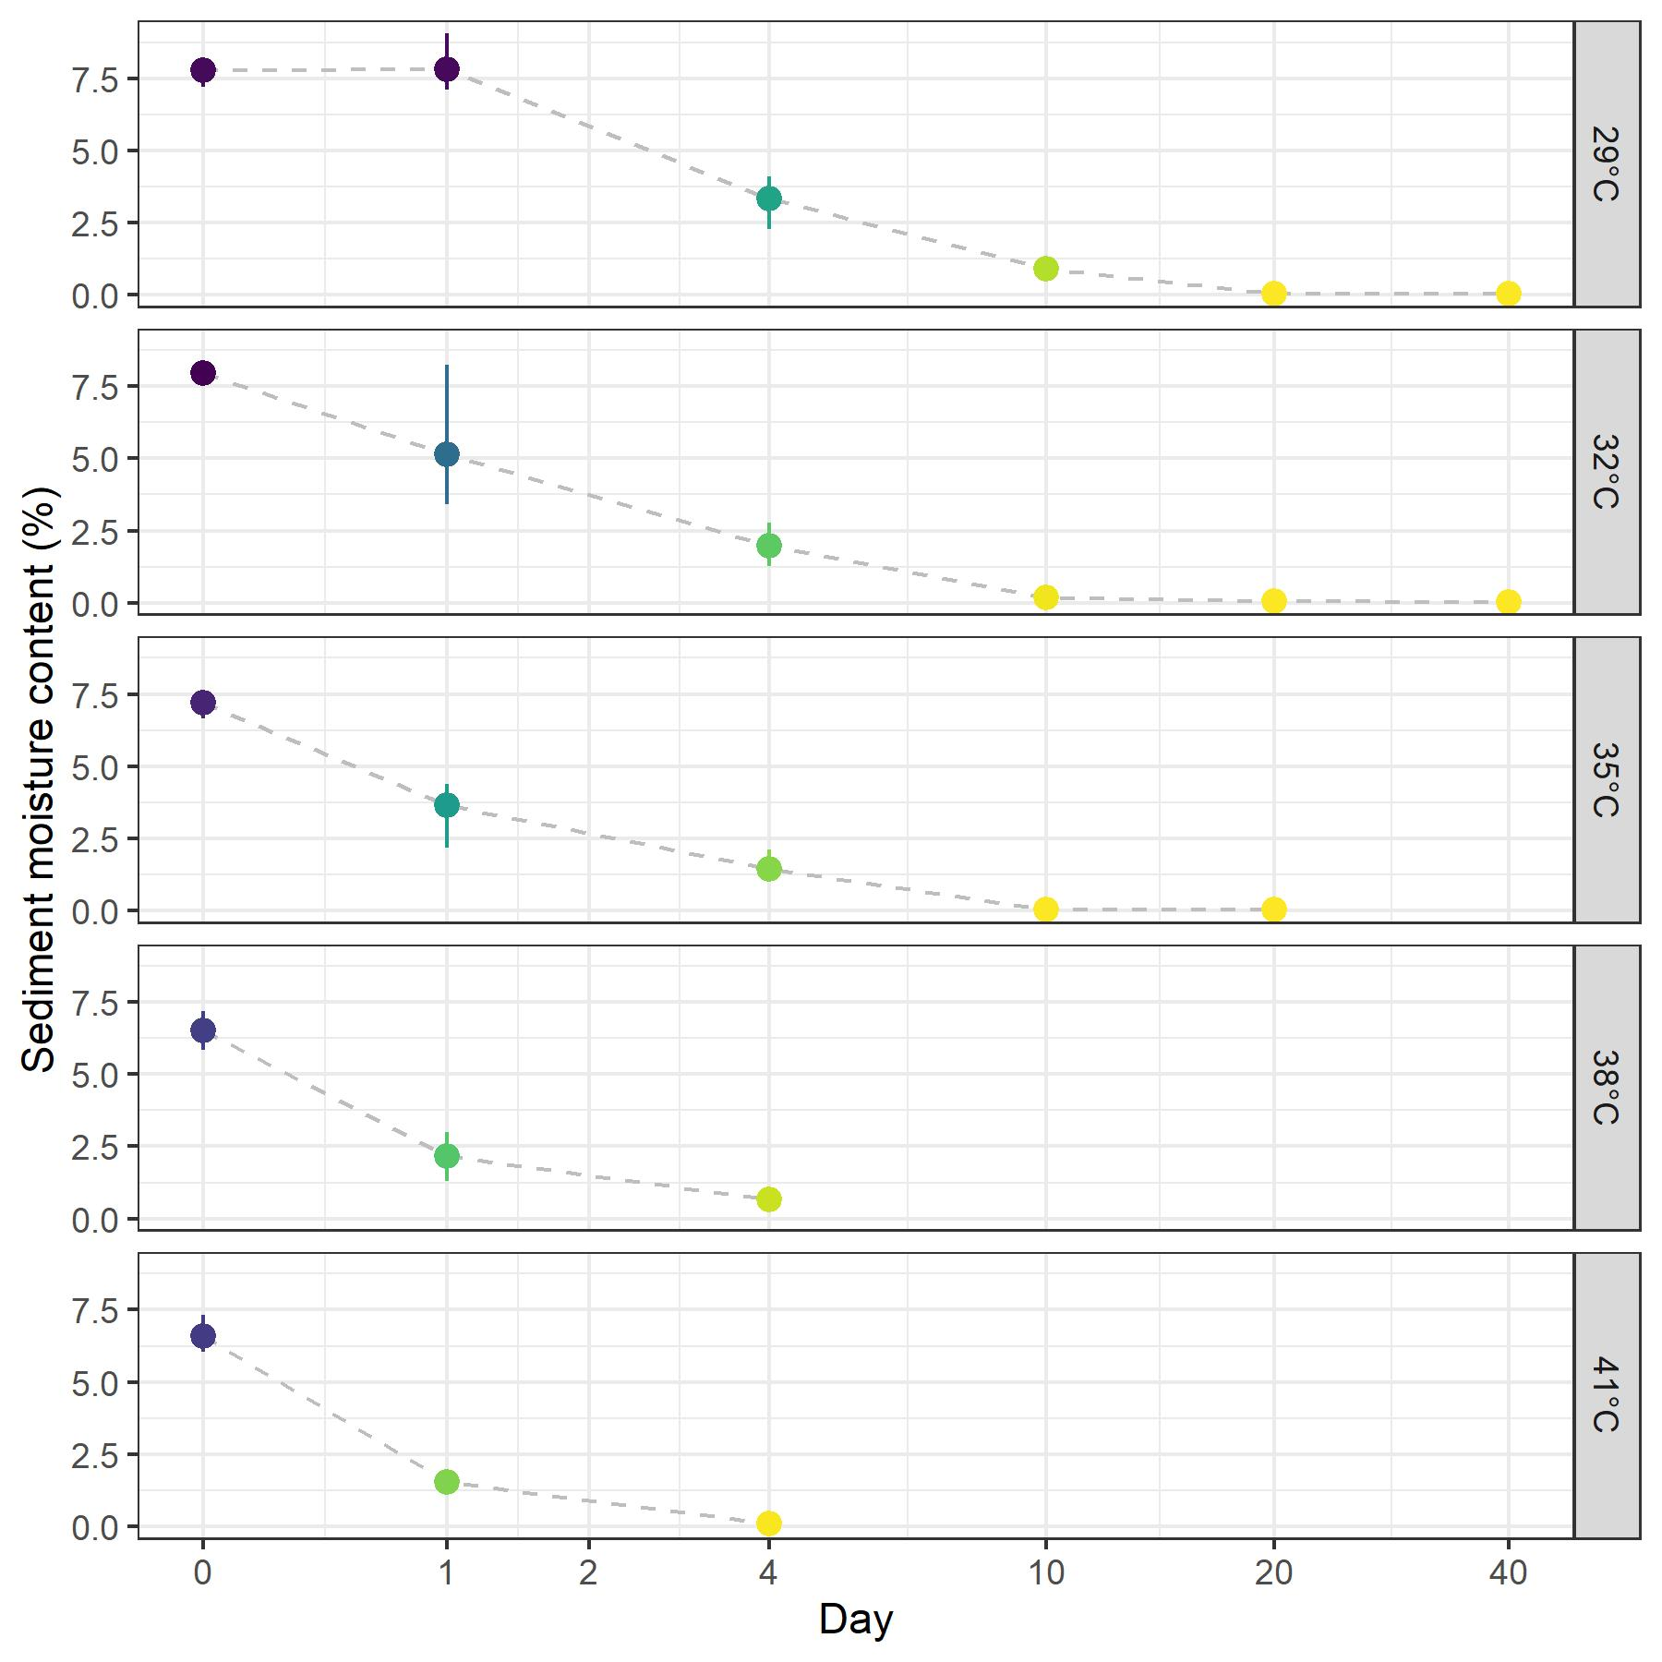

**Figure 12** Moisture content of sediment within containers which held mussels are shown for Trial 1 at day 0, 1, 4, 10, 20 and 40. Points indicate mean values of measurements from individual tanks and bars represent ranges. Points and bars are colour coded according to mean values. Note that values are not shown once no mussels were alive for several days in a treatment.

#### Lethal times

Predictably, mussels died faster at higher temperatures in simulated river drying conditions (Table 5, Figure 13). Maximum survival times were 2 days at 41°C, 3 days at 38°C and 29 days at 35°C, while a subset of mussels were still alive at the experiment end for 32 and 29°C treatments. While maximum survival times appeared similar between species at high temperatures of 41 (2 days for both species) and 38°C (3 days for both species), differences became apparent at lower temperatures. For example, at 35°C, the maximum survival time of a river mussel was 4 days; well short of a floodplain mussel at 29 days.

The lethal time that killed 50% of mussels (LT50) also decreased at higher temperatures (Table 5, Figure 13). These estimates were similar between species at higher temperatures (41°C: ~1 day, 38°C: ~1 day, 35°C: 2-3 days and 32°C: 10-12 days), although tended to be shorter for river mussels. However, at 29°C, lethal time LT50 estimates differed between floodplain and river mussels, with floodplain mussels surviving much longer than river mussels (14 vs 63 days). For controls at 20°C in water and fed throughout the experiment, none of the 15 floodplain mussels died and 1 of the 15 river mussels (6.7%) died at day 37.

**Figure 13** Survival times of river and floodplain mussels under experimental desiccation conditions in Trial 1. Points represent mussel survival at each assessment in a replicate tank, with point shading indicating the number of replicates with an identical survival value (darker colour for more replicates with the same value). Lines show the two-parameter logistic regression curves and are colour-coded by temperature and 95% confidence intervals around lethal time LT50 values.

**Table 5** Lethal times that 50% of mussels died (LT50) and 95% confidence intervals (CI) for river and floodplain mussels in simulated river drying conditions at 29, 32, 35, 38 and 41°C, with previous acclimation at 26°C. Confidence interval ratio test results for comparisons of LT50 estimates between mussel species are also provided at each temperature.

|  |  |  |  |  |
| --- | --- | --- | --- | --- |
| Acclimation | Simulated river drying temperatures | River mussel lethal time LT50 (95% CI) | Floodplain mussel lethal time LT50 (95% CI) | Confidence interval ratio test: Estimate (CI) |
| 26°C | 29°C | 14.2 days  (12.7-15.6 days) | 57.8 days  (39.4-76.2 days) | 0.25  (0.16-0.32) |
|  | 32°C | 12.6 days  (10.9-14.2 days) | 10.3 days  (7.4-13.06 days) | 1.23  (0.85-1.59) |
|  | 35°C | 1.9 days  (1.6-2.2 days) | 3.4 days  (2.4-4.3 days) | 0.56  (0.37-0.74) |
|  | 38°C | 1.0 days  (0.7-1.3 days) | 1.3 days  (1.0-1.5 days) | 0.78  (0.49-1.06) |
|  | 41°C | 0.8 days  (-1.7-3.4 days) | 1.0 days  (0.4-1.6 days) | 0.82  (-1.86-3.50) |

#### Lethal temperatures

As expected, lethal temperatures that killed 50% of mussels decreased over time (Table 6, Figure 14). Over an acute 10-day exposure period of simulated river drying, lethal temperature LT50 estimates at a given time point did not differ between river and floodplain mussels acclimated to 26°C. However, LT50 estimates were consistently higher in floodplain mussels. While LT50 estimates appeared to become distinctly separate between river and floodplain mussels at chronic 20 and 40-day exposure periods, a statistical difference was not found due to the large error around estimates for river mussels which had >50% mortality at all temperatures by this point. LT50 estimates for river mussels fell progressively over time from 39°C at 1 day to 31°C at 10 days, 28°C at 20 days and 26°C at 40 days. In contrast, LT50 values for floodplain mussels fell steadily from 40°C at 1 day to 31°C at 10 days, but then largely stabilised to reach only 30°C at 20 and 40 days.

Over the acute 10-day exposure period, LT50 estimates did not differ between river mussels acclimated at 23 (Trial 1) and 26°C (Trial 2) (Table 7). There was also no consistent effect of acclimation temperature on LT50 estimates at the 1, 2, 4 and 10-day exposures. Note that 1 out of 15 river mussels (6.7%) died at day 10 in the 20°C in water control group in Trial 2.

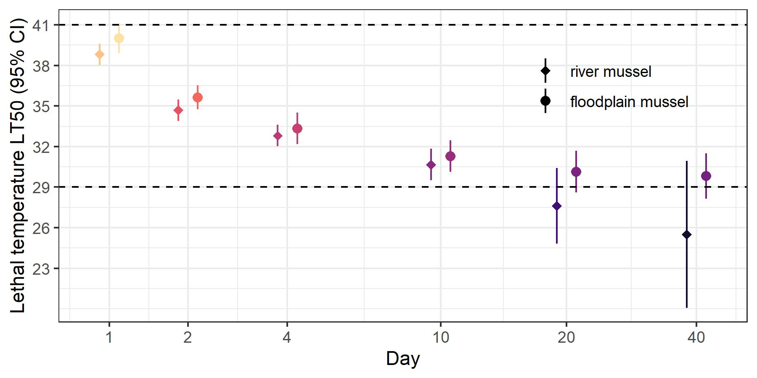

**Figure 14** Lethal temperatures that 50% of mussels died (LT50) and 95% confidence intervals for river and floodplain mussels at 1, 2, 4, 10, 20 and 40 days. The upper and lower temperatures at which mussels were held in simulated river drying conditions are shown as dashed horizontal lines. Note that points at the same time interval are dodged apart and the x axis in log(*x*+1) transformed. The colour of points refers to the corresponding lethal temperature LT50 value.

**Table 6** Lethal temperatures that 50% of mussels died (LT50) and 95% confidence intervals (CI) for river and floodplain mussels in simulated river drying conditions previously acclimated to 26°C at 1, 2, 4, 10, 20 and 30 day intervals. Confidence interval ratio test results for comparisons of LT50 estimates for between mussel species are also provided at each temporal interval.

|  |  |  |  |  |
| --- | --- | --- | --- | --- |
| Acclimation | Days of simulated river drying conditions | River mussel lethal temp. LT50 (95% CI) | Floodplain mussel lethal temp. LT50 (95% CI) | Confidence interval ratio test: Estimate (CI) |
| 26°C | 1 | 38.8°C  (38.0-39.6°C) | 40.0°C  (38.9-41.1°C) | 0.97  (0.94-1.004) |
|  | 2 | 34.7°C  (33.9-35.5°C) | 35.6°C  (34.8-36.5°C) | 0.97  (0.94-1.006) |
|  | 4 | 32.8°C  (32.1-33.4°C) | 33.3°C  (32.2-34.5°C) | 0.98  (0.94-1.03) |
|  | 10 | 30.7°C  (29.5-31.8°C) | 31.2°C  (30.1-32.5°C) | 0.98  (0.93-1.03) |
|  | 20 | 27.6°C  (24.8-30.4°C) | 30.1°C  (28.6-31.7°C) | 0.92  (0.81-1.02) |
|  | 40 | 25.5°C  (20.1-30.9°C) | 29.8°C  (28.2-31.5°C) | 0.86  (0.67-1.04) |

**Table 7** Lethal temperatures that 50% of mussels died (LT50) and 95% confidence intervals (CI) for river mussels in simulated river drying conditions previously acclimated to 23 and 26°C at 1, 2, 4 and 10 day intervals. Confidence interval ratio test results for comparisons of LT50 estimates between acclimation temperature are also provided at each temporal interval.

|  |  |  |  |  |
| --- | --- | --- | --- | --- |
| Species | Days of simulated river drying conditions | 23°C Acclimation Lethal temp. LT50 (95% CI) | 26°C Acclimation Lethal temp. LT50 (95% CI) | Confidence interval ratio test: Estimate (CI) |
| River mussel | 1 | 38.5°C  (36.9-40.1°C) | 38.8°C  (38.0-39.6°C) | 0.99  (0.95-1.04) |
|  | 2 | 34.5°C  (33.5-35.4°C) | 34.7°C  (33.9-35.5°C) | 0.99  (0.96-1.02) |
|  | 4 | 33.2°C  (32.4-34.1°C) | 32.8°C  (32.1-33.4°C) | 1.01  (0.98-1.05) |
|  | 10 | 29.2°C  (27.9-30.5°C) | 30.7°C  (29.5-31.8°C) | 0.92  (0.90-1.01) |

## Discussion

The river mussel, *Alathyria jacksoni*, and the floodplain mussel, *Velesunio ambiguus*, are the most widely distributed freshwater mussel species in the MDB, but little is known of their environmental tolerances. In this study, we found that floodplain mussels were more resistant to desiccation than river mussels, as previously reported by Walker (1981), but we also found that this resistance to desiccation was highly temperature-dependent. Walker (1981) reported 50% mortality of floodplain mussels after 280 days of drying at 18°C, compared to 100% mortality of river mussels within 31 days. In our study, 50% of floodplain mussels were able to survive out of water for about 58 days at 29°C, compared to only 14 days for river mussels, whereas at 41°C the survival time for 50% of both species was around one day. Furthermore, 50% of mussels of both species could survive temperatures of 39-40°C for one day out of water, but over 40 days this was reduced to 29.8°C for floodplain mussels and 25.5°C for river mussels.

### Interaction of water emersion and temperature

Although a number of previous studies have examined the tolerance of freshwater mussel species to desiccation, the influence of temperature on desiccation tolerance has only rarely been considered. Gough et al. (2012) and Mitchell et al. (2018) examined the survival of different mussel species in the USA after emersion at temperatures ranging between 25 and 45°C and found that survival times of all species were reduced at higher temperatures. Higher temperatures have a direct effect on mussel survival through cellular damage (Sørensen et al. 2013) and a higher metabolic rate which depletes energy stores (Golladay et al. 2004), and can reduce sediment moisture content, which will increase the rate of water loss in mussels which burrow in the sediment.

Sediment temperature profile, recorded over a two-week period mid-summer in the MDB, was greatly influenced by moisture content, exposure to the sun and position (surface or buried), but largely independent of sediment type (clay or sand). Temperatures were always lower within the sediment than on the surface and were further reduced by soil moisture and shade. At an air temperature of 32°C and a depth of 2.5 cm, moist soil in our shaded treatment was only 24°C, compared to 38°C on the surface of dry soil in full sun. A difference in temperature of this magnitude is likely to have a major impact of the ability of mussels to survive desiccation. Previous studies have found that desiccation tolerance in freshwater mussels is greatly enhanced by the presence of shade and the utilisation of moist microhabitats, for example by burrowing into sediment (Gagnon et al. 2004, Golladay et al. 2004, Lymbery et al. 2021).

Our desiccation trials simulated a drying river, by starting with fully saturated sediments and then withholding water, allowing the sediments to dry over the course of the 40-day trial. Water content decreased more rapidly at higher temperatures and this likely contributed to the increase in mortality with temperature, by increasing the rate of water loss from mussel tissue (Lymbery et al. 2021).

We found no difference in the desiccation tolerances of river mussels following acclimation to different temperatures (23°C and 26°C). Although some previous studies have found that freshwater mussels have greater tolerance to increasing water temperature following acclimation (Galbraith et al. 2012), most, like ours, have shown no effect of acclimation on either thermal tolerance within water or on tolerance to desiccation (Pandolfo et al. 2009, Archambault et al. 2013, Archambault et al. 2014, Khan et al. 2020).

### Differences between species in desiccation tolerance

While freshwater mussels are generally more tolerant of desiccation than both estuarine or marine bivalves (Byrne and McMahon 1994) and other freshwater molluscs such as gastropods (Collas et al. 2014), there is still substantial variation among species (Gough et al. 2012, Newton et al. 2015, Mitchell et al. 2018, Nakano 2018). This variation can often be related to differences in life history characteristics and habitat use. Mitchell et al. (2018), for example, studied the desiccation tolerance of five freshwater mussel species in Texas and found that the two species with lowest tolerance (*Lampsilis bracteata* and *L. teres)* were found most often in deeper pools and lentic microhabitats that very rarely dried completely.

Although the two species we studied are both widely distributed throughout the MDB, they typically occupy very different habitats. River mussels are found in the main channel of large, flowing rivers; they are rare in slow-flowing rivers and never found in lentic environments (Walker 1981). Floodplain mussels, by contrast, typically occur in lakes, billabongs, impoundments and small streams (Walker 1981). Sheldon and Walker (1989) reported cohabitation of the two species along the Murray River, but with river mussels in the deeper waters of the main channel and floodplain mussels restricted to sheltered pockets along the river margins.

The greater physiological tolerance to desiccation of floodplain mussels is therefore likely to be an adaptation to more frequent drying. Sheldon and Walker (1989) also found floodplain mussels to be much more tolerant than river mussels of low oxygen levels. River mussels are unable to regulate their oxygen consumption when exposed to declining oxygen levels, whereas floodplain mussels can maintain a steady rate of oxygen consumption under hypoxic conditions, and have a greater capacity than river mussels to metabolise anaerobically (Sheldon and Walker 1989). Under conditions of desiccation and severe oxygen stress, floodplain mussels, unlike river mussels, are able to completely close their valves, forming an airtight seal and presumably relying on anaerobic metabolism (Walker et al. 2001). Floodplain mussels are able to survive very high levels of blood ammonia, a two-fold increase in the ionic composition of body fluids and a weight loss of up to 40% (Ch'ng-Tan 1968, Walker 1981).

### Behavioural responses to water emersion

Freshwater mussels can respond to water emersion with both physiological adaptations and behavioural adaptations, such as horizontal movements to track receding water levels and vertical movements (burrowing) into cooler and moister microclimates. Both horizontal and vertical movement behaviours have been found to vary widely among species (Watters et al. 2001, Allen and Vaughn 2009). Mussel species which are physiologically more tolerant of desiccation have often been found to have a greater propensity to burrow, but a reduced capacity to track receding water (Gough et al. 2012, Mitchell et al. 2018).

As river mussels have a lower physiological tolerance to desiccation than floodplain mussels, we might expect that they would exhibit greater horizontal movement, but less vertical movement than floodplain mussels in drying rivers. Unfortunately, only anecdotal information is available on behavioural differences between these two species, and that information is somewhat contradictory. Jones (2007) reported that during the 2002 drought, river mussels in the Barwon–Darling River were unable to either move into deeper water or burrow into sediments and, as a consequence, were stranded on the surface above the waterline, where they suffered high mortality. Floodplain mussels, by contrast, have been observed to survive for more than a year buried in the sediments of dry waterholes (Walker 1981, Jones 2007). Walker et al. (2001), however, suggest that both river mussels and floodplain mussels are capable of burrowing into the sediment, although this was observed within water bodies in response to low temperatures, rather than as a response to drought.

### Management implications and recommendations

Freshwater mussels play important functional roles in freshwater ecosystems. Their filter-feeding activity reduces the amount and type of suspended particles in water, improving water quality and clarity (Welker and Walz 1998, Pigneur et al. 2014, Vaughn 2018). Living mussels and their shells provide or improve habitats by giving physical structure, stabilising and mixing sediments, directly or indirectly controlling food availability for other organisms through biodeposition of organic material and nutrient flux and providing micro-refugia for benthic organisms (Vaughn and Hakenkamp 2001, Zimmerman and de Szalay 2007, Strayer 2014). This study has provided important information for the management of mussel populations in the MDB during extreme conditions, both in perennial rivers and ephemeral floodplain habitats.

#### Identify critical populations and sites for management intervention

In order to target efforts relating to the conservation and management of mussel populations, it is essential to understand the spatial context in which they occur and any significant risks to their ability to support self-sustaining populations. In this context we note the recent contribution from Sheldon et al. (2020) focussed in the northern MDB. However, IUCN red list assessments are often lacking or data deficient for freshwater mussel species in Australasia (including the river mussel *A. jacksoni* listed as data deficient in 2011 and the floodplain mussel *V. ambiguus* which has not been assessed). This limits the ability to discern the risks posed to these freshwater mussels given that quantification of range reductions is an essential input into the IUCN assessment process and listings for protection under state and federal legislation.

**Management recommendation 1.**

Identify any current critical source populations of *Alathyria jacksoni* and *Velesunio ambiguus*, quantify range reductions and map the spatial extent and vegetation types associated with these locations. This includes revisiting IUCN listing status. Identify and prioritise future colonisation sites and migration pathways of mussel fish-hosts on a catchment and basin scale.

#### Flow management and river operations

Specific consideration of mussels in both river management operations and environmental watering plans may require managers to adjust timing of flow delivery and closer consideration of inundation intervals to avoid mortality. Maintaining river base flow will be important for river mussels, which have a low physiological tolerance for desiccation.

**Management recommendation 2.**

Both species of mussel, *Alathyria jacksoni* and *Velesunio ambiguus* are extremely vulnerable to mortality during periods of emersion. Complete drying of habitat and subsequent exposure of either species, particularly for critical source populations, should be avoided at any time.

Based on observations during the 2017-2020 drought, critical and persistent riverine refugia capable of supporting aquatic biota were pools that were generally >5 m in depth at the point of cease to flow. Mussels were able to persist under these conditions within these refugia up to 450 days (Sheldon et al. 2020), with zero inflow and pool depth reduction driven daily by evaporative losses in river systems for extended periods of time. Consideration of warming climates and adjustment of timing of seasonal water deliveries will require review by water managers on an individual planning area basis to account for this.

**Management recommendation 4.**

If at risk of drying, habitatssupporting critical mussel source populations of *Velesunio ambiguus* should have any emersion and complete exposure events confined to the cooler months of the year when ambient temperatures are <30°C. Complete drying of these habitats should be conservatively managed during these months and extend for no longer than 20 days to avoid mass mortality events.

**Management recommendation 3.**

During times of low water resource availability or extreme shortages, maintain very low flows, baseflows or refugia replenishment for the source populations of *Alathyria jacksoni* and *Velesunio ambiguus* identified in **Management recommendation 1**.

#### Vegetation maintenance

The maintenance and restoration of riparian and floodplain vegetation will be important for reducing mussel mortality during water emersion, by lowering surface and subsurface temperatures. It will also benefit aquatic ecosystems more broadly, by increasing bank stability, and providing instream wood habitat and allochthonous carbon sources to support food webs (Davies 2010, Medeiros and Arthington 2011).

**Management recommendation 5.**

Support specific watering targets for riparian and floodplain vegetation types associated with mussel habitat for source populations and priority recolonisation sites identified in **Management recommendation 1,** in both annual watering and long-term water plans to maintain and increase vegetation extent for temperature buffering and system productivity.

#### Life-history and host interactions

Review of Long-Term Water Plans will be required to also ensure mussels and their hosts are given commensurate consideration in line with other hydrologically dependant species. This may require formulation and insertion of specific ecological flow requirements for mussels.

**Management recommendation 6.**

Develop specific hydrographs to support critical life-history stages of mussels that relate to reproduction, dispersal and settlement opportunities (colonisation linked to **Management recommendation 1**) with synchronicity to fish host species hydrographs. Consider inclusion of specific ecological flow requirements for mussels in Long-Term Water Plans, where required.

#### Further research

There are several areas where further research is needed to better understand the effects of river drying on mussel populations in the MDB. Firstly, mussels may not have behavioural adaptations allowing them to either move into deeper water as levels fall or to burrow into the sediment once emersed (Jones 2007). Even for floodplain mussels, which do appear to burrow in response to emersion and may also track receding water levels (Jones 2007), rapid drawdown of water may limit their ability to respond behaviourally to falling water levels, as has been found for *Amblema plicata* and *Lampsilis cardium* in the USA (Newton et al. 2015) and *Westralunio carteri* in Western Australia (Lymbery et al. 2021). In our desiccation trials, all mussels were buried in sediment to the top of the shell and had no capacity to either burrow more deeply or move horizontally into more suitable microclimates. Given the uncertainty over behavioural adaptations of river and floodplain mussels, more research is needed on their ability to undertake horizontal and vertical movements in response to river drying. This is especially important considering that we found very large effects of subsoil depth, shade and soil moisture on sediment temperature.

**Research recommendation 1.**

Examine the behavioural mechanisms both river and floodplain mussels use in response to river drying, including investigating their ability and the relevant timeframes required to undertake horizontal and vertical movements in response to receding water levels.

Second, we measured the desiccation tolerance only of adult mussels. Juvenile freshwater mussels are often more susceptible to environmental stressors than adults (e.g. Bringolf et al. 2007, Blakeslee et al. 2013), so an examination of the effect of water emersion on different age classes of river and floodplain mussels would allow a more robust interpretation of the effects of river drying on mussel survival.

**Research recommendation 2.**

Extend this current research to encompass the interactive effects of water emersion and temperature on multiple life-history stages of MDB mussels. Combined with the collection and modelling of sediment moisture content, water quality and temperature data under cease to flow conditions at several representative sites, this information could be used to provide prescriptive guidance to water managers regarding refugia longevity and maximum cease-to-flow durations.

Finally, in addition to direct mortality from desiccation, river drying may have sublethal effects that impact the long-term viability of mussel populations, for example by limiting mussel food sources, decreasing gamete production or reducing numbers of host fishes; these remain to be investigated.

**Research recommendation 3.**

Investigate the sublethal effects of short-term emersion and associated desiccation on MDB mussels. Further, populations that have adapted to changing environmental conditions and have high levels of genetic diversity are more likely to overcome environmental stressors (Attard et al. 2018). This could be assessed in freshwater mussels at the population level using a combination of landscape genomics to identify adaptation in response to environmental factors and population genetics to identify patterns of genetic diversity and connectivity across the MDB.

## References

Allen, D. C., and C. C. Vaughn. 2009. Burrowing behavior of freshwater mussels in experimentally manipulated communities. Journal of the North American Benthological Society **28**:93-100.

Archambault, J. M., W. G. Cope, and T. J. Kwak. 2013. Burrowing, byssus, and biomarkers: behavioral and physiological indicators of sublethal thermal stress in freshwater mussels (Unionidae). Marine and Freshwater Behaviour and Physiology **46**:229-250.

Archambault, J. M., W. G. Cope, and T. J. Kwak. 2014. Survival and behaviour of juvenile unionid mussels exposed to thermal stress and dewatering in the presence of a sediment temperature gradient. Freshwater Biology **59**:601-613.

Attard, C. R. M., C. J. Brauer, J. Sandoval-Castillo, L. K. Faulks, P. J. Unmack, D. M. Gilligan, and L. B. Beheregaray. 2018. Ecological disturbance influences adaptive divergence despite high gene flow in golden perch (Macquaria ambigua): Implications for management and resilience to climate change. Molecular Ecology **27**:196-215.

Balme, J. 1995. 30,000 years of fishery in western New South Wales. Archaeology in Oceania **30**:1-21.

Bartsch, M. R., D. L. Waller, W. G. Cope, and S. Gutreuter. 2000. Emersion and thermal tolerances of three species of unionid mussels: survival and behavioral effects. Journal of Shellfish Research **19**.

Blakeslee, C. J., H. S. Galbraith, L. S. Robertson, and B. St. John White. 2013. The effects of salinity exposure on multiple life stages of a common freshwater mussel, Elliptio complanata. Environmental Toxicology and Chemistry **32**:2849-2854.

Bringolf, R. B., W. G. Cope, C. B. Eads, P. R. Lazaro, M. C. Barnhart, and D. Shea. 2007. Acute and chronic toxicity of technical-grade pesticides to glochidia and juveniles of freshwater mussels (unionidae). Environmental Toxicology and Chemistry **26**:2086-2093.

Byrne, R. A., and R. F. McMahon. 1994. Behavioral and physiological responses to emersion in freshwater bivalves. American Zoologist **34**:194-204.

Castelli, E., P. Parasiewicz, and J. N. Rogers. 2012. Use of frequency and duration analysis for the determination of thermal habitat thresholds: application for the conservation of *Alasmidonta heterodon* in the Delaware River. Journal of Environmental Engineering **138**:886-892.

Ch'ng-Tan, K. S. 1968. Some aspects of renal and excretory physiology in the Australian freshwater mussel, Velesunio ambiguus (Philippi),(Mollusca, Bivalvia). Monash University, Department of Zoology and Comparative Physiology.

Collas, F. P. L., A. Ellen, B. M. Marieke, and R. S. E. W. Leuven. 2021. Effect of airflow on overland transport potential of the invasive quagga mussel (*Dreissena bugensis*). Management of Biological Invasions **12**:165–177.

Collas, F. P. L., K. R. Koopman, A. J. Hendriks, G. van der Velde, L. N. H. Verbrugge, and R. S. E. W. Leuven. 2014. Effects of desiccation on native and non-native molluscs in rivers. Freshwater Biology **59**:41-55.

Davies, P. M. 2010. Climate Change Implications for River Restoration in Global Biodiversity Hotspots. Restoration Ecology **18**:261-268.

Ferreira-Rodríguez, N., Y. B. Akiyama, O. V. Aksenova, R. Araujo, M. Christopher Barnhart, Y. V. Bespalaya, A. E. Bogan, I. N. Bolotov, P. B. Budha, C. Clavijo, S. J. Clearwater, G. Darrigran, V. T. Do, K. Douda, E. Froufe, C. Gumpinger, L. Henrikson, C. L. Humphrey, N. A. Johnson, O. Klishko, M. W. Klunzinger, S. Kovitvadhi, U. Kovitvadhi, J. Lajtner, M. Lopes-Lima, E. A. Moorkens, S. Nagayama, K.-O. Nagel, M. Nakano, J. N. Negishi, P. Ondina, P. Oulasvirta, V. Prié, N. Riccardi, M. Rudzīte, F. Sheldon, R. Sousa, D. L. Strayer, M. Takeuchi, J. Taskinen, A. Teixeira, J. S. Tiemann, M. Urbańska, S. Varandas, M. V. Vinarski, B. J. Wicklow, T. Zając, and C. C. Vaughn. 2019. Research priorities for freshwater mussel conservation assessment. Biological Conservation **231**:77-87.

Gagnon, P. M., S. W. Golladay, W. K. Michener, and M. C. Freeman. 2004. Drought Responses of Freshwater Mussels (Unionidae) in Coastal Plain Tributaries of the Flint River Basin, Georgia. Journal of Freshwater Ecology **19**:667-679.

Galbraith, H. S., C. J. Blakeslee, and W. A. Lellis. 2012. Recent thermal history influences thermal tolerance in freshwater mussel species (Bivalvia:Unionoida). Freshwater Science **31**:83-92.

Golladay, S. W., P. Gagnon, M. Kearns, J. M. Battle, and D. Hicks. 2004. Response of freshwater mussel assemblages (Bivalvia: Unionidae) to a record drought in the Gulf Coastal Plain of southwestern Georgia. Journal of the North American Benthological Society **23**:494-506.

Gough, H. M., A. M. Gascho Landis, and J. A. Stoeckel. 2012. Behaviour and physiology are linked in the responses of freshwater mussels to drought. Freshwater Biology **57**:2356-2366.

Graf, D. L., and K. S. Cummings. 2021. A ‘big data’ approach to global freshwater mussel diversity (Bivalvia: Unionoida), with an updated checklist of genera and species. Journal of Molluscan Studies **87**: eyaa034.

Haag, W. R., and M. L. Warren. 2008. Effects of severe drought on freshwater mussel assemblages. Transactions of the American Fisheries Society **137**:1165-1178.

Hobday, A. J., and J. M. Lough. 2011. Projected climate change in Australian marine and freshwater environments. Marine and Freshwater Research **62**:1000-1014.

Holland, D. F. 1991. Prolonged emersion tolerance in freshwater mussels (Bivalvia: Unionidae): interspecific comparison of behavioral strategies and water loss rates. PhD thesis, University of Texas.

Humphries, P. 2007. Historical Indigenous use of aquatic resources in Australia's Murray-Darling Basin, and its implications for river management. Ecological Management & Restoration **8**:106-113.

IUCN. 2021. The IUCN Red List of Threatened Species. Version 2021-1, <https://www.iucnredlist.org> (accessed July 2021).

Jones, H. A. 2007. The influence of hydrology on freshwater mussel (Bivalvia: Hyriidae) distributions in a semi-arid river system, the Barwon-Darling River and intersecting streams.*in* C. Dickman, D. Lunney, and S. Burgin, editors. Animals of Arid Australia: Out On Their Own? Royal Zoological Society of New South Wales, Mosman, Australia.

Khan, J. M., J. Dudding, M. Hart, C. R. Robertson, R. Lopez, and C. R. Randklev. 2020. Linking flow and upper thermal limits of freshwater mussels to inform environmental flow benchmarks. Freshwater Biology **65**:2037-2052.

Kundzewicz, Z. W., L. J. Mata, N. W. Arnell, P. DÖLl, B. Jimenez, K. Miller, T. Oki, Z. ŞEn, and I. Shiklomanov. 2008. The implications of projected climate change for freshwater resources and their management. Hydrological Sciences Journal **53**:3-10.

Lehner, B., and G. Grill. 2013. Global river hydrography and network routing: baseline data and new approaches to study the world's large river systems. Hydrological Processes **27**:2171-2186.

Lopes-Lima, M., L. E. Burlakova, A. Y. Karatayev, K. Mehler, M. Seddon, and R. Sousa. 2018. Conservation of freshwater bivalves at the global scale: diversity, threats and research needs. Hydrobiologia **810**:1-14.

Lough, J. M., and A. J. Hobday. 2011. Observed climate change in Australian marine and freshwater environments. Marine and Freshwater Research **62**:984-999.

Lymbery, A. J., L. Ma, S. J. Lymbery, M. W. Klunzinger, S. J. Beatty, and D. L. Morgan. 2021. Burrowing behavior protects a threatened freshwater mussel in drying rivers. Hydrobiologia **848**:3141-3152.

Mallen-Cooper, M., and B. P. Zampatti. 2020. Restoring the ecological integrity of a dryland river: Why low flows in the Barwon–Darling River must flow. Ecological Management & Restoration **21**:218-228.

Maloney, K. O., W. A. Lellis, R. M. Bennett, and T. J. Waddle. 2012. Habitat persistence for sedentary organisms in managed rivers: the case for the federally endangered dwarf wedgemussel (*Alasmidonta heterodon*) in the Delaware River. Freshwater Biology **57**:1315-1327.

Medeiros, E. S. F., and A. H. Arthington. 2011. Allochthonous and autochthonous carbon sources for fish in floodplain lagoons of an Australian dryland river. Environmental Biology of Fishes **90**:1-17.

Milliman, J. D., K. L. Farnsworth, P. D. Jones, K. H. Xu, and L. C. Smith. 2008. Climatic and anthropogenic factors affecting river discharge to the global ocean, 1951–2000. Global and Planetary Change **62**:187-194.

Mitchell, Z. A., J. McGuire, J. Abel, B. A. Hernandez, and Astrid N. Schwalb. 2018. Move on or take the heat: Can life history strategies of freshwater mussels predict their physiological and behavioural responses to drought and dewatering? Freshwater Biology **63**:1579-1591.

Nakano, M. 2018. Survival duration of six unionid mussel species under experimental emersion. Hydrobiologia **809**:111-120.

Newton, T. J., S. J. Zigler, and B. R. Gray. 2015. Mortality, movement and behaviour of native mussels during a planned water-level drawdown in the Upper Mississippi River. Freshwater Biology **60**:1-15.

Noble, M., P. Duncan, D. Perry, K. Prosper, D. Rose, S. Schnierer, G. Tipa, E. Williams, R. Woods, and J. Pittock. 2016. Culturally significant fisheries: keystones for management of freshwater social-ecological systems. Ecology and Society **21**:1-22.

Pandolfo, T. J., W. G. Cope, and C. Arellano. 2009. Heart rate as a sublethal indicator of thermal stress in juvenile freshwater mussels. Comparative Biochemistry and Physiology Part A: Molecular & Integrative Physiology **154**:347-352.

Pigneur, L.-M., E. Falisse, K. Roland, E. Everbecq, J.-F. Deliège, J. S. Smitz, K. Van Doninck, and J.-P. Descy. 2014. Impact of invasive Asian clams, Corbicula spp., on a large river ecosystem. Freshwater Biology **59**:573-583.

Ponder, W. F., A. Hallan, M. E. Shea, S. A. Clark, K. Richards, M. W. Klunzinger, and V. Kessner. 2020. Australian Freshwater Molluscs. Revision 1. <https://keys.lucidcentral.org/keys/v3/freshwater_molluscs/> (accessed July 2020).

Sheldon, F., N. McCasker, M. Hobbs, P. Humphries, H. Jones, M. W. Klunzinger, and M. Kennard. 2020. Habitat and flow requirements of freshwater mussels in the northern Murray-Darling Basin. Report to the Commonwealth Environmental Water Office.

Sheldon, F., and K. Walker. 1989. Effects of Hypoxia on Oxygen consumption by two species of Freshwater Mussel (Unionacea: Hyriidae) from the River Murray. Marine and Freshwater Research **40**:491-499.

Sørensen, J. G., V. Loeschcke, and T. N. Kristensen. 2013. Cellular damage as induced by high temperature is dependent on rate of temperature change – investigating consequences of ramping rates on molecular and organismal phenotypes in *Drosophila melanogaster*. Journal of Experimental Biology **216**:809-814.

Strayer, D. L. 2014. Understanding how nutrient cycles and freshwater mussels (Unionoida) affect one another. Hydrobiologia **735**:277-292.

United Nations Environmental Programme. 2004. Biogeographical realms, <https://www.arcgis.com/home/item.html?id=27eef65481234036bdf55a78150e1f9d> (accessed December 2020).

Ussery, T., A. C. Miller, and B. S. Payne. 1998. Effects of forced hot air on Zebra mussel (*Dreissena polymorpha*) survival. Journal of Freshwater Ecology **13**:365-367.

Vaughn, C. C. 2018. Ecosystem services provided by freshwater mussels. Hydrobiologia **810**:15-27.

Vaughn, C. C., and C. C. Hakenkamp. 2001. The functional role of burrowing bivalves in freshwater ecosystems. Freshwater Biology **46**:1431-1446.

Vrijenhoek, R. 1994. DNA primers for amplification of mitochondrial cytochrome c oxidase subunit I from diverse metazoan invertebrates. Molecular Marine Biology and Biotechnology **3**:294-299.

Walker, K. F. 1981. Ecology of freshwater mussels in the River Murray. Australian Water Resources Council Technical Paper 63.

Walker, K. F., M. Byrne, C. W. Hickey, and D. S. Roper. 2001. Freshwater mussels (Hyriidae) of Australia.*in* G. Bauer and K. Wächtler, editors. Ecology and Evolution of the Freshwater Mussels Unionoida. Springer, New York.

Watters, G. T., S. H. O'Dee, and S. Chordas. 2001. Patterns of Vertical Migration in Freshwater Mussels (Bivalvia: Unionoida). Journal of Freshwater Ecology **16**:541-549.

Welker, M., and N. Walz. 1998. Can mussels control the plankton in rivers?—a planktological approach applying a Lagrangian sampling strategy. Limnology and Oceanography **43**:753-762.

Wheeler, M. W., R. M. Park, and A. J. Bailer. 2006. Comparing median lethal concentration values using confidence interval overlap or ratio tests. Environmental Toxicology and Chemistry **25**:1441-1444.

Zimmerman, G. F., and F. A. de Szalay. 2007. Influence of unionid mussels (Mollusca: Unionidae) on sediment stability: an artificial stream study. Fundamental and Applied Limnology **168**:299-306.