DIGITAL FOUNDATIONS FOR AGRICULTURE STRATEGY
Driving the development and uptake of digital technologies in the Australian agriculture, fisheries and forestry industry
March 2022


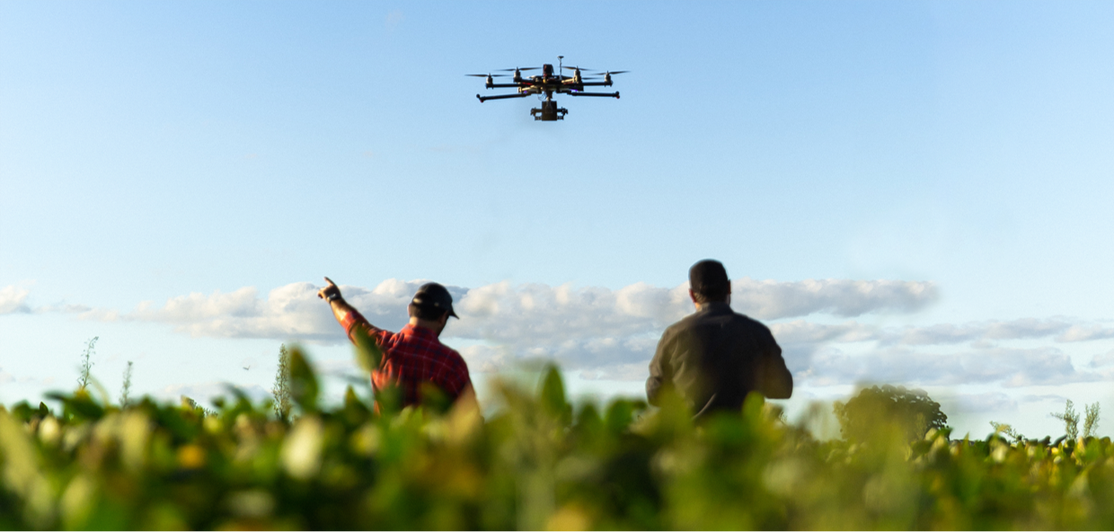

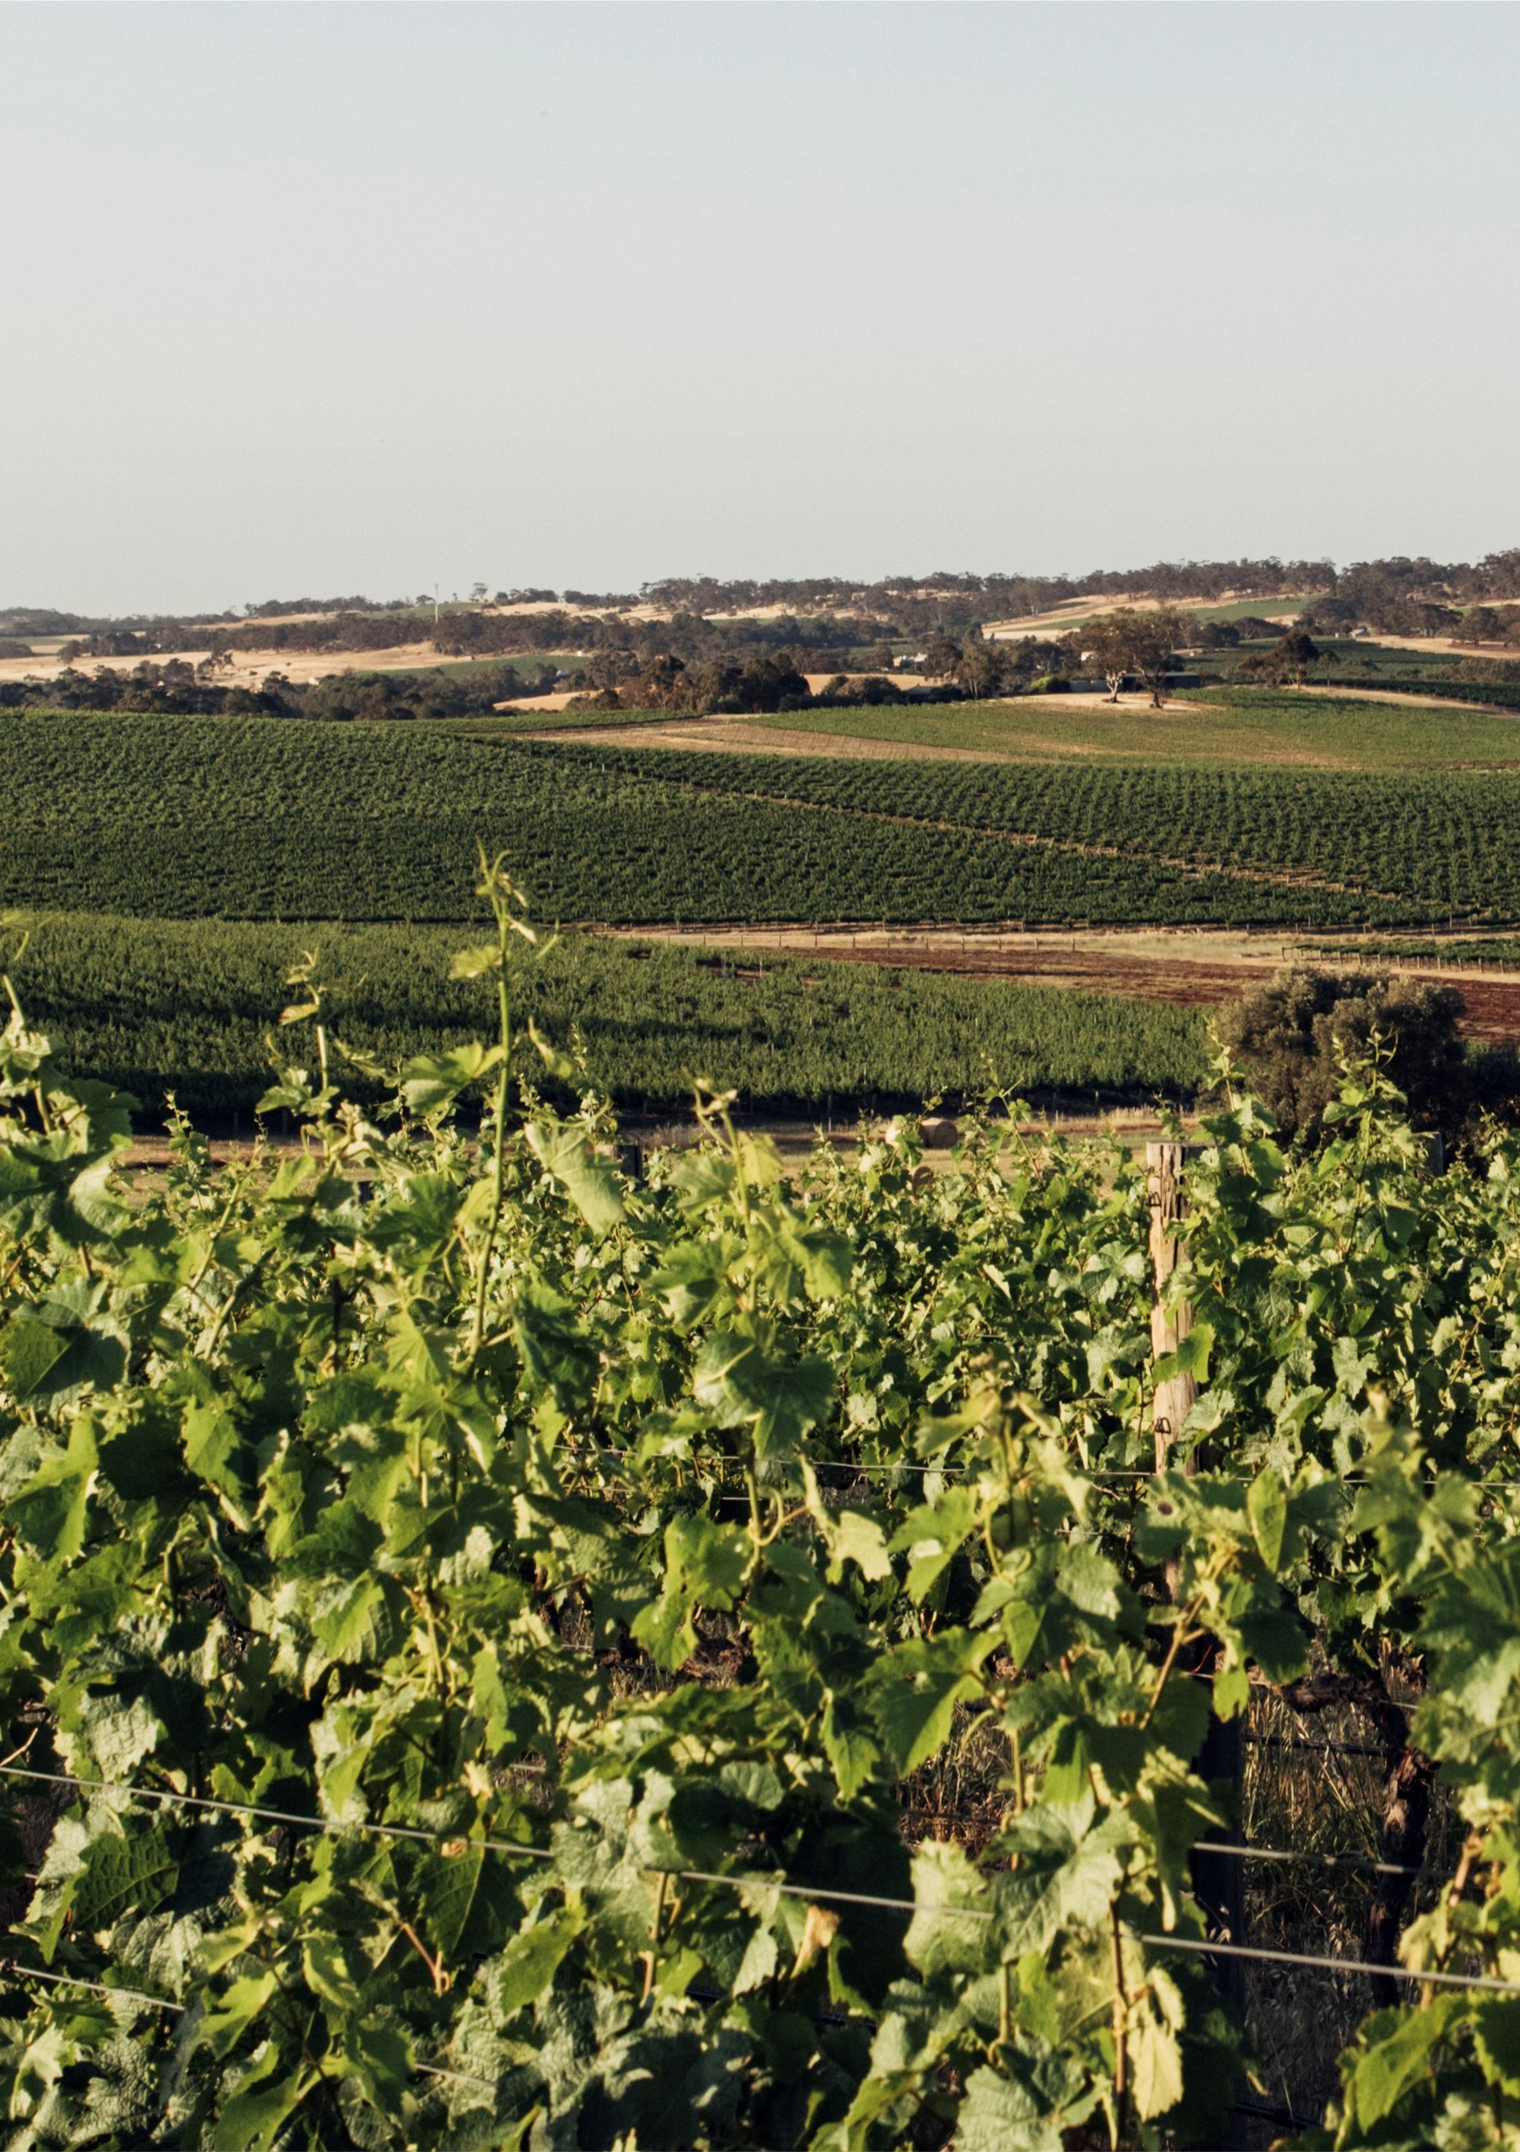

Table of
Contents

Minister’s foreword 1
Our digital opportunity 3
Connecting the agricultural innovation system 7
Our innovation priorities 8
Realising our innovation agenda 9
Our foundational focus areas and strategic actions 10
Leadership 13
Skills 19
Data and governance 23
Opportunities and value proposition 27
Connectivity and infrastructure 31
Monitoring and evaluating our success 34
Glossary 36
Bibliography 39

© Commonwealth of Australia 2022
Ownership of intellectual property rights
Unless otherwise noted, copyright (and any other intellectual property rights) in this publication is owned by the Commonwealth of Australia (referred to as the Commonwealth).
Creative Commons licence
All material in this publication is licensed under a Creative Commons Attribution 4.0 International Licence except content supplied by third parties, logos and the Commonwealth Coat of Arms.
Inquiries about the licence and any use of this document should be emailed to copyright@awe.gov.au.

Cataloguing data
This publication (and any material sourced from it) should be attributed as:
DAWE 2022, Digital Foundations for Agriculture Strategy: Driving the development and uptake of digital technologies in the Australian agriculture, fisheries and forestry industry, Department of Agriculture, Water and the Environment, Canberra, March. CC BY 4.0.
ISBN 978-1-76003-348-4
This publication is available at www.awe.gov.au/agriculture-land/
farm-food-drought/innovation/national-ag-innovation-agenda.
Department of Agriculture, Water and the Environment
GPO Box 858 Canberra ACT 2601
Telephone 1800 900 090
Web awe.gov.au
Disclaimer
The Australian Government acting through the Department of Agriculture, Water and the Environment has exercised due care and skill in preparing and compiling the information and data in this publication. Notwithstanding, the Department of Agriculture, Water and the Environment, its employees and advisers disclaim all liability, including liability for negligence and for any loss, damage, injury, expense or cost incurred by any person as a result of accessing, using or relying on any of the information or data in this publication to the maximum extent permitted by law.
Acknowledgements
The Department of Agriculture, Water and the Environment would like to
thank the agricultural businesses, agritech businesses, industry groups, rural research and development corporations, states and territories, extension
and adoption providers and the education, research and telecommunication sectors who contributed to the development of this strategy. The Department of Agriculture, Water and the Environment also thanks KPMG and PricewaterhouseCoopers, who provided research and consultation support for the department.

Minister’s foreword


We are living in an increasingly digital world. Ways of doing things that were unimaginable years ago are now modernising the way we do business and live our lives.
Our agriculture, fisheries and forestry industry has a strong tradition of adapting to new challenges and taking advantage of opportunities. Through digital agriculture farmers can safeguard and improve their farm gate returns.
The Australian Farm Institute estimated that the uptake of digital technologies could help the agriculture industry increase the gross value of production by more than $20 billion annually.
Digital agriculture will allow for the creation of new services and markets, new job opportunities, supply chain efficiencies and greater sustainability. It will be critical to building and maintaining Australia’s competitiveness as a trusted exporter of premium food and agricultural products into the future.
Digital agriculture promises to help farmers do more with less through data-driven decisions. It also extends our leading agricultural sciences, driving practical applications and improvements for producers around the country.
This Digital Foundations for Agriculture Strategy will support widespread uptake of digital technologies across the agriculture, fisheries and forestry industry. It underpins how we will achieve one of our four National Agricultural Innovation Priorities.
This strategy is the culmination of engagement with stakeholders from across our agricultural innovation system. It brings together the work and investments made by the Australian Government to support the five key focus areas identified in the strategy.
However, this is a start and it is not the end of that collaboration.
As part of demonstrating the Government’s commitment to the Strategy, the Government has committed $30 million to the establishment of a National Centre for Digital Agriculture. The new National Centre will provide national leadership, coordination and facilitation of work to address the key barriers to the uptake of technology across our primary industries.
The initiative will also provide additional funding for dedicated digital officers and activities in each of our eight Innovation Hubs. These digital officers will be focused on driving the uptake of digital agriculture on the ground with producers.
While the Australian agriculture sector demonstrates excellence in some aspects of agritech adoption and innovation, we also know the digital maturity across our system and producers is highly varied. This strategy sets out a nationally-focused, whole-of-sector approach that will increase impact on-farm and along the whole supply-chain – delivering value for all Australians.
Collective effort from all levels of government, industry, agritech and the research and adoption communities will be needed to implement and sustain the strategy across the five focus areas.
The potential gains for Australian producers, the economy, the environment and consumers are clear and substantial.

The Hon. David Littleproud MP
Minister for Agriculture and
Northern Australia

Agritech is a collection of technologies – including digital, that provides the agriculture, fisheries and forestry industry with tools, data and knowledge. Agritech enables more informed and timelier on-farm decisions to improve productivity and sustainability.

Our digital opportunity
A world class agricultural innovation system will help Australia reach the industry’s target of becoming a $100 billion sector by 2030.
However, if we are going to grow Australian agriculture to $100 billion, we need to make it easier for our farmers, fishers and foresters, and the broader supply chain, to adopt digital technology.

Driving agricultural innovation and investment
Australia currently has a strong pipeline of research and innovation, resulting from collaboration with industry groups, Rural Research and Development Corporations (RDCs), agritech businesses and the education and research sectors. RDCs invest around $800 million each year in agricultural innovation, with more than $300 million of funding coming from the Australian Government and the remainder from industry levies.
Recognising the need to address significant
cross-sectoral challenges, in 2020 the RDCs established Agricultural Innovation Australia,
a not-for-profit, public company designed to
attract investment and encourage collaboration in agricultural innovation initiatives.
This capacity and appetite for innovation, together with a strong knowledge of areas such as climate resilience and water efficiency, presents opportunities to lift profitability across agricultural businesses and open new export prospects for Australian technology and expertise.
There is now an opportunity for Australia to significantly increase its share of the global capital available for agritech in order to maximise growth and drive innovation.

Delivering productivity, profitability and growth with digital technologies
Digital technologies are foundational to the next major wave of agricultural productivity. These digital technologies will not only help create stronger regional communities and deliver more dollars into the pockets of Australian farmers, but will also bring further opportunities such as reduced food waste, more efficient use of resources, greater sustainability and improve supply chain tracking.
Some agricultural businesses have already successfully accelerated their adoption of digital technologies to respond quickly to the challenges of COVID-19. For example, farmers supplying produce to restaurants pivoted to digital platforms to enable them to connect directly with consumers.
Australian farmers are natural innovators. They are eager to apply new technologies, but there are several barriers currently preventing wholesale progress.
Australian agriculture has led the way over the past 26 years, with a high rate of productivity growth (ABS, 2021).
While Australia has already benefited from digital innovation, the value realised has been less than other advanced economies. Statistics show that from 2000 to 2018, Australia’s digital industries accounted for 34% less GDP than other advanced economies (CSIRO Data61 2018).
To ensure Australia continues to grow and keep pace with a global marketplace, digital tools are needed. Without the use of emerging tools and technologies, the productivity growth that Australian agriculture has achieved may stagnate.
This is a whole of sector issue that needs whole of sector solutions. No one player can achieve the required change on their own.

Opening up market access
Investing in digital agriculture will help deliver new trade and market access for producers, create jobs and reduce red tape. Actions as part of the Delivering Ag2030 plan, including elements of the Simplified Trade System and Future Traceability Project, will help reduce regulatory costs and facilitate trade, as well as predict future needs by using climate, consumer demand and other data more effectively.
These initiatives will help encourage co-investment from new players, including agritech developers and international investors, to accelerate development and commercialisation across the Australian agriculture industry. They also highlight the role that the Australian Government is currently playing to support the sector’s digital transition.

Realising the potential of digital technologies
Digital technologies such as artificial intelligence, robotics and blockchain are transforming agriculture and the food system.

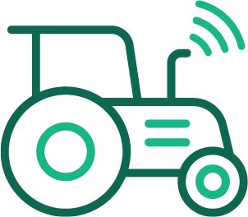 Farm machinery automation allows fine-tuning of inputs and traffic control, while reducing demand for manual labour.
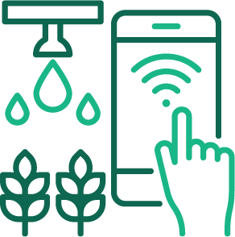
Edge-of-field monitoring documents the quality of runoff water on farms, reducing costs related to sampling systems and allowing improvements to be made.
 Increased functionality of satellites allows for improved remote monitoring of agriculture, with measurement of field areas, identification of crop types, groundcover percentage, geo-location of landscape features, and assessment of environmental impacts.

Traceability technologies and digital logistics services offer the potential to streamline agrifood supply chains, reduce regulatory burdens and provide trusted information for consumers, producers and other supply chain participants.
 Soil carbon sequestration may improve farm productivity and resilience, and create new market and revenue opportunities for land managers via decarbonisation pathways.

Drone farming provides the opportunity for more frequent, cost-effective remote monitoring of large areas and enables remote interventions to boost yield and reduce losses from pests.

Smart-livestock monitoring allows for the early detection of illnesses and facilitates the provision of optimal feed and medicine mixes for each animal through connected-body-sensor data and movement tracking. Furthermore, remote sensing telemetry for stock water monitoring has been a major change for the pastoral industry.

THE SIZE OF THE OPPORTUNITY


In mid 2021, agritech products and services were estimated to be worth $500 billion globally. This is expected to increase to
$730 billion
by the end of 2024
(AgThentic 2021)

Digital technologies alone hold the potential to increase the gross value of production in Australia by over
$20 billion
per year, an increase of 25%
(Australian Farm Institute 2017)
 For Australia, digital innovation has the potential to deliver
$315 billion
in gross economic value over the next decade, making it a critical ingredient in the nation’s ongoing economic success
(CSIRO Data61 2018)

Across the world, agrifood tech startups raised $26.1 billion in 2020. This is expected to increase to more than $30 billion as new deals come to light. This would represent a 34.5% increase from 2019
(AgFunder 2021)



Blockchain-enabled traceability could
reduce food losses
by up to
30 million tons
annually, if it was used to monitor supply chain information in half of the world’s supply chains
(World Bank Group 2021)

Over the next 10 years, one in three new jobs in the agriculture, fisheries and forestry industry will be technology related
(KPMG & Skills Impact 2019)

Creating the strategy together

To understand the barriers to digital agriculture development and uptake, the Australian Government engaged a broad range of stakeholders across the agricultural innovation system to determine where efforts should focus.
These insights have helped shape what we need to do to deliver the digital agriculture innovation priority and create a world class agricultural innovation system. Together, we will build on the momentum created by the launch of this strategy to continue meaningful and lasting engagement and collaboration.

Key themes – what you told us

 National coordination and collaboration is crucial to accelerating digital agriculture innovation and adoption, as well as reducing duplication of effort across geographies, sectors and the value chain.
 Good connectivity is key to widespread digital uptake, but in some cases, farms do not need streaming-grade connectivity to use all types of technologies.


Data frameworks and a code of conduct or practise should consider interoperability, access permissions, digital identity, data transformation and federation, governance, intellectual property and data ownership.

A skills and education uplift is required. Farmers are lacking “translators” of agritech (skilled workforce) to unlock the value it can provide.
.


More clarity and a filtering process are needed to help farmers better understand the risk profile of different solutions being developed before they decide to implement a technology.


A key challenge for farmers is fully understanding the value and benefits that the application of agritech solution brings, and whether it suits their business needs. Resolving this will provide confidence for farmers to adopt these technologies.

Connecting the agricultural innovation system

Delivering this strategy will see the adoption of digital agriculture solutions by end-users across the agriculture industry.
It will see farmers at the centre of digital innovation, with the government providing the foundations to drive uptake and transform agritech in Australia.
We have an exciting opportunity ahead of us, and this strategy will help us move forward by coordinating key players across the innovation system, who each have a key role to play.
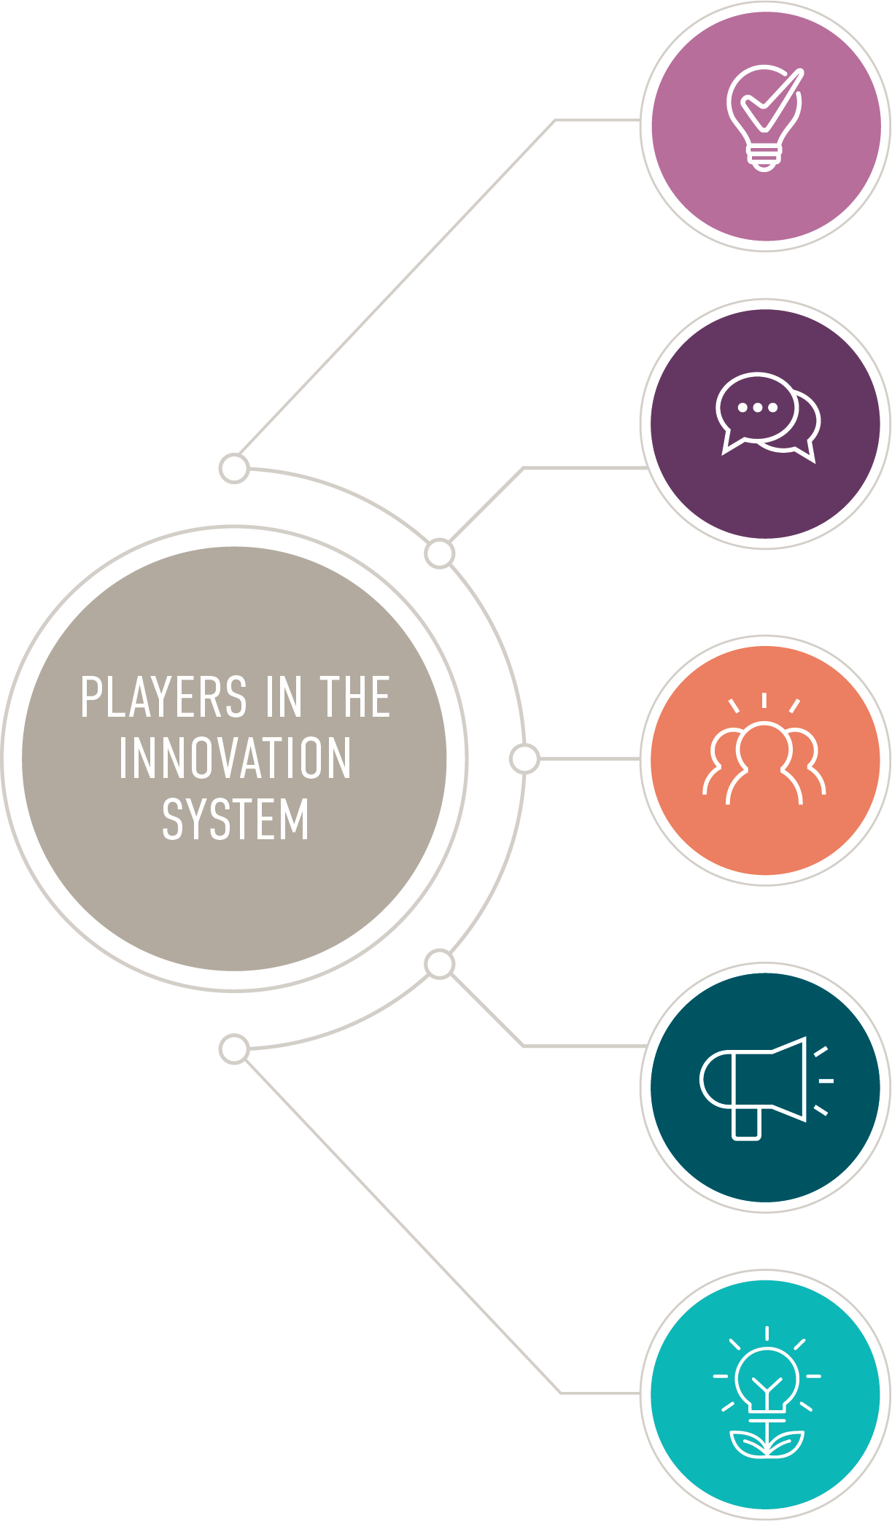
RESEARCH AND EDUCATION
Universities
- Private research organisations
- CSIRO
- CRCs
- Government (Australian, State, Territory, and local)
- International collaborators
BRIDGING INSTITUTIONS
RDCs
Industry representative bodies
Industry consultants, advisors and farming system groups
Government (Australian, State, Territory, and local)
Extension providers
BUSINESS AND ENTERPRISE
Producers
Input providers (chemicals, machinery and ag tech to farms)
Supply chain participants (buyers, markets, processors)
Investors
ENABLING ENVIRONMENT
Government (Australian, State, Territory, and local)
Venture capitalists
Financial institutions
AGRITECH
Start-ups
Incubators and accelerators
Other ag-tech businesses

Our innovation
priorities
Based on the key challenges Australia’s agricultural innovation system needs to address
by 2030, the Australian Government has set four National Agricultural Innovation Priorities (Innovation Priorities), of which digital agriculture is one. Together, these Innovation Priorities will help to align efforts, embrace strategic opportunities and promote collaboration and innovation.

The Innovation Priorities are for Australia to be a:

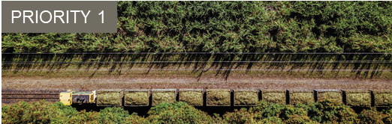
Trusted exporter of premium food and agricultural products
The protection of our food and agricultural products through the adoption of enhanced biosecurity and technology in order to deliver greater returns to farmers


Champion of climate resilience to increase the productivity, profitability and sustainability of the agriculture sector
To increase on-farm resilience and the ability of the sector to respond to external factors by utilising new technology and tools

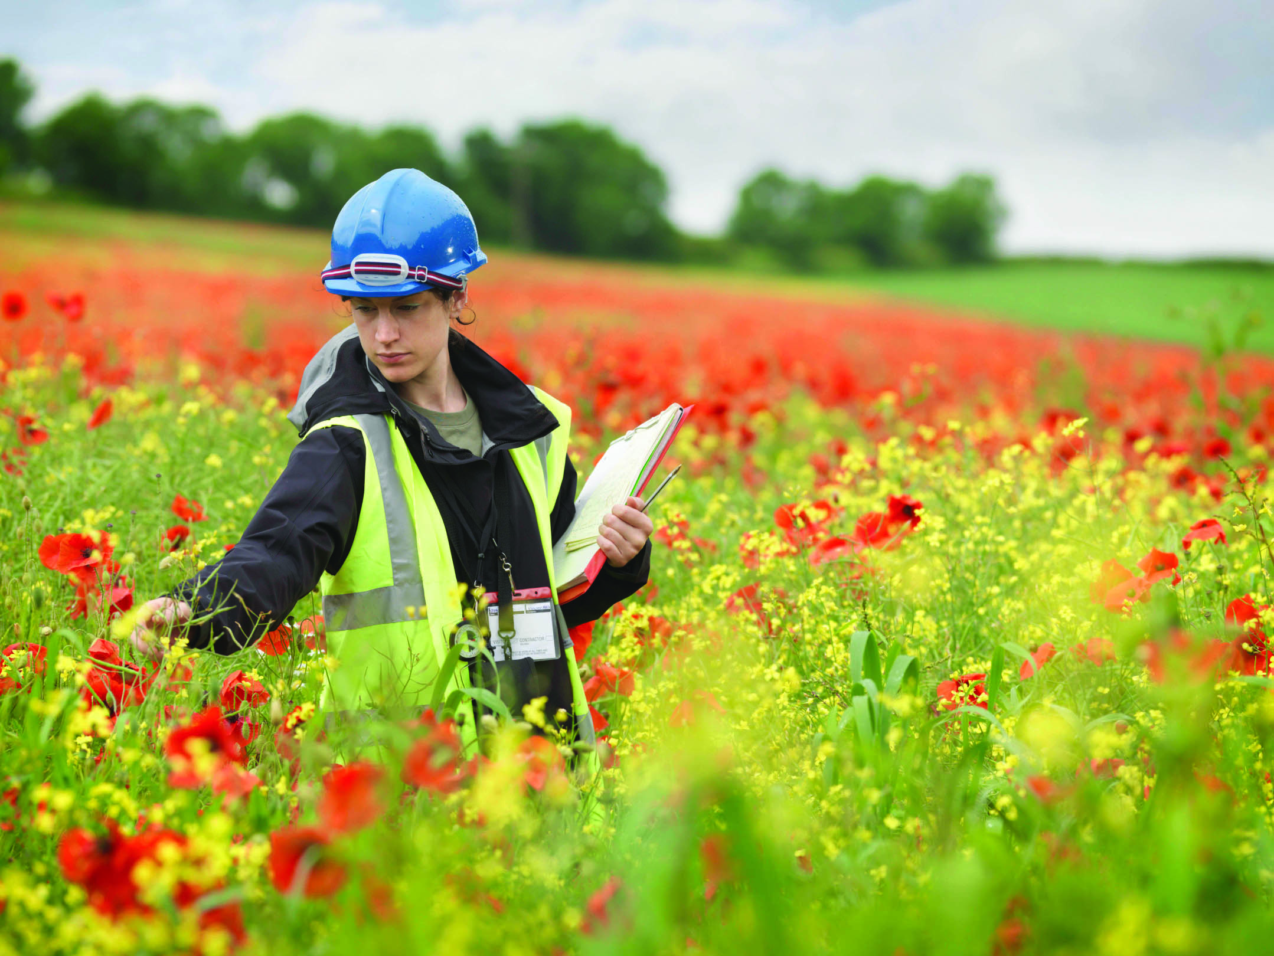
World leader in preventing and rapidly responding to significant pests and diseases through future-proofing our biosecurity system
To roll out advancements in detection technologies and enhance on-farm biosecurity practices to create a future-oriented and efficient national biosecurity system

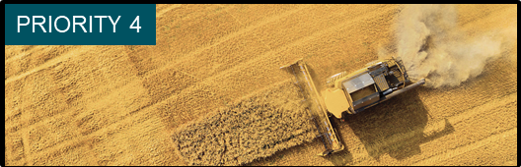
Mature adopter, developer and exporter of digital agriculture
To reduce the barriers to digitalisation and drive adoption of digital agriculture solutions in order to grow the value of Australian food and fibre

These four priorities set out how we plan to be a strong, vibrant and collaborative agriculture sector, where our producers are empowered to adopt the latest science, technology and tools. This will improve how they operate, making Australian food and fibre systems more competitive, prosperous and sustainable.

Realising our innovation agenda
This strategy sets out how we will realise the digital agriculture innovation priority of being a mature adopter, developer and exporter of digital agriculture. It is specific to the agriculture, fisheries and forestry sector and contributes to several Australian Government priorities, including Australia’s Digital Economy Strategy 2030, Delivering Ag2030 and the National Agricultural Innovation Agenda.
As part of our digital agriculture priority, we have identified five foundational focus areas.
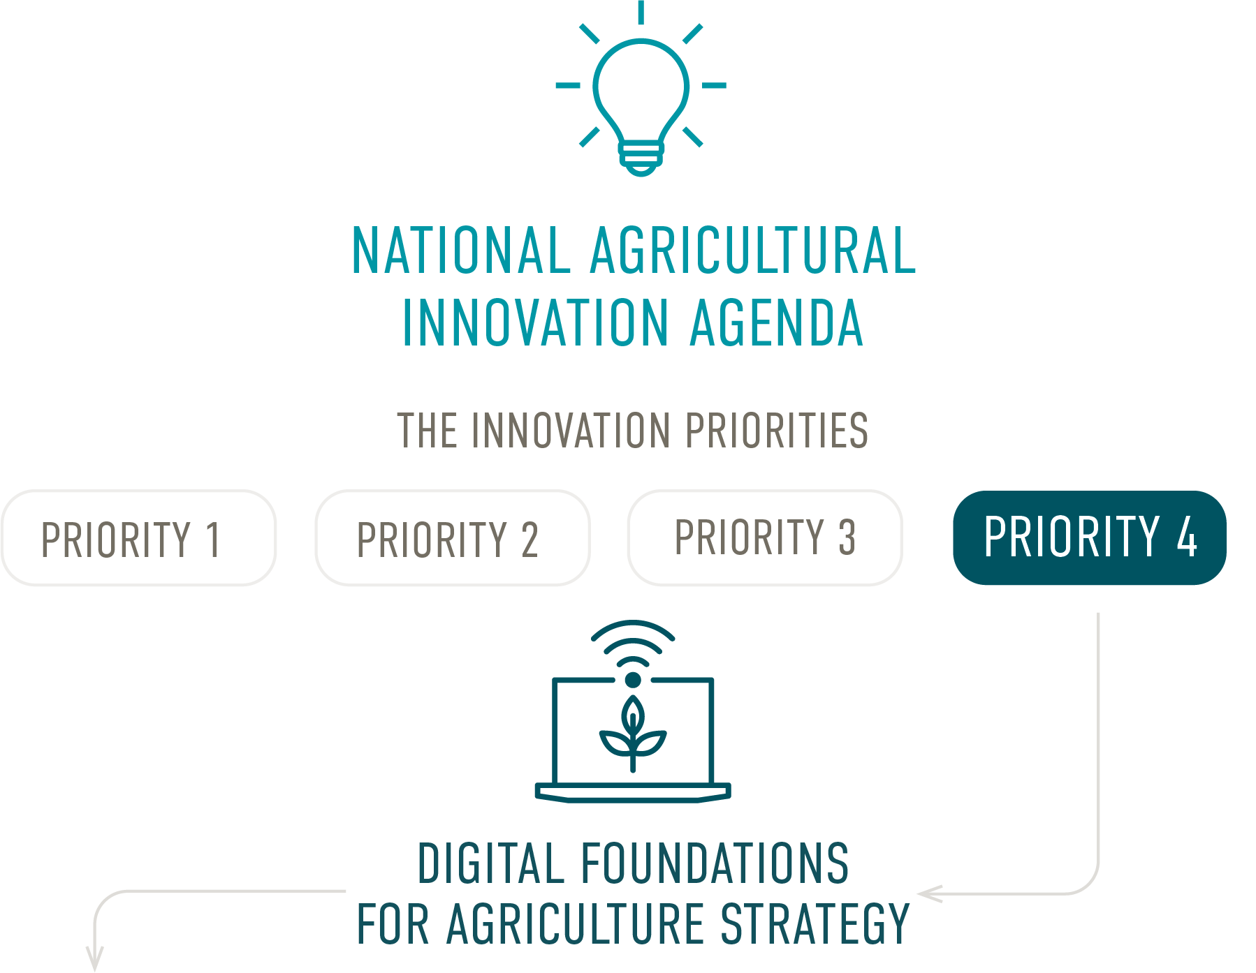
FOCUS AREAS

01

Leadership
Enhance connection and coordination across the sector, encourage pooling of resources and provide a clear plan to unify stakeholders around collective long-term goals
02

Skills
Deliver the skills and expertise needed by both the current and future workforce to modernise the sector
03

Data and governance
Maximise data use, good data management, common data standards, and interoperability
04

Opportunities and value proposition
Help producers understand and realise the benefits from digitising their businesses, ensuring appropriate and agile regulation, while fostering faster commercialisation
05

Connectivity and infrastructure
Help agricultural businesses understand their connectivity options and access the infrastructure they need

Our foundational focus areas and strategic actions
This strategy identifies five key areas of focus where collective action is needed
to increase the uptake of digital technologies in the agriculture sector to drive
growth, prodctivity, profitability and sustainability.
All participants in the innovation system will have a role to play – from farmers
and researchers to private investors and government. With action needed across
the whole agriculture sector and supply chain, different actors will have different
responsibilities under each of the five focus areas.

01 

Leadership
Enhance connection and coordination across the sector, encourage pooling of resources and provide a clear plan to unify stakeholders around collective long-term goals
1. Foster a strong, vibrant and collaborative culture across key participants in the agricultural innovation system
2. Encourage collaborative efforts and pooling of resources and knowledge across the supply chain and beyond
3. Promote Australia as open to agritech, and the benefits of agritech
4. Accelerate the growth and commercialisation of Australia’s agritech industry and pathways for export
5. Help develop agritech that delivers outcomes for producers
6. Create ‘try, test and learn’ cultures to drive uptake of digital agriculture

02 

Skills
Deliver the skills and expertise needed by both the current and future workforce to modernise the sector
1. Develop digital agriculture skills and capabilities to meet the needs of the future workforce
2. Work with governments and educational institutions at all levels to implement and deliver the National Agricultural Workforce Strategy
3. Promote an agriculture industry that attracts and invests in skilled workers
4. Foster an environment that enables digital agriculture to continuously capitalise on international experiences
5. Enhance understanding of changing digital workforce needs and our ability to respond in an agile way
6. Invest in organisations that will grow digital agriculture, including RDCs, the Innovation Hubs and CSIRO
7. Consider digital investment opportunities when making investment decisions

03 

Data and governance
Maximise data use, good data management, common data standards, and interoperability
1. Build trust in, and processes for, data use, privacy and security
2. Increase understanding and scope for digital information and data to streamline and improve regulation, including compliance
3. Support agriculture players to collect information and use it to benefit their business decisions and profitability
4. Implement, and benefit from, interoperability frameworks that enable connected devices and data to work together
5. Establish standards that support agriculture and make it simple for businesses to operate

04 

Opportunities and value proposition
Help producers understand and realise the benefits from digitising their businesses, ensuring appropriate and agile regulation, while fostering faster commercialisation
1. Create a culture of digital uptake and innovation
2. Continue to build a regulatory environment that enables new innovations and technologies, without removing necessary protections
3. Use digital agriculture to deliver value through greater productivity, profitability, resilience and sustainability
4. Increase investment from the non-government sector in Australian digital agriculture
5. Explore new connectivity options to enable digital agriculture in regional and remote Australia
6. Enable digital products and services to commercialise and reach domestic and international markets
7. Embed digital systems that demonstrate value and therefore encourage government investment
05 

Connectivity and infrastructure
Ensure agricultural businesses understand their connectivity options and can access the infrastructure they need
1. Build understanding of the types of connectivity and infrastructure that will deliver agricultural solutions
2. Invest in telecommunications
3. Foster partnerships that deliver multiple solutions, understanding that no one solution will be fit for purpose
4. Develop technology partnerships that deliver regionally-based solutions
5. Utilise the skills of those across agriculture, not just in telecommunications, to deliver digital connectivity

01

Leadership
Enhance connection and coordination across the sector, encourage pooling of resources and provide a clear plan to unify stakeholders around collective long-term goals

Our aspiration
To be recognised as a serious player in international markets. Prioritising technological innovation development and adoption will highlight that Australia is ‘open for business’ and an attractive destination for international investment.

By 2030, there are expected to be breakthroughs in emerging technologies that can transform the Australian economy. These transformational technologies will support and grow a modern agriculture sector that is globally competitive.
Australia’s agritech industry is still in its early stages relative to other global players.
Becoming a mature agritech industry will allow Australia’s farmers, fishers and foresters early access to the latest technology. It will enable key players in the innovation system to work more closely together towards common goals, with pooled resources. It will also mean new technologies are fit for purpose and tailored to Australia’s unique climate, growing conditions and supply chains.
This collaboration will empower Australian producers to adopt the latest technology, improve how they operate, and ensure results are maximised across the innovation sector.
Strategic actions
Foster a strong, vibrant and collaborative culture across key participants in the agricultural innovation system
Encourage collaborative efforts and pooling of resources and knowledge across the supply chain and beyond
Promote Australia as open to agritech and the benefits of agritech
Accelerate the growth and commercialisation of Australia’s agritech industry and pathways for export
Help develop agritech that delivers outcomes for producers
Create ‘try, test and learn’ cultures to drive uptake of digital agriculture


New leadership initiative

The Australian Government is providing national leadership by investing $30 million in a new National Centre for Digital Agriculture and in bolstering regional Innovation Hubs resources for faster digital uptake.

The new National Centre will provide national leadership, coordinate and facilitate efforts to drive a cohesive uplift in skills, education, awareness, and ultimately adoption of digital agriculture and growth of the agritech industry. The National Centre will work across the agricultural innovation ecosystem to inform and support the efforts of others.

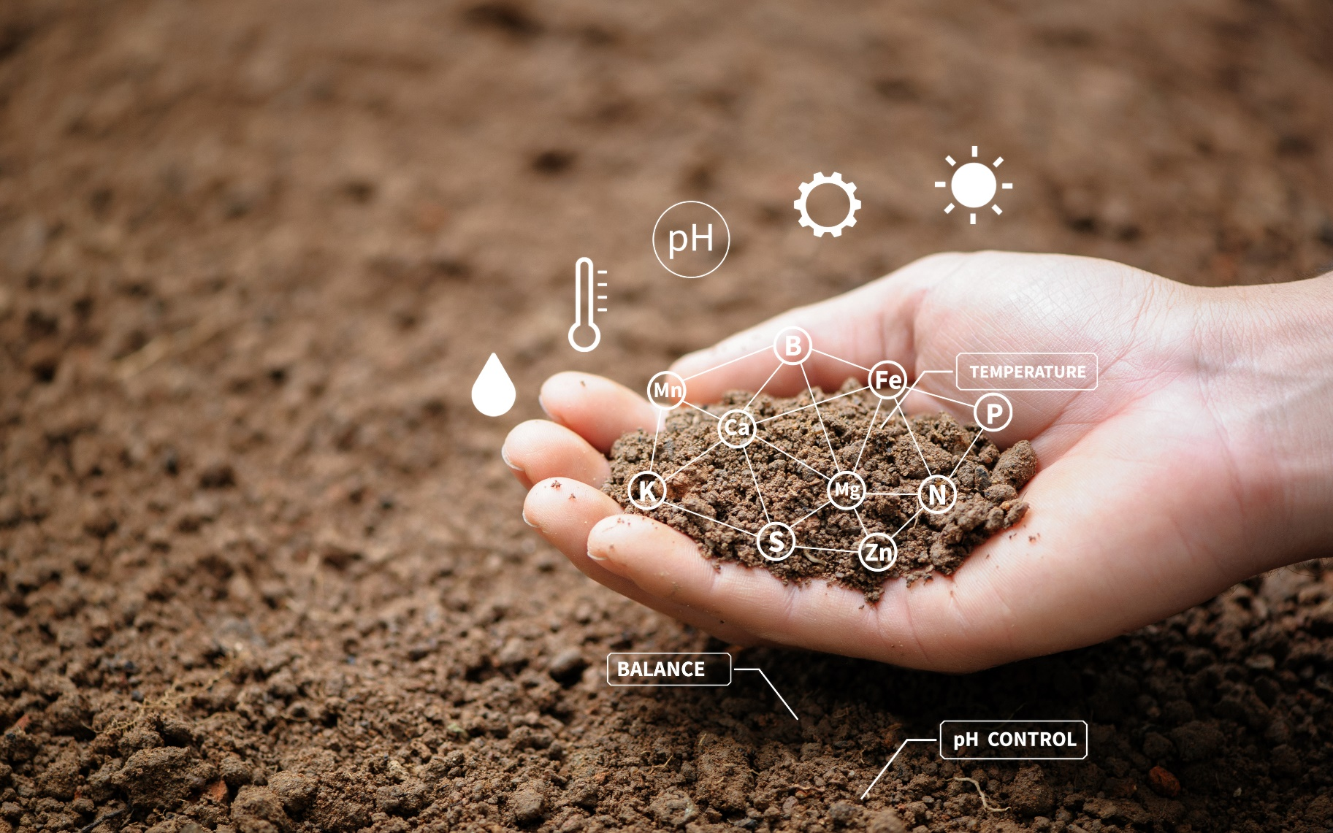
This includes working with the existing 8 regional Innovation Hubs. The Hubs will provide a grass-roots perspective to the National Centre on what farmers need and to help overcome the barriers to adopting digital agriculture. The Innovation Hubs are embedded in regional Australia to ensure they are firmly connected to and responding to the needs of farmers. The connection between the National Centre and the Hubs will provide a unique pathway to bridge the gap between the opportunities arising from digital agriculture and the current barriers to their adoption on the ground.
Under this new funding, the Innovation Hubs will build the skills and digital awareness of farmers and others in their region, and to extend and demonstrate agritech tools with:
- Digital officers, including a digital strategist, in each Hub to support farmers and agribusinesses to improve their digital literacy and confidence in using digital technologies. They will also facilitate the connection between the National Centre, industry and end-users; and
- Digital extension activities that will have highest impact within each Hub region.
This funding builds on the Australian Government’s existing $86 million funding for the Innovation Hubs to undertake activities that lead to practical uptake of drought resilience and broader innovation practises by producers, stimulate collaboration in the agricultural systems and increase commercialisation outcomes.

Making progress
Leading the way in digital agriculture relies on building a more coordinated approach within, and across, industry and with Australian and state and territory governments. A more aligned and integrated approach will deliver faster and more widespread impact across the agricultural innovation system, including growing the agritech sector.
There are a range of whole-of-government strategies and initiatives that set a pathway for widespread adoption of digital technology across the entire economy.
The Digital Economy Strategy sets out how the government plans to be a leading digital economy and society by 2030, with growth priorities that include lifting the digital capability of small to medium enterprises; supporting modern and globally competitive industry sectors including agriculture; building a dynamic and emerging technology sector; and delivering simple and secure digital government services.
The Artificial Intelligence (AI) Action Plan is a key feature of the Digital Economy Strategy, which sets out the steps being taken for Australia to become a global leader in developing and adopting trusted, secure and responsible AI. AI could contribute more than $15 trillion to the global economy by 2030, and this action plan is backed by a $124.1 million government investment (PwC 2019).
The Critical Technologies Policy Blueprint, Action Plan and List include tangible actions designed to protect and promote the 63 current and emerging technologies, such as AI, seen as critical to Australia’s future.
The Simplified Trade System will streamline Australia’s international trade regulations, modernise outdated ICT systems and help strengthen Australia’s economic resilience. It will also create efficiencies for the export and import of agricultural goods and inputs.

This includes delivering a ‘tell us once’ trade system, which will streamline trade through more integrated digital services and making better use of all sources of data to support Australia’s importers and exporters.
Case study
Agricultural Innovation Australia
A core component of the innovation agenda has been the establishment of Agricultural Innovation Australia (AIA), which is a not-for-profit, public company established by the 15 RDCs in 2020.
Its aim is to facilitate joint investment and collaboration in cross-industry agricultural issues of national importance.
The establishment of AIA is evidence of the need to shift investment towards transformational and cross-sectoral outcomes, increase flexibility of investment across the system and encourage new collaborations and global partnerships.
AIA will identify, develop and invest in strategies that address shared challenges. It will also seek opportunities to deliver outcomes that drive sustainability, productivity and profitability across Australian agricultural value chains.
AIA attracts investment from public, private, not-for-profit and global commercial entities to deliver agricultural innovation initiatives.

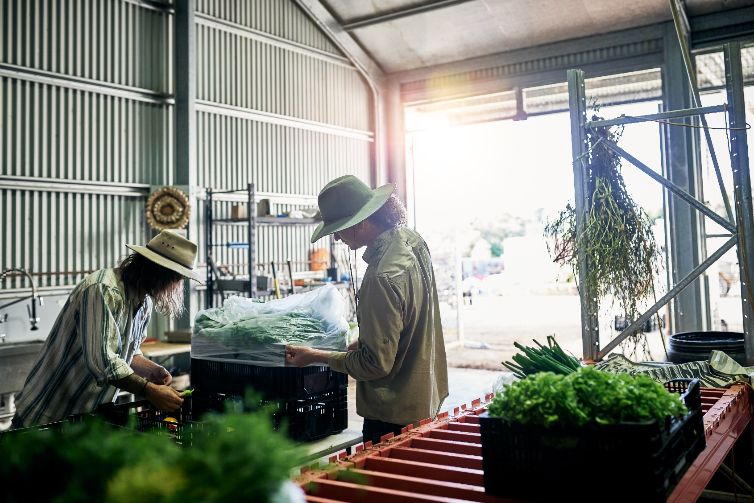

Key initiatives uplifting the agriculture industry
The Australian Government is investing in the National Centre for Digital Agriculture to provide national leadership, coordinate and facilitate efforts to drive a cohesive uplift in skills, education, awareness, and ultimately adoption of digital agriculture and growth of the agritech industry. Supported by the new digital officers in the each of the Innovation Hubs, the National Centre will work across the agricultural innovation ecosystem to inform and build on the efforts of others.
Agricultural Innovation Australia will streamline co-investment arrangements and target significant cross-sectoral challenges. It was set up by the RDCs in 2020 and to date has received an investment of $2.8 million from the Australian Government.
Smart Farming Partnerships is a component of the National Landcare Program. These partnerships encourage the widespread uptake of digital agriculture to help farmers and land managers improve productivity and protect soils, water and vegetation. Over six years, $57.5 million is being invested.
grow^{AG} is a digital platform that enables RDCs, universities and private organisations to showcase their agricultural research and engage with investors in Australia and overseas. Lead by AgriFutures Australia, the platform plays a role in connecting organisations and fostering commercialisation outcomes.
evoke^{AG} is another initiative lead by AgriFutures which compliments grow^{AG}. evoke^{AG} is an agrifood tech event which connects the agrifood innovation community across Asia Pacific and the world. The event gives start-ups a forum to pitch their potential, farmers the opportunity to share their experiences, and scientists a chance to showcase their discoveries.

02

Skills
Deliver the skills and expertise needed by both the current and future workforce to modernise the sector

Our aspiration
Technology uptake varies across the agriculture sector, and one contributor to this is the variation in digital capabilities. Efforts are needed to ensure more workers have the skills and digital literacy required to fully utilise digital agriculture. An initial uplift in skills and education is needed for people entering the agricultural workforce for the first time, as well as the existing workforce and the digital workforce from other sectors.
Widespread adoption of digital technology will require a focus on education and training. Therefore, it is vital to build a culture of lifelong learning to maintain a skilled workforce that can better capitalise on the opportunities presented by technology. Linkages with universities and businesses need to be in place to promote career learning opportunities.

By 2030, one in three new jobs in the agriculture, fisheries and forestry industry are estimated to be technology related (KPMG & Skills Impact 2019). This means that non-agricultural disciplines, such as science, technology, engineering and maths specialists, will be a key part of the future agricultural workforce. This new workforce will be equipped to handle complex digital technology and big data.
Strategic actions
Develop digital agriculture skills and capabilities to meet the needs of the future workforce
Work with governments and educational institutions at all levels to implement and deliver the National Agricultural Workforce Strategy
Promote an agriculture industry that attracts and invests in skilled workers
Foster an environment that enables digital agriculture to continuously capitalise on international experiences
Enhance understanding of changing digital workforce needs and our ability to respond in an agile way
Invest in organisations that will grow digital agriculture, including RDCs, the Innovation Hubs and CSIRO
Consider digital investment opportunities when making investment decisions

Making progress
Attracting and retaining highly skilled people from the science, technology, engineering and mathematics (STEM) disciplines will help grow digital technologies. Establishing a collaborative education effort between educational institutions, farmers and industry stakeholders is also a growing opportunity.
The Australian Government has a number of key initiatives underway which are focused on developing and delivering digital skills.
The Digital Skills Cadetship Trials involve the government working with industry to trial tailored training alongside on-the-job experience provided by host employers. These trials are set to increase the number of Australians with high-level digital skills, as part of the Digital Economy Strategy.
The Cyber Security Skills Partnership Innovation Fund seeks to increase the quality and quantity of cyber security professionals in the Australian workforce by supporting innovative collaboration projects between industry and education providers. In the first round of funding, La Trobe University received $2.35 million to increase high school student awareness of cyber security skills and training.
The Digital Readiness Assessment Tool helps businesses measure their readiness and capability for free, including their digital skills, against a range of metrics.

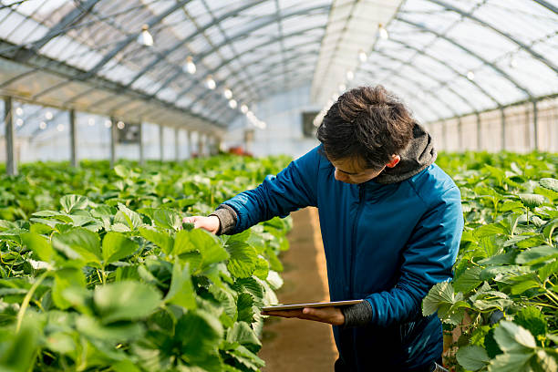
Case study
A Preparing the next generation with industry-ready experience
To ensure there is a sustainable pipeline of graduates, the government is investing $47.3 million over a six-year period, beginning in 2021–22. This will support two programs of competitive national scholarships – the Next Generation Emerging Technology Graduates Program and the AI Graduates Program.
The Next Generation AI Graduate program is designed to enable cohorts of high-performing students to undertake industry-focused research projects and placements to build real-world experience. This will bridge the research-industry divide by focusing research on industry-specific topics, translating research directly into industry and developing students with industry-ready experience. This would likely include experience in key sectors where Australia has a comparative advantage, including the Food and Beverage National Manufacturing Priority under the Modern Manufacturing Strategy.
In addition to the AI Action Plan initiatives, a further investment in the Next Generation Emerging Technology Graduates Program will attract and train a further 234 specialists through competitive national scholarships. These specialists will have expertise in other emerging technologies, such as robotics, cyber security, quantum computing, blockchain and data.

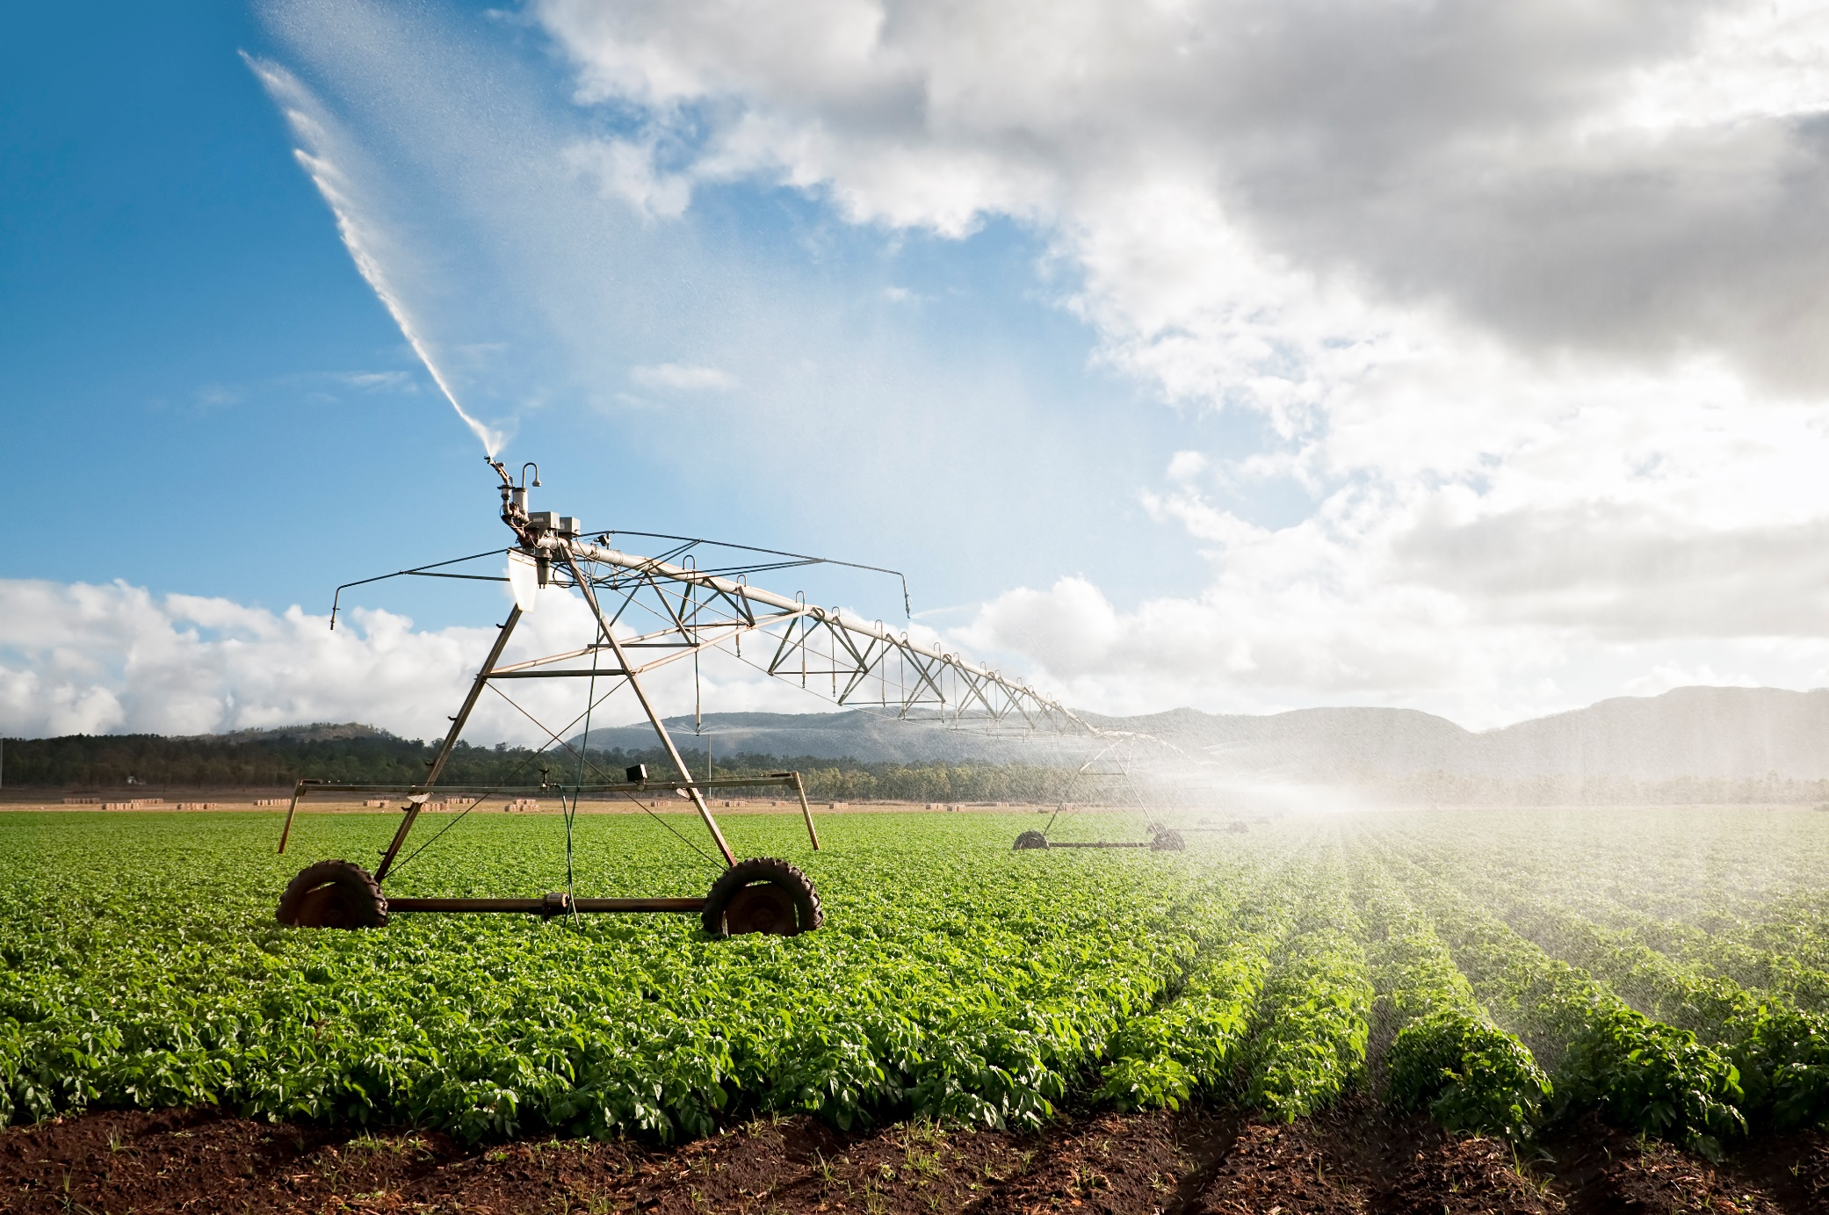

Key initiatives uplifting the agriculture industry
Digital Officers in the Innovation Hubs are part of a $30 million investment, the Government is supporting the Innovation Hubs to build the skills and digital awareness of farmers and others in their region, and to extend and demonstrate agritech tools. New digital officers will be funded in each of the 8 existing Innovation Hubs along with extension activities to support farmers and agribusinesses to improve their digital literacy and confidence in using digital technologies.
National Agricultural Workforce Strategy and the Australian Government Roadmap are focused on attracting, retaining, upskilling and modernising the agricultural workforce. They set a path to ensure the agriculture industry has access to sufficient and appropriately skilled workers.
AgATTRACT aims to shift perceptions of agriculture and agricultural work by showcasing the diverse career opportunities on offer. It also includes the AgCAREERSTART pilot program, which is a structured employment program designed to help young Australians start a career in agriculture during their gap year.
Next Generation Emerging Technology Graduates Program and AI Graduates Program will help drive the competitiveness of Australian businesses and ensure local talent is available to fill high-skilled jobs in Australia, including in the agriculture sector. The government’s investment of $47.3 million will help ensure a sustainable pipeline of home-grown talent.

03

Data and governance
Maximise data use, good data management, common data standards, and interoperability

Our aspiration
Data has been essential to the work of farmers for generations. Weather patterns, soil tests, historical crop yield data, paddock management decisions and market information all help to inform planting cycles, livestock management and watering plans.
As agriculture becomes increasingly digitised, there is a need to simplify data ownership and establish trust between primary producers and service providers, and across the system.
The ease with which data can be shared and technology can be adopted will increase with industry-wide alignment on data-management practices. This includes clear rules of engagement and frameworks for sharing agricultural data between, and across, farm systems and the value chain.
Establishing this governance will enable better integration, targeted decision-making and greater efficiency and profitability. It will help facilitate the collection of data through aggregation and make it more accessible to farmers and the broader sector. A governance framework will also build trust between participants by increasing certainty in how data will be used. It will help unlock value between agritech applications by using data collectively and avoiding siloed applications that deliver limited long-term value.
In addition, new digital tools that collect, store and share data along the agricultural value chain will improve services and products, as well as improve productivity and profitability.
Strategic actions
Build trust in, and processes for, data use, privacy and security
Increase understanding and scope for digital information and data to streamline and improve regulation including compliance
Support agriculture players to collect information and use it to benefit their business decisions or profitability
Implement, and benefit from, interoperability frameworks that enable connected devices and data to work together
Establish standards that support agriculture and make it simple for businesses to operate

As businesses are gathering more data and tapping into its value, there is an increased focus on robust data privacy measures. Agritech businesses can address these concerns in a constructive manner, for example by anonymising data, processing data lawfully, fairly and transparently, and managing access.

Making progress
Data and technology continue to change how Australians live, work and prosper. Across the globe, the pace of digital transformation is accelerating. The Australian Government is committed to improving the understanding and trust around the storage, management and sharing of data across the economy, with a range of initiatives already in place.
The Digital Transformation Strategy 2018–2025 guides Australia’s digital journey to 2025 by setting out how Australia will become one of the top three digital governments in the world.
The Digital Economy Strategy 2030 maps how Australia will continue to improve access to data, data sharing arrangements and data asset management and strengthen collaboration between government and industry.
The Consumer Data Right is an economy-wide framework that will provide greater competition in the marketplace by giving end-users the right to share their data between the service providers of their choosing. It is currently being applied to banking and is set to expand into the energy sector by the end of 2022, and the telecommunications sector thereafter. The roll-out will continue on a sector-by-sector basis, including agriculture.

Case study
Managing and exchanging national agricultural and food data
The Australian AgriFood Data Exchange is a project that assesses the methods and benefits of creating an interconnected data highway for Australia’s agrifood value chain. The Australian Government is contributing $600,000 to the pre-business case experiment phase, alongside funding and support from universities, RDCs, state governments and industry organisations.
The end-goal is to develop a digital platform that will enable permissioned exchange of data between value chain partners and timely access to information to support decision-making across the value chain.
Following industry consultation, priorities of the Australian AgriFood Data Exchange include reducing the burden of regulatory compliance, identifying and anticipating biosecurity risks, benchmarking performance to inform decision-making, and bringing traceability to the entire value chain.
Data is the lifeblood of any industry. The Australian AgriFood Data Exchange is a nation building project that will support the growth and resilience of the Australian agrifood industry by building a secure and trusted framework for data to be shared across the sector. This will create transformational opportunities to innovate and supercharge Australian agriculture.
The Honourable Andrew Robb AO,
Chair of the Australian AgriFood
Data Exchange.
The Australian AgriFood Data Exchange is an industry initiative delivered in partnership with the Australian Government, state governments, industry representatives and universities.



Key initiatives uplifting the agriculture industry
National Centre for Digital Agriculture and Digital Officers is an Australian Government’s $30 million investment in the National Centre and the new digital officers for the Innovation Hubs will provide a unique pathway to bridge the gap between the opportunities arising from digital agriculture and the current barriers to their adoption on the ground. Trust in how farm data will be used, stored and managed is a known barrier to uptake of digital technologies. This investment seeks to strengthen stakeholder’s confidence in data, including using data to make informed business decisions and understanding how data is used by others in the supply chain.
Australian Farm Data Code provides a framework to create comfort for farmers in how their data is used, shared and managed, and to enable farmers to compare providers and inform negotiations about data policies. For service providers, there will also be clear and agreed guidance on data policies, as well as a helpful framework to inform discussions with farmers about data. The code is lead by the National Farmers’ Federation, with $400,000 in funding from the Australian Government to support the expansion.
National Soil Package is the Australian Government’s $214.9 million investment consisting of many projects, which aim to capture historical and new soil data and make it publicly available, including:
- $5.9 million to implement the National Soil Strategy including the development of a National Action Plan.
- $54.4 million for a two-year Pilot Soil Monitoring and Incentives Program where land managers will be able to access low cost soil sampling and Australasian Soil and Plant Analysis Council (ASPAC)-certified testing in exchange for sharing their data.
- $15 million to develop the Australian National Soil Information System to store soil data, track and report trends and changes in soil health, and be used to monitor the impact of land management practices and environmental shocks over time.
- $20 million over four years for a Soil Science Challenge Grants Program to address fundamental gaps in soil science and improve our understanding of how to better manage soil.
The National Stewardship Trading Platform (agsteward.com.au) provides a marketplace for advertising carbon and biodiversity projects and a spatial tool for project planning. This is part of the Australian Government’s $66.1 million Agriculture Biodiversity Stewardship Package, which was recently granted an additional $25 million. The package aims to create new stewardship market opportunities, diversity incomes and enable private sector investment in farm biodiversity.

04

Opportunities and value proposition
Help producers understand and realise the benefits from digitising their businesses, ensuring appropriate and agile regulation, while fostering faster commercialisation

Our aspiration
Australian farmers are natural innovators, but they need to see the value that digital agriculture can bring to their businesses. Removing the barrier of real and perceived affordability is therefore key to increasing the uptake of digital technologies. Similarly, pathways for commercialising and the environment for overseas investment are already in place, but need to feel accessible and in line with economic developments.
Creating a more accessible environment means minimising differences in regulation and standards between jurisdictions to reduce industry barriers and encourage the adoption of technology for commercial benefit. Streamlining the operating rules for producers across state and international borders will also support product development and enable market participants to trial solutions that deliver value for the industry.
By harmonising systems of international trade with digitally enabled traceability frameworks, introducing traceability data standards and utilising regulatory technology solutions, cost savings will be achieved through less staffing and paperwork requirements.
Ultimately, successful adoption of emerging technologies requires a culture of digital innovation and uptake. This can already be seen within the innovation system, with RDCs and Innovation Hubs bringing people together to address challenges in their regions.
Strategic actions
Create a culture of digital uptake and innovation
Continue to build a regulatory environment that enables new innovations and technologies, without removing necessary protections
Use digital agriculture to deliver value through greater productivity, profitability, resilience and sustainability
Increase investment from the non-government sector in Australian digital agriculture
Explore new connectivity options to enable digital agriculture in regional and remote Australia
Enable digital products and services to commercialise and reach domestic and international markets
Embed digital systems that demonstrate value and therefore encourage government investment

Making progress
There are a range of government initiatives which have been designed to help producers and regional communities understand the benefits of digital agriculture. This includes pathways for businesses and researchers to capitalise on AI and commercialisation opportunities.
The Catalysing the AI Opportunity in our Regions Program is specifically aimed at regional industries, including agriculture, as well as businesses and communities partnering together to deliver projects using AI technologies. The program will provide $12 million over five years to support the development, implementation and demonstration of real-world applications of AI technologies in our regions.
The University Research Commercialisation Action Plan is a $2.2 billion Australian Government investment to coordinate and incentivise the translation of Australia’s world leading research for commercial benefit. This package of initiatives builds on and strengthens the National Manufacturing Priorities, one of which focuses on doubling the value of food and beverage manufacturing.
The Business Research and Innovation Initiative provides funding to businesses to help solve policy and service delivery challenges facing government. It uses digital technologies to streamline or enhance compliance processes, making them smoother for businesses or individuals, and reducing administration for government. Import and export is a key area where this will benefit the agriculture sector.
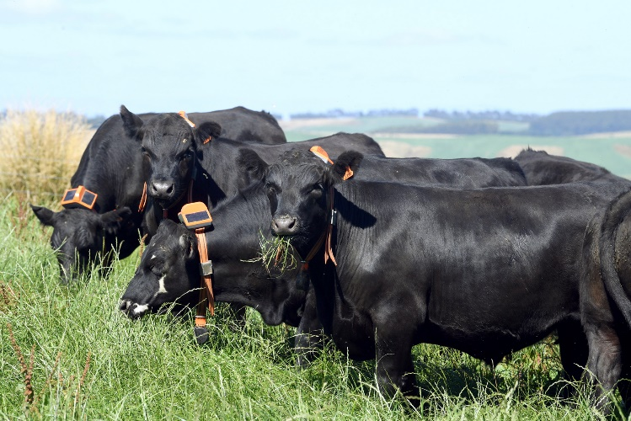
Case study
Accelerating commercialisation and innovation through smart technology
With a focus on developing smart technology to benefit the beef and dairy industries, agriculture and farming technology start-up Agersens sought funding through the Australian Government’s Accelerating Commercialisation grant program, designed to support businesses in developing new products and taking them to market.
The Accelerating Commercialisation service forms part of the Entrepreneurs’ Programme, which transforms Australian businesses with advice and grants. It aims to strengthen, grow, innovate and commercialise businesses nationally and globally.
In partnership with the CSIRO, Agersens developed the revolutionary eShepherdTM, a solar powered, wearable collar device that trains livestock to recognise, and stay within, virtual boundaries. Agersens has since been acquired by the New Zealand-based Gallagher Group, who recognised their pioneering virtual fencing technology.

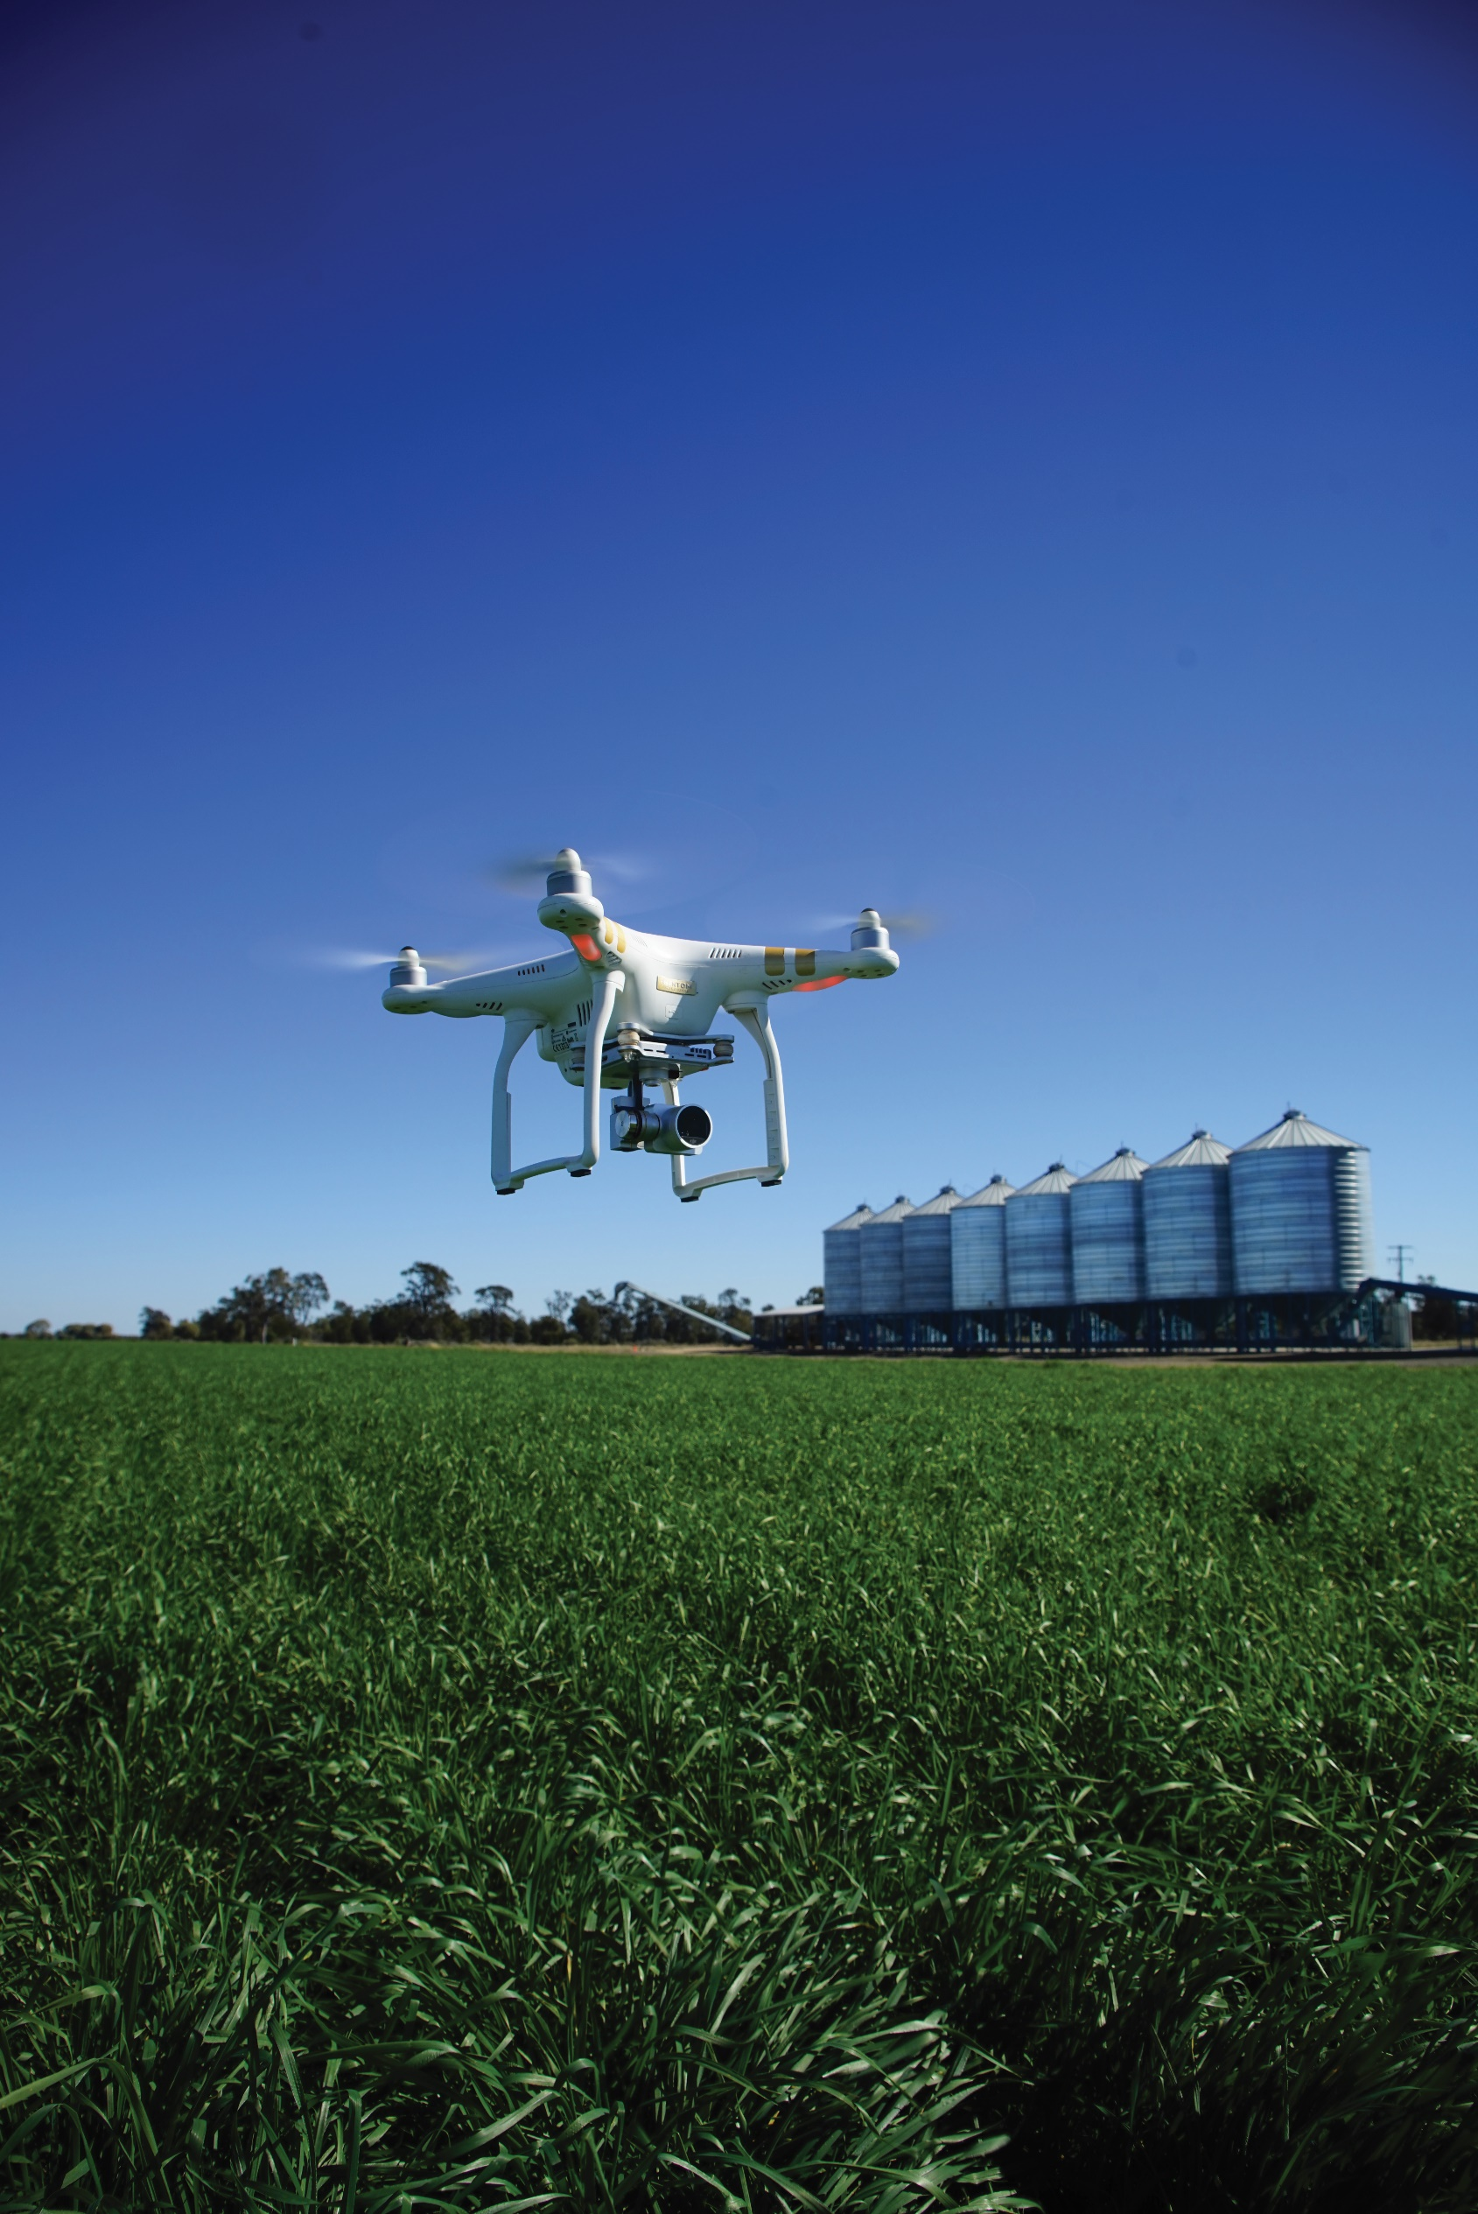
Photo attribution: Ben White

Key initiatives uplifting the agriculture industry
Digital Officers in the Innovation Hubs is a new funding for digital officers to be placed in each Innovation Hub will help to farmers understand the value of digital technologies and data to their businesses and other businesses along the supply chain. By facilitating the connection between the National Centre and the Innovation Hubs, these officers will also help roll-out extension activities such as seminars and workshops to demonstrate and share first-hand the benefits of these technologies.
Producer Technology Uptake Program is led by AgriFutures. This pilot program aims to deliver practical, on-ground technology adoption to farmers. The program is currently delivered in partnership with existing producer networks such as farming systems groups, and targets ‘early majority’ technology adopters.
Busting Congestion for Agricultural Exporters is the Australian Government’s $328 million package that will support agricultural exporters to get products to market faster, by reducing regulatory burden and transforming Australia’s agricultural export system into a modern digital trading platform. This will also support the government’s Simplified Trade System, which has a vision to simplify international trade regulations, modernise outdated ICT systems and strengthen Australia’s economic resilience.
In addition, the government has committed an additional $127.4 million in the Digital Services to Take Farmers to Market measure to continue the digital transformation of our agricultural export systems. These changes will streamline export regulatory services for agricultural goods – to navigate trade processes to make sure they can access premium export markets quicker and with less government charges.
Agricultural traceability investments worth $68.4 million will build on the already strong traceability frameworks in place, especially around food safety, provenance and biosecurity. An additional $20.1 million investment will also help support on-farm biosecurity traceability. This will drive consistent, streamlined and harmonised traceability data and regulatory technology to reduce compliance burdens and support producers to capitalise on shifts in the market.

05

Connectivity and infrastructure
Help agricultural businesses understand their connectivity options and access the infrastructure they need

Our aspiration
To enable stakeholders across agriculture to innovate and implement technologies, Australia’s agricultural innovation system needs to have the right connectivity infrastructure in place.
Australia is a large continent with diverse topography and geography. This presents a number of opportunities, but also means connectivity levels can vary within and across farms. While the COVID-19 pandemic has accelerated the uptake and use of digital technologies, it has also highlighted the existing challenges and barriers.
Adopting internet-enabled digital technologies could have a $15.6 billion impact across the agriculture sector. It is estimated that by 2029–30, the additional economic benefit from broadband-supported technology alone could be between $3 billion and $10.6 billion per year. The technologies likely to make the greatest impact are related to decision support, monitoring and automation (nbn 2021).
Digital technologies have the potential to transform the Australian agriculture industry. It needs to be easier for farmers to find and understand how to choose, implement and effectively use the connectivity method best suited to their needs.
In recognition of this opportunity, the Australian Government has worked with NBN Co and retailers to improve rural coverage, including through improvements to SkyMuster and other National Broadband Network (nbn) delivery services. There are also a range of additional measures currently in place, or in development, to continue to improve regional connectivity and educate end-users about options available to them.
Strategic actions
Build understanding of the types of connectivity and infrastructure that will deliver agricultural solutions
Invest in
telecommunications
Foster partnerships that deliver multiple solutions, understanding that no one solution will be fit for purpose
Develop technology partnerships that deliver regionally-based solutions
Utilise the skills of those across agriculture, not just in telecommunications, to deliver digital connectivity

Making progress
The Australian Government is committed to improving the capacity and range of connectivity infrastructure, including public, private and mixed investment solutions. The government is also committed to improving awareness among agricultural businesses of the availability of existing telecommunications technology solutions, including solutions to extend connectivity across entire properties.
The National Centre for Digital Agriculture and Digital Officers is a $30 million investment by the Australian Government to strengthen stakeholder’s confidence in understanding and accessing connectivity solutions for their business. One known barrier to digital agriculture uptake is access to and understanding of connectivity options, which this investment seeks to address.
The 5G Innovation Initiative provides $40 million in competitive grants to help Australian businesses test and develop 5G technologies in key industries, including agriculture. One of these grants has supported multiple 5G high-quality video streams to count sheep at a regional livestock exchange, automating the process and removing human error.
The Emerging Aviation Technologies Partnerships Program is part of the Australian Government’s Digital Economy Strategy. This program is providing funding of $32.6 million to support strategic partnerships with industry, using emerging aviation technology – such as drones, to address community needs, particularly in regional Australia.
The Australian Broadband Advisory Council has been established to provide advice on ways to maximise the benefits of high speed networks in key sectors of the economy. The Council has delivered a report that considered how connectivity and digital services technology can enhance productivity and support opportunities for growth across the agriculture sector. The main finding of the report is that apart from the broad mobile coverage and NBN fixed and wireless networks, there are localised connectivity gaps on, across and between farms in regional, rural and remote Australia.
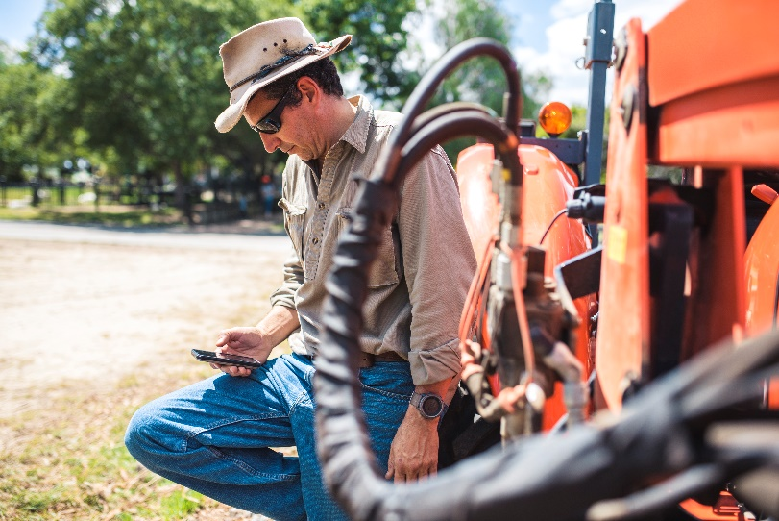
Case study
Improving regional connectivity with CRISP Wireless
CRISP Wireless is a fixed wireless provider based in Narrogin, Western Australia, that currently provides around 27,000 square kilometres of fixed wireless coverage to communities and businesses in mining and agricultural areas of regional Western Australia.
The business was one of the successful applicants through the Australian Government’s Regional Connectivity Program. Its proposal was to deploy a fixed wireless broadband network, comprising 28 repeater stations, across the Central Western Australian Wheatbelt region, connecting into the existing CRISP Wireless network in the northeast of the region.

A survey conducted by the National Farmers’ Federation found that
57%
of respondents felt there was a lack of information to allow consumers to identify, choose and use the best connectivity options for their personal circumstance
(National Farmers Federation 2021).

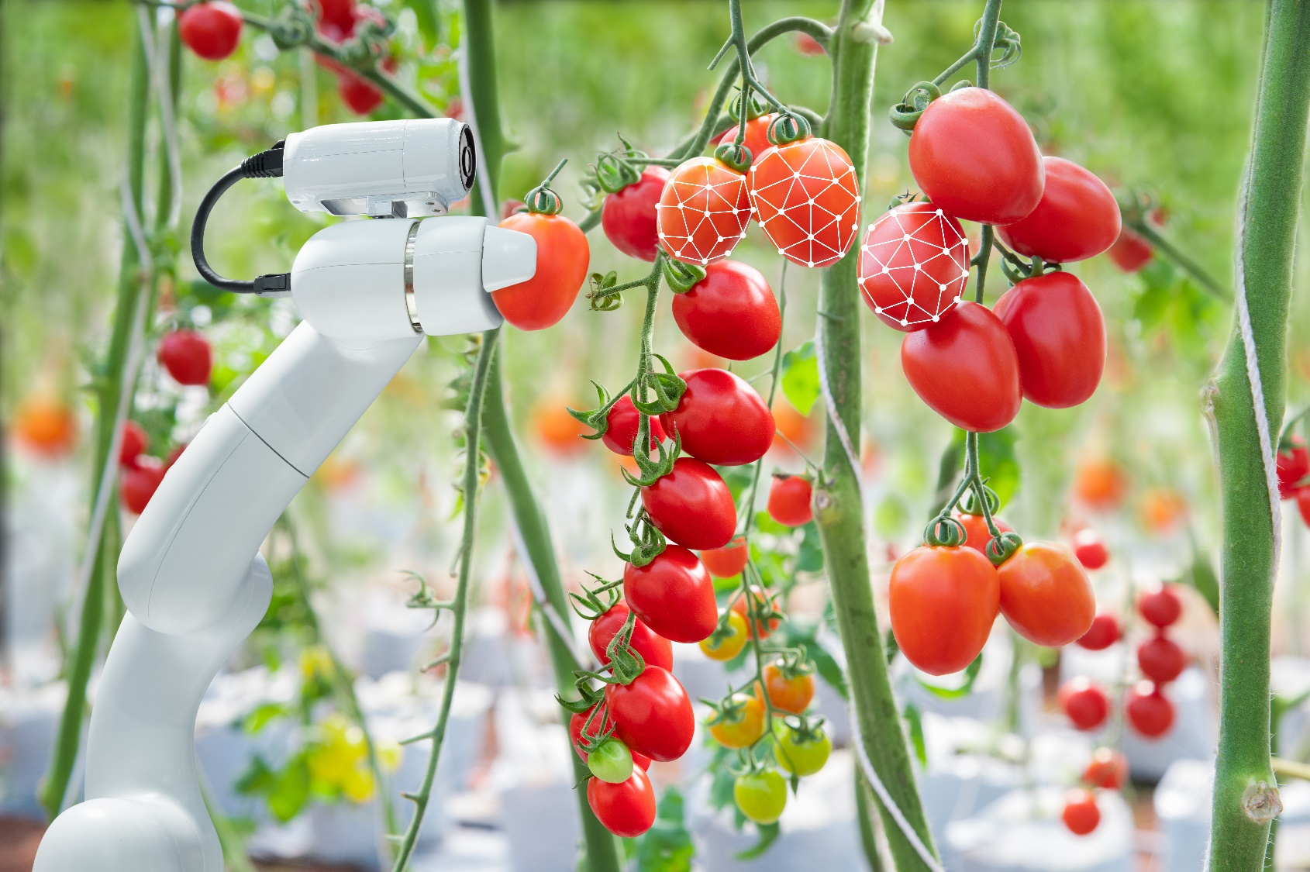

Key initiatives uplifting the agriculture industry
The Connecting Regional Australia initiative is a $811.8 million multi-purpose investment to expand mobile coverage, target specific and localised needs, enhance resilience, trial emerging technologies, boost Indigenous connectivity and foster affordability, as well as improve community digital awareness. CRA is a key component of the Australian Government‘s response to the 2021 Regional Telecommunications Review. CRA builds on the $380 million Mobile Black Spot Program which is addressing mobile black spots across regional and remote Australia and the $230 million Regional Connectivity Program providing place-based digital solutions.
The Australian Government is providing a $480 million grant towards an upgrade of the NBN fixed wireless network by the end of 2024, with flow-on benefits for Sky Muster users.
Regional Connectivity Program funds ‘place-based’ telecommunications infrastructure projects to improve digital connectivity across regional, rural and remote Australia. Under Round 1 of the program, $117.9 million has been allocated to address local digital priorities in 132 regional areas.
Strengthening Telecommunications against Natural Disasters is a $37.1 million Australian Government investment to improve the resilience of Australia’s telecommunications networks in bushfire and natural disaster-prone areas. This includes funding for the hardening of mobile networks.
Regional Tech Hub assists people who live and work in regional, rural and remote parts of Australia to realise the benefits of being digitally connected. The Australian Government selected the National Farmers’ Federation to establish the Hub. The Government is providing an additional $5 million to expand and continue the Regional Tech Hub to support better consumer awareness. This is a further part of the Government’s in response to the 2021 Regional Telecommunications Review.

Monitoring and evaluating our success

Successful execution of this strategy will not only see the adoption of digital agriculture solutions by end-users across the agriculture industry. It will enable the creation of new services and markets, new job opportunities, supply chain efficiencies and greater sustainability.
Widespread adoption of agritech will see farmers doing more with less through data-driven decisions and technologies that optimise farming, and will cement Australia’s position as a trusted exporter of premium food and agricultural products.
Ultimately, delivering on our digital agriculture innovation priority will help us create a world class agricultural innovation system and meet the industry’s target of becoming a $100 billion sector by 2030.
Regular monitoring and evaluation will therefore be key to our success across the five foundational focus areas, and to achieving our digital agriculture innovation priority.

In line with the National Agricultural Innovation Policy Statement, the monitoring and evaluation of these foundational focus areas will be centred on:


An innovation baseline that measures the innovation system’s current performance

Key outputs that measure efforts
to improve innovation

Innovation outcomes that measure the overall innovation system impact

Work is currently underway to develop these measurement tools.
To establish a robust baseline for the monitoring and evaluation of the National Agricultural Innovation Agenda, the government is investing $2.7 million over a four-year period, beginning in 2021–22. This will play an important role in demonstrating success and identifying areas for improvement as the sector digitises further.
The National Data Centre and new digital officers being placed in the Innovation Hubs will contribute to positive change across the agricultural innovation system, by playing a pivotal role in driving cohesive uplift and adoption of digital agriculture. These initiatives will be embedded in regional Australia to ensure they are firmly connected to and responding to the needs of farmers. This will provide valuable the ground intel to inform the monitoring and evaluation of success of the National Agricultural Innovation Agenda, including this strategy.
This work is also closely connected to the Digital Economy Strategy and Commonwealth Biosecurity 2030 roadmap work already under way across government. It will ensure activities are cohesive and aligned to address government priority areas.

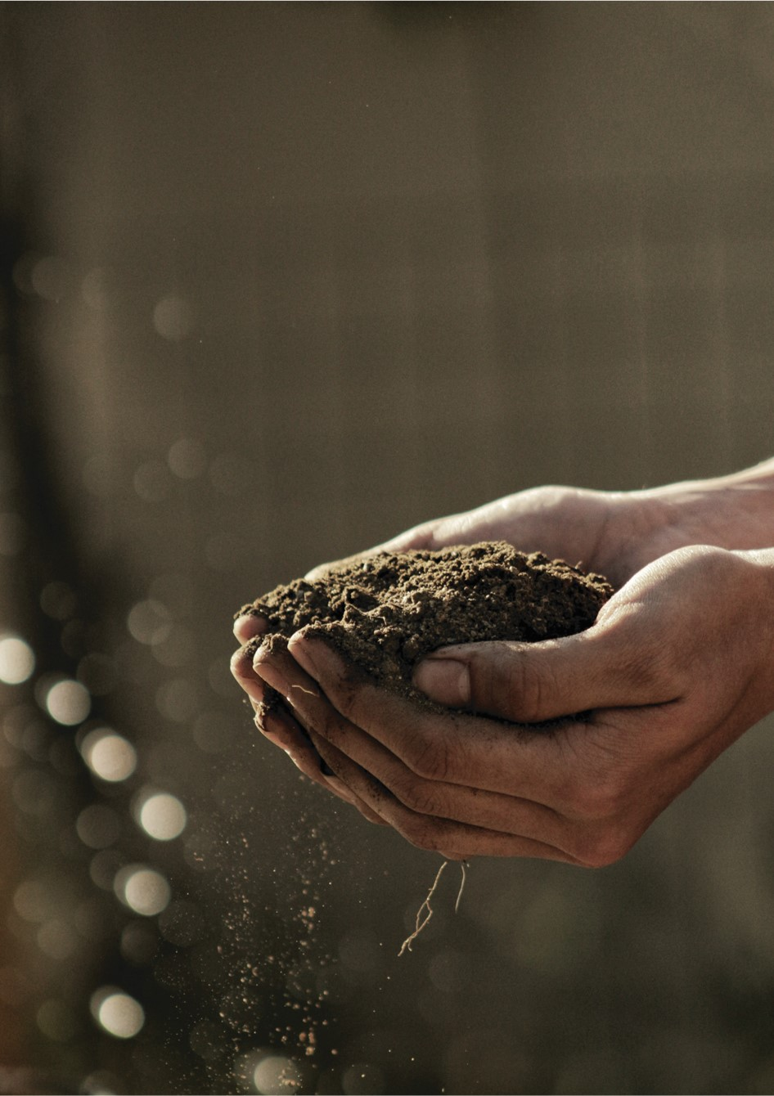

Glossary

Agribusiness A business that operates in the agriculture, fisheries and forestry industry; includes farmers, producers and growers as well as other actors across the supply chain, such as abattoirs and input service providers.
Agriculture The science or practice of farming, including cultivation of soil for the growing of crops and the rearing of animals to provide products such as finished food, wool and beef. Consistent with the National Agriculture Innovation Policy Statement – a national approach to grow Australia’s future – we also include the fisheries and forestry industries within the broad definition of agriculture. Professional farming rather than hobby or recreational activities.
Agriculture sector Agriculture, fisheries and forestry industry. Professional farming rather than hobby or recreational activities.
Agritech Also known as ‘agtech’, agritech is a collection of technologies, including digital, that provide the agriculture, fisheries and forestry industry with tools, data and knowledge. Agritech enables more informed and timely on-farm decisions to improve productivity and sustainability. Biotechnology and gene technology are related fields but are not captured in this definition for the purpose of this report.
Biosecurity Managing risks to Australia’s economy, environment and community of pests and diseases entering, emerging, establishing or spreading in Australia.
Digital agriculture The leveraging of on-farm technologies to enable growers, producers and the broader supply chain to make faster, more informed decisions, automate processes and predict future events. Digital agriculture also includes the infrastructure and connectivity required by these technologies.
Digital economy The global network of economic and social activities that are enabled by platforms such as the internet, mobile and sensor networks.
Digitally enabled When an ecosystem, and people within it, have the education, connectivity and infrastructure required to facilitate digital ways of working.
Digital literacy The ability to acquire and maintain a basic awareness and knowledge of current and emerging digital technologies and use those technologies.
IoT The Internet of Things refers to an ecosystem in which applications and services are driven by data collected from devices that sense and interface with the physical world. In the Internet of Things, devices and objects have communication connectivity, either a direct connection to the internet or mediated through local or area networks.

Glossary

Interoperability The ability of digital applications to exchange data and make use of that information.
Infrastructure Facilities, services and installations that support society, such as water, power, transport and communication systems.
Innovation Doing new things and doing existing things in new ways. It involves generating, diffusing and applying knowledge.
Policy A statement of intent adopted and pursued by a government
Productivity The quantity of output produced with a given quantity of inputs. The ABARES preferred measure of productivity is total factor productivity(TFP), capturing all outputs and inputs used in production.
RDCs Rural Research and Development Corporations have helped drive agricultural innovation since 1989. They allow Australian governments and primary producers to co-invest in R&D to benefit industry and regional communities. Currently, there are 15 RDCs that are funded through R&D grower levy payments and Commonwealth Government funding arrangements.
Regulation A governing direction or law
Space technology Space-based technologies and applications such as satellites, Earth observation data and analytics, communications and tracking, robotics, remote operations and resource utilisation, and technologies that support space life sciences.
Sustainability The capacity for development that can be sustained into the future, within the capacity of the natural resource base.
Supply chain A network between a company and its suppliers to produce and distribute a product.
Technology Methods for using scientific discoveries for practical purposes, especially in industry.
Value chain The entire set of production steps required to create, distribute and consume a product.



Bibliography

AgFunder 2021, AgFunder Farm Tech Investment Report, Upstream AG Insights.
AgThentic 2021, Agritech: Australia’s next big export opportunity.
Australian Farm Institute 2017, Accelerating precision agriculture to decision agriculture - analysis of the economic benefit and strategies for delivery of digital agriculture in Australia, Sydney, November.
CSIRO Data61 2018, Digital Innovation: Australia’s 315B Opportunity, alphaBeta strategy x economics, September.
KPMG and Skills Impact 2019, Agricultural workforce digital capability framework, Faethm and The University of Queensland, May.
National Farmers Federation and nbn co limited 2021, Connecting Australian Agriculture, November.
nbn co limited 2021, Connecting Australia’s agricultural landscape, December.
Perrett, E., Heath, R., Laurie, A. and Darragh, L. (2017), Accelerating precision agriculture to decision agriculture – analysis of the economic benefit and strategies for delivery of digital agriculture in Australia, Australian Farm Institute and Cotton Research and Development Corporation.
World Bank Group 2021, What’s Cooking: Digital Transformation of the Agrifood System, Agriculture and Food Series, March.

