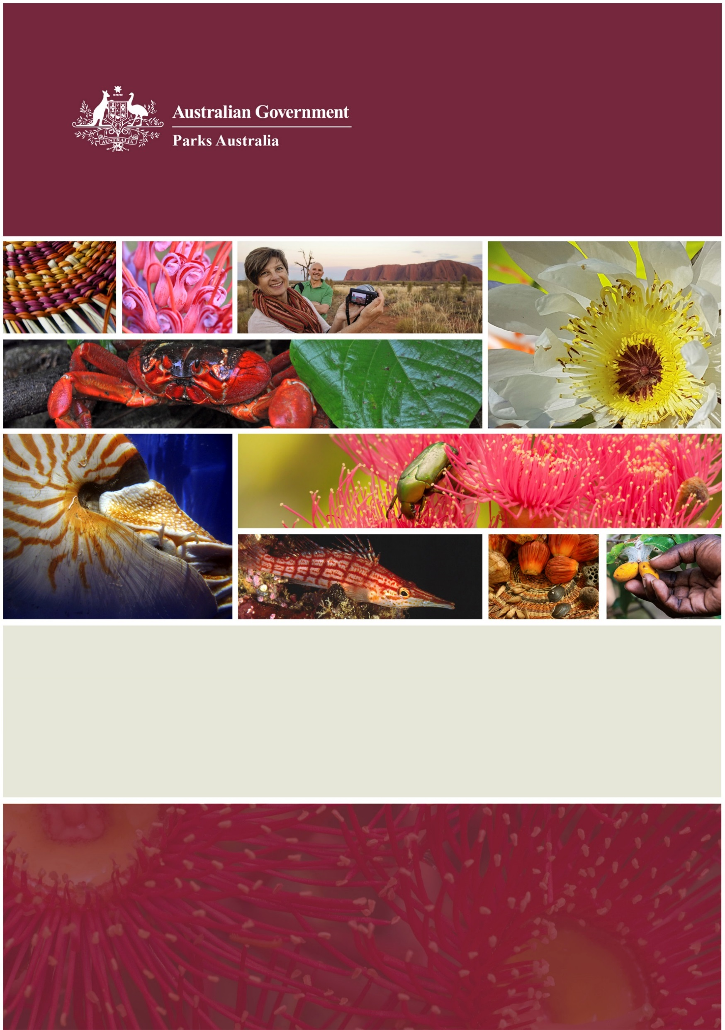

**Director of National Parks**

Corporate Plan 2017-2021

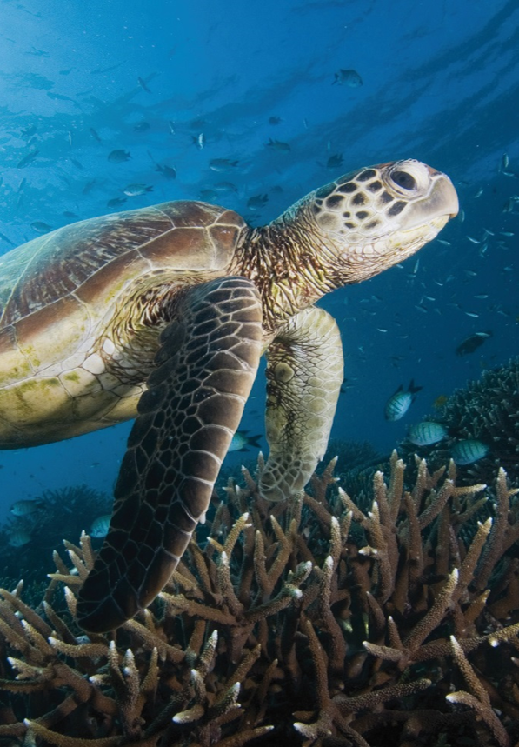



## Statement of Preparation

I, Gillian Sally Barnes, as the accountable authority of the Director of National Parks, present the Director of National Parks Corporate Plan 2017-2021, which covers the reporting periods of 2017-2018 to 2020-21, as required under paragraph 35(1)(b) of the *Public Governance, Performance and Accountability Act 2013*. The plan is prepared in accordance with the *Public Governance, Performance and Accountability Rule 2014*.



Sally Barnes

Director of National Parks

28 August 2017

**The Director of National Parks’ statutory functions**

The Director of National Parks is a Corporate Commonwealth Entity, operating under the *Environment Protection and Biodiversity Conservation Act 1999* (EPBC Act). The Director is responsible for the administration of Divisions 4 and 5 of Part 15 of the EPBC Act (Commonwealth reserves and conservation zones) and regulations made for the purposes of those divisions.

The functions of the Director, as set out in subsection 514B(1) of the EPBC Act, are to:

* administer, manage and control Commonwealth reserves and conservation zones
* protect, conserve and manage biodiversity and heritage in Commonwealth reserves and conservation zones
* contribute to the protection, conservation and management of biodiversity and heritage in areas outside Commonwealth reserves and conservation zones
* cooperate with any country in matters relating to the establishment and management of national parks and nature reserves in that country
* provide, and assist in the provision of, training in knowledge and skills relevant to the establishment and management of national parks and nature reserves
* carry out alone, or in cooperation with other institutions and persons, and arrange for any other institution or person to carry out research and investigations relevant to the establishment and management of Commonwealth reserves
* make recommendations to the Minister in relation to the establishment and management of Commonwealth reserves
* administer the Australian National Parks Fund
* undertake any other functions conferred on the Director under the EPBC Act or any other Act
* do anything incidental or conducive to the performance of any of the functions mentioned above.

As at 1 July 2017, the Director was responsible for seven Commonwealth terrestrial reserves (six national parks and one botanic garden) and 59 Australian marine parks, established under the   
EPBC Act.

The terrestrial reserves and 58 of the 59 marine reserves are managed by Parks Australia, a division of the Department of the Environment and Energy.

Under delegation from the Director, the department’s Australian Antarctic Division manages the Heard Island and McDonald Islands Marine Reserve.

In addition to statutory functions under the EPBC Act, the Director of National Parks also has a range of obligations under the leases for Kakadu, Booderee and Uluru-Kata Tjuta National Parks.

The Director of National Parks engages with the Department of Environment and Energy on policy direction, heritage management and species conservation, and directly contributes to the Department’s environmental information and research outcomes through biodiversity science programs that support the discovery and classification of Australia’s biota, fund taxonomy research and capability building, collate and manage fundamental national biodiversity information, and make it openly and publicly available.

**Parks Australia’s places and services**

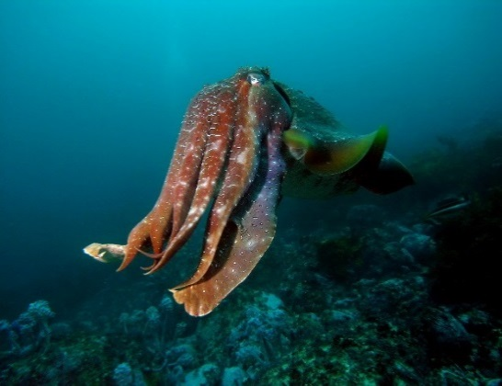Australia’s natural and cultural heritage is unique. Our natural landscape is distinctive and diverse, home to plants and animals found nowhere else in the world and the oldest living cultures on earth. It’s no wonder our land and sea are an essential part of our national identity–and visitors travel from across the country and the world to experience their beauty, inspiration and wonder.

The Director of National Parks is the statutory agency responsible for the Australian Government’s terrestrial and marine protected area estates. The Director is assisted by staff within Parks Australia, a division of the Department of the Environment and Energy.

We manage six national parks and 58 marine parks–a rich and fascinating range of ecosystems and communities, from spectacular oceanic islands and the tropical wonderland of Kakadu, to the coastal habitats of Booderee and the spinifex sand plains of arid Uluru-Kata Tjuta. Three of our national parks are leased by their Aboriginal owners to the Director of National Parks to be jointly managed by their traditional owners and Parks Australia.

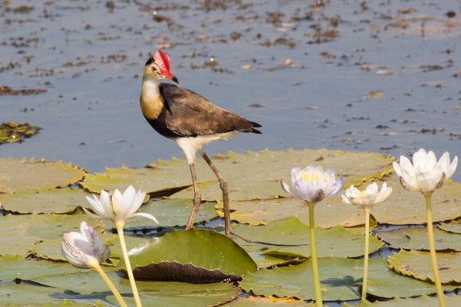Australia has one of largest networks of marine parks in the world, most of which is managed by Parks Australia. Marine parks protect the vast range of life in our oceans–from astonishing coral reefs in our tropical seas to deep ocean canyons and undersea mountains in temperate marine regions.

Australia’s National Botanic Gardens is the nation’s largest living collection of Australian native plants. It’s a tranquil setting for walking and spending time with family and friends, and a living classroom for visitors of all ages. The Gardens plays a significant role in the conservation and propagation of rare and threatened plants.

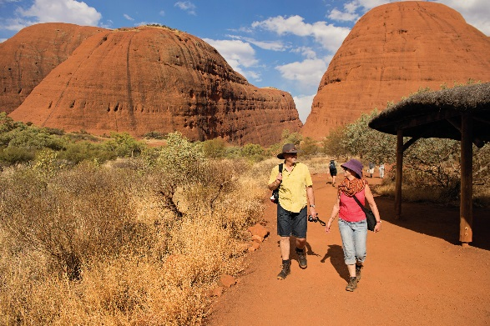Our biodiversity science programs including the Australian Biological Resources Study, Centre for Australian National Biodiversity Research (in partnership with CSIRO), and National Seed Bank work in partnerships to support and deliver research, manage physical and digital science and conservation collections, and collate, manage and make available fundamental national biodiversity data and information for use by the nation through the application of innovative technologies. For example, we collaborate on initiatives such as the Australian National Herbarium, Bush Blitz species discovery program, Australian Seed Bank Partnership, eFlora of Australasia, the National Species List and Australia’s Virtual Herbarium to ensure research knowledge is shared with others.

We want to showcase these natural wonders to the world, demonstrating to all why these places and Australia’s biota are so special and inspiring them to become more invested in their care and future.

**Figure 1: Location of Commonwealth parks and reserves**

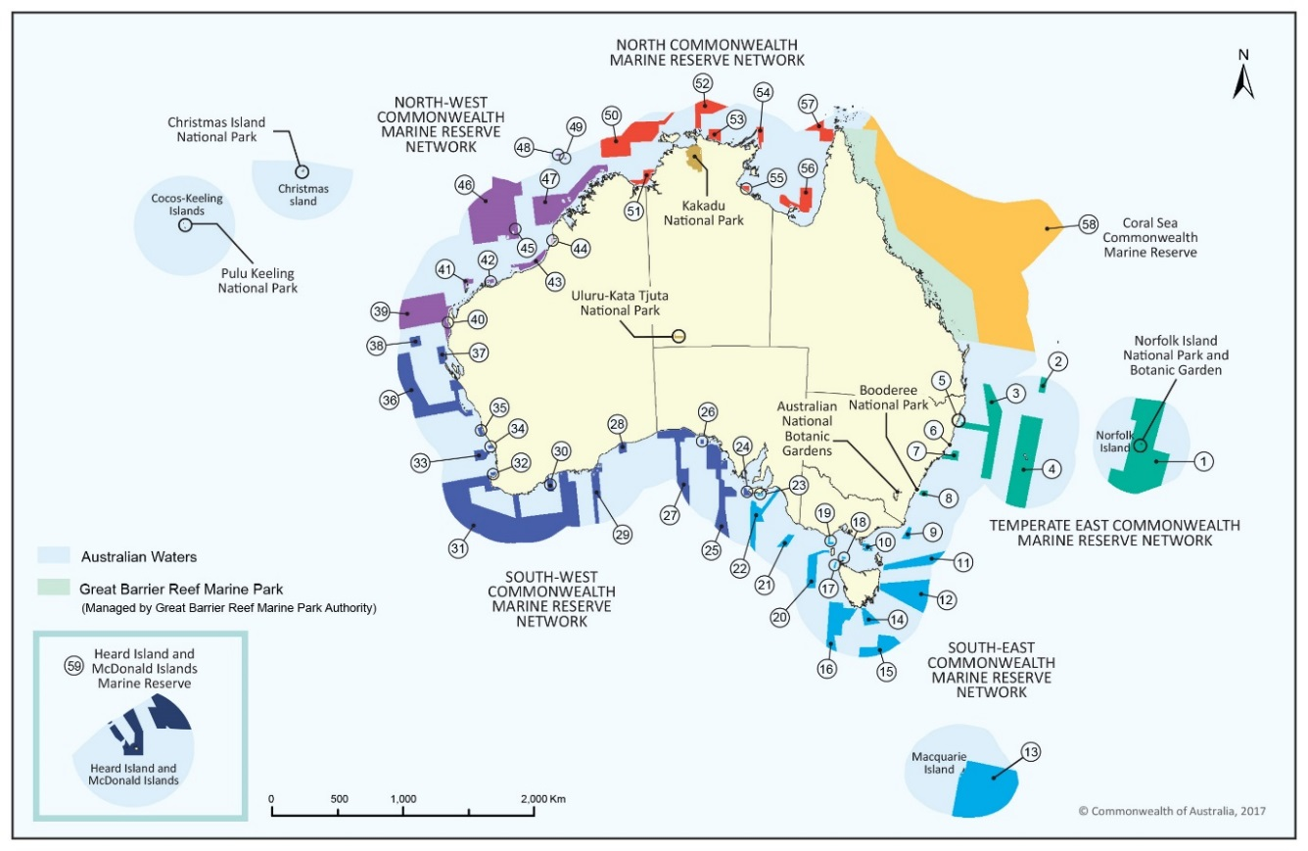

**Key to the location of Commonwealth Marine Reserves**

|  |  |  |  |  |  |  |  |
| --- | --- | --- | --- | --- | --- | --- | --- |
| Reserve Name | Map Label |  | Reserve Name | Map Label |  | Reserve Name | Map Label |
| **Temperate East Commonwealth Marine Reserve Network** | |  | **South-west Commonwealth Marine Reserve Network** | |  | Kimberley | 47 |
| Argo-Rowley Terrace | 46 |
| Norfolk | 1 |  | Western Kangaroo Island | 24 |  | Kimberley | 47 |
| Gifford | 2 |  | Western Eyre | 25 |  | Ashmore Reef | 48 |
| Central Eastern | 3 |  | Murat | 26 |  | Cartier Island | 49 |
| Lord Howe | 4 |  | Great Australian Bight | 27 |  | **North Commonwealth Marine Reserve Network** | |
| Solitary Islands | 5 |  | Twilight | 28 |  |
| Cod Grounds | 6 |  | Eastern Recherche | 29 |  | Joseph Bonaparte Gulf | 50 |
| Hunter | 7 |  | Bremer | 30 |  | Oceanic Shoals | 51 |
| Jervis | 8 |  | South-west Corner | 31 |  | Arafura | 52 |
| **South-east Commonwealth Marine Reserve Network** | |  | Two Rocks | 32 |  | Limmen | 53 |
|  | Geographe | 33 |  | Arnhem | 54 |
| East Gippsland | 9 |  | Perth Canyon | 34 |  | West Cape York | 55 |
| Beagle | 10 |  | Jurien | 35 |  | Gulf of Carpentaria | 56 |
| Flinders | 11 |  | Abrolhos | 36 |  | Wessel | 57 |
| Freycinet | 12 |  | Shark Bay | 37 |  | **Coral Sea Commonwealth Marine Reserve** | 58 |
| Macquarie Island | 13 |  | Carnarvon Canyon | 38 |  |
| Huon | 14 |  | **North-west Commonwealth Marine Reserve Network** | |  | **Heard Island and McDonald Islands Commonwealth Marine Reserve** | 59 |
| South Tasman Rise | 15 |  |  |
| Tasman Fracture | 16 |  | Gascoyne | 39 |  |
| Zeehan | 17 |  | Ningaloo | 40 |  |
| Boags | 18 |  | Montebello | 41 |  |  |  |
| Apollo | 19 |  | Dampier | 42 |  |  |  |
| Franklin | 20 |  | Eighty Mile Beach | 43 |  |  |  |
| Nelson | 21 |  | Roebuck | 44 |  |
| Murray | 22 |  | Mermaid Reef | 45 |  |  |  |
| Southern Kangaroo Island | 23 |  | Argo-Rowley Terrace | 46 |  |

**Parks Australia’s goals and objectives**

Our three goals represent Parks Australia’s long term objectives (Table 1) and the logic for planning and reporting across the agency, from the corporate level to individual performance and development agreements for our staff. The four ‘ways of working’ are the ways we achieve our goals. The diversity of our places and partners means that outcomes may be delivered in different ways, in different places.

**Table 1: Our goals and objectives**

|  |  |  |  |  |  |  |
| --- | --- | --- | --- | --- | --- | --- |
| Vision | Outstanding natural places that enhance Australia’s well-being | | | | | |
|  | | | | | | |
| Goals | **Resilient places and ecosystems** | | **Multiple benefits to traditional owners and local communities** | | **Amazing destinations** | |
| Objectives | To protect and conserve the natural and cultural values of Commonwealth reserves. | | To support the aspirations of traditional owners and local communities in managing land and sea country. | | To offer world class natural and cultural experiences, enhancing Australia’s visitor economy. | |
|  | | | | | | |
| Ways of working | **Evidence based management** | **Ecologically sustainable use** | | **Partnerships and co-investments** | | **Responsive organisation:** |
| Science, research and traditional knowledge are used to make management decisions. | Parks Australia acts to enhance Australia’s social and economic well-being through ecologically sustainable use of our places, including through awareness of our own environmental footprint. | | Partnerships and working together with our stakeholders to support delivery of innovative programmes that achieve our goals. | | Parks Australia is an efficient and effective agency with a proud and motivated workforce, supported by efficient business systems. |

**Parks Australia’s operating environment**

Our operating environment is influenced by a range of factors, both internal and external to Parks Australia.

**External factors**

The 2016 Australian State of the Environment report highlighted the continued pressures on Australia’s biodiversity, particularly on terrestrial species, and the importance of protected areas in managing those pressures. More than 1,700 species and ecological communities are known to be threatened or at risk of extinction, while it has been estimated that up to 75% of Australia’s plants and animals have not yet been described by science. Pressures on terrestrial biodiversity–for example invasive species, inappropriate fire regimes and disease–will shape our priorities, decisions and activities beyond the life of this plan.

In the marine environment, significant management challenges exist such as pollution, marine debris and illegal unreported and unregulated fishing but most species are in good condition and the trajectories of many rare species are improving. Key threatening processes such as marine invasive species and algal blooms are stable. Marine parks are one of the most effective methods of conserving marine life and livelihoods of those who rely on the sea and this year we will take steps to begin active management of 44 new marine parks around the country.

**Family, clan and community obligations to keep land and sea healthy**

Aboriginal people have looked after land and sea country for tens of thousands of years. Parks Australia understands that the traditional owners of the land and sea we manage together have significant cultural and spiritual responsibilities to keep plants, animals and ecosystems healthy.   
All of our work must respect and complement these obligations.

Our efforts to protect the natural and cultural values of our parks must be undertaken in collaboration with traditional owners. We must work side by side in designing and implementing programs and activities. We can also assist elders and community members to enhance social and economic well-being by ensuring these issues are addressed in the way we work.

**Climate Change**

Climate change poses threats to both our terrestrial and marine environment and adopting a long term view to mitigation and adaptation will be an important consideration for Parks Australia throughout the life of this plan. Climate change continues to affect all landscapes including protected areas. A changing climate is exacerbating existing threats and introducing new challenges for managing species, ecosystems, infrastructure and visitors. We know that change is happening and will increase: saltwater intrusion, erosive processes through increased rainfall, coral bleaching events, incursion of novel invasive species and disease vectors, extreme weather and fire risk.   
All of these also have implications for visitor safety, visitor satisfaction and park revenue.

As local effects become better known, we need to understand the likely direction of change to prepare, adapt and build effective responses. Given the uncertainties of climate change predictions, improving our understanding is an on-going effort relying on the best available science and best practice park management around the world.

**Connections and partnerships**

Many people interested in protected area management have technical knowledge, skills and experiences that can help us deliver world class reserves. Community engagement, including citizen science and volunteerism are ways that the immense goodwill and enthusiasm for Australia’s protected areas can contribute to their health and good management. We will continue to build on our strong relationships with research organisations, including our partnership with CSIRO in the Centre for Australian National Biodiversity Research, through the National Environmental Science Program and the National Marine Science Committee and with our tourism partners such as Tourism Australia.

Our partnerships with the Maritime Border Command, the Australian Fisheries Management Authority and State and Territory partners will contribute to a whole of government approach to surveillance and enforcement in marine parks. Working with the Great Barrier Reef Marine Park Authority will provide consistency of management approaches and visitor experiences and ensure conservation outcomes beyond the boundaries of the Coral Sea Commonwealth Marine Reserve.

We are only beginning to understand the importance of natural places for people’s health and wellbeing, and to prioritise that connection in the way we manage places. The social, economic and natural values of Australia’s special places for visitors, local communities and the nation must be the foundation of our work.

Innovative partnerships across sectors and under different governance and financial models are emerging. We face a competitive environment for partnerships, with many organisations pursuing alternative funding options to deliver their business.

**Accountability**

The expectations of local, national and global communities continue to evolve, with ever higher scrutiny. Investment of public funds in our reserves must be accountable, with improved quality of planning and performance evaluation that provides meaningful information for stakeholders.

Best-practice protected area management is continually updated by international bodies such as the United Nations Educational Scientific and Cultural Organisation (UNESCO), the International Union for the Conservation of Nature (IUCN), the Convention on Biological Diversity, and other multilateral environment agreements. Parks Australia engages in this global conversation to respond flexibly to new ways of working. Rapid technological development provides many opportunities for transformation in the way we work, and has raised visitor expectations for our service delivery.

**Government priorities – innovation and regulatory maturity**

The Government is committed to making it easier for individuals to access government services through digital platforms. Parks Australia is working to deliver services in a simpler way online.   
We will continue to expand our Wi-Fi access, improve the usability of our online services and social media to better engage our visitors.

As a regulator, Parks Australia is committed to improving regulatory maturity, in particular with a customer focused approach to administering park management plans and legislation so that visitors can access and enjoy protected areas with minimum fuss and impact.

By simplifying our application processes with clear and logical guidance and complementing our regulatory partners, such as the Australian Fisheries Management Authority and the National Offshore Petroleum Safety and Environmental Management Authority, Parks Australia is committed to improving efficiencies and reducing regulatory burden, allowing cooperative arrangements with communities, users and business/industry sectors.

With a significant footprint in the economy of communities in Kakadu and Uluru-Kata Tjuta National Parks, Parks Australia is contributing to the Government’s strategy to develop Northern Australia. The township of Jabiru is part of the future of the Kakadu region, a future that will move into a new phase, with potential new opportunities following the closure of the Ranger uranium mine in 2021. Parks Australia will continue to work with all stakeholders, including the Northern Territory government, the tourism industry, Energy Resources of Australia, Traditional Owners and relevant Australian Government agencies towards a transition that stimulates public and private tourism investment.

**Our visitors**

What motivates visitors to travel to our parks? How do they want to spend their time? Visitation trends are sensitive to changing demographics and the global economy. The emerging Asian middle class and the increasing scarcity of natural places in urban landscapes will change the nature of our tourist base. This will influence the planning and design of our infrastructure and development of new visitor experiences. In particular, park visitors are more connected to technology, social media and on-line information than ever before. We need to continue to work collaboratively with our tourism partners, including licensed tour operators, who bring a significant number of people to our places.

**Internal factors**

**Marine Park Management**

In 2017-18, Parks Australia will take steps to transition to active management of one of the largest networks of marine parks in the world. This will coincide with a large program of discovery to improve our understanding of the species, communities and habitats in our reserves and how best to manage them. Innovative solutions for marine management will be required to enable remote management of large areas of ocean and to engage marine users and local communities through citizen science programs.

**Science Informing Park Management**

We manage a changing environment, face new challenges across all of the many ecosystems in our reserves and work with many partners, stakeholders and local communities. Priority will increasingly be given to research and monitoring projects that directly inform management of the natural, cultural, social and economic values of our reserves. We need to address significant knowledge gaps and to respond appropriately and adapt to new circumstances. Citizen science and community involvement will be key considerations in planning our ongoing science program.

Our Information and Communication Technology environment must allow for innovation in management and business processes, the reliable storage and ability to rapidly convert data to useful information, and communication between staff and with our visitors. We will plan our Information Technology transformation strategically to enable a different way of doing business.

**Responding to the contemporary aspirations of traditional owners and local communities**

Traditional owners from our jointly managed parks and marine parks, and others in our local communities have provided us with a better understanding of their contemporary aspirations for our ongoing partnerships. This picture of reserve management reflects the aspirations of families, clans and local groups to fulfil their obligations to look after the health of the environment while keeping cultures strong, fostering social cohesion and achieving greater economic benefits.

We must continue to find new ways of working together which promotes the identification of cultural values, the involvement of communities in reserve management and the inclusion of younger people and older people in park work. Programs such as the carbon farming initiative in Kakadu National Park have begun this journey. An increasing emphasis on community involvement and consultation, tourism opportunities, and employment pathways for young people will build on this in 2017-18 and into the future.

**Responding to the changing needs of the organisation**

Our IT environment is changing rapidly. We are developing fit for purpose and easy to use IT systems for both our customers and staff to use in regulatory, licencing and permitting processes. Throughout the life of this plan we will extend these efforts to incorporate other areas of our business to ensure that our IT systems are serving the needs of our varied and often remote workforce and partners.

Parks Australia manages complex projects and contracts in many sectors such as infrastructure development and asset maintenance, large science contracts, extensive natural and cultural value management programs and substantial service delivery arrangements. A Project Management Office will be established in 2017-18 to improve coordination and standardise delivery.

Parks Australia has assessed our financial management systems and the financial literacy of Directors and Managers. We anticipate making changes to how and where we manage large projects, procurements and assets. We think we need to improve specialist skills and support in these areas.

The introduction of a new Performance Development Scheme in 2017-18, will encourage more regular conversations between staff and supervisors and assist Parks Australia develop a clear line of sight from this corporate plan, to operational plans and to individual work programs and performance agreements.

**Parks Australia’s organisational capability and capital asset management directions**

**Our people**

We have a very diverse workforce, across remote and metropolitan centres, with a range of roles from seasonal rangers and scientists to strategic policy planners. We know that our relationships with traditional owners, neighbours, other land managers and scientific, operational and commercial partners will be the key to our success.

We will dedicate effort and resources to improving the well-being of our staff and their families, particularly in remote areas–including improving the standard of housing available to staff. We will implement our staff mobility policy to assist in building a flexible, cohesive and agile workforce.   
We will respond to concerns and ideas of staff raised through regular staff surveys. We will encourage our people to test innovative and creative solutions to some of the pressing problems we face in conservation and land and sea management.

**Our capital assets**

Parks Australia is responsible for a large portfolio of capital assets, including visitor sites, offices, workshops and staff housing. During 2017-18 Parks Australia will respond to recommendations regarding strategic asset management, with a view to the use and future life of existing assets and the alignment of new acquisitions with our goals and priorities.

In addition to improvements in staff housing, Parks Australia is committed to providing refreshed and revitalised tourism and essential park infrastructure.

**Risk Management Framework**

Employees, volunteers and contractors who undertake Parks Australia business often operate in remote areas. We also operate in a dynamic environmental, social and business context and our people manage a diverse and complex array of issues. Additionally, Parks Australia has a responsibility to ensure that risks to visitors are minimised so far as reasonably practicable.   
As such we need to be realistic about what we can deliver and always consider the risks that can be encountered in our unique places. Effective risk management is critical to the achievement of our goals in our ever changing operating environment.

Parks Australia’s Risk Management Framework aims to ensure that we are conscious of risks, make informed decisions in managing those risks, and that we identify and harness potential opportunities when they arise. The Parks Australia Risk Management Framework aligns with the Commonwealth Risk Management Policy and is consistent with the *Australian/New Zealand Standard ISO 31000:2009 Risk management – Principles and guidelines*.

Risk watch lists or risk registers for each reserve or shared-services section are periodically reviewed in accordance with the Risk Management Framework. Risks and incidents in workplaces are reported regularly to the executive board who monitor their effect on the corporate goals and Parks Australia workforce and the effectiveness of mitigation strategies.

## Parks Australia’s strategies

This corporate plan outlines our corporate priorities and strategies against each goal and way of working for the next four years. It has been designed as a rolling four-year plan with detailed strategies and results for the first year and more indicative strategies and results for the subsequent years. The corporate plan forms a critical element of our planning framework and sets the strategic priorities for a range of other planning documents.

|  |  |
| --- | --- |
| Goal: **Resilient places and ecosystems** |  |

|  |  |
| --- | --- |
| **Objective** | To protect and conserve the natural and cultural values of Commonwealth parks |
| **Desired outcome s** | * Living culture and cultural heritage values are identified protected and conserved * The health and integrity of natural values are protected, conserved and where appropriate restored |

|  |  |  |  |
| --- | --- | --- | --- |
|  | **Priority** | **Business owner** | **Way of working** |
| **Corporate priorities  for 2017-18** | Increase our understanding of the values of Commonwealth Parks. | All Branch Heads | Evidence Based Management |
| Build, curate and share knowledge and understanding of Australia’s biodiversity. | Director Biodiversity Science | Evidence Based Management |
| Continue to establish ecological baselines to detect changes within Commonwealth Parks. | All Branch Heads | Evidence Based Management |
| Understand, respect and protect living cultural and cultural heritage values in Commonwealth Parks. | All Branch Heads | Evidence Based Management/ Ecologically Sustainable Use |
| Implement projects to reverse the decline of threatened species and communities and reduce the impact of key threatening processes. | All Branch Heads | Evidence Based Management |
| Develop action plans to monitor and address the impacts of climate change. | Director  Protected Area Policy and Planning | Evidence Based Management |

|  | **Strategy** | **Results** | **Business owner** |
| --- | --- | --- | --- |
| **How we will deliver our corporate priorities in 2017-18** | * Continue to reduce the overall impact of feral animals, weeds and inappropriate fire on natural and cultural values. * Increase our intervention in populations of threatened and significant species where necessary. | * Targeted projects to reduce the impacts of threatening processes on threatened and significant species: * cat control trials begun in Kakadu National Park; * cat eradication program continued on Christmas Island; * yellow crazy ant biocontrol program continued on Christmas Island; * extended early dry season burning program and wet season burning in Kakadu; * tropical fire ants on Ashmore islands managed; * cat and rat control protecting Green Parrot nesting sites on Norfolk Island; and * support the removal of marine debris and ghost nets through partnerships with State and Territory governments. | Relevant park managers |
| **How we will deliver our corporate priorities in 2017-18** | * Continue to reduce the overall impact of feral animals, weeds and fire on natural and cultural values. * Increase our intervention in populations of threatened and significant species where necessary. | * Translocation projects finalised including: * populations of green parrots on Phillip Island in Norfolk National Park; * brush tailed rabbit rats in Kakadu National Park; and * Eastern quolls in Booderee National Park. * Critical monitoring programs undertaken including: * Christmas Island frigate bird survey; * Christmas Island flying fox survey; * Pulu Keeling National Park Island wide survey; * Christmas Island yellow crazy ant survey; * Norfolk Island boobook owl survey; * Seabird survey of Christmas Island National Park; * Mala survey at Uluru-Kata Tjuta National Park; * Great Desert Skink survey at Uluru-Kata Tjuta National Park; * Crocodile survey at Kakadu National Park; * Grey Nurse shark monitoring at the Cod Grounds Commonwealth Marine Park; and * Monitoring the extent of coral bleaching and recovery of affected reefs. | Relevant park managers |
| **How we will deliver our corporate priorities in 2017-18** | * Continue to reduce the overall impact of feral animals, weeds and fire on natural and cultural values. * Increase our intervention in populations of threatened and significant species where necessary. | * Management activities prioritised using the Parks Australia prioritisation tool for critically endangered flora are begun including: * *banksia vincentia* seed orchard established at the Australian National Botanic Gardens and Booderee; * conservation programs on selected plant species in Norfolk Island National Park; and * targeted seed research and seed collections for banking of priority plant species. * The Parks Australia prioritisation tool used to prioritise management activities for endangered animals on Commonwealth terrestrial parks. | Relevant park managers |
| * A consistent approach to planning and implementation of fire programmes across the estate. | * The Parks Australia Fire Management Forum meets; and * Implementation of the Fire Manual prepared and endorsed. | Director Protected Area Policy and Planning |
| * Increase our management of cultural heritage values on jointly managed parks | * Cultural heritage action plans exist that guide the management of cultural heritage on parks: * a Cultural Heritage Strategy for Booderee National Park developed; * plan and implement cultural heritage activities with traditional owners, including through the cultural heritage and scientific consultative committee; and * activities from the Kakadu National Park Cultural Heritage Action Plan Implemented. * Rock art conservation activities undertaken at Uluru-Kata Tjuta National Park and Kakadu National Park. | Relevant park managers |
| **How we will deliver our corporate priorities in 2017-18** | * Manage finalisation and implementation of marine park management plans | * Guidance material, class approvals and determinations developed. * Robust arrangements to design and deliver grants and fisheries adjustments for Australian Marine Parks developed. * Conduct secondary statutory consultations on draft Commonwealth Marine Reserve Management Plans. * Prepare Directors’ reports for Ministerial approval. | Assistant Secretary Marine Protected Areas Branch |
| * Provide guidance, direction and prioritisation for science activities across Parks Australia | * Parks Australia Science Direction Statement available to external science partners to guide and prioritise science activities. * Research and monitoring strategies for Commonwealth marine and terrestrial parks developed. * NRM Science managers forum held. | Assistant Secretary Parks Island and Biodiversity Science Branch  Assistant Secretary Marine Protected Areas Branch |
| * Increase our understanding of the values of Commonwealth parks and other natural places. | * Baseline surveys conducted in priority marine parks. | Assistant Secretary Marine Protected Areas Branch |
| **How we will deliver our corporate priorities in 2017-18** | * Continue to research, document, curate and share scientific knowledge and understanding of Australia’s biodiversity. | * The Australian National Herbarium and National Seed Bank collections developed, curated and used in biodiversity research. * National biodiversity data and digital collections developed, compiled, curated and shared. * Australian National Herbarium Collections Management System replaced, and Australian National Botanic Gardens Living Collections information management systems upgrade completed to ensure collections are managed, used and shared via modern, integrated IT systems. * National Species List developed in partnership with the Atlas of Living Australia. * E-Flora of Australasia launched and adopted as the national platform for Australasia’s flora information. * The Australian National Botanic Gardens Living Collection developed, curated and used in biodiversity and conservation research, and for tourism, education and public enjoyment. * Development of the Commonwealth Marine Parks Science Atlas. | Director Biodiversity Science  Park Manager ANBG  Science Director, Commonwealth Marine Parks |
| * Appropriately address climate change mitigation and adaptation on Commonwealth Parks | * Begin development of action plans to address the impacts of climate change. | Relevant park managers |

|  | **Strategy** | **Results** | **Business owner** |
| --- | --- | --- | --- |
| **How we will deliver our corporate priorities in 2018-21** | * Annual park report cards completed to measure progress towards corporate goals. | * Results of surveys, conducted according to agreed approach for monitoring ecological health, and indicating progress towards the resilient place goal. | Director Parks Policy and Planning |
| * Research on parks is directed to support management outcomes. | * Informed research and science activities that: * Ensure that research partnerships established between research institutions and the DNP are management focused; * Work with the National Environmental Science Program (NESP) to ensure that ongoing and future research contributes to delivering adaptive management outcomes; and * Analyse long standing Parks Australia data sets to ensure they are informing park management activities. * Opportunities explored for community engagement in citizen science projects to contribute to monitoring and research needs identified in Commonwealth parks. * Encourage and facilitate knowledge brokering to support collaboration and partnerships with the science community, state and territory agencies and citizen science organisations to improve our understanding of park values, ecosystem health, pressures and management effectiveness. * Engage in science communication including through the National Marine Science Committee. | Assistant Secretary Parks Island and Biodiversity Science Branch  Assistant Secretary Marine Protected Areas Branch  Relevant park managers |

|  | **Strategy** | **Results** | **Business owner** |
| --- | --- | --- | --- |
| **How we will deliver our corporate priorities in 2018-21** | * Catalogue and mine existing literature for all Commonwealth parks to inform new science directions. | * Science research and monitoring strategies developed for all Commonwealth parks. | Assistant Secretary Parks Island and Biodiversity Science Branch  Assistant Secretary Marine Protected Areas Branch |
| * Increase our intervention in populations of threatened and significant species where necessary. | * Continue to plan and implement research and management for plant and animal conservation including options for  ex situ conservation. * Translocate the required number of mala individuals from Uluru-Kata Tjuta National Park to Newhaven Sanctuary to contribute to the establishment of a large, genetically diverse population. | Assistant Secretary Parks Island and Biodiversity Science Branch  Relevant park managers |
|  | * Implement user-friendly management actions to protect natural values of marine parks. | * A mooring and anchoring strategy is developed to protect values and improve visitor experience. | Assistant Secretary Marine Protected Areas Branch |

|  |
| --- |
| Goal: **Multiple benefits for traditional owners and local communities** |

|  |  |
| --- | --- |
| **Objective** | To support the aspirations of traditional owners and local communities in managing land and sea country |
| **Desired outcome s** | * Traditional owners and local communities have received a measurable economic benefit * Traditional owners and local communities have received a measurable social and/ or cultural benefit |

|  |  |  |  |
| --- | --- | --- | --- |
|  | **Priority** | **Business owner** | **Way of working** |
| **Corporate priorities  for 2017-18** | Work with traditional owners to develop Indigenous employment pathways and associated mentoring, training and support. | Director People and Workplace Development | Responsive Organisation/ Partnerships and  Co-Investment |
| Work with traditional owners and local communities to improve governance to better reflect and achieve their aspirations and priorities for park management. | All Branch Heads | Responsive Organisation/ Partnerships and  Co-Investment |
| Encourage, and provide opportunities for, the intergenerational transfer of cultural knowledge and information. | All Branch Heads | Evidence Based Management/ Responsive Organisation/ Partnerships and  Co-Investment |

|  | **Strategy** | **Results** | **Business owner** |
| --- | --- | --- | --- |
| **How we will deliver our corporate priorities in 2017-18** | * Work with traditional owners to develop Indigenous employment pathways and associated mentoring, training and support. | * Development of models to incorporate and formally recognise Traditional Skills and Knowledge in employment begun. * Formalise Indigenous employment pathways and continue to work with partners to provide training and capacity building to support pathways. * An approach developed to evaluate and monitor Indigenous employment pathways. | Director People and Workplace Development |
| * Work with traditional owners to increase revenue earned from Commonwealth Parks | * Carbon credit calculation governance arrangements, guidelines and methodology finalised. * Revenue earned by traditional owners through carbon farming of the burn program in Kakadu. * Lease arrangements for jointly managed parks reviewed. | Assistant Secretary Joint Management Branch  Relevant park managers |
| * Work with traditional owners and local communities to improve governance and better reflect and achieve their aspirations and priorities for park management. | * Enhance the decision making capabilities of Boards of Management by improving governance systems and processes, including: * Greater Board involvement in setting the agenda  and discussion topics; * Effective meeting structures; * Improving effectiveness of advisory and reporting mechanisms, for example consultative committees and annual park report cards; and * Engaging Boards in strategic aspects of operational and other planning processes. * Levels of satisfaction of Board members with the operation of Board meetings measured. | Assistant Secretary Joint Management Branch  Relevant park managers |

|  | | **Strategy** | **Results** | **Business owner** |
| --- | --- | --- | --- | --- |
| **How we will deliver our corporate priorities in 2017-18** | * Work with traditional owners and local communities to improve governance and better reflect and achieve their aspirations and priorities for park management. | | * Park planning processes, for both marine and terrestrial parks, including management planning, incorporate traditional owner priorities which have been established through participatory planning, monitoring and reporting. * Staff have continued to engage traditional owners and traditional knowledge in day to day park management activities. This will include a strong focus on engaging young traditional owners, such as through traineeships and junior ranger programmes. * On country trips have facilitated exchange of knowledge between staff and traditional owners. * Community aspirations to move towards sole management of Booderee National Park are documented and considered by the Wreck Bay Aboriginal Community Council and the Booderee National Park Board of Management. * An approach developed to monitor economic, social and cultural benefits to traditional owners and local communities. * The percentage of park services delivered by traditional owner businesses is increased. * Increase in revenue to traditional owners through lease arrangements. | Assistant Secretary Joint Management Branch  Relevant park managers |
| * Work with native title holders and Indigenous people to develop partnerships to manage sea country in marine parks. | | * Develop an Australian Marine Parks Indigenous engagement and cultural heritage strategy to improve understanding of cultural heritage, link management with sea country plans and maximise employment and enterprise opportunities for traditional owners. | Director Marine Protected Areas Management (North)  Park Managers |

|  | **Strategy** | **Results** | **Business owner** |
| --- | --- | --- | --- |
| **How we will deliver our corporate priorities in 2018-21** | * Support traditional owners in achieving their aspirations for joint management. | * Wreck Bay Aboriginal Community Council supported to develop a clear direction and set of actions to achieve desired models of sole management. | Assistant Secretary Joint Management Branch  Park Manager Booderee National Park |
|  | * Work with native title holders and Indigenous people to develop partnerships to manage sea country in marine parks. | * Develop agreements to support Indigenous groups (including ranger programs) to deliver management in marine parks. | Director Marine Protected Areas Management (North) |

|  |  |
| --- | --- |
| Goal: **Amazing destinations** |  |

|  |  |
| --- | --- |
| **Objective** | To offer world class natural and cultural experiences, enhancing Australia’s visitor economy |
| **Desired outcome** | Our contribution to Australia’s visitor economy is maintained or increased |

|  |  |  |  |
| --- | --- | --- | --- |
|  | **Priority** | **Business owner** | **Way of working** |
| **Corporate priorities  for 2017-18** | Encourage increased visitation by building and delivering on our marketing capability. | Director Customer Experience and Destination Planning | Partnerships and Co-Investment/ Ecologically Sustainable Use |
| Increase opportunities for commercial operators to develop new, environmentally appropriate, high quality visitor experiences. | Responsive Organisation |
| Improve the visitor experience by refreshing and improving visitor infrastructure in high use areas. | Park Managers | Responsive Organisation/ Ecologically Sustainable Use |
| Identify and pursue environmentally appropriate, high quality recreation and tourism experiences within Australian Marine Parks | Director Marine Protected Areas Management (South) | Evidence Based Management/ Ecologically Sustainable Use |

|  | **Strategy** | **Results** | **Business owner** |
| --- | --- | --- | --- |
| **How we will deliver our corporate priorities in 2017-18** | * Provide clear direction for growth and development by completing tourism planning. | * Branding for selected Commonwealth parks completed. * Marketing plans that identify target markets and actions exist for selected Commonwealth reserves. | Director Customer Experience and Destination Planning |
| * Precinct Plan for the Horticulture Centre (including the seedbank) precinct finalised at the Australian National Botanic Gardens. | Park Manager Australian National Botanic Gardens |
| * At Kakadu National Park: * Kakadu Tourism Master Plan for visitor experience completed and implementation commenced; * Implementation of the Mary River Tourism Development Plan begun; and * In collaboration with NT tourism industry, set service level standards and guidelines for campgrounds and visitor amenities in Kakadu National Park. | Park Manager Kakadu National Park |
| * At Uluru-Kata Tjuta National Park * Cultural Centre Master Plan completed; and * Continue implementation of proposals from Uluru-Kata Tjuta National Park Expressions of Interest process supported by the Board progressed and delivering employment outcomes. | Park Manager UKTNP |
| * In partnership with Cairns Aquarium, pilot land based interpretation for Australian marine parks. | Director Marine Protected Areas Management - South |
| * A 2017-18 Sustainable Business Plan for Booderee National Park developed and priority actions begun. | Assistant Secretary Joint Management Branch |
| **How we will deliver our corporate priorities in 2017-18** | * Promote visitor experiences and nature education through the use of best practice digital technology. | * Expand E-ticketing system roll out to Uluru-Kata Tjuta National Park. * Redevelop Parks Australia’s consumer website to increase park and reserves information and support visitor trip planning. * Initiate Electronic Direct Mail (EDM) communication to fostering visitor and stakeholder relationships. * The Bush Blitz TeachLive skype project continues on expeditions. | Director Customer Experience and Destination Planning  Director Biodiversity Science |
| * Facilitate investment in infrastructure, new products and experiences in priority areas. | * The Treehouse public art commission at the Australian National Botanic Gardens. * Eco lodge operating in Christmas Island National Park. * Kakadu walking track upgrades and associated signage completed and implementation of the Kakadu Walking Track Strategy continued. * Christmas Island upgrade of blow-hole infrastructure designed. * Commence the upgrade of walking tracks at UKTNP. | Relevant park managers |
| * Improve the supply and quality of visitor experiences according to the principles of Healthy Parks Healthy People. | * Use of visitor surveys to inform and refine visitor experiences. * In partnership with state tourism agencies, new marketing and interpretive materials for Asian tourists developed and trialled at the Australian National Botanic Gardens. * Eco tours available in Christmas Island. * Kakadu seasonal ranger program undertaken. * Provide a range of public programs and events throughout the year at the Australian National Botanic Gardens. * Taste of Kakadu Festival delivered. * Kakadu and Christmas Island bird week programs delivered. | Director Customer Experience and Destination Planning  Relevant park managers |
| **How we will deliver our corporate priorities in 2017-18** | * Provide clear direction for growth and development by completing tourism planning. | * Branding for remaining Commonwealth parks completed. * Marketing Plans that identify target markets and actions exist for the remaining Commonwealth parks. * Develop a marketing and communication strategy for Australian Marine Parks to raise awareness and understanding of marine park values and the contribution marine parks make to enhancing Australia’s wellbeing. * Master/Visitor Experience Plans completed for all reserves and Australian Marine Parks (as appropriate) that tailor the development of products/experiences to meet the needs identified in Marketing Plans. | Director Customer Experience and Destination Planning  Director Marine Protected Areas Management- South |
| **How we will deliver our corporate priorities in 2018-21** | * Facilitate investment in infrastructure, new products and experiences in priority areas. | * The Ian Potter National Conservatory at the Australian National Botanic Gardens completed * A range of public programs celebrates the 50th anniversary of the Australian National Botanic Gardens in 2020. | Park Manager Australian National Botanic Gardens |
| * Continued implementation of the Mary River Tourism Development Strategy 2017-2020. | Park Manager Kakadu National Park |
| * Priority actions from the Uluru-Kata Tjuta National Park Cultural Centre Master Plan implemented and a four year program of capital works projects developed for the rest of the park. * Commence the development of an Uluru and Kata Tjuta precinct Master Plan, consistent with the Cultural Centre Master Plan. | Park Manager Uluru-Kata Tjuta National Park |
| * Promote visitor experiences and nature education through the use of best practice digital technology. | * Maximise the use of new technologies and partnerships (including with schools, universities, museums and non-government organisations) to inspire people of all ages to become involved in terrestrial and marine park management and protection. | Director Customer Experience and Destination Planning |

|  |
| --- |
| Cross Cutting Activities |

|  |  |
| --- | --- |
| **Objective** | Strategies and results that contribute to the achievement of more than one of the Parks Australia goals, including enabling corporate functions. |

|  | **Strategy** | **Results** | **Business owner** | **Way of working** |
| --- | --- | --- | --- | --- |
| **How we will deliver our corporate priorities in 2017-18** | * Increase the efficiency and effectiveness of our business systems with a particular focus on financial literacy, asset management and procurement processes. | * Recommendations on financial literacy considered and implemented as appropriate. * A benchmarked approach to strategic asset management against best practice and a new strategy. * A project initiated to map the strategic information and communication technology requirements of the organisation and a roadmap towards implementation. | Director Governance and Business Systems  Director Parks Policy and Planning | Responsive Organisation |
| * Monitor and report on our management actions and use this information to review our priorities and adapt our practices. | * Next generation operational plans linked to budgets, ASL and corporate goals in place. * Annual report cards exist for all Commonwealth terrestrial parks and marine networks. | All Branch Heads | Evidence Based Management/ Responsive Organisation |
| * Explore, establish and maintain partnerships that complement Parks Australia’s progress towards corporate goals. | * Corporate sponsorship and philanthropic opportunities pursued/undertaken. * Development of a bequest and donation program for parks undertaken. | All Branch Heads | Partnerships and  Co-Investment |

|  | **Strategy** | **Results** | **Business owner** | **Way of working** |
| --- | --- | --- | --- | --- |
| **How we will deliver our corporate priorities in 2017-18** | * Increase our revenue base | * A prospectus of co-investment and partnership opportunities, including EOIs, used and refreshed. * Review of all fees and charges in line with Government directives. | Partnership Manager | Responsive Organisation/ Partnerships and  Co-Investment  Park Managers |
| * Continue to support our people and increase skills to maximise workforce capability. | * A workforce strategy to ensure the effective and efficient use of staff resources to address divisional priorities. * Support staff to build their capability to achieve effective performance. * The new Departmental Performance Development Scheme implemented. * The Parks Australia mobility policy implemented. | Director People and Workforce Development | Responsive Organisation |
| * Continue to drive a culture of Work, Health and Safety to ensure all staff are safe | * Improved Work, Health and Safety culture and reporting. | Director, Governance and Business Systems | Responsive Organisation |
| * Management plans are in place for Commonwealth Parks. | * Statutory processes for the making of the Norfolk Island Management Plan and Australian marine parks complete. * Continue preparation of the Uluru-Kata Tjuta National Park Management Plan. | Assistant Secretaries Parks Island and Biodiversity Science Branch and Joint Management Branch  Director  Parks Policy and Planning  Park Manager UKTNP | Responsive Organisation/Evidence Based Management |
| * Establish stakeholder advisory groups covering all Australian Marine Parks. | * Process to establish network advisory committees is commenced. | Partnerships and  Co-Investment |

|  | **Strategy** | **Results** | **Business owner** | **Way of working** |
| --- | --- | --- | --- | --- |
| **How we will deliver our corporate priorities in 2017-18** | * Provide for efficient and effective online permit application and authorisations. | * Design and build a customer focused online services portal and database for both marine and terrestrial Commonwealth parks for research permits, commercial tour operator permits and licence applications and media permits. | Director Parks Policy and Planning | Responsive Organisation |
| **How we will deliver our corporate priorities in 2018-21** | * Provide for efficient, effective and transparent assessment, authorisation and monitoring processes to enable sustainable use and protection of marine park values. | * Collaborate with industry to investigate innovative technologies and systems (including acoustic platforms and vessel monitoring systems) that can assist businesses and individuals to comply with regulatory requirements. | Director Marine Protected Areas Authorisations and Compliance | Ecologically Sustainable Use/ Evidence Based Management |

## Performance monitoring and measurement

Our performance indicators are designed to demonstrate Parks Australia’s progress and success in achieving our goals and objectives. While a number of indicators build on previous measures, others will be reported on for the first time in 2017-18. As outlined in our strategies, there are also a number of areas, including amazing destinations and partnerships and co-investments, where we will continue to develop our indicators and monitoring over the life of this plan. These indicators are designed to build a picture of our performance over time – over the four years of this plan and beyond. They will be measured at least annually and reported on in our annual report. Over time we will be able to build information on the trends against these indicators, illustrating how we are tracking in achieving our goals.

|  |  |  |  |  |
| --- | --- | --- | --- | --- |
| **Goal** | **Indicator** | **Baseline** | **Method/data source** | **Reporting business owner** |
| **Resilient places** | Populations of threatened and significant species are increasing | New baseline on 122 species | Park level monitoring programs | Park Managers |
| Populations of priority invasive species are reduced | New baseline based on reassessment of priority invasive species in 2015-16 | Park level monitoring programs | Park Managers |
| New management plans for Australian marine parks in effect and implemented. | 2016-17 | Number of management plans | Assistant Secretary  Marine Protected Areas Branch |
| Increase in the number of marine park long term monitoring sites | 2016-17 | Number of long term monitoring sites |
| **Multiple benefits for traditional owners and local communities** | Increase in numbers of Indigenous staff and/or contractors directly or indirectly providing park services | Level of Indigenous staffing in 2015-16 | SAP and Indigenous Procurement Policy records for employment data | Relevant Directors |
| **Amazing destinations** | Maintain or improve the level of visitor satisfaction and number of visitors | 2016-17 | Historical data including website traffic, visitation trends and visitor satisfaction levels | Director Customer Experience and Destination Planning |

## Performance monitoring and measurement - Continued

|  |  |  |  |  |
| --- | --- | --- | --- | --- |
| **Goal** | **Indicator** | **Baseline** | **Method/data source** | **Reporting business owner** |
| **Cross cutting activities** | Proportion of park management plans in place | 2014-15 | Count of plans in place | Director Protected Area Policy and Planning  Assistant Secretary Marine Protected Areas Branch |
| Timeliness of response to incoming ministerial correspondence items, ministerial submission, question time briefs, parliamentary questions on notice, senate estimates questions on notice and public enquiries to the Community Information Unit | 2015-16 | PDMS and CIU records | Director Protected Area Policy and Planning |
| Achieve a risk maturity of ‘Advanced’ in the annual Comcover Risk Management Benchmarking Survey | 2014-15 | Comcover | Director Governance and Business Systems |
| Number of externally reportable breaches of the *Public Governance, Performance and Accountability Act 2013* | 2015-16 | Certificate of Compliance |
| Increase in net return from commercial operations and activities listed in DNP Charges for Commonwealth Parks | 2014-15 | Commercial operations and activities listed in DNP charges for Commonwealth Parks  SAP/Revenue Reporting | Director Customer Experience and Destination Planning |

