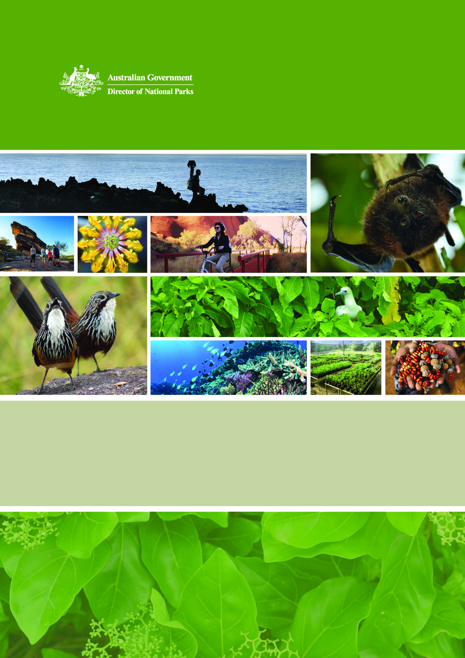

**Director of National Parks**

Corporate Plan 2018-2022

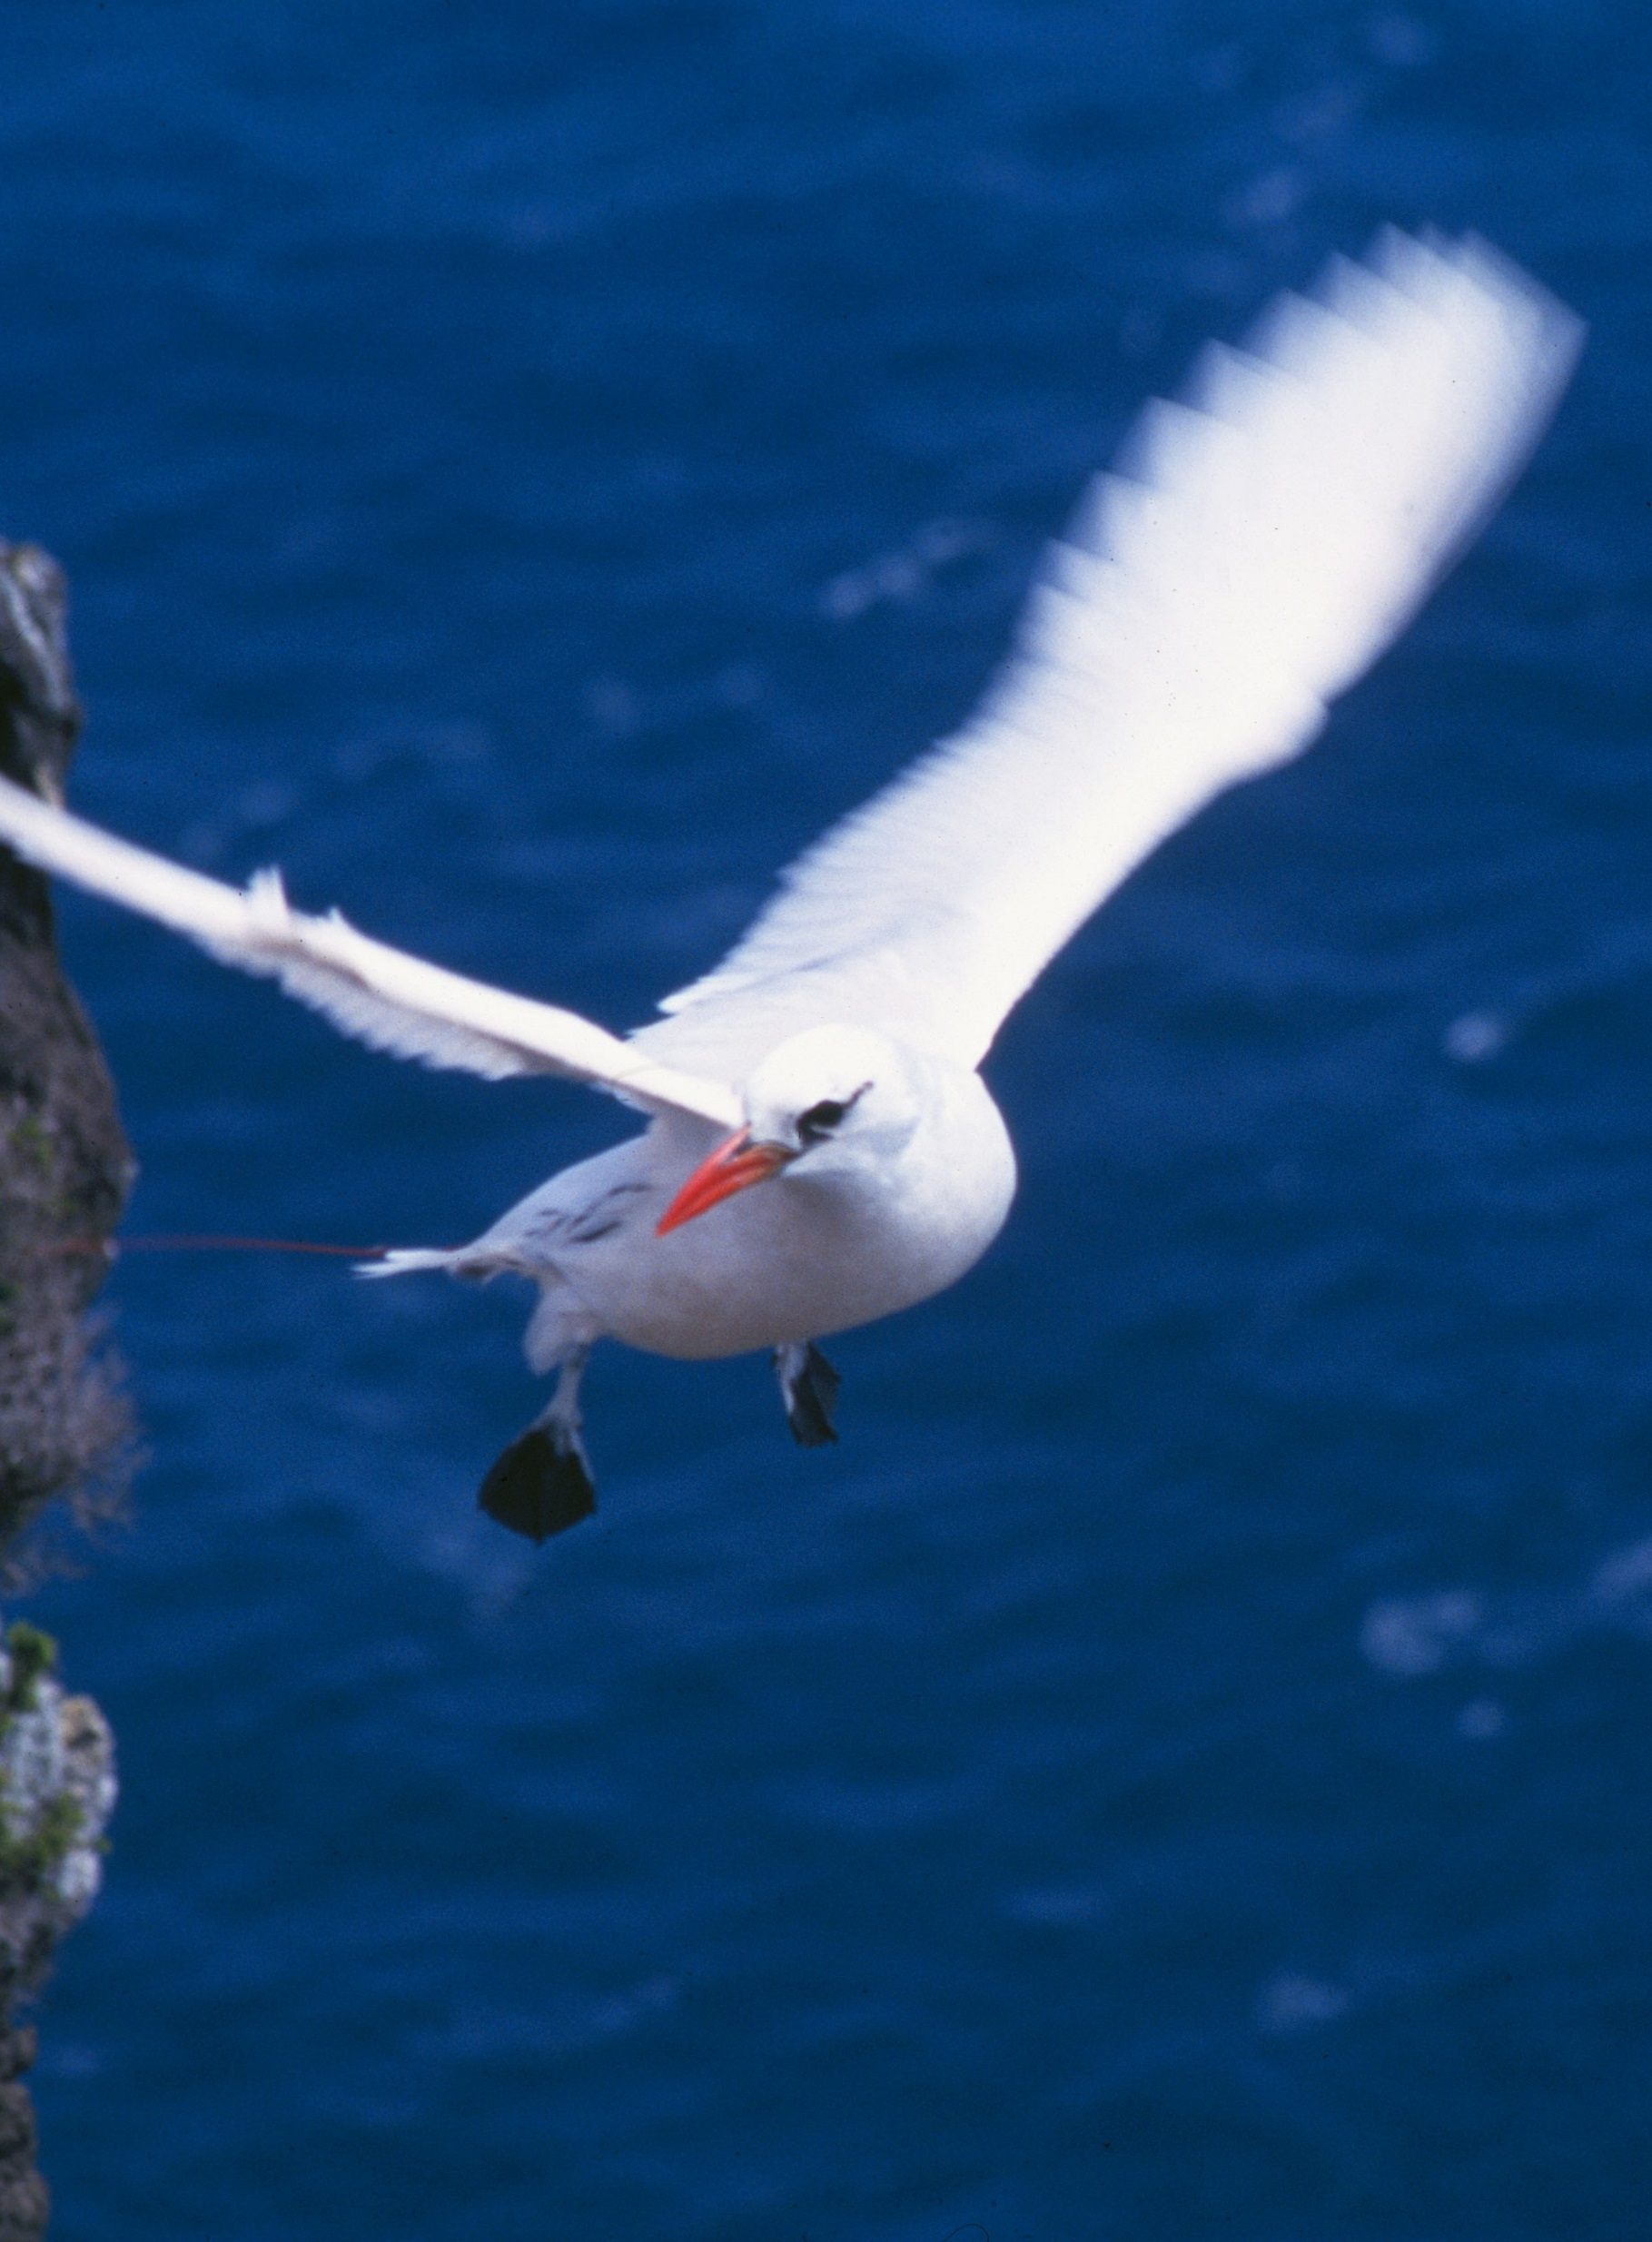

**Statement of Preparation**

I, Judith Gay West, as the accountable authority of the Director of National Parks, present the Director of National Parks Corporate Plan 2018-2022, which covers the reporting periods of 2018-2019 to 2021-22, as required under paragraph 35(1)(b) of the *Public Governance, Performance and Accountability Act 2013*. The plan is prepared in accordance with the *Public Governance, Performance and Accountability Rule 2014*.

\\pvac01file02\user$\A22839\Documents\My Pictures\Judy.jpg

Acting Director of National Parks

27 August 2018

**The Director of National Parks’ statutory functions**

The Director of National Parks is a Corporate Commonwealth Entity, operating under the *Environment Protection and Biodiversity Conservation Act 1999* (EPBC Act). The Director is responsible for the administration of Divisions 4 and 5 of Part 15 of the EPBC Act (Commonwealth reserves and conservation zones) and regulations made for the purposes of those divisions.

The functions of the Director, as set out in subsection 514B(1) of the EPBC Act, are to:

* administer, manage and control Commonwealth reserves and conservation zones
* protect, conserve and manage biodiversity and heritage in Commonwealth reserves and conservation zones
* contribute to the protection, conservation and management of biodiversity and heritage in areas outside Commonwealth reserves and conservation zones
* cooperate with any country in matters relating to the establishment and management of national parks and nature reserves in that country
* provide, and assist in the provision of, training in knowledge and skills relevant to the establishment and management of national parks and nature reserves
* carry out alone, or in cooperation with other institutions and persons, and arrange for any other institution or person to carry out research and investigations relevant to the establishment and management of Commonwealth reserves
* make recommendations to the Minister in relation to the establishment and management of Commonwealth reserves
* administer the Australian National Parks Fund
* undertake any other functions conferred on the Director under the EPBC Act or any other Act
* do anything incidental or conducive to the performance of any of the functions mentioned above.

As at 1 July 2018, the Director was responsible for seven Commonwealth terrestrial reserves (six national parks and one botanic garden) and 59 Australian Marine Parks, established under the   
EPBC Act.

The terrestrial reserves and 58 of the 59 marine reserves are managed by Parks Australia, a division of the Department of the Environment and Energy.

Under delegation from the Director, the department’s Australian Antarctic Division manages the Heard Island and McDonald Islands Marine Reserve.

In addition to statutory functions under the EPBC Act, the Director of National Parks also has a range of obligations under the leases for Kakadu, Booderee and Uluru-Kata Tjuta National Parks.

**Parks Australia’s places and services**

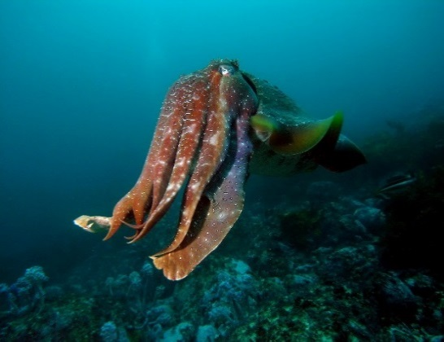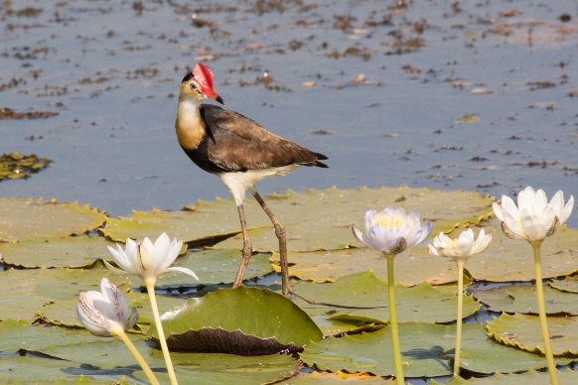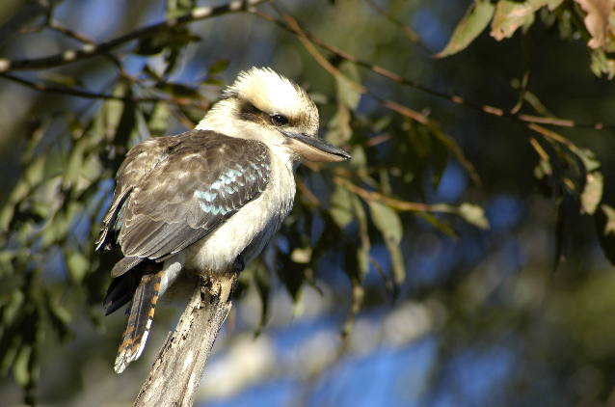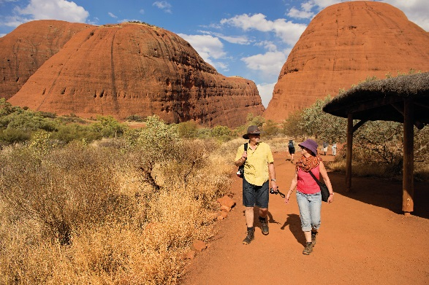

Australia’s natural and cultural heritage is unique. Our land and seascapes are distinctive, home to plants and animals found nowhere else in the world, and to the oldest living cultures on earth. These environments are an essential part of our national identity–and visitors travel from across the country and the world to experience them.

The Director of National Parks is the statutory agency responsible for the Australian Government’s terrestrial and marine protected area estates. The Director is assisted by Parks Australia, a division of the Department of the Environment and Energy.

Australia has one of the largest networks of marine parks in the world, 58 of them managed by Parks Australia. Marine parks protect the diversity of life in our oceans–from astonishing coral reefs in our tropical seas to deep ocean canyons and undersea mountains in temperate marine regions.

Onshore, we manage six national parks and the Australian National Botanic Gardens–a rich and fascinating range of ecosystems and communities, from oceanic Pulu Keeling, Norfolk and Christmas Islands, the stone country of Kakadu, the coastal habitats of Booderee and the spinifex sand plains of arid Uluru-Kata Tjuta.

Three of our national parks are leased by their Aboriginal owners to the Director of National Parks to be jointly managed by their traditional owners and Parks Australia.

Australia’s National Botanic Gardens is the nation’s largest living collection of Australian native plants. It’s a tranquil setting for walking and spending time with family and friends, and a living classroom for visitors of all ages. The Gardens plays a significant role in the conservation and propagation of rare and threatened plants.

Our biodiversity science programs–the Australian Biological Resources Study, the Centre for Australian National Biodiversity Research and National Seed Bank­–are partnerships for biodiversity research, for management of physical and digital biological collections, and for management of fundamental national biodiversity data and information used by the nation.

We want to showcase these natural and cultural wonders to the world, demonstrating to all why these places are so special and inspiring communities to become more invested in their care and future.

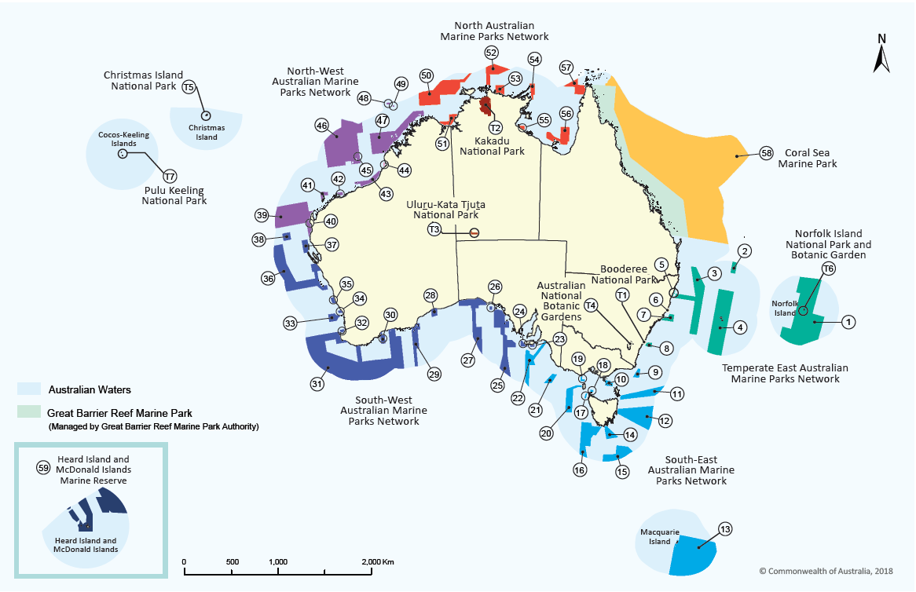**Figure 1: Location of Commonwealth parks and reserves**

**Key to the location of the Commonwealth parks and reserves**

|  |  |  |  |  |  |  |  |  |  |  |
| --- | --- | --- | --- | --- | --- | --- | --- | --- | --- | --- |
|  | **Park Name** | **Map Label** |  |  | **Park Name** | **Map Label** |  |  | **Park Name** | **Map Label** |
|  | **Terrestrial Reserve** |  |  |  | Huon | 14 |  |  | **North-west** |  |
|  | Booderee National Park | T1 |  |  | South Tasman Rise | 15 |  |  | **Marine Parks Network** |  |
|  | Kakadu National Park | T2 |  |  | Tasman Fracture | 16 |  |  | Gascoyne | 39 |
|  | Uluṟu-Kata Tjuṯa National Park | T3 |  |  | Zeehan | 17 |  |  | Ningaloo | 40 |
|  | Australian National Botanic | T4 |  |  | Boags | 18 |  |  | Montebello | 41 |
|  | Gardens |  |  | Apollo | 19 |  |  | Dampier | 42 |
|  | Christmas Island National Park | T5 |  |  | Franklin | 20 |  |  | Eighty Mile Beach | 43 |
|  | Norfolk Island National Park | T6 |  |  | Nelson | 21 |  |  | Roebuck | 44 |
|  | and Botanic Garden |  |  | Murray | 22 |  |  | Mermaid Reef | 45 |
|  | Pulu Keeling National Park | T7 |  |  | **South-west** |  |  |  | Argo-Rowley Terrace | 46 |
|  | **Temperate East** |  |  |  | **Marine Parks Network** |  |  |  | Kimberley | 47 |
|  | **Marine Parks Network** |  |  |  | Southern Kangaroo Island | 23 |  |  | Ashmore Reef | 48 |
|  | Norfolk | 1 |  |  | Western Kangaroo Island | 24 |  |  | Cartier Island | 49 |
|  | Gifford | 2 |  |  | Western Eyre | 25 |  |  | **North** |  |
|  | Central Eastern | 3 |  |  | Murat | 26 |  |  | **Marine Parks Network** |  |
|  | Lord Howe | 4 |  |  | Great Australian Bight | 27 |  |  | Joseph Bonaparte Gulf | 50 |
|  | Solitary Islands | 5 |  |  | Twilight | 28 |  |  | Oceanic Shoals | 51 |
|  | Cod Grounds | 6 |  |  | Eastern Recherche | 29 |  |  | Arafura | 52 |
|  | Hunter | 7 |  |  | Bremer | 30 |  |  | Limmen | 53 |
|  | Jervis | 8 |  |  | South-west Corner | 31 |  |  | Arnhem | 54 |
|  | **South-east** |  |  |  | Two Rocks | 32 |  |  | West Cape York | 55 |
|  | **Marine Parks Network** |  |  |  | Geographe | 33 |  |  | Gulf of Carpentaria | 56 |
|  | East Gippsland | 9 |  |  | Perth Canyon | 34 |  |  | Wessel | 57 |
|  | Beagle | 10 |  |  | Jurien | 35 |  |  | **Coral Sea Marine Park** | 58 |
|  | Flinders | 11 |  |  | Abrolhos | 36 |  |  | **Heard Island and McDonald** | 59 |
|  | Freycinet | 12 |  |  | Shark Bay | 37 |  |  | **Islands Marine Reserve** |
|  | Macquarie Island | 13 |  |  | Carnarvon Canyon | 38 |  |  |  |  |

**Parks Australia’s goals and objectives**

Parks Australia’s long term objectives are described in our three goals (Table 1). They give planning and reporting direction across the agency, from the corporate level to individual performance and development agreements for our staff. The four ‘ways of working’ are the ways we achieve our goals. The diversity of our places and partners means that outcomes may be delivered in different ways, in different places.

**Table 1: Our goals and objectives**

|  |  |  |  |  |  |  |
| --- | --- | --- | --- | --- | --- | --- |
| Vision | Outstanding natural places that enhance Australia’s well-being | | | | | |
|  | | | | | | |
| Goals | **Resilient places and ecosystems** | | **Multiple benefits to traditional owners and local communities** | | **Amazing destinations** | |
| Objectives | To protect and conserve the natural and cultural values of Commonwealth reserves. | | To support the aspirations of traditional owners and local communities in managing land and sea country. | | To offer world class natural and cultural experiences, enhancing Australia’s visitor economy. | |
|  | | | | | | |
| Ways of working | **Evidence based management** | **Ecologically sustainable use** | | **Partnerships and co-investments** | | **Responsive organisation:** |
| Science, research and traditional knowledge are used to make management decisions. | Parks Australia acts to enhance Australia’s social and economic well-being through ecologically sustainable use of our places, with awareness of our own environmental footprint. | | Partnerships and working together with our stakeholders to support delivery of innovative programmes that achieve our goals. | | Parks Australia is an efficient and effective agency with a proud and motivated workforce, supported by efficient business systems. |

**Parks Australia’s operating environment**

Our operating environment is influenced by a range of factors, both internal and external to Parks Australia.

**External factors**

More than 1,700 species and ecological communities are known to be threatened or at risk of extinction and an estimated 75% of Australia’s plants and animals have not yet been formally described and little is reliably known of their status.

Pressures on terrestrial biodiversity–for example invasive species, inappropriate fire regimes, habitat loss and changing land use–will shape our priorities, decisions and activities now and beyond the life of this plan.

In the marine environment most species are in good condition and the trajectories of many rare species are improving and key threatening processes such as marine invasive species and algal blooms are stable.

Marine parks are one of the tools used to protect marine habitats and the species that rely on them. Marine parks also support the livelihoods of marine park users, including fishers and tourism operators. Five new management plans which cover 44 Australian Marine Parks came into effect on 1 July 2018, bringing all 60 Australian Marine Parks, covering more than 3.2 million square kilometres of ocean, under protection. Significant management challenges still exist such as pollution, marine debris, managing the impacts of climate change and illegal unreported and unregulated fishing.

**Family, clan and community obligations to keep land and sea healthy**

Aboriginal people have looked after land and sea country for tens of thousands of years. Parks Australia understands that the traditional owners of the land and sea we manage together have significant cultural and spiritual responsibilities to keep plants, animals and ecosystems healthy.   
All of our work must respect and complement these obligations.

Our efforts to protect the natural and cultural values of our parks must be undertaken in collaboration with traditional owners. We must work with each other to design and implement programs and activities. We can also assist elders and community members to improve social and economic well-being by making sure these issues are addressed in the way we work.

**Climate Change**

Climate change is a threat to all terrestrial and marine environments. A changing climate exacerbates existing threats and brings new challenges for managing species, ecosystems, infrastructure and visitors. We know that change is happening such as saltwater intrusion, erosive processes through increased rainfall, coral bleaching events, incursion of novel invasive species and disease vectors, extreme weather and fire risk and these are likely to increase. These changes also have implications for visitor safety, visitor satisfaction and park revenue. Adopting a long term view to mitigation and adaptation will remain an important consideration for Parks Australia throughout the life of this plan. As local impacts become better known, we need to understand the likely direction of change to prepare, adapt and build effective responses. Given the uncertainties of climate change predictions, improving our understanding is an on-going effort relying on the best available science and best practice park management around the world.

**Connections and partnerships**

Many people interested in protected area management have technical knowledge, skills and experiences that can help us deliver world class reserves. Community engagement, including citizen science and volunteering are ways that the immense goodwill and enthusiasm for Australia’s protected areas can contribute to their health and good management.

Parks Australia is working to establish Australian Marine Park Advisory Committees – multi-stakeholder committees to advise the Director of National Parks on management of 58 marine parks.

We will continue to build on our strong relationships with research organisations, in partnership with CSIRO in the Centre for Australian National Biodiversity Research, through the National Environmental Science Program and the National Marine Science Committee, through scientific advisory panels who provide support on terrestrial parks and with our tourism partners such as Tourism Australia.

Our partnerships with the Maritime Border Command, the Australian Fisheries Management Authority and State and Territory counterparts will contribute to a whole of government approach to surveillance and enforcement in marine parks. Working with the Great Barrier Reef Marine Park Authority will provide consistency of management approaches and visitor experiences and ensure conservation outcomes beyond the boundaries of the Coral Sea Marine Park.

Innovative partnerships across sectors and under different governance and financial models are emerging. We face a competitive environment for partnerships, with many organisations pursuing alternative funding options to deliver their business.

**Accountability**

The expectations of local, national and global communities continue to evolve, with ever higher scrutiny. Investment of public funds in our reserves must be transparent and accountable, with improved quality of planning and performance evaluation that provides meaningful information for stakeholders.

Best-practice protected area management is continually reviewed by international bodies such as the United Nations Educational Scientific and Cultural Organisation (UNESCO), the International Union for the Conservation of Nature (IUCN), the Convention on Biological Diversity, and other multilateral environment agreements. Parks Australia engages in this global conversation to respond flexibly to new ways of working. Rapid technological development provides many opportunities for transformation in the way we work, and has raised visitor expectations for our service delivery.

**Government priorities – innovation and regulatory maturity**

The Government is committed to making it easier for individuals to access government services through digital platforms. Parks Australia is working to deliver services in a simpler way online.   
We will continue to expand our Wi-Fi access, improve the usability of our online services and use social media to better engage our visitors.

We are committed to improving our regulatory maturity, in particular through a customer focused administration of park management plans and legislation, so that visitors can access and enjoy protected areas with minimal fuss and impact.

By simplifying our application processes with clear and logical guidance and complementing our regulatory partners, such as the Australian Fisheries Management Authority and the National Offshore Petroleum Safety and Environmental Management Authority, Parks Australia is committed to improving efficiencies and reducing regulatory burden, allowing cooperative arrangements with communities, users and business/industry sectors.

With a significant footprint in the economy of communities in Kakadu and Uluru-Kata Tjuta National Parks, Parks Australia is contributing to the Government’s strategy to develop Northern Australia. The township of Jabiru is part of the future of the Kakadu region with new opportunities set to emerge following the closure of the Ranger uranium mine in 2021. Parks Australia will continue to work with all stakeholders, including the Northern Territory government, the tourism industry, Energy Resources of Australia, traditional owners and relevant Australian Government agencies towards a transition that stimulates public and private tourism investment.

**Our visitors**

What motivates visitors to travel to our parks? How do they want to spend their time? Visitation trends are sensitive to changing demographics and the global economy. The emerging Asian middle class and the increasing scarcity of natural places in urban landscapes is changing the nature of our tourist base. This will influence the planning and design of our infrastructure and development of new visitor experiences. Park visitors are more connected to technology, social media and on-line information than ever before. We need to continue to work collaboratively with our tourism partners, peak bodies, tourism agencies and licensed tour operators, who bring a significant number of people to our places.

We are only beginning to understand the scale of the importance of natural places for people’s health and wellbeing, and to prioritise that connection in the way we manage places. The social, economic and natural values of Australia’s special places for visitors, local communities and the nation must be the foundation of our work.

**Internal factors**

**Marine Park Management**

In 2018-19, Parks Australia will transition to the active management of the largest representative network of marine parks in the world at 3.2 million square kilometres. This includes implementing seven management programs and numerous actions across marine parks, to support Indigenous engagement; communication and education; tourism; compliance; assessment and authorisations; park protection and science.

This will coincide with a significant program of discovery to improve our understanding of the species, communities and habitats in our reserves and how best to manage them. Innovative solutions will be required to enable remote management of large areas of ocean and to engage marine users and local communities through citizen science programs.

**Science informing Park Management**

We manage a changing environment, face new challenges across all of the many ecosystems in our reserves and work with many partners, stakeholders and local communities. Priority will increasingly be given to research and monitoring projects that directly inform management of the natural, cultural, social and economic values of our reserves. Our new Science Direction Statement aims to encourage science that identifies and address significant knowledge gaps, helping us to respond appropriately and adapt to new circumstances. Citizen science and community involvement will be key considerations in planning our ongoing science program.

**Responding to the contemporary aspirations of traditional owners and local communities**

Traditional owners from our jointly managed parks and marine parks, and others in our local communities have given us a better understanding of their contemporary aspirations for their places and our ongoing partnership. This picture of reserve management is fashioned from the aspirations of families, clans and local groups to fulfil their obligations: looking after the health of the environment and keeping cultures strong, building social cohesion and achieving greater economic benefits.

We must continue to find new ways of working together which cultivate the identification of cultural values, the involvement of communities in reserve management and the inclusion of all generations of people in park work. Programs such as the carbon farming initiative in Kakadu National Park have begun this journey. An emphasis on community involvement and consultation, tourism opportunities, and employment pathways for young people will build on this in 2018-19 and into the future.

**Responding to the changing needs of the organisation**

Our Information and Communication Technology environment must allow for innovation in management and business processes, the reliable storage of data, and the ability to rapidly convert data to useful management information which is effectively communicated to staff and visitors. We will plan our Information Technology transformation strategically to enable a different way of doing business. Our IT environment is changing rapidly. We continue to fine tune our IT systems to make them easy to use for our customers and staff in authorisations and regulatory interactions. Throughout the life of this plan we will extend this environment to incorporate other areas of our business, so that our IT systems serve the needs of our varied and often remote workforce and partners.

Parks Australia manages complex projects and contracts in many sectors such as infrastructure development and asset maintenance, large science contracts, extensive natural and cultural value management programs and substantial service delivery arrangements. We look to continue improvements in coordination and standardised delivery.

We have assessed our financial management systems and the financial literacy of Directors and Managers, and are now making changes to how and where we manage large projects, procurements and assets. We will focus on ways to improve specialist skills and support in these areas.

With the new Performance Development Scheme settling in, Parks Australia will support regular conversations between staff and supervisors and assist us to develop a clear line from this corporate plan through operational plans in our places and sections to individual work programs and performance agreements.

In recognition of the transition to active management, a change management plan has been developed for the Marine Protected Areas Branch, with training, capacity building and new systems to be implemented to assist staff to adapt to new challenges in marine park management.

**Parks Australia’s organisational capability and capital asset management directions**

**Our people**

We have a very diverse workforce, spread across remote and metropolitan centres, and a range of roles from seasonal rangers and scientists to strategic policy planners. We know that our relationships with traditional owners, neighbours, other land managers and scientific, operational and commercial partners will be the key to our success.

Parks Australia will dedicate effort and resources to improving the well-being of our staff and their families, particularly in remote areas. We will implement our staff mobility policy to assist in building a flexible, cohesive and agile workforce.

We will respond to concerns and ideas of staff raised through regular staff surveys. We will encourage our people to test innovative and creative solutions to some of the pressing problems we face in conservation and land and sea management.

**Our capital assets**

Parks Australia is responsible for a large portfolio of capital assets, including visitor sites, offices, workshops and staff housing. During 2018-19, Parks Australia focus on strategic asset management, with a view to the use and future life of existing assets and the alignment of new acquisitions with our strategic goals.

Parks Australia is committed to the revitalisation of tourism and essential park infrastructure.

**Risk Management Framework**

Employees, volunteers and contractors who undertake Parks Australia business often operate in remote areas. We also operate in a dynamic environmental, social and business context and our people manage a diverse and complex array of issues. Parks Australia has a responsibility to ensure that risks to ourselves and to our visitors are minimised so far as reasonably practicable.

We need to be realistic about what we can deliver and always consider the risk of the particular threats in our extraordinary places. Effective risk management is critical to the achievement of our goals in our constantly evolving operating environment.

Parks Australia’s Risk Management Framework aims to make sure that we are aware of risks, make informed decisions in managing those risks, and to identify and harness potential opportunities when they arise. The Parks Australia Risk Management Framework aligns with the Commonwealth Risk Management Policy and is consistent with the *Australian/New Zealand Standard ISO 31000:2009 Risk management – Principles and guidelines*.

Risk watch lists or risk registers for each reserve or shared-services section are periodically reviewed in accordance with the Risk Management Framework. Risks and incidents in workplaces are reported regularly to the executive board who monitor their effect on the corporate goals and Parks Australia workforce and the effectiveness of mitigation strategies.

**Parks Australia’s strategies**

The following tables represent a rolling four-year plan which describes our corporate strategies and planned actions against each of our three goals. This corporate plan is the central planning document within our planning and reporting framework, and sets the strategic direction for other planning documents – such as the annual operational plans that are specific to each of the places we manage.

|  |  |
| --- | --- |
| Goal: **Resilient places and ecosystems** |  |

|  |  |
| --- | --- |
| **Objective** | To protect and conserve the natural and cultural values of Commonwealth parks |
| **Desired outcome s** | Living culture and cultural heritage values are identified protected and conserved  The health and integrity of natural values are protected, conserved and where appropriate restored |

|  |
| --- |
| Goal: **Multiple benefits for traditional owners and local communities** |

|  |  |
| --- | --- |
| **Objective** | To support the aspirations of traditional owners and local communities in managing land and sea country |
| **Desired outcome s** | Traditional owners and local communities have received a measurable economic benefit  Traditional owners and local communities have received a measurable social and/ or cultural benefit |

|  |  |
| --- | --- |
| Goal: **Amazing destinations** |  |

|  |  |
| --- | --- |
| **Objective** | To offer world class natural and cultural experiences, enhancing Australia’s visitor economy |
| **Desired outcome** | Our contribution to Australia’s visitor economy is maintained or increased |

|  |  |
| --- | --- |
| Goal: **Resilient places and ecosystems** |  |

|  |  |
| --- | --- |
| **Objective** | To protect and conserve the natural and cultural values of Commonwealth parks |
| **Desired outcome s** | Living culture and cultural heritage values are identified protected and conserved  The health and integrity of natural values are protected, conserved and where appropriate restored |

|  |  |  |  |  |  |
| --- | --- | --- | --- | --- | --- |
| **Strategy: Reduce the overall impact of threatening processes, invasive species and inappropriate fire on natural and cultural values** | | | | | |
| **Actions** | **2018-19** | **2019-20** | **2020-21** | **2021-22** | **Business Owner** |
| Manage cats on Norfolk Island |  |  |  |  | Park Manager-Norfolk Island National Park |
| Continue to work towards cat eradication and yellow crazy ant control on Christmas Island |  |  |  |  | Park Manager-Christmas Island National Park |
| Manage foxes and bitou bush at Booderee |  |  |  |  | Park Manager-Booderee National Park |
| Manage tropical fire ants at Ashmore Reef Marine Park |  |  |  |  | Director-Marine Protected Areas Management North |
| Take actions to reduce marine debris in Australian Marine Parks |  |  |  |  | Assistant Secretary-Marine Protected Areas Branch |

|  |  |  |  |  |  |
| --- | --- | --- | --- | --- | --- |
| **Strategy: Take action to protect threatened and significant species** | | | | | |
| **Actions** | **2018-19** | **2019-20** | **2020-21** | **2021-22** | **Business Owner** |
| External review eastern quoll translocation for Booderee National Park |  |  |  |  | Park Manager-Booderee National Park |
| Finalise a feasibility study for the translocation of the blue tailed skink to the Cocos Islands |  |  |  |  | Park Manager-Christmas Island National Park |
| Revise translocation plan for Green parrots to Phillip Island |  |  |  |  | Park Manager-Norfolk Island National Park |
| Implement Norfolk Island threatened plant species ‘prioritisation tool’ project as part of the Flora Conservation Program |  |  |  |  | Park Manager-Norfolk Island National Park |
| Continue seed banking and ex situ conservation programs at the ANBG |  |  |  |  | General Manager-Australian National Botanic Gardens |
| Manage the red crab migration to minimise loss from vehicles on Christmas Island |  |  |  |  | Park Manager-Christmas Island National Park |
| Initiate research on the decline and recovery option for greater gliders at Booderee National Park |  |  |  |  | Park Manager-Booderee National Park |
| Remove marine debris and ghost nets to protect threatened and culturally significant species in marine parks, in partnership with traditional owners and ranger groups |  |  |  |  | Assistant Secretary- Marine Protected Areas Branch and Joint Management Branch |

|  |  |  |  |  |  |
| --- | --- | --- | --- | --- | --- |
| **Strategy: Conduct monitoring programs on threatened species to assess management effectiveness** | | | | | |
| **Actions** | **2018-19** | **2019-20** | **2020-21** | **2021-22** | **Business Owner** |
| Revise *Tjakura* monitoring methods at Uluru-Kata Tjuta National Park |  |  |  |  | Park Manager-Uluru-Kata Tjuta National Park |
| Complete regular monitoring of the Christmas Island flying fox |  |  |  |  | Park Manager-Christmas Island National Park |
| Complete annual monitoring of mala at Uluru-Kata Tjuta National Park |  |  |  |  | Park Manager-Uluru-Kata Tjuta National Park |
| Complete regular monitoring of Green Parrots on Norfolk Island |  |  |  |  | Park Manager-Norfolk Island National Park |
| Complete regular monitoring of the Southern brown bandicoots, long nosed potoroos, eastern quolls and eastern bristle birds at Booderee National Park |  |  |  |  | Park Manager-Booderee National Park |
| Conduct monitoring and research of threatened and culturally significant species (such as sharks, marine turtles, dugong, black cod) and biologically important habitats within Australian Marine Parks |  |  |  |  | Assistant Secretary- Marine Protected Areas Branch |

|  |  |  |  |  |  |
| --- | --- | --- | --- | --- | --- |
| **Strategy: Research, document, curate and share scientific knowledge to build understanding of Australia’s biodiversity** | | | | | |
| **Actions** | **2018-19** | **2019-20** | **2020-21** | **2021-22** | **Business Owner** |
| Provide leadership through a National Coordinator and Secretariat services for the Australian Seed Bank Partnership |  |  |  |  | Executive Director- Australian National Botanic Gardens |
| Curate and manage scientific collections including:   * + the Australian National Herbarium;   + the Australian Plant Image collection;   + the Australian National Botanic Gardens living collection;   + the Booderee Botanic Gardens; and   + the National Seed Bank collection |  |  |  |  | Director- Biodiversity Science Section  General Manager- Australian National Botanic Gardens |
| Maintain botanical information and data systems |  |  |  |  | Director- Biodiversity Science Section |
| In partnership with Atlas of Living Australia, develop and manage the Flora of Australasia digital platform, and develop the National Species List system and services |  |  |  |  | Director- Biodiversity Science Section |
| Commission research in Australian Marine Parks to improve understanding of marine biodiversity and establish baselines |  |  |  |  | Assistant Secretary- Marine Protected Areas Branch |
| Launch the online Science Atlas to communicate scientific research and understanding about marine parks |  |  |  |  | Director-Marine Protected Areas Policy & Programs Coordination |
| Through the Science Atlas and other online tools, communicate scientific research and understanding about marine parks |  |  |  |  | Director-Marine Protected Areas Policy & Programs Coordination |
| Develop a system and monitor, evaluate and regularly report to stakeholders and the community on Australian Marine Park values, biodiversity, condition and management effectiveness |  |  |  |  | Director-Marine Protected Areas Policy & Programs Coordination |
| Fund and facilitate prioritised scientific research in taxonomy and systematics |  |  |  |  | Director- Biodiversity Science Section |
| Use and facilitate use of collections and data for public good scientific research and knowledge |  |  |  |  | Director- Biodiversity Science Section |

|  |  |  |  |  |  |
| --- | --- | --- | --- | --- | --- |
| **Strategy: Implement park compliance and authorisation programs** | | | | | |
| **Actions** | **2018-19** | **2019-20** | **2020-21** | **2021-22** | **Business Owner** |
| Authorise activities within parks in accordance with management plans, to ensure park values are protected and to enable sustainable use - including the development of policy and new systems to support assessment, authorisation processing and decision-making |  |  |  |  | Director-Marine Protected Areas Authorisations & Compliance and Park Managers |
| Implement compliance planning, based on risk assessment with targeted and appropriate compliance actions, including enforcement, auditing and working with partner agencies to support compliance delivery on parks |  |  |  |  | Director-Marine Protected Areas Authorisations & Compliance and Park Managers |
| Investigate and implement new technologies to support effective compliance in parks, including acoustic monitoring, satellite use and exploring opportunities to expand vessel monitoring |  |  |  |  | Director-Marine Protected Areas Authorisations & Compliance |

|  |  |  |  |  |  |
| --- | --- | --- | --- | --- | --- |
| **Strategy: Provide guidance, direction and prioritisation for science activities across Parks Australia** | | | | | |
| **Actions** | **2018-19** | **2019-20** | **2020-21** | **2021-22** | **Business Owner** |
| Ensure that research on park is directed to support management outcomes:   * + Ensure that research partnerships established between research institutions and the DNP are effective and outcomes focused;   + Work with the National Environmental Science Program so ongoing and future research contributes to delivering adaptive management outcomes;   + Analyse long standing Parks Australia data sets to determine their contribution to well-informed park management;   + Explore opportunities for community engagement in citizen science projects to contribute to research and monitoring needs in parks;   + Encourage and facilitate knowledge brokering to support collaboration and partnerships with the science community, state and territory agencies and citizen science; and   + In partnership with the science community, engage in effective science communication for our stakeholders and the broader community, including through the National Environmental Science Program and National Marine Science Committee. |  |  |  |  | Assistant Secretaries-Parks Island and Biodiversity Science, Marine Protected Areas and Joint Management Branches |
| Convene the annual NRM Science Managers Forum to coordinate approach and share knowledge, experience and skills |  |  |  |  | Assistant Secretary-Parks Island and Biodiversity Science Branch |
| Outline priorities for research and monitoring in Parks Australia, through the development of a Marine Park and a Terrestrial Park science strategy |  |  |  |  | Assistant Secretary-Parks Island and Biodiversity Science Branch and Director-Marine Protected Areas Management (South) |

|  |
| --- |
| Goal: **Multiple benefits for traditional owners and local communities** |

|  |  |
| --- | --- |
| **Objective** | To support the aspirations of traditional owners and local communities in managing land and sea country |
| **Desired outcome s** | Traditional owners and local communities have received a measurable economic benefit  Traditional owners and local communities have received a measurable social and/ or cultural benefit |

|  |  |  |  |  |  |
| --- | --- | --- | --- | --- | --- |
| **Strategy: Work with traditional owners and local communities to improve governance and better reflect and achieve their aspirations and priorities for park management** | | | | | |
| **Actions** | **2018-19** | **2019-20** | **2020-21** | **2021-22** | **Business Owner** |
| Enhance decision making capabilities of Boards of Management and traditional owner input into decision making |  |  |  |  | Assistant Secretary-Joint Management Branch |
| Continue development of the Booderee National Park Sustainable Business Plan |  |  |  |  | Park Manager-Booderee National Park and Director Strategic Project Delivery Section |
| Establish the joint management team in Kakadu National Park |  |  |  |  | Park Manager-Kakadu National Park |
| Engage with Indigenous people and traditional owners to support collaborative management of sea country in Australian Marine Parks |  |  |  |  | Assistant Secretary-Marine Protected Areas Branch |
| Undertake an internal review of lease obligations in the jointly managed national parks |  |  |  |  | Assistant Secretary-Joint Management Branch |
| Curate and provide access to the Kakadu National Park Cultural Heritage database |  |  |  |  | Park Manager-Kakadu National Park |

|  |  |  |  |  |  |
| --- | --- | --- | --- | --- | --- |
| **Strategy: Work with traditional owners to develop employment opportunities on parks** | | | | | |
| **Actions** | **2018-19** | **2019-20** | **2020-21** | **2021-22** | **Business Owner** |
| Develop and implement the Indigenous Employment and Education Pathway Project   * + Initiate pathway project at Uluru-Kata Tjuta National Park |  |  |  |  | Director-People and Workforce Development |
| Prepare a Cultural Heritage Action Plan for Uluru-Kata Tjuta National Park |  |  |  |  | Park Manager-Uluru-Kata Tjuta National Park |
| Develop and implement priorities for Cultural Heritage Management for the joint managed parks, and undertake activities under the direction of traditional owners and Boards of Management |  |  |  |  | Park Managers -Joint Managed Parks |
| Consult on the idea and if feasible convene a combined Joint Boards of Management meeting |  |  |  |  | Assistant Secretary-Joint Management Branch |
| Develop an Indigenous Engagement and Cultural Heritage Strategy for Australian Marine Parks |  |  |  |  | Director-Marine Protected Areas Management (North) |
| In partnership with traditional owners and in accordance with relevant agreements, mobilise fire management activities in Kakadu National Park funded by carbon credits |  |  |  |  | Park Manager-Kakadu National Park |
| Manage sea country in Australian Marine Parks in partnership with Indigenous people |  |  |  |  | Assistant Secretary- Marine Protected Areas Branch |
| Provide a range of employment opportunities for traditional owners of joint managed parks |  |  |  |  | Assistant Secretary-Joint Management Branch |
| Develop an Indigenous business development strategy to inspire engagement in tourism, facilitate business advice and mentoring |  |  |  |  | Director -Customer Experience and Destination Planning |

|  |  |
| --- | --- |
| Goal: **Amazing destinations** |  |

|  |  |
| --- | --- |
| **Objective** | To offer world class natural and cultural experiences, enhancing Australia’s visitor economy |
| **Desired outcome** | Our contribution to Australia’s visitor economy is maintained or increased |

|  |  |  |  |  |  |
| --- | --- | --- | --- | --- | --- |
| **Strategy: Improve the visitor experience by refreshing and improving visitor infrastructure in high use areas** | | | | | |
| **Actions** | **2018-19** | **2019-20** | **2020-21** | **2021-22** | **Business Owner** |
| Implement Stage 1a Australian National Botanic Gardens Masterplan- constructing the Ian Potter National Conservatory |  |  |  |  | General Manager-Australian National Botanic Gardens |
| Continue to provide informed and educational experiences in the discovery, visitor and cultural centres at Uluru-Kata Tjuta, Norfolk Island, Booderee and Kakadu National Parks and the Australian National Botanic Gardens |  |  |  |  | Park Managers |
| Upgrade selected walking tracks at Kakadu and Uluru-Kata Tjuta National Parks |  |  |  |  | Park Managers and Director -Strategic Project Delivery Section |
| Develop an infrastructure policy including determining requirements for mooring, anchoring, fish attracting devices, artificial reefs, signage and marker buoys within Australian Marine Parks |  |  |  |  | Director-Marine Protected Areas Management (West) |
| Maintain existing moorings in Australian Marine Parks (e.g. at Ashmore and Mermaid Reef) |  |  |  |  | Director-Marine Protected Areas Management (West) |
| Construct the Blow Holes Board Walk on Christmas Island National Park |  |  |  |  | Park Manager- Christmas Island National Park |
| Implement the climb closure strategy at Uluru-Kata Tjuta National Park including a celebration marking the climb closure |  |  |  |  | Park Manager- Uluru-Kata Tjuta National Park |
| Commence implementation for Stage 1b and Stage 2- Australian National Botanic Gardens Masterplan |  |  |  |  | Executive Director and General Manager- Australian National Botanic Gardens |

|  |  |  |  |  |  |
| --- | --- | --- | --- | --- | --- |
| **Strategy: Ensure the reputation of the DNP is maintained through effective communication strategies** | | | | | |
| **Actions** | **2018-19** | **2019-20** | **2020-21** | **2021-22** | **Business Owner** |
| Increase awareness of marine parks and management arrangements |  |  |  |  | Director-Marine Protected Areas Policy & Programs Coordination |
| Develop a marketing and communications strategy for Australian Marine Parks |  |  |  |  | Director-Marine Protected Areas Policy & Programs Coordination |
| Develop an Uluru Climb closure communication strategy |  |  |  |  | Park Manager- Uluru-Kata Tjuta National Park |
| Manage Commonwealth communications on the future of Jabiru in Kakadu National Park |  |  |  |  | Director- Customer Experience and Destination Planning |
| Implement the climb closure communication strategy at Uluru-Kata Tjuta National Park |  |  |  |  | Park Manager- Uluru-Kata Tjuta National Park |

|  |  |  |  |  |  |
| --- | --- | --- | --- | --- | --- |
| **Strategy: Promote visitor experiences and nature education through the use of best practice digital technology** | | | | | |
| **Actions** | **2018-19** | **2019-20** | **2020-21** | **2021-22** | **Business Owner** |
| Launch new Australian Marine Park website |  |  |  |  | Director- Customer Experience and Destination Planning |
| Implement online tools and platforms, and update the Parks Australia website to promote opportunities to visit and explore Parks |  |  |  |  | Director- Customer Experience and Destination Planning |
| Implement an e-commerce strategy to generate revenue, increase efficiency and reduce costs |  |  |  |  | Director- Customer Experience and Destination Planning |
| Develop new visitor apps for Kakadu and Uluru-Kata Tjuta National Parks and the Australian National Botanic Gardens |  |  |  |  | Director- Customer Experience and Destination Planning |

|  |  |  |  |  |  |
| --- | --- | --- | --- | --- | --- |
| **Strategy: Provide assistance for the transition to active management of Australian Marine Parks** | | | | | |
| **Actions** | **2018-19** | **2019-20** | **2020-21** | **2021-22** | **Business Owner** |
| Design and deliver an assistance package relating to the management of Australian Marine Parks including:   * + An adjustment package that provides fair and reasonable assistance to commercial fishers affected by new Australian Marine Parks   + A process to facilitate the uptake of vessel monitoring systems for commercial vessels operating in Australian Marine Parks   + Grants available on a competitive basis to Australian Marine Park users to facilitate engagement with ongoing management |  |  |  |  | Director- Marine Protected Areas Fisheries Adjustment Taskforce |

|  |  |  |  |  |  |
| --- | --- | --- | --- | --- | --- |
| **Strategy: Facilitate** **investment in new infrastructure, new products and experiences in priority areas** | | | | | |
| **Actions** | **2018-19** | **2019-20** | **2020-21** | **2021-22** | **Business Owner** |
| Develop an event strategy for Parks Australia to encourage external events that complement parks values |  |  |  |  | Director- Customer Experience and Destination Planning |
| Produce plans and communications strategy for Australian National Botanic Gardens’ 50th and Kakadu National Park’s 40th anniversary celebrations |  |  |  |  | General Manager- Australian National Botanic Gardens  Director- Customer Experience and Destination Planning |
| Develop an Uluru-Kata Tjuta National Park Visitor Infrastructure Plan |  |  |  |  | Park Manager- Uluru-Kata Tjuta National Park and Director- Strategic Project Delivery Section |
| Implement key projects of the Uluru-Kata Tjuta National Park Visitor Infrastructure Plan |  |  |  |  | Park Manager- Uluru-Kata Tjuta National Park |
| Continue to develop projects identified in the tourism EOI process at Uluru-Kata Tjuta National Park |  |  |  |  | Director- Customer Experience and Destination Planning |
| Support government negotiations for the future of the Jabiru township |  |  |  |  | Assistant Secretary- Joint Management Branch  Directors- Customer Experience and Destination Planning and Strategic Project Delivery Section |
| Implement key projects from the Mary River precinct plan at Kakadu |  |  |  |  | Director-Strategic Project Delivery Section |
| Work with national, state and local tourism authorities to market, promote and maximise tourism in all parks |  |  |  |  | Director- Customer Experience and Destination Planning |

|  |  |  |  |  |  |
| --- | --- | --- | --- | --- | --- |
| **Strategy: Provide clear direction for growth and development through marketing planning** | | | | | |
| **Actions** | **2018-19** | **2019-20** | **2020-21** | **2021-22** | **Business Owner** |
| Develop marketing plans that identify target markets for key parks, including Australian Marine Parks |  |  |  |  | Directors- Customer Experience and Destination Planning Marine Protected Areas Management (South) |
| Refresh the branding for Kakadu and Uluru-Kata Tjuta National Parks and the Australian National Botanic Gardens |  |  |  |  | Director- Customer Experience and Destination Planning |
| Produce a digital content strategy for Kakadu and Uluru-Kata Tjuta National Parks and the Australian National Botanic Gardens |  |  |  |  | Director- Customer Experience and Destination Planning |
| Refresh branding for Booderee National Park and other selected parks |  |  |  |  | Director- Customer Experience and Destination Planning |

|  |  |  |  |  |  |
| --- | --- | --- | --- | --- | --- |
| **Strategy: Provide clear direction for growth and development through tourism planning** | | | | | |
| **Actions** | **2018-19** | **2019-20** | **2020-21** | **2021-22** | **Business Owner** |
| Develop a Visitor Destination and Experience Plan for Norfolk Island National Park |  |  |  |  | Director- Customer Experience and Destination Planning |
| Produce a tourism planning strategy for key parks, outlining requirements to implement infrastructure upgrades and Expressions of Interest for tourism products |  |  |  |  | Director- Customer Experience and Destination Planning |
| Develop a sustainable tourism and visitor experience strategy for Australian Marine Parks |  |  |  |  | Director-Marine Protected Areas Management (South) |
| Update the Visitor Destination and Experience Plan for Christmas Island National Park |  |  |  |  | Director- Customer Experience and Destination Planning |

|  |
| --- |
| Cross Cutting Actions: **Actions that contribute to achieving all three goals** |

|  |  |
| --- | --- |
| **Objective** | To protect and conserve the natural and cultural values of Commonwealth parks |
| **Desired outcome s** | Living culture and cultural heritage values are identified protected and conserved  The health and integrity of natural values are protected, conserved and where appropriate restored |

|  |  |  |  |  |  |
| --- | --- | --- | --- | --- | --- |
| **Strategy: Expand our revenue base and streamline costs where appropriate** | | | | | |
| **Actions** | **2018-19** | **2019-20** | **2020-21** | **2021-22** | **Business Owner** |
| At the Australian National Botanic Gardens:   * + Trial the commercial release of Australian National Botanic Gardens branded Australian plants through the nursery industry   + Expand if the trial is successful; and   + Undertake fundraising campaigns for Master Plan implementation and to supplement conservation and education priorities |  |  |  |  | General Manager-Australian National Botanic Gardens  Executive Director- Australian National Botanic Gardens |
| Undertake studies essential to transferring the provision of essential services in Mutitjulu to the Northern Territory government |  |  |  |  | Assistant Secretary-Joint Management Branch |
| Revise ticketing structure and pricing in line with new park entry arrangements at Uluru-Kata Tjuta National Park |  |  |  |  | Director- Customer Experience and Destination Planning |
| Develop an approach to fees and charges for Australian Marine Parks |  |  |  |  | Director-Marine Parks Protected Areas Authorisations & Compliance |
| Promote the National Parks Conservation Trust to explore innovative funding opportunities |  |  |  |  | Executive Director-Australian National Botanic Gardens |

|  |  |  |  |  |  |
| --- | --- | --- | --- | --- | --- |
| **Strategy: Management plans and governance systems are in place for Parks** | | | | | |
| **Actions** | **2018-19** | **2019-20** | **2020-21** | **2021-22** | **Business Owner** |
| Establish advisory committees for Australian Marine Parks to advise the Director |  |  |  |  | Assistant Secretary- Marine Protected Areas Branch |
| Develop implementation plans for Australian Marine Park management plans in the South-West, North-West, North and Temperate East Networks, and the Coral Sea |  |  |  |  | Assistant Secretary- Marine Protected Areas Branch |
| Finalise strategy and progress developing action plan to monitor and address the impacts of climate change |  |  |  |  | Director- Parks Planning and Coordination |
| Continue development of the Uluru-Kata Tjuta National Park Management Plan 2020-2030 |  |  |  |  | Park Manager- Uluru-Kata Tjuta National Park |
| Undertake the technical audit of the Australian National Botanic Gardens Management Plan 2012-2022 |  |  |  |  | General Manager- Australian National Botanic Gardens |
| Develop the Australian National Botanic Gardens Management Plan to succeed the current 2012-2022 plan |  |  |  |  | General Manager- Australian National Botanic Gardens |
| Develop the Christmas Island National Park Management Plan to succeed the current 2014-2024 plan |  |  |  |  | Park Manager-Christmas Island National Park |

|  |  |  |  |  |  |
| --- | --- | --- | --- | --- | --- |
| **Strategy: Provide legal certainty for the use of biological resources in research in line with international standards** | | | | | |
| **Actions** | **2018-19** | **2019-20** | **2020-21** | **2021-22** | **Business Owner** |
| Maintain documentary consistency with the Nagoya Protocol |  |  |  |  | Director-Parks Planning and Coordination |
| Provide a focal point for the domestic implementation of access and benefit sharing issues under the CBD |  |  |  |  | Director- Parks Planning and Coordination |

|  |  |  |  |  |  |
| --- | --- | --- | --- | --- | --- |
| **Strategy: Increase the efficiency and effectiveness of our business systems with a particular focus on financial literacy, asset management, regulatory maturity and procurement processes** | | | | | |
| **Actions** | **2018-19** | **2019-20** | **2020-21** | **2021-22** | **Business Owner** |
| Implement Stage 1 of the Parks Australia Business Transformation Project, including:   * + Develop streamlined procurement processes and suite of contract templates;   + Pilot an asset management project for road maintenance; and   + At Uluru-Kata Tjuta National Park remove the underground diesel storage facility |  |  |  |  | Assistant Secretary – Parks Services Branch |
| Develop an overall ICT strategy for Parks Australia |  |  |  |  | Assistant Secretary – Parks Services Branch |
| Administer, maintain and upgrade as required the Parks Australia Online Services portal to provide efficient online applications and authorisations |  |  |  |  | Director-Parks Planning and Coordination |
| Complete and begin implementation of the Parks Regulatory Improvement Plan |  |  |  |  | Director-Marine Parks Protected Areas Authorisations & Compliance |

|  |  |  |  |  |  |
| --- | --- | --- | --- | --- | --- |
| **Strategy: Continue to support our people, increase skills to maximise workforce capability and drive a culture of Work Health and Safety to ensure all staff are safe** | | | | | |
| **Actions** | **2018-19** | **2019-20** | **2020-21** | **2021-22** | **Business Owner** |
| Implement a workforce strategy to ensure the effective and efficient use of staff resources to address divisional priorities |  |  |  |  | Director- People and Workforce Development |
| Support developing staff to build their capability to achieve effective performance |  |  |  |  | Director- People and Workforce Development |
| Improve work, health and safety culture and reporting |  |  |  |  | Director- People and Workforce Development |

**Performance monitoring and measurement**

Our performance indicators are designed to demonstrate Parks Australia’s progress and degree of success in achieving our goals and objectives. As outlined in our strategies, there are a number of areas, including amazing destinations and partnerships and co-investments, where we will continue to develop our indicators and monitoring over the life of this plan. These indicators are designed to build a picture of our performance over time – over the four years of this plan and beyond. They will be measured at least annually and reported on in our annual report. Over time we will be able to build information on the trends against these indicators, illustrating how we are tracking in achieving our goals.

|  |  |  |  |  |
| --- | --- | --- | --- | --- |
| **Goal** | **Indicator** | **Baseline** | **Method/data source** | **Reporting business owner** |
| **Resilient places and Ecosystems** | Populations of threatened and significant species are increasing. | 2016-17 | Park level monitoring programs | Park Managers |
| Populations of priority invasive species are reduced. | 2016-17 | Park level monitoring programs | Park Managers |
| Enhance level of active management of Australian Marine Parks and engagement of users and stakeholders. | 2018-19 | Meetings of advisory groups,  Compliance partnerships in place with State and Federal agencies,  Number of authorisations in place,  Website and social media traffic | Assistant Secretary  Marine Protected Areas Branch |
| Increase the knowledge base for long term adaptive management of the Australian Marine Parks | 2016-17 | Long term monitoring site databases, and Number of long term monitoring sites | Assistant Secretary  Marine Protected Areas Branch |
| **Multiple benefits for traditional owners and local communities** | Increase in numbers of Indigenous staff and/or contractors directly or indirectly providing park services. | 2015-16 for both Indigenous staff and Indigenous contractors | SAP and Indigenous Procurement Policy records for employment data | Relevant Directors |
| **Amazing destinations** | Maintain or improve the level of visitor satisfaction and number of visitors | 2015-16 for visitor numbers  2017-18 for visitor satisfaction | Historical data including website traffic, visitation trends and visitor satisfaction levels | Director Customer Experience and Destination Planning |

**Performance monitoring and measurement – Continued**

|  |  |  |  |  |
| --- | --- | --- | --- | --- |
| **Goal** | **Indicator** | **Baseline** | **Method/data source** | **Reporting business owner** |
| **Cross cutting actions** | Proportion of park management plans in place | 2014-15 | Count of plans in place | Director Parks Planning and Coordination  Assistant Secretary Marine Protected Areas Branch |
| Timeliness of response to incoming ministerial correspondence items, ministerial submission, question time briefs, parliamentary questions on notice, senate estimates questions on notice and public enquiries to the Community Information Unit | 2015-16 | PDMS and CIU records | Director Parks Planning and Coordination |
| Risk maturity of ‘Advanced’ in the annual Comcover Risk Management Benchmarking Survey | 2014-15 | Comcover | Director Governance and Business Systems |
| Number of externally reportable breaches of the *Public Governance, Performance and Accountability Act 2013* | 2015-16 | Certificate of Compliance |
| Net return from commercial operations and activities listed in DNP Charges for Commonwealth Parks | 2014-15 | Commercial operations and activities listed in DNP charges for Commonwealth Parks  SAP/Revenue Reporting | Director Customer Experience and Destination Planning |

The web address for this corporate plan is:  
http://www.environment.gov.au/resource/corporate-plan-2018-22-director-national-parks