Draft Assessment Report for

***Cimex lectularius* (Common Bed Bug)**

February 2022

**Rationale**

We are requesting that *Cimex lectularius*, the most common bed bug species, be added to the list of specimens to be imported into Australia for research purposes. *C. lectularius* has a worldwide distribution and is particularly common in large cosmopolitan cities where tourism is high. Although the development of pesticides in the early twentieth century reduced their prevalence, outbreaks have been increasing rapidly over the past 20 – 30 years in Australia. Whilst *C. lectularius* does not transmit any known diseases, it feeds almost exclusively on human blood which can cause allergic reactions and psychological trauma, such that bed bugs have re- emerged as an insect of public health concern. Additionally, bed bug infestations are difficult to diagnose requiring thorough inspection and treatment by trained professionals. This has, and continues, to have a significant financial and reputational cost to the hospitality industry in Australia. This clearly necessitates the research into alternative control and monitoring methods.

Several different bed bug species and strains have been cultured in laboratories across the globe without any evidence of ecological and environmental impacts from their introduction. *C. lectularius* already exists in Australia through its continuous introduction by tourists and travellers. Obtaining reliable and consistent sources of bed bugs, however, remains difficult due to our inability to import live populations from commercial breeders, thus limiting our capacity to conduct novel research on this species here in Australia.

**Table of Contents**

1. Taxonomy 4
2. Transport, Storage, and Disposal 4
3. Previous Risk Assessments 6
4. Potential Environmental Impact 6
5. Potential Conditions or Restrictions on Import 7
6. Summary of Proposed Activities 8

Import Purpose 8

Animal Husbandry and Containment Facilities 9

1. Commonwealth, State, and Territory Legislative Controls on Cimex lectularius 11
2. Species Status Under International Conventions 11

Convention on International Trade in Endangered Species of Wild Fauna and Flora (CITES) 11

International Union for the Conservation of Nature (IUCN) Red List Conservation Status 12

Convention on the Conservation of Migratory Species of Wild Animals (CMS) 12

1. Ecology 12

Morphology 12

Lifecycle and Longevity 13

Natural Geographic Range 14

Habitat 14

Feeding Behaviour 14

Social Behaviour and Groupings 14

Territorial and Aggressive Behaviour 15

Natural Predators 15

Characteristics That May Cause Harm 15

1. Reproductive Biology 15

Age at Sexual Maturity 15

Breeding Frequency 15

Sperm Storage 16

Eggs per Breeding Event 16

Hybridisation 16

Parthenogenesis or Sequential Hermaphroditism 16

1. References 16

# Taxonomy

Common name: Bed bug Scientific name: *Cimex lectularius* Kingdom: Animalia

Phylum: Arthropoda Class: Insecta

Order: Hemiptera Suborder: Heteroptera Family: Cimicidae Genus: Cimex

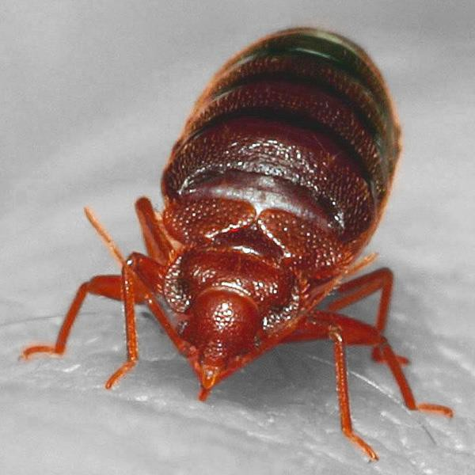

Figure 1. Adult *Cimex lectularius* engorged after a blood meal. Image obtained from wordpress.org under a CC BY-SA 2.0 license.

Subspecies: There are no known subspecies for *Cimex lectularius*, however, it is often mistaken for *Cimex hemipterus*, a closely related species of bed bug that is also common in the tropical regions of Australia. *C. lectularius* typically ranges in size from 2-8 mm and has a red-brown exoskeleton.

Taxonomic reference: Linnaeus, C. (1758). *Systema Naturae per regna tria naturae, secundum classes, ordines, genera, species, cum characteribus, differentiis, synonymis, locis*. Editio decima, reformata [10th revised edition], vol. 1: 824 pp. Laurentius Salvius: Holmiae.

Recent overview of suborder: Henry, T. J. (2009). Biodiversity of Heteroptera. *Insect Biodiversity: Science and Society* (ed. by R. G. Foottit and P.H. Adler), pp. 223-263. Blackwell Publishing, Oxford.

# Transport, Storage, and Disposal

- *Cimex lectularius* live insects (insecticide susceptible) will be imported from a commercial

(Cimex Store Ltd; www.cimexstore.co.uk) breeding facility located in London, UK,

directed by the entomologist Dr Richard Naylor.

* *Cimex lectularius* will only be used for research purposes. We will be studying their behavioural response to chemical, mechanical, and other environmental stimuli.
* All consignments containing live bed bugs will be labelled “ATTENTION DEPARTMENT OF

AGRICULTURE, WATER AND THE ENVIRONMENT – LIVE INSECTS UNDER QUARANTINE”

and will state the approximate number and species of insect within. Bed bugs (*Cimex lectularius*) will be packaged in new, insect-proof, and crush-resistant containers that are sealed within an outer package. The space between the insect container and outside package will be filled with shredded paper or inflatable plastic cushion to lower any risk of the inner population container from movement and subsequent damage. To facilitate clearance, all shipments will have the documentation securely attached to the outside of the package with a clear label marked “ATTENTION QUARANTINE”. All transport, handling, and labelling of insects will comply with the International Air Transport Association (IATA) regulations and permit requirements issued by the Department of the Environment, and Biosecurity Australia. All original packaging and imported host material will be frozen after processing within our quarantine approved insectary then sent to an outside facility for incineration.

* The bed bugs will be housed in our insectary at

that complies with the requirements set out by

the Department of Agriculture.

* In the extremely unlikely scenario that animals are found outside of the Approved Arrangement (AA) facility, the facility manager will be informed immediately to fortify the risk mitigation procedure to all staff who have access to this facility.
* *C. lectularius* are particularly susceptible to freezing temperatures. Short-term exposure (1 hour) to a temperature range of -16 to -18°C has been shown to be a highly effective disposal method resulting in mortality at every life stage for *C. lectularius* (Benoit, 2011). Surplus animals will thus be killed either by freezing at -18 °C for a minimum of 72 hours or by heating to 90°C for one hour in sealed plastic containers inside the AA facility. At the end of their use, all containers and harbourages will be frozen for at minimum 72 hours then brought outside of the facility to be incinerated.

# Previous Risk Assessments

* Bed bugs are not considered internationally as a harmful pest species. The list of species that are considered invasive in various regions in the world can be found from the website of the United States Department of Agriculture (https://[www.invasivespeciesinfo.gov/terrestrial/invertebrates).](http://www.invasivespeciesinfo.gov/terrestrial/invertebrates)) *C. lectularius* is not named on this list.
* Bed bugs are considered cosmopolitan and occur worldwide but are particularly common in Britain, Asia, the United States, and Australia. As well as rising in many other nations, bed bug infestations here in Australia have undergone a dramatic rise in the last few decades (Stephen L. Doggett et al., 2004, 2012; Lilly et al., 2018).
* *C. lectularius* is classified as a native species in the Atlas of Living Australia and is thought to have been first introduced with the early European colonialists in the 18th century (Stephen L. Doggett, 2005; Woodward et al., 1970).

# Potential Environmental Impact

* The impacts of release of *Cimex lectularius* on the Australian environment are considered very little, especially considering that they are already present and established here.
* There are currently no definitive reports of human or bird pathogens being transmitted by bed bugs (Basnet & Kamble, 2019; Zorrilla-Vaca et al., 2015).
* Bed bugs feed exclusively on animal blood, mainly humans and mammals, posing some risk to commercial poultry farming. Severe parasite loads have been shown to result in a decrease in egg production and feather loss in poultry farms across the United States of America (Krinsky, 2019; Tabler et al., 2015).
* *C. lectularius* does not consume plant material nor is expected to compete with any native animal species for the same food sources.

# Potential Conditions or Restrictions on Import

Potential negative impacts from the importation of *C. lectularius* can be reduced by following correct importation and quarantine practices. Below, we outline potential conditions or restrictions that may be applied to reduce the potential for any negative environment l impacts:

* Firstly, limitation of the import of *C. lectularius* to a secure facility. One way to reduce the risk of escape and establishment of feral populations is to import them to a secure facility where multiple containment measures and cleaning protocols are maintained. Periodic application of pesticide to the surrounding handling areas will also be conducted should any bed bugs have escaped their containment within the facility.
* Limiting the import of *C. lectularius* from specified breeding facilities. To maintain high quality and safety standards to ensure that the high standards of importation packaging and labelling are met (see Importation and Disposal section above for detail).
* Careful management of breeding of imported *C. lectularius*. To efficiently and humanely regulate bed bug population numbers, all excess individuals will be frozen or heated (details also stated above) in sealed containers, then sent to an external facility for incineration.
* The importation of eggs of *C. lectularius* rather than live bed bugs. The importation of any live animal comes with a risk of escape which is particularly true of live insects where many individuals are typically required. The risk of escape is greatly reduced if eggs are imported rather than live adults. Secondly, eggs are more robust to temperature fluctuations when compared to adults during transit meaning that mortality is also reduced.
* Only importing insecticide susceptible strains of *C. lectularius*. Many strains of bed bugs have become resistant to commercial pesticides making eradication difficult. To avoid causing a persistent outbreak, importation of bed bug will be restricted to strains that are susceptible to Australian approved insecticides/pesticides. Additionally, no genetically modified strains will be imported.

# Summary of Proposed Activities

## Import Purpose

The purpose of importing live bed bugs into Australia is for use on a research project that aims to develop a device for bed bug detection (monitoring) to enable early eradication of wild populations. All imported bed bugs will be utilised in controlled laboratory experiments to examine the following:

* Quantify the efficacy of our device to attract and detect *C. lectularius*.
* Optimise best-use procedure of our device.
* Understand olfactory behaviour and biology of *C. lectularius.*

-

university researchers.

will be the primary researcher with links to both industry and

* Individual *C. lectularius* will not be able to be identified or tracked for the import process but will be carefully packaged and labelled as outlined previously.
* *C. lectularius* will be kept in the AA-accredited facility at

Approval for the importation of bed bugs into Australia is also likely to benefit other researchers interested in examining management strategies, and the ecology and biology of *C. lectularius*. Knowledge of the biology and evolutionary ecology of *C. lectularius* is relatively unknown but remains vital for the development of control methods. As already stated, studies suggest that *C. lectularius* is becoming more prevalent in Australia (Stephen L. Doggett et al., 2004; Kim et al., 2017). Without reliable and consistent access to bed bug populations from commercial breeding facilities, however, the ability of researchers to conduct studies that are competitive on the world stage but also relevant to Australian conditions, remains very limited. Currently, to obtain bed bugs in Australia, researchers must rely on collaborations with pest control managers or the public. This method of obtaining study populations is unpredictable and unstable making the establishment of a laboratory-based colony challenging. Additionally, obtaining *C. lectularius* from the wild results in high mortality rates when introduced to laboratory conditions before

populations have time to become adapted to the culturing conditions. This adaptation process and the optimisation of environmental parameters can take many generations increasing both the difficulty and cost of research on this species here in Australia. Commercial breeding facilities and the many academic research groups around the world on the other hand, have already undergone this process of adaptation with their populations. With access to these populations, establishment of a research programme on *C. lectularius* in Australia becomes much less problematic increasing both our ability to understand the behaviour and biology this common pest species but also our capacity to produce innovative solutions for its control.

## Animal Husbandry and Containment Facilities

* The containment facility to be certified was designed based on knowledge from our in- house entomologist and consultation with an external bed bug expert

All specifically built facilities and activities will comply with the requirements set out by the Department of Agriculture, Water and the Environment (DAWE) under an Approved Arrangement (AA).

* Bed bugs will be kept at an average temperature of 28°C, 70% relative humidity, and entrained to a reverse 12:12 hour light/dark cycle to maintain optimal growth and reproduction of populations.
* Primary containment: Bed bugs will be kept in wide-mouthed plastic jars (750 mL) with a lid made from fine nylon mesh to enable gas exchange whilst preventing the escape of specimens. This is a well-established method for housing *C. lectularius* where populations inhabit folded card (herein referred to as harbourage) within these jars (see an example pictured in Figure 2). This housing method also enables the feeding of populations without having to open the containers, further decreasing the risk of any outbreak events.
* Secondary containment: A large (666mm x 469 mm x 459 mm), sealed box where the population jars of bed bugs will be kept. To prevent any bed bugs from climbing out in the scenario that any insects have escaped their primary containment (i.e., tear in nylon mesh lid) the walls of this secondary containment will be coated in a slippery coating of

Teflon (PTFE) spray and lined with double sided tape around the top perimeter (both replenished periodically).

* Tertiary containment: A hydroponic airtight indoor grow tent (1200mm x 1200mm x 2000mm) equipped with stainless steel bench where all experimentation will be conducted.
* Both secondary and tertiary containment mechanisms will be inspected periodically to confirm the integrity of primary population jars.
* All handling, sorting, and feeding of populations will be conducted within Teflon coated trays to prevent and minimise the risk of a bed bug outbreak.
* All areas where bed bugs are handled will be restricted, only allowing access to qualified staff and personnel. Staff handling bed bugs will strictly adhere to using the appropriate PPE, safety protocols, along with periodic cleaning and inspection of all surfaces and instruments with 80% Isopropyl alcohol (acts as a desiccant to kill both eggs and adults).
* Insecticide/pesticide will be applied to areas within handling facility periodically by a qualified pest controller.

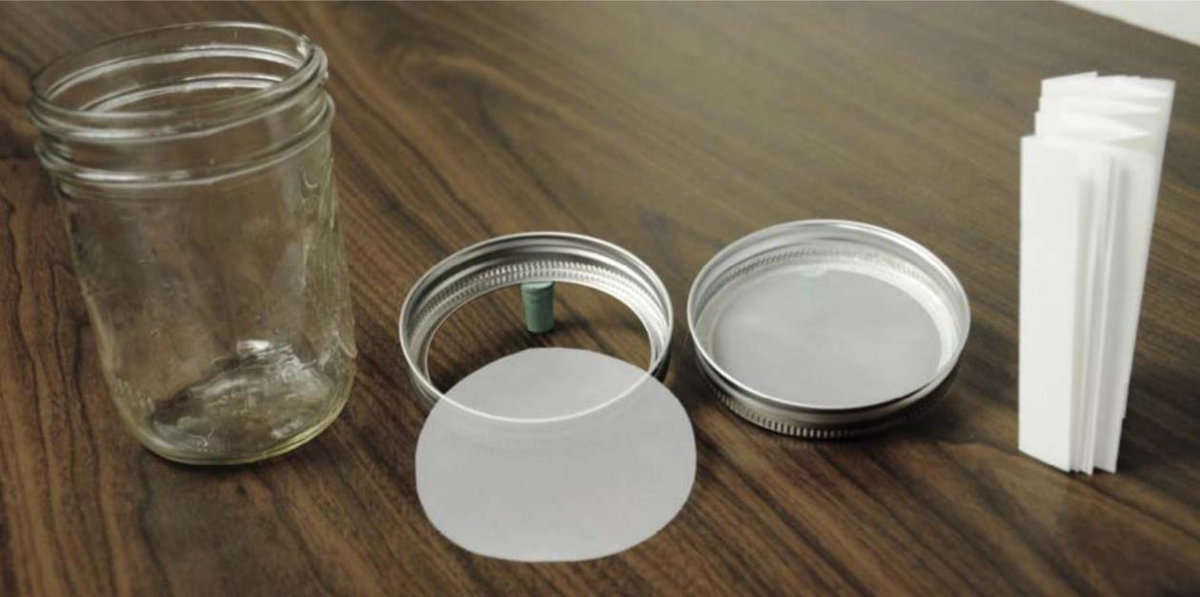

Figure 2: Example of bed bug container (left), nylon mesh lid, and harborage (on right). Photo sourced from Feldlaufer et al., (2014).

* 1. **Commonwealth, State, and Territory Legislative Controls on *Cimex lectularius***

There are no Commonwealth, state, or territory legislative controls on *C. lectularius*. *C. lectularius* must be added to the DAWE’s “List of Specimens Suitable for Live Import (Requiring an Import Permit)” before an appropriate permit can be applied for. Import and containment conditions are specified throughout this import permit. See additional sources of information produced by several government agencies below:

* Department of Health & Human Services, State Government of Victoria, Australia mentions bed bugs as a common pest and discusses methodologies for the control of bed bugs ([www.health.vic.gov.au/environmental-health/bedbugs-pest-control).](http://www.health.vic.gov.au/environmental-health/bedbugs-pest-control))
* The NSW Health bed bug information page ([www.health.nsw.gov.au/environment/pests/parasites/Pages/bed-bugs.aspx)](http://www.health.nsw.gov.au/environment/pests/parasites/Pages/bed-bugs.aspx)) states that “bed bugs are not considered as a public health hazard” and references the Bed Bug Code of Practice ([www.aepma.com.au/Resources/PageContent/Files/e83423e3-5d65-](http://www.aepma.com.au/Resources/PageContent/Files/e83423e3-5d65-) 4908-a9a7-e44a24b755c2.pdf) produced by the Department of Medical Entomology at Westmead Hospital.
* The Review, Risk Assessment and Management of Introduced Animals in the Tasmanian Wilderness World Heritage Area by the Department of Primary Industries, Parks, Water and Environment states that *Cimex lectularius* is of negligible risk requiring no management actions ([www.nre.tas.gov.au/Documents/Nature-Conservation-Report-](http://www.nre.tas.gov.au/Documents/Nature-Conservation-Report-) 10-01.pdf).

# Species Status Under International Conventions

## Convention on International Trade in Endangered Species of Wild Fauna and Flora (CITES)

*Cimex lectularius* is not listed in any of the appendix of CITES.

## International Union for the Conservation of Nature (IUCN) Red List Conservation Status

*Cimex lectularius* is not listed on the IUCN Red List.

## Convention on the Conservation of Migratory Species of Wild Animals (CMS)

*Cimex lectularius* is not listed on the CMS.

# Ecology

## Morphology

*Cimex lectularius* are wingless brown insects having a flattened body when unfed and are roughly oval in shape (Doggett et al., 2004). Generally, adults are 5-6mm long, but body size is dependent on sex and life stage (Figure 3). Generally, females are larger and have a rounder abdomen than males (Saari et al., 2019). The life stage and blood feeding behaviour of *C. lectularius* also influences their appearance. Both adults and juveniles can range from pale- to dark-brown when unfed to dark red to brown when fully fed. Fully fed individuals become elongated to accommodate a blood meal. *C. lectularius* has a proboscis that is used for piercing and sucking a blood meal.

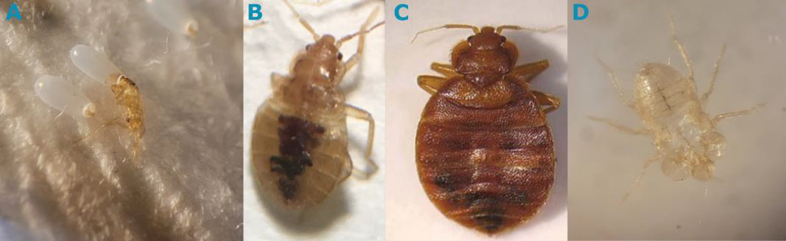

Figure 3: Life stages of *Cimex lectularius*. (A) shows two eggs, one of which has a freshly hatched nymph exiting the egg case, (B), a 3/4 instar juvenile, (C) a full-grown adult (female) and (D) a shed exoskeleton.

## Lifecycle and Longevity

*C. lectularius* has five juvenile life stages, also known as instars (Figure 4), where each nymph is a miniature version of the adult stage but without fully developed genitalia (meaning they are reproductively inactive). In warm conditions (~23°C) it takes approximately two months to develop from egg to adult. The length of the lifecycle, however, can be highly variable (Benoit, 2011; Usinger, 1966) and is dependent on a number of factors including the availability of blood meals, temperature, humidity, and population density (Stephen L. Doggett et al., 2004). Typically, adults live up to 4.5 months (Busvine, 1980) but some reports suggest that bed bugs can live for up to two years without access to blood as long as other conditions are optimal (Benoit, 2011; How & Lee, 2010a; How & Lee, 2010b; Usinger, 1966). Since nymphs need a continuous feeding schedule for developing from one stage to next, they are more susceptible to mortality without food (Reinhardt & Siva-Jothy, 2007).

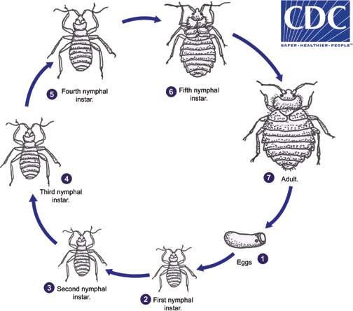

Figure 4: Complete lifecycle of bed bugs and representation of different stages. Image source: https:/[/www](http://www.cdc.gov/parasites/bedbugs/biology.html).[cdc.gov/parasites/bedbugs/biology.html.](http://www.cdc.gov/parasites/bedbugs/biology.html)

## Natural Geographic Range

*C. lectularius* first appeared in the fossil record 115 million years ago and have been known as a human ectoparasite since the beginning of recorded history (Usinger, 1966). *C. lectularius* has a worldwide distribution and is particularly common in large cosmopolitan cities where tourism is high. In many industrialised countries (i.e., USA, Canada, Spain, France, and Australia) outbreaks of bed bugs have seen a recent resurgence likely because many strains have developed a resistance to conventional insecticides such as dichlorodiphenyltrichloroethane (DDT) (Hwang et al., 2005). Bed bug distributions in developing nations, on the other hand, (i.e., Africa, South Asia, and Central America) remain poorly documented (Zorrilla-Vaca et al., 2015).

## Habitat

*C. lectularius* thrive at temperature ranges between 20 – 30 °C and at relatively high humidity (> 70%). Due to their hematophagous life history, bed bugs are attracted to body heat, human scents, and carbon dioxide released from breathing (Stephen L. Doggett et al., 2012). Bed bugs live close to their host, preferring to aggregate in dark and spatially restricted crevices (i.e., along the seams of mattresses, travelling bags, old clothes, and furniture) but are also thigmotactic, preferring textiles and natural fibres over smooth surfaces such as plastic. This harbourage seeking behaviour makes bed bug infestations particularly difficult to diagnose. Whilst the bed is mostly known to be associated with humans, populations of *C. lectularius* are also still known to coexist with their ancestral hosts, bats within cave systems across the old world (Doggett et al., 2018; Usinger, 1966).

## Feeding Behaviour

Bed bugs are obligately hematophagous insects requiring a blood meal for reproduction and development and typically feed during periods of minimal host activity (Reinhardt & Siva-Jothy, 2007). In the absence of humans, *C. lectularius*, will also feed on mice, rats, chickens and other warm-blooded animals (Rozendaal, 1997). Our populations will be fed using exogenous blood supplies (heparinised sheep’s blood) using specialised glassware.

## Social Behaviour and Groupings

*C. lectularius* are group living sub-social ectoparasites that aggregate when not feeding on a host. Aggregation is crucial for mating and is seen amongst all stages of bed bugs (Reinhardt & Siva-

Jothy, 2007). *C. lectularius* release several chemical pheromones which are recognized by mechanoreceptors on their antennae to detect one another and form aggregations (Weeks et al., 2020).

## Territorial and Aggressive Behaviour

This species is not territorial, nor does it exhibit aggressive behaviour towards humans.

## Natural Predators

*Ploiaria domestica, Monomorium pharaonis and Thanatus flavidus* are known to be predacious of bed bugs (Usinger, 1966).

## Characteristics That May Cause Harm

*Cimex lectularius* are known to be a pest but are not currently known to spread any infectious diseases to humans but can cause allergic reactions. They have, however, recently been shown to infest poultry farms in the USA decreasing egg production (Doggett et al., 2012).

# Reproductive Biology

## Age at Sexual Maturity

Sexual maturity occurs after completion of 5th nymphal stage where the bed bugs molt into an adult with reproductive organs (Reinhardt & Siva-Jothy, 2007). With a continuous source of blood meals and ambient conditions, this requires approximately 4-6 weeks from egg to adult.

## Breeding Frequency

Bed bugs have a unique mode of copulation commonly referred to as traumatic insemination where the male pierces the female abdominal cuticle with his needle-like intromittent organ and inseminates directly into her body cavity (Carayon, 1966). Males impose a mating rate on females that far exceeds what is needed to maintain fecundity and results in a significant reduction to female and male lifespan (often in scramble competition to find a mate, males will pierce each other) (Reinhardt & Siva-Jothy, 2007).

## Sperm Storage

Female bed bugs can store sperm for weeks and often disperse from the aggregating colony in search of new hosts or to start a new infestation (Balvín et al., 2019).

## Eggs per Breeding Event

Egg production begins approximately 2-5 days after the female has a blood meal. With sufficient blood meal at ambient environmental conditions, female *C. lectularius* can lay 5-8 eggs per week for 18 weeks (Doggett et al., 2012).

## Hybridisation

*Cimex hemipterus* and *Cimex lectularius* share common hosts, are closely related species, and both occur in Australia. Interspecific mating between both these species has been observed both in the laboratory environment and in the field, however, most eggs produced have been sterile (Newberry, 1989; Walpole & Newberry, 1988). In one study only 0.2 % of eggs laid were fertile and capable of producing a hybrid (Newberry, 1988) suggesting that reproductive isolation is significantly advanced between these two species. Mating barriers have even been observed within *C. lectularius* that differ in the host species that they parasitize resulting in no egg production (Wawrocka et al., 2015). There is no evidence or suggestion that *C. lectularius* is likely to form any viable hybrids with other Hemipterids within Australia.

## Parthenogenesis or Sequential Hermaphroditism

*C. lectularius* are not capable of parthenogenesis or are known to exhibit sequential hermaphroditism (Doggett et al., 2018; Usinger, 1966).

# References

Balvín, O., Chajma, P., & Naylor, R. (2019). Age structure of bed bug (Heteroptera: Cimicidae) aggregations affects the nymphal feeding success. *Parasites and Vectors*, *12*(1), 1–5. https://doi.org/10.1186/s13071-019-3659-5

Basnet, S., & Kamble, S. T. (2019). Advances in Molecular Research on Bed Bugs (Hemiptera: Cimicidae). *Journal of Entomological Science*, *54*(1), 43–53. https://doi.org/10.18474/JES18- 30

Benoit, J. B. (2011). Stress tolerance of bed bugs: A review of factors that cause trauma to cimex lectularius and C. hemipterus. *Insects*, *2*(2), 151–172. https://doi.org/10.3390/insects2020151

Busvine, J. R. (1980). *Insects and Hygiene: The biology and control of insect pests of medical and domestic importance* (3rd ed.). Springer. https://doi.org/https://doi.org/10.1007/978-1- 4899-3198-6

Carayon, J. (1966). Paragenital System, in Monograph of the Cimicidae (Hemiptera – Heteroptera). In R. L. Usinger (Ed.), *Monograph of Cimicidae (Hemiptera-Heteroptera)* (pp. 81– 167). Entomological Society of America.

Doggett, Stephen L., Miller, D. M., & Lee, C. (2018). *Advances in the Biology and Management of Modern Bed Bugs*. John Wiley & Sons.

Doggett, Stephen L. (2005). Bed bug ecology and control. *Conference: Peset of Disease and Unease, At Westmead Hospital, Sydney*, 1–67.

Doggett, Stephen L., Dwyer, D. E., Peñas, P. F., & Russell, R. C. (2012). Bed bugs: Clinical relevance and control options. *Clinical Microbiology Reviews*, *25*(1), 164–192. https://doi.org/10.1128/CMR.05015-11

Doggett, Stephen L., Geary, M. J., & Russell, R. C. (2004). The resurgence of bed bugs in Australia: with notes on their ecology and control. *Environmental Health*, *4*(2), 30–38.

Feldlaufer, M., Harlan, H., & Miller, D. (2014). Laboratory Rearing of Bed Bugs. *Rearing Animal and Plant Pathogen Vectors*, *May*, 118–130. https://doi.org/10.1201/b16804-6

How, Yee Fatt, & Lee, C. Y. (2010a). Effects of temperature and humidity on the survival and water loss of Cimex hemipterus (Hemiptera: Cimicidae). *Journal of Medical Entomology*, *47*(6), 987–995. https://doi.org/10.1603/ME10018

How, Y. F., & Lee, C. (2010b). Fecundity, nymphal development and longevity of field-collected tropical bedbugs, Cimex hemipterus. *Medical and Veterinary Entomology*, *24*(2), 108–116. https://doi.org/10.1111/j.1365-2915.2010.00852.x

Hwang, S. W., Svoboda, T. J., De Jong, I. J., Kabasele, K. J., & Gogosis, E. (2005). Bed bug infestations in an urban environment. *Emerging Infectious Diseases*, *11*(4), 533–538. https://doi.org/10.3201/eid1104.041126

Kim, D. Y., Billen, J., Doggett, S. L., & Lee, C. Y. (2017). Differences in Climbing Ability of Cimex lectularius and Cimex hemipterus (Hemiptera: Cimicidae). *Journal of Economic Entomology*, *110*(3), 1179–1186. https://doi.org/10.1093/jee/tox039

Krinsky, W. L. (2019). True Bugs (Hemiptera). *Medical and Veterinary Entomology*, 107–127. https://doi.org/10.1016/B978-0-12-814043-7.00008-X

Lilly, D. G., Dang, K., Webb, C. E., & Doggett, S. L. (2018). Are Australian field-collected strains of Cimex lectularius and Cimex hemipterus (Hemiptera: Cimicidae) resistant to deltamethrin and imidacloprid as revealed by topical assay? *Austral Entomology*, *57*(1), 77–84. https://doi.org/10.1111/aen.12268

Newberry, K. (1988). Production of a hybrid between the bedbugs Cimex hemipterus and Cimex lectularius. *Medical and Veterinary Entomology*, *2*, 297–300. https://doi.org/https://doi.org/10.1111/j.1365-2915.1988.tb00199.x

Newberry, K. (1989). The effects on domestic infestations of Cimex lectularius bedbugs of interspecific mating with C. hemipterus. *Medical and Veterinary Entomology*, *3*, 407–414. https://doi.org/https://doi.org/10.1111/j.1365-2915.1989.tb00248.x

Reinhardt, K., & Siva-Jothy, M. T. (2007). Biology of the bed bugs (Cimicidae). *Annual Review of Entomology*, *52*(August), 351–374. https://doi.org/10.1146/annurev.ento.52.040306.133913

Rozendaal, J. A. (1997). Bedbugs, fleas, lice, ticks and mites. In *Control: Methods for Use by Individuals and Communities* (pp. 237–241). WHO.

Saari, S., Näreaho, A., & Nikander, S. (2019). Insecta. *Canine Parasites and Parasitic Diseases*, 159– 185. https://doi.org/10.1016/B978-0-12-814112-0.00008-8

Tabler, T., Loftin, K. M., Farnell, M., Wells, J. B., & Yakout, H. M. (2015). *Bed bugs: Difficult pests to control in poultry breeder flocks*. Mississippi State University Extension Service.

Usinger, R. L. (1966). Monograph of Cimicidae (Hemiptera – Heteroptera). *Entomological Society of America*.

Walpole, D. E., & Newberry, K. (1988). A field study of mating between two species of bedbug in northern KwaZulu, South Africa. *Medical and Veterinary Entomology*, *2*, 293–296. https://doi.org/https://doi.org/10.1111/j.1365-2915.1988.tb00198.x

Wawrocka, K., Balvín, O., & Bartonička, T. (2015). Reproduction barrier between two lineages of bed bug (Cimex lectularius) (Heteroptera: Cimicidae). *Parasitology Research*, *114*(8), 3019– 3025. https://doi.org/10.1007/s00436-015-4504-1

Weeks, E. N. I., Logan, J. G., Birkett, M. A., Caulfield, J. C., Gezan, S. A., Welham, S. J., Brugman, V. A., Pickett, J. A., & Cameron, M. M. (2020). Electrophysiologically and behaviourally active semiochemicals identified from bed bug refuge substrate. *Scientific Reports*, *10*(1), 4590. https://doi.org/10.1038/s41598-020-61368-6

Woodward, T. E., Evans, J. W., & Eastop, V. F. (1970). Hempitera. In *The Insects of Australia*. CSIRO, Melbourne University Press.

Zorrilla-Vaca, A., Silva-Medina, M. M., & Escandón-Vargas, K. (2015). Bedbugs, Cimex spp.: Their current world resurgence and healthcare impact. *Asian Pacific Journal of Tropical Disease*, *5*(5), 342–352. https://doi.org/10.1016/S2222-1808(14)60795-7