

CAM Assessment

Short-tail Galaxias

*Galaxias brevissimus*

**Assessment outcome:** CRITICALLY ENDANGERED

**Category:** IUCN category criteria **B1ab(iii, iv)**

The Fisheries Scientific Committee, established under Part 7A of the *Fisheries Management Act 1994* (the Act), has assessed the ***Galaxias brevissimus* (Short-tail Galaxias)** under the Common Assessment Method and has determined that it is eligible to be listed as a **CRITICALLY ENDANGERED SPECIES** in Part 1 of Schedule 4 of the Act.

## Species information and status

1. **Species: *Galaxias brevissimus* (Short-tail Galaxias)**
2. **Taxonomy**

*Galaxias brevissimus* Raadik, 2014 (Raadik 2014)– Short-tail Galaxias (family Galaxiidae) is a valid, recognised taxon and is a species as defined in the Fisheries Management Act 1994.

*Galaxias brevissimus* was initially considered part of *Galaxias olidus* Günther, 1866. Genetic analysis found 15 genetically-defined candidate taxa which were then found to be morphologically discernible from each other (Raadik 2011, Adams *et al*. 2014). Consequently *G. olidus* sensu lato (s.l.) is now known to comprise a hyper-cryptic species complex of distinct species, all valid under multiple species concepts (Raadik 2014). This grouping of species is herein referred to as the ‘*Galaxias olidus* complex’, or ‘upland galaxiids’.

1. **Current conservation status**

|  |  |  |  |
| --- | --- | --- | --- |
| Jurisdiction | State / Territory in which the species is listed | Date listed or assessed (or N/A) | Listing category known |
| International (IUCN Red List) | IUCN | 2019 | Critically Endangered [A3ce, B1ab(i,ii,iii,iv,v)] |
| National (EPBC Act) | Not listed | Not listed | N/A |
| National (Australian Society for Fish Biology) | Not listed | 2014 | Critically Endangered |
| State / Territory | NSW: not listed | Not listed | N/A |

1. **Description of species**

*Galaxias brevissimus* belongs to the Galaxiidae family, a widespread freshwater fish family of southern-temperate affinity (McDowall 2006, Raadik 2014). It is morphologically very similar to other species of the *Galaxias olidus* complex.

*Galaxias brevissimus* has an average length to caudal fork (LCF) of 70–75 mm but can grow to 97 mm, and has the shortest caudal peduncle and caudal fin compared to other members of the *G. olidus* complex (M. Lintermans, University of Canberra, unpublished data; Raadik 2014). The species is predominantly brown on the back and upper sides, overlain by small to moderately large, irregularly shaped, dark brown to black abundant blotches and spots (Raadik 2014).

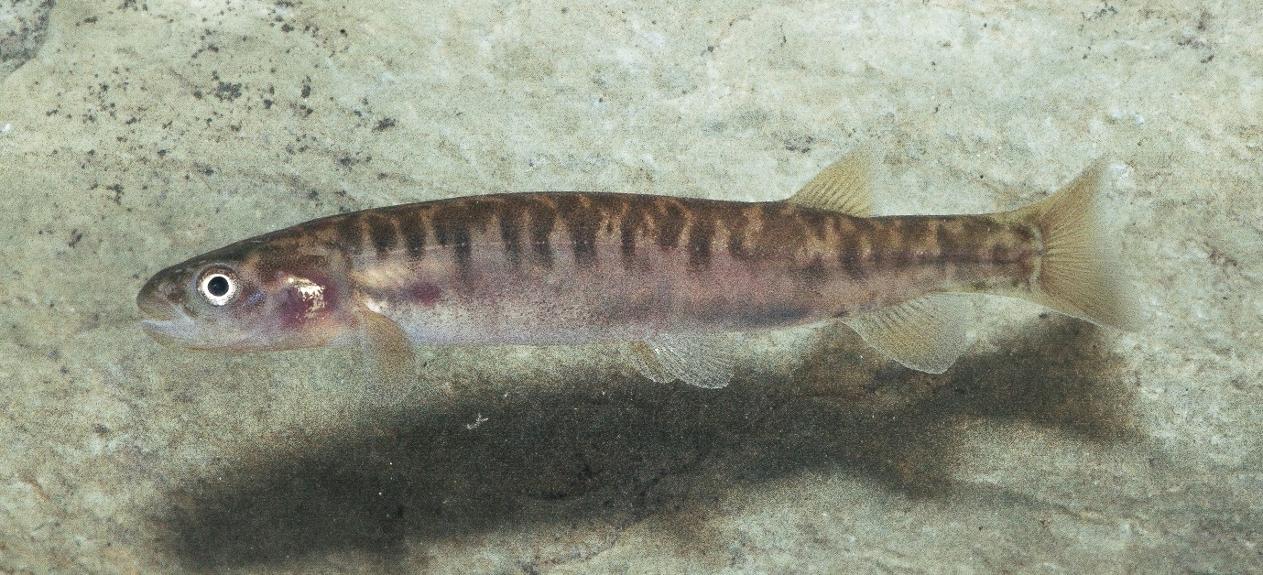

Figure 1. *Galaxias brevissimus* (Tarmo A. Raadik)

1. **Distribution of species**

*Galaxias brevissimus* is known only from the upper reaches of the Tuross River system (above 900m ASL) in southern coastal New South Wales. There are four known localities of *G. brevissimus*. In each of these localities, the species is patchily distributed and known from only a limited number of sites.

The historic distribution of *G. brevissimus* is unknown but the species is considered to have been historically more widespread, extending a considerable distance further downstream in the Tuross River Catchment before predatory trout likely reduced and fragmented its range (Raadik 2014, Lintermans & Raadik 2019)..

Using all available observation records, the Extent of Occurrence (EOO, IUCN Standards and Petitions Committee 2022) of *G. brevissimus* is 29 km2 and the Area of Occupancy (AOO, IUCN Standards and Petitions Committee 2022) is 24 km2 (Figure 1), using the recommended 2 x 2 km grid methodology in GeoCAT (Bachman et al. 2011, IUCN Standards and Petitions Committee 2022).

1. **Relevant biology/ecology of the species**

The biology and ecology of *G. brevissimus* is not well known. However, it is recognised that the species will likely possess characteristics consistent with other species that comprise the *G. olidus* complex. For instance, *G. brevissimus* is a freshwater fish and like all species of the *G. olidus* complex, is not considered to undertake a diadromous migration (Berra 1973; M. Lintermans, University of Canberra, unpublished data). The generation length of the species is estimated at ~3 or 4 years (Lintermans & Raadik 2019) although information on age at maturity and longevity is unknown. Reproduction and spawning is largely unknown, but spawning is thought to occur in late winter or early spring as is documented for other species of the *G. olidus* complex (O'Connor & Koehn 1991, Shirley & Raadik 1997, Dexter et al. 2014, Raadik 2014). In support, spent individuals (indicating recent spawning) were observed during late winter 2021 at one locality (M. Lintermans, University of Canberra, unpublished data). Like other species in the *G. olidus* complex, spawning is suspected to occur on the underside of rocks in riffles where water flow ensures eggs remain clear of sediment and are well oxygenated (O'Connor & Koehn 1991, Raadik et al. 2010, Stoessel et al. 2015, Allan et al. 2021). Similar to *G. olidus,* the upper thermal tolerance (33 °C) anticipated to be impaired by reductions in dissolved oxygen and mild exposure to ash and sediment (Cramp et al. 2021; Mulvey 2021)

The diet of *G. brevissimus* is unknown, but it can confidently be assumed to be a macro-invertivore, as are other species of the *G. olidus* complex (Cadwallader et al. 1980, Closs 1994, Lintermans 2007). Insect fall from riparian vegetation can be an important dietary component for the closely-related *G. olidus* (Cadwallader et al. 1980) and this also may be the case for *G. brevissimus.*

1. **Indigenous significance of the species**

*Galaxias brevissimus* occurs within the country of the Ngarigo and Yuin (Walbanga)(AIATSIS 2021), but the cultural significance of the species is undocumented*.*

Given the acknowledged importance to Aboriginal peoples of Connection to Country and the widespread importance of Caring for Country (which includes biodiversity, ‘place’, custom and totemic elements) it is considered likely that the species has or is associated with some cultural and/or community significance. The significance of the ecological community, particular species, spiritual and other cultural values are diverse and varied for the many Indigenous peoples that live in the area and care for Country. Such knowledge may be only held by Indigenous groups and individuals who are the custodians of this knowledge.

1. **Habitat requirements of the species**

*Galaxias brevissimus* have been recorded from two differing stream types. The Jibolaro, Guinea and Lantooley creeks are generally narrow (0.5–3 m, occasionally to 5–6 m in Guinea Creek pools), gently flowing and of moderate turbidity and depths of up to 0.3–1.5 m (Figure 3). The species is predominantly found in pools connected by short sections of shallow riffles, the substrate is generally clay overlain by fine and coarse sand and sediment. Habitat at these localities has been highly modified through clearing for grazing and agriculture, which may influence instream habitat by reducing stream shading and increased sedimentation. Riparian vegetation at all three localities has been cleared and consists of pasture and tussock grass, with occasional patches of native Eucalypt forest. By comparison, Bumberry Creek is a narrow, moderate velocity stream flowing through a deeply-incised valley in a steep gradient native Eucalypt forest in Wadbilliga National Park. Here the stream substrate is dominated by bedrock/boulder/cobble with fine and coarse sand in shallow pools. Stream width and depth is 1–3.5 m and 0.15–0.75 m, respectively (M. Lintermans, University of Canberra, unpublished data). The preferred spawning habitat for this species is unknown.

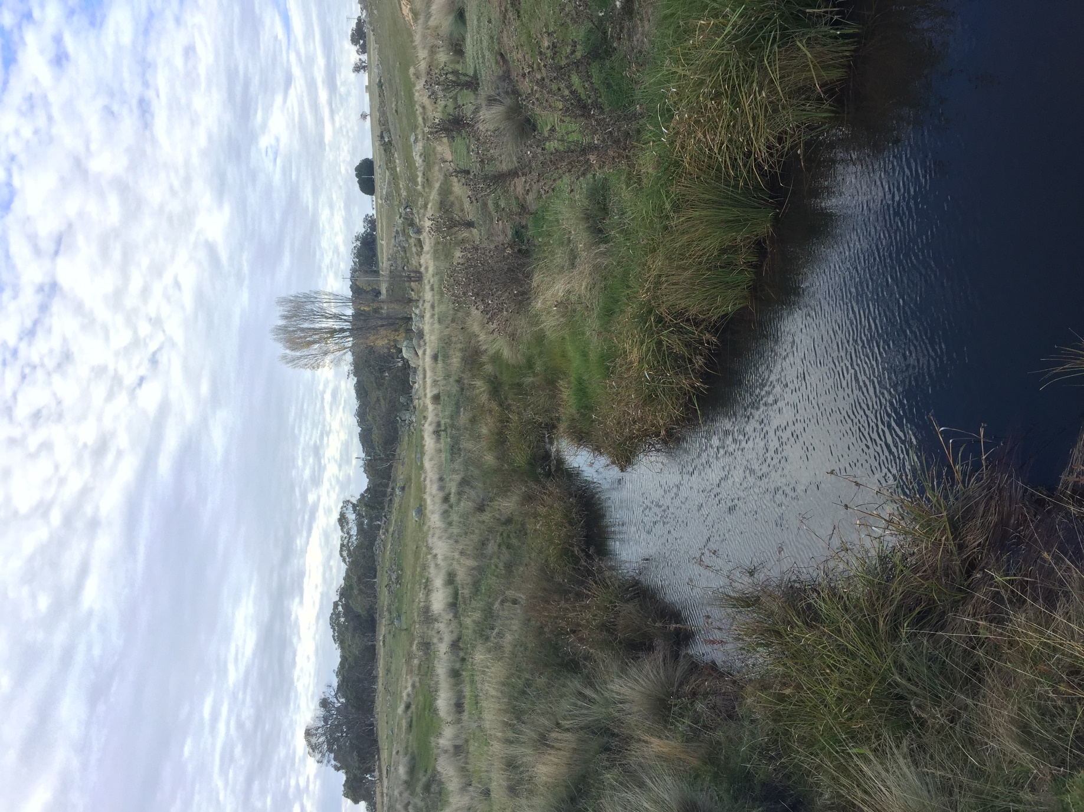

Figure 3. Representative habitat for *Galaxias brevissimus* © Copyright, Mark Lintermans.

1. **Threats and level of risk to the species**

*Galaxias brevissimus* faces similar threats to other species in the mountain galaxias complex (Raadik 2014, Lintermans & Raadik 2019, Lintermans et al. 2020). Climate change induced intensification of bushfires, changes to water availability and extreme weather events represent emerging threats. The introduction and establishment of invasive salmonid fishes, particularly the Brown Trout (*Salmo trutta*) and Rainbow Trout (*Oncorhynchus mykiss*), into waterways that support the species, poses serious threat.

|  |  |  |
| --- | --- | --- |
| Threats | | |
| Threat | Extent | Impact |
| Climate change | | |
| Increased intensity and frequency of bushfires | **Status**: Current/Future  **Confidence**: High  **Consequence**: Severe  **Trend**: Increasing  **Extent**: Across entire range | The frequency and magnitude of bushfires is predicted to increase under climate change scenarios ((Di Virgilio et al. 2019). For the South East and Tableland region of NSW, average fire weather and severe fire weather days are projected to increase during summer and spring (NSW OEH 2014).  Bushfires pose potentially devastating consequences for aquatic ecosystems and species (Gomez Isaza et al. 2022, Legge et al. 2022). Aquatic habitats within the fire footprint can alter the physiochemical properties of the water, including causing extreme temperature of the water in the small streams that these fish inhabit, leading to mortality of fish (Raadik et al. 2010). Storm events following fire usually result in significant inputs of ash and sediment to streams which severely impact aquatic habitats (Ward et al. unpublished data). Post-fire sedimentation can impact waterways 50‒80 km downstream of the burnt area (Lyon & O'Connor 2008, Silva et al. 2020) and have severe effects on water quality and aquatic fauna including threatened fish and crayfish (Cramp et al. 2021, Legge et al. 2021, Gomez Isaza et al. 2022, Ward et al. unpub data). Ash and sediment inputs smother stream substrates, alter water chemistry, alters riparian shading and organic inputs. Post-fire rainfall impacts on aquatic habitats from high severity fire can significantly alter fish habitat and severely reduce local fish populations within a single generation. The spatial extent of the threat from fires is not fixed for any one fire, and will vary with ignition point, fuel loads, antecedent climatic conditions (e.g. rainfall/drought) and weather variables.  The 2019-20 bushfires impacted the species, with Ward et al. (unpub data) predicting increased sedimentation over almost half of the range of *G. brevissimus*, and onground impacts were noted (M. Lintermans, University of Canberra, unpublished data) and emergency rescues were undertaken in some cases (Shelley et al. 2021)  A single bushfire has the capacity to impact the entire population of this restricted range species, potentially leading to a population decline across the species’ range, or extirpation of the species. |
| Increased and more severe droughts decrease habitat quality and availability | **Status**: Current/Future  **Confidence**: Inferred  **Consequence**: Severe  **Trend**: Increasing  **Extent**: Across entire range | For the South East and Tableland region of NSW, maximum annual temperature is expected to increase by 0.7°C in the near future (2020-39) and 2.1°C longer term (2060-79) (NSW OEH 2014). Furthermore, there will be more hot spells, severe weather and reduced rainfall in areas of the region (NSW OEH 2014).  It is anticipated that this will result in increased and more severe droughts which will decrease the availability and quality of surface water. This will result in loss of instream refuge habitats and increased water temperatures (Raadik et al. 2010). Physiologically, species of the mountain galaxias complex are highly susceptible to such changes in water quality, with an upper thermal tolerance of approximately 33 °C (which declines with reductions in dissolved oxygen) (Mulvey 2021). It is anticipated that this will impose thermal stress on the species as well as impacting key life history processes, particularly when other threats are impacting (such as bushfires). |
| Invasive species | | |
| Introduced salmonids (trout) | **Status**: Historical and Future  **Confidence**: Inferred, but high confidence.  Consequence: Severe  **Trend**: Increasing  **Extent**: Across all of the range | The introduction of predatory trout species is known to have significantly impacted galaxiid populations generally (see McDowall 2006) and is believed to have historically reduced the range of *G. brevissimus* (Adams et al. 2014, Lintermans & Raadik 2019).  Trout species are known to prey upon on Galaxias species (Vidal et al. 2020).  These impacts are anticipated to lead to rapid local extirpation with previous documented declines in galaxiid populations in montane areas following salmonid invasion occurring rapidly, with complete extirpation of *G. olidus* within 3 years of salmonid invasion (Tilzey 1976).  Whilst trout species do not presently coexist with *G. brevissimus*, they have been recorded downstream of at least one known locality (H. Allan & M. Lintermans, University of Canberra, unpublished data; Lintermans & Raadik 2019). While there are some partial barriers to the upstream movement of trout species in the range of *G. brevissimus* (see Allan & Lintermans 2021) their behaviour under high flows remain unknown. Trout species continue to be stocked into areas within the same catchment where *G. brevissimus* occurs (NSW DPI Fisheries, stocking database).  It is plausible that trout may be illegally stocked into or invade localities of the Tuross River Catchment that support *G. brevissimus*, If this occurred, population decline is anticipated to be rapid with local extirpation projected. |
| Habitat loss and modification | | |
| Impacts of land clearing for agricultureon riparian vegetation and water quality. | **Status**: Historical and Future  **Confidence**: Known  **Consequence**: Moderate  **Trend**: Unknown  **Extent**: Most of the range. | Land clearing for agricultural grazing can result in the degradation and removal of stream habitat and vegetation utilised *by G. brevissimus*. Earthworks associated with these land use practices can include soil disturbance and removal or disturbance aquatic and overhanging vegetation. This can potentially lead to erosion, with increased sedimentation and, effluent runoff into waterways containing the species. Rainfall can exacerbate sedimentation and effluent runoff as less canopy and ground vegetation cover is available to capture/intercept rain. Declines in water quality via land clearing can have the similar impacts as that of bushfires (see that threat). |

1. **Eligibility against criteria**

|  |  |  |
| --- | --- | --- |
| FSC assessment of eligibility against the criteria: | | |
| A | Population size reduction | **Category and criteria (or Data Deficient):** Insufficient data.  **Eligibility against the criteria:** There is insufficient data to determine eligibility of *G. brevissimus* for listing under Criterion A.  There is some survey data that suggest population reduction in the species. For instance, at one site in Jibolaro Creek (Tuross Road Bridge), relative abundance was demonstrated to reduce by 100% between 2015 (50 individuals per seine haul) and 2021 (zero individuals) (M. Lintermans, University of Canberra, unpublished data). Similarly in Guinea Creek, relative abundance has also declined over time (M Lintermans, University of Canberra, unpublished data). Further survey effort is required to confirm these temporal trends.  In terms of subcriterion A3, it is projected that there will be a population reduction in the future due to the threat imposed on the species. Namely, a decline in AOO, EOO and quality of habitat is anticipated due to climate change as increasing temperatures and reduced moisture availability, as well as increased frequency and intensity of bushfires (NSW OEH 2014). Declines in habitat quality are projected, similar to those observed in Jibolaro and Guinea creeks between 2016‒17 and 2020 as a result of drought and bushfire and subsequent rain events washing organic material into these streams (M. Lintermans, University of Canberra, unpublished data). Introduced trout species remain a threat, particularly as they continue to be stocked in the vicinity of localities that support *G. brevissimus* (NSW DPI Fisheries, stocking database).  A report by the National Environmental Science Programme (NESP) Threatened Species Recovery (TSR) Hub (Legge et al. 2021) estimated a future population decline of 41 percent in the *G. brevissimus* over the next three generations, within an estimated range of 21 to 76% (bound of 80 percent confidence limit). This was done using a structured expert elicitation process.  The observations of decline from field surveys and the results of the expert elicitation suggest the population is declining at a rate exceeding 30% in 10 years/three generations. However, the estimates of decline have high uncertainty, and it is concluded that there are insufficient data to assess changes in population size under the IUCN criteria |
| B | Geographic range | **Category and criteria (or Data Deficient):** Critically Endangered B1ab(iii, iv).  **Eligibility against the criteria:** *Galaxias brevissimus* occurs across a restricted range in the Tuross River Catchment in New South Wales. The EOO was estimated at 29 km2 and AOO at 24km2 using the recommended 2 x 2 km grid methodology in GeoCAT (Bachman et al. 2011, IUCN Standards and Petitions Committee 2022). The EOO meets the threshold for Critically Endangered listing under B1 whereas the AOO of 24km2 satisfies Endangered under criterion B2.  The species is only known from four localities across two, isolated subpopulations that are considered a single location. The species’ highly restricted distribution at one location leaves it highly vulnerable to extinction following a single stochastic event, with the most plausible threat being a severe bushfire. A single bushfire event has the potential to rapidly affect the entire population of this restricted range species, potentially leading to extinction of the species (IUCN 2019). Accordingly, the species satisfies subcriterion (a) for Critically Endangered listing.  This isolation increases the risk of extirpation of an individual subpopulation through environmental and demographic stochasticity (De Castro & Bolker 2005). Therefore, established, emergent, and future threats (consistent across species that once formed part of the *G. olidus* complex: TSSC 2021) could all potentially rapidly eliminate all specimens in the taxon. In particular, it is inferred that there will be a decline in area, extent and/or quality of habitat due to impacts of climate change (principally more frequent and intense bushfires and extreme weather events, increasing temperature, and trout inclusion) (NSW OEH 2014), which will result in declines in the number of mature individuals, thus satisfying subcriterion (b)(iii, iv).  The data presented above demonstrate that *G. brevissimus* meets the relevant elements of Criterion B to make it eligible for listing as Critically Endangered (B1ab(iii, iv)) under this criterion. |
| C | Small population size and decline | **Category and criteria (or Data Deficient):** Insufficient data.  **Eligibility against the criteria:** There is insufficient information about the total number of mature individuals of this species or any data on the decline in the total number of mature individuals that will allow assessment of *G. brevissimus* for eligibility for listing under Criterion C. |
| DD. | Very small or restricted population | **Category and criteria (or Data Deficient):** Insufficient data.  **Eligibility against the criteria:** The number of mature individuals of *G. brevissimus* is presently unknown, making assessment against Criterion D1 not possible.  The species occurs across a single location, and although AOO is (marginally) greater than 24 km2,it is plausible that future threats could drive the species to Critically Endangered or Extinct in a very short time, and would satisfy the elements of Criterion D2 to make it eligible for listing as D2 Vulnerable. |
| E | Quantitative analysis | **Category and criteria (or Data Deficient):** Insufficient data.  **Eligibility against the criteria:** A quantitative analysis of extinction risk has not been undertaken for the species. Therefore, there are insufficient data to demonstrate if *G. brevissimus* is eligible for listing in any category under this criterion. |

* In 2015 the NSW Government signed an Intergovernmental Memorandum of Understanding on the Agreement on a Common Assessment Method for listing of threatened species and threatened ecological communities (the CAM). The CAM provides a nationally consistent approach to assessing and listing threatened species in Australia, using the IUCN Redlist Categories and Criteria (Version 3.1). To ensure that this Proposed Final Determination meets the requirements under the CAM, an assessment against the IUCN Redlist Categories and Criteria (Version 3.1) has been included. This assessment also reflects the requirements for listing species provided under clause 237 and 238 of the NSW Fisheries Management (General) Regulation 2019.

For more information on the CAM please visit <http://www.environment.gov.au/biodiversity/threatened/cam>

**Fisheries Scientific Committee conclusion pursuant to Section 220F of the NSW Fisheries Management Act 1994**:

It is the opinion of the NSW Fisheries Scientific Committee that *Galaxias breviissimus* is facing an extremely high extinction risk in New South Wales in the near future, as determined in accordance with criteria prescribed by the regulations.

1. **Additional information**
2. **Fisheries Scientific Committee Management Recommendations for *G. brevissimus***

Recommended management and research actions that will benefit the conservation of the species:

* Following fires, implement management responses where possible to prevent/reduce ash and sediment deposition into streams with post-fire rainfall.
* Consider physiological tolerances to post-fire changes in water temperature and water oxygen saturation as triggers for emergency extraction/relocation of fire-affected subpopulations.
* Carry out surveys to identify new populations of the species (to determine contemporary geographic range), to identify sites suitable for future translocations (predator-free or suitable if predators removed), and potential sites for trout barrier installation.
* Establish monitoring to track the trajectory of known populations.
* Extract a portion of each remaining population into ex situ captive management as an insurance against the extinction of the species in the wild.
* Population genetic analysis of current and new subpopulations, to inform genetic management of subpopulations and guide captive breeding and translocation plans.
* Evaluate trout stocking practices (to lessen threat) and undertake predator (trout) removal, if present, from potential translocation sites.
* Assessment of all populations for security from trout incursion: implement annual predator detection and removal for less secure sites, and every 5 years (or following 1: 50-year rainfall events) at other locations.
* Development of a detailed captive breeding plan and undertake breeding.
* Development of a detailed translocation plan and undertake translocations to establish additional, viable populations to spread extinction risk (reintroduction or assisted colonisation) or to bolster populations (reinforcement).
* Study into the species’ ecology (reproduction, growth, longevity, habitat use, age, movement).

1. **Priorities Action Statement**

The NSW Department of Primary Industries Priorities Action Statement (PAS) is a statutory, non-regulatory document addressing each threatened species, population, ecological community and key threatening process (KTP) listed on the schedules of the *Fisheries Management Act 1994*. The PAS provides an agreed list of strategies and actions that will assist to down-grade or de-list species, populations and ecological communities from the threatened species schedules of the *Fisheries Management Act 1994*, as well as actions that will assist to abate or eliminate the impacts of KTPs.

The draft Priorities Action Statement for the *Galaxias brevissimus* is being drafted as part of the NSW listing process and will be available on the NSW DPI Website when finalised at [www.dpi.nsw.gov.au/fishing/threatened-species/priorities-action-statement](http://www.dpi.nsw.gov.au/fishing/threatened-species/priorities-action-statement)

1. **Statement on the standard of scientific evidence and adequacy of survey**

This assessment has been prepared by the Fisheries Scientific Committee in good faith using the highest possible standard of scientific evidence and adequacy of survey.

As prescribed under Section 4 of the Intergovernmental MOU on the CAM, in preparing this documentation the Committee gave consideration to:

(i) the nature of the data, including adequacy of survey (occurrences) and monitoring (to detect change), including factors such as sampling design, effort applied, number of variables considered, proportion of a species’ range covered, time period covered etc.;

(ii) the number of data sets relevant to the conclusion;

(iii) the range of uncertainty in the data and degree of consistency between different data sets;

(iv) the source of the data and its credibility; and

(v) the relevance of the data to the particular assessment criterion.

# References

Adams M, Raadik TA, Burridge CP & Georges A (2014). Global biodiversity assessment and hyper-cryptic species complexes: more than one species of elephant in the room? *Systematic Biology*63(4): 518-533.

Allan H, Duncan RP, Unmack P, White D & Lintermans M (2021). Reproductive ecology of a critically endangered alpine galaxiid. *Journal of Fish Biology*98: 622-633.

Allan H & Lintermans M (2021). *Investigating the utility of drones to identify potential fish refugia*. A report to the Australian Society for Fish Biology Threatened Fishes Committee. University of Canberra. Canberra.

Allan, H & Lintermans M (unpublished data). Data on populations of *G. brevissimus*. In possession of authors.

Bachman S, Moat J, Hill A, J de la Torre & Scott B (2011). Supporting Red List threat assessments with GeoCAT: geospatial conservation assessment tool. *In*. Smith V, Penev L (Eds) e-Infrastructures for data publishing in biodiversity science. *Zookeys*150: 117-126. doi: 110.3897/zookeys.3150.2109.

Berra TM (1973). A home range study of *Galaxias bongbong* in Australia. *Copeia*2: 363-366.

Cadwallader PL, Eden AK & Hook RA (1980). Role of streamside vegetation as a food source for *Galaxias olidus* Günther (Pisces: Galaxiidae). *Australian Journal of Marine and Freshwater Research*31: 257-262.

Closs GP (1994). Feeding of *Galaxias olidus* (Gunther) (Pisces, Galaxiidae) in an intermittent Australian stream. *Australian Journal of Marine and Freshwater Research*45: 227-232.

Cramp R, Mulvey C, Cameron J, Wintour M, Gomez Isaza D & Franklin C (2021). *Impacts of post-fire ash and runoff sediment on the physiological tolerances of Australian freshwater aquatic fauna*. NESP Threatened Species Recovery Hub Project 8.3.7 report, Brisbane.

De Castro F & Bolker B (2005). Mechanisms of disease‐induced extinction. *Ecology Letters*8(1): 117-126.

Dexter T, Bond N, Hale R & Reich P (2014). Dispersal and recruitment of fish in an intermittent stream network. *Austral Ecology*39(2): 225-235.

Di Virgilio G, Evans JP, Blake SA, Armstrong M, Dowdy AJ, Sharples J & McRae R (2019). Climate change increases the potential for extreme wildfires. *Geophysical Research Letters*46: 8517-8526.

Gomez Isaza DF, Cramp RL & Franklin CE (2022). Fire and rain: A systematic review of the impacts of wildfire and associated runoff on aquatic fauna. *Global Change Biology*: <https://doi:10.1111/gcb.16088>.

IUCN (2019). *Guidelines for Using the IUCN Red List Categories and Criteria: Version 14*. Prepared by the Standards and Petitions Committee. Gland, Switzerland and Cambridge, UK.

IUCN Standards and Petitions Committee (2022). *Guidelines for Using the IUCN Red List Categories and Criteria. Version 15. Prepared by the Standards and Petitions Committee. Downloadable from* [*https://www.iucnredlist.org/documents/RedListGuidelines.pdf*](https://www.iucnredlist.org/documents/RedListGuidelines.pdf).

Legge S*, et al.* (2022). Assessing the conservation impacts of ecological disturbance: time-bound estimates of population loss and recovery for fauna affected by the 2019-20 Australian megafires *Global Ecology and Biogeography*: DOI: 10.1111/geb.13473.

Legge S*, et al.* (2021). *Estimates of the impacts of the 2019–20 fires on populations of native animal species*. NESP Threatened Species Recovery Hub. Project 8.3.2 report. Brisbane, Australia.

Lintermans M (unpublished data). Data on populations of *G. brevissimus*. In possession of author.

Lintermans M (2007). *Fishes of the Murray-Darling Basin: An Introductory Guide*. edition, Murray-Darling Basin Commission. Canberra, Australia.

Lintermans M, Geyle HM, Beatty S, Brown C, Ebner BC, Freeman R, Hammer MP, Humphreys WF, Kennard MJ & Kern P (2020). Big trouble for little fish: identifying Australian freshwater fishes in imminent risk of extinction. *Pacific Conservation Biology*26: 365-377.

Lintermans M & Raadik T (2019). *Galaxias brevissimus*. *The IUCN Red List of Threatened Species 2019*:

Lyon JP & O'Connor JP (2008). Smoke on the water: can riverine fish populations recover following a catastrophic fire‐related sediment slug? *Austral Ecology*33(6): 794-806.

McDowall RM (2006). Crying wolf, crying foul, or crying shame: alien salmonids and a biodiversity crisis in the southern cool-temperate galaxioid fishes? *Reviews in Fish Biology and Fisheries*16: 233–422.

Mulvey C (2021) Impacts of bushfire associated stressors for threatened freshwater fishes. Thesis submitted in fulfilment of Honours Degree, University of Queensland, Brisbane

NSW OEH (2014). *New South Wales Climate change snapshot*. Office of Environment and Heritage. Government of New South Wales, Sydney South, New South Wales.

O'Connor WG & Koehn JD (1991). Spawning of the mountain galaxias Galaxias olidus Günther, in Bruce's Creek, Victoria. *Proceedings of the Royal Society of Victoria*103: 113-123.

Raadik TA (2014). Fifteen from one: a revision of the *Galaxias olidus* Günther, 1866 complex (Teleostei, Galaxiidae) in south-eastern Australia recognises three previously described taxa and describes 12 new species. *Zootaxa*3898(1): 1-198.

Raadik TA, Fairbrother PS & Smith SJ (2010). *National recovery plan for the Barred Galaxias Galaxia fuscus*. Victorian Department of Sustainability and Environment. Melbourne.

Shelley JJ, Raadik TA & Lintermans M (2021). *Summary of the 2019/20 bushfire impacts on freshwater fish and emergency conservation response in south-eastern Australia. NESP Threatened Species Recovery Hub Project 8.3.6 report*. Brisbane, Australia.

Shirley MJ & Raadik TA (1997). Aspects of the ecology and breeding biology of *Galaxias fuscus* Mack, in the Goulburn River system, Victoria. *Proceedings of the Royal Society of Victoria*109: 157-166.

Silva LG, Doyle KE, Duffy D, Humphries P, Horta A & Baumgartner LJ (2020). Mortality events resulting from Australia's catastrophic fires threaten aquatic biota. *Global Change Biology*26(10): 5345-5350.

Stoessel DJ, Raadik TA & Ayres RM (2015). Spawning of threatened barred galaxias,'*Galaxias fuscus*' (Teleostei: Galaxiidae). *Proceedings of the Linnean Society of New South Wales*137: 1-6.

Tilzey RDJ (1976). Observations on interactions between indigenous Galaxiidae and introduced Salmonidae in the Lake Eucumbene Catchment, New South Wales. *Australian Journal of Marine and Freshwater Research*27: 551-564.

TSSC (2021). *Conservation Advice Galaxias tantangara Stocky Galaxias*. Threatened Species Scientific Committee, Department of Agriculture, Water and the Environment. Canberra. Available from: <http://www.environment.gov.au/biodiversity/threatened/species/pubs/87879-conservation-advice-03032021.pdf>. In effect under the EPBC Act from 03-Mar-2021.

Vidal N, Trochine C, Amsinck SL, Barmuta LA, Christoffersen KS, Ventura M, Buchaca T, Landkildehus F, Hardie SA & Meerhoff M (2020). Interaction between non-native predatory fishes and native galaxiids (Pisces: Galaxiidae) shapes food web structure in Tasmanian lakes. *Inland Waters*10(2): 212-226.

Ward, M., D. Southwell, R. Gallagher, T. A. Raadik, N. S. Whiterod, M. Lintermans, G. Sheridan, P. Nyman, A. F. Suárez-Castro, J. Marsh, J. Woinarski and S. Legge (unpublished data). Modelling data on post-fire sedimentation risk to estimate the impacts of fire on waterways and vulnerability to aquatic species. In possession of author.