

**NEW SOUTH WALES**

**COMMERCIAL KANGAROO HARVEST MANAGEMENT PLAN**

**2017 – 2021**

**DRAFT AUGUST 2016: FOR EXHIBITION**

© Copyright Office of Environment and Heritage on behalf of State of NSW

The Office of Environment and Heritage and the State of NSW are pleased to allow this material to be reproduced in whole or in part for educational and non-commercial use, provided the meaning is unchanged and its source, publisher and authorship are acknowledged.

Published by:

Office of Environment and Heritage

Department of Planning and Environment (NSW)

59-61 Goulburn Street, Sydney, NSW 2000

PO Box A290, Sydney South, NSW 1232

Phone: 9995 5000 (switchboard)

Phone: 131 555 (environment information and publications requests)

Phone: 1300 361 967 (national parks, climate change and energy efficiency information, and publications requests)

Fax: 9995 5999

TTY: 9211 4723

Email: [info@environment.nsw.gov.au](mailto:info@environment.nsw.gov.au)

Website: [www.environment.nsw.gov.au](http://www.environment.nsw.gov.au/)

***Purpose***

The NSW Commercial Kangaroo Harvest Management Plan 2017 – 2021 provides the framework for an ecologically sustainable kangaroo harvest. Kangaroos have been harvested for commercial activity in NSW since the early 1970s. Monitoring of the populations shows that the measures in place to manage and mitigate the impacts of the harvest on population sustainability are effective.

The NSW Commercial Kangaroo Harvest Management Plan 2017 – 2021 has been prepared in accordance with Part 13A of the Commonwealth *Environment Protection and Biodiversity Conservation Act 1999*.

NSW Commercial Kangaroo Harvest Management Plan 2017 – 2021: Draft August 2016: For Exhibition i

**Table of Contents**

***Purpose* ................................................................................................................ i**

Definitions ............................................................................................................... 1

**1. Introduction........................................................................................................ 2**

**2 Legislative framework ....................................................................................... 2**

**3. Assessment of Environmental Impacts ........................................................... 4**

3.1 Biology, ecology and conservation of kangaroos.................................... 4

3.2 Assessment of threats and impacts of commercial harvest .................... 8

**4. Controls to manage, mitigate and monitor commercial harvesting ............. 11**

4.1 Protecting animal welfare ..................................................................... 11

4.2 Ecological sustainability ....................................................................... 11

4.3 Restriction of harvest area (no-harvest sanctuaries) ............................ 11

4.4 Employing the precautionary principle.................................................. 11

4.5 Compliance and regulation................................................................... 12

4.6 Monitoring and reporting ...................................................................... 12

4.7 Raising community awareness............................................................. 12

**5. Monitoring and reporting ................................................................................ 16**

**6. References ....................................................................................................... 17**

**APPENDIX 1 ............................................................................................................. 19**

**Table of figures**

Figure 1: NSW Kangaroo Management Zones to monitor quotas for harvesting kangaroos ................................................................................................ 4

Figure 2 Distribution of eastern grey kangaroo *Macropus giganteus* (a), wallaroo *M.*

*...... robustus* (b), red kangaroo *M. rufus* (c) and western grey kangaroo *M. fuliginosus* (d) ........................................................................................... 5

Figure 3 Assessment of factors that may influence recorded abundance of

kangaroos. The graph shows temporal variation of kangaroo populations

in relation to wet and dry periods during harvest activities. The pattern of a slower rise and sudden drop of kangaroo populations is similar throughout the period. Kangaroo populations have not been effected by the rate of harvesting, under the quota setting method. Drought periods appear to have had the greatest impact on absolute population size...................... 10

**Tables**

Table 1: Actions and indicators for achieving plan objectives

ii

NSW Commercial Kangaroo Harvest Management Plan 2017 – 2021: Draft August 2016: For Exhibition

**Definitions**

|  |  |
| --- | --- |
|  | **Definitions** |
| Carcass | The entire body (including the skin) of the kangaroo, excluding the head and viscera. |
| Chiller premises | A refrigerated facility used for the temporary storage of kangaroo carcasses until collection and transport to a processing works. |
| Commercial operators | Kangaroo carcass processors, chiller premises operators and harvesters. |
| Harvester | A person registered with and authorised by OEH to harvest kangaroos for commercial purposes. |
| Kangaroo | The kangaroo species that can be utilised in accordance with this management plan: the red kangaroo (*Macropus rufus*), western grey kangaroo (*M. fuliginosus*), eastern grey kangaroo (*M. giganteus*) and wallaroo (*M. robustus robustus*). |
| Landholder | The owner or occupier of specified lands. |
| National Code of Practice for the Humane Shooting of Kangaroos and Wallabies for Commercial Purposes | The national set of standards endorsed by the Natural Resource Management Ministerial Council in 2008 to ensure the minimum of pain is inflicted to kangaroos and wallabies being harvested. This Code is enforced by all State governments managing commercial kangaroo harvesting programs. |

**1. Introduction**

The purpose of this plan is to provide a management framework for the commercial harvest of kangaroos in NSW. The primary objectives of this plan are:

• to ensure that the commercial harvest is ecologically sustainable, and

• to ensure the humane treatment of animals harvested in accordance with the plan.

The NSW Office of Environment and Heritage (OEH) will implement this plan, and is committed to engaging with the community and industry to ensure it meets the objectives.

The plan applies to the commercial harvesting of red kangaroo (*M. rufus*), eastern grey kangaroo (*M. giganteus*), western grey kangaroo (*M. fuliginosus*) and common wallaroo (*M. robustus robustus*) within NSW.

Kangaroos are protected in NSW under the *National Parks and Wildlife Act 1974* (NPW Act). The use of kangaroos is regulated under the NPW Act and the National Parks and Wildlife Regulation

2009 (NPW Regulation). OEH administers the commercial kangaroo harvest in accordance with the NPW Act and NSW Regulation, and in accordance with the International Union for Conservation of Nature (IUCN) Recommendation 18.24, which provides that ‘the ethical, wise and sustainable use

of some wildlife can provide an alternative or supplementary means of productive land use, and can be consistent with and encourage conservation, where such use is in accordance with the

appropriate safeguards’ (IUCN 1990).

This plan relates to the commercial harvest of kangaroos on privately owned land within NSW. It does not provide a framework for the management of kangaroos within protected areas, and does not regulate the non-commercial culling of kangaroos in NSW. This plan is current for a maximum of five years from the date of approval by the Commonwealth Minister for the Environment and Energy.

This plan prohibits the taking of kangaroos for skin only.

**2 Legislative framework**

Commonwealth *Environment Protection and Biodiversity Conservation Act 1999* (EPBC Act)

The EPBC Act requires the development and approval of wildlife trade management plans in order for permits to be issued for the commercial export of wildlife products. Export of wildlife products must meet the following objectives (Part 13A):

a) to ensure compliance with the Convention on International Trade in Endangered Species of Wild

Fauna and Flora (CITES) and the Biodiversity Convention

b) to protect wildlife that may be adversely affected by trade

c) to promote the conservation of biodiversity in Australia and other countries

d) to ensure that any commercial utilisation of Australian native wildlife for the purposes of export is managed in an ecologically sustainable way

e) to promote humane treatment of wildlife

f) to ensure ethical conduct during any research associated with the utilisation of wildlife

g) to ensure the precautionary principle is taken into account in making decisions relating to the utilisation of wildlife.

The EPBC Act states that the Commonwealth Minister responsible for the environment may approve a wildlife trade management plan for a maximum of five years. The EPBC Act specifies that such approval must be given only if the Minister is satisfied that:

• the plan is consistent with the objects of Part 13A of the EPBC Act (above)

• an assessment of the environmental impacts of the activities in the plan has been undertaken

• the plan includes management controls directed towards ensuring the impacts of the activities covered by the plan are ecologically sustainable

• the activities in the plan are not detrimental to the species to which the plan relates or any relevant ecosystem

• the plan includes measures to mitigate, monitor and respond to the environmental impacts of the activity covered by the plan.

In deciding whether to declare a plan, the Minister must also have regard to whether:

• legislation relating to the protection, conservation or management of the species to which the plan relates is in force in the State or Territory concerned

• the legislation applies throughout the State or Territory concerned

• in the opinion of the Minister, the legislation is effective.

In deciding whether to declare a plan, the Minister must be satisfied that if an animal is killed, it is done in a way that is generally accepted to minimise pain and suffering. Animal welfare standards for the commercial harvesting of kangaroos are detailed in the [*National Code of Practice for the Humane Shooting of Kangaroos and Wallabies for Commercial Purposes*](http://www.environment.gov.au/system/files/resources/8ae26c87-fb7c-4ddc-b5df-02039cf1483e/files/code-conduct-commercial.pdf). All kangaroos must be taken in accordance with this Code or any subsequent relevant nationally-endorsed codes that replace that document.

NSW *National Parks and Wildlife Act 1974* (NPW Act) and Regulation

The NPW Act and the NPW Regulation make provisions for licensing of a range of activities relating to the commercial harvesting of kangaroos in NSW.

Kangaroos can be taken only in accordance with this management plan under a licence issued by OEH. Licences may be issued under Part 9 of the NPW Act to land owners, harvesters, fauna dealers, skin dealers, and for importing or exporting kangaroos or kangaroo products to or from NSW. Tags are issued as a condition of licences, in accordance with the NPW Regulation.

Commercial harvesting of kangaroos in NSW is presently restricted under this plan to the kangaroo management zones illustrated in Figure 1. Within the life of this plan new kangaroo management zones may be opened to meet a market demand, on the basis of population surveys.

*Review of biodiversity legislation in NSW*

The NSW Government is proposing reforms to land management and conservation management. The reforms propose a risk-based approach to wildlife interactions that protects native plants and animals, establishes minimum standards of animal care and maximises public safety. These changes reflect international best practice.

The reforms will see the introduction of a tiered risk-based approach to regulating wildlife interactions, as recommended by the Independent Biodiversity Legislation Review Panel. The three tiers proposed are exempt activities (lowest risk), activities that comply with a code of practice (moderate risk) and licensed activities (highest risk).

Under the reforms, it is proposed to allow registered commercial kangaroo harvesters to undertake harvest activities without a licence, provided they comply with a new code of practice. The draft code of practice has been publicly exhibited, and relevant provisions of this plan will be updated as required at the time of legislative change. The intent of the kangaroo management reforms is to remove unnecessary red tape, while also ensuring that the harvest is ecologically sustainable, and is conducted in a way that is humane.

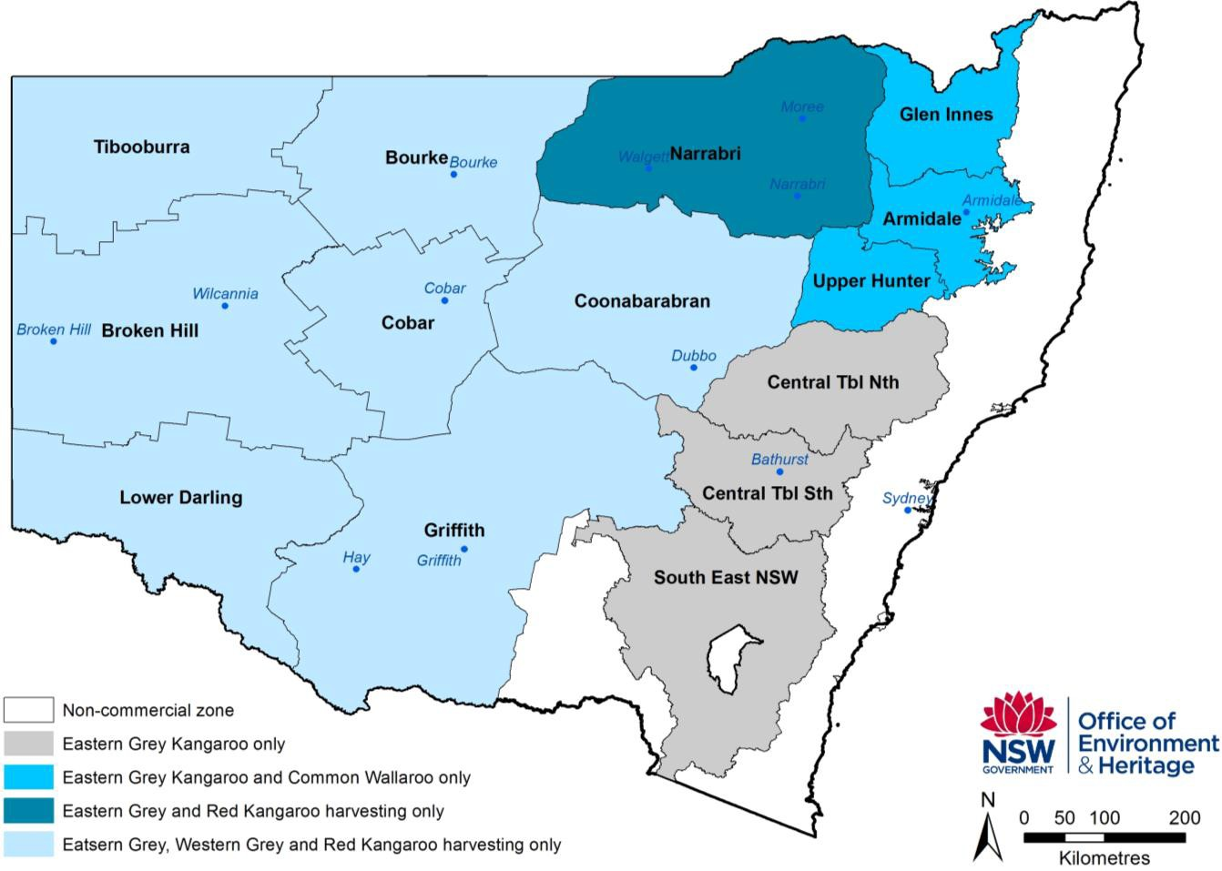

Figure 1: NSW kangaroo management zones

**3. Assessment of environmental impacts**

**3.1 Biology, ecology and conservation of kangaroos**

Kangaroos are among the most widely studied species in Australia, largely as a consequence of the commercial harvest. The biology, ecology, conservation status, threats and issues relating to the conservation and harvesting of the kangaroo species that are the subject of this plan have been comprehensively documented in a large number of widely available publications, for example Caughley *et al.* 1987, Dawson 1995, and Hacker and McLeod 2003.

The four kangaroo species that are the subject of this plan are abundant over a broad area of Australia and NSW (Figure 2). The three most abundant species (red kangaroo, eastern grey kangaroo and western grey kangaroo), which comprise approximately 97 per cent of the commercial harvest, are particularly common over pastoral areas of western NSW. The provision of permanent watering points for livestock means kangaroos are now more likely to be limited by food than water (Oliver 1986, Hacker and McLeod 2003). This has affected their distribution and abundance across the state (Newsome 1965a).

Kangaroos are robust species that respond to climatic variation (Caughley *et al*. 1987). Populations in NSW decreased in response to drought and have increased in response to rainfall following the drought breaking in 2009.

**a. eastern grey kangaroo**

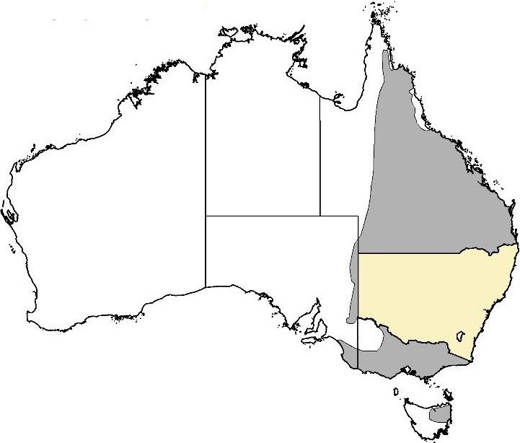

**b. common wallaroo**

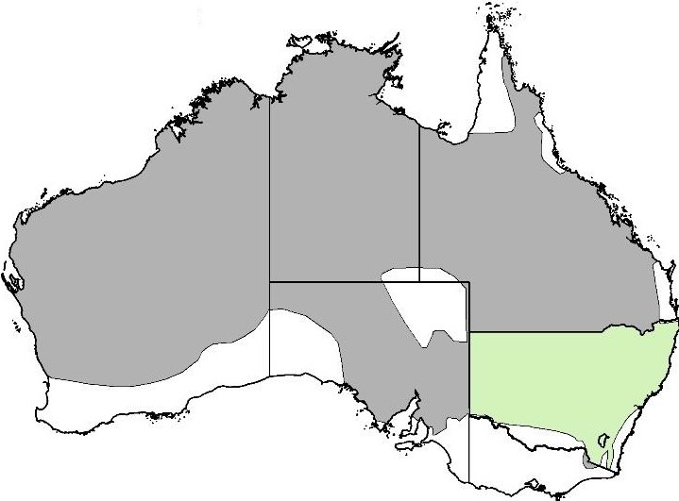

**c. red kangaroo**

**d. western grey kangaroo**

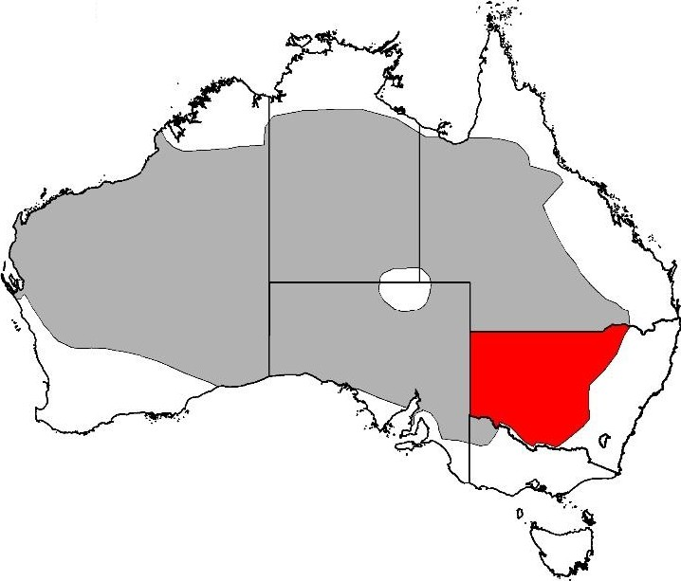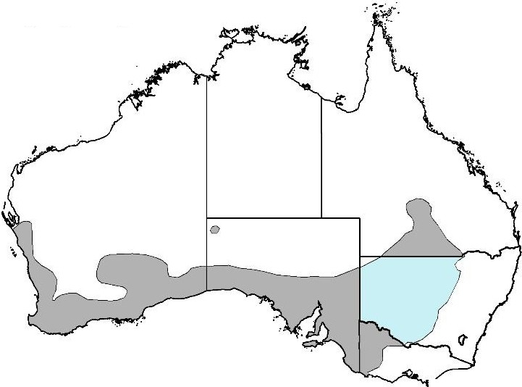

0. ··-

**N**

o. ;..

**A**

DEastern grey kangaroo - Red kangaroo ·v

DWallaroo DExtended species range .

D Western grey kangaroo 1 em = 300 km

v ...

**Office of**

**tN'SlW}; I**

**Environment**

'''""' "'"' & **Heritage**

**Figure** 2: Distribution of eastern grey kangaroo *Macropus giganteus,* wallaroo *M robustus,* red kangaroo *M rufus,* and western grey kangaroo *M fuliginosus*

**Red kangaroo *(Macropus rufus)***

Red kangaroo is the most abundant species of kangaroo. It is distributed over much of dry, inland Australia and is the only species exclusively restricted to the arid zone (Tyndale-Biscoe 2005). This distribution reflects the interaction between mean annual precipitation and mean annual temperature (Caughley *et al*. 1987). Red kangaroo occupies a wide range of habitats including mulga and mallee scrub, scrublands, woodlands, grasslands and desert (Caughley 1964; Russell

1974; Johnson & Bayliss 1981; Low *et al*. 1981; Short *et al*. 1983; Strahan 1995). Strahan (1995)

and Russell (1974), however, described a preference of this species for open plains habitat.

The red kangaroo is herbivorous and has a preference for green herbage including grasses and dicotyledonous plants (Griffiths & Barker 1966; Chippendale 1968; Storr 1968; Bailey *et al.* 1971; Ellis 1976).

The reproductive biology of red kangaroo has been thoroughly studied (Frith & Sharman 1964; Newsome 1964a, b, 1965b; Sharman 1964; Sharman & Pilton 1964). Females are fertile throughout the year, although periods of extreme drought may lead to suppression of the oestrus cycle, which is cued to body condition (Moss & Croft 1999). Females can come into breeding condition almost immediately after drought-breaking rains.

Red kangaroo is a gregarious species (Kirkpatrick 1967) and although relatively large groups may sometimes form, these groups are unstable in their composition (Croft 1980). The only enduring red kangaroo relationship is between a mother and her young.

Several studies have examined the movement patterns of red kangaroo (Frith 1964; Bailey 1971; Denny 1980; Croft 1980; Priddel 1987). These studies indicated the majority of the population is relatively sedentary. Individual home ranges have been found to overlap. In western NSW, Croft (1991) found that red kangaroos had weekly home ranges of 259 to 560 hectares.

The regular aerial population surveys provide a means of assessing population dynamics, including the response of macropod populations to environmental conditions, particularly rainfall. Caughley *et al*. (1984) found that, at average annual rainfall red kangaroos increase 35 per cent per annum in the east and 30 per cent per annum in the west. When rainfall is below average, kangaroo numbers decline.

The dingo is the main predator of red kangaroos (Caughley *et al.* 1980) where dingoes and red kangaroos co-exist.

**Eastern grey kangaroo *(Macropus giganteus)***

Eastern grey kangaroo is distributed across eastern Australia from northern Queensland to Tasmania between the inland plains and the coast (Russell 1974; Strahan 1995). The distribution corresponds with areas where rainfall either has little seasonal trend or where rainfall in summer exceeds rainfall in winter (Caughley *et al*. 1987). Eastern grey kangaroo is common and occupies a range of habitats including woodland, scrublands, open forest, and semi-arid mallee and mulga scrubs (Caughley 1964; Calaby 1966; Bell 1973; Russell 1974; McCann 1975; Taylor 1980; Hill

1981; Strahan 1995; Southwell 1987).

It is likely that the development of the pastoral industry has led to an increase in the abundance of this species (Poole, in Strahan 1995). Population densities of eastern grey kangaroos may be increasing in the rangelands, due partly to the increase in watering points for sheep and cattle (Tyndale-Biscoe 2005).

The eastern grey kangaroo prefers grasses such as spinifex (*Triodia mitchelli*). Breeding occurs throughout the year but there is a peak of births in summer (Kirkpatrick 1965, 1967; Poole 1975; Kirsch & Poole 1972).

The social behaviour of eastern grey kangaroo reflects their seasonal breeding and preference for woodland habitat. Eastern grey kangaroo is gregarious (Southwell 1984a), forming groups that are unstable in their composition (Southwell 1984b).

Eastern grey kangaroos are less mobile than red kangaroos, and the species occupies well- defined, overlapping home ranges (Jarman and Taylor 1983; Jarman & Southwell 1986). Both sexes are relatively sedentary (Zenger *et al.* 2003), but genetic analysis undertaken by Zenger *et al*. (2003) indicates only weak genetic structuring of populations, suggesting there are high levels of dispersal at both a local (<50 kilometres) and regional (50–230 kilometres) scale.

Populations have been found to have a maximum rate of increase of 35 per cent per annum where rainfall was above average, and a rate of increase of 25 per cent per annum at average rainfall. Populations declined only when rainfall was well below average (Caughley *et al.* 1984).

Eastern grey kangaroos are subject to predation by the dingo (Robertshaw & Harden 1985). Removal of dingoes from areas of eastern grey kangaroo habitat has reduced the effects of this natural predation on populations.

**Western grey kangaroo *(Macropus fuliginosus)***

Eastern and western grey kangaroos have probably diverged from a common ancestor relatively recently, and the biological and ecological differences between the two species are subtle.

The western grey kangaroo is perhaps named inappropriately because the species actually occurs across the south of the continent, with a distribution extending northwards through western NSW and into a small area of southern central Queensland. This distribution corresponds to areas of a seasonal or winter rainfall (Caughley *et al.* 1987). Where the range of western grey kangaroos overlaps with eastern grey kangaroos, the latter are more abundant. Both species have similar habitat preferences.

Western grey kangaroos feed mainly on grasses (Coulson and Norbury 1988) and shift to forbs and shrubs as pasture biomass declines (Norbury 1987). Both eastern and western grey kangaroos are less mobile than red kangaroos. Western grey kangaroos occupy relatively small home ranges that overlap extensively (Priddel 1987, Priddel *et al.* 1988a, b).

Western grey kangaroos do not exhibit embryonic diapause (Poole, in Strahan 1995).

**Wallaroo *(Macropus robustus)***

The wallaroo has the widest distribution of the larger macropod species. It occurs across the entire mainland continent and is absent only from the extreme northern and southern portions of Australia (Russell 1974; Strahan 1995). Despite their relative abundance, wallaroos are infrequently seen because of their association with mountains and rocky hill country (Dawson

1995). Two wallaroo subspecies are found in NSW – the common wallaroo (*M. robustus robustus*), which is found on the eastern and western slopes of the Great Dividing Range; and the euro or inland wallaroo (*M. robustus erubescens*), which is found in the drier areas of the state (Dawson

1995). Under this plan, only the common wallaroo will be eligible for harvesting.

The wallaroo occupies a wide range of habitats but prefers areas with steep escarpments, rocky hills and stony rises (Calaby 1966; Kirkpatrick 1968; Russell 1974; McCann 1975; Strahan 1995; Taylor 1985). Newsome (1975) considers the alteration of vegetation communities to sub-climax spinifex by the grazing of sheep in north-west Western Australia has enabled wallaroos to inhabit previously unoccupied valley areas.

In the NSW tablelands, wallaroos have a diet consisting primarily of grasses (Ealey and Main

1967, Storr 1968, Ellis 1976, Squires 1982, Taylor 1983b), whereas in the arid Pilbara region of

Western Australia, the wallaroo was found to concentrate on spinifex (Ealey & Main 1967).

Wallaroos are opportunistic breeders. Under normal conditions females breed continuously, giving birth to a single young every eight to nine months (Sadlier 1965, Ealey 1963, Kirkpatrick 1968, Poole and Merchant 1987). If drought persists for more than six months, wallaroos stop breeding until the drought breaks (Tyndale-Biscoe 2005).

The wallaroo is less gregarious than the other large macropod species (Kirkpatrick 1968, Croft

1981, Taylor 1982). Social groups within groups are highly unstable, the only enduring relationship being between a female and her progeny (Croft 1981).

Wallaroos are relatively sedentary, occupying small home ranges that overlap broadly with those of other individuals (Ealey 1967, Croft 1981, Jarman and Taylor 1983) and home ranges remain stable from year to year.

**3.2 Assessment of threats and impacts of commercial harvest**

In the context of commercial kangaroo harvesting in NSW, threats to the conservation of harvested kangaroo species are limited. Management for conservation and for harvesting of kangaroos is well understood. Assessment of the impacts of harvesting on kangaroos as well as other species, habitats and ecosystems is comprehensive. Kangaroo populations can be affected by environmental and ecosystem processes, such as climate change, drought, disease, flood and predation. These processes are not considered a threat to the conservation status of kangaroos.

With more than 40 years of commercial kangaroo harvesting in NSW, viable populations of harvested kangaroo species have been maintained across their range, and the ranges of the eastern grey and western grey kangaroo species have expanded. Accordingly, commercial harvesting is not considered a threat to the genetic viability or the conservation status of the harvested species (Hale 2004).

Kangaroos are protected species and considered common in NSW. There is no national or state threatened species listing of kangaroo species. The four kangaroo species subject to this plan are ranked as of lower risk in the sub-category of least concern on the IUCN Red List. CITES, which aims to ensure international trade in wildlife does not threaten the survival of those species, does not list any protection measures for the kangaroo species subject to this plan. The conservation status of kangaroos in NSW is considered of least concern by state, national and international standards.

***3.2.1 Assessment of impact to population numbers***

Landscape changes since European settlement have favoured kangaroos and kangaroo ranges have increased. Commercial harvest is not considered a threat to population numbers due to the relatively small size of the harvest and the ability to limit or stop the harvest if required.

OEH undertakes monitoring of kangaroo population numbers, setting of quotas and identification of trigger points to ensure the harvest is ecologically sustainable (see Appendix 1). Kangaroo populations are monitored using scientifically robust and peer reviewed methods of aerial wildlife population surveying (Barker 2008; Cairns *et al.* 2008; Fewster and Pople 2008; Fleming and Tracey 2008; Hone 2008; Laake *et al.* 2008; Pople 2008). Kangaroo populations are assessed annually or triennially as appropriate to the survey method (Payne 2008). A full description of methods for surveying populations is available on the OEH kangaroo management web page <http://www.environment.nsw.gov.au/wildlifemanagement/KangarooManagementProgram.htm>.

Maximum harvest quotas are set at 15 per cent of the population for grey kangaroo and wallaroo species, and 17 per cent of the population for red kangaroo species (Hacker *et al.* 2004; McLeod e*t al.* 2004). OEH manages the commercial harvest of kangaroos using a proportional harvesting strategy (see Appendix 1), with quotas set annually based on population monitoring. This strategy has been well studied and is considered to be an effective approach to managing a fluctuating population (Caughley 1987; Engen, Lande *et al*. 1997; McLeod and Pople 1998). The tagging system (licensees are required to affix a tag to every carcass harvested) enables OEH to track the harvest against the quota.

Trigger reference points are in place to manage the harvest if the quotas are being approached or met. Where populations have declined below certain population estimates (also known as

‘triggers’), harvesting of that particular species will be reduced (for instance, if the normal quota is

15 per cent then it may be reduced to 10 per cent), or suspended until the population increases to a nominated size. Further information on triggers is available in Appendix 1.

Minimum carcass weights are prescribed in licences to ensure that the harvest does not impact on population dynamics. Average carcass weights are monitored monthly to detect any change in population health through observation of a sudden drop in carcass weights. This is also used as a trigger to suspend harvest in the affected area so that an assessment of population health can be made.

Apart from the non-commercial zone, refuges and areas of no commercial harvest exist within public land including national parks, state forests and crown land across the state.

***3.2.2 Assessment of impact to genetic integrity***

Commercial harvesting is not considered to have an adverse impact on the genetic integrity or conservation status of kangaroos in NSW. Research commissioned by the NSW National Parks and Wildlife Service (Hale 2001) indicates that genetic integrity, fitness and gene diversity of kangaroo populations would not be compromised by commercial harvesting. The genetic populations of all kangaroo species have a large geographic range and environmental factors provide a greater selective influence on kangaroos than the harvest.

Recent data shows that a higher proportion of male kangaroos are harvested than female kangaroos. Hale (2004) showed commercial harvesting could not impact genetic integrity of kangaroo populations, even when the harvest is male biased. Kangaroos are genetically diverse species and every individual contains relevant genes for size-related phenotype. Even if the full quota is harvested, the biased harvesting of large males will not have any impact on the evolution of kangaroos.

***3.2.3 Assessment of impact from harvest combined with environmental factors***

Kangaroo species have boom and bust population cycles in response to environmental factors. Figure 3 shows kangaroo population fluctuations in relation to quotas and the number of kangaroos harvested. This figure shows that kangaroo populations have not been impacted by the rate of harvesting, even when the quota was reached at the peak of population declines in

1985, 1996 and 2005–2007. In fact, the quotas set in 1995, 1996 and 1997 could have been higher if they had been based on population surveys from that year. Drought periods, and flood events in parts of NSW and southern Queensland, appear to have had the greatest impact on absolute population size.

The kangaroo harvest has a negligible impact on kangaroo population dynamics. After 40 years of commercial harvesting in NSW, kangaroos remain common, and populations are ecologically sustainable.

18,000,000

16,000,000

14,000,000

12,000,000

10,000,000

**Population estimate**

8,000,000

6,000,000

4,000,000

2,000,000

0

1975

1976

1977

1978

1979

1980

1981

1982

1983

1984

1985

1986

1987

1988

1989

1990

1991

1992

1993

1994

1995

1996

1997

1998

1999

2000

2001

2002

2003

2004

2005

2006

2007

2008

2009

2010

2011

2012

2013

2014

2015

**Year**

Kangaroos harvested Population estimate

15% quota for current estimate (lag) 15% quota set on previous estimate

■ Dry period

■ Wet period

Figure 3: Assessment of factors that may influence recorded abundance of kangaroos. The graph shows temporal variation of kangaroo populations in relation to wet and dry periods during harvest activities. The pattern of a slower rise and sudden drop of kangaroo populations is similar throughout the period. Kangaroo populations have not been effected by the rate of harvesting, under the quota setting method. Drought periods appear to have had the greatest impact on absolute population size.

***3.2.4 Assessment of impact to kangaroo habitat***

Licences to undertake commercial kangaroo harvest do not authorise licence holders to impact other species, or modify habitats or ecosystems. Kangaroos are permitted to be harvested only on private land. Farmland ecosystems are generally impacted by land clearing, hard hoofed domestic stock, hydrological modifications, cropping, machinery and infestations of weeds. Any change in kangaroo numbers is likely to have no impact on kangaroo habitat in this environment. There is potential for an increased abundance of introduced predators and native predators consuming off-cuts and carcasses (Kay *et al*. 2000; Read & Wilson 2004; Saunders *et al.* 1995). These animals are usually managed through pest control programs conducted by NSW Government departments, private landholders and community working groups.

***3.2.5 Certain indigenous rights not affected***

While the EPBC Act allows for commercial utilisation of native wildlife in accordance with the objectives of Part 13A, it is not intended to prevent indigenous persons from carrying out traditional use of wildlife. To avoid doubt, nothing in this plan prevents an indigenous person from continuing in accordance with law the traditional use of an area for:

a) hunting (except for the purposes of sale); or

b) food gathering (except for the purposes of sale); or c) ceremonial or religious purposes.

**4. Controls to manage, mitigate and monitor commercial harvesting**

The following controls provide a framework for a humane harvest and sustainable kangaroo population management in NSW.

The legislative framework for commercial kangaroo harvesting in NSW is outlined in Section 2. OEH manages the commercial harvest in accordance with this framework. OEH regulates compliance with this framework in accordance with the Compliance Policy for OEH Regional Operations (see Section 4.5)

**4.1 Protecting animal welfare**

All harvesting licences require the licence holders to comply with the *National Code of Practice for the Humane Shooting of Kangaroos and Wallabies for Commercial Purposes*. Licenced harvesters are required to be accredited under this kangaroo management program and undergo competency testing every five years.

Compliance assurance is embedded in the program through OEH compliance inspections and program audits, as well as reports from wholesalers, the NSW Food Authority and the Department of Agriculture and Water Resources and the public through OEH’s Environment Line. See Section

4.5 for compliance and regulation.

**4.2 Ecological sustainability**

Kangaroo populations are monitored using best practice survey methods for the terrain (Payne

2008). Monitoring is undertaken for each species and for each management zone. Population monitoring data are used as the basis for setting quotas and monitoring population health.

The harvest of all four kangaroo species is monitored regularly throughout their range to identify threats and to enable early identification of abnormal population trends. Diseased animals can be traced to their origin through the tagging system and observations are investigated. The harvest can be regulated using methods including limiting or stopping the harvest if triggers are met (see Appendix 1).

In setting the quotas and analysing trends, OEH uses accepted population thresholds for each species. Quotas are set annually. The quota report is submitted to the Commonwealth Department of the Environment and Energy by 30 November and published on the OEH kangaroo management web page. The population counts determine the quota for the following calendar year, commencing on 1 January. Quotas are set per species and per zone (Figure 1). Quotas are set only when the kangaroo population trends are within the normal range. If there is any concern about kangaroo population trends the quota can be reduced or suspended.

**4.3 Restriction of harvest area (no-harvest sanctuaries)**

Restrictions on harvest areas are implemented through licence conditions. Kangaroos are permitted to be harvested only in kangaroo harvest management zones. Harvesting kangaroos from public lands is not permitted. The no-harvest areas are, by default, areas of sanctuary habitat for kangaroos.

**4.4 Employing the precautionary principle**

Quotas, thresholds and targets are supported by the scientific literature (see Appendix 1), and are set conservatively to ensure populations will not be affected by harvesting rate. Population trends are monitored annually. Data is analysed to identify potentially adverse trends. Adverse,

concerning or unexplained trends are investigated and acted upon with the aim of conserving kangaroo populations.

**4.5 Compliance and regulation**

To effectively regulate the NSW commercial kangaroo harvest, OEH implements a range of programs to promote voluntary compliance, and to identify and respond to non-compliance. Compliance covers all of the activities which help support adherence to the law. This includes statutory mechanisms such as licences with conditions, engaging with industry and community to help prevent non-compliance, targeted auditing informed by intelligence, investigating reports of possible non-compliance, and taking appropriate enforcement action when non-compliance is detected.

OEH escalates its compliance response according to the seriousness of the non-compliance, and the culpability of the offender. OEH measures the performance of its compliance function so that it can continually improve its effectiveness, and identify emerging compliance issues. This approach enables OEH to accurately evaluate the overall effectiveness of the commercial kangaroo harvest management program, and to detect and respond to emerging risks.

**4.6 Monitoring and reporting**

Annual reports will be prepared to demonstrate compliance with this plan and to provide observations of the population from the OEH monitoring program. The annual report will report against the performance indicators provided in Table 1 to demonstrate the effectiveness of the management actions in meeting the objectives of this plan. Annual reports will be submitted by 31

March each year.

Quota reports will be prepared annually, to provide population estimates and quotas for each of the species in each management zone, and submitted to the Commonwealth Department of the Environment and Energy by 30 November each year. The reports will be published on the OEH kangaroo management website.

**4.7 Raising community awareness**

The Kangaroo Management Advisory Panel (KMAP) is established to provide information and engage with key stakeholders.

The following documents are published on the OEH website for each year/period:

• NSW Commercial Kangaroo Harvest Mangement Plan

• Annual Report – NSW Commercial Kangaroo Harvest Mangement Plan

• NSW Commercial Kangaroo Harvest Mangement Plan – Quota Report

• NSW Handbook for Kangaroo Harvesters.

Table 1: Actions and indicators for achieving the plan’s objectives

**Management action Method Performance indicators**

**Objective 1: To ensure humane treatment of animals harvested in accordance with this plan**

Implement the *National Code of Practice for the Humane Shooting of Kangaroos and Wallabies* across all harvesting activity

Licence requirements including:

• Firearms licence

• Accreditation under National code of practice

• Achievement of competency

(annual)

• Self-reporting of non-compliance

• Risk-based approach to auditing compliance

1a. 100% of licence holders have met shooter competency standards and have demonstrated an understanding of humane harvest guidelines

1b. Reports received from chiller operators weekly

1c. Results of weekly reports assessed for any non- compliances

1d. Compliance response taken for identified non-compliances proprotionate to the risk to program objectives

**Objective 2: To ensure that the commercial harvest is ecologically sustainable**

Population monitoring • Annual aerial surveys 2. 100% of surveys conducted by November 30 (annually or triennially as relevant)

Quota set each year as a percentage of kangaroo population

• Quota percentage set for each species and calculated for each management zone based on population estimates

3. Quotas commence at 1 January each year, and harvest does not exceed allocations as stated in Quota Reports

Restriction of harvest area (no-harvest sanctuaries)

• Harvesting is permitted only on private land

4. 100% harvest returns specify the private land where the kangaroo was harvested

Risk assessment of species through harvest data

• Analysis of kangaroo data from harvesters (weight, sex, number) per zone

5a. All required data captured

5b. All data analysed

5c. Kangaroo populations statistics are compared against thresholds to measure whether kangaroo populations are within normal range

5d. Action taken, including possible suspension of harvest, if population statistics show trends below thresholds

Maintenance of population within thresholds • Tags allocated in accordance with quotas only

• Quarterly returns to monitor actual take against quota numbers

6. Actual take and tag allocations are kept within quota allocations

Regular review and adaptive program management.

Triggers to suspend the harvest if population declines, or if population health is declining.

Implementation of a risk based compliance program.

Audit of compliance program undertaken periodically to ensure confidence in the program.

• Aspects of the harvest including population size, population trends, species health, and harvester compliance are reviewed annually against performance indicators

• Relevant data are required to be submitted from harvesters and chiller operators

• Data is analysed and compared against performance indicators

• The harvest program is adjusted annually in accordance with

population monitoring

• The Kangaroo Management Plan is reviewed and re-submitted for assessment by the Commonwealth and public comment before

approval by the Minister for the

Environment and Energy at least

12 months before its expiry

• Reducing or ceasing the harvest as needed to maintain population sustainability and/or health (managed through the tag

allocation system).

• OEH will implement proactive compliance, including analysing data and intelligence to apply a

risk-based approach to compliance

• OEH will assess reports of non- compliance and take a compliance response to confirmed non- compliances that is commensurate

7a. 100% of harvester returns is received each quarter

7b. Annual report prepared and submitted to the Commonwealth Department of the Environment, and published on the OEH kangaroo management web page by

31 March each year

7c. The Commercial Kangaroo Harvest Management Plan is reviewed in 2021 or as required, including in the event of legislative change

8. All relevant quotas suspended if populations are below thresholds

9a. All allegations of non-compliance assessed for risk to program objectives, and investigated as required

9b. All self-reports of non-compliance assessed for risk to program objectives and investigated as required

9c. At least one audit program undertaken in the period covered by this plan

with the level of risk of the non- compliance

• OEH audit team to periodically audit higher risk aspects of the program

• Self-reporting of non-compliance is a licence condition forharvesters and chillers

**OEH Commitment: Engage with community and industry stakeholders to ensure the objectives of this plan are met**

Proactive engagement with community and industry stakeholders

• Engage a KMAP, with members representing the range of stakeholder interests, to be appointed by the Chief Executive of OEH

• Engage with KMAP on the preparation of the annual report and quota report, and other items as required

10. KMAP meetings at least twice per year

Provide regular up-to-date information on

OEH website

• Maintain active role in web-based and manual delivery of information.

11. Annual report and quota report uploaded to OEH kangaroo management web page, and other relevant documents accessible as required.

**5. Monitoring and reporting**

A review of the NSW Commercial Kangaroo Harvest Management Plan 2017 – 2021 will commence no later than 12 months prior to the expiry of this plan. The review will be conducted by OEH Kangaroo Management Team and seek to identify areas where wildlife trade management plans can be improved. The current plan will be evaluated against its performance measures. The results of this review will be presented to the Commonwealth Department of the Environment and placed on the OEH kangaroo management web page.

**6. References**

Barker, R. (2008) Theory and application of mark– recapture and related techniques to aerial surveys of wildlife. *Wildlife Research* **35**, 268–274.

Calaby JH and Grigg GC (1989) ‘Changes in

macropodoid communities and populations in the past

200 years, and the future’, in G Grigg, P Jarman and I Hume (eds), *Kangaroos, wallabies and rat-kangaroos*, Surrey Beatty & Sons, Sydney, pp. 813-820.

Caughley G, N Shepherd and J Short (1987) Kangaroos: their ecology and management in the sheep rangelands of Australia, Cambridge University Press, Cambridge

Caughley G (1987a) ‘Ecological relationships’, in G Caughley, N Shepherd and J Short (eds), *Kangaroos: their ecology and management in the sheep rangelands of Australia,* Cambridge University Press, Cambridge, pp. 159-187.

Caughley G, Grigg GC and Smith L (1985) ‘The effect of drought on kangaroo populations’, *Journal of Wildlife Management* **49**, 679-685.

Caughley G, Grigg GC, Caughley J and Hill GJE (1980) Does dingo predation control the densities of kangaroos and emus?, *Australian Wildlife Research* **7**,

1-12.

Convention on International Trade in Endangered Species of Wild Fauna and Flora 2015 The CITES Appendices, Appendices I, II and III Valid from 5

February 2015. Available:

<https://www.cites.org/eng/app/appendices.php>

Accessed: 19 August 2015

Dawson, TJ (1995) Kangaroos: biology of the largest marsupials University of New South Wales Press ltd, Sydney

Dawson TJ, McTavish KJ and Ellis BA (2004) ‘Diets and foraging behaviour of red and eastern grey kangaroos in arid shrub land: is feeding behaviour involved in the range expansion of the eastern grey kangaroo into the arid zone?’ *Australian Mammalogy*

**26**, 169–178.

Dawson TJ, Blaney CE, McCarron HCK and Maloney SK (2007) Dehydration, with and without heat, in kangaroos from mesic and arid habitats: different thermal responses including varying patterns in heterothermy in the field and laboratory. *Journal of Comparative Physiology B Biochemical Systemic and*

*Environmental Physiology* **177**, 797‐807.

Fewster, R.M., and Pople, A.R. (2008) A comparison

of mark–recapture distance-sampling methods applied to aerial surveys of eastern grey kangaroos. *Wildlife Research* **35**, 320–330.

Fleming, P.J.S., and Tracey, J.P. (2008) Some human, aircraft and animal factors affecting aerial surveys: how to enumerate animals from the

air. *Wildlife Research* **35**, 258–267.

Grigg G (1982) ‘Roo harvesting. Are kangaroos really under threat?’ *Australian Natural History* **21**, 123-127.

Grigg G (1995) ‘Kangaroo harvesting for conservation of rangelands, kangaroos and graziers’, in GC Grigg, PT Hale and D Lunney (eds), *Conservation through sustainable use of wildlife*, Centre for Conservation Biology, The University of Queensland, Brisbane, pp.

161-165.

Grigg GC and Pople AR (2001) ‘Sustainable use and pest control: kangaroos, a case study’, in JD Renyolds, G Mace and KH Redford (eds), *Conservation of exploited species*, Cambridge University Press, Melbourne.

Hacker R and McLeod S (2003) *Living with kangaroos: a guide to kangaroos and their management in the Murray-Darling Basin*, New South Wales Department of Agriculture, Orange.

Hacker R, McLeod S, Druhan J, Tenhumberg B and Pradhan U (2004) Kangaroo management options in the Murray-Darling Basin, report to Murray-Darling Basin Commission, Canberra.

Hacker RB, McLeod SR and Druhan J (2003) *Evaluating alternative management strategies for kangaroos in the Murray-Darling Basin*, final report to the Murray-Darling Basin Commission, Canberra.

Hale PT (2001) *Kangaroo genetics: impacts of harvesting* Online: ([http://www.environment.nsw.gov.au/resources/nature](http://www.environment.nsw.gov.au/resources/nature/genetics.pdf)

[/genetics.pdf](http://www.environment.nsw.gov.au/resources/nature/genetics.pdf)) Office of Environment and Heritage. Accessed: 30 September 2015

Hale PT (2004) Genetic effects of kangaroo harvesting, *Australian Mammalogy* **26**, 75–86.

Hone, J. (2008) On bias, precision and accuracy in wildlife aerial surveys. *Wildlife Research* **35**, 253–

257.

The IUCN Red List of Threatened Species. Version

2015.2. Online: [www.iucnredlist.org](http://www.iucnredlist.org/) Accessed: 19

August 2015.

Jarman PJ and Denny MJS (1976) ‘Red kangaroos and land use along the New South Wales, Queensland and South Australian borders’, in PJ Jarman (ed), *Agriculture, forestry and wildlife: conflict*

*or coexistence?*, University of New England, Armidale,

pp. 56-67.

Jonzen N, Pople T, Knape J and Skold M (2010) Stochastic demography and population dynamics in the red kangaroo *Macropus rufus*. *Journal of Animal*

*Ecology* **79**, 109‐116.

Kay B, Gifford E, Perry R and van der Ven R (2000)

‘Trapping efficiency for foxes (*Vulpes vulpes*) in

central New South Wales: age and sex biases and the

effects of reduced fox abundance’, *Wildlife Research*

**27**, 547-552.

Kirkpatrick TH (1985) ‘Biology for management’, in HJ Lavery (ed), *The kangaroo keepers*, University of Queensland Press, St Lucia, pp. 135-160.

Laake, J., Dawson, M.J., and Hone, J. (2008) Visibility bias in aerial survey: mark–recapture, line- transect or both?. *Wildlife Research* **35**, 299–309.

McLeod SR, Hacker RB and Druhan JP, 2004. Managing the commercial harvest of kangaroos in the Murray-Darling Basin. *Australian Mammalogy* **26**: 9-

22.Neaves LE, Zenger KR, Prince RIT, Eldridge MDB and Cooper DW (2009) ‘Landscape discontinuities influence gene flow and genetic structure in a large, vagile Australian mammal, *Macropus fuliginosus. Molecular Ecology* **18**, 3363-3378.

Neaves LE, Zenger KR, Cooper DW and Eldridge

MDB (2010) Molecular detection of hybridization

between sympatric kangaroo species in south‐eastern

Australia. *Heredity* **104**, 502‐512.

NSW Scientific Committee (2012) *Guidelines for*

*interpreting listing criteria for species, populations and ecological communities under the NSW Threatened*

*Species Conservation Act* NSW Scientific Committee

Listing guidelines version 1.3

Payne, N 2008 *Population monitoring methods for the NSW kangaroo management program* Department of Environment and Climate Change NSW, Hurstville

Pople AR (2003) *Harvest management of kangaroos during drought*, Online: [http://www.environment.nsw.gov.au/resources/parks/ NSWNPWSDroughtHarvestmanagementColour.pdf](http://www.environment.nsw.gov.au/resources/parks/NSWNPWSDroughtHarvestmanagementColour.pdf) Report to the New South Wales National Parks and Wildlife Service. Accessed: 30 September 2015

Pople, A.R. (2008) Frequency and precision of aerial surveys for kangaroo management. *Wildlife Research* **35**, 340–348.

Pople AR, Grigg GC, Phinn SR, Menke N, McAlpine C, Possingham HP (2010) ‘Reassessing spatial and temporal dynamics of kangaroo populations’ in *Macropods: the Biology of Kangaroos, Wallabies and Rat-kangaroos*. (Eds G Coulson and MDB Eldridge) pp. 197-210. (Melbourne: CSIRO Publishing)

Pople AR, Phinn SR, Menke N, Grigg GC, Possingham HP and McAlpine C (2007) Spatial patterns of kangaroo density across the South Australian pastoral zone over 26 years: aggregation during drought and suggestions of long distance

movement. *Journal of Applied Ecology* **44**, 1068‐1079

Pople AR and Page M (2001) *Management of artificial*

*watering points on National Parks in western*

*Queensland*, report for the Queensland National Parks and Wildlife Service.

Pople T and Grigg G (1999) *Commercial harvesting of kangaroos in Australia*, Online: <http://www.environment.gov.au/biodiversity/trade->use/wild-harvest/kangaroo/harvesting/index.html Department of the Environment and Heritage Accessed: 20 September 2015.

Read JL, and Wilson D (2004) ‘Scavengers and detritivores of kangaroo harvest off cuts in arid Australia’, *Wildlife Research* **31**, 51-56.

Saunders G, Coman B, Kinnear J and Braysher M (1995) *Managing vertebrate pests: foxes*, Bureau of Resource Sciences, Canberra.

Short J and Grigg GC (1982) ‘The abundance of kangaroos in suboptimal habitats: wheat, intensive pastoral and mallee’, *Australian Wildlife Research* **9**,

221-228.

Smith JA, Wellehan JFX, Jr., Pogranichniy RM, Childress AL, Landolfi JA and Terio KA (2008) Identification and isolation of a novel herpesvirus in a captive mob of eastern grey kangaroos (*Macropus*

*giganteus*). *Veterinary Microbiology* **129**, 236‐245.

Speare R, Donovan JA, Thomas AD and Speare PJ

(1989) ‘Disease of free-ranging Macropodoidea’, in G Grigg, P Jarman and I Hume (eds), *Kangaroos, wallabies and rat-kangaroos*, Surrey Beatty & Sons,

Sydney, pp. 705-734.

Tenhumberg B, Tyre AJ, Pople AP and Possingham HP (2002) *Evolutionary responses to selective harvesting in a stochastic environment*, report to Murray-Darling Basin Commission, Canberra.

Tenhumberg B, Tyre AJ, Pople AP and Possingham HP (2004) ‘Do harvest refuges buffer kangaroos against evolutionary responses to selective harvesting?’, *Ecology* **85**, 2003–2017.

Thompson PC (1992) ‘The behavioural ecology of dingoes in north-western Australia. III. Hunting and feeding behaviour, and diet’, *Wildlife Research* **19**,

531-541.

Wilson D and Read JL (2003) ‘Kangaroo harvesters:

fertilising the rangelands’, *The Rangeland Journal* **25,**

47-55.

Zenger KR, Eldridge MDB and Cooper DW (2003)

‘Intraspecific variation, sex-biased dispersal and phylogeography of the eastern grey kangaroo (*Macropus giganteus*). *Heredity* **91**, 153-162.

**APPENDIX 1**

Adapted from unpublished work by SR McLeod and AR Pople.

**Trigger Points**

If kangaroo populations decline to specific trigger points, the commercial harvest of kangaroos in particular zones will be reduced or suspended.

Kangaroo populations fluctuate in response to changes in seasonal conditions. Populations change more quickly and more dramatically in environments where rainfall is erratic, such as in the Far West of NSW. In more temperate areas, such as the Northern Tablelands, populations change more slowly, and do not vary as much from the average.

Trigger points are based on long-term average population or density and standard deviation. Natural population fluctuations in response to climatic or seasonal variation is not a trigger point.

‘Standard deviation’ is a statistical measure of how much the population changes relative to its

average – in erratic environments, the population changes much more and the standard deviation is larger than in environments that are more stable. This means that the standard deviation is different for each species in each zone. The standard deviations are recalculated after each survey to ensure all available information is used.

**Thresholds for reducing or suspending harvest**

Commercial harvest quotas are reduced if population estimates fall below 1.5 standard deviations of the long-term average density, or suspended if population estimates fall below two standard deviations of the long-term average.

If aerial survey results indicate a population has fallen below the long term average density for that species in that zone, the commercial quota will be reduced or suspended for the following calendar year. Where the harvest is suspended, any licences current at that time will be allowed to continue until their expiry, but no new licences authorising the harvest of that species in that zone will be issued. The suspension will remain in place until aerial surveys indicate population density has increased.

Reduction in quota – when populations are below the long-term average by between 1.5 and two standard deviations.

• The annual quota for the following calendar year (commencing January, year 1) will be calculated at ten per cent of the population estimate for that species in that zone.

• If the next aerial survey indicates population size has increased above the 1.5 standard deviation threshold, or are above average, the commercial quota will be calculated at 15 or

17 per cent of the new estimate for the following calendar year (January, year 2).

• However, if the survey indicates populations have further declined and are more than two standard deviations below the average, the commercial quota will be suspended from the beginning of the following calendar year.

Suspension of quota – when populations are more than two standard deviations below the long- term average density.

• There will be no annual quota for the following calendar year (commencing January, year 1)

for that species in that zone.

• If the next aerial survey indicates population size has increased to between 1.5 and two standard deviations below the average, a commercial quota will be set at ten percent for that species in that zone for the following year (commencing January, year 2).

• If the next aerial survey indicates populations have increased to less than 1.5 standard deviations below the average, or are above average, the commercial quota will be calculated at 15 or 17 percent of the new estimate for the following calendar year (commencing January, year 2).

• However, if the survey indicates that populations have not increased or have further declined, the harvest suspension will remain in place and no commercial quota will be set for that species in that zone for the following calendar year (commencing January, year 2).