

Alpine *Sphagnum* Bogs and Associated Fens ecological community National Recovery Plan

**DRAFT**

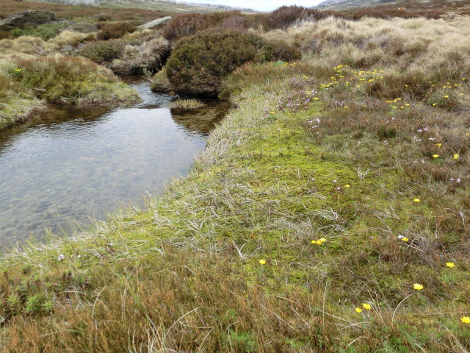

August 2014

Prepared by: Department of the Environment

Made under the *Environment Protection and Biodiversity Conservation Act 1999*

© Commonwealth of Australia, 2014



This work is copyright. You may download, display, print and reproduce this material in unaltered form only (retaining this notice) for your personal, non-commercial use or use within your organisation. Apart from any use as permitted under the *Copyright Act 1968*, all other rights are reserved. Requests and inquiries concerning reproduction and rights should be addressed to Commonwealth Copyright Administration, Attorney-General’s Department, Robert Garran Offices, National Circuit, Barton A[CT 2600 or posted at: ag.gov.au/cca](http://ag.gov.au/cca)

Note: This recovery plan sets out the actions necessary to stop the decline of, and support the recovery of, a listed threatened ecological community. The Australian Government is committed to acting in accordance with the plan and to implementing the plan as it applies to Commonwealth areas. The plan has been developed with the involvement and cooperation of a broad range of stakeholders, but individual stakeholders have not necessarily committed to undertaking specific actions. The attainment of objectives and the provision of funds are subject to budgetary and other constraints affecting the parties involved. Proposed actions may be subject to modification over the life of the plan due to changes in knowledge.

While reasonable efforts have been made to ensure that the contents of this publication are factually correct, the Commonwealth does not accept responsibility for the accuracy or completeness of the contents, and shall not be liable for any loss or damage that may be occasioned directly or indirectly through the use of, or reliance on, the contents of this publication.

This plan should be cited as:

Department of the Environment (2014) *Draft Alpine* Sphagnum *Bogs and Associated Fens Recovery Plan*

Department of the Environment, Canberra.

ALPINE SPHAGNUM BOGS AND ASSOCIATED FENS RECOVERY PLAN DRAFT

# Acknowledgements

The Department of the Environment is grateful to the organisations and individuals who contributed to or provided information for the preparation of this draft recovery plan and have been or are still involved in implementing conservation and management actions that benefit the Alpine *Sphagnum* Bogs and Associated Fens ecological community.

In particular, the Department acknowledges researchers and conservation experts, including academics, Non-Government Organisations, Commonwealth, State , and Territory Government staff, and the Steering Committee, established to contribute to and provide advice on the Alpine *Sphagnum* Bogs and Associated Fens recovery plan’s preparation. The Steering Committee comprised representatives of the New South Wales, Tasmanian, Australian Capital Territory and Victorian governments, as well as Wetlandcare, and independent experts in the ecological community. The views expressed in this document do not necessarily represent the views of the members of the Steering Committee or the agencies they represent.

### Acknowledgement of Traditional Owners and Country

The Australian Government acknowledges Australia’s

Traditional Owners and pays respect to Elders past and present. We acknowledge the deep spiritual, cultural and customary connections of Traditional Owners to the Australian alpine landscape, including The Alpine *Sphagnum* Bogs and Associated Fens.

Contents

Acknowledgements v

1. Introduction 1

1.1 Purpose and scope 1

1.2 Objectives 1

1.3 Legislative context 2

2. Description of the ecological community 3

2.1. Community description 3

2.2. Distribution 6

3. Threats 11

3.1. Key threats 11

3.2. National severity rating 17

4. Recovery Strategy 18

4.1. Objectives 18

4.2. Strategies 18

4.3. Performance criteria 19

4.4. Recovery Actions 21

5. Implementation 34

5.1. Affected interests and potential contributors 34

5.2. Projected funding needs and timing 35

5.3. Monitoring, evaluation, reporting and review 39

5.4. Management practices 39

5.5. Biodiversity impacts and benefits 39

6. References 40

# Introduction

## Purpose and scope

The primary purpose of the Alpine *Sphagnum* Bogs and Associated Fens Recovery Plan is to provide the research and management actions necessary to stop the decline, and support the recovery of, the ecological community so that the chances of its long-term survival in nature are maximised. A major focus of this plan is to address threats affecting the ecological community.

The Alpine *Sphagnum* Bogs and Associated Fens ecological community has a limited distribution and is highly fragmented. The ecological community is found in permanently wet sites in high rainfall alpine, sub-alpine and montane areas of NSW, ACT, Victoria and Tasmania. The majority of examples of this ecological community are found in areas under conservation related tenure, usually in national parks. Therefore, this recovery plan is intended as a key resource for park management agencies, to guide and assist actions to support the recovery of the ecological community. Ideally, the priority actions identified in this plan will be incorporated into future versions of park management plans, and other key management plans, such as those for relevant state forests, and plans dealing specifically with key threats to the ecological community, such as management of feral horses.

The Recovery Plan is also intended to support decision making for environmental regulation and alps natural resource management, including the allocation of resources.

This recovery plan is not intended to provide a comprehensive literature review of all of the available information for the Alpine *Sphagnum* Bogs and Associated Fens ecological community. Rather, it includes the minimum information necessary to support funding and on-ground implementation actions to support the recovery of the ecological community. The plan includes the key requirements for a recovery plan under the *Environment Protection and Biodiversity Conservation Act 1999* (EPBC Act). The recovery plan complements the information provided in the [Commonwealth Listing Advice on Alpine *Sphagnum* Bogs and Associated Fens](http://www.environment.gov.au/biodiversity/threatened/communities/pubs/29-listing-advice.pdf) and the [Commonwealth Conservation Advice on Alpine *Sphagnum* Bogs and Associated Fens](http://www.environment.gov.au/biodiversity/threatened/communities/pubs/29-conservation-advice.pdf).

Supporting information will be compiled in the accompanying document: Background information: Alpine *Sphagnum* Bogs and Associated Fens Recovery Plan which will be made available [here](http://www.environment.gov.au/cgi-bin/sprat/public/publicshowcommunity.pl?id=29&status=Endangered) when it is completed.

## Objectives

The primary objective for the Alpine *Sphagnum* Bogs and Associated Fens Recovery Plan is to:

**Maintain or extend the current known extent (area) and maintain or improve the condition of the Alpine Sphagnum Bogs and Associated Fens ecological community over the life of the recovery plan.**

The supporting objective of the plan is to:

**Ensure effective, adaptive implementation of the plan.**

## Legislative context

This is the first national recovery plan for the Alpine *Sphagnum* Bogs and Associated Fens (ASBF) ecological community (hereafter called the ecological community) which is listed as threatened under the EPBC Act.

### National status

The Alpine Sphagnum Bogs and Associated Fens ecological community was listed as **endangered** under the EPBC Act in January 2009, due to:

* its small geographic distribution coupled with demonstrable threats,
* the continued decline of functionally important species, and
* the severe reduction in community integrity across its range.

Listing under national legislation means that any new or intensified activities that may have a significant impact on the ecological community may require referral and approval under the EPBC Act.

Relevant national policies and resources for this ecological community include the [Alpine *Sphagnum* Bogs and Associated Fens Policy Statement 3.16](http://www.environment.gov.au/resource/alpine-sphagnum-bogs-and-associated-fens-epbc-act-policy-statement), and the [Commonwealth listing and conservation advices on Alpine Sphagnum Bogs and Associated Fens](http://www.environment.gov.au/cgi-bin/sprat/public/publicshowcommunity.pl?id=29&status=Endangered).

### Conservation status in state and territory jurisdictions

The ecological community is either wholly or partially protected in each state and territory in which it occurs.

#### Australian Capital Territory

The community is represented within two ecological communities described in the ACT. These are: *Sphagnum cristatum* Montane and Subalpine Bogs (*Sphagnum* Montane and Subalpine Bogs), and *Carex gaudichaudiana* Montane and Subalpine fen (*Carex* Montane and Subalpine Fen). The former, (located at Blundell’s Flat, outside Namadgi National Park) although identified as requiring conservation action is not currently listed under the *Nature Conservation Act 1980* (NCA Act), but is still protected within the ACT catchment area. The latter is considered adequately conserved in the ACT (Sharp et al., 2007) within ACT’s Namadgi National Park and Parks Conservation and Lands reserve system (ACT Parks). Protection and management of these two described communities occurs through implementation of the Namadgi National Park Plan of Management, the Ginini Ramsar Site Plan of Management, the Strategic Bushfire Management Plan 2004 and the ACT Bushfire Operational Plan. A plan of management for bogs and fens synonymous with the EPBC listed ecological community is in preparation (ACT Government, in prep).

#### New South Wales

In NSW, the ecological community is protected under the *Threatened Species Conservation Act 1995* (TSC Act), as a component of a broader endangered ecological community called “Montane peatlands and swamps of the New England Tableland, NSW North Coast, Sydney Basin, South East Corner, South Eastern Highlands and Australian Alps Bioregions”.

#### Victoria

Two components of the ecological community have been listed as threatened under the *Flora and Fauna Guarantee Act 1988* (FFG Act). These are the ‘Alpine Bog Community’ and the ‘Fen (Bog Pool) Community’ (VSAC, 1991a; 1991b). The ‘*Psychrophila introloba* Herbland Community’ (formerly *Caltha introloba*), also listed under the FFG Act, may also be found within or abutting *Sphagnum* bogs, particularly around areas of late-lying snow (VSAC, 1992; VDSE, 2007).

#### Tasmania

‘*Sphagnum* peatland’ is listed as ‘Rare’ under the *Nature Conservation Act 2002* (NC Act). The Act specifies that there can be no clearance or conversion of listed communities without a certified Forest Practices Plan. This means that it cannot be cleared or converted unless exceptional circumstances have been approved by the Forest Practices Authority (FPA, 2011).

# The ecological community



## Community description

Although it is not always the dominant genus, Alpine *Sphagnum* Bogs and Associated Fens can usually be defined by the visual presence or absence of *Sphagnum* spp. (absence being likely in fens and degraded bogs), the most common of which is *Sphagnum cristatum* (Kirkpatrick, 1997).

The absorptive properties of *Sphagnum* spp. and the underlying peat regulate the lateral spread of moisture within this ecological community and ultimately this defines its boundaries. There are also some Alpine *Sphagnum* Bogs and Associated Fens that are dominated by shrubs or *Restionaceae* spp., where *Sphagnum* spp. are only a minor component, and others where *Sphagnum* has been depleted or lost due to disturbance. In these cases, the site may still be considered to be part of this ecological community if other key species are dominant (see Table 1 in the [Commonwealth Listing Advice on Alpine *Sphagnum* Bogs and Associated Fens](http://www.environment.gov.au/biodiversity/threatened/communities/pubs/29-listing-advice.pdf) for the list of key species) and a peat substrate is evident.

Alpine *Sphagnum* Bogs and Associated Fens lie across the alpine, sub-alpine and montane landscapes of Australia in permanently wet areas, such as along streams, drainage lines, valley edges and valley floors. They are also situated on slopes where soils are waterlogged (Costin et al., 2000; Slattery, 1998). The key to bog formation is a good supply of groundwater and an impeded drainage system that keeps the water table at or near the surface (Whinam et al., 2003). Under these conditions, the decomposition of organic materials is incomplete, eventually forming the peat that underlies the Alpine *Sphagnum* Bogs and Associated Fens ecological community (Good, 1992).

The full description of the ecological community is in the [Commonwealth Listing Advice on Alpine *Sphagnum* Bogs and Associated Fens](http://www.environment.gov.au/biodiversity/threatened/communities/pubs/29-listing-advice.pdf). Diagnostic keys to assist in identifying the ecological community on mainland Australia and Tasmania will be developed and included in the document ‘Background information: Alpine *Sphagnum* Bogs and Associated Fens Recovery Plan’ which will be made available [here](http://www.environment.gov.au/cgi-bin/sprat/public/publicshowcommunity.pl?id=29&status=Endangered) when it is completed.

### 

### Peat

Peat, or a peat substrate is a defining component of the ecological community. Peat forms under waterlogged conditions and in addition to the peat layers beneath alpine bogs, Australia’s alpine and subalpine areas also have extensive areas of dried peat. Bog peats that respond to a shift in either natural or anthropologic hydrological conditions are thought to be responsible for dried peats (Costin, 1954). Such shifts can be caused by major disturbance, where processes of compaction, trenching and redirection of flow (for example from hard-hoofed animals), can cause peat to dry and erode to form dried peats (Costin, 1954; Ashton & Williams, 1989).

### Characteristic Flora

In the bog complexes of the mainland Snowy Mountains there are several keystone flora species: S*phagnum cristatum* forming hummocks in bogs, *Empodisma minus* in bogs and associated fens, *Carex gaudichaudiana* dominates fens; *Poa costiniana* occurs on the margins of bogs or invading degraded mires (Hope *et al.* 2012). The other keystone bog species are shrubs that can be divided into two functional groups: species that regenerate only from seed after fire (e.g. *Richea continentis*, *Epacris brevifolia*, *E. gunnii*, *E. glacialis*, *E. paludosa*); species that may regenerate by re-sprouting or seed after fire (e.g. *Baeckea gunniana*, *B. utilis*, *Callistemon pityoides*) (Hope et al 2012; Walsh and McDougall 2004). These functional groups have varying recovery times after fire, and this, combined with hydrology, drives the dynamics of the vegetation.

Tasmanian *Sphagnum bogs* have floristic affinities with mainland bog communities at the genus and family level, including some key species such as *Empodisma minus* and *Carex gaudichaudiana*. The Tasmanian endemics *Richea gunnii* and *R. scoparia* are the major bog *Epacrids* in Tasmania (Whinam et al., 2001).

Further information on the characteristic flora of the ecological community can be found in the [Commonwealth Listing Advice on Alpine Sphagnum Bogs and Associated Fens](http://www.environment.gov.au/biodiversity/threatened/communities/pubs/29-listing-advice.pdf) and in the SPRAT profile [here](http://www.environment.gov.au/cgi-bin/sprat/public/publicshowcommunity.pl?id=29).

### 

### EPBC Threatened Flora found in the ecological community

There are several EPBC listed threatened species occurring within the ecological community, some of these are also listed under the relevant State legislation. The Bogong Eyebright (*Euphrasia eichleri)* is endemic to Victoria but is restricted to alpine and subalpine vegetation between the Bogong High Plains and Mt. Bogong, and possibly the Dargo High Plains.

The Swamp everlasting (*Xerochrysum palustre*) listed as Vulnerable, is a widespread but rare herbaceous daisy which occurs in a variety of habitats including highland *Sphagnum* bogs. Its habitat extends to wet sites, mostly at lower altitude but can extend into the alpine area in a few places. It is not clear how important the ecological community is for this species.

Additionally, the Kiandra Greenhood (*Pterostylis oreophila)*, Bago Leek orchid (*Prasophyllum bagoensis)*, Brandy Mary’s Leek Orchid (*Prasophyllum innubum)* and Kelton’s Leek-orchid (*Prasophyllum keltonii)* are orchid species listed as critically endangered, and are likely to occur in the ecological community.

### EPBC Threatened fauna found in the ecological community

The Alpine *Sphagnum* Bogs and Associated Fens ecological community is known to provide significant habitat for a number of endemic and threatened fauna species. These include the critically endangered Southern and Northern Corroboree frogs *(Pseudophryne corroboree* and *Pseudophryne pengilleyi* respectively*)* and the endangered Booroolong Frog *(Litoria booroolongensis)* (Mansergh et al., 2002)*.* The endangered Baw Baw Frog *(Philoria frosti)* uses this environment for both breeding and hibernation, while Verreaux’s Alpine Tree Frog *(Litoria verreauxii alpina) listed as Vulnerable,* also uses the Alpine *Sphagnum* Bogs and Associated Fens ecological community for breeding. Additionally, the Alpine She-Oak Skink (*Cycoldomorphus prealtus*) is known to use habitat provided by the ecological community.

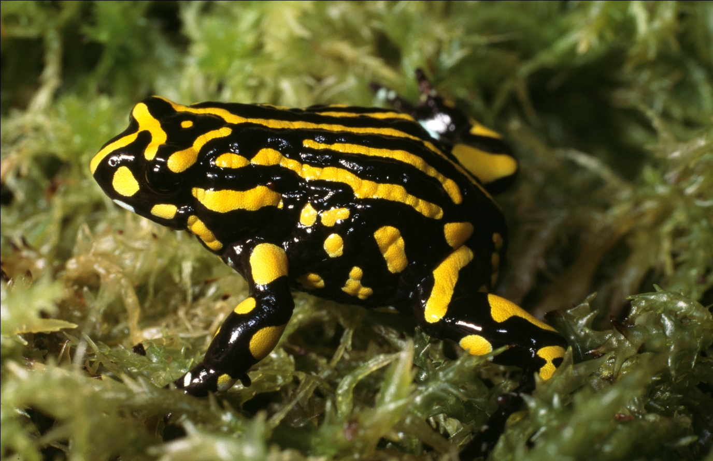

*Pseudophryne corroboree* (Southern Corroboree Frog) ©Steve Wilson

### Ecology

As the name suggests, *Sphagnum* spp. are an integral component of the Alpine *Sphagnum* Bogs and Associated Fens ecological community. *Sphagnum*, along with *Empodisma minus* (Agnew et al., 1993) are known to contribute greatly to peat formation in bogs in the southern hemisphere, with many bogs forming on *Sphagnum* derived peat (Whinam et al., 2003). Like peat, *Sphagnum* has a significant water holding capacity which is important in modulating water flow and maintaining the hydrology of surrounding environments (Ashton & Williams, 1989). The manner in which bog and fen communities gradually release water from the spring snow melt is critical to the survival of numerous other ecological communities (Good, 1992).

The Alpine *Sphagnum* Bogs and Associated Fens ecological community is maintained by summer groundwater rather than winter climatic regimes (Good, 1998). Although the snowpack is important for slow release of water into the bogs throughout the spring and summer thaw, snow cover itself is not a required factor in their ecology. The snow pack can assist in protecting the community during the snow-covered period from intense winds, eroding rains and solar radiation. It is these factors that have partly allowed the community to evolve into the topographic environments or macrogradients in which they now occur (Good, 1998).

### Hydrology

The importance of bogs in the catchment hydrology of the Australian Alps has long been recognised and studies continue to investigate the importance of peat in hydrological processes (Grover et al., 2012). Bogs and fens rely on groundwater baseflows, which can vary depending on the bog’s position within the landscape. The bogs are sensitive to changes to groundwater flows or discharge, which may result from a range of activities.

If the bogs and fens become degraded, their water holding capacity is frequently reduced or destroyed as a result of erosion and channelling (Ashton & Williams, 1989; Wahren et al*.*, 1996). Such degradation can lead to drying out of bogs, further reducing the integrity of the ecological community and impacting the hydrology of the surrounding area. As a critical function of the ecological community is water supply, such changes can in turn have repercussions downstream (Ashton & Williams, 1989).

### Current Condition

Most, if not all, of the occurrences of this ecological community on mainland Australia have become somewhat degraded from a natural condition due to the combined impacts of multiple threats, which includes grazing and trampling by hoofed animals at some sites, and repeated wildfires. Tasmanian bog and fen communities have also been affected by a range of threatening processes, such that degradation is also likely to be widespread, particularly on the Central Plateau.

Condition thresholds define categories of condition for an ecological community and may be used to prioritise protection for the best quality vegetation remnants by excluding very low quality examples from the legal definition. Condition thresholds have not been adopted for the Alpine *Sphagnum* Bogs and Associated Fens ecological community. A method for assessing baseline condition for Alpine *Sphagnum* Bogs and Associated Fens has not yet been developed and has recommended actions in this plan (Actions 8.1b, 8.2c).

## Distribution

The Alpine *Sphagnum* Bogs and Associated Fens ecological community occurs primarily within the Australian Alps, the Tasmanian Central Highlands and the Tasmanian Southern Ranges Interim Biogeographic Regionalisation for Australia (IBRA) bioregions. It is also found in a small area of the Bondo subregion of the South Eastern Highlands IBRA bioregion on mainland Australia, and may be present within the Ben Lomond and Tasmanian South East IBRA bioregions in Tasmania. The ecological community occurs in small pockets in New South Wales and the Australian Capital Territory (see Map 1 below), Victoria (see Map 2 below) and Tasmania (see Map 3 below). The ecological community consists mostly of highly fragmented, isolated patches, and its geographic extent is restricted. Most examples of the ecological community are situated within national parks and other conservation related land tenure.

The Alpine *Sphagnum* Bogs and Associated Fens ecological community is typically found in alpine, sub-alpine and montane (mountainous, or of higher elevation) environments, often above the climatic treeline and also in frost-prone valleys.

From a geographical perspective, alpine and subalpine regions typically occur above 1400 metres above sea level (ASL) on the mainland and above 800 metres ASL in Tasmania (Kirkpatrick, 1997; Slattery, 1998). However, the ecological community may occur in isolated pockets as low as 800 to 1000 metres ASL in parts of the mainland, and 650 metres ASL in Tasmania.

### Important occurrences

The limited distribution and fragmented nature of the Alpine *Sphagnum* Bogs and Associated Fens across its range means that all occurrences of this ecological community are considered important.

The ecological community is dependent on the maintenance of local hydrological conditions, particularly ground water. Local catchments for the ground water that supports bog and fen habitat are important to the survival of the ecological community.

### Areas of the ecological community under particular pressure for survival

Such areas may include but not be limited to areas where the ecological community is or has been subject to:

* fire impacts
* grazing and trampling from domestic stock
* wallowing, grazing and trampling from feral horses, pigs and deer
* localised impacts from weed infestation
* localised impacts from infrastructure and associated activities
* localised impacts from timber harvesting

These threats are discussed further in Section 3.

Priority sites for protection in New South Wales and the Australian Capital Territory are listed in the Technical report prepared for the NSW Office of Environment and Heritage (Hope et al., 2012). In Victoria, priority sites and actions are identified in the Victorian Alpine Peatlands Spatial Action Plan (VEPI in prep.).

**Map 1: Distribution of the ecological community in ACT and NSW**

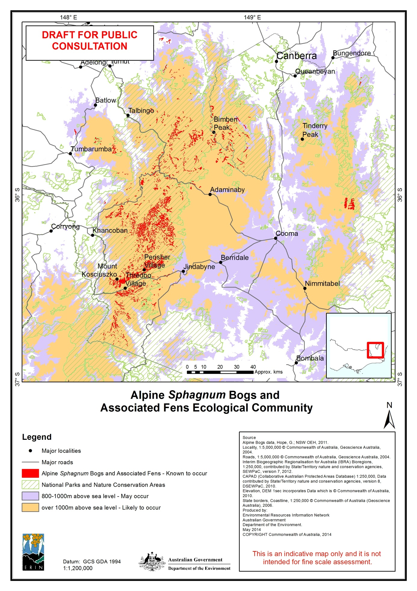

**Map 2: Occurrence of the ecological community in Victoria**

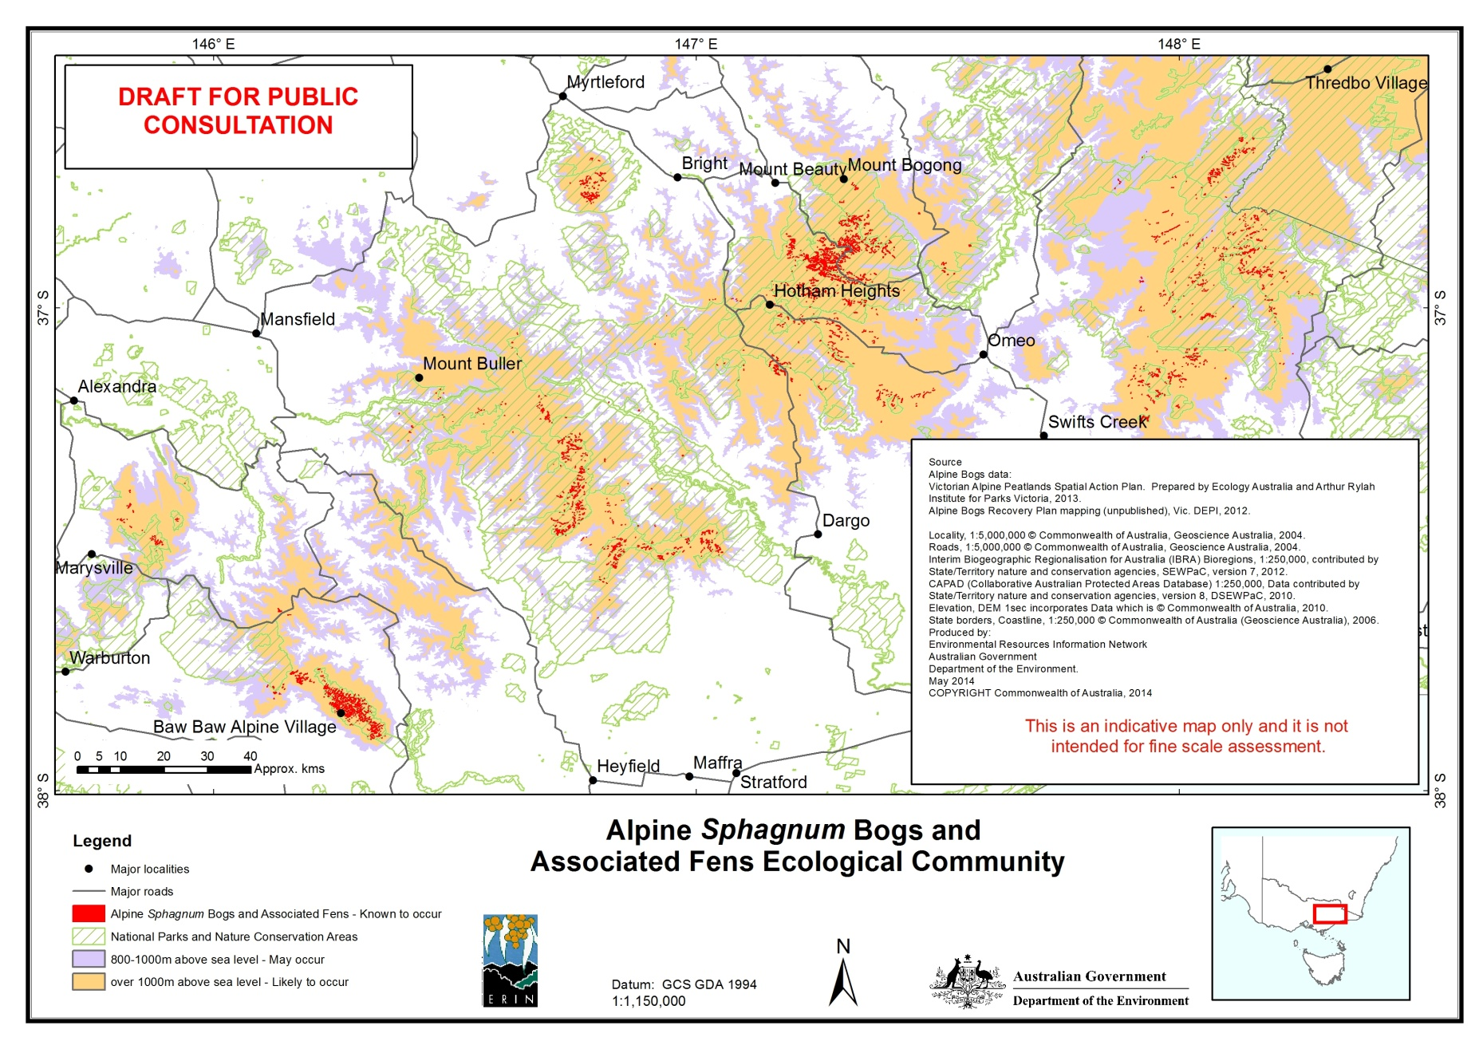

**Map 3: Occurrence of the ecological community in Tasmania**

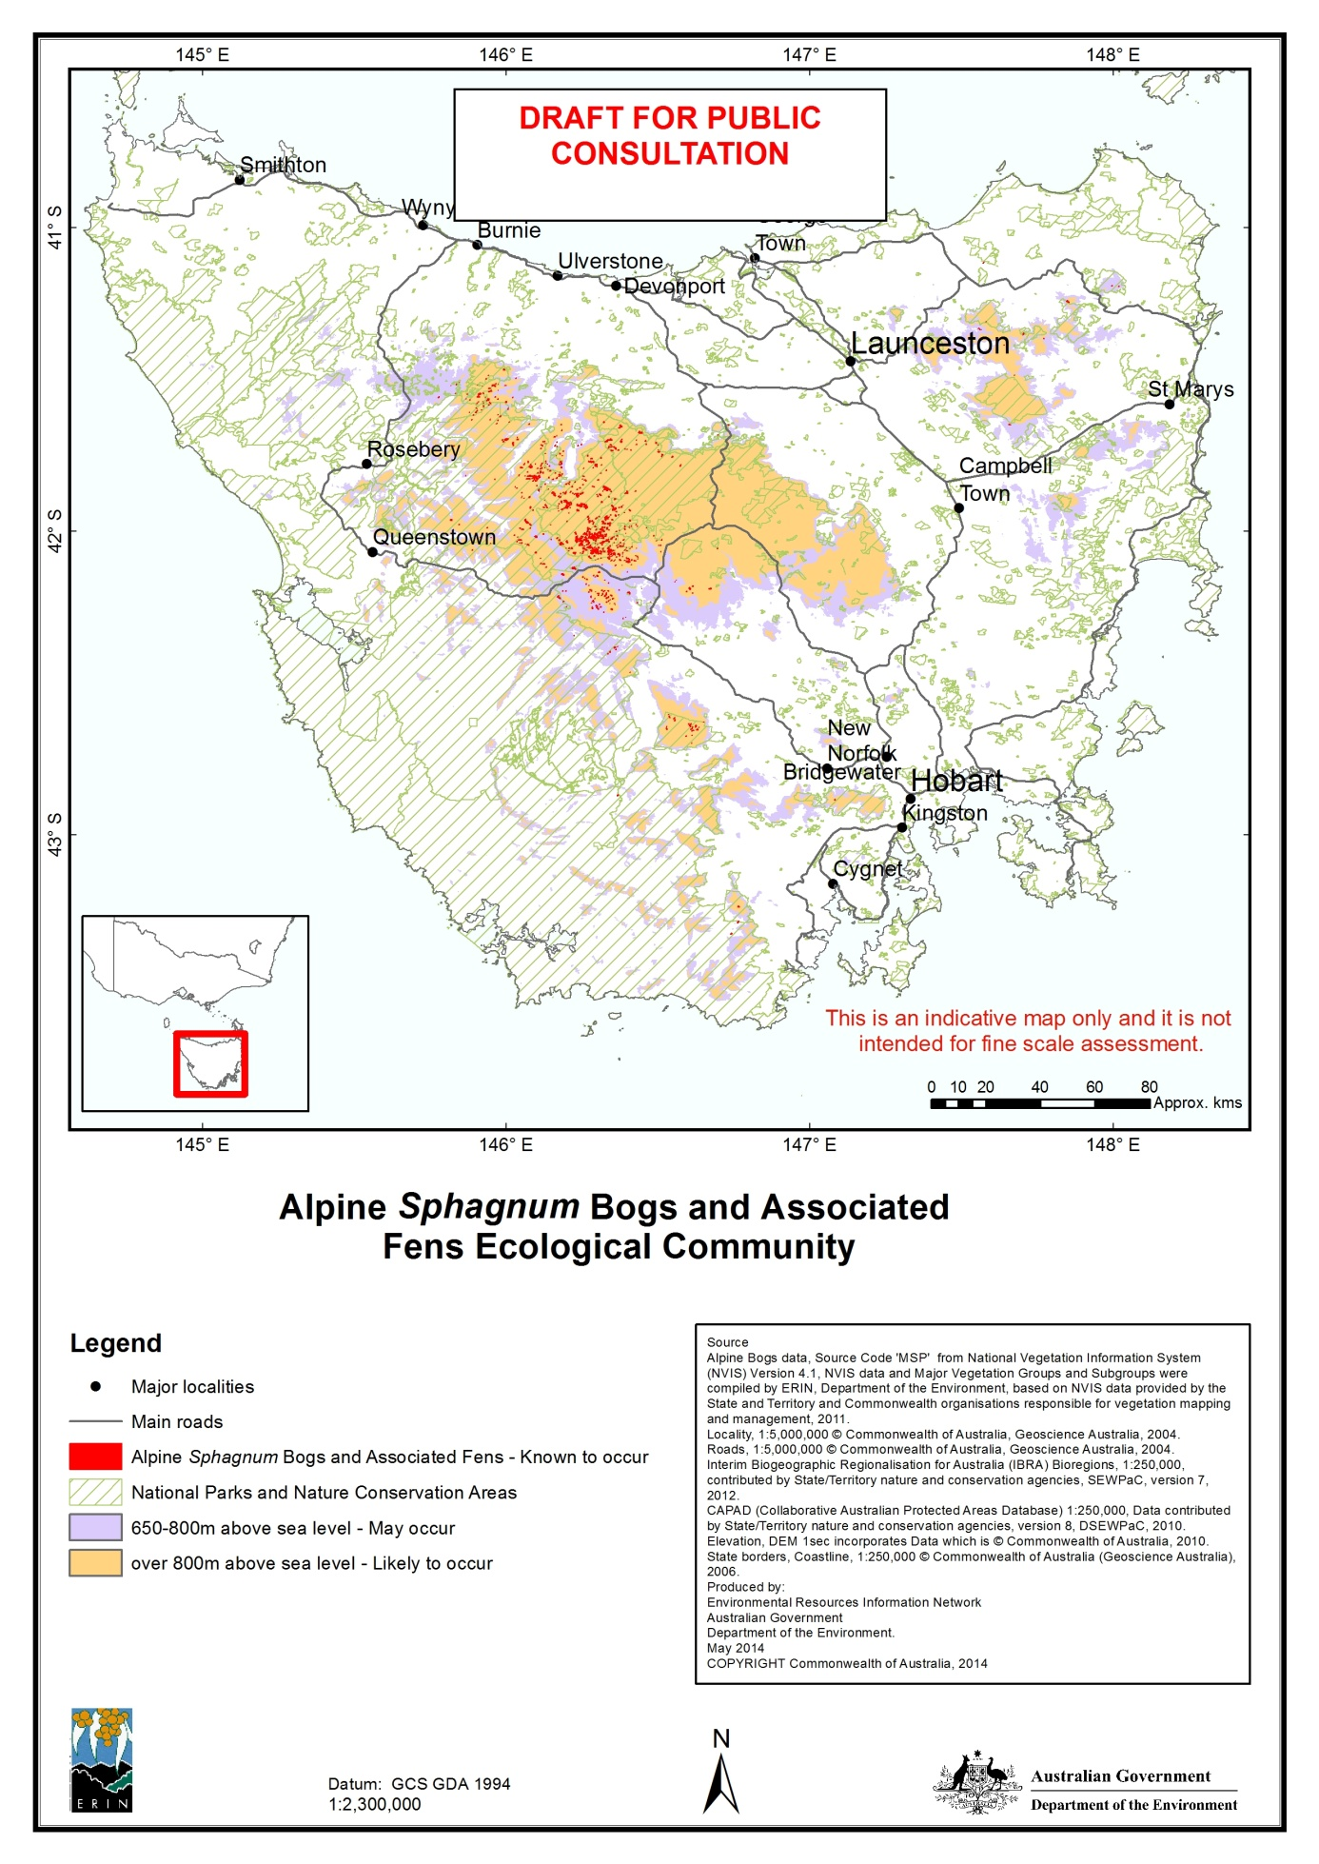

# Threats

Alpine vegetation is particularly susceptible to change in general, along with a range of more specific adverse impacts. This is due in part to the restricted growing season of the alpine and subalpine regions, but also the very fragile nature of some systems, particularly alpine snowpatch vegetation and the Alpine *Sphagnum* Bogs and Associated Fens ecological community (Ashton & Williams, 1989).

The effects of a range of threats impacting on the integrity of the Alpine *Sphagnum* Bogs and Associated Fens ecological community are complex, long lasting and may have serious implications for persistence of the ecological community in some locations. Where degradation has occurred, the recovery of structure and function is likely to take several decades (McDougall, 2007). Furthermore, if *Sphagnum* has been completely lost from a site, both the *Sphagnum* and the bogs which depend on it for the development of permanently moist conditions may become locally extinct unless new *Sphagnum* plants can be introduced (Walsh & McDougall, 2004).

The impacts of threats acting on the ecological community are often exacerbated by the occurrence of other threats, such that the overall resilience of the ecological community is diminished. For example, frequent fires make the ecological community more susceptible to weed invasion.



## Key threats

### 

### Fire

Unlike many ecological communities in Australia, fire is not a key process that supports the ecosystem function of the Alpine *Sphagnum* Bogs and Associated Fens. Therefore, a fire regime with long intervals between disturbances is unlikely to result in the long-term decline in the condition of the ecological community. The greatest threat is from fire regimes where there are repeated disturbances without adequate time for recovery in vegetation cover and diversity. A reduction in vegetation cover within and adjoining alpine bogs and fens may result in changes in hydrological regimes and increase the risk of invasion by exotic species.

The post-European settlement practice of burning to provide green feed for livestock and supposedly to reduce fuel load has permanently altered the Australian alpine and subalpine landscape. Most of the detrimental changes that can follow a fire, such as loss of vegetation cover and subsequent erosion, are also associated with the impacts of grazing and exotic weed invasion, both of which are addressed elsewhere in this section.

Over 1.4 million hectares of alpine and subalpine country in north-east Victoria, south-east NSW and the ACT were severely burnt by the wildfires of January 2003. Most of the areas covered by the Alpine *Sphagnum* Bogs and Associated Fens ecological community were affected (Gill et al., 2004; Hope et al., 2005).

The impacts of the 2003 wildfires were variable, depending on the particular location, vegetation type, fire intensity and prevailing weather conditions that occurred at the time. The result was a landscape mosaic ranging from wide areas severely burnt to patches that escaped untouched by fire (Crabb, 2003). However, some areas affected by a further major fire in 2006-2007, following the severity of 2003, indicate that too frequent wildfire is also a threat as some communities need extended periods of time between fire events in order to adequately recover (McDougall, 2007; Whinam et al., 2010).

The impact of fire on the Alpine *Sphagnum* Bogs and Associated Fens ecological community is long-term. However, evidence from previous smaller fires suggests that whilst post-fire recovery of *Sphagnum cristatum* is frequently negligible for several years, a more rapid recovery rate does follow later (McDougall, 2007). Too frequent fire remains an ongoing threat to the Alpine *Sphagnum* Bogs and Associated Fens ecological community, particularly under drought conditions (Whinam et al., 2010). Climate change will also impact upon both fire risk and fire behaviour.

### Climate change

Climate change must be considered as one of the most ominous threats currently facing the Alpine *Sphagnum* Bogs and Associated Fens ecological community, even though the implications and specific details are as yet unclear (Keith, 2004; McDougall and Walsh, 2007; Williams & McDougall, 2007).

It is projected that ecological communities currently existing at the limits of their possible range are amongst the most vulnerable to the potential impacts of a changing climate (Mansergh et al., 2002; Whinam et al*.,* 2003). The Alpine *Sphagnum* bogs and Associated Fens ecological community is a leading example of this situation. Even a small increase in mean ambient temperature is likely to result in the loss of more bogs and fens due to changes in snowfall and snowmelt regimes, which will in turn affect groundwater and runoff patterns. Observed trends show a significant decline in snow cover and snow depth since the 1960’s in the south-east Australian highlands (Dunlop and Brown 2008; Osborne, Green and Davis 1998). Models of climate change impacts on natural snow cover also suggest continuing reduction of the snow pack even under modest climate change scenarios (Galloway 1988; Hewitt 1994; Whetton1998; CIG 1996). Over time, a reduction in snowmelt and soil moisture is likely to result in some occurrences of the Alpine *Sphagnum* bogs and Associated Fens ecological community being replaced by tussock grasslands or wet heath assemblages (Pickering *et al.* 2004).

### In addition, recent literature supports the proposition that montane regions will become critical refugia for both flora and fauna under enhanced greenhouse scenarios (Shoo & Williams, 2006; Mackey et al., 2012), which will affect alpine bogs and fens found in those areas (Mansergh et al., 2002).

### Domestic livestock

One of the well documented threats to alpine vegetation is the impact of animals introduced to Australia since European settlement. All alpine and subalpine regions on the mainland and in Tasmania were used for summer grazing of domestic cattle from the early 1800s. Grazing in national parks in Tasmania, NSW and the ACT ceased by the 1970s and 1980s, (considerably earlier in some areas, such as 1914 in the Cotter Catchment, ACT) and formally came to an end in Victoria in 2005 (Kirkpatrick, 1983; Ashton and Williams, 1989; Crabb, 2003; Jacobs, 2005), with exception of grazing trials for fuel load reduction in the Wonnangatta Valley. Where cattle have restricted access to the national parks, it is critical that key management options such as fencing, conditional licenses and enforcement are strengthened , as grazing does continue in neighbouring state forests and on private lands and there is potential for cattle to stray from these areas into sensitive areas.

Australian soils and vegetation are very susceptible to the impacts of hoofed animals. In particular, *Sphagnum* is easily crushed and broken up by trampling and wallowing, both of which are inevitable around any water course where animals are liable to congregate on a regular basis. Cattle and horse hoof prints are especially enduring in *Sphagnum cristatum* at the edges of pools and streams (McDougall, 2007). Once the *Sphagnum* cover is lost, alpine soils and peat environments are very susceptible to desiccation, incision and soil erosion (Good, 1992). Trampling and wallowing cause channels to form in the disturbed *Sphagnum* and underlying peat*,* resulting in water exiting the landscape more rapidly than occurs in undisturbed bogs. The formation of channels is in turn detrimental to the fens associated with the bogs. Where *Sphagnum* cover has been impacted by non-native animals, the erosion channels that can result mean the fens drain directly into the stream system.

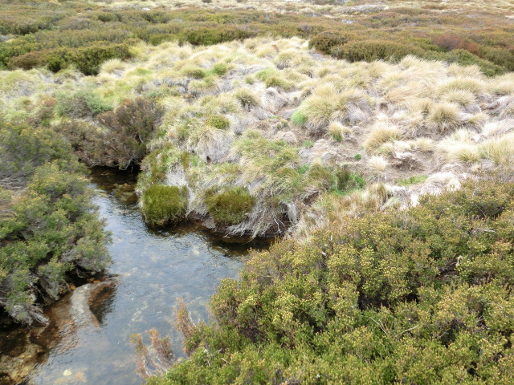

Legacy of historic grazing damage in Alpine *Sphagnum* Bogs and Associated Fens at Betts Creek, Kosciuszko National Park. ©Department of the Environment and Kåren Watson.

### 

### Invasive Fauna

Feral horses

In alpine, subalpine and montane areas of the Australian mainland, along with domestic stock, feral horses are the largest animals to impact on the ecological community and represent a threat that requires complex management strategies (O’Brien & Wren, 2002). Feral horse populations in NSW and Victoria have been increasing at a rate that has outpaced active management. The number of feral horses in the Australian Alps national parks increased by approximately 20 per cent annually between 2003 and 2009 from an estimated 2 500 to 7 600 (Dawson, 2009). The next survey results are expected sometime in 2014.

In 2013 Worboys and Pulsford observed the direct impacts of a ‘very large number of horses’ and considered the damage to be comparative to the worst historic domestic grazing pressures that triggered the removal of stock from Kosciuszko National Park in the 1940s.

Feral horses are not currently a threat in Tasmania or the ACT.

Feral deer

Feral Deer are an emerging and urgent issue threatening biodiversity in the Alpine and subalpine areas of mainland Australia and Tasmania. Deer populations (and extent) have increased significantly in recent years and they are rated as a ‘high threat’ as there is limited information available on their potential proliferation, and they cause significant damage to the ecological community through trampling, browsing and wallowing.

Feral Pigs

Feral pigs are a significant problem causing damage to bogs in both the ACT and NSW, but are less problematic in Victoria and are not currently present in mainland Tasmania. Damage occurs generally on the edges of, or grasslands adjacent to bogs where these animals wallow in pools and waterways, and can dig and uproot vegetation over large areas, making them an ongoing threat to the structural integrity of the ecological community.

Rabbits

Rabbits can reduce cover and diversity of forb species in sub-alpine areas and disturb the soil by digging (Leigh, Wimbush et al*.*, 1987). Greater numbers of rabbits are often prevalent post-fire which inhibits vegetation resprouting and regeneration (Leigh, Wimbush et al*.*, 1987). Although there is some evidence that rabbits can be active at the margins of some bogs, it appears to be minor (Tolsma and Shannon, 2009).

Foxes, cats and trout

Foxes and cats may impact populations of native frogs (including the critically endangered Corroboree frog - *Pseudophryne* spp.), native fish (*Galaxias* spp.) and alpine spiny crays (*Eustacus* and *Engaeus* spp.) in some high altitude areas, including in the ecological community. Trout generally remain small (less than 20cm) in smaller streams and fens, such as for this ecological community. However, an incursion could have an impact on native *Galaxias* species.

### Invasive Flora

Weeds

Exotic weed invasion is a current and increasing threat to the Alpine *Sphagnum* bogs and Associated Fens ecological community. There are few weed species that have serious impacts on herbaceous bog flora composition, but it is the interaction between large fires and weeds that has been identified as a key threat to the resilience and function of alpine ecosystems (Williams et al., 2008). Post-fire studies in the Kosciuszko National park have found a significant increase in both diversity and average numbers of weeds impacting on bog sites (Hope et al*.*,2005).

Weed invasion has the potential to reduce or destroy the integrity of the Alpine Sphagnum Bogs and Associated Fens ecological community. Some exotic weeds such as *Juncus* spp. and willows have the capacity to establish themselves in such abundance that they permanently alter floristic composition and structural integrity, as well as affecting the overall hydrology of the area (McDougall, 2007).

*Woody*

Willow (*Salix spp.*) invasion into the ecological community can cause major structural impacts and fundamental alteration of root structures and hydrology, as they have in many other river and freshwater systems. (Cremer, 1995; 1999). Willows are a significant issue, particularly in Victoria, where willow spread and infestation has increased after major fire events in the recent past.

*Non-woody*

The three key non-woody weeds that threaten the Alpine Sphagnum Bogs and Associated Fens ecological community are:

* Orange Hawkweed *(Heiracium aurantiacum) -* the species is considered a significant threat to biodiversity and native ecosystems due to its ability use both seeds and stolons to spread and establish itself densely over large areas (Morgan, 2000).
* Ox-eye Daisy *(Leucanthemum vulgare) –* the speciesmay spread into burnt native vegetation with catastrophic invasive potential, and
* *Juncus effusus* – the species is now in such abundance over previously grazed areas (e.g. Rocky Valley on the Bogong High Plains) that they are permanently altering the floristic composition and structural integrity of some bog and fen sites (Walsh and McDougall, 2004; McDougall, 2007).

Other weed species commonly found in the Alpine *Sphagnum* bogs and Associated Fens ecological community include *Mimulus moschatus* (Musk Monkey Flower), *Phleum pratense* (Timothy Grass) *Anthoxanthum odoratum* (Sweet Vernal-Grass), *Holcus lanatus*  (Yorkshire Fog), and *Hypochaeris radicata*  (Cat’s Ear) (McDougall & Walsh, 2007; VDSE, 2007).

### Pathogens and Diseases

Pathogens, like wildfire, are unpredictable in terms of where and when they will appear. Containment or control of a pathogenic infestation in isolation is always likely to be difficult, but not compared to the risk of a pathogenic outbreak in combination with other threats facing the ecological community.

*Chytrid* fungus is a known pathogen that affects Australian frogs and has been listed under the EPBC Act as a Key Threatening Process contributing to the decline in Australian frog species. Although there is no documented suggestion that *Chytrid* is of significant threat to the ecological community itself, it unquestionably affects the health of its frog fauna. These include the Northern and Southern Corroboree frogs (which are closely associated with the ecological community) which have recorded major declines in population due in large part to this fungal disease. The Australian Government has produced a [Threat abatement plan for infection of amphibians with *chytrid* fungus resulting in *chytridiomycosis*](http://www.environment.gov.au/resource/infection-amphibians-chytrid-fungus-resulting-chytridiomycosis).

Other pathogens likely to emerge or become introduced to alpine, sub alpine and montane areas include *Phytophthera*, myrtle rust and didymo. Dieback of vegetation caused by *Phytophthera cambivora* has recently been detected in the alpine area of Kosciuszko National Park (Green, K & McDougall, K., pers.comms.). The emergence of *Phytophthera* and potentially other diseases and pathogens in areas where they have been previously absent has been linked to a changing climate. The Australian Government has produced a [Threat abatement plan for disease in natural ecosystems caused by *Phytophthora cinnamomi*](http://www.environment.gov.au/resource/threat-abatement-plan-disease-natural-ecosystems-caused-phytophthora-cinnamomi).

### Infrastructure, development and recreation

Tourism, associated infrastructure and other human uses of the area encompass a range of threats affecting the Alpine *Sphagnum* Bogs and Associated Fens ecological community, even though most examples of this community are located within national parks. Recreational demands on alpine and subalpine regions continue to rise as more people visit the area in the summer months, as well as the more traditional winter ski season (McDougall & Walsh, 2007). Trampling of vegetation by walkers not keeping to pathways is a growing problem (Whinam & Chilcott, 2002). Other threats include ski resort developments, associated roadworks, and dams required for the production of hydro-electricity (McDougall & Walsh, 2007). Dams and aqueducts are a significant issue due to their permanent impact on local hydrology, as they can lead to affected bogs and fens being drained and ultimately drying out.

Resource use

*Sphagnum* moss has previously been harvested from the wild, notably in Tasmania with very minor amounts coming from Victoria and NSW, for use in the horticultural industry (Whinam & Buxton, 1997). The Australian Code of Practice for *Sphagnum* harvesting states that harvesting should not be carried out in alpine or subalpine environments. However, illegal harvest does occur (TDPIW, 2007). Forestry Tasmania ceased issuing permits to harvest *Sphagnum* moss from the forest estate in 2011.

Timber harvesting and silvicultural regimes in catchments containing Alpine *Sphagnum* Bogs and Associated Fens may impact the community through physical disturbance and the potential for associated changes in local hydrology, as well as through fire regimes (Whinam & Chilcott, 2000).

Ground water extraction proposals are a newly-emerging issue that may be a potential high-impact threat to the long-term hydrological health of the ecological community. Groundwater extraction may be a localised threat to the ecological community, depending on the amount of water extracted and the locality.

Further information can be found in the [Commonwealth Listing Advice on Alpine Sphagnum Bogs and Associated Fens](http://www.environment.gov.au/biodiversity/threatened/communities/pubs/29-listing-advice.pdf) and in the SPRAT profile [here](http://www.environment.gov.au/cgi-bin/sprat/public/publicshowcommunity.pl?id=29).



## National severity rating

A risk assessment, estimating the likelihood of a threat occurring and the consequence of its occurrence, was undertaken for each of the key identified threats at the jurisdictional level. The risk assessments were done separately for known threats as existing threats, and potential threats considered as new or emerging threats and new incursions or expanded distribution of an existing threat. It may be a higher priority (and more cost effective) to deal with the emergence of a new threat or new incursion of an existing threat quickly, before it establishes.

The results of the risk assessment were consolidated to provide an overall national level severity rating (Table 1). Acknowledging that many threats are already existing in many locations, the severity rating is the level of severity of impact a threat will have on the ecological community when or as it occurs.

**Table 1:** National Severity rating of key threats

|  |  |  |
| --- | --- | --- |
| **Category** | **Threat (source)** | **National Severity Rating** |
| Climate change | Climate change | Very High |
| Fire | Fire frequency and intensity | Very High |
| Domestic stock | Grazing and trampling | Very High |
| Invasive species | Feral horses | Very High |
| Deer | High |
| Feral pigs | High |
| Rabbits and hares | Low |
| Foxes (fauna impacts) | Medium |
| Cats (fauna impacts) | Medium |
| Trout (fauna impacts) | Medium |
| Invasive species | Weeds – woody | Very High |
| Weeds – non-woody | High |
| Pathogens/disease (including chytrid, *Phytophthera,* and potentiallymyrtle rust and Didymo) | Very High |
| Infrastructure, development and recreation | Water infrastructure (includes aqueducts, hydro developments) | Very High |
| Resort development | High |
|  | Tracks and Roads | Medium |
|  | Off-track recreation use | Medium |
| Resource use | Peat and sphagnum harvesting | Very High |
| Timber harvesting | Medium |
|  | Ground-water extraction | Medium |

The detailed risk assessment for each jurisdiction is available in the decision matrix that was used to prioritise the actions outlined below. The decision matrix will be made available in the document ‘Background information: Alpine *Sphagnum* Bogs and Associated Fens Recovery Plan’ which will be made available [here](http://www.environment.gov.au/cgi-bin/sprat/public/publicshowcommunity.pl?id=29&status=Endangered) when it is completed.

# Recovery Strategy



## Objectives

**Primary objective:**

**Maintain or extend the current known extent (area) and maintain or improve the condition of the Alpine *Sphagnum* Bogs and Associated Fens ecological community over the life of the recovery plan.**

**Supporting objective:**

**Ensure effective adaptive implementation of the plan.**



## Strategies

The objective will be achieved by three strategies:

* Implementing the priority recovery actions identified in the recovery plan in order to address those threats most affecting the ongoing survival of the ecological community;
* Maintaining or enhancing the condition of the ecological community through supporting research and restoration efforts to enhance the resilience and adaption of the ecological community to climate change; and
* Improving knowledge of the ecological community, monitoring its status, and using adaptive management in response to new information.

The following factors will be important for the successful delivery of the strategies:

* Sufficient and enduring funding to complete priority actions;
* Recognition that maintenance and recovery of this ecological community requires commitment to on-ground actions and long-term effort;
* A community that values the Alpine and subalpine environments and their role in biodiversity conservation and ecosystem services;
* A culture of inclusiveness, transparency and accountability for all aspects of the recovery program by recovery program partners;
* Effective mechanisms for cross jurisdictional co-operation and coordination to implement priority actions efficiently and effectively;
* A network of stakeholders and partners that includes relevant experts, delivery partners and affected interests;
* Effective mechanisms for communicating with stakeholders and partners;
* A strong adaptive management framework for program delivery, with the capacity for adaptive and timely decision-making based on monitoring data;

This ecological community will continue to be impacted by climate change. It is outside of the scope of this plan to address the drivers of climate change. Implementing the actions identified in this plan will support the resilience and adaptation of the Alpine *Sphagnum* bogs and associated fens in the context of a changing climate.

The objectives, strategies and actions are consistent with the priority management responses recommended by the Caring for our Australian Alps Catchments report (Worboys et al., 2011).



## Performance criteria

The plan requires a short review in 5 years and a full review after 10 years. It is intended that the reviews will measure the success of the recovery plan in achieving the overall objective and supporting objective using the following performance criteria.

**Overall objective and performance criteria:**

**Maintain or extend the current known extent (area) and maintain or improve condition of the Alpine *Sphagnum* Bogs and Associated Fens ecological community over the life of the recovery plan.**

Achievement of this objective will be measured against the following performance criterion:

There has been no decrease in current known extent or overall condition of the ecological community between 2014 and 2024 (to be further informed by condition baselines as they become available).

**Supporting objective and performance criteria:**

**Ensure effective adaptive implementation of the plan**

Achievement of this objective will be measured against the following performance criterion:

There are 3 strategies, and 10 actions to achieve the objectives. To achieve the supporting objective, priority actions will have been undertaken, the results understood and shared, and any required modifications to priority actions made as new information becomes available.

The strategies, actions and the specific tasks to be undertaken under those actions are outlined below.

Relationship between objectives, strategies and recovery actions

Actions and strategies are summarised. Please refer to the Recovery Actions section below for details.

SUPPORTING OBJECTIVE

Ensure effective adaptive implementation of the plan

**OVERARCHING OBJECTIVE**

**Maintain or extend the current known extent (area) and maintain or improve condition of the Alpine *Sphagnum* Bogs and associated Fens ecological community over the life of the plan.**

**OBJECTIVES**

Resources, information & priorities

4. INFRASTRUCTURE & RECREATION

A4.1 Avoid and minimise Infrastructure & development impacts

A4.2 Avoid and minimise recreation impacts

A4.3 Increase compliance surveillance and enforcement

3. PROTECT FROM LIVESTOCK

A3.1 Avoid new impacts, minimise current impacts

9. MANAGE PLAN

A9.1 Implement, coordinate, review and report on progress

8. KNOWLEDGE

A8.1 Improve mapping for the EC

A8.2 Increase field research and monitoring

Governance, adaptive management, communication

STRATEGY 3

Improve knowledge, review and adapt management

STRATEGY 2

Maintain or enhance condition of the EC

**ACTIONS**

**STRATEGIES**

**STRATEGY 1**

**Manage and reduce threats to the EC**

6. CLIMATE CHANGE

A6.1 Support resilience: Implement Actions under strategy 1

A6.2 Identify, research & mitigate potential CC impacts

7. REHABILITATE CATCHMENTS

A7.1 Support resilience: Implement Actions under strategy 1

A7.2 Rehabilitate and restore flows in damaged areas

A7.3 Develop rehabilitation methods for damaged areas of the EC

Functional work - overall objective, associated strategy and actions for mitigating threats and supporting resilience

10. COMMUNICATION

A10.1 Secure partnerships and resources

A10.2 Communicate with partners, stakeholders & community

2. MANAGE INVASIVE SPECIES

A2.1 Minimise impacts from weeds

A2.2 Minimise impacts from invasive herbivores/omnivores

A2.3 Minimise impacts from invasive carnivores

A2.4 Minimise impacts of pathogens

1. MANAGE FIRE and MINIMISE IMPACTS

A1.1 Maintain an appropriate fire regime to protect the EC

5. RESOURCE USE

A5.1 Avoid new impacts

A5.2 Increase compliance and enforcement



## Recovery Actions

The Recovery Actions table below outlines the actions and associated tasks or activities that are to be undertaken to implement each strategy in order to achieve the objectives. The identified actions and priorities are informed by current knowledge, threats and regulatory arrangements. Consistent with an adaptive management approach, it is intended that they are refined where new information becomes available and/or circumstances change.

The actions have been prioritised separately in recognition that Alpine *Sphagnum* Bogs and Associated Fens in each jurisdiction have differing management challenges which require targeted prioritisation for different threats. The listed tasks under each strategy have been prioritised through the use of a decision matrix which assesses the risk that a threat poses to the ecological community (through assessing the likelihood the impacts of the threat will occur, the severity of the impact and the extent of the impact) and the likelihood of success in undertaking actions to address the threat (tractability). This decision matrix will be included in the document ‘Background information: Alpine *Sphagnum* Bogs and Associated Fens Recovery Plan’ which will be made available [here](http://www.environment.gov.au/cgi-bin/sprat/public/publicshowcommunity.pl?id=29) when it has been completed.

The attainment of objectives and the provision of funds necessary to implement actions are subject to budgetary and other constraints affecting the parties involved, as well as the need to address other priorities. It is recommended that tasks prioritised as moderate to highest are implemented at a minimum. Otherwise it is likely the investment will not result in significant outcomes for the Alpine *Sphagnum* Bogs and Associated Fens ecological community.

The prioritisations allocated in the tables below have been guided by expert input, but may not necessarily represent all the views of those experts or of the jurisdictions for which the priorities are allocated.

**Table 2:** Priority recovery actions table

|  |  |  |  |  |  |  |  |  |  |  |
| --- | --- | --- | --- | --- | --- | --- | --- | --- | --- | --- |
| **Strategy 1. MANAGE AND REDUCE THREATS TO THE ECOLOGICAL COMMUNITY** | | | | | | | | | | |
| **Action 1 MANAGE FIRE** | | **Tasks to minimise the threat and impacts of fire on the ecological community** | | **Priority rating** | | | | | | |
| **ACT** | **NSW** | | **VIC** | | **TAS** | |
| **1.1 Maintain a fire regime appropriate to protect the ecological community.** | | 1. Maintain accurate fire history mapping of extent, frequency and severity (as a surrogate for intensity). | | Moderate | Moderate | | Highest | | Highest | |
| 1. Include updated mapping of the ecological community (Action 8.1) in fire management plans. | | Moderate | Moderate | | Highest | | Highest | |
| 1. Improve knowledge about the importance and locations of the ecological community in field staff and fire management operators. | | Moderate | Moderate | | Highest | | Highest | |
| 1. Avoid negative impacts to the ecological community from fuel reduction burns. | | Moderate | Moderate | | Highest | | Highest | |
|  | | | | | | | | |
| 1. Ensure that impacts from activities associated with fire management operations (e.g. control line construction vehicle access, back burning) have negligible effect on the ecological community. | | Highest | Highest | | Highest | | Highest | |
|  | | | | | | | | |
| 1. Develop a rapid assessment tool for assessing fire impacts and required responses (e.g. restoration, water spreading) to mitigate landscape-scale fire impacts. | | Moderate-high | Moderate-high | | Moderate-high | | Highest | |
| 1. Develop and implement targeted management responses for fire affected areas (for example through restricting access in the post fire recovery period). | | Highest | Highest | | Moderate - high | | Highest | |
| **Action 2**  **MANAGE INVASIVE SPECIES** | | **Tasks to prevent the threat and establishment of invasive species and diseases at ecological community sites where they don’t occur and minimise their impacts at sites where they do occur.** | | **Priority rating** | | | | | | |
| **ACT** | **NSW** | | **VIC** | | **TAS** | |
| **2.1 Minimise the impacts of weeds (woody and non-woody) on the ecological community, consistent with national and regional weed management plans, where applicable).** | | 1. Prevent the establishment of weeds likely to threaten the ecological community. | Woody | Low | Low | | Highest | | Highest | |
| Non-woody | Moderate | Moderate | | Highest | | Moderate | |
| 1. Eradicate, contain or control existing weeds threatening the ecological community; such as Willow (*Salix spp.*), Orange Hawkweed *(Heiracium aurantiacum),* Ox-eye Daisy *(Leucanthemum vulgare)*, and *Juncus effusus*. | Woody | Not present | Not present | | Highest | | Highest (only Salix spp. present) | |
| Non-woody | Highest | Highest | | Moderate-high | | Moderate | |
| 1. Encourage private landholders, ski resorts and other land managers to prevent, eradicate, contain or control weeds threatening the ecological community. | Woody | Moderate-High | Moderate-high | | Highest | | Highest | |
| Non-woody | Moderate | Moderate | | Moderate-high | | Moderate | |
| 1. Undertake surveillance, monitoring and mapping of weeds threatening the ecological community, including new outbreaks and emerging threats. | Woody | Low | Low | | Highest | | Moderate | |
| Non-woody | Moderate | Moderate | | Moderate-high | | Moderate | |
| 1. Identify key sources of weed introduction and infestation, to prioritise targeted monitoring and control. | Woody | Low | Low | | Highest | | Moderate | |
| Non-woody | Low-moderate | Low-moderate | | Moderate-high | | Moderate | |
| 1. Identify priority weed species and prepare and disseminate information to help engage land managers and the public in identifying and reporting new incursions. | Woody | Low | Low | | Moderate-high | | Low-moderate | |
| Non-woody | Low-moderate | Low-moderate | | Moderate-high | | Moderate | |
| 1. Investigate control techniques for identified priority weed species, where control methods are not well understood. | Woody | Low | Low | | Highest | | Low | |
| Non-woody | Moderate | Moderate | | Highest | | Low-moderate | |
| **2.2 Minimise the impact of invasive herbivores/omnivores on the ecological community, (consistent with national and regional invasive animal plans, where applicable).** | | 1. Prevent establishment of new populations of hoofed animals, particularly feral horses, feral pigs and deer. | | Moderate-high | Moderate-high | | Moderate-high  Highest (horses) | | Highest (horses, pigs) Moderate-high (deer), | |
| 1. Eradicate, contain or control existing populations of feral horses, feral pigs, deer, rabbits and hares. | | Highest (pigs & deer)  Horses (not present | Highest | | Moderate-high  Highest (horses) | | Highest (rabbits)  Low-mod (deer)  Horses & pigs not present | |
| 1. Encourage private landholders, ski resorts and other land managers to prevent, eradicate, contain or control invasive herbivores threatening the ecological community. | | Moderate-high | Moderate-high | | Moderate-high | | Moderate-high | |
| **2.3 Minimise impact of invasive carnivores on the ecological community’s associated fauna (consistent with national and regional invasive animal plans where applicable).** | | 1. Eradicate, contain or control existing populations of foxes and cats threatening fauna in the ecological community. | | Moderate | Moderate | | Low-moderate | | Foxes currently not present | |
| 1. Prevent establishment of new populations of trout in high altitude streams and water bodies where they currently don’t occur. | | Low | Low | | moderate | | Highest | |
| **2.4 Minimise the impacts of pathogens/diseases on the ecological community, (consistent with national and regional disease management plans where applicable).** | | 1. Continue vigilance for new disease outbreaks and emerging threats by developing field capability in land management staff, public and private landholders in identifying diseases likely to threaten the ecological community. | | Low-moderate | Low-moderate | | moderate | | Moderate | |
| 1. Where possible, identify, prevent, eradicate, contain or control pathogens and diseases where they threaten the ecological community. | | Moderate | Moderate | | Low-moderate | | Moderate | |
| **Action 3**  **PROTECT FROM LIVESTOCK IMPACTS** | | **Tasks to avoid new impacts on the ecological community where livestock impacts don’t currently occur and minimise impacts where they do occur** | | **Priority rating** | | | | | | |
| **ACT** | **NSW** | | **VIC** | | **TAS** | |
| **3.1 Avoid and minimise the impacts from livestock on the ecological community.** | | * 1. For National Parks, State forests and other public land, prevent livestock impacts from occurring in the ecological community where these impacts are currently absent. | | Moderate | Moderate | | Highest | | Moderate | |
| * 1. Minimise the impacts from livestock where it occurs in the ecological community. | | Not present | Moderate | | Highest | | Highest | |
| * 1. Work with landholders to minimise or remove the impact of livestock on the ecological community, including through promoting the exclusion of livestock from bogs. | | Not present | Moderate | | Moderate-high | | Highest | |
| **Action 4**  **INFRASTRUCTURE & RECREATION** | **Tasks to avoid new impacts from infrastructure and recreational activities and minimise impacts where they do occur.** | | | **Priority rating** | | | | | | |
| **ACT** | | **NSW** | | **VIC** | | **TAS** |
| **4.1 Avoid and minimise impacts of infrastructure and development.** | * 1. Identify areas of the ecological community in proximity to and potentially impacted by roads and tracks, hydroelectric, ski resorts and other infrastructure. | | | Not present | | Low | | Moderate-high | | Moderate |
| * 1. Develop site-specific management actions to reduce impacts on the ecological community from existing infrastructure and maintenance activities where possible. | | | Not present | | Low | | Moderate-high | | Moderate |
| * 1. Identify opportunities where infrastructure including roads, tracks, aqueducts that are no longer required may be removed or altered to restore the ecological community. | | | Not present | | Low | | Moderate | | Moderate |
| * 1. Ensure that new infrastructure, including roads, tracks, trails and ski resort infrastructure is planned to avoid impacts on the ecological community. | | | Low | | Low | | Highest | | Highest |
| * 1. Provide maps and specific guidelines to Councils for use in development applications. | | | Low | | Low | | Moderate | | Moderate |
| **4.2 Avoid and minimise impacts of recreational activities.** | * 1. Ensure that permitted off-track recreational activities do not impact the community. | | | Moderate | | Moderate | | Highest | | Moderate |
| * 1. Mitigate the impacts of illegal or inappropriate off-track use by managing sites to prevent access and rehabilitating damaged sites. | | | Moderate | | Moderate | | Highest | | Moderate |
| * 1. Promote awareness about the ecological community and its vulnerability to damage by recreational activities to user groups through various media and interpretation methods. | | | Low-moderate | | Low-moderate | | Moderate | | Moderate |
| * 1. Support research to understand the potential impacts of changing recreational use patterns (e.g. increased summer visitation, mountain bikes) on the EC. | | | Low | | Low | | Moderate-high | | Low |
| * 1. Support research to understand the impacts of reducing snow depths and associated recreation use on the EC. | | | Low | | Low | | Moderate | | Low |
| **4.3 Increase surveillance and enforcement of penalties to deter illegal activities that may impact the ecological community.** | 1. Improve surveillance for illegal activities that impact the ecological community, including in approved development areas (e.g. ski resorts, hydro leased areas). | | | Low | | Low | | Moderate-high | | Moderate |
| 1. Ensure that appropriate penalties are applied for illegal activities that damage the ecological community. | | | Low | | Low | | Moderate-high | | Moderate |
| **Action 5**  **RESOURCE USE** | **Tasks to avoid new impacts from resource use and minimise impacts where they do occur.** | | | **Priority rating** | | | | | | |
| **ACT** | | **NSW** | | **VIC** | | **TAS** |
| **5.1 Avoid new impacts from resource use (e.g. peat, *Sphagnum* and timber harvesting, groundwater extraction and mitigate past impacts, where possible.** | 1. For National Parks, State forests and other public land, prevent new resource use that will damage the ecological community. | | | Low | | Low | | Highest | | Highest |
| 1. Minimise the impacts of resource use where it already occurs or has previously occurred in or adjacent to the ecological community. | | | Not present | | Not present | | Low-moderate | | Low-moderate |
| 1. Develop guidelines for forestry management and other planning mechanisms to ensure harvesting and regeneration activities occur over time and develop a temporal-mosaic within sub-catchments that contain the EC. | | | Not present | | Not present | | Moderate | | Moderate |
| 1. Work with landholders to minimise the impacts of resource use on the ecological community. | | | Not present | | Not present | | Moderate | | Moderate |
| **5.2 Increase compliance and enforcement for illegal resource use.** | 1. Improve surveillance and compliance for illegal resource use. | | | Low | | Low | | Low-moderate | | Moderate |
| 1. Ensure that appropriate penalties are applied for illegal activities that damage the ecological community. | | | Low | | Low | | Low-moderate | | Low |

|  |  |  |  |  |  |
| --- | --- | --- | --- | --- | --- |
| **Strategy 2. MAINTAIN OR ENHANCE CONDITION OF THE ECOLOGICAL COMMUNITY** | | | | | |
| **Action 6 – CLIMATE CHANGE** | **Tasks to support resilience and adaptation to climate change impacts** | **Priority rating** | | | |
| **ACT** | **NSW** | **VIC** | **TAS** |
| **6.1 Implement Actions 1-5 under Strategy 1 to support resilience and adaptation to climate change impacts.** | Implementing actions under Strategy 1 to manage and reduce the impacts of threats will contribute to making the ecological community more resilient to climate change. These actions are crucial to maintaining the biodiversity and condition of the ecological community. | Highest | Highest | Highest | Highest |
| **6.2 Identify other potential climate change impacts and investigate latest research and techniques to combat them at a local scale.** | 1. Further develop and use climate models to identify threats to the community from climate change impacts in different parts of the landscape to identify where control of invasive plants and animals will be most critical. | Low-moderate | Low-moderate | Moderate | Moderate |
| 1. Develop a climate change impact conceptual model of risks to the ecological community and revise regularly as impacts and feedback mechanisms are identified. | Low-moderate | Low-moderate | Moderate | Moderate |
| 1. Keep up to date with new research and techniques for local scale amelioration of climate change impacts in high altitude environments and undertake trials as appropriate. | Low-moderate | Low-moderate | Moderate | Low-moderate |
| 1. Identify characteristics of the ecological community that may make some patches more resilient to UV-B (e.g. greater shrub cover, aspect, shading proximity, snow cover duration) and consider this and model these variables in rehabilitation/ restoration triage spatial fire protection planning. | Low-moderate | Low-moderate | Low-moderate | Low-moderate |
| 1. Monitor effects of UV-B and if possible, develop management responses. | Low-moderate | Low-moderate | Low | Low |
| **Action 7 – REHABILITATE CATCHMENTS** | **Tasks to rehabilitate alps catchments and restore the ecological community** | **Priority rating** | | | |
| **ACT** | **NSW** | **VIC** | **TAS** |
| **7.1 Implement Actions 1-5 under Strategy 1 to assist restoring catchments to maintain the hydrological processes upon which the ecological community depends.** | Implementing actions to manage and reduce threats to Alps/Tasmanian highland catchments will contribute to restoring health and biodiversity to this ecological community. These catchments are crucial to maintaining the hydrological processes relevant to the ecological community. | Highest | Highest | Highest | Highest |
| **7.2 Rehabilitate and restore flows to damaged areas of the ecological community (e.g. from fire, historic grazing, infrastructure damage, areas containing erosion tunnels, flow line incisions and bog collapse).** | * 1. Partition damaged areas to minimise cumulative impacts of threats to other areas. | Low | Moderate | Moderate | Low-Moderate |
| * 1. Implement management responses for fire affected areas. | Moderate-high | Moderate | Low-moderate | Moderate |
| * 1. Use appropriate methods where required to slow and spread surface water inundation to ensure damage to the ecological community does not occur. | Moderate-high | Moderate | Low | Low-Moderate |
| * 1. Where possible, remove artificial barriers that impede natural flow (e.g. hydro drains, weirs and dams used for stock) ensuring further damage to the ecological does not occur | Moderate | Moderate | Moderate | Moderate |
| * 1. Identify and assess disturbances within local and wider catchments that impact on their hydrological function which may also impact the ecological community. | Low | Low | Low | Low |
| **7.3 Develop rehabilitation management methods for the ecological community.** | 1. Continue to trial and monitor rehabilitation methods on patches of the ecological community. | Moderate  Very High (after significant disturbance) | Low | Low | Low |
| 1. Undertake research into the biology and ecology of key species in the ecological community to determine how they can be restored or recovered. | Moderate | Low | Low | Low |
| 1. Undertake restorative trials and revegetation works to assist bog recovery. | Moderate | Low | Low | Low |

|  |  |  |  |  |  |
| --- | --- | --- | --- | --- | --- |
| **Strategy 3. IMPROVE KNOWLEDGE, REVIEW AND ADAPT MANAGEMENT.** | | | | | |
| **Action 8 - KNOWLEDGE** | **Tasks to improve knowledge** | **Priority** | | | |
| **ACT** | **NSW** | **VIC** | **TAS** |
| **8.1 Improve mapping of the ecological community.** | 1. In conjunction with field research (Action 8.2), update mapping to cover all known occurrences of the ecological community, potentially using a central repository. | Low | Moderate | Moderate-high | Moderate |
| 1. Use all existing mapping data; provide a baseline from which changes to the extent and condition of the ecological community can be monitored (see also 8.2 c). | Low | moderate | Moderate-high | moderate |
| 1. Support development of technology and methods to accurately map the EC across its range using remote sensing. | Moderate - high | Moderate-high | Moderate-high | Moderate-high |
| 1. Survey and report condition and extent for 5 yearly review periods (consistent with the tasks in 8.2). | Moderate | Moderate | Moderate-high | Moderate |
| **8.2 Increase field research and monitoring.** | 1. Undertake alps-wide remote sensing at 5 year intervals to monitor extent of the ecological community across the landscape and help determine catchment-scale changes. | Moderate (funding dependant) | High | High | High |
| 1. Identify and develop an agreed method for determining condition of the ecological community. | Low | moderate | High | High |
| 1. Determine an acceptable baseline condition rating for each patch of the ecological community. | Low | Moderate-high | High | High |
| 1. Continue support for established long-term monitoring programs | Low | High | High | High |
| 1. Undertake annual monitoring of an appropriate sample of patches of the ecological community to monitor changes in local hydrology regimes, species composition, identify new threats, determine success or setbacks in threat abatement, and improve understanding of the causes of change in the ecological community and the drivers and mechanisms of those changes. | Moderate | Moderate | Moderate-high | Moderate |
| 1. Collect data on species diversity, threats and functionality to determine further specific priority management actions for locations affected by particular threats. | Moderate-high | Moderate-high | Moderate-high | Moderate-high |
| **8.3 Improve knowledge associated with threat abatement techniques and effectiveness.** | 1. Maintain and enhance forums for sharing of latest knowledge amongst Alps managers on threats, threat abatement and techniques, e.g. Alps management workshops, national environmental research hub forums. | Moderate- high | Moderate-high | Moderate-high | Moderate- high |
| 1. Develop all-of-alps and Tasmania repository for relevant information on threats, threat abatement and the ecological community. | Moderate-high | Moderate-high | Moderate-high | Moderate-high |
| **Action 9 – MANAGE PLAN** | **Tasks to coordinate, implement, review and report of progress of the Recovery plan** | **Priority** | | | |
| **ACT** | **NSW** | **VIC** | **TAS** |
| **9.1 Coordinate implementation** | 1. Establish a recovery team and functional, regional sub-groups where possible and appropriate, in accordance with agreed Terms of Reference. | Low | Moderate | Moderate | Moderate |
| 1. Appoint a recovery program coordinator to facilitate operations of the recovery team. | Low | Low | Low- moderate | Low |
| 1. Recovery team to ensure consideration of the Recovery Plan is incorporated into other relevant management plans as they are revised. | Moderate | Moderate | Moderate-high | Moderate- high |
| 1. Recovery team to prepare annual reports to outline progress against recovery plan objectives and performance criteria, and any changes in recovery priorities in light of monitoring data and any other new information. | Low-moderate | Low-moderate | Low-moderate | Low-moderate |
| 1. Develop mechanisms for sharing information, potentially including databases, to facilitate responsive and informed decision-making. | Moderate | Moderate | Moderate | Moderate |
| 1. Review mid-term progress of the Recovery Plan against the objectives in year 5. | Moderate | Moderate | Moderate | moderate |
| **Action 10 - COMMUNICATION** | **Tasks to foster effective collaboration and knowledge transfer** | **Priority** | | | |
| **ACT** | **NSW** | **VIC** | **TAS** |
| **10.1 Secure partnerships and resources for implementation:** | 1. Maintain relationships with existing key delivery partners. | Moderate - high | Moderate-high | Moderate-high | Moderate-high |
| 1. Identify and target new partnerships for effective delivery of actions. | Moderate-high | Moderate-high | Moderate-high | Moderate-high |
| 1. Identify and secure funding to support implementation of actions. | Moderate-high | Moderate-high | Moderate-high | Moderate-high |
| 1. Continue to involve volunteers in as many aspects of implementation as possible, providing safe, supported and engaging opportunities to participate. | Moderate | Moderate | Moderate | Moderate |
| 1. Provide opportunities for local Indigenous community engagement in implementation and other biodiversity conservation. | Moderate-high | Moderate-high | Moderate-high | Moderate-high |
| **10.2 Communicate effectively with partners, stakeholders and the community:** | 1. Disseminate the recovery plan widely using a range of media. | High | High | High | High |
| 1. Provide high quality annual reports (e.g. to funding bodies) to foster productive partnerships. | Low-moderate | Low-moderate | Low-moderate | Low-moderate |
| 1. Develop and implement a communications plan to service the information requirements of a range of partners and stakeholders. | Moderate-high | Moderate- high | Moderate- high | Moderate-high |
| 1. Disseminate new information, including findings from research, monitoring etc., widely using a range of media. | High | High | High | High |

# Implementation

The success or failure of a recovery plan depends on its implementation.

The Alpine *Sphagnum* Bogs and Associated Fens ecological community has a limited distribution and is highly fragmented. The majority of examples of the ecological community are found in areas under conservation tenure, usually in national parks. Therefore, this recovery plan is intended as a key resource for park management agencies, to guide and assist actions to support the recovery of the ecological community. Ideally, the priority actions identified in this plan will be incorporated in to future versions of park management plans, as well as other key management plans, such as those for state forests and those dealing specifically with key threats to the ecological community, such as management of feral horses.

The Recovery Plan is also intended to guide funding decisions. For example, projects consistent with a national recovery plan for a listed species or ecological community are targets for funding under the National Landcare Programme. Regional investment through such programmes is necessary to support the implementation of the recovery plan.



## Affected interests and potential contributors

The interests listed below may be affected by the plan’s implementation as they own or manage (or may otherwise influence the way land is managed) relatively large areas of land on which the ecological community may occur. Consequently, these parties may be affected by and/or have a role in the implementation of recovery actions, for instance, invasive species control and environmental monitoring, which may need to occur across different land tenures. The major affected interests are:

* National Parks, State forests and other public land management agencies
* Organisations operating in national parks and state forests
* Traditional Owners

Non-Commonwealth government organisations and individuals are not bound by or obliged to implement the actions under this plan, but may choose to support the implementation of recovery actions.

There are a number of other parties with interests in the national parks where the ecological community occurs. These include: ski resort operators, recreation interests, electricity providers, roads and transport infrastructure agencies, and telephone companies. In addition, a small proportion of instances of this ecological community are found in state forests and on private land. It will be important for these operators to fully understand their obligations to avoid significant impacts to the ecological community, and to act consistently with the actions outlined in this plan.

**Indigenous knowledge, role and interests**

Compared to other areas of Australia, Aboriginal history across the Alps is still quite poorly understood (Context, 2014).

Evidence from archaeological sites suggests Aboriginal peoples continuously visited or inhabited the alpine and sub-alpine regions from at least 21000 years ago (Flood, 1980). Many groups maintain strong cultural links and interest in the area today including the Ngunnawal, Wiradjuri, Warundjeri, Ngarigo, Monaro Ngarigo, and the Wolgalu peoples. Wiradjuri, Wolgalu and Ngunnawal are known by their own totems but are acknowledged through the matrilineal bloodline of the Monaro Ngarigo peoples. Many other clans also have associations with the mountains (NSW DEC, 2006).

On the mainland, most of these traditional owner groups share representation on the Australian Alps Traditional Owners Reference Group, where Traditional Owners engage with other land managers in the Alps through the Australian Alpine Liaison Committee. Discussion with members on the significance of the ecological community to their people suggested that the wetland and bogs areas in the Australian Alps were likely used historically for many activities.

Traditional Owners were highly aware of the threats faced by the ecological community and the Alps more broadly, and were supportive of the implementation of actions to protect the Alpine *Sphagnum* Bogs and Associated Fens. It was acknowledged that significant sites known to the Traditional Owners were also under threat from many of the same threats: in particular, fires, grazing and trampling. Opportunities for Traditional Owners to contribute to management of the ecological community were strongly supported by the reference group.

Further information will be included in the document ‘Background information: Alpine *Sphagnum* Bogs and Associated Fens Recovery Plan’ which will be made available [here](http://www.environment.gov.au/cgi-bin/sprat/public/publicshowcommunity.pl?id=29) when it has been completed.

## Projected funding needs and timing

Overall it is expected that implementation of the actions in this Recovery Plan will cost around $10.79 million annually for ACT, NSW and Victoria combined, to be implemented over five years with a total cost of $53.95 million (Table 3).

The implementation of actions in Tasmania is expected to cost $3.6 million annually, with a total cost over five years of $31.7 million, assuming costs are the same annually (Table 4).

Indicative funding for ACT, NSW and Victoria for implementation of recovery plan actions is outlined in Table 3 below. These costings have been derived from the whole-of-alps estimates provided to the Australian Government in the Caring for our Alps Catchment report (Worboys et al*.,* 2011) to implement six priority actions which are consistent with the actions in this recovery plan:

1. Halting catchment degradation
2. Investing in resilient ecosystems
3. Adapting to new climates
4. Investing in management innovation
5. Investing in people and communities, and
6. Researching for better catchments.

The report details and costs specific targets under each priority action. Where a target in the report is consistent with an action identified in the Recovery Plan, the cost of managing that target has been included in the cost against the recovery action in Tables 3 and 4. Where a target under a priority action in the catchment report does not have a corresponding action in the Recovery Plan, the cost for that target has been excluded.

The Caring for our Alps Catchment report includes additional costs appropriate to ‘whole-of alps’ catchment management and are not covered by the Recovery Plan (although it should be noted that this does not exclude the need for establishment and follow-up activities to be undertaken under the Recovery Plan, just that they are not specifically identified and costed here). These additional costs are:

* A start-up period of 2 years at a total cost of $3 million to cover whole-of-alps project planning, environmental impact assessments, jurisdictional approvals and support the cost of administrative and field equipment.
* And an 8 year ‘follow-up’ period for adequate, continuing control of threats at a total estimated cost of $35 million.

The Caring for our Alps Catchment report also noted that inaction will be costly. Inaction may jeopardise the ability for Alps catchments, including the ecological community, to provide water generation that is estimated to be worth $9.5 billion to Australia’s annual economy (Worboys et al., 2011).

Costing estimates for the report were developed in consultation with ACT, NSW and Victorian Alps management agencies. Provision of funds necessary to implement actions is subject to budgetary and other constraints affecting the parties involved.

**Table 3: Indicative funding required for the implementation of actions in ACT, NSW and Victoria**

|  |  |  |  |
| --- | --- | --- | --- |
| **Relevant priority action from Caring for Our Alps Catchment** | **Description** | **Relevant Recovery Plan actions** | **Annual cost estimate** |
| Halting catchment degradation | Management of invasive weeds and feral animals | A2.1  A2.2  A6.1  A7.1 | $5,838,000 |
| Investing in resilient ecosystems | Revegetate selected wetlands, restore soil eroded areas | A2.2  A3.1  A7.2  A7.3 | $1,043,000 |
| Adapting to new climates | Undertake fire management research, post-fire restoration, Manage visitor impacts | A1.2  A4.1  A4.2  A4.3  A5.1  A5.2  A6.2  A7.2  A7.3  A8.2 | $886,000 |
| Investing in Management innovation | Management and operational data, decision making, risk management, staff training | A1.1  A2.4  A8.1  A8.2  A10.1  A10.2 | $886,000 |
| Investing in people and communities | Accessible information, connectivity, conservation partnerships, indigenous participation | A 2.1  A4.2  A10.1  A10.2 | $156,000 |
| Researching for better catchments | Baseline and change in condition data, adaptive management | A1.2  A2.2  A2.4  A3.1  A4.2  A5.1  A6.2  A8.1  A8.2  A9.1 | $1,981,000 |
| **Total annual cost:** | | | **$10,790,000** |

Figures are derived from page 132-136 of the Caring for our Alps Catchment report (Worboys *et.* al. 2011) and have been adjusted for inflation from 2011 dollars to 2013 dollars (rounded to the nearest $1,000) using the [Reserve Bank of Australia Inflation Calculator](http://www.rba.gov.au/calculator/) which uses a total change in cost of 4.3 per cent over two years at an average inflation rate of 2.1 per cent. It is not possible to translate the costs into 2014 dollars as the yearly inflation rate is not yet known. The costs are not inclusive for A.2.3: Minimise impacts from invasive carnivores. Although there is a target for invasive carnivores, it is not due to direct impacts to the ecological community, but for unquantified, indirect impacts due to impacts on overall biodiversity. See threats section [insert hyperlink] in the background information document for details.

**Table 4 - Indicative funding required for the implementation of actions in Tasmania.**

Figures have been estimated at one-third of the figures listed in Table 3.

|  |  |  |  |
| --- | --- | --- | --- |
| **Relevant priority action from Caring for Our Alps Catchment** | **Description** | **Relevant Recovery Plan actions** | **Annual cost estimate** |
| Halting catchment degradation | Management of invasive weeds and feral animals | A2.1  A2.2  A6.1  A7.1 | $1,946,000 |
| Investing in resilient ecosystems | Revegetate selected wetlands, restore soil eroded areas | A2.2  A3.1  A7.2  A7.3 | $347,667 |
| Adapting to new climates | Undertake fire management research, post-fire restoration, Manage visitor impacts | A1.2  A4.1  A4.2  A4.3  A5.1  A5.2  A6.2  A7.2  A7.3  A8.2 | $295,332 |
| Investing in Management innovation | Management and operational data, decision making, risk management, staff training | A1.1  A2.4  A8.1  A8.2  A10.1  A10.2 | $295,332 |
| Investing in people and communities | Accessible information, connectivity, conservation partnerships, indigenous participation | A 2.1  A4.2  A10.1  A10.2 | $52,000 |
| Researching for better catchments | Baseline and change in condition data, adaptive management | A1.2  A2.2  A2.4  A3.1  A4.2  A5.1  A6.2  A8.1  A8.2  A9.1 | $660,332 |
| **Total annual cost:** | | | **$3,596,663** |

## Monitoring, evaluation, reporting and review

This plan will be in force over a 10 year period.

Implementation of the tasks within actions 9 and 10 will serve to monitor and evaluate, report and review the plan.

Review of progress toward achieving the objectives of the plan will be undertaken in year 5. Full review and potential revision of the plan should occur in year 10.



## Management practices

Under the Commonwealth *Environment Protection and Biodiversity Conservation Act* 1999 (EPBC Act), or other national environmental legislation as may apply at the time an activity is proposed, any person proposing to undertake actions which may have a significant impact on any listed threatened species or ecological community should refer the action to the Minister for the Environment. The Minister will determine whether the action requires EPBC Act assessment and approval. Further advice on the EPBC Act is available on the [Department of the Environment website](http://www.environment.gov.au/topics/environment-protection/environment-assessments/assessment-and-approval-process).

Management practices that are inconsistent with the priority actions identified in this plan may have a significant impact on the ecological community.



## Biodiversity impacts and benefits

The Alpine *Sphagnum* Bogs and Associated Fens ecological community is known to provide significant habitat for a number of endemic and threatened fauna species. The persistence of this ecological community is likely to be critical to the survival of a number of these species.

*Sphagnum* vegetation and the underlying peat organosol have a significant water-holding capacity which is important in modulating water flow and maintaining the hydrology of surrounding environments (Ashton and Williams, 1989). The manner in which bog and fen communities gradually release water from the spring snow melt is critical to the survival of numerous other ecological communities (Good, 1992). Intact stands of *Sphagnum* also act as a natural filter for nutrients, pathogens and sediments, thus playing an important role in maintaining water quality throughout catchments (McDougall, 1989).

The ecological community occurs as part of a mosaic of alpine and subalpine communities with close hydrological and ecological connections. By necessity and cost effectiveness, the management of threats such as fire and exotic fauna will be enacted at a landscape scale with benefits for the full range of catchment flora and fauna.

# References

ACT Government. (in prep). ACT *Sphagnum* Bogs and Fens Management Plan. Environment and Sustainable Development, ACT Government, Canberra.

Agnew, A.D.Q., Rapson, G.L., Sykes, M.T. and J. Bastow Wilson 1993. The functional ecology of *Empodisma minus* also in New Zealand ombotrophic mires. New Phytologist 124 pp. 703-710.

Ashton, D. H. and R. J. Williams. 1989. Dynamics of the sub-alpine vegetation in the Victorian region. *in* Fenner Conference -The Scientific Significance of the Australian Alps.

Australian Alps National Parks Liaison Committee, Canberra.

CIG (Climate Impact Group) 1996. Climate scenarios for the Australian Region. CSIRO Division of Atmospheric Research.

Context 2014. Aboriginal Cultural and Spiritual values of the Australian Alps Project Report Vol 1. Prepared for the Australian Alps Liaison Committee and the Australian Alps Traditional Owners Reference Group.

Costin, A. B. 1954. A study of the ecosystems of the Monaro region or New South Wales.

Soil Conservation Service of New South Wales.

Costin, A. B., M. Gray, C. J. Totterdell, and D. J. Wimbush. 2000. Kosciusko Alpine Flora. 2nd edition. CSIRO publishing, Melbourne.

Crabb, P. 2003. Managing the Australian Alps: a history of cooperative management of the Australian Alps National Parks. Australian Alps Liaison Committee and Centre for Resource and Environmental Studies, Australian National University.

Cremer , K.W. 1995. Willows spreading by seed – Implications for Australian river management. Australian journal of Soil and Water Conservation 8: 18-27.

Cremer, K.W. 1999. Willow management for Australian rivers. Natural resource management, Special issue, Pp2-22.

Dawson, M. 2009. 2009 Aerial Survey of Feral Horses in the Australian Alps. Australian Alps Liaison Committee.

Dunlop, M., and Brown, P.R. 2008. Implications of Climate Change for Australia’s National Reserve System: A preliminary assessment. Report to the Department of Climate Change, February 2008.

Flood, J. 1980. The Moth Hunters: Aboriginal prehistory of the Australian Alps. Australian Institute of Aboriginal studies, Canberra.

FPA. 2011. Flora Technical Note No. 6 - Sphagnum Communities. Forest Practices Authority, Hobart, Tasmania.

Galloway, R.W. 1988. The potential impact of climate changes on Australian ski fields. In: Greenhouse: Planning for Climate Change (Ed. Pearman, G.I.) CSIRO. Pp 428-37.

Gill, A.M., Good, R.B., Kirkpatrick, J.B., Lennon, J.B., Mansergh, I. and Norris, R. 2004. Beyond the Bushfires 2003- Environmental Issues in the Australian Alps. Report to the Australian Alps Liaison Committee, Canberra.

Good, R. 1992. Kosciuszko Heritage - The Conservation Significance of Kosciuszko National Park. National Parks and Wildlife Service of New South Wales, Hurstville.

Good, R. 1998. Changing snow regimes and distribution of alpine vegetation *in* Snow; A Natural History; and Uncertain Future. Pages 98-112 *Ed.* K. Green. Australian Alps Liaison Committee, Canberra.

Grover, S. P. P., Baldock, J. A. and Jacobsen, G. E. 2012. Accumulation and attrition of peat soils in the Australian Alps: Isotopic dating evidence. Austral Ecology 37:510-517.

Hewitt, S.D. 1994. The impact of enhanced greenhouse conditions on the Australian snow-pack. In: Proceedings of Symposium on Snow and Climate, University of Geneva.

Hope, G., Whinam, J. and Good, R. 2005. Methods and preliminary results of post-fire experimental trials of restoration techniques in the peatlands of Namadgi (ACT and Kosciuszko National Parks (NSW). Ecological Management and Restoration 6: 3, 214-217.

Hope, G., Nanson, R. and Jones, P. 2012. The Peat-forming bogs and fens of the Snowy Mountains of New South Wales. NSW Department of Environment, Climate Change and Water.

Jacobs, P. 2005. A National Park Without Cows. News from the Alps, Vol 31:1-2.

Keith, D. 2004. Ocean Shores to Desert Dunes – The Native Vegetation of New South Wales and the ACT. Department of Environment and Conservation (NSW), Hurstville.

Kirkpatrick, J. B. 1997. Alpine Tasmania. An illustrated guide to the flora and vegetation. Oxford University Press, Melbourne.

Kirkpatrick, J.B. 1983, Treeless plant communities of the Tasmanian high country. Proceedings of the Ecological Society of Australia 12: 61-77.

Leigh, J.H., Wimbush, D.J., Wood, D.H., Holgate, M.D., Slee, A.V., Stanger, M.G., and Forrester R. I. 1987. Effects of rabbit grazing and fire on a subalpine environment. In: Herbaceous and shrubby vegetation. Australian Journal of Botany 35: 433-64.

Mackey, B., Berry, S., High, S., Ferrier, S., Harwood, T.D. and Williams, K.J. 2012. Ecosystem Greenspots: identifying potential drought, fire and climate-change micro-refuges. Ecological Applications, 22(6) pp1852-1864.

Mansergh, I., Newsome, A. and Shorthouse, D. 2002. Fauna Values (with reference to introduced vertebrates). NSW National Parks and Wildlife Service, Queanbeyan.

McDougall, K. 1989. The effect of excluding cattle from a mossbed on the Bogong High Plains, Victoria., Arthur Rylah Institute for Environmental Research, Melbourne.

McDougall, K. 2007. Grazing and fire in two subalpine peatlands. Australian Journal of Botany 55:42-47.

McDougall, K, and Walsh, N. 2007. Treeless vegetation of the Australian Alps. Cunninghamia 10:1: 1-57

Morgan, J. 2000. Orange Hawkweed *Heiracium aurantiacum L.*: a new naturalised species in alpine Australia. Victorian Naturalist 117(2): 50-51.

NSWDEC. 2006. Kosciuszko National Park Plan of Management. NSW Department of Environment and Conservation, Sydney.

O’Brien, P. and Wren, L. 2002. Managing a Legend-Wild horse management in Kosciuszko National Park. In: Celebrating Mountains – An International Year of Mountains Conference Proceedings, Jindabyne 2002. Australian Alps Liaison Committee. Pp449-451.

Osborne, W., Green, K., and Davis, M. 1998. Temporal and spatial variation in snow cover, In: Snow: A Natural History; and Uncertain Future (Ed. Green, K.). for the Australian Alps Liaison Committee. Pp 56-68.

Pickering, C., Good, R., and Green, K. 2004. Potential Effects of Global warming on the biota of the Australian Alps. Australian Greenhouse Office.

Sharp, S., Macdonald, T., Kitchin, M., and Dunford, M. 2007. Setting conservation targets for vegetation communities in the ACT. Report to the ACT Natural Resource Management Council.

Shoo, L.P., Williams, S.E, and Hero, J. 2006. Detecting climate change induced range shifts: Where and how should we be looking? Austral Ecology 31, pp 22-29.

Slattery, D. 1998. The Australian Alps: Kosciuszko, Alpine and Namadgi National Parks. UNSW Press Ltd., Sydney.

TDPIW 2007. *Sphagnum* moss – sustainable use and management. Department of Primary Industries and Water, Hobart.

Tolsma A., and Shannon, J. 2009. An Assessment of the Management needs of Mossbeds at lake Mountain and the Baw Baw Plateau. Report to Parks Victoria. Arthur Rylah Institute for Environmental Research.

VDSE. 2007. *Flora and Fauna Guarantee Act 1988)* Threatened List December 2007. Victorian Department of Sustainability and Environment.

VEPI, (in prep). Victorian Alpine Peatlands Spatial Action Plan. Department of Sustainability, Victoria.

VSAC. 1991a. Fen (Bog Pool) Community. No.182. Final recommendation on a nomination for listing under Section 10 of the *Flora and Fauna Guarantee Act 1988.* Victorian Scientific Advisory Committee to the Department of the Environment and Sustainability.

VSAC. 1991b. Alpine Bog Community, No. 159. Final recommendation on a nomination for listing under Section 10 of the *Flora and Fauna Guarantee Act 1988.* Victorian Scientific Advisory Committee to the Department of the Environment and Sustainability, Melbourne.

VSAC. 1992. *Caltha introloba* Herbland Community No.202. Final recommendation on a nomination for listing under Section 10 of the *Flora and Fauna Guarantee Act 1988.*  Victorian Scientific Advisory Committee to the Department of the Environment and Sustainability

Wahren, C. H. A., Williams, R. J. and Papst, W. A. 1996. The Ecology of wetlands and snow patches on the Bogong High Plains. Australian Heritage Commission and Department of Natural Resources and Environment, Melbourne.

Walsh, N. and K. McDougall. 2004. Progress in the recovery of the flora of treeless subalpine vegetation in Kosciuszko National Park after the 2003 fires. Cunninghamia 8:439-452.

Whetton, P. 1998. Climate Change impacts on the spatial extent of snow-cover. In: Snow: A Natural History; and Uncertain Future. (Ed. Green, K.). for the Australian Alps Liaison Committee. Pp195-206.Whinam, J. and Buxton, R.P. 1997. *Sphagnum* peatlands of Australasia; an assessment of harvesting sustainability. Biological Conservation 82, 21-89.

Williams, R.J, and McDougall, K. 2007. Possible effects of climate change on Ecosystems of the Australian Alps. Climate Change Management Implications Australian Alps National Parks – Science Management Workshop April 16-18 2007. Australian Alps Liaison Committee.

Williams, R.J., Wahren, C.H.A., Tolsma, A.D., Sanecki, G.M., Papst, W.A., Myers, B.A., McDougall, K., Heinze, D.A., and Green, K. 2008. Large fires in Australian alpine landscapes: their part in the historical fire regime and their impacts on Alpine biodiversity. International Journal of Wildland Fire, Vol 17, pp 793-808.

Whinam, J. and Chilcott, N. 1999. Impacts of trampling on alpine environments in central Tasmania. Journal of Environmental Management 57, 205-220.

Whinam, J. and Buxton, R.P. 1997. *Sphagnum* peatlands of Australasia; an assessment of harvesting sustainability. Biological Conservation 82, pp 21-29.

Whinam, J and Chilcott, N. 2000. Conservation and reservation assessment of Tasmanian *Sphagnum*  peatlands. Hobart: Department of Primary Industries, Water and Environment.

Whinam, J., Barmuta, L. A. and Chilcott, N. 2001. Floristic description and environmental relationships of Tasmanian *Sphagnum* communities and their conservation management. Journal of Botany, CSIRO 49.

Whinam, J. and Chilcott, N. 2002. Floristic description and environmental relationships of *Sphagnum* communities in NSW and the ACT and their conservation management. Cunninghamia, 7(3) pp.463-500

Whinam, J., Hope, G.S., Clarkson, B.R., Alspatch, P.A. and Adam, P. 2003. *Sphagnum*  in peatlands of Australasia: The resource, its utilisation and management. Wetlands Ecology and Management 11, 37-49.

Whinam, J., Hope, G., Good, R. and Wright, G. 2010. Post-fire experimental trials of vegetation restoration techniques in the peatlands of Namadgi (ACT) and Kosciuszko National Parks (NSW). In: Altered Ecologies: Fire, climate and human influence on terrestrial landscapes (Eds. Haberle, S., Stevendon, J., and Prebble, M.), Terra Australis 32.

Worboys, G. L., Good, R,. and Spate, A. 2011. *Caring for our Australian Alps Catchments: “A climate change action strategy for the Australian Alps to conserve the natural condition of the catchments and to help minimise threats to high quality water yields”.* Technical report prepared for the Australian Alps Liaison Committee and the Commonwealth Department of Climate Change and Energy Efficiency, Canberra.

Worboys, G.L. and Pulsford, I. (2013) *Observations of Pest Horse Impacts in the Australian Alps*, Canberra, Available at: www.mountains-wcpa.org