# Draft Golden-shouldered Parrot Recovery Plan

Golden-shouldered Parrot Recovery Team

Olkola Aboriginal Corporation, Cairns

**Aboriginal and Torres Strait Islander people are advised that this publication contains the names and images of deceased people.**



The Recovery Plan for the Golden-shouldered Parrot (*Psephotus chrysopterygius)* is a recovery plan made under the Commonwealth *Environment Protection and Biodiversity Conservation Act* *1999*.

© Olkola Aboriginal Corporation 2022

For further information on this plan and its progress, please contact

Olkola Aboriginal Corporation [recoveryteam@olkola.com.au](mailto:recoveryteam@olkola.com.au)

**Ownership of intellectual property rights**

Unless otherwise noted, copyright (and any other intellectual property rights) in this publication is owned by Olkola Aboriginal Corporation.

All reasonable efforts have been made to identify content supplied by third parties using the following format ‘© Copyright, [*name of third party*]’.

All Indigenous knowledge in this plan has been provided by the Traditional Owners who are the holders of that knowledge and is published with their consent. **All quotes, stories and Traditional Knowledge can not be reproduced without the express consent of the Traditional Owners and information is not to be used out of context for any purpose.**

**Creative Commons licence**

All material in this publication is licensed under a [Creative Commons Attribution 4.0 International Licence](https://creativecommons.org/licenses/by/4.0/legalcode) except content supplied by third parties, logos and the Commonwealth Coat of Arms, and any images depicting people.

Inquiries about the licence and any use of this document should be emailed to [copyright@awe.gov.au](mailto:copyright@awe.gov.au).



**Cataloguing data**

This publication (and any material sourced from it) should be attributed as: Olkola Aboriginal Corporation 2022, *Draft Recovery Plan for Golden-shouldered Parrot (Psephotus chrysopterygius)*, Department of Agriculture, Water and the Environment, Canberra. CC BY 4.0.

ISBN XXX-X-XXXXX-XXX-X

An electronic version of this draft recovery plan is available on the Department of Agriculture, Water and the Environment website through the Species Profile and Threats Database at [<http://www.environment.gov.au/cgi-bin/sprat/public/sprat.pl>](https://www.awe.gov.au/publications).

Department of Agriculture, Water and the Environment

GPO Box 858 Canberra ACT 2601

Telephone 1800 900 090

Web [awe.gov.au](https://www.awe.gov.au/)

**Disclaimer**

The Australian Government acting through the Department of Agriculture, Water and the Environment has exercised due care and skill in preparing and compiling the information and data in this publication. Notwithstanding, the Department of Agriculture, Water and the Environment, its employees and advisers disclaim all liability, including liability for negligence and for any loss, damage, injury, expense or cost incurred by any person as a result of accessing, using or relying on any of the information or data in this publication to the maximum extent permitted by law.

**Image credits**

Cover photo and photograph on page ii: © Olkola Corporation

Photograph on page vi: © Ashaley Ross.

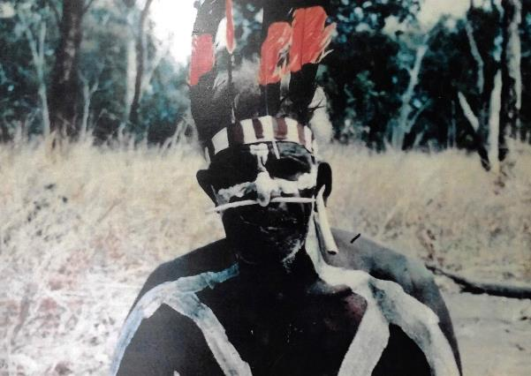

This Old Fella is Willy Long – he’s a proper tribal man. Willy Long is the boss for that Totem, for Alwal. He’s passed on now so It’s up to us to look after Alwal for him. (Mike Ross, Olkola Elder and Knowledge Holder and Recovery Team Chair)

## **Acknowledgements**

This recovery plan was developed by the Olkola Aboriginal Corporation on behalf of the Golden-shouldered Parrot recovery team. Preparation of this plan was supported by Bush Heritage Australia, and the NESP Threatened Species Hub.

The recovery team sincerely thanks the Elders and Knowledge Holders of Olkola, Wakamin, Thaypan, Kunjen and Kokoberrin Traditional Owners for their work producing this plan, along with Gabriel Crowley. The recovery team greatly appreciates the advice and valuable contributions of Peter Latch, Sarah Legge, Stephen Garnett, Steve Murphy, Vanessa Westcott, Alex Kutt and the Queensland Government. We also thank the following people for use of their photographs and artworks: Ashaley Ross, Olkola Aboriginal Land Managers, Olkola Corporation, Geoffrey Jones, Allana Brown and Annette Ruzicka (Bush Heritage Australia), Sarah Allen, Kay Breeden Williams, Wendy Cooper (on behalf of the late William Cooper), Gabriel Crowley, Stephen Garnett, David Gillieson, Noel Hart, Jane Mutiny and Peter Valentine. All reasonable efforts have been made to ensure these artworks have been reproduced with the consent of the copyright owners.

## Foreword

This plan here is important. The whole public of Australia will understand why Alwal needs being protected. But for us, it’s more of a spiritual thing. We’ve got to look after it for our Old People. (Mike Ross, Olkola Elder and Knowledge Holder and Recovery Team Chair)

This *Golden-shouldered Parrot National Recovery Plan* is not just a roadmap for the recovery of an endangered species. This plan is a celebration – it is the first Aboriginal-led recovery program in Australia. Olkola Traditional Owners are leading the recovery of this iconic species of Cape York Peninsula that is also an important cultural Totem. This plan is driven by a marriage between cultural values and western science and for the first time enables landscape-scale management for this beautiful little parrot.

The golden-shouldered parrot is important to all of us. It is a Totem to Olkola people, and an indicator of Country that is being kept healthy through customary rights. Olkola people know that if their parrot is thriving then country is healthy. Other Traditional Owners also want to look after the parrot and its country; and their commitment to its recovery is part of their desire to re-establish connection to their traditional lands. The parrot’s decline is also symptomatic of the loss of natural ecosystem processes, and its recovery will demonstrate our capacity to restore environmental function. And finally, the parrot is a beautiful bird, whose rainbow colours represent renewal. Its subtle beauty is a source of inspiration, and its fascinating biology a source of intrigue. Recovery of the golden-shouldered parrot is a responsibility we all carry for this unique species.

## Executive summary

This recovery plan is a two-way science document. The recovery actions have been developed through scientific knowledge and research, embedded within the cultural knowledge and ecological expertise of Traditional Owners. It is not just about saving an endangered parrot, but very much about ensuring people are on Country to look after Country properly. The recovery team is committed to working respectfully with all Traditional Owners, landholders, agencies and stakeholders to ensure the future of these extraordinary parrots, and the unique habitats on which they depend.

Our conservation vision for the golden-shouldered parrot

In the next 10 years, Traditional Owners will feel strongly that they are meeting cultural obligations to care for Country and the important Story places relating to the golden-shouldered parrot and other Totem species. All landholders will have the resources and support needed to implement recovery actions every year.

In the next 20 years, the future of this iconic species of Cape York Peninsula is secure. The population will no longer be in decline and there will always be an ongoing commitment to keeping the Country healthy across the parrot’s range.

This conservation vision for the golden-shouldered parrot will be achieved through strategies contributing to 9 recovery objectives:

**Objective 1 – Return people to country to make golden-shouldered parrot habitat strong again**

* Strategy 1.1 Support Golden-shouldered Parrot recovery through on-country programs, joint-management arrangements, ranger programs and healthy country planning across the species’ distribution.
* Strategy 1.2 Improve understanding of the multiple benefits of Indigenous people living and working on their traditional lands.
* Strategy 1.3 Build understanding of the cultural and biodiversity significance of golden-shouldered parrots and their habitat to raise the species’ profile and support for recovery efforts.

**Objective 2. Understand and restore the role of dingoes in golden-shouldered parrot recovery.**

* Strategy 2.1 Understand historical changes in dingo populations across golden-shouldered parrot distribution in relation to the parrot’s decline.
* Strategy 2.2 Understand the dingo's relationship with other species significant to the life history of golden-shouldered parrots.
* Strategy 2.3 Maintain and restore the health of dingo populations in key areas of golden-shouldered parrot habitat in consultation with all stakeholders.

**Objective 3. Restore and maintain golden-shouldered parrot nesting and early wet season habitat.**

* Strategy 3.1 Maintain and restore open vegetation structure of nesting and wet season feeding habitat.
* Strategy 3.2 Maintain and restore healthy antbeds for nesting.

**Objective 4. Restore golden-shouldered parrot’s wet season foods.**

* Strategy 4.1 Manage total grazing pressure in key wet season feeding areas to maintain and restore cockatoo grass and other key wet season foods.
* Strategy 4.2 Maintain the golden-shouldered parrot's population on Artemis, Dixie and Mary Valley at its retreating edge through supplementary feeding.

**Objective 5. Reduce and reverse unsustainable predation of the golden-shouldered parrot.**

* Strategy 5.1 Understand predation pressure on golden-shouldered parrots.
* Strategy 5.2 Understand the link between golden-shouldered parrots and black-faced woodswallows.
* Strategy 5.3 Reduce predation pressure on golden-shouldered parrots.

**Objective 6. Ensure mining, clearing and land use change do not threaten golden-shouldered parrot recovery.**

* Strategy 6.1 Assess and avert the likely impacts of proposed development, and land use change and other emerging issues on golden-shouldered parrot recovery.

**Objective 7. Address new and emerging threats to golden-shouldered parrots.**

* Strategy 7.1 Manage the impact of adverse weather events and climate change.
* Strategy 7.2 Monitor and address emerging weed and pest animal threats.
* Strategy 7.3 Implement appropriate protocols needed to avert disease spread.
* Strategy 7.4 Annually review other potential threats and identify and implement appropriate mitigation options.

**Objective 8. Demonstrate improvement in the golden-shouldered parrots’ extent, population size and extinction risk.**

* Strategy 8.1 Improve understanding of the golden-shouldered parrot’s extent and population size and their response to management regimes.
* Strategy 8.2 Improve understanding of the golden-shouldered parrot’s extinction risk, including whether the species is vulnerable to catastrophic events and/or captive breeding has a role in the species’ recovery.
* Strategy 8.3 Ensure information used for mapping golden-shouldered parrot distribution and assessing impacts on the species is based on the best available evidence.

**Objective 9. Manage the recovery program using culturally appropriate and scientifically robust principles.**

* Strategy 9.1 Manage the recovery program through the recovery team, with appropriate review and revision.

Contents

Acknowledgements v

Foreword vi

Executive summary vii

Acknowledgement of Country and Golden-shouldered Parrot’s significance 1

Statements from Traditional Owners caring for the golden-shouldered parrot 2

Olkola 2

Wakamin 2

Thaypan 3

Kunjen 3

Kokoberrin 3

Statements from other landholders caring for the golden-shouldered parrot 5

Artemis 5

Queensland Parks and Wildlife Service 6

National and international significance 8

Conservation status 8

Traditional Owner cultural knowledge and understanding of the golden-shouldered parrot 9

Western scientific contribution 14

1 Biology 16

1.1 Taxonomy 16

1.2 Appearance 16

1.3 Ecology 16

2 Distribution and population 18

2.1 Habitats critical for the species’ survival 20

2.2 Habitat modelling 23

2.3 Current population 24

3 Threats 25

3.1 Altered fire regimes 25

3.2 Grazing animals 27

3.3 Wet season food shortage 28

3.4 Vegetation thickening 29

3.5 Loss of black-faced woodswallows 30

3.6 Predation 31

3.7 Loss of nest sites 32

3.8 Loss of dingoes 33

3.9 Replacement of Aboriginal land management by pastoralism 34

3.10 Mining, clearing and land use change 35

3.11 New and emerging threats 36

4 The recovery program 37

4.1 Co-benefits 38

4.2 Recovery framework 39

References 42

Appendix A: Engagement protocol for working with Traditional Owner groups 51

Appendix B: Key stakeholders 52

Appendix C: Annual cost of recovery 55

Appendix D: Cost of meeting recovery objectives 56

Objective 1 Return People to Country to make golden-shouldered parrot habitat strong again 56

Objective 2 Understand and restore the role of dingoes in golden-shouldered parrot recovery 57

Objective 3 Restore and maintain golden-shouldered parrot nesting and early wet season habitat 58

Objective 4 Restore golden-shouldered parrot’s wet season food 59

Objective 5 Reduce and reverse unsustainable predation of the golden-shouldered parrot 61

Objective 6 Ensure mining, clearing and land use change do not threaten golden-shouldered parrot recovery 62

Objective 7 Address new and emerging threats to golden-shouldered parrots 62

Objective 8 Demonstrate improvement in the golden-shouldered parrot’s extent, population size and extinction risk 64

Objective 9 Manage the recovery program using culturally appropriate and scientifically robust principles 66

Appendix E: Names and terms 68

Appendix F: Glossary 69

**Tables**

Table 1 Estimates of the number of adult birds 24

Table 2 Recovery framework 39

Table C1 Annual cost of golden-shouldered parrot recovery 54

Table D1 Strategies, actions and costs associated with Objective 1 55

Table D2 Strategies, actions and costs associated with Objective 2 56

Table D3 Strategies, actions and costs associated with Objective 3 57

Table D4 Strategies, actions and costs associated with Objective 4 58

Table D5 Strategies, actions and costs associated with Objective 5 60

Table D6 Strategies, actions and costs associated with Objective 6 61

Table D7 Strategies, actions and costs associated with Objective 7 61

Table D 8 Strategies, actions and costs associated with Objective 8 63

Table D9 Strategies, actions and costs associated with Objective 9 65

Table E1 Indigenous, English and scientific names for species and concepts 67

**Figures**

Figure 1 Works featuring golden-shouldered parrot 7

Figure 2 *Ootalkarra* at Alwal nest on Olkola Country 10

Figure 3 Environmental outcomes when Aboriginal people are not on country 11

Figure 4 Environmental outcomes when Aboriginal people are on country 12

Figure 5 Gabriel Crowley measuring grasses, Glen Kulka and Stephen Garnett measuring a nest, and Sue Shephard checking for chicks 13

Figure 6 Research and monitoring being undertaken by Olkola Aboriginal Land Managers 14

Figure 7 Grass seed lodged in crevices in rocky hills provides golden-shouldered parrots with wet season habitat after other seeds have germinated 20

Figure 8 Most golden-shouldered parrot nests are made in antbeds on grassy flats that are flooded in the wet season 21

Figure 9 Brown goshawk, black-backed butcherbird, yellow spotted monitor and feral cat taking golden-shouldered parrots 30

Figure 10 Female golden-shouldered parrot attending her nest. Monitoring cameras like this one are used to assess breeding success and predation events. 37

Figure A1 Engagement protocol for working with Traditional Owner groups 50

Figure B1 Stakeholders in golden-shouldered parrot recovery 53

**Maps**

Map 1 Interconnections between golden-shouldered parrots and Aboriginal people 10

Map 2 Historical records and distribution of golden-shouldered parrot 19

Map 3 Distribution of golden-shouldered parrot records in relation to Köppen climatic zones and annual average rainfall 20

## Acknowledgement of Country and Golden-shouldered Parrot’s significance

The authors of this plan acknowledge the Traditional Owners of Australian Aboriginal and Torres Strait Islander communities and pay respect to their Elders past, present and emerging. We honour their deep spiritual, cultural and customary connections to the Australian landscape, including its waterways, land and sea country.

In particular, we acknowledge the Traditional Owners of the lands on which the golden-shouldered parrot currently lives: the Olkola, Wakamin, Thaypan, Kunjen and Kokoberrin Peoples and their Elders and Ancestors. In writing this plan, we recognise the importance of their connection to Country in its own right and for its importance to the parrot’s future.

Golden-shouldered parrots once occurred more widely across Cape York Peninsula. We also acknowledge the Traditional Owners of these lands, and hope that by implementing this plan we will help the golden-shouldered parrot find its own way back to their country.

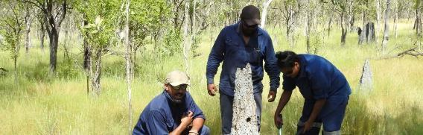

Photograph: ©Bush Heritage Australia

## Statements from Traditional Owners caring for the golden-shouldered parrot

### Olkola

Alwal’s decline started when Olkola people were taken away from country. Ancestral tenure was discarded as the Queensland Government conscripted Olkola land to lease for pastoralism. Throughout this displacement, Olkola People have fought to sustain community, culture and connections to Country. It is a struggle Olkola are winning.

The Olkola Corporation now holds and manages 869,822 hectares of Olkola Traditional Lands. Olkola arrgi (land) holds many sites of spiritual and cultural significance. Ingin (Story) connects these places to our People by Totem and by descent. We have a 10-year Healthy Country Plan that is our road map for how we will move forward and manage country the Olkola Way. Looking after our Totems and wildlife is an important target in our plan. Our Totems are a central part of our identity as Olkola People, linking significant ingin connections across our arrgi. We know that some of our Totems and wildlife – like Alwal – are very special to us and others as well, and some only found on Olkola arrgi.

Our strategies to protect and look after Alwal include continuing to lead and implement the ‘Bringing Alwal Home’ project. We will be the first Aboriginal People to lead a National Recovery Team for Alwal, and we will champion the implementation of this new national recovery plan. We will support our fellow countrymen across Alwal’s range to look after and manage Country their way too.

If you got something on your Country and it’s rare, look after it. We got all different bird life and different mammals and different water places; and our stories and our culture and out of that you’ve got Alwal, the golden-shouldered parrot, which is very rare. Look after it for our future generations…50…100 years to come, that little bird will still be there. (Mike Ross, Olkola Elder and Knowledge Holder and Recovery Team Chair)

### Wakamin

Wakamin Traditional Owners know what to do to look after our Country, and when we can look after our Country that will help the golden-shouldered parrot. Don’t tell us what to do – we know what to do – give us the resources to do the job. We want to invite other Traditional Owners to come on Country with us and work together to gain a greater understanding about the golden-shouldered parrot and the differences across its Country. The parrots on Wakamin Country live on different soils, there is different timber, different habitat. If the Traditional Owners came together we could put these different parts of the puzzle together and learn more to help the species. Right now we only get to go there once or twice a year, alongside Queensland Parks and Wildlife Service (QPWS). There is no access until August or October because it is so wet. At that time, we only see the adult parrots. There is a lot we need to learn about the southern population. Wakamin People can be the ones to look after the parrot and its habitat on our areas, and we would like to work with the other Traditional Owners too.

### Thaypan

Thaypan People are the Traditional Owners of the north-east corner of the golden-shouldered parrot’s range. Thaypan Traditional Owners want to see a ranger program started up at Mary Valley – Thaypan Elders are looking for funding to get their ranger group started up, so that they know that their Country is being looked after up there and the parrots in that Country too. Thaypan People have already been talking to Sue Shepherd (Artemis) about the parrots, and want to learn more about the parrots and where they are now in that Mary Valley area. Thaypan Elder and Knowledge Holder Fred Coleman says that the Thaypan People got to work together on this, and support each other to look after their Country and the parrots that are there too.

### Kunjen

Kunjen People are the Traditional Owners of Oriners Station, and along the west of the golden-shouldered parrot’s range towards Kowanyama. Charlotte Yam is working as a ranger and she and her family are taking more of an interest in the parrot since Olkola got started on their Bringing Alwal Home project. Kunjen Traditional Owners want to do more on the Kowanyama side – Kunjen want to look after the parrot, make sure it is healthy on that side and do more bird watching activities too. Caring for the golden-shouldered parrot is a good way to get the young ones more involved. Hopefully Kunjen People will be able to see more of their Kowanyama Land and Sea Rangers do more work for the parrot in the future.

### Kokoberrin

Kokoberrin People would love to do some survey work over the Staaten River area. We want to get in there and really see where the parrots are and how they are doing on our Country. Kokoberrin People have done cultural knowledge projects and oral history recording projects along our coastal Country, but access to our lands is still a big challenge for our people. Currently, Kokoberrin People have no ownership and no access – we need to get ownership of our lands and make a base where we can run Kokoberrin Rangers to look after our Country. We want to have access into the west, into the Staaten River area that is also our traditional lands. A lot of Kokoberrin People are from that inland Staaten area and we want to get the remaining custodians back on Country. Anything that occurs inland with the parrots on Staaten also affects the catchment right through to our sea country. So we want to work together with our Indigenous neighbours – as Aboriginal people we are all connected, just like the parrots were connected. We want to make sure that we are doing our bit on our Country to help with the recovery of the golden-shouldered parrot, an Endangered species.

## Statements from other landholders caring for the golden-shouldered parrot

### Artemis

Tom Shephard has always known golden-shouldered parrots, which he has always called antbed parrots. When he was a boy at Musgrave, antbed parrots were all around him. He got wild whenever Joe Mattinson came up with cages to catch parrots and take them back to Sydney to sell. At the age of 14, he opened all the cages and set the parrots free.

Sue came to Musgrave to work, but ended up marrying Tom, and staying. She took an interest in the antbed parrots, and probably knows more about them than anyone else on earth. In some areas, she can tell you when the birds have nested in each of the last 25 years, and the antbed that they used. She has been monitoring their nests, eggs, chicks, trees and grasses for almost as long. She even stopped the birds from disappearing from Artemis by feeding them through the wet season.

Tom worked out that the parrot’s nesting habitat was getting thick because the country wasn’t being burnt the right way. He said that the old people used to storm-burn the country to keep it open. Tom reintroduced storm-burning for the parrots, and for cattle. Sue measured the trees, and found the country was starting to open up again. Now everyone knows that’s the right way to burn.

Sue and Tom help anyone with an interest in the parrots. When people come from all over the world for a glimpse of the antbed parrot, it is Sue that finds the birds for them to see, paint and photograph. Each year, they host up to 250 people who travel to see the birds. Sue and Tom even invited Stephen Garnett and Gabriel Crowley and their two children to live with them for three years to research the parrot, and shared everything they know about the country and the parrots with them. Most recently, Sue and Tom have been helping the Olkola Aboriginal Land Managers and Bush Heritage Australia in their efforts to find and protect the parrot. They just want to see the country managed well and the parrots back on country again.

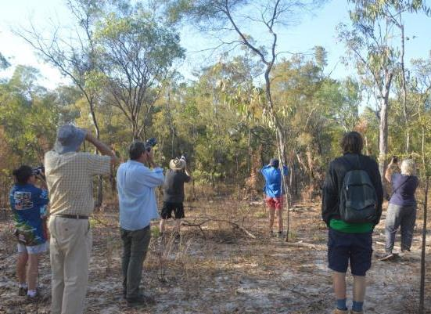

Photograph: © Allana Brown and Bush Heritage Australia

We drove 9,000 km to get here. To us, it is such an iconic amazing species we just had to visit. In the back of your mind there’s this thought that they might not be here for the next time. It’s great that Tom and Sue can show us around and be the guardians for golden-shouldered parrots here on Artemis.

(Phil Lewis, Birdwatcher from Western Australia visiting Artemis in August 2018)

### Queensland Parks and Wildlife Service

Queensland Parks and Wildlife Service (QPWS) is responsible for the protection and management of the natural and cultural values of Queensland’s parks and forests to maintain the habitat critical to support threatened species. Through joint management arrangements, QPWS works closely with Traditional Owners to manage country to maintain natural and cultural values and places for future generations.

QPWS has a long history of involvement in efforts to conserve golden-shouldered parrots. QPWS staff led early research on the parrot in the 1970s and then together with World Wildlife Fund funded the first major research on the species, including the employment of dedicated researchers to work on the project. Through dedicated and diligent work, QPWS staff recorded the first non-indigenous discovery of golden-shouldered parrot nests on Staaten National Park. Through the implementation of fire and feral animal management programs on National Parks throughout the range of golden-shouldered parrots on Cape York Peninsula, the Gulf Country and Einasleigh Uplands QPWS is continuing to work with Traditional Owners and other land managers to conserve the golden-shouldered parrot and its habitat.

Golden-shouldered Parrots were once known from a number of national parks on the Cape York Peninsula, but we now recognise that their numbers are declining, and they have only been recorded on a few national parks in recent years. QPWS has had a long-standing involvement in the conservation of the Golden-shouldered Parrot, including through the recovery plan process, and as a member of the Golden-shouldered Parrot recovery team looks forward with great enthusiasm to working with Traditional Owners, other Land Owners and other members of the recovery team to work to conserve this very endangered species.

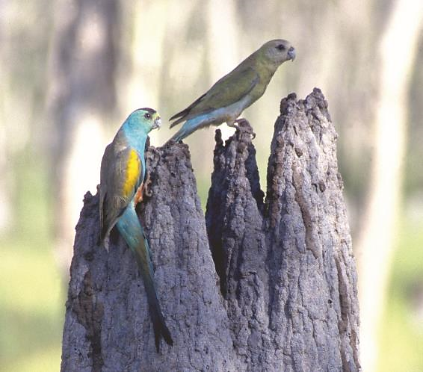

Photograph: © Roland and Julia Seitre

## National and international significance

The Golden-shouldered parrot is one of Australia’s best loved birds. Every year, it brings birdwatching tours, artists and photographers to Cape York Peninsula. It has featured in graffiti in London streets, inspired needlework, glasswork and greetings cards, and has even appeared on postage stamps in Australia, Lesotho, the Marshall Islands and the Congo (Figure 1).

Figure Works featuring golden-shouldered parrot

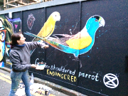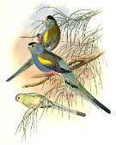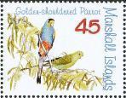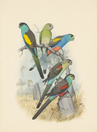

Images: clockwise from left © Sarah Allen; M. Frenchi and Jane Mutiny; William Cooper; Kay Breeden Williams; John Gould and Noel Hart

## Conservation status

Psephotus chrysopterygius (Golden-shouldered Parrot) is currently nationally listed as Endangeredunder the Environment Protection and Biodiversity Conservation Act 1999 (EPBC Act);listed as Endangered by the IUCN; and listed as Endangeredin Queensland, under the Nature Conservation Act 1992.

## Traditional Owner cultural knowledge and understanding of the golden-shouldered parrot

Golden-shouldered Parrots once occurred through most of Cape York Peninsula. Olkola and Kunjen people know the golden-shouldered parrots as Alwal. They have long known of the species’ existence, as is indicated by this Olkola creation story.

Alwal originated from the depths of the Morehead River. As it freed itself from the mud and swam to the surface of the river, the sun’s filtered rays hit Alwal’s wings, marking it with its brilliant blue and gold colours.

(Mike Ross, Olkola Elder and Knowledge Holder and Recovery Team Chair in interview with BHA in 2016)

The mud, the earth, the soil of Olkola Country is central to Alwal – Alwal was created from that earth, and belongs to that place, just like Olkola People belong to Olkola Country.

I’m always telling the younger people Alwal hasn’t forgotten where he came from…He still makes his nest…and his young ones are hatched in mud…in anthills…

(Mike Ross, Olkola Elder and Knowledge Holder and Recovery Team Chair in interview with BHA in 2016 explaining how Alwal nests in the termite mounds made from the Olkola earth, the witch’s hats (conical termite mounds) built from ancient soil)

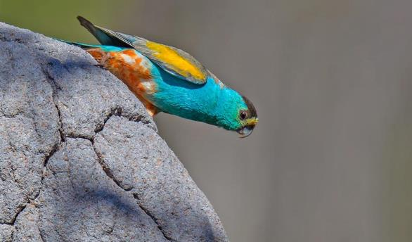

Photograph: © Geoffrey Jones

As well as the Olkola and Kunjen name for Alwal, the golden-shouldered parrot has at least three other Indigenous language names (see Appendix E). The parrot is called Arrmorral in the Kuku Thaypan language 1. The Lama Lama People, whose country includes Silver Plains and the northern part of Rinyirru NP (CYPAL), use the name Thaku (meaning left-handed) 2. The name the Wakamin people of Bulimba and Staaten River NP use for golden-shouldered parrot is Minpin, meaning beautiful bird 3. The parrot’s continuous song-line shows that the species’ distribution centred on Olkola Country extended throughout the area from Lama Lama lands to Wakamin lands 4 (Map 1).

Those birds were following the Old People around long time before any of us were here. (Fred Coleman, Thaypan Elder and Knowledge Holder talking about the connections between people moving around the landscape and the previous broader range of the parrots)

There’s movement amongst them Old People, and there’s movement amongst them parrots. The Old People, they walked right through that Country. (Mike Ross, Olkola Elder and Knowledge Holder and Recovery Team Chair)

Map Interconnections between golden-shouldered parrots and Aboriginal people

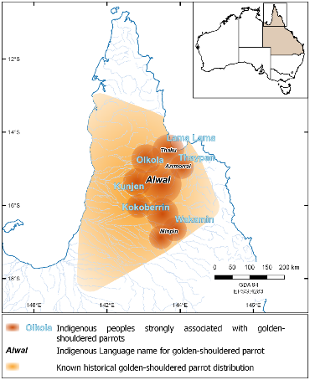

This plan also acknowledges the importance of the dingo to Indigenous people across Australia. The Olkola name of dingo is Ootalkarra. Ootalkarra is the boss of the Olkola People. Ootalkarra’s story is a very important story for the Olkola People. Ootalkarra provides balance to golden-shouldered parrot habitat and is also important for the golden-shouldered parrot’s ongoing existence.

Figure  *Ootalkarra* at Alwal nest on Olkola Country

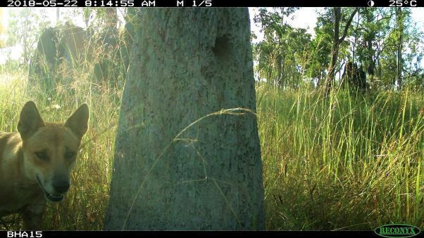

Photograph: © Olkola Aboriginal Land Managers and Bush Heritage Australia

The camera picked up the same dingo hanging around this nest the whole breeding season, keeping other predators away (Figure 2). This nest ended up having no signs of predation and we saw successful baby Alwal chicks fledge. Olkola Land Managers are looking after our Totems, and our Totems are looking out for each other. (Olkola Aboriginal Land Managers, 2018)

Traditional Owners understand that the golden-shouldered parrot is an indicator species for proper fire management and healthy country. Olkola People want to bring Alwal’s habitat back into balance by addressing the underlying causes of the many threatening processes impacting their Totem. First and foremost, this requires People to be on Country caring for Alwal, looking after important sites and story places, protecting Ootalkarra and undertaking proper fire management.

These diagrams by Olkola Alwal Project Manager, Ashaley Ross, depict the interconnectedness between Aboriginal people and Alwal (Figure 3 and Figure 4). They show how removing the Traditional Owners from Country affected the golden-shouldered parrot and how restoration of Aboriginal land management is necessary for the parrot’s health to be restored.

Figure Environmental outcomes when Aboriginal people are not on country

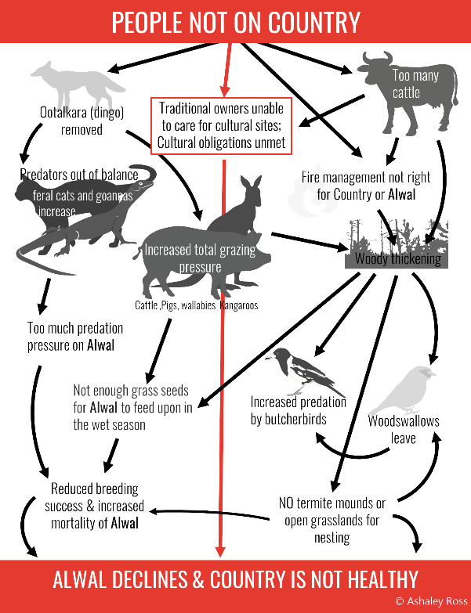

Image: © Ashaley Ross

Figure Environmental outcomes when Aboriginal people are on country

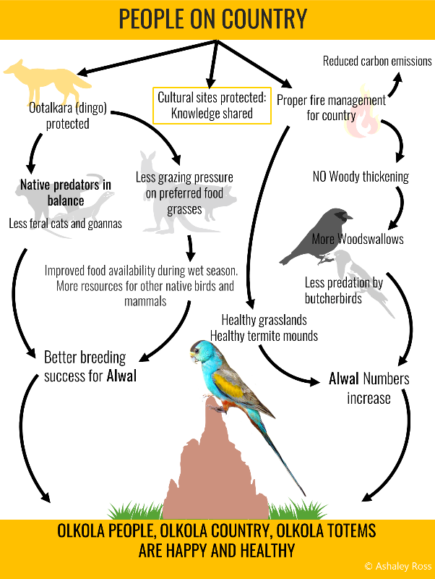

Image: © Ashaley Ross

## Western scientific contribution



For many years, bird enthusiasts have been intrigued by this small, colourful parrot that nests in antbeds. Scientists began collecting the parrot in the 1850s, and by the 1920s realised it was getting hard to find. Many birds were trapped in the Musgrave area for the aviary trade in the 1960s and early 1970s5, and descendants from these parrots are still kept in cages in Australia and around the world, from Townsville to Newcastle and from Tenerife to the Czech Republic. However, nowadays, rather than taking birds, people are more likely to take away photographs, paintings and memories.

Figure Gabriel Crowley measuring grasses, Glen Kulka and Stephen Garnett measuring a nest, and Sue Shephard checking for chicks

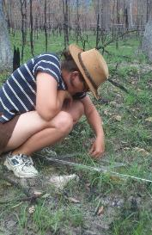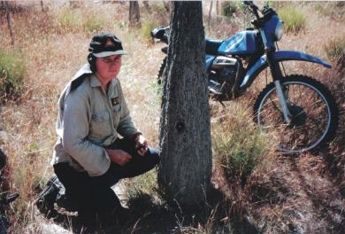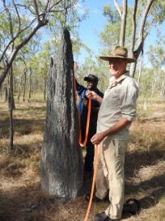

Photographs: © Stephen Garnett and Bush Heritage Australia

Much understanding of the golden-shouldered parrot has come from the direct ecological studies. Even the early collectors, such as Elsey, McLennan and even Mattinson, provided useful information on the species’ distribution and biology. Dedicated studies by Weaver, Garnett, Crowley, Shephard and Collingwood – drawing on the knowledge of local landholders and Traditional Owners then followed (Figure 5). Now Traditional Owners are leading the research, combining their Traditional Knowledge with western science (Figure 6). Piecing together each aspect of golden-shouldered parrot’s ecology from a scientific perspective brings us closer to the Indigenous understanding of how Country should be kept healthy. Hence, recognition of the importance of taking a collaborative approach that incorporates Traditional Knowledge and western science is central to this plan.

Figure Research and monitoring being undertaken by Olkola Aboriginal Land Managers

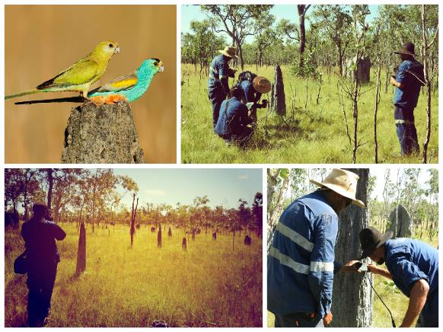

Photographs: © Olkola Aboriginal Land Managers and Bush Heritage Australia

## Biology



### Taxonomy

The golden-shouldered parrot Psephotus chrysopterygius (Gould, 1857) is one of three small seed-eating parrots that nest in antbeds. Indigenous language names for this parrot include Alwal, Arrmorral, Thaku and Minpin (see Traditional Owner Cultural Knowledge). Historically referred to as the golden-winged parrot or golden-shouldered parakeet, it is also known locally as the antbed parrot 5; 6. The species is closely related to the extinct paradise parrot P. pulcherrimus (Gould, 1845) of south-east Queensland and more distantly related to the secure hooded parrot P. dissimilis (Collett, 1898) of the Northern Territory 7. Based on genetic studies, all three species have recently been reclassified into the genus Psephotellus along with the mulga parrot P. varius 8-10.

### Appearance

The male golden-shouldered parrot is a multi-coloured bird 11. Most of its body is turquoise, but its back is grey-brown and it has a scarlet belly with white scalloping. Its wings are grey-brown with a bright yellow shoulder patch. It has a yellow flush to its turquoise face, and a black crown. Its long tail is greenish-blue. Females and immature birds are mostly yellowish-green, with a turquoise rump and red markings around the legs.

### Ecology

English common names are used throughout this document. See Appendix E for scientific names, and Indigenous names (where known).

The golden-shouldered parrot nests in conical or magnetic antbeds that are built by termites in open grassy drainage depressions that flood during the wet season 12. They occasionally nest in bulbous antbeds on slopes close to drainage lines 13. The birds are territorial around their nest mounds, although in healthy populations up to three nests have been recorded within a ‘fifty yard radius’ 5. Aggression between breeding males is commonly observed in captivity 5.

The parrot’s staple food is grass seed. Fire grass is the main seed taken through the dry season, but its availability declines towards the end of the dry season, and all seed is lost to germination once the heavy rains set in 14. There follows a period of food shortage, which lasts about six weeks until cockatoo grass begins producing seed, which stimulates nesting behaviour 15; 16. However, availability of cockatoo grass seed may be sporadic, and food is reliably assured only later in the wet season 17. As well as grass seeds, the chicks are fed legumes, which may provide additional essential nutrients 17.

Parent birds remain within about 3 km of the nest in the breeding season 13; 17. It appears that most parrots remain within 20 km of nest sites through the rest of the year, where they feed in groups on rich patches of fire grass 18. Congregations of over 100 birds have been recorded in the past 5; 13, but in recent years sightings of groups of more than 20 birds are unusual.

Goannas and butcherbirds are thought to be the golden-shouldered parrot’s main predators, particularly at the nest, although live birds can also be taken by cats and brown goshawks (see Section 3.6 Predation)5; 17; 19; 20. Open vegetation is considered important for minimising golden-shouldered parrot’s exposure to predation – particularly by butcherbirds, which perch on low branches close to the nests waiting for an opportunity to pounce 17; 20.

Golden-shouldered parrots have a symbiotic relationship with the endangered antbed parrot moth, which cleans droppings from the parrot’s nest 21, and with black faced woodswallows, which alert the parrots to predators in the early wet season 13; 17.

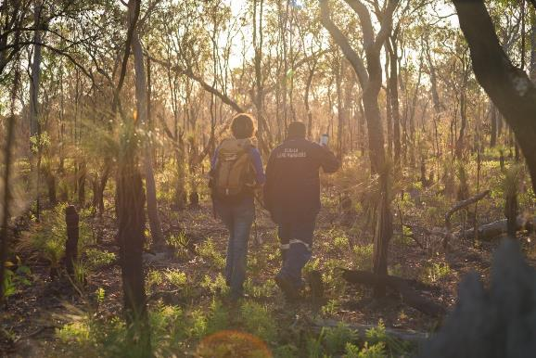

Photograph:© Olkola Aboriginal Land Managers, Bush Heritage Australia

## Distribution and population

Golden-shouldered parrots are found only on Cape York Peninsula, north Queensland (Map 2). Their distribution once covered most of the peninsula. Breeding is currently known from only two small areas, in the headwaters of the Morehead and Staaten Rivers and nearby catchments, which are separated by about 140 km 17. Songlines connecting the species and its people from the north to the south indicate that the species existed in one continuous population 4. The distribution fragmented following the introduction of the grazing industry to the peninsula. There have been no records in the southwest since 1800s, and the distribution has experienced a steady contraction from its north-east edge since the 1920s. The last nests were recorded on Silver Plains in the 1950s 22, and on Violet Vale in the 1970s 12. This contraction continued in the north-eastern section of Artemis through the 1990s 13, although the population appeared to have stabilised by 2002 13. However, recent nest surveys have shown a continuing decline in this area, and that the parrots have since deserted most nesting areas on Artemis and Dixie. Three decades of nest surveys suggest that the population is stable through the remainder of the species’ range.

Map Historical records and distribution of golden-shouldered parrot

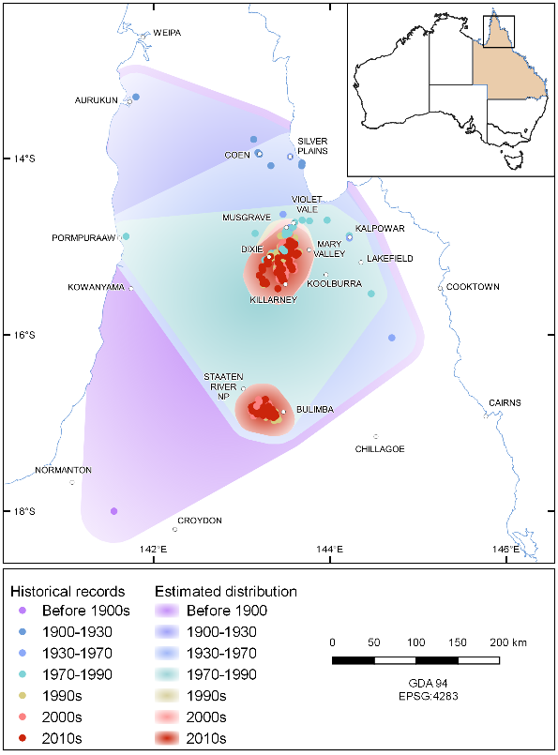

Note: Distributions based on verified sightings 23; 24 (pre-1970) and verified nest sites (post-1970, Recovery Team data)

### Habitats critical for the species’ survival

Estimating the parrot’s population size requires an accurate assessment of both the species’ distribution and its occupation of habitat within this extent. The key factors that influence the Golden-shouldered parrot’s use of habitat on Cape York Peninsula are its dependence on grass seed for food, and on antbeds for nests. Hence both feeding and breeding habitat are critical for the species’ survival. The parrots’ broad historical distribution closely matches the extent of the tropical savannazone on Cape York Peninsula (Map 3). To the east and north (Equatorial SavannaandMonsoon rainforest zones), fallen seed availability is likely to be limited by short and sometimes non-existent dry seasons 25; 26. To the south (Grasslandzone), rainfall is too unreliable with many wet seasons failing altogether 25; 27. The parrot’s southern extent may also be limited by risk of exposure to cold during the nesting season (April to May), as brooding of young stops a few days after hatching5; 28.

Map Distribution of golden-shouldered parrot records in relation to Köppen climatic zones and annual average rainfall

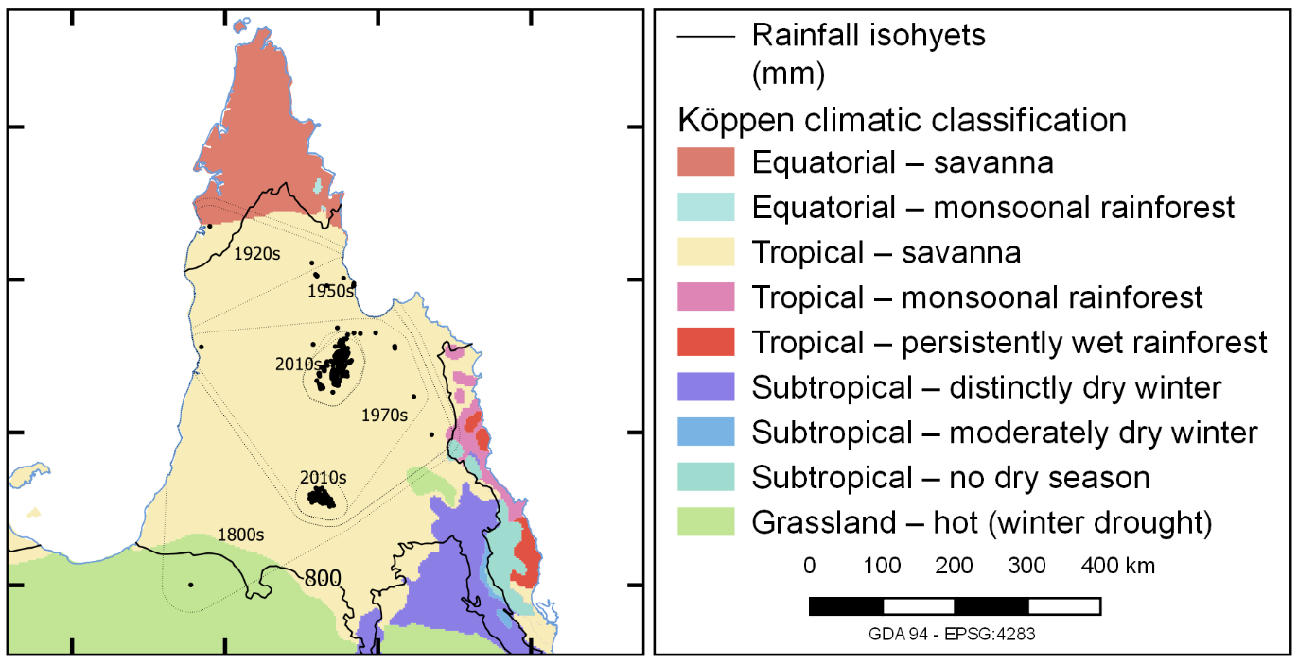

Note: Climatic zone categories based on Dick (1975) 25

#### Early wet season feeding habitat

Food for golden-shouldered parrots becomes scarce as soon as early storms bring heavy rains. These rains bury and geminate seed, immediately doubling the time parrots must take to find enough food 17. Initially, the birds are most likely to find ungerminated seed on gravelly, well-drained soils, or where seed has become lodged in rock crevices (Figure 7). Other important features of these sites are an open structure and presence of nesting black-faced woodswallow, both of which help to minimise predation risk. The only parrot chicks known to survive a full year are those that have been seen feeding on such sites in the wet season. In the parrot’s northern distribution, these sites are most abundant where the sedimentary rocks abut granites producing metamorphic gravels. They are found along the Great Dividing Range in the headwaters of the Morehead River, as well as north of Coen, where the parrots were found in the 1920s. While similar habitat may occur on the divide between the Lynd and Staaten Rivers, difficulty in accessing this area in the wet season has prevented wet season feeding sites being identified in the parrot’s southern distribution. Hence feeding areas cannot yet be used to model the parrot’s distribution or population. The parrots may also find seed that has been killed by fire, and so is unable to germinate 14; 17. However, as such sites are ephemeral, and their distribution varies with pattern of late dry season fires and storm-burns, they can only be used to predict within-season habitat use.

Figure Grass seed lodged in crevices in rocky hills provides golden-shouldered parrots with wet season habitat after other seeds have germinated

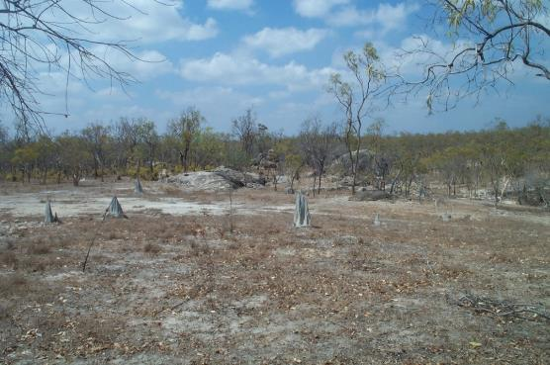

Photograph: © Gabriel Crowley

#### Nesting habitat

Parrots build nests in antbeds along drainage lines either in open grassy drainage depressions that flood during the wet season or on seasonally saturated gravel slopes in the upper reaches of the catchment 12; 17 (Figure 8). The adults must find enough food close to the nest to raise their chicks, and have not been recorded more than 3 km away from their nests at this time 13. Open vegetation in these sites is again important for minimising exposure to predation risk 13; 17. Long periods of flooding are likely to destroy both breeding habitat and nearby feeding habitat by submerging antbeds, fallen grass seeds and seeding perennial grasses; destroying antbeds; and killing termite colonies 29-31. Hence the species’ known breeding range is restricted to areas where flooding is both relatively shallow and restricted in extent. Such conditions are found along narrow drainage lines, and on seasonally saturated gravel slopes in the headwaters of creeks, and where open vegetation structure minimises predation risk.

Figure Most golden-shouldered parrot nests are made in antbeds on grassy flats that are flooded in the wet season

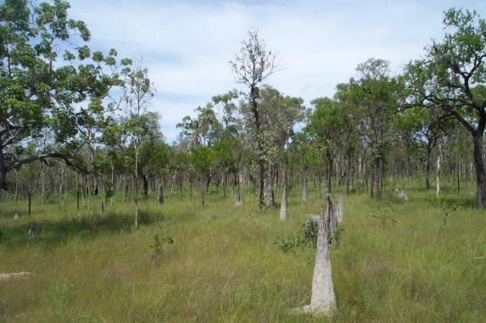

Photograph: © Gabriel Crowley

### Habitat modelling

This detailed knowledge of the parrot’s nesting requirements in both populations enabled the characteristics of known nesting sites to be used to predict where else nesting might occur. Preliminary assessment has been undertaken using Maxent modelling 32 by intersecting four decades of nest records with data layers reflecting the environmental features that characterise nesting habitat33, including:

* geology 34
* distance from mapped watercourses 35; 36
* drainage density 35; 36
* terrain roughness 37; 38

vegetation (regional ecosystems)39.

The Maxent program was used to assess the capacity of each of these variables to identify suitable nesting habitat, both when used alone or in various combinations with other variables. Separate models were run for the now-separated northern and southern sections of the distribution. In both areas, the variable that best predicted location of nest sites when used alone was vegetation. Terrain roughness was the weakest predictor, but still made a useful contribution to the strongest northern model. The remaining three factors had intermediate value and were included in the final models for both areas. Nesting habitat in the northern section of the distribution was best predicted by a model in which geology had the most influence (34%); followed by stream density (27%), vegetation (25%), terrain roughness (9%) and distance from watercourse (6%). The best model for the southern section of the distribution was most influenced by vegetation (49%); followed by distance from watercourses (22%), stream density (17%) and geology (11%). These results confirm that within the broad climatic envelope defined by the tropical savanna zone nesting habitat is restricted to distinctive combinations of vegetation and drainage patterns that are geologically constrained.

Habitat suitability ratings (p-scores) generated by each of the models allowed study areas around each population to be mapped as primary, secondary and marginal nesting habitat. This mapping shows that just over half of the confirmed breeding range in northern area is likely to be suitable for nesting (primary habitat 34.5%, secondary habitat 20.8%), and that this proportion is much lower in the southern area (primary habitat 14.4%, secondary habitat 9.7%). The mapping also identified that northern nesting habitat may extend to the south and west of the currently known range; and that southern nesting habitat may be as much as three times greater than that mapped to date. This modelling is currently being extended to include additional survey data and environmental factors, including climate and vegetation density.

### Current population

The population of the golden-shouldered parrot has been estimated as being approximately 2,500 adult birds 13; 40; 41, but these estimates did not take habitat suitability into account. After incorporating habitat suitability, the parrot’s current population has been recalculated 33, using the equation:

**Number of adult birds = [(**Area of primary habitat **× nesting territory density** in primary habitat**) + (Area** of secondary habitat **× Nesting territory density** in secondary habitat**)] × correction factor × Adult birds per nest**

where:

* nesting territory density in primary habitat = 0.28 nest/km2
* nesting territory density of secondary habitat = 0.24 nest/km2
* 20% of nests are located in marginal habitat, so correction factor = 1.25
* 2.1 adult birds are associated with each nest.

This equation indicates a current golden-shouldered parrot population of between 770 adult birds in known nesting areas and 1,100 adult birds, when potential additional nesting areas are taking into account (Table 1). These estimates are preliminary and currently under revision. As they are based on new information, they do not indicate the trend or direction of change in the golden-shouldered parrot’s population over time and should not be used to assess the species’ conservation status.

Table 1 Estimates of the number of adult birds

| Item | Minimum population estimate (known nesting habitat) | Maximum population estimate (known and potential nesting habitat) |
| --- | --- | --- |
| Area of primary nesting habitat (km2) | 561 | 790 |
| Area of secondary nesting habitat (km2) | 345 | 497 |
| Number of nesting territories, primary | 213 | 300 |
| Number of nesting territories, secondary | 83 | 119 |
| Number of nesting territories, other | 74 | 105 |
| Number of nesting territories, total | 370 | 524 |
| Estimated number of adult birds | 777 | 1,101 |

Source: Crowley (2018) 33

## Threats

The golden-shouldered parrot is threatened by a suite of interacting processes. One process chain has led to a loss of wet season foods and potential starvation, and another to increased predation pressure. Ultimately these two chains converge so that birds suffer from loss of wet season foods and nests sites and have increased vulnerability to predators. The effects of these threatening processes on golden-shouldered parrots are summarised in the following sections, and in more detail in the guiding document *42*. These descriptions inform the actions in Section 4 The Recovery Program.

Although the golden-shouldered parrot has completely disappeared from both the northern and south-western sections of its former distribution, causes of decline are best understood in the north, where intensive ecological studies have occurred. Replacement of Aboriginal land management has occurred throughout the species’ distribution. Changes to vegetation structure, loss of termite mounds, loss of black-faced woodswallows, increased predation and loss of dingoes appear to be most severe on properties with a history of intense grazing pressure. The extent to which these threats are occurring in the south which is primarily managed for conservation is unclear. Mining, clearing and other land-use change have occurred more sporadically through the species distribution.

### Altered fire regimes

Traditional Owners lit fires throughout the year, particularly at storm-time 43; 44. Introduction of pastoralism saw the intentional use of fire largely restricted to the early dry season in order to protect pastures from later wildfires 44 and the reduction of fire intensities (and so potentially extent) by cattle grazing (see Section 3.2 Grazing Animals) 45. Fire exclusion or limiting fires to the early dry season was also initially adopted on properties acquired and managed as national parks 46. After a long period with little storm-burning, the practice is now increasingly being incorporated into management across the golden-shouldered parrot’s range 17; 19; 47; 48.

Storm-burning is important for nesting habitat quality because it maintains an open vegetation structure 48. This enhances the ability of the parrots to avoid predators (see Section 3.6 Predation). Through maintaining the grass layer and reducing shading, storm-burning is also likely to benefit the termite colonies that build the antbeds used by the parrots for nesting (see Section 3.7 Loss of nest sites). Storm-burning also improves quality of early wet season feeding habitat in a number of ways. First, it toasts the seeds before they fully germinate, providing parrots with food for an extended period 14. Secondly, it increases and extends seed production in cockatoo grass 15; 16. Finally, by keeping the habitat open, it helps the parrots to avoid predators 48 and probably keeps these areas suitable for black-faced woodswallows (see Section 3.5 Loss of black-faced woodswallows). When properly managed, storm-burns are restricted to small areas, enabling parrots to move easily between patches with changes in seed availability.

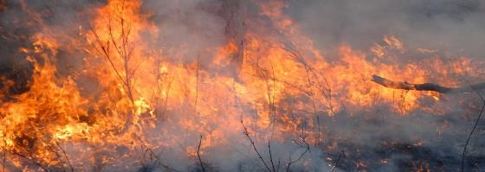

Photograph: © David Gillieson

Fire management across much of the parrot’s habitat has recently been modified again with the adoption of the Savanna Burning methodology, whereby carbon emissions are reduced through a shift from high intensity late dry season fires to lower intensity early dry season fires 49. There is a risk that such a fire regime will increase the density of vegetation in golden-shouldered parrot habitat 17. While the Savanna Burning methodology specifically excludes the grasslands and melaleuca open woodlands in which the parrots’ nest 50, it does apply to the surrounding eucalypt woodlands. This increases the risk that critical parrot habitat will also be burnt early in the dry season, especially as many landholders either do not understand that they are permitted to use storm-burning or late dry season fires for habitat management where this is appropriate, or simply find it too difficult to exclude parrot habitat from their early dry season burning programs.

Altered fire regimes with reduced fire intensity and cessation of storm-burning has resulted in the degradation and loss of critical habitat through vegetation thickening, and possibly contributed to the loss of black-faced woodswallows. It has also probably extended and intensified the period of food-shortage that the parrots experience in early wet season. The impacts of altered fire regimes are evident in the north. Fire regimes over Staaten River National Park appear to have maintained the open structure of nesting habitat, thus sustaining the parrot’s population in this area. It is important that this fire management continues. The impact of adoption of Savanna Burning within the parrot’s range will need to be closely monitored. Maintenance and reintroduction of appropriate fire regimes is necessary for restoring golden-shouldered parrot breeding and wet season feeding habitat.Fire regime maintenance and restoration will be undertaken under Objective 3.

### Grazing animals

Introduction of cattle to Cape York Peninsula in the mid-nineteenth century started a process of change that has led to the progressive decline of the golden-shouldered parrot. Cattle grazing affects golden-shouldered parrots through many pathways. Pastoralism has altered fire regimes, particularly through a reduction in storm-burning, which is necessary for maintaining the open structure of critical habitat (see Section 3.1 Altered fire regimes). Heavy cattle grazing also reduces the intensity and potentially extent of fires needed for habitat management. Cattle also change the tree-grass balance by preferentially grazing perennial grasses, but not ti-tree suckers 48. Hence, cattle grazing helps to drive vegetation thickening around nests and in early wet season habitat, thereby contributing to an increase in predation of parrots and loss of nest sites. Where cattle are numerous, they can also damage or knock over antbeds 17.

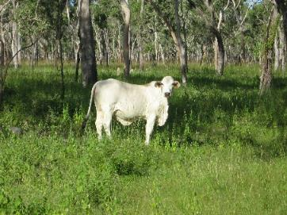

Photograph: © Gabriel Crowley

Grazing pressure on perennial grasses is greatest in the early wet season, when these plants are just starting to resprout in response to rain 51. Wet season grazing is particularly detrimental to seed production in cockatoo grass 15 and other early-seeding perennial grasses 52. Hence cattle grazing on Cape York Peninsula has extended the parrot’s period of food shortage in the early wet season (see Section 3.3 Wet season food shortage), thereby contributing to a decline in parrot health and increasing their vulnerability to predation.

Pigs are common and widespread on Cape York Peninsula. They eliminate cockatoo grass by rooting through grass swards, eating the succulent stem bases 16. Where cockatoo grass is exposed to pigs, but protected from cattle grazing, both its growth and seed production is suppressed 17. They also knock over the termite mounds in which the parrots nest.

Heavy cattle grazing is also likely to increase total grazing pressure leading to increased densities of agile wallabies and eastern grey kangaroos, which prefer to feed on short grass 53; 54. In combination with reduced dingoes populations, cattle grazing may therefore drive the explosion of macropod populations on cattle stations 55. As wallabies also selectively graze cockatoo grass, this is likely to intensify wet season foods food shortages caused by cattle. These processes may explain the recent increases in wallaby and kangaroo numbers on Artemis station, and the elimination of both cockatoo grass and golden-shouldered parrots from some important wet season feeding sites on Artemis 56. The impacts of cattle grazing are particularly evident in the north-east of the species’ distribution, and pig numbers are high throughout Cape York Peninsula. However, the golden-shouldered parrot has benefitted from effective feral grazing animal management on Staaten River National Park, and it is important that this work continues*.* Minimising the impact of cattle and other grazing animals on fuel loads, antbeds and grass seed availability is required for golden-shouldered parrot recovery.Management of grazing animals is addressed under Objective 4.

### Wet season food shortage

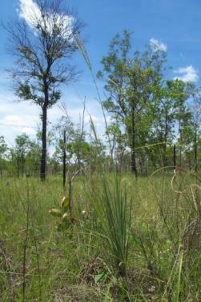

Photograph: © Gabriel Crowley

Fallen grass seed provides a bountiful food supply through most of the dry season 14. However, seed availability declines towards the end of the dry season and is greatly depleted once seeds start to germinate in response to rain. A shortage of seed at this time means that the birds need to feed longer and switch to food sources that are either low in energy or are harder and more time-consuming to find and process 17; 57; 58. The onset of seed production by cockatoo grass about six weeks after the first storms breaks this food-supply bottleneck and is likely to be critical to the parrot’s survival 15; 16. Even then, if seed production is not sustained, food supply will not be assured until widespread production of seeds by other grasses a few weeks later.

This food-supply bottleneck 13; 16; 17 can be intensified and extended by altered fire regimes and grazing animals adversely reducing the parrots’ condition 59, extending the time they spend feeding, and increasing their exposure to predation. Wet season food shortage is particularly an issue in the north-east. However, the stable population on Staaten River National Park suggests that wet season feeding areas in proximity to the park remain in a good condition Protection and restoration of cockatoo grass and other early-seeding plants is required to ensure golden-shouldered parrots have enough food to survive the early wet season. Wet season foods will be restored under Objective 4.

### Vegetation thickening

Altered fire regimes and grazing animals have driven the loss of many grasslands on Cape York Peninsula 60; 61. The suckers of broad-leaved ti-tree and many other woody plants that can draw on sub-soil moisture flourish when the surrounding grasses are grazed or burnt early in the dry season. Relieved of the competitive effect of grasses, suckers that had been trapped within the grass layer will have out-grown it before the arrival of the first rains 48. These saplings can then grow rapidly and reach sub-canopy height within a couple of years. At that height, ti-trees are unlikely to be affected by fire. Nesting habitat has been modelled as reaching a density of 150-400 ti-tree stems per hectare after 10 years without fire 48.

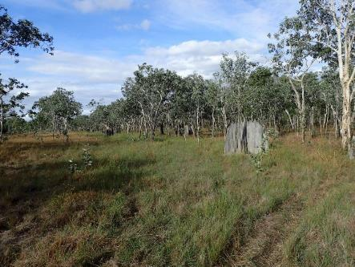

Photograph: © David Gillieson

Woody thickening has flow-on effects for golden-shouldered parrots. In thickened habitat, predation losses, particularly to butcherbirds, are highest (see Section 3.6 Predation)17; 20, and antbeds needed by parrot for nest sites do not persist (see Section 3.7 Loss of nest sites)17. Woody thickening may also contribute to loss of black-faced woodswallows, thereby reducing predator surveillance and parrot survivorship at wet season feeding sites. Hence, vegetation thickening has contributed to loss of nesting and early wet season habitat, and probably increased predation rates. Storm-burning slows and in some cases reverses vegetation thickening by arresting the progression of suckering plants to the canopy and returning many saplings to suckers that can be kept within the grass layer with ongoing fire management. Vegetation thickening is an issue in the northern part of the parrot’s distribution, particularly on Artemis and Dixie. By contrast, there is no evidence of it occurring on Alwal National Park (CYPAL), Killarney or Staaten River National Park. Managing vegetation thickening by controlling grazing pressure and storm-burning is critical for increasing golden-shouldered parrot survival in the nesting season and early wet season.Vegetation thickening will be addressed under Objective 3.

### Loss of black-faced woodswallows

Alarm calls of black-faced woodswallows are important for alerting ground-feeding birds of the approach of predators 17; 28; 58; 62. Therefore golden-shouldered parrots and other seed-eating birds feed close to woodswallow nests when the woodswallows are breeding (late dry to early wet season). Healthy woodswallow populations appear to be restricted to open vegetation 63, and they may rely on seed-eating birds to flush insects from the grass layer 64-67. Records of nesting woodswallows appear to have declined across the golden-shouldered parrot’s range 68; 69,, and since nest monitoring commenced in the 1990s – this decline has occurred on Artemis in the same places from which the golden-shouldered parrots have disappeared *42; 56*. Hence, loss of black-faced woodswallows is likely to be reducing parrot survival through the wet season 17; 28; 58; 62. Loss of black-faced woodswallows has occurred in the north-east of the parrot’s northern distribution, but there is no information on whether this is the case across the remainder of the parrot’s range. Understanding the black-faced woodswallows’ interactions with parrots and reversing their decline are essential steps in reducing predation pressure on golden-shouldered parrots.Loss of black-faced woodswallows will be addressed under Objective 3.

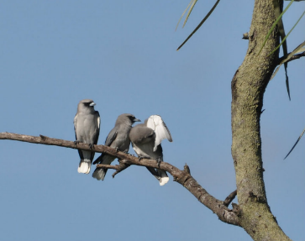

Photograph: © Peter Valentine

### Predation

Golden-shouldered parrots suffer high levels of predation at the nest, and probably when they spend extended periods searching for scarce seed at the start of the wet season 6; 13; 17. Goannas and butcherbirds were originally thought to be the most important nest predators, with small tree goannas taking eggs and chicks, and butcherbirds taking chicks and adult birds 5; 17; 28. Recent camera trapping (Figure 9) has also recorded two yellow-spotted monitors, one brown goshawk and at least one cat taking live birds and potentially adults from nests 19; 20,70. Except for cats, these predators are native species, and probably preyed on the parrots at lower levels before the population started to decline.

Nest losses particularly to butcherbirds are highest when the nest is surrounded by woody vegetation 17; 19; 20, but it is unclear whether this is just because thickened vegetation facilitates predation success or whether predator numbers have increased in response to habitat change. Goanna numbers, though drastically reduced by the arrival of cane toads 71 are likely to have returned to previous levels within a few years 72. They may have even increased as a result of cessation of hunting by Traditional Owners and long-term dingo control (see Section 3.9 Replacement of Aboriginal land management by pastoralism and Section 3.8 Loss of dingoes). Cats are now twice as common on Cape York Peninsula as they are in the rest of northern Australia 73, and are frequently recorded at parrot nests 20. They too, may have benefited from long-term dingo control, and their predation success is likely to be highest where grass cover has been reduced by grazing or vegetation thickening 73-76.

An increase in predation pressure beyond sustainable levels appears to be the main cause of the parrot’s decline at the north-eastern edge of the northern population. However, it is not clear whether it is also the case across the remainder of the parrot’s distribution. Reducing predation back to previously sustainable levels will be essential for the parrot’s recovery, and will require not only addressing the predators themselves, but also addressing the contributing threats. Unsustainable predation will be addressed under Objective 5.

Figure Brown goshawk, black-backed butcherbird, yellow spotted monitor and feral cat taking golden-shouldered parrots

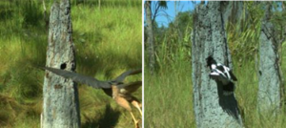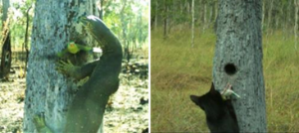

Photographs: © Olkola Aboriginal Land Managers and Bush Heritage Australia

### Loss of nest sites

Most of the antbeds used by golden-shouldered parrot for nests are built by *Amitermes scopulus*, and only a small proportion of nests or antbeds are used more than once 6. Antbeds can take at least 30 years to reach a size where they are suitable for nesting 13; 17. Ongoing recruitment of antbeds is needed to provide an adequate supply of nest sites. Recruitment does not appear to be occurring in some areas on Artemis, where most antbeds of a suitable size have already been used for nests and few new ones are starting 56. Antbeds have also disappeared from other areas that have been subject to vegetation thickening17. However, there is no information on whether this is the case through the remainder of the species’ current nesting distribution.

Although not fully understood, there are a number of factors that could be causing an apparent shortage of antbeds of a nestable size. The termites that build the antbeds feed on grass and detritus 77, so vegetation thickening as a result ofaltered fire regimes and/or grazing animals may influence the health, abundance and composition of their colonies by reducing grass cover. Shading may also degrade termite colonies 77; 78 and in some places many antbeds have been damaged or knocked over by cattle and/or pigs 17. Knowledge of the factors that influence ongoing availability of antbeds for golden-shouldered parrot nesting is needed to inform habitat management for sustaining a viable parrot population. In the meantime, areas of suitable antbeds should be protected from introduced herbivores and kept open using storm-burning. Loss of nest sites will be addressed under Objective 3.

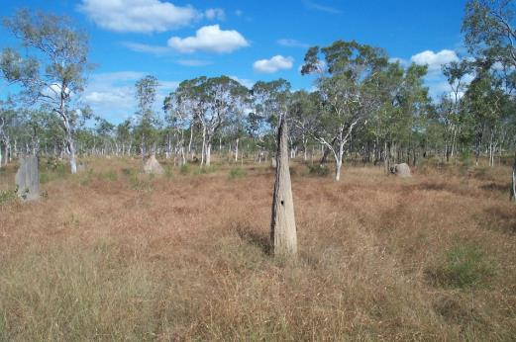

Photograph: © Susan Shephard

### Loss of dingoes

Traditional Owners of golden-shouldered parrot Country have long known that dingoes play an important role keeping everything in balance. Now, western science is also starting to understand the importance of dingoes and their regulatory role to ecosystem function. By controlling mid-level predators, dingoes help to reduce predation pressure on small animals 79-81. By controlling grazing animals, such as wallabies and kangaroos, they help to maintain grass cover 79. It is therefore possible that dingoes help to alleviate predation and starvation pressures on golden-shouldered parrots. Control of dingoes must therefore be considered as a potential threat to the species. Dingo control has been undertaken on most pastoral properties within the parrot’s distribution, but only at the north-eastern edge has control been successful to the extent that it is possibly driving an increase in macropod numbers. Options to maintain dingo populations in golden-shouldered parrot habitat that do not infringe on neighbouring cattle operations are required to help reduce the impact of predators and native herbivores on the parrots.Loss of dingoes will be addressed under Objective 2.

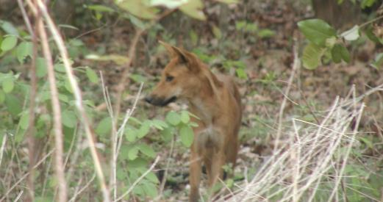

Photograph: © Stephen Garnett

### Replacement of Aboriginal land management by pastoralism

Many threats have only occurred since the removal of Aboriginal people from their Country throughout the historical distribution of the golden-shouldered parrot. The first impact of pastoralism was to wrest the control of land from the Traditional Owners 82; 83. There followed a progressive loss of Aboriginal people’s ability to access, use and manage their traditional lands 83. Their dispossession drove altered fire regimes throughout the historical distribution of the golden-shouldered parrot, leading to vegetation thickening in at least parts of the parrot’s range, andthereby contributing to the cascade of factors affecting golden-shouldered parrots. This plan recognises the importance of Traditional Owners having control over land management to reverse these threatening processes and to care for country the proper way.

The impact of the loss of other ecosystem services Traditional Owners provided to the golden-shouldered parrot 84, particularly regulation of herbivores (such as wallabies) and mid-level predators (notably large goannas)85 have not previously been considered. In this plan, we raise the possibility that that loss of Traditional Owner control over land management has also contributed to increased predation pressure on golden-shouldered parrots; and that repopulating the golden-shouldered parrot habitat to restore fire regimes and control of herbivores and mid-level predators will be important for the recovery of the golden-shouldered parrot. Traditional Owners know that the parrots decline began when their Elders were taken away from country. To bring the parrot back, Traditional Owners must once again have access to their lands and to the important Story Places necessary to practice ceremony to keep culture and country strong. Returning People to Country is Objective 1.

If we look after the place where Alwal was created then maybe the population will rise up again. That’s our cultural way. (Ashaley Ross, Olkola Alwal Project Manager)

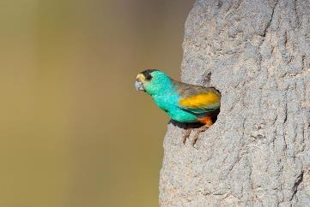

Photograph: © Geoffrey Jones

### Mining, clearing and land use change

Very little vegetation has been cleared from golden-shouldered parrot habitat. In 2017, 0.1% of the bioregional province containing the golden-shouldered parrot’s northern population (Coen - Yambo Inlier province of the Cape York Peninsula bioregion) and 0.9% of the province containing the southern population (Holroyd Plain-Red Plateau province of the Gulf Plains bioregion) had been cleared 86. However, pressure for land clearance for agricultural and other developments is increasing in the region 87. Land clearing within critical golden-shouldered parrot habitat would further threaten this species’ survival as it would remove the antbeds needed for nesting and destroy the grasses needed to produce wet season foods. It is therefore important that any proposed development that involves land clearing within or near golden-shouldered parrot habitat is fully scrutinised for potential impacts on the species, and that where adverse impacts are likely, the development is prevented from proceeding.

One of the most serious development pressures on the golden-shouldered parrot habitat comes from mining. At Alice River, in the parrot’s northern distribution, attempts are being made to revive gold mining at eight active mining leases that have operated sporadically since 190488. All eight leases are near currently occupied nesting territories. In addition, Exploration Permits for Minerals have been granted (or are under application) over substantial areas of breeding habitat in both parrot distributions. Vegetation clearance associated with mining and exploration therefore have the potential to destroy or degrade critical feeding and breeding habitat 89. Another issue associated with mining is noise that is likely to be produced by compressors or drills. Noise from mining and exploration is known to disrupt bird behaviour; cause nest desertion and reduce population size 90-92. In addition, cyanide used in gold extraction makes parrot death from poisoning a real threat, unless all contaminated water supplies are covered 89; 93; 94.

As all areas of critical habitat identified for golden-shouldered parrot are necessary for the protection and recovery of this species, and no measures have yet been identified for rehabilitating degraded habitat, the concept of replacing critical habitat lost to development through an offsetting program is not appropriate for this species at this stage.

Therefore, every effort should be made to ensure that mining and mineral exploration and land clearance for agricultural development are excluded from areas critical to the lifecycle of this species and used by the parrots for nesting, feeding or drinking. In the event that activities be permitted within this species’ range, but outside of their critical habitat requirements, appropriate mitigation measures and rehabilitation measures should be implemented, monitored and enforced.The impacts of mining, clearing and land use change will be addressed under Objective 6.

### New and emerging threats

Detecting and responding to threats early will help to minimise their impact on golden-shouldered parrot recovery. Climate change 14; 95; 96, disease 97-100, invasive species 101-103, mining 104; 105 and land clearing for intensive agriculture 106 are all potential threats to golden-shouldered parrots 106.

Recent extensive bushfires in southern Australia 107 have highlighted the need to assess the risk of species suffering catastrophic decline and to ensure contingency plans are in place to avert such risks. The nature of bushfires in northern Australia, the timing of the breeding season and the insulation properties of the antbeds in which the parrots nest make extirpation of the golden-shouldered parrot by wildfires highly unlikely 108; 109. However, other threats that could cause a catastrophic decline across the range of the golden-shouldered parrot include disease or intense, incessant rainfall associated with cyclonic conditions or a complete failure of the wet season 110.

These and other potential threats should be assessed and reported regularly; and options for addressing them identified and implemented as soon as possible. New and emerging threats will be addressed under Objective 7.Conditions that could potentially place the golden-shouldered parrot at risk of imminent extinction will be identified under Objective 8,along with strategies to both minimise the impact of such conditions and respond appropriately should the parrot’s population be in danger of declining to critical levels.

## The recovery program

An extensive review of past recovery efforts and a review of progress against previous recovery plan objectives has been conducted. This information is presented in detail within the *2019–2029 Golden-shouldered Parrot Recovery Plan – Guiding Document42*. Important learnings from this valuable history have informed this plan and the recovery program priorities. Nine recovery objectives for the next 10 years have been identified as essential to golden-shouldered parrot recovery. Priority strategies have also been identified to be implemented towards achieving these objectives.

**Objective 1.** Return People to Country to make golden-shouldered parrot habitat strong again

**Objective 2.** Understand and restore the role of dingoes in golden-shouldered parrot recovery

**Objective 3**. Restore and maintain golden-shouldered parrot nesting and early wet season habitat

**Objective 4.** Restore golden-shouldered parrot’s wet season foods

**Objective 5.** Reduce and reverse unsustainable predation pressure on golden-shouldered parrots

**Objective 6.** Ensure mining, clearing and land use change do not threaten golden-shouldered parrot recovery

**Objective 7**. Address new and emerging threats to golden-shouldered parrots

**Objective 8.** Demonstrate improvement in the golden-shouldered parrots’ extent, population size and extinction risk

**Objective 9.** Manage the recovery program using culturally appropriate and scientifically robust principles

### Co-benefits

This recovery program will have multiple socio-economic and biodiversity co-benefits. It restores the rights of Traditional Owners to undertake their customary obligations to care for Country and provides an economic base for them to do so. empowering Traditional Owners to strengthen and re-establish connection to Country has well-established wellbeing benefits 111; 112.

The integrated nature of this recovery program ensures restoration of lost ecosystem function, with benefits for a range of species that are integral to the parrot’s habitat, particularly for the antbed parrot moth, which depends on golden-shouldered parrots to complete its life cycle 113. Restoration of grasslands and grassy woodlands (including Regional Ecosystem 3.5.15 Eucalyptus brassiana +/- Melaleuca viridiflora +/- Corymbia clarksoniana woodland on alluvial plains, which is listed as Of Concern 114) should benefit numerous declining granivorous birds 115, including the endangered Buff-breasted buttonquail 116.

This recovery program is consistent with key threatening processes and threat abatement plans for feral cats 117 and pigs 118. Other key threatening processes that will be addressed under this program include introduced grasses 119 and parrot beak and feather disease 120.

Figure Female golden-shouldered parrot attending her nest. Monitoring cameras like this one are used to assess breeding success and predation events.

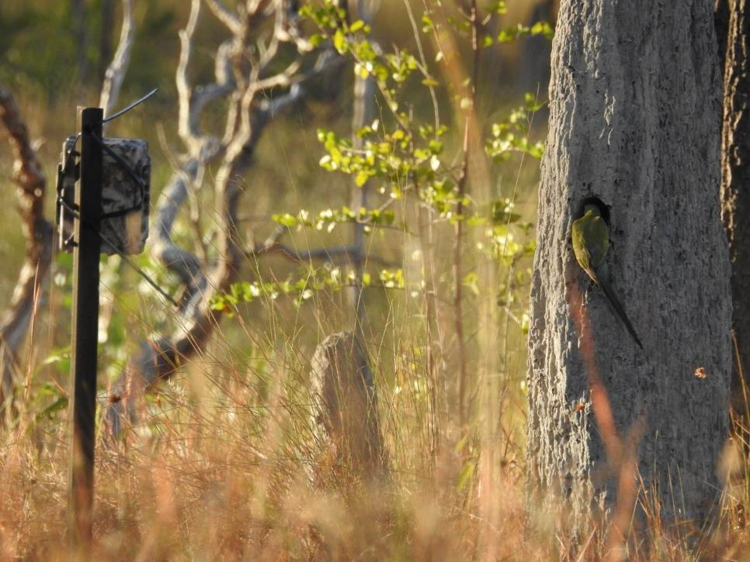

Photograph: © Allana Brown and Bush Heritage Australia.

### Recovery framework

Table Recovery framework

| Recovery objectives | Performance criteria | Strategies |
| --- | --- | --- |
| Objective 1 Return People to Country to make golden-shouldered parrot habitat strong again. | By year 10, a strong workforce exists across golden-shouldered parrot habitat with the capacity to undertake recovery actions supported by adequate funding, logistical support, Healthy Country Planning, and commitment of responsible organisations. | 1. Support golden-shouldered parrot recovery through on-country programs, joint-management arrangements, ranger programs and Healthy Country Planning across the species’ distribution. 2. Improve understanding of the multiple benefits of Indigenous people living and working on their traditional lands. 3. Build understanding of the cultural and biodiversity significance of golden-shouldered parrots and their habitat to raise the species’ profile and support for recovery efforts. |
| Objective 2 Understand and restore the role of dingoes in golden-shouldered parrot recovery. | By year 5, reinstatement of dingoes as the top-level predator in core golden-shouldered parrot habitat is having demonstrated benefits in regulating key predators and herbivores.  By year 10, golden-shouldered parrot nesting activity has increased in areas where dingoes have been reinstated as the top-level predator. | 1. Understand historical changes in dingo populations across golden-shouldered parrot distribution in relation to the parrot’s decline. 2. Understand the dingo’s relationship with other species significant to the life history of golden-shouldered parrots. 3. Maintain and restore the health of dingo populations in key areas of golden-shouldered parrot habitat in consultation with all stakeholders. |
| Objective 3 Restore and maintain golden-shouldered parrot nesting and early wet season habitat. | By year 5, condition of key areas of wet season habitat has improved as a result of management (as indicated by seed availability, vegetation structure, Black-faced woodswallow nests and use by golden-shouldered parrots).  By year 10, golden-shouldered parrots nesting activity has increased in close proximity to areas of restored wet season feeding habitat. | 1. Maintain and restore open vegetation structure of nesting and wet season feeding habitat. 2. Maintain and restore healthy antbeds for nesting. |
| Objective 4 Restore golden-shouldered parrot’s wet season foods | By year 5, key wet season feeding sites for both populations have been identified and protected, support healthy populations of wet season food plants, and are being used by golden-shouldered parrots.  By year 10, golden-shouldered parrots have returned to deserted nesting areas within 3 to 5 km of protected wet-season feeding areas. | 1. Manage total grazing pressure in key wet season feeding areas to maintain and restore cockatoo grass and other key wet season foods. 2. Maintain the golden-shouldered parrot’s population at its retreating edge on Artemis, Dixie and Mary Valley through supplementary feeding. |
| Objective 5 Reduce and reverse unsustainable predation of the golden-shouldered parrot | By year 5, predation by feral cats in intensively managed nesting areas has been reduced through effective control efforts.  By year 10, predation by goannas, butcherbirds and woodland predators has been reduced to sustainable levels where dingoes have been reinstated and vegetation condition restored. | 1. Understand predation pressure on golden-shouldered parrots. Understand the link between golden-shouldered parrots and Black-faced woodswallows. 2. Reduce predation pressure on golden-shouldered parrots. |
| Objective 6 Ensure mining, clearing and land use change do not threaten golden-shouldered parrot recovery. | No adverse impacts on golden-shouldered parrot population or critical habitat from mining, clearing or other land use change. | 1. Assess and avert the likely impacts of proposed mining, development and land use change on golden-shouldered parrot recovery. |
| Objective 7 Address new and emerging threats to golden-shouldered parrots. | New and emerging threats to golden-shouldered parrots and habitat are identified and managed. | 1. Manage the impact of adverse weather events and climate change. Monitor and address emerging weed and pest animal threats. 2. Implement appropriate protocols needed to avert disease spread. 3. Annually review other potential threats and identify and implement mitigation options where appropriate. |
| Objective 8 Demonstrate improvement in the golden-shouldered parrots’ extent, population size and extinction risk. | Robust data are available to assess population parameters accurately, conservation status and extinction risk in years 5 and 10.  By year 5, population modelling shows that survival rates are sufficient to stabilize or increase the golden-shouldered parrot population.  By year 10, the golden-shouldered parrot extent, population size and extinction risk has significantly improved over 2019 values. | 1. Improve understanding of the golden-shouldered parrot’s extent and population size and their response to management regimes. 2. Improve understanding of the golden-shouldered parrot’s extinction risk, including whether the species is vulnerable to catastrophic events and/or captive breeding has a role in the species’ recovery. 3. Ensure information used for mapping golden-shouldered parrot distribution and assessing impacts on the species is based on the best available evidence. |
| Objective 9 Manage the recovery program using culturally appropriate and scientifically robust principles. | By year 5, good progress has been made in all recovery objectives.  By year 10, golden-shouldered parrot recovery can be attributed to good progress across all recovery objectives. | 1. Manage the recovery program through the recovery team, with appropriate review and revision. |

## References

1. Coleman, Fred 2019, Personal communication, 22 January 2019, Thaypan Elder and Knowledge Holder.

2. Rigsby, B 1980, 'Land, language and people in the Princess Charlotte Bay area ', in N.C. Stevens and A. Bailey (eds), *Contemporary Cape York Peninsula.*, Royal Society of Queensland, St Lucia, pp. 89-94.

3. Thomas, Billy 2018, Personal communication, 21 March 2018.

4. Ross, Mike 2019, Personal communication, 30 October 2019, Olkola Elder and Knowledge Holder and Recovery Team Chair.

5. Mattinson, JS 1975, ['The golden-shouldered parakeet'](http://aviculturalsocietynsw.org/_articles/GoldenShouldered.htm#.YBssgXn05PY), *AVIDATA: The Journal of the Avicultural Society of New South Wales*, Vol. 2, p. Spring 1975, viewed 4 Feb 2021.

6. Garnett, ST & Crowley, GM 1999, 'Golden-shouldered Parrot', in P.J. Higgins (ed), *Handbook of Australian, New Zealand and Antarctic, Vol. 4. Parrots to Dollarbird*, Oxford University Press, Melbourne.

7. Christidis, L & Norman, J 1996, *Genetic variability in the Golden-shouldered Parrot, Psephotus chrysopterygius. Report to Queensland Department of Environment and Heritage.*, Museum of Victoria, Abbotsford, Victoria.

8. Provost, KL, Joseph, L & Smith, BT 2018, 'Resolving a phylogenetic hypothesis for parrots: implications from systematics to conservation', *Emu - Austral Ornithology*, vol. 118, no. 1, pp. 7-21.

9. Joseph, L, Toon, A, Schirtzinger, EE & Wright, TF 2011, 'Molecular systematics of two enigmatic genera *Psittacella* and *Pezoporus* illuminate the ecological radiation of Australo-Papuan parrots (Aves: Psittaciformes)', *Molecular Phylogenetics and Evolution*, vol. 59, no. 3, pp. 675-84.

10. Schweizer, M, Güntert, M & Hertwig, ST 2013, 'Out of the Bassian province: historical biogeography of the Australasian platycercine parrots (Aves, Psittaciformes)', *Zoologica Scripta*, vol. 42, no. 1, pp. 13-27.

11. Forshaw, JM & Cooper, WT 1989, *Parrots of the World*, 3rd revised edn., Lansdowne Editions, Willoughby.

12. Weaver, CM 1982, 'Breeding habitats and status of the golden-shouldered parrot *Psephotus chrysopterygius* in Queensland', *Emu*, vol. 82, pp. 2-6.

13. Garnett, ST & Crowley, GM 2002, [*Recovery plan for the Golden-shouldered Parrot (Psephotus chrysopterygius) 2003-2007*](http://www.environment.gov.au/node/15778), Report to Environment Australia, Canberra, Queensland Parks and Wildlife Service, Brisbane, 4 Feb 2021.

14. Crowley, GM & Garnett, ST 1999, 'Seed of the annual grasses *Schizachyrium* spp. as a food for tropical granivorous birds', *Australian Journal of Ecology*, vol. 24, pp. 208-20.

15. Crowley, GM & Garnett, ST 2001, 'Growth, seed production and effect of defoliation in an early flowering perennial grass, *Alloteropsis semialata* (Poaceae), on Cape York Peninsula, Australia', *Australian Journal of Botany*, vol. 49, pp. 735-43.

16. Crowley, GM 2008, 'Cockatoo grass *Alloteropsis semialata* as a keystone species in northern Australia', *Northern Territory Naturalist*, vol. 20, pp. 58-63.

17. Crowley, GM, Garnett, ST & Shephard, S 2004, [*Management guidelines for Golden-shouldered Parrot conservation*](http://www.firescape.com.au/wp-content/uploads/2012/10/Management-Guidelines-GSP-Conservation.pdf), Queensland Parks and Wildlife Service, Cairns, accessed 4 Feb 2021. [pdf, 1.5MB].

18. Garnett, ST & Crowley, GM 1995, *Antbed - An occasional newsletter about the Golden-shouldered Parrot. Vol. 5 - May 1995*, Queensland Department of Environment and Hertiage, Cairns.

19. Bush Heritage Australia & Olkola Aboriginal Land Managers 2017, ['Bringing Alwal Home](http://www.youtube.com/watch?v=bb8MZDgtT2I)', Storm Boy Productions, Evans Head, NSW, viewed 4 Feb 2021 [video].

20. Collingwood, T 2018. ‘Nest predation of Alwal (golden-shouldered parrot *Psephotellus chrysopterygius*) on Olkola Country, Cape York Peninsula, Australia’ In *Ecological Society of Australia Annual Conference. Ecology in the Anthropocene. 25-29 Nov 2018*, Brisbane.

21. Common, IFB 2000, *Oecophorine Genera of Australia III: The Barea Group and Unplaced Genera (Lepidoptera: Oecophoridae)*, Monographs on Australian Lepidoptera. Volume 8., CSIRO, Canberra.

22. Garnett, ST & Crowley, GM 1994, *Antbed - An occasional newsletter about the Golden-shouldered Parrot. Vol. 3 - April 1994*, Queensland Department of Environment and Hertiage, Cairns.

23. Atlas of Living Australia 2019, [*Atlas of Living Australia*](http://www.ala.org.au), viewed 4 Feb 2021.

24. State of Queensland 2017, [*WildNet records for Psephotus chrysopterygius*](https://environment.ehp.qld.gov.au/species-search/details/?id=1117), Department of Environment and Science, Brisbane, viewed 4 Feb 2021.

25. Dick, RS 1975, 'A map of the climates of Australia according to Köppen's principles of definition', *Queensland Geographic Journal*, vol. 3, pp. 33-69.

26. Australian Bureau of Meteorology 2019, [*Climate data online*](http://www.bom.gov.au/climate/data/index.shtml), viewed 4 Feb 2021.

27. Australian Bureau of Meteorology 2016, [*Climate of Mount Isa*](http://www.bom.gov.au/qld/mt_isa/climate.shtml), viewed 4 Feb 2021.

28. Garnett, ST & Crowley, GM 1995, *Recovery Plan for the Golden-shouldered Parrot*, Department of Environment and Heritage, Cairns.

29. Capon, SJ & Brock, MA 2006, 'Flooding, soil seed bank dynamics and vegetation resilience of a hydrologically variable desert floodplain', *Freshwater Biology*, vol. 51, no. 2, pp. 206-23.

30. James, CS, Capon, SJ, White, MG, Rayburg, SC & Thoms, MC 2007, 'Spatial variability of the soil seed bank in a heterogeneous ephemeral wetland system in semi-arid Australia', *Plant Ecology*, vol. 190, no. 2, pp. 205-17.

31. Dangerfield, JM, McCarthy, TS & Ellery, WN 1998, 'The mound-building termite *Macrotermes michaelseni* as an ecosystem engineer', *Journal of Tropical Ecology*, vol. 14, no. 4, pp. 507-20.

32. Phillips, SJ, Dudík, M & Schapire, RE 2017, '[Maxent software for modeling species niches and distributions'](http://biodiversityinformatics.amnh.org/open_source/maxent/), viewed 4 Feb 2021.

33. Crowley, GM 2018, *Current extent of golden-shouldered parrot nesting habitat and population estimates: internal report to Olkola Aboriginal Corporation, Bush Heritage Australia and The Nature Conservancy*, Firescape Science, Atherton.

34. Bain, JHC & Haipola, D 1996, 'North Queensland geology 1:1 000 000 scale map', Geoscience Australia, Canberra.

35. Department of Natural Resources, Mines and Energy 2015, 'Watercourse lines - Gulf drainage division', State of Queensland, Brisbane.

36. Department of Natural Resources, Mines and Energy 2015, 'Watercourse lines - North East Coast drainage division', State of Queensland, Brisbane.

37. Zevenbergen, LW & Thorne, CR 1987, 'Quantitative analysis of land surface topography', *Earth Surface Processes and Landforms*, vol. 12, pp. 47-56.

38. Gallant, J, Wilson, N, Dowling, T, Read, A & Inskeep, C 2000, 'SRTM-derived 1 Second Digital Elevation Models Version 1.0', Geoscience Australia, Canberra.

39. Queensland Herbarium 2016, [*Pre-clearing vegetation communities and regional ecosystems of Queensland*](http://qldspatial.information.qld.gov.au/catalogue)*, Version 10.0 (December 2016)*, Department of Science, Information Technology and Innovation, Brisbane, viewed 4 Feb 2021.

40. Garnett, ST, Szabo, J & Dutson, G 2011, *Action plan for Australian birds 2010*, CSIRO Publishing, Collongwood.

41. BirdLife International 2016, '[*Psephotellus chrysopterygius*'](https://dx.doi.org/10.2305/IUCN.UK.2016-3.RLTS.T22685150A93060760.en), *The IUCN Red List of Species*, e.T22685150A93060760. viewed 4 Feb 2021.

42. Golden-shouldered Parrot Recovery Team 2019, *Draft golden-shouldered parrot recovery plan 2019-2029: Guiding document.*, Olkola Aboriginal Corporation, Cairns, Australia.

43. Bassani, P, Lakefield, A & Popp, T 2006, *Lamalama country: Our country - Our culture-way*, ed. B. Rigsby and N. Cole, Akito, Graceville, Qld, and Queensland Government Arts.

44. Crowley, GM & Garnett, ST 2000, 'Changing fire management in the pastoral lands of Cape York Peninsula: 1623 to 1996', *Australian Geographical Studies*, vol. 38, pp. 10-26.

45. Liedloff, AC, Coughenour, MB, Ludwig, JA & Dyer, R 2001, 'Modelling the trade-off between fire and grazing in a tropical savanna landscape, northern Australia', *Environment International*, vol. 27, no. 2-3, pp. 173-80.

46. Stanton, JP 1992, 'J. P. Thomson oration: The neglected lands: Recent changes in the ecosystem of Cape York Peninsula and the challenge of their management', *Queensland Geographical Journal*, vol. 7, pp. 1-18.

47. Department of National Parks Recreation Sport and Racing 2013, [*Planned Burn Guidelines – Einasleigh Uplands Bioregion of Queensland*](http://www.nprsr.qld.gov.au/managing/pdf/pbg-einasleigh-uplands.pdf), Queensland Department of National Parks, Recreation, Sport and Racing, Brisbane, viewed 4 Feb 2021. [pdf, 5.4 MB]

48. Crowley, GM, Garnett, ST & Shephard, S 2009, 'Impact of storm-burns on *Melaleuca viridiflora* invasion of grasslands and grassy woodlands on Cape York Peninsula, Australia', *Austral Ecology*, vol. 34, pp. 196-209.

49. Perry, JJ, Vanderduys, EP & Kutt, AS 2016, 'Shifting fire regimes from late to early dry-season fires to abate greenhouse emissions does not completely equate with terrestrial vertebrate biodiversity co-benefits on Cape York Peninsula, Australia', *International Journal of Wildland Fire*, vol. 25, no. 7, pp. 742-52.

50. Lynch, D, Cuff, N & Russell-Smith, J 2015, 'Chapter 4: Vegetation fuel type classification for lower rainfall savanna burning abatement projects', in Brett Murphy, Jeremy Russell-Smith, Andrew Edwards and C.P. Meyer (eds), *Carbon Accounting and Savanna Fire Management*, CSIRO, Australia, pp. 73-96.

51. Mott, JJ, Tothill, JC & Weston, E 1981, 'The native woodlands and grasslands of Northern Australia as a grazing resource for low cost animal production', *Journal of the Australian Institute for Agricultural Science*, vol. 47, pp. 132-41.

52. Smith, EL 1960, 'Effects of burning and clipping at various times during the wet season on tropical tall grass range in Northern Australia', *Journal of Range Management*, vol. 13, no. 4, pp. 197-203.

53. Johnson, P 1980, 'Field observations on group compositions in the agile wallaby, *Macropus agilis* (Gould) (Marsupialia : Macropodidae)', *Wildlife Research*, vol. 7, no. 3, pp. 327-31.

54. Milne, N & O'Higgins, P 2002, 'Inter-specific variation in Macropus crania: form, function and phylogeny', *Journal of Zoology*, vol. 256, no. 4, pp. 523-35.

55. Morrant Damian, S, Wurster Christopher, M, Johnson Christopher, N, Butler James, RA & Congdon Bradley, C 2017, 'Prey use by dingoes in a contested landscape: Ecosystem service provider or biodiversity threat?', *Ecology and Evolution*, vol. 7, no. 21, pp. 8927-35.

56. Shephard, Susan 2018, Personal communication, 21 March 2018, Landholder of Artemis Station.

57. Garnett, ST & Crowley, GM 1994, 'Wet season feeding by four species of granivorous birds in the Northern Territory', *Australian Bird Watcher*, vol. 15, no. 7, pp. 306-9.

58. Garnett, ST & Crowley, GM 1995, 'Feeding ecology of hooded parrots *Psephotus dissimilis* during the early wet season', *Emu*, vol. 95, pp. 54-61.

59. Maute, KL, French, K, Legge, S & Astheimer, LB 2013, 'Seasonal stress physiology and body condition differ among co-occurring tropical finch species', *Journal of Comparative Physiology B*, doi. 10.1007/s00360-013-0775-y, pp. 1-15.

60. Crowley, GM & Garnett, ST 1998, 'Vegetation change in the grasslands and grassy woodlands of east-central Cape York Peninsula, Australia', *Pacific Conservation Biology*, vol. 4, pp. 132-48.

61. Neldner, VJ, Fensham, RJ, Clarkson, JR & Stanton, JP 1997, 'The natural grasslands of Cape York Peninsula, Australia: Description, distribution and conservation status', *Biological Conservation*, vol. 81, pp. 121-36.

62. Garnett, ST & Crowley, GM 1999, *Recovery plan for the Golden-shouldered Parrot (Psephotus chrysopterygius) 1999-2002*, Report to Environment Australia, Canberra, Queensland Parks and Wildlife Service, Brisbane.

63. Higgins, PJ, Peter, JM & Cowling, SJ 2006, 'Handbook of Australian, New Zealand and Antarctic birds. Volume 7. Boatbill to starlings', Oxford University Press, Melbourne.

64. Sridhar, H, Beauchamp, G & Shanker, K 2009, 'Why do birds participate in mixed-species foraging flocks? A large-scale synthesis', *Animal Behaviour*, vol. 78, no. 2, pp. 337-47.

65. Greenberg, RS 2001, 'Birds of many feathers: the formation and structure of mixed species flocks of forest birds'.

66. Britton, PL 1997, 'Winter mixed-species flocks at Charters Towers, North Queensland', *Sunbird*, vol. 27, no. 2, pp. 29-37.

67. Vanderduys, EP, Kutt, AS, Perry, JJ & Perkins, GC 2012, 'The composition of mixed-species bird flocks in northern Australian savannas', *Emu - Austral Ornithology*, vol. 112, no. 3, pp. 218-26.

68. Schodde, R & Mason, IJ 1999, *The Directory of Australian birds: Passerines*, CSIRO, Collingwood, Victoria.

69. Garnett, ST & Crowley, GM 2000, [*The Action Plan for Australian Birds 2000*](https://catalogue.nla.gov.au/Record/1773782), Environment Australia, Canberra, viewed 4 Feb 2021.

70. Olkola Aboriginal Land Managers and Bush Heritage Australia Personal communication.

71. Burnett, S 1997, 'Colonising cane toads cause population declines in native predators: reliable anecdotal information and management implications', *Pacific Conservation Biology*, vol. 3, pp. 65-72.

72. Shine, R 2010, 'The ecological impact of invasive cane toads (*Bufo marinus*) in Australia', *The Quarterly Review of Biology*, vol. 85, no. 3, pp. 253-91.

73. McGregor, HW, Cliff, HB & Kanowski, J 2016, 'Habitat preference for fire scars by feral cats in Cape York Peninsula, Australia', *Wildlife Research*, vol. 43, no. 8, pp. 623-33.

74. McGregor, H, Legge, S, Jones, ME & Johnson, CN 2015, 'Feral cats are better killers in open habitats, revealed by animal-borne video', *PLoS ONE*, vol. 10, no. 8, p. e0133915.

75. McGregor, HW, Legge, S, Jones, ME & Johnson, CN 2014, 'Landscape management of fire and grazing regimes alters the fine-scale habitat utilisation by feral cats', *PLoS ONE*, vol. 9, no. 10, p. e109097.

76. Fancourt, BA, Cremasco, P, Wilson, C & Gentle, MN 2019, 'Do introduced apex predators suppress introduced mesopredators? A multiscale spatiotemporal study of dingoes and feral cats in Australia suggests not', *Journal of Applied Ecology*, vol. 56, no. 12, pp. 2584-95.

77. Lee, KE & Wood, TG 1971, *Termites and soil*, Academic Press, London.

78. Dawes-Gromadzki, TZ 2003, 'Sampling subterranean termite species diversity and activity in tropical savannas: an assessment of different bait choices', *Ecological Entymology*, vol. 28, pp. 397-404.

79. Ritchie, EG, Elmhagen, B, Glen, AS, Letnic, M, Ludwig, G & McDonald, RA 2012, 'Ecosystem restoration with teeth: what role for predators?', *Trends in Ecology & Evolution*, vol. 27, no. 5, pp. 265-71.

80. Moseby, KE, Neilly, H, Read, JL & Crisp, HA 2012, 'Interactions between a top order predator and exotic mesopredators in the Australian rangelands', *International Journal of Ecology*, vol. 2012.

81. Doherty, TS, Dickman, CR, Johnson, CN, Legge, SM, Ritchie, EG & Woinarski, JCZ 2017, 'Impacts and management of feral cats *Felis catus* in Australia', *Mammal Review*, vol. 47, no. 2, pp. 83-97.

82. Rigsby, B 1981, 'Aboriginal people, land rights and wilderness on Cape York Peninsula', *Proceedings of the Royal Society of Queensland*, vol. 92, pp. 1-10.

83. May, D 1994, *Aboriginal labour and the cattle industry in Queensland from white settlement to the present*, Cambridge University Press, Cambridge.

84. Bliege Bird, R & Nimmo, D 2018, 'Restore the lost ecological functions of people', *Nature Ecology & Evolution*, vol. 2, no. 7, pp. 1050-2.

85. Lunney, D & Leary, T 2006, 'The impact on native mammals of land‐use changes and exotic species in the Bega district, New South Wales, since settlement', *Australian Journal of Ecology*, vol. 13, no. 1, pp. 67-92.

86. Accad, A, Neldner, VJ, Kelley, JAR, Li, J & Richter, D 2019, [*Remnant regional ecosystem vegetation in Queensland: Analysis 1997-2017*](http://www.qld.gov.au/environment/plants-animals/plants/ecosystems/remnant-vegetation), Queensland Department of Environment and Science, Brisbane, viewed 4 Feb 2021.

87. Australian Government 2015, 'Our North, Our Future: White paper on developing northern Australia'.

88. Colwell, LJ 'The North Queensland goldfields', *Ch 6 Lectures on North Queensland History*.

89. Woinarski, JCZ 2013, *Independent assessment of issues relating to the Gouldian Finch in the Draft Environmental Impact Statement Mt Todd Gold Project*, Report to the Northern Territory Environment Protection Authority.

90. Francis, CD, Ortega, CP & Cruz, A 2009, 'Noise pollution changes avian communities and species interactions', *Current Biology*, vol. 19, no. 16, pp. 1415-9.

91. Bayne, EM, Habib, L & Boutin, S 2008, 'Impacts of chronic anthropogenic noise from energy-sector activity on abundance of songbirds in the boreal forest', *Conservation Biology*, vol. 22, no. 5, pp. 1186-93.

92. Catherine, PO 2012, 'Chapter 2: Effects of noise pollution on birds: A brief review of our knowledge', *Ornithological Monographs*, vol. 74, no. 1, pp. 6-22.

93. Azcue, JM 2012, *Environmental impacts of mining activities: emphasis on mitigation and remedial measures*, Springer Science & Business Media.

94. Donato, DB, Nichols, O, Possingham, H, Moore, M, Ricci, PF & Noller, BN 2008, 'A critical review of the effects of gold cyanide-bearing tailings solutions on wildlife', *Environment International*, vol. 33, pp. 974-84.

95. Reside, AE, VanDerWal, J, Garnett, ST & Kutt, AS 2016, 'Vulnerability of Australian tropical savanna birds to climate change', *Austral Ecology*, vol. 41, pp. 106–16.

96. Garnett, ST & Williamson, G 2010, 'Spatial and temporal variation in precipitation at the start of the rainy season in tropical Australia', *The Rangeland Journal*, vol. 32, no. 2, pp. 215-26.

97. Peters, A, Patterson, EI, Baker, BGB, Holdsworth, M, Sarker, S, Ghorashi, SA, et al. 2014, 'Evidence of psittacine beak and feather disease virus spillover into wild critically endangered orange-bellied parrots (*Neophema chrysogaster*)', *Journal of Wildlife Diseases*, vol. 50, no. 2, pp. 288-96.

98. Vitali, SD, Eden, PA, Payne, KL & Vaughan, RJ 2006, 'An outbreak of mycobacteriosis in gouldian finches caused by *Mycobacterium peregrinum*', *Veterinary Clinics of North America: Exotic Animal Practice*, vol. 9, no. 3, pp. 519-22.

99. Sarker, S, Forwood, JK, Ghorashi, SA, Peters, A & Raidal, SR 2015, 'Beak and feather disease virus genotypes in Australian parrots reveal flexible host-switching', *Australian Veterinary Journal*, vol. 93, no. 12, pp. 471-5.

100. Raidal, SR, Sarker, S & Peters, A 2015, 'Review of psittacine beak and feather disease and its effect on Australian endangered species', *Australian Veterinary Journal*, vol. 93, no. 12, pp. 466-70.

101. Far North Queensland Regional Organisation of Councils 2008, 'Gamba grass (*Andropogon gayanus*) 1:50000 Map Sheet: Kalinga', Far North Queensland Regional Organisation of Councils, Cairns.

102. Brooks, KJ, Setterfield, SA & Douglas, MM 2010, 'Exotic grass invasions: Applying a conceptual framework to the dynamics of degradation and restoration in Australia’s Tropical Savannas', *Restoration Ecology*, vol. 18, no. 2, pp. 188-97.

103. Department of Environment and Energy 2016, [*Threat Abatement Advice for the key threatening process: Invasive pasture grasses in northern Australia - gamba grass, para grass, olive hymenachne, perennial mission grass and annual mission grass - Introduction*](https://www.awe.gov.au/environment/biodiversity/threatened/threat-abatement-advices/invasive-pasture-grasses-annual-mission), Commonwealth of Australia, Canberra, viewed 4 Feb 2021.

104. Department of Natural Resources Mines and Energy 2018, '[Exploration and production permits - Queensland](http://qldspatial.information.qld.gov.au/catalogue)’, State of Queensland, Brisbane, accessed 4 Feb 2021.

105. Michael Ross & Others on behalf of the Cape York United Number 1 Claim v Lithium Australia NL and State of Queensland 2018, 'QO2016/0047, QO2016/0048, QO2016/0049', National Native Title Tribunal.

106. Department of the Environment Water Heritage and the Arts 2009, *The Australian environment act – Report of the independent review of the Environment Protection and Biodiversity Conservation Act 1999*, Commonwealth of Australia, Canberra.

107. Ward, M, Tulloch, AIT, Radford, JQ, Williams, BA, Reside, AE, Macdonald, SL, et al. 2020, 'Impact of 2019–2020 mega-fires on Australian fauna habitat', *Nature Ecology & Evolution*, vol. 4, no. 10, pp. 1321-6.

108. Williams, RJ, Bradstock, RA, Cary, GJ, Enright, NJ, Gill, AM, Leidloff, A, et al. 2009, *Interactions between climate change, fire regimes and biodiversity in Australia: a preliminary assessment*, Department of Climate Change, Canberra.

109. Garnett, ST & Crowley, GM 1995, *Ecology and conservation of the Golden-shouldered Parrot*, Cape York Land Use Strategy, Office of the Co-ordinator General of Queensland, Brisbane, Department of Environment, Sport and Territories, Canberra, and Department of Environment and Heritage, Brisbane, p. 15.

110. Ameca y Juárez, EI, Mace, GM, Cowlishaw, G, Cornforth, WA & Pettorelli, N 2013, 'Assessing exposure to extreme climatic events for terrestrial mammals', *Conservation Letters*, vol. 6, no. 3, pp. 145-53.

111. Burgess, CP, Johnston, FH, Bowman, DMJS & Whitehead, PJ 2005, 'Healthy Country: Healthy People? Exploring the health benefits of Indigenous natural resource management', *Australian and New Zealand Journal of Public Health*, vol. 29, no. 2, pp. 117-22.

112. Johnston, FH, Jacups, SP, Vickery, AJ & Bowman, DMJS 2007, 'Ecohealth and Aboriginal testimony of the nexus between human health and place', *EcoHealth*, vol. 4, no. 4, pp. 489-99.

113. Threatened Species Scientific Committee 2016, [*Conservation Advice Trisyntopa scatophaga antbed parrot moth*](https://www.awe.gov.au/environment/biodiversity/threatened/nominations/comment/trisyntopa-scatophaga), Department of the Environment and Energy, Canberra, Australian Capital Territory, viewed 4 Feb 2021.

114. Department of Environment and Science 2018, [*Biodiversity status of 2015 remnant regional ecosystems of Queensland*](http://qldspatial.information.qld.gov.au/catalogue)*, Version 10.1 (March 2018)*, State of Queensland, Brisbane, viewed 4 Feb 2021.

115. Franklin, DC 1999, 'Evidence of disarray amongst granivorous bird assemblages in the savannas of northern Australia, a region of sparse human settlement', *Biological Conservation*, vol. 90, no. 1, pp. 53-68.

116. Mathieson, MT & Smith, GC 2009, [*National recovery plan for the buff-breasted button-quail Turnix olivii*](https://www.awe.gov.au/environment/biodiversity/threatened/recovery-plans/national-recovery-plan-buff-breasted-button-quail-turnix-olivii)*. Report to Department of the Environment, Water, Heritage and the Arts, Canberra*, Department of Environment and Resource Management, Brisbane, viewed 29 Nov 2021.

117. Department of the Environment 2015, ['Threat abatement plan for predation by feral cats](http://www.environment.gov.au/biodiversity/threatened/publications/tap/threat-abatement-plan-feral-cats)', Commonwealth of Australia, Canberra, viewed 4 Feb 2021.

118. Department of the Environment and Energy 2017, [*Threat abatement plan for predation, habitat degradation, competition and disease transmission by feral pigs*](http://www.environment.gov.au/biodiversity/threatened/publications/tap/feral-pig-2017) *(Sus scrofa)* Commonwealth of Australia, Canberra, viewed 4 Feb 2021.

119. Threatened Species Scientific Committee 2009, [*Commonwealth Listing Advice on invasion of northern Australia by Gamba Grass and other introduced grasses*](https://www.awe.gov.au/environment/biodiversity/threatened/key-threatening-processes/ministers-decision-invasion-by-gamba-grass-other-introduced-grasses), *Key threatening processes*, viewed 4 Feb 2021.

120. Threatened Species Scientific Committee 2018, [*Advice to the Minister for the Environment and Heritage from the Threatened Species Scientific Committee on a public nomination of a Key Threatening Process under the Environment Protection and Biodiversity Conservation Act 1999*](http://www.environment.gov.au/biodiversity/threatened/key-threatening-processes/psittacine-circoviral-beak-and-feather-disease), Commonwealth of Australia, Canberra, viewed 4 Feb 2021.

## Appendix A: Engagement protocol for working with Traditional Owner groups

Traditional Owner groups participating in the Golden-shouldered Parrot Recovery Team welcome the opportunity to work with partners who can help to meet the objectives of the recovery plan. The protocol for working with Olkola, Kokoberrin, Kunjen, Wakamin and Thaypan Traditional Owner groups for golden-shouldered parrot recovery is outlined here. All requests to work in partnership with the Recovery Team and participating Traditional Owner groups should be directed to the recovery team secretariat at [recoveryteam@olkola.com.au](mailto:recoveryteam@olkola.com.au). Potential partners will be requested to complete an Expression of Interest form to identify the purpose of their proposed work and whether there is a good alignment of purpose with the Recovery Plan objectives (Figure A1). This process is necessary to protect Indigenous interests in golden-shouldered parrot recovery as outlined in Objective 1 of the recovery program.

Figure A Engagement protocol for working with Traditional Owner groups

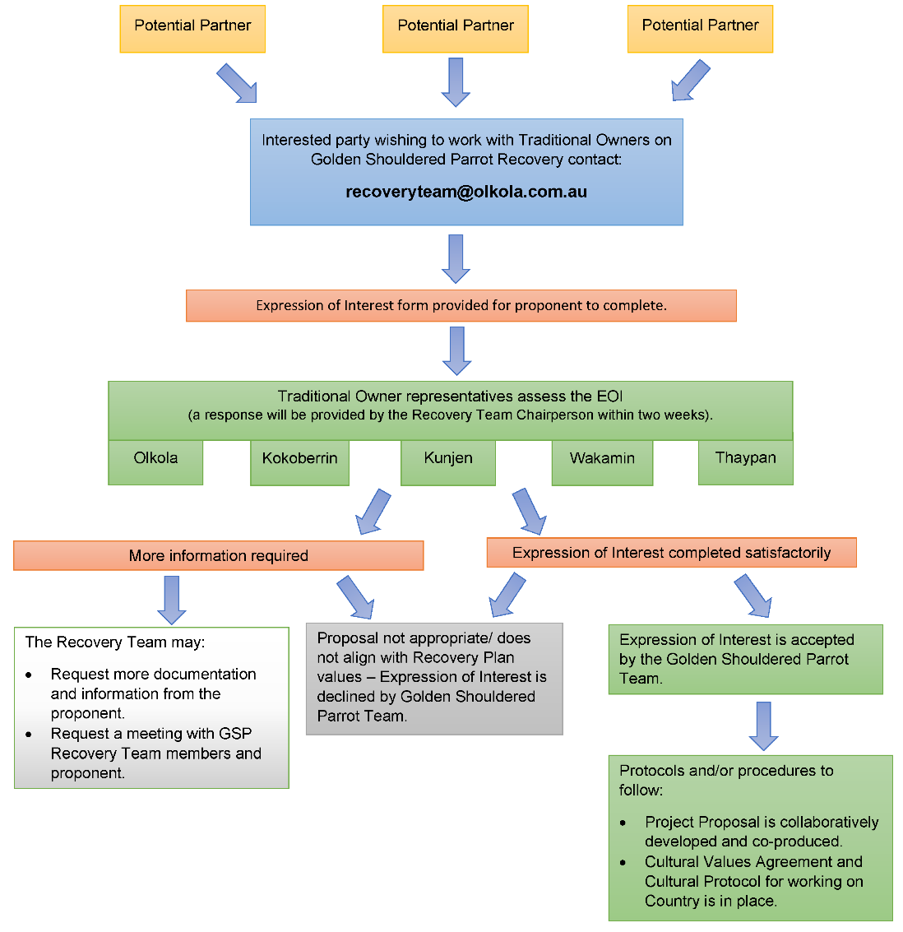

## Appendix B: Key stakeholders

The golden-shouldered parrot is a high-profile species that has attracted a high degree of local to global interest (Table B1, Figure B1). The golden-shouldered parrot is recognised as being of totemic significance to the Olkola people, and at least six Indigenous peoples have Native Title interests over land on which golden-shouldered parrot nesting has been recorded. This land is now mostly held under Indigenous ownership, including Olkola land, with some areas being covered by co-management arrangements with Queensland Parks and Wildlife Service. A small portion of the parrots’ range is still used for grazing, and all may be subject to mining interests. The Queensland Government has responsibility for the species as both a native animal and a species listed under the Nature Conservation Act*,* and the Australian Government has responsibility for the species because it is listed as Endangered under the EPBC Act. Conservation of the species also attracts the interest of non-government organisations with a focus on Indigenous advancement and/or biodiversity conservation. Research has been undertaken into golden-shouldered parrot ecology both within and outside research institutions over several decades, and there is continuing interest in research to support recovery efforts. The parrot has high Ecotourism value, for local, interstate and international birdwatchers. The recovery team is composed of representatives of the key stakeholders interested in supporting the species recovery.

Table B Key stakeholders in golden-shouldered parrot recovery

| Category | Key stakeholder | Nature of interest | Recovery team representation |
| --- | --- | --- | --- |
| **Indigenous interests** | Olkola Aboriginal Corporation | Totemic significance, Land owners/Native Title holders (northern population – Olkola IPA/Alwal NP) | Yes |
| Olkola Land Managers | Totemic significance, Land managers (northern population – Olkola IPA/Alwal NP), leading the implementation of the ‘Bringing Alwal Home’ project | Yes |
| Kokoberrin Tribal Aboriginal Corporation | Land owners/Native Title holders (northern population) | Yes |
| Thaypan and Possum people (Kyerrwanhdha Thingalkal Land Trust) | Land owners/Native Title holders (northern population) | Yes |
| Wakamin people | Land owners/Native Title holders (southern population) | Yes |
| Uwoykand Aboriginal Corporation | Land owners/Native Title holders (southern population) | No |
| **Other landholder and managers** | Artemis station | Landholders/ researchers | Yes |
| Alice River station | Landholders | No |
| **Industry sectors** | Grazing industry | Involved pastoral properties over parts of golden-shouldered parrot habitat | No |
| Ecotourism industry | Partnerships with Traditional Owners and landholders providing alternative income for parrot conservation | No |
| **Government interests** | Queensland Department of Environment and Science | Biodiversity conservation – statutory responsibility | No |
| Queensland Parks and Wildlife Service | Joint management of Alwal NP (CYPAL), Olkola NP (CYPAL), Oyala Thumotang NP (CYPAL), Lama Lama NP (CYPAL) management of Staaten River NP | Yes |
| Commonwealth Department of Agriculture, Water and the Environment | Biodiversity conservation – statutory responsibility | No |
| Clean Energy Regulator | Carbon emission reduction | No |
| **Non-government organisations** | Bush Heritage Australia | Formal partnership arrangements with Olkola, supporting implementation of ‘Bringing Alwal Home’ project. Provides funding, on-ground and planning support, research and supports capacity building. | Yes |
| The Nature Conservancy | Funding support | No |
| Birdlife Northern Queensland | Conservation/ecotourism | No |
| Birdlife Australia | Conservation/ecotourism | No |
| Birdlife International | Conservation/ecotourism | No |
| Australian Conservation Foundation | Profile raising, fundraising, advocacy and research (through partnership with Olkola people) | No |
| Myer Foundation | (through partnership with Olkola people) | No |
| **Research and planning** | Universities and research institutions | Research | No |
| Environmental consultants | Research and planning support | Yes |

Figure B Stakeholders in golden-shouldered parrot recovery

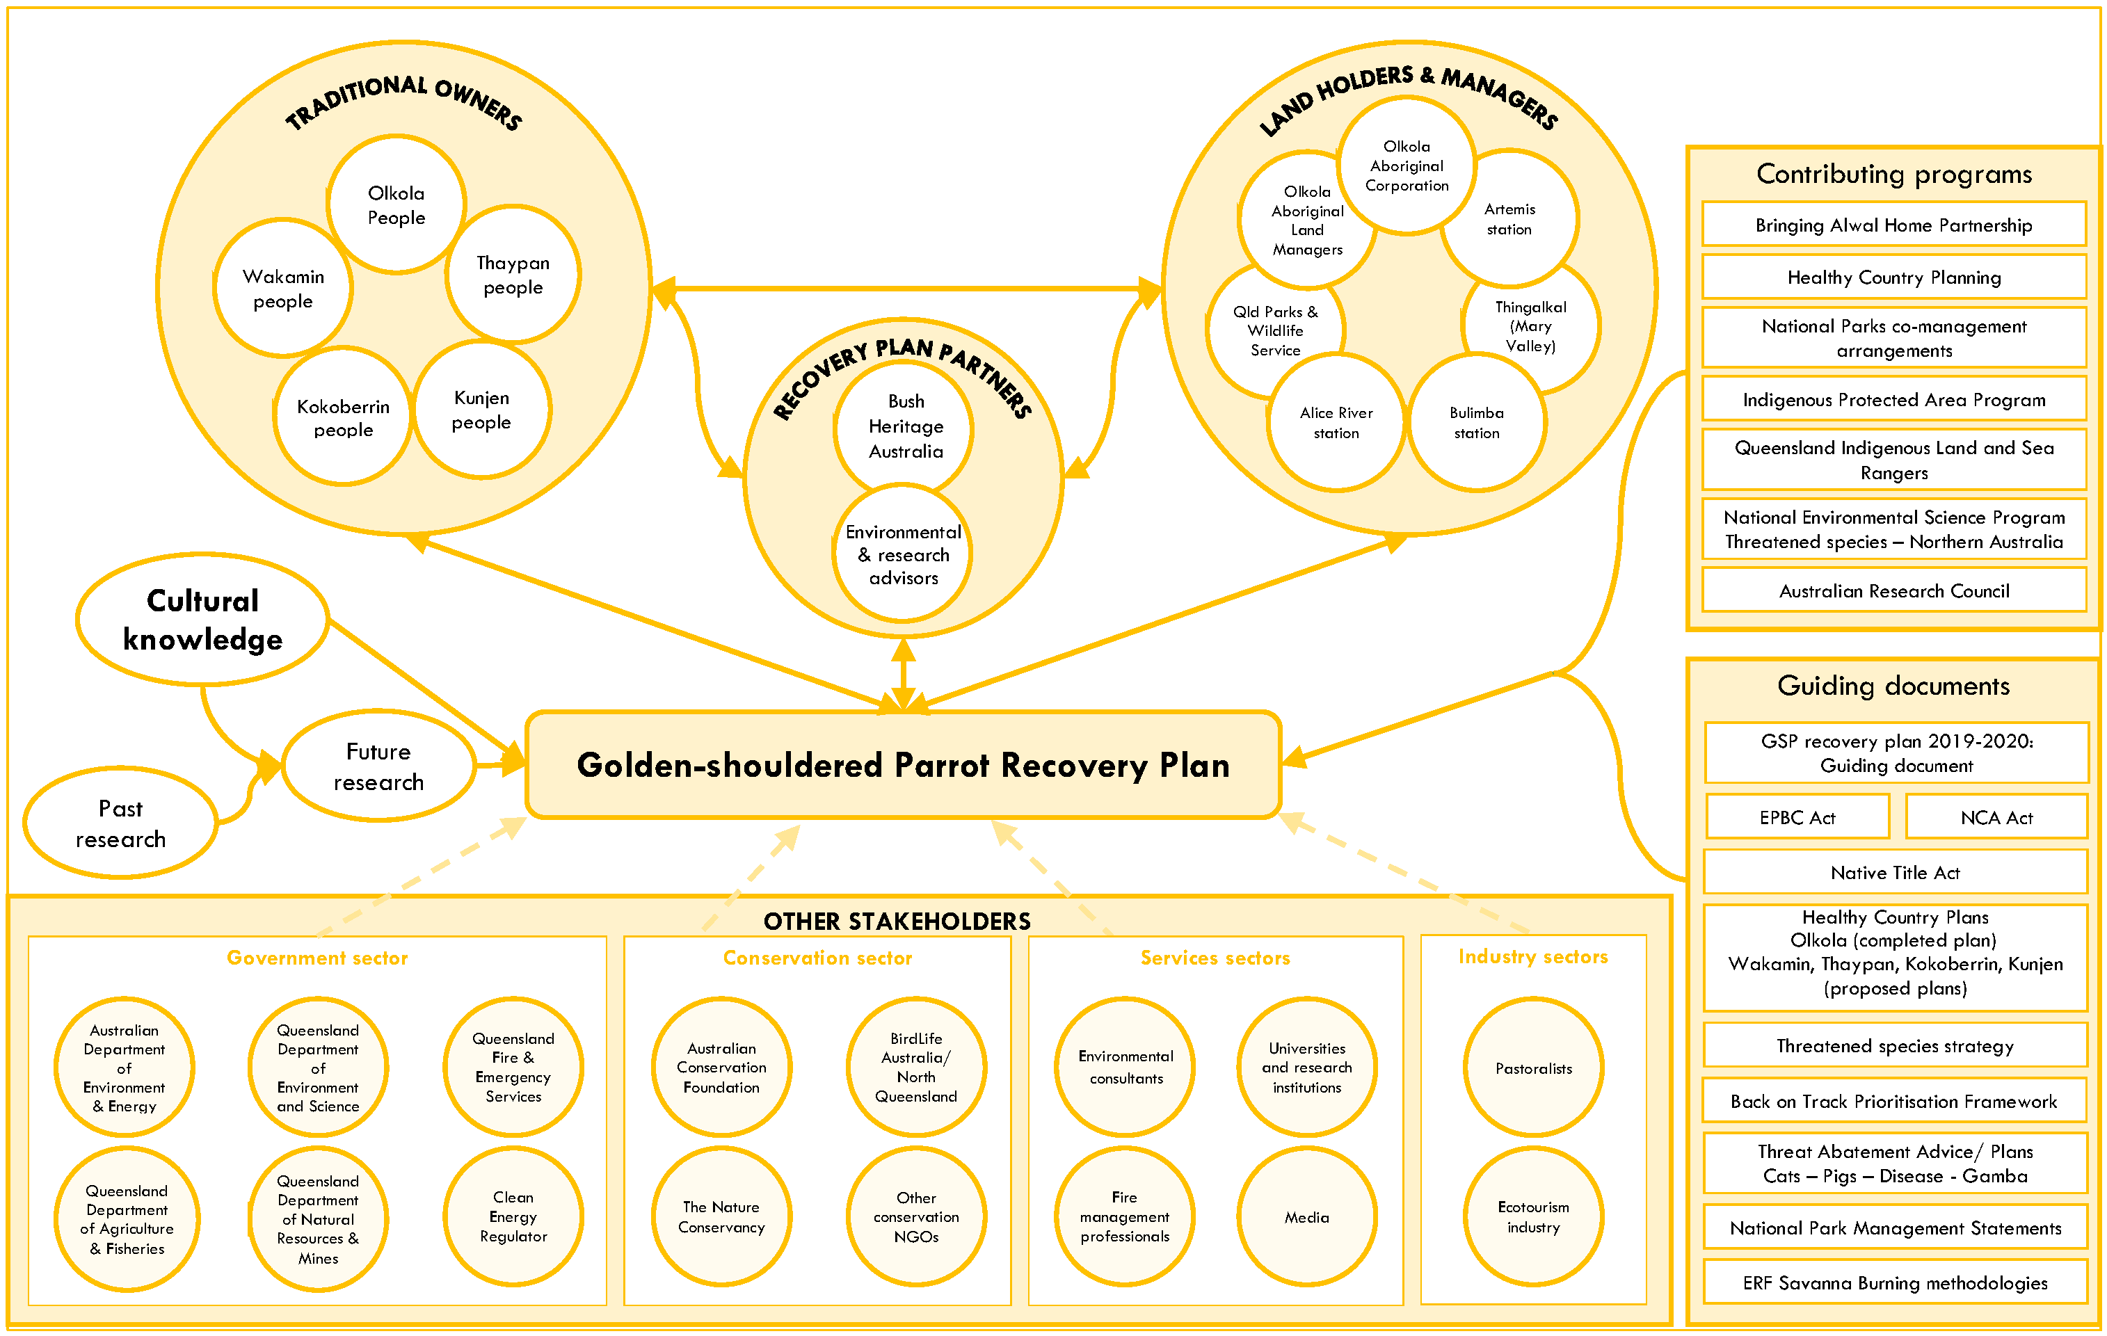

## Appendix C: Annual cost of recovery

An overview of the annual costs for golden-shouldered parrot recovery is provided in Table C1. Costing of each strategy is provided in Appendix D. Costs per year presented in Table C1 are the totals for multiple strategies and objectives and are based on detailed costings that can be provided to prospective funding bodies on request. All prices are GST exclusive.

Table C Annual cost of golden-shouldered parrot recovery

|  |  |
| --- | --- |
| Year | Cost ($) |
| Year 1 | 4,426,907 |
| Year 2 | 5,166,757 |
| Year 3 | 3,856,087 |
| Year 4 | 3,998,187 |
| Year 5 | 4,171,101 |
| Year 6 | 3,758,251 |
| Year 7 | 4,223,451 |
| Year 8 | 4,442,215 |
| Year 9 | 4,182,815 |
| Year 10 | 4,028,715 |
| **Total** | **42,254,486** |

## Appendix D: Cost of meeting recovery objectives

### ****Objective 1**** Return People to Country to make golden-shouldered parrot habitat strong again

Table D Strategies, actions and costs associated with Objective 1

| Strategy | Cost years 1 to 5 ($) | Cost years 6 to 10 ($) | Associated actions |
| --- | --- | --- | --- |
| **1.1 Support golden-shouldered parrot recovery through on-country programs, joint-management arrangements, ranger programs and Healthy Country Planning across the species’ distribution** | 15,949,051 | 18,364,947 | 1. Develop a two-way science and co-research engagement plan within the first year that prioritises Traditional Owner and local landholder direction and involvement, and review when the recovery plan is updated. This plan will provide a pathway to Indigenous-leadership of planning, management, research and monitoring for golden-shouldered parrot recovery (see Action 9.1c for elements of this plan). 2. Support Traditional Owners to have Healthy Country Plans in place for their traditional lands and support local landholders to have property management plans that will enable golden-shouldered parrot recovery. 3. Undertake on-country trips for knowledge exchange between Traditional Owner groups, QPWS and local landholders across the distribution of the golden-shouldered parrot. 4. Employ Traditional Owners and other local landholders through partnership arrangements; directly supporting Traditional Owner aspirations to be on country, have employment and to recover the species. 5. Provide professional development to Traditional Owners and local landholders to further develop local leadership of the recovery program. 6. Provide educational (undergraduate and postgraduate) opportunities for Traditional Owners to support Indigenous-led co-research and monitoring for golden-shouldered parrot recovery, as identified in Action 1.1a. |
| **1.2 Improve understanding of the multiple benefits of Indigenous people living and working on their traditional lands** | Costs included in Action 1.1 | Costs included in Action 1.1 | 1. Benchmark health and wellbeing co-benefits of Traditional Owner association with the golden-shouldered parrot recovery program through Healthy Country Planning. 2. Institute a Traditional Owner-led monitoring and evaluation process to measure and report on the health and wellbeing co-benefits of caring for golden-shouldered parrots. This can occur through Healthy Country Planning on a five yearly cycle or as determined by each Traditional Owner group. |
| **1.3 Build understanding of the cultural and biodiversity significance of golden-shouldered parrots and their habitat to raise the species’ profile and support for recovery efforts** | 58,300 | 38,500 | 1. Develop a communication and engagement strategy (see Action 9.1c) in the first year and update when plan is updated. 2. Gather and disseminate stories that provide cultural and scientific perspectives about the interconnectedness between golden-shouldered parrots, people and Country. 3. Incorporate information from actions 1.1 and 1.2 into Indigenous Protected Area, Key Biodiversity Area (KBA), National Park and National Park (Cape York Aboriginal Land) documentation and ensure KBA boundaries reflect the species’ distribution and management arrangements. 4. Incorporate appropriate cultural and scientific information about golden-shouldered parrots into promotional material for community engagement activities and wider communication |

Note: All costings are at 2019 rates and not adjusted for inflation. All prices are GST exclusive.

### ****Objective 2**** Understand and restore the role of dingoes in golden-shouldered parrot recovery

Table D Strategies, actions and costs associated with Objective 2

| Strategy | Cost years 1 to 5 ($) | Cost years 6 to 10 ($) | Associated actions |
| --- | --- | --- | --- |
| **2.1 Understand historical changes in dingo populations across golden-shouldered parrot distribution in relation to the parrot’s decline** | 22,000 | 0 | 1. Document historical changes in the dingo’s population and management across the golden-shouldered parrot’s present and former distribution in relation to the parrot’s decline. |
| **2.2 Understand the dingo’s relationship with other species significant to the life history of golden-shouldered parrots** | 187,000 | 374,000 | 1. Support targeted research to investigate the dingo’s role in regulating availability of foods that are key to golden-shouldered parrot survival through the wet season and identify options for restoring this role. 2. Support targeted research to investigate the dingo’s role in regulating predation of the golden-shouldered parrot and identify options for restoring this role. |
| **2.3 Maintain and restore the health of dingo populations in key areas of golden-shouldered parrot habitat in consultation with all stakeholders** | 192,500 | 110,000 | 1. Protect dingoes on Indigenous lands golden-shouldered parrot to support return of ecological function, meso-predator impacts and grazing pressure by macropods, and continue dingo protection on QPWS estate. 2. Assess the condition of dingo populations and current management regimes across the golden-shouldered parrot’s distribution. 3. In consultation with stakeholders, identify and implement options for restoring dingo populations on Indigenous lands across the golden-shouldered parrot’s distribution where this does not have adverse impacts on neighbouring pastoral enterprises. |

### ****Objective 3**** Restore and maintain golden-shouldered parrot nesting and early wet season habitat

Table D Strategies, actions and costs associated with Objective 3

| Strategy | Cost years 1 to 5 ($) | Cost years 6 to10 ($) | Associated actions |
| --- | --- | --- | --- |
| **3.1 Maintain and restore open vegetation structure of nesting and wet season feeding habitat** | 407,750 | 50,050 | 1. Trial innovative solutions to restore and maintain the open structure of nesting habitat. 2. Maintain and restore the open condition of nesting and wet season feeding habitat through adaptive fire management, with an emphasis on storm-burning across the species’ distribution. 3. Assess and report on effectiveness of fire management through: 4. establishing benchmarks for vegetation structure that minimises predation pressure on golden-shouldered parrots 5. monitoring fire regimes across the species’ distribution 6. monitoring the impact of fire regimes on vegetation structure and condition of golden-shouldered parrot nesting and wet season feeding habitat across the species' distribution 7. undertaking a landscape-scale assessment of current and historical changes in vegetation structure across the parrot’s distribution using remote sensing 8. monitoring impact of fire regimes on abundance and condition of important food grasses and termite mounds 9. monitoring presence of active Black-faced woodswallow nest sites (as part of Action 4.2a). 10. Develop and implement guidelines for managing fire for golden-shouldered parrot recovery within the broader context of carbon and biodiversity. |
| **3.2 Maintain and restore healthy antbeds for nesting** | 1,864,500 | 335,500 | 1. Protect areas with antbeds suitable for nesting (or where conical mounds are recruiting) from cattle and feral animals by: 2. Identifying priority current and potential nesting areas affected by cattle grazing and reduce grazing pressure through destocking and/or fencing (as required) 3. Reducing grazing pressure in current and priority nesting areas by managing populations of feral pigs, feral horses and feral cattle on QPWS reserves 4. Assessing and managing the impacts of cattle, horses and pigs on antbeds through the species’ distribution. 5. Assess abundance, condition and growth rate of antbeds in declining and stable sections of the golden-shouldered parrot’s distribution and the influence of vegetation cover, grass abundance, fire and grazing regimes; and establish benchmarks for healthy nesting habitat. 6. Assess termite communities and antbed health across the species’ distribution and investigate relationships with fire and grazing regimes. 7. Complete and publish previous studies of factors affecting antbed dynamics. 8. Develop and implement guidelines for maintaining and restoring antbed recruitment and health for golden-shouldered parrot recovery, and for monitoring management effectiveness. |

### Objective 4 Restore golden-shouldered parrot’s wet season food

Table D Strategies, actions and costs associated with Objective 4

| Strategy | Cost years 1 to 5 ($) | Cost years 6 to 10 ($) | Associated actions |
| --- | --- | --- | --- |
| **4.1 Maintain and restore open vegetation structure of nesting and wet season feeding habitat** | 463,100 | 25,850 | 1. Identify Key Wet Season Feeding Areas (KWSFAs) through the species’ distribution, and minimise the impact of cattle, feral pigs, and vegetation thickening, using fencing, shooting and storm-burning, as appropriate. 2. Assess condition of KWSFAs and efficacy of their management by measuring: 3. presence and abundance of golden-shouldered parrots, and duration of use 4. abundance and seed production of wet-season foods 5. presence of Black-faced woodswallows 6. presence and abundance of other granivores 7. vegetation structure 8. proximity to nest sites 9. use of nearby supplementary feeding stations (see Action 4.2d)   in relation to management interventions (notably fire and grazing) in order to establish relationship with golden-shouldered parrot recovery.   1. Complete and publish previous studies of food availability and feeding patterns through the year and provide rangers with skills in seed and plant identification (see 1.1e). 2. Investigate the cascading factors influencing abundance of wet season foods (particularly cockatoo grass), including the role of dingoes, cattle, pigs, kangaroos, wallabies and fire (as described in 2.2a). 3. Complete and publish previous studies of the impact of pigs and cattle grazing on cockatoo grass. 4. Develop and implement strategies and guidelines for managing total grazing pressure to promote golden-shouldered parrot recovery and for monitoring management effectiveness. |
| **4.2 Maintain the golden-shouldered parrot’s population at its retreating edge on Artemis, Dixie and Mary Valley through supplementary feeding** | 234,410 | 112,750 | 1. Develop and implement a strategy and guidelines for supplementary feeding within the first year that identifies clear thresholds for where and when feeding stations should be deployed through the wet season, based on: 2. local population trends (as indicated by golden-shouldered parrot nesting activity) 3. local food abundance 4. proximity to black-faced woodswallow nests 5. wet season rainfall, pattern of rainfall 6. access, and replenishing and monitoring arrangements 7. potential additional benefits (such as tracking parrot abundance and movements, and education and engagement) 8. potential for disease detection, transmission and treatment 9. permit requirements across different land tenures. 10. Continue to operate feeding stations to maintain golden-shouldered parrots at the retreating edge of the population at (Artemis and on key areas on Dixie) where black-faced woodswallows can be located. 11. Assess need for – and efficacy of – supplementary feeding through: 12. use of cameras and other technologies (that are approved under Action 9.1c) to monitor feeder use by golden-shouldered parrots 13. golden-shouldered parrot breeding activity close to feeders. |

### Objective 5 Reduce and reverse unsustainable predation of the golden-shouldered parrot

Table D Strategies, actions and costs associated with Objective 5

| Strategy | Cost years 1 to 5 ($) | Cost years 6 to 10 ($) | Associated actions |
| --- | --- | --- | --- |
| **5.1 Understand predation pressure on and survivorship of golden-shouldered parrots** | 520,300 | 553,300 | 1. Complete and publish previous studies of the impact of predators on golden-shouldered parrots. 2. Quantify population size and impact of predators on golden-shouldered parrots, focusing on goannas, butcherbirds and feral cats by measuring nesting outcomes in both stable and declining sections of the parrot’s distribution (and incorporate results into population viability analysis in Action 8.2b). 3. Track survival of nestlings and adult birds between breeding seasons (and incorporate results into population viability analysis in Action 8.2b). 4. Investigate the factors driving predation pressure, including the role of dingoes and fire in both stable and declining sections of the parrot’s distribution (as described in 2.2b). |
| **5.2 Understand the link between golden-shouldered parrots and black-faced woodswallows** | 214,000 | 11,000 | 1. Survey black-faced woodswallows through the golden-shouldered parrot’s distribution to establish location and habitat characteristics of nest sites and (where possible) historical population trends. 2. Study the dynamics and ecological requirements of mixed-species feeding flocks that include black-faced woodswallows to understand reasons for the woodswallow’s demise within the parrot’s historical range. |
| **5.3 Reduce predation pressure on golden-shouldered parrots** | 304,500 | 127,500 | 1. Trial methods to reduce predation of golden-shouldered parrots in the short- to medium-term through predator exclusion, deterrence and (in the case of feral cats) elimination at nest sites. 2. Trial methods to reduce predation of golden-shouldered parrots in the long-term through restoration of ecosystem function at the landscape-scale. 3. Assess effectiveness of predator management by monitoring: 4. adult survival between breeding seasons and at nests in both stable and declining sections of the golden-shouldered parrot’s distribution 5. nest success rates in both stable and declining sections of the golden-shouldered parrot’s distribution 6. locations of black-faced woodswallow nests 7. predator densities 8. Reduce feral cat numbers across the golden-shouldered parrot's distribution using appropriate methods. |

### Objective 6 Ensure mining, clearing and land use change do not threaten golden-shouldered parrot recovery

Table D Strategies, actions and costs associated with Objective 6

| Strategy | Cost years 1 to 5 ($) | Cost years 6 to 10 ($) | Associated actions |
| --- | --- | --- | --- |
| **6.1 Assess and avert the likely impacts of mining, clearing and land use change on golden-shouldered parrot recovery** | 21,000 | 42,000 | 1. Identify all existing and key areas of potential golden-shouldered parrot nesting habitat within the species’ current Extent of Occurrence and register as critical habitat under EPBC. 2. Ensure all golden-shouldered parrot critical habitat is protected from mining-related activities through prohibition of application for mining and geothermal tenements under the Mineral Resources Act 1989 and the Geothermal Energy Act 2010. 3. Liaise with government agencies to ensure that: 4. they are aware that any alteration of golden-shouldered parrot habitat (notably destruction of antbeds in nesting habitat and vegetation clearance or modification) is referrable under the EPBC Act 1999 5. significant impacts on golden-shouldered parrots are seriously considered in assessment of development, mining and mineral exploration applications. 6. When approval is granted for any land use change (including development, mineral exploration or mining) within golden-shouldered parrot critical habitat, work with proponents to ensure adoption of best management practice for golden-shouldered parrot recovery. |

### Objective 7 Address new and emerging threats to golden-shouldered parrots

Table D Strategies, actions and costs associated with Objective 7

| Strategy | Cost years 1 to 5 ($) | Cost years 6 to 10 ($) | Associated actions |
| --- | --- | --- | --- |
| **7.1 Manage the impact of adverse weather events and climate change** | 53,800 | 3,300 | 1. Establish at least one automated weather station on each property with occupied parrot nesting habitat and incorporate findings into 7.1c. 2. Design and implement a response strategy to widespread heavy rains at the start of the wet season or extensive flooding in the golden-shouldered parrot’s distribution that includes: 3. monitoring rainfall and flood patterns 4. where adverse conditions are indicated, undertaking a rapid survey of food resources 5. where food shortage is indicated in accessible areas, implementing a supplementary feeding regime, consistent with 4.2a. 6. Design and implement a strategy for identifying and responding to adverse impacts of climate change that is informed by: 7. knowledge of physiological tolerances of golden-shouldered parrots (and analogous species) in captivity 8. onsite collection of weather data, water availability through golden-shouldered parrot habitat, nest conditions and parrot behaviour 9. projected patterns of climate change. 10. Identify whether temperature stress during the breeding season is likely to become an issue by collecting nest temperatures as part of routine nest monitoring and incorporate findings into 7.1c. 11. Assess quality and availability of water in the late dry season and (where appropriate) provide alternative watering points and incorporate findings in 7.1c. |
| **7.2 Monitor and address emerging weed and pest animal threats** | 18,700 | 0 | 1. Design and implement a weed reporting and rapid response strategy that includes: 2. a risk assessment framework to identify weeds that pose a significant risk to golden-shouldered parrots 3. rangers and other land managers working across golden-shouldered parrot habitat identify significant weeds 4. training of rangers and other land managers in appropriate use of chemicals for weed control and other weed control measures 5. protocols for rapid weed response, including land access agreements (where required) 6. records of the location of all significant weed incursions and management efforts in order to facilitate follow-up control and assessment of management effectiveness 7. Assess the prevalence of pest animals (for example. European honeybee, feral cats) with potential to affect golden-shouldered parrots at dry season waterpoints, and mitigate where appropriate. |
| **7.3 Implement appropriate protocols needed to avert disease spread** | 22,000 | 11,000 | 1. Work with aviculturists to prevent mixing of wild and captive birds for disease prevention by prohibiting keeping golden-shouldered parrots in captivity within the current distribution and develop protocols for people moving between captive and wild populations. 2. Maintain awareness of developments of the Threat Abatement Plan for ‘*Psittacine Circoviral (beak and feather) Disease (PCD)* *affecting endangered species*’ and implement identified measures, as appropriate. 3. Design and implement protocols for ensuring any new health concerns within the wild or captive populations (including symptoms of PCD, any other disease or pathogen) are recorded and reported to the Recovery Team in a timely manner. |
| **7.4 Annually review other potential threats, and identify and implement appropriate mitigation options** | 13,750 | 13,750 | 1. Include new and emerging threats as a standing agenda item at all Recovery Team meetings. |

### Objective 8 Demonstrate improvement in the golden-shouldered parrot’s extent, population size and extinction risk

Table D Strategies, actions and costs associated with Objective 8

| Strategy | Cost years 1 to 5 ($) | Cost years 6 to 10 ($) | Associated actions |
| --- | --- | --- | --- |
| **8.1 Improve understanding of the golden-shouldered parrot’s extent and population size and their response to management regimes** | 518,100 | 192,500 | 1. Establish the outer limits to golden-shouldered parrot’s distribution, including through surveys in areas of potential habitat that have not previously been surveyed. 2. Track management regimes (fire, feral animal control and grazing pressure) across golden-shouldered parrot’s distribution to allow assessment of relationship with habitat quality and golden-shouldered parrot recovery (as outlined in Action 9.1c(iv)). 3. Monitor use of known golden-shouldered parrot nesting habitat on a five-year cycle. 4. Monitor bird movements through appropriate technologies approved under Action 1.1 and 9.1c(v) to determine dry season movements and relationships between populations. 5. Develop non-breeding season GSP monitoring protocols such as banding, waterhole counts, automated radio-telemetry tracking and any relevant standardised birdlife methodology. 6. Record and collate composition of golden-shouldered parrot flocks seen in course of other management actions. 7. Refine previous modelling of nesting habitat extent based on new information. 8. Estimate population size based on nest distribution and habitat modelling. 9. Survey suitable habitat based on recent habitat modelling across both the northern and southern sub-populations and between these areas. |
| **8.2 Improve understanding of the golden-shouldered parrot’s extinction risk** | 225,500 | 27,500 | 1. Assess the trajectory of the golden-shouldered parrot population based on decadal changes in use of nesting habitat 2. Use population data and nest success data to estimate the golden-shouldered parrot’s extinction risk (for example. using population viability analysis) at the population and property scale. 3. Undertake genetic analysis to: 4. Assess the genetic viability of the population and the influence of genetic bottlenecks, isolation and movements between separate parts of the species’ distribution. 5. Estimate the species’ effective population size. 6. Determine whether fragmentation is leading to the development of separate sub-populations, and – if so – the estimated effective size of sub-populations. 7. Whether the global captive population is of sufficient genetic diversity to make taking further birds from the wild for an insurance population unnecessary. 8. Assess the prevalence of beak and feather disease, and other diseases and genetic abnormalities that could affect survival and reproductive success. 9. Use extinction risk information to prioritise recovery efforts at the population and property scale. 10. Develop an emergency response strategy to put in place should the species suffer a catastrophic decline, which would: 11. Summarise potential catastrophic threats to the species, and prevention/mitigation options. 12. Identify the issues and risks associated with captive breeding and reintroduction. 13. Document the genetic diversity of the wild and captive populations (see 8.2c). 14. Delineate the role of captive-breeding and reintroduction in GSP emergency recovery. 15. Develop protocols, triggers, and criteria for implementing a captive-breeding and/or reintroduction program. 16. Reassess golden-shouldered parrot’s conservation status every five years. |
| **8.3 Ensure information used for mapping golden-shouldered parrot distribution and assessing impacts on the species is based on the best available evidence** | 11,000 | 5,500 | 1. Produce nest survey protocols, including for methods for confirming that a nest was made by a golden-shouldered parrot, the likely year of construction and the likely outcome, and inclusion of experienced Traditional Owner or landholder in the survey team. 2. Produce protocols for collecting and verifying golden-shouldered parrot sightings, including information on how the species’ identify was determined, and the locational information recorded. 3. Ensure materials (for example maps and survey guidelines) aimed at guiding development assessments are consistent with recovery plan outputs. 4. Institute data-management arrangements to ensure only verified golden-shouldered parrot records enter public databases and the recovery team is informed of any new nest or sighting records in a timely manner 5. Ensure verified data are available for decision makers to ensure legislation and mapping, with Recovery Team approval. |

### Objective 9 Manage the recovery program using culturally appropriate and scientifically robust principles

Table D Strategies, actions and costs associated with Objective 9

| Strategy | Cost years 1 to 5 ($) | Cost years 6 to 10 ($) | Associated actions |
| --- | --- | --- | --- |
| **9.1 Manage the recovery program through the Recovery Team, with appropriate review and revision** | 321,200 | 236,500 | 1. Operate the Recovery Team according to the Terms of Reference, including holding at least two Recovery Team meetings a year, annual review and reporting of recovery actions, and five-yearly reviews of recovery program. 2. Familiarise Traditional Owners with western scientific methods used in other recovery programs through an international/national exchange program to ensure informed contribution to co-research framework. 3. Within the co-research framework developed in Action 1.1a, design and implement culturally appropriate and scientifically robust protocols and procedures for recovery plan operation (and update as appropriate), including: 4. Protocols for engaging with the Recovery Team and Traditional Owner groups (completed and presented in Appendix 1 of the Recovery Plan). 5. A communication and engagement strategy. 6. A two-way science plan that identifies information needs and appropriate research methods and technologies for:  * filling knowledge gaps affecting golden-shouldered parrot recovery. * demonstrating management effectiveness. * demonstrating species population trends.   and identifies research priorities and how to address them within an Indigenous-led science framework.   1. A performance monitoring plan that assesses performance criteria by compiling information about:  * Size and resourcing of the on-Country workforce. * Healthy Country Plan wellbeing measures. * Health of Dingo populations. * Extent and condition of occupied golden-shouldered parrot nesting habitat in each population. * Number and condition of identified KWSFAs in each population. * Number of occupied nests close to restored wet season feeding habitat and/or supplementary feeding stations. * Knowledge population size and impacts of key predators in each population. * Knowledge of state and decadal trend for each population in (1) extent of occupied nesting habitat; (2) adult population; (3) extinction risk. * Knowledge of and response to new and emerging threats.  1. Protocols for collection, transfer and analysis of crop, tissue, feather or any genetic materials that may be collected under permits for scientific research purposes. 2. Data and information sharing arrangements that enable managers across the golden-shouldered parrot’s distribution to learn from each other and support each other in recovery actions. 3. Ensure all Recovery Team members and partners are aware of, and adhere to, all Recovery Team protocols and procedures developed under Actions 1.1 and 9.1c. 4. Liaise with government agencies and permitting staff to ensure all work on golden-shouldered parrots research and management is consistent with the Recovery Plan and is approved by the Recovery Team. 5. Submit the recovery plan to external five-yearly reviews to inform its revision. |

## Appendix E: Names and terms

Table E Indigenous, English and scientific names for species and concepts

| Indigenous name  (and language group) | English name | Scientific name |
| --- | --- | --- |
| Alwal (Olkola), Thaku (Lama Lama), Arrmorral (Thaypan), Minpin (Wakamin) | Golden-shouldered parrot | *Psephotus chrysopterygius, Psephotellus chrysopterygius* |
| Arrgi | Land | *Not applicable* |
| Ingin | Story | *Not applicable* |
| Ootalkarra (Olkola), Ut Alkar, Ug | Dingo | *Canis familiaris dingo, Canis dingo, Canis lupis dingo* |
| Not recorded | Agile wallaby | *Macropus agilis* |
| Not recorded | Antbed parrot moth | *Trisyntopa scatophaga* |
| Not recorded | Black-faced woodswallows | *Artamus cinereus* |
| Not recorded | Broad-leaved ti-tree | *Melaleuca viridiflora* |
| Not recorded | Buff-breasted buttonquail | *Turnix olivii* |
| Not recorded | Butcherbird | *Cracticus mentalis (black-backed butcherbird) or Cracticus nigrogularis (pied butcherbird),* |
| Not recorded | Cane toad | *Rhinella marina or Bufo marinus* |
| Not recorded | Cockatoo grass | *Alloteropsis semialata* |
| Not recorded | Eastern grey kangaroo | *Macropus giganteus* |
| Not recorded | European honeybee | *Apis mellifera* |
| Not recorded | Fire grass | *Schizachyrium fragile of S. pachyarthron* |
| Not recorded | Goanna (large) | *Varanus panoptes (yellow-spotted monitor) or V. gouldii (Gould’s goanna)* |
| Not recorded | Goanna (small) | *Varanus tristis (black-headed monitor) or V. scalaris (spotted tree monitor)* |
| Not recorded | Hooded parrot | *Psephotus dissimilis* |
| Not recorded | Mulga parrot | *Psephotus varius* |
| Not recorded | Paradise parrot | *Psephotus dissimilis* |
| Not recorded | Termites (bulbous antbeds) | *Nasutitermes triodeae* |
| Not recorded | Termites (conical antbeds) | *Amitermes scopulus* |
| Not recorded | Termites (magnetic antbeds) | *Amitermes laurensis* |

Note: Not recorded means Indigenous name not recorded in this document.

## Appendix F: Glossary

| Term | Definition |
| --- | --- |
| BHA | Bush Heritage Australia |
| CITES | Convention on International Trade in Endangered Species of Wild Fauna and Flora |
| CYPAL | Cape York Peninsula Aboriginal Land |
| EPBC Act 1999 | Environment Protection and Biodiversity Act 1999 |
| IPA | Indigenous Protected Area |
| IUCN | International Union for Conservation of Nature |
| KBA | Key Biodiversity Area |
| NP | National Park |
| QPWS | Queensland Parks and Wildlife Service |