

Environment Protection and Biodiversity Conservation Act 1999 Draft Referral guidelines for the nationally listed Brigalow Belt reptiles

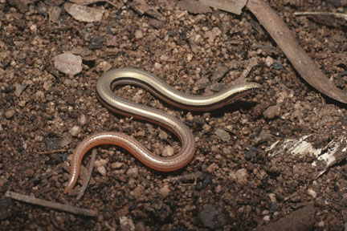

© Commonwealth of Australia 2011
This work is copyright. You may download, display, print and reproduce this material in unaltered form only (retaining this notice) for your personal, non-commercial use or use within your organisation. Apart from any use as permitted under the Copyright Act 1968, all other rights are reserved. Requests and inquiries concerning reproduction and rights should be addressed to Commonwealth Copyright Administration, Attorney General’s Department, Robert Garran Offices, National Circuit, Barton ACT 2600 or posted at www.ag.gov.au/cca.

Disclaimer
The contents of this document have been compiled using a range of source materials and is valid as at 23 May 2011. The Australian Government is not liable for any loss or damage that may be occasioned directly or indirectly through the use of reliance on the contents of the document.

Front page photograph: Mount Cooper striped lerista. Photo by Steve Wilson.
Important notice
Please note that these guidelines are general in nature and do not affect your obligation to consider whether you need to make a referral to the federal environment minister under the Environment Protection and Biodiversity Conservation Act 1999 (EPBC Act). While these guidelines provide information to help you decide whether to refer your action, the possible impact of your proposal will depend on the particular circumstances of the action. These circumstances may include issues such as the precise location, mitigation measures, indirect impacts and the like.

This guideline was made on the basis of the best information available at the time of writing. However, the impacts of proposals will be assessed by the department on the basis of the best information available at that point in time, which may differ from the information on which this guideline is based.

These guidelines do not provide guidance on requirements under state and local government laws. Information on Queensland, New South Wales and local government council laws can be obtained from the respective state government agencies: the Queensland Department of Environment and Resource Management (QLD DERM), the New South Wales Department of Environment, Climate Change and Water, and the local councils in or near the proposed project area.

How to use these guidelines

These guidelines are intended to assist you in determining whether your action needs to be referred to the Australian Government Department of the Environment (the Department). These guidelines should be read in conjunction with the EPBC Act Policy Statement 1.1 Significant Impact Guidelines - Matters of National Environmental Significance, available on the department’s website at http://www.environment.gov.au/epbc/publications/nes-guidelines.html.

These guidelines apply to the nine nationally listed reptile species of the Brigalow Belt (see Section 1, page 6), hereafter referred to as the listed Brigalow Belt reptiles, anywhere they may occur in Australia. Listed threatened species and ecological communities are matters of national environmental significance under the EPBC Act.
If you plan to undertake an action that has, will have or is likely to have a significant impact on any of the listed Brigalow Belt reptiles you must refer the proposal to the Minister before commencing. The Minister will then decide, within 20 business days, whether assessment and approval is required under the EPBC Act. The potential significance of each action is judged on a case-by-case basis. Substantial penalties apply for taking an action, to which the EPBC Act applies, without approval (civil penalties up to $5.5 million or criminal penalties including up to seven years imprisonment). More information on referral, assessment and compliance is available at www.environment.gov.au/epbc/.

The decision tree in Figure 1 and the rest of these guidelines are designed to assist you in determining whether your proposed action needs to be referred. You may also refer your proposed action if you are unsure of the need to refer, or if you think the proposal would not have significant impacts on matters of national environmental significance, but would like legal certainty.

Possible exceptions to the need to refer
Certain actions are exempt from the requirement of assessment and approval under the EPBC Act. These include lawful continuations of land use that started before 16 July 2000, or actions that were legally authorised before 16 July 2000. There are a number of criteria that must be satisfied to rely on any such exemptions. More information on exemptions under the EPBC Act is available at www.environment.gov.au/epbc/publications/exemptions.html.

Figure 1 Decision making

YES
NO

NO

YES or UNSURE

Have you surveyed for listed Brigalow Belt reptiles and their habitats using the recommended methods (see Section 4)?

Could the impacts of your action occur within the modelled distributions of the listed Brigalow Belt reptiles (see Section 2)?
Assume that your action may impact on important habitats for one or more listed Brigalow Belt reptiles (see Section 5) or on the species as a whole (see Section 6).
YES or UNSURE

REFERRAL MAY NOT BE REQUIRED*
Low risk of significant impact

Could your action impact on important habitats for one or more listed Brigalow Belt reptiles (see Section5) or on any of these species as a whole (see Section 6)?

YES or UNSURE
Could the impacts of your action affect suitable habitats for listed Brigalow Belt reptiles (see Section 3) or individuals of these species?

NO

High risk that your action will result in a significant impact on one or more listed Brigalow Belt reptiles (see Section 8) **
Uncertainty that your action will result in a significant impact on one or more listed Brigalow Belt reptiles (see Section 8)***

Low risk that your action will result in a significant impact on one or more listed Brigalow Belt reptiles (see Section 8)**

REFERRAL MAY NOT BE REQUIRED*
Low risk of significant impact

YES

Could your action require a referral to the federal environment minister
for a significant impact on one or more listed Brigalow Belt reptiles (see Section 8)?
REFERRAL MAY NOT BE REQUIRED*
Low risk of significant impact

NO

NO
or UNSURE
REFERRAL RECOMMENDED
High risk of significant impact

Is your impact mitigation best practice so that it may reduce the significance of your impacts on listed Brigalow Belt reptiles (see Section 7)?

REFERRAL RECOMMENDED

REFERRAL RECOMMENDED
OR CONTACT THE DEPARTMENT
REFERRAL MAY NOT BE REQUIRED*

* Although it would appear a referral may not be required, you may still refer your proposed action if you are unsure of the need to refer your action, or if you think the proposal would not have significant impacts on matters of national environmental significance, but would like legal certainty. An example may be when other matters of national environmental significance, in addition to the listed Brigalow Belt reptiles, are potentially affected.
** Risk is the chance of something happening that will have a [significant] impact on objectives [eg protecting matters of national environmental significance] (adapted from Australian / New Zealand Risk Management Standard 4360: 2004).

***If you are uncertain about the need to refer then you may also contact the Department to discuss your action by emailing epbc.referrals@environment.gov.au

1. What is known about the listed Brigalow Belt reptiles?
The listed Brigalow Belt reptiles (see Table 1) are distributed to varying extents across the Brigalow Belt and surrounding bioregions (under the Interim Biogeographic Regionalisation of Australia: see Glossary of terms). This is a vast and biodiverse region extending mostly on the western side of the Great Dividing Range from Cape York south through Central Queensland to Dubbo, New South Wales (refer to Map 1). Broad-scale clearing and alteration of vegetation in these bioregions, particularly on fertile alluvial plains, has lead to considerable loss of habitat for these species.

Table 1 The listed Brigalow Belt reptiles
Reptile family | Common name | Scientific name | EPBC Act Listing
Skinks (Scincidae) | Five-clawed worm-skink | Anomalopus mackayi | Vulnerable
Skinks (Scincidae) | Yakka skink | Egernia rugosa | Vulnerable
Skinks (Scincidae) | Retro slider (Allan’s lerista) | Lerista allanae | Endangered
Skinks (Scincidae) | Mount Cooper striped lerista | Lerista vittata | Vulnerable
Legless lizards (Pygopodidae) | Striped-tailed delma | Delma labialis | Vulnerable
Legless lizards (Pygopodidae) | Collared delma | Delma torquata | Vulnerable
Legless lizards (Pygopodidae) | Brigalow scaly-foot | Paradelma orientalis | Vulnerable
Venomous snakes (Elapidae) | Ornamental snake | Denisonia maculata | Vulnerable
Venomous snakes (Elapidae) | Dunmall’s snake | Furina dunmalli | Vulnerable

As shown in Table 1, the listed Brigalow Belt reptiles consist of four skink species, three legless lizards, and two venomous snake species. Under the EPBC Act, eight of these species are listed as vulnerable and one species is listed as endangered.

Whilst these reptiles are known collectively to occupy a wide variety of vegetation types on a range of soils and substrates, they have fairly similar habitat requirements for shelter and foraging. During the heat of the day, most of the listed Brigalow Belt reptiles tend to shelter under coarse woody debris, leaf litter, rocks or artificial materials on or embedded in the topsoil. Some species may utilise cracks that form in alluvial clay soils during extended dry periods. Given their need to utilise shelter habitats to survive typically hot, dry conditions, the listed Brigalow Belt reptiles tend to be difficult to detect.

More detailed information on each of the listed Brigalow Belt reptiles is provided in the department’s Species Profile and Threats (SPRAT) Database, which is accessible on the department’s website at www.environment.gov.au/cgi-bin/sprat/public/sprat.pl.

2. Could the impacts of your action occur within the modelled distributions of the listed Brigalow Belt reptiles?
The modelled distribution of the listed Brigalow Belt reptiles is centred on the Brigalow Belt and extends into the surrounding bioregions (see Map 1). For the purposes of these guidelines, the boundary of the Brigalow Belt is defined as the combined boundaries of the Brigalow Belt North and Brigalow Belt South bioregions.

The distributions of these species are indicated in Map 1, and individually in Maps 2 to 10 in Appendix 1. These distributions are defined as the broad environmental envelopes encompassing areas where the species’ habitats may occur. A more detailed explanation of the method used to model these distributions is provided in Appendix 2.

Please note that the maps presented in these guidelines are based on available information at the time of publication and remain static products. For the most up-to-date report on an area, always use the Protected Matters Search Tool available on the department’s website at www.environment.gov.au/epbc/pmst/index.html.
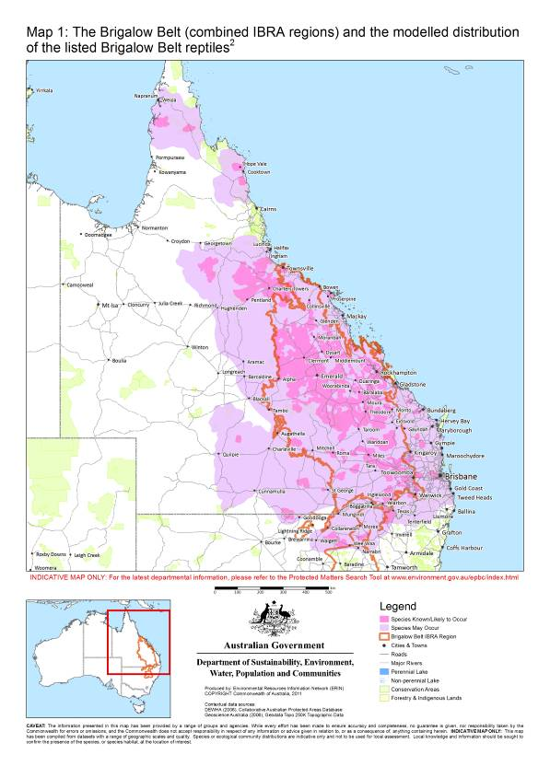

3. Could the impacts of your action affect suitable habitats for listed Brigalow Belt reptiles?
Suitable habitats for the listed Brigalow Belt reptiles occur in a wide variety of remnant and non-remnant vegetation: predominantly eucalypt or acacia-dominated forests to woodlands and grassland communities. These species are typically found sheltering in microhabitats where moisture is retained at or just below the soil surface. Microhabitats include, but are not limited to:
- loose, friable topsoils,
- cracks in alluvial clay soils,
- live or decaying plant material, such as tussock bases, rotting logs or tree bases, and
- debris situated at the soil surface, such as coarse woody debris, leaf litter, rocks or artificial debris.
Table 2 lists the suitable habitats of the listed Brigalow Belt reptiles. Detailed descriptions of suitable habitat and key microhabitat requirements of these species are provided in the department’s SPRAT database.

Table 2 Suitable habitats of the listed Brigalow Belt reptiles
Species | Suitable habitat
Five-clawed worm-skink | Grasslands and woodlands on alluvial, cracking clay soils or self-mulching, friable basalt soils in New South Wales and in Queensland Regional Ecosystems (QLD REs) 11.3.21, 11.3.25, 11.8.5, 11.8.15, 13.3.3, 13.3.4 and associated non-remnants
Yakka skink | Open-forests to low-woodlands and scrub in QLD RE Land Zones (LZ) 3, 4, 5, 7, 8, 9, 10 and 12 (LZ 8 not considered core habitat; LZ 12 in Wet Tropics bioregion only). Colonies have been found in large hollow logs, cavities or burrows under large fallen trees, tree stumps, logs, stick-raked piles, large rocks and rock piles, dense ground-covering vegetation, and deeply eroded gullies, tunnels and sinkholes
Retro slider | Vegetation occurring on mid to dark-brown-coloured, non-cracking clay soils in QLD REs 11.8.5 and 11.8.11/11.8.5 and grassy open-woodland mapped as cleared but where the above REs formerly occurred
Mount Cooper striped lerista | Low closed-forests and woodlands corresponding to QLD REs 2.5.10, 2.10.3, 9.12.1a, 9.12.14, 9.12.36a, 11.5.9, 11.5.15 and associated non-remnants
Striped-tailed delma | Forests to open-woodlands and adjacent exposed rocky slopes to 800 metres above sea level in QLD RE Land Zones 2, 3 and 12
Collared delma | Open-forests, woodlands and adjacent exposed rocky areas in QLD RE Land Zones 3, 9 and 10
Brigalow scaly-foot | Open-forests to woodlands in QLD RE Land Zones 3, 4, 5, 7, 8 (near the periphery of LZ 10), 9 and 10
Ornamental snake | Open-forests to woodlands associated with gilgai formations and wetlands. These are commonly mapped as QLD REs 11.3.3, 11.4.3, 11.4.6, 11.4.8, 11.4.9, 11.5.16 or mapped as cleared but where the above REs formerly occurred
Dunmall’s snake | Forests to woodlands within the range of the species (see Figure 11 in Appendix 1).

4. Have you surveyed for listed Brigalow Belt reptiles and their habitats using the recommended methods?
Where suitable habitat for listed Brigalow Belt reptiles may be affected by your proposed action, surveys are recommended to determine whether one or more species is present and/or whether your proposal is likely to affect important habitats for these species (see Section 5). A general guide to conducting surveys for the listed Brigalow Belt reptiles and their important habitats is outlined below. Surveys should:
- be conducted by suitably qualified zoologists/ecologists with demonstrated skill in reptile surveys
- maximise the chance of detecting the species and/or important habitat
- account for uncertainty and error, and
- be conducted in accordance with the Department’s Survey guidelines for Australia’s threatened reptiles (available at www.environment.gov.au/epbc/guidelines-policies.html).

Surveys for listed Brigalow Belt reptiles should include a preliminary assessment and targeted survey.

Preliminary assessment
A preliminary assessment is recommended to inform your decision to undertake a targeted survey to determine whether your proposed action is likely to affect important habitats for the listed Brigalow Belt reptiles. Habitat information gathered during the assessment should be included in a referral for your proposed action if you determine that it is necessary to refer the action.

A preliminary assessment should consider the following:
- The proximity of the nearest records of each of the listed Brigalow Belt reptiles to the proposed action.
Databases to search are:
  - National - the Protected Matters Search Tool
  - Queensland - Zoology Data Search (Queensland Museum)
- Wildlife Online (QLD DERM)
- Australian Museum records
  - NSW - Atlas of NSW Wildlife (NSW National Parks and Wildlife Service)
- Australian Museum records
- What vegetation types characterize the local region in which you propose to take an action?
  - Obtain state vegetation mapping centred on your proposed action to determine how much suitable habitat (see Table 2) exists in the local area and what vegetation communities need to be targeted for survey.
  - How might one or more listed Brigalow Belt reptiles use the habitats in the region, i.e., for foraging, breeding or dispersal (see the relevant species profiles in the department’s SPRAT database)?
- A habitat assessment of each vegetation type in your study area needs to be carried out to determine its suitability as reptile habitat. The suitability may vary with natural variation in microhabitat features (e.g. distribution and number of shelter sites) within a state-mapped vegetation type (e.g. QLD REs). It is recommended that you characterise the quality of the habitat, locate suitable microhabitat features and design a survey effort to optimize the sampling of these features across the landscape.

Targeted surveys
If suitable habitat for any one of the listed Brigalow Belt reptiles is likely to be affected by your proposed action, targeted surveys should be undertaken to determine if it could be important habitat (see Section 5).
Surveys should be undertaken during conditions optimal for detecting the targeted reptile species. As general rule surveys should only be undertaken from late September through to late March when weather conditions are warm, not too dry and maximum temperatures are greater than 25°C on most survey days. Optimal survey times vary between species, but generally are early morning (within 4 hours of sunrise) and late afternoon to early evening for diurnal species, and into late warm nights for nocturnal species.
All of the listed Brigalow Belt reptiles are difficult to detect and, therefore, are likely to require more than one applicable survey technique to ascertain whether they are present or absent in areas likely to be affected by your proposed action.
The level of survey effort required will depend on the species targeted, the area and type of environment to be surveyed, and the survey techniques used. Under optimal conditions for reptile activity, enough time needs to be spent physically searching microhabitat in each habitat type.

As a general rule:
- the time required to adequately search habitat increases with microhabitat complexity.
- if the targeted species is not detected using all of the recommended survey techniques, at least one replicate survey should be conducted.

Note that there may be additional approval requirements before conducting surveys. Permits for native fauna surveys must be sought from relevant state government agencies. Additionally, activities in commonwealth areas may require permits under Part 13 of the EPBC Act. Ethical considerations are also important when searching for reptiles.

Important ethical considerations include:
    - taking care to minimize damage to microhabitat whilst conducting surveys (e.g. return rocks, logs and ground litter to original position with care; do not peel all bark that is potentially suitable microhabitat for the species)
    - using state government-approved techniques to ensure that trapped animals, including by-catch, do not suffer injury or death, whilst caught in traps (e.g. Elliott-style, cage, pit or funnel traps), from the effects of high temperatures, dehydration or predation
  - if such measures cannot be taken, traps must be closed immediately after being checked in the early morning (i.e., after optimal foraging hours for a targeted species) to prevent the trapping of animals during the heat of the day
    - taking measures to ensure that invasive weeds and other pathogens are not introduced to the study area.
Survey techniques and minimum survey efforts required to detect listed Brigalow Belt reptiles are recommended in Table 3.
Table 3 Targeted survey effort and techniques required to detect listed Brigalow Belt reptiles
Technique | Effort and other considerations | Suitability
One-off diurnal searches | - Searching microhabitats, such as carefully turning woody debris, rocks and artificial debris, raking the soil surface or leaf litter beneath trees and looking beneath peeling bark for reptiles or their sloughs  - Optimal survey time is during the coolest parts of the day  - Survey over a minimum of 1.5 person hours per hectare for habitats of average complexity per targeted species  - Survey over a minimum of 3 days | - All Brigalow Belt reptiles  - Not suitable for surveying the five-clawed worm-skink on floodplains where the species may shelter deep within clay soil cracks  - Potential yakka skink colony sites can be watched using a telescope or binoculars at 30 m distance
Transects | - Transects (number and size of area sampled) should be strategically designed / positioned in large habitat patches (>10 ha) to adequately sample representative microhabitats in each habitat type | Dunmall’s snake, brigalow scaly-foot and yakka skink
Spotlighting | - Targeting water-inundated gilgais, wetlands, riparian habitats and the surrounding environment (e.g., roads) and large logs between dusk and early morning hours  - More effective on warm, humid evenings  - Survey over a minimum of 1.5 person hours per hectare for habitats of average complexity per targeted species  - Survey over a minimum of 3 nights | Dunmall’s snake, ornamental snake, brigalow scaly-foot and yakka skink
Opportunistic surveys of roads | - Actively look for reptiles whilst driving along roadways in your study area  - Especially following heavy rainfall events and during warm evenings for snakes | Dunmall’s snake and ornamental snake
Pitfall and funnel trapping | - Six 20 litre (500 mm deep) buckets evenly distributed under a 30 m drift fence where optimal microhabitats occur  - Place a funnel at each end of a pitfall line  - At least 2 replicates per habitat type  - Check every morning and early evening (after the optimal foraging periods) over four days | Mount Cooper Striped Lerista, Retro slider, striped-tailed delma, brigalow scaly-foot, Dunmall’s snake and ornamental snake (not in wet habitats)
Elliott and cage trapping | - Target colony sites through diurnal surveys of suitable habitat  - One large Elliott-style trap (15.5 cm x 15 cm x 46 cm) and one cage trap placed as close as possible to burrow entrances  - Check every morning and early evening (after the optimal foraging periods) over four days | Yakka skink
Artificial shelter sites  - Hay bale plots  - Tile grids | - Placed at least 3 months before survey period  - Check once per week over a minimum of a month’s survey period | - Hay bale plots suitable for the five-clawed worm-skink  - Tile grids should be trialled as a supplementary technique in surveying for the Retro slider, Mount Cooper striped lerista and collared delma
Artificial shelter sites  - Hay bale plots  - Tile grids | - Hay bales and other decomposable materials in strategically placed, 4 m x 4 m fenced plots  - Materials sufficiently layered to retain soil surface moisture over a month without additional watering or further rainfall  - Materials are only effective when heavy rainfall wets the plot sufficiently to start their decomposition underneath
Artificial shelter sites  - Hay bale plots  - Tile grids | - Grids of 50 tiles placed at 5 m intervals in suitable habitat  - Minimum two grids should be used for sites less than two hectare in size, one grid per two hectares for sites up to 40 ha, and 20 grids for sites greater than 40 ha

5. Are important habitats for one or more listed Brigalow Belt reptiles present in your study area?
When assessing whether an action is likely to have a significant impact on a species listed as vulnerable under the EPBC Act, the department considers nine significant impact criteria (see page 11 of EPBC Act Policy Statement 1.1 Significant Impact Guidelines – Matters of National Environmental Significance). Four of these criteria relate to impacts on important populations of the listed vulnerable species.
However, given that the listed Brigalow Belt reptiles are difficult to detect and population information is limited, the department regards important habitat as a surrogate for important populations in the assessment of whether an action is likely to have a significant impact on one or more of these species.
Suitable habitat for any one of the listed Brigalow Belt reptiles is considered important if it is:
- habitat where the species has been identified during a survey,;
- near the limit of the species’ known range;
- large patches of contiguous, suitable habitat and viable landscape corridors (necessary for the purposes of breeding, dispersal or maintaining the genetic diversity of the species over successive generations); or
- a habitat type where the species is identified during a survey, but which was previously thought not to support the species.

Table 4 provides general information on the sorts of environments in which important habitats for the listed Brigalow Belt reptiles are known to occur. The information contained in Table 4 is not exhaustive. In order to determine whether important habitat for any given Brigalow Belt reptile is present in your study area, the above-listed criteria should be applied in all situations.

Table 4 Known important habitats of the listed Brigalow Belt reptiles
Species | Known important habitat | Comments
Five-clawed worm-skink | - All suitable habitat within floodplains and riparian zones, uncultivated grassy headlands and strips between cropped areas, road reserves, travelling stock routes and remnant vegetation on vacant lands  - Suitable habitat within the Known / Likely-to-occur distribution of the species (see Map 3 in Appendix 1) | - Habitat connectivity is essential
Yakka skink | - Any contiguous patch of suitable habitat, particularly remnant vegetation, where a colony is known or identified  - Any microhabitat where colonies are likely to be found | - Given the yakka skink’s longevity (up to 20 years), low fecundity (2-5 years to sexual maturity), high site-fidelity, and that populations are highly fragmented, this species may be prone to localised extinctions
Retro slider | - All suitable habitat (see page 8) | - Habitat connectivity on freehold land and along road reserves may be essential
Mount Cooper striped lerista | - Suitable habitat within the Known / Likely-to-occur distribution of the species (see Map 6 in Appendix 1) | - Habitat connectivity on freehold land, and along road reserves may be essential
Striped-tailed delma | - Suitable habitat within the Known / Likely-to-occur distribution of the species (see Map 7 in Appendix 1) and in QLD RE Land Zone 12 | - Important habitat is under increasing pressure from agricultural and urban development
Collared delma | - Suitable habitat within the Known / Likely-to-occur distribution of the species (see Map 8 in Appendix 1) and the Toowoomba Range  - Suitable habitat between grazed or cropped areas, along road reserves, and travelling stock routes, especially the Donnybrook Stock Route region | - The species exhibits high site-fidelity and appears to be sensitive to grazing  - Maintaining connectivity between habitat patches is important
Brigalow scaly-foot | - Remnant vegetation on the Central Queensland sandstone rises and the Blackwater - Blackdown Tableland, Moura - Theodore and Boyne Island regions | - Habitat connectivity between large contiguous areas of remnant vegetation is important
Ornamental snake | - Gilgai depressions and mounds | - Habitat connectivity between gilgais and other suitable habitats is important
Dunmall’s snake | - Suitable habitat within the Known / Likely-to-occur distribution of the species (see Map 11 in Appendix 1) and any habitat corridors in between | - Identifying and maintaining areas of connective habitat is essential

6. Could your action impact on any listed Brigalow Belt reptile species as a whole?
Potential impacts on important habitats for one or more Brigalow Belt reptiles need to be considered when determining whether to refer your action. However, you should also consider referring your action if it is likely to have a significant impact on any species as a whole. The criteria used to judge significant impact differ for vulnerable and endangered species. They are listed in the EPBC Act Policy Statement 1.1 Significant Impact Guidelines – Matters of National Environmental Significance.

Section 8 provides guidance for when one or more of these criteria may trigger the need to refer your action.

7. Is your impact mitigation best practice so that it may reduce the significance of your impacts on listed Brigalow Belt Reptiles?
Mitigation has the principle aim of avoiding significant impacts and should be applied in the following order:
1. Avoid impacts – preserve important habitat and prevent further habitat loss.
2. Mitigate impacts – minimise habitat degradation and retain habitat function.
3. Monitor effectiveness of mitigation – ensure mitigation is effective and feeds back into an adaptive management plan.
Table 5 outlines the main threats to the listed Brigalow Belt reptiles, their impacts and mitigation. It is not intended to be exhaustive or prescriptive.

Table 5 Primary threats, impacts and mitigation
Threat | Impact | Mitigation
Habitat loss and fragmentation | - Restricted reptile dispersal  - Isolated populations  - Genetic fragmentation  - Increased habitat degradation from edge effects | - Alternative project location  - Avoid clearing/ retain suitable habitat  - Maintain habitat connectivity at a landscape scale (e.g. along roadside reserves)  - Retain microhabitat features in place
Habitat degradation | - Reduced habitat quality and function  - Reduced resilience of populations to adverse environmental change | - Design proposed action to avoid habitat disturbance  - Establish adequate buffer zones to protect suitable habitats  - Implement measures to exclude cattle from suitable habitats (e.g. gilgai habitats during the wet season)  - Devise and implement water management, sediment erosion and pollution control/ monitoring plans
Invasion of weeds, animal pests or predatory species  e.g., buffel grass, cane toads, cats, pigs | - Habitat degradation  - Increased reptile mortality | - Implement measures to reduce the risk of invasive and predatory species accessing reptiles and their habitats  - Reduce predation opportunities for birds of prey, e.g. avoid locating powerlines close to suitable reptile habitat  - Devise and implement a habitat management and monitoring plan specific to local reptile species
Inappropriate fire regimes | - Increased reptile mortality  - Increased predation risk  - Habitat loss, fragmentation and/or degradation | - Devise and implement a fire management and monitoring plan appropriate to local reptile species  - Conduct only patchy, low-intensity, fuel-reduction burns where necessary
Reptile mortality  Through actions, e.g., intensification of grazing regimes; construction works | - Potential decrease in reptile populations to critically low numbers | - Cover gas well-head cellars to prevent reptiles from falling in and becoming trapped.  - Adequately check pipeline trenches for trapped reptiles every three days.  - Design and implement cell grazing regimes that avoid habitat destruction by considering buffer zones (as above), stocking rates, paddock numbers/sizes, and grazing regimes.

8. Could your action require a referral to the federal environment minister for significant impacts on one or more listed Brigalow Belt reptiles?
As the person proposing the action it is your responsibility to decide whether or not to refer your action. If you believe your action is at high risk of having a significant impact on important habitat for one or more listed Brigalow Belt reptiles, or on any one of these species as a whole, you should refer the action to the federal environment minister. If you are uncertain whether your action will have a significant impact on one or more listed Brigalow Belt reptiles, you may also refer your action or contact the department. Table 6 provides general guidance on what, in the department’s view, may be at high or low risk of requiring a referral to the department as well as providing some guidance on uncertainty.

Table 6 Referral guidelines
High risk of significant impacts on listed Brigalow Belt reptiles: referral recommended
Listed Brigalow Belt reptiles | Example of high-risk significant impact
All species | - The loss, fragmentation or change in the ecological character or function of important habitat which is likely to adversely affect the recovery of one or more Brigalow Belt reptile species
All species | - The fragmentation of important habitat or landscape corridors through the introduction of a barrier to dispersal
All species | - The introduction of invasive weeds, including the deliberate or accidental sowing of pasture grasses, within 30 m of important reptile habitat without appropriate and ongoing control measures
All species | - Enabling the access of animal pests, including cats, pigs and cane toads, to important reptile habitat without appropriate and ongoing control measures
All species except the yakka skink and brigalow scaly-foot | - Cattle grazing activities resulting in the degradation of microhabitat features within important habitat patches (for important gilgai habitats, this only applies when gilgais contain surface water)
Dunmall’s snake, striped-tailed delma and five-clawed worm-skink | - Clearing four or more hectares of important habitat
Dunmall’s snake and ornamental snake | - Alteration of water quality or quantity affecting four or more hectares of important gilgai or riparian habitat
Mount Cooper striped lerista and Retro slider | - The felling or deliberate destruction (poisoning or any other means) of shrubs and trees in important habitat  - Fragmentation of important habitat that results in a local restriction in the dispersal of the species (inappropriate actions can include the burning or removal of microhabitat), or  - Destroying more than 50% of all microhabitat (e.g. leaf litter) in any discrete patch or strip of important habitat through inappropriate burning practices
Ornamental snake and collared delma | - Clearing two or more hectares of important habitat
Yakka skink | - The removal of any microhabitat features within 200 m of a colony
Brigalow scaly-foot | - Clearing six or more hectares of important habitat
Uncertainty about significant impacts on listed Brigalow Belt reptiles: referral recommended or contact the department
Listed Brigalow Belt reptiles | Example where uncertainty may arise as to the risk of significant impact
All species | - Uncertainty about whether an impact is likely to occur within the modelled distributions of the listed Brigalow Belt reptiles (see Appendix 1)  - Uncertainty about whether a patch of non-remnant vegetation or habitat degraded by invasive animal or plant species constitutes suitable habitat for one or more listed Brigalow Belt reptiles  - Uncertainty about whether an action is likely to have a direct or indirect impact on important habitat for one or more listed Brigalow Belt reptiles (see Section 4)
All species | - Uncertainty about whether an action will substantially impede the recovery of one or more listed Brigalow Belt reptile species
Dunmall’s snake, striped-tailed delma and five-clawed worm-skink | - Clearing between two and four hectares of important habitat
Ornamental snake and collared delma | - Clearing between one and two hectares of important habitat
Brigalow scaly-foot | - Clearing between three and six hectares of important habitat
Low risk of significant impacts on listed Brigalow Belt reptiles: referral may not be required but you may refer for legal certainty.
Listed Brigalow Belt reptiles | Example of low-risk significant impact
All species | - Removal or degradation of habitat which is not considered to be important habitat for one or more Brigalow Belt reptiles (see Table 4)  - Actions designed to retain all important habitat for listed Brigalow Belt reptiles within the affected area  - Action plans that retain an adequate buffer zone to protect the important habitat within the affected area  - The loss, fragmentation or change in the ecological function of habitat which is not likely to adversely affect the recovery of one or more Brigalow Belt reptile species
All species except the ornamental snake | - The removal of suitable habitat that is already degraded by weeds to the extent that the long-term persistence of a species in that habitat is unlikely
Mount Cooper striped lerista, Retro slider, Dunmall’s snake and five-clawed worm-skink | - Road upgrades and road maintenance designed to retain or have a minimal impact on the area of important habitat and its connectivity both along road reserves and adjoining land tenures
Dunmall’s snake, striped-tailed delma and five-clawed worm-skink | - Clearing two or less hectares of important habitat (providing that important habitat connectivity is not compromised)
Ornamental snake and collared delma | - Clearing one hectare or less of important habitat (providing that important habitat connectivity is not compromised)
Yakka skink | - Clearing habitat that is not considered important to the yakka skink at distances greater than 500 m from a colony (providing that important habitat connectivity is not compromised)
Brigalow scaly-foot | - Clearing three or less hectares of important habitat (providing that important habitat connectivity is not compromised)  - The removal of small (5 ha or less), isolated patches (greater than 500 m from larger patches) of suitable habitat

9. Where can I get more information?
The SPRAT profiles for these species provide more information on their ecological requirements, thus, providing a context for survey guidelines, significant impact guidance and mitigation measures. SPRAT profiles can be accessed at www.environment.gov.au/cgi-bin/sprat/public/sprat.pl.

Other EPBC Act policy statements are available to help you understand the EPBC Act and your obligations. These are available from the department’s website at www.environment.gov.au/epbc/guidelines-policies.html, or by contacting the community information unit by email: ciu@environment.gov.au or by phone: 1800 803 772. The department can provide assistance in ensuring your action complies with the EPBC Act, especially when contacted early in the planning process.

The Protected Matters Search Tool can provide a good starting point for determining the likelihood of having matters of national environmental significance in your area. State and territory government agencies may also hold relevant information including habitat and species distribution information.

Glossary of terms

Affected area:
The area likely to be affected by the action. This includes the project area and any additional areas likely to be affected, either directly or indirectly. That is, anywhere on or off site where the effects, good and bad, of the proposed action would be felt. Habitat and/or populations may, and often will, extend beyond the development site boundaries. Therefore, the affected area should extend as far as necessary to take all potential impacts, including off site impacts, into account. This is the area that the person proposing an action must survey.

Alluvial (sediments):
Eroded, transported and deposited by water in a non-marine environment.

Contiguous (habitats):
Adjoining; connecting.

Gilgai:
Gentle mounds and depressions associated with swelling and cracking clay soils on alluvial floodplains.

Interim Biogeographic Regionalisation of Australia (IBRA):
A map of Australia's 85 recognized bioregions derived from state and territory government mapping of vegetation communities and land systems. Further information on the IBRA is available on the department’s website at www.environment.gov.au/parks/nrs/science/bioregion-framework/ibra/index.html.

Microhabitat:
The habitat features of a particular site (e.g. rock formations, coarse woody debris, the vegetation structure of a woodland)

Polygon (in Queensland Regional Ecosystem mapping):
A shape with many sides which represents a defined on a map.

Remnant vegetation:
Any patch of vegetation in which the original structure and plant species composition of the vegetation remains largely intact or undisturbed.

Riparian:
Of or on a riverbank.

Slough:
The shed (old) skin of a reptile.

Transect:
A straight line across a landscape along which ecological measurements are taken or observations made.

Acknowledgements

This policy statement was developed in consultation with reptile experts,who attended a policy development workshop in August 2010:

Phil Spark, Melanie Venz, Eric Vanderduys, Stephen Peck, Juliana McCosker, Glen Ingram, Rod Hobson, Alex Dudley, Lindsay Agnew, Steve Wilson, Andrew Veary and Adrian Borsboom.

Appendix 1

Maps 2 to 10 indicate the current modelled distributions of the listed Brigalow Belt reptiles as at November 2010. When assessing whether potential impacts from your proposed action may occur within the modelled distributions of the Brigalow Belt reptiles, always generate an EPBC Act Environmental Report based on the most up-to-date mapping using the department’s Protected Matters Search Tool (www.environment.gov.au/epbc/pmst/index.html).

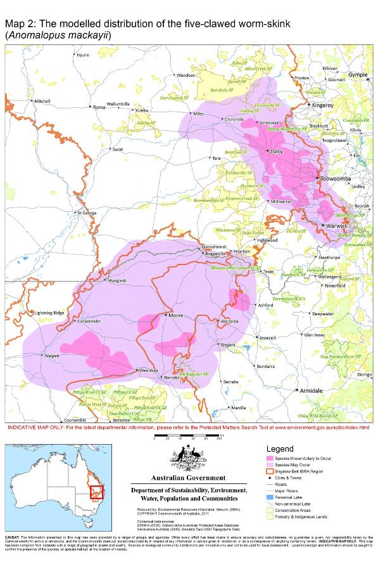

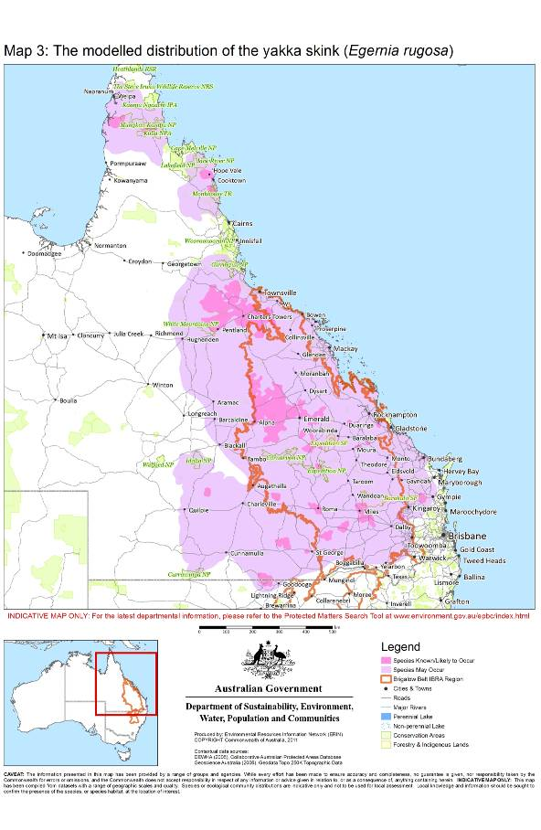

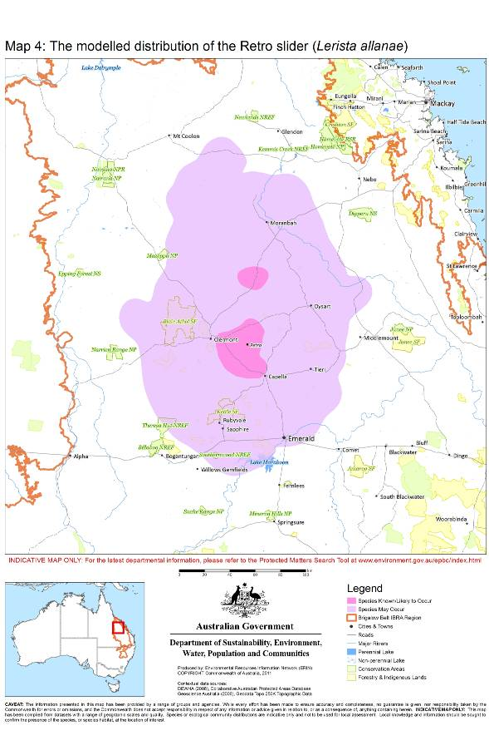

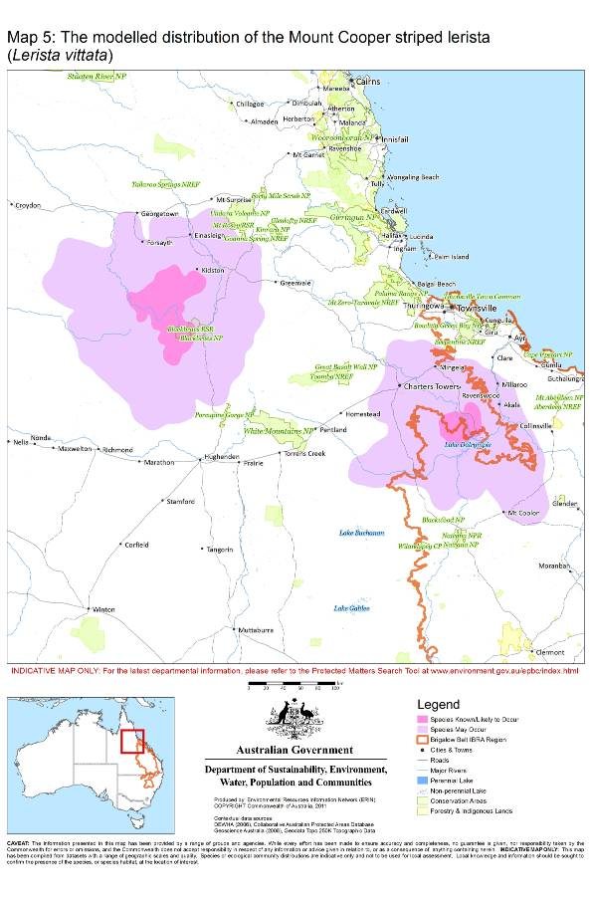

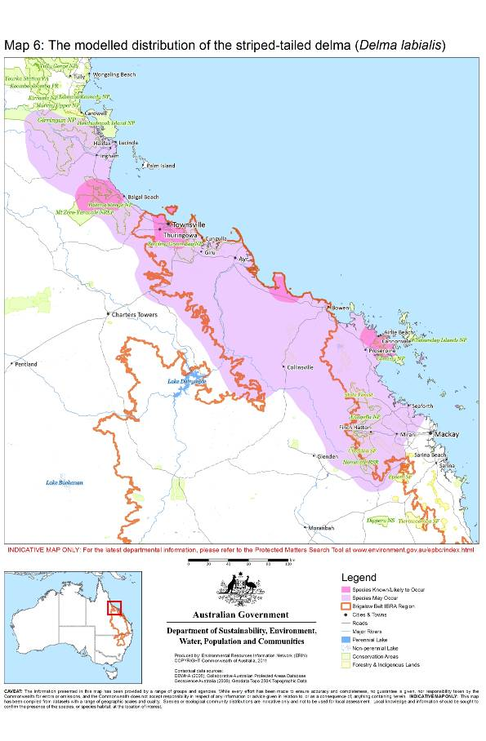

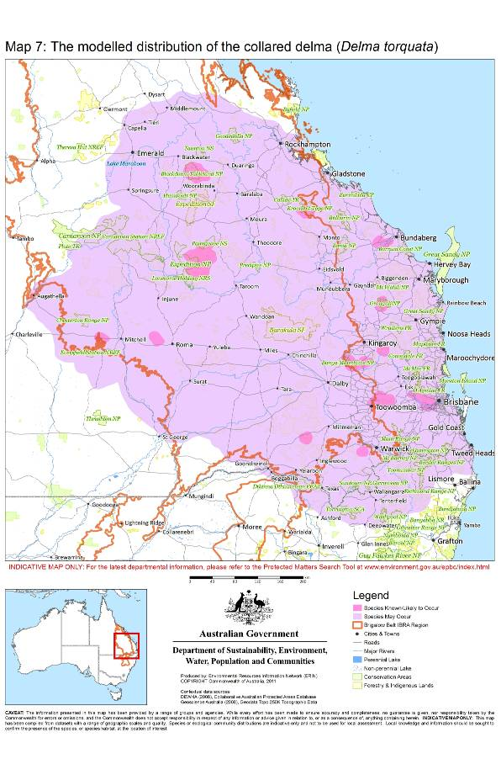

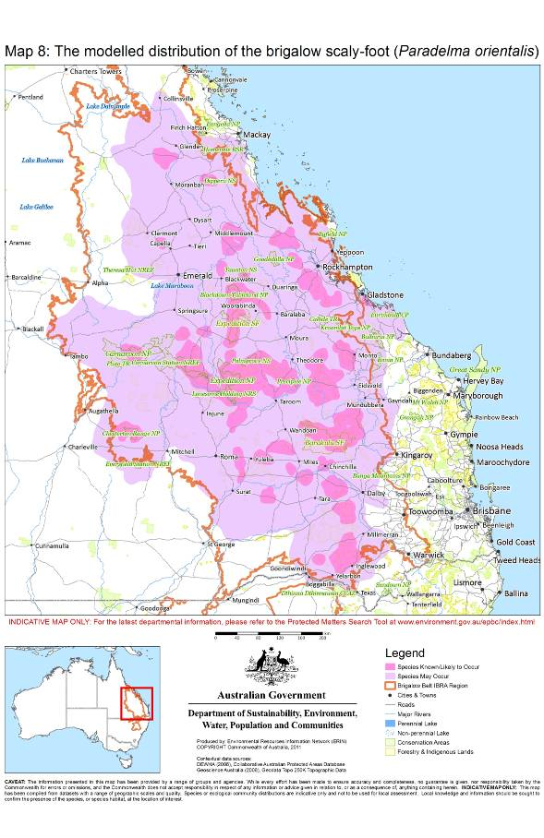

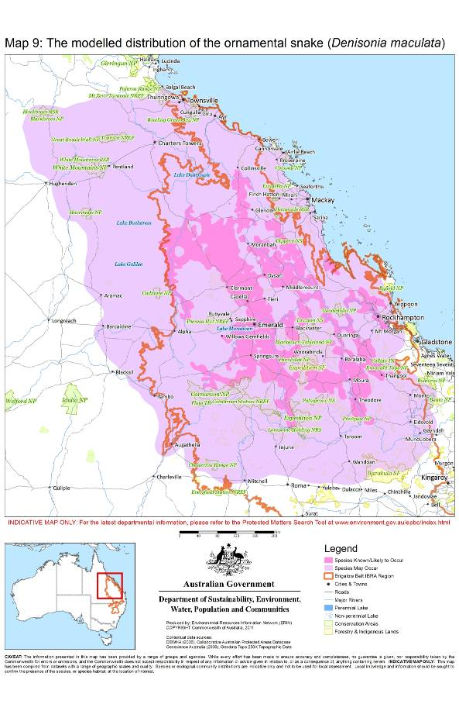

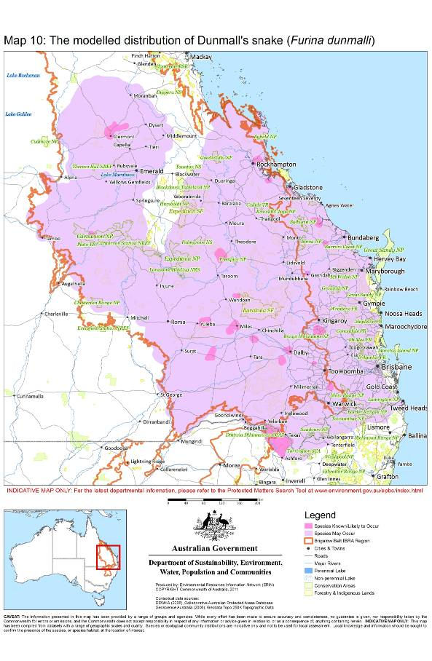

Appendix 2

A description of the method with which the modelled distributions of the Brigalow Belt reptiles (as indicated in Maps 2 to 10) were determined is provided below.

Observational point records for all nine of the Brigalow Belt reptiles were sourced from the department’s records database in July 2010, along with additional location descriptions provided by experts at the Brigalow Belt Reptiles Workshop (Brisbane, 18 August 2010). Point records with a suitable taxonomic classification, currency and spatial precision were selected for use in distribution mapping. The Known-to-occur distributions were created by buffering selected point records by the lowest quality spatial precision value for each species, ranging from 1km (for the five-clawed worm-skink) up to 5km (for the yakka skink).

The Likely-to-occur and May-occur distributions were created by identifying suitable areas, or regional patterns, of habitat that are coincident with the known locations of these species. The primary data sources used to assist in defining these distributions were the department’s National Vegetation Information System (NVIS), QLD DERM’s Regional Ecosystems data (QLD RE), CSIRO’s Atlas of Australian Soils (soils) and GA’s 1M Geology dataset (geology).

Native vegetation communities and soil types were selected for use as habitat surrogates to assist in defining the Likely-to-occur distributions. These selections were based upon geographic coincidence with Known-to-occur distributions and from detailed habitat descriptions provided by experts (i.e. described NVIS vegetation categories, QLD RE numbers and specified soil types). Selected suitable habitat areas were buffered by 5km to account for spatial imprecision in the source data.

The May-occur distributions were created by identifying regional patterns of suitable habitat using soils and/or geology as a surrogate. Soils and geology types coincident with the Known-to-occur and Likely-to-occur distributions were selected and buffered by 10km to account for spatial imprecision in the source data.

When considering whether or not your action will have a significant impact on one or more listed Brigalow Belt reptiles, it is relevant to consider all adverse impacts from the action, including direct, indirect and offsite impacts such as downstream or downwind impacts, upstream impacts and facilitated impacts (impacts which result from further actions which are made possible or facilitated by the action).
This map indicates where habitats of the listed Brigalow Belt reptiles may occur, i.e., it does not suggest that Brigalow Belt reptiles occur throughout the entire modelled distribution.
A QLD RE’s suitability for reptile habitation is only broadly indicative as RE polygons are mapped at a 2-5 ha scale depending on how, where and when the mapping was carried out. This means that RE polygons mapped as unsuitable habitat may actually contain 2-5 ha of suitable habitat and vice versa for polygons mapped as suitable.
All suitable habitats for the endangered Retro slider (including remnant or non-remnant vegetation) are considered important for the species’ long-term survival and recovery. Whilst a targeted survey for the Retro slider is, therefore, not necessary to determine whether your action is likely to affect important habitat for this species, a targeted survey is still recommended to ascertain the species’ presence/absence in your study area.
The Mount Cooper striped lerista and the Retro slider may be surveyed at any time of year.
This criterion does not necessarily apply to the endangered Retro slider. Note that all suitable habitats for the Retro slider are considered important.
This criterion does not necessarily apply to the vulnerable brigalow scaly-foot. This species is known to occur where the vegetation characteristics of their habitats have been significantly altered from their natural conditions. Therefore, confirmation of the presence of the brigalow scaly-foot during a targeted survey does not automatically qualify the surveyed habitat as important for this species, unless at least one other important habitat criterion (listed above), or any of the descriptions of known important habitats for the species presented in Table 4, apply.

