

DRAFT

Background document:

Threat abatement plan for competition and land degradation by rabbits

2015

The Department acknowledges the traditional owners of country throughout Australia and their continuing connection to land, sea and community. We pay our respects to them and their cultures and to their elders both past and present.

© Copyright Commonwealth of Australia, 2015.



The Background document to the *Threat abatement plan for competition and land degradation by rabbits* is licensed by the Commonwealth of Australia for use under a Creative Commons Attribution 4.0 Australia licence with the exception of the Coat of Arms of the Commonwealth of Australia, the logo of the agency responsible for publishing the report, content supplied by third parties, and any images depicting people. For licence conditions see: <https://creativecommons.org/licenses/by/4.0/>

This report should be attributed as ‘**Draft** Background document to the Threat abatement plan for competition and land degradation by rabbits, Commonwealth of Australia 2015’.

The Commonwealth of Australia has made all reasonable efforts to identify content supplied by third parties.

The contents of this document have been compiled using a range of source materials and is valid as at October 2015.

While reasonable efforts have been made to ensure that the contents of this publication are factually correct, the Commonwealth does not accept responsibility for the accuracy or completeness of the contents, and shall not be liable for any loss or damage that may be occasioned directly or indirectly through the use of, or reliance on, the contents of this publication.

Table of Contents

1. Introduction 5

2. Overview 5

2.1. History of rabbit introduction 5

2.2. Distribution 5

2.3. Abundance 6

3. Rabbit Biology 7

3.1. Habitat 7

3.2. Behaviour 7

3.3. Diet 8

3.4. Reproduction and social structure 8

3.5. Mortality 8

4. Impacts of rabbits 9

4.1. Environmental impacts 9

Impact on vegetation 10

Impact on native fauna 10

Impact on livestock and agriculture 11

Supporting pest predator populations 12

4.2. Economical impacts 12

4.3. Social impacts 12

5. Monitoring rabbits and their impacts 13

6. Rabbit control 14

6.1. Integrated control 14

6.2. Conventional control methods 15

Baiting 15

Fumigation 16

Destruction of warrens and above-ground shelters 16

Exclusion fencing 18

Shooting and trapping 19

6.3. Biological control 19

Myxomatosis 19

Rabbit haemorrhagic disease 20

Fertility control (immunocontraceptives) 21

7. Animal welfare 21

8. Strategic research – biological control agents 22

8.1. RHD Boost 23

8.2. RHD Accelerator 23

8.3. Bio-prospecting 23

9. Factors affecting rabbit control 24

9.1. Non target species 24

9.2. Cross–species control 24

9.3. Community perceptions to rabbits and control activities 25

Commercial use 25

Indigenous use and association. 26

10. Legislation 26

11. Strategic management 27

11.1. Adaptive management 27

11.2. Economic decision model 27

11.3. Rabbits and bio-sequestration 28

References 29

Appendix A 36

Appendix B 39

Table of Figures and Tables

**Figure 1:** Reported abundance and distribution of European rabbits (*Oryctolagus cuniculus*) across Australia (from Cox *et al.* 2013). 8

**Figure 2:** Rabbit distribution and locations of threatened ecological communities and species that may be adversely affected by rabbits (Commonwealth of Australia 2015). 10

**Figure 3:** Modelled distribution of rabbits in Australia (Commonwealth of Australia 2015). 39

**Figure 4:** Rabbit distribution and locations of threatened fauna (animal) species that may be adversely affected by rabbits (Commonwealth of Australia 2015). 39

**Table 1:**  Information resources for rabbit monitoring…………………………………………………………………..13

**Table 2:** Summary of state and territory rabbit management legislation 26

# Introduction

This is the background document to the *2015* Threat abatement plan for competition and land degradation by rabbits. The document aims to provide information on:

* rabbit characteristics, biology and distribution
* impacts on environmental, economic, social and cultural values, and
* current management practices and research findings.

Competition and land degradation by rabbits is listed as a key threatening process under the Environment Protection and Biodiversity Conservation Act 1999 (EPBC Act). The original Threat Abatement Plan for competition and land degradation by rabbits (TAP) under the EPBC Act was published in 1999 (EA 1999) to establish a national framework to guide and coordinate Australia’s response to the effects of competition and land degradation by rabbits on biodiversity.

Relevant sections of the EPBC Act in relation to making and revising threat abatement plans are at Appendix A.

# Overview

## History of rabbit introduction

The European rabbit (*Oryctolagus cuniculus*) originated in southern France, Iberia and north-western Africa (Wilson & Reeder 2005). They are first thought to have arrived in Australia in 1788 with the First Fleet who released them onto many islands within the Bass Strait and Tasman Sea to provide food for shipwrecked sailors (Ingersoll 1964; Williams *et al.* 1995; McLeod 2004; van Leeuwen & Kerr 2008).

The first feral rabbit populations established in south-eastern Tasmania with numbers exceeding several thousand by 1827 (Williams *et al.* 1995; McLeod 2004). Rabbits were also introduced in Melbourne, Sydney, Armidale (NSW), Port Lincoln and Kapunda (SA), Geraldton, Cheynes Beach and the Darling Ranges (WA), but populations failed to establish (the reasons for the failure of these populations is unknown) (cited in Henzell, Cooke & Mutze 2008). Many years later (1859), twenty-four rabbits were imported onto mainland Australia (Victoria) from Europe with at least thirteen of these being released at Barwon Park (near Geelong) to start a population for game hunting (Ingersoll 1964; Williams *et al.* 1995). Within six years, the Victorian population grew to over 14,000 individuals (Ingersoll 1964; Williams *et al.* 1995).

The spread of rabbits from Geelong was generally slow, taking approximately 15 years for rabbits to reach the New South Wales Border (cited in Williams *et al.* 1995). Subsequently, the spread of rabbits was rapid (100 km per year reported in arid regions (Williams *et al.* 1995)). Rabbits dominated two-thirds of the continent within 70 years, the fastest rate of any colonizing mammal anywhere in the world (cited in Williams *et al.* 1995; McLeod 2004). Their colonisation was aided by existing native animal burrows, habitat modification for farming, lack of natural predators, and by further deliberate human introductions for meat and hunting (Williams *et al.* 1995; McLeod 2004).

## Distribution

Rabbits are particularly well-adapted to Mediterranean climates (Williams *et al.* 1995), but can occur in a wide range of environments. South of the Tropic of Capricorn they have established in environments including subalpine areas, stony deserts, subtropical grasslands and wet coastal plains; but tend to avoid environments with high altitudes and dense forests (Williams *et al.* 1995). North of the Tropic of Capricorn, most rabbit populations are generally small, isolated and restricted to areas with more fertile soils or where there is a shallow water table (Williams *et al.* 1995). In urban and semi-urban areas, rabbits can be found in a variety of areas including roadsides, rail reserves, winery vineyards, cemeteries, golf courses, sports grounds, school and university grounds, creek lines and home gardens (Cooke 2012a).

Rabbits are thought to have largely reached their ecological limit in terms of range and overall distribution in Australia (West 2008). In the future, the distribution of rabbits is however, predicted to change with increasing temperatures (Pavey & Bastin 2014). Pavey and Bastin (2014) predict that increasing temperatures are likely to have a negative impact on rabbits, with the general trend for reduced distribution and reduced density. As such, by 2050, rabbits are predicted to become absent from large areas of central and western NSW due to these areas becoming hotter and more arid (Pavey & Bastin 2014).

## Abundance

Rabbits were in plague proportions leading up to the release of the myxoma virus in 1950, but then dramatically declined, with initial mortality rates of over 99%. Rabbits are now abundant across most of Australia (except some regions in northern Australia), but are most abundant in areas with deep, sandy soils which make it easier to dig warrens (Myers *et al.* 1994).

The exact abundance of rabbits in Australia is difficult to quantify given that population sizes frequently fluctuate through factors such as breeding events, mortality caused from biocontrol agents or extreme climatic events (e.g. droughts), and availability of resources (predominantly vegetation). Based on sightings of rabbits, estimates of the levels of rabbits (low to very high) in particular areas have been developed (see Figure 1).

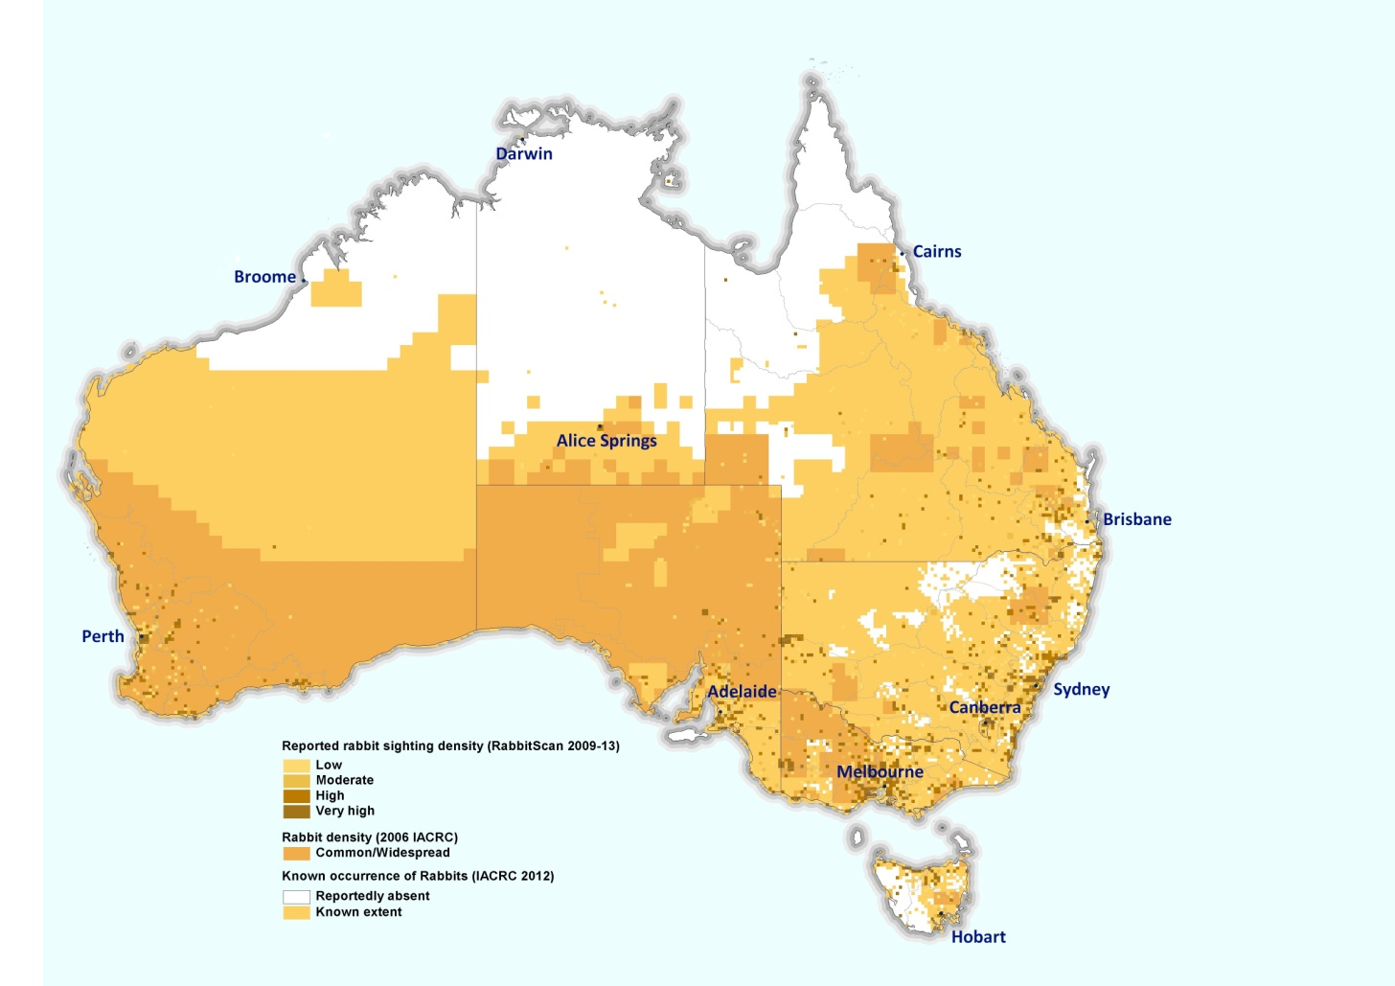

Figure 1: Reported abundance and distribution of European rabbits (*Oryctolagus cuniculus*) across Australia (from Cox *et al.* 2013).

# Rabbit Biology

The majority of the information below has been adapted from Williams *et al.* (1995).

## Habitat

Rabbits are found in a wide variety of habitats in Australia, from deserts to coastal plains and urban areas. In general, they avoid large cultivated areas, forests, floodplains and areas with black cracking soils where warrens become easily waterlogged. They are also scarce in areas with clay soils, but abundant in areas where soils are deep and sandy, such as in the north-east of South Australia where warrens are easier to dig (DSEWPAC 2011). In arid areas rabbits need access to water, but elsewhere they obtain enough moisture from their food (DSEWPAC 2011).

The use of warrens, which provide protection from predators and extreme weather conditions, enables them to persist in a much greater range of habitat types, including arid and semi-arid areas. Where there is abundant vegetation available, rabbits can also readily live above ground rather than in warrens; however, short warrens may be dug to house nests.

## Behaviour

Most rabbit activity tends to occur in the late afternoon (one to three hours before sunset) until sunrise (Williams *et al.* 1995; DPI 2012), but can be active at any time if: left undisturbed; there is high vegetative cover; low predator activity; or if there is a high density of rabbits in that area. High winds or rain have been found to reduce activity levels as predators are less easy to detect (DPI 2012). Rabbits generally travel between 150 to 200 m from warrens, but during droughts, this has been found to increase up to 1500m (Williams *et al.* 1995; DPI 2012).

Rabbit home ranges vary depending on a number of factors including: the individual rabbit, season, dwelling type, amount of available food resources and habitat type. For example, Moseby *et al.* (2005) found that in northern South Australia, home ranges vary from 0.77ha to 9.18 ha, with an average of 2.1ha in summer and 4.2ha in winter; and White *et al*. (2003) found that in central New South Wales, surface-dwelling rabbits had a mean range size of 3.14 ± 0.48ha, and warren-dwelling rabbits had mean range sizes of 1.74 ± 0.26ha.

## Diet

Rabbits are herbivores and eat a wide variety of plant material. Rabbits tend to be night-time grazers, preferring green grass, herbs, young seedlings, and short, succulent plants, but will also dig below grasses to reach roots and seeds (DSEWPAC 2011; DPI 2012). They also readily consume pastoral crops. Rabbits consume, on average, around 100-150grams of food daily (DPI 2012).

## Reproduction and social structure

Rabbits can breed at any time provided there is sufficient food available (breeding is increased in periods of high rainfall when food resources are more readily available due to new and enhanced growth – this is generally in Spring). Rabbits can begin breeding at around three to four months of age and may produce five or more litters each year (average gestation period of 28-31 days), with up to seven young per litter. Dominant females in the groups will breed earlier than the younger females.

The sizes of rabbit social groups vary, but generally consist of 2-10 individuals. Large warrens may consist of several social groups. During the breeding season, territorial groups of one to three males with up to seven females are formed with one dominant pair. After breeding, the groups break up again, except for dominant pair.

In Australia, young rabbits (from one month to two months old) leave their birth warrens and move to other warrens of lower rabbit density or to adjacent social groups (although movements greater than 20km have been recorded (cited in Williams *et al.* 1995)). Dispersal from high density populations has also been found to occur when food resources decline.

## Mortality

Wild rabbits rarely survive past six years of age, generally living for one to two years. Mortality rates of young rabbits (kittens) is extremely high, with almost 80% of kittens not surviving past three months of age (DPI 2013) and only 1-10% surviving past their first year. The lowest survival rates generally occur in young which are born either late or early in the season due to increased predation and declines in food quality. Survival rates of adult rabbits each year has been estimated at 40-60%.

In Australia, predators of rabbits include feral cats, foxes, dingoes, wild dogs, birds of prey (e.g. wedgetail eagles, goshawks and falcons) and large reptiles (goannas and snakes). Mortality is also caused by drought, parasite infestation and infection by bio-control agents.

# Impacts of rabbits

The European rabbit inflicts substantial damage upon both agricultural and environmental assets in Australia and has been described as Australia’s most costly vertebrate pest (Cooke *et al.* 2013). The introduction of rabbit biocontrol agents (myxoma and rabbit haemorrhagic disease virus) have helped to reduce both the economic and environmental impacts of rabbits in Australia, although even at lower numbers, their impact is still severe (cited in Cooke *et al.* 2013).

## Environmental impacts

Not only do rabbits compete with native wildlife for resources (food and shelter), but they also have severe impacts on native plants through grazing, browsing and ring-barking (Ingersoll 1964; Williams *et al.* 1995) and preventing regeneration of seedlings (Mutze *et al.* 2008). These impacts can often threaten species with either severe range contraction or extinction (Williams *et al.* 1995) and are a cause for concern for many species and ecological communities, particularly those listed as nationally threatened under the EPBC Act. Currently, 73 species of fauna (44 birds, 20 mammals, 6 reptiles, 1 invertebrate, 1 fish and 1 amphibian); 260 listed plant species; and a further nine endangered ecological communities are nationally impacted by rabbits (Department of the Environment 2015) (see Appendix A of the *Threat abatement plan* for the full list). Figure 2 shows the locations and densities of threatened ecological communities and species that may be adversely affected by rabbits (Commonwealth of Australia 2015). Additional maps showing flora and ecological communities, and fauna adversely affected by rabbits are at Appendix B. The decline and extinction of many critical-weight-range species (weights of between 35 and 5500g), has also been attributed to impacts caused by rabbits, particularly in the arid and semi-arid zones (Calaby 1969).

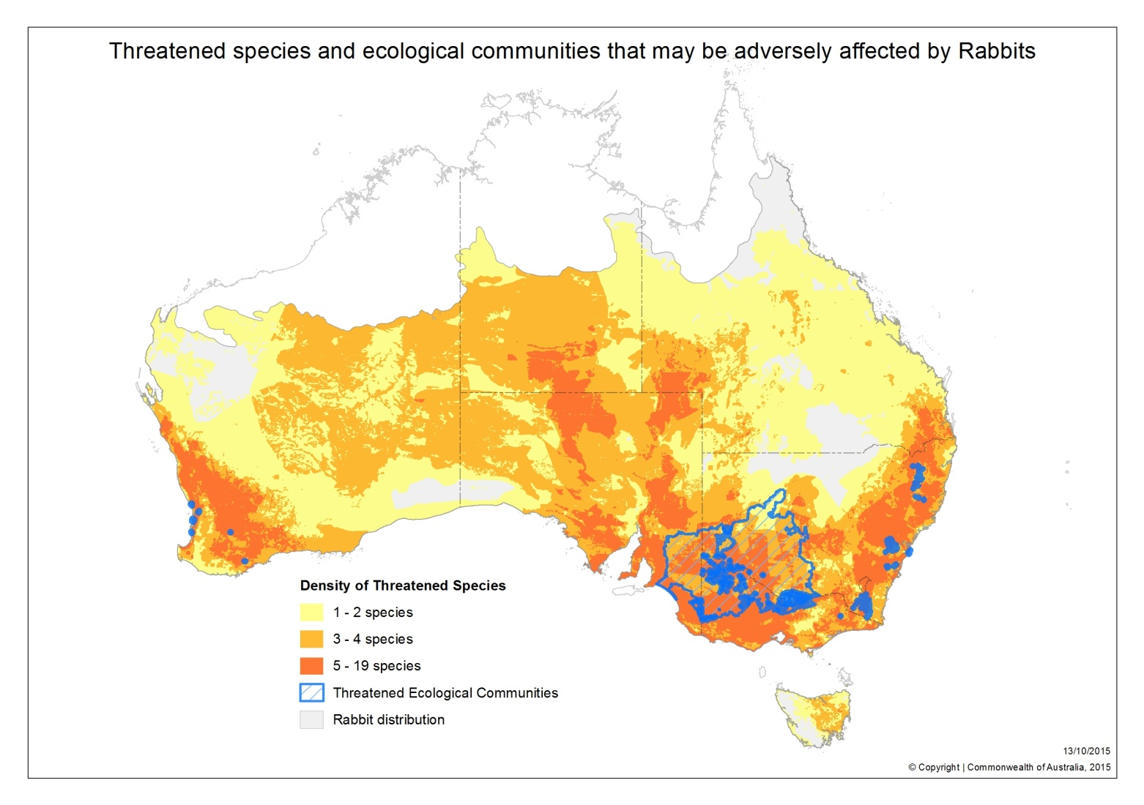

Figure 2: Rabbit distribution and locations of threatened ecological communities and species that may be adversely affected by rabbits. Rabbit distribution is based on observed locations and climate thresholds (as limiting factors for spread across the landscape) and includes both the areas where threatened species densities and ecological communities are indicated and grey areas (Commonwealth of Australia 2015).

### 

### Impact on vegetation

Rabbits have severe impacts on vegetation and surrounding ecosystems through overgrazing and general damage (e.g. ring-barking, digging up of roots, removal of leaves) (Williams *et al.* 1995) which restricts the regeneration of trees and shrubs (Mutze *et al.* 2008); and through promoting growth of introduced plant species such as weeds (particularly around warrens due to high levels of grazing and soil disturbance, and an increase in nutrients (Williams *et al.* 1995; Cooke 2012b)). The most significant impacts are likely to occur on small islands where vegetation is quickly exhausted before populations become regulated through density-dependent effects (Lees & Bell 2008).

Rabbits have also been found to reverse the normal process of change in plant species structure over time (e.g. weeds become the final dominant species of the ecological community) (Williams *et al.* 1995). This significantly alters complex vegetation communities (through removal of the most nutritious species), creating poor habitat consisting of annuals, short grasses or bare-ground and then to weeds, moss and lichens, over a relatively short time period (Williams *et al.* 1995; Bergstrom *et al.* 2009; Bengsen & Cox 2014). This is expected to change soil structure, nutrient-cycling and lead to significant wind and water erosion (Eldridge, Costantinides & Vine 2006; Bergstrom *et al.* 2009; Bengsen & Cox 2014; Invasive Animals CRC 2014). It also removes valuable habitat for arboreal mammals and birds, resulting in changes to communities; and reduces the carbon storage potential of vegetation.

In addition, rabbits create hostile environments for germinating seeds by moving nutrient-poor subsoil (e.g. clay-rich soils) to the surface when creating warrens (Eldridge, Costantinides & Vine 2006). The survival probability of new seedlings and suckers is also greatly reduced by rabbit grazing, with low rabbit abundance and favourable climatic conditions required over the long term (at least 3-5 years) to facilitate recruitment (Denham & Auld 2004). Cooke (2012a) suggests that even low densities of rabbits (less than 0.5 rabbits per hectare) can prevent the recruitment/regeneration of most native trees and shrubs. In most cases, this regeneration is limited and prolonged (Eldridge, Costantinides & Vine 2006) and may cause many palatable trees and shrubs to gradually become locally extinct across Australia (Mutze *et al.* 2008). For slow-growing species such as mulga (*Acacia aneura*), this is particularly evident, with studies in the northern Flinders Ranges finding little to no seedling survival after 28 years (Mutze *et al.* 2008). Species such as sheoak (*Allocasuarina* spp.) and buloke (*Allocasuarina luehmannii*) are also likely to become extinct throughout their range if rabbits continue to prevent regeneration of seedlings (Bird *et al.* 2012). Conversely, orchid species have been found to significantly increase in both density and species richness over a period of four years of rabbit exclusion (Mutze *et al.* 2008).

### Impact on native fauna

Rabbits have been found to directly compete for resources with native fauna, particularly smaller marsupial herbivores with limited foraging ranges and dispersal capacity (Bird *et al.* 2012). Bird *et al.* (2012) suggest that this competition may have had a greater role in the decline of small mammal populations in southern Australia than previously thought. For example, Lees and Bell (2008) suggest that competition for burrows lead to the extinction of the Nalpa bilby (*Macrotis lagotis grandis*) (a sub-species of the greater bilby) and the lesser stick-nest rat (*Leporillus apicalis*). They also consider that rabbits may have also been responsible for significant declines in the night parrot (*Geospittacus occidentalis*) through habitat degradation. This degradation of habitat and removal of nesting material is also likely to have had a significant impact on the survival and reproductive ability of many other native species.

Red kangaroos (*Macropus rufus*), Western grey kangaroos (*Macropus fuliginosus*)and Hill wallaroos (*Macropus robustus*) have been found to readily re-colonise areas in South Australia (SA) where rabbit control has been undertaken due to reduced competition for resources (Mutze *et al.* 2008). Bird *et al.* (2012) also found that Kangaroo numbers increased rapidly in SA in the first few months after rabbit control, indicating the competition exerted by rabbits and removal of more nutritious native plant species. Common wombats (*Vombatus ursinus*) have also showed a similar, but more gradual, response to a reduction in rabbits in SA (Mutze *et al.* 2008; Bird *et al.* 2012). Bird *et al.* (2012) suggest that the suppression in wombat numbers is being caused by strong dietary overlap including the removal of perennial native grasses and sedges by rabbits. As such, it has been suggested that rabbit control may play an important role in the conservation of wombats (Bird *et al.* 2012).

In a small number of studies, it has been suggested that rabbits may act aggressively towards native mammals, even those which are much larger such as yellow-footed rock wallabies (*Petrogale xanthopus*) in order to protect resources (Williams *et al.* 1995). This may lead to the eviction and/or exclusion of native species from areas where rabbits are present (Williams *et al.* 1995).

### Impact on livestock and agriculture

Rabbits have significant impacts on agricultural commodities such as crops and livestock (Cooke 2012a). The reduction in vegetation by rabbits reduces the capacity of land to carry and sustain livestock, with livestock having to compete for remaining vegetation (Cooke 2012a). For example, for sheep farmers, this has meant lower wool yields (although qualities i.e. micron rating were higher (finer wool) and attracted higher values), reduced lambing, an increase in stock mortality, and fewer animals available for market (McLeod 2004; cited in Cooke 2012a). The impacts are exasperated with the effects of drought, with livestock dying earlier than they would have had rabbits not been present (Williams *et al.* 1995). Mutze *et al*. (2008) noted that in the few years following the release of RHD in 1996, productivity of the livestock industry was estimated to have increased annually by $43 per square kilometre, or $206 million over eight years, for cattle in inland Australia; and $7-38 million per year for sheep in higher rainfall areas. However, due to increasing rabbit immunity to the Czech strain of RHD, this value has continued to decline.

Cooke (2012b) noted that invasive weeds such as Paterson’s curse (*Echium plantaginium*), common horehound (*Marrubrium vulgare*) also tend to thrive around rabbit warrens. An increased presence of these weeds can have negative impacts on livestock. For example, Paterson’s curse can be toxic to a range of livestock (pigs and horses are highly susceptible, cattle are moderately susceptible), causing liver damage, reduced life spans, and in some cases, death after prolonged grazing (NSW DPI 2015). It also reduces pasture productivity by competing with more nutritious species, and reduces the value of hay or grain which may be contaminated by it (NSW DPI 2015). Horehound has also been found to de-value wool by contaminating fleece, cause stomach impaction in sheep (severe constipation where faeces remains stuck in the colon), and taint the flavor of meat of animals who have consumed it (DEPI 2015).

### Supporting pest predator populations

In semi-arid Australia, rabbits have been reported as a staple (and in some cases, primary) prey species for introduced species such as feral cats and foxes, and are thought to directly influence the abundance of these predators (Read & Bowen 2001; Holden & Mutze 2002; Glen & Dickman 2005). As such, there is general consensus that rabbits support populations of pest predators, with evidence of an initial decline in feral cat and fox numbers in 1995 after RHD reduced rabbit numbers by approximately 85% (Sandell & Start 1999; Holden & Mutze 2002). Holden and Mutze (2002) also found that the physical condition (body fat and general weight) of feral cats deteriorated due to the decrease in rabbit numbers and reproduction was reduced; under similar circumstances, foxes had to resort to eating more invertebrates and carrion. Declines in cat, fox and dingo populations (cat numbers declining first and dingoes last) were also observed in New South Wales six months to two years following reductions of rabbit numbers during drought (Williams *et al.* 1995). When rabbit numbers were low, pest predators were likely to predate more often on small to medium sized native mammals (Williams *et al.* 1995; Read & Bowen 2001). For example, Read and Bowen (2001) found an increase in other vertebrates (1 to 2.5 individuals) taken by cats when rabbit numbers were low. However, the total predation on native species is likely to be reduced as pest predator (feral cat) numbers are also expected to have declined (Holden & Mutze 2002).

See section 9.2 on cross-species control for further information on interactions with pest predators.

## Economical impacts

Rabbits have become one of Australia’s most costly vertebrate pest through widespread loss to pastoral and agricultural production (McLeod & Norris 2004; Cooke *et al.* 2013). The overall agricultural loss (from data up to 2002) is estimated at $206 million annually, five times greater than the losses from wild dogs and almost ten times greater than the losses caused by foxes and mice (Gong *et al*. 2009). The only agricultural loss to surpass the impact of rabbits is that of birds, which is estimated to cost agriculture $313.1 million per year (Gong *et al*. 2009).

The actual economic benefit of rabbit biological control has been estimated at $70 billion for Australian agricultural industries over the last 60 years (Cooke *et al.* 2013). The first released biocontrol agent, myxoma virus, generated the most return (Cooke *et al.* 2013). Cooke *et al.* (2013) estimated that losses to sheep and cattle production would have been equivalent to about $1.866 billion per year if the myxoma virus had not been released. The introduction of the rabbit haemorrhagic disease virus (RHDV) also resulted in an immediate increase in benefits to Australia’s livestock industries of about $350 million per year (Cooke *et al.* 2013; Cox *et al.* 2013; Williams *et al.* 1995).

## Social impacts

The social impacts of rabbits are often hard to quantify or measure and can vary substantially between different demographics (Fitzgerald & Wilkinson 2009). Impacts may include psychological stress, e.g. anxiety, frustration and depression, due to financial loss through reduced agricultural production, trauma associated with members of the public finding sick animals, and concern about potential injury to horses from warrens (Fitzgerald & Wilkinson 2009). There are additional concerns that rabbits increase the workload for land managers, although many continue to believe that rabbits are under control (Fitzgerald & Wilkinson 2009).

# Monitoring rabbits and their impacts

Monitoring rabbits, including their abundance, is critical in determining whether a management program has been successful or not. This can be a difficult task, particularly when the impacts of rabbits on native vegetation e.g. inhibition and regeneration are not always apparent and there are few sightings of rabbits in the area (Lowe *et al.* 2003; Cooke *et al.* 2010; Bird *et al.* 2012).

There are several methods for monitoring rabbit populations including visual counts of rabbits, live-trapping, counts of rabbit warrens or holes, and dung-based surveys (cited in Mutze *et al.* 2014a). More recently, camera-trap surveys have proven to be an effective, alternative method for estimating decreases in rabbit numbers during control operations. Cameras also allow monitoring in rugged terrain or dense vegetation where transect surveys are not practicable (Latham *et al.* 2012). Similar to cameras, dung-based surveys allow monitoring to be undertaken in difficult terrain with minimal equipment and effort whilst providing a reasonable accurate estimate of rabbit density (Mutze *et al.* 2014a).

Several information resources on monitoring techniques have been published in recent years and are accessible online (see Table 1 for an outline of some of these publications). These manuals aim to provide details of available rabbit monitoring techniques, including step-by-step instructions.

**Table 1:** Information resources for rabbit monitoring.

| **Publication** | **Description** | **Link** |
| --- | --- | --- |

|  |  |  |
| --- | --- | --- |
| *Monitoring techniques for vertebrate pests: rabbits.*  Mitchell and Balogh (2007) | Provides information on the different monitoring techniques for land managers | <http://www.feral.org.au/wp-content/uploads/2010/03/Monitoring-techniques-for-vertebrate-pests---rabbits.pdf> |
| *Rabbits: a threat to conservation and natural resource management*  Cooke, McPhee and Hart (2008) | Designed to assist land managers to rapidly assess their rabbit situation and take action. | <http://www.feral.org.au/rabbits-a-threat-to-conservation-and-natural-resource-management/> |
| *Glovebox Guide for Managing Rabbits*  Brown (2012)  (Part of the Invasive Animals CRC PestSmart Toolkit for rabbits) | Designed to provide best practice rabbit management information for land managers, pest animal officers and others involved in the management of rabbits. | <http://www.feral.org.au/pestsmart-glovebox-guide-for-managing-rabbits/> |

# Rabbit control

Given the vast area of Australia occupied by rabbits, broad scale eradication is not feasible using the methods and resources currently available, except in some island/exclusion zone situations. However, long-term suppression of rabbit populations is feasible across much of Australia.

Local eradication efforts in islands and exclusions zones will only be feasible where:

* Reinvasion risks are manageable
* All animals are accessible and at risk of being killed during the control operation, and
* Rabbits are killed at a higher rate than the population’s ability to regenerate and replace the losses (through breeding or immigration).

Rabbit control will be most important (and is a high priority) in areas of high conservation concern, particularly those that support populations of threatened species.

Further detail on the various rabbit control options are outlined below.

## Integrated control

Successful, long term, and cost-effective rabbit control is more likely to be achieved where integrated approaches are undertaken. For example, when reliance is placed on only one technique and follow-up control is not implemented, initial gains are lost as rabbits will readily re-colonise in the absence of further control (Parer & Milkovits 1994; Williams & Moore 1995). Further, as the behaviour of rabbits varies between individuals, the use of a single method is unlikely to ensure the capture or death of all individuals e.g. some rabbits are trap shy, but others may readily be caught (Read *et al.* 2011).

While the importance of biocontrol agents cannot be overstated—myxoma and RHD are estimated to have produced a benefit of $70 billion for agricultural industries over the last 60 years (Cooke *et al.* 2013; Cox *et al.* 2013)—there are concerns that there is a growing reliance on biocontrol methods resulting in a reduction in conventional control efforts. For example, Cooke *et al.* (2013) suggest that after the release of myxomatosis, efforts to control rabbits fell from over 90% of farmers to approximately 10-40% depending on region. However, as biocontrol agents will not kill all individuals, conventional control methods must continue to be used to achieve long-term reductions in rabbit numbers.

Detailed guidance (standard operating procedures) on the use of the various rabbit control techniques is available at [www.feral.org.au/tag/rabbit-sop/](http://www.feral.org.au/tag/rabbit-sop/).

Integrated control also involves the coordinated use of control techniques with other land management activities. For example, the control of rabbits should be integrated with the control of other pest species (e.g. foxes and feral cats) and weed management programs. This is particularly important where removal of predators (foxes and feral cats) may cause unintended increases in abundance of rabbits (refer to Section 9.2: Cross species control for further information).

Integrated control should ensure that the planning of control activities is undertaken in a strategic manner to take advantage of the environmental conditions and other complementary activities. In this way, control effectiveness is maximised and costs are minimised. Ongoing monitoring should also be undertaken to ensure that outbreaks can be dealt with quickly through conventional control measures to limit any increase in populations.

## Conventional control methods

***Note****: some control methods may be prohibited or restricted under state and territory, animal welfare or occupational health and safety legislation; all legal requirements should therefore be checked prior to beginning activities.*

### *Baiting*

Poison baiting is often used as the initial step in a control program. Baiting aims to remove a high percentage of rabbits to prevent populations from quickly recovering and to allow follow up control activities such as warren destruction to be undertaken (Williams *et al.* 1995). In some situations, such as rabbits living in dense vegetation on the edge of pastoral land, baiting may be the only immediate and feasible solution.

Currently, there are two different poisons available for use: 1080 (sodium fluoroacetate) and pindone. 1080 applied to oat baits is most commonly used. 1080 toxin is considered to be effective (with mortality rates of up to 90% (McIlroy & Gifford 1991) and relatively inexpensive (Martin *et al.* 1994); it degrades rapidly under field conditions (although not in dead rabbits, who may represent a risk to native species) and does not accumulate in rabbits that ingest a sub-lethal dose (see Twigg *et al.* 2003); and some native species (particularly in Western Australia) have a higher natural resistance.

Pindone is generally used in areas where 1080 cannot be used, such as urban areas where there is a high risk to domestic pets, children and livestock. For both poisons, there are ongoing concerns about the humaneness and target specificity—although 1080 toxin is considered more humane than pindone (see Section 7: Animal welfare for further information, including symptoms of these poisons).

The use of poison baits can also present additional issues including:

* Potential poisoning of non-target species, including native fauna, livestock and domestic animals. For example, marsupials such as macropods, bandicoots, and birds are very sensitive to pindone. Pindone has also been found to accumulate in the liver, fat and muscle of poisoned rabbits, increasing secondary exposure to non-target species, particularly scavengers (Fisher, Brown & Arrow 2015)
* Avoidance of baits by rabbits that have previously consumed a sub-lethal dose due to neophobia or bait aversion (this can be caused by frequent and ineffective baiting and cannot be overcome through a change in poison (Williams *et al.* 1995))
* Lack of an antidote for 1080 (pindone has an available antidote for domestic animals), and
* Water-soluble toxins leaking from baits laid in damp environments or during wet weather.

Effective methods for using toxins, including published protocols and effective labeling, have been developed, and control programs that are well designed and carefully implemented will help to minimise any potential issues including non-target effects (e.g. Sharp &Saunders 2012).

Another issue affecting poison baiting is the development of genetic resistance to 1080 poison in some populations (Twigg, Martin & Lowe 2002). This means that a higher lethal dose of 1080 is required to cause death (Twigg, Martin & Lowe 2002). Populations which have had the least exposure to 1080 baits in the past are likely to have greater sensitivity to this poison, than populations where baiting occurs regularly (Twigg, Martin & Lowe 2002). For example, Twigg, Martin and Lowe (2002) found that the lethal dose(LD50) value of 1080 for some populations in now approximately 0.744 to 1.019mg of pure 1080 kg-1 which is significantly higher than previously reported values of 0.34 to 0.46mg of pure 1080 kg-1; for populations with low exposure to 1080, the LD50 value did not change. This has implications for control programs which may become less effective over time (Twigg, Martin & Lowe 2002). Further, increasing the amount of 1080 poison in baits may lead to increases in non-target species impacts (Twigg, Martin & Lowe 2002).

If using poison baits, rabbits will need to be ‘trained’ by free-feeding to reduce development of bait aversion and to increase the number of rabbits killed in a baiting session (Williams *et al.* 1995; Cooke 2012a). Free-feeding has been found to be most effective when it is undertaken several times at approximately two to three day intervals before poison baits are laid (Cooke 2012a). Baiting should occur in late summer to early winter (winter is best in sub-alpine areas) when there are few young rabbits, few alternative food sources and rabbits range further, low likelihood of toxins being leached from baits, rabbit numbers are generally lower, and non-target species activity is generally lower (Read *et al.* 2011; Cooke 2012a; Williams *et al*. 1995). To ensure young rabbits consume baits, baits should also be laid close to warrens (Williams *et al.* 1995). For all other baiting, baits have been found to be most effective within a 300m radius of warrens, with bait lines closer together in summer than in winter to increase encounter rates (Moseby *et al.* 2005). Poison baiting using 1080 in oat baits is estimated to cost roughly $52 per hectare (Cooke 2012a).

### Fumigation

Fumigation is a valuable follow-up technique to poison baiting, and is a useful control method in areas where other techniques (e.g. poison baiting) cannot be used. Studies suggest that fumigation is best conducted between 0900 and 1600 hours in winter and 1100 and 1800 hours in summer to increase the number of rabbits in warrens (Moseby *et al.* 2005).

Fumigation works by replacing the air in warrens with lethal gas and is generally undertaken when soil is damp to: limit toxins diffusing from the warren; stimulate the release of gases; and allow for tighter sealing of warren entrances (Williams *et al.* 1995; Cooke 2012a). The fumigants currently registered for use in Australia are chloropicrin and phosphine, although welfare concerns exist in relation to their humaneness (Gigliotti *et al.* 2009; Marks 2009) – see Section 7: Animal Welfare for further information. Fumigation with aluminium phosphide tablets is currently estimated to cost approximately $56 per hectare ($40 of this is spent searching for open warrens); although this cost will be reduced when integrated with other rabbit control activities (Cooke 2012a).

The Invasive Animals Cooperative Research Centre has been developing a carbon monoxide (CO) fumigator for rabbits as an improved approach to warren fumigation with respect to efficacy, ease of use, fumigator portability, logistical use and humaneness. An initial prototype to improve field reliability and operational performance has been engineered and field testing has been undertaken (Invasive Animals CRC 2012a).

### Destruction of warrens and above-ground shelters

Rabbits living in semiarid and arid zones depend on warrens for protection from climatic extremes and can reach higher densities when warrens are present (Hall & Myers 1978; Parer & Libke 1985; Williams *et al.* 1995; Murray, Berman & van Klinken 2014). The inclusion of warren and shelter site destruction in control programs is therefore considered to be the most cost-effective and long-term method to reduce rabbit populations and prevent ongoing damage and recolonisation, particularly when applied over large, semi-arid or temperate areas (Williams *et al.* 1995; McPhee & Butler 2010; Berman *et al.* 2011; Cooke 2012a; Ramsey *et al.* 2014; Murray, Berman & van Klinken 2014).

Warren ripping is highly target specific and can be successfully employed throughout the year, although destruction is thought to be best carried out when clay soils are slightly damp or sandy soils are dry (Williams *et al.* 1995) and after poisoning and/or disease outbreaks when numbers are lower. Warren ripping is considered a successful method to reduce rabbit numbers in an area as warrens are not readily replaced as they represent a significant energetic investment (usually by females) over a long period of time (Williams *et al.* 1995; Ramsey *et al.* 2014). Therefore, if ripping is undertaken correctly, it may only need to be completed once (Berman *et al.* 2011).

There have been several studies in recent years highlighting the benefits of warren ripping, including coordinated ripping across properties, to achieve long-term and rapid reductions in rabbit populations (McPhee &Butler 2010; Berman *et al.* 2011; Ramsey *et al.* 2014). For example, McPhee and Butler (2010) found that rabbit numbers were reduced for up to 10 years after warren ripping, whereas rabbit numbers continued to increase in un-treated sites. McPhee and Butler (2010) also found that the percentage of warrens ripped on a site was roughly proportional to the reduction in rabbit numbers (i.e. a 90% reduction in rabbit numbers when 90% of warrens were ripped). Ramsey *et al.* (2014) also found, on average, an 84% reduction (range 38-99%) in rabbit abundance per kilometre nine years after ripping.

The use of large machinery (e.g. bulldozers, bobcats with backhoes, excavators), while often more expensive to run, are more effective and rapid at destroying warrens, resulting in cheaper costs per warren (Cooke 2012a). They are also more effective at deep ripping (a depth of at least 80cm (Eldridge, Costantinides & Vine 2006)) to minimise the possibility of rabbits becoming trapped in partially destroyed tunnels and to ensure that entire tunnels can be destroyed (Sharp & Saunders 2012). Berman *et al.* (2011) estimated the cost of warren ripping by a contractor to be approximately $3.62 to $13.70 per warren, or $432.67 to $3922 per km2 (higher costs per km2 were associated with the density of warrens in an area, although these were generally the cheapest per warren). For steep sand hills with dense scrub, Cooke (2012a) estimated that warren destruction using a bobcat backhoe would cost approximately $69/ha (range: $35-$117/ha); with machinery hire costs of approximately $70 to over $120 per hour including the driver and, in some cases, the spotter.

By ripping areas closer to long-lasting or permanent water as a priority, drought refuge is likely to be removed with rabbit numbers suppressed at a greater rate and at a lower cost across an area (Berman *et al.* 2011). This area is estimated to be within approximately 1km from the source of water (Berman *et al.* 2011).

Explosives (such as liquid propane gas (LPG), mixture of ammonium nitrate and fuel oil (ANFO), or oxygen-fuelled explosive devices (Cooke 2012a)) can also be used to destroy warrens in rocky areas, along rivers and in steep sandbanks where ripping is not possible. If used correctly, explosives will completely destroy the tunnel system (Barnes 1983) and may have lower impacts on native vegetation (Bruce 2001). However, the use of explosives can be expensive and requires qualified personnel with a thorough knowledge of their use for safe and effective control. For example, the use of ANFO explosives for warren destruction is estimated at around $140-$160 per warren (cited in Cooke 2012a). However, the use of LPG or oxygen-fuelled explosives costs a similar amount to ripping at about $10 per warren, but is unlikely to destroy the whole warren system (Cooke 2012a). There are also concerns in relation to the humaneness of the use of LPG for warren destruction.

The success of ripping depends on the efficient destruction of the entire burrow system, adequate follow-up control (Williams & Moore 1995) and the implementation of appropriate control measures on adjacent land (Parer & Parker 1986; Parer & Milkovits 1994). Ripping programs should therefore be well planned and completed thoroughly to avoid the need to repeat the process. Complete destruction will also greatly inhibit resurgence and re-colonisation of the area. This will be particularly important in areas where warrens are large, or where ripped warrens are within 1km of an active warren, as these warrens have a greater re-colonisation rate (Ramsey *et al.* 2014). A 3km buffer will further reduce the risk of re-colonisation in the medium term (10-15 years) (Ramsey *et al.* 2014).

Monitoring of warrens, and follow-up control activities, where required, is recommended annually for five years after the initial destruction (highest risk period for re-colonisation), with periodic monitoring after this (e.g. every 2-3 years) (Ramsey *et al.* 2014). Large warrens (i.e. warrens that had greater than 20 active entrances) should also be prioritized for monitoring given their high risk of re-colonisation if not completely destroyed (Ramsey *et al.* 2014).

Rabbits in some parts of Australia also commonly use surface refugia (e.g. hollow logs, vegetation such as blackberry bushes) even when warrens are present (Wheeler *et al.* 1981; Williams *et al.* 1995). The destruction of surface refugia is more complex than the destruction of warrens (which are generally more obvious and easier to pinpoint). Any destruction of surface refugia should, where possible, avoid the removal of native vegetation and logs which provide important habitat for native species (e.g. amphibians, reptiles, small mammals and ground-dwelling or ground-feeding birds). An assessment should also be undertaken to determine the benefits versus the potential risks, especially if it is to be undertaken in, or close to, conservation areas, or is part of a broader plan to reinstate habitat or protect native species. The removal of vegetation in some areas may also lead to soil erosion and therefore should be avoided in such circumstances (Lowe *et al.* 2003). The removal of exotic weeds such as blackberry and lantana is however, encouraged, and should ideally be undertaken prior to warren destruction activities.

### Exclusion fencing

Exclusion fencing will not eradicate rabbits, but can be useful in maintaining rabbit-free areas and for protecting small areas of native vegetation with a high conservation value (Lowe *et al.* 2003). They are however, costly to construct and maintain (estimated at approximately $5000 per kilometer to construct, and lasting around 15 years (Lowe *et al.* 2003)). Although, this cost may be considered reasonable to protect significant threatened flora or ecological communities by encouraging regeneration in the absence of rabbits.

To protect native vegetation and ensure its long-term viability within the fenced area, all rabbits from within that area must be removed either before or immediately after the erection of fencing (Lowe *et al.* 2003). In order to ensure that areas with an exclusion fence remain rabbit free, the fence construction must prevent burrowing underneath and independent juveniles from entering through holes in the mesh. For example, Read *et al.* (2011) found that the mesh needs to be 30mm or smaller to avoid the entry of young rabbits (40mm mesh can be breached). Regular monitoring and maintenance are also required to ensure that fences continue to be effective and cannot be breached.

Before erecting any fences, consideration should be given to likely impacts on other species. Fences, particularly those that act as rabbit barriers, can alter the movement and foraging of non-target fauna (Lowe *et al.* 2003; Sharp & Saunders 2012), can cause entanglement, and are a significant hazard in the event of bushfire (Sharp & Saunders 2012). Electric fences may also cause electrocution (Sharp & Saunders 2012).

### Shooting and trapping

Shooting and trapping are not effective techniques for long-term control or for reducing rabbit populations and maintaining low levels. These methods are labour-intensive and require a high skill of level (they should only be undertaken by experienced and skilled shooter/trappers to ensure humaneness). Shooting also tends to focus on adult and sub-adult rabbits with little impact on juvenile rabbits (Cooke 2012a). However, both shooting and trapping can be useful in removing survivors as part of an integrated rabbit control program, particularly when numbers are extremely low.

Standard operating procedures for ground shooting of rabbits and trapping (both soft net traps and padded-jaw traps) (Sharp & Saunders 2012) have been developed and are available at: <http://www.pestsmart.org.au/pest-animal-species/european-rabbit/>.

## Biological control

Biological control agents, such as myxoma virus, RHDV and immunocontraceptives, work to control pests by increasing their mortality or decreasing their fertility.

The release of biocontrol agents is considered the most successful method for reducing rabbit numbers and their associated impacts (Cox *et al.* 2013)*.* Given the large scale of the rabbit problem in Australia, and the expenses and limited number of personnel available to manage rabbits entirely through conventional control programs, there will always be a need for biocontrols to reduce rabbit numbers. However, as rabbit densities decrease within Australia, facilitating the spread of biocontrol agents will become more difficult and may reduce the efficiency of new control agents (Henzell, Cooke & Mutze 2008).

Currently, the myxoma virus and rabbit haemorrhagic disease virus achieve annual benefits of $1.19 billion per year, killing approximately 85% of all rabbits born that year (Cox *et al.* 2013).

### Myxomatosis

The myxoma virus (MV) (standard laboratory (Moses) strain) was imported into Australia in August 1936 to evaluate its potential as a bio-control agent for rabbits (Bull & Mules 1943). Since its release into the wild near Corowa (New South Wales) in 1950 (Rendel 1971), myxomatosis spread rapidly and has become endemic in Australian rabbit populations (Williams, Moore & Robbins 1990; Best & Kerr 2000). The effects of myxomatosis immediately following the 1950 release were not well documented (Williams *et al.* 1995), but at Corowa, 99% of rabbits were thought to have died from infection (Myers *et al.* 1954). Rabbits and the virus have coevolved, with rabbits developing genetic resistance and the virus attenuating (weakening), so that today only about 50% of rabbits infected with myxomatosis succumb to the disease. The co-evolution of the virus and host is described in Fenner and Fantini (1999).

Mortality and morbidity rates from myxomatosis vary considerably (Williams & Parer 1972) and may depend on:

* Genetic resistance (Williams, Moore & Robbins 1990)
* Non-genetic resistance (Sobey & Conolly 1986; Williams & Moore 1991; Parer *et al.* 1995)
* Age at infection (Cooke 1983), and
* Weather (Dunsmore & Price 1972; Parer &Korn 1989).

Myxoma is generally transmitted by mosquitoes or other biting arthropods (Best & Kerr 2000). Symptoms are severe and include anorexia, general swelling, as well as temporary swelling of the eyelids (Sharp & Saunders 2012). Death occurs approximately two to four weeks after infection (Sharp & Saunders 2012).

Despite a decrease in the effectiveness of the myxoma virus since its initial release in the 1950s, it continues to have an important role in rabbit control.

### 

### Rabbit haemorrhagic disease

The rabbit haemorrhagic disease virus (RHDV) (Czech strain) was imported into Australian quarantine (Australian Animal Health Laboratory, Geelong) in 1991 (Cooke & Fenner 2002). It was then transferred to Wardang Island, South Australia, to further test its efficacy in the field. However, despite measures to keep the virus contained on the island, it spread to the mainland population shortly after (it is thought that this occurred through the transfer of the virus by insect vectors (flies)). From Point Pearce in South Australia, RHDV rapidly spread north-east continuing through South Australia, into New South Wales, and south-west Queensland, with RHDV found in all states and territories (except Tasmania) by May 1996 (Neave 1999). The virus was officially approved and released in Wagga Wagga, New South Wales, in October 1996 (Neave 1999).

In August 2005, RHDV (Czech CAPM-v351 strain (Matthaei *et al.* 2014)) products were registered by the Australian Pesticide and Veterinary Medicine Association (APVMA) for rabbit control, allowing it to be administered through baits by trained personnel to initiate new outbreaks. [Refer to section 8: strategic research – biocontrol agents for the latest information on the development of new RHDV strains].

RHDV is usually transmitted through: direct contract between infected and susceptible rabbits; contract with the secretions or excretions of infected rabbits; contaminated food items or water (Xu & Chen 1989); and wind-borne insect vectors (Cooke 1996). Clinical signs of infection develop following an incubation period of one to three days (Marcato *et al.* 1991). Death (usually from heart or respiratory failure) generally occurs several hours to two days after the onset of clinical signs (Rodak *et al.* 1991). RHD is more likely to infect adult or sub-adult rabbits than kittens younger than approximately 8-12 weeks of age (cited in Mutze *et al.* 2008; Cox *et al.* 2013; Matthaei *et al.* 2014). Kittens up to the age of three to four weeks of age have been found not to die from RHDV (Cox *et al.* 2013). Therefore, the most effective outbreaks of RHD occur in autumn/early winter before the breeding season and when young rabbits are present, although most outbreaks occur in spring (Cox *et al.* 2013).

The effects of RHD on Australian rabbit population have been variable, with the greatest impacts in arid and semi-arid inland (Mediterranean) areas with some populations reducing by 80-95% (cited in Mutze *et al.* 2008; Cooke 2012a). Where conditions are more humid, the disease appears to be much less effective (Mutze *et al.* 2008). RHD has been recorded as least effective in: some coastal areas; cool moist areas; and during summer in areas of summer rainfall (cited in Mutze *et al.* 2008). This has generally been attributed to the presence of the benign endemic RHD virus (RCV-A1) (Strive, Wright & Robinson. 2009; Nyström *et al.* 2011; Elsworth *et al.* 2012). RCV-A1 was found to offer some immunity to the introduced RHD virus (Strive *et al.* 2010) and in experimental trials, appeared to reduce mortality by up to 52% (Liu *et al.* 2014; Strive *et al.* 2010). Infection may also be delayed through maternal antibodies being passed to kittens (Cox *et al.* 2013; Marchandeau *et al.* 2014; Matthaei *et al.* 2014). Further, individuals that survive infection are likely to achieve life-long immunity to RHDV, with re-infection boosting their immunity and being passed onto their offspring (Mutze *et al.* 2008; Cox *et al.* 2013; Matthaei *et al.* 2014).

Current studies indicate that RCV-A1 is restricted to cool, humid and wet climates in Tasmania and the south-eastern and south-western coasts of mainland Australia, with higher prevalence in south-east New South Wales and Victoria, and the Mount Lofty Ranges (South Australia) (Liu *et al.* 2014). As such, additional releases of the current RHDV strain would be more cost-effective in areas with zero or low RCV-A1 prevalence, and applied when limited young are present (Liu *et al*. 2014).

*See also section 8 for further information on strategic research priorities for RHD viruses.*

### Fertility control (immunocontraceptives)

Fertility control agents that use viral vectors have been advocated as a means of controlling vertebrate pest populations (Tyndale-Biscoe 1994). The concept of virally vectored immunocontraception is based on the encoding of an antigen specific to elements of an animal’s reproductive system and inserting it into a virus (Tyndale-Biscoe 1991). In theory, when an animal is challenged with the virus carrying the antigen it develops antibodies, which reduce fertility. To gain a sustained reduction in rabbit numbers, 60–80% of female rabbits must be prevented from breeding on a permanent basis (Williams & Twigg 1996; Twigg *et al.* 2000; McLeod & Twigg 2006; van Leeuwen & Kerr 2008; Williams *et al.* 2007).

Fertility control is an attractive and humane control option, but programs to develop immunocontraception in rabbits have not been successful (e.g. Holland & Jackson 1994). Although rabbits can be rendered infertile by a recombinant myxoma virus, the effect is of short duration; most breeding rabbits are immune or have antibodies against myxoma, having recovered from myxomatosis; and, given the high level of sterility needed to drive populations down (Twigg *et al.* 2000; McLeod & Twigg 2006; McLeod *et al.* 2007; Williams *et al.* 2007), it is most unlikely that the release of the recombinant virus would be effective. Another adverse impact of moderately effective immunocontraception is that reduced competition may create healthier fertile females which are able to give birth to larger litters with higher survival rates (cited in McLeod *et al.* 2007).

If a viable immunocontraceptive was to be developed and considered cost-effective it would either need to be: cheaper, more effective or interact positively with existing control methods e.g. RHD or myxomatosis; or fill a niche where biocontrols have not been entirely effective and/or have infrequent transmission (Williams *et al.* 2007). It would also need to ensure that it was species-specific, only altering the fertility of rabbits (McLeod *et al.* 2007).

# Animal welfare

Animal welfare issues, including the humaneness of control methods, should be considered at the outset of any rabbit control program.

Sharp and Saunders (2012) have developed a [national code of practice](http://www.pestsmart.org.au/wp-content/uploads/2012/09/rabbitCOP2012.pdf) for the humane control of rabbits which includes an assessment of, and advice on, the humaneness of each rabbit control technique. Note: the code of practice is intended as a guide only; relevant state or territory legislation must also be adhered to. A range of standard operating procedures have also been developed for the use of control methods to limit suffering to rabbits (see <http://www.pestsmart.org.au/tag/rabbit-sop/>).

While all control methods currently have some identified risk of harm, pressure fumigation of warrens using chloropicrin has been regarded as highly inhumane and should not be used (Sharp & Saunders 2012); chloropicrin is known to cause severe sensory irritation and distress and chronic debilitation in survivors (cited in Williams *et al.* 1995; Marks 2009). Phosphine is an alternative toxin used for fumigation when rabbit populations are low. Phosphine works by depressing the central nervous system and respiratory function, but the exact nature and extent of suffering is unknown (Williams *et al.* 1995; Sharp & Saunders 2012).

Concerns about the humaneness and efficacy of both chloropicrin and phosphine have prompted investigation into the use of carbon monoxide (CO) as an alternative fumigant (Giglotti, Marks & Busana2009; Invasive Animals CRC 2012b). Studies into the use of CO have demonstrated that it is rapid-acting (at a concentration of six percent, acts eight times faster than chloropicrin and phosphine), humane (causes no immediate irritation or distress and causes a gradual stupor before unconsciousness and death) and is effective (resulted in the death of 8 out of 10 rabbits at a concentration of six percent) (Giglotti, Marks & Busana 2009). Registration of a carbon monoxide pressure fumigator system with the Australian Pesticide and Veterinary Medicine Authority (APVMA) is currently pending (Invasive Animals CRC 2012b) and is likely to provide a valuable control tool in the future.

There is also some debate as to the humaneness of the use of 1080 poison, but 1080 is generally considered to be the most humane option of the toxins currently available. For example, symptoms of 1080 poisoning in rabbits include lethargy, laboured respiration, increased sensitivity to noise or disturbance, convulsions and death (Sharp & Saunders 2012). Time to death is usually about three to four hours (Sharp & Saunders 2012). In contrast, pindone has been reported to cause lethargy, haemorrhages, labored breathing, weakness, bleeding and swollen joints. Time to death is usually about 10-14 days (Sharp & Saunders 2012).

In considering control methods for rabbits, the most humane technique may not always be the most efficient and effective under the circumstances (e.g. broad-scale shooting in arid lands is not possible due to the vast area). It may also be prohibited or limited under state or territory legislation. The humaneness of each technique may also be dependent on correct deployment (e.g. sufficient poison in bait, correct machinery for ripping, skill of operator) and overall effectiveness in the given situation (e.g. cage traps will have little effect in a setting where numbers of rabbits are too high to remove individuals and make a difference to the population). These factors will need to be taken into consideration by land managers when designing control programs.

# Strategic research – biological control agents

As the development of new biocontrol agents can take many years (e.g. 10 years for the introduction of Spanish rabbit fleas from concept to field release), strategic research and development of new bio-control agents should begin prior to significant increases in rabbit numbers (Saunders *et al.* 2010; Cox *et al.* 2013).

Saunders *et al.* (2010) have noted that before the release of any further biocontrol agents, net benefits must be identified and the epidemiological interaction between the different biocontrol agents should be better understood. Cox *et al.* (2013) also support this, suggesting that monitoring and surveillance across Australia is critical to understand the prevalence, seasonal fluctuations and interactions between the current biocontrol agents and the endemic RCV-A1. This will help inform and define how successful future releases of biocontrol agents in the field might be and how they might complement or reduce the effects of existing measures (Saunders *et al.* 2010; Cox *et al.* 2013).

To further Australia’s strategic research into bio-control agents, the Invasive Animals CRC’s rabbit research program is in the process of progressing three key research initiatives: RHD Boost, RHD Accelerator and Bio-prospecting. Details of these initiatives are described in further detail below.

## RHD Boost

The RHD Boost initiative seeks to evaluate naturally occurring overseas RHDV strains in order to consider whether they may be able to overcome growing immunity to the current RHDV strain (Cox *et al.* 2013). This initiative aims to find highly lethal strains that can counteract the decreasing effectiveness of existing strains and provide effective control in cooler, wetter areas (Cox *et al.* 2013).

THE RHD Boost initiative is expected to provide a net benefit of $1.4 billion over 15 years ($840 million in agricultural benefits and $560 million in carbon sequestration benefits) (Cox *et al.* 2013).

The K5 strain from South Korea (South Korea 08Q712-1) has shown the most promise, demonstrating that it can overcome the immunity caused by the endemic RCV-A1 strain (Invasive Animals CRC 2014). It has also been found to kill adult rabbits faster than the existing Czech strain (Invasive Animals CRC 2014). Approvals for the release of the K5 strain are being sought.

In addition to the RHD Boost initiative is the RHD-Boost Release and Performance Measurement project. This project has been designed to evaluate the interactions between the different strains of RHDV in the field with any new strains, including: their impacts on rabbits; resultant outcomes for the Australian environment; recovery of native wildlife including threatened species; regeneration potential of native vegetation through reduction in rabbit numbers; and impact on carbon sequestration (Cox *et al.* 2013). It will also monitor a number of sites both pre and post release of any new biocontrol agent to measure the impact of the virus (Cox *et al.* 2013).

## RHD Accelerator

The RHD Accelerator initiative builds on the RHD Boost initiative and seeks to develop platform technology to allow for the ongoing selection of RHDV strains that overcome the immunity experienced with existing RHDV strains (Cox *et al.* 2013). The platform technology is proposed to rapidly accelerate the evolution of the virus and allow for the continuous selection of highly lethal strains e.g. another strain is ready to be released as soon as the previous strain starts to lose efficiency (Cox *et al.* 2013).

The RHD Accelerator project is estimated to achieve a net value of $79 million over 15 years and $300 million over 30 years (Cox *et al.* 2013). However, the positive impacts of this initiative are not expected to be realised until approximately 2022/23 (Cox *et al.* 2013).

## Bio-prospecting

The bio-prospecting initiative aims to identify and assess potential new biocontrol agents to reduce rabbit numbers (Cox *et al.* 2013). This will be undertaken through an assessment of currently known rabbit pathogens and identification of agents requiring further examination, but also an international search to detect new biological control agents (Cox *et al.* 2013).

Bio-prospecting for potential new biocontrol agents is expected to provide a net benefit of $28 million over 30 years.

# Factors affecting rabbit control

## Non target species

Rabbit control operations can have both direct and indirect impacts on a range of other species. Direct impacts occur when a control technique directly kills species other than rabbits; indirect impacts occur when the reduction of rabbits or control measures have flow-on effects to other species. For example, indirect impacts may occur when:

* native species consume poisoned rabbit carcasses, leading to mortality of a non-target species
* burrows used by native species are destroyed
* undesirable vegetation changes and regeneration occurs as a result of plant species, such as weeds, no longer being suppressed by rabbits, and
* species rely on rabbits as prey and the removal of rabbits may cause population declines in that species, or alternatively that species switches prey increasing predation on native fauna, including threatened species.

The above issues must be carefully considered in planning any rabbit control programs, particularly in areas where threatened species may be adversely affected. Further, monitoring and research continue to be required to understand the extent of these impacts. For example, a study by Olsen *et al*. (2014) found little evidence to suggest that the abundance, survival or breeding of wedge-tailed eagles (*Aquila audax*) depends on rabbits as prey species, with eagles instead preying on kangaroos, reptiles and birds when rabbit numbers declined. There were also minimal variations in clutch sizes.

## Cross–species control

Control measures for introduced predators such as foxes and cats may have a trophic-cascade effect; inadvertently increasing rabbit abundances, which in turn augments resource competition with native herbivores. Conversely, control of rabbits may help to reduce numbers of predators such as feral cats and foxes, or may have negative impacts on the predation rate of native species.

Several studies have examined the effects of cross-species control. For example:

* Holden and Mutze (2002) found that feral cat numbers halved in the Flinders Ranges, South Australia, after RHD reduced rabbit numbers and follow-up warren ripping was undertaken
* Lees and Bell (2008) found that rabbit populations increased 6.5-12 times their initial population size within 12 months when foxes were controlled in south-east Australia
* Bergstrom *et al.* (2009) suggest that feral cat eradication on the sub-Antarctic Macquarie Island inadvertently triggered landscape-wide change e.g. tall complex vegetation to short grazed lawns or bare ground, and secondary consequences for breeding seabirds (petrels), through a substantial increase in rabbit numbers (c. 20,000 rabbits to 130,000).

These studies demonstrate the importance of considered risk assessments to determine and anticipate any unexpected consequences (direct and/or indirect) of proposed control actions, and follow-up monitoring of sites. This is likely to save land managers considerable flow-on remedial management costs, and will help to ensure that previous control actions are not reversed (Bergstrom *et al.* 2009). It also demonstrates the importance of integrating control activites for other invasive pests such as foxes, cats and weeds.

## Community perceptions to rabbits and control activities

Community perceptions towards rabbits and their control varies widely among different demographics within the community. This can range from considerations of rabbits as “cute and likeable” creatures (often from experiences of childhood stories, toys and cartoons) to those who see rabbits as serious pests that need to be controlled by all measures possible (Williams *et al.* 1995).

A large proportion of the community also have unrealistic expectations of bio-control agents. This has meant that efforts to control rabbits via conventional measures has been signifcantly reduced and rabbits have lost some of their public profile as a major pest species (Williams *et al.* 1995; Cox *et al.* 2013).

Williams *et al.* (1995) have found that to successfully engage groups in the management of rabbit control, there needs to be:

* A high degree of local community understanding of the nature and extent of rabbit damage
* Group reinforcement through peer pressure and good communication
* Clear, identifiable and shared goals
* Synchronisation of control efforts, and
* Strong support from local and state pest management authorities.

The consideration of the above factors are an important component of control programs and may help to minimise conflict and misunderstanding amongst the community.

### Commercial use

Before 1950, there was a substantial wild-harvest rabbit industry trading products in both the domestic and export markets. Exports peaked in 1948–49 when 50 million rabbits were exported, with a value equal to the total of mutton and lamb shipped in the same year (Ramsay 1994). Following the introduction of myxomatosis in the 1950s, rabbit populations collapsed, as did the supply to the commercial trade.

Currently, commercial interest in rabbits in Australia is based on a domestic farmed rabbit industry, which commenced in 1987 and peaked in 1996 following the collapse of wild rabbits populations due to the release of RHD (RIRDC 2014). This industry occurs in New South Wales, Victoria, South Australia and Western Australia and predominantly focuses on rabbit meat and underfur (used in the manufacture of felt for hats) (RIRDC 2014). In 2011-12, it was estimated that there were approximately 22 rabbit farms operating, with around 300 breeding females each (RIRDC 2014). The gross value of farmed rabbits during 2011-12 was estimated at $3.181 million, with approximately 265 tonnes of meat produced; exports were valued at $34,000 with 1.1 tonne of meat exported; and imports were valued at $7,000 with 735 skins imported (RIRDC 2014).

There is also a commercial interest in rabbits for the domestic pet market; although the number of pet rabbits sold each year in Australia is unknown. Most of the domestic pet market is supplied through hobbyists and backyard breeders, with young rabbits and kittens (usually older than 6 weeks) being sold for approximately $40-60 depending on breed.

The release of bio-control agents is a concern for both industries, as commercial rabbits may become infected, reducing that industries’ commercial output. Vaccinations for the current strain of RHDV are available and reduce the risk of pets and other commercial rabbits contracting the virus.

### Indigenous use and association.

Perceptions of rabbits by Indigenous persons vary. In some areas, they may be culturally perceived as an integral part of the land, having as much right as native fauna. They may also be seen as a major food source (particularly in central Australia where native mammals are scarce) (Burbidge *et al.* 1988; Reid *et al.* 1993). In other areas, they are seen as a pest species, affecting native plant and animal species and having significant impacts on areas of cultural significance.

Indigenous persons have a long history of skillfully hunting and tracking rabbits and are often employed in control programs for these skills. Indigenous persons may also be employed, or gain economic incentives, from the commercial harvesting of rabbits (Williams *et al.* 1995).

# Legislation

Competition and land degradation by rabbits is listed as a key threatening process under the Commonwealth *Environment Protection and Biodiversity Conservation Act 1999* (EPBC Act). On a national scale, rabbit legislation is important in allowing state, territory and Australian Government agencies to facilitate integrated management of the rabbit problem.

Rabbits are defined as a pest in all Australian states and territories. Private and public landowners are required to take reasonable actions to control rabbits on their land. ‘Control’ is defined as taking action to minimize the species’ impact and limit its spread. Landowners need to note that legislation for rabbit management can vary between different states (see Table 2).

Rabbit control techniques must also be humane (refer to Section 7: Animal Welfare) and comply with relevant animal welfare legislation. Other related laws, such as Work Health and Safety, and nature conservation Acts (e.g. clearing of native vegetation or disturbance of significant sites when warren ripping) must also be complied with when undertaking rabbit control activities.

**Table 2:** Summary of state and territory rabbit management legislation (from Invasive Animals CRC (2012d))

| State | *Legislation* | *Declared pest* | *Must be controlled* | *Domestic pets allowed* | *Farmed rabbits allowed* |
| --- | --- | --- | --- | --- | --- |
| ACT | *Pest Plants and Animals Act 2005* | *Yes* | *Yes* | *Yes* | *Yes* |
| NSW | *Rural Lands Protection Act 1998, Game and Feral Animal Control Act 2002* | *Yes\** | *Yes* | *Yes* | *Yes* |
| NT | *Territory Parks and Wildlife Conservation Act 2006* | *Yes* | *Yes* | *Yes* | *No* |
| QLD | *Land Protection (Pest and Stock Route Management) Act 2002* | *Yes* | *Yes* | *No* | *No* |
| SA | *National Resources Management Act 2004* | *Yes* | *Yes* | *Yes\*\** | *Yes* |
| TAS | *Vermin Control Act 2000* | *Yes* | *Yes* | *Yes* | *Yes* |
| VIC | *Catchment and Land Protection Act 1994* | *Yes* | *Yes* | *Yes* | *Yes* |
| WA | *Agriculture and Related Resources Protection Act 1976* | *Yes* | *Yes* | *Yes* | *Yes* |

* *Rabbits living in the wild are declared “game animals” for the purpose of the Game and Feral Animal Control Act 2002.*

*\*\* Except on offshore islands.*

# Strategic management

## Adaptive management

Adaptive management is a useful technique for land managers, allowing control activities to be critically analysed and adapted to ensure continued effectiveness. In order to analyse efforts, land managers will need to monitor and record abundances and potential impacts of rabbits in that area both pre and post control activities (see Monitoring in Section 5). If particular control activities do not appear to affect rabbit numbers, land managers should evaluate these activities and determine why they have not achieved the desired outcomes e.g. whether it was the timing of activities, the procedures employed, the amount of dedicated resources, or simply whether those activities are ineffective in that landscape. In developing future control plans, land managers will need to reconsider activities and remove any risks/failure points to ensure that new operations are more likely to achieve the desired outcomes. It is also useful to communicate outcomes with other local and regional managers (including neighbours) to allow them to effectively adapt their control programs without having to experience similar failures.

## Economic decision model

Economic decision models are being developed to help maximise cost-benefit outcomes of control programs, and allow a monetary value to be associated with native vegetation (Cooke 2012a). These models provide a framework for deciding how limited resources might best benefit the protection of native vegetation (and in some cases, native fauna) including which combination of control methods is likely to best achieve this. For example, a model developed by Cooke *et al.* (2010) for rabbits across south-eastern Australia shows that investment in the protection of intact vegetation with a high capacity to regenerate, has more benefit than spending money on badly degraded vegetation (estimated net present value of $1092 ha-1 ± $52.60 for management of high quality vegetation compared to a loss of $316 ha-1 ± $0 for degraded vegetation). It also reinforces the importance of integrated control (i.e. a combination of baiting, warren destruction and fumigation) to achieve useful and cost-effective outcomes such as reducing rabbit numbers below the impact threshold (0.5 rabbit per hectare).

Whilst economic decision models can provide a useful tool for determining areas to focus effort, land managers will need to remain aware of the need, in some instances, to protect degraded natural vegetation e.g. areas adjacent to sown crops or replanted seedlings, even though this may not be cost-efficient (Cooke 2012a).

## Rabbits and bio-sequestration

Bio-sequestration (capture and storage of atmospheric carbon (e.g. carbon dioxide) in vegetation and soils) to reduce Australia’s greenhouse gas emissions has generally focused on encouraging tree planting, managing livestock grazing pressure and the adoption of modified agricultural practices (Bengsen & Cox 2014). Given that invasive herbivores such as rabbits have significant adverse impacts on native vegetation (and therefore the bio-sequestration potential of this vegetation), studies suggest that control measures could contribute to emission reduction targets by facilitating natural regeneration of vegetation (cited in Bengsen & Cox 2014). Bengsen and Cox (2014) also suggest that the control of invasive herbivores to enhance bio-sequestration may be more cost-effective and feasible than active tree planting, and would allow for major co-benefits for both agricultural productivity and the environment.

# References

Barnes, AD 1983, Explosives for destroying rabbit warrens, Department of New South Wales Agriculture, New South Wales, Agfact A9.0.8.

Bengsen, A & Cox, T 2014, *The role of rabbit and other invasive herbivore control in reducing Australia’s greenhouse gas emissions*, PestSmart Toolkit publication, Invasive Animals Cooperative Research Centre, Canberra, Australia.

Bergstrom, DM, Lucieer, A, Kiefer, K, Wasley, J, Belbin, L, Pedersen, TK. & Chown, SL 2009, Indirect effects of invasive species removal devastate World Heritage Island, *Journal of Applied Ecology* 46, 73-81.

Berman, D, Brennan, M & Elsworth, P 2011, How can warren destruction by ripping control European wild rabbits (*Oryctolagus cuniculus*) on large properties in the Australian arid zone? *Wildlife Research* 38, 77-88.

Best, SM & Kerr, PJ 2000, Coevolution of host and virus: the pathogenesis of virulent and attenuated strains of myxoma virus in resistant and susceptible European rabbits, *Virology* 267, 36-48.

Bird, P, Mutze, G, Peacock, D & Jennings, S 2012, Damage caused by low-density exotic herbivore populations: the impact of introduced European rabbits on marsupial herbivores and *Allocasuarina* and *Bursaria* seedling survival in Australian coastal shrubland, *Biological Invasions* 14, 743-755.

Brown, A 2012, Glovebox Guide for Managing Rabbits, PestSmart Toolkit publication, Invasive Animals Cooperative Research Centre, Canberra, ACT.

Bruce, JS 2001, Developing technology for target-specific rabbit warren destruction in vegetation protected for conservation and landcare: a report to the Bureau of Rural Sciences Vertebrate Pest Program, Bureau of Rural Sciences and National Feral Animal Control Program, Canberra.

Bull, LB & Mules, MW 1943, An investigation of *Myxomatosis cuniculi* with special reference to the possible use of the disease to control rabbit populations in Australia, Journal of the Council for Scientific and Industrial Research 16:79–93.

Commonwealth of Australia 2008, *Caring for our Country buisness plan 2009-2010*, Canberra.

Cooke, BD 1983, Changes in the age structure and size of populations of wild rabbits in South Australia, following the introduction of European rabbit fleas, *Spilopsyllus cuniculi* (Dale), as vectors of myxomatosis, Australian Wildlife Research 10:105–120.

Cooke, BD 1993, Integrated control of rabbits, In: *Australian rabbit control conference*, Cooke BD (ed), Australian Rabbit Control Conference, Adelaide, 2-3 April 1993, Anti-Rabbit Research Foundation of Australia, 14-17.

Cooke, BD 1996, Analysis of the spread of rabbit calicivirus from Wardang Island through mainland Australia, a report prepared for the Meat Research Corporation, October 1996, Project CS.236.

Cooke, BD, Chudleigh, P, Simpson, S & Saunders, G 2013, The Economic Benefits of the Biological Control of Rabbits in Australia, 1950–2011, *Australian Economic History Review* 53, 91-107.

Cooke, BD & Fenner, F 2002, Rabbit haemorrhagic disease and the biological control of wild rabbits, *Oryctolagus cuniculus*, in Australia and New Zealand, *Wildlife Research* 29:689–706.

Cooke, B, Jones, R & Gong, W 2010, An economic decision model of wild rabbit *Oryctolagus cuniculus* control to conserve native vegetation, *Wildlife Research*, 37, 558-565.

Cooke, BD 2012a, *Planning landscape-scale rabbit control*, PestSmart Toolkit publication, Invasive Animals Cooperative Research Centre, Canberra, Australia.

Cooke, BD 2012b, Rabbits: manageable environmental pests or participants in new Australian ecosystems? *Wildlife Research* 39, 279-289.

Cooke, BD, McPhee, S & Hart Q 2008, *Rabbits: a Threat to Conservation and Natural Resource Management: How to rapidly assess a rabbit problem and take action*, Bureau of Resource Sciences, Canberra.

Cox, T, Strive, T, Mutze, G, West, P & Saunders, G 2013, *Benefits of rabbit biocontrol in Australia*, PestSmart Toolkit publication, Invasive Animals Cooperative Research Centre, Canberra.

Denham, AJ & Auld, TD 2004, Survival and recruitment of seedlings and suckers of trees and shrubs of the Australian arid zone following habitat management and the outbreak of rabbit calicivirus disease (RCD), *Austral Ecology* 29, 585–599.

Department of the Environment 2015, *Species Profile and Threats Database*. Commonwealth of Australia, Available at: <http://www.environment.gov.au/cgi-bin/sprat/public/sprat.pl>

DEPI (Victorian Department of Environment and Primary Industries) 2015, *Horehound,* Available at: <<http://www.depi.vic.gov.au/agriculture-and-food/pests-diseases-and-weeds/weeds/a-z-of-weeds/horehound>>, [Accessed on 22 June 2015]

DEWHA 2008, *Threat abatement plan for competition and land degradation by rabbits*, Commonwealth of Australia, Canberra.

DPI 2013, *Biology, ecology and management of vertebrate pests in NSW*. NSW Department of Primary Industries, Orange.

DPI 2012 *Rabbit biology*, Available at: <http://www.dpi.nsw.gov.au/agriculture/pests-weeds/vertebrate-pests/pest-animals-in-nsw/rabbit-biology> [Accessed on 22 June 2015]

Dunsmore, JD & Price, WJ 1972, A non-winter epizootic of myxomatosis in subalpine south-eastern Australia, Australian Journal of Zoology 20:405–409.

DSEWPAC, 2011, *Fact sheet: Feral European rabbit (Oryctolagus cuniculus).* Australian Government Department of Sustainability, Environment, Water, Population and Communities, Canberra, Available at: <https://www.environment.gov.au/system/files/resources/7ba1c152-7eba-4dc0-a635-2a2c17bcd794/files/rabbit.pdf> [Accessed on 29 June 2015].

EA (Environment Australia) 1999, Threat abatement plan for competition and land degradation by feral rabbits, EA, Canberra.

Eldridge, DJ, Costantinides, C & Vine, A 2006, Short-term vegetation and soil responses to mechanical destruction of rabbit (*Oryctolagus cuniculus* L.) warrens in an Australian box woodland, *Restoration Ecology* 14, 50-59.

Elsworth, P, Kovaliski, J & Cooke, B 2012, Rabbit haemorrhagic disease: are Australian rabbits (*Oryctolagus cuniculus*) evolving resistance to infection with Czech CAPM 351 RHDV? *Epidemiology and infection* 140, 1972-1981.

Fenner, F & Fantini, B 1999, *Biological control of vertebrate pests: the history of myxomatosis, an experiment in evolution*, CABI publishing.

Fisher, P, Brown, S & Arrow, J 2015, Pindone residues in rabbit tissues: implications for secondary hazard and risk to non-target wildlife, *Wildlife Research* 42, 362-370.

Fitzgerald, G & Wilkinson, R 2009, *Assessing the social impact of invasive animals in Australia*, Invasive Animals Cooperative Research Centre, Canberra.

Gigliotti, F, Marks, CA & Busana, F 2009, Performance and humaneness of chloropicrin, phosphine and carbon monoxide as rabbit-warren fumigants, *Wildlife Research* 36, 333-341.

Glen, AS & Dickman, CR 2005, Complex interactions among mammalian carnivores in Australia, and their implications for wildlife management, *Biological Review* 80, 387-401.

Gong, W, Sinden, J, Braysher, M, Jones, R & Wales, NS 2009, *The economic impacts of vertebrate pests in Australia,* Invasive Animals Cooperative Research Centre Canberra.

Henzell, RP, Cooke, BD & Mutze, GJ 2008, The future biological control of pest populations of European rabbits, *Oryctolagus cuniculus*, *Wildlife Research* 35, 633-650.

Holden, C & Mutze, G 2002, Impact of rabbit haemorrhagic disease on introduced predators in the Flinders Ranges, South Australia, *Wildlife Research* 29, 615-626.

Invasive Animals CRC 2012a, *Fumigation for Rabbit Control*, PestSmart Factsheet publication, Invasive Animals Cooperative Research Centre, Canberra, Australia.

Invasive Animals CRC 2012b, *Poison Baiting for Rabbit Control*, PestSmart Factsheet publication, Invasive Animals Cooperative Research Centre, Canberra, Australia.

Invasive Animals CRC 2014, *RHD-Boost. Import and evaluate new rabbit haemorrhagic disease virus (RHDV) variants to strengthen rabbit biocontrol*. *Report to the Vertebrate Pests Committee*, PestSmart Toolkit publication, Invasive Animals Cooperative Research Centre, Canberra, Australia.

Latham, ADM, Nugent, G & Warburton, B 2012, Evaluation of camera traps for monitoring European rabbits before and after control operations in Otago, New Zealand, *Wildlife Research* 39, 621-628.

Liu, J, Fordham, DA, Cooke, BD, Cox, T, Mutze, G & Strive, T 2014, Distribution and Prevalence of the Australian Non-Pathogenic Rabbit Calicivirus is Correlated with Rainfall and Temperature, *PLoS ONE* 9(12), 1-15.

Lowe, TJ, Wheeler, SH &Twigg, LE 2003, Impact of rabbits on native bush remnants, *Journal of the Royal Society of Western Australia* 86: 97-105.

Marcato, PS, Benazzi, C, Vecchi, G, Galeotti, M, Salda, LD, Sarli, G & Lucidi 1991, Clinical and pathological features of viral haemorrhagic disease of rabbits and the European brown hare syndrome, Revue Scientifique et Technique Office International des Epizooties 10:371–392.

Marchandeau, S, Pontier, D, Guitton, J-S, Fouchet, D, Aubineau, J, Berger, F, Leonard, Y, Roobrouck, A, Gelfi, J, Peralta, B & Bertagnoli, S 2014, Early infections by myxoma virus of young rabbits (*Oryctolagus cuniculus*) protected by maternal antibodies activate their immune system and enhance herd immunity in wild populations, *Veterinary Research* 45

Marks, C 2009, Fumigation of rabbit warrens with chloropicrin produces poor welfare outcomes – a review, *Wildlife Research* 36, 342-352.

Martin, GR, Kirkpatrick, WE, King, DR, Robertson, ID, Hood, PJ & Sutherland, JR 1994, Assessment of the potential toxicity of an anticoagulant, pindone (2-pivalyl-1, 3-indandion), to some Australian birds, *Wildlife Research* 21: 85-93

Matthaei, M, Kerr, PJ, Read, AJ, Hick, P, Wright, JD & Strive, T 2014, Comparative quantitative monitoring of rabbit haemorrhagic disease viruses in rabbit kittens, *Virology Journal 2014*, 11:109 doi:10.1186/1743-422X-11-109.

McIlroy, JC & Gifford EJ 1991, Effects of non-target animal populations of a rabbit trail-baiting campaign with 1080 poison., *Wildlife Research* 18: 315-325.

McLeod, SR 2004, *Counting the cost: impact of invasive animals in Australia, 2004*, Cooperative Research Centre for Pest Animal Control Canberra.

McLeod, SR & Twigg, LE 2006, Predicting the efficacy of virally-vectored immunocontraception for managing rabbits, New Zealand Journal of Ecology 30:103–120.

McLeod, SR, Saunders, G, Twigg, LE, Arthur, AD, Ramsey, D & Hinds, LA 2007, Prospects for the future: is there a role for virally vectored immunocontraception in vertebrate pest management? *Wildlife Research* 34, 555-566

McPhee, SR, Butler, KL 2010, Long-term impact of coordinated warren ripping programmes on rabbit populations, *Wildlife Research* 37, 68-75.

Mitchell, B & Balogh, S 2007, *Monitoring Techniques for Vertebrate Pests – Rabbits*, New South Wales Department of Primary Industries, Orange, NSW.

Moseby, KE, De Jong, S, Munro, N & Pieck, A 2005, Home range, activity and habitat use of European rabbits (*Oryctolagus cuniculus*) in arid Australia: implications for control, *Wildlife Research*, 32, 305-311.

Murray, JV, Berman, DM & van Klinken, RD 2014, Predictive modelling to aid the regional-scale management of a vertebrate pest, *Biological Invasions* 16(11), pp 2403-2425.

Mutze, G, Bird, P, Cooke, B & Henzell, R 2008, Geographic and seasonal variation in the impact of rabbit haemorrhagic disease on European rabbits, *Oryctolagus cuniculus*, and rabbit damage in Australia, in: C. Alves, N.F.a.K.H. (Ed.), *Lagomorph Biology: Evolution, Ecology and Conservation*. Springer-Verlag, Berlin, pp. 279-293.

Mutze, G, Cooke, B, Lethbridge, M & Jennings, S 2014, A rapid survey method for estimating population density of European rabbits living in native vegetation, *The Rangeland Journal* 36, 239-247.

Myers, K, Marshall, I & Fenner, F 1954, Studies in the epidemiology of infectious myxomatosis of rabbits: III. Observations on two succeeding epizootics in australian wild rabbits on the riverine plain of south-eastern Australia 1951–1953, *Journal of Hygiene* 52, 337-360.

Myers, K, Parer, I, Wood, D & Cooke, BD 1994, The history and biology of a successful colonizer: the rabbit in Australia, In: *The European rabbit,* Thompson HV and King CM (eds), Oxford Science Publications, Oxford, 101–157.

Neave, HM, 1999, *Rabbit Calicivirus Disease Program Report 1: Overview of Effect on Australian Wild Rabbit Populations and Implications for Agriculture and Biodiversity*, Bureau of Rural Sciences, Canberra.

NSW DPI (Department of Primary Industries) 2015, Paterson's curse (*Echium plantagineum*), available from: <<http://weeds.dpi.nsw.gov.au/Weeds/Details/102>> [Accessed on 22 June 2015].

Nyström, K, Le Gall-Reculé, G, Grassi, P, Abrantes, J, Ruvoën-Clouet, N, Le Moullac-Vaidye, B, Lopes, AM, Esteves, PJ, Strive, T & Marchandeau, S 2011, Histo-blood group antigens act as attachment factors of rabbit hemorrhagic disease virus infection in a virus strain-dependent manner, *PLoS pathogens* 7, e1002188.

Olsen, J, Cooke, B, Trost, S & Judge, D 2014, Is wedge-tailed egale, *Aquila audax*, survival and breeding success closely linked to the abundance of European rabbits, *Oryctolagus cuniculus*? *Wildlife Research* 41, 95-105.

Parer, I & Korn, TJ 1989, Seasonal incidence of myxomatosis in New South Wales, Australian Wildlife Research 16:563–568.

Parer, I & Libke, JA 1985, Distribution of rabbit, *Oryctolagus cuniculus*, warrens in relation to soil type, *Australian Wildlife Research* 12:387–405.

Parer, I & Milkovits, G 1994, Recolonisation by rabbits (Oryctolagus cuniculus) after warren ripping or warren fumigation, Rangeland Journal 16:51–63.

Parer, I & Parker, BS 1986, Recolonisation by rabbits (Oryctolagus cuniculus) after warren destruction in western New South Wales, Australian Rangeland Journal 8:150–152.

Parer, I, Sobey, WR, Conolly, D & Morton, R 1995, Sire transmission of acquired resistance to myxomatosis, Australian Journal of Zoology 43:459–465.

Pavey, CR & Bastin, G 2014, *Australian rangelands and climate change - invasive animals*. Ninti One Limited and CSIRO, Alice Springs.

Ramsay, BJ 1994, Commercial use of wild animals, Bureau of Resource Sciences, Australian Government Publishing Service, Canberra.

Ramsey, D, McPhee, S, Forsyth, D, Stuart, I, Scroggie, M, Lindeman, M & Matthews, J 2014, Recolonisation of rabbit warrens following coordinated ripping programs in Victoria, south-eastern Australia, *Wildlife Research* 41, 46-55.

Read, J & Bowen, Z 2001, Population dynamics, diet and aspects of the biology of feral cats and foxes in arid South Australia, *Wildlife Research* 28, 195–203.

Read, JL, Moseby, KE, Briffa, J, Kilpatrick, AD & Freeman, A 2011, Eradication of rabbits from landscape scale exclosures: pipedream or possibility? *Ecological Management & Restoration* 12, 46-53.

Rendel, JM 1971, Myxomatosis in the Australian rabbit population, Search 2:89–94.

RIRDC (Rural Industries Research & Development Corporation) 2014, *Emerging animal and plant industries: their value to Australia,* RIRDC Publication number 14/069, available at: <https://rirdc.infoservices.com.au/items/14-069>

Rodak, L, Smid, B & Valicek, L 1991, Application of control measures against viral haemorrhagic disease of rabbits in the Czech and Slovak Federal Republic, Revue Scientifique et Technique Office International des Epizooties 10:513–524.

Sandell, PR & Start, AN 1999, *Rabbit calicivirus disease program report 4: implications for biodiversity in Australia* Bureau of Rural Sciences, Canberra.

Saunders, G, Cooke, B, McColl, K, Shine, R & Peacock, T 2010, Modern approaches for the biological control of vertebrate pests: an Australian perspective, *Biological Control* 52, 288-295.

Sharp, T & Saunders, G 2012, *Model Code of Practice for the Humane Control of Rabbits.* PestSmart Toolkit publication, Invasive Animals Cooperative Research Centre, Canberra, Australia.

Sharp, T, Saunders, G & Wales, NS 2011, *A model for assessing the relative humaneness of pest animal control methods,* Australian Government Department of Agriculture, Fisheries and Forestry, Canberra, ACT.

Sobey, WR & Conolly, D 1986, Myxomatosis: non-genetic aspects of resistance to myxomatosis in rabbits, Oryctolagus cuniculus, Australian Wildlife Research ,13:177–187.

Strive, T, Wright, J, Kovaliski, J, Botti, G & Capucci, L 2010, The non-pathogenic Australian lagovirus RCV-A1 causes a prolonged infection and elicits partial cross-protection to rabbit haemorrhagic disease virus, *Virology* 398, 125-134.

Strive, T, Wright, J & Robinson, A 2009, Identification and partial characterisation of a new lagovirus in Australian wild rabbits, *Virology* 384, 97-105.

Twigg, LE, Lowe, TJ, Martin, GR, Wheeler, AG, Gray, GS, Griffin, SL, O’Reilly, CM, Robinson, DJ & Hubach, PH 2000, Effects of surgically imposed sterility on free-ranging rabbit populations, Journal of Applied Ecology 37:16–39.

Twigg, LE, Lowe, TJ, Kirkpatrick, WE & Martin, GR 2003, Tissue residue levels in rabbits and rats, poisoned with 1080 one-shot bait, and the location of rabbit carcasses, *Wildlife Research* 30: 621-631.

Twigg, LE, Martin, GR & Lowe, TJ 2002, Evidence of pesticide resistance in medium-sized mammalian pests: a case staud with 1080 poison and Australian rabbits, *Journal of Applied Ecology* 39, 549-560.

Tyndale-Biscoe, CH 1991, Fertility control in wildlife, Reproductive Fertility and Development 3:339–343.

Tyndale-Biscoe, CH 1994, Virus-vectored immunocontraception of feral mammals, Reproduction Fertility and Development 6:281–287.

Van Leeuwen, B & Kerr, P 2008, Prospects for fertility control in the European rabbit (*Oryctolagus cuniculus*) using myxoma virus-vectored immunocontraception, *Wildlife research* 34, 511-522.

West, P 2008, *Assessing invasive animals in Australia 2008*, National Land & Water Resources Audit, Canberra.

White, PCL, Newton-Cross, GA, Gray, M, Ashford, R, White, C & Saunders, G 2003, Spatial interactions and habitat use of rabbits on pasture and implications for the spread of rabbit haemorrhagic disease in New South Wales, *Wildlife Research*, 30: 49-58.

Williams, CK & Moore, RJ 1991, Inheritance of acquired immunity to myxomatosis, Australian Journal of Zoology 39:307–311.

Williams, CK & Moore, RJ 1995, Effectiveness and cost-efficiency of control for the wild rabbit, *Oryctolagus cuniculus* (L.), by combinations of poisoning, ripping, fumigation and maintenance fumigation, *Wildlife Research* 22:253–269.

Williams, CK, Moore, RJ & Robbins, SJ 1990, Genetic resistance to myxomatosis in Australian wild rabbits, Oryctolagus cuniculus, Australian Journal of Zoology 38:697–703.

Williams, RT &Parer, I 1972, The status of myxomatosis at Urana, New South Wales, from 1968 until 1971, Australian Journal of Zoology 20:391–404.

Williams, CK, Parer, I, Coman, BJ, Burley, J & Braysher, ML 1995, *Managing Vertebrate Pests: Rabbits,* Australian Government Publishing Service, Canberra.

Williams, CK & Twigg, LE 1996, Responses of wild rabbit populations to imposed sterility, In: Frontiers of population biology, Floyd RB, Sheppard AW and De Barro PJ (eds), CSIRO Publishing, Melbourne, 532–547.

Williams, CK, Davey, CC, Moore, RJ, Hinds, LA, Sivers, LE, Kerr, PJ, French, N, Hood, GM, Pech, RP & Krebs, CJ 2007, Population responses to sterility imposed on female European rabbits, Journal of Applied Ecology 44:291–301.

Wilson, DE & Reeder, DM 2005, *Mammal Species of the World: A Taxonomic and Geographic Reference,* Third edition, Vol. 1-2, pg 205, Baltimore (John Hopkins University Press).

Xu, ZJ & Chen, WX 1989, Viral haemorrhagic disease in rabbits: a review, Veterinary Research Communications 13:205–212.

# Appendix A

**Relevant sections of the *Environment Protection and Biodiversity Conservation Act 1999 relating to threat abatement plans***

Objects of Act

(1) The objects of this Act are:

(a) to provide for the protection of the environment, especially those aspects of the environment that are matters of national environmental significance; and

(b) to promote ecologically sustainable development through the conservation and ecologically sustainable use of natural resources; and

(c) to promote the conservation of biodiversity; and

(ca) to provide for the protection and conservation of heritage; and

(d) to promote a cooperative approach to the protection and management of the environment involving governments, the community, landholders and Indigenous peoples; and

(e) to assist in the cooperative implementation of Australia’s international environmental responsibilities; and

(f) to recognise the role of Indigenous people in the conservation and ecologically sustainable use of Australia’s biodiversity; and

(g) to promote the use of Indigenous peoples’ knowledge of biodiversity with the involvement of, and in cooperation with, the owners of the knowledge.

Section 271 Content of threat abatement plans

(1) A threat abatement plan must provide for the research, management and other actions necessary to reduce the key threatening process concerned to an acceptable level in order to maximise the chances of the long-term survival in nature of native species and ecological communities affected by the process.

(2) In particular, a threat abatement plan must:

(a) state the objectives to be achieved; and

(b) state criteria against which achievement of the objectives is to be measured; and

(c) specify the actions needed to achieve the objectives; and

(g) meet prescribed criteria (if any) and contain provisions of a prescribed kind (if any).

(3) In making a threat abatement plan, regard must be had to:

(a) the objects of this Act; and

(b) the most efficient and effective use of the resources that are allocated for the conservation of species and ecological communities; and

(c) minimising any significant adverse social and economic impacts consistently with the principles of ecologically sustainable development; and

(d) meeting Australia’s obligations under international agreements between Australia and one or more countries relevant to the species or ecological community threatened by the key threatening process that is the subject of the plan; and

(e) the role and interests of Indigenous people in the conservation of Australia’s biodiversity.

(4) A threat abatement plan may:

(a) state the estimated duration and cost of the threat abatement process; and

(b) identify organisations or persons who will be involved in evaluating the performance of the threat abatement plan; and

(c) specify any major ecological matters (other than the species or communities threatened by the key threatening process that is the subject of the plan) that will be affected by the plan’s implementation.

(5) Subsection (4) does not limit the matters that a threat abatement plan may include.

Section 274 Scientific Committee to advise on plans

(1) The Minister must obtain and consider the advice of the Scientific Committee on:

(a) the content of recovery and threat abatement plans; and

(b) the times within which, and the order in which, such plans should be made.

(2) In giving advice about a recovery plan, the Scientific Committee must take into account the following matters:

(a) the degree of threat to the survival in nature of the species or ecological community in question;

(b) the potential for the species or community to recover;

(c) the genetic distinctiveness of the species or community;

(d) the importance of the species or community to the ecosystem;

(e) the value to humanity of the species or community;

(f) the efficient and effective use of the resources allocated to the conservation of species and ecological communities.

(3) In giving advice about a threat abatement plan, the Scientific Committee must take into account the following matters:

(a) the degree of threat that the key threatening process in question poses to the survival in nature of species and ecological communities;

(b) the potential of species and ecological communities so threatened to recover;

(c) the efficient and effective use of the resources allocated to the conservation of species and ecological communities.

Section 279 Variation of plans by the Minister

(1) The Minister may, at any time, review a recovery plan or threat abatement plan that has been made or adopted under this Subdivision and consider whether a variation of it is necessary.

(2) Each plan must be reviewed by the Minister at intervals of not longer than 5 years.

(3) If the Minister considers that a variation of a plan is necessary, the Minister may, subject to subsections (4), (5), (6) and (7), vary the plan.

(4) The Minister must not vary a plan, unless the plan, as so varied, continues to meet the requirements of section 270 or 271, as the case requires.

(5) Before varying a plan, the Minister must obtain and consider advice from the Scientific Committee on the content of the variation.

(6) If the Minister has made a plan jointly with, or adopted a plan that has been made by, a State or self-governing Territory, or an agency of a State or self-governing Territory, the Minister must seek the cooperation of that State or Territory, or that agency, with a view to varying the plan.

(7) Sections 275, 276 and 278 apply to the variation of a plan in the same way that those sections apply to the making of a recovery plan or threat abatement plan.

Content of threat abatement plans — Environment Protection and Biodiversity Conservation Regulations 2000

Part 7 Species and communities

Regulation 7.12 Content of threat abatement plans

For paragraph 271 (2) (g) of the Act, a threat abatement plan must state:

(a) any of the following that may be adversely affected by the key threatening process concerned:

(i) listed threatened species or listed threatened ecological communities;

(ii) areas of habitat listed in the register of critical habitat kept under section 207A of the Act;

(iii) any other native species or ecological community that is likely to become threatened if the process continues; and

(b) in what areas the actions specified in the plan most need to be taken for threat abatement.

# Appendix B

**Distribution maps**

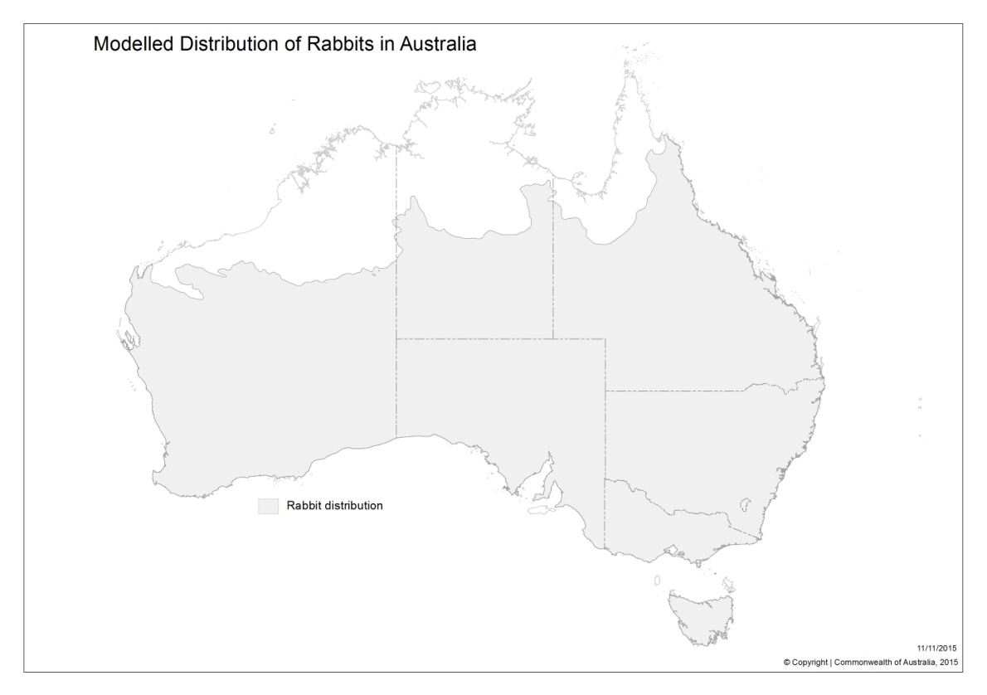

Figure 3: Distribution of rabbits in Australia. Note: this distribution is based on modeling using climate parameters and records of rabbit occurrence (Commonwealth of Australia 2015).

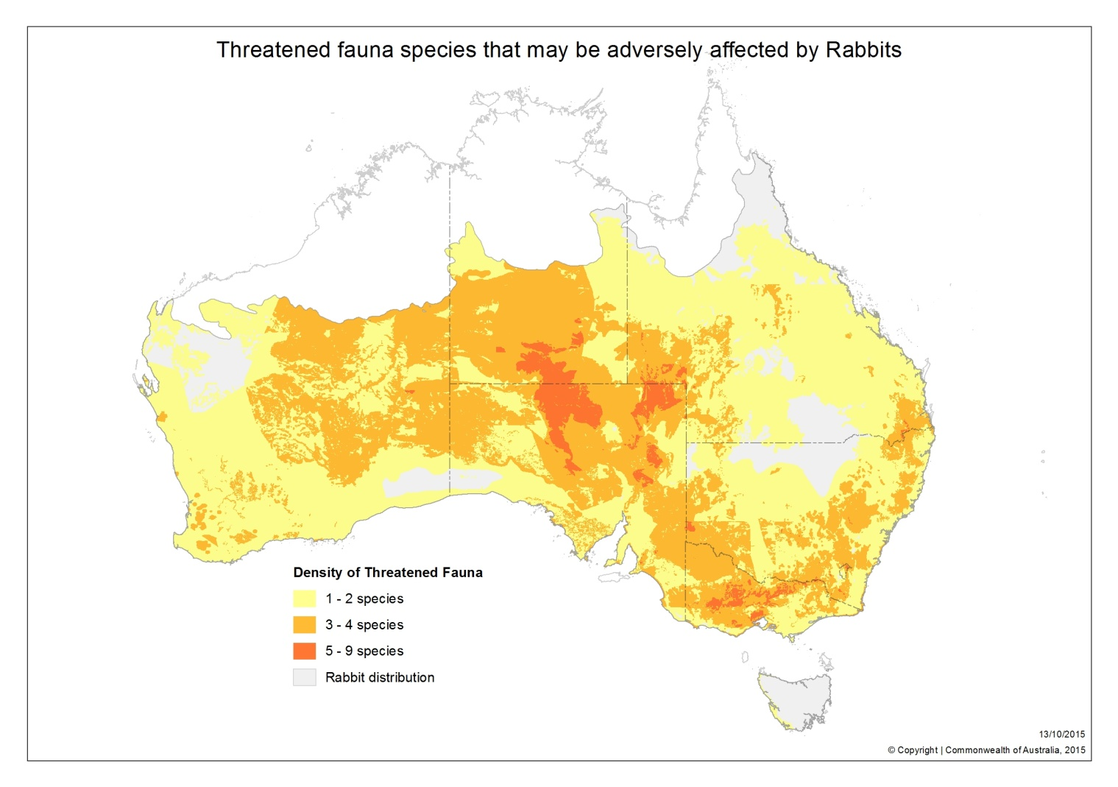

Figure 4: Rabbit distribution and locations of threatened fauna (animal) species that may be adversely affected by rabbits (Commonwealth of Australia 2015). Rabbit distribution includes areas indicated for threatened species densities and grey areas.

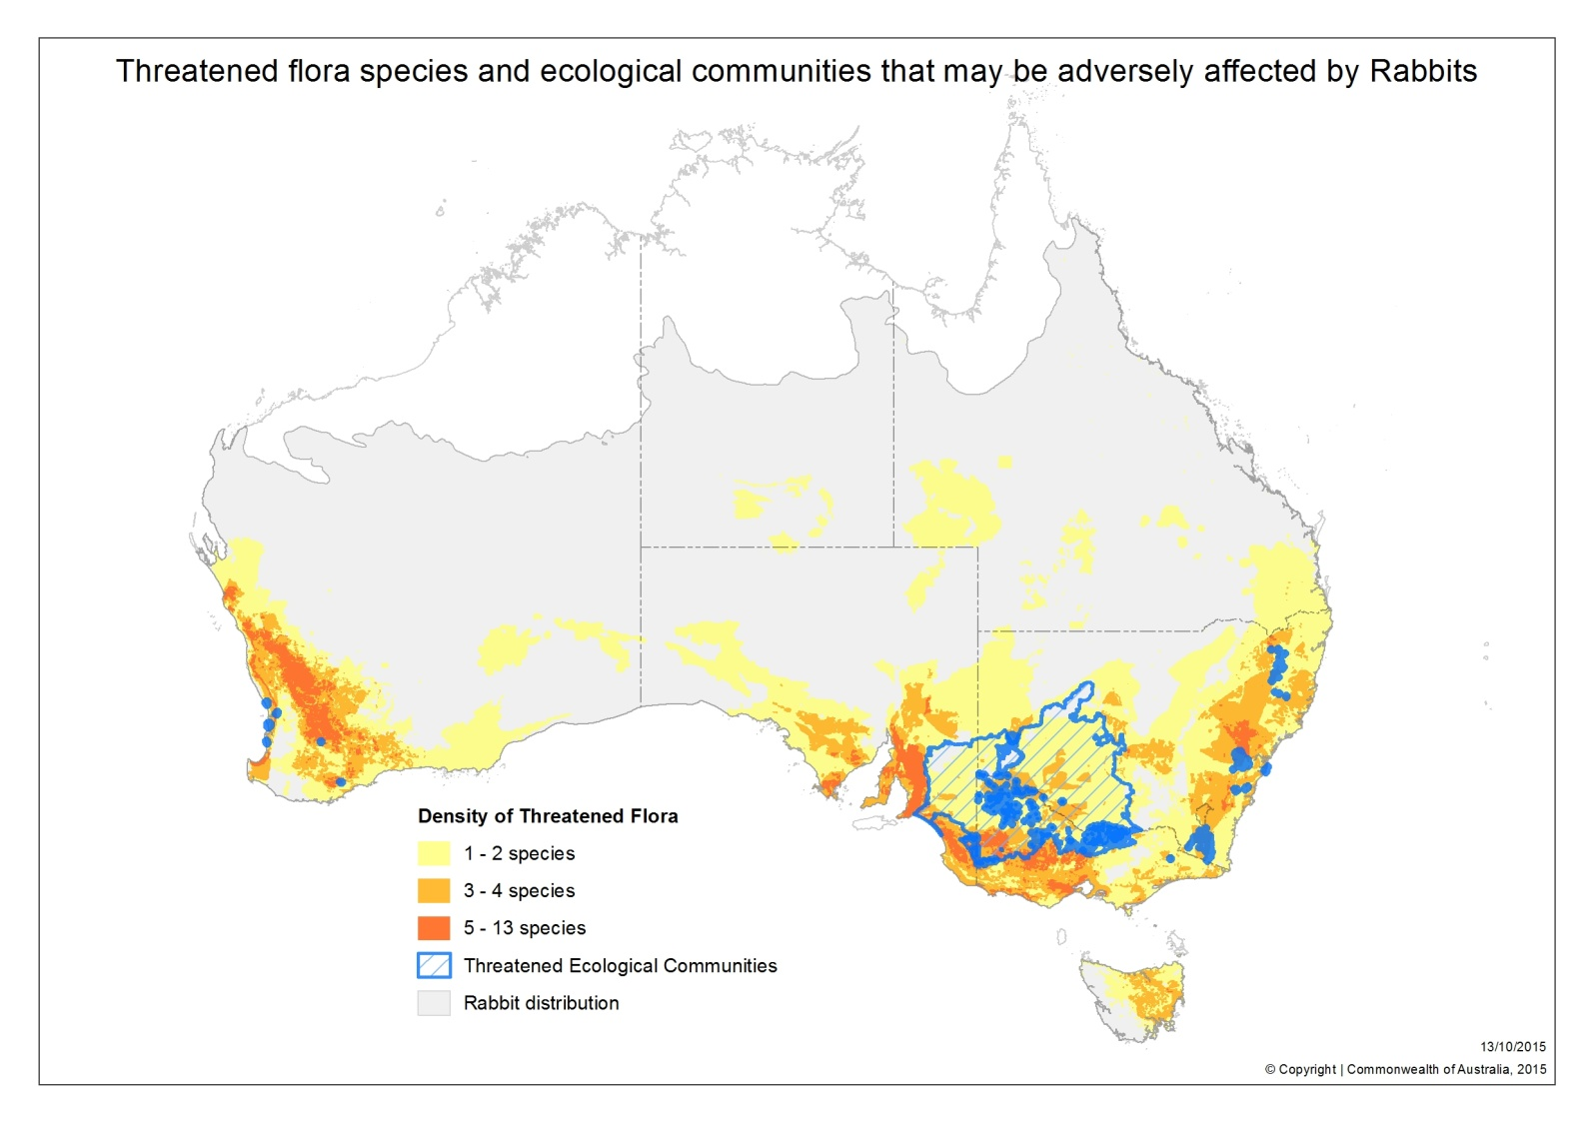

**Figure 5**: Rabbit distribution and locations of threatened flora (plant) species and ecological communities that may be adversely affected by rabbits (Commonwealth of Australia 2015). Rabbit distribution includes areas indicated for threatened species densities, ecological communities and grey areas.