Application to add Drosophila eugracilis in the list of Specimens taken to be Suitable for Live Import

*Submitted by* Lecturer, The Australian National University 131 Garran Road, Acton, ACT 2601

@anu.edu.au

We are requesting Drosophila eugracilis to be added to the list of specimens to be imported to Australia for research purpose. Fruit fly (vinegar fly) Drosophila species is one of the best- established genetic model organisms in biology. Drosophila research has over a hundred years of history that awarded six Nobel Prizes for Physiology or Medicine to date. In addition to its importance in research, a number of different fruit flies have been cultured in many countries across the globe and there has been no significant evidence of ecological and environmental impacts caused by introducing exotic Drosophila species to the laboratories. About twenty Drosophila species have been previously assessed for their potential risks of introducing to Australia, and they are in the list of specimens to be imported to Australia since 2001. Most other Drosophila species that are not listed have little difference in their habitat requirement, reproduction capacity, and potential impacts on Australia’s wild life and agriculture.

Here are the pictures of male and female Drosophila eugracilis. They are readily distinguishable from each other (photos courtesy of Dr Masayoshi Watada, Ehime University). Males are thinner than females and have a dark spot at the tail of the abdomen.

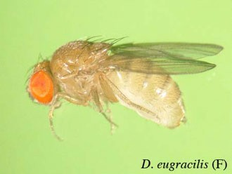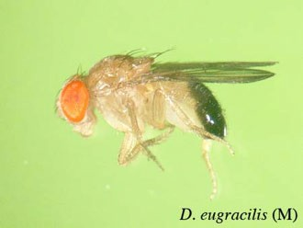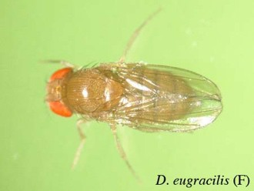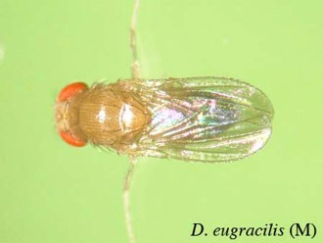

# Provide information on the taxonomy of the species

Family: Drosophilidae Genus: Drosophila

Species: Drosophila eugracilis

# Provide details on the way in which the species should be kept, transported and disposed of in accordance with the types of activity that the species will be used for if imported into Australia.

* + Drosophila eugracilis live flies will be imported from Drosophila resource centres in Japan (<http://shigen.nig.ac.jp/fly/kyorin/)>or in USA (https://www.drosophilaspecies.com).
  + Drosophila eugracilis will be used for research purpose only. We will study the mechanism of genome evolution by examining the gene expression and the tissue anatomy of the species.
  + Animals are doubly contained at all time during the transportation; primarily in a plastic vial with a cotton plug, and secondarily in a larger box, for example a standard shipping cardboard box. Animals will be firstly imported to the local Approved Arrangements (AA)-Accredited quarantine facility. After the pest infection is monitored, animals will be transferred to the Physical Containment 2 (PC2) animal facility while animals being doubly contained during the transportation. Both the AA- Accredited facility and the PC2 animal facility are credited to use exotic animal species in the academic research environment. Persons who enter these facilities are appropriately trained and aware of the risks of potential release to the environment. Both facilities must have the anteroom where an accidental release of animals will be checked and contained.
  + In an extremely unlikely scenario where animals are found outside the AA- Accredited or the PC2 facilities, the facility manager will be informed and reinforce the risk mitigation procedure to all members of the laboratory who have access to these facilities.
  + Surplus animals are killed either by freezing or by heating at 90C for one hour in doubly contained plastic bags inside the AA-accredited or PC2 facility. Bags are brought to outside the facility to be autoclaved and incinerated.

# Provide information on, and the results of, any other environmental risk assessments undertaken on the species both in Australia and overseas, including any Import Risk Analyses.

* + Drosophila eugracilis is not internationally considered as a harmful pest species. The list of species that are considered invasive in various regions in the world can be found from the website of United States Department of Agriculture (https://www.invasivespeciesinfo.gov). Drosophila eugracilis is not named in the list.

# Provide an analysis of the overall potential impacts on the Australian environment should the species escape containment, including a statement on the likelihood that the species could become an environmental pest.

* + The impacts of the release of Drosophila eugracilis on the Australian environment are considered very little. Most Drosophila species including Drosophila eugracilis live on decaying plant materials and feed on the microbial community1. Hence, it is unlikely that they do any harm on agricultural plants and crops or other animals.

# What conditions or restrictions, if any, could be applied to the import of the species to reduce any potential for negative environmental impacts (e.g. single sex imports, desexing animal prior to import etc.).

* + The species will be kept across generations for the research purpose. Therefore, they should not be desexed, and single sex imports are not appropriate.

# Provide a summary of the proposed purpose of import, including why this species has been chosen for import and details of the research facilities.

* + is the principal investigator at the John Curtin School of Medical Research at the Australian National University.
  + Drosophila eugracilis will be kept in the AA-accredited quarantine facility or in the PC2 animal facility in the John Curtin School of Medical Research.
  + As outlined in the section 2, animals will be kept in the plastic vials at all time. When doing the experiments, animals are taken out from the vials and laid still on the CO2 gas pad. There is very little chance of them escaping. In case they escape, they will be captured by insect zappers situated inside the facility or they will die by starvation because there is no food source in the facility. Insect zappers are also located in the anteroom situated between the facility and outside. Animals are killed inside the plastic vial by freezing or heating at 90C. The freezer and the heating oven are located inside the AA-accredited and the PC2 animal facility.
  + Drosophila is one of the best genetic model organisms. Drosophila eugracilis uniquely forms its own subgroup within the Drosophila melanogaster group2. Therefore, studying Drosophila eugracilis will provide great insights into the mechanism of speciation and the genome evolution.
  + Individual Drosophila eugracilis specimens will not be able to be identified or tracked through the import process.

1. **Provide information on the status of the species under the following international conventions.**
   * Drosophila eugracilis is not listed in CITES Appendices I, II or III.
   * Drosophila eugracilis is not listed in IUCN.
   * Drosophila eugracilis is not listed in CMS.
2. **Provide information about the ecology of the species.**
   * The lifespan of Drosophila eugracilis adults is reported to be between 40 to 50 days for both females and males3. About the same lifespans are observed for most other Drosophila species.
   * There is no detailed information of the body weight and size of Drosophila eugracilis adult flies. However, most Drosophila species are about the same size and weight4. Based on the information of Drosophila melanogaster5, it is expected that both

females and males of Drosophila eugracilis are sized between 2 to 3 mm including wings, and they weigh about 100 ~ 160mg.

* + Drosophila eugracilis has been found in humid tropical to subtropical climates in Australia/Indomalaya regions6. Below map (taken from http://evolution.ibmc.up.pt) shows sites (yellow circles) where the species has been identified and regions that are predicted to be suitable for survival (coloured in red).

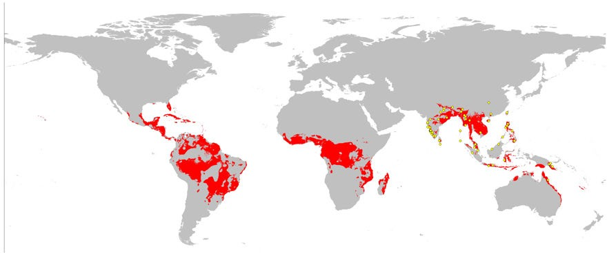

* + Drosophila eugracilis can feed on decaying plants of all sorts. They feed on the microbial community (bacteria, moulds, and yeasts) responsible for decomposition1.
  + Drosophila species are largely solitary and have very limited social behaviours7,8. No aggressive behaviours or any behavioural traits that would harm humans or domesticated animals have been reported. Zebra jumping spiders and Chinese mantis are among the known natural predators of Drosophila species9.

1. **Provide information on the reproductive biology of the species:**
   * Drosophila males become sexually mature after 0 to 19 days of eclosion while females take 0 to 6 days before they can fertilise10.
   * A single fertilised Drosophila female can lay up to 500 to 1000 eggs for her life in the laboratory setting (about 30 days of reproductive period)11 although it is expected that they reproduce considerably less in the wild. Drosophila females can store sperms for a couple of weeks after a single episode of mating12.
   * When a female animal mates with a male animal from a different species, the male progeny becomes infertile. This phenomenon is called “hybrid dysgenesis” and is commonly observed between different Drosophila species. This is caused by difference in the repertoire of transposable elements and their counteracting RNA molecules or by the sex chromosome linked toxin-antitoxin system that is highly diverged between species13,14.
   * Female Drosophila lay unfertilised eggs, but they do not develop to become larvae11. Hermaphroditism has been documented only for a few insect species, not including fruit flies15.
2. **Provide information on all other Commonwealth, state and territory legislative controls on the species and proposed research, including any state/ territory risk assessments of the species available.**
   * Drosophila eugracilis is not registered as the potential invasive alien species for the European Union including the United Kingdom (https://ec.europa.eu/environment/nature/invasivealien/list/index en.htm), or Canada ([http://habitattitude.ca/home-2/).](http://habitattitude.ca/home-2/))
   * To the best of our knowledge, no control measures are installed in any countries to regulate the transportation of Drosophila eugracilis or research using this species.

References

1. Markow, T. & O'Grady, P. Reproductive ecology of Drosophila. *Functional Ecology* **22**, 747-759, doi:10.1111/j.1365-2435.2008.01457.x (2008).
2. O'Grady, P. M. & DeSalle, R. Phylogeny of the Genus. *Genetics* **209**, 1-25, doi:10.1534/genetics.117.300583 (2018).
3. YOON, J. S., GAGEN, K. P. & ZHU, A. L. Longevity of 68 species of Drosophila. *Ohio journal of science* **90**, 17 (1990).
4. Bolstad, G. H. *et al.* Complex constraints on allometry revealed by artificial selection on the wing of Drosophila melanogaster. *Proc Natl Acad Sci U S A* **112**, 13284-13289, doi:10.1073/pnas.1505357112 (2015).
5. Karan, D., Morin, J., Moreteau, B. & David, J. Body size and developmental temperature in Drosophila melanogaster: Analysis of body weight reaction norm. *Journal of Thermal Biology* **23**, 301-309, doi:10.1016/S0306-4565(98)00021-7 (1998).
6. BOCK, I. DROSOPHILIDAE OF AUSTRALIA .1. DROSOPHILA (INSECTA-DIPTERA).

*Australian Journal of Zoology*, 1-105 (1976).

1. Li, W. *et al.* Chronic social isolation signals starvation and reduces sleep in Drosophila. *Nature* **597**, 239-244, doi:10.1038/s41586-021-03837-0 (2021).
2. Klibaite, U. & Shaevitz, J. W. Paired fruit flies synchronize behavior: Uncovering social interactions in Drosophila melanogaster. *PLoS Comput Biol* **16**, e1008230, doi:10.1371/journal.pcbi.1008230 (2020).
3. Parigi, A., Porter, C., Cermak, M., Pitchers, W. R. & Dworkin, I. The behavioral repertoire of Drosophila melanogaster in the presence of two predator species that differ in hunting mode. *PLoS One* **14**, e0216860, doi:10.1371/journal.pone.0216860 (2019).
4. Pitnick, S., Markow, T. A. & Spicer, G. S. Delayed male maturity is a cost of producing large sperm in Drosophila. *Proc Natl Acad Sci U S A* **92**, 10614-10618, doi:10.1073/pnas.92.23.10614 (1995).
5. Hanson, F. B. & Ferris, F. R. Vol. 54 485 - 506 (Journal of Experimental Zoology, 1929).
6. Manier, M. K. *et al.* Resolving mechanisms of competitive fertilization success in Drosophila melanogaster. *Science* **328**, 354-357, doi:10.1126/science.1187096 (2010).
7. Bozzetti, M. P. *et al.* The "Special" crystal-Stellate System in Drosophila melanogaster Reveals Mechanisms Underlying piRNA Pathway-Mediated Canalization. *Genet Res Int* **2012**, 324293, doi:10.1155/2012/324293 (2012).
8. Khurana, J. S. *et al.* Adaptation to P element transposon invasion in Drosophila melanogaster. *Cell* **147**, 1551-1563, doi:10.1016/j.cell.2011.11.042 (2011).
9. Mongue, A. J. *et al.* Sex, males, and hermaphrodites in the scale insect Icerya purchasi. *Evolution*, doi:10.1111/evo.14233 (2021).