|  |  |
| --- | --- |
|  | DSEWPaC research projects 2010–11  Global and Australian emissions of ozone depleting substances  Paul Fraser, Paul Krummel, Bronwyn Dunse, Paul Steele, Nada Derek  and Colin Allison  September 2011  Australian Government Department of Sustainability, Environment, Water,  Population and Communities |
|  | |



DSEWPaC research projects 2010–11

Global and Australian emissions of ozone depleting substances

Paul Fraser, Paul Krummel, Bronwyn Dunse, Nada Derek and Colin Allison

The Centre for Australian Weather and Climate Research  
A partnership between CSIRO and the Bureau of Meteorology

September 2011

Copyright and disclaimer

© 2011 CSIRO and the Bureau of Meteorology.

ISBN: 978-1-921733-56-7

To the extent permitted by law, all rights are reserved and no part of this publication covered by copyright may be reproduced or copied in any form or by any means except with the written permission of CSIRO and the Bureau of Meteorology.

CSIRO and the Bureau of Meteorology advise that the information contained in this publication comprises general statements based on scientific research. The reader is advised and needs to be aware that such information may be incomplete or unable to be used in any specific situation. No reliance or actions must therefore be made on that information without seeking prior expert professional, scientific and technical advice. To the extent permitted by law, CSIRO and the Bureau of Meteorology (including each of its employees and consultants) excludes all liability to any person for any consequences, including but not limited to all losses, damages, costs, expenses and any other compensation, arising directly or indirectly from using this publication (in part or in whole) and any information or material contained in it.

This document has been prepared by the Centre for Australian Weather and Climate Research (CAWCR). CAWCR is a partnership between Australia’s leading atmospheric and oceanographic research agencies: the Bureau of Meteorology and CSIRO.

Contents

1. Introduction 1

2. Global CCl4 Concentrations and Emissions 1

3. Australian CCl4 emissions 3

4. Australian CCl4 sources 7

4.1. Urban CCl4 measurements 7

4.2. Landfills 8

4.3. Bushfires 10

4.4. Soils 11

4.5. Coal burning 11

4.6. Major non-urban CCl4 events 12

5. Global and Australian HCFC emissions 13

5.1. Global HCFC-22 13

5.2. Australian HCFC-22 emissions 15

5.3. Global HCFC-124, -141b, -142b 17

5.4. Australian HCFC-124, -141b, -142b 18

6. Global and Australian methyl bromide emissions 20

7. n-Propyl bromide (n-PrBr) 22

8. Australian sulfuryl fluoride emissions 23

9. Conclusions 25

10. References 27

**List of figures**

**Figure 1.** Global concentration of CCl4 from AGAGE observations 2

**Figure 2.** Global CCl4 emissions from AGAGE global data compared to scenarios  
 that reflect likely adherence to the Montreal Protocol 3

**Figure 3.** Baseline (red) and total (black) AGAGE GC-ECD CCl4 observations   
(ppt: part per 1012 molar) at Cape Grim, Tasmania. 4

**Figure 4.** Australian CCl4 emissions estimated by ISC and NAME from Cape Grim data,   
1994–2008. 6

**Figure 5.** Aspendale and Cape Grim CCl4 observations 7

**Figure 6.** Aspendale CCl4 observations (ppt): 2006–10, showing distinct CCl4   
pollution episodes 8

**Figure 7.** Air mass back-trajectories to Aspendale in 2006, 2007, 2010 for four typical   
CCl4 pollution episodes. 9

**Figure 8**. Trace gas enhancements in a ‘pure’ bushfire plume (i.e. a plume that is not   
contaminated with urban air) seen at Cape Grim, Tasmania, 26–27 February 1995 11

**Figure 9.** Trace gas enhancements in a ‘pure’ bushfire plume seen at Cape Grim. 11

**Figure 10.** CCl4 concentration measures in ambient atmospheric and water well head-space   
air samples from Otway, Victoria, a site used formerly to extract natural gas. 13

**Figure 11.** Annual average HCFC-22 concentrations (up to 2009) measured in background   
air from the southern hemisphere 14

**Figure 12.** Global HCFC-22 emissions (kilotonnes per year) from AGAGE global data   
(including Cape Grim) compared to emission scenarios used in past. 15

**Figure 13.** Cape Grim monthly mean HCFC-22 (ppt): *in situ* and air archive data 16

**Figure 14.** Australian HCFC-22 consumption (DSEWPaC data) and emissions 16

**Figure 15.** Annual average HCFC-124, -141b and -142b concentrations (up to 2009) 17

**Figure 16**. Global HCFC-141b and -142b emissions (kilotonnes per year) from AGAGE   
global data (including Cape Grim) compared to emission scenarios used in past 18

**Figure 17.** Australian HCFC-124, -141b and -142b consumption 19

**Figure 18.** Global and Cape Grim annual mean CH3Br concentrations 20

**Figure 19.** Methyl bromide concentrations (ppt) observed at Cape Grim 21

**Figure 20.** Global CH3Br emissions calculated top down from AGAGE CH3Br data. 21

**Figure 21.** Australian CH3Br imports and consumption 22

**Figure 22.** Sulfuryl fluoride concentrations (ppt) observed at Cape Grim 23

**Figure 23**. Melbourne/Port Phillip SO2F2 pollution episode observed at Cape Grim 24

**Figure 24**. Western Victorian SO2F2 pollution episode observed at Cape Grim 24

**Figure 25**. Cape Grim SO2F2 and SF6 concentration ‘roses’ 25

## List of shortened forms

ADS Absorption/Desorption System

AGAGE Advanced Global Atmospheric Gases Experiment

CAWCR Centre for Australian Weather and Climate Research

CBD central business district

CFC chlorofluorocarbons

GC-ECD gas chromatography-electron capture detection

GC-MSD gas chromatography mass spectrometric detection

GDP gross domestic product

Gg gigagrams

GWP global warming potential

HCFC hydrochlorofluorocarbon

ISC interspecies correlation

MATCH Multi-Scale Atmospheric Transport and Chemistry Model

MBTOC Methyl Bromide Technical Options Committee

NAME Numerical Atmospheric Modelling Environment

NOAA National Oceanic and Atmospheric Administration

ODP ozone depleting potential

ODS ozone depleting substance

ppb parts per billion molar

ppt parts per trillion molar

QPS quarantine and pre-shipment

RCP Representative Concentration Pathway

TAPM The Air Pollution Model

UNEP United Nations Environment Programme

# Introduction

The species whose emissions provide the last major uncertainties in predicting the timing of the decline in effective stratospheric chlorine, and hence stratospheric ozone recovery, are:

(i) carbon tetrachloride (CCl4)

(ii) the hydrochlorofluorocarbons (HCFCs)

(iii) methyl bromide (CH3Br) from quarantine and pre-shipment (QPS) use

(iv) the remaining chlorofluorocarbons (CFCs) and other ozone depleting substances (ODSs) in their respective ‘banks’ (that is, old equipment and landfills).

CSIRO has developed, or is developing, techniques to estimate Australian emissions for all ODSs, as well as for the new QPS fumigant sulfuryl fluoride (SO2F2). Sulfuryl fluorideis a replacement for methyl bromide, having zero ozone depletion potential (ODP) but a significant global warming potential (GWP: 4800, Muhle *et al*. 2009).

Globally, there are significant incentives to reduce the remaining emissions of ODSs as quickly as possible. If current global emissions of ODSs could be stopped by 2015 (including emissions from the banks) then effective stratospheric chlorine could be reduced by >40%, with HCFCs contributing 14%, halons 9%, CCl4 8%, CFCs 7% and CH3Br 7% (WMO 2011).

Australia’s role in reducing global emissions of ODSs is likely to be small but could provide a paradigm for identifying and possibly reducing the remaining emissions of ODSs in the developed world.

Throughout the following document, reference is made to air composition data measured at the Cape Grim Baseline Air Pollution Station in Tasmania, Australia. Cape Grim was relied upon as it is part of a worldwide network of measurement stations, and is the only one in Australia that measures unpolluted ambient air circulating in the lower southern hemisphere. It also measures polluted air from the Australian continent which often contains emissions from Melbourne, Victoria; these emissions, once estimated, can then be extrapolated to the rest of Australia on various bases (population, population density, industry type etc.).

# Global CCl4 concentrations and emissions

Global concentrations of CCl4 from atmospheric observations and scenarios of emissions expected under adherence to the Montreal Protocol (‘the Protocol’) are shown in Figure 1. At the current rate of decline (2 ppt (parts per trillion) per year, 2005–10), CCl4 in the atmosphere will cease to be a source of stratospheric chlorine around 2050–60.

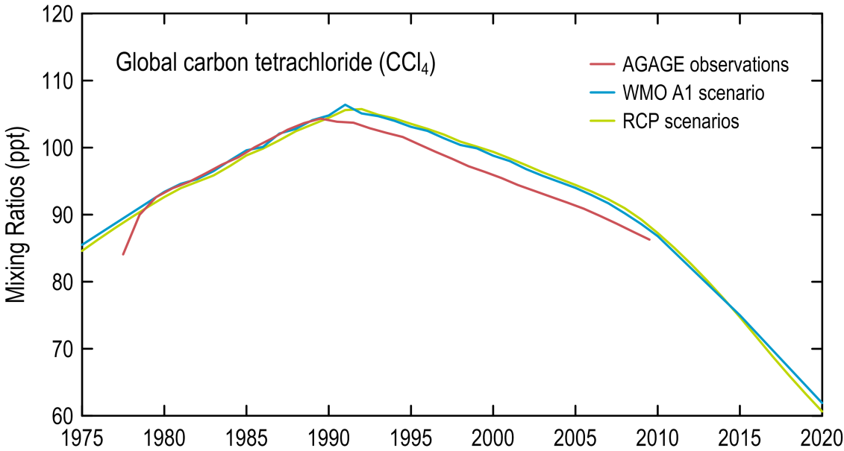

**Figure 1.** Global concentration of CCl4 from AGAGE observations (Xiao *et al*. 2010; AGAGE unpublished data) compared to concentrations expected from global adherence to the Montreal Protocol (Montzka & Reimann 2011).

Global CCl4 emissions are declining (Figure 2, Montzka & Reimann 2011). Throughout the 1970s and 1980s the emissions averaged about 130 Gg (gigagrams) (kilotonnes) per year, which declined rapidly (nearly 10% per year) in the early 1990s to about 80 Gg per year in the mid 1990s, presumably due to the rapid phase out of CFC production under the Montreal Protocol. From the mid 1990s to about 2005 the decline in CCl4 emissions slowed to about 2% per year, falling to about 70 Gg per year by 2005. The most recent data suggest that the rate of decline has increased again. The scenarios for future CCl4 emissions have emissions declining by more than 10% per year from 2005 to 2015–20. Whether such a rapid decline in emissions can be achieved is problematic. The next few years of atmospheric observations will show whether such a decline can be achieved.

By contrast, potential global emissions – calculated from production, feedstock and destruction (assumed 75% efficient) data reported to the United Nations Environment Programme (UNEP), and assuming 2% fugitive emissions – showed maximum CCl4 emissions of only 25±5 Gg per year during 2005–08 (Montzka & Reimann 2011). There are large uncertainties in the CCl4 data reported to UNEP due to confusion over reporting procedures (Xiao *et al*. 2010). If the data reported to UNEP were correct, then there must be unknown and/or misreported anthropogenic sources and/or natural sources responsible for this bottom-up/top-down discrepancy in emissions (25±5 Gg per year compared to 65±5 Gg per year over the period 2005–08).

Using AGAGE (Advanced Global Atmospheric Gases Experiment) atmospheric data and 3D inverse modelling (MATCH – Multi-scale Atmospheric Transport and Chemistry Model), Xiao *et al*. (2010) calculated global emissions of CCl4 at 74±4 kilotonnes (Gg) per year, averaged over 1996–2004 (Figure 2), with approximately 77% of global emissions coming from Asia, 9% from Africa, 7% from N. America, 4% from Europe, 3% from S. America and 0.5% (400 tonnes/yr) from Australia/New Zealand (Oceania).

Global CCl4 emissions have also been calculated from AGAGE data (1979–2008), using 2D inverse modelling (Montzka & Reimann 2011) showing good agreement with the 3D emission estimates (Figure 2). Global emissions are declining slowly (~2% per year), similar to emission scenarios reported in *Scientific Assessment of Ozone Depletion: 2010* (Montzka & Reimann 2011; Figure 2) and the emission scenarios (RCPs, Moss *et al*. 2010) to be used in the forthcoming IPCC *5th Assessment Report on Climate Change* (Figure 1). Emissions scenarios are typically tuned (that is, fine-tuned or ‘ground-truthed’ to match actual observations to ensure accuracy) to observations and then extrapolated forward, making assumptions about emissions from new production, consumption and destruction. Emissions from CCl4 banks, if they exist, could be important, but are not considered in the scenarios. For example, landfills could constitute a bank of old CCl4 whose magnitude and resultant emissions are very uncertain.

The unresolved question is this: Are the sources of CCl4 (emissions from production, emission from use to make CFCs and other chemicals and leaks from CCl4 banks) significantly larger than has been anticipated under the Protocol or are there other processes (natural and/or anthropogenic) that are released CCl4 into the atmosphere but have not been anticipated under the Protocol?

As explored below (by CSIRO) Australia reflects the global situation in its emissions of CCl4 (more than 100 tonnes per year, but significantly less than that identified by UNEP in 2009) and no identified and quantified sources that can account for these emissions. CSIRO is attempting to locate and quantify these CCl4 sources.

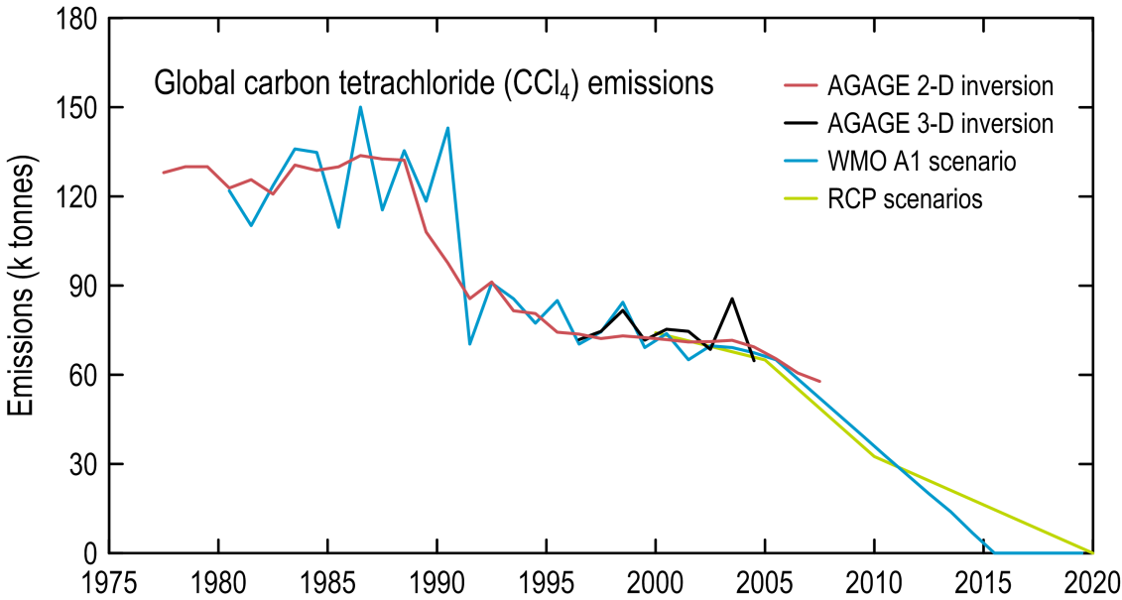

**Figure 2.** Global CCl4 emissions from AGAGE global data compared to scenarios that reflect likely adherence to the Montreal Protocol (Xiao *et al*. 2010; Montzka & Reimann 2011; RCP: <http://www.iiasa.ac.at/web-apps/tnt/RcpDb/dsd?Action=htmlpage&page=download>; Moss *et al*. 2010.

# Australian CCl4 emissions

Cape Grim Baseline Air Pollution Station in Tasmania was designed to measure the background air of the mid-latitudes of the southern hemisphere. It achieves this under so-called ‘baseline’ conditions, when the air arrives at Cape Grim after traversing the Southern Ocean (about 40% of the time). A significant fraction of the air arriving at Cape Grim comes from the Australian continent and contains information about the sources and sinks of ODS and greenhouse gases from the south-east Australian region. CSIRO’s Aspendale Laboratory in Victoria also samples south-east Australian air but, in particular, is able to monitor emissions from a significant urban complex (i.e. Melbourne).

A recent report by UNEP (2009) estimated very large Australian/New Zealand emissions of CCl4 at 2500±1000 tonnes/yr for the period 1996–2004 (based on global (including Cape Grim) atmospheric observations of CCl4, with emissions calculated using inverse modelling techniques). The UNEP (2009) report was based on a preliminary version of Xiao *et al.* (2010) which, when published, actually reported significantly reduced emissions compared to the UNEP (2009) report (see below).

The modelling technique employed a first guess (*a priori*) of Australian/New Zealand CCl4 emissions and then attempted to revise the emission estimate to best fit the atmospheric observations of CCl4, in particular at Cape Grim. The first guess, or ‘prior’ Australian/New Zealand emissions estimate (1300 tonnes per year), was based on a previous estimate of global emissions assigned to Australia on a *pro rata* basis using global and Australian/New Zealand gross domestic product (GDP) data.

The Australian/New Zealand CCl4 emissions (1996–2004: 2500 tonnes per year) reported by UNEP (2009) have since been revised down in Xiao *et al*. (2010) to 400±200 tonnes per year, using an alternative prior estimate (200 tonnes per year), cognisant of the Dunse *et al*. (2005) estimate of Australian CCl4 emissions (see below). On a population basis Australian emissions, from the Xiao *et al*. (2010) estimate for Australia/New Zealand, would equate to 320±160 tonnes per year.

It is clear that the Xiao *et al*. (2010) method is critically dependent on the prior estimate of emissions, suggesting that there are not enough CCl4 observing stations in the southern hemisphere to derive an optimised (*a posteriori*) emission estimate that is significantly different than the first guess, or prior (*a priori*), estimate.

Australian urban CCl4 emissions have been estimated independently by interspecies correlation (ISC) techniques from AGAGE atmospheric observations of CCl4 and carbon monoxide (CO) at Cape Grim, Tasmania, during periods of enhanced concentration (so called ‘pollution events’) (Figure 3). The polluted air masses arrive at Cape Grim from the Australian mainland (from the Melbourne/Port Phillip region), under conditions of strong northerly winds, with the dominant pollution source (for CCl4 and CO) being the Australian city of Melbourne and the surrounding Port Phillip region (current population four million) (Dunse *et al*. 2005).

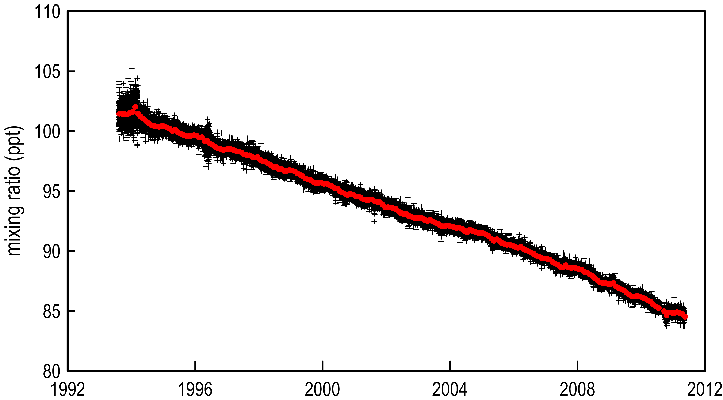

**Figure 3.** Baseline (red) and total (black) AGAGE GC-ECD CCl4 observations (ppt: part per 1012 molar) at Cape Grim, Tasmania (Xiao *et al*. 2010; Krummel *et al*.,2011).

There are two AGAGE CCl4 measurement instruments at Cape Grim. The first is based on gas chromatography-electron capture detection (GC-ECD) and has been measuring CCl4 at Cape Grim since 1978, in high precision form since 1994 (shown in Figure 3). The second is based on gas chromatography mass spectrometric detection (GC-MSD), which has operated at Cape Grim since 1998 and in high precision form since 2004. In many cases the CCl4 episodes are seen more clearly in the GC-ECD data compared to the GC-MSD data. This may be due to the noise (that is, minor additional data that could be from another source, or from uncertainties) in the GC-MSD data and also the less frequent measurements (every two hours compared with every 40 minutes for the GC-ECD). The quality of the GC-ECD CCl4 data is superior to the GC-MSD data; therefore, the emissions results from the Cape Grim GC-ECD data will be more reliable and are the results that we discuss in this report.

In 1996 the Cape Grim GC-ECD data indicated Australian urban CCl4 emissions of 140±40 tonnes per year (Dunse *et al*. 2005), assuming Australian emissions can be derived from Melbourne emissions on a population *pro rata* basis.

The CCl4 pollution episodes (1995–2010) at Cape Grim are relatively weak, with pollution episodes typically less than 2 ppt (maximum concentration, Figure 3). Estimates of annual emissions are therefore problematic using the interspecies correlation technique, which – for CCl4 – has a limit of detection of about 80 tonnes per year. The pollution data have been grouped into running three-year blocks to produce an average assigned to the middle year of each block. Over the period 1996 to 2009, Australian urban CCl4 emissions averaged 150±40 tonnes per year, based on Melbourne/Port Phillip emissions (27±5 tonnes per year) seen at Cape Grim (see Figure 4), not significantly different that the original estimate by Dunse *et al*. (2005).

A majority of air masses arriving at Cape Grim, carrying pollution information from the mainland, pass over Melbourne/Port Phillip, while a minority pass over the Latrobe Valley. When the CCl4 emissions are calculated for the Latrobe Valley air masses they are enhanced typically by about 15% but in some years (1996, 2001, 2002) by as much as 70%. Considering the relative populations of the Latrobe Valley and Melbourne/Port Phillip, this is not an emission that is proportional to population. It appears to be a Latrobe Valley-specific emission, which could be from coal burning (A McCulloch, Uni. Bristol, UK, private communication). If we, the authors, assume that about 50±10% of Australia’s coal burning occurs in the Latrobe Valley and the CCl4 emission factors for brown- and black-coal burning are approximately the same, then Australian coal burning could account for about 7±3 tonnes per year of CCl4.

Total Australian CCl4 emissions, from urban sources and coal burning, are 157±45 tonnes per year (1996–2009) and 150±30 tonnes per year (1996–2008).

Australian emissions of CCl4 in 2009 appear unusually large, but with such a large uncertainty no significant trend in CCl4 emissions can be deduced. This appears to be the case for the entire CCl4 emissions record as deduced from Cape Grim data; that is, no significant trend over the period 1996 to 2009.

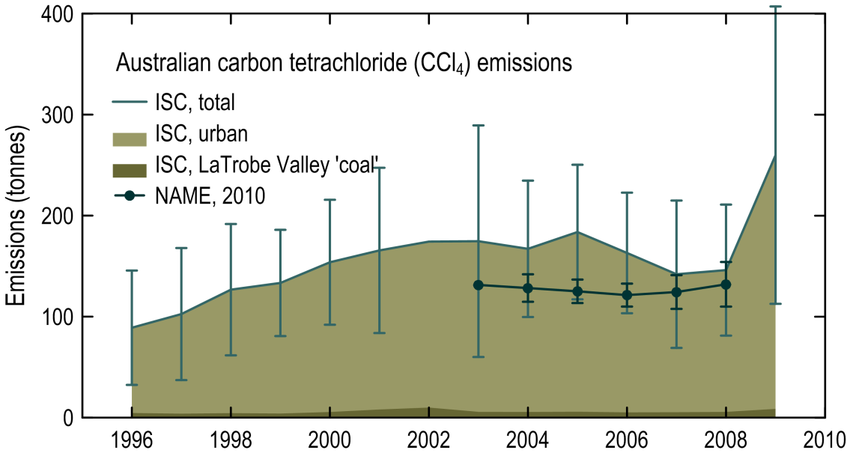

**Figure 4.** Australian CCl4 emissions estimated by ISC and NAME from Cape Grim data, 1994–2008.

Australian CCl4 emissions have been estimated (A Manning, UK Met. Office, unpublished data) at 127±4 tonnes per year (2003–2008) from Cape Grim GC-ECD data using the UK Meteorological Office Lagrangian disperion model (Numerical Atmospheric Modelling Equipment, or NAME: Manning *et al*. 2011); that is, the figures are smaller than, but not statistically different from, the ISC estimate of 150±30 tonnes per year over the same period.

In summary, the ISC and NAME estimates of current Australian CCl4 emissions are 140±35 tonnes per year, lower than the 320±160 tonnes per year estimated in Xiao *et al*. (2010), but similar to the estimate for the 1990s using ISC techniques (Dunse *et al*. 2005).

Australian CCl4 production and consumption data were 120 tonnes in 1992, declining to <5 tonnes in 1998, as reported to UNEP by Australia under the requirements of the Vienna Convention/Montreal Protocol (<http://ozone.unep.org/Data_Reporting/Data_Access>).

Australia, like the rest of the world, is reporting production/consumption data to UNEP that are significantly lower than emissions calculated from atmospheric data. This may be because Australian emissions are coming from banks (‘old’ production not previously released to the atmosphere through, for example, landfills) and not from ‘new’ CCl4 production or imports (is the emissions that are reported to UNEP). This may not be the case for CCl4 emissions outside Australia, where, for example there may be some unreported or even illegal production and consumption of new CCl4.

The ISC and NAME methods largely capture CCl4 emissions from the Melbourne/Port Phillip/Latrobe Valley region and these are then scaled to Australia on a population/coal consumption basis. If there exist significant other non-urban CCl4 emissions, then these methods could underestimate Australian emissions.

Australian CCl4 emissions are about 140 tonnes per year, presumably from landfills and other CCl4 contaminated sites (see below). For most synthetic chemicals (HFCs, HCFCs, SF6 etc.), Australia accounts for 0.5–1.5% of global emissions (CSIRO, unpublished data). If this relationship holds true for CCl4 from landfills, then the global emissions from this source could be 10–30 kilotonnes. As noted above, the difference between so-called ‘top down’ and ‘bottom up’ estimates of global CCl4 emissions is 40±10 kilotonnes. A significant fraction of this difference could be due to global emissions from landfills and other contaminated sites.

# Australian CCl4 sources

Since reported Australian imports for the last decade or more are effectively zero (<5 tonnes per year), the question arises: Where does the 140±35 tonnes per year come from? Are there any non-urban CCl4 sources? We have examined some potential sources below.

## Urban CCl4 measurements

CCl4 has been measured quasi-continuously at CSIRO Aspendale, 25 kilometres south-east of the Melbourne central business district (CBD) on two GC-MSD instruments: Medusa (Krummel *et al*. 2006; Miller *et al*. 2008) and ADS (Sturrock *et al*. 2001). The data are shown in Figure 5, together with Cape Grim data from Figure 3.

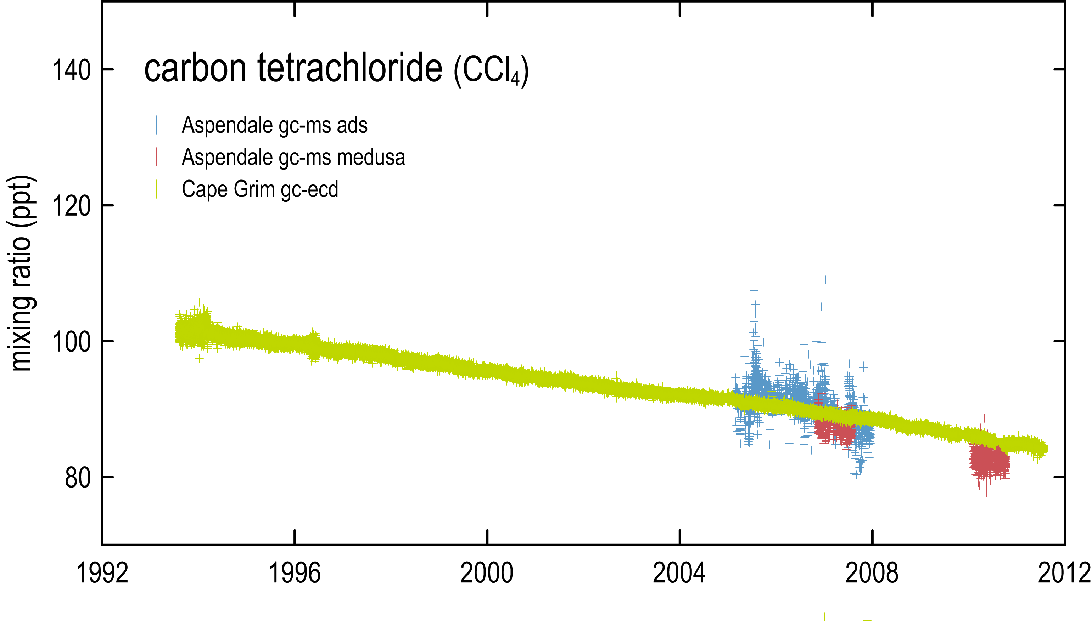

**Figure 5.** Aspendale (blue: GC-MSD-ADS; red: GC-MSD-Medusa; CSIRO unpublished data) and Cape Grim (green: GC-ECD; Xiao *et al*. 2010; Krummel *et al*. 2011) CCl4 observations (ppt).

The Cape Grim CCl4 data (GC-ECD) exhibit better precision than the Aspendale data (GC-MSD); nevertheless, the Aspendale data are consistent with the long-term downward trend seen in the Cape Grim data. The CCl4 pollution episodes (up to 4–5 ppt above baseline, Figure 5) are more obvious in the Aspendale data compared to the Cape Grim data (1–2 ppt above baseline). This is because Aspendale is closer to the CCl4 source(s), which are presumably within or close to the Melbourne/Port Phillip region.

Figure 6 shows 2006–10 GC-MSD-Medusa data from Aspendale, with four typical CCl4 pollution episodes, showing 4–5 ppt CCl4 enhancements above baseline.

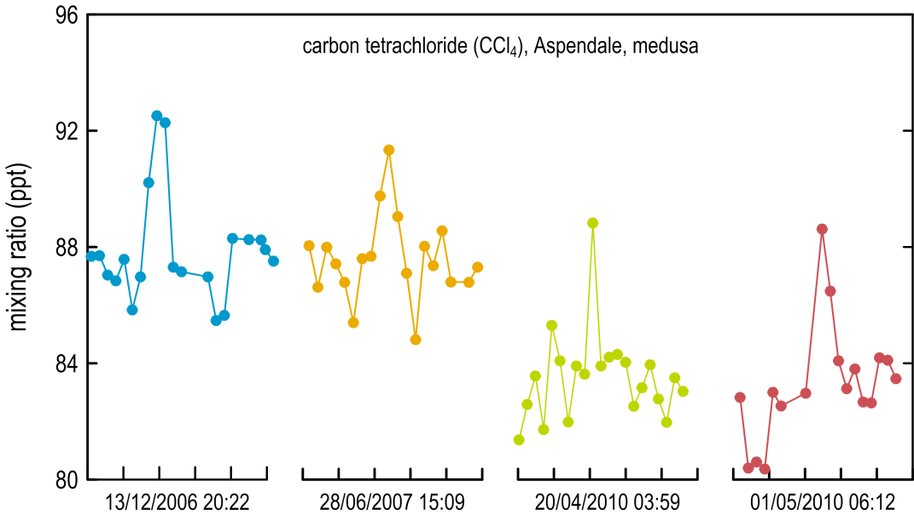

**Figure 6.** Aspendale CCl4 observations (ppt): 2006–10, showing distinct CCl4 pollution episodes (13 December 2006, 28 June 2006, 20 April 2010, 1 May 2010).

For these episodes seen at Aspendale in 2006, 2007 and 2010, the last 5–10 hours of 96-hour air mass back-trajectories to Aspendale are shown in Figure 7. Also shown in Figure 7 is the CCl4 ‘rose’ concentration pattern as seen at Aspendale, using the average of GC-MSD-Medusa data and the wind direction data from the closest Bureau of Meteorology meteorological site (Moorabbin Airport). The rose is obtained by subtracting the baseline monthly mean (Cape Grim) from each CCl4 observation at Aspendale (in the appropriate month) and binning the resultant concentration differences into 9o sectors (40 bins in total). The concentration rose suggests that three source regions (north-west, north-east and south-east of Aspendale) are potentially impacting on the CCl4 observations. All four trajectories enter the Melbourne/Port Phillip air shed from the north-western sector, suggesting that this sector is the most important source region for the larger pollution episodes seen at Aspendale. Three trajectories arrive directly at Aspendale from the north-western sector and one from the south-western sector (after entering the air shed from the north-west).

Also shown in Figure 7 is the concentration rose for HFC-134a (CH2FCF3), which is released into the atmosphere largely from automobile air conditioners and domestic/commercial refrigeration. The rose is consistent with the HFC-134a sources being distributed over Melbourne and its suburban environs and does not show the distinctive north-western source region typical of CCl4.

It would appear that CCl4 is released into the Melbourne/Port Phillip air shed predominantly in the north-western sector where there are a number of facilities (see below) for treating and disposing of toxic waste.

## Landfills

Environmental Protection Authority Victoria (the EPA) (M Bannister 2011, private communication) has identified five sites currently containing CCl4 contaminated soil: Victoria Park; South Yarra; South Melbourne; Footscray (20–30 kilometres north-north-west of Aspendale); and at the former toxic waste facility at Tullamarine (45 kilometres north-north-west of Aspendale). All five contaminated sites are in the north-western sector with respect to Aspendale (Figure 7) and could potentially be sources of atmospheric CCl4 pollution.

The five waste processing sites for Melbourne’s toxic waste are located at: Lyndhurst and Dandenong South (10–15 kilometres east-south-east of Aspendale); Laverton North and Brooklyn (35–45 kilometres north-west of Aspendale; and Corio (60 kilometres west of Aspendale). All processing sites, except Corio, are located in the north-western or south-eastern sectors with respect to Aspendale (Figure 7) and are potential sources of CCl4 pollution.

The Aspendale CCl4 data suggest that some CCl4 pollution arrives at Aspendale from the north-eastern sector. This sector contains the major waste receiving sites at Clayton (Figure 7) and Springvale South (not shown), 7–8 kilometres north-north-east of Aspendale. Although the EPA has indicated that the Clayton and Springvale South facilities are not currently licensed to receive toxic waste, these landfill sites (or adjacent sites) have been in operation for many years and may have received CCl4 contaminated waste earlier than the period of their current licences (before the mid 1990s).

|  |  |
| --- | --- |
| asa-medusa CCl4 HFC134a wind rose on map | **Figure 7.** Air mass back-trajectories to Aspendale in 2006, 2007, 2010 for four typical CCl4 pollution episodes (Figure 6: December 2006, June 2007, April 2010, May 2010); Aspendale CCl4 (yellow)and HFC-134a (green) concentration (ppt) ‘roses’ (see text); EPA identified CCl4 contaminated sites and waste collection sites licensed to handle Melbourne’s toxic waste, including solvents such as CCl4. |

The largest current CCl4 contaminated site in the Melbourne region, as identified by EPA Victoria, is a former textile mill site adjacent to Victoria Park, Abbotsford. The site used to contain an underground tank for holding dry-cleaning solvents, which likely included CCl4 (modern dry-cleaning uses perchloroethylene, C2Cl4). Approximately 1500 tonnes of contaminated soil have been identified at this site and are being removed to Corio (last shipment June 2011).

A total of 28 tonnes of CCl4 contaminated soil have been identified at a council depot (Stonnington, ex-Prahran) in South Yarra; 34 tonnes of CCl4 contaminated soil have been identified in South Melbourne. Other CCl4 contaminated sites have been identified in Footscray (adjacent to the Fish Market, 1–2 kilometres west of the CBD) and at Tullamarine, the site of a former toxic waste landfill operation. The amounts of contaminated soil at these latter two sites have not been estimated to date.

The former landfill site at Tullamarine shows atmospheric and vent pipe concentrations of CCl4 at <0.4 ppb (parts per billion) and <1.2 ppb respectively (M Bannister, EPA Victorian, 2011, private communication).

The details of the five sites around Melbourne that can receive, treat and dispose of toxic liquid waste and contaminated soil are given below. Depending on the level of CCl4 contamination, the soil may be heated before disposing to landfill at these sites.

The five sites are:

* Taylors Road, Lyndhurst: waste is treated or buried in lined cells, then covered with soil. This site takes Melbourne’s highest level toxic waste.
* Veolia, McDonald Road, Brooklyn. This site takes the largest amount of Melbourne’s largest toxic waste.
* Trans-Waste Technologies, Ordish Road, Dandenong South.
* Dolomatrix, Dohertys Road, Laverton North.
* City of Geelong waste disposal site, Bell Road, Corio.

We have conducted a three-year experiment at the Rye landfill (Figure 7), south of Melbourne, and have measured small fluxes of CCl4 emanating from the cover soil of the landfill. In addition we have measured the composition of the landfill gas at Rye (0.2 ppb CCl4) used to fuel a modified diesel-powered generator to produce electricity. There is no CCl4 in the exhaust gas, indicating complete CCl4 destruction in the gas-powered diesel engine, which is not surprising given combustion temperatures of ~1000 oC are expected in the engine. Even if we assume that all of the landfill gas at Rye escaped into the atmosphere (i.e. was not combusted), and assumed the same for all Australian landfills, the CCl4 emission would amount to probably less than 0.1 tonne per year. Hence it would appear, based on this one study, that modern landfills are not a significant source of Australian CCl4 emissions.

We have commenced an atmospheric monitoring program (flask samples) to approximately define the ambient CCl4 concentrations at the five soil-contaminated and toxic waste sites identified above. Once the data are assembled we will be able to ascertain whether the CCl4 levels at these sites are large enough to influence CCl4 measurements at Aspendale and at Cape Grim and may then be able to make a judgement whether these are the likely sources of the emissions of CCl4 (~25 tonnes per year) from the Melbourne/Port Phillip region.

The first results were obtained in September 2011 for the Lyndhurst site. From five samples collected near Lyndhurst, and the ongoing monitoring of CCl4 at Aspendale, the Lyndhurst upwind (72±12 ppt) and downwind (81±11 ppt) concentrations suggest that this is a source of CCl4 on the day tested, with, on average, the air exiting the Lyndhurst site with ~9 ppt enhancement of CCl4 compared to air entering the site. This is significantly larger than the CCl4 pollution seen at Aspendale from this south-eastern sector (0.6 ppt). Note that the number of samples taken thus far (5) is small and uncertainties of the average ‘upwind’ and ‘downwind’ concentrations overlap. It is anticipated that these uncertainities will be reduced with further sampling. It would appear that the Lyndhurst facility is a source of CCl4 emissions to the Melbourne atmosphere.

## Bushfires

We have examined a number of episodes at Cape Grim when bushfire plumes impinge on the station. It is difficult to obtain examples of plumes from mainland south-eastern Australia fires without mixing in with Melbourne air (and hence seeing a CCl4 source which could be due to a combination of the fire and/or Melbourne non-fire emissions).

However, we have examples of Tasmanian fires from the Bass Strait islands or the Tasmanian mainland that impinge on Cape Grim and do not show the usual urban markers such as HFC‑134a (CH2FCF3). These plumes affecting Cape Grim are likely to be due to fires only. In these instances there is no evidence of any CCl4 enhancement in the bushfire plumes. We conclude that bushfires are not a significant source of CCl4 emissions. These examples are shown in Figures 8 and 9.

Although not obvious from the data, there is the suggestion that CCl4 levels in the fire plumes are slightly lower than baseline, indicating some CCl4 destruction in the fire. This will be further investigated later for a wider range of fires at Cape Grim.

|  |  |
| --- | --- |
|  |  |
| **Figure 8**. Trace gas enhancements in a ‘pure’ bushfire plume (i.e. a plume that is not contaminated with urban air) seen at Cape Grim, Tasmania, 26–27 February 1995 (purple vertical column). The large biomass burning episode (27 February) shows no enhancement in CCl4, but a very large enhancement in CO (approx. 1000 ppb). This biomass burning event was the result of a local grass fire. In contrast, on 25 February 1995 (grey vertical column) there is a Melbourne pollution event that results in elevated CCl4, CFC-12, CH4 and CO (approx. 100 ppb). | **Figure 9.** Trace gas enhancements in a ‘pure’ bushfire plume seen at Cape Grim. On 19 March 2008 (purple vertical column), there is a large biomass burning episode that shows no enhancement in CCl4, but a very large enhancement in CO (approx 3000 ppb). According to back-trajectory information this large event has not been influenced by Melbourne (urban) air. Earlier biomass burning episodes (13–18 March) have been influenced by Melbourne air and therefore show a small enhancement in CCl4. |

## Soils

A series of flux chamber experiments on the salty soils around Cape Grim (Cox *et al*. 2004) led to the discovery of copious emissions of chloroform (CHCl3) but no measurable emissions of CCl4. It would appear that biological processes in these soils use CHCl3 production to remove excess chlorine from the soil but do not produce CCl4. We could find no reference in the literature for significant CCl4 emissions from soils.

## Coal burning

As indicated above, coal burning may be a source of the elevated CCl4 that we have seen in the air that pass over the Melbourne air shed and the Latrobe Valley compared to air that passes only over the Melbourne air shed. It might be that CCl4 may be produced in the process of burning coal. We have examined pollution episodes at Cape Grim originating from the Latrobe Valley, where as much as 50% of coal burnt in Australia occurs, and found that there are CCl4 emissions that are about 15% higher than the emissions emanating purely from Melbourne.

If the 15% enhancement from the Latrobe Valley is adding to Melbourne CCl4 emissions, and if Latrobe Valley CCl4 emissions are typical of other coal-burning areas around Australia, then coal burning could be contributing about 7 tonnes per year (4%) to the 157 tonnes per year of Australian CCl4 emissions (see above).

It is difficult to be conclusive about a coal burning CCl4 source from Cape Grim data due to the proximity of the Latrobe Valley to Melbourne and the likelihood that plumes from Melbourne and the valley are mixed by the time they reach Cape Grim. In addition, one of the sites licensed to accept toxic waste from Melbourne and the Latrobe Valley is Dutson Downs, located in the Latrobe Valley.

The best way to answer the question about the contribution of coal burning to CCl4 emissions will be to obtain direct stack or plume samples from the Latrobe Valley’s power stations. We are continuing to try to secure exhaust gas samples from brown– and black–coal-fired power stations.

The Aspendale data may be more useful in identifying CCl4 emissions from brown coal combustion from the Latrobe Valley (~120 kilometres east-south-east of Aspendale) and Anglesea (100 kilometres south-west of Aspendale). As indicated above (Figure 7) the sector south-east of Aspendale shows elevated CCl4 levels which could originate from the close-by toxic waste facilities in this sector and/or the further removed brown coal combustion in the Latrobe Valley. There is some evidence in the Aspendale data of slightly elevated CCl4 levels in the south-western sector (Figure 7) which could conceivably be coming from the Anglesea brown-coal power station.

## Major non-urban CCl4 events

We have identified the major CCl4 pollution episodes (up to 1 ppt) seen at Cape Grim that are not from Melbourne (and therefore not in the ISC method for estimating Melbourne emissions, but may be in the NAME method) and we have used back-trajectory techniques in order to pinpoint the location and identification of possible CCl4 sources in the south-east Australian region.

From 1995 to 2010 there were 17 major CCl4 pollution episodes identified that did not originate from the Melbourne region. Back-trajectory analysis of these episodes suggests the source region to be west of Melbourne/Port Phillip, in the general direction of King Island or the Otway region.

We have examined pollution episodes at Cape Grim with back-trajectories that pass over King Island (but not Melbourne), and found the average peak intensity of these episodes (1995–2010) to be about 7% higher (0.87 ppt average) than the levels emanating from Melbourne (0.81 ppt average).

The kelp industry on King Island may be a possible source of CCl4. A paper by Rhew *et al*. (2008) suggested that Californian Bull kelp may be a small net source of CCl4, which extrapolates (with very large uncertainties) to a global source of about 100 tonnes per year. We have investigated the kelps beds around Cape Grim as a potential source of CCl4. Flux chamber studies showed significant CHCl3 emissions but no significant CCl4 emissions (see above). If we accept that there is a global kelp source of about 100 tonnes per year and Australia possesses about 3% of global coastline, then Australian kelps may be a CCl4 source of about 3±3 tonnes per year.

Another possible source of non-urban CCl4 emissions is gas wells in the Otway region as there are indications in the literature that a range of solvents, including chlorinated solvents, are or were used in the natural gas industry. We have conducted trace halocarbon measurements in the Otway region and did not find any ambient air samples showing significant CCl4 pollution (Figure 10). We also conducted some water well head-space analyses on air samples from Otway water wells; again, there were no signs of elevated CCl4 (Figure 10).

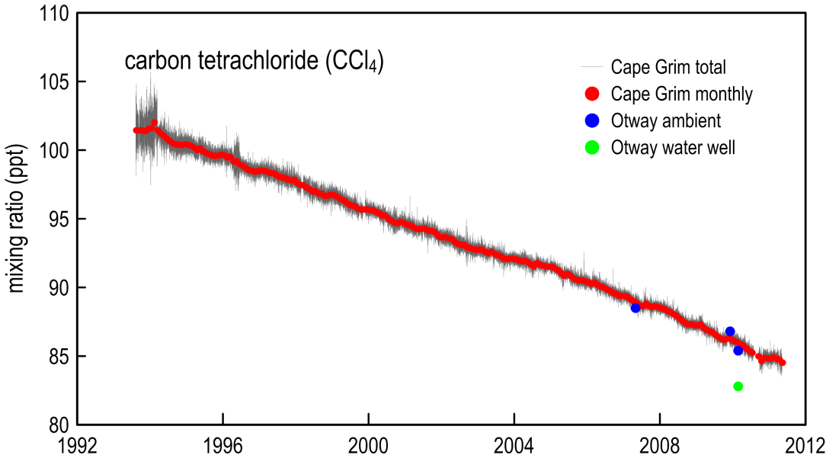

**Figure 10.** CCl4 concentration measures in ambient atmospheric and water well head-space air samples from Otway, Victoria, a site used formerly to extract natural gas.

A third possibility is the brown-coal power station at Anglesea (see above). Though relatively small compared to the Latrobe Valley power stations, it is closer and more directly in line with Cape Grim in the northerly events that bring mainland air to Cape Grim. Once we have obtained data from the exhaust stacks of coal-burning power stations we will be in a better position to comment on the possible impact that the Anglesea power station has on Cape Grim observations.

# Global and Australian HCFC emissions

The global emissions of HCFCs (which are used as CFC replacements in the refrigeration and air conditioning industries) have accelerated since ~2005 due to rapid growth of consumption in developing countries, particularly South-East Asia (Montzka & Reimann 2011). The consumption of HCFCs in Australia is declining, with imports in 2010 at about 1200 tonnes per year.

Australian HCFC-22 emissions have been estimated at very high levels (7000–9000 tonnes per year for 2005–06) from a global inversion model (Stohl *et al*. 2009). These estimated emissions seem unrealistically high and need to be tested and challenged by independent emission estimates.

CSIRO has developed an interspecies correlation technique to independently estimate south-east Australian emissions of non-CO2 greenhouse gases (Dunse *et al*. 2005), which can then be used to derive Australian emissions of HCFCs.

## Global HCFC-22

Figure 11 shows the concentration of HCFC-22, as measured at Cape Grim and in Antarctic firn air, from the 1940s to the present. HCFC-22 levels reached 188 ppt in 2009, an growth rate of 4% per year, consistent with the latest HCFC-22 emission scenario (RCP 4.5, Moss *et al*. 2010) and the previous A1 2007 scenario[1] (Daniels & Velders 2007), which has HCFC-22 levels rising in the atmosphere for decades to come, peaking beyond 2030. By contrast, the previous scenario (A1, Montzka & Fraser 2003) had HCFC-22 levels reaching a maximum as early as 2010 and then declining rapidly. The atmospheric data closely follow the RCP4.5 and A1 2007 scenarios.

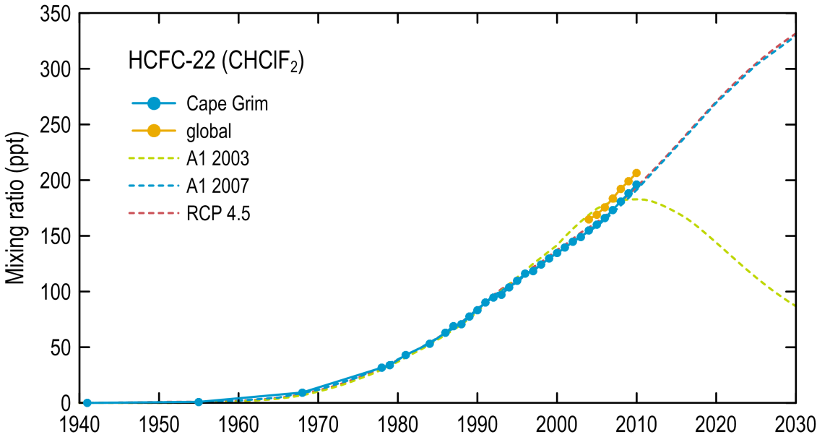

**Figure 11.** Annual average HCFC-22 concentrations (up to 2009) measured in background air from the southern hemisphere – Cape Grim, Tasmania (*in situ* and archive), and from ice-firn at Law Dome, on the Antarctic coast – and global (Prinn *et al*. 2000; Sturrock *et al*. 2002; O’Doherty *et al*. 2004; Krummel *et al.* 2011; Miller *et al*. 2010; Montzka & Reimann 2011; CSIRO, unpublished data). The lines are concentrations resulting from the previous A1 scenarios: Montzka & Fraser (2003, red) and Daniel & Velders (2007, blue) and the recent RCP 4.5 scenario (Moss *et al*. 2010, green).

Recent analysis of atmospheric HCFC-22 observations shows a shift in emissions from higher to lower latitudes in the northern hemisphere, consistent with significantly enhanced emissions from Asian countries (Montzka *et al*. 2009).

Global emissions of HCFC-22 have been derived from AGAGE data (Figure 12; Montzka & Reimann 2011). The emissions are higher than scenarios used in recent assessments of climate change and ozone depletion, but the trend in emissions from the atmospheric data is similar to the scenarios. Global emissions have accelerated since the early 2000s and exceeded 350 kilotonnes per year by 2008. The growth in emissions is anticipated to slow down after 2010. It will be informative to follow this scenario over the next few years with emissions calculated from atmospheric data.

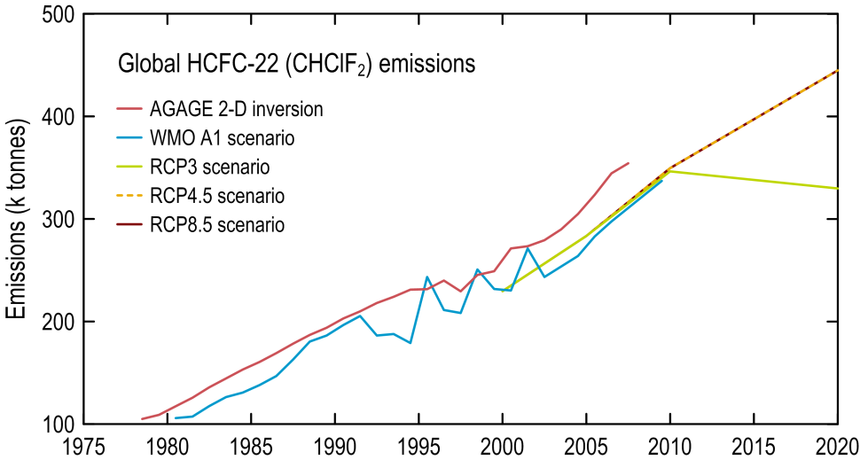

**Figure 12.** Global HCFC-22 emissions (kilotonnes per year) from AGAGE global data (including Cape Grim) compared to emission scenarios used in past (WMO A1) and to be used in future (RCPs) assessments of climate change and ozone depletion.

## Australian HCFC-22 emissions

Australian emissions of HCFC-22, calculated from Cape Grim data (Figure 13), using ISC and NAME are compared (Figure 14) to Australian emissions reported in Jubb (2002) and Energy Strategies (2008). Contrary to Jubb (2002), which estimated that HCFC-22 emissions would peak in 2003, the Cape Grim data show increasing HCFC-22 emissions increased to over 2000 tonnes per year in 2008. Over the period 2005 to 2008 the Cape Grim derived emissions are a factor of three greater than those derived by Jubb (2002). Energy Strategies (2008) estimated Australian HCFC-22 emissions at 1640 tonnes in 2006 (Figure 14), similar to the emissions estimated by ISC and NAME.

The HCFC-22 import/consumption data for Australia (DSEWPaC, private communication) indicate a gradual decline in imports falling to about 1200 metric tonnes in 2010 in line with import quotas under the Commonwealth *Ozone Protection and Synthetic Greenhouse Gas Management Act 1989*; 2009 imports were about 1900 tonnes. A spreadsheet model of Australian HCFC-22 emissions has been constructed, based on DSEWPaC import/consumption data, production data from Burnbank (Jubb 2002) and emission factors (12% per year, weighted over all major HCFC-22 uses: domestic and commercial air conditioning, commercial refrigeration), including a 3% per year factor for emissions from equipment failure (Energy Strategies 2008). The results are shown in Figure 14. Emissions peaked at 2400–2500 tonnes in the late 1990s and have declined to ~2000 tonnes in 2009, similar to current NAME/ISC estimates.

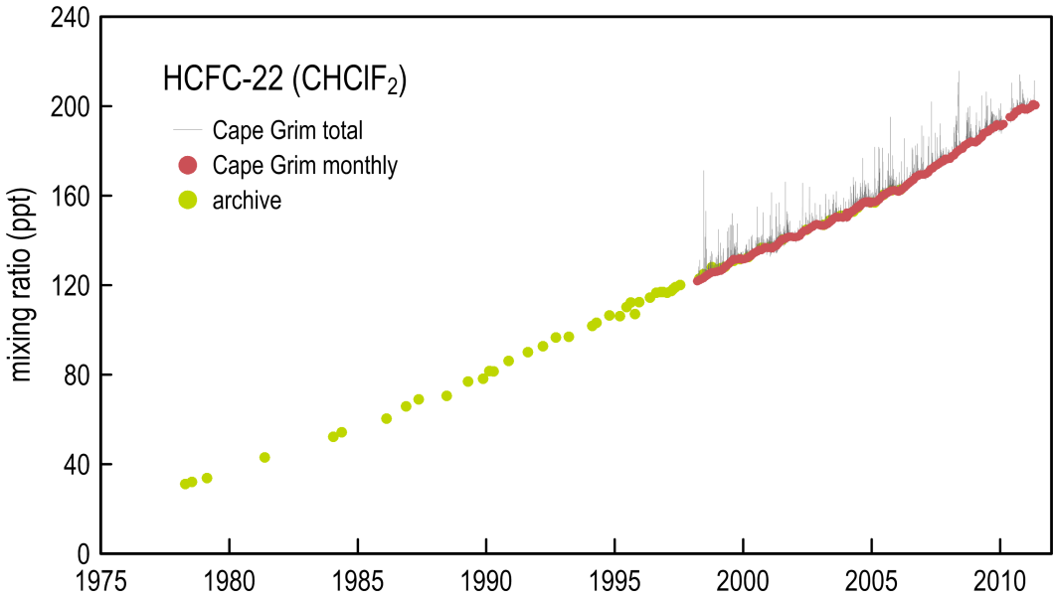

**Figure 13.** Cape Grim monthly mean HCFC-22 (ppt): *in situ* and air archive data. *In situ* data are from the GC-MSD-ADS and GC-MSD-Medusa instruments; the air archive data are from the Aspendale GC-MSD-Medusa instrument.

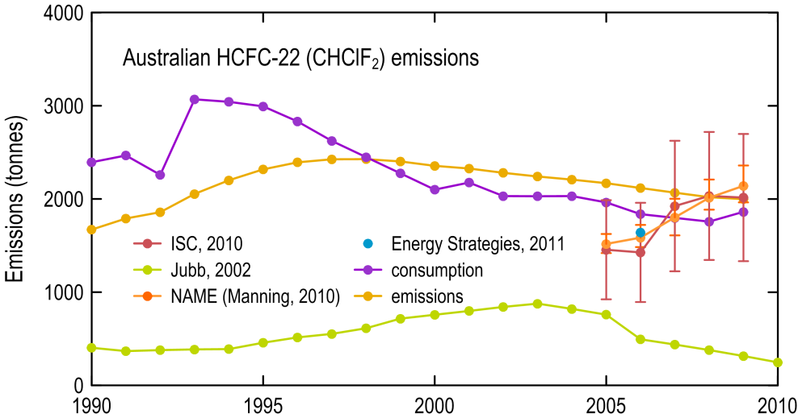

**Figure 14.** Australian HCFC-22 consumption (DSEWPaC data) and emissions from Jubb (2002), from a simple CSIRO emissions model based on consumption (see text) and from Melbourne/Port Phillip emissions calculated from Cape Grim data (CSIRO, unpublished data) using ISC and NAME (A Manning, UK Met. Office) methodologies. Australian emissions (2005 to 2009) are scaled from Melbourne regional emissions on a population basis.

Note that NAME/ISC indicate that emissions are increasing whereas the model based on consumption data suggests emissions are declining slowly. Just how significant these increasing emissions are compared to decreasing consumption is difficult to assess given the large uncertainties in the emission estimates. This uncertainty will decline as the observational record increases in length. Some information may become available as we reprocess Cape Grim GC‑MSD-ADS data from 1998 to 2004.

The emissions must be coming from the HCFC-22 bank (existing operational refrigeration/air conditioning equipment) with perhaps some small emissions from such equipment buried in landfills. This would not happen today as the recycling of the metal in such equipment means that the HCFC-22 would be captured or vented at the point of metal recycling. It is possible that in the early days of HCFC-22 use in Australia that equipment containing HCFC-22 (air conditioners, aerosol cans) was buried in landfills. This is now likely to be a very small source of HCFC-22 to the atmosphere.

The NAME model data show that emissions were less than consumption from 2002 to 2006 but have been about the same as consumption from 2007 to 2009. At present the cause of such behaviour is not obvious. Emissions are expected to approximately equal consumption in a mature, stable market. The emission data suggest that the refrigeration/air conditioning uses of HCFC-22 have stabilised.

In summary, Australian emissions of HCFC-22 are close to 2000 tonnes per year, which, in 2009, is close to the consumption data (~1900 tonnes). Based on consumption data, emissions should be declining slowly, whereas atmospheric data suggest they may be still increasing, but the rate of increase is slowing and the uncertainties are such that a decline in emissions cannot be ruled out. Observations over the next two to three years will confirm or refute the expected decline in HCFC-22 emissions in the Australian region. The consumption of HCFC-22 in 2010 (~1200 tonnes; DSEWPaC, unpublished data) was significantly lower in 2009. We would expect this to be reflected in the 2011 atmospheric data.

## Global HCFC-124, -141b, -142b

Global concentrations of HCFC-124, -141b and -142b are shown in Figure 15, while the calculated global emissions from these atmospheric data are shown in Figure 16.

Global concentrations of HCFC-124 peaked in the mid 2000s at about 1.5 ppt and are now in decline. Global concentrations of HCFC-141b and -142b continue to rise, both exceeding 20 ppt by 2010 (Figure 15).

|  |  |
| --- | --- |
|  | **Figure 15.** Annual average HCFC-124, -141b and -142b concentrations (up to 2009) measured in background air from the southern hemisphere – Cape Grim, Tasmania (*in situ* and archive), and from ice-firn at Law Dome, on the Antarctic coast – and global (Prinn *et al*. 2000; Sturrock *et al*. 2002; O’Doherty *et al*. 2004; Krummel *et al.* 2011; Miller *et al*. 2010; Montzka & Reimann 2011; CSIRO, unpublished data). The lines are concentrations resulting from the previous A1 scenarios: Montzka & Fraser (2003, red) and Daniel & Velders (2007, blue) and the recent RCP 4.5 scenario (Moss *et al*. 2010, green). |

Global emissions of HCFC-124 have not yet been estimated, but the concentration data would suggest they are small and in decline.

Global emissions of HCFC-141b and -142b are shown in Figure 16. Both peaked in the late 1990s to early 2000s at 60 and 30 kilotonnes respectively, before declining to 50 and 25 kilotonnes in the mid 2000s. However, the decline was short-lived: HCFC-141b emissions are now (late 2000s) back at 55 kilotonnes and HCFC-142b emissions have increased dramatically to nearly 40 kilotonnes. Growing South-East Asia/China emissions have been suggested as the cause of this phenomenon (Montzka *et al*. 2009).

|  |  |
| --- | --- |
|  | **Figure 16**. Global HCFC-141b and  -142b emissions (kilotonnes per year) from AGAGE global data (including Cape Grim) compared to emission scenarios used in past (WMO A1) and to be used in future (RCPs) assessments of climate change and ozone depletion. |

## Australian HCFC-124, -141b, -142b

HCFC-124 is used in centrifugal chillers/larger refrigeration systems. HCFC-141b and HCFC‑142b are used as foam blowing agents.

Australian emissions (2005 to 2009, Figure 17) of HCFC-124, 141b and -142b, calculated by ISC and NAME methodologies, averaged about 70, 250 and 45 tonnes per year respectively. HCFC-124 emissions appear to be declining, HCFC-141b emissions are constant, while HCFC‑142b emissions are increasing. These estimates of HCFC-124 and HCFC-141b emissions are consistent with Australian HCFC consumption data (DSEWPaC, private communication) with HCFC bank emission factors ranging from 5% per year to 15% per year.

For HCFC-124, reasonable agreement between current top-down and bottom-up estimates of emissions (40 tonnes per year) can be achieved by assuming emissions from the HCFC-124 bank of 12% per year. Consumption in 2010 was about 13 tonnes per year, with a current HCFC‑124 bank of about 300 tonnes.

For HCFC-141b, emissions from the HCFC-141b bank of 5% per year (240 tonnes per year) are consistent with emissions estimated from atmospheric observations. The HCFC-141b bank is about 4700 tonnes.

For HCFC-142b, atmospheric data suggest recent emissions of ~60 tonnes per year, whereas the maximum emission that can be derived from the HCFC-142b bank are 35 tonnes per year, with the bank containing 230 tonnes and emissions from the bank of 15% per year. Recent Australian consumption of HCFC-142b is reported to be <10 tonnes per year, whereas emissions from atmospheric data are estimated to be ~60 tonnes per year. It is not obvious what could be causing these differences. The uncertainties on the emissions from atmospheric data are large and we made need a longer atmospheric data record to understand this behaviour. We will be reprocessing emission estimates from GC-MSD-ADS data from Cape Grim back to 1998, which may also provide a clue.

One possibility is that, historically, a large amount of HCFC-142b ended up in landfill and is now being emitted to the atmosphere from that bank. In the 1980s and 1990s, 90% of HCFC-142b was used to manufacture closed-cell foams (e.g. polystyrene), which had a residence time in the foam of >10 years. If the foam was buried in a porous landfill then we would expect HCFC-142b emissions from this source over several decades. Australian consumption of HCFC-142b peaked at about 60 tonnes in 1997 but has since been declining steadily, falling to about 10 tonnes in 2009 (apart from one anomalous year, 2005, when consumption was 80 tonnes). If this was largely used to make polystyrene foam, then the emissions from this source will be over the period 1997 to 2013 and beyond, if the effective residence time is greater than 10 years. However, in order to sustain emissions of about 60 tonnes per year, the bank would have to be 600–1200 tonnes, with a 5–10% emission rate. This would require significantly larger imports of HCFC-142b in the peak years than the reported 60 tonnes per year.

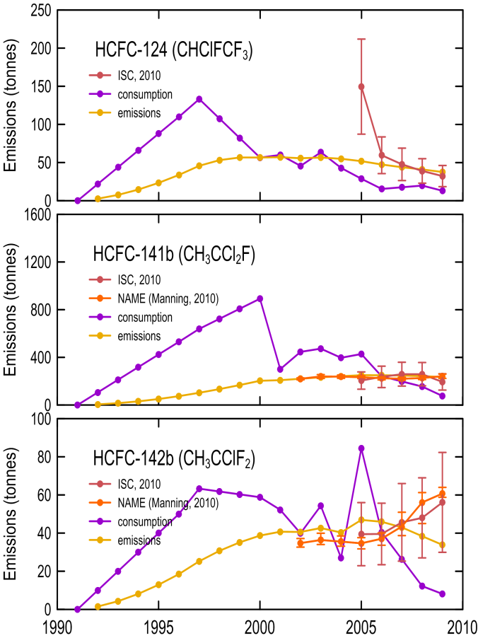

**Figure 17.** Australian HCFC-124, -141b and -142b consumption (DSEWPaC data) and emissions from a simple CSIRO emissions model (see text) and from Melbourne/Port Phillip emissions calculated from Cape Grim data (CSIRO, unpublished data) using ISC and NAME (A Manning, UK Met. Office) methodologies. Australian emissions (2005–2009) are scaled from Melbourne regional emissions on a population basis.

# Global and Australian methyl bromide emissions

Global and Cape Grim annual mean CH3Br concentrations are shown in Figure 18, together with scenarios of future CH3Br levels developed for recent assessments of ozone depletion and the next assessment of climate change. Atmospheric concentrations are declining rapidly, with current concentrations almost 25% lower than peak concentrations observed in the mid 1990s. Scenarios suggest that the impact of the restriction of non-QPS uses of CH3Br will bottom out before 2020, with concentrations falling to about 6.5 ppt, about a 10% decline from current values. If this occurs, global concentrations will be at their lowest level in nearly 50 years.

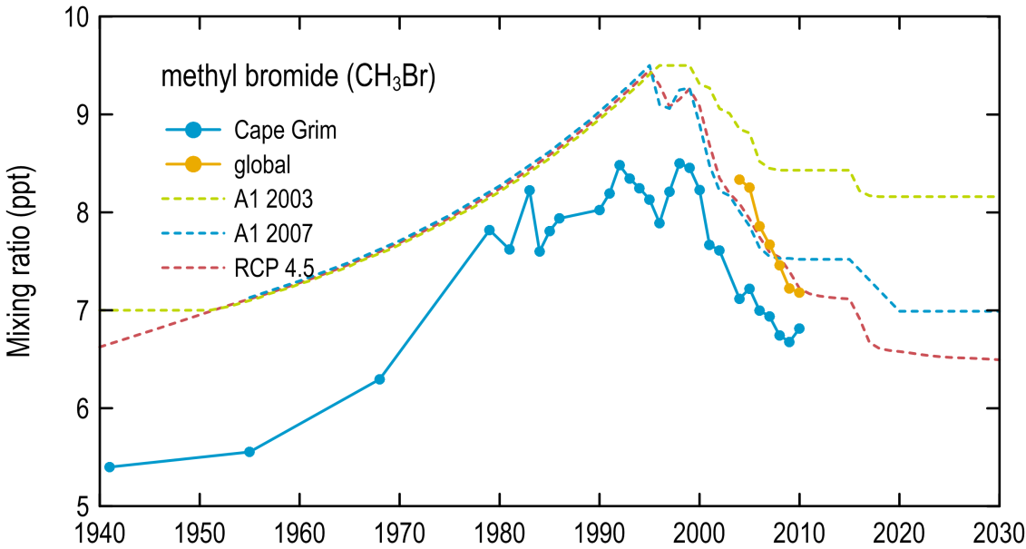

**Figure 18.** Global and Cape Grim annual mean CH3Br concentrations (ppt); scenarios of past and future levels of CH3Br: A1 *– Scientific Assessments of Ozone Depletion*; RCP – *5th Assessment of Climate Change*.

The baseline concentration of CH3Br at Cape Grim continues to decline (Figure 19), reflecting a long-term decline in global emissions of CH3Br (Figure 20).

The pollution episodes seen at Cape Grim (Figure 19) are from agricultural/industrial CH3Br sources in the Melbourne/Port Phillip region and from natural marine/coastal sources adjacent to Cape Grim (Cox *et al*. 2004). Only the pollution episodes that originate from the Melbourne/Port Phillip region are used to calculate Melbourne/Port Phillip emissions. Methyl bromide is one of a few ODS species whose stability in the Cape Grim air archive is problematic; hence, the degree of variability seen in the archive compared to, for example, HCFC-22 (Figure 13).

The global emissions calculated from AGAGE and National Oceanic and Atmospheric Administration (NOAA) data include anthropogenic and natural emissions, whereas the UNEP and MBTOC model data only consider QPS and non-QPS CH3Br emissions, which, by the late 2000s, are only 10% of global emissions. The data show that the long-term decline in global CH3Br emissions is largely driven by the overall decline in QPS and non-QPS CH3Br emissions.

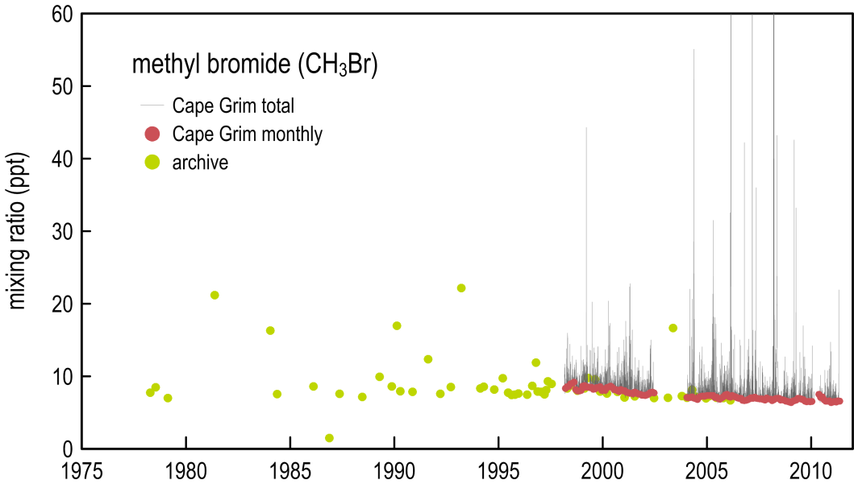

**Figure 19.** Methyl bromide concentrations (ppt) observed at Cape Grim (red: *in situ* baseline monthly means; green: Cape Grim air archive; grey: *in situ* total data); *in situ* data are from the GC-MSD-ADS and GC-MSD-Medusa instruments at Cape Grim; the air archive data are from the GC-MSD-Medusa at Aspendale.

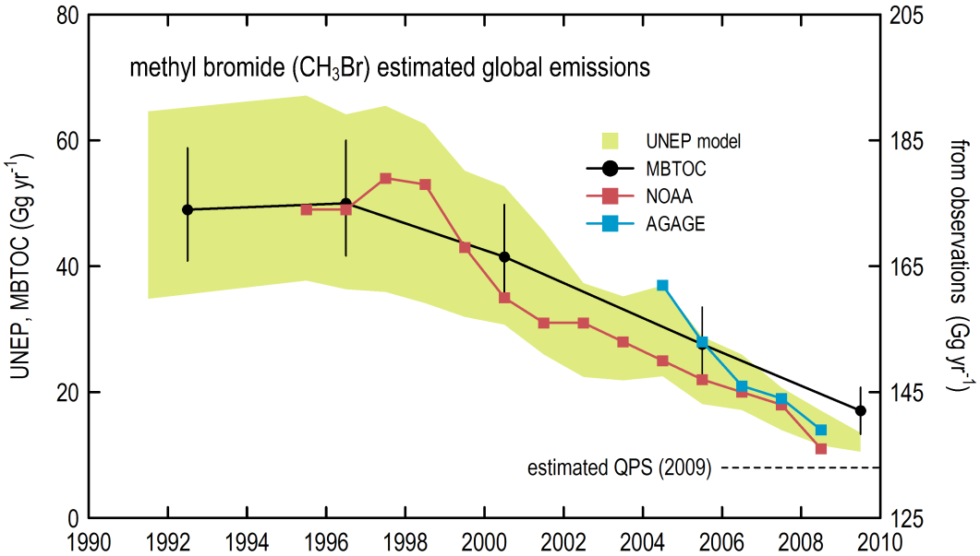

**Figure 20.** Global CH3Br emissions calculated top down from AGAGE CH3Br data (including Cape Grim) and NOAA CH3Br data (including NOAA flask data from Cape Grim), compared to bottom-up estimates of CH3Br global emissions from MBTOC (Methyl Bromide Technical Options Committee) and a UNEP emissions model (Montzka & Reimann 2011).

Consumption of CH3Br (non-QPS uses) in Australia has declined in recent years, reaching about 30 tonnes in 2009 (DSEWPaC data) due to significant restriction in its use as an agricultural and structural fumigant. QPS use in Australia is therefore now higher than non-QPS uses, varying between 250–500 metric tonnes per annum in recent years and around 470 metric tonnes in 2010 (DSEWPaC data). This variation in consumption may be a result of drought reducing the need for methyl bromide use in some years, the more efficient use of offshore fumigation procedures, or the need to address specific pests (DSEWPaC private communication). QPS uses are not controlled by the Montreal Protocol. In recent years, total CH3Br imports were at a minimum in 2006 (420 tonnes), but in 2010 exceeded 500 tonnes (Figure 21).

Australian and Victorian emissions can be derived from the import data (bottom-up estimates). The simple assumptions are that 100% of QPS use is emitted to the atmosphere and 50% of non‑QPS use (largely soil fumigation) is emitted to the atmosphere. For Victoria, it is assumed that 80% of Australian non-QPS occurs in the region north-east of Melbourne (around Toolangi, strawberry runners; I Porter, DPI Victoria, private communication), the only significant non‑QPS use outside Victoria being involved with rice production (emissions of which are not seen at Cape Grim). It is assumed that 35% of Australian QPS use occurs in Victoria (Melbourne, Geelong, Portland). The Victorian emissions are shown in Figure 21, reaching a minimum of 150 tonnes in 2006 and increasing to about 185 tonnes in 2010.

CSIRO has developed an interspecies correlation technique to independently estimate south-east Australian emissions of non-CO2 greenhouse gases (Dunse *et al*. 2005), which can be used to derive south-east Australian emissions of CH3Br. The emissions are shown in Figure 21. Emissions based on atmospheric data also reached a minimum in 2006 (124 tonnes), increasing to 179 tonnes in 2009, although this increase may not be significant. These emissions are three-year running averages. In 2005 the single-year emissions were 270 tonnes and 300 tonnes in 2010. The overall agreement with the emissions based on imports is encouraging.

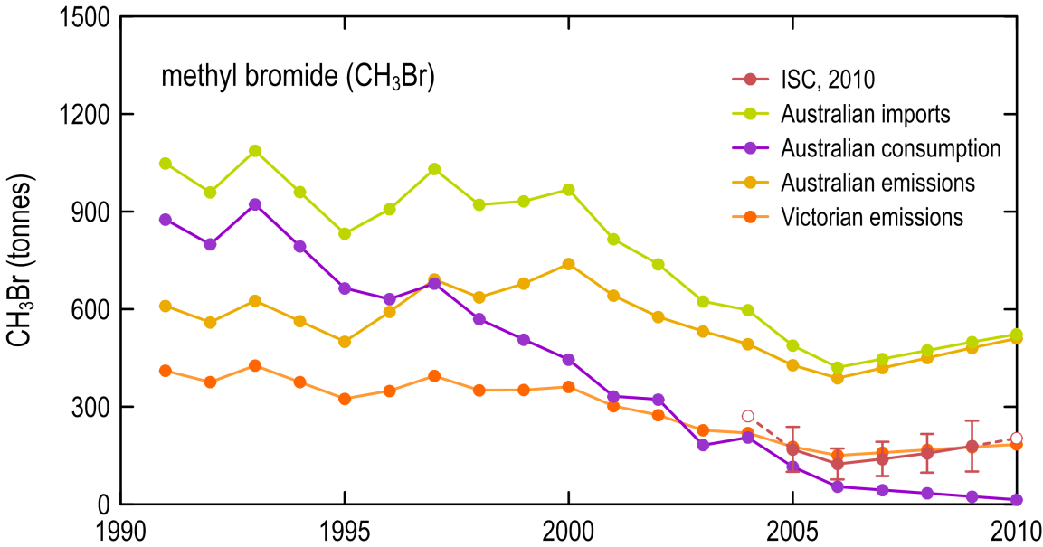

**Figure 21.** Australian CH3Br imports and consumption (tonnes, DSEWPaC data, 1991–2009; 2010 data: I Porter, DPI Victoria). Bottom-up estimates of Australian emissions are calculated assuming that 100% of QPS use and 50% of non-QPS use of CH3Br is emitted to the atmosphere; bottom-up estimates of Victorian (Melbourne/Port Phillip) CH3Br emissions assume that 80% of Australian non-QPS use occurs around Toolangi, north-east of Melbourne (I Porter, DPI Victoria) and 35% of Australian QPS use occurs on the Melbourne, Geelong and Portland docks; top-down estimates of Melbourne/Port Phillip CH3Br emissions are from Cape Grim data using ISC techniques. Note that the purple line (consumption) is from non-QPS use of CH3Br.

# n-Propyl bromide (n-PrBr)

n-Propyl bromide (n-PrBr, CH3CH3CH3Br) is not controlled by the Montreal Protocol but has a small ODP assigned to it, depending on where it is emitted around the world as this determines how much of emitted n-PrBr reaches the stratosphere (for year 2010, WMO 2011). Its atmospheric behaviour has not been measured in Australia but techniques have been developed overseas to measure the atmospheric concentration of this species in the northern hemisphere.

The techniques developed overseas to measure atmospheric n-PrBr were installed recently at Cape Grim and at Aspendale, but it would appear that levels of n-PrBr in baseline air in the southern hemisphere are below the limit of detection (<0.1 ppt) of the Cape Grim instrument. We are therefore unable to estimate n-PrBr emissions using Cape Grim data.

Although we cannot resolve background levels of n-PrBr at Aspendale, we do occasionally see n-PrBr pollution episodes (indicating some use in the Melbourne/Port Phillip region), but, for the majority of the times, the n-PrBr concentrations are below the detection limit of the Aspendale instrument (<0.1 ppt). We are not in a position to be able to calculate n-PrBr emissions from the Aspendale data.

# Australian sulfuryl fluoride emissions

Sulfuryl fluoride (SO2F2) is being used increasingly worldwide as a replacement fumigant for CH3Br. Australian emissions are believed to be low, but are likely to grow as uses increase. Sulfuryl fluoride is not an ODS and, although it has a significant GWP (~5000, 100 year integration period, Muhle *et al*. 2009), its emissions are not currently part of the United Nations Framework Convention on Climate Change ‘basket’ of greenhouse gas emissions.

We have identified 33 significant SO2F2 pollution episodes at Cape Grim over the period 2007 to 2011 (Figure 22), typically 10 episodes per year. Some 40% of episodes originate from or near Melbourne/Port Phillip and about 60% of trajectories appear to be coming from the western half of Victoria (Otway, Portland via King Island). SO2F2 may be used in Australia as a QPS replacement for CH3Br in grain fumigation (DSEWPaC, private communication). There are significant grain exports from Portland, which may be the source of western Victorian SO2F2 pollution seen at Cape Grim. The Melbourne/Port Phillip episodes are about a factor of two stronger than the western Victorian episodes (for example see Figure 23, SO2F2 episode 1.2 ppt, Figure 24, 0.06 ppt)

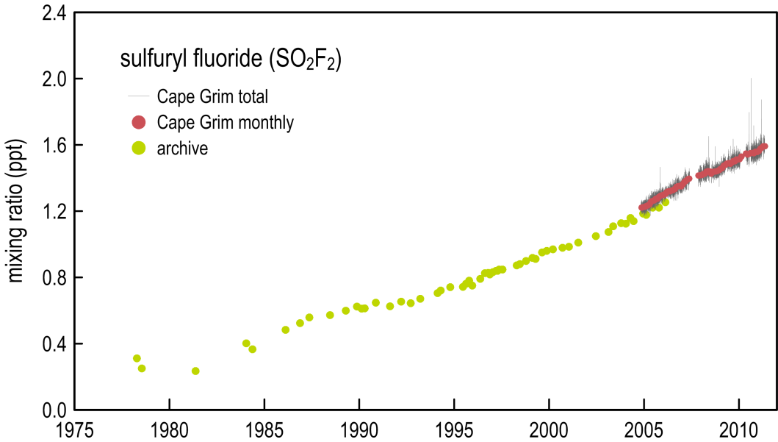

**Figure 22.** Sulfuryl fluoride concentrations (ppt) observed at Cape Grim (red: *in situ* baseline monthly means; green: Cape Grim air archive; grey: *in situ* total data); *in situ* data are from the GC-MSD-Medusa instrument at Cape Grim; the air archive data are from the GC-MSD-Medusa instrument at Aspendale (Mühle *et al*. 2009; Krummel *et al*. 2011).

For those SO2F2 episodes that originate from or near Melbourne/Port Phillip/Latrobe Valley, we see corresponding episodes in urban pollution markers such as CO and HFC-134a (Figure 23). For the western Victorian SO2F2 episodes, these urban marker species are absent (Figure 24).

|  |  |
| --- | --- |
|  |  |
| **Figure 23**. Melbourne/Port Phillip SO2F2 pollution episode observed at Cape Grim 12 September 2009: note the co-incident urban marker peaks: CO and HCFC-134a. | **Figure 24**. Western Victorian SO2F2 pollution episode observed at Cape Grim 12 June 2009: note the lack of co-incident urban marker peaks: CO and HCFC-134a. |

For the Melbourne/Port Phillip/Latrobe Valley SO2F2 episodes, we are able to estimate SO2F2 emissions by ISC for the period 2008–10. For Port Phillip episodes, the annual emissions of SO2F2 were 2.7±1.6 tonnes from seven episodes and for Port/Phillip (including Latrobe Valley), 2.5±1.6 tonnes from 10 episodes. These emissions are not significantly different. Based on these estimates, the western Victorian SO2F2 sources could be 1.3±0.8 tonnes, with total Victorian SO2F2 sources close to 4±2 tonnes. If the Victorian fraction of Australian SO2F2 use is the same as the CH3Br QPS fraction (35%), then Australian emission of SO2F2 could be just over 10 tonnes.

The SO2F2 concentration rose observed at Cape Grim supports the finding of a western Victorian source, with the majority of SO2F2 arriving at Cape Grim from the north-western sector. By contrast SF6 arrives at Cape Grim, like other urban markers such as HFC-134a or CO, from the northern or north-eastern sectors (Figure 25).

|  |  |
| --- | --- |
|  |  |
| **Figure 25**. Cape Grim SO2F2 and SF6 concentration ‘roses’ | |

For the western Victorian SO2F2 episodes we may be able to calculate SO2F2 emissions using The Air Pollution Model (TAPM) forward modelling if we can independently locate the emission source(s). Once we have sufficient data, the NAME model should be able to calculate the magnitude and approximate location of these SO2F2 sources. This work has not been done to date.

In order to interpret these emission numbers, Australian import and sales data for SO2F2 are required. This information is not available to date.

# Conclusions

1. Global emissions of CCl4 fell below 60 kilotonnes per year in 2008 and are continuing to decline at about 2% per year. These emissions are high compared to emissions (25 kilotonnes per year) derived from reported global consumption of CCl4. It would appear that emissions of CCl4 from ‘banks’ (landfills for example) are significantly larger than previously anticipated, or there is unidentified production/consumption of CCl4, or both.
2. The ISC and NAME estimates of current (2005–09) Australian CCl4 emissions are 140±35 tonnes per year, lower than the 320±160 tonnes per year estimated in Xiao *et al*. (2010) and significantly lower than emissions reported (2500 tonnes, 1996–2004 average) by UNEP (2009). As explained previously, the UNEP (2009) study contained an unrealistic prior estimate of Australian/New Zealand CCl4 emissions, which were later revised to significantly lower emissions (Xiao *et al*. 2010).
3. The only significant CCl4 sources seen in Cape Grim or Aspendale data seem to be from the Port Phillip region and possibly from the brown coal combustion in the Latrobe Valley and at Anglesea. The Australian CCl4 source from coal combustion may be less than 10 tonnes per year, but stack measurements are required to determine actual emissions. The Melbourne urban emissions appear to originate from some contaminated land sites near the Melbourne CBD and/or from the toxic waste landfills licensed to handle CCl4 contaminated toxic waste. This assumption will be further studied in 2011 and 2012.
4. Cape Grim data suggest that 2009 Australian emissions of HCFC-22 are around 2000±700 tonnes per year, based on ISC and NAME modelling studies, growing from ~1500 tonnes in 2005. Over this same period, HCFC-22 consumption data have been approximately constant, or slightly in decline, at about 1900 tonnes per year, from which emissions of about 2100 tonnes per year can be derived. These top-down and bottom-up estimates of Australian HCFC-22 emissions are consistent, but the atmospheric data show increasing emissions, presumably from the HCFC-22 banks (with large uncertainties), whereas the consumption data indicate near constant emissions.
5. Cape Grim data suggest 2009 Australian emissions of HCFC-124, -141b and 142b of 32±13, 194±68 and 56±26 tonnes per year respectively, based on ISC and NAME modelling studies. The HCFC-124 and HCFC-141b emissions are consistent with banks of 300 and 4600 tonnes respectively, with emissions of 12% per year and 5% per year respectively. It is difficult to reconcile the HCFC-142b emissions derived from atmospheric data with Australian consumption data: the maximum emissions that can be derived from consumption data are about 35 tonnes per year from a bank of 230 tonnes. However, the uncertainties (1σ) on the emission estimate from atmospheric data just overlap emission estimate from consumption data. It is possible that 1990’s imports of HCFC-142b were larger than reported here; if this is the case then the HCFC-142b bank would be larger leading to larger emissions, more consistent with the atmospheric data.
6. Australian CH3Br consumption (non-QPS uses) has continued to decline from about 900 tonnes in the early 1990s to around 30 metric tonnes in 2009. Total CH3Br imports in recent years were at a minimum of about 344 tonnes in 2007, but are generally higher than this, with over 500 tonnes imported in 2010. The Melbourne/Port Phillip emissions based on import data, using a simple emissions model, are consistent with emissions based on atmospheric data. Both bottom-up and top-down estimates of CH3Br emissions reached minima in 2006 (150 and 125 tonnes respectively), growing to 175–180 tonnes by 2009. Whether CH3Br emissions are actually growing is uncertain due to the uncertainties in the emission estimates based on atmosphere data. However, there is no evidence that CH3Br emissions have declined in recent years. QPS emissions of CH3Br depend heavily on the level of grain production, which does vary significantly from year to year.
7. Melbourne/Port Phillip emissions of SO2F2 have been estimated at 1–4 tonnes per year. Small emissions are also estimated from western Victoria (0.5–2 tonnes per year), with total Victorian emissions of about 4 tonnes, with a large uncertainty (1–6 tonnes), suggesting Australian emissions of about 10 tonnes per year.

# References

[Cox, M., P. Fraser, G. Sturrock, S. Siems and L. Porter, Terrestrial sources and sinks of halomethanes near Cape Grim, Tasmania, *Atmos. Environ*., 38 (23): 3839-3852, 2004](https://ejournal.csiro.au/cgi-bin/sciserv.pl?collection=journals&journal=13522310&issue=v38i0023&article=3839_tsasohncgt%20).

Daniel, J. and G. Velders (Lead Authors), Halocarbon scenarios, ozone depletion potentials and global warming potentials, Chapter 8 in *Scientific Assessment of Ozone Depletion: 2006*, Global Ozone Research and Monitoring Project – Report No. 50, 572 pp, WMO, Geneva, Switzerland, 2007.

Dunse, B., P. Steele, S. Wilson, P. Fraser and P. Krummel, Trace gas emissions from Melbourne Australia, based on AGAGE observations at Cape Grim, Tasmania, 1995-2000, *Atmos. Environ*., 39, 6334-6344, 2005.

Energy Strategies, ODS and SGGs in Australia – a study of end uses, emissions and opportunities for reclamation, prepared for Australian Department of Environment, Water, Heritage and the Arts, 57 pp., by Energy Strategies/Expert Air, H. Saddler and T. Lee, Level 1 Manuka Arcade, 20 Franklin St., Manuka, ACT, October 2008.

Jubb, C., Development of inventories for ozone depleting and synthetic greenhouse gases in the Montreal Protocol industries, Burnbank Consulting Pty. Ltd., 162 pp, 2002.

Krummel, P., P. Fraser, P. Steele, L. Porter, N. Derek, C. Rickard, J. Ward, B. Dunse, R. Langenfelds, S. Baly, M. Leist & S. McEwan, The AGAGE *in situ* program for non-CO2 greenhouse gases at Cape Grim, 2007-2008: methane, nitrous oxide, carbon monoxide, hydrogen, CFCs, HCFCs, HFCs, PFCs, halons, chlorocarbons, hydrocarbons and sulphur hexafluoride, *Baseline 2007-2008*, 67-80, 2011.

Manning, A., S. O’Doherty, A. Jones, P. Simmonds & R. Derwent, Estimating UK methane and nitrous oxide emissions from 1990 to 2007 using an inversion modelling approach, *J. Geophysical Research*, 116, d02305, doi:10.1029/2010JD014763, 2011.

Miller, B., R. Weiss, P. Salameh, T. Tanhua, B. Greally, J. Mühle & P. Simmonds, Medusa: A Sample Preconcentration and GC/MS Detector System for in Situ Measurements of Atmospheric Trace Halocarbons, Hydrocarbons, and Sulfur Compounds, Anal. Chem., 80, 10.1021/ac702084k, 701536-701545, 2008.

Miller, B., M. Rigby, L. Kuijpers, P. Krummel, P. Steele, M. Leist, P. Fraser, A. McCulloch, C. Harth, P. Salameh, J. Muhle, R. Weiss, R. Prinn, R. Wang, S. O’Doherty, B. Greally & P. Simmonds, CHF3 (HFC-23) emission trend response to CHClF2 (HCFC-22) production and recent CHF3 emissions abatement measures, *Atmos. Chem. Phys.*, 10, 7875-7890, 2010.

[Montzka, S. and P. Fraser (Lead Authors), Controlled Substances and Other Gas Sources, Chapter 1 in: *Scientific Assessment of Ozone Depletion: 2002*, Global Ozone Research and Monitoring Project Report No. 47, Geneva, Nairobi; Washington, D.C., Brussells: WMO, UNEP, NOAA, NASA, EC., 1.1-1.83, 2003.](http://www.unep.org/ozone/pdf/06-Chapter1.pdf%20)

Montzka, S., B. Hall and J. Elkins, Accelerated increases observed for hydrofluorocarbons since 2004 in the global atmosphere, Geophys. Res. Lett., 36, L03804, doi:10.1029/2008GL036475, 2009.

Montzka, S. and S. Reimann (Lead Authors), Ozone Depleting Substances (ODSs) and Related Chemicals, Chapter 1 in: *Scientific Assessment of Ozone Depletion: 2010*, WMO Global Ozone Research and Monitoring Project – Report No. 52, 1.1-1.108, Geneva, Switzerland, 2011.

Moss, R., J. Edmonds, K. Hibbard, M. Manning, S. Rose, D. van Vuuren, T. Carter, S. Emori, M. Kainuma, T. Kram, G. Meehl, J. Mitchell, N. Nakicenovic, K. Riahi, S. Smith, R. Stoudder, A. Thompson, J. Weyant and T. Wilbanks, The next generation of scenarios for climate change research and assessment, *Nature*, 463, 747-757, 2010. doi:10.1038/nature08823.

Muhle, J., J. Huang, R. Weiss, R. Prinn, B. Miller, P. Salameh, C. Harth, P. Fraser, L. Porter, B. Greally, S. O’Doherty, P. Simmonds, P. Steele & P. Krummel, Sulfuryl fluoride in the global atmosphere, *J. Geophysical Research*, 114, D05306, doi:10.1029/2008JD011162, 2009.

[O'Doherty, S., D. Cunnold, A. Manning, B. Miller, R. Wang, P. Krummel, **P. Fraser, P.** Simmonds, A. McCulloch, R. Weiss, P. Salameh, L. Porter, R. Prinn, J. Huang, G. Sturrock, D. Ryall, R. Derwent and S. Montzka, Rapid growth of hydrofluorocarbon-134a and hydrochlorofluorocarbons-141b, -142b, and -22 from Advanced Global Atmospheric Gases Experiment (AGAGE) observations at Cape Grim, Tasmania, and Mace Head, Ireland, *Journal of Geophysical Research - Atmospheres*, **109**: D06310, doi:10.1029/2003JD004277, 2004.](http://www.agu.org/pubs/crossref/2004/2003JD004277.shtml%20)

[Prinn, R., R. Weiss, P. Fraser, P. Simmonds, D. Cunnold, F. Alyea, S. O'Doherty, P. Salameh, B. Miller, J. Huang, R. Wang, D. Hartley, C. Harth, P. Steele, G. Sturrock, P. Midgley and A. McCulloch, A history of chemically and radiatively important gases in air deduced from ALE/GAGE/AGAGE, *Journal of Geophysical Research - Atmospheres*, 105 (D14): 17751-17792, 2000.](http://www.agu.org/journals/jd/jd0014/2000JD900141/0.html%20)

Rhew, R., B. Miller and R. Weiss, Chloroform, carbon tetrachloride and methyl chloroform fluxes in southern California ecosystems, *Atmospheric Environment*, 42, 7135-7140, 2008.

Stohl, A., P. Seibert, J. Arduini, S. Eckhardt, P. Fraser, B. Greally, C. Lunder, M. Miaone, J. Muhle, S. O’Doherty, R. Prinn S. Reimann, T. Saito, N. Schmidbauer, P. Simmonds, M. Vollmer, R. Weiss and Y. Yokouchi, An analytical inversion method for determining regional and global emissions of greenhouse gases: sensitivity studies and application to halocarbons, *Atmos. Chem. Phys*., 9, 1597-1620, 2009.

Sturrock, G., L. Porter and P. Fraser, *In situ* measurement of CFC replacement chemicals and other halocarbons at Cape Grim: the AGAGE GC-MS program, in: *Baseline Atmospheric Program Australia 1997-1998*, N. W. Tindale, N. Derek and R. J. Francey (editors), Melbourne: Bureau of Meteorology and CSIRO Atmospheric Research, 43-49, 2001.

[Sturrock, G., D. Etheridge, C. Trudinger, P. Fraserand A. Smith, Atmospheric histories of halocarbons from analysis of Antarctic firn air: major Montreal Protocol species, *Journal of Geophysical Research - Atmospheres*, **107** (D24): 4765, doi:10.1029/2002JD002548, 2002.](http://www.agu.org/pubs/crossref/2002/2002JD002548.shtml%20)

UNEP, Report on emission reductions and phase-out of CTC (Decision 55/45), UNEP/OzL.Pro/ExCom/58/50, June 2009, tabled at the *58th Meeting of the Executive Committee of the MLF for the Implementation of the Montreal Protocol*, Montreal, 6-10 July 2009.

WMO, *Scientific Assessment of Ozone Depletion: 2010*, WMO Global Ozone Research and Monitoring Project – Report No. 52, Executive Summary, Table ES1, p. ES.9, Geneva, Switzerland, 2011.

Xiao, X., R. Prinn, P. Fraser, R. Weiss, P. Simmonds, S. O’Doherty, B. Miller, P. Salameh, C. Harth, P. Krummel, A. Golombek, L. Porter, J. Butler, J. Elkins, G. Dutton, B. Hall, P. Steele, R. Wang & D. Cunnold, Atmospheric three-dimensional inverse modelling of regional industrial emissions and global oceanic uptake of carbon tetrachloride, *Atmos. Chem. Phys.*, 10, 10421-10424, doi:10.5194/acp-10-10421-2010, 2010.



1. A1 is normally the standard or reference scenario, RCP4.5 is a scenario (or Representative Concentration Pathway) designed to stabilise in the future (usually 100+ years) at 4.5 Watts per m2 of radiative forcing.