|  |  |  |  |
| --- | --- | --- | --- |
| To | Shaun Guilfoyle | From | Adelaide Guinness |
| Copy | Dominic Adshead | Reference | **EST04585 and 04586** |
| Date | **2021-09-16** | Pages  (including this page) | **4** |
| Subject | **04586 – Singleton TA Bushfire Mitigation Works – Addendum to Singleton EST04585 and EST04586 ecological assessment report (Rev2 2020-20-15)** | | |

## Purpose

To review the changes in impact area identified at Mudies Creek and Doughboy Hollow Creek in order to accommodate construction of the respective bridges and consider any further implications as outcomes of the adjusted areas.

## Summary of Changes

The Singleton EST04585 and EST04586 ecological assessment report (Rev2 2020-20-15) identifies the following TEC’s be removed allowing for implementation of the Mudies Creek and Doughboy Hollow Creek bridges. However, adjustments are required to the area of the TEC’s impact in order to accommodate bridges construction. These adjustments are identified in the table below and further identified in **Figure 1** and **Figure 2**:

Table TEC Impact Area's

|  |  |  |  |
| --- | --- | --- | --- |
| TEC Impacted | Conservation Status under the EPBC Act | Initial Impacted Area | Adjusted Impact Area accommodation construction |
| Coast Swamp Oak (*Casuarina glauca)* Forest of the New South Wales and South East Queensland ecological community | EN | Up to 0.0748 ha | Up to 0.1380 ha |
| Central Hunter Valley eucalypt forest and woodland | CE | Up to 0.0014 ha | Up to 0.0110 ha |

As a result of these adjustments further changes are thus required in the following sections of the attached Singleton EST04585 and EST04586 ecological assessment report, as documented in the table below:

Table EST04585 and EST04586 ecological assessment report adjustments

|  |  |  |
| --- | --- | --- |
| Section Identification | Current Version | Revised Version |
| Section 5.4, Table 5.2, row 2, column 2, paragraph 2, sentence 1. | The total areas of PCT 1800 cleared will be 0.0748 ha whilst the total estimated area of EPBC listed Swam Oak forest is estimated to be 31 950 ha. | The total areas of PCT 1800 cleared will be 0.1380 ha whilst the total estimated area of EPBC listed Swam Oak forest is estimated to be 31 950 ha. |
| Section 5.4, Table 5.2, row 3, column 2, paragraph 2, sentence 1. | The total area of PCT 1604 cleared will be 0.0014 hectares. | The total area of PCT 1604 cleared will be 0.0110 hectares. |

## Conclusion

The additional broader areas were surveyed by two Aurecon ecologists Liam Stephen and Sarah Glauert whilst undertaking the field assessments. The extended area bodes no further impacts to the assessment significance outcomes, with the mitigation measures identified in section 6.2 of the attached Singleton EST04585 and EST04586 ecological assessment remaining applicable to the activity.

In summary, the works will result in the removal of 0.149 ha of EPBC Act listed communities. Due to the limited and localised extent of impact, it is unlikely that any listed TECs or threatened species will be significantly impacted by the works.

Through the application of recommended mitigation measures identified in Section 6.2 of the report, along with appropriate standard environmental controls through the construction phase, impacts to biodiversity are likely to be minimised.

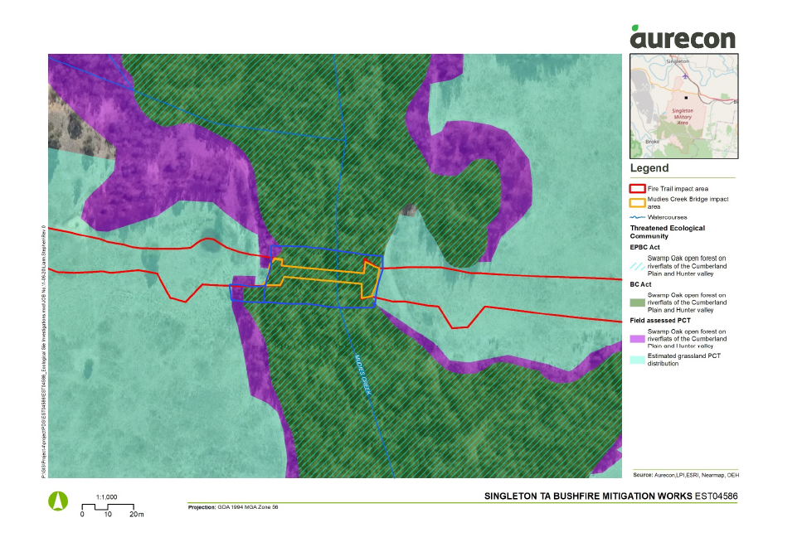

Figure Adjusted Mudies Creek Bridge Impact Area (blue outline)

Figure Adjusted Doughboys Hollow Creek Bridge Impact Area (blue outline)