**Australian Government**

**Department of Agriculture,**

**Water and the Environment**

Supplementary Form C

* **Threatened species & Ecological Communities**
* **Migratory species**
* **Listed marine species**

**(use Form A for Cetaceans)**

*Use this supplementary form if you are applying for a permit to kill, injure, take, trade, keep or move a listed species or ecological community, a listed migratory species, or a listed marine species in a Commonwealth Area.* ***You will also need to complete "The General Permit Application Form".***

*If* ***you are proposing to take or send specimens out of Australia it is likely that you will also need an export permit. Import permits may also be necessary for taking specimens into an overseas country. For more information on imports and exports contact the Wildlife Trade Assessments Section on 02 6274 1900 or email*** [***wps@awe.gov.au.***](mailto:wps@awe.gov.au)

***Please note that it is a requirement under subsection 200(3) of the Environment Protection and Biodiversity Conservation Act 1999 that details of this application (which may include the applicant's name) be provided to persons or bodies registered with the Department of Agriculture, Water and the Environment under section 266A of the Act, and to whom notice of applications is to be given, for the purpose of inviting submissions from those***

***persons or bodies regarding permit applications.***

**1** Under which section(s) of the EPBC Act are you applying for this permit?

It will help you complete your application if you know which list in the EPBC Act the affected species/ecological community appears on. Search the lists at: [www.environment.qov.au/cgi-bin/sprat/public/sprat.pl](http://www.environment.qov.au/cgi-bin/sprat/public/sprat.pl)

Please note some species appear on more than one list. For example, the Green Turtle *Chelonia mydas is a listed threatened species, a listed migratory species, and a listed marine species*

***Select all that apply***

Section 201 - Listed threatened species and ecological communities

Section 216 - Listed migratory species

Section 258 - Listed marine species

**2** On the next page list details of species or ecological communities that will be affected by the action. Use the following codes to enter details in columns 3, 4 and 5.

**Column 3 Conservation status of threatened species or ecological communities under EPBC Act**

EW Extinct in the wild EX Extinct

CE Critically endangered

EN Endangered VU Vulnerable

CD Conservation dependent

**Column 5 Type of effect**

DE Death IN Injury

TR Trading

TA Taking KE Keeping MO Moving

*Page 1 of6 21 May2019*

Details of species or ecological communities that will be affected by the action.

|  |  |  |  |  |
| --- | --- | --- | --- | --- |
| **Common name of listed species/ecological communities, listed migratory species, or listed marine species.** | **Scientific name of species**  **Common and scientific names are available at the Department’s website:** [**www.environment.gov.au/cgi-bin/sprat/public/sprat.pl**](http://www.environment.gov.au/cgi-bin/sprat/public/sprat.pl) | **Conservation status under EPBC Act** | **Estimated number that will be affected. For ecological communities, provide estimate of the affected area** | **Type of effect** |
| White Shark | *Carcharhinus carcharias* | VU | 4 Max, Likely 2 | IN |
| Shortfin Mako | *Isurus oxyrhinchus* | Migratory | 4 Max, Likely 2 | IN |
|  |  |  |  |  |
|  |  |  |  |  |
|  |  |  |  |  |
|  |  |  |  |  |
|  |  |  |  |  |
|  |  |  |  |  |
|  |  |  |  |  |
|  |  |  |  |  |

Where the project is of less than 1 km2 in size, provide the location as a single pair of latitude and longitude references. Latitude and longitude references should be used instead of AMG and/or digital coordinates.

Locality:

Latitude: degrees: minutes: seconds:

Longitude: degrees: minutes seconds:

Where the project area is greater than 1 km2, or any dimension is greater than 1 km, provide additional coordinates to enable accurate identification of the location of the project area.

Attach a map to show the boundaries of the area in which the action will be conducted.

The Study will take place in Commonwealth waters offshore from the east coast of New South Wales, extending to Lord Howe Island.

*Page 2 of 8 21 May 2019*

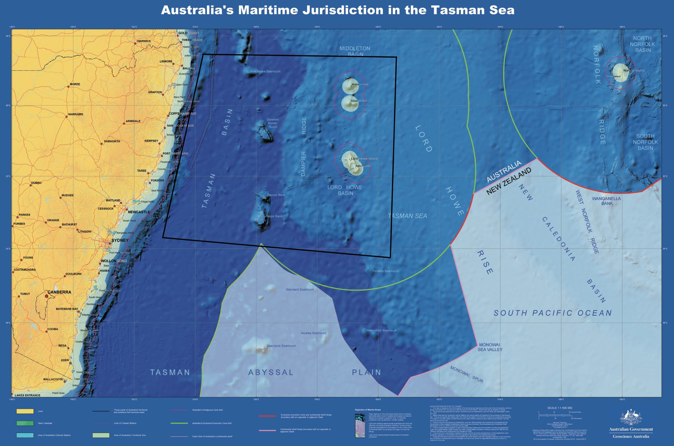

**3** Provide an attachment describing the action addressing the following points.

1. The objectives and purposes of the action;
2. The equipment and methods used;
3. What are the likely short and long term impacts of the proposed action on the species or the ecological community?

**Short-term**

Tagging and biopsies:

Slight discomfort of the animal during split second deployment of tags or taking of small muscle biopsy, after which there will be no reaction and the animal will return to normal swimming activities.

Bio-logging:

Slight discomfort of the animal carrying the clamp and bio-logging tag on the dorsal fin. The tag will detach after a pre-determined number of days and a corrodible link will ensure that the clamp also falls off a few days later.

**Long-term**

Nil, as bio-logging tag and clamp will fall off after a few days. External acoustic tags are not permanent and shed from shark in ~1-3 years (depending on individual sharks). Capture (if needed) will also have nil long-term impacts as previous studies have shown sharks to recover from the proposed capture and tagging process.

1. Describe the steps that will be taken to minimise impacts on the listed species/ecological community, including contingency plans in the case of events that may adversely affect members of the species/ecological community.

All tagging and the collection of biopsies will be undertaken by scientists with extensive experience in the methods proposed. Tagging and the collection of biopsies will occur at the best location to minimise shark injury and maximise tag retention and muscle collection, i.e., at the base of the first dorsal fin.

All proposed activities will follow the CSIRO code of practice for tagging marine animals.

1. Attach a description of any research relevant to the affected species or communities that will be carried out in the course of or in conjunction with the proposed action, including:
   1. a copy of the research proposal;
   2. the names of the researchers and institutions involved in or supporting the research; and

C relationship of the researchers to the permit applicant, including any funding being provided by the permit applicant.

1. Will the action involve invasive techniques? No ***Go to next question***



Yes If permit relates to mammals, birds, reptiles or amphibians, attach evidence that the proposed methods have been approved by an independent Animal Ethics Committee (this may include a State or Territory ethics committee, even if the action is conducted in a Commonwealth area).



### A permit can only be issued under one of the following criteria: the action

* *will contribute significantly to the conservation of a listed species/ecological community (go to Question 8); or*
* *will be incidental to, and not the purpose of the action (go to Question 12); or*
* *is of particular significance to indigenous tradition (go to Question 15); or*
* *is necessary to control pathogen(s) (go to Question 18).*

1. Are you applying on the basis that the action will contribute significantly to the conservation of a listed species/ecological community?

No ***Go to 12***



#### Yes Go to next question



1. Why do you believe that the action will contribute significantly to the conservation of listed species/ecological communities, listed migratory species or listed marine species?

The white shark (*Carcharodon carcharias*) is long- lived, relatively slow growing, late in maturing, and low in reproductive potential. This combination of life- history traits, and world-wide concerns regarding their population status, has prompted their protection across a number of jurisdictions. This includes listings under the International Union for the Conservation of Nature (IUCN – ‘Vulnerable’), the Convention on International Trade in Endangered Species (CITES – Appendix I + II), and the Convention on Migratory Species (CMS – Appendix I + II), all of which Australia is a signatory country.

White sharks are listed as ‘Vulnerable’ under the Australian Commonwealth Government’s Environment Protection and Biodiversity Conservation (EPBC) Act 1999 and are protected in all Australian and Commonwealth waters. However, as identified by the National Recovery Plan for White Sharks, the Australian white shark population is still threatened by interactions with commercial and recreational fishing,

The proposed study addresses the following objectives of the National Recovery Plan for the White Shark:

Objective 1: Develop and apply quantitative measures to assess population trends and any recovery of the white shark in Australian waters and monitor population trends.

Objective 7: Continue to identify and protect habitat critical to the survival of the white shark and minimise the impact of threatening processes within these areas.

Objective 8: Continue to develop and implement relevant research programs to support the conservation of the white shark.

**11** Will the proposed action respond directly or indirectly to recommendations of any national or international organisation responsible for management of the affected species?

shark control activities, illegal trade in body parts, and the potential impacts of ecotourism and cage-diving operations.

The shortfin mako is taken as bycatch in commercial long-line and gill-net fisheries, targeted by game and recreational fishers, and is currently listed as Vulnerable by the IUCN, and as Migratory under Appendix II of the Convention on the Conservation of Migratory Species of Wild Animals (CMS) Appendix II; Migratory). In 2010, the species was the focus of controversy in Australia owing to protection measures that were proposed in response to the CMS listing under the provisions of the Australian Federal Government’s Environmental Protection Biodiversity and Conservation Act (EPBC Act 1999).

This study will assess the movements of these species in relation to oceanographic and environmental conditions, i.e. sea surface temperature, Chl-a concentrations, current, to improve our understanding of the drivers of large-scale movements. Overall, data collected by tags will enable an understanding of the habitat and environment in which the shark lives, and identify behavioural patterns such as residency and mobility in relation to threatening processes such as fisheries interaction or climate change (e.g. increasing water temperature). This knowledge is also essential for interpreting white sharks and shortfin mako abundance trends, migratory patterns, and overall stock status.

The biopsies obtained will be provided to the CSIRO to contribute to their study of white shark abundance and NERP project A3: A national assessment of the status of white sharks, which is required to determine population levels and trends, and assess recovery.

#### No Go to next question



Yes Describe how the proposed action will respond.



1. Will the proposed action implement the recommendations of any recovery plan or wildlife conservation plan in force for the species or ecological community that may be affected by the action?

Under the Convention on Migratory Species (CMS), white sharks and shortfin makos have gained further protection through the Memorandum of Understanding on the Conservation of Migratory Sharks, also referred to as the Sharks MoU. The Sharks MoU aims to:

* achieve and maintain a favourable conservation status for the Seven shark species, which includes ensuring healthy and viable populations of these species remain in their existing habitats
* promote cooperation and information-sharing between countries that have signed the MoU
* improve understanding of migratory shark populations, key pressures and key habitats, and current and future actions to conserve these species.

*Commonwealth recovery plans that are in force are available at*

[*www.environment.gov.au/biodiversity/threatened/recovery-list-*](http://www.environment.gov.au/biodiversity/threatened/recovery-list-) *common.html*

*Commonwealth wildlife conservation plans that are in force are available at* [*www.environment.gov.au/biodiversity/migratory/publications/sh*](http://www.environment.gov.au/biodiversity/migratory/publications/sh) *orebird-plan.html*

*State and territory recovery plans are available from state and territory environmental agencies.*

#### No Go to next question



Yes Describe how this will be implemented.



1. Are you applying on the basis that the impact of the action will be incidental to, and not the purpose of, the action?

No ***Go to 15***



#### Yes Go to next question



1. Why do you believe that the impact of the action will be incidental to and not the purpose of the action?
2. Why do you believe that the taking of the action will not adversely affect the:
   1. survival or recovery in nature of the species or ecological community?
   2. conservation status of a listed species or ecological community?
3. Are you applying on the basis that the action is of particular significance to indigenous tradition?

No ***Go to 18***



#### Yes Go to next question



1. Explain why do you believe that the proposed action will be of particular significance to indigenous tradition?

# 17

Why do you believe that the proposed action will not adversely affect the:

1. survival or recovery in nature of the listed species or ecological community; or
2. conservation status of the listed species or ecological community.

1. Are you applying on the basis that the action is necessary to control a pathogen(s), and is conducted in a way that will, as far as is practicable, keep to a minimum any impact on listed species/ecological communities, listed migratory species or listed marine species?

#### No Continue to Payment Section



Yes ***Go to next question***



1. Why do you believe that the action is necessary for the control of pathogen(s)?
2. Explain how the action will be conducted in a way to minimise impacts on the species/communities affected.

**If you have answered NO to Questions 8, 12, 15 and 18, it is unlikely that a permit can be issued under the EPBC Act.**

# Fees

The following fees apply:

* + permits relating to listed threatened species or ecological communities - $100
  + permits relating to listed migratory species - nil
  + permits relating to listed marine species – nil

Please note that exemption from fee payment may apply under circumstances as set out in EPBC Regulation 18.04.

# Method of Payment

To make a payment, the department’s preferred methods of payment are by credit card, bank cheque or by electronic funds transfer (EFT). A tax invoice can be arranged prior to payment, but you should allow up to five business days to process the transaction.

Please contact [EPBC.permits@awe.gov.au](mailto:EPBC.permits@awe.gov.au) if you would like to request a tax invoice.

### Credit Card

Please submit your permit application to the Department to obtain a permit reference number. This reference number will be required when you contact the Department to make the payment.

Contact the Collector of Public Money (Accounts) on (02) 6274 1151

### EFT Payments

EFT Payments can be made to: BSB: 092-009

Bank Account No. 115859

Amount: See applicable fee in section 21 above.

Account Name: Department of Agriculture, Water and the Environment

Department address GPO Box 858, Canberra ACT 2601 Bank: Reserve Bank of Australia

Bank Address 20-22 London Circuit Canberra ACT 2601

Description Part13 permit application fee (Include name of project]

Reference [include Permit reference number (if known)]

## Attachments

Indicate below which documents are attached.

Description of proposed action

**See question3**

Description of relevant research

***See question 6***

Evidence of approval of invasive techniques

***See question 7***

Details for payment of fee

***See question 22***

Environment Approvals Division

Department of Agriculture, Water and the Environment

GPO Box 858

CANBERRA ACT 2601

Email: [EPBC.Permits@awe.gov.au](mailto:EPBC.Permits@awe.gov.au)

## Declaration

I declare that the information contained in this supplementary form is correct to the best of my knowledge.

Signature of applicant

Name of person signing



Date

18/01/2022

## Send this application and fee to:

EPBC Referrals