      

TRUCK ENTRY

# GLOBAL AVENUE

TRUCK

EXIT

PEDESTRIAN ENTRY/EXIT

CARPARK ENTRY/ EXIT

HEAVY DUTY CONCRETE HARDSTAND

29.5

### Gas Storage

GATE

15.5

14

/ Services 450 m2

1 2 3 4 5

124

SITE APPROX

79

OVERALL BUILDING

30.5

42

Warehouse 608 m2

**NEW ROAD**

20 Specialist Fitout Warehouse

49

8056 m2

ENTRY

TOTAL CARPARKS 140

PROPOSED SITE AREA - A 20017 m2

79

Office 632 m2

### 25

18.5

25.5

94.5

8.5

OVERALL BUILDING

109.5

OUTDOOR AREA

12

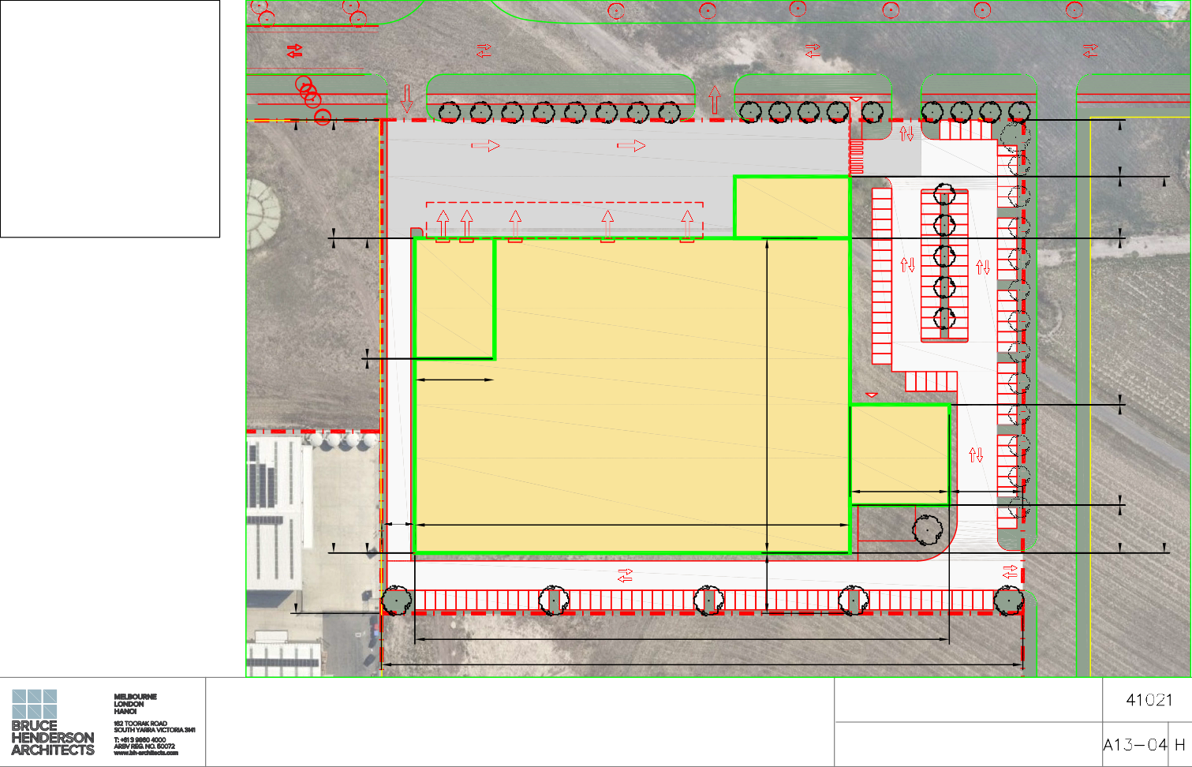

**AREAS:**

**SITE AREA:**

**20016 m2**

**BUILDING AREA:**

Specialist Fitout Warehouse: Warehouse:

Office:

Gas Storage / Services: Canopy:

**9296 m2**

8056 m2

608 m2

632 m2

450 m2

626 m2

Heavy Duty Concrete Hardstand: 3210 m2 Asfalt Car Park: 5010 m2

Staff Outdoor Area: 130 m2

FUTURE CROSSOVER

15

## 134.5 OVERALL BUILDING

161.5 SITE APPROX

BAVQ LABORATORY

GLOBAL AVE, ESSENDON FIELDS SITE PLAN - OPTION 1F