|  |  |  |
| --- | --- | --- |
|  |  |  |
|  |  |  |

1:400 A3 30/07/2021

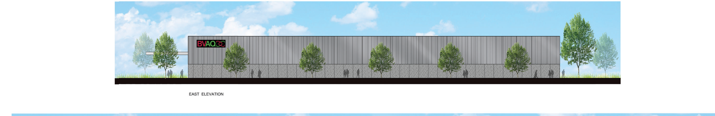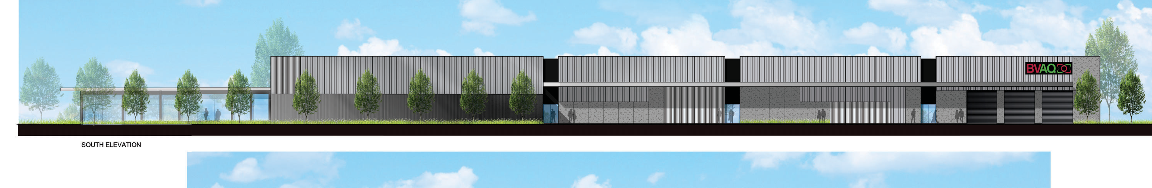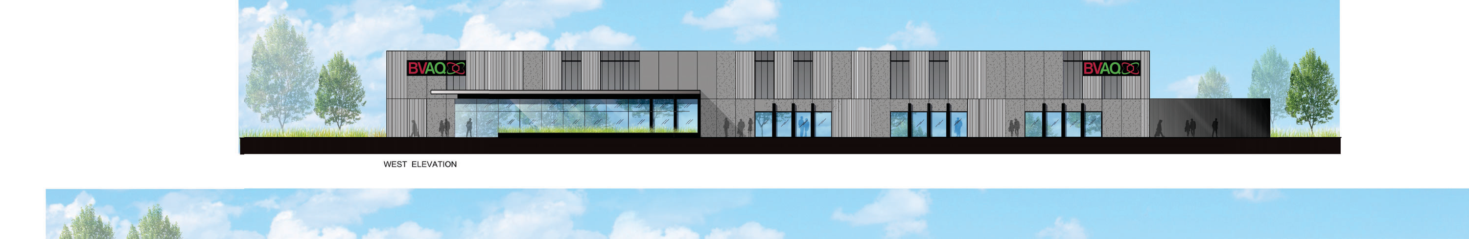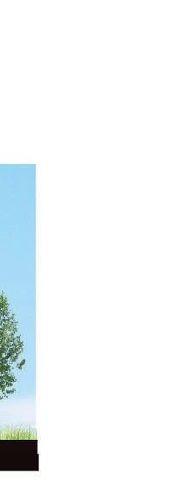

|  |  |  |  |  |
| --- | --- | --- | --- | --- |
|  |  | BVAQ LABORATORY  GLOBAL AVE, ESSENDON FIELDS | 41021 | |
| ELEVATIONS | A14-02 | A |