

Essendon Airport – Ecological Assessment

Essendon Airport Pty Ltd

Report date: 20 August 2020




Essendon Airport – Ecological Assessment

English Street, Essendon Fields

Kleinfelder Document Number: NCA
Project No: 20202284
All Rights Reserved

Prepared for:

ESSENDON AIRPORT PTY LTD 7 ENGLISH STREET ESSENDON FIELDS, VIC, 3041

Only Essendon Airport Pty Ltd, its designated representatives or relevant statutory authorities may use this document and only for the specific project for which this report was prepared. It should not be otherwise referenced without permission.

Document Control:
Version | Description | Date | Author | Technical Reviewer
1.0 | Draft Report | 22 February 2020
2.0 | Final Report | 10 June 2020
3.0 | Final Report – Revision 1 | 20 August 2020

Kleinfelder Australia Pty Ltd Melbourne Office
Level 1, 95 Coventry Street South Melbourne VIC 3205 Phone: (03) 9907 6000

ABN: 23 146 082 500

20022284.001A/EcoAssessment/MLB20R112692 Page i 20 August 2020
Copyright 2020 Kleinfelder

Contents
- INTRODUCTION 1

LOCAL CONTEXT 1
SCOPE OF WORKS 2
ASSESSMENT METHODOLOGY 3
    - Desktop Assessment 3
    - Site inspection 3
STATEMENT OF LIMITATIONS 4
- LEGISLATIVE REVIEW 5
AIRPORTS ACT 1996 5
ENVIRONMENT PROTECTION AND BIODIVERSITY CONSERVATION ACT 1999 5
STATE LEGISLATION 6
- ENVIRONMENTAL SETTING 8
SITE DESCRIPTION 8
ENVIRONMENTAL SETTING 9
REGIONAL CONTEXT 9
PREVIOUS STUDIES 10
- METHODS 11
DATABASE SEARCHES 11
SURVEY ACTIVITY SUMMARY 12
SPECIES & COMMUNITY ASSESSMENT - DETERMINING SIGNIFICANCE 13
    - Species Status 13
    - Likelihood of Occurrence 14
FLORA 14
    - Vegetation Community Mapping and Condition Assessment 14
    - Random Meanders 15
FAUNA 15
SURVEY LIMITATIONS 16
- RESULTS 18
DATABASE SEARCHES 18
STUDY AREA VEGETATION 18
FLORA 22
FAUNA 22
LIKELIHOOD OF OCCURRENCE 22
    - Vegetation Communities and Flora 22
    - Fauna 23
- CONCLUSIONS AND RECOMMENDATIONS 25
SURVEY FINDINGS 25
RECOMMENDATIONS 26

- REFERENCES 28

TABLES
Table 4-1: Schedule of activities during the survey period 12
Table 4-2: Characteristics that Determine Species Significance 13
Table 4-3: The Likelihood of Occurrence Criteria for Threatened Flora Species 14
Table 5-1 Threshold criteria for determining presence of Natural Temperate Grassland
of the Victorian Volcanic Plain 19
Table 5-2: Summary of cover requirements 20
Table 5-3: Vegetation communities and approximate extents within the Study Area (hectares) 21

FIGURES
Figure 1: Locality and Study Area 2
Figure 2: Extent of NTGVVP within the Study Area 3

APPENDICES
Appendix 1. Areas for Assessment Appendix 2. Flora Species List
Appendix 3. Assessment of Likelihood of Occurrence Appendix 4. Photographs
Appendix 5. Correspondence from DOEE

ABBREVIATIONS
AEO Airport Environment Officer
AEPR Airports (Environment Protection) Regulations 1997
CEMP Construction Environmental Management Plan
DELWP Department of Environment, Land, Water and Planning (Victoria)
DITRDC Department of Infrastructure, Transport, Regional Development and Communications (Commonwealth)
DoEE Department of the Environment and Energy
EAPL Essendon Airport Pty Ltd
EF Essendon Fields
EMP Environmental Management Plan
EPBC Act Environment Protection and Biodiversity Conservation Act (Commonwealth)
EVC Ecological Vegetation Class (Victoria) FFG Act Flora and Fauna Guarantee Act (Victoria) Kleinfelder Kleinfelder Australia Pty Ltd
MNES Matters of National Environmental Significance (as identified under the EPBC Act)
NTGVVP Natural Temperate Grassland of the Victorian Volcanic Plain
PMST Protected Matters Search Tool (EPBC Act)
SEPP State Environment Protection Policy (Victoria)
Site Essendon Airport
VBA Victorian Biodiversity Atlas
VVP Victorian Volcanic Plain
WONS Weed of National Significance

INTRODUCTION

Kleinfelder Australia Pty Ltd (Kleinfelder) was engaged by Essendon Airport Pty Ltd (EAPL) to undertake a vegetation survey of parts of the Airport for the presence of ecological communities listed under the Commonwealth Environment Protection and Biodiversity Conservation Act 1999 (EPBC Act) or Victorian Flora and Fauna Guarantee Act 1988 (FFG Act).

The following definitions have been used within this report:

- Study Area – those parts of the Site subject to the survey documented in this report including most undeveloped (grassed) areas of both landside and airside areas of the Airport.

- Main Site – covering both landside and airside areas of the Airport.

- Locality – land within a 5-kilometre (km) radius of the Study Area.

This report compiles a summary of flora, vegetation communities and habitat features recorded within the Study Area during the assessment.


LOCAL CONTEXT

Essendon Airport is located approximately 11 kilometres north of Melbourne's CBD and began as the Essendon Aerodrome in 1921, originally with grass runways, but was extended with additional land during the 1930s and upgraded with a concrete tarmac in 1946. It became Australia’s second international airport in 1950 and then transitioned to general aviation and corporate jet traffic following the development of Tullamarine Airport in the 1960s to 1970s. In 2007 it was redesigned as the Essendon Fields (EF) development which has a mix of aviation and non-aviation uses divided between areas known as airside and landside.

The airport lies within a bioregion known as the Victorian Volcanic Plain (VVP). This stretches westward from Melbourne to near Port Fairy on the Victorian west coast and is characterized by an extensive basalt plain with vast areas of open grasslands, small patches of open woodland and stony rises. Annual rainfall is between 500 and 700 mm (BOM, 2019).


SCOPE OF WORKS

Natural Temperate Grassland of the Victorian Volcanic Plain (NTGVVP) is an endangered ecological community listed under the EPBC Act that was once common across the VVP. EAPL, as lessees of the Airport, are required to identify significant environmental values of the Main Site including the presence of any ecological communities listed under the EPBC Act.

The scope of works for this assessment consisted of the following:

- Desktop assessment to review recent biodiversity records for the area and establish EPBC or FFG listed species/ communities with potential to occur at the site.

- A site inspection to determine the presence/absence and location of EPBC/FFG Act listed communities in undeveloped portions of landside and airside areas of the airport (as defined by EAPL – refer Appendix 1). This assessed open areas of the airport against condition thresholds established by the Commonwealth Department of the Environment and Energy (DoEE) for relevant listed communities such as NTGVVP, determine the extent where present and provide a qualitative assessment of quality against the Commonwealth guidelines.

- Site inspection of the same areas for suitable habitat for threatened flora or fauna species listed under the EPBC/FFG Act and known to occur on the VVP such as Golden Sun Moth and Striped Legless Lizard.

- Preparation of a factual report that includes a brief discussion of the investigation and results and provides location maps and extent of any communities identified or areas that may provide suitable habitat for species listed under the Act.

- Where relevant, any recommendations for further works such as targeted flora or fauna surveys or measures to minimize impacts to any areas identified.

Areas identified by EAPL for assessment are included in Appendix 1.


ASSESSMENT METHODOLOGY

Desktop Assessment

Relevant literature, online resources and databases were reviewed to provide a preliminary assessment of flora and fauna values associated with the Site. These included:

- The Native Vegetation Information Management (NVIM) system for the presence and extent of historic and current Ecological Vegetation Classes (EVCs).

- The Victorian Biodiversity Atlas for records of flora and fauna within the Locality.

- The DoEE Protected Matters Search Tool (PMST) for Matters of National Environmental Significance (MNES) with potential to occur in the Study Area and Locality.

- Aerial photography of the Locality.

- Previous ecological assessments within the Study Area.

Site inspection

An assessment of the Site was undertaken by an experienced and qualified ecologist between 8 and 14 November 2019. Access to all airside areas was undertaken in the company of an appropriately qualified airport employee and in accordance with visitor requirements (VIC pass). The inspection sought to:

- Identify areas of vegetation that contained sufficient cover and quantity of relevant species to qualify as a vegetation community listed under the Federal EPBC Act or State Flora and Fauna Guarantee Act (FFG Act).

- Identify any areas that may provide potential habitat for species listed as threatened under the Federal EPBC Act or State FFG Act.

The extent of the area identified for survey is shown in Appendix 1.

The diagnostic characteristics and condition thresholds for NTGVVP are generally best assessed during spring when many native bulbous species (e.g. lilies, orchids) occur above ground and when most species are flowering (DSEWPC, 2011). All surveys were undertaken in November 2019 and confirm to recommended requirements.


STATEMENT OF LIMITATIONS

The findings and conclusions contained within this report are made following a review of information, reports, correspondence and data previously reported by third parties. Kleinfelder does not provide guarantees or assurances regarding the accuracy and validity of information and data obtained by third parties in previously commissioned investigations. The conclusions presented in this report are relevant to the conditions of the site and the state of legislation currently enacted as at the date of this report.

Kleinfelder has used a degree of skill and care ordinarily exercised by reputable members of our profession practicing in the same or similar locality.

Kleinfelder does not make any representation or warranty that the conclusions in this report will be applicable in the future as there may be changes in the condition of the site, applicable legislation or other factors that would affect the conclusions contained in this report.

This report has been prepared exclusively for use by Essendon Airport Pty Ltd. This report cannot be reproduced without the written authorisation of Kleinfelder Australia Pty Ltd and then can only be reproduced in its entirety.

LEGISLATIVE REVIEW

Legislative obligations with respect to flora and fauna at the Airport are reviewed below.


AIRPORTS ACT 1996

Commonwealth land occupied by airports is regulated under the Airports Act 1996. Together with the Airports (Environment Protection) Regulations 1997 (AEPR), the Act establishes a comprehensive environmental regulatory framework that applies to the management of all on- ground environmental issues including air, soil, water, noise and chemical pollution on an airport.

In accordance with the Act, each Airport Lessee is required to operate under an approved Airport Environmental Strategy which is incorporated into an Airport Master Plan. Clause 71 2
(h) (ii) of the Airports Act requires that a draft or final master plan must specify … an environment strategy that details:

the areas (if any) within the airport site which the airport-lessee company, in consultation with State and Federal conservation bodies, identifies as environmentally significant

In addition, Clause 4.04 of the Airports (Environment Protection) Regulations 1997 (AEPR) imposes a general duty on airport operators to ensure that, during operations, there are no adverse consequences on any species or ecological community listed as threatened under the EPBC Act. There is also a requirement to consider existing scientific values of the local area and therefore this report has also considered species or communities that may be considered threatened under State legislation.


ENVIRONMENT PROTECTION AND BIODIVERSITY CONSERVATION ACT 1999

The key relevant Commonwealth legislation relating to protection of the environment is the
Environment Protection and Biodiversity Conservation Act 1999 (EPBC Act).

Under the EPBC Act, actions that have the potential to significantly impact upon matters of national environmental significance (‘MNES’) will trigger Commonwealth assessment and approval. Matters defined as of MNES include the presence of:

- World Heritage properties

- National heritage places

- Ramsar wetlands of international significance

- Listed threatened species and ecological communities

- Migratory and marine species listed under international agreements

- Great Barrier Reef Martine Park

- Commonwealth marine areas

- Nuclear actions (including uranium mining) and

- Water resources in respect to Coal Seam Gas and large coal mines

Items 1, 2 and 5 to 9 are not considered to apply to this report while Item 3 is not considered to apply to the Airport as there are no Ramsar wetlands of international significance at the Site. Item 4 is relevant to this assessment.

In addition to the requirement to consider impacts to MNES, an application for a permit must be made to DoEE where an activity will affect an EPBC listed species or ecological community that is on Commonwealth land irrespective as to whether that impact may be considered significant under the Act. This is separate to an approval that may be required under the EPBC Act (ie is required irrespective of decision under Act).

This report has therefore focused on whether species or communities under Item 4 have the potential to occur at the Airport.


STATE LEGISLATION

The Flora and Fauna Guarantee Act (FFG Act) is the primary legislation for the protection of threatened native flora and fauna within Victoria. The Act primarily applies to Crown Land but contains a number of lists relating to threatened biodiversity including:

- Threatened native flora and fauna.

- Threatened communities of native flora and fauna.

In addition, to aid in planning and protection of biodiversity values, the Victorian Government has also prepared a number of supplementary publications:

- Advisory List of Rare or Threatened Plants in Victoria (DEPI, 2014).

- Advisory List of Threatened Invertebrate Fauna in Victoria (DSE, 2009).

- Advisory List of Threatened Vertebrate Fauna (DSE, 2013).

The assessment has therefore also considered issues under State legislation applicable to threatened species and communities when determining areas or issues of environmental significance at the Airport.

Note that the Planning and Environment Act (P&E Act) is the main State legislation governing the use (zoning), development and environmental protection of private land in Victoria. It includes rules on the clearing of native vegetation and how native vegetation in Victoria is defined (Clause 72 of Victorian Planning Provisions). This assessment has focused on identifying significant environmental values (threatened species and communities) that may be present within the Airport (Commonwealth land) and has not assessed on site vegetation according to the definition of native vegetation within Clause 72 of the Victorian Planning Provisions nor assessed vegetation quality in accordance with the state endorsed Vegetation Quality Assessment method (DSE 2004).

ENVIRONMENTAL SETTING


SITE DESCRIPTION

Essendon Airport is located approximately 11 kilometres north of Melbourne's CBD on land owned by the Commonwealth of Australia. While located within the City of Moonee Valley, being on Commonwealth land, the airport lies outside the planning scheme.

The Airport covers approximately 290 hectares of which about 135 hectares has been developed (surfaced) for various uses including support areas for the airfield (hangars etc) and various commercial uses. The airfield and surrounding undeveloped areas (largely unsurfaced but inclusive of runways) covers about 155 hectares. For the purposes of airport operations, the airport is divided into two sections:

- landside covers those parts of the airport that are open to the public.

- airside includes all parts of the airport that are directly involved in the arrival and departure of aircraft such as loading, take-offs and landings including parts of the buildings that are only accessible to passengers and staff (such as hangars etc). Access to the airside area is tightly controlled.

The Study Area (area for assessment) consists largely of unsurfaced open undeveloped grassed areas in both landside and airside areas of the airport (Appendix 1): it is estimated that the total area for assessment covers approximately 160 hectares. Regular maintenance of these areas ensures that grass is kept short to maintain airport safety requirements.

Prior to formation of the airport (1921), the Study Area and surrounding locality was cultivated and grazed. Since formation, the Study Area has been managed as part of airport operations with ongoing mowing to manage biomass levels and fire risk. It is now embedded within Melbourne’s north-western suburbs with residential and industrial development established around the whole airport over the past 20 – 50 years. There are no significant visible signs of erosion or other forms of site disturbance in the Study Area.


ENVIRONMENTAL SETTING

The site is located within the Port Phillip Basin and is underlain by a series of basaltic lava flows known as the Newer Volcanics that have infilled pre-existing drainage systems incised into the underlying Brighton Group sediments. Weathering of the upper surfaces of individual flows has resulted in the development of buried paleosols that were overlain by younger flows.

Located about 80m above sea level, the Study Area lies between two incised streams. Moonee Ponds Creek lies approximately 350 metres (m) to the northeast of the Main Site boundary while Steele Creek is situated approximately 1.2 km from the site boundary to the southwest. Elevation of both waterways near the site is about 50m.


REGIONAL CONTEXT

The Study Area is situated near the eastern edge of the VVP, an extensive plain dominated by recent volcanic deposits. These deposits formed a large flat to undulating basaltic plain with stony rises, old lava flows, numerous volcanic cones and old eruption points and is dotted with shallow lakes both salt and freshwater.

The Victorian Department of Environment, Land, Water and Planning (DELWP) has divided native vegetation across Victoria into a number of Ecological Vegetation Classes (EVCs) based on floristic, structural, and ecological features. Modelling of vegetation distribution by DELWP indicates the majority of land occupied by the Airport is likely to have originally been covered by EVC 132 Plains Grassland with possible small amounts of EVC55 Plains Grassy Woodland / EVC175 Grassy Woodland on the eastern and south-eastern periphery of the Main Site where the land drops away to drainage lines. EVC 132 is described as treeless vegetation, mostly less than 1 m tall, that is dominated by short to medium height, tussock-forming grasses and herb life forms. Trees and shrubs are either absent or are restricted to watercourses, swamps or rocky hills and slopes bordering the plains. No native woodland areas currently occur on the Airport.

Native grassland is largely formed from both annual and perennial grass and herb species However, to qualify for listing as threatened under the EPBC Act, the vegetation must meet condition thresholds which are intended to focus protection on vegetation remnants that are most functional and in relatively good to excellent condition (DSEWPC, 2011).

These are provided in the Policy Statement prepared for the community where vegetation of the NTGVVP is described as mostly limited to a ground layer of grasses and herbs with large

shrubs and trees absent to sparse. The ground layer is dominated by native tussock-forming perennial grasses with a variety of herbs, mostly from the daisy (Asteraceae), lily (Anthericaceae, Asphodelaceae, Phormiaceae), pea (Fabaceae) and orchid (Orchidaceae) families, occupying the spaces among grass tussocks. The main grass species present are Kangaroo-grass (Themeda triandra), particularly on drier sites, Wallaby-grasses (Austrodanthonia spp.), Spear-grasses (Austrostipa spp.) and Tussock-grasses (Poa spp.) (TSSC, 2008).


PREVIOUS STUDIES

A number of studies have been undertaken of various parts of the Airport. These have been primarily located on landside areas of the Airport and have included the following:
- Ecology Australia. 1998. Essendon Airport - Survey for Significant Flora and Fauna. Ecology Australia Pty Ltd for Federal Airports Corporation.
- Biosis. 2012. Essendon Fields: Golden Sun Moth Survey. Report to Essendon Fields Pty Ltd by Biosis Research Pty Ltd.
- Ecology and Heritage Partners Pty Ltd. 2015. Flora and Fauna Assessment, Hart Precinct, Essendon Airport, Essendon Fields, Victoria. Letter Report prepared for Essendon Fields Pty Ltd, February 2015.

The Ecology Australia report was prepared prior to declaration of the EPBC Act but found no flora, fauna or ecological communities that were listed under state (FFG Act) and/or Commonwealth legislation (per the prior Endangered Species Protection Act 1992).

The Ecology and Heritage Partners (EHP) report identified about 2.0 ha of low quality NTGVVP in a number of discrete patches distributed across the north-west of the airport in an area known as the Hart Precinct. Parts of this area have subsequently been subject to development following referral to DoEE in 2017. No flora species of national significance were considered likely to occur within the area assessed.

Biosis undertook surveys for Golden Sun Moth in accordance with Commonwealth guidelines across landside areas of the airport but did not detect any Golden Sun Moth. Biosis concluded that it was unlikely that the species is present within the area.

METHODS


DATABASE SEARCHES

The following databases were searched in order to obtain a list of threatened species, populations and ecological communities that have been reported within a 3 km radius of the Study Area or where modelling indicates they have the potential to occur within the Locality:
- Department of the Environment and Energy (Commonwealth) (DoEE), Protected Matters Search Tool (www.environment.gov.au/erin/ert/epbc/index.html).

- The Victorian Biodiversity Atlas (VBA), a database maintained by DELWP of records of flora and fauna sightings across Victoria. (The database records sightings of all species reported to DELWP (including the locality and date of sighting) and indicates whether species are listed under the EPBC Act, the State FFG Act or DELWP Advisory Lists (DEPI 2014d; DSE 2013; DSE 2009)).
- Maps maintained by DELWP that includes modelled mapping of historic and extant Ecological Vegetation Classes, Bioregions and key ecological values across Victoria (known as the Native Vegetation Information Management system).

- Literature reviews for targeted species and communities including:
  - Species Profile and Threats database (SPRAT) maintained by DoEE for EPBC Act listed species including relevant species impact guidelines, policy statements and recovery plans.
  - Actions Statements and Listing Advice prepared by the Victorian government on State listed threatened species and/or communities.

Based on information available concerning habitat requirements of these threatened matters and results of the site inspection, an assessment was made as to the likelihood of any of the reported threatened matters occurring within the Study Area or using the habitat within the Study Area as an essential part of a foraging range.

Pelagic and marine species were omitted from the results as the Study Area does not support potential habitat for these species.

Results of the database search are provided in Appendix 3. Information from both databases was compiled to obtain a preliminary listing of species that may be expected within the vicinity of the Site.

Common and scientific names used for flora within this report follow those used by DELWP as itemised in the VBA.


SURVEY ACTIVITY SUMMARY

Field surveys were conducted between 8 and 14 November 2019 by an experienced and qualified ecologist. A list of survey activities is provided in Table 4-1.
Table 4-1: Schedule of activities during the survey period

Activity | Date (s) | Location
Vegetation Community Mapping | 8 Nov | Landside (excluding Hart Precinct)
 | 12 Nov | Airside
 | 13 Nov | Airside
 | 14 Nov | Airside & Hart Precinct

Surveys were undertaken to determine the existing vegetation and flora species present within the Study Area. The survey methods were designed for the purposes of conducting a preliminary ecological assessment in order to gain an understanding of the vegetation and flora species and assemblages located within the Study Area and the locality.

The diagnostic characteristics and condition thresholds for NTGVVP are generally based on features which apply all year round, with the exception of the ground cover of native forbs (wildflowers). This feature is best assessed during spring because it is only during this time when many native bulbous species (e.g. lilies, orchids) occur above ground and when most species are flowering (DSEWPC, 2011). All surveys were undertaken in November 2019 and conform to recommended survey period requirements.

Prior to commencement of surveys, where possible, the airport mowing and maintenance schedule was suspended for a period to allow for an extended growth period and maximise the ability of the survey to identify native species across the survey area. However, with spring conditions leading to significant growth, in most cases the mowing schedule could only be adjusted to allow for about 4-6 weeks growth depending on the area. In particular, within the airfield, the longest period that mowing could be suspended was approximately 2-3 weeks, due to wildlife management measures to minimise the safety risks to aircraft from bird strikes.

Due to the need to maintain safety requirements, some areas closer to the runways could not be allowed to accumulate extended growth and were maintained in accordance with normal schedule requirements. Surveys were therefore undertaken as much as possible in surrounding areas prior to approaching areas closer to the runways to allow comparison with adjoining vegetation to assist in determining vegetation characteristics.

Results from the desktop and field surveys have also been used to identify areas within the Site that may potentially provide habitat for state or nationally listed species or communities. This assessment has then been used to identify any potential survey requirements that may be recommended to determine the presence/absence of species listed under the EPBC Act.


SPECIES & COMMUNITY ASSESSMENT - DETERMINING SIGNIFICANCE

Species Status

All flora and fauna species records for the assessment area obtained during the literature and database review (refer Section 4.5) were evaluated to determine those species of significance that may occur within the Study Area.

The significance of a species or community was determined by reference to its listing under Commonwealth and/or State legislation. The sources used to categorise significance of species and communities in this report are summarised in Table 4-2.

Table 4-2: Characteristics that Determine Species Significance
Legislation | Species / Community Significance
Commonwealth | Listed as critically endangered, endangered, vulnerable or conservation dependant under the EPBC Act. Also species listed under various international  agreements.
State | Listed as threatened or nominated under the FFG Act.  Fauna listed as critically endangered, endangered or vulnerable on the DELWP Advisory List (DSE, 2013).  Flora listed as endangered or vulnerable on the DELWP Advisory List (DEPI, 2014).  Invertebrates listed as critically endangered, endangered or vulnerable on the  DELWP Advisory List (DSE, 2009).

Species found to fit the criteria provided in Table 4-2 were subsequently assessed for their potential to occur within habitat contained in the Site.

Likelihood of Occurrence

Habitat requirements of significant flora and fauna species previously recorded within 3km of the Site, or that may potentially occur within the Locality, were assessed to determine their likelihood of occurrence within the Site. The likelihood of a species occurring within the Site was then ranked as Negligible, Low, Moderate or High.

Only those species listed under the EPBC Act, listed under the FFG Act or considered endangered or vulnerable on the DELWP Advisory Lists (DEPI 2014d; DSE 2013; DSE 2009) were assessed to determine their likelihood of occurrence. Descriptions of criteria utilised by Kleinfelder to rank the likelihood of occurrence of flora and fauna within the Study Area are summarised in Table 4-3.

Table 4-3: The Likelihood of Occurrence Criteria for Threatened Flora Species
Likelihood of  Occurrence | Criteria
Known | Species identified within the site during surveys
High | Recent reputable records of the species in the local vicinity (i.e. within the last 10 years)  e.g. VBA
Known resident in the area based on site observations, database records or expert advice
and/or the Site contains suitable high quality habitat (such as roosting and foraging habitat)
Moderate | Previous reputable records of the species in the local vicinity (e.g. VBA); and/or the Site  contains moderate quality potential habitat
Low | Limited previous records of the species in the local vicinity; and/or, the Site contains poor  or limited habitat.
Nil | No suitable habitat and/or outside species range


FLORA

Vegetation Community Mapping and Condition Assessment

There is potential for the Site to be occupied by vegetation communities that are listed under Commonwealth or State legislation. The PMST and the VBA was reviewed to determine if any threatened communities occur or are likely to occur within the Site and the characteristics that apply to these communities.

During the field survey, the identification of vegetation communities was then based on dominant species present in the shrub and/or ground layer.

All vegetation was assessed against either the condition thresholds or the listing advice that is provided for the community (DSEWPC, 2011; TSSC, 2008). Vegetation that met the required characteristics was then mapped using a handheld GPS device.

Vegetation was also stratified on condition from low to high, which was dependent upon species diversity, presence of weed species, structural complexity and level of disturbance.

Note that in Victoria, a patch of native vegetation or grassland is an area of vegetation where at least 25 per cent of the total perennial understory plant cover is native (being plants that are indigenous to Victoria including shrubs, herbs and grasses). Threshold criteria for determining presence of Natural Temperate Grassland of the Victorian Volcanic Plain requires a patch to be dominated by native grasses (ie minimum of 50% of the ground layer cover comprises native grasses and/or herbs - refer Section 4). Mapping of vegetation in the Study Area was focused on determining presence of vegetation that met criteria for NTGVVP.

Random Meanders

Random meanders over the Study Area were conducted, in conjunction with the vegetation community mapping, to identify floristic species and assess habitat suitability for threatened species. All vascular plant species observed during meander transect surveys were recorded (see Appendix 2).


FAUNA

The focus of the field survey was to obtain an understanding of the fauna habitat types and conditions available within the Study Area, in conjunction with observational fauna surveys. Trapping and other intensive methods were not conducted as part of the fauna methodology.

Fauna habitat assessments conducted across the Study Area considered attributes that typically affect refuge and foraging sites for native fauna such as presence of bare ground, leaf litter, rocks, water bodies, vegetation cover and structural complexity, presence of weed species and connectivity to surrounding vegetation (corridors).

In forming conclusions on the likelihood of a species occurrence in the area, the following general considerations have been taken into account (other species specific considerations may apply):

- Areas devoid of remnant native vegetation are generally considered to have few if any ecological values and are usually of negligible significance for threatened native fauna. Species richness or diversity is relatively limited within these areas due to the homogeneity of the environment, land use practices and prevalence of exotic weed species.

- Areas subject to regular maintenance are generally of negligible significance to many native fauna depending on species specific requirements (eg Golden Sun Moth, Striped Legless Lizard) and presence of surface habitats such as soil cracks, embedded rocks.

Environmental features/habitat of the Study Area are discussed in Section 4.


SURVEY LIMITATIONS

The methodology employed for this assessment (i.e. field survey combined with information available from other desktop information sources) is considered sufficient to determine if the Study Area contains habitat for any threatened species, population or ecological community. No significant study limitations were identified. However, the following considerations apply:

- The surveys covered vascular flora only (ferns, conifers and flowering plants). Non- vascular flora (e.g. mosses, liverworts) were not considered.

- The survey was undertaken in a time period considered optimal for determining the presence of typical grassland species. However, surveys provide a sampling of flora at a given time only; different seasonal conditions may provide more flora species. While every effort has been taken to identify the significant species that may be expected to occur in the area and to examine parts of the Site at times appropriate to the flowering of the significant species associated with the vegetation type, some flora species may not have been visible due to dormancy (e.g. orchids or certain herbaceous species which leaf and flower during certain periods of the year but remain underground at other times) or their presence during the survey period as seeds only (e.g. annuals whose life cycle is completed within one season). Other plant species are perennial but are inconspicuous unless flowering. More plant species may have been recorded with additional surveys, however, the field surveys, which were undertaken at times when detection of most threatened species is high, combined with information available from other sources documented in this report is deemed appropriate to assess the ecological values of the Site.

- Much of the Site is subject to ongoing maintenance to ensure that grass is kept short to maintain safety requirements. This could lead to the removal of live plant material and/or fruiting materials and may hinder or prevent the effective identification of some species and restrict the ability to identify all the plants species that could be present within the Site.

- Field equipment used to map vegetation included handheld GPS devices. Accuracy of such equipment varies but is not guaranteed beyond about ±5m. As a result, there may be some differences between patches represented on mapping produced for this report and on ground conditions. Note also that grassland vegetation is intrinsically variable and therefore boundaries may shift depending on the season. In particular, community extent is dependent on the amount (percentage) of vegetative cover (refer Section 4) and this may impact identification of community boundaries. However, this is not expected to significantly affect the overall extent of any native vegetation identified.

RESULTS


DATABASE SEARCHES

A total of 42 threatened flora and fauna species have previously been recorded and / or are modelled to have potential to occur within a 3 km radius of the Study Area (Appendix 2). These include 16 plant, two reptile, three fish, 18 bird and three mammal species. Five threatened ecological communities were modelled to occur while five migratory bird species have been previously recorded and/or are modelled to occur in the region. Pelagic bird and marine fish and mammal species were excluded from the list due to the lack of suitable habitat within the Study Area.

The full list of threatened species, populations and ecological communities recorded in the database searches is provided in Appendix 3. The assessment of likelihood of occurrence of these listed species, populations and ecological communities within the Study Area is also provided in Appendix 3.


STUDY AREA VEGETATION

At the time of the survey, much of the open grassed areas of the Airport were dominated by exotic grass and weed species such as Rye-grass (Lolium perenne), Wild Oat (Avena fatua), Barley (Hordeum leporinum), Cape Weed (Arctotheca calendula), Dandelion (Taraxacum spp), Buck’s-horn Plantain (Plantago coronopus) and Ribwort (Plantago lanceolata). Chilean Needle-grass (Nassella neesiana), considered a Weed of National Significance, is also present in some areas. These areas are not considered as native vegetation and do not qualify as a listed community.

Several native grass tussock species were, however, present and in some areas were of sufficient abundance to dominate the local vegetation and be considered as native grassland. No other native vegetation communities were observed at the Site.

Most patches of native grassland that remain on the Victorian Volcanic Plain show some degree of disturbance and degradation. Condition thresholds have therefore been established by the Federal government to allow determination patches of grassland which should be listed as NTGVVP and receive protection under the EPBC Act.

These thresholds, described within the Policy Statement prepared for the community (DSEWPC, 2011), are intended to focus protection on native vegetation remnants that are most functional and in relatively good to excellent condition and are. This is a two-step process to determine firstly whether the NTG ecological community is present and secondly to determine whether it is of sufficient quality for national listing. Those patches that meet the key diagnostic characteristics and the condition thresholds for better quality sites of the ecological community qualify to be listed as Natural Temperate Grassland of the Victorian Volcanic Plain ecological community. A summary of the threshold criteria is provided in Table 5-1.

Table 5-1 Threshold criteria for determining presence of Natural Temperate Grassland of the Victorian Volcanic Plain
Threshold condition (DSEWPC, 2011) | Assessment
STEP 1 Is the Natural Temperate Grassland ecological community present at the site?
Does the patch occur within or near the Victorian Volcanic Plain | Yes, EF falls within the VVP.
Is the site dominated by native vegetation | Partly. Vegetation varies across the Site but a number of discrete patches are dominated by native species.
Are trees absent or sparse such that the projective foliage cover of native trees in the patch is 5% or less? | Yes, there are no trees present in the areas assessed.
Is the ground vegetation layer dominated by native grasses and/or other native herbs? | Yes, in a number of discrete patches, the ground layer is dominated by native grasses.
Conclusion | The grassland ecological community is present in patches.
STEP 2 Is the patch of sufficient quality for national listing?
Is the patch bigger than or equal to 0.05 hectares (e.g. 10 x 50m OR 20 x 25m | Most patches exceed 0.05ha
Does the dominant1 native species represent at least 50% of the native species and the perennial tussock cover; OR  non-grass weeds comprise less than 30% of ground cover  OR native forbs (wildflowers) comprise at least 50% of total vegetation cover during spring – summer. | Red-leg Grass and/or Wallaby Grass are the dominant native species within most patches assessed as NTG. They exceed 50% of the native tussock cover.  Native forbs are very poorly represented while all patches were impacted by grass and non-grass weeds.
Conclusion | The Study Area contains patches that are of sufficient quality to consider EPBC protection.
1 Dominated means that a minimum of 50% of the ground layer cover comprising native grasses and/or other herbs. The dominant grass genus is typically Themeda (kangaroo grass), but other genera may include Austrodanthonia (wallaby grass), Austrostipa (spear grass), Poa (tussock grass) and/or Microlaena (weeping grass). Herbs are typically of the native daisy (Asteraceae), lily (Anthericaceae, Asphodelaceae, Phormiaceae) or orchid (Orchidaceae) families, and occupy spaces among native grass tussocks (DSEWPC, 2011).

Within the Study Area, most patches found to have a predominance of native species were dominated by Wallaby Grass (Rytidospema spp.) and/or Red-leg Grass (Bothriochloa macra) with some native Spear-grass species (Austrostipa), Weeping Grass (Microlaena) and occasional specimens of Kangaroo Grass (Themeda triandra). Very few native herb or forb species were present and, where present, were found in low numbers only. These consisted predominantly of Slender Bindweed (Convolvulus angustissimus), Stonecrop (Crassula sieberiana), Sheep’s Burr (Acaena echinata) and Woodruff (Asperula conferta). Diversity and quality is therefore considered to be poor across all areas considered to meet the requirement for native grassland.

All patches of NTGVVP identified during the survey were therefore considered to be of low quality. All patches also had a high cover of introduced weed species (between 25-50%) such as Chilean Needle grass (Nassella neesiana), Rye Grass (Lolium sp) and Plaintain (Plantago coronopus. Nevertheless, they contained at least 50% vegetative cover of indigenous species Therefore the NTG ecological community is considered to be present in a number of patches across both landside and airside areas of the Airport (refer Figure 2 attached).

Note that Red-leg Grass (Bothriochloa macra), while native, is not listed as one of the key species of NTGVVP. According to the listing advice for the community (TSSC, 2008), tussock cover is generally dominated by Themeda, Austrodanthonia (now Rytidosperma), Austrostipa or Poa species. Refer Table 5-2 below.

Table 5-2: Summary of cover requirements

Threshold condition (TSSC, 2008) | Comment
- The total perennial tussock cover represented by the native grass genera Themeda, Austrodanthonia, Austrostipa or Poa is at least 50%; OR | - Total perennial tussock cover by Austrodanthonia (now Rytidosperma) or Austrostipa is 50% in some patches.
- If the total perennial tussock cover represented by the above 4 native grass genera is less than 50%, then the ground cover of native forbs (wildflowers) is at least 50% of total vegetation cover during spring-summer (September to February); OR | - Ground cover of native forbs is much less than 50% in all areas (where present generally less than 1%).
- The cover of non-grass weeds is less than 30% of total vegetation cover at any time of the year. | - Cover of non-grass weeds varies but was generally less than 30% at the time of inspection.
Threatened Species Scientific Committee (2008). Commonwealth Listing Advice on Natural Temperate Grassland of the Victorian Volcanic Plain. Department of the Environment, Water, Heritage and the Arts.

In a number of areas, Red-leg Grass was the dominant native species present and formed a significant proportion of native ground cover. Growth of Red-leg Grass, like Kangaroo Grass, tends to be most vigorous in summer and therefore the predominance of Red-leg Grass in some areas during the survey may be a result of seasonal influences.

Given the dominance of Red-leg Grass in some areas, advice was sought from DoEE as to whether patches with a large component of Red-leg Grass are considered to meet the requirement for listing as NTGVVP. Based on the information provided via email received on 11 August 2020 (refer Appendix 5), it was determined that the areas of Red-leg Grass present at the Airport are not one of the key grass genera characteristic of the national NTGVVP ecological community.

As a result, the field survey has classified vegetation found in the Study Area into three broad categories:

- No native vegetation.

- NTG community present but does not qualify for national listing.

- NTG community present of sufficient quality to qualify for national listing.

A summary of vegetation communities identified and mapped within the Study Area is provided in Table 5-3 below. The approximate extent of NTGVVP is shaded in pink in Figure 2 (attached).

Table 5-3: Vegetation communities and approximate extents within the Study Area (hectares)
Vegetation Community | Study area |  | Total
 | Landside | Airside
Non-native vegetation | 54 | 97 | 151
NTG community present but does not qualify for national listing. | 0.6 | 1.9 | 2.5
NTG community present of sufficient quality to qualify for national listing. | 0.3 | 1.4 | 1.7
TOTAL | 55 | 100 | 155

Note that irrespective of whether the grassland patches qualify for national listing as NTGVVP, as the Airport lies on Commonwealth land, permits are still required under the Act in circumstances where the native grassland community may be impacted by operations. This is discussed further in Section 6.


FLORA

A total of 67 flora species were recorded during field surveys across the Study Area (Appendix 1). No threatened species, listed under the EPBC Act or the FFG Act, were detected within the Study Area.

Of the flora species recorded, 51 are considered to be exotic or weed species. One species, Nassella neesiana is a listed Weed of National Significance (WONS) and a declared weed species in Victoria (under the Catchment and Land Protection Act 1994) and must be controlled. One other species (Cirsium vulgare) is a declared weed species in Victoria (under the Catchment and Land Protection Act 1994) and should be controlled.


FAUNA

The Study Area provides limited fauna habitat due to the highly disturbed and cleared nature of the property. Much of the Study Area consists of exotic grassland with some patches of poor condition derived native grassland interspersed among these areas. These are typically lacking in fauna habitat values such as surface rocks and cracking soils that may provide suitable shelter sites for small native fauna species.

While the grassland vegetation within the Study Area is relatively homogenous with fairly low diversity, it may provide sheltering habitat for some common ground dwelling bird species. The low vegetation may also provide favourable hunting habitat for common birds of prey. On-going maintenance to maintain a low vegetation profile for safety requirements is likely to reduce the habitat potential and the airport is therefore considered unlikely to provide significant habitat for other than the most common fauna.


LIKELIHOOD OF OCCURRENCE

Vegetation Communities and Flora

Five EPBC Act listed communities were identified as having potential to occur at the Site (refer Appendix 3). However, the only potential EPBC Act listed community identified within the Site was Natural Temperate Grassland of the Victorian Volcanic Plain. This is considered to be synonymous to an FFG Act listed community known as Western Basalt Plains Grassland.

While meeting the minimum requirement of at least 50% native plant cover, all patches are considered to be of relatively low quality. Diversity of flora species is quite low with all areas impacted by exotic weed species. Little in the way of natural rock outcrops is also evident, probably as a result of past developments for farming and airport uses.

Conditions within the Airport are considered unlikely to form suitable habitat for other species listed under the PMST that may occur in the vicinity of the airport such as Spiny Rice Flower (Pimelea spinescens) and Matted Flax-lily (Dianella amoena). The Site is considered to offer poor habitat for threatened flora species due to its highly degraded state and no flora species of national significance are considered likely to occur within the Study Area. No surveys for flora species listed under the EPBC Act are recommended at this time.

Fauna

With regard to the significant species listed in the region and their potential for being present at the Site, the following is noted:

- The Golden Sun Moth (Synemon plana) is a diurnal moth that inhabits grassy woodlands and grasslands. These grasslands are generally dominated by Wallaby Grass (Austrodanthonia sp) although the species has also been found in areas with less than 10% cover of Wallaby Grass. Nevertheless, an open tussock structure with sparse inter- tussock spaces and/or much bare ground appears to be an important attribute of sites supporting the species. In some areas this can include weed species such as Chilean Needlegrass (Nassella neesiana) although this is not the natural habitat.

- While the Site falls within the EPBC modelled area as ‘species may occur’, there are no records for the species within the Locality (the closest known recorded populations are located to the north in open areas on the urban fringe). Given the long-term history of the site (previous agricultural practices and ongoing management as an airport requiring vegetation to be kept low for safety purposes), the relatively isolated situation due to urban development and the largely disturbed nature of the land surface, it is considered unlikely that conditions at the Site would form suitable habitat for the species.

- The Growling Grass Frog (Litoria raniformis) occurs in a range of habitat types but generally requires permanent still or slow moving water such as lakes, ponds and dams to breed, especially those with bulrushes and emergent vegetation. The Site falls within the EPBC modelled area for Growling Grass Frog as ‘species may occur’ but no records have been found within the VBA for the immediate area. Four records, however, are known from the City of Moonee Valley dating from before 2009. No suitable areas of standing water

occur in the Study Area – open areas of permanent water are generally discouraged to prevent flocking of bird life that may interfere with airport operations. It is therefore considered unlikely that conditions at the Study Area would form suitable habitat for the species.

- The Striped Legless Lizard (Delma impar) is generally found on flat areas derived from basalt. In Victoria they are known to occupy areas derived from the Western (Basalt) Plains Grassland community but were once more widely distributed across the south-eastern corner of Australia. The Site falls within the EPBC modeled area where the ‘species may occur’ although most currently known populations tend to occur within native grasslands on the volcanic plains to the north and west of Melbourne. Where the species occurs, it tends to prefer sites with habitat features that provide refuge sites such as surface rock cover, cracking soils or a dense grass cover where it can shelter in the base of grass tussocks. Much of the airport lacks these features and, given the scarcity of these features and the highly disturbed nature of the surface environment, it is considered unlikely that Striped Legless Lizard would be present at the site.

No surveys for fauna species listed under the EPBC Act are recommended at this time.

CONCLUSIONS AND RECOMMENDATIONS


SURVEY FINDINGS

The assessment has found that there are issues of national environmental significance occurring within the Site that may require a referral under the EPBC Act to the Commonwealth Minister of Environment should they be disturbed.

A summary of findings from the field assessments across the Site are listed below:

- The assessment has identified the presence of vegetation consistent with one EPBC Act listed ecological communities known as NTGVVP. This is considered to be equivalent to the Western Basalt Plains Grassland community listed under the Victorian FFG Act.

- Patches of NTGVVP have been found to occur in a number of discrete patches both within landside and airside areas of the Airport (refer Figure 2).

- While meeting the minimum requirement of at least 50% native plant cover, all patches are considered to be of relatively low quality. Diversity of flora species is quite low with all areas impacted by exotic weed species.

- Conditions within the Airport are considered unlikely to form suitable habitat for species listed under the EPBC Act that may occur in grassland environments such as Spiny Rice Flower (Pimelea spinescens), Matted Flax-lily (Dianella amoena), Growling Grass Frog (Litoria raniformis) or Striped Legless Lizard (Delma impar).

Note that the field survey has classified vegetation found in the Study Area into three broad categories:

- No native vegetation.

- NTG community present but does not qualify for national listing.

- NTG community present of sufficient quality to qualify for national listing.

For future planning purposes, the following is noted:

- No further action is required with respect to the EPBC Act where no native vegetation is present.

- Where NTG is present but does not quality for national listing, then a permit will be required from DoEE prior to any disturbance of the community.

- Where NTGVVP is present that qualifies for national listing then, prior to any disturbance, a referral to DoEE may be required to determine whether the action is a Controlled Action under the EPBC Act. Where approval is provided for the action, a permit will also be required prior to any disturbance.


RECOMMENDATIONS

Approval is required under the EPBC Act for developments or undertakings that are likely to have a significant impact on a MNES (Section 2). Of the nine MNES listed under the Act, one, being a listed threatened community known as NTGVVP has been found to occur at the Airport in a number of discrete patches across both landside and airside areas of the Airport. These areas are generally of low quality and conditions within the Airport are considered unlikely to form suitable habitat for species listed under the EPBC Act. No surveys for species listed under the Act are recommended at this time.

Recommendations include:

- Areas of NTGVVP mapped during this assessment be recorded on the Airport GIS system.

- All future development activities be assessed against the mapping to determine whether works occur in proximity to, or have the potential to impact upon, a mapped area of NTGVVP.

- Impacts to NTGVVP be avoided where practicable.

- Where a development is likely to impact on a mapped community, consideration of whether a referral to DoEE is required. Self-assessment is possible. Note that while impacts may not be significant, application may still be required to DoEE for a permit to remove parts of NTGVVP.

- Discussions be held with DoEE to confirm whether mapped areas of NTGVVP are still considered significant given the poor quality and previous levels of disturbance.

- Where practical, a confirmatory survey should be undertaken to confirm the extent of the community where a development is likely to occur within 20m of a mapped area.

- A CEMP should be prepared where developments may occur within proximity to areas mapped as NTGVVP to ensure impacts are minimised. Areas to be covered by the CEMP should include:

- Induction of employees and contractors prior to commencement of works to highlight environmental, cultural and other construction issues (such as threatened flora and fauna, vegetation communities etc.).

- Vegetation to be retained shall be identified and located on construction sheets and clearly flagged in the field as not to be disturbed.

- Flagging of remnant vegetation prior to and during construction activities to prevent damage to the vegetation and to prevent any construction access to retained vegetation.

- Photo monitoring points be established prior to construction to monitor ecologically sensitive areas throughout the project including prior to construction, during construction and post-reinstatement.

- No works, including loading and unloading, storage of materials, dumping of waste, vehicle access and parking or other construction activity, should occur within areas of retained native vegetation identified in the site maps outside the approved construction area.

REFERENCES

Biosis. 2012. Essendon Fields: Golden Sun Moth Survey. Report to Essendon Fields Pty Ltd by Biosis Research Pty Ltd.
DELWP. 2019. Nature Kit. https://www.environment.vic.gov.au/biodiversity/naturekit

DEPI. 2014. Advisory List of Rare or Threatened Plants in Victoria. State of Victoria Department of Environment and Primary Industries, Melbourne.
DoEE. 2019. Protected Matters Search Tool: Interactive Map. URL http://www.environment.gov.au/webgis-framework/apps/pmst/pmst.jsf
DEWHA. 2009. Significant Impact Guidelines 1.1 Matters of National Environmental Significance. Department of the Environment, Water, Heritage and the Arts Canberra
DSE. 2004. Vegetation Quality Assessment Manual Version 1.3. Department of Sustainability and Environment, East Melbourne.
DSE. 2009. Advisory List of Threatened Invertebrate Fauna in Victoria. Department of Sustainability and Environment, East Melbourne.
DSE. 2013. Advisory List of Threatened Vertebrate Fauna. Department of Sustainability and Environment, Melbourne.
DSEWPC. 2011. Nationally Threatened Ecological Communities of the Victorian Volcanic Plain: Natural Temperate Grassland & Grassy Eucalypt Woodland – A guide to the identification, assessment and management of nationally threatened ecological communities. Department of Sustainability, Environment, Water, Population and Communities, Canberra.
DSEWPC. 2013. Significant impact guidelines 1.2. Actions on, or impacting upon, Commonwealth land, and actions by Commonwealth agencies. Department of Sustainability, Environment, Water, Population and Communities, Canberra.
Ecology Australia. 1998. Essendon Airport - Survey for Significant Flora and Fauna. Ecology Australia Pty Ltd for Federal Airports Corporation.
Ecology and Heritage Partners Pty Ltd. 2015. Flora and Fauna Assessment, Hart Precinct, Essendon Airport, Essendon Fields, Victoria. Letter Report prepared for Essendon Fields Pty Ltd, February 2015
EHP. 2016. Ecological Assessment for Direct Factory Outlet Staff Car Park Extension, Essendon Fields. Prepared by Ecology and Heritage Partners for EAPL.

EHP. 2016. Flora and Fauna Assessment, North-west English Street Precinct, Essendon Airport, Essendon Fields, Victoria. Prepared by Ecology and Heritage Partners for EAPL
TSSC. 2008. Commonwealth Listing Advice on Natural Temperate Grassland of the Victorian Volcanic Plain. Threatened Species Scientific Committee, Department of the Environment, Water, Heritage and the Arts.

.

FIGURES

Figure 1: Locality and Study Area

SITE
Tullamarine Freeway

SOURCE: NEARMAP.COM, DATED 17.02.20
Tullamarine Freeway

SITE
MELBOURNE

0

SCALE

150 300 450 600 750

1:15000 METRES

The information included on this graphic representation has been compiled from a variety of sources and is subject to change without notice. Kleinfelder makes no representations or warranties, express or implied, as to accuracy, completeness, timeliness, or rights to the use of such information. This document is not intended for use as a land survey product nor is it designed or intended as a construction design document. The use or misuse of the information contained on this graphic representation is at the sole risk of the party using or misusing the information.

PROJECT: 20202284.001A
SITE LOCATION PLAN
FIGURE

www.kleinfelder.com
DATE DRAWN: DRAWN BY:
CHECKED BY: FILE NAME:
13.03.20

1
ESSENDON AIRPORT
ESSENDON FIELDS, VICTORIA

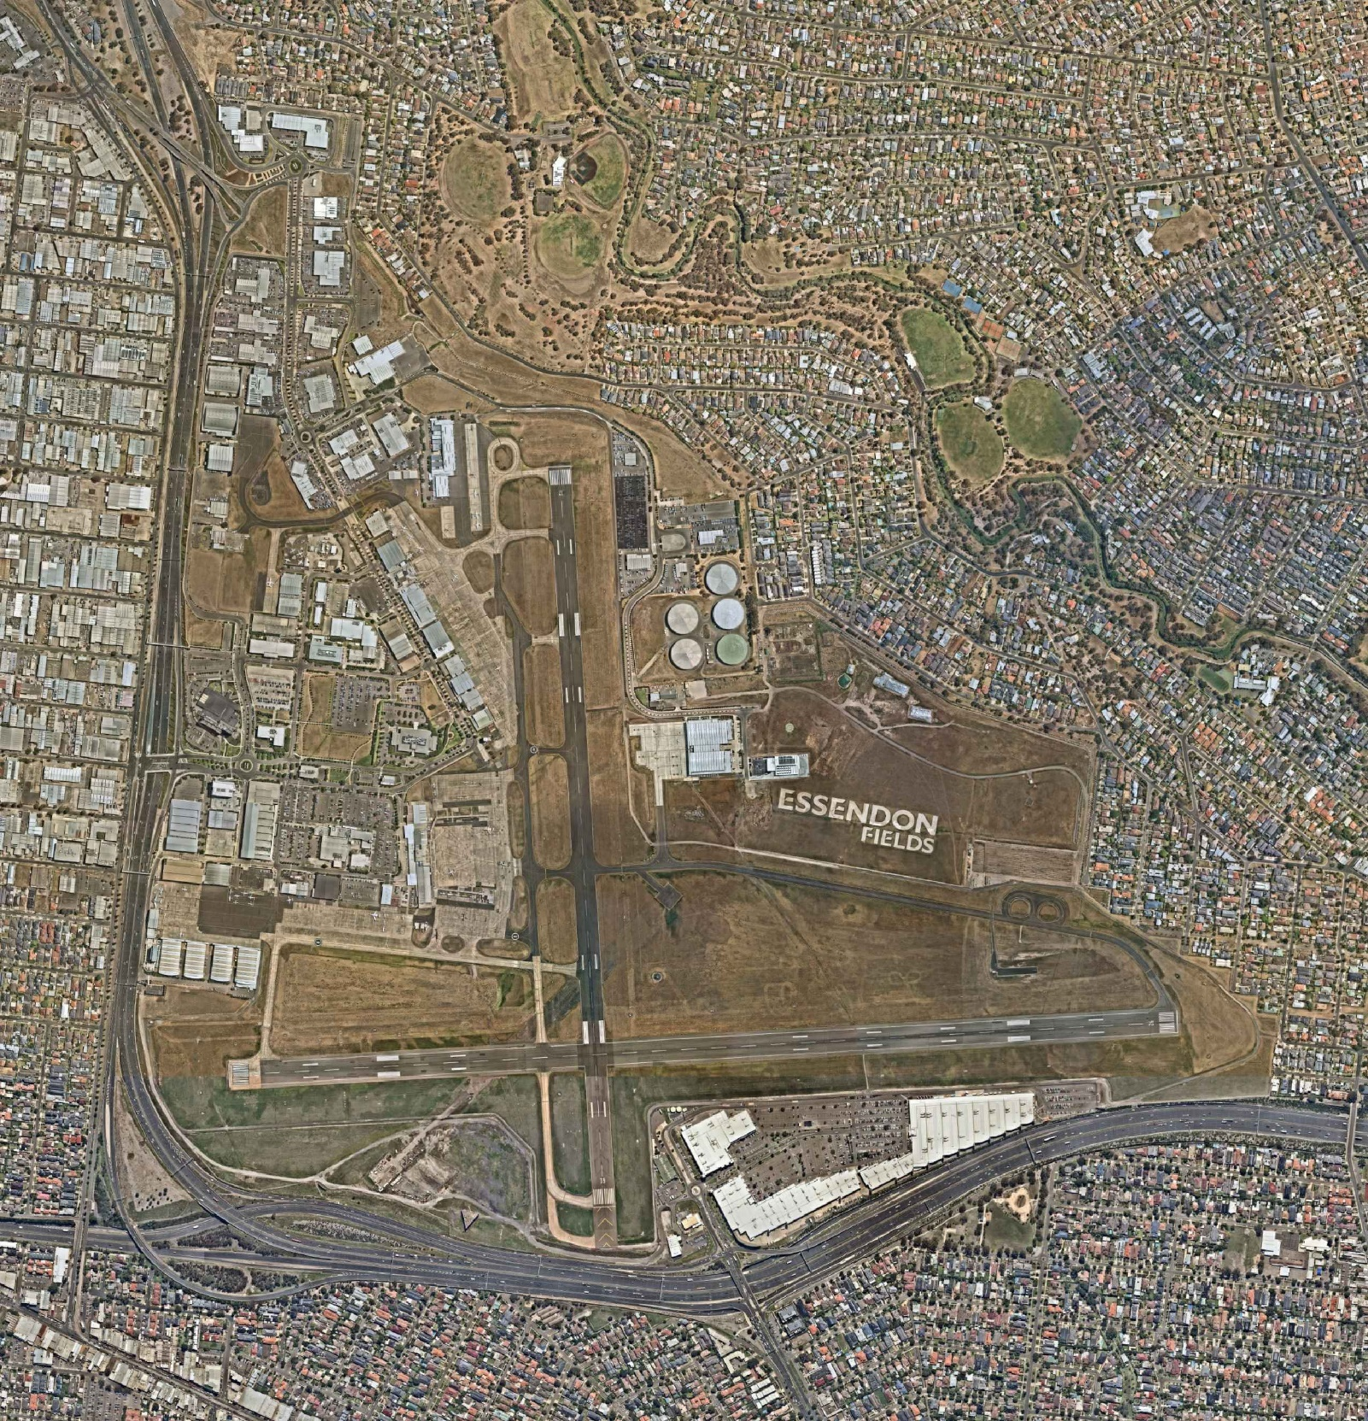
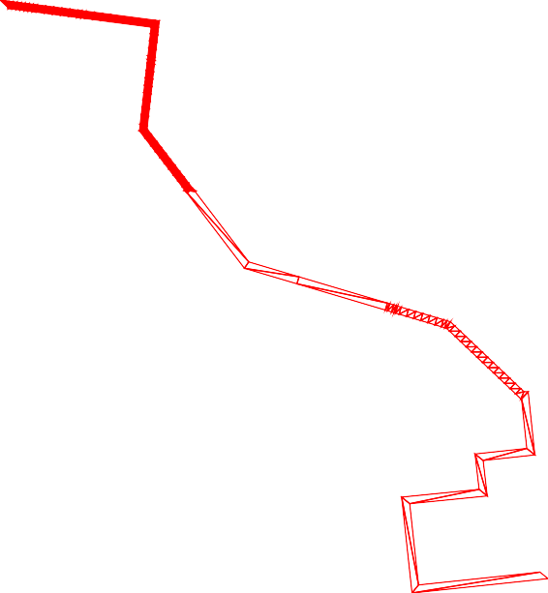
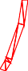



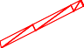

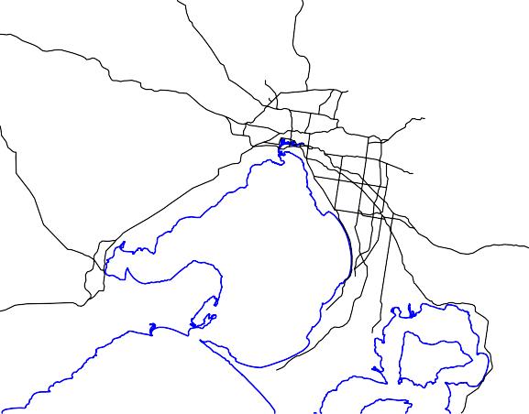


20202284.001A.dwg
CAD FILE: O:\09_Projects\DELTEK Projects\Regular\2020\Essendon Fields Projects\20202284.001A - Ecological Assessment\Figures LAYOUT: 1 MELBOURNE, AU
PLOTTED: 13-Mar-2020, 02:06PM, lziemelis



Figure 2: Extent of NTGVVP within the Study Area

20022284.001A/EcoAssessment/MLB20R112692 20 August 2020
Copyright 2020 Kleinfelder

LEGEND
NTG
(NATURAL TEMPERATE GRASSLAND)

NTGVVP (EPBC)
NATURAL TEMPERATE GRASSLAND OF THE VICTORIAN VOLCANIC PLAIN (ENVIRONMENT PROTECTION AND
BIODIVERSITY CONSERVATION)

SOURCE: NEARMAP.COM, DATED 17.02.20

NOTE: ALL LOCATIONS ARE APPROXIMATE. DIMENSIONS IN METRES (m).

0 120 240 360 480 600

PROJECT:

20202284.001A

SCALE

EXTENT OF NGTVVP

1:12000 (A3) METRES

FIGURE

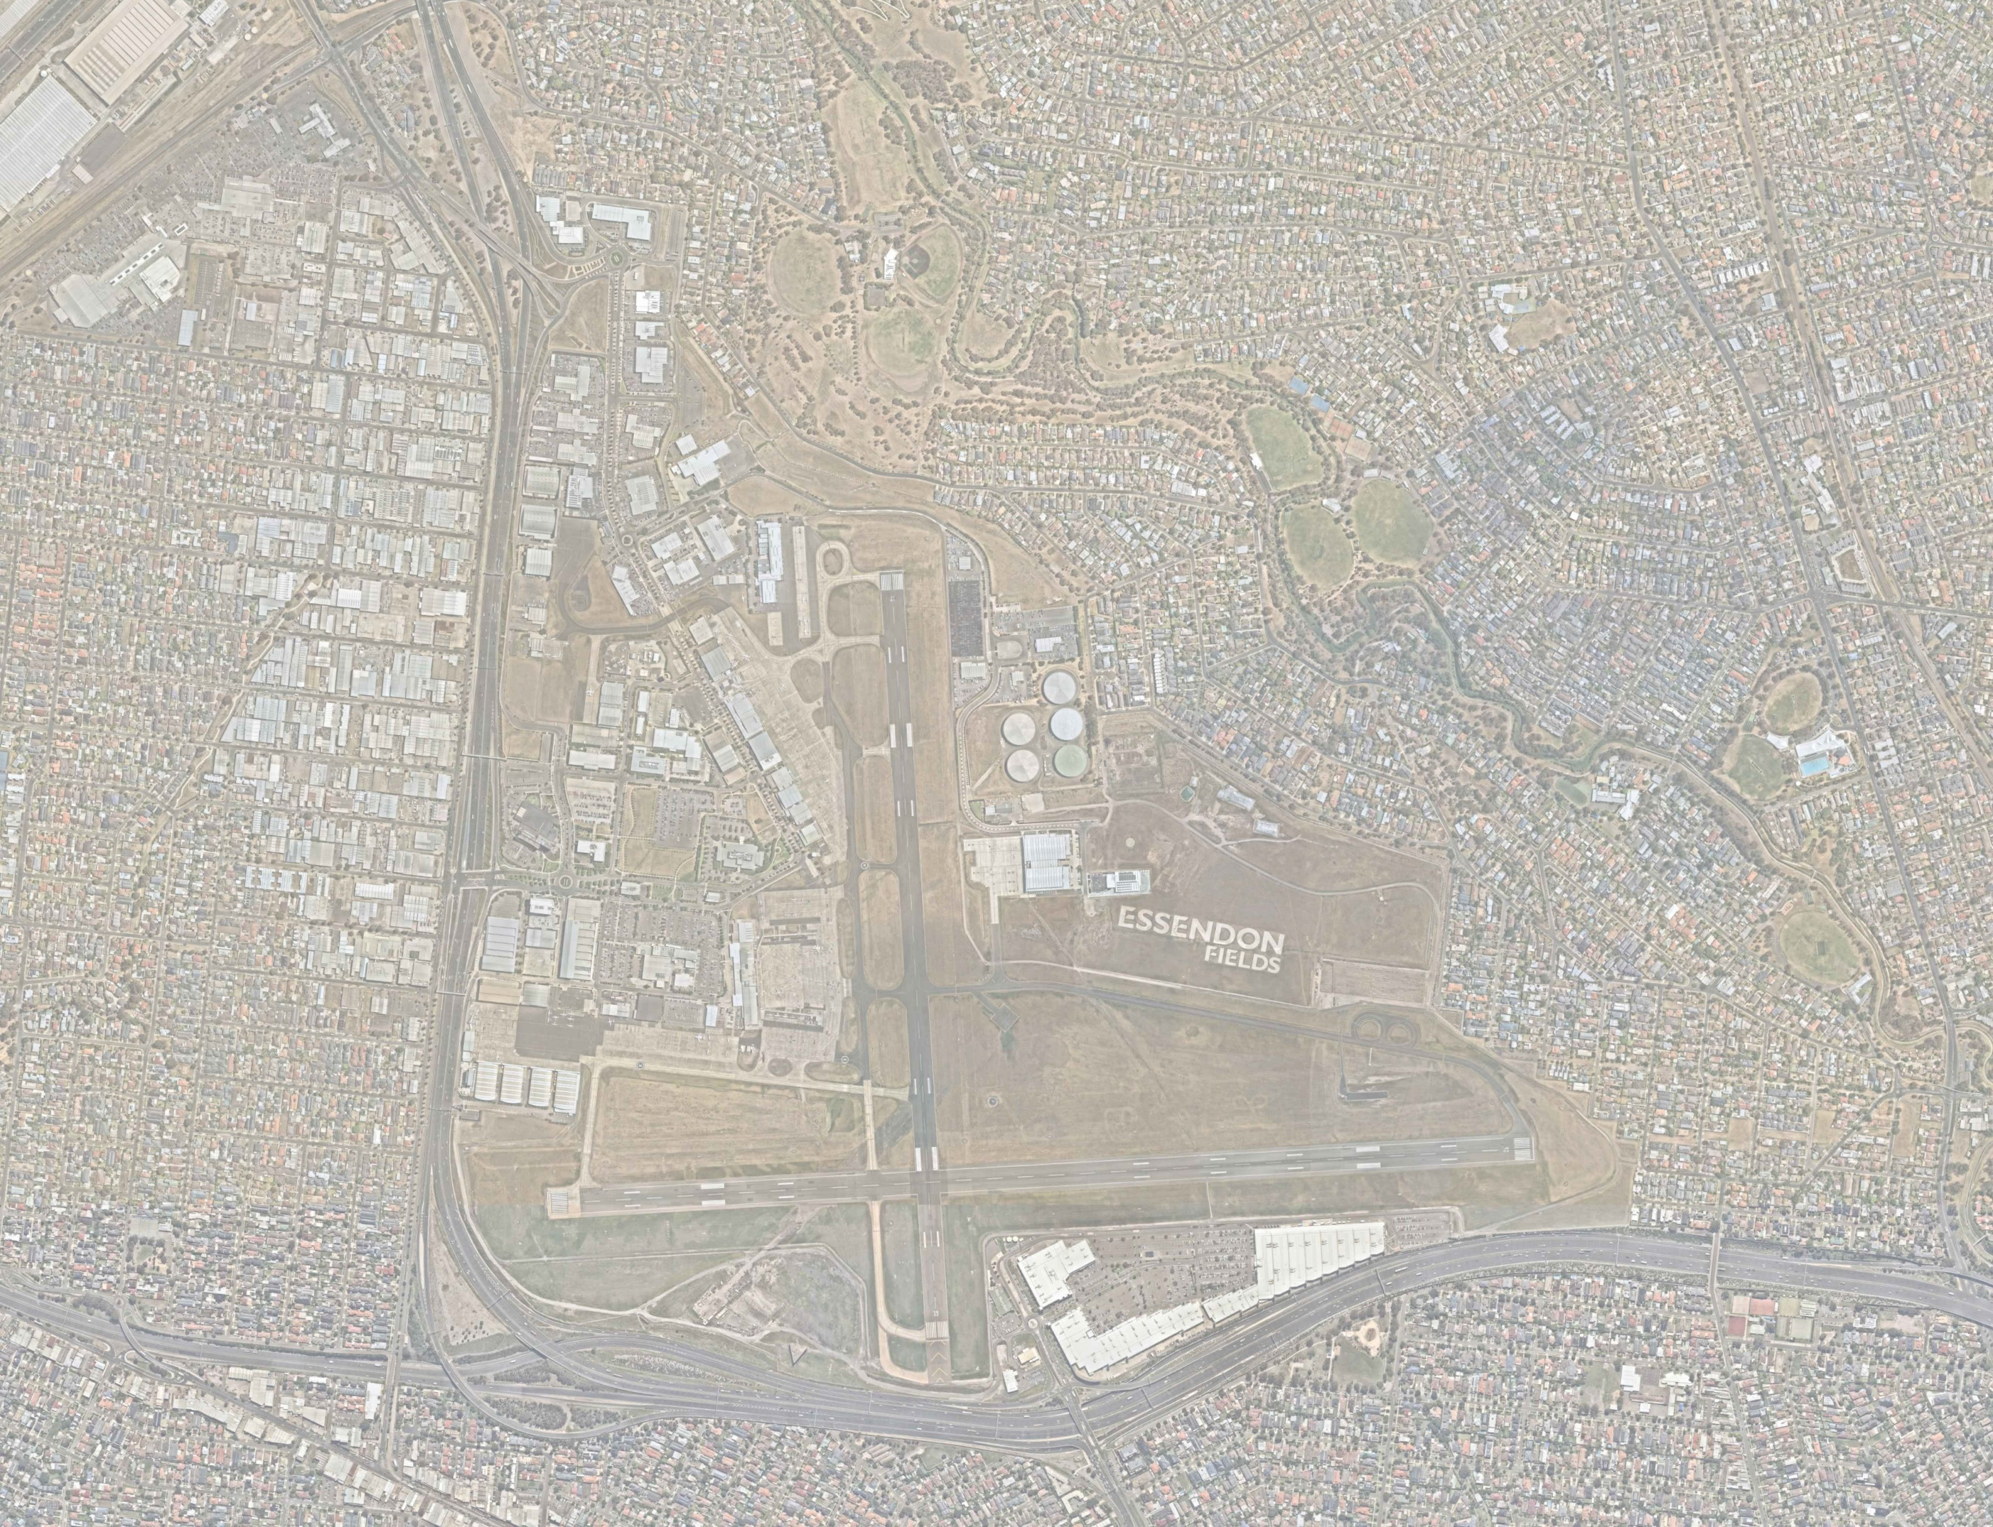
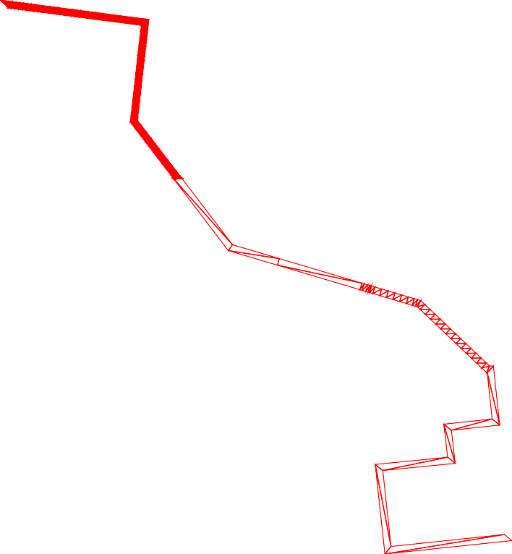

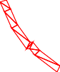









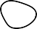


CAD FILE: O:\09_Projects\DELTEK Projects\Regular\2020\Essendon Fields Projects\20202284.001A - Ecological Assessment\Figures LAYOUT: 2 MELBOURNE, AU
PLOTTED: 13-Mar-2020, 02:06PM, lziemelis

www.kleinfelder.com
The information included on this graphic representation has been compiled from a variety of sources and is subject to change without notice. Kleinfelder makes no representations or warranties, express or implied, as to accuracy, completeness, timeliness, or rights to the use of such information. This document is not intended for use as a land survey product nor is it designed or intended as a construction design document. The use or misuse of the information contained on this graphic representation is at the sole risk of the party using or misusing the information.
DATE DRAWN: DRAWN BY:
CHECKED BY: FILE NAME:
20202284.001A.dwg
13.03.20

WITHIN THE STUDY AREA
2
ESSENDON AIRPORT
ESSENDON FIELDS, VICTORIA

APPENDIX 1. AREAS FOR ASSESSMENT

20022284.001A/EcoAssessment/MLB20R112692 20 August 2020
Copyright 2020 Kleinfelder

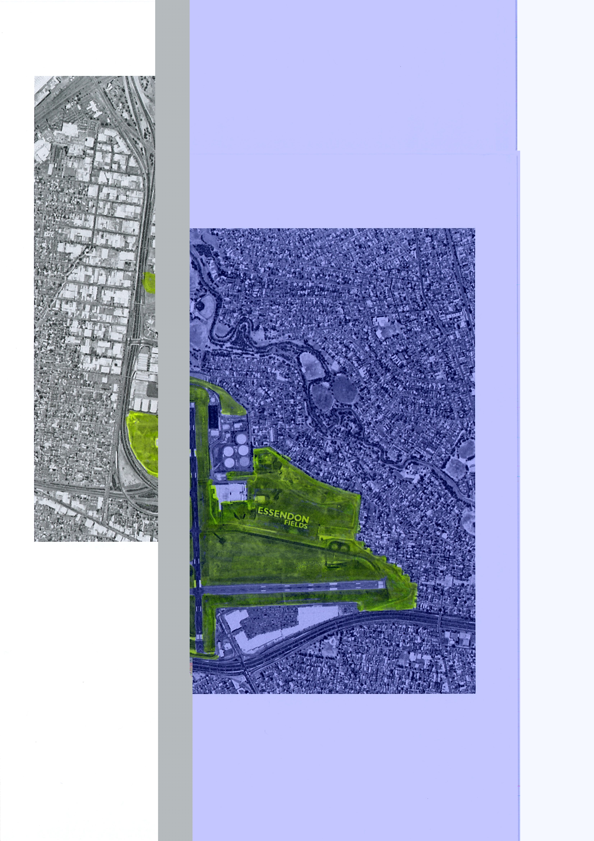

APPENDIX 2. FLORA SPECIES LIST

No. | Family | Scientific Name | Common Name | Introduced
1. | Asteraceae | Arctotheca calendula | Cape weed | Y
2. | Asteraceae | Cirsium vulgare | Spear Thistle | Y
3. | Asteraceae | Conyza bonariensis | Fleabane | Y
4. | Asteraceae | Helminthotheca echiodes | Oxtongue | Y
5. | Asteraceae | Hypochaeris radicata | Cat's Ear | Y
6. | Asteraceae | Lactuca serriola | Prickly Lettuce | Y
7. | Asteraceae | Leontodon taraxacoides | Hairy Hawkbit | Y
8. | Asteraceae | Pseudognaphalium luteoalbum | Jersey Cudweed
9. | Asteraceae | Sonchus oleraceus | Common Sow-thistle | Y
10. | Asteraceae | Taraxacum spp. | Dandelion | Y
11. | Aizoaceae | Galenia pubescens | Galenia | Y
12. | Brassicaceae | Capsella bursa-pastoris | Shepherd’s Purse | Y
13. | Brassicaceae | Lepidium africanum | Peppercress | Y
14. | Brassicaceae | Rapistrum rugosum | Turnipweed | Y
15. | Carophyllaceae | Cerastium glomeratum | Mouse-ear Chickweed | Y
16. | Carophyllaceae | Stellaria media | Chickweed | Y
17. | Convolvulaceae | Convolvulus angustissimus | Slender Bindweed
18. | Crassulaeae | Crassula sieberiana | Stonecrop
19. | Fabaceae | Medicago polymorpha | Burr Medic | Y
20. | Fabaceae | Trifolium arvense | Hare’s Foot Clover | Y
21. | Fabaceae | Trifolium spp | Clover | Y
22. | Gentianaceae | Centaurium erythraea | Common Centaury | Y
23. | Geraniaceae | Erodium sp | Heron's Bill | Y
24. | Geraniaceae | Pelargonium spp | Stork’s Bill | Y
25. | Iridaceae | Romulea rosea | Onion Grass | Y
26. | Linaceae | Linum marginale | Native Flax
27. | Lythraceae | Lythrum hyssopifolia | Loosestrife | Y
28. | Malvaceae | Malva sp | Mallow | Y
29. | Malvaceae | Modiola caroliniana | Red-flower Mallow | Y
30. | Oxalidaceae | Oxalis perennans | Native Sorrel | Y
31. | Papaveraceae | Fumaria spp | Fumitory | Y
32. | Plantaginaceae | Plantago coronopus | Buck's-horn Plantain | Y
33. | Plantaginaceae | Plantago lanceolata | Ribwort | Y
34. | Poaceae | Aira elegantissima | Delicate Hair-grass
35. | Poaceae | Austrostipa spp | Spear Grass
36. | Poaceae | Avena fatua | Wild Oat | Y

No. | Family | Scientific Name | Common Name | Introduced
37. | Poaceae | Bothriochloa macra | Red-leg Grass
38. | Poaceae | Briza minor | Lesser Quaking-grass | Y
39. | Poaceae | Bromus sp. | A Brome | Y
40. | Poaceae | Catapodium rigidum | Fern Grass
41. | Poaceae | Chloris sp | Windmill Grass | Y
42. | Poaceae | Cynodon dactylon | Couch | Y
43. | Poaceae | Dactylis glomerata | Cocksfoot | Y
44. | Poaceae | Dichelachne sp | Plume-grass
45. | Poaceae | Ehrharta erecta | Panic Veldt-grass | Y
46. | Poaceae | Ehrharta longiflora | Annual Veldt-grass | Y
47. | Poaceae | Elymus scaber | Common Wheat-grass
48. | Poaceae | Holcus lanatus | Yorkshire Fog | Y
49. | Poaceae | Hordeum leporinum | Barley-grass | Y
50. | Poaceae | Lolium perenne | Perennial Rye-grass | Y
51. | Poaceae | Lolium rigidum | Wimmera Rye-grass | Y
52. | Poaceae | Microlaena stipoides | Weeping Grass
53. | Poaceae | Nassella neesiana | Chilean Needle-grass | Y
54. | Poaceae | Paspalum dilatatum | Paspalum | Y
55. | Poaceae | Pennisetum clandestinum | Kikuyu | Y
56. | Poaceae | Poa annua | Annual Bluegrass | Y
57. | Poaceae | Rytidosperma caespitosum | Common Wallaby-grass
58. | Poaceae | Rytidosperma sp | Wallaby-grass
59. | Poaceae | Setaria verticillata | Bristle Grass | Y
60. | Poaceae | Themeda triandra | Kangaroo Grass
61. | Poaceae | Triticum aestivum | Wheat | Y
62. | Poaceae | Vulpia muralis | Fescue | Y
63. | Polygonaceae | Persicaria prostrata | Creeping Knotweed
64. | Polygonaceae | Rumex dumosus | Wiry Dock
65. | Primulaceae | Lysimachia arvensis | Pimpernel | Y
66. | Rosaceae | Acaena echinata | Sheep's Burr
67. | Rubiaceae | Asperula conferta | Common Woodruff
68. | Rubiaceae | Galium aparine | Cleavers | Y

Notes:
Y Yes

APPENDIX 3. ASSESSMENT OF LIKELIHOOD OF
OCCURRENCE

A list of threatened species, populations and ecological communities that have been reported or modelled to occur within a five-kilometre radius of the Site was obtained from the following databases:

- Victorian Biodiversity Atlas maintained by Victorian Department of Environment, Land Water and Planning (DELWP) (https://www.environment.vic.gov.au/biodiversity/victorian- biodiversity-atlas )
- Department of the Environment and Energy (DoEE) Protected Matters Search Tool:
(www.environment.gov.au/erin/ert/epbc/index.html).

Note: Pelagic and shorebird species have not been included in the list due to the lack of potential habitat within the Site or Locality.

An assessment was then made of the likelihood of the threatened species, populations, and / or ecological communities reported or modelled to occur in the locality occurring within the Site or using the habitat within the Site as an essential part of a foraging range.

The table below summarises the likelihood of threatened species and EPBC Act listed migratory species occurring within the Site based on the habitat requirements of each species. A brief definition of the likelihood of occurrence criteria is provided below:
- Known – species identified within the site during surveys.
- High – species known from the locality (VBA records), suitable habitat (such as roosting and foraging habitat) present within the site.
- Moderate – species may be known from the locality; potential habitat is present within the site.
- Low – species not known from the area and/or marginal habitat is present within the site.
- Nil – habitat requirements not met for this species within the site.

An assessment of the likelihood of threatened species, populations and ecological communities occurring within the Site
No. | Species | Legal Status* |  |  | No. of Records | Source# | Habitat Preferences | Likelihood of occurrence | Assessment Required (EPBC)?
 |  | DELWP  Advisory | FFG  Act | EPBC  Act
Flora
1. | Amphibromus fluitans River Swamp Wallaby- grass | - | - | V | - | PMST | Grows mostly in permanent swamps as well as billabongs, dams and roadside ditches. The species requires moderately fertile soils with some bare ground; conditions that are caused by seasonally fluctuating water levels.  No suitable habitat within the Site. | Negligible | No
2. | Cullen tenax  Tough Scurf-pea | e | L |  | 2 | VBA | Generally occurs on heavy clay soils in grassland and grassy woodland where the sites are subject to irregular flooding and have relatively rich soils derived from alluvium. Now only eight known populations in Victoria. Flowers from October to February March.  No suitable habitat within the Site. | Negligible | No
3. | Desmodium varians  Slender Tick-trefoil | k | - | - | - | VBA | A small climbing or prostrate herb, generally occurring within moist well drained soils in open forests under semi-shade Flowering mostly occurs from spring to summer.  No suitable habitat within the Site. | Negligible | No
4. | Dianella amoena  Matted Flax-lily | e | L | E | 2 | PMST, VBA | Occurs most commonly in lowland grasslands, grassy woodlands, valley grassy forest and creeklines of herb-rich woodland. Typically, the species occurs on well drained to seasonally wet fertile sandy loams to heavy cracking clays derived from Silurian or Tertiary sediments, or from volcanic geology. Sites are dominated by a grassy understorey with Kangaroo Grass (Themeda triandra), Wallaby Grass (Austrodanthonia racemosa var. racemosa), Common Wheat Grass, Weeping Grass (Microlaena stipoides var. stipoides) and Common Tussock-grass (Poa labillardieri).  Low habitat suitability due to ongoing history of disturbance and maintenance | Low | No

No. | Species | Legal Status* |  |  | No. of Records | Source# | Habitat Preferences | Likelihood of occurrence | Assessment Required (EPBC)?
 |  | DELWP  Advisory | FFG  Act | EPBC  Act
5. | Diuris frangrantissima  Sunshine Diuris | e | L | E | - | PMST | Found in Themeda triandra dominated grasslands with a high level of native herbs on heavy clay loam soils, or basalt soils often with embedded basalt boulders. The orchid grows in the intertussock spaces. Only known populations occur in areas west of Melbourne near Sunshine and Altona. Flowers October-November.  No records in area. Low habitat suitability due to level of disturbance. | Low | No
6. | Glycine latrobeana  Clover Glycine | v | L | V | - | PMST | Occurs in lowland grasslands, grassy woodlands and sometimes in grassy heath. The grasslands are dominated by Themeda triandra as well as Poa species. Soils have been described as fine loamy sand to coarse sandy loam, grey silty clay or black clay loam occurring on plains or gentle to moderate slopes. Flowers from September to November/December.  Low habitat suitability within the Site. | Low | No
7. | Coronidium gunnianum Pale Swamp Everlasting | v | - | - |  | VBA | Principally occurs within grasslands and riverine woodlands (under Eucalyptus camaldulensis) on soils that are prone to inundation  No habitat suitability within the Site. | Negligible | No
8. | Lachnagrostis adamsonii  Adamson’s Blown-grass | v | L | E | - | PMST | Confined to slow moving creeks, swamps, flats, depressions or drainage lines that are seasonally inundated or waterlogged and usually moderately to highly saline. Soils are black, cracking clays or duplex soils with poorly permeable subsoils ranging from acidic to alkaline. Plants appear to favour sites that have some shelter from the wind. Flowers from November to December.  No suitable habitat within the Site. | Nil | No

No. | Species | Legal Status* |  |  | No. of Records | Source# | Habitat Preferences | Likelihood of occurrence | Assessment Required (EPBC)?
 |  | DELWP  Advisory | FFG  Act | EPBC  Act
9. | Leucochrysum albicans var tricolor  Grassland Paper-daisy | e | L | E | - | PMST | Occurs in a wide variety of grassland, woodland and forest habitats, generally on relatively heavy soils. Plants can be found in natural or semi-natural vegetation and grazed or ungrazed habitat. Bare ground is required for germination. In Victoria, occurs almost exclusively on acidic clay soils derived from basalt, occasionally on nearby sandy-clay soils derived from sedimentary material  Low habitat suitability within the Site.
10. | Pimelea spinescens subsp. spinescens Spiny Rice-flower | e | (L) | CE | - | PMST | Small shrub, endemic to the grasslands of Victoria. usually occurring on basalt-derived soils, comprising black or grey clays. It is typically associated with the critically endangered NTGVVP. In contrast to most other grassland species, typically blooms in mid-winter  Low habitat suitability due to long-term history of disturbance and maintenance. | Low | No
11. | Prasophyllum frenchii  Maroon Leek-orchid | e | L | E | - | PMST | Grows mainly in open sedge swampland or in wet grassland and wet heathland generally bordering swampy regions. Sites are generally low altitude, flat and moist with soils that are generally moderately rich damp sandy or black clay. Known populations in Victoria are distributed widely in about six disjunct populations across southern Victoria from the south-west to east of Melbourne and across to Gippsland. Flowers from October to December.  Low habitat suitability within the Site. | Low | No

No. | Species | Legal Status* |  |  | No. of Records | Source# | Habitat Preferences | Likelihood of occurrence | Assessment Required (EPBC)?
 |  | DELWP  Advisory | FFG  Act | EPBC  Act
12. | Pterostylis cucullata  Leafy Greenhood | e | L | V | - | PMST | Occurs in two distinct habitat types that correspond with the two distinct sub-species of Leafy Greenhood; one that occurs in coastal environments and the other in montane/inland environments. Inland populations occur on riverbanks or alluvial flood plains in protected positions with a southerly or easterly aspect and can be found amongst the sub-alpine vegetation in the Victorian Highlands.  No suitable habitat within the Site. | Nil | No
13. | Rutidosis leptorrhynchoides Button Wrinklewort | e | L | E | - | PMST | In Victoria, restricted to open stands of plains grassland and grassy woodlands, on fertile clays to clay loams, usually in areas where the grass cover is more open, either as a result of recurrent fires or grazing by native macropods or stock.  Low habitat suitability within the Site. | Low | No
14. | Rytidosperma setaceum var. brevisetum  Short-bristle Wallaby Grass | r | - | - |  | VBA | Generally occurs in dryish environments but tolerant of most conditions, flowering from September to December. No records in area.  Low habitat suitability within the Site. | Low | No
15. | Senecio macrocarpus  Large-fruit Fireweed | e | L | V | - | PMST | In Victoria, occurs predominantly in the Western (Basalt) Plains grassland on red brown earth soils found on recent Quaternary (basalt) deposits. It may also occur in grassy woodlands and open woodlands. such as Grey Box Open Woodland and Long-leaved Box Open Woodland. Flowers in Spring, from September to November  Low habitat suitability within the Site. | Negligible | No

No. | Species | Legal Status* |  |  | No. of Records | Source# | Habitat Preferences | Likelihood of occurrence | Assessment Required (EPBC)?
 |  | DELWP  Advisory | FFG  Act | EPBC  Act
16. | Xerochrysum palustre  Swamp Everlasting | v | L | V | - | PMST | Grows in wetlands including sedge-swamps and shallow freshwater marshes, often on heavy black clay soils. Commonly associated genera include Swamp Wallaby- grasses, Sedges (Carex spp.), Chorizandra, Billy-buttons (Craspedia spp.), Spike-sedges (Eleocharis spp.), Club- sedges (Isolepis spp.), Common reed (Phragmites australis), Kangaroo grass. Colonial, extensively rhizomatous perennial, dying off in late summer and resprouting in winter (depending on rains). Flowering occurs from November to March and fruiting, December to April.  No suitable habitat within the Site. | Nil | No
Threatened Ecological Communities
1. | Grassy Eucalypt Woodland of the Victorian Volcanic Plain |  |  | CE |  | PMST | restricted to Quaternary basalt soils. It occurs on flat to gently undulating plains and associated stony knolls, generally at elevations up to 500 metres above sea level. Ecological community includes patches of derived grassland where the tree canopy is known to have been removed but a native ground layer remains  Community does not occur within Locality. | Low | No
2. | Grey Box (Eucalyptus macrocarpa) Grassy Woodlands and Derived native Grasslands of South-eastern Australia |  |  | E |  | PMST | Occurs in two forms, a grassy woodland form and as a derived native grassland. grassy woodland form has a tree canopy that is dominated or co-dominated by Grey Box (Eucalyptus microcarpa). The community predominantly occurs on the drier edge of the temperate grassy eucalypt woodland belt that covered the lower slopes and plains of mainland eastern Australia, inland of the Great Dividing Range.  No suitable habitat within the Site. Community does not occur within Locality. | Nil | No

No. | Species | Legal Status* |  |  | No. of Records | Source# | Habitat Preferences | Likelihood of occurrence | Assessment Required (EPBC)?
 |  | DELWP  Advisory | FFG  Act | EPBC  Act
3. | Natural Damp Grassland of the Victorian Coastal Plains |  |  | CE |  | PMST | Ranges from closed tussock grassland to open grassy woodland with a sparse canopy of woody species. Generally found on heavy grey silty–loamy soils, which are poorly drained and therefore often damp and sometimes waterlogged. The heavy soils may be derived from floodplain or swamp deposits, and they may be influenced by moisture from local rainfall, surface flows from local creeks or runoff from surrounding land, and occasionally groundwater. The grassland has a variable floristic composition but is generally dominated by tussock grasses,  No suitable habitat within the Site. Community does not occur within Locality. | Low | No
4. | Natural Temperate Grassland of the Victorian Volcanic Plain |  |  | CE |  | PMST | Limited to the basalt plain that extends from Melbourne west to about Hamilton, the community is dominated by a ground layer of native tussock-forming perennial grasses interspersed with a variety of herbs, mostly from the Asteraceae, lily, pea (Fabaceae) and orchid families, occupying the spaces among grass tussocks. The main grass species present are Kangaroo-grass (Themeda triandra), particularly on drier sites, Wallaby-grasses (Rytidosperma spp.), Spear-grasses (Austrostipa spp.) and Tussock-grasses (Poa spp.).  Patches of the community have been found within the Site. | High | Yes

No. | Species | Legal Status* |  |  | No. of Records | Source# | Habitat Preferences | Likelihood of occurrence | Assessment Required (EPBC)?
 |  | DELWP  Advisory | FFG  Act | EPBC  Act
5. | White Box-Yellow Box- Blakely’s Red Gum Grassy Woodland and Derived Native Grassland |  |  | CE |  | PMST | Can occur either as woodland or a derived grassland from which the trees have been removed. White Box, Yellow Box or Blakely’s Red Gum dominate the community where a tree layer still occurs with a ground layer of native tussock grasses and herbs and a sparse scattered shrub layer. In Victoria. The community tends to occur on the slopes and tablelands on the northern side of the Great Dividing Range of the Great Dividing Range. The EVCs that may correspond to this community include Valley Grassy Forest (EVC 47) and Grassy Woodland (EVC 175).  Community does not occur within Locality. | Nil | No
Insects
1. | Synemon plana  Golden Sun Moth | ce | L | CE | 1 | PMST, VBA | Inhabits grassy woodlands and grasslands generally dominated by Wallaby Grass (Rytidosperma sp) although the species has also been found in areas with less than 10% cover of Wallaby Grass. Nevertheless, an open tussock structure with sparse inter-tussock spaces and/or much bare ground appears to be an important attribute of sites supporting the species.  Low habitat suitability within Site due to history of disturbance. | Low | No
Fish
1. | Galaxiella pusilla  Eastern Dwarf Galaxias | e | L | V | - | PMST | Occurs in slow flowing and still, shallow, permanent and temporary freshwater habitats such as swamps, drains and the backwaters of streams and creeks, often (but not always) containing dense aquatic macrophytes and emergent plants. Some wetlands where it occurs may partially or completely dry up during summer and such wetlands rely on seasonal flooding plus linkages to other sites where the species occurs, for recolonisation.  No suitable habitat within the Site. | Nil | No

No. | Species | Legal Status* |  |  | No. of Records | Source# | Habitat Preferences | Likelihood of occurrence | Assessment Required (EPBC)?
 |  | DELWP  Advisory | FFG  Act | EPBC  Act
2. | Maccullochella peelii  Murray Cod | v | L | V | - | PMST | Utilises a diverse range of habitats from clear rocky streams, such as those found in the upper western slopes of NSW to slow-flowing, turbid lowland rivers and billabongs. Frequently found in the main channels of rivers and larger tributaries. The species is, therefore, considered a main- channel specialist.  No suitable habitat within the Site. | Nil | No
3. | Prototroctes maraena  Australian Grayling | v | L | V | - | PMST | Occurs in streams and rivers on the eastern and southern flanks of the Great Dividing Range, from Sydney, southwards to the Otway Ranges of Victoria and in Tasmania.  No suitable habitat within the Site. | Nil | No
Amphibians
1. | Litoria raniformis  Growling Grass Frog | e | L | V | 4 | PMST, VBA | Generally requires permanent still or slow moving water such as lakes, ponds and dams to breed, especially those with bulrushes and emergent vegetation. Submerged vegetation is important habitat for breeding success as it provides egg-laying sites, calling stages for males, and food and shelter for tadpoles. Grassland provides habitat for foraging, dispersal and shelter, and may also provide overwintering sites for the species.  Lack of suitable refuge, breeding or display areas. | Low | No
Reptiles

No. | Species | Legal Status* |  |  | No. of Records | Source# | Habitat Preferences | Likelihood of occurrence | Assessment Required (EPBC)?
 |  | DELWP  Advisory | FFG  Act | EPBC  Act
1. | Delma impar  Striped Legless Lizard | e | L | V | 3 | PMST, VBA | Known to occupy areas derived from the Western (Basalt) Plains Grassland community but generally preferring areas with suitable tussock structure, where the soil is of appropriate type and structure, and the site has not had major disturbance such as ploughing. Known occupied sites have a grassy ground cover, often with a mixture of native and exotic perennial and annual species of tussock-forming grasses (often >20–50% cover). The majority of sites in Victoria and NSW occur on cracking clay soils with some surface rock which provide shelter for the species. The species shelters in grass tussocks, soil cracks, under rocks, spider burrows and under debris such as timber.  Low habitat suitability within the Site | Low | No
2. | Tympanocryptis pinguicolla  Grassland Earless Dragon | ce | L | E | - | PMST | Inhabits natural temperate grasslands with embedded surface rocks and tussocks believed to be habitat components that are critical to the species survival. There are three extant distinct subpopulations known from southern NSW but the subpopulation of the species in southern Victoria (formerly occurring from Melbourne to Melton and south to Geelong) is presumed extinct.  No suitable habitat within the Site. No records in Locality.
Birds
1. | Accipter novaehollandiae  Grey Goshawk | v | L |  | 2 | VBA | Generally found along the coasts from northern to south- eastern Australia, their preferred habitat is forests, tall woodland and timbered watercourses where they will hunt for birds, small mammals, reptiles and insects.  Marginal habitat within Locality. | Low | No

No. | Species | Legal Status* |  |  | No. of Records | Source# | Habitat Preferences | Likelihood of occurrence | Assessment Required (EPBC)?
 |  | DELWP  Advisory | FFG  Act | EPBC  Act
2. | Anthochaera phrygia  Regent Honeyeater | ce | L | CE | - | PMST | Mostly recorded in box-ironbark eucalypt associations. At times of food shortage, the species also uses other woodland types and wet lowland coastal forest dominated by Swamp Mahogany or Spotted Gum.  No suitable habitat within the Site. No known records from the locality | Nil | No
3. | Ardea alba  Great Egret | v | L |  | 64 | VBA | A large waterbird that feeds on a range of vertebrates and invertebrates such as fish, frogs, crustaceans and insects.  No suitable habitat within the Site. | Nil | No
4. | Botaurus poiciloptilus  Australasian Bittern | e | L | E | - | PMST | Occurs in reeds and marshes in terrestrial freshwater wetlands and, occasionally estuarine habitats. Nests in stands of Phragmites, Typha, and rushes (Juncus, Baumea spp.).  Marginal habitat (semi-vegetated waterbodies) within the Locality. No known records from the locality. | Low | No
5. | Callidris ferruginea  Curlew Sandpiper | e | L |  | 1 | VBA | A small wader that forages in soft mud in marshes and coastal areas for insects and other small invertebrates.  No suitable habitat within the Site. | Nil | No
6. | Egretta garzetta  Little Egret | e | L |  | 2 | VBA | Occupies a variety of habitats including lakes, rivers, ponds and marshes with open areas where they generally stalk prey in shallow water although, being opportunistic, they will also feed in farmland on small reptiles and invertebrates.  No suitable habitat within the Site. | Nil | No
7. | Falco subniger  Black Falcon | v | L |  | 4 | VBA | Usually occurs in arid and semi-arid zones near watercourses. The diet primarily consists of bird species and will hunt over wooded grasslands or wetlands that end to attract abundant birdlife.  Marginal habitat within the Locality. | Low | No

No. | Species | Legal Status* |  |  | No. of Records | Source# | Habitat Preferences | Likelihood of occurrence | Assessment Required (EPBC)?
 |  | DELWP  Advisory | FFG  Act | EPBC  Act
8. | Grantiella picta  Painted Honeyeater | v | L | V | - | PMST | Inhabits Boree, Brigalow and Box-Gum Woodlands and Box-Ironbark Forests. The primary food source for this bird is the fruit and flowers of mistletoes in the genus Amyema, though it will also take some nectar and insects.  No suitable habitat due to lack of mistletoes and suitable tree species. No records in locality. | Nil | No
9. | Haliaeetus leucogaster White-belled Sea-Eagle | v | L |  | 1 | VBA | Generally found in coastal habitats (especially those close to the sea-shore) and around terrestrial wetlands but have been recorded flying over a variety of terrestrial habitats. However, generally forages over large expanses of open water.  Low habitat suitability within the Locality. | Low | No
10. | Ixobrychus dubius Australian Little Bittern | e | L |  | 1 | VBA | Smallish heron-like bird generally occupying swamps or wetland where tall rushes or other dense cover vegetative is available.  No suitable habitat within the Site. | Nil | No
11. | Lathamus discolor  Swift Parrot | e | L | CE | 6 | PMST, VBA | This migratory species has been recorded on the mainland from a variety of habitat types including dry and wet sclerophyll forest, forested wetlands, coastal swamp forests and heathlands.  No suitable habitat within the Site. | Nil | No
12. | Neophema pulchella  Turquoise Parrot | nt | L |  | 1 | VBA | Inhabits open woodland, either of native cypress or eucalypts. Occurs predominantly in the foothills of the Great Dividing Range, from northern Victoria through to Queensland.  No suitable habitat within the Site. | Nil | No
13. | Numenius madagascariensis  Eastern Curlew | v | L |  | 1 | VBA | Large shorebird that winters in Australia mostly in estuaries and marshes where it probes for invertebrates in the mud.  No suitable habitat within the Site. | Nil | No

No. | Species | Legal Status* |  |  | No. of Records | Source# | Habitat Preferences | Likelihood of occurrence | Assessment Required (EPBC)?
 |  | DELWP  Advisory | FFG  Act | EPBC  Act
14. | Oxyura australis  Blue-billed Duck | e | L |  | 2 | VBA | Mostly aquatic occupying open lakes, dams or deep freshwater swamps and sometimes large rivers.  No suitable habitat within the Site. | Nil | No
15. | Pedionomus torquatus  Plains Wanderer | ce | L |  | 2 | VBA | Small quail like ground bird that tend to live in semi-arid lowland native grasslands growing on hard red-brown soils, typically with extensive bare ground between tussocks with plenty of leaf litter and herbs and forbs. The majority of remaining population is found in the Riverina region.  No suitable habitat within the Site. | Low | Nil
16. | Porzana pusilla  Baillon’s Crake | V | L |  | 22 | VBA | A small waterbird that typically occupies swamps and other wetlands with dense fringing vegetation  No suitable habitat within the Site. | Nil | No
17. | Rostratula australis  Australian Painted-snipe | ce | L | E | - | PMST | Prefers fringes of swamps, dams and nearby marshy areas where there is a cover of grasses, lignum, low scrub or open timber.  Low habitat suitability within the Locality | Low | No
18. | Stictonetta naevosa  Freckled Duck | e | L |  | 2 | VBA | Prefers large bodies of fresh water for breeding, generally within inland regions of eastern Australia. At other times may disperse to more coastal areas with permanent water such as lakes and ponds.  No suitable habitat within the Site. | Nil | No
Mammals
1. | Dasyurus maculatus  Spotted-tailed Quoll | e | L | E | - | PMST | Recorded across a range of habitat types, including rainforest, open forest, woodland, coastal heath and inland riparian forest, from the sub-alpine zone to the coastline.  No suitable habitat within the Site | Nil | No

No. | Species | Legal Status* |  |  | No. of Records | Source# | Habitat Preferences | Likelihood of occurrence | Assessment Required (EPBC)?
 |  | DELWP  Advisory | FFG  Act | EPBC  Act
2. | Petauroides volans  Greater Glider | v |  | V | - | PMST | Open woodland and tall remnant forests where there is suitable eucalypt trees. Rests in hollow trees during the day and feeds at night. Presence and density of Greater Gliders is related to soil fertility, eucalypt tree species, disturbance history and density of suitable tree hollows  No suitable habitat within the Site | Nil | No
3. | Pteropus poliocephalus  Grey-headed Flying-fox | v | L | V | 1 | PMST, VBA | Occurs across a wide range of habitat types along the eastern seaboard of Australia, depending on food availability. Fruit from myrtaceous trees and rainforest trees form the major components of their diet.  No suitable habitat within the Site | Nil | No
Migratory Terrestrial Species
1. | Hirundapus caudacutus  White-throated Needletail | v | - | M | 11 | PMST, VBA | Forages in high open spaces over varied habitat types although probably recorded most often above wooded or partly wooded areas, including open forest and rainforest, and may also fly between trees or in clearings.  Low habitat suitability within the Study Area | Low | No
2. | Monarcha melanopsis  Black-faced Monarch | - | - | M | - | PMST | Found in rainforests, moist eucalypt woodlands, coastal scrub and damp gullies. It may be found in more open woodland when migrating.  No suitable habitat within the Site | Nil | No
3. | Motacilla flava  Yellow Wagtail | - | - | M |  | PMST | Found in a variety of habitats including short grass and bare ground, swamp margins, sewage ponds, saltmarshes, playing fields, airfields, ploughed land and town lawns.  Low habitat suitability within the Study Area. No records from locality. | Low | No
4. | Myiagra cyanoleuca  Satin Flycatcher | - | - | M | 1 | PMST, VBA | Found in tall forests, preferring wetter habitats such as heavily forested gullies.  No suitable habitat within the Site. | Nil | No

No. | Species | Legal Status* |  |  | No. of Records | Source# | Habitat Preferences | Likelihood of occurrence | Assessment Required (EPBC)?
 |  | DELWP  Advisory | FFG  Act | EPBC  Act
5. | Rhipidura rufifrons  Rufous Fantail | - | - | M | 8 | PMST, VBA | Found in rainforest, dense wet forests, swamp woodlands and mangroves, preferring deep shade, and is often seen close to the ground.  No suitable habitat within the Site. | Nil | No
* Legal Status: L = Listed under FFG Act; V = Vulnerable, E = Endangered, CE = Critically Endangered under EPBC Act; M = Migratory under EPBC Act. # Source: VBA = Victorian Biodiversity Atlas, PMST = Protected Matter Search Tool (Australian Government)



APPENDIX 4. PHOTOGRAPHS

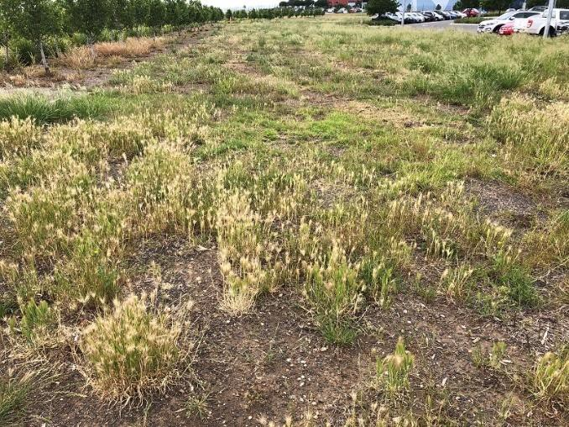  Landside (Wirraway North Precinct) - exotic vegetation | 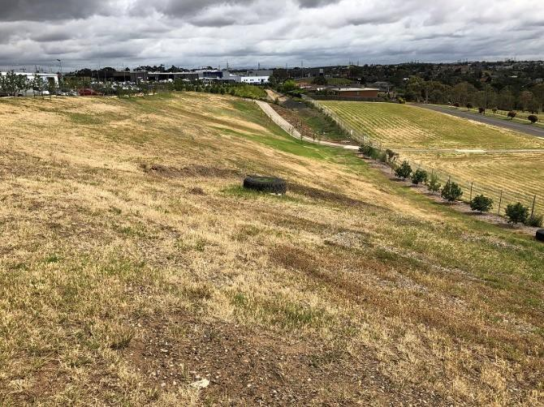  Landside (north – Global Avenue, north) –  exotic vegetation
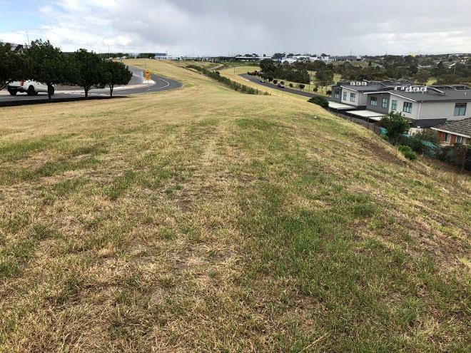  Landside (north – Global Avenue, north-east) –  exotic vegetation | 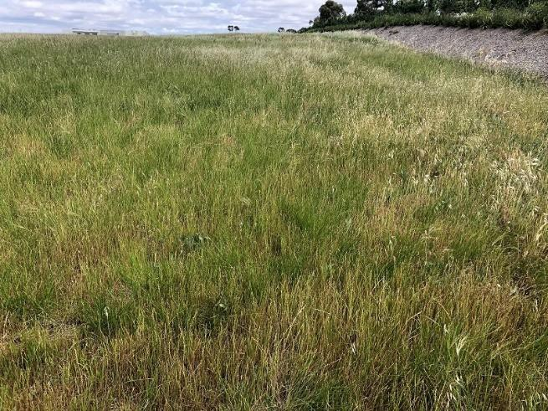  Landside (Hart Precinct, NE) – exotic grassland
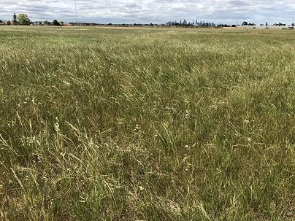  Landside – Hart Precinct | 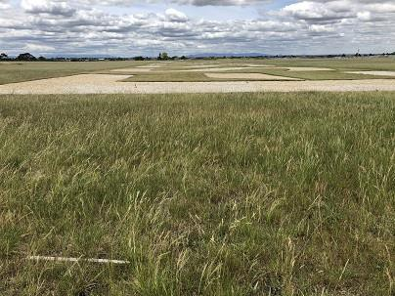  Landside – Hart Precinct

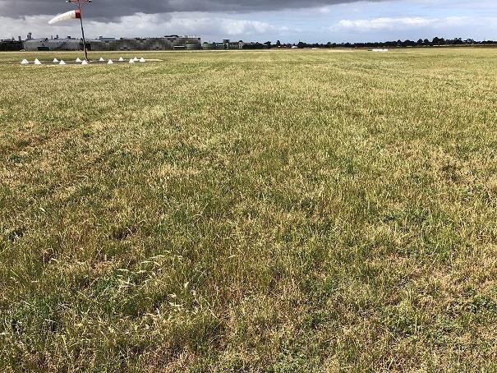  Airside (windsock) – no native vegetation | 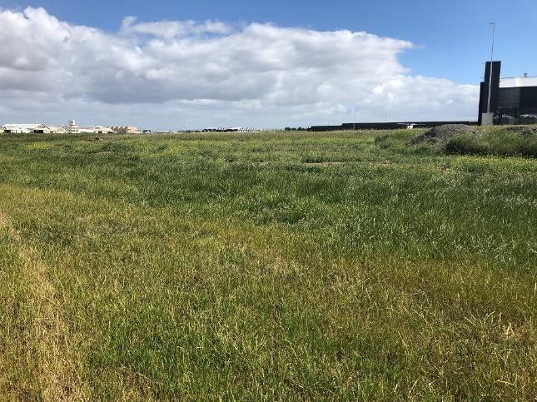  Airside (west of Hart Precinct) – exotic grassland
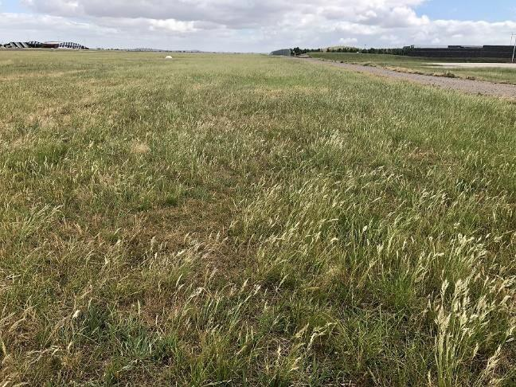  Airside (south of airfield) – partial Wallaby Grass dominated area | 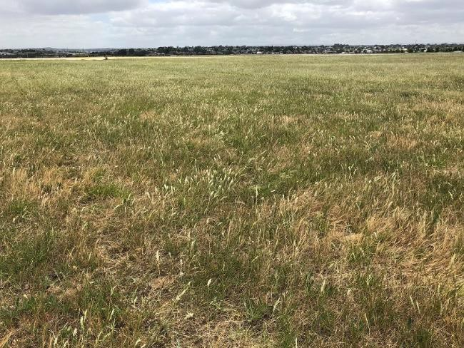  Airside (south of airfield) – partial Wallaby Grass dominated area
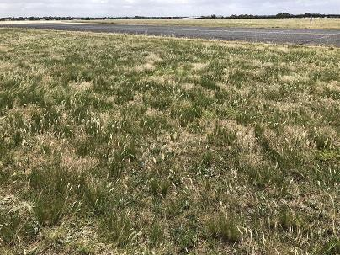  Airside (south of airfield) – partial Wallaby Grass dominated area | 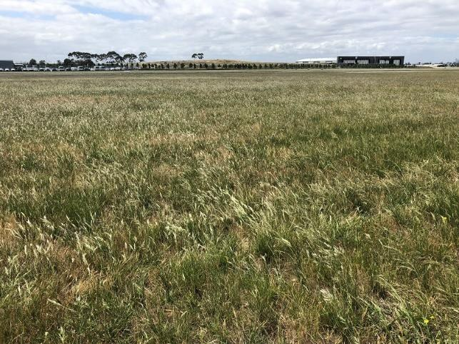  Airside (north-east of airfield) -

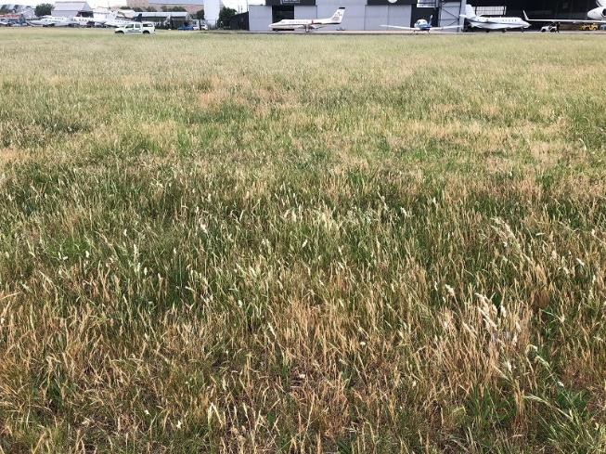  Airside (Lionel St) –Wallaby Grass dominated area | 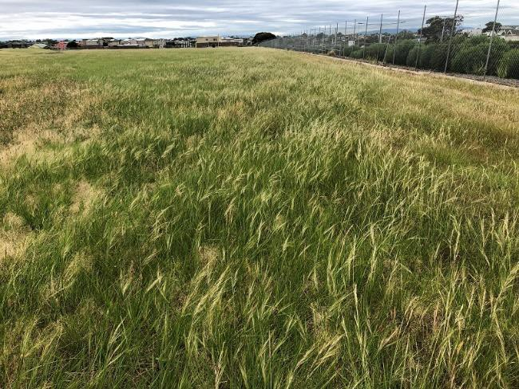  Airside (east of airfield) – exotic grassland
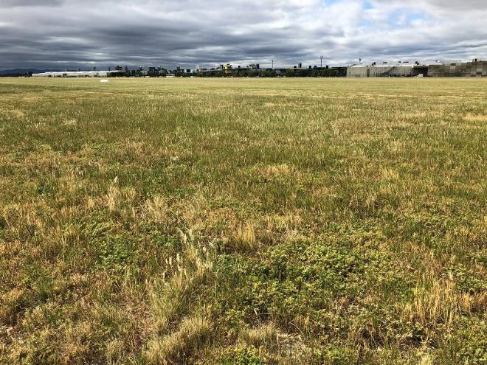  Airside (south of airfield) – | 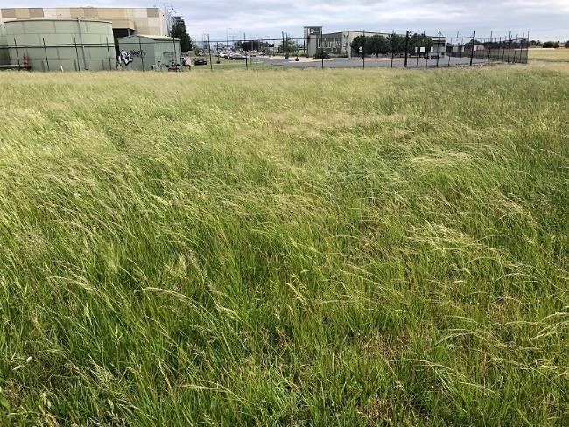  Airside (south of airfield) –
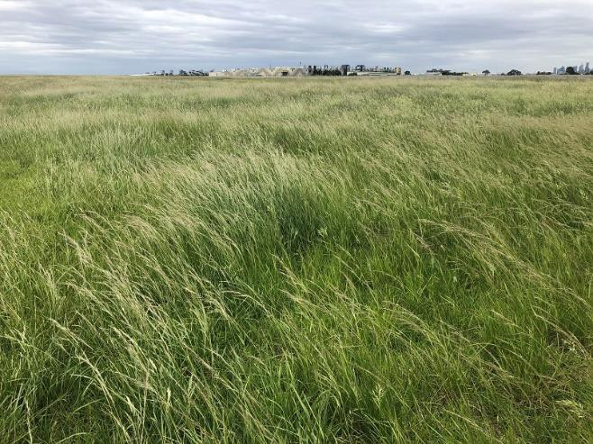  Airside (south of airfield) – | 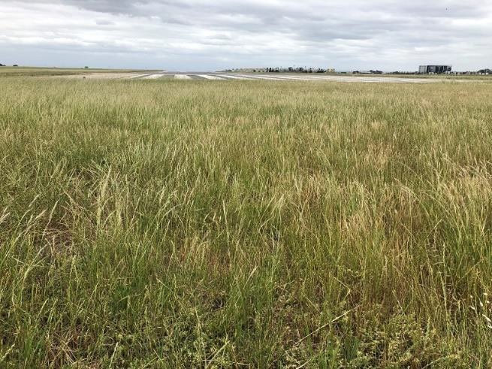  Airside (west of end of runway) -

APPENDIX 5. CORRESPONDENCE FROM DOEE

From:
Sent: Tuesday, 11 August 2020 4:13 PM
To:
Cc:
Subject:

External Email.

Thank you for your enquiry about the Natural Temperate Grassland of the Victorian Volcanic Plain (NTGVVP), following our telephone conversation in July.

As I said on the phone, the short answer to your question is: No, Red-leg Grass (Bothriochloa macra) is not identified as one of the key grass genera characteristic of the national NTGVVP ecological community. It’s one of the native species that’s very tolerant of heavy grazing, so persists in overgrazed pastures. The degree to which it was dominant in original native grassland and grassy woodland vegetation is unclear, so it was not regarded as a key native grass species.

The key native grass genera in NTGVVP are limited to Themeda, Rytidosperma (syn. Austrodanthonia), Austrostipa and Poa spp; the key native grass genera in the closely related community, Grassy
Eucalypt Woodland of the VVP ecological community includes these four grass genera plus Microlaena as the key native genera.

The presence of Bothriochloa does contributes to the criterion for cover of perennial native tussock grasses, that identifies it as a native grassland. However, where redleg grass is the dominant grass over a substantial area or proportion of the site, then that indicates the NTGVVP is not present for that part of the site, because Bothriochloa is not a key native grass species for NTGVVP. Red-leg Grass is indicative of a more disturbed and degraded grassland. If Red-leg Grass is only locally dominant in small areas amongst, say a sward of Rytidosperma and Austriostipa, then it may reasonably be considered as a natural variation in the same way as localised patches of weed or breaks in tussock cover are acceptable for identifying the site as NTGVVP.

The impression I got was that the occurrences of Bothriochloa are extensive within the site, beyond what can be reasonably expected as local variation. If that’s the case, then they should be disregarded for calculating the area of NTGVVP present.

Regards

Department of Agriculture, Water and the Environment
GPO Box 858, Canberra ACT 2601 awe.gov.au

From: Sent: Friday, 7 August 2020 5:54 PM
To: Cc:
Subject:

Just following up on my query below.

Regards,

From: Sent: Friday, 17 July 2020 4:26 PM
To: Cc:
Subject:

Thanks for your time earlier this week to discuss my inquiry regarding a recent ecological survey my colleague completed at a site in Victoria.

Please see below a summary of the details relating to our discussion:

- Kleinfelder recently completed an ecological survey for the presence of ecological communities listed under the Commonwealth Environment Protection and Biodiversity Conservation Act 1999 (EPBC Act) or Victorian Flora and Fauna Guarantee Act 1988 (FFG Act).
- The site where the survey was completed sits on Commonwealth land (i.e. a federally leased airport) and lies within a bioregion known as the Victorian Volcanic Plain (VVP), which is an extensive plain dominated by recent volcanic deposits.
- Natural Temperate Grassland of the Victorian Volcanic Plain (NTGVVP) is an endangered ecological community listed under the EPBC Act that was once common across the VVP.
- The site covers about 155 hectares and is situated near the eastern edge of the VVP.
- In a number of areas, Red-leg Grass (Bothriochloa macra) was the dominant native species present and formed a significant proportion of native ground cover (i.e. >50% vegetation cover), thus meeting the condition threshold as per the Threatened Species Scientific Committee (TTSC 2008).
- Red-leg Grass (Bothriochloa macra) is not listed as one of the key species of NTGVVP.

My query is would Red-leg Grass (Bothriochloa macra) meet the requirement for listing as NTGVVP as it would for the native grass genera Themeda, Austrodanthonia (now Rytidosperma), Austrostipa or Poa?
I understand that you are returning to the office on Monday and can discuss further then if required. Thanks again,

