Help Card: Republic of Korea eCertificate

Introduction
This help card summarises the country-specific requirements to support our paperless eCertificate exchange with the Republic of Korea’s (ROK) Animal and Plant Quarantine Agency (APQA). This Help Card supports brokers and importers when lodging eCertificates for APQA, including for the clearance of goods under approved arrangement class 19.2 Automatic Entry Processing for Commodities (AEPCOMM). More information can be found on our eCertificate imports website: http://agriculture.gov.au/eCertimports

Paperless eCertificate exchange with Republic of Korea
Since 16 April 2025, ROK no longer issues paper phytosanitary certificates. Original paper certificates will continue to be provided for sanitary and zoo sanitary certificates (live animals and reproductive material) and goods arriving as accompanied passenger baggage or via mail. Importers and brokers are given a certificate number where a phytosanitary certificate is required for import clearance. The ROK exporter gives this to importers and brokers with other import documentation. This eCertificate number must be provided to the department for assessment, as per Table 1. More information can be found on our eCertificate imports website: https://www.agriculture.gov.au/biosecurity-trade/import/online-services/electronic-certification
Table 1 ROK eCertificate format
Trading partner | Government certificate type | Document type | Document number format | Status of exchange
ROK | Phytosanitary | KRPHYTO | 12-123456789 | Paperless

Import declarations processed under approved arrangement class 19.2 from ROK
Republic of Korea exporters must provide the certificate details of the phytosanitary certificate (refer to section 3) that will be used for the clearance of goods lodged under approved arrangement class 19.2. Accredited persons must access the External Verification for eCertificates (EVE) system to view the certificate (and any attachments) in order to conduct the assessment via class 19.2. With the introduction of the EVE system, copies of phytosanitary certificates are no longer required to be kept as evidence under the approved arrangement class 19.2 operating conditions.
Refer to our eCertificate imports website for more information on lodging import declarations under approved arrangement class 19.2: https://www.agriculture.gov.au/biosecurity-trade/import/online-services/electronic-certification

3 ROK copy phytosanitary certificate examples

3.1 ROK copy phytosanitary certificate
Below is an example of a copy phytosanitary certificate.
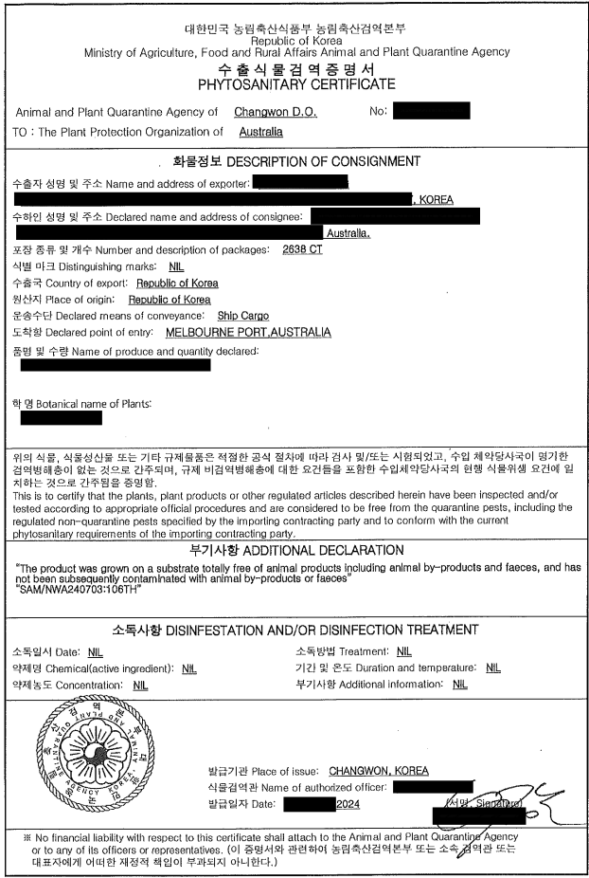

3.2 ROK electronic phytosanitary Certificate
Below is an example of the electronic phytosanitary eCertificate. An extract of this may be provided as an email extract direct from the ROK APQA eCertificate system or a PDF extract. This will only be required in specific circumstances. The status will say approved/acknowledged.
Republic of Korea
Animal and Plant Quarantine Agency / MAFRA Phytosanitary Certificate
Cert No: 12-12345678
Status | Issued
Item  Package Details | Scientific Name / Common Name  KIMCHI / KIMCHI | Package Details  Outer: | Description  KIMCHI | Weight/Volume  Net Weight: 12345.1 Kilogram
Other Package Types | 999 CASES
Distinguishing Marks | LOT 123456
Product Origin | Republic of Korea, Republic of Korea (KR)
Date of issue | 16 April 2025
Exporter | Sample Company  100 Street Road  Seoul, REPUBLIC OF KOREA 12345
Consignee | TEST Industries  1 Test Road Victoria  West Melbourne, 1000, Australia
Exporting Country | Republic of Korea
Importing Country | Australia
Loading Port | Seoul
Declared Point of Entry | Brisbane
Transport Mode | Maritime transport
Vessel | Vessel Name
Voyage/Flight
Financial Liability Statement | No financial liability with respect to this certificate shall attach to Animal and Plant Quarantine Agency / MAFRA or to any of its officers or representatives
Additional declaration | NIL
Date of Inspection | 16 April 2025
Name of authorised officer | Officer Name
Place of Issue | SEOUL, REPUBLIC OF KOREA
Declarations | This is to certify that the plants, plant product or other regulated articles described herein have been inspected and/or tested according to appropriate official procedures and are considered to be free from the quarantine pests, specified by the importing contracting party and to conform with the current phytosanitary requirements of the importing contracting party including those for regulated non-quarantine pests.  They are deemed to be practically free from other pests.

Contact
Phone 1800 900 090
Email ecertadministrator@agriculture.gov.au
Web agriculture.gov.au/Ecertimports
Acknowledgement of Country
We acknowledge the Traditional Custodians of Australia and their continuing connection to land and sea, waters, environment and community. We pay our respects to the Traditional Custodians of the lands we live and work on, their culture, and their Elders past and present.
© Commonwealth of Australia 2025
Unless otherwise noted, copyright (and any other intellectual property rights) in this publication is owned by the Commonwealth of Australia (referred to as the Commonwealth).
All material in this publication is licensed under a Creative Commons Attribution 4.0 International Licence except content supplied by third parties, logos and the Commonwealth Coat of Arms.
The Australian Government acting through the Department of Agriculture, Fisheries and Forestry has exercised due care and skill in preparing and compiling the information and data in this publication. Notwithstanding, the Department of Agriculture, Fisheries and Forestry, its employees and advisers disclaim all liability, including liability for negligence and for any loss, damage, injury, expense or cost incurred by any person as a result of accessing, using or relying on any of the information or data in this publication to the maximum extent permitted by law.

