# Help Card: Sri Lanka eCertificate

## Introduction

This help card summarises the country-specific requirements to support our paperless eCertificate exchange with the Sri Lankas Department of Agriculture(DEA). This Help Card supports brokers and importers when lodging eCertificates for DEA, including for the clearance of goods under approved arrangement class 19.2 Automatic Entry Processing for Commodities (AEPCOMM). More information can be found on our eCertificate imports website: <http://agriculture.gov.au/eCertimports>

## Paperless eCertificate exchange with Sri Lanka

Since 28 May 2025, Sri Lanka no longer issues paper phytosanitary certificates. Original paper certificates will continue to be provided for sanitary and zoo sanitary certificates (live animals and reproductive material) and goods arriving as accompanied passenger baggage or via mail. Importers and brokers are given a certificate number where a phytosanitary certificate is required for import clearance. The Sri Lankan exporter gives this to importers and brokers with other import documentation. This eCertificate number must be provided to the department for assessment, as per Table 1. More information can be found on our eCertificate imports website: <https://www.agriculture.gov.au/biosecurity-trade/import/online-services/electronic-certification>

Table 1 Sri Lanka eCertificate format

| **Trading partner** | **Government certificate type** | **Document type** | **Document number format\*** | **Status of exchange** |
| --- | --- | --- | --- | --- |
| **Sri Lanka** | **Phytosanitary** | **LKPHYTO** | **PC-NN1234567890ABCD** | **Paperless** |

* - Note document number format listed is an example of the typical alphanumeric format that Sri Lanka utilises.

### 2.1 Import declarations processed under approved arrangement class 19.2 from Sri Lanka

Sri Lanka exporters must provide the certificate details of the phytosanitary certificate (refer to section 3) that will be used for the clearance of goods lodged under approved arrangement class 19.2. Accredited persons must access the [External Verification for eCertificates (EVE)](https://www.agriculture.gov.au/biosecurity-trade/import/online-services/EVE) system to view the certificate (and any attachments) in order to conduct the assessment via class 19.2. With the introduction of the EVE system, copies of phytosanitary certificates are no longer required to be kept as evidence under the approved arrangement class 19.2 operating conditions.

Refer to our eCertificate imports website for more information on lodging import declarations under approved arrangement class 19.2: <https://www.agriculture.gov.au/biosecurity-trade/import/online-services/electronic-certification>

## Sri Lanka copy phytosanitary certificate examples

### Copy phytosanitary certificate

Below is an example of a copy phytosanitary certificate.

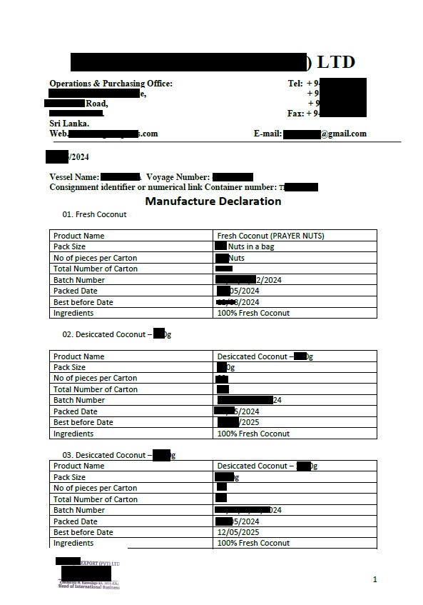

### Sri Lanka electronic phytosanitary Certificate

Below is an example of the electronic phytosanitary eCertificate. An extract of this may be provided as an email extract direct from the Sri Lanka DEA eCertificate system or a PDF extract. This will only be required in specific circumstances. The status will say approved/acknowledged.

|  |  |  |  |  |
| --- | --- | --- | --- | --- |
| **Sri Lanka**  **Department of Agriculture**  **Phytosanitary Certificate**  **Cert No:** PC-NN1234567890ABCD | | | | |
| **Status** | Issued | | | |
| **Item**  **Package Details** | **Scientific Name / Common Name**  *Juglans regia* / Walnuts | **Package Details**  Outer: | **Description**  Shelled nuts | **Weight/Volume**  Net Weight: 12345.1 pound |
| **Other Package Types** | 999 CASES | |  |  |
| **Distinguishing Marks** | LOT 123456 | |  |  |
| **Product Origin** | Sri Lanka (LK) | | | |
| **Date of issue** | 16 April 2025 | | | |
| **Exporter** | Sample Company  100 Street Road Getambe, 20400, Sri Lanka | | | |
| **Consignee** | TEST Food Industries  1 Test Road Victoria Melbourne, 3003, Australia | | | |
| **Exporting Country** | COUNTRY | | | |
| **Importing Country** | Australia | | | |
| **Loading Port** |  | | | |
| **Declared Point of Entry** | Brisbane | | | |
| **Transport Mode** | Maritime transport | | | |
| **Vessel** | Vessel Name | | | |
| **Voyage/Flight** |  | | | |
| **Financial Liability Statement** | No financial liability with respect to this certificate shall attach to NPPO Sri Lanka or to any of its officers or representatives. | | | |
| **Additional declaration** | Representative samples were inspected and found free from evidence of any species of Trogoderma (whether live, dead or exuviae ) in Australias's list of Trogoderma species and The goods were fumigated with methyl bromide in accordance with Australia's methyl bromide fumigation methology as per the attached methyl bromide certificate ( certificate no: 237 & 239 ) and The goods were fumigated prior to packaging and Representative samples were inspected and found free from all live species of Trogoderma of biocecurity concern. | | | |
| **Date of Inspection** |  | | | |
| **Name of authorised officer** | John Doe | | | |
| **Place of Issue** | Plant Quarantine Station- Seaport, Getambe | | | |
| **Declarations** | This is to certify that the plants, plant product or other regulated articles described herein have been inspected and/or tested according to appropriate official procedures and are considered to be free from the quarantine pests, specified by the importing contracting party and to conform with the current phytosanitary requirements of the importing contracting party including those for regulated non-quarantine pests.  They are deemed to be practically free from other pests. | | | |

# Contact

Phone 1800 900 090

Email ecertadministrator@agriculture.gov.au

Web agriculture.gov.au/Ecertimports

**Acknowledgement of Country**

We acknowledge the Traditional Custodians of Australia and their continuing connection to land and sea, waters, environment and community. We pay our respects to the Traditional Custodians of the lands we live and work on, their culture, and their Elders past and present.

© Commonwealth of Australia 2025

Unless otherwise noted, copyright (and any other intellectual property rights) in this publication is owned by the Commonwealth of Australia (referred to as the Commonwealth).

All material in this publication is licensed under a Creative Commons Attribution 4.0 International Licence except content supplied by third parties, logos and the Commonwealth Coat of Arms.

The Australian Government acting through the Department of Agriculture, Fisheries and Forestry has exercised due care and skill in preparing and compiling the information and data in this publication. Notwithstanding, the Department of Agriculture, Fisheries and Forestry, its employees and advisers disclaim all liability, including liability for negligence and for any loss, damage, injury, expense or cost incurred by any person as a result of accessing, using or relying on any of the information or data in this publication to the maximum extent permitted by law.