Help Card: Thailand eCertificate

Introduction
This help card summarises the country-specific requirements to support our paperless eCertificate exchange with the Thailand’s Food and Drug Administration (FDA). This Help Card supports brokers and importers when lodging eCertificates for the FDA, including for the clearance of goods under approved arrangement class 19.2 Automatic Entry Processing for Commodities (AEPCOMM). More information can be found on our eCertificate imports website: http://agriculture.gov.au/eCertimports

Paperless eCertificate exchange with Thailand
Since 28 May 2025, Thailand no longer issues paper phytosanitary certificates. Original paper certificates will continue to be provided for sanitary and zoo sanitary certificates (live animals and reproductive material) and goods arriving as accompanied passenger baggage or via mail. Importers and brokers are given a certificate number where a phytosanitary certificate is required for import clearance. The Thailand exporter gives this to importers and brokers with other import documentation. This eCertificate number must be provided to the department for assessment, as per Table 1. More information can be found on our eCertificate imports website: https://www.agriculture.gov.au/biosecurity-trade/import/online-services/electronic-certification
Table 1 Thailand eCertificate format
Trading partner | Government certificate type | Document type | Document number format* | Status of exchange
Thailand | Phytosanitary | THPHYTO | TH1234567890 | Paperless
* - Note document number format listed is an example of the typical alphanumeric format that Thailand utilises.

2.1 Import declarations processed under approved arrangement class 19.2 from Thailand
Thailand exporters must provide the certificate details of the phytosanitary certificate (refer to section 3) that will be used for the clearance of goods lodged under approved arrangement class 19.2. Accredited persons must access the External Verification for eCertificates (EVE) system to view the certificate (and any attachments) in order to conduct the assessment via class 19.2. With the introduction of the EVE system, copies of phytosanitary certificates are no longer required to be kept as evidence under the approved arrangement class 19.2 operating conditions.
Refer to our eCertificate imports website for more information on lodging import declarations under approved arrangement class 19.2: https://www.agriculture.gov.au/biosecurity-trade/import/online-services/electronic-certification

Thailand copy phytosanitary certificate examples

copy phytosanitary certificate
Below is an example of a copy phytosanitary certificate.
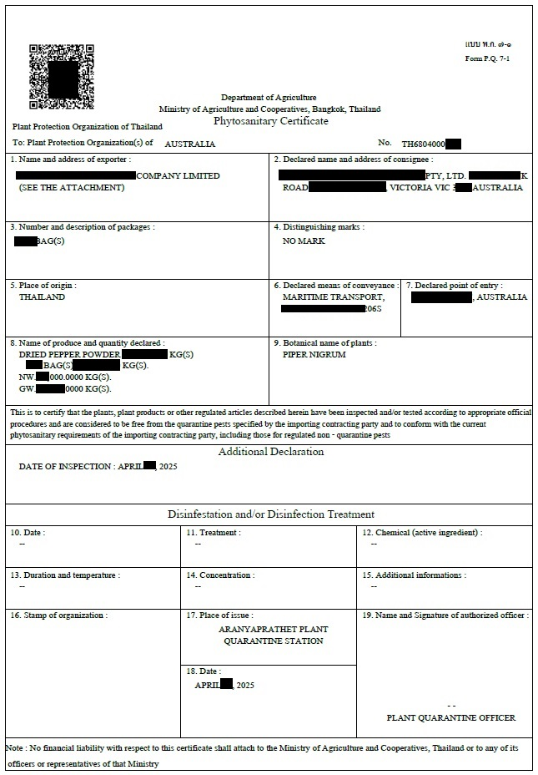

Thailand electronic phytosanitary Certificate
Below is an example of the electronic phytosanitary eCertificate. An extract of this may be provided as an email extract direct from the Thailand FDA eCertificate system or a PDF extract. This will only be required in specific circumstances. The status will say approved/acknowledged.
Thailand
Aranyaprathet Plant Quarantine Station
Phytosanitary Certificate
Cert No: TH680400001
Status | Issued
Item  Package Details | Scientific Name / Common Name  Juglans regia / Walnuts | Package Details  Outer: | Description  Shelled nuts | Weight/Volume  Net Weight: 12345.1 pound
Other Package Types | 999 CASES
Distinguishing Marks | LOT 123456
Product Origin
Date of issue | 16 April 2025
Exporter | Sample Company  1 Test Street,  Bangkok Thailand 10110
Consignee | TEST Food Industries  1 Test Road Victoria  Melbourne, 3003, Australia
Exporting Country | Thailand
Importing Country | Australia
Loading Port | Bangkok
Declared Point of Entry | Brisbane
Transport Mode | Maritime transport
Vessel | Vessel Name
Voyage/Flight
Financial Liability Statement | No financial liability with respect to this certificate shall attach to Aranyaprathet Plant Quarantine Station or to any of its officers or representatives
Additional declaration | Representative samples were inspected and found free from evidence of any species of Trogoderma (whether live, dead or exuviae) in Australia's list of Trogoderma species of biosecurity concern.
Date of Inspection
Name of authorised officer | John Doe
Place of Issue
Declarations | This is to certify that the plants, plant product or other regulated articles described herein have been inspected and/or tested according to appropriate official procedures and are considered to be free from the quarantine pests, specified by the importing contracting party and to conform with the current phytosanitary requirements of the importing contracting party including those for regulated non-quarantine pests.

Contact
Phone 1800 900 090
Email ecertadministrator@agriculture.gov.au
Web agriculture.gov.au/Ecertimports
Acknowledgement of Country
We acknowledge the Traditional Custodians of Australia and their continuing connection to land and sea, waters, environment and community. We pay our respects to the Traditional Custodians of the lands we live and work on, their culture, and their Elders past and present.
© Commonwealth of Australia 2025
Unless otherwise noted, copyright (and any other intellectual property rights) in this publication is owned by the Commonwealth of Australia (referred to as the Commonwealth).
All material in this publication is licensed under a Creative Commons Attribution 4.0 International Licence except content supplied by third parties, logos and the Commonwealth Coat of Arms.
The Australian Government acting through the Department of Agriculture, Fisheries and Forestry has exercised due care and skill in preparing and compiling the information and data in this publication. Notwithstanding, the Department of Agriculture, Fisheries and Forestry, its employees and advisers disclaim all liability, including liability for negligence and for any loss, damage, injury, expense or cost incurred by any person as a result of accessing, using or relying on any of the information or data in this publication to the maximum extent permitted by law.

