

Ecological response to the Lake Victoria bypass trial 2015–2017

Deborah Furst1, Kane Aldridge1, Chris Bice2, Brenton Zampatti2 and Qifeng Ye2

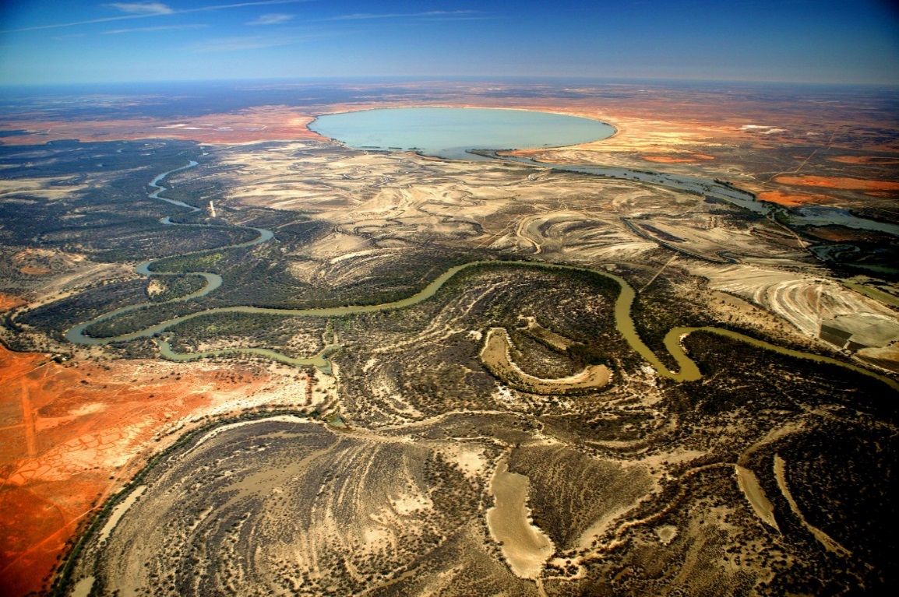

March 2018

1School of Biological Sciences & Environment Institute, The University of Adelaide,

2South Australian Research and Development Institute, Aquatic Sciences





Cover photo source: Photo was taken by Michael Bell for the Murray–Darling Basin Authority (MDBA). Permission was received by both the MDBA (Andrew Beer) and Michael Bell to use this photo within this report.

Disclaimer:

The results and comments contained in this report have been provided on the basis that the recipient assumes the sole responsibility for the interpretation and application of them. The authors give no warranty, express or implied, or assumes any legal liability or responsibility for the accuracy, completeness or use of the results and comments contained in this report by the recipient or any third party.

The views and opinions expressed in this publication are those of the authors and do not necessarily reflect those of the Australian Government or the Minister of the Environment and Energy. While reasonable efforts have been made to ensure that the contents of this publication are factually correct, the Commonwealth does not accept responsibility for the accuracy or completeness of the contents, and shall not be liable for any loss or damage that may be occasioned directly or indirectly through the use of, or reliance on, the contents of this publication.

Cite as:

Furst D., Aldridge K., Bice C., Zampatti B. and Ye Q. (2018). Ecological response to the Lake Victoria bypass trial 2015–2017. Report to the Commonwealth Environmental Water Office, Canberra.

# Acknowledgments

Funding of this project was provided by the Commonwealth Environmental Water Office (CEWO) through the South Australian Research and Development Institute (SARDI). We would like to thank SARDI staff David Short, Luciana Bucater and Zygmunt Lorenz for assistance with field sampling and laboratory analysis and Charles James for helping with the analysis of hydraulic data. Thanks to Russell Shiel (The University of Adelaide) for assistance with species identification. Thanks to Garry Fyfe and other SA Water staff for helping with water sample collections, and to Jarrod Eaton and Tony Herbert (Department of Environment, Water and Natural Resources) for supporting this project from the perspective of river operations. Flow data and background information related to watering actions and Lake Victoria operations were provided by the CEWO and the Murray–Darling Basin Authority (MDBA), with assistance from Melissa Head, Ryan Breen and Irene Wegener (CEWO) and John Waterworth, Kerry Greenwood and Jim Foreman (MDBA). We would also like to thank the MDBA (Andrew Beer) and Michael Bell for providing permission to use the cover photo.

# Contents

Acknowledgments ii

Contents iii

Executive Summary 1

1. General background 4

2. Study site 6

3. Pilot study: evaluation of the Lake Victoria bypass trial on nutrient transportation and zooplankton community during spring 2015 7

3.1 Aims 7

3.2 Methods 7

3.3 Results and evaluation 9

3.3.1 Findings 9

4. Assessment of the ecological response to the Lake Victoria bypass trial period, 2016–17 12

4.1 Aims and hypotheses 12

4.2 Methods 13

4.3 Results and evaluation 15

4.3.1 Hydrology and hydraulics 15

4.3.2 Changes in river channel zooplankton communities in relation to varying hydraulic conditions and inputs from the Rufus River 17

4.4 Discussion 23

4.5 Conclusions 25

References 26

# Executive Summary

The alteration of natural flow regimes has profound impacts on riverine ecosystems, affecting ecological processes and patterns, and overall ecosystem ‘health’. This is well recognised in the Murray–Darling Basin, highlighted by the development of the *Basin Plan*, which aims to return water to the environment to improve ecological integrity. An objective of the *Basin Plan* is to protect and restore connectivity within and between water dependent ecosystems, by ensuring that: 1) ecological processes dependent on hydrological connectivity (longitudinally along watercourses) are protected and restored; and 2) barriers to the passage of biological resources (i.e. biota, carbon and nutrients) through the Murray–Darling Basin (MDB) are overcome or mitigated (See Basin-wide Environmental Watering Strategy (BWS). Achieving these aims requires environmental water provisions, but also addressing management constraints including consideration of changes to river operations that can otherwise impede lateral and longitudinal connectivity.

In the lower River Murray, the operation of Lake Victoria, a large off-channel water storage downstream of the junction of the Murray and Darling rivers, has the potential to profoundly influence longitudinal connectivity, riverine hydraulics and associated ecological processes. Under natural conditions, Lake Victoria only received inflows during periods of high river flow. The lake is now one of the River Murray’s four major water storages and is used to manage flows to the lower River Murray. Typically, Lake Victoria is filled (via Frenchman’s Creek) when salinity at Lock 9 is greater than that in Lake Victoria during flows < 11,000 ML.day-1 or when salinity at Lock 9 is less than that in Lake Victoria during flows > 11,000 ML.day-1. Subsequent releases (via the Rufus River) are used to supplement low flows in the river and to dilute saline water flowing into South Australia and made primarily during late summer and early autumn. As such, a large portion of water flowing to the lower River Murray passes through the lake (a daily average of 27% of flows daily since 20 June 2011), bypassing approximately 73 km of the main river channel between Lock 9 and Lock 7.

This flow diversion may alter longitudinal connectivity, riverine hydraulics and the downstream matter transport, with associated ecological impacts. In recognition of this, the Commonwealth Environmental Water Office (CEWO) and Murray–Darling Basin Authority (MDBA) River Murray Operations Division are exploring potential changes to the operation of Lake Victoria. New operating rules are currently being considered and developed that aim to:

* Improve environmental outcomes associated with increased longitudinal and lateral connectivity of river flows downstream of Lock 9 (increased flow past Lock 9);
* Improve water quality delivered to South Australia during periods of low river flow; and
* Improve water quality in Lake Victoria and the main channel during periods of high river flow.

The aim of this project was to investigate how current operation of Lake Victoria influences riverine hydraulics (e.g. water velocity) and zooplankton communities. Zooplankton provide a key link between primary producers and higher trophic organisms (e.g. fish), and riverine hydraulics are a major driver of zooplankton community composition and abundance. In 2015–16, a pilot study was undertaken to establish spatial differences in the riverine zooplankton community adjacent to Lake Victoria, during a period of moderate–high flow diversion to the lake (41–45% of riverine flows of 11,000 ML.day-1). The pilot study revealed lateral and longitudinal differences in zooplankton community structure in the lower River Murray characterised by:

* Distinct zooplankton communities exported from Lake Victoria, in comparison to those within the main river channel upstream of the Rufus River. These inputs influenced riverine communities downstream of the Rufus River by contributing higher abundances of copepods, cladocerans from the families *Moinidae*, *Daphniidae*, *Ceriodaphniidae*, *Sididae* and *Chydoridae*, and the rotifer species *Hexarthra intermedia*, *Conochilus dossuarius* and *Filinia longiseta*.
* A significant decrease in zooplankton abundance in the River Murray between the Lock 9 weir pool (downstream of Frenchman’s Creek) and the Lock 7 weir pool (upstream of the Rufus River), primarily due to a decrease in numbers of rotifer species *Trichocerca pusilla* and *Synchaeta pectinata*.

The distinct communities exported from Lake Victoria were most likely due to the longer water residence times within the lake promoting a unique lentic community. Whereas the decreases in zooplankton abundance within the River Murray were a result of reduction in water velocities due to water diversion, thus reducing suspension and downstream transportation. Based on these preliminary findings, we hypothesised that during periods of low water diversion into Lake Victoria, the maintenance of discharge and water velocities within the main river channel promotes greater suspension and downstream transport of rotifers. This will result in greater abundances of rotifers along the main river channel relative to periods of high water diversion into Lake Victoria. We also expected that when Lake Victoria releases comprised a high proportion of flow in the lower River Murray, the lake would act as a source of lentic zooplankton, resulting in copepods and/or cladocerans being more abundant below Rufus River in comparison to periods of low discharge from the lake. To investigate these hypotheses, zooplankton community structure and cross-sectional water velocities were measured under two flow scenarios in 2016–17:

1. A low proportion of River Murray flows (6.7% of River Murray flow above Frenchman’s Creek) diverted into Lake Victoria and a high proportion of flows coming out of Rufus River (35% of flows at the South Australian border).
2. A high proportion of River Murray flows (59-67%) diverted into Lake Victoria and a high proportion of flows coming out of Rufus River (25% of flows at the South Australian border).

During both scenarios, between 25 and 35% of River Murray flows downstream of Lake Victoria were from Rufus River. The two sampling events occurred within a two-month period to minimise results being confounded by temporal variability.

In support of our hypothesis, under low diversion into Lake Victoria (i.e. high proportion of flow passing from Lock 10 to Lock 8), mean cross-sectional water velocities in the river channel between Lock 8 and Lock 10 (i.e. between Rufus River and Frenchman’s Creek) were greater than during high diversion into Lake Victoria. In conjunction, abundances of zooplankton were high and downstream transport of lotic zooplankton (e.g. rotifers) in the River Murray main channel was evident. Conversely, high diversion into Lake Victoria was associated with declines in zooplankton abundance below the Lake Victoria inlet. Furthermore, zooplankton communities transported in water discharged from Lake Victoria via Rufus River were distinct to those within the River Murray channel, and influenced River Murray zooplankton communities downstream of Rufus River. Under both scenarios, mean zooplankton abundance was lower in Rufus River than the main channel sites, suggesting that flow from Lake Victoria was diluting communities in the main river channel. Nonetheless, the abundance of some species had partially recovered at the furthest downstream site in the River Murray channel, approximately 18 km downstream of the Rufus River confluence.

Declines in zooplankton abundance within the River Murray channel, appear to be associated with reductions in main channel water velocities due to diversion of water into Lake Victoria. Thus, during diversion of large proportions of water to Lake Victoria, such as those during this study (59–67%), pelagic food resources may be falling out of suspension and transferred to the benthic and/or microbial food web within this region of the River Murray. This transfer and/or loss of food resources may have implications for the local and downstream pelagic food webs. Therefore, conserving riverine discharge and associated water velocities within the River Murray channel plays an important role in maintaining the integrity of riverine food webs.

# 

# General background

Flow determines the way resources are produced, transported and assimilated by biota in riverine ecosystems (Poff et al. 1997). In arid and semi-arid systems, such as the River Murray, the natural flow regime is highly variable (Puckridge et al. 1998). Shifts from lower to higher flows under natural conditions increase hydrological connectivity, enhancing lateral floodplain inundation at the same time as increasing downstream discharge. Floodplain inundation mobilises terrestrial carbon and nutrients that may stimulate productivity (Aldridge et al. 2012, Furst et al. 2014, Klement et al. 1999), whilst longitudinal flow transports resources, providing fuel for downstream aquatic food webs (Aldridge and Brookes 2015, Aldridge et al. 2012). River regulation can alter the degree of longitudinal connectivity, with subsequent impacts upon aquatic ecosystems (Nilsson et al. 2005). Impoundment of lotic systems typically alters riverine hydraulics (i.e. water depth and velocity) and increases water residence times (WRTs), resulting in increased deposition of sediments, nutrients and carbon, and changes in the proportion of nutrients available for primary production (Cook et al. 2010). These changes can alter the community composition and structure of primary producers (e.g. diatoms in the presence of high concentrations of silica and blue-green algae’s in the presence of high concentrations of phosphorus and nitrogen), compromising the quality of food for higher trophic organisms both within impoundments and downstream environments.

Changes in riverine hydraulics associated with river regulation influence the dynamics of riverine zooplankton communities (i.e. species composition and abundance) (Shiel et al. 1982). In general, cladocerans and cyclopoid copepods tend to thrive within slower flowing littoral zones and floodplain habitats, in comparison to the lotic pelagic zones within river systems. The structural complexity of littoral and floodplain habitats mediate competitive and predatory interactions by providing refuges (e.g. Meerhoff et al. 2007), thus stabilising predator–prey interactions and promoting more abundant and diverse zooplankton communities over longer periods of time. Additionally, crustaceans cannot reproduce or maintain their position within fast flowing water and thus, the rate of water movement is a fundamental factor affecting their density in lotic habitats. In contrast to crustacean zooplankton, rotifers dominate communities within fast-flowing water. The factors driving this dominance are not fully understood; however, may be related to rotifers higher reproduction rates and buoyancy. Rotifers have poor swimming abilities (e.g. <0.5 millimetres per second escape velocity for *Polyarthra vulgaris* in Gilbert 1985, 1987) and may be flushed from floodplains and slackwaters, and entrained and transported within the faster flowing zones of the river channel.

Zooplankton provide a key link between primary producers and higher trophic organisms such as macroinvertebrates, fish and birds. The degree and direction in which zooplankton are assimilated into aquatic food webs depends on the composition and abundance of zooplankton communities, and their consumers (e.g. fish). Zooplankton abundance can affect the rate at which predator-prey encounters occur (Cooper and Goldman 1980, Vinyard 1980), whereas composition affects the range of morphological and behavioural characteristics present within a community, some of which are restrictive to predators. For example, feeding in larval and juvenile fishes is often restricted by mouth gape and their ability to detect and consume prey, and often as predator size increases, the range of suitable prey types and/or food size increases (Lazzaro 1987). Changes in hydrodynamics that favour certain groups and species of zooplankton may alter the availability, variety and quality of food for higher trophic organisms and in doing so influence food web structure and dynamics.

The profound impact that alteration of natural flow regimes has had on ecological processes and patterns, and overall ecosystem ‘health’, is well recognised in the Murray–Darling Basin (MDB). This was highlighted by the development of the *Basin Plan*, which aims to return water to the environment to rehabilitate aquatic ecosystems and improve ecological integrity. An objective of the *Basin Plan* is to protect and restore connectivity within and between water dependent ecosystems, by ensuring that: 1) ecological processes dependent on hydrological connectivity (longitudinally along watercourses) are protected and restored; and 2) barriers to the passage of biological resources (including biota, carbon and nutrients) through the MDB are overcome or mitigated (See Basin-wide Environmental Watering Strategy (BWS)) (MDBA 2014). Achieving these aims requires environmental water provisions, but also consideration of changes to river management, including addressing physical, operational and management constraints (MDBA 2013a).

In the lower River Murray, the operation of Lake Victoria, a large off-channel water storage downstream of the junction of the Murray and Darling rivers, potentially influences longitudinal connectivity, riverine hydraulics and associated ecological processes. Under natural conditions, Lake Victoria only received inflows during periods of high river flow, but it is now one of the River Murray’s four major water storages and used to manage flows to the South Australian lower River Murray. Typically, Lake Victoria is used to supplement low flows in the river and to dilute saline water flowing into South Australia. More recently, Lake Victoria has been used to supplement peak flows or re-shape the hydrograph for environmental flow delivery to the lower River Murray (MDBA 2018). A large proportion (an average of 28% of daily discharge in the River Murray at Lock 10 since 1 January 2015) of water travelling to South Australia now passes through the lake, bypassing approximately 73 km of the main river channel. This results in diminished flow downstream of the inlet to Lake Victoria (Frenchman’s Creek), which in turn has been associated with decreases in the concentration of nutrients transported downstream in the River Murray channel (Aldridge and Brookes 2015). Considering this, the Commonwealth Environmental Water Office (CEWO) and MDBA River Murray Operations Division are exploring potential changes to the operation of Lake Victoria (MDBA 2013b). A trial was proposed by the CEWO and the MDBA to test conditional triggers for a refined operating rule (Table 1) that aims to:

* Improve environmental outcomes associated with increased longitudinal and lateral connectivity of river flows downstream of Lock 9 (increased flow past Lock 9);
* Improve water quality delivered to South Australia during periods of low river flow; and
* Improve water quality in Lake Victoria and the main channel during periods of high river flow

Table 1: Old and trial scenario flushing rule flow and salinity triggers for Lake Victoria. Grey shading highlights where the old and trial flushing rule differ.

|  |  |  |  |  |
| --- | --- | --- | --- | --- |
| Scenario | Flow to South Australia (ML.day-1) | Salinity at Lock 9 > Salinity at Lake Victoria | Salinity at Lock 9 < Salinity at Lake Victoria | Electrical conductivity in Lake Victoria |
| Old flushing rule | Less than 11,000 | √ |  |  |
| Greater than 11,000 |  | √ |  |
| Trial flushing rule | Less than 11,000 | √ |  |  |
| Greater than 11,000 |  | √ | > 350 µS/cm |

The aim of this project was to investigate how operation of Lake Victoria influences riverine hydraulics and key components of aquatic food webs, namely nutrients and zooplankton communities. To achieve this, a pilot study was undertaken to investigate potential spatial differences in riverine zooplankton communities in the River Murray adjacent to Lake Victoria, during a period of moderate/high flow diversion to the lake (41–45%) in 2015–16. This informed a second, more comprehensive study that investigated the implications of Lake Victoria operations on the riverine zooplankton community during 2016–17, including investigating potential drivers (e.g. hydraulics, water sources).

# Study site

The River Murray was once a lotic system, but due to the construction of 10 low level weirs between Blanchetown and Wentworth, the river is now characterised by a series of discrete, cascading weir pools that are lentic in character. The weirs have altered water level and river gradient (i.e. water surface slope), which in turn has resulted in drastically reduced water velocities within the main channel (Walker 2006; Bice *et al*. 2017). The highest density of weirs on the River Murray exists adjacent to Lake Victoria, with six weirs along a 260 km reach between Wentworth and Renmark (Lock 10 to Lock 6). Hydrology in this reach of river is also impacted by upstream and local water extraction, as well as the diversion of water through Lake Victoria via Frenchman’s Creek (inlet to Lake Victoria) and Rufus River (Lake Victoria outlet). These reductions in flow, exacerbate the impacts of the weirs on hydraulics (Bice *et al*. 2017), further reducing water velocity and promoting homogenous hydraulics, characterised by narrow velocity ranges and low mean depth-averaged velocities (Kilsby 2008).



Figure 1: Map of the study area (lower River Murray, including Lake Victoria).

# Pilot study: evaluation of the Lake Victoria bypass trial on nutrient transportation and zooplankton community during spring 2015

## 3.1 Aims

A pilot study was undertaken in 2015–16 to determine spatial variability in zooplankton community structure in the lower River Murray in the vicinity of Lake Victoria, during a period of moderate/high water diversion (approximately 40% of River Murray flows at Lock 10) to the lake. Ultimately, the pilot study aimed to inform a more comprehensive study in 2016–17.

Assuming that the water diverted through Lake Victoria has a higher residence time than water that flows down the river, we hypothesised that the zooplankton community coming out of Lake Victoria would have a higher zooplankton abundance and a higher proportion of crustaceans (cladocerans and copepods) than that in the River Murray above Rufus River. It was also hypothesised that due to inflows from Lake Victoria, the zooplankton community in the River Murray downstream of the Rufus River junction would reflect a combination of the upstream river community and that exported from Lake Victoria.

## 3.2 Methods

The pilot study was undertaken between 10 and 11 November 2015. During November 2015, flow in the River Murray (at Lock 10) was maintained at ~11,000 ML.day-1, but over this period the proportion of flow diverted to Lake Victoria increased (Figure 2 and Table 2).

Figure 2: Discharge from August to December 2015 (sampling conducted 10-11 November) at 1) Lock 9 on the River Murray; 2) Frenchman’s Creek; 3) immediately above Frenchman’s Creek (calculated as the sum of Lock 9 and Frenchman’s Creek flows) and into Lake Victoria; and 4) the Rufus River. Data provided by the CEWO and the MDBA.

Table 2: Average weekly percent of flows immediately above Frenchman’s Creek (calculated as the sum of Lock 9 and Frenchman’s Creek flows) that flowed down the River Murray leading up to and during the study period. Grey shading indicates the period in which the study took place.

|  |  |
| --- | --- |
| Weekly period | % of River Murray flows above Frenchman’s Creek that flowed down the River Murray |
|
|
| 24/10/2015 - 30/10/2015 | 78 |
| 31/10/2015 - 6/11/2015 | 64 |
| 7/11/2015 - 13/11/2015 | 59 |
| 14/11/2015 - 20/11/2015 | 53 |
| 21/11/2015 - 27/11/2015 | 44 |

To investigate spatial differences in zooplankton community structure, sampling was conducted at five sites (here after site names will be italicised for clarity), on a single occasion, from 10–11 November 2015:

* The River Murray *above Frenchman’s Creek*;
* The River Murray *above Lock 7*;
* *Rufus River*;
* The River Murray *below Lock 7* and the Rufus River confluence; and
* The River Murray *above Lock 6*.

At the time of sampling, discharge in the River Murray at Lock 10 was approximately 11,000 ML.day-1, with 55–59% of flow continuing down the main river channel and the remainder (41–45%) passing into Lake Victoria. Quantitative zooplankton samples were collected using a 4 litre Haney trap, with three replicates taken approximately 50 meters (m) apart mid-channel. Samples were identified and counted in the laboratory on an Olympus compound microscope at 100 times magnification.

Differences in the total abundance (individuals per litre, ind.L-1) of zooplankton (all species combined) between sites were analysed using a one-way uni-variate PERMANOVA (Anderson et al. 2008). These analyses were performed on fourth-root transformed relative abundance data and Euclidean distance resemblance matrices (Anderson et al. 2008). Spatial variability in the zooplankton community structure (i.e. species identity and abundance) among sites was assessed graphically using multidimensional scaling (MDS), whilst a multi-variate PERMANOVA was used to test for significant differences in community structure. These analyses were performed on Bray-Curtis similarity matrices of fourth-root transformed relative abundance data (ind.L-1). The low number of samples collected for these analyses resulted in low numbers of unique permutations for both sets of analysis, and thus, Monte-Carlo *p*-values are presented and a significance level of α=0.05 was retained (Anderson *et al* 2008). When significant differences occurred between pairwise comparisons of community structure, a similarity percentages (SIMPER) analysis was undertaken to identify species contributing to these differences. A 40% cumulative contribution cut-off was applied.

## 3.3 Results and evaluation

### 3.3.1 Findings

#### Influence of Lake Victoria on downstream zooplankton communities

Zooplankton abundance differed significantly between sites (P<0.0001), with abundance significantly higher (a minimum of 2.8 times greater) at the River Murray *above Frenchman’s Creek* relative to all other sites (*P*=0.006–0.0025) (Table 3). This result was unexpected due to the likely shorter water residence times (WRTs) within the river channel in comparison to Lake Victoria, as short WRT commonly inhibits reproduction in many species of zooplankton.

Table 3: Average total abundance of zooplankton (including protists, rotifers, cladocerans and copepods)

|  |  |  |
| --- | --- | --- |
| Site | Average abundance  (ind L-1) | Standard deviation |
| River Murray above Frenchman’s Creek | 2492 | 410 |
| River Murray above Lock 7 | 895 | 182 |
| Rufus River | 727 | 84 |
| River Murray below Lock 7 | 605 | 80 |
| River Murray above Lock 6 | 880 | 180 |

Community structure (species composition and abundance) differed significantly between sites (P<0.001). As hypothesised, the community at the *Rufus River* site consisted of a higher abundance of copepods than at the River Murray sites *above Frenchman’s Creek* and *above Lock 7* (Figure 3). This increased copepod abundance appeared to be influencing the downstream riverine community at River Murray *above Lock 6* with a higher abundance of copepods in comparison to upstream at River Murray site *above Lock 7* (Figure 3). The community at the *Rufus River* site did not consist of higher abundances of total cladocerans than at the River Murray site *above Lock 7* (Figure 3); however, in support of our hypothesis, the abundance of cladocerans from the families Moinidae*,* Daphniidae*,* Ceriodaphniidae*,* Sididae and Chydoridaewere all higher at *Rufus River* (Figure 4). Species from the families Daphniidae and Ceriodaphniidae increase in abundance as water residence time increases (e.g. Baranyi et al. 2002). Moinidaeare opportunistic cladocerans, typically occurring in temporary pools, saline lakes or other waters subject to physico-chemical extremes (e.g. high temperature fluctuations) (Goulden 1968, Petrusek 2002). Diaphanosoma(Sididae) are lacustrine planktonic filter feeders and common in reservoir and river plankton (pers. Comm. Russell Shiel). Chydoridae are primarily near bottom-dwellers (King 2004, Ning et al. 2010). The community at the River Murray site *above Lock 6* had higher abundances of cladocerans than all other sites primarily due to higher abundances of *Bosmina meridionalis* (Figure 4). Species of *Bosmina*, which are generally smaller than those from the above mentioned families, may dominate crustacean communities within river environments where lotic conditions prevail (e.g. Baranyi et al. 2002). Thus, it is possible that the high abundances of *B. meridionalis* observed at the River Murray site *above Lock 6* were coming from the Lindsay River system, an anabranch system that discharges into the Lock 6 weir pool and comprises considerable reaches (10s km’s) of ‘fast flowing’ creek habitats. The cladoceran community at the River Murray site *above Lock 7* was primarily made up of members from the family Macrothricidae (Figure 4). Macrothricidae are primarily found within the epibenthos (King 2004). In this case, the epibenthos may have unintentionally been sampled by scraping the trap along the river bed, and as Macrothricidae were only found in one out of the three replicates this is quite possible.

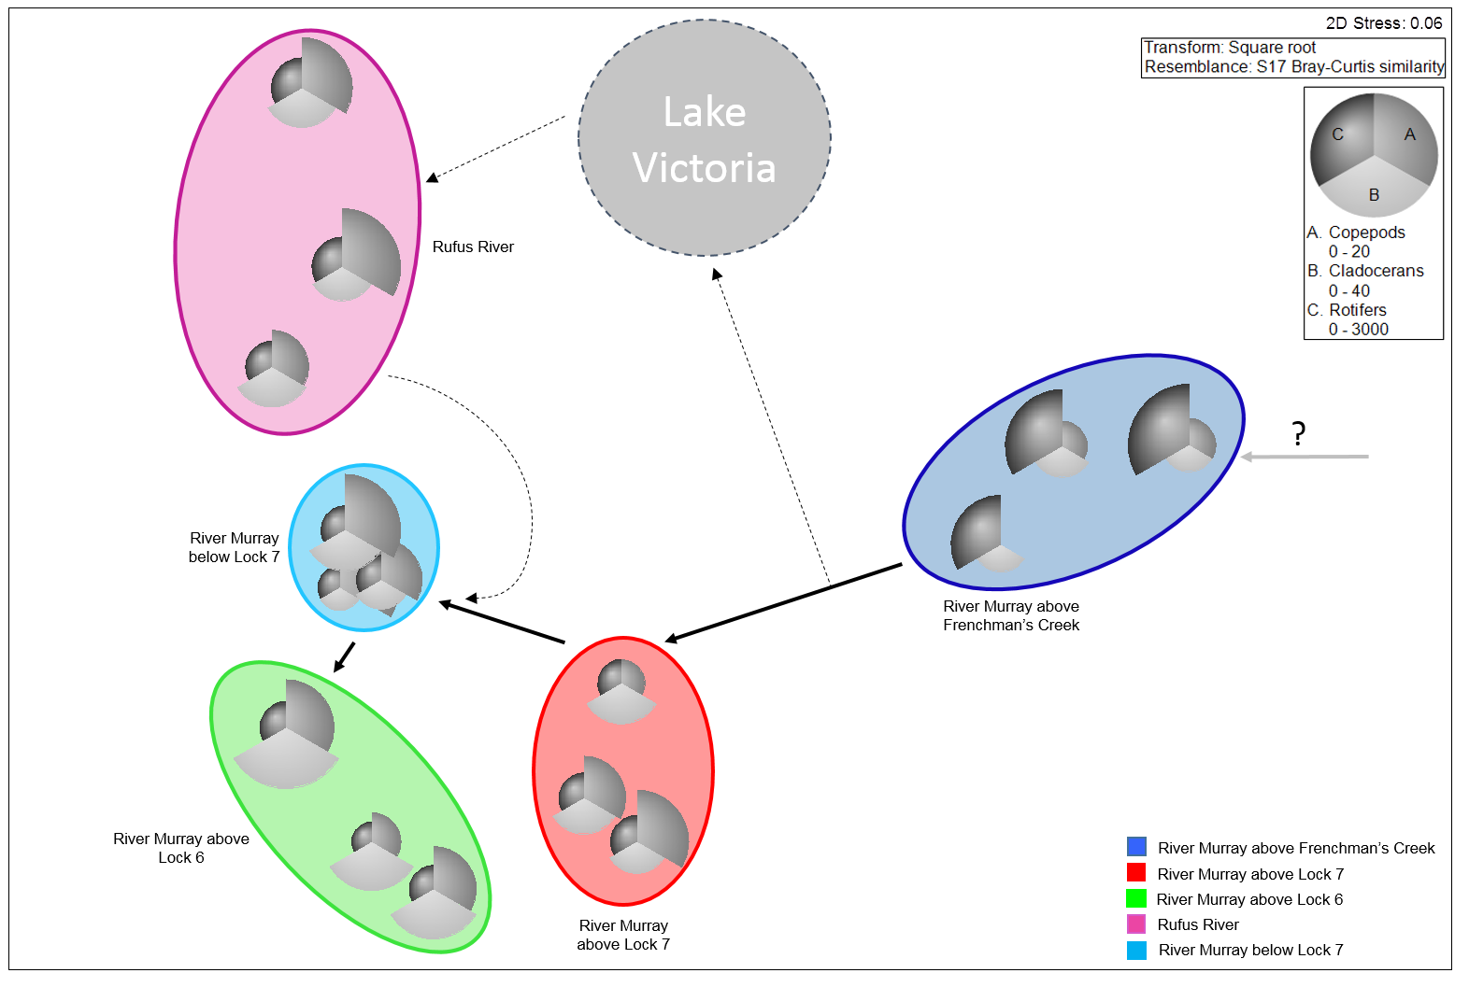

Figure 3: Nonmetric Multidimensional Scaling (MDS) ordination of zooplankton community structure across sites, presented as a bubble plot with the abundance of each of the three major zooplankton groups, rotifers, cladocerans and copepods as variables. Different coloured circles represent different sites. Arrows represent direction of flow where solid lines represent flow within the main channel of the River Murray and broken lines represent flow through the inlet, lake and Rufus River.

Despite differences in the cladoceran and copepod communities between sites, key contributors to variability between the *Rufus River* site and all other sites was the presence of higher abundances of the rotifer species *Hexarthra intermedia, Conochilus dossuarius* and *Filinia longiseta* (Figure 4). All three of these species are pelagic species, however, *F. longiseta* is more commonly known as a littoral species, often found in larger and deeper lakes such as Lake Victoria (Kuczyńska-Kippen 2014, Shiel et al. 1982). Abundances of *H. intermedia* and *F. longiseta* usually peak in the summer months, whereas *C. dossuarius* is perennial (Shiel et al. 1982).

The average abundance of *Asplanchna*, an important food resource for larval fish (e.g. Ghan and Sprules 1993), was much lower at *Rufus River* (4 ind.L-1) and River Murray *above Lock 6* (1 ind.L-1) in comparison to the River Murray *above Frenchman’s Creek* (33 ind.L-1) and River Murray *above Lock 7* (10 ind.L-1).

Zooplankton community structure was significantly different between *Rufus River* and all other sites (*P*=0.0066–0.0429). Community structure at the River Murray *below Lock 7*, however, diverged from the longitudinal trend indicated by the other three sites within the River channel, showing a shift towards the community structure found withi Rufus River (Figure 3).

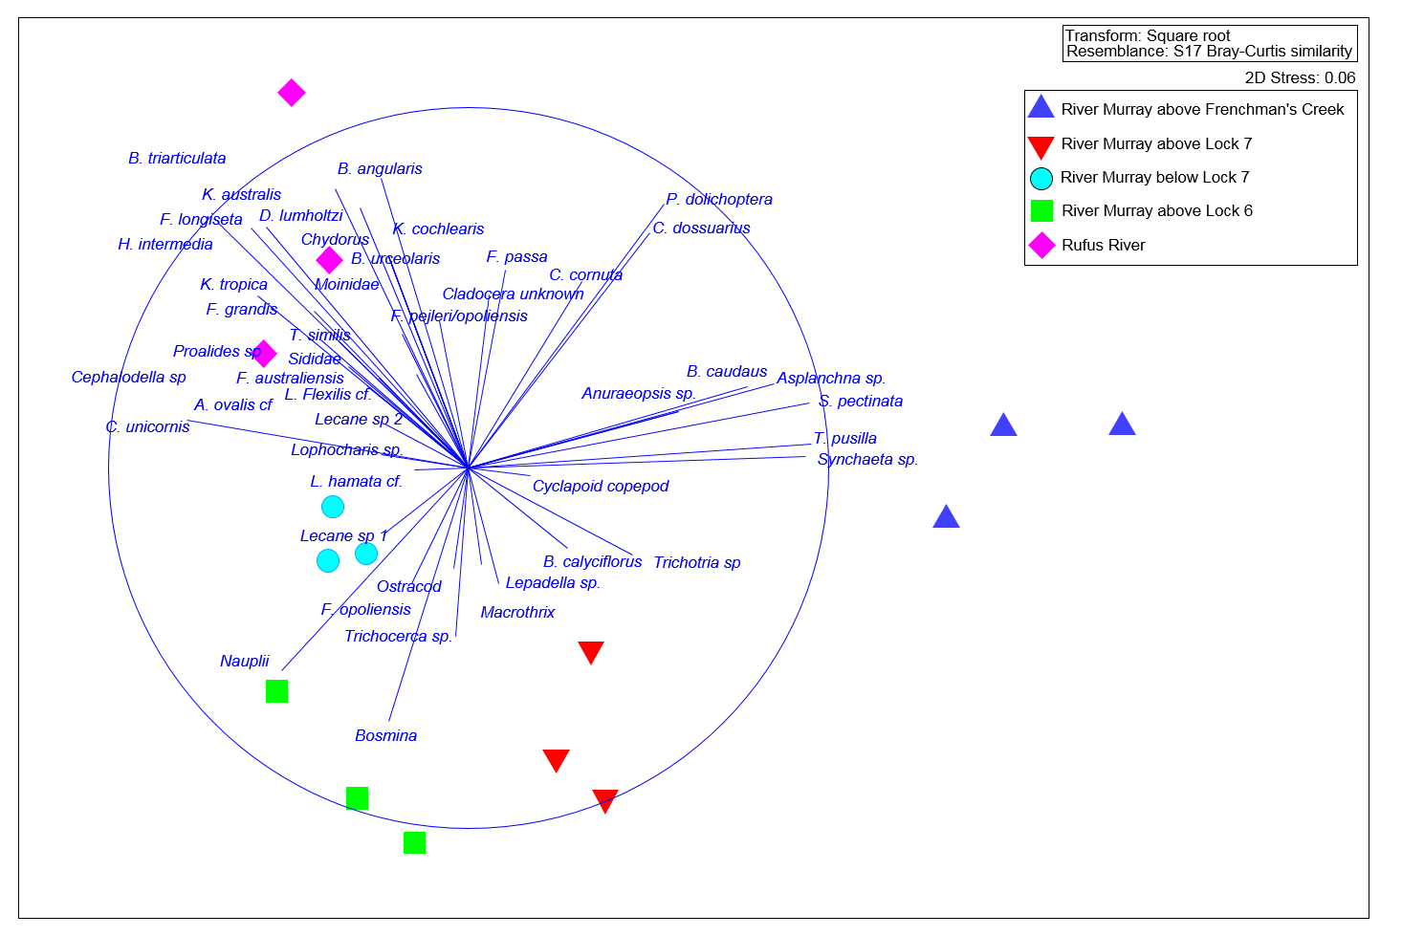

Figure 4: Nonmetric Multidimensional Scaling ordination (MDS) of zooplankton community structure across sites with species abundance vectors overlain.

#### Longitudinal trends in zooplankton community

Zooplankton community structure varied longitudinally along the river channel from the site furthest upstream, in the River Murray *above Frenchman’s Creek*, to the River Murray *above Lock 7*, the River Murray *below Lock 7* and the River Murray *above Lock 6* (Figure 3 and Figure 4). This was unexpected given the proximity of sites and similarities in habitat characteristics among sites. However, the rapid change in hydraulics caused by the sudden reduction of flows within the River Murray due to water diversions into Lake Victoria had not been considered.

The community structure was significantly different between the River Murray *above Frenchman’s Creek* and all other sites (*P*=0.006–0.043) (Figure 3 and Figure 4). The primary contributors to variability between sites was greater abundances of the rotifer species *Trichocerca* *pusilla* and *Synchaeta pectinata* in the River Murray *above Frenchman’s Creek*, relative to all other sites(Figure 4). Typically, a littoral species, *T. pusilla* is facultatively planktonic and common in shallow, vegetated waters. Alternatively, the soft-bodied, but relatively large rotifer, *S. pectinata,* is planktonic and common in small and large lakes. *S. pectinata* has been found to be a preferred prey item for planktonic crustaceans (e.g. Diacyclops thomasi in Stemberger 1985) and some macroinvertebrates (e.g. Chaoborus sp. in Moore and Gilbert 1987).

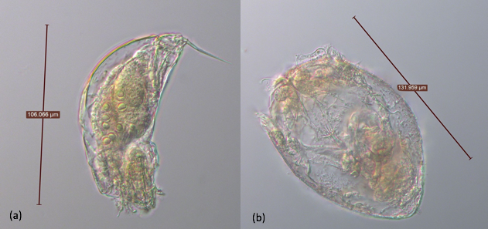

Figure 5: Photo of (a) *Trichocerca pusilla* and (b) *Synchaeta pectinata*. The two primary contributors to the variability between the River Murray above Frenchman’s Creek and all other sites due to the presence of higher abundances.

Due to the lack of temporal replication of the pilot study the underlying mechanisms for longitudinal differences, in the zooplankton community within the main channel of the lower River Murray cannot be conclusively determined. At the time of sampling there were apparent lateral and longitudinal differences in the zooplankton community structure in the lower River Murray associated with the operation of Lake Victoria, as reflected by:

* Distinct communities coming out of Lake Victoria in comparison to those within the river channel. These Lake Victoria derived zooplankton influenced riverine communities downstream, primarily through the contribution of high abundances of copepods and the rotifer species *H. intermedia*, *C. dossuarius* and *F. longiseta*.
* A significant decrease in zooplankton abundance between the River Murray above Lake Victoria and the River Murray *above Lock 7*, primarily due to a decrease in the abundance of the rotifer species, *T. pusilla* and *S. pectinata*.

Further investigations should consider how different volumes of water entering and exiting Lake Victoria effect longitudinal variation in the zooplankton community along the river channel.

# Assessment of the ecological response to the Lake Victoria bypass trial period, 2016–17

## 4.1 Aims and hypotheses

The pilot study indicated there was substantial spatial variability in the zooplankton community of the lower Murray between Locks 6 and 10 during 2015–16. This spatial variability appeared to be driven by a combination of: 1) the influence of water (and zooplankton) sourced from Lake Victoria on downstream riverine communities; and 2) longitudinal changes in the rotifer community in riverine habitats in association with disparate hydraulic conditions. Phytoplankton populations can largely be structured by riverine hydraulics (Maier et al. 2001). In comparison, there is a paucity of knowledge regarding the influence of hydraulics on zooplankton, particularly rotifers.

Based on the results of the 2015–16 pilot study, we hypothesised that when a high proportion (greater than 50%) of River Murray discharge is diverted to Lake Victoria, resulting reductions in main channel water velocities will cause some species of rotifer to fall from suspension, manifesting in declining abundance in a downstream direction. Alternatively, when a low proportion (less than 10%) of discharge is diverted through Lake Victoria, main channel velocities are likely maintained, promoting suspension and transport, and increased abundance of specific rotifers in a downstream direction. It is also expected that when a high proportion of water is released from Lake Victoria, it will act as a source of lentic zooplankton, resulting in copepods and/or cladocerans being more abundant in the River Murray below Rufus River in comparison to above.

To investigate this hypothesis, zooplankton community structure and cross-sectional water velocities were measured under two flow scenarios during 2016–17:

1. A low proportion (less than 10%) of River Murray flows diverted into Lake Victoria
2. A high proportion (greater than 50%) of River Murray flows diverted into Lake Victoria

During both scenarios, between 25 and 35% of River Murray flows downstream of Lake Victoria were from Rufus River.

## 4.2 Methods

Sampling was conducted on two occasions, March and April 2017. During the sampling period in March 2017, water levels in Weir Pools 7 and 8 were ~0.5 m below the normal supply levels (22.1 and 24.6 meters Australian Height Datum (m AHD) respectively) whilst in April 2017, levels in both weir pools were ~0.8 m below the normal supply levels. In contrast, water levels in Weir Pool 9 were maintained at about the normal pool level (27.4 m AHD) during the sampling period. Sampling trips were conducted within eight weeks to minimise seasonal influences on zooplankton dynamics. Sampling was undertaken at four sites. One site was located within the main channel of the River Murray above Frenchman’s Creek (hereafter termed ‘*above Frenchman’s Creek*’) to characterise the zooplankton community in the River Murray upstream of the influence of Lake Victoria. One site, located within the Lock 7 weir pool (hereafter termed ‘*below Lock 8’*), was used to assess longitudinal changes associated with altered hydrodynamics due to water diversion into Lake Victoria. One site was located within Rufus River (hereafter termed ‘*Rufus River’*) to characterise the zooplankton community derived from Lake Victoria. The final site, located in the Lock 6 weir pool (hereafter ‘*below Lock 7*’), assessed longitudinal changes due to the combination of flows from the River Murray upstream and from Lake Victoria via Rufus River, and associated hydrodynamics. All three sites within the main channel of the River Murray were located approximately two-thirds along the length of the weir pool (i.e. the “upper” weir pool).



Figure 6: Map of the study area (lower River Murray, including Lake Victoria). White stars represent sampling sites and black dots represent key landscape features.

Water samples were collected for nutrient analyses, and for the identification and enumeration of phytoplankton and zooplankton. At each site, two composite samples, one for nutrient and phytoplankton analyses, and one for zooplankton analyses, were generated from three independent samples collected from spatially separated (approximately 200 m) locations. Each independent sample was generated using a 4 L Haney trap, and transferring a "grab" from the top, middle and bottom of the water column respectively from mid-channel, to a pre-rinsed 20 L drum to produce a 12 L sample. Sub-samples were taken from one composite sample, and processed and stored according to the Australian Water Quality Centre’s (AWQC’s) requirements for the parameters: reactive silica; total phosphorus; oxidised nitrogen; total Kjeldahl nitrogen; suspended solids; volatile suspended solids; chlorophyll a and b concentrations; and phytoplankton identification and counts. The total volume of the second composite sample was concentrated to ca 50 mL by filtering through a 30 μm net. Concentrated samples were then transferred to a 200 mL jar and preserved with 70% ethanol. Additionally, to assist with species identification, at each site, a highly concentrated qualitative zooplankton sample was taken using a 35 μm plankton net. At the same location, *in situ* measurements of dissolved oxygen, electrical conductivity, pH, turbidity and water temperature were conducted.

In the laboratory, quantitative samples were inverted three times and a 1 mL sub-sample transferred into a Pyrex gridded Sedgewick-Rafter cell. The entire sub-sample was counted, and zooplankton identified using a Leica DM2500 compound microscope. The average number of zooplankton was calculated and expressed as ind.L-1 (± SE). Differences in the total abundance (ind.L-1) of zooplankton (rotifer, cladocerans and copepods only) between sites was analysed using a two-way uni-variate PERMANOVA (Anderson et al. 2008). These analyses were performed on square-root transformed relative abundance data and Bray-Curtis similarity matrices (Anderson et al. 2008). Spatio-temporal variability in zooplankton community structure (species identity and abundance) among sites and across trips was assessed graphically using multidimensional scaling (MDS). All water quality variables were normalised and phytoplankton community structure fourth-root transformed. A two-way multi-variate PERMANOVA was used to test for significant differences in community structure. These analyses were performed on Bray-Curtis similarity matrices of square-root transformed relative abundance data (ind.L-1). The low number of samples collected for these analyses resulted in low numbers of unique permutations for both sets of analysis, and thus, Monte-Carlo *p*-values are presented and a α=0.05 was retained (Anderson *et al* 2008). Pairwise comparisons of community structure and zooplankton abundance between sites within trips were also conducted. When significant differences occurred between pairwise comparisons of community structure, a similarity percentages (SIMPER) analysis was undertaken to identify species contributing to these differences. A 40% cumulative contribution cut-off was applied.

On each sampling occasion at each site, cross-sectional velocity profiles were measured across five transects (separated by 200 m) using a boat mounted SonTek River Surveyor M9 Acoustic Doppler Current Profiler (ADCP). ADCP measure the Doppler shift in acoustic signals as they are reflected off suspended particles in the water column. Transducers on the unit send acoustic pulses vertically into the water column and, after a brief blackout period, begin recording pulses reflected from suspended particles, assuming that the velocity of suspended particles equates to fluid flow velocities (Shields and Rigby 2005). The water column is divided into depth ‘cells’ and the instrument uses the speed of sound in water to group reflected signals from given depth cells. Data, including water depth, heading, echo intensity and velocity are recorded at intervals of ~1 second and are used to produce measures of mean velocity for each depth cell. The ADCP unit was mounted on the gunwale of the boat and transects driven across a river reach to generate cross-sectional flow velocity profiles.

## 4.3 Results and evaluation

### 4.3.1 Hydrology and hydraulics

During sampling in March 2017, discharge at Lock 10 ranged 6,646–6,600 ML.day-1, and a low proportion (≤ 6.7%) of this flow was being diverted into Lake Victoria via Frenchman’s Creek (Figure 7 and Table 4). Mean cross-transect water velocity was greater at *below Lock 8* (0.22 ± 0.0091 (SE) m.s-1) than *above Frenchman’s Creek* (0.15 ± 0.0016 (SE) m.s-1) despite discharge at *below Lock 8* (6,215 ML.day-1) being lower than at *above Frenchman’s Creek* (6,660 ML.day-1). This was due to a lower mean total cross-sectional area at *below Lock 8* (321 ± 15 (SE) m²) than at *above Frenchman’s Creek* (537 ± 3.8 (SE) m²) (Table 5). A combination of flows of up to 3,014 ML.day-1 from Rufus River (between 30 and 35% of flows into South Australia) (Figure 7 and Table 5), in addition to a lower mean total cross-section area at *below Lock 7* (269 ± 4.3 (SE) m²) than *below Lock 8*, resulted in a greater mean cross-transect water velocity at *below Lock 7* (0.35 ± 0.0049 (SE) m.s-1) than *below Lock 8* (0.22 ± 0.0091 (SE) m.s-1) (Table 5).

Table 4: Flow at Frenchman’s Creek, Rufus River, Lock 10, Lock 9 and Lock 6 (flow into South Australia) at time of zooplankton sampling during March and April 2017.

|  |  |  |  |  |  |  |  |
| --- | --- | --- | --- | --- | --- | --- | --- |
|  | **Lock 10 (ML.day-1)** | **Frenchman’s Creek (ML.day-1)** | **Lock 9 (ML.day-1)** | **Rufus River (ML.day-1)** | **Lock 6 (ML.day-1)** | **Percent (%) of flows at Lock 6 from Rufus River** | **Percent (%) of flows at Lock 10 diverted into Frenchman’s Creek** |
| March | 6,646 – 6,660 | 445 – 446 | 6,215 – 6,200 | 2,479 – 3,014 | 8,247 – 8,710 | 30-35 | 6.7 |
| April | 7,372 – 7,768 | 4,380 – 5,101 | 2,567 – 2,992 | 888 – 971 | 3,902 – 4,209 | 21 – 25 | 59 – 67 |

Discharge at Lock 10 during sampling in April was similar to March, ranging 7,372–7,768 ML.day-1, but a high proportion (59–67%) of this flow was diverted into Lake Victoria (Figure 7 and Table 4). This resulted in substantially lower discharge and mean cross-sectional velocity at *below Lock 8* (2,992 ML.day-1 and 0.11 ± 0.0055 (SE) m.s-1 respectively) than *above Frenchman’s Creek* (7,372 ML.day-1 and 0.19 ± 0.0026 (SE) m.s-1 respectively) (Figure 7 and Table 5), despite the mean total area of the cross-section being less at *below Lock 8* (270 ± 10 (SE) m²) than *above Frenchman’s Creek* (514 ± 7.6 (SE) m²) (Table 5). Mean cross-transect velocity was greater at *below Lock 7* (0.22 ± 0.007 (SE) m.s-1) than *below Lock 8* (0.11 ± 0.0036 (SE) m.s-1) (Table 5), due to additional flows from the Rufus River (21–25% of flow to South Australia (QSA)) (Figure 7 and Table 5) and a smaller mean total area of the cross-section at *below Lock 7* (211 ±7.1 (SE) m²) than *below Lock 8* (270 ± 10 (SE) m²) (Table 5).

Figure 7: Discharge (ML.day-1) in the lower River Murray in March–April 2017. Discharge is presented for: 1) the River Murray at Lock 10; 2) the River Murray at Lock 9; 3) at Frenchman’s Creek; 4) at Rufus River; and 5) total flow to South Australia (QSA). Grey boxes indicate timing of sampling trips 1 and 2.

Table 5: Hydraulic habitat metrics calculated from ADCP generated data from below Lock 7, below Lock 8 and above Frenchman’s Creek sites. Metrics include point discharge (m3.s-1) at each location, the transect length (m), mean depth (m) across the cross-section, total area of the cross-section (m2) and mean cross-transect velocities (m.s-1). Standard errors are in brackets. Values have been reported to 2 s.f..

|  |  |  |  |
| --- | --- | --- | --- |
| **March 2017** | **Below Lock 7** | **Below Lock 8** | **Above Frenchman’s Creek** |
| Discharge (m3.s-1) | 86 (0.23) | 65 (0.34) | 75 (0.4) |
| Transect length (m) | 111 (3.2) | 114 (5.6) | 165 (5.9) |
| Mean depth (m) | 3.4 (0.28) | 3.9 (0.37) | 4.8 (0.5) |
| Cross-sectional area (m2) | 269 (4.3) | 321 (15) | 537 (3.8) |
| Mean cross-transect velocity (m.s-1) | 0.35 (0.0049) | 0.22 (0.0091) | 0.15 (0.0016) |
| **April 2017** | **Below Lock 7** | **Below Lock 8** | **Above Frenchman’s Creek** |
| Discharge (m3.s-1) | 42 (0.27) | 27 (0.26) | 90 (0.22) |
| Transect length (m) | 103 (3.8) | 111 (5.8) | 164 (5.3) |
| Mean depth (m) | 2.8 (0.23) | 3.5 (0.37) | 4.5 (0.4) |
| Cross-sectional area (m2) | 211 (7.1) | 270 (10) | 514 (7.6) |
| Mean cross-transect velocity (m.s-1) | 0.22 (0.007) | 0.11 (0.0036) | 0.19 (0.0026) |

### 4.3.2 Changes in river channel zooplankton communities in relation to varying hydraulic conditions and inputs from the Rufus River

Total abundance of zooplankton varied between trips and sites (Figure 8). On both sampling occasions, zooplankton abundance was significantly lower at the *Rufus River* site than all other sites (*P*=0.002−0.0212) (Figure 8) and associated with high turbidity and low concentrations of phosphorus (Figure 9, Figure 10 and Table 6). PERMANOVA indicated there was a significant interaction between site and trip (*P*=0.001) however the fundamental differences between the river sites occurred between sampling trips.

Figure 8: Average total abundance of zooplankton including rotifers, cladocerans and copepods at each site during the first sampling trip in March and the second sampling trip in April.

Differences between *above Frenchman’s Creek* and *below Lock 8*

In March 2017, when a low percentage of flow (6.7%) was being diverted into Lake Victoria (Table 4), zooplankton abundance was significantly greater at *below Lock 8* than at *above Frenchman’s Creek* (*P* =0.015) (Figure 8). Community structure was also significantly different between these sites (*P*=0.018) (Figure 9). The primary contributors to greater abundances at *below Lock 8* were the rotifer species *Filinia pejleri* and *Polyarthra dolichoptera* (Figure 8, Figure 9 and Table 8). These differences in abundance and community structure were associated with greater mean cross-transect velocity and abundance of phytoplankton cells from the genera *Monoraphidium* and *Synedra* and lower abundance of phytoplankton cells from the genera *Anabaena*, *Dolichospermum*, *Euglena* and *Aphanocapsa* at *below Lock 8* in comparison to *above Frenchman’s Creek* (Figure 9 and Table 6).

In comparison, in April 2017, when a high percentage (59-67%) of flows were diverted into Lake Victoria (Table 4), zooplankton abundance was significantly less at *below Lock 8* than *above Frenchman’s Creek* (*P*=0.0005) (Figure 8), and community structure was significantly different between the two sites (*P*=0.006). The primary contributors to lower abundances at *below Lock 8* in comparison to *above Frenchman’s Creek* were the rotifer species *Synchaeta pectinata* (5 and 283 ind.L-1­ respectively), *Synchaeta oblonga* cf. (0 and 228 ind.L-1respectively), *Keratella americana* (0 and 185 ind.L-1 respectively), *P. dolichoptera* (97 and 376 ind.L-1 respectively) and *Keratella tropica* (185 and 495 ind.L-1 respectively) (Table 7). These differences in abundance and community structure were associated with higher mean cross-transect velocity at *above Frenchman’s Creek* (Figure 10 and Table 6).

##### Differences between below Lock 8 and below Lock 7

In March 2017, zooplankton abundance was significantly less at *below Lock 7* than at *below Lock 8* (*P*=0.025) despite there being a greater mean cross-transect velocity (Figure 8 and Table 5). There was, however, a large volume (2,479–3,014 ML.day-1, 30–35% of *below Lock 7* discharge) of water being released from Lake Victoria via Rufus River, which had significantly lower average zooplankton abundances than all other sites (*P*=0.0008–0.0124) (Figure 8 and Table 4). Despite there being no significant difference in community structure between *below Lock 7* and *below Lock 8*, this is consistent with *below Lock 7* appearing to be characterised by a mixture of both *below Lock 8* and Rufus River communities (Figure 9). The copepod species *Calamoecia ampulla*, was abundant at the *Rufus River* site, but was not present at any of the main channel sites, including downstream at *below Lock 7* (Figure 9).

In comparison, in April 2017, when a lower percentage of discharge at *below Lock 7* was from Lake Victoria (21-25% of flows *below Lock 7*), abundance was significantly greater at *below Lock 7* than at *below Lock 8* (*P*=0.011) (Figure 8 and Table 4). Community structure was also significantly different between these sites (*P*=0.039) (Figure 10). These differences in abundance and community structure were associated with greater mean cross-transect velocity at *below Lock 7* in comparison to *below Lock 8* (Figure 10 and Table 5). The primary contributors to greater abundances at *below Lock 7* were the rotifer species *S. oblonga* cf., *P. dolichoptera*, *S. pectinata* and *Brachionus angularis* (Figure 10 and Table 7). Again, *below Lock 7* appeared to be a mixture of the communities from *below Lock 8* and the *Rufus River* site (Figure 10). The greater abundances of *P. dolichoptera* at *below Lock 7* (276 ind.L-1) in comparison to *below Lock 8* (97 ind.L-1) appeared to primarily be due to the greater abundances at the *Rufus River* site (585 ind.L-1). The rotifer *K. tropica* was present at lower abundances at *below Lock 7* (154 ind.L-1) in comparison to *below Lock 8* (185 ind.L-1) potentially due to lower abundances derived from *Rufus River* (18 ind.L-1). The rotifer *S. oblonga* was not present at *below Lock 8* yet was present at *below Lock 7* (77 ind.L-1). Again, this may be partially due to derivation from the Rufus River (74 ind.L-1). The rotifer *S. pectinata* was present in low abundances at *below Lock 8* (5 ind.L-1) yet was present at greater abundances at *below Lock 7* (45 ind.L-1) despite not being present at the *Rufus River* site. The copepod species *Calamoecia canberra*, which was present at *below Lock 7*, was not present at *below Lock 8* or *above Frenchman’s Creek*, however was present at the *Rufus River* site.

Table 6: Water quality at below Frenchman’s Creek, below Lock 8, below Lock 7 and Rufus River in March (between the 7th and 10th) and April (between the 26th and 29th) 2017.

|  |  |  |  |  |  |  |  |  |
| --- | --- | --- | --- | --- | --- | --- | --- | --- |
|  | **March** | | | | **April** | | | |
| **Result Name** | **Below Frenchman’s Creek** | **Below Lock 8** | **Below Lock 7** | **Rufus River** | **Below Frenchman’s Creek** | **Below Lock 8** | **Below Lock 7** | **Rufus River** |
| Temperature (°C) | 26.93 | 27.24 | 27.18 | 24.3 | 19.11 | 19.51 | 18.98 | 17.15 |
| Electrical conductivity (µS) | 321 | 315 | 287 | 256 | 231 | 236 | 308 | 297 |
| Turbidity (NTU) | 43.9 | 52.8 | 46.9 | 52.4 | 31.3 | 26.3 | 29.3 | 31 |
| pH | 9.04 | 9.37 | 9.12 | 7.59 | 8.02 | 9.04 | 9.08 | 9.21 |
| Dissolved oxygen (ppm) | 7.91 | 7.91 | 7.12 | 6.58 | 6.99 | 8.56 | 7.42 | 8.65 |
| Chlorophyll-a (ug.L-1) | 31.1 | 26.8 | 18.4 | 15.4 | 30.5 | 21.1 | 19.9 | 9.1 |
| Chlorophyll-b (ug.L-1) | 5.35 | 4 | 3.26 | 2.83 | 4.5 | 2.43 | 2.61 | 1.75 |
| Nitrate + Nitrite as N (mg.L-1) | 0 | 0 | 0 | 0 | 0 | 0 | 0 | 0 |
| Nitrogen – Total (mg.L-1) | 0.89 | 0.86 | 0.93 | 0.9 | 0.76 | 0.7 | 0.67 | 0.73 |
| Phosphorus – Total (mg.L-1) | 0.154 | 0.149 | 0.13 | 0.1 | 0.097 | 0.095 | 0.09 | 0.087 |
| Silica – Reactive (mg.L-1) | 13 | 11 | 13 | 2 | 7 | 6 | 6 | 5 |
| Suspended Solids (mg.L-1) | 55 | 49 | 61 | 56 | 36 | 34 | 32 | 33 |
| TKN as N (mg.L-1) | 0.89 | 0.86 | 0.93 | 0.9 | 0.76 | 0.7 | 0.67 | 0.73 |
| Volatile Suspended Solids (mg.L-1) | 13 | 11 | 13 | 11 | 7 | 6 | 6 | 5 |

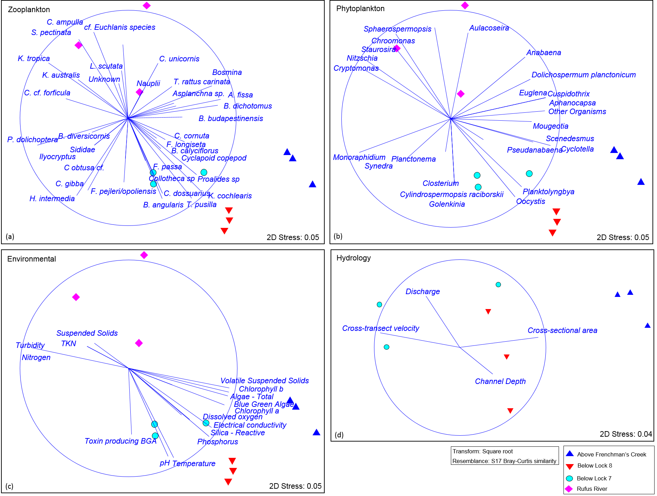

Figure 9: Nonmetric Multidimensional Scaling (MDS) ordinations of zooplankton community structure across sites during the first sampling conducted in March 2017 across all four sites for plots a-c and the three river sites for plot d. Vectors plotted include (a) zooplankton species abundance (ind.L-1), (b) phytoplankton abundance (cells.mL-1), (c) environmental variables and (d) ADCP measurements where mean U = mean water velocity, Q = flow, area = area of the cross section and channel depth = maximum channel depth.

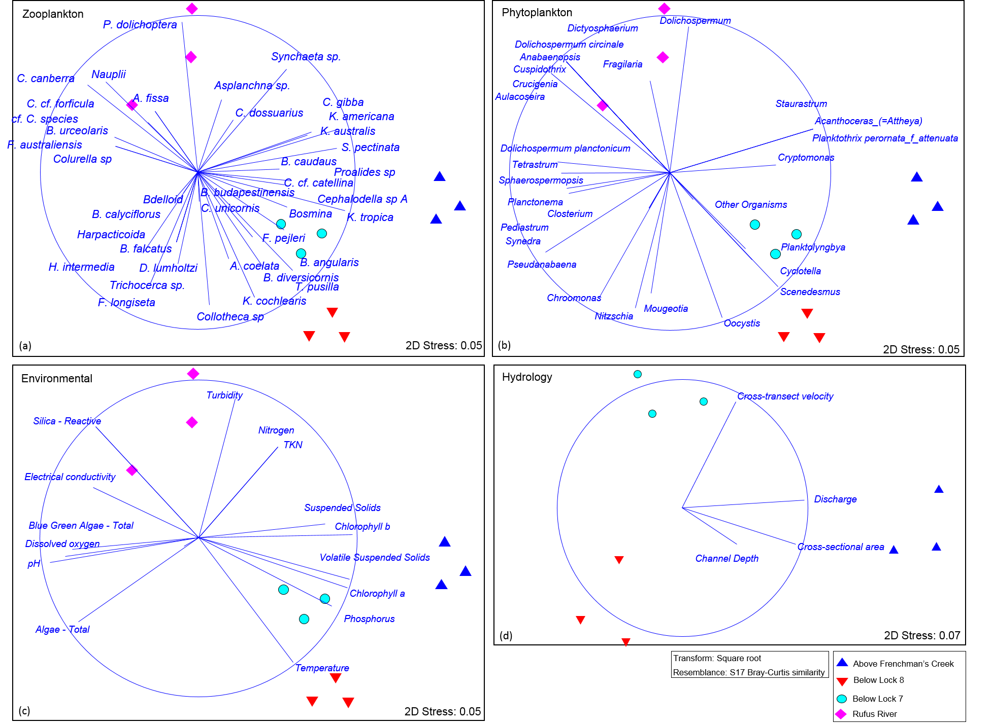

Figure 10: Nonmetric Multidimensional Scaling (MDS) ordinations of zooplankton community structure across sites during the second sampling conducted in April 2017 across all four sites for plots a-c and the three river sites for plot d. Vectors plotted include (a) zooplankton species abundance (ind.L-1), (b) phytoplankton abundance (cells.mL-1), environmental variables and (d) ADCP measurements where mean U = mean water velocity, Q = flow, area = area of the cross section and channel depth = maximum channel depth.

Table 7: Summary results from SIMPER (Similarity percentages analysis) indicating the species contribution to differences in zooplankton community structure between all sites and trips. A 40% cumulative contribution cut-off was applied. All average abundances rounded to zero decimal points.

|  |  |  |  |  |  |  |
| --- | --- | --- | --- | --- | --- | --- |
|  | **March 2017** | | | | | |
|  | **Rufus River & Below Lock 7** | | | | | |
|  | **Rufus River** | | **Below Lock 7** | | **Contrib%** | **Cum.%** |
|  | **SqrRt** | **Actual** | **SqrRt** | **Actual** |
| *T. pusilla* | 6 | 34 | 16 | 275 | 11 | 11 |
| *K. cochlearis* | 3 | 10 | 13 | 163 | 10.2 | 21.2 |
| *F. pejleri* | 6 | 43 | 15 | 233 | 9 | 30.2 |
| *C. unicornis* | 7 | 57 | 2 | 17 | 5.8 | 36 |
| *H. intermedia* | 3 | 14 | 8 | 72 | 5.6 | 41.6 |
|  | **Rufus River & Below Lock 8** | | | | | |
|  | **Rufus River** | | **Below Lock 8** | | **Contrib%** | **Cum.%** |
|  | **SqrRt** | **Actual** | **SqrRt** | **Actual** |
| *T. pusilla* | 6 | 34 | 27 | 734 | 14.9 | 14.9 |
| *K. cochlearis* | 3 | 10 | 17 | 289 | 10 | 25 |
| *F. pejleri* | 6 | 43 | 19 | 383 | 9 | 33.9 |
| *Proalides sp* | 0 | 0 | 11 | 125 | 7.7 | 41.6 |
|  | **Rufus River & Above Frenchman’s Creek** | | | | | |
|  | **Rufus River** | | **Above Frenchman’s Creek** | | **Contrib%** | **Cum.%** |
|  | **SqrRt** | **Actual** | **SqrRt** | **Actual** |
| *T. pusilla* | 6 | 34 | 23 | 521 | 12.7 | 12.7 |
| *K. cochlearis* | 3 | 10 | 17 | 282 | 10.5 | 23.3 |
| *K. tropica* | 13 | 163 | 1 | 5 | 8.4 | 31.7 |
| *Proalides sp* | 0 | 0 | 8 | 63 | 5.9 | 37.5 |
| *Anauropsis fissa* | 0 | 0 | 7 | 44 | 4.8 | 42.3 |
|  | **Below Lock 7 & Above Frenchman’s Creek** | | | | | |
|  | **Below Lock 7** | | **Above Frenchman’s Creek** | | **Contrib%** | **Cum.%** |
|  | **SqrRt** | **Actual** | **SqrRt** | **Actual** |
| *F. pejleri* | 15 | 233 | 1 | 521 | 12.6 | 12.6 |
| *K. tropica* | 8 | 72 | 1 | 5 | 6.4 | 19 |
| *P. dolichoptera* | 15 | 215 | 8 | 72 | 6 | 25 |
| *Anauropsis fissa* | 0 | 0 | 7 | 44 | 5.9 | 30.9 |
| *T. pusilla* | 16 | 275 | 23 | 521 | 5.9 | 36.8 |
| *Proalides sp* | 2 | 17 | 8 | 63 | 5.2 | 42 |
|  | **Below Lock 8 & Above Frenchman’s Creek** | | | | | |
|  | **Below Lock 8** | | **Above Frenchman’s Creek** | | **Contrib%** | **Cum.%** |
|  | **SqrRt** | **Actual** | **SqrRt** | **Actual** |
| *F. pejleri* | 19 | 383 | 1 | 5 | 16.4 | 16.4 |
| *Bosmina* | 0 | 0 | 7 | 53 | 6.7 | 23.1 |
| *Anauropsis fissa* | 0 | 0 | 7 | 44 | 6 | 29 |
| *C. unicornis* | 4 | 40 | 7 | 49 | 5.4 | 34.5 |
| *P. dolichoptera* | 14 | 195 | 8 | 72 | 5.3 | 39.8 |
| *B. budapestinensis* | 0 | 0 | 5 | 29 | 4.7 | 44.5 |
|  |  |  |  |  |  |  |
|  | **April 2017** | | | | | |
|  | **Rufus River & Below Lock 7** | | | | | |
|  | **Rufus River** | | **Below Lock 7** | | **Contrib%** | **Cum.%** |
|  | **SqrRt** | **Actual** | **SqrRt** | **Actual** |
| *K. cochlearis* | 3 | 18 | 20 | 407 | 13.5 | 13.5 |
| *T. pusilla* | 9 | 84 | 19 | 368 | 8.2 | 21.7 |
| *K. tropica* | 4 | 18 | 12 | 154 | 7.1 | 28.7 |
| *P. dolichoptera* | 24 | 585 | 17 | 276 | 6.2 | 34.9 |
| *B. angularis* | 0 | 0 | 6 | 54 | 4.8 | 39.6 |
| *S. pectinata* | 0 | 0 | 5 | 45 | 4.5 | 44.1 |
|  | **Rufus River & Below Lock 8** | | | | | |
|  | **Rufus River** | | **Below Lock 8** | | **Contrib%** | **Cum.%** |
|  | **SqrRt** | **Actual** | **SqrRt** | **Actual** |
| *K. cochlearis* | 3 | 18 | 18 | 330 | 10.9 | 10.9 |
| *P. dolichoptera* | 24 | 585 | 10 | 97 | 10.6 | 21.5 |
| *K. tropica* | 4 | 18 | 14 | 185 | 7.4 | 28.9 |
| *T. pusilla* | 9 | 84 | 18 | 315 | 6.3 | 35.2 |
| *Synchaeta sp.* | 8 | 74 | 0 | 0 | 6 | 41.2 |
|  | **Rufus River & Above Frenchman’s Creek** | | | | | |
|  | **Rufus River** | | **Above Frenchman’s Creek** | | **Contrib%** | **Cum.%** |
|  | **SqrRt** | **Actual** | **SqrRt** | **Actual** |
| *K. tropica* | 4 | 18 | 22 | 496 | 11.4 | 11.4 |
| *S. pectinata* | 0 | 0 | 17 | 283 | 10.2 | 21.6 |
| *K. americana* | 0 | 0 | 14 | 185 | 8.3 | 29.9 |
| *K. cochlearis* | 3 | 18 | 14 | 209 | 6.8 | 36.7 |
| *T. pusilla* | 9 | 84 | 19 | 360 | 6 | 42.8 |
|  | **Below Lock 7 & Above Frenchman’s Creek** | | | | | |
|  | **Below Lock 7** | | **Above Frenchman’s Creek** | | **Contrib%** | **Cum.%** |
|  | **SqrRt** | **Actual** | **SqrRt** | **Actual** |
| *K. americana* | 0 | 0 | 14 | 185 | 10.2 | 10.2 |
| *S. pectinata* | 5 | 45 | 17 | 283 | 8.4 | 18.7 |
| *K. tropica* | 12 | 154 | 22 | 496 | 7.6 | 26.2 |
| *F. longiseta* | 8 | 74 | 1 | 5 | 5.4 | 31.6 |
| *H. intermedia* | 9 | 85 | 2 | 15 | 5 | 36.6 |
| *Synchaeta sp.* | 8 | 77 | 15 | 228 | 5 | 41.6 |
|  | **Below Lock 8 & Above Frenchman’s Creek** | | | | | |
|  | **Below Lock 8** | | **Above Frenchman’s Creek** | | **Contrib%** | **Cum.%** |
|  | **SqrRt** | **Actual** | **SqrRt** | **Actual** |
| *S. pectinata* | 1 | 5 | 17 | 283 | 11.3 | 11.3 |
| *Synchaeta sp.* | 0 | 0 | 15 | 228 | 11 | 22.3 |
| *K. americana* | 0 | 0 | 14 | 185 | 9.9 | 32.2 |
| *P. dolichoptera* | 10 | 97 | 19 | 376 | 6.9 | 39.2 |
| *K. tropica* | 14 | 185 | 22 | 496 | 6.3 | 45.5 |
|  | **Below Lock 7 & Below Lock 8** | | | | | |
|  | **Below Lock 7** | | **Below Lock 8** | | **Contrib%** | **Cum.%** |
|  | **SqrRt** | **Actual** | **SqrRt** | **Actual** |
| *Synchaeta sp.* | 8 | 77 | 0 | 0 | 8.8 | 8.8 |
| *P. dolichoptera* | 17 | 276 | 10 | 97 | 7 | 15.8 |
| *Anuraeopsis coelata* | 0 | 0 | 6 | 33 | 5.9 | 21.7 |
| *S. pectinata* | 5 | 45 | 1 | 5 | 5.3 | 27 |
| *C. unicornis* | 0 | 0 | 5 | 34 | 4.9 | 31.9 |
| *B. angularis* | 6 | 54 | 4 | 24 | 4.7 | 36.6 |
| *Bosmina* | 0 | 0 | 4 | 20 | 4.6 | 41.2 |

## 4.4 Discussion

The primary aim of this study was to investigate longitudinal variability in zooplankton community structure within the main channel of the River Murray, adjacent to and downstream of Lake Victoria, and to investigate potential drivers of variability in association with Lake Victoria operations. Two key mechanisms in which Lake Victoria operations may influence river zooplankton communities were explored: 1) the influence of altered main channel hydraulics due to diversions into Lake Victoria; and 2) the influence of the zooplankton communities exported from Lake Victoria and mixing with the river community. While the low number of sampling events limits the ability to develop causal relationships between river operations and the zooplankton community, there was evidence to suggest that both of these mechanisms affect the zooplankton community in the River Murray. This evidence is summarised against the hypotheses tested below.

***Hypothesis 1:*** *Increasing the proportion of flow passing from Lock 10 to Lock 7 will increase water velocity within the river channel and thus facilitate the longitudinal transfer of a lotic zooplankton community.*

Discharge and water velocity at the site *below Lock 8* during a period of low diversion to Lake Victoria (~6.7% of Lock 10 discharge), were at least 50% greater than that measured during the period of high flow diversion (59–67%). Concurrently, zooplankton abundance increased in a downstream direction during low diversion, but decreased significantly during high diversion, suggesting higher water velocities may have facilitated greater downstream transfer of lotic zooplankton. Decreased longitudinal abundances during periods of high water diversion were primarily due to a decrease in the abundance of five rotifer species. Two species from the genus *Synchaeta*, *S. pectinata* and *S. oblonga*, did however appear to recover a small proportion of their upstream abundances downstream of Rufus River, where flow velocity again increased. *P. dolichoptera* recovered a considerable proportion of its upstream abundances; although this appeared to be due to inputs from Lake Victoria, not hydrodynamics within the main river channel. Abundances of another two species, *K. americana* and *K. tropica* did not recover at all within the study area. Lastly the cladoceran *B. meridionalis*, which can dominate crustacean communities within river environments where lotic conditions prevail (e.g. Baranyi et al. 2002), also exhibited a longitudinal decline along the river channel at the time when a large proportion of water was being diverted into Lake Victoria.

Longitudinal variability in zooplankton communities is possibly related to water velocity and associated hydraulic factors such as turbulence. Decreased water velocities and turbulence may promote settlement of some rotifer species, and subsequent deposition in the deeper areas of the channel. Despite the whole water column being sampled in this study (i.e. samples taken from the surface, middle and lower water column), samples were taken mid-channel which in most cases was not the deepest part of the river (see Appendix 1: Figure 11 – Figure 16). Therefore, if zooplankton was accumulating on the river bed in the deepest parts of the river, as on all occasions this was not mid-channel, it was not captured by our sampling. To our knowledge, there are no published studies explicitly investigating the relationship between water velocity and the suspension of rotifers, but two studies lend support to a water velocity/settlement mechanism for decreased rotifer abundance. Baranyi et al. (2002) demonstrated a negative correlation between the number of rotifer species and water age, where water age was defined by the authors as “*how long the water has been contained in the respective water body system, up to any position within the system and at any point in time*”. The authors, however, did not provide an explanatory mechanism. Additionally, Gruberts and Paidere (2014), investigated the zooplankton community along a 62 km stretch of the Middle Daugava River in South-East Latvia and found that the highest total abundance of zooplankton was recorded at drift speeds of 1.94 m.s-1, some of the highest drift speeds measured throughout the study. At the same point the abundance of several common rotifers including *Synchaeta* sp., *Keratella cochlearis*, and *Keratella quadrata* simultaneously reached their maximum. Water velocities in the Latvian study were significantly higher than those measured in our study, but the same genera of rotifer were impacted.

This significant reduction in the abundance of these rotifer species in association with reduced water velocities in the River Murray is somewhat conflicting, as these species are commonly found in low to no velocity environments such as lakes (e.g. Ge et al. 2018, Gutierrez et al. 2018, Stich et al. 2018). Nevertheless, lakes have different hydraulic driving forces to rivers (e.g. wind) which may explain the ability of rotifers to persist in these environments. In the River Murray, it is possible that the abruptness of the change in water velocity, a combination of decreased water velocity and increased water depth or more local hydrodynamics surrounding the weirs may have negatively impacted some rotifers. Changes in river hydraulics have been found to be associated with disruptions in longitudinal trends in zooplankton community structure at the system scale (Furst et al. 2017). If sudden decreases in water velocities are causing the loss of specific zooplankton from the pelagic zone, pelagic food resources may be redistributed to the benthic and/or microbial food web within this area of the River Murray, with commensurate implications for food webs within and downstream of the region.

The loss of rotifers may have significant implications for the food web. Keratella are an important food resource for other rotifers (e.g. Conde-Porcuna and Sarma 1995). Polyarthra and Synchaeta are considered important food resources for copepods and cladocerans (e.g. Gilbert and Williamson 1978, Stemberger 1985), which in turn, have been demonstrated to be a key food resource for a number of native fish species including Australian smelt, carp gudgeons, *Gambusia*, rainbow fish and Murray cod (Kaminskas and Humphries 2009, King 2005). Additionally, River Murray borne *B. meriodinalis*, are a major food resource for sandy sprat, a highly important species for the Coorong food web. Therefore, a reduction in population numbers of this species could potentially impact food webs as far downstream as the Coorong (Bice et al. 2015).

***Hypothesis 2:*** *Increased inputs of water from Lake Victoria to lower River Murray channel will increase the abundance of lentic zooplankton in the river.*

Zooplankton communities emanating from Lake Victoria were distinct to those within the river channel and influenced communities downstream of Lake Victoria in March and April 2017. During both sampling trips, zooplankton abundance was lower at Rufus River than any of the river sites and these low concentrations of zooplankton were likely diluting communities in the main river channel downstream. This was especially evident during March when a large volume of water (2,479–3,014 ML.day-1) was being released from Lake Victoria (30–35% of flow at Lock 6). The low abundances of zooplankton emanating from Lake Victoria was unexpected, as longer water residence times have been demonstrated to be positively correlated with zooplankton abundance and biomass, especially for crustaceans (e.g. Baranyi et al. 2002). It is possible, however, that local environmental factors within Lake Victoria were limiting population growth. Regardless, there was some contribution of calanoid copepods, from Lake Victoria, to downstream communities in the River Murray; calanoid copepods have been demonstrated to be a dominant food resource for juvenile and small-bodied fishes (e.g. fish 13mm and larger in Siefert 1972).

Cladocerans are an important food resource for fish, and growth and survival of fish have been positively correlated with the abundance of zooplankton prey (Welker et al. 1994). In both March and April 2017, the Rufus River zooplankton communities were associated with low phosphorus concentrations. Cladocera have lower C:P ratios than most other freshwater zooplankton, and phosphorus limitation is thought to result in trade-offs in phosphorus allocation between reproductive and somatic tissues (Færøvig and Hessen 2003). Therefore phosphorus limitation may impact individuals and in turn, population growth (Færøvig and Hessen 2003). This may explain why cladocerans were rare at Rufus River (excluding a small number of *B. meridionalis*) during both trips when it was thought that they would be abundant in out-flows from Lake Victoria.

## 4.5 Conclusions

The operation of Lake Victoria influences spatio-temporal variability in zooplankton communities in the lower River Murray. This is mediated by two key mechanisms: 1) diversion of water decreases discharge and water velocity in the River Murray between the inlet and outlet of Lake Victoria, with commensurate changes in the pelagic zooplankton community; and 2) the generation of an alternative zooplankton community in Lake Victoria and export via the Rufus River influences zooplankton community structure in the River Murray downstream of Lake Victoria. Unexpectedly, however, outflows from Lake Victoria diluted River Murray zooplankton communities and decreased overall abundance. The longitudinal decline in zooplankton abundance downstream of the Frenchman’s Creek junction during times of high diversion, may have been resulting in pelagic food resources between Lock 9 and Lock 7 being redistributed to the benthic and/or microbial food web, thus, decreasing availability to pelagic consumers (e.g. fish). Conversely, low diversion of flows into Lake Victoria promotes maintenance and longitudinal integrity of lotic zooplankton assemblages.

Overall, maintenance of greater discharge within the River Murray promotes hydraulic conditions that facilitate the downstream transport and maintain the longitudinal integrity of riverine zooplankton communities. In turn, this provides a greater availability of food resources for higher trophic organisms, locally and downstream.

## References

Aldridge, K. and Brookes, J. (2015) An evaluation of the effect of increasing longitudinal connectivity within the lower River Murray on water quality and longitudinal transport of nutrients. The University of Adelaide.

Aldridge, K., Lorenz, Z., Oliver, R. and Brookes, J. (2012) Changes in water quality and phytoplankton communities in the Lower River Murray in response to a low flow-high flow sequence. Goyder Institute for Water Research Technical Report Series 12(5).

Anderson, M., Gorley, R. and Clarke, K.P. (2008) for PRIMER: Guide to software and statistical methods. PRIMER-E, Plymouth, UK.

Baranyi, C., Hein, T., Holarek, C., Keckeis, S. and Schiemer, F. (2002) Zooplankton biomass and community structure in a Danube River floodplain system: effects of hydrology. Freshwater Biology 47(3), 473-482.

Bice, C., Furst, D., Lamontagne, S., Oliver, R., Zampatti, B. and Revill, A. (2015) The influence of freshwater discharge on productivity, microbiota community structure and trophic dynamics in the Murray estuary: evidence of freshwater derived trophic subsidy in the sandy sprat. Goyder Institute for Water Research Technical Report Series No. 15/40, Adelaide, South Australia. ISSN: 1839-2725.

Conde-Porcuna, J.M. and Sarma, S.S.S. (1995) Prey selection by Asplanchna girodi (Rotifera): the importance of prey defence mechanisms. Freshwater Biology 33(3), 341-348.

Cook, P.L., Aldridge, K.T., Lamontagne, S. and Brookes, J. (2010) Retention of nitrogen, phosphorus and silicon in a large semi-arid riverine lake system. Biogeochemistry 99(1-3), 49-63.

Cooper, S.D. and Goldman, C.R. (1980) Opossum shrimp (Mysis relicta) predation on zooplankton. Canadian Journal of Fisheries and Aquatic Sciences 37(6), 909-919.

Færøvig, P.J. and Hessen, D.O. (2003) Allocation strategies in crustacean stoichiometry: the potential role of phosphorus in the limitation of reproduction. Freshwater Biology 48(10), 1782-1792.

Furst, D., Aldridge, K., Bice, C., Zampatti, B. and Ye, Q. (2017) An interim report for “The influence of flow translucency and longitudinal integrity on resource availability and lower order food web structure in the River Murray”. Report to the Commonwealth Environmental Water Office and Murray-Darling Basin Authority, Canberra. .

Furst, D.J., Aldridge, K.T., Shiel, R.J., Ganf, G.G., Mills, S. and Brookes, J.D. (2014) Floodplain connectivity facilitates significant export of zooplankton to the main River Murray channel during a flood event. Inland Waters 4(4), 413-424.

Ge, Y., Xi, Y., Ma, J. and Xu, D. (2018) Factors Influencing Morphological Characteristics of Keratella cochlearis in Lake Tingtang. Proceedings of the National Academy of Sciences, India Section B: Biological Sciences 88(1), 421-428.

Ghan, D. and Sprules, W. (1993) Diet, prey selection, and growth of larval and juvenile burbot Lota lota (L.). Journal of Fish Biology 42(1), 47-64.

Gilbert, J.J. (1985) Escape response of the rotifer Polyarthra: a high-speed cinematographic analysis. Oecologia 66(3), 322-331.

Gilbert, J.J. (1987) Rotifer Symposium IV: Proceedings of the Fourth Rotifer Symposium, held in Edinburgh, Scotland, August 18–25, 1985. May, L., Wallace, R. and Herzig, A. (eds), pp. 235-238, Springer Netherlands, Dordrecht.

Gilbert, J.J. and Williamson, C.E. (1978) Predator-prey behavior and its effect on rotifer survival in associations of Mesocyclops edax, Asplanchna girodi, Polyarthra vulgaris, and Keratella cochlearis. Oecologia 37(1), 13-22.

Goulden, C.E. (1968) The systematics and evolution of the Moinidae. Transactions of the American Philosophical Society 58(6), 1-101.

Gruberts, D. and Paidere, J. (2014) Lagrangian drift experiment on the Middle Daugava River (Latvia) during the filling phase of the spring floods. Fundamental and Applied Limnology/Archiv für Hydrobiologie 184(3), 211-230.

Gutierrez, M.F., Tavşanoğlu, Ü.N., Vidal, N., Yu, J., Teixeira-de Mello, F., Çakiroglu, A.I., He, H., Liu, Z. and Jeppesen, E. (2018) Salinity shapes zooplankton communities and functional diversity and has complex effects on size structure in lakes. Hydrobiologia 813(1), 237-255.

Kaminskas, S. and Humphries, P. (2009) Diet of Murray cod (Maccullochella peelii peelii)(Mitchell) larvae in an Australian lowland river in low flow and high flow years. Hydrobiologia 636(1), 449.

Kilsby, N.N. (2008) Reach-scale spatial hydraulic diversity in lowland rivers: characterisation, measurement and significance for fish, The University of Adelaide.

King, A. (2004) Density and distribution of potential prey for larval fish in the main channel of a floodplain river: pelagic versus epibenthic meiofauna. River research and applications 20(8), 883-897.

King, A.J. (2005) Ontogenetic dietary shifts of fishes in an Australian floodplain river. Marine and Freshwater Research 56(2), 215-225.

Klement, T., Doris, P., Niko, R., Fritz, S. and V., W.J. (1999) Hydrological connectivity, and the exchange of organic matter and nutrients in a dynamic river–floodplain system (Danube, Austria). Freshwater Biology 41(3), 521-535.

Kuczyńska-Kippen, N. (2014) Environmental Variables of Small Mid-Field Water Bodies and the Presence of Rotifera Groups of Different Ecological Requirements. Polish Journal of Environmental Studies 23(2).

Lazzaro, X. (1987) A review of planktivorous fishes: Their evolution, feeding behaviours, selectivities, and impacts. Hydrobiologia 146(2), 97-167.

Maier, H.R., Burch, M.D. and Bormans, M. (2001) Flow management strategies to control blooms of the cyanobacterium, Anabaena circinalis, in the River Murray at Morgan, South Australia. Regulated Rivers: Research & Management 17(6), 637-650.

MDBA (2013a) Constraints Management Strategy 2013 to 2024. The Murray–Darling Basin Authority Publication No. 28/13.

MDBA (2013b) Investigating Potential Changes in the Lake Victoria Flushing Rule for Maximising the Effectiveness of Environmental Watering. Licensed from the Murray-Darling Basin Authority under a Creative Commons Attribution 3.0 Australia Licence.

MDBA (2014) Basin-wide environmental watering strategy. Authority, M.-D.B. (ed), Australian Government, Canberra.

MDBA (2018) River Murray system> Running the River Murray> Lake Victoria.

Meerhoff, M., Iglesias, C., De Mello, F.T., Clemente, J.M., Jensen, E., Lauridsen, T.L. and Jeppesen, E. (2007) Effects of habitat complexity on community structure and predator avoidance behaviour of littoral zooplankton in temperate versus subtropical shallow lakes. Freshwater Biology 52(6), 1009-1021.

Moore, M.V. and Gilbert, J.J. (1987) Age‐specific Chaoborus predation on rotifer prey. Freshwater Biology 17(2), 223-236.

Nilsson, C., Reidy, C.A., Dynesius, M. and Revenga, C. (2005) Fragmentation and Flow Regulation of the World's Large River Systems. Science 308(5720), 405-408.

Ning, N.S., Nielsen, D.L., Paul, W.L., Hillman, T.J. and Suter, P.J. (2010) Microinvertebrate dynamics in riverine slackwater and mid‐channel habitats in relation to physico‐chemical parameters and food availability. River research and applications 26(3), 279-296.

Petrusek, A. (2002) Moina (Crustacea: Anomopoda, Moinidae) in the czech republic: a review. Acta Soc Zool Bohem 66(3), 213-220.

Poff, N.L., Allan, J.D., Bain, M.B., Karr, J.R., Prestegaard, K.L., Richter, B.D., Sparks, R.E. and Stromberg, J.C. (1997) The natural flow regime. BioScience 47(11), 769-784.

Puckridge, J.T., Sheldon, F., Walker, K.F. and Boulton, A.J. (1998) Flow variability and the ecology of large rivers. Marine and Freshwater Research 49(1), 55-72.

Shiel, R., Walker, K. and Williams, W. (1982) Plankton of the lower River Murray, South Australia. Marine and Freshwater Research 33(2), 301-327.

Shields, F.D. and Rigby, J.R. (2005) River Habitat Quality from River Velocities Measured Using Acoustic Doppler Current Profiler. Environmental Management 36(4), 565-575.

Siefert, R.E. (1972) First Food of Larval Yellow Perch, White Sucker, Bluegill, Emerald Shiner, and Rainbow Smelt. Transactions of the American Fisheries Society 101(2), 219-225.

Stemberger, R.S. (1985) Prey selection by the copepod Diacyclops thomasi. Oecologia 65(4), 492-497.

Stich, H.B., Schumann, M. and Brinker, A. (2018) Dynamics of pelagic rotifers subject to trophic fluctuations in Upper Lake Constance (1963–2012). Journal of Plankton Research 40(2), 118-128.

Vinyard, G.L. (1980) Differential Prey Vulnerability and Predator Selectivity: Effects of Evasive Prey on Bluegill (Lepomis macrochirus) and Pumpkinseed (L. gibhosus) Predation. Canadian Journal of Fisheries and Aquatic Sciences 37(12), 2294-2299.

Welker, M.T., Pierce, C.L. and Wahl, D.H. (1994) Growth and Survival of Larval Fishes: Roles of Competition and Zooplankton Abundance. Transactions of the American Fisheries Society 123(5), 703-717.

Appendix 1: Horizontal current velocity profiles

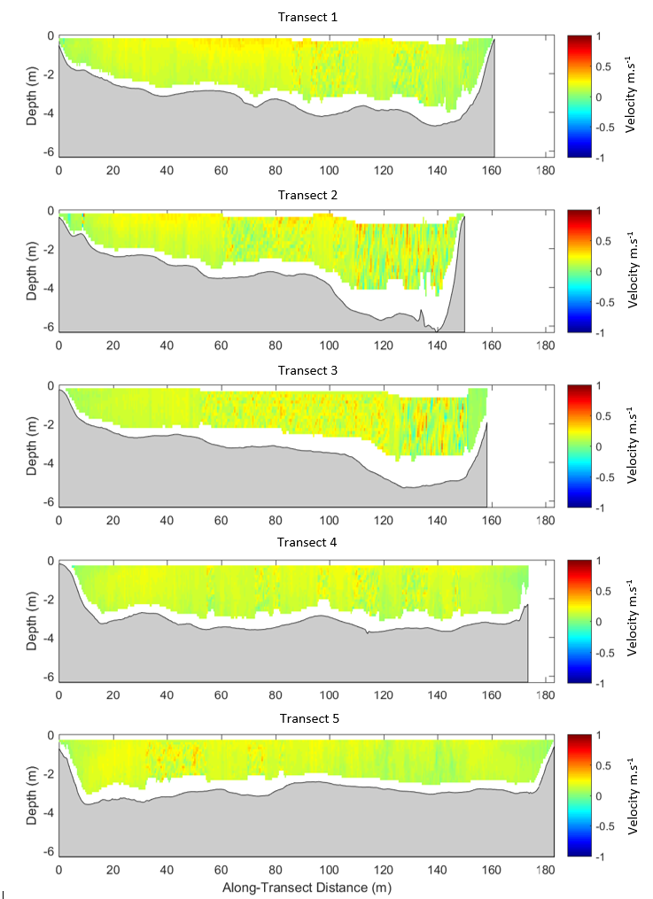

Figure 2: Horizontal current velocity profiles generated for the site *above Frenchman’s Creek* during the first sampling trip. Plots present cross-transect velocities (U) in cells 0.5 m in width x 0.25 m in height.

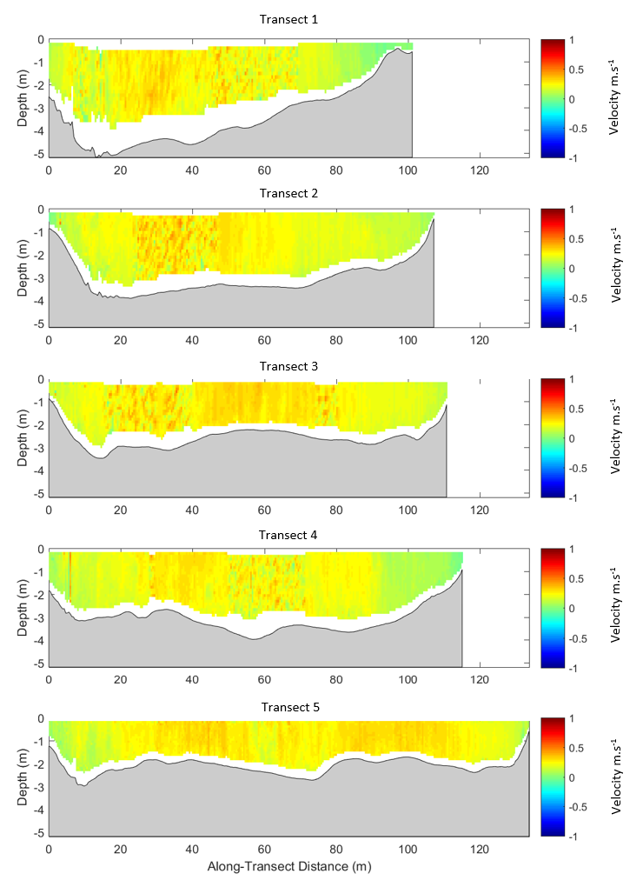

Figure 3: Horizontal current velocity profiles generated for the site *below Lock 8* during the sampling first sampling trip. Plots present cross-transect velocities (U) in cells 0.5 m in width x 0.25 m in height.

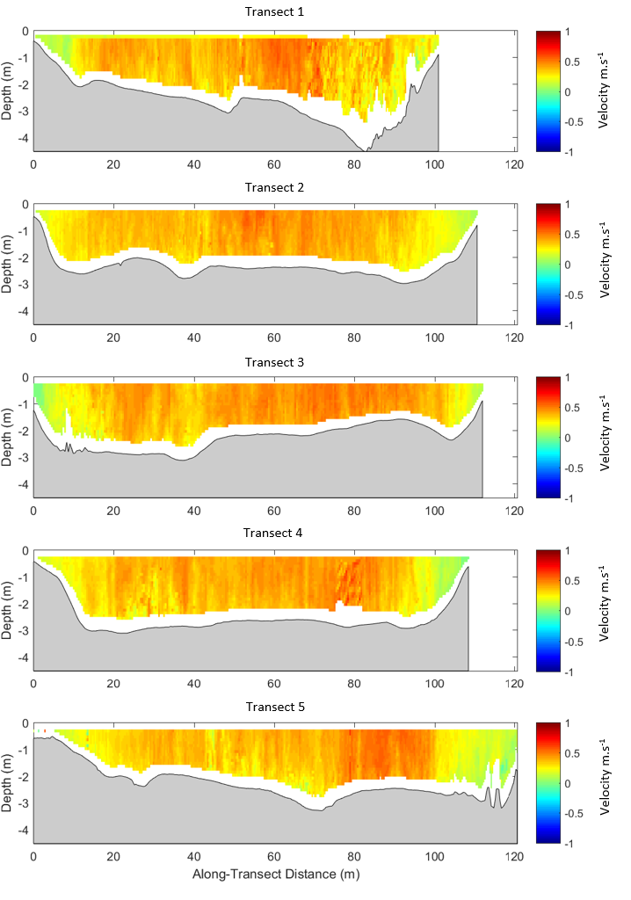

Figure 4: Horizontal current velocity profiles generated for the site *below Lock 7* during the sampling trip S1. Plots present cross-transect velocities (U) in cells 0.5 m in width x 0.25 m in height.

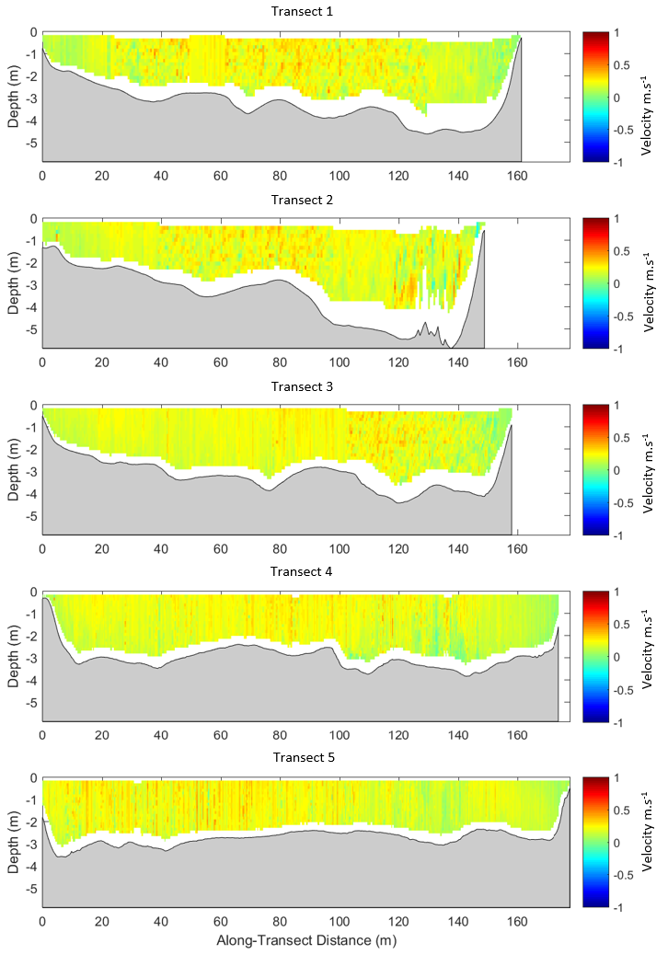

Figure 5: Horizontal current velocity profiles generated for the site *above Frenchman’s Creek* during the sampling trip S2. Plots present cross-transect velocities (U) in cells 0.5 m in width x 0.25 m in height.

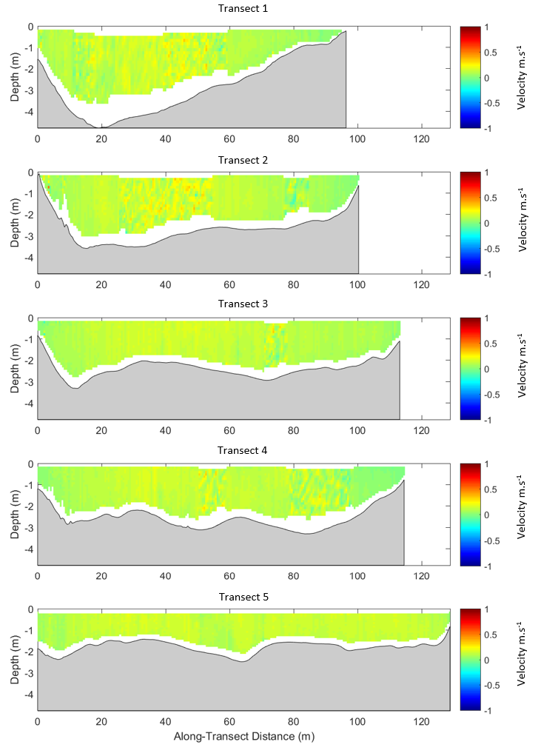

Figure 6: Horizontal current velocity profiles generated for the site *below Lock 8* during the sampling trip S2. Plots present cross-transect velocities (U) in cells 0.5 m in width x 0.25 m in height.

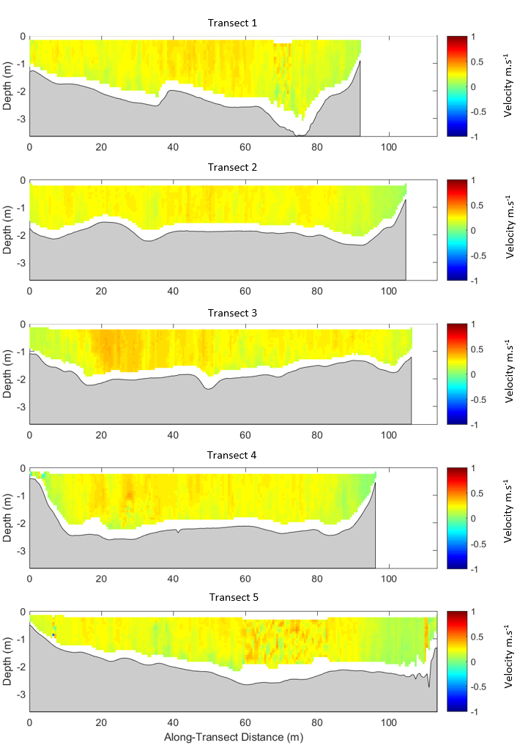

Figure 7: Horizontal current velocity profiles generated for the site *below Lock 7* during the sampling trip S2. Plots present cross-transect velocities (U) in cells 0.5 m in width x 0.25 m in height.