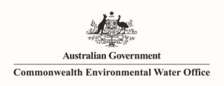

**Monitoring the ecological response of Commonwealth Environmental Water delivered in 2013-14 in the Gwydir River system**

**A report to the Department of Environment.**

**Mark Southwell1, Glenn Wilson1, Darren Ryder1, Phil Sparks2, Martin Thoms1**

**1University of New England, Armidale NSW 2351**

**2 North West Ecological Services, Tamworth NSW 2340**

**24 March 2015**

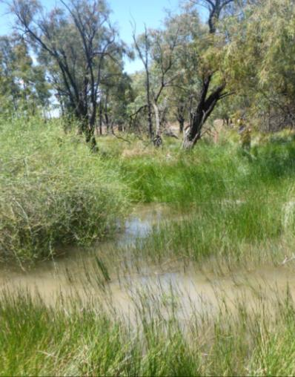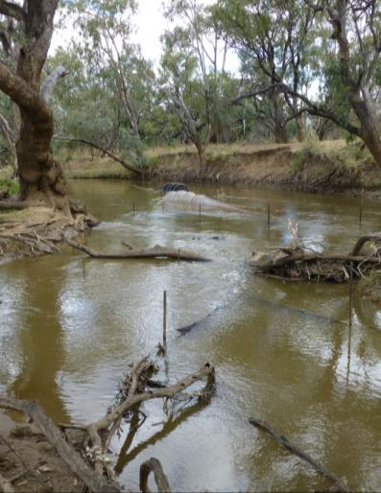

**Copyright**© Copyright Commonwealth of Australia, 2014



‘Monitoring the ecological response of Commonwealth Environmental Water delivered in 2013-14 in the Gwydir River system’ is licensed by the Commonwealth of Australia for use under a Creative Commons By Attribution 3.0 Australia licence with the exception of the Coat of Arms of the Commonwealth of Australia, the logo of the agency responsible for publishing the report, content supplied by third parties, and any images depicting people. For licence conditions see: <http://creativecommons.org/licenses/by/3.0/au/>

This report should be attributed as ‘Monitoring the ecological response of Commonwealth Environmental Water delivered in 2013-14 in the Gwydir River system, Commonwealth of Australia 2014’.

The Commonwealth of Australia has made all reasonable efforts to identify content supplied by third parties using the following format ‘© Copyright, [name of third party] ’.

**Disclaimer**

The views and opinions expressed in this publication are those of the authors and do not necessarily reflect those of the Australian Government or the Minister for the Environment.

While reasonable efforts have been made to ensure that the contents of this publication are factually correct, the Commonwealth does not accept responsibility for the accuracy or completeness of the contents, and shall not be liable for any loss or damage that may be occasioned directly or indirectly through the use of, or reliance on, the contents of this publication.

Cover photos:

Left: Fyke nets set in the Carole Creek near “Laurella: to monitor fish, crustaceans and turtles (photo: M. Southwell)

Right: Wetland vegetation submerged by Commonwealth environmental water in the Mallowa Creek wetlands at “Valetta” (photo: K. Cousins)

**TABLE OF CONTENTS**

Acknowledgements 3

Executive Summary 4

1 Introduction 10

2 Study area 11

2.1 Geomorphology 12

2.2 Hydrology 12

2.3 Ecology 13

3 The Use of Commonwealth environmental water in 2013-14 14

3.1 Mallowa Creek wetlands. 15

3.2 Mehi River and Carole Creek 16

4 Monitoring Indicator – Hydrological connectivity 17

4.1 Methods 17

4.1.1 Longitudinal connectivity 17

4.1.2 Targeted in-channel environmental flow event analysis 18

4.1.3 Lateral connectivity analysis in the Mallowa Creek wetlands 18

4.1.4 Sampling regime/locations 20

4.2 Results 20

4.2.1 Longitudinal connectivity 20

4.2.2 Targeted in-channel environmental flow event analysis 22

4.2.3 Lateral connectivity analysis in the Mallowa Creek wetlands 24

4.3 Outcomes 26

5 Monitoring Indicator – Fish, turtles and Macrocrustaceans 29

5.1 Methods 29

5.2 Results 32

5.2.1 Fish – assemblage structure 32

5.2.2 Fish – size-structure 35

5.2.3 Fish – spawning-timing 39

5.2.4 Macrocrustaceans 45

5.2.5 Turtles 48

5.3 Outcomes 50

6 Monitoring Indicator – Water Quality 52

6.1 Methods 52

6.1.1 Sampling regime/locations 52

6.2 Results 52

6.3 Outcomes 58

7 Monitoring Indicator – Macroinvertebrates and Zooplankton 59

7.1 Methods 59

7.1.1 Macroinvertebrates 59

7.1.2 Zooplankton 59

7.1.3 Sampling regime/locations 60

7.2 Results 60

7.2.1 Macroinvertebrates 60

7.2.2 Zooplankton 64

7.3 Outcomes 65

8 Monitoring Indicator – Frogs 67

8.1 Methods 67

8.1.1 Site scale plot design 67

8.1.2 Frog and reptile diurnal and nocturnal surveys 67

8.1.3 Tadpole survey 67

8.1.4 Site descriptions 68

8.1.5 Sampling regime/locations 68

8.2 Results 70

8.2.1 Gwydir wetland sites 71

8.2.2 Gingham wetland sites 73

8.2.3 Mallowa wetland site 75

8.3 Outcomes 77

9 Monitoring Indicator – Native vegetation 80

9.1 Methods 80

9.1.1 Field based vegetation community response 80

9.1.2 Remote sensing based vegetation biomass 81

9.1.3 Sampling regime/locations 83

9.2 Results 84

9.2.1 Aquatic transects 84

9.2.2 Wider vegetation plot survey 85

9.2.3 Remote sensing based vegetation response 96

9.3 Outcomes 98

10 Implications 100

10.1 To what degree were the expected outcomes achieved? 100

10.2 What was the ecological significance of the outcomes of environmental watering? 101

10.3 In future, what changes to the watering regime might enhance outcomes? 102

11 References 105

Appendix 1 – Plot locations at frog sampling sites monitored in the study 109

**List of Figures**

Figure 2.1 Location map of the Gwydir River catchment 11

Figure 4.1 Flow entering the Mallowa system measured at the Mallowa Creek Regulator (418049) noting the temporal distribution of Landsat 8 images used for analysis. Green bar represents period over which Commonwealth environmental water was delivered down Mallowa Creek 19

Figure 4.2 Location map showing the gauging stations used in the longitudinal connectivity analysis, and the spatial extent of the lateral connectivity component of the study. 20

Figure 4.3 Stream flows down the Mehi River measured at the upstream (green) and downstream (light blue) gauges. Periods of longitudinal connectivity denoted by the dark blue line. The arrow shows the peak provided by Commonwealth environmental water delivery. 21

Figure 4.4 Stream flows down the Carole creek measured at the upstream (green) and downstream (light blue) gauges. Periods of longitudinal connectivity denoted by the dark blue line. The arrow shows the peak provided by Commonwealth environmental water delivery. 21

Figure 4.5 Stream flows down the Gingham watercourse measured at the upstream (green) and downstream (light blue) gauges. Periods of longitudinal connectivity denoted by the dark blue line. 22

Figure 4.6 Stream flows down the Gwydir river measured at the upstream (green) and downstream (light blue) gauges. Periods of longitudinal connectivity denoted by the dark blue line. 23

Figure 4.7 Plot of upstream (green) and downstream (blue) flow hydrographs compared to the target hydrograph for the Commonwealth in-channel environmental flow delivered within the Mehi River channel. 24

Figure 4.8 Plot of upstream (green) and downstream (blue) flow hydrographs compared to the target hydrograph for the Commonwealth in-channel environmental flow delivered within Carole Creek channel. 25

Figure 4.9 Pattern of inundation along the Mallowa Creek wetlands during the 2013-14 water year. 26

Figure 4.10 The progression of inundated area in the Mallowa Creek wetlands measured from 30 July 2013 – 11 March 2014. 28

Figure 5.1 Flow hydrographs for the upstream gauging stations in each channel, and the timing of fish sampling undertaken throughout the 2013-14 water year. 29

Figure 5.2 Location of the 15 in-channel monitoring sites monitored during 2013-14. 30

Figure 5.3 Non-metric multidimensional scaling ordination of variation in fish assemblage structure in the four lower Gwydir channels, November 2013 to June 2014. Data are coded by Data are coded by (A) month: ▲ November, ▼ December, □ March, ◇ April, ⚫ June; (B) channel: ▲ Carole Creek, ▼ Gingham Watercourse, □ Lower Gwydir River, ◇ Mehi River; and (C) site: ▲ “Laurella”, ▼”Windmill”, ■ Garah, ◆ “Willowlee”, ⚫ Goddard’s Lease, 🞤 Gingham Waterhole, 🞬 “Boyanga”, 🞶 Brageen Crossing, △ “Allambie”, ▽ “Birrah”, □ “Chinook”, ◇ Sollings Stock Reserve, ⭘ DS Combadello Weir, ▲ Hickey Bridge, ▼ “Derra”. 34

Figure 5.4 Carp gudgeon, *Hypseleotris species*. Variation in size-structure among the four lower Gwydir study channels, November 2013 to June 2014. 36

Figure 5.5 Spangled perch, *Leiopotherapon unicolor*. Variation in size-structure among the four lower Gwydir study channels, November 2013 to June 2014. 37

Figure 5.6 Bony bream, *Nematolosa erebi*. Variation in size-structure among the four lower Gwydir study channels, November 2013 to June 2014. 38

Figure 5.7 European carp, *Cyprinus carpio*. Variation in size-structure among the four lower Gwydir study channels, November 2013 to June 2014. 40

Figure 5.8 Australian smelt, *Retropinna semoni*. Variation in size-structure among the four lower Gwydir study channels, November 2013 to June 2014. 41

Figure 5.9 Olive perchlet, *Ambassis agassizii*. Variation in size-structure in “Boyanga” Waterhole, November and December 2013. 42

Figure 5.10 Typical otolith microstructure in (A) bony bream, (B) spangled perch, and (C) European carp, showing the increment microstructure used to derive daily age and hatch-date estimates. 43

Figure 5.11 Bony bream, *Nematolosa erebi*. Comparison of hatch-date distribution and channel hydrology (A) in the Mehi River at “Derra” and (B) in the Lower Gwydir River at “Allambie”, October 2013 to March 2014. Flow data were obtained from the Mehi River U/S Ballin Boora Creek gauge (418068) for “Derra” and from the Gwydir River at Millewa gauge (418066) for “Allambie”. The arrow in (A) indicates the timing of Commonwealth environmental watering. 44

Figure 5.12 Spangled perch, *Leiopotherapon unicolor.* Comparison of hatch-date distribution and channel hydrology in (A) Carole Creek at “Laurella” from October 2013 to February 2014 and in the Gingham Watercourse at (B) “Goddard’s Lease” and (C) “Boyanga” Waterhole in mid 2013. Flow data were obtained from the Carole Creek at the Downstream Regulator (Bells Crossing) gauge (418011) for “Laurella”, from the Gingham Watercourse at the Tillaloo Bridge gauge (418076) for “Goddard’s Lease”, and from the Gingham Watercourse at the Gingham Bridge gauge (418079) for “Boyanga”. The arrow in (A) indicates the timing of Commonwealth environmental watering. 45

Figure 5.13 European carp, *Cyprinus carpio.* Comparison of hatch-date distribution and channel hydrology (A) in the Carole Creek at “Laurella” from September to November 2013, (B) in the Mehi River at DS Combadello Weir and “Derra” from September to November, and (C) in the Lower Gwydir River at “Birrah” from October to December 2013. Flow data were obtained from the Carole Creek at the Downstream Regulator (Bells Crossing) gauge (418011) for “Laurella”, from the Mehi River at the DS Combadello Weir gauge (418037) for the DS Combadello Weir and “Derra” sites, and from the Lower Gwydir River at Millewa gauge (418066) for “Birrah”. The arrow in (A) and (B) indicates the timing of Commonwealth environmental watering. 46

Figure 5.14 Standardized abundances of freshwater shrimps captured during the 2013-14 water year. 47

Figure 5.15 Abundance of freshwater shrimps observed grouped by sampling times during the 2013-14 water year. 47

Figure 5.16 Standardized abundances of freshwater yabbies’ captured during the 2013-14 water year. 48

Figure 5.17 Abundance of freshwater yabbies observed in the four study channels monitored during the 2013-14 water year. 49

Figure 5.18 Size distribution for turtles caught in the study across all channels and sampling times. 49

Figure 6.1 Concentrations of total suspended solids (TSS) in the Gwydir, Gingham, Carole and Mehi systems from November 2013 to June 2014. 55

Figure 6.2 Concentrations of chlorophyll a in the Gwydir, Gingham, Carole and Mehi systems from November 2013 to June 2014. 55

Figure 6.3 Concentrations of total nitrogen (TN) in the Gwydir, Gingham, Carole and Mehi systems from November 2013 to June 2014. 56

Figure 6.4 Concentrations of total phosphorus (TP) in the Gwydir, Gingham, Carole and Mehi systems from November 2013 to June 2014. 57

Figure 6.5 Concentrations of dissolved organic carbon (DOC) in the Gwydir, Gingham, Carole and Mehi systems from November 2013 to June 2014. 57

Figure 7.1 Total number of macroinvertebrates collected from each channel during the 2013-14 water year. 61

Figure 7.2 A nMDS ordination for macroinvertebrate community composition in the Gwydir, Gingham, Carole and Mehi systems from November 2013 to June 2014. 62

Figure 7.3 Average water column zooplankton densities (individuals m-3) in the Gwydir, Gingham, Carole and Mehi systems from March 2014 to June 2014. 64

Figure 7.4 A nMDS ordination for water column zooplankton densities (individuals m-3) in the Gwydir, Gingham, Carole and Mehi systems from March 2014 to June 2014. 65

Figure 8.1 Plot configuration at each of the frog survey sites. 68

Figure 8.2 Location of the five frog sites, monitored over the 2013-14 water year. 69

Figure 8.3 Number of individuals from a range of frog life stages observed in the Gwydir wetland sites during the study. 72

Figure 8.4 Number of adult frogs observed at the Gingham Wetland during the two sampling occasions. 74

Figure 8.5 Individuals of different frog life stages observed in the Mallowa Wetland frog site. 76

Figure 9.1 Location of the 11 vegetation sites monitored within the Gingham, Gwydir and Mallowa Creek wetlands during the 2013-14 water year. 83

Figure 9.2 Cover of vegetation species recorded in the Gwydir wetland transects during the two sampling times. Values represent the percentage of each species. 84

Figure 9.3 Cover of vegetation species recorded in the Gingham wetland transects during the two sampling times. Values represent the percentage of each species. 85

Figure 9.4 Number of species recorded at each site during the 2013-2014 water year arranged by wetland. 86

Figure 9.5 A nMDS plot of vegetation community composition for plots studied during the 2013-14 water year in the lower Gwydir catchment. Symbols represent different sites which are coloured according to wetland with green being the sites located in the Mallowa Creek wetlands, blue in the Gingham wetland and orange in the Gwydir wetland. 87

Figure 9.6 Total number of species present within the Mallowa wetland plots surveyed during the November 2013 and May 2014 sampling periods. 88

Figure 9.7 A nMDS plots showing the distribution of vegetation plots within the Mallowa Creek wetlands grouped by whether plots were inundated by Commonwealth environmental water (‘wet’), or not (‘dry’). 90

Figure 9.8 Percentage cover of bare ground observed in plots within the Mallowa Creek wetlands grouped by sampling time (month) and treatment (plot subject to Commonwealth environmental water or not) 91

Figure 9.9 Percent cover of flat spike-sedge (*Eliocharis plana*) observed in the Mallowa Creek wetlands grouped by treatment (plot subject to Commonwealth environmental water or not). 92

Figure 9.10 Percent cover of Common Nardoo (*Marsilia drummondii*) observed in the Mallowa Creek wetlands grouped by sampling time (month) and treatment (plot subject to Commonwealth environmental water or not) 92

Figure 9.11 Percent cover of Warrego Grass (*Paspalidium jubiflorum*) observed in the Mallowa Creek wetlands grouped by sampling time (month) and treatment (plot inundated by Commonwealth environmental water during 2013-14 or not) 93

Figure 9.12 Maximum heights of Noogoora Burr (*Xanthium occidentale*) observed in the Mallowa Creek wetlands grouped by sampling time (month). 95

Figure 9.13 Maximum biomass production measured throughout the 2013-14 water year in the Mallowa Creek Wetlands. 97

Figure 9.14 Distribution of vegetation community classes defined by Bowen and Simpson (2010) within the boundary of the Mallowa Creek wetlands used in the biomass assessment. 98

**List of Tables**

Table 3.1 Comparison between long term average annual flow volume, 2013-14 water year flow volume, and the contribution of Commonwealth environmental water in each channel of the Gwydir River system 14

Table 3.2 Expected outcomes of environmental water used in the Gwydir wetlands against relevant Basin Plan objectives 15

Table 3.3 Expected outcomes of environmental water delivered to the Mehi River and Carole Creek against relevant Basin Plan objectives. 16

Table 4.1 Flow gauging stations used in the longitudinal connectivity analysis. 18

Table 4.2 Variables describing the duration and character of longitudinal connectivity within the channels of the Lower Gwydir River. 21

Table 4.3 Comparison of target and actual flow hydrographs for the in-channel Commonwealth environmental flow released down the Mehi River during the 2013-14 water year. Green indicators result in within 20% of target, red indicates result is >20% target. 23

Table 4.4 Comparison of target and actual flow hydrographs for the in-channel Commonwealth environmental flow released down Carole Creek during the 2013-14 water year. Green indicators result in within 20% of target, red indicates result is >20% target. 24

Table 5.1 In channel sampling sites in the Lower Gwydir catchment monitored during the 2013-14 water year. 30

Table 5.2 Total raw abundances of fish, macrocrustacea and turtles from lower Gwydir watercourses, November 2013 to June 2014. Percentage values for fish indicate the contribution of a species to the total catch from a watercourse or all sites pooled. Note that BOY was only sampled in November and December, that GIN was only sampled in March to June, and that BIR was not sampled in April. 33

Table 5.3 Two-way crossed Analysis of Similarities (ANOSIM) of temporal (monthly) and spatial (channel) differences in assemblage structure across the four lower Gwydir channels, November 2013 to June 2014. Significance was judged at p⩽0.05. 35

Table 6.1 Water chemistry variables temperature, pH, Conductivity and Dissolved Oxygen (DO) in the Gwydir, Gingham, Carole and Mehi systems from November 2013 to June 2014. Minimum and maximum values are reported for each system and date, with the site code provided to identify the location of the value. Values in bold-italics are those indicative of poor or deteriorating water quality that may negatively affect aquatic biota. Refer to Table 5.1 for site code names. 54

Table 7.1 Abundance, taxonomic richness, dominant taxa and their abundance for macroinvertebrates collected from the Gwydir, Gingham, Carole and Mehi systems from November 2013 to June 2014. 61

Table 7.2 Macroinvertebrate abundance, taxonomic richness, dominant taxa and their abundance collected from sites in the Gwydir, Gingham, Carole and Mehi from November 2013 to June 2014. 63

Table 8.1 Frog survey methods carried out at each site within the 2013-14 water year 70

Table 8.2 Frog species recorded during the monitoring in the Lower Gwydir catchment. 70

Table 9.1 Vegetation site and plot design employed in the study noting the broader vegetation class of each site. 80

Table 9.2 Vegetation community composition of plots located in the Mallowa Creek wetlands. 89

Table 9.3 Percent cover of exotic species observed within plots in the study. 94

Table 9.4 Dry Matter (biomass) production measured for the Mallowa Creek wetlands from eight Landsat Images captured during the 2013-14 water year. 96

# Acknowledgements

The project team would like to thank the Gwydir landholders for granting us access to their properties to undertake this project. Without their continued support, the effective monitoring of environmental water could not have been undertaken. We would also like to thank NSW OEH staff for their assistance with fieldwork and advice, especially Jane Humphries, Sharon Bowen and Daryl Albertson. We also like to thank the NSW National Parks and Wildlife Service for providing accommodation at “Bunnor” homestead, which minimized travel times while undertaking fieldwork. Finally, the advice and direction provided throughout the duration of the project by the Project’s Steering Committee, is gratefully acknowledged.

# Executive Summary

**Commonwealth Environmental water use in 2013-14**

A total of 32.335 GL of Commonwealth environmental water was delivered within the Gwydir River system in the 2013-14 water year, which accounted for 89% of the total flow down Mallowa Creek and 3% down the Mehi, and Carole channel systems. 20 GL of Commonwealth environmental water was released down Mallowa Creek to provide wetland and floodplain inundation and to support ongoing recovery of wetland vegetation in this system. Commonwealth environmental water was released down the Mehi River (8.42 GL) and Carole Creek (3.95GL) as in-channel flows during late October / early November 2013 to support fish movement and breeding and to promote nutrient cycling and primary production.

Commonwealth environmental water was not delivered along either the Gingham or Gwydir channels, although both channels did receive 5GL of flows from unregulated flows and from the Environmental Contingency Allowance (ECA) account operated by the NSW Office of Environment and Heritage, in April 2014.

**Mallowa Creek wetlands**

**Monitoring and evaluation**

Monitoring the ecological response to Commonwealth environmental water delivered to the Mallowa Creek Wetlands focused on:

* Lateral hydrological connectivity
* Native Vegetation including landscape scale vegetation response.
* Frogs

**Ecosystem Responses**

***Lateral hydrological connectivity***

The maximum area of land inundated by Commonwealth environmental water during 2013-14 was approximately 2,011 ha of floodplain and wetland area during March 2014. This was considerably higher than in previous years within the Mallowa Creek (approx. 1,600 ha in 2012-13). Given the additional contribution from heavy spring rainfall the total area inundated later in the season may have been as high as 4,000 ha. Significant areas of target vegetation communities were inundated as a result of Commonwealth environmental water, including 1,545 ha of Coolibah-River Cooba-Lignum Association and 337 ha of Coolibah woodlands. In addition, around 1,288 ha of cultivated land was inundated towards the western end of the Mallowa Creek system.

***Native Vegetation***

Differences were seen in the vegetation community structure between areas that were inundated by Commonwealth environmental water and those that were not in the Mallowa Creek wetlands. Flooded sites were characterized by common wetland forb and sedge species, with species such as flat spike-sedge (*Eleocharis plana*) and common nardoo (*Marsilia drummondii*) having significantly higher cover in flooded plots. Exotic species such as lippia (*Phyla canescens*) were only observed in low abundance in plots studied in the Mallowa, and their abundance remained relatively stable throughout the project.

The landscape scale analysis suggests that Commonwealth environmental water contributed significantly to vegetation biomass production, with rates of biomass production being up to 25 times higher in areas flooded by Commonwealth environmental water than those that were not. Greatest responses were seen towards the end of the season (March 2014) within the Coolibah-River Cooba-Lignum association vegetation class and some areas of cultivated land.

***Frogs***

A substantial frog breeding event of four common species *Limnodynastes tasmaniensis, Limnodynastes fletcheri, Litoria latopalmata*, and *Crinia parinsignifera*, was observed in the Mallowa Wetland plots during November 2013. The absence of significant rainfall in the two months prior suggests that this breeding event was triggered by Commonwealth environmental water. By comparison, no breeding activity was observed in the Gingham wetlands and only a minor event was observed in the Gwydir later in the season in response to recent rainfall and ECA releases.

**Implications for Commonwealth Environmental water use**

* Commonwealth environmental water provided extensive inundation of key vegetation communities such as Coolibah-River Cooba-Lignum Association and Coolibah woodlands.
* A clear vegetation response was observed in the Mallowa system with the addition of Commonwealth environmental water. Previous environmental watering in past years and good rainfall aided this response late in the current season. The volume, timing and duration of inundation appeared to provide favorable conditions for significant areas of permanent and semi-permanent vegetation to respond, strengthening the resilience of these communities.
* In terms of frog communities within the Mallowa, the trigger of a breeding event, followed by a relatively long duration of inundation, would have provided sufficient time for juveniles to reach maturity.
* An earlier timing for future environmental water releases may help to promote earlier seasonal spawning in a range of species. Moreover, it may also help with temporal separation of these events from releases for irrigation or other purposes.

**Mehi River and Carole Creek**

**Monitoring and evaluation**

Monitoring the ecological response to Commonwealth environmental water delivered to the Mehi River and Carole Creek focused on:

* Longitudinal hydrological connectivity and hydrograph shape
* Fish, turtles and macro-crustaceans.
* Water quality
* Macroinvertebrates and zooplankton

**Ecosystem Responses**

***Longitudinal hydrological connectivity and hydrograph shape***

Longitudinal connectivity was achieved throughout the lower Gwydir channels between 36 and 53% of the time. The nature of water delivery down the Mehi and Carole channels influenced the nature of connections with the Mehi experiencing fewer longer flow connections and the Carole a higher number of shorter flow events. In-channel releases of Commonwealth environmental water appeared to do little to influence the duration of longitudinal connectivity in the system given the high proportion of irrigation water delivered down the Mehi and Carole channels during 2013-14. However, the protection of the Commonwealth environmental water flow in the Mehi down the channel allowed full connection of this channel to the Barwon River.

The delivery of environmental water appeared to mimic the target flow hydrographs more successfully at gauges towards the end of each channel. The duration of the falling limb of the flows at upstream gauges was significantly shortened due to irrigation demand increasing flows shortly after the Commonwealth environmental water flow peaks.

***Fish, turtles and macro-crustaceans.***

Thirteen fish species were recorded in the four channels sampled, with Carole Creek and Mehi River having a higher number of species that the Gingham or Gwydir channels. Three exotic species were recorded (goldfish, European carp, mosquito fish) but these made up less than 10% of the total catch in both the Carole and Mehi Channels. Overall, fish abundances were relatively low compared to sampling in previous years. In contrast, shrimp numbers were high across all channels though no apparent influence of Commonwealth environmental water was evident. Similarly, there was no evidence of Commonwealth environmental water-related shifts in fish assemblage structure.

Otolith analysis suggested that at least three species of fish (bony bream, spangled perch and European carp) spawned in response to flow events during 2013-14. The timing of bony bream spawning could be directly linked to the Commonwealth environmental water flows delivered down the Mehi River and the majority of spangled perch spawning that occurred in Carole Creek. Spangled perch spawned either much earlier in the season (Gingham Watercourse) or following the Commonwealth environmental water (Carole Creek). European Carp also spawned in the Mehi River and Carole Creek, though this appeared to be related to initial low-level flow rises in early October, before the Commonwealth environmental flows. Other species such as Australian smelt appeared to spawn earlier in the season a well, while carp gudgeon showed very little recruitment across all channels.

Sixty three freshwater turtles from three species (*Chelodina longicollis, Emydura macquarii, Chelodina expansa*) were collected during the 2013-14 water year, with the vast majority (82%) being found in the Gingham Watercourse, predominantly at “Boyanga” and Gingham waterholes at the downstream end of the channel. The vast majority of turtles were adults, with only one *C.longicollis* recorded under 140mm.

***Water quality***

For the most part, water quality in all lower Gwydir channels was within the limits acceptable for aquatic biota. Although the two waterholes in the Gingham Watercourse did show particularly poor water quality during the summer months, with elevated levels of all parameters measured during this period. Temperatures along the Carole Creek and Mehi River tended to reflect seasonal patterns. While temperatures were relatively high in the Carole system over the summer, minimum temperatures were also relatively warm, and were not low enough to inhibit fish spawning. The general trend across sites in the Mehi and Carole channels for increased levels of TN, TP and DOC early in the season associated with increased flows, may suggest that the in channel flows associated with the release of Commonwealth environmental water did stimulate the movement of nutrients through these channels.

***Macroinvertebrates and zooplankton***

The number of macroinvertebrates collected in each sampling month increase with time in the Carole and Mehi channels, while numbers tended to fluctuate in both the Gingham Watercourse and Lower Gwydir River. These patterns suggest that the increased flows associated with the delivery of both Commonwealth environmental water and irrigation flows may have influenced the abundance of macroinvertebrates within these channels, with an increase in abundances as flows receded towards the end of the season.

A similar pattern of increased abundances throughout the water year was observed in the zooplankton communities, which is likely a result of increased breeding throughout the season (shown by higher catches of nauplii or juvenile zooplankton in April and June) and lower flows concentrating zooplankton numbers. The particular influence of Commonwealth environmental water was less obvious in the zooplankton communities, as while there were significant differences between channels, these were between the Gingham Watercourse and the other three study channels.

**Implications for Commonwealth Environmental water use**

* Delivering Commonwealth environmental water, as in-channel freshes did appear to stimulate increased levels of dissolved nutrients and carbon along both the Mehi and Carole channels.
* Delivering Commonwealth environmental water in association with other water deliveries appeared to lead to a reduced accuracy of achieving the desired target hydrograph, especially in upstream sections of both channels, where the extended drawdown component of the flows were overtaken by increased irrigation demand.
* Fish breeding was observed in the study, which could be linked to Commonwealth environmental water. In the Mehi River, this response was clearest at downstream sites where the actual hydrograph best reflected the planned hydrograph. This highlights the importance of segregating flows aimed at stimulating fish breeding from other flows as far as possible, to maximise the benefit of the steady drawdown and allowing a period of low flows to enable larvae to better establish.
* To best be able to decipher the ecological benefit of Commonwealth environmental water, future monitoring needs to allow sufficient time to undertake sampling before the delivery of Commonwealth environmental water. In this way, the full ecological benefit of environmental water may be assessed. Monitoring over multiple years, such as will occur under the Commonwealth Long Term Intervention Monitoring program will go a long way to achieving this.
* Emphasising the use of population-level indicators for key species, such as hatch-date distributions and size-structure show more promise for detection of event-scale responses in fish than does assemblage structure.

# Introduction

The Gwydir River, in northern NSW, is an important River valley, both agriculturally and environmentally. The valley supports an extensive irrigated and dryland agricultural industry, built upon the rich fertile floodplain soils of the region. This industry is supported by a highly regulated river system, where water held in the main upstream impoundment, Copeton Dam, is delivered throughout the downstream system during periods of high water demand. The Gwydir valley also features a number of important environmental assets, such as an extensive terminal wetland system, which supports a variety of threatened species and communities (DECCW 2011). Some of these sites, species and ecological communities are formally recognized under international agreements (such as the Ramsar Convention, and Migratory Bird agreements with China, Japan and Republic of Korea).

Changes to the flow regime of the rivers within the lower Gwydir Valley (CSIRO 2007), along with clearing of vegetation for agricultural purposes (Bowen and Simpson 2010), have placed increasing pressures on the ecological communities of the Gywdir system. In an effort to improve the health of these communities, several environmental water accounts have been established which are used to maintain the extent and condition of the in stream and floodplain plant and animal communities. Both state and federal governments, under the direction of the Basin Plan’s environmental watering plan, manage these accounts.

This report details efforts to monitor and evaluate the ecological response to the use of Commonwealth environmental water delivered within the lower Gwydir valley during the 2013-14 water year. Commonwealth environmental water was targeted at several key assets during the 2013-14 water year; water was used to promote wetland condition and resilience in the Mallowa creek system, and also to provide in-channel freshes in both the Mehi River and Carole Creek to support fish movement, breeding and condition, carbon/nutrient cycling, and primary production processes.

A number of indicators were monitored to evaluate the ecological response to Commonwealth environmental water, and the results for these are presented individually throughout the report. Section 10 then outlines the implications of these findings for the use of the Commonwealth water by addressing the following overarching questions:

* To what degree were the expected outcomes achieved?
* What was the ecological significance of the outcomes of environmental watering?
* In future, what changes to the watering regime might enhance future outcomes?

# Study area

The Gwydir River catchment is located in Northern NSW and covers a total area of 26,000 km2 (Figure 2.1). The Gwydir River originates near Uralla in the Great Dividing Range, before flowing westward over the western slopes and plains to terminate in the Barwon River near Collarenebri. Upstream of Moree, the catchment is medium to high relief with areas of plateau, hilly and mountainous terrain. To the west, the catchment comprises the low relief Gwydir fan-plain; featuring a number of distributary channels (Pietsch 2006 in Gawne *et al.,* 2013). Approximately 26,000 people live in the catchment with Moree being its biggest population center. Land uses in the catchment include dryland sheep and beef grazing, dryland cropping, and irrigated agriculture (around 85,000 ha) in the western parts of the catchment (CSIRO 2007).

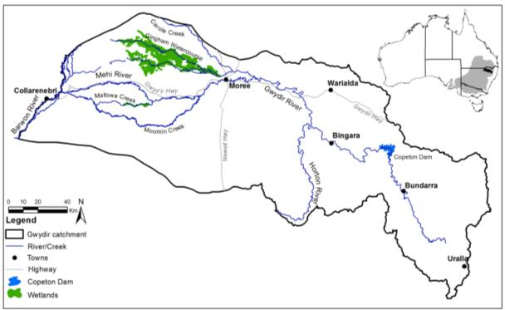

Figure 2.1 Location map of the Gwydir River catchment

The Gwydir experiences a summer-dominated rainfall pattern, driven by thunderstorms and the southward movement of tropical rain depressions from Queensland, which can cause large flooding events. Approximately 60% of the annual rainfall is received between November and March, with 15% falling as winter rain during June and July (McCosker *et al.,* 1999). An east-west gradient in mean annual rainfall exists across the catchment with mean annual rainfall figures or around 500 mm in the west of the catchment increasing to 600mm around Moree and 760mm in the upper catchment to the east (BOM, 2014). Thus river flows to the lower Gwydir (west of Moree) are reliant upon flows from the middle and upper catchments.

## Geomorphology

Upstream of Pallamallawa, the Gwydir is predominantly a gravel bed stream characteristic of the higher relief catchment, which it drains. Downstream of this, the river breaks into a number of distributary channels, which flow out, through a flat landscape. Upstream of Moree the Mehi River breaks from the main Gywdir channel to the south at Terrelaroi weir where it then flows through Moree and on through the south west of the catchment (Figure 2.1). Several other creeks break from the Mehi, namely Moomin Creek and further downstream Mallowa Creek, which contains significant wetland areas. Downstream of Tareelaroi Weir, Carole Creek breaks from the Gwydir to the north. Downstream of the Carole Creek Junction, the Gwydir River flows through what is known as “the Raft” which is a 15km long accumulation of woody debris and silt which largely obscures the main channel and heavily influences inundation patterns in this part of the catchment (DECCW 2011). Around this area the Gingham watercourse splits from the Lower Gwydir River. Both these watercourse take the form of a series of wetlands, waterholes and paleochannels rather than well-defined single channels, and as such support a range of habitats consistent with wetland systems (Pietsch, 2006 in Gawne *et al.,* 2013).

## Hydrology

Like most systems in the Murray-Darling Basin, river flows in the Gwydir River are heavily regulated and have been significantly changed from their natural regime (Sheldon *et al.,* 2000). Copeton Dam, built in 1976 is the major regulating structure in the catchment with a total volume of 1,364,000 ML. However, due to significant tributaries (such as the Horton River) that flow into the Gwydir downstream, Copeton Dam only regulates approximately 55% of inflow to the river. A number of other re-regulatory structures in the lower Gwydir system divert flows into the distributary channels described above, especially to the Mehi River and Carole Creek. In addition, a number of other physical changes including the lowering of channel off-takes, and the building of new channels have occurred, which has impacted the flow regime of the Gwydir system (DECCW 2011). These regulatory structures have decreased the frequency and magnitude of moderate and large flooding events to the wetlands associated with the Lower Gwydir and Gingham watercourses, while the occurrence of low flow conditions has almost doubled (Sheldon *et al.,* 2000). In addition, the amount of water harvested from unregulated flows (off allocation access) has also risen (Wilson *et al.,* 2009).

## Ecology

The Gwydir catchment is best known for its large expanses of wetland vegetation that periodically supports large-scale bird breeding events. Although the spatial extent of wetland and floodplain water dependent vegetation communities has significantly decreased (Bowen and Simpson 2010), the Gwydir Wetlands still support the largest stand of marsh club rush sedgeland in New South Wales (Green and Bennet 1991). Other key vegetation species include, water couch, spike rush, river cooba, lignum, River red gum, coolibah and blackbox. Of the waterbirds that breed in the wetlands, colonial nesting species are prominent. Species that breed in the largest numbers include the eastern great egret, intermediate egret, little egret, nankeen night heron, glossy ibis, Australian white ibis, straw-necked ibis, little pied cormorant and little black cormorant (CSIRO 2007). Some of these species are captured under various international Migratory Bird Agreements, such as the Japan-Australia, China-Australia and the Republic of Korea-Australia Migratory Bird Agreements. In addition to waterbirds, the wetlands and river channels of the Gwydir River system support a range of other native fauna including fish, frogs, turtles, crustaceans, macroinvertebrates and reptiles (Wilson *et al.,* 2009, DECCW 2011).

# The Use of Commonwealth environmental water in 2013-14

A total of 32.335 GL of Commonwealth environmental water was delivered within the Gwydir River system in the 2013-14 water year, which accounted for 3%, 89% and 3% of the total flow down the Mehi, Mallowa, and Carole systems respectively. Compared to the long-term average annual flow, flows down the Gwydir and Gingham channels were less than average, and flows down the Mehi, Mallowa and Carole channels were more than average (Table 3.1). In the Mallowa channel, Commonwealth environmental water made up the bulk of the annual flow (89%). In contrast, Commonwealth environmental water only made up a small fraction (3%) of the total water in the Mehi and Carole Creeks, as measured at the off take to each, with most of the flow within the upstream portions of these channels consisting of delivered irrigation water. Commonwealth environmental water was not delivered down either the Gingham or Gwydir channels, however both channels did receive 5GL of flow from unregulated flows and the Environmental Contingency Allowance (ECA) account operated by NSW Office of Environment and Heritage, in April 2014.

Table 3.1 Comparison between long term average annual flow volume, 2013-14 water year flow volume, and the contribution of Commonwealth environmental water in each channel of the Gwydir River system

|  |  |  |  |  |  |
| --- | --- | --- | --- | --- | --- |
| **Gauging Station (period of record)** | **Average Annual flow (ML)** | **2013/2014 flow (ML)** | **Difference (%)** | **Commonwealth environmental water** | **% 2013/14 flow that is Commonwealth environmental water** |
| 418063 - GWYDIR RIVER (SOUTH ARM) AT D/S TYREEL OFFTAKE REGULATOR (1985-2014) | 70594 | 69508 | -2 | 0 | 0 |
| 418074 - GINGHAM CHANNEL AT TERALBA (1997-2011) | 79429 | 17403 | -78 | 0 | 0 |
| 418044 - MEHI RIVER D/S TAREELAROI REGULATOR (1977 – 2011) | 229379 | 259589 | 13 | 8420 | 3 |
| 418049 - MALLOWA CREEK AT REGULATOR (1986 – 2014) | 7951 | 22418 | 182 | 20000 | 89 |
| 418011 - CAROLE CREEK AT DOWNSTREAM REGULATOR(BELLS CROSSING) (1940 – 2014) | 64554 | 129807 | 101 | 3915 | 3 |

## Mallowa Creek wetlands.

Commonwealth environmental water (20 GL ) was delivered down the Mallowa Creek to provide a third successive year of inundation to the Mallowa Creek wetlands. Commonwealth environmental water was delivered between late September 2013 and early March 2014.

Watering of the Mallowa Creek wetlands in the previous two years stimulated an extensive ecological response, and the watering in 2013-14 aimed to further improve on the viability and resilience of the wetlands communities in this system (OEH 2013). The following outcomes were expected for the use of Commonwealth environmental water in the wider Gwydir wetlands (including Lower Gwydir, Gingham and Mallowa Creek wetlands):

* Maintain permanent and semi-permanent wetlands vegetation condition and reproduction;
* Promote waterbird survival, condition, reproduction and fledgling; and,
* Promote fish movement, nutrient and carbon cycling, and primary production

These outcomes are consistent with the objectives of the Basin Plan’s environmental watering plan (Table 3.2).

Table 3.2 Expected outcomes of environmental water used in the Gwydir wetlands against relevant Basin Plan objectives

|  |  |  |
| --- | --- | --- |
| **Expected outcome** | **Timeframe** | **Relevant Basin Plan objective** |
| Maintain vegetation condition and reproduction | < 1 year | Biodiversity (8.05) |
| Promote waterbird survival, condition and fledgling |
| Promote fish movement, nutrient and carbon cycling, and primary production | < 1 year | Ecosystem function (8.06) |

More specifically, these watering actions were expected to support the ongoing recovery of wetlands and build resilience by contributing to the annual watering requirements of semi-permanent vegetation (e.g. water couch, spike rush, marsh club rush and lignum). Wetland inundation was also thought to aid native wetland species to outcompete invasive species such as lippia (*Phyla canescens*).

## Mehi River and Carole Creek

Targeted in-stream freshes were delivered to both the Mehi River (8.42GL) and Carole Creeks (3.95GL) in late October/ early November 2013. The aim of these flows was to contribute to in-stream freshes and provide a slower, more natural rate of recession to achieve the following outcomes:

* Support fish movement, carbon/nutrient cycling, and primary production processes; and
* Support native aquatic species (including fish, invertebrates) condition and fish larval abundance.

These outcomes are consistent with the objectives of the Basin Plan’s environmental watering plan (Table 3.3).

Table 3.3 Expected outcomes of environmental water delivered to the Mehi River and Carole Creek against relevant Basin Plan objectives.

|  |  |  |
| --- | --- | --- |
| **Expected outcome** | **Timeframe** | **Relevant Basin Plan objective** |
| Support primary production | < 1 year | Ecosystem function (8.06) |
| Nutrient and carbon cycling |
| Fish movement |
| Fish larval abundance | < 1 year | Biodiversity (8.05) |
| Fish condition |

A primary objective of the proposed watering action was to increase the diversity of flows in the Mehi and Carole systems, with these flows contributing to high primary productivity associated with carbon inputs from runoff and inundation of features such as benches and bars. In-stream fresh flows were also hoped to improve connectivity along the river, including to the Barwon Darling, and provide opportunities for native aquatic species to move and disperse. Increased access to food sources and habitat was also though to improve native fish condition.

# Monitoring Indicator – Hydrological connectivity

Hydrological connectivity is a critical component of river systems, which can be measured in four dimensions; longitudinally along the river channels; vertically through groundwater-surface water interactions, or within the channel; laterally between the river channels and their associated floodplains and wetlands; and over time (Ward 1989). The following section characterises the longitudinal connectivity through the Lower Gwydir River provided by Commonwealth environmental water. It also assesses the character of the delivered flows in comparison to the planned flow hydrographs for the two in-channel freshes delivered using Commonwealth environmental water, and then quantifies the floodplain and wetland inundation achieved in the Mallowa Creek wetlands through Commonwealth environmental water.

## Methods

### Longitudinal connectivity

An assessment of the longitudinal connectivity experienced throughout the main effluent channels of the lower Gwydir system was undertaken by identifying a number of flow levels measured at upstream gauging stations that would ensure flow through the length of each channel. The gauging stations used for this analysis are presented in Table 4.1, along with the thresholds estimated to provide longitudinal connectivity. These thresholds were estimated through an analysis of historical flow records (from 1990-2014) whereby corresponding peaks of small flow events were observed at both upstream and downstream gauging sites, suggesting connection throughout the length of the channel. These thresholds were then compared with known average stream losses provided by NSW State Water. Due to recent channel works within the Gingham wetlands along the Gingham watercourse to promote water flow out into the wetlands (D. Albertson pers comm.), an upstream threshold for longitudinal connectivity was not successfully estimated from historical data. Instead, a threshold was identified at the lowermost gauge (418079 – Gingham channel at Gingham Bridge) that corresponded to upstream flows throughout the system, and this was used to define longitudinal connectivity in this system.

Once the thresholds were identified, a SPELL analysis (Gordon *et al.,* 1992) was undertaken to assess the total duration and frequency of flows that provided full longitudinal connectivity along these channels throughout the 2013-14 season.

Table 4.1 Flow gauging stations used in the longitudinal connectivity analysis.

|  |  |  |  |
| --- | --- | --- | --- |
| **Channel** | **Gauging station (upstream or downstream)** | **Gauging station number** | **Threshold for longitudinal connectivity** |
| Gwydir | Gwydir River @ D/S Tyreel offtake regulator (U/S) | 418063 | 40 MLD |
| Gwydir River @ Millewa (D/S) | 418066 |  |
| Mehi | Mehi River @ D/S Tareelaroi Regulator (U/S) | 418044 | 300 MLD |
| Mehi River @ near Collarenebri (D/S) | 418055 |  |
| Carole | Carole Creek @ D/S Regulator (Bells Crossing)(U/S) | 418011 | 40 MLD |
| Carole Creek @ near Garah (D/S) | 418052 |  |
| Gingham | Gingham channel @ Teralba (U/S) | 418074 |  |
| Gingham channel @ Gingham bridge (D/S) | 418079 | 5 MLD |

### Targeted in-channel environmental flow event analysis

To assess the nature of the Commonwealth water delivered down the Mehi River and Carole Creek, a targeted analysis of each in-channel event was undertaken. This was done by comparing the target flow hydrograph with the actual hydrograph at several gauging stations throughout both channels. In the Mehi, the Mehi River @ D/S Combadello Weir (418037) and Mehi River @ near Collarenebri (418055) gauges were compared, and in the Carole, the Carole Creek @ D/S Regulator (Bells Crossing) (418011) and Carole Creek @ near Garah (418052) gauges were used. A number of metrics were calculated to compare the target and actual flow hydrographs at these gauging stations. These included; the rate and duration of the rising and falling limbs of the flow; the magnitude and duration of the flow peak and the total volume of the delivered flows. The actual flow was rated as good if the metric was within 20% of the intended flow.

### Lateral connectivity analysis in the Mallowa Creek wetlands

A remote sensing based approach was undertaken to map the extent and duration of wetland inundation that occurred as a result of Commonwealth environmental water released along the Mallowa system during the 2013-14 water year.

Eight Landsat 8 images were used for the inundation mapping analysis, captured between 30/7/2013 to 11/3/2014 and these were downloaded from <http://earthexplorer.usgs.gov/>. These images covered the duration of Commonwealth environmental water delivery (Figure 4.1). While images captured after March 2014 were considered for analysis, additional inundation related to heavy rainfall that fell in the catchment in April 2014 was evident, and it was felt that these images would have provided an overestimation of inundation as a result of Commonwealth environmental water. Images were preprocessed by merging 8 single bands to one single multispectral band, then performing radio-metric calibration following Chandler *et al.,* (2009) and also image normalization.

7/2/14

5/12/13

2/10/13

30/7/13

11/3/13

6/1/14

3/11/13

15/8/13

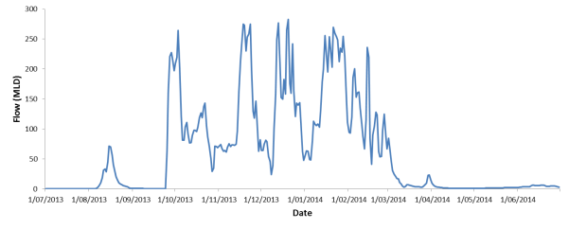

Figure 4.1 Flow entering the Mallowa system measured at the Mallowa Creek Regulator (418049), noting the temporal distribution of Landsat 8 images used for analysis. The green bar represents the period over which Commonwealth environmental water was delivered down Mallowa Creek.

To map the inundation extent within each image, visualization, density slicing and several moisture related indexes were calculated, including the Normalised Difference Water Index (Xu 2006), and Land Surface Water Index (Xio *et al.,* 2004; Huang *et al.,* 2010). In some cases, due to heavy vegetation cover, unsupervised classification was also used, based on the response of vegetation to flooding. These methods have been successfully used to map the inundation extent on Australian floodplains using Landsat satellite imagery (Frazier and Page 2000; Overton 2005; Rayburg and Thoms 2009; Thomas *et al.,* 2010; Shaikh, 2001). Results from these approaches were combined to estimate the inundation extent of each image and provide data on the pattern and extent of inundation over the 2013-14 water year.

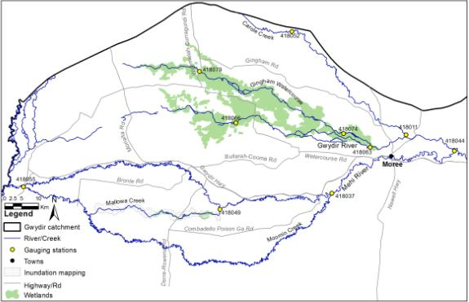

Figure 4.2 Location map showing the gauging stations used in the longitudinal connectivity analysis, and the spatial extent of the lateral connectivity component of the study.

### Sampling regime/locations

Figure 4.2 provides the location of the gauging stations used in the hydrological analysis and the extent of the remote sensing based analysis undertaken in the Mallowa system.

## Results

### Longitudinal connectivity

The degree to which channels in the lower Gwydir were hydrologically connected during the 2013-14 water year ranged from 36.6% in the Gingham Watercourse to 53.2% in the Lower Gwydir River (Table 4.2). However, the nature of hydrological connection varied between sites. The Mehi River experienced several periods of longitudinal connectivity of relatively long duration (81 days average length) throughout the season, reflective of the delivery of environmental water to the Mallowa system and irrigation deliveries earlier in the season (Figure 4.4). However, the Mehi also experienced a relatively long period of low flow or reduced connectivity for 126 days towards the end of the season. By contrast, connection in the Carole channel was more episodic (Figure 4.4), especially towards the beginning of the year, with flows capable to providing connection down the length of the channel occurring during twelve periods of relatively short duration (15 days average). This resulted in

Table 4.2 Variables describing the duration and character of longitudinal connectivity within the channels of the Lower Gwydir River.

|  |  |  |  |  |  |
| --- | --- | --- | --- | --- | --- |
| Channel | Days connected (%) | No of times connected | Av duration of connection events (days) | Longest wet (days) | Longest dry (days) |
| Gwydir | 194 (53.2%) | 7 | 28 | 110 | 82 |
| Mehi | 162 (44.4%) | 2 | 81 | 137 | 126 |
| Carole | 187 (51.2%) | 12 | 15 | 122 | 56 |
| Gingham | 132 (36.6%) | 4 | 33 | 117 | 153 |

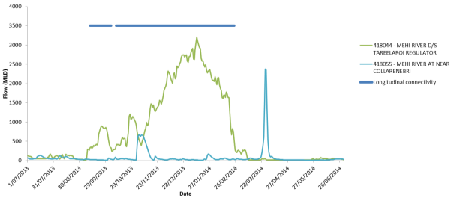

Commonwealth environmental water

Figure 4.3 Stream flows down the Mehi River measured at the upstream (green) and downstream (light blue) gauges. Periods of longitudinal connectivity are denoted by the dark blue line. The arrow shows the peak provided by Commonwealth environmental water delivery.

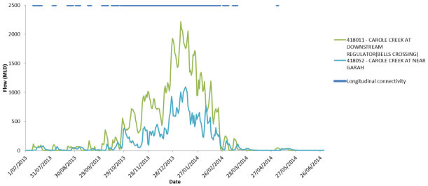

Commonwealth environmental water

Figure 4.4 Stream flows down the Carole creek measured at the upstream (green) and downstream (light blue) gauges. Periods of longitudinal connectivity denoted by the dark blue line. The arrow shows the peak provided by Commonwealth environmental water delivery.

Carole Creek experiencing the shortest periods of no connection with the longest dry period being 56 days. The in-channel freshes released by the Commonwealth down both the Mehi River and Carole Creek did not appear to increase hydrological connection to any great degree, compared to irrigation deliveries. This is not to downplay their importance for providing an additional in channel flow peak in these systems.

The Gingham Watercourse experienced the least connection of all channels (36.6%) and this lead to a period of 153 days of limited connectivity during the middle of the season from late October 2013 to late March 2014 (Figure 4.5). This result is most likely a result of recent channel works that have been undertaken to encourage the lateral movement of water into fringing wetlands, reducing longitudinal connections along this channel. By contrast, the Lower Gwydir River channel had flows sufficient to maintain connection through the channelised section of this channel (to at least Millewa) for the majority of the summer (Figure 4.6).

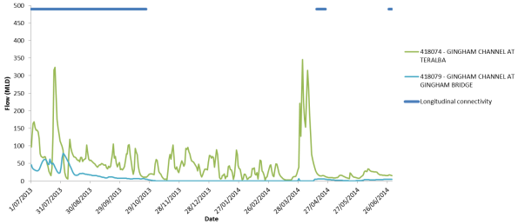

Figure 4.5 Stream flows down the Gingham Watercourse measured at the upstream (green) and downstream (light blue) gauges. Periods of longitudinal connectivity are denoted by the dark blue line.

### Targeted in-channel environmental flow event analysis

Similar trends were seen in both the Mehi and Carole channels when the delivered in-channel flow events were compared with the ‘target’ flow hydrographs. In both channels, the total event volumes were substantially larger at the upstream gauges than the target flow volume (Table 4.3, 4.4). However, total event volumes were within 20% of target at the downstream gauges in both channels.

Within the Mehi River, the flows at both gauges were within 20% of target for the rising limb of the flow, and while the peak was a similar magnitude at the upstream Tareelaroi gauge, the duration of the peak flow was over twice the targeted duration at both gauges (Figure 4.7). In terms of the falling limb, both gauges were within 20% of target for the rate of change. However, the duration of the falling limb was 5 days shorter than target at the upstream gauge before flows increased substantially. This appears to be a result of irrigation orders ‘overtaking’ the Commonwealth environmental water flow event (Figure 4.7). The duration of the falling limb was within 20% of target further downstream.

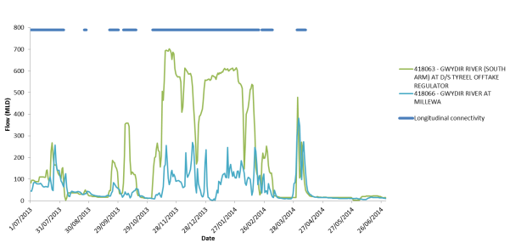

Figure 4.6 Stream flows down the Gwydir river measured at the upstream (green) and downstream (light blue) gauges. Periods of longitudinal connectivity are denoted by the dark blue line.

Table 4.3 Comparison of target and actual flow hydrographs for the in-channel Commonwealth environmental flow released down the Mehi River during the 2013-14 water year. Green indicators result in within 20% of target, red indicates result is >20% target.



Within Carole Creek, the rising limb at the upstream gauge was steeper than the target, although the magnitude and duration of the flow peak was within 20% of target (, ). The falling limb at the upstream gauge was significantly shorter than the target being only 3 days before irrigation flows again overtook the targeted flow and flow levels increased. The actual flow hydrograph was more successful at the downstream gauge near Garah, with the duration of the rising limb, peak and falling limbs being within 20% of target. At this gauge the magnitude of the peak was less than target (350MLD opposed to 500MLD), as was the rate of the falling limb.

Table 4.4 Comparison of target and actual flow hydrographs for the in-channel Commonwealth environmental flow released down Carole Creek during the 2013-14 water year. Green indicators result in within 20% of target, red indicates result is >20% target.



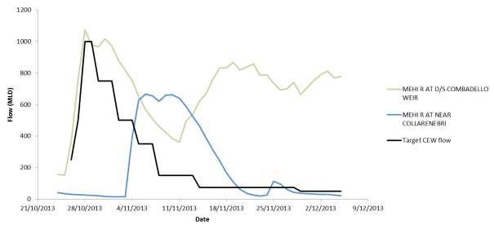

Figure 4.7 Upstream (green) and downstream (blue) flow hydrographs compared to the target hydrograph for the Commonwealth in-channel environmental flow delivered within the Mehi River channel.

### Lateral connectivity analysis in the Mallowa Creek wetlands

Analysis on Landsat imagery suggests that a maximum of 2,011 ha of floodplain was inundated along the Mallowa Creek system by Commonwealth environmental water during 2013-14. Around 711 ha ware assessed as being inundated at the beginning of the season in July, reflecting the previous year’s watering. Total inundation areas increased steadily throughout the season (Figure 4.9) to the maximum level (2,011 ha) recorded in the 11 March 2014 image. The total inundated areas of floodplain and associated wetlands did increase after this time to an area of approximately 4,000 ha, however this was boosted by significant rainfall (300 mm) towards the end of March 2014, hence is not an accurate reflection of the influence of Commonwealth environmental water only.

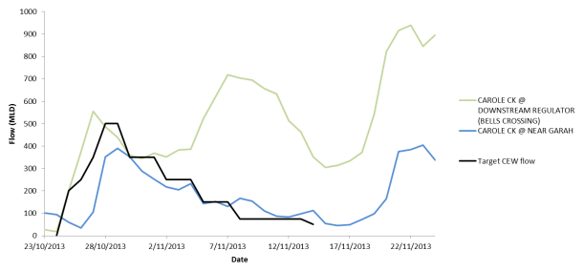

Figure 4.8 Upstream (green) and downstream (blue) flow hydrographs compared to the target hydrograph for the Commonwealth in-channel environmental flow delivered within Carole Creek channel.

The spatial distribution of inundation changed throughout the water year in the Mallowa Creek wetlands (Figure 4.10). During July and August, there was still water present towards the western end of the wetlands, and little water in the upstream (eastern) end of the creek. From October, the influence of the Commonwealth environmental releases could be seen in the upstream end of the creek, with inundation increasing along the creek channel. From December onwards, flows began to increase inundation the western area of the wetlands, reaching a maximum in the March image.

Over the June 2013 – March 2014 period in the Mallowa Creek wetlands, Commonwealth environmental water inundated a total of 1,545 ha of Coolibah-River Cooba-Lignum Association vegetation class as defined by Bowen and Simpson (2010). The next highest area inundated was that of Cultivated land (1,288ha) followed by Coolibah woodlands (337 ha), Coolibah-cultivated (180 ha) and 87 ha of native grasslands. In addition, smaller areas (20-25 ha) of River Cooba-Lignum and Myall-Rosewood Associations were inundated throughout the 2013-14 season.

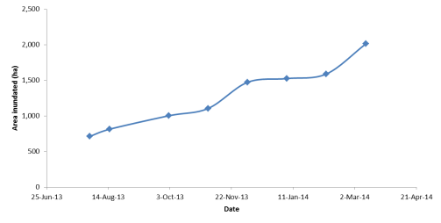

Figure 4.9 Extent of floodplain inundation in the Mallowa Creek wetlands during the 2013-14 water year.

## Outcomes

Longitudinal connectivity was achieved throughout the lower Gwydir channels between 36 and 53% of the time. This was greatest in the Gwydir and least in the Gingham channel. The nature of water delivery down the Mehi and Carole channels influenced the nature of connections with the Mehi experiencing fewer longer flow connections and the Carole a higher number of shorter flow events. In-channel releases of Commonwealth environmental water appeared to do little to influence the duration of longitudinal connectivity in the system given the high proportion of irrigation water delivered down the Mehi and Carole channels during 2013-14.

The delivery of environmental water appeared to mimic the target flow hydrographs more successfully at gauges towards the end of each channel. The duration of the falling limb of the flows at upstream gauges was significantly shortened due to irrigation demand increasing flows shortly after the Commonwealth environmental water flow peaks. Given the importance of a steady recession of relatively long duration for the ecology of the stream, these increased flow levels soon after the environmental flows may have hampered their effectiveness at achieving the desired outcomes in the upstream sections of these channels.

Commonwealth environmental water released down the Mallowa system contributed to at least 2,011 ha of inundation through the season. The full extent of inundation with the addition of rainfall later in the season was likely to be around 4,000ha. The inundation extent calculated in this report is less than similar inundation modelling carried out by NSW OEH, which estimated around 3,600 ha of inundation in the Mehi/Mallow system during 2013-14 (R. Thomas presentation, Gwydir Wetlands Conference, 6th May 2014 Moree). However, this larger area also included wetland inundation along the Mehi River and off-river irrigation while the current analysis was restricted to the free flowing areas of the Mallowa Creek wetlands. Nevertheless, it appears that Commonwealth environmental water contributed to considerably more wetland inundation than the previous water year (approx. 1,600 ha of inundated wetland; Humphries and Albertson 2013) with a significant proportion of this consisting of target wetland vegetation communities such as Coolibah-River Cooba-Lignum associations and Coolibah woodlands.

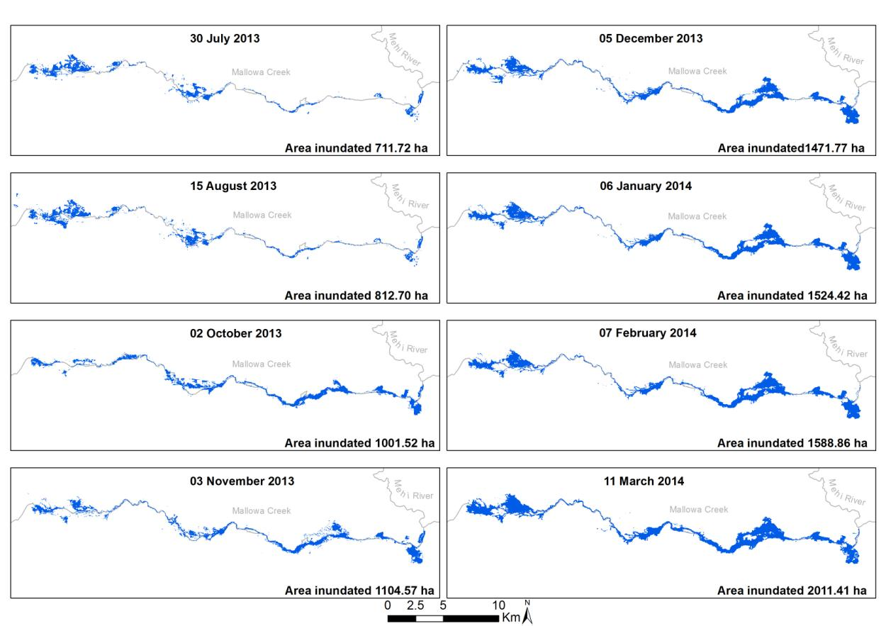

Figure 4.10 The progression of inundated area in the Mallowa Creek wetlands measured from 30 July 2013 – 11 March 2014.

# Monitoring Indicator – Fish, turtles and Macro-crustaceans

The Lower Gwydir system is home to at least eight species of native freshwater fishes, some of strong angling interest, some rare or endangered, and three exotic species (Wilson *et al.,* 2009). It also contains significant populations of riparian reptile species such as turtles and red-bellied black snakes. Given the direct outcomes of Commonwealth environmental water linked to support native aquatic species (including fish, invertebrates) condition and fish larval abundance, this chapter details the results of the monitoring of fish, turtles and macro-crustaceans for the 2013-14 water year, and assesses the relative benefits of Commonwealth environmental water to these communities.

## Methods

Fish were sampled on five occasions throughout the project – November and December 2013, and March, April, and June in 2014 – from multiple sites in each of the Mehi River, Lower Gwydir River, Gingham Watercourse and Carole Creek (Figure 5.1, 5.2, Table 5.1). At each site, two fykes (one large and one small) were set facing upstream and two facing downstream, following the established protocol of Wilson *et al.* (2009). The small nets were constructed from 2 mm mesh with a 0.4 m diameter body and 1.5 m wings, while the large nets were constructed from 12 mm mesh with a 1.1 m diameter body and 7 m wings.

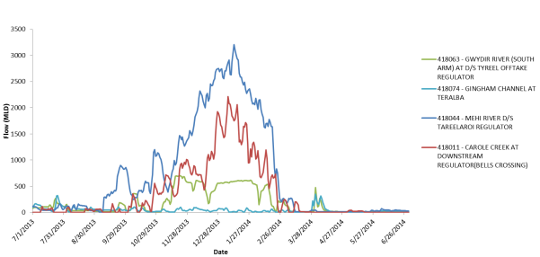

Nov

Dec

Mar

Apr

June

Figure 5.1 Hydrographs for the upstream gauging stations in each study channel. Arrows indicate the timing of fish sampling throughout the 2013-14 water year.

Table 5.1 Channel sampling sites in the lower Gwydir catchment monitored during the 2013-14 water year.

|  |  |  |  |  |
| --- | --- | --- | --- | --- |
| **Channel** | **Site Name** | **Site Code** | **Latitude** | **Longitude** |
| Mehi River | “Chinook” | CHI | -29.475213 | 149.977375 |
| Sollings Stock reserve | SOL | -29.466958 | 149.913418 |
| D/S Combadello Weir | COM | -29.560298 | 149.648523 |
| Hickey Bridge | HIC | -29.568188 | 149.406003 |
| “Derra” | DER | -29.52736 | 149.267257 |
| Lower Gwydir River | Brageen Crossing | BRA | -29.396992 | 149.543054 |
| “Allambie” | ALL | -29.343083 | 149.425286 |
| “Birrah” | BIR | -29.361078 | 149.35554 |
| Gingham Watercourse | “Willowlee” | WIL | -29.367893 | 149.638974 |
| “Goddard's Lease” | GOD | -29.257563 | 149.373879 |
| Gingham Waterhole | GIN | -29.243339 | 149.303452 |
| “Boyanga” Waterhole | BOY | -29.209429 | 149.238157 |
| Carole Creek | “Laurella” | LAU | -29.373175 | 149.808306 |
| “Windmill” | WIN | -29.218461 | 149.662016 |
| Garah | GAR | -29.124818 | 149.552981 |

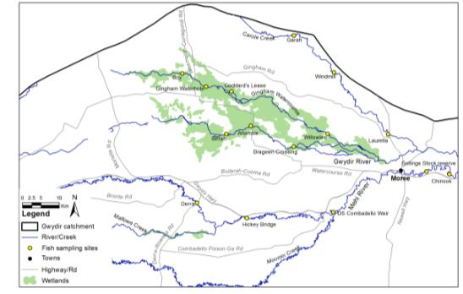

Figure 5.2 Location of the 15 in-channel monitoring sites monitored during 2013-14.

Fish were sampled at 15 sites across the study area. Three sites were sampled in each of the Carole Creek, Lower Gwydir River and Gingham Watercourse, while five sites were sampled in the Mehi River – three downstream of Combadello Weir and two upstream of the weir (Table 5.1; Figure 5.2). The two sites at “Chinook” and Sollings Lane upstream of Combadello Weir were sampled at the request of NSW OEH to provide data on the potential influence of environmental water for fish in this part of the Mehi channel.

Nets were set in the late afternoon and retrieved the following morning. Data were recorded of the timing of net set and pick-up and wing-width in order to allow calculation of standardized ‘catch-per-unit-effort’ abundance estimates. All fish and turtles were identified and counted, and the standard length (mm) of a sample of up to 100 individuals per site was recorded. Where samples exceeded this size, the total count and proportion of measured fish in each size-class was used to estimate the total sample size-structure. Macrocrustaceans (shrimp and yabbies) were identified, counted and then returned to the water.

During the November and December sampling periods, nets were set in “Boyanga” Waterhole in the lower Gingham Watercourse. However, due to low flows and rainfall over the Christmas period, this site dried out in early 2014 and subsequent sampling of a downstream site in this channel was shifted to the Gingham Waterhole. This site is a larger, more permanent waterhole and held water throughout the remainder of the project. The “Birrah” site in the Lower Gwydir River was not sampled during April 2014 sampling due to restricted access following local rainfall.

Otolith samples were collected to obtain daily age estimates for juveniles of dominant species from the study channels. While the original focus of this was the native spangled perch (*Leiopotherapon unicolor*), low catches of individuals of a size suitable for otolith analysis led to bony bream (*Nematolosa erebi*) and European carp (*Cyprinus carpio*) specimens also being retained for this purpose. Specimens for otolith analysis were collected in November, December, March and April, and returned frozen to the laboratory where weight (0.001 g) and standard length (0.1 mm) data were recorded for each fish. Specimens were then sent to Fish Aging Services Pty Ltd in Victoria for otolith extraction, preparation and aging. This was done using standard aging techniques (Robbins and Choat 2002). Age data were used to back-calculate spawning-dates to estimate the influence of discrete Commonwealth watering events on spawning activity and recruitment.

Variation in assemblage structure was examined over time (between months) and space (between channels) using non-metric multidimensional scaling analysis. The extent of any significant differences among month or channel groups was assessed using a two-way crossed Analysis of Similarities. Both analyses were undertaken using Primer 6 software.

## Results

### Fish – assemblage structure

A total of 3,512 fish from 13 fish species were sampled across the five field trips (). Of these, three species and 424 fish (12.07 %) were exotic (goldfish, European carp, mosquito fish), although this contribution to the fish fauna varied between the three watercourses (Mehi River, 4.4%; Carole Creek, 8.9%; Gingham Watercourse, 16.6%; Lower Gwydir River, 21.8 %). Carole Creek (10) and Mehi River (9) contained more native species than either the Gingham Watercourse or Lower Gwydir River (8). Mosquito fish were absent from both the Lower Gwydir and Mehi rivers, but goldfish and carp were detected in each channel. Bony bream was the most prevalent species overall (43.2 %), followed by carp gudgeon (16.0 %) and Australian smelt (14.3 %). Un-specked hardyhead was the least abundant species, encountered at only two sites (“Willowlee”, DS Combadello Weir) and contributing only 0.1% to the overall fish abundance.

Similar to previous findings (e.g. Wilson *et al.*, 2009), species dominance varied between the channels. Assemblages in the Gingham Watercourse were dominated numerically by carp gudgeons (33.7 %) and bony bream (23.6 %), by just bony bream in both the Lower Gwydir River (68.1 %) and Carole Creek (53.9 %), and by both bony bream (41.6 %) and Australian smelt (31.9 %) in the Mehi River. Together, these and the next most abundant native species (spangled perch) accounted for 80.0 % of all fish sampled across the four channels and five sampling events. Only bony bream and spangled perch were encountered at all sites across the four channels at some point during the study. Olive perchlet was detected at “Boyanga” Waterhole in November and December sampling prior to the site drying up in January. A single individual was also detected in Gingham Waterhole in March but not in April or June.

Non-metric multidimensional scaling ordination suggested no overall differences in assemblage structure over time (between months) or space (between channels) (Figure 5.3). The two-way crossed Analysis of Similarities (Table 5.3) detected a Global R of 0.089 (p = 0.054) for comparison between months and 0.087 (p = 0.092) for comparison between channels. Similarly, no significant differences at p⩽0.05 were evident in any monthly or channel pair-wise comparisons.

Table 5.2 Total raw abundances of fish, macrocrustacea and turtles from lower Gwydir watercourses, November 2013 to June 2014. Percentage values for fish indicate the contribution of a species to the total catch from a watercourse or all sites pooled. Note that BOY was only sampled in November and December, that GIN was only sampled in March to June, and that BIR was not sampled in April.

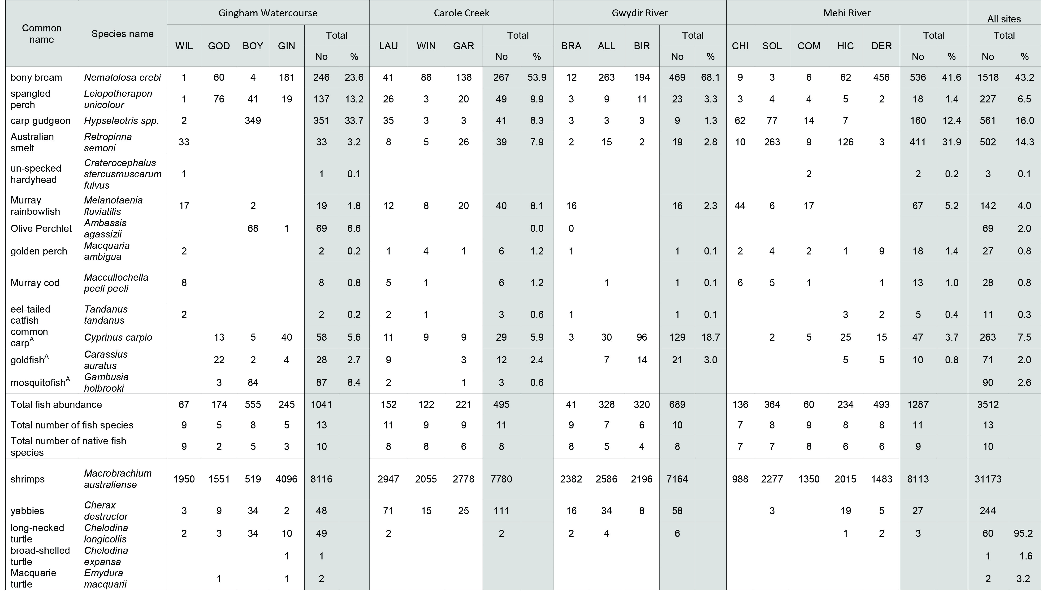

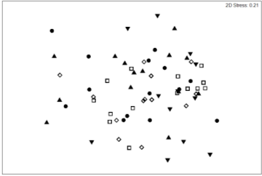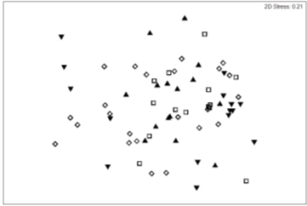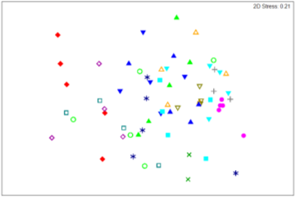

B)

C)

A)

Figure 5.3 Non-metric multidimensional scaling ordination of variation in fish assemblage structure in the four lower Gwydir channels, November 2013 to June 2014. Data are coded by Data are coded by (A) month: ▲ November, ▼ December, □ March, ◇ April, ⚫ June; (B) channel: ▲ Carole Creek, ▼ Gingham Watercourse, □ Lower Gwydir River, ◇ Mehi River; and (C) site: ▲ “Laurella”, ▼”Windmill”, ■ Garah, ◆ “Willowlee”, ⚫ Goddard’s Lease, 🞤 Gingham Waterhole, 🞬 “Boyanga”, 🞶 Brageen Crossing, △ “Allambie”, ▽ “Birrah”, □ “Chinook”, ◇ Sollings Stock Reserve, ⭘ DS Combadello Weir, ▲ Hickey Bridge, ▼ “Derra”.

Table 5.3 Two-way crossed Analysis of Similarities (ANOSIM) of temporal (monthly) and spatial (channel) differences in assemblage structure across the four lower Gwydir channels, November 2013 to June 2014. Significance was judged at p⩽0.05.

|  |  |  |  |  |  |  |
| --- | --- | --- | --- | --- | --- | --- |
| **Pairwise tests** | **R** | **Significance level** |  | **Pairwise tests** | **R** | **Significance level** |
| November, December  November, March  November, April  November, June  December, March  December, April  December, June  March, April  March, June  April, June | 0.014  0.148  0.080  -0.044  0.197  0.121  0.162  -0.102  0.157  0.185 | 0.354  0.102  0.233  0.625  0.072  0.171  0.118  0.788  0.104  0.084 |  | Carole, Gingham  Carole, Lower Gwydir  Carole, Mehi  Gingham, Lower Gwydir  Gingham, Mehi  Lower Gwydir, Mehi | 0.041  0.143  0.067  -0.075  0.159  0.181 | 0.350  0.190  0.239  0.744  0.062  0.053 |

### Fish – size-structure

***Carp gudgeon.*** This species was in generally low abundance throughout the study period, apart from in the Mehi River, and there was only limited evidence of a cohort structure or recent recruitment (). A cohort of 20 to 30 mm SL fish was present in Carole Creek in March, although was absent in April and June samples. A stronger cohort of similarly-sized fish was also present in November and March to June in the Mehi River.

***Spangled perch.*** Some cohort structure and progression was evident in this species in each of the study channels at some point during the study (). In the Gingham Watercourse, 2 to 3 cohorts were evident in November and the large of these appeared to be present in the population in April but absent by June. A cohort of smaller fish was also present in March but absent in the following month. A similar pattern was evident in the Lower Gwydir River. In both Carole Creek and the Mehi River, a cohort of 50 to 60 mm SL was present in April and June, while larger fish in Carole Creek (April, June) and the Mehi River (June) suggested spawning activity earlier in this season.

***Bony bream.*** At least one or two cohorts were present in each channel across the sampling period (). In the Gingham Watercourse, a single cohort was present in November and persisted until April, and a second cohort of new recruits was present in December to April. In June, only this second cohort was still evident in the population. The Lower Gwydir River population appeared to be dominated by a single cohort in November and

Gingham Watercourse Lower Gwydir River Carole Creek Mehi River

Nov

Dec

March

April

June

0 10 20 30 40 45

**No. of fish**

0 10 20 30 40 45 0 10 20 30 40 45 0 10 20 30 40 45

**Standard length (mm)**

Figure 5.4 Carp gudgeon, *Hypseleotris species*. Variation in size-structure among the four lower Gwydir study channels, November 2013 to June 2014.

Gingham Watercourse Lower Gwydir River Carole Creek Mehi River

**No. of fish**

Nov

Dec

March

April

June

0 50 100 150 200

0 50 100 150 200

0 50 100 150 200 0 50 100 150 200

**Standard length (mm)**

Figure 5.5 Spangled perch, *Leiopotherapon unicolor*. Variation in size-structure among the four lower Gwydir study channels, November 2013 to June 2014.

Gingham Watercourse Lower Gwydir River Carole Creek Mehi River

Nov

Dec

March

April

June

**No. of fish**

0 100 200 300 0 100 200 300 0 100 200 300 0 100 200 300

**Standard length (mm)**

Figure 5.6 Bony bream, *Nematolosa erebi*. Variation in size-structure among the four lower Gwydir study channels, November 2013 to June 2014.

December, with a weak cohort of larger fish also present in November through to March. In March and June, one or more cohorts of fish of < 100 mm SL were also present. In Carole Creek, a cohort of approximately 100 mm SL in November was still evident through to June, while another cohort of modal size of approximately 100 mm SL in March was still evident in June. A cohort of modal size approximately 80 mm SL was also present in June. In the Mehi River, three to four cohorts were evident in November, with some evidence of cohort progression from November through to June. An additional cohort of 40 mm SL modal size in December was also apparent through to June.

***Carp.*** This species was in general low abundance across all channels throughout the season, with the exception of Lower Gwydir River in December (). There was only limited evidence of recent recruitment throughout the study period, apart from Gingham Watercourse in April, Lower Gwydir River in December, Carole Creek in November and Mehi River in November and December.

***Australian smelt.*** Smelt largely reflected a bimodal size structure in each of the channels (), although this was less clear in the Lower River. In the Gingham Watercourse, a cohort of large fish was evident in November, but absent from the population thereafter. A second cohort of 24-25 mm SL modal size was also present in November, and appeared to be retained in the population through to until at least June. A near-identical pattern was evident in Carole Creek and the Mehi River across the study period. A single cohort of large fish was also present in the Lower Gwydir River in June.

***Olive perchlet.*** Olive perchlet were only detected in significant numbers in “Boyanga” Waterhole in November and December, prior to the site drying out. In November, 2 or 3 cohorts were evident in the size-structure, comprising a cohort of recruits between 15 and 20 mm SL and 1 or 2 cohorts of larger fish > 30 mm SL (). In December, these larger fish were in far lower abundance, without a clear cohort structure. However, the smaller November fish were still apparent as a cohort of 20-21 mm SL modal size while an additional cohort of smaller fish (14 –16 mm SL modal size) appeared to represent spawning subsequent to that of the small November fish.

### Fish – spawning-timing

Daily otolith age data allowed estimates of spawning activity in species for which significant samples of juveniles were obtainable.

***Bony bream.*** Juveniles were retained for ageing from the Mehi River at “Derra” in March (56 fish) and the Lower Gwydir River at “Allambie” in April (18 fish). Sagittal sections of the sagittal otoliths from this species contained a clear increment structure (A) and provided reliable age data. At “Derra”, hatch dates appeared to commence immediately

Gingham Watercourse Lower Gwydir River Carole Creek Mehi River

Nov

Dec

March

April

June

**No. of fish**

0 200 400 600 0 200 400 600 0 200 400 600 0 200 400 600

**Standard length (mm)**

Figure 5.7 European carp, *Cyprinus carpio*. Variation in size-structure among the four lower Gwydir study channels, November 2013 to June 2014.

Gingham Watercourse Lower Gwydir River Carole Creek Mehi River

Nov

Dec

March

April

June

**No. of fish**

0 10 20 30 40 50 60- 70 0 10 20 30 40 50 60- 70 0 10 20 30 40 50 60- 70 0 10 20 30 40 50 60- 70

**Standard length (mm)**

Figure 5.8 Australian smelt, *Retropinna semoni*. Variation in size-structure among the four lower Gwydir study channels, November 2013 to June 2014.

November

December

**No. of fish**

0 5 10 15 20 25 30 35 40 45

**Standard length (mm)**

Figure 5.9 Olive perchlet, *Ambassis agassizii*. Variation in size-structure in “Boyanga” Waterhole, November and December 2013.

prior to the Commonwealth environmental water (A) but were particularly concentrated over the subsequent month or so of relatively low-flow conditions. However, at “Allambie”, the link between bony bream spawning and discrete flow events was less clear (B). Hatch dates appeared to coincide with a period of declining flow levels throughout February and March, although peaked at the timing of a brief late-February flow pulse.

***Spangled perch.*** Juveniles were retained for ageing from the Gingham Watercourse at “Boyanga” Waterhole in November (22 fish) and “Goddard’s Lease” in December (23 fish), and from Carole Creek at “Laurella” in March (16 fish). Transverse sections of the sagittal otoliths from this species also contained a clear increment structure (B) and provided reliable age data. Spawning in both channels appeared to coincide with the onset of flows. In Carole Creek, the data suggested that spawning activity commenced in response to flow pulse events above 500 ML.d-1, which first occurred in October (2A). Interestingly, no further spawning activity was detected in relation to the late-February flow pulse. In the Gingham Watercourse at “Goddard’s Lease”, all fish aged from the December sampling originated from mid-2013 spawning activity. This appeared to have coincided with a flow event from late-June through to mid-August (B).

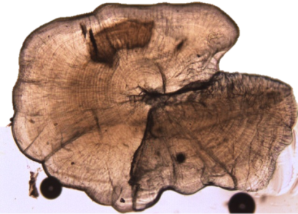

(A)

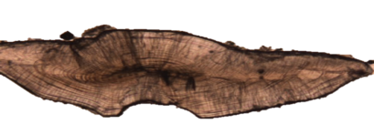

(B)

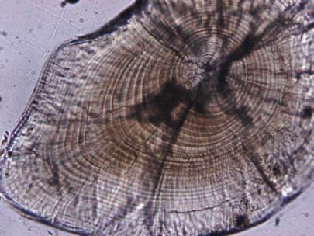

(C)

Figure 5.10 Typical otolith microstructure in (A) bony bream, (B) spangled perch, and (C) European carp, showing the increment microstructure used to derive daily age and hatch-date estimates.

**(A) (B)**

**Discharge (ML.d-1) No. of Fish**

Oct Nov Dec Jan Feb Mar Oct Nov Dec Jan Feb Mar

2013 2014 2013 2014

**Estimated hatch date**

Figure 5.11 Bony bream, *Nematolosa erebi*. Comparison of hatch-date frequency distribution and channel hydrology (A) in the Mehi River at “Derra” and (B) in the Lower Gwydir River at “Allambie”, October 2013 to March 2014. Flow data were obtained from the Mehi River U/S Ballin Boora Creek gauge (418068) for “Derra” and from the Gwydir River at Millewa gauge (418066) for “Allambie”. The arrow in (A) indicates the timing of Commonwealth environmental watering.

***Carp.*** Juveniles were retained for ageing from the Mehi River at DS Combadello Weir and “Derra” in November (5 fish), from Carole Creek at “Laurella” in November (10 fish), and from the Lower Gwydir River at “Birrah” in December (62 fish). Lapillar otoliths from this species also contained a clear increment structure (C) and provided reliable age data. Carp spawning activity reflected a consistent pattern in all three channels in which recruits were sampled. In all cases, spawning appeared to have commenced in response to the first significant flow event in the channel for the September to November period ().

**(A) (B)**

**Discharge (ML.d-1) No. of Fish**

Oct Nov Dec Jan Feb May June July Aug

2013 2014 2013

**Estimated hatch date**

Figure 5.12 Spangled perch, *Leiopotherapon unicolor.* Comparison of hatch-date distribution and channel hydrology in (A) Carole Creek at “Laurella” from October 2013 to February 2014 and (B) in the Gingham Watercourse at (B) “Goddard’s Lease” in mid 2013. Flow data were obtained from the Carole Creek at the Downstream Regulator (Bells Crossing) gauge (418011) for “Laurella”, from the Gingham Watercourse at the Tillaloo Bridge gauge (418076) for “Goddard’s Lease”. The arrow in (A) indicates the timing of Commonwealth environmental watering.

### Macro-crustaceans

***Macrobrachium australiense***. A total of 31,173 shrimps were recorded from all sites during the 2013-14 water year. The largest catch was at Gingham Waterhole in March (3,585 individuals) and the smallest catch at “Chinook” on the Mehi in December (24 individuals). When standardized abundances are compared some differences were evident between sites and times (Figure 5.14), though these were inconsistent either through time or in a downstream direction along each channel. Statistically, there were no significant differences between channels (ANOVA, log10 transformed data, p=0.123), although there were significant differences between times (f=5.007, d.f. 4,1, p<0.005) with abundances in March being significantly higher than in December and June (Figure 5.15). This result was primarily driven by high catches in both Gingham Waterhole and at “Laurella” in the Mehi River during March. No interaction was evident between sampling time and channel (p=165).

**(A) (B) (C)**

**Discharge (ML.d-1) No. of Fish**

**`**

Sep Oct Nov Dec Sep Oct Nov Dec Sep Oct Nov Dec

2013 2013 2013

**Estimated hatch date**

Figure 5.13 European carp, *Cyprinus carpio.* Comparison of hatch-date distribution and channel hydrology (A) in the Carole Creek at “Laurella” from September to November 2013, (B) in the Mehi River at DS Combadello Weir and “Derra” from September to November, and (C) in the Lower Gwydir River at “Birrah” from October to December 2013. Flow data were obtained from the Carole Creek at the Downstream Regulator (Bells Crossing) gauge (418011) for “Laurella”, from the Mehi River at the DS Combadello Weir gauge (418037) for the DS Combadello Weir and “Derra” sites, and from the Lower Gwydir River at Millewa gauge (418066) for “Birrah”. The arrow in (A) and (B) indicates the timing of Commonwealth environmental watering.

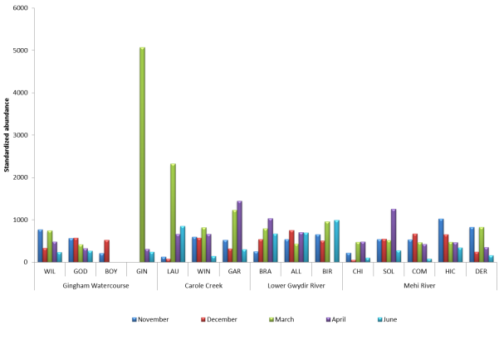

Figure 5.14 Standardized abundances of freshwater shrimps captured during the 2013-14 water year.

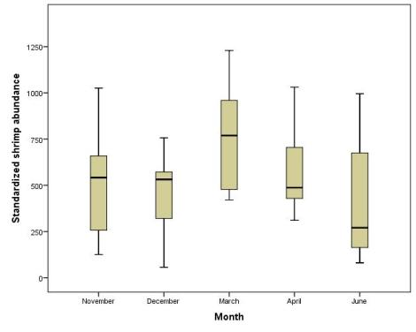

Figure 5.15 Variation in the abundance of freshwater shrimps between sampling times during the 2013-14 water year.

a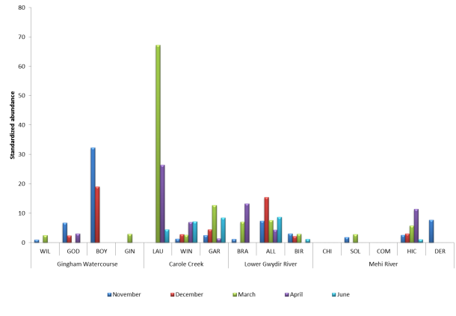

Figure 5.16 Standardized abundances of freshwater yabbies’ captured during the 2013-14 water year.

***Cherax destructor***. A total of 244 freshwater yabbies (*Cherax destructor*) were caught throughout the study with catches ranging from none up to 42 individuals caught at “Laurella” in the Carole Creek during March. There was high variability in the standardized abundances, with no consistent trends evident at individual sites through time or along any of the channels (Figure 5.16). However, significant differences were observed between channels (ANOVA; log10 transformed data, f=6.801, d.f.4,1, p<0.005), with Carole Creek and the Lower Gywdir River having significantly higher abundances than the Gingham Watercourse or Mehi River (Figure 5.17). No significant differences were observed in yabby abundance between sampling times (p=0.308) and there was no significant interaction between channel and sampling time.

### Turtles

Sixty three freshwater turtles from three species (*Chelodina longicollis, Emydura macquarii, Chelodina expansa*) were collected during the 2013-14 water year, with the vast majority (82%) being found in the Gingham Watercourse, predominantly at “Boyanga” and Gingham waterholes (Table 5.2). The common long necked turtle (*C.longicollis*) constituted 92% of the total population of turtles collected, with the *E.macquarii* and *C.expansa* only making up a very small proportion of the catch at 6.4% and 1.6% respectively. The vast majority of turtles caught in the study were adult animals, with only one *C.longicollis* recorded under 140mm (Figure 5.18).

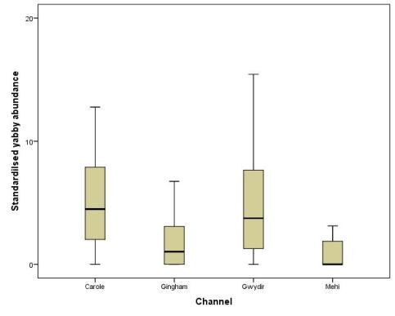

Figure 5.17 Abundance of freshwater yabbies observed in the four study channels monitored during the 2013-14 water year.

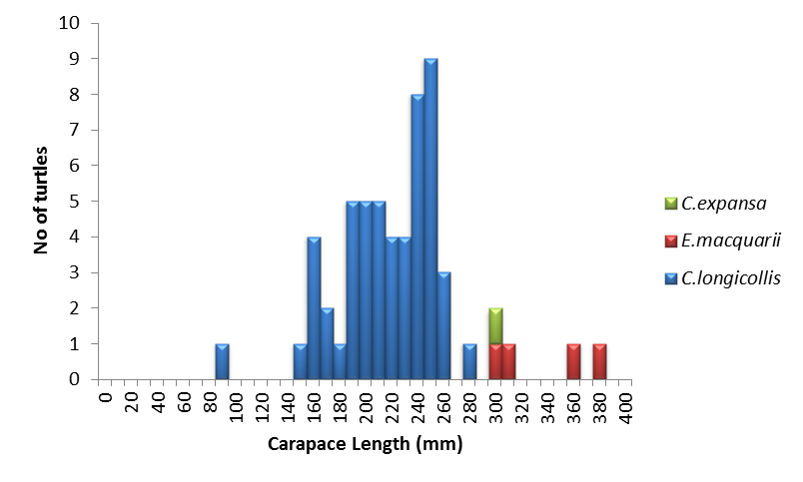

Figure 5.18 Size distribution for turtles caught in the study across all channels and sampling times.

## Outcomes

The lower Gwydir channels contain a diverse assemblage of native fish species, with silver perch (*Bidyanus bidyanus*) the only species from the region not encountered during 2013-14. In contrast, olive perchlet, detected at “Boyanga” and Gingham Waterholes during 2013-14, was absent from three years of previous fish sampling at largely identical sites (including “Boyanga” Waterhole; Wilson *et al.*, 2009). Overall, there was no evidence that Commonwealth environmental water or other flow events had a significant influence on fish assemblage structure during 2013-14. This may reflect a number of factors. First, the height characteristics of the 2013-14 flow regime may have been insufficient to detect assemblage shifts easily under the typical levels of lower Gwydir fish species diversity. In contrast, Wilson (in prep) detected a clear series of shifts in assemblage structure at the present sites from September 2011 to June 2012, albeit with an earlier commencement of sampling in the recruitment season and two near-record flood pulses. Second, the 2013-14 flow regime was punctuated by frequent releases with only limited low-flow periods in between (e.g. see Figure 5.11 for the Lower Gwydir and Mehi river hydrographs). Separating the relative influence of these two factors is difficult, although it seems likely that allowing periods of low-flow following an environmental release would promote the local retention and/or survivorship of larvae or juveniles.

In contrast, population-level data within dominant species did reveal flow-related responses to flow events, including the October-November Commonwealth environmental water. Spawning by bony bream in the Mehi River appeared to occur immediately after the Commonwealth environmental water in that channel, albeit for about a six-week interval. The response of spangled perch was not as clear-cut but the majority of spawning did occur in response to Commonwealth environmental water in Carole Creek. However, spangled perch spawned for approximately two months after the Commonwealth environmental water event in Carole Creek. This may suggest Commonwealth environmental water was of an insufficient height to trigger spawning in this species. European carp did spawn in late October but this was prior to the delivery of Commonwealth environmental water. It is plausible that this response was related to a small flow pulse in the Carole Creek prior to the Commonwealth environmental water. This prior event would have been responsible for initiation of final gonad maturation and/or adult migration in readiness for spawning, rather than relating directly to the Commonwealth environmental water itself.

Both otolith and size-structure data also indicated that native species in the region can spawn at a far earlier point in the season than the timing of the Commonwealth environmental water event in late October. For example, spangled perch spawning in the Gingham Watercourse occurred in response to a series of June to August flow rises (Figure 5.12B) and the size-structure for Australian smelt in each channel showed evidence of spawning several months prior to the initial November sampling (Figure 5.8). An earlier timing for future environmental water releases may help to promote earlier seasonal spawning in range of species. Moreover, it may also help with temporal separation of these events from releases for irrigation or other purposes.

Overall, a key implication of these findings is that population-level indicators such as size-structure, recruit abundance and otolith-derived hatch-date distributions will be more reliable as indicators of event-scale fish flow-responses than assemblage structure. While approaches such as the use of otolith-derived age estimates involve additional efforts such as the retention of suitable samples and the expertise or expense of otolith extraction and age-data acquisition, the subsequent hatch-date distributions provide retrospective insights into flow responses that are difficult or impossible to obtain in other ways.

In contrast to the above species responses, carp gudgeon showed very little evidence of recent spawning activity in any of the channels over the 2013-14 water year. The main exception was the Mehi River, where the species is most common among the lower Gwydir channels (Wilson *et al*., 2009; G. Wilson unpubl. data; present study). Nevertheless, recent Mehi spawning was only evident in very low levels in April and June after cessation of the extended period of irrigation and other releases. Findings from the Border Rivers (Wilson & Ellison, 2010) and the lower Gwydir (G. Wilson, unpubl. data) show that highest levels of recruitment in this species occur under low-flow conditions. This suggests that future use of Commonwealth environmental water in the lower Gwydir will most benefit this species if pulses are followed by as long a low-flow interval as possible.

Turtle abundance and size-structure did not reveal any event-scale information on flow response. Similarly, yabbies did not reveal any temporal information although their abundances were probably too low and variable to have detected a response. However, shrimps did show temporal variation in abundances, though this was not consistent throughout the season, and could not be linked to Commonwealth environmental water.

# Monitoring Indicator – Water Quality

Water quality including both physio-chemical parameters, and nutrients were monitored during the 2013-14 water year as they provide information on the suitability and quality of the aquatic habitats for aquatic organisms. Water quality parameters have also previously been shown to respond to the release of environmental water in this system (Wilson *et al.,* 2009).

## Methods

A range of physio chemical parameters including pH, Dissolved oxygen (mg/L, % saturation), Temperature (˚C) and Conductivity (µS/cm) were measured *in situ* using a Hach Quanta Multi-meter. At each site, three replicate measurements were taken for each parameter from the top half of the water column. In addition, two replicate water samples were taken from each site on each occasion and processed to provide measures of TP, SRP, TN, NOx, DOC, Chlorophyll *a* and total suspended sediments (TSS). Standard measurement protocols were followed for the sample preparation and analysis of these nutrient parameters. All the water quality data was compared with both ANZECC trigger values and past datasets, as well as aiding interpretation of biotic responses.

Given the nature of the environmental water use in the Gwydir system during 2013-14, and the short timeframe between project inception and the release of environmental water through the system, the proposed network of Dissolved Oxygen and Temperature probes were not deployed during the project.

### Sampling regime/locations

Water Quality parameters were measured and collected at the sites previously described for fish, turtles and crustaceans (Figure 5.2), during the November, December, March, April and June sampling occasions.

## Results

Temperature, pH, conductivity and dissolved oxygen (DO) were measured at each site and sampling event to identify any phisico-chemical stressors on aquatic biota (Table 6.1). Gingham (GIN) and Boyanga (BOY) waterholes were clear outliers with very poor water quality over the summer period.

Temperatures in the lower Gwydir reflected seasonal patterns, with high values recorded in December and March, and lowest values in June. The temperature range was greatest in summer with a maximum difference among sites within the same system of 8.8°C recorded in the Gingham. All sites in the Gwydir, and the majority of sites in the Gingham and Carole had temperatures exceeding 27°C in summer, with “Boyanga” Waterhole reaching 33.4°C in December as the water levels in the wetland lowered.

Values for pH were consistently alkaline with only a single value of 6.8 at COM in April below 7 across all systems. Increases in pH to values approximating or over 10 were associated with systems with high algal primary productivity, suggesting the rise in alkalinity is associated with algal carbonate production. This process was most evident in BOY and GIN waterholes in systems that did not receive environmental water.

Conductivity was surprisingly low for a terminal wetland system where evapo-concentration processes dominate. Only the high values of 1.05 and 1.2mS cm-1 at BOY and GIN, respectively, may have resulted in salinity stress for organisms. These high values were recorded as the 2 systems that did not receive environmental water dried out, while the Carole and Mehi systems that did receive environmental water retained low conductivity throughout summer and only increased once environmental watering and irrigation water delivery ceased.

Dissolved oxygen concentrations varied greatly among sites and systems and reflected site specific processes. For example, concentrations of DO less than 3.0mg/L that may affect the distribution of obligate aerobic aquatic organisms were only recorded in the Gingham and Gwydir systems that did not receive environmental water. Conversely, very high concentrations of DO above 11mg/L that suggest both physical re-aeration and biological oxygen input (photosynthesising algae) are contributing the oxygen-rich environments were recorded in the Carole and Mehi systems that received environmental water.

Concentrations of total suspended solids were consistently below 0.15mg/L across all sites (Figure 6.1). Although the majority of concentrations were high, the recording of 0.401 mg/L at GOD in the Gingham system was extremely high, most likely representing an increase due to runoff from an earlier localised rainfall event, or increased influence by stock accessing the site. There was a consistent general pattern of decreasing suspended solids from Nov to June across all sites irrespective of whether the system received environmental water (Figure 6.1).

Table 6.1 Water chemistry variables temperature, pH, Conductivity and Dissolved Oxygen (DO) in the Gwydir, Gingham, Carole and Mehi systems from November 2013 to June 2014. Minimum and maximum values are reported for each system and date, with the site code provided to identify the location of the value. Values in bold-italics are those indicative of poor or deteriorating water quality that may negatively affect aquatic biota. Refer to Table 5.1 for site code names.

|  |  |  |  |  |  |  |  |  |  |  |
| --- | --- | --- | --- | --- | --- | --- | --- | --- | --- | --- |
|  | November | | December | | March | | April | | June | |
|  | Min. | Max. | Min. | Max. | Min. | Max. | Min. | Max. | Min. | Max. |
| Gwydir |  |  |  |  |  |  |  |  |  |  |
| Temp °C | 22.3 ALL | 24.3 BRA | ***27.1 BIR*** | ***27.6 ALL*** | 25.7 BIR | 26.8 ALL | 20.4 ALL | 20.5 BRA | 12.4 BIR | 13.3 ALL |
| pH | 8.4 ALL | ***9.3 BRA*** | ***9.1 ALL*** | ***9.3 BRA*** | ***9.1 ALL*** | ***9.4 BRA*** | 7.6 ALL | 8.0 BRA | 8.6 ALL | 8.9 BRA |
| Cond mS cm-1 | 0.16 BRA | 0.18 BIR | 0.15 BRA | 0.16 BIR | 0.23 BIR | 0.26 BRA | 0.31 BRA | 0.53 ALL | 0.52 BIR | 0.54 BRA |
| DO mg L-1 | 6.6 BIR | 7.4 BRA | ***3.0 ALL*** | 4.7 BIR | 6.4 BIR | 7.4 BRA | 6.7 ALL | 7.8 BRA | 9.9 ALL | 10.8 BRA |
| Gingham |  |  |  |  |  |  |  |  |  |  |
| Temp °C | 21.1 BOY | 25.1 GOD | 24.6 GOD | ***33.4 BOY*** | 25.6 WIL | ***32.0 GIN*** | 20.7 WIL | 23.5 GIN | 13.7 GOD | 16.2 GIN |
| pH | 8.9 BOY | ***9.9 GOD*** | 8.9 GOD | ***10.3 BOY*** | 8.7 GOD | ***10.1 GIN*** | 7.7 GOD | 8.0 WIL | 8.3 GOD | 8.7 WIL |
| Cond mS cm-1 | 0.25 WIL | 0.83 BOY | 0.18 WIL | ***1.05 BOY*** | 0.21 WIL | ***1.20 GIN*** | 0.55 WIL | 0.60 GIN | 0.53 WIL | 0.64 GIN |
| DO mg L-1 | 9.2 BOY | ***11.3 GOD*** | ***2.6 WIL*** | 11.9 BOY | ***3.5 GOD*** | ***11.3 GIN*** | 7.5 WIL | 8.6 GIN | 9.2 WIL | 10.4 GOD |
| Carole |  |  |  |  |  |  |  |  |  |  |
| Temp °C | 23.0 GAR | 24.3 LAU | 23.9 LAU | ***27.5 GAR*** | ***27.7 LAU*** | ***28.3 WIN*** | 18.9 WIN | 22.0 GAR | 13.6 GAR | 14.5 LAU |
| pH | ***9.2 WIN*** | ***9.4 GAR*** | ***9.2 LAU*** | ***9.4 GAR*** | ***9.3 WIN*** | ***9.4 GAR*** | 7.8 WIN | 8.0 GAR | 8.6 LAU | 8.9 LAU |
| Cond mS cm-1 | 0.17 LAU | 0.19 GAR | 0.15 LAU | 0.15 GAR | 0.23 GAR | 0.27 LAU | 0.22 LAU | 0.35 WIN | 0.50 GAR | 0.54 LAU |
| DO mg L-1 | 8.8 WIN | ***11.5 WIN*** | 4.3 WIN | 4.7 LAU | 6.9 LAU | 7.9 GAR | 4.2 WIN | 7.4 GAR | 8.8 WIN | ***11.5 LAU*** |
| Mehi |  |  |  |  |  |  |  |  |  |  |
| Temp °C | 24.8 COM | 26.3 DER | 22.4 CHI | 25.1 HIC | 26.1 HIC | ***27.0 COM*** | 19.6 COM | 22.2 SOL | 13.7 COM | 15.7 SOL |
| pH | 8.9 COM | ***9.2 CHI*** | 8.7 COM | ***9.3 SOL*** | ***9.0 COM*** | ***9.2 DER*** | 6.8 COM | 7.7 SOL | 7.8 SOL | 8.8 DER |
| Cond mS cm-1 | 0.17 SOL | 0.19 DER | 0.15 CHI | 0.17 DER | 0.21 DER | 0.30 CHI | 0.21 DER | 0.46 CHI | 0.43 DER | 0.62 CHI |
| DO mg L-1 | 10.0 CHI | ***12.2 DER*** | 4.3 HIC | 6.5 DER | 6.2 HIC | 7.4 DER | 6.8 COM | ***11.4 SOL*** | 9.5 CHI | ***11.1 COM*** |

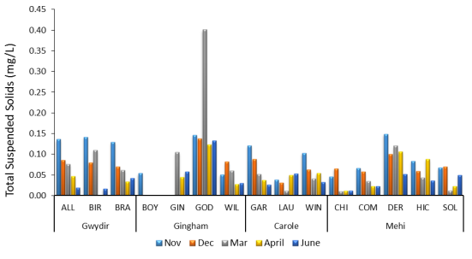

Figure 6.1 Concentrations of total suspended solids (TSS) in the Gwydir, Gingham, Carole and Mehi systems from November 2013 to June 2014.

Chlorophyll *a* concentrations as a measure of water column algal biomass were generally low (<5µg/L) and did not demonstrate a consistent pattern within a system or throughout the study, and did not track patterns in temperature or nutrients (). The Gwydir and Gingham systems had higher overall concentrations than the Mehi and Carole that received environmental water, with the GOD site in March having an exceptionally high concentration of 0.40ug/L. In the Gwydir system, there was a consistent trend from highest concentrations in November to lowest in June. The BOY site in the Gingham system recorded increasing and very high concentrations as the waterhole dried.

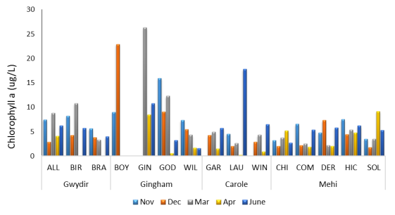

Figure 6.2 Concentrations of chlorophyll a in the Gwydir, Gingham, Carole and Mehi systems from November 2013 to June 2014.

Total nitrogen (TN) and total phosphorus (TP) concentrations were consistently highest in Nov and Dec across all study sites (Figure 6.3, 6.4), with 12 of the 15 sites having TN concentrations exceeding 1000µg/L in this period. Increased TN, TP and DOC concentrations are expected immediately following the inundation of channel and wetland sediments with the majority of sites following this pattern. The maximum TN concentration of an exceptionally high 3,319µg/L was matched by the highest TP concentration of 450µg/L and 13.9µg/L in Dec in BOY waterhole as it dried. DOC concentrations were generally low and below 10µg/L throughout the study, with higher values recorded as systems dried in March and April (Figure 6.5). There is no apparent trend in TN, TP and DOC associated with systems receiving environmental water compared to those that did not (except the drying of waterholes), suggesting site specific sources are influencing nutrient patterns over time.

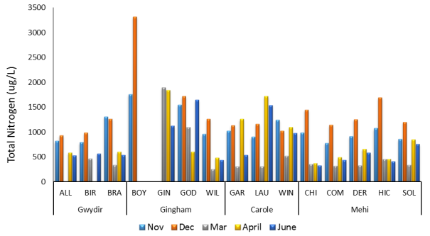

Figure 6.3 Concentrations of total nitrogen (TN) in the Gwydir, Gingham, Carole and Mehi systems from November 2013 to June 2014.

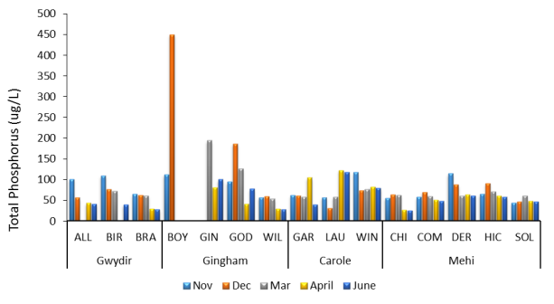

Figure 6.4 Concentrations of total phosphorus (TP) in the Gwydir, Gingham, Carole and Mehi systems from November 2013 to June 2014.

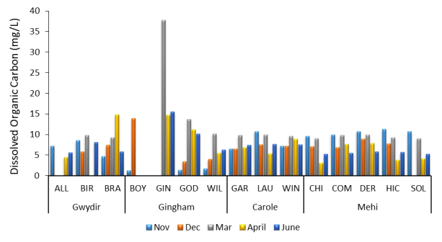

Figure 6.5 Concentrations of dissolved organic carbon (DOC) in the Gwydir, Gingham, Carole and Mehi systems from November 2013 to June 2014.

## Outcomes

Results for this component suggest that for the most part, water quality in all sampled lower Gwydir channels was within the limits acceptable for aquatic biota. Although the two waterholes in the Lower Gingham did show particularly poor water quality during the summer months, with elevated levels of all parameters measured during this period. Measurements taken throughout 2013-14 show similar values to those observed by Wilson *et al.,* (2009) for the most part, who also noted the deterioration of water quality in a downstream direction especially in the Gingham channel from 2006 – 2009. Both ‘Boyanga’ and ‘Gingham’ waterholes are relatively shallow and so are susceptible to increased temperatures, especially when both inflows and water levels are low. Similarly, increased levels of conductivity in these sites are probably reflective of the concentrating effect of receding water levels.

Temperatures along the Carole Creek and Mehi River tended to reflect seasonal patterns. While temperatures were relatively high in Carole Creek over the summer, minimum temperatures were also relatively warm, and were not low enough to inhibit fish spawning (Preece and Jones, 2002). The warmer temperatures measured in the Mehi and Carole also suggest there was no cold water influence of dam released flows in these systems - a factor which has been demonstrated to restrict biological and chemical functioning below major dams in similar systems (Preece & Jones 2002).

The general trend across sites in the Mehi and Carole channels for increased levels of TN, TP and DOC early in the season associated with increased flows, may suggest that the in channel flows associated with the release of Commonwealth environmental water did stimulate the movement of nutrients through these channels, a feature common in semi-arid floodplain systems (Baldwin & Mitchell 2000). This trend appeared to be strongest in the Mehi, with elevated levels of TN and TP found at some sites along the Carole towards the end of the season. These may reflect a concentration effect resulting from the reduced hydrological connectivity along the channel at this time.

# Monitoring Indicator – Macroinvertebrates and Zooplankton

Macroinvertebrates and zooplankton are common components of freshwater biological monitoring (Rosenburg and Resh 1993). They form important links in aquatic food webs and they show relatively rapid responses change (Resh 2008). For these reasons, macroinvertebrates and zooplankton were monitored during this study to assess their response to the in-channel flows delivered using Commonwealth environmental water.

## Methods

### Macroinvertebrates

One representative macroinvertebrate sample was collected from each site on each sampling occasion. Samples were taken from different microhabitats (including; open water, trailing bank vegetation, submerged woody debris, submerged leaf packs, emergent and submergent vegetation) in proportion to their percentage cover of each habitat at the time of sampling and combined into one representative sample for each site. Macroinvertebrates were collected by sweeping a net (350 x 250 mm opening and a 0.25 mm mesh) through the water column of each microhabitat for one minute. For the hard microhabitats, the net was used to disturb the surface of the habitat and then swept past it to collect the macroinvertebrates that had been washed off. Samples were preserved in 70% ethanol and identified to the lowest possible taxon following standard laboratory procedures (Turak *et al.,* 2004).

In addition to the sample collection, habitat assessment sheets were completed at each site to record the physical nature of the site, potential impacts to the site and the weather and flow conditions present at the time of sampling. Standard AUSRIVAS field data sheets were used to record this information (http://ausrivas.ewater.com.au/protocol/pubs/chapter4b.pdf)

### Zooplankton

Three replicate pelagic samples were collected for zooplankton by towing a net (300mm diameter opening 56 ųm mesh) through the water column. For each replicate sample, the net was pulled through approximately 5m of water column, to provide a total sampling volume of 0.35m2. Care was made to pull the net at a range of depths to negate stratification of zooplankton communities. Each replicate sample was retained in a 200 mL jar in 70% ethanol stained with Rose Bengal to aid in sample identification. In the laboratory, these samples were sorted under a dissecting microscope to count (abundance) and identify (richness and diversity) taxa.

### Sampling regime/locations

Macroinvertebrate and zooplankton samples were collected at the sites previously described for fish, turtles and crustaceans (Figure 5.2). Macroinvertebrate and Zooplankton samples were collected during the November, March, April and June sampling occasions. Unfortunately, Zooplankton samples from the November sampling occasion could not be successfully identified due to unexpected sample deterioration. However, samples from the other three occasions were successfully identified and included in the analysis for this indicator.

## Results

### Macroinvertebrates

Abundances of macroinvertebrates varied greatly over time, with large differences evident between systems within each sampling period (Figure 9.1). The lowest abundance of 118 was recorded in the Gwydir system in November, and the highest of 1926 in the Mehi in June. The abundance of macroinvertebrates increased with time in both the Carole and Mehi, whereas this pattern was not observed in the Gwydir or Gingham. Taxa richness also varied within sampling periods and among systems over time (Table 9.1). The Gwydir (14-28) and Carole (13-26) systems were consistently lower in taxonomic richness compared with the Gingham (19-35) and Mehi (20-28), suggesting no effect of environmental flow delivery on taxonomic richness. Dominant taxa in each system shifted between November and March (except for Gingham). The Gwydir (Chironomidae) and Carole (Palaemonidae) retained dominant taxa from April to June, with Gingham and Mehi shifting dominant taxa in this period.

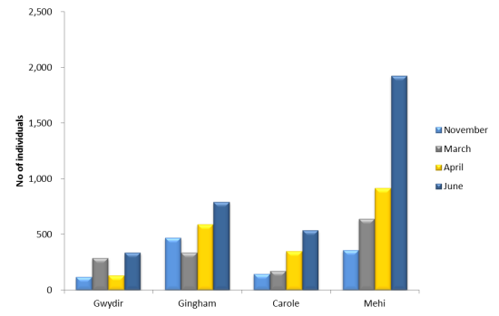

Figure 7.1 Total number of macroinvertebrates collected from each channel during the 2013-14 water year.

Table 7.1 Abundance, taxonomic richness, dominant taxa and their abundance for macroinvertebrates collected from the Gwydir, Gingham, Carole and Mehi systems from November 2013 to June 2014.

|  |  |  |  |  |  |
| --- | --- | --- | --- | --- | --- |
| Month | River | Total Abundance | Taxa Richness | Dominant taxa | Number of Dominant taxa |
| November |  |  |  |  |  |
|  | Gwydir | 118 | 14 | Corixidae | 67 |
|  | Gingham | 472 | 21 | Corixidae | 111 |
|  | Carole | 146 | 13 | Baetidae | 100 |
|  | Mehi | 361 | 20 | Corixidae | 154 |
| March |  |  |  |  |  |
|  | Gwydir | 289 | 14 | Gerridae | 191 |
|  | Gingham | 339 | 19 | Corixidae | 106 |
|  | Carole | 173 | 12 | Gerridae | 50 |
|  | Mehi | 641 | 23 | Baetidae | 281 |
| April |  |  |  |  |  |
|  | Gwydir | 133 | 15 | Chironomidae | 43 |
|  | Gingham | 590 | 35 | Corixidae | 133 |
|  | Carole | 351 | 17 | Palaemonidae | 188 |
|  | Mehi | 915 | 25 | Palaemonidae | 262 |
| June |  |  |  |  |  |
|  | Gwydir | 338 | 28 | Chironomidae | 157 |
|  | Gingham | 793 | 34 | Chironomidae | 153 |
|  | Carole | 539 | 26 | Palaemonidae | 112 |
|  | Mehi | 1926 | 28 | Atyidae | 640 |

There was no significant difference in the macroinvertebrate communities between systems (R = 0.054. P <0.21), but there was a significant difference between times (R = 0.362, P <0.015) (Figure 7.2). Pairwise comparisons identified no significant differences between systems, but significant differences between all dates except April and June. There was no significant interaction between sites and times (R = 0.017 P > 0.25). Differences between sites were explained predominantly (>35% variance contribution by Corixidae>Chironomidae>Palaemonidae >Baetidae> Gerridae. Differences between times were explained by the same dominant taxa but a different order, Corixidae> Palaemonidae> Gerridae>Chironomidae>Baetidae (Table 7.2).

The lack of a significant difference between systems suggests the delivery of environmental water to the Carole and Mehi systems has not affected the composition or trajectory of change in macroinvertebrate communities.

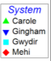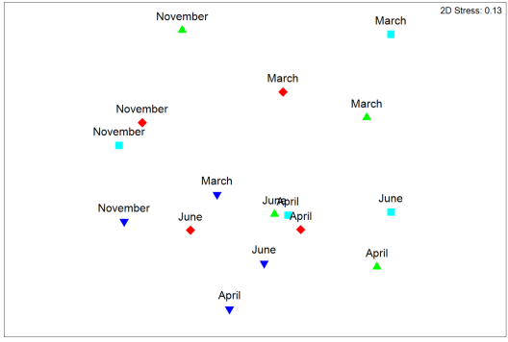

Figure 7.2 A nMDS ordination for macroinvertebrate community composition in the Gwydir, Gingham, Carole and Mehi systems from November 2013 to June 2014.

Table 7.2 Macroinvertebrate abundance, taxonomic richness, dominant taxa and their abundance collected from sites in the Gwydir, Gingham, Carole and Mehi from November 2013 to June 2014.

| **Month** | **System** | **Site** | **Taxa Richness** | **Total Abundance** | **Number of Dominant Taxa** | **Dominant Taxa** |
| --- | --- | --- | --- | --- | --- | --- |
| **November** | Gwydir | BRA | 8 | 31 | 12 | Corixidae |
| ALL | 4 | 7 | 4 | Ecnomidae |
| BIR | 8 | 80 | 55 | Corixidae |
| Gingham | WILL | 5 | 35 | 22 | Corixidae |
| GOD | 15 | 341 | 89 | Corixidae |
| BOY | 11 | 96 | 43 | Chironomidae |
| Carole | LAU | 4 | 19 | 14 | Corixidae |
| WIN | 4 | 76 | 68 | Baetidae |
| GAR | 10 | 51 | 29 | Baetidae |
| Mehi | CHI | 4 | 126 | 99 | Corixidae |
| SOL | 5 | 62 | 38 | Corixidae |
| COM | 7 | 21 | 7 | Atyidae |
| HIC | 4 | 15 | 8 | Atyidae |
| DER | 17 | 137 | 65 | Baetidae |
| **March** | Gwydir | BRA | 11 | 77 | 26 | Gerridae |
| ALL | 9 | 181 | 144 | Gerridae |
| BIR | 5 | 31 | 21 | Gerridae |
| Gingham | WILL | 10 | 112 | 47 | Palaemonidae |
| GOD | 13 | 159 | 88 | Corixidae |
| GIN | 11 | 68 | 19 | Chironomidae |
| Carole | LAU | 7 | 53 | 24 | Chironomidae |
| WIN | 9 | 54 | 21 | Gerridae |
| GAR | 7 | 66 | 26 | Gerridae |
| Mehi | CHI | 16 | 357 | 224 | Baetidae |
| SOL | 9 | 115 | 49 | Atyidae |
| COM | 11 | 76 | 38 | Chironomidae |
| HIC | 8 | 64 | 25 | Baetidae |
| DER | 5 | 29 | 13 | Gerridae |
| **April** | Gwydir | BRA | 12 | 78 | 27 | Corixidae |
| ALL | 8 | 55 | 27 | Palaemonidae |
| Gingham | WILL | 9 | 135 | 66 | Palaemonidae |
| GOD | 27 | 274 | 73 | Dytiscidae |
| GIN | 17 | 181 | 121 | Corixidae |
| Carole | LAU | 11 | 166 | 90 | Palaemonidae |
| WIN | 12 | 120 | 49 | Palaemonidae |
| GAR | 8 | 65 | 49 | Palaemonidae |
| Mehi | CHI | 17 | 166 | 62 | Corixidae |
| SOL | 16 | 274 | 107 | Corixidae |
| COM | 16 | 291 | 119 | Palaemonidae |
| HIC | 8 | 136 | 83 | Chironomidae |
| DER | 6 | 48 | 31 | Palaemonidae |
| **June** | Gwydir | BRA | 21 | 168 | 71 | Chironomidae |
| ALL | 13 | 92 | 38 | Chironomidae |
| BIR | 11 | 78 | 48 | Chironomidae |
| Gingham | WILL | 17 | 227 | 97 | Chironomidae |
| GOD | 22 | 223 | 72 | Hydrophilidae |
| GIN | 19 | 343 | 123 | Corixidae |
| Carole | LAU | 19 | 267 | 58 | Palaemonidae |
| WIN | 15 | 186 | 83 | Corixidae |
| GAR | 17 | 86 | 31 | Palaemonidae |
| Mehi | CHI | 15 | 452 | 188 | Hydropsychidae |
| SOL | 17 | 1080 | 600 | Atyidae |
| COM | 11 | 137 | 45 | Chironomidae |
| HIC | 13 | 94 | 45 | Palaemonidae |
| DER | 21 | 163 | 44 | Hydrophilidae Hydrochus |

### Zooplankton

Abundances of zooplankton varied enormously over time, but systems were more similar to each other within each sampling period (Figure 7.3). Over the course of the study ranged from 1661 ind. m-3 in the Mehi in March to 264,416 ind. m-3 in June in the Carole system. Average densities were lowest in March ranging from 1661 to 8430 ind. m-3 andhighest in Junefrom 21,764 to 264,416 ind. m-3. Rotifers were the numerically dominant group throughout the study, ranging from 79 to 97% of individuals. The exception was the Gingham in April where a shift in taxonomic composition was driven by rotifers 28%, cladocerans 15%, copepods 12% and nauplii 45% (juvenile zooplankton) dominating the sample.

Figure 7.3 Average water column zooplankton densities (individuals m-3) in the Gwydir, Gingham, Carole and Mehi systems from March 2014 to June 2014.

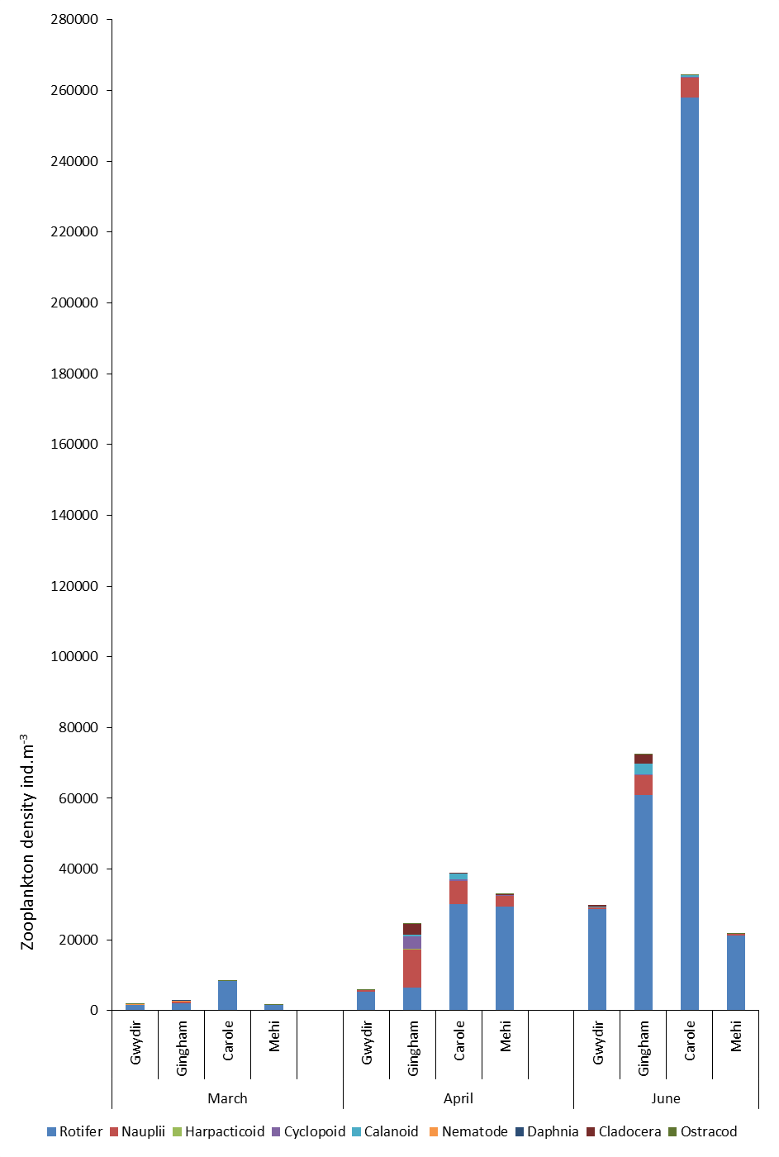

Figure 1. Average water column zooplankton densities (individuals m-3) in the Gwydir, Gingham, Carole and Mehi systems from March 2014 to June 2014.

There was a significant difference in the zooplankton communities between systems (R = 0.218. P <0.01), and times (R = 0.228, P <0.05) (). Pairwise comparisons identified significant differences were evident between the Gingham and the other 3 systems, and between March and the other two sample periods. There was no significant interaction between sites and times (R = 0.01 P > 0.45). Between 79 and 93% of differences between sites, and between 69 and 89% of variance between times were explained by shifts in rotifer abundance. The Gingham system was substantially different to the other systems in April, where rotifer numbers were reduced relative to increased calanoid and cyclopoid copepod abundances.

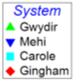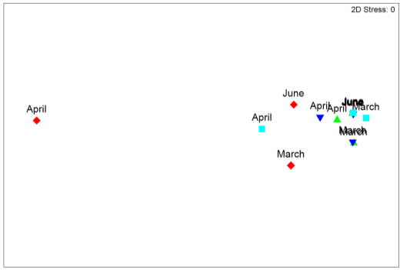

Figure 7.4 A nMDS ordination for water column zooplankton densities (individuals m-3) in the Gwydir, Gingham, Carole and Mehi systems from March 2014 to June 2014.

## Outcomes

Changes to macroinvertebrate abundances over time showed similar trends in the two channels that received Commonwealth environmental water during 2013-14. The number of macroinvertebrates collected in each sampling month increased with time in the Carole and Mehi channels, while numbers tended to fluctuate in both the Gingham and Gwydir channels. These patterns suggest that the increased flows associated with the delivery of both Commonwealth environmental water and irrigation flows may have influenced the abundance of macroinvertebrates within these channels, with an increase in abundances as flows receded towards the end of the season. These patterns also suggest that there would have been an increase in food availability for animals in higher levels of the food chain in these channels. However, it appeared that Commonwealth environmental water had little influence on the diversity of macroinvertebrate communities.

A similar pattern of increased abundances throughout the water year was observed in the zooplankton communities, which is likely a result of increased breeding throughout the season (shown by higher catches of Nauplii or juvenile zooplankton in April and June) and lower flows concentrating zooplankton numbers. The particular influence of Commonwealth environmental water was less obvious in the zooplankton communities, as while there were significant differences between channels, these were between the Gingham and the other three channels studied. The dominance of Rotifers in the samples is consistent with the findings of *Wilson et al.,* (2009) from sampling in the Gwydir during 2006-2009. Given that zooplankton constitute an important food source for many native fish species, especially as juveniles (Humphries *et al.,* 1999), the increased abundances observed towards the end of the season would be thought to contribute to sustaining the fish community’s in these channels.

# Monitoring Indicator – Frogs

Frogs are periodically abundant in the wetlands of the Gwydir, and they play an important role in the local food web, for other reptiles, such as snakes, and for breeding birds (DECCW 2011). While there is little evidence of current populations within the system, up to 14 species have been identified previously (Wilson *et al.,* 2009). This chapter outlines the results of frog specific monitoring carried out in the Gingham, Gwydir and Mallowa Creek wetlands over the 2013-14 water year.

## Methods

### Site scale plot design

At each site, six plots were established and were located according to the inundation status of the area, suitability of the vegetation and the practical ability to search the ground for fauna. Each plot corner was GPS recorded to allow for successive sampling at these locations. Plots were located at varying distances apart (40-100m) according to the vegetation present and the slope/elevation above the lowest water level.

Where water was present two ‘wet’ plots were located below or at the water level, two ‘edge’ plots were located above the water level at the edge of wetland vegetation, and the final two ‘dry’ plots were located where the vegetation reflected the dry floodplain (Figure 8.1). Where water was not present the wet plots were located at the lowest elevation in the wetland, usually associated with dry channels.

### Frog and reptile diurnal and nocturnal surveys

Each established plot was physically searched for frogs and reptiles once by day and once by night using 25 watt spotlights. Searches were conducted at roughly the same time and during similar weather conditions at each site. All individuals observed in the plots were identified to species and recorded as adult, sub adult, or meta-morph. The number of calling individuals was estimated for each plot and calling individuals off site were also noted.

Where possible, continuous spotlight surveys were conducted over 100m transects along the water line. Thick wetland vegetation at some locations prevented this.

### Tadpole survey

Sweep net surveys were conducted opportunistically at the wet plot locations where there were sections of open water (i.e. not overgrown with thick wetland vegetation).At each site a 10m sweep was undertaken either as one continuous sweep in the larger pools, or as multiple smaller sweeps in smaller pools.

The tadpoles collected were sorted into life stages according to leg growth and counted, and the species present were identified. Each species and life stage were photographed. Likewise the fish collected were counted and photographed.

Water’s edge

4 corner waypoint references for each plot

20 x 10m plots

20 x 10 m Edge plot

20 x 10m Dry plot

Wet plot

40 - 100 m spacing

20 x 10m plots

20 x 10m Dry plot

20 x 10 m Edge plot

Wet plot

Plot distances apart determined by the vegetation and practicality to survey

Figure 8.1 Plot configuration at each of the frog survey sites.

### Site descriptions

At each site a number of large scale site features were noted, including, the vegetation structure (woodland, open woodland, shrubland, grassland, and wetland), tree age class, dominant tree, shrub and ground cover species and their percentage cover, The disturbance history (broad scale cleared, selective cleared, grazed, cultivated) and the land use within the immediate proximity, and any potential threats to the frog communities at the site (predators, livestock, weeds, likelihood of chemical use in vicinity)

Within each plot, habitat variables were recorded including the dominant ground cover vegetation, percentage cover and height, litter and bare soil percentage cover, length of logs > 10cm dia, average width of soil cracks, number of tree hollows dead and alive, water depth and temperature.

### Sampling regime/locations

Five sites were established across the Gingham (two sites), Gwydir (two sites) and Mallowa (One site) Wetlands (Figure 8.2). Sites in the Gingham wetlands were located within the Gwydir Wetlands SCA at ‘Bunoor’. Similarly the two sites in the Gwydir Wetlands were also located within the Gwydir Wetlands SCA at ‘Old Dromana’. The site within the Mallowa Creek wetlands was located on ‘Valetta’ to the north of the Mallowa channel (Plot locations provided in Appendix 1). These sites were sampled on two occasions throughout the water year, once early in the season (mid November 2013) and a second time towards the end of the season (late April/ early May 2014). Table 8.1 outlines the survey methods undertaken at each site.

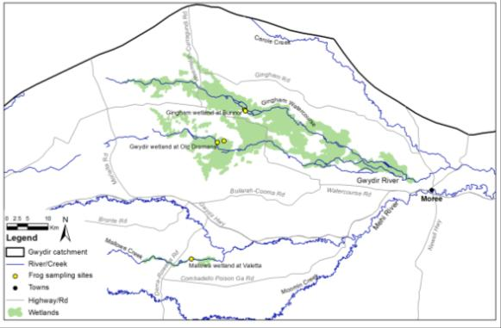

Figure 8.2 Location of the five frog sites, monitored over the 2013-14 water year.

Table 8.1 Frog survey methods carried out at each site within the 2013-14 water year

|  |  |  |  |  |  |
| --- | --- | --- | --- | --- | --- |
| Site | Nocturnal search | Diurnal search | Tadpole/fish Sweep net survey | 100m water line spotlight | Habitat description |
| Gwydir wetlands 1 | Yes | Yes | 2 plots x 2 funnel traps per plot | None | Yes |
| Gwydir wetlands 2 | Yes | Yes | 2 plots x 2 funnel traps per plot | None | Yes |
| Gingham wetlands 3 | Yes | Yes | Too shallow | Yes | Yes |
| Gingham wetlands 4 | Yes | Yes | 2 plots x 2 funnel traps per plot | None | Yes |
| Mallowa Creek wetlands 5 | Yes | Yes | Too shallow | Yes | Yes |

## Results

A total of six frog species were recorded within or around the study plots during the two sampling occasions (Table 10.2). All species were found at the Gwydir sites, while five species (*Litoria peronii, L. latopalmata, Crinia parinsignifera, Limnodynastes fletcheri,* and *L. tasmaniensis)* were observed at the Gingham Wetland sites, and only three common species (*L. latopalmata, L. fletcheri,* and *L. tasmaniensis)* being found in the Mallowa Creek wetlands site at Valetta. An additional six species were observed in May within Ephemeral pools located in the Lower Gywdir catchment that resulted from significant rainfall during late March/ early April (Table 8.2)

Table 8.2 Frog species recorded during the monitoring in the Lower Gwydir catchment.

| **Scientific Name** | **Common Name** | **Wetlands** | **Ephemeral pools** | **Flood stimulated breeding** | **Rainfall stimulated breeding** | **Shelter habitat** |
| --- | --- | --- | --- | --- | --- | --- |
| *Cyclorana platycephala* | Water-holding Frog |  | Recorded |  | Yes | Burrows |
| *Cyclorana verrucosa* | Rough Frog |  | Recorded |  | Yes | Burrows |
| *Litoria alboguttata* | Striped Burrowing Frog |  | Recorded |  | Yes | Burrows |
| *Platyplectrum ornatum* | Ornate Burrowing Frog |  |  |  | Yes | Burrows |
| *Limnodynastes salmini* | Salmon-striped Frog |  | Recorded |  | Yes | Burrows |
| *Notaden bennettii* | Holy Cross Toad |  | Recorded |  | Yes | Burrows |
| *Litoria caerulea* | Green Tree Frog |  | Recorded |  | Yes | Tree hollows |
| *Litoria peronii* | Peron's Tree Frog | Few | Recorded |  | Yes | Tree hollows |
| *Litoria rubella* | Desert Tree Frog | Few | Recorded |  | Yes | Tree hollows |
| *Litoria latopalmata* | Broad-palmed Frog | Common | Recorded | Both | Both | Ground, logs, litter, cracks |
| *Crinia parinsignifera* | Eastern Sign-bearing Froglet | Common | Recorded | Both | Both | Ground, logs, litter, cracks |
| *Limnodynastes fletcheri* | Long-thumbed Frog | Abundant |  | Both | Both | Ground, soil cracks, logs, litter |
| *Limnodynastes tasmaniensis* | Spotted Marsh Frog | Abundant |  | Both | Both | Ground, soil cracks, logs, litter |
| *Uperoleia rugosa* | Wrinkled Toadlet |  | Recorded |  | Yes | Ground, logs, litter, cracks |

### Gwydir wetland sites

Within the Gwydir frog study plots, dominant vegetation included Spike rush (*Eleocharis sp.*), Slender Knotweed (*Persicaria decipiens*) Rushes (*Juncus sp.*), Water Couch (*Paspalum distichum*), Cumbungi (*Typha sp.*), Swamp Buttercup (*Ranunculus undosus*), Willow Primrose (*Ludwigia octovalvis*), with sparse Lignum (*Muehlenbeckia florulenta*), Nardoo (*Marsilea drummondii*), and River Cooba (*Acacia stenophylla*). Adjoining the wetland channel was a mixed age Coolibah (*Eucalyptus coolabah*) open woodland – woodland with couch grass ground cover. Due to limited grazing in the past several years, vegetation during the November sampling trip was tall and thick at both stuyd sites (40 cm – 2 m tall) with mostly 100% ground cover around site 1 and 50-60% cover around site 2.

During November at site 1, the only water present was in a stock water diversion channel overgrown with Cumbungi. There were no tadpoles in the clear warm water of the channel (Figure 8.3) and it appeared that there had been no frog breeding event this season up until November - no egg masses or frogs in amplexus were observed.

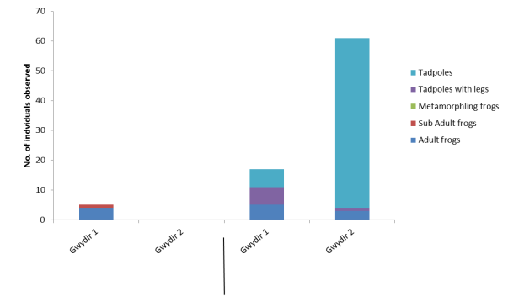

May

November

Figure 8.3 Number of individuals from a range of frog life stages observed in the Gwydir wetland sites during the study.

A total of five adult and sub adult frogs were observed at Site 1 in the Gwydir during November from four species - *Limnodynastes fletcheri, Limnodynastes tasmaniensis, Litoria peronii & Litoria latopalmata*. There were no frogs observed at site 2, however, the thick vegetation made observations difficult.

The wetland vegetation and decomposing plant material in the channel at site 1 was providing a great food source and shelter for tadpoles and invertebrates. However, the permanency of the water in the channel and its resident predators of tadpoles and eggs are likely to be a deterrent to frog breeding.

During the May 2014 sampling trip, vegetation within plots at both sites had been effected by a fire that occurred in the Gwydir wetlands in February 2014. At site 1, the stock water channel appeared to have stopped the fire spreading to the eastern transect and vegetation communities in these plots were similar to the November sampling time. The western transect plots had been burnt and now displayed a cover of regenerating water couch, buttercup and Juncus species. All plots at site 2 had been affected by the fire and were covered in regenerating Cumbungi, Spike Rush, and Water Couch up to 30cm high. Most of the logs and trees were burnt, fire also burnt the dry Coolibah woodland plots adjoining the wetland.

The district had heavy rain of 100mm to 200mm from 20th to 28th March that caused local flooding and surface ponding early April 2013. In early April an additional ECA water release down the Gwydir channel also added to increased inundation of these sites. Most had dried away by May 2014, however at site 1 the wetland plots had increased depth and cover of water in depressions, water was limited to the lowest depressions and the diversion channel where it was up to 50 cm deep. Approximately 10% of the wet plots were covered by shallow water up to 15 cm deep from the adjoining channel, residual pools had a trickle of inflow. At site 2, runoff created two small streams in the depressions of the two wet plots, elsewhere the ground was wet but not boggy.

Twenty-seven individuals were observed at site 1 during the May sampling time (Figure 8.3). These included, 5 adult frogs of the species *L. fletcheri* and *L. tasmaniensis*, 1 metamorphling, 5 tadpoles with legs and 6 tadpoles without legs of *L. fletcheri and L. tasmaniensis* and 10 small tadpoles likely to be *C. parinsignifera*. The observed tadpoles appear to be the result of a frog breeding event that lasted a short while after the rain and river flows in April. However, given the rapid rate of drying occurring, most would have been unlikely to survive through to maturity.

At site 2 in May sixty-one individuals were recorded. Minor flows into the site in April appeared sufficient to stimulate a minor frog breeding event for 2 – 3 species. Site 2 south wet plot recorded 2 small tadpoles likely to be *C. parinsignifera*. Several *Crinia parinsignifera* and *Limnodynastes fletcheri* were heard calling and 1 adult *Limnodynastes tasmaniensis*  was recorded at the dry plot.

Site 2 north wet plot recorded 47 large tadpoles likely to be *L. fletcheri* and two adult frogs were found at night of *Limnodynastes fletcheri.* In general very low frog activity and diversity of species were active. Of the tadpoles netted only one had 2 legs and 47 had no legs. Water was drying up rapidly, there was unlikely to be sufficient time for the tadpoles to develop into frogs.

### Gingham wetland sites

Frog survey sites in the Gingham Wetlands were located in the core wetland area, with the wet plots contained within a monoculture of Cumbungi (*Typha sp.*), which appeared to have been grazed heavily along the shallow edge with only the root bases of the Cumbungi visible. The wetland edge was dominantly bare mud due to the receding water level and prior stock grazing. At the top water level there was a diversity of wetland plants regenerating including Spike rush (*Eleocharis sp*.), Slender Knotweed (*Persicaria decipiens*) Rushes (*Juncus sp.*), Water Couch (*Paspalum distichum*), Willow Primrose (*Ludwigia octovalvis*), and Nardoo (*Marsilea drummondii*), also sparsely present is Lignum (*Muehlenbeckia florulenta*), and River Cooba (*Acacia stenophylla*).

During November, the water level at the Gingham sites was low, having receded since the last filling event a year or so ago. Tadpoles were absent in the dirty warm water (21 – 23C). It appeared there had been no frog breeding event up to November 2013 and no egg masses or frogs in amplexus were observed. There were few frogs active in the 12 plots, 22 adults of just four species *Limnodynastes fletcheri, Limnodynastes tasmaniensis, Litoria peronii* & *Litoria latopalmata* (Figure 8.4). The 100m spotlight at site three wetland edge recorded 2 *L. tasmaniensis*, 48 *L. fletcheri* and 3 *Litoria latopalmata*. Several individuals of *Litoria peronii* and *Limnodynastes fletcheri* were heard calling.

The apparent poor water quality and lack of wetland vegetation and decomposing plant material is likely to be limiting the food source and shelter for tadpoles and invertebrates. Also being semi-permanent water it is likely to support higher numbers of fish, yabbies and other predators that would prey on tadpoles and egg masses.

During the April sampling occasion, the water level looked to be rising, no mud surfaces were present, new growth of floating and fringing wetland vegetation was evident on the water’s edge, and some Cumbungi regrowth was beginning. There were no frogs calling by day, a few frogs were calling after dark in the twelve plots. There was a big frog chorus in the roadside table drains along the Watercourse Road stimulated by the recent rainfall in the district.

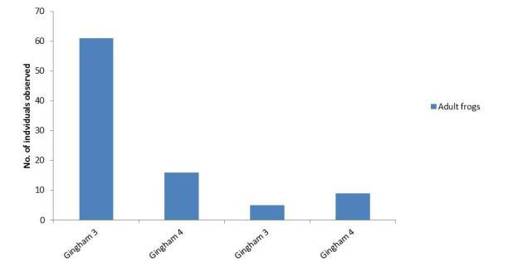

November

April

Figure 8.4 Number of adult frogs observed at the Gingham Wetland during the two sampling occasions.

Two adults of two species *Limnodynastes fletcheri,* and *Limnodynastes tasmaniensis* were recorded at site 3 during April, and Seven adults of three frog species; *Limnodynastes fletcheri, Limnodynastes tasmaniensis, & Litoria latopalmata* were recorded at site 4. The 100m spotlight conducted at site 3 wetland edge recorded 2 *L. tasmaniensis* and 1 *L. fletcheri*, and a few frogs of 3 species were heard calling *L. tasmaniensis L. fletcheri* & *Litoria peronii*.

Six individuals of *Limnodynastes fletcheri, Limnodynastes tasmaniensis, & Litoria latopalmata* were heard calling within the plots at site 4, with five of the same three species heard calling off site*.* Within the plots of site 3, 2 individuals were heard and six individuals of four species; *Limnodynastes fletcheri, Limnodynastes tasmaniensis, Crinia parinsignifera,* and *Litoria latopalmata* were heard off site.

Two fog egg masses were found in the edge plot of Site 4, but few frogs were calling or active during the April sampling trip. The flooded vegetation looks good habitat but was a bit smelly. The new vegetation growth did make it difficult to locate frogs.

### Mallowa wetland site

Wetland vegetation at the Mallowa frog site included Spike rush, Juncus sp., Lignum, Nardoo and River Cooba. Adjoining the wetland was a grassy immature Coolibah woodland.

In November 2013 the floodplain area was flooded with 30cm of water. The entire area had been grazed lightly to maintain good ground cover. Wetland vegetation growth was 50 - 80cm tall and thick (95% cover), edge plots had 60 – 90 % cover of short grasses and rushes 5 – 40cm tall. The dry plots in the Coolibah woodland had sparse short vegetation 25 – 60% cover, ground surface was dominantly bare ground and litter and the soil was cracked.

In November 2013 the level appeared to be either rising slightly or at its peak as a result of the Commonwealth environmental water being released down the Mallowa. Flooding was occurring throughout the wetland drainage lines and spilling out over low lying areas of the floodplain. Water depth was mostly shallow 10 - 30 cm, with deeper drains up to 50 cm deep.

In November large tadpoles were abundant in the clear warm flood water (Figure 8.5). The abundance of tadpoles (40), tadpoles getting legs (51), and metamorphlings (12) indicated there was a breeding event for three species approximately 3 weeks prior (*Limnodynastes fletcheri, Limnodynastes tasmaniensis, & Litoria latopalmata*). The tadpoles should reach sub adult size in two more weeks. Since then breeding had been quiet with few frogs calling, no egg masses observed and no frogs in amplexus. The 100m spotlighting recorded 25 metamorphlings, 2 sub adults, 12 adults and 22 frogs calling of three species (*Limnodynastes fletcheri, Limnodynastes tasmaniensis, & Litoria latopalmata*).

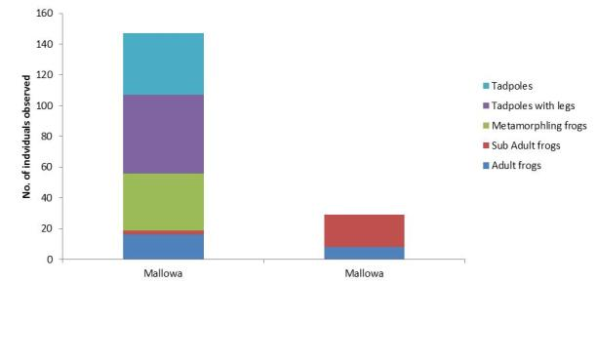

November

April

Figure 8.5 Individuals of different frog life stages observed in the Mallowa Wetland frog site.

The vegetation in and out of the water was providing very good shelter for metamorphling frogs and while relatively few were visible, many more are likely to be hidden under vegetation than the count suggests. When flooded the wetland vegetation and decomposing plant material in the water was providing a great food source and shelter for tadpoles and invertebrates.

Monitoring of the Mallowa wetland site in April was very difficult, the water had all but gone, only a trickle in the deepest depression with no tadpoles observed, presumably all either left the water or were taken by waterbirds. What water that was left was very muddy and full of decomposing vegetation; sheep had bogged up the channel which was the wetland.

Only 2 adult frogs and 19 sub adult frogs of *Limnodynastes fletcheri,* and *Limnodynastes tasmaniensis,* were recorded within the plots under spotlight. The drier conditions and cooler weather may have started to limit frog activity in April, and burrowing frogs are likely to have dug in. Only two frogs of *Crinia parinsignifera* were calling. The April 100m spotlighting recorded 2 sub adults, 6 adults and no frogs calling, those were the same three species (*Limnodynastes fletcheri, Limnodynastes tasmaniensis, & Litoria latopalmata*).

The sub adults are likely to have left the water mid-March after the water release was stopped. The low number of sub adult frogs in April indicated that it is unlikely there had been another major breeding event after the October – November event. That November breeding event coincided with a small rain event of 16mm and followed the flooding from the initial Commonwealth environmental water release. It is likely that the initial release of Commonwealth environmental water provided the cue to stimulate the November breeding response.

## Outcomes

The results from the Mallowa wetland site suggest that there was a substantial frog breeding response to Commonwealth environmental water released during the 2013-14 water year. By comparison, the Gingham wetland water level was receding over the monitoring period until the March rainfall and Gwydir wetland was dry with no inflow up until the heavy rainfall event in March. Environmental Contingency Allowance (ECA) releases of 500 megalitres into both the Gingham and Gwydir wetlands may have contributed to the small frog breeding event in the Gwydir, but did not stimulate breeding at the Gingham wetland sites.

The permanency of the water in the Gingham core wetland may be limiting its productive potential for frog breeding and also improving its suitability for predator species such as Gambusia. No tadpoles were recorded in Gingham although two egg masses were observed amongst vegetation when the water level was high in April 2014.

The four common frog species recorded in the wetlands *Limnodynastes tasmaniensis, Limnodynastes fletcheri, Litoria latopalmata*, and *Crinia parinsignifera*, belong to the non-burrowing group of floodplain frogs. Those four species are the most likely to breed in response to regulated flooding that inundates vegetation in the absence of heavy rain. They are not floodplain specialists, as they occur across a broad range of habitats from the tablelands to semi- arid regions across inland NSW.

They are opportunists that will breed in response to flooding or heavy rain events, whereas the burrowing and tree frog groups (shown in Table 8.2) are less likely to respond to released flooding, requiring heavy rain to stimulate breeding in flooded depressions. The heterogeneously inundated floodplain provides vital shelter and breeding habitat for those four species that may not otherwise be available in semi-arid areas (Ocock 2013).

Given the choice it seems most frogs will preferentially breed in ephemeral flooded depressions after heavy rain rather than large water bodies or permanent wetlands. The author has observed this behavior numerous times at various locations where floodplain frogs avoided breeding in the larger more permanent water bodies, preferring flooded depressions that can be highly ephemeral.

This was evident at the Gingham property “Bunnor” in the early April monitoring, where significant breeding events were occurring in the roadside table drains, where frog abundance and diversity was much greater than that recorded at the Gwydir or Gingham monitoring sites.

All the frog groups were present in the roadside flooded depressions, tree frogs, burrowing frogs and non-burrowing ground frogs, stimulated to breed by the heavy rain and warm temperatures, shown in Table 8.2.

Presumably there are benefits from breeding at such sites, food resources of decaying vegetation are high and predators that prey on eggs and tadpoles are low. For the burrowing frogs that have short development times it is ideal, however such locations can be risky for species that require long development times such as *Limnodynastes fletcheri* which can take up to three months to complete metamorphosis (Anstis 2002).

Overall the results from monitoring appear consistent with the response to flooding researched at the Macquarie Marshes by Joanne Ocock for her PhD thesis in 2013. In this system she found that regulated flooding of those wetlands in October and November stimulated a breeding response from *L. fletcheri, L. tasmaniensis, L. latopalmata*, and to some extent *L. salmini* and sometimes *C. parinsignifera*. Those species are likely to be the only ones that breed in response to released floodwater without coincidental heavy rains (Joanne Ocock 2014, pers comm.)

Common floodplain frogs *L. fletcheri, L. tasmaniensis, L. latopalmata* will breed in shallow 'marshy' areas of the floodplain with aquatic vegetation, that are temporarily inundated by a flood event. They are less likely to breed in large permanent water bodies that lack vegetation and may contain fish. Those floodplain species will also utilise ephemeral shallow depressions filled by high rainfall events. However, due to their long (approx. 3 month) tadpole development time compared to the short inundation period of these ephemeral depressions, there may not be a successful recruitment event. Burrowing frogs and tree frogs are more likely to breed in rain-inundated ephemeral sites, especially in combination with warmer temperatures (Joanne Ocock 2014, pers comm.).

The most numerous species found to be strongly associated with inundated floodplain habitats were the non-burrowing ground frog species *Crinia parinsignifera, Limnodynastes fletcheri, Limnodynastes tasmaniensis*, and *Litoria latopalmata* that require shelter near damp places (Ocock 2013). Ocock (2013) reported there are three particular benefits from flooding that suit the life cycle of the strongly- associated floodplain species. Firstly, the temporarily flooded water bodies probably have lagged colonisation by tadpole predators such as fish and odonates (Babbitt and Tanner 2000), Second, availability of waterbodies with sufficient hydroperiod for successful recruitment for species with long tadpole development phases such as L. fletcheri which requires up to three months (Anstis 2002). Lastly, flooding produces abundant food resources for adults and tadpoles such as invertebrates, algae and detritus (Altig *et al.,* 2007; Kupferberg 1997).

The tree frogs *Litoria caerulea, Litoria rubella,* and *Litoria peronii* were more abundant in woodland habitats and generally unaffected by the duration of water at survey sites. Those species are characterised as moderately associated species, their abundance was not influenced to a similar extent as the strongly associated species (Ocock 2013).

Those tree frog species moderately associated to flooding and the rain-associated burrowing frog group have behavioral and physiological adaptations that enable them to shelter in locations away from damp places e.g. in trees or burrowing. Tree frogs have relatively low rates of evaporative water loss (Young *et al.,* 2005) and the burrowing frogs seal themselves in a membrane in the soil to minimise water loss.

# Monitoring Indicator – Native vegetation

The Lower Gwydir system supports a diverse range of water dependent wetland vegetation communities which form important habitat for migratory birds and other aquatic fauna (Bowen and Simpson 2010). While the extent and condition of the vegetation communities has been significantly reduced in recent decades with the onset of river regulation (Bowen and Simpson 2010), a dedicated adaptive Environmental Management Plan (DECCW 2011) is attempting to restore these communities through the use of environmental water and improved land management (DECCW 2011). This chapter outlines the findings from vegetation monitoring undertaken by the project team during 2013-14.

## Methods

### Field based vegetation community response

A number of ‘control’ and ‘response’ plots were surveyed at 11 locations within the Gwydir, Gingham and Mallowa Creek wetlands. At each location, ‘wet’ plots and ’dry’ plots were surveyed to allow for a comparison between plots that were likely to be inundated with Commonwealth environmental water during the system (‘wet’) to those that were not (‘dry’). At each location, plots were located within the same broader vegetation class (Table 9.1). In addition, at each of two locations, three transects were established to monitor aquatic vegetation communities (Non-woody submerged and floating aquatic and fringing or dense wetland vegetation).

Table 9.1 Vegetation site and plot design employed in the study noting the broader vegetation class of each site.

| **Site** | **Wetland** | **Sampling design** | **Broad vegetation class\*** |
| --- | --- | --- | --- |
| Bunnor | Gingham | 2 wet and 2 dry plots  3 transects | Water couch marsh grassland |
| Westholme | Gingham | 2 wet and 2 dry plots | Water couch marsh grassland |
| Lynworth | Gingham | 2 wet and 2 dry plots | River Cooba swamp/Lignum shrubland |
| Munwonga | Gingham | 2 wet and 2 dry plots | River Cooba swamp/Lignum shrubland |
| Old Dromana | Gwydir | 3 transects | marsh clubrush very tall sedgeland |
| Old Dromana Ramsar1_1 | Gwydir | 2 wet and 2 dry plots | Water couch marsh grassland |
| Old Dromana Ramsar2_1 | Gwydir | 2 wet and 2 dry plots | Water couch marsh grassland |
| Old Dromana Ramsar 3_2 | Gwydir | 2 wet and 2 dry plots | Coolibah open woodland |
| Coombah | Mallowa | 2 wet and 2 dry plots | Coolibah-River Cooba-Lignum Association |
| Valetta | Mallowa | 2 wet plots | Coolibah-River Cooba-Lignum Association |
| Bungungya | Mallowa | 2 wet and 2 dry plots | Coolibah-River Cooba-Lignum Association |

* as defined by Bowen and Simpson (2010)

Vegetation characteristics were be measured at each plot and transect using a fit-for-purpose version of the NSW Government *Native vegetation interim type standard* (Siversten 2009),which is specifically geared towards determining vegetation response to watering.This protocol includes measures of the presence/absence of species, floristic structure, population demographics, canopy health and recruitment of floodplain vegetation communities (Bowen 2013). It also allowed for the assessment of the potential influence of environmental water on target native (e.g. water couch, spike rush, marsh club rush and lignum), and non-native species (lippia, Noogoora Burr). This protocol was employed to ensure alignment of the methods used in this study with the routine vegetation monitoring being undertaken in the Gwydir and other northern MDB catchments by NSW OEH staff.

### Remote sensing based vegetation biomass

Remotely sensed data were used to provide information on the response of floodplain and riparian vegetation to inundation at larger landscape scales. The productivity of floodplain plant communities was determined using the Normalised Difference Vegetation Index (NDVI) calculated from satellite imagery, and this was then used to determine a measure of the daily dry organic matter accumulation (biomass) within the study area. This was done based on the methods employed by Shilpakar (2013) with several modifications.

The accumulation of dry organic matter (biomass) in any given period is proportional to the photosynthetically active radiation (PAR) absorbed by the canopy or vegetation surface during a period. Total accumulated biomass during period *t* can be expressed as:

[g m-2] (1)

Where, $B_{act}^{tot}$ = accumulated dry organic matter in period *t* [g m-2];

ε = the light use efficiency [g Mj-1];

*t* = the period over which accumulation takes place (e.g. 24 hours, weekly, period between two TM images etc.).

Light use efficiency or ε was calculated using:

*εn* = *εo * T1 *T2 * W* (Potter *et al.,* 1993; Field *et al.,* 1995).

An optimum light use efficiency (εo ) value of 1.26 was used in this study as this maximum light use efficiencyhas been successfully used in Australian eucalyptus forest- open forest types by Kanniah *et al.,* (2009, 2011) and grass and lignum shrubs by Hill *et al.,* ( 2004).

T1 and T2 relate to plant growth regulation (acclimation) by temperature Where

*T1* = 0.8+0.02*Topt–0.0005*(Topt)2 (Field *et al.,* 1995)

*T2***=** 1.185*{1+exp (0.2Topt-10-Tmon)}-1*{1+exp (-0.3Topt-10+Tmon)}-1 (Field *et al.,* 1995)  
Where Tmon = the mean monthly temperature and Topt = mean temperature during the month of maximum NDVI value.

The effect of water on plant photosynthesis f(W) was derived following the Xio *et al.,* (2004) and Huang *et al.,* (2010) satellite based Vegetation Photosynthesis Model (VPM).

Given that the Mallowa Creek wetlands were the only overbank asset to be influenced by Commonwealth environmental water during the 2013-14 period, the Remote sensing based assessment was targeted to this area of the system. Eight Landsat 8 images that were captured at regular intervals throughout the study period, both before and after the delivery of Commonwealth environmental water were used for the analysis. These were used to calculate NDVI and biomass of the various floodplain vegetation communities previously mapped in the Mallowa catchment. By comparing the NDVI and Biomass values from vegetation communities within these images, an understanding of the larger scale response of vegetation community productivity to Commonwealth environmental water could be gained.

### Sampling regime/locations

A total of 36 plots and 6 transects were sampled in 11 locations within the Gingham, Gwydir and Mallowa Creek wetlands (Figure 9.1). Their locations were chosen in close consultation with NSW OEH vegetation staff. Some of the plots/transects were located at existing NSW OEH vegetation monitoring sites, whereas the location of others were specific to this project.

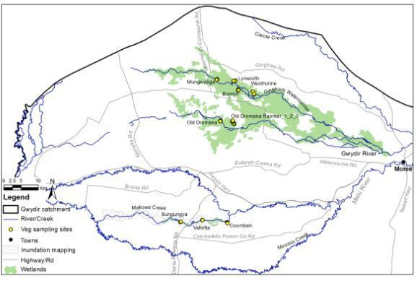

Figure 9.1 Location of the 11 vegetation sites monitored within the Gingham, Gwydir and Mallowa Creek wetlands during the 2013-14 water year.

Sites were surveyed on two occasions, once in November 2013 at the start of the season, and again in May 2014 at the end of the water season. In November all sites were surveyed by UNE project staff. However sampling in May was undertaken jointly between UNE and NSW OEH staff. It should be noted that some plots monitored in May were not in the exact same location as those sampled in November, however where considered to be representative of the vegetation communities for analysis purposes.

The remote sensing based assessment of vegetation response was confined to the Mallowa system only (Figure 9.1), using the same images utilized for the connectivity component of this project (Section 2).

## Results

### Aquatic transects

Three aquatic transects were examined in each of the Gwydir and Gingham wetlands. Gwydir transects were located within the marsh clubrush very tall sedgeland vegetation class while the Gingham transects were located within the water couch marsh grassland vegetation class as defined by Bowen and Simpson (2010).

During the November sampling occasion, 5 species were recorded along the Gwydir transects. The coverage of these species was dominated by Marsh club-rush (*Bolboschenus fluviatilis*) which was present at 87% of sample points, then Paspalum (*Paspalum distichum*) which was present at 67% of sample points (Figure 9.2). Similarly in May, there were still 5 species present along these transects; however, Tall spike-rush (Eleocharis spathulata) that was observed in November had been replaced by Wild gooseberry (Physalis) that was present in low abundance. The major difference between the two sampling events was the increase in the coverage of bare ground in May making up 21% of the sample points. The most marked reduction in coverage was seen in Paspalum, which was only found in 2% of points in May compared to 67% in November (Figure 9.2). These results are consistent with the impact of the wildfire which burnt through the Gwydir wetlands study area in March, and the subsequent re-establishment of these vegetation communities.

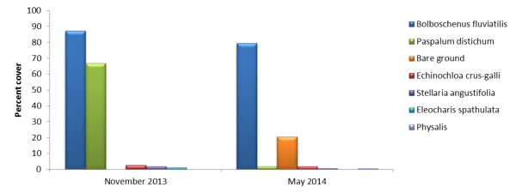

Figure 9.2 Cover of vegetation species recorded in the Gwydir wetland transects during the two sampling times. Values represent the percentage of each species.

Along the Gingham transects, nine species were recorded during the November sampling period, including the exotic water hyacinth (*Eichornia crassipes*) in low abundance (3.5% of total; Figure 9.3). During this sampling occasion, Narrow leafed cumbungi (*Typha domingensis*) was the dominant species present covering 29% of sample points (Figure XX), while 27% of sample points were bare ground. Nine species were present again in May, however, there was a 33% turnover of species with three new species being observed and three others present in November no longer there. These included Water hyacinth, which was not present, and Lippia (*Phyla canescens*), which was recorded in May at 2.3% of points. In terms of abundance, Narrow Leafed Cumbungi decreased in abundance in May to 3%, whereas Paspalum, water primrose (*Ludwigia peploides*) and Barnyard grass (*Echinochloa crus-galli*) increased their coverage by 21%, 13% and 13% respectively. There was also less bare ground recorded in May (5%) suggesting that there was an overall greater vegetation coverage later in the season along these transects.

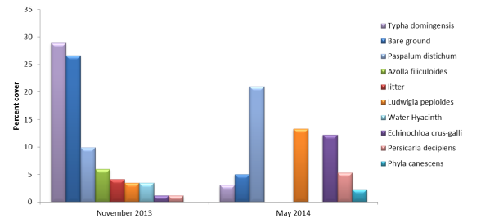

Figure 9.3 Cover of vegetation species recorded in the Gingham wetland transects during the two sampling times. Values represent the percentage of each species.

### Wider vegetation plot survey

A total of 97 vegetation species from 36 families were recorded across all the plots studied. The average number of species recorded per site was 13.7±5.6, however this differed significantly both between sites (F=11.909, df=9,1, p<0.001; Figure 9.4) and between wetlands (F=16.826, df=2,1, p<0.001). The Bunnor and Lynworth sites in the Gingham wetlands had the greatest species diversity with an average of 20.3±1.7 and 19.1±4.2 species respectively, while the Ramsar 2_1 and 1_1 sites in the Gwydir wetlands were the least diverse with an average of 8.1±2.2 and 6±2 species respectively.

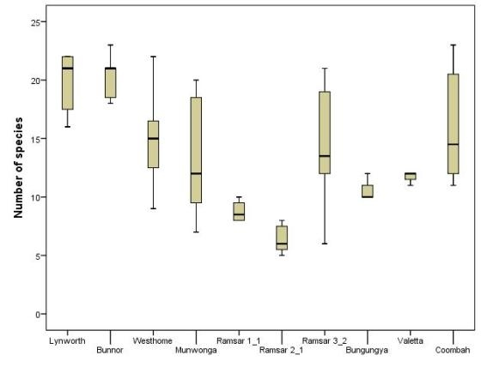

Gingham wetland

Gwydir wetland

Mallowa wetland

Figure 9.4 Number of species recorded at each site during the 2013-2014 water year arranged by wetland.

The composition of vegetation communities (measured at each plot as the percentage cover of each species) differed between sites in Multi-dimensional space (Figure 9.5). This was confirmed by a Permanova test that returned a significant result for comparisons between sites (F=7.882, DF 9,1, P<0.001). Vegetation community composition was also significantly different between the three wetlands studied (F=8.8456, D.F. 2,1, P<0.001) with plots within the Gwydir and Gingham wetlands showing more overlap than sites within the Mallowa Creek wetlands (Figure 9.5). This is not a surprising result given that plots were located within different vegetation classes in each wetland as defined by Bowen and Simpson (2010). Indeed, significant differences were detected between plots located in different vegetation classes irrespective of wetland (F=6.9552, D.F. 67,3, p<0.001).

Figure 9.5 A nMDS plot of vegetation community composition for plots studied during the 2013-14 water year in the lower Gwydir catchment. Symbols represent different sites which are coloured according to wetland with green being the sites located in the Mallowa Creek wetlands, blue in the Gingham wetland and orange in the Gwydir wetland.

Vegetation community composition also differed between sampling times (November 2013 and May 2014; F=9.3094, D.F. 2,1 p<0.005) and there was an interaction between wetland and sampling time (F=2.1561, D.F. 2,1 p<0.001). Pairwise comparisons suggest that community composition was significantly different between sampling times in plots located within the Gingham (p<0.005) and Gwydir (p<0.01) wetlands, however there was no difference between sampling times within the Mallowa Creek wetlands (p=0.175). Thus it appears as if there were seasonal patterns influenced by both rainfall and wildfire shaping vegetation community composition change in the Gingham and Gwydir, but this same trend was not observed in the Mallowa system.

To understand which of the variables (species) were driving these differences between sampling times within the Gingham and Gwydir, a SIMPER analysis was undertaken. This suggests that the main contributing variables to the within group similarity in the Gingham were water couch (*Paspalum distichum*; 12%), Bare ground (7.6%) Slender knotweed (*Persicaria decipiens*; 7%) and Litter (6.3%) in November; and Shiny Dock (*Rumex tenax;* 9.8%), Water couch (9.7%), the exotic Medic Burr (*Medicago polymorpha;* 8%) and Litter (6.3%) in May. For the November sampling in the Gwydir, water couch (14.5%), the exotic wild aster (*Aster subulatus*; 12.6%) slender knotweed (*Persicaria decipiens;* 11%) and Small tussock rush (*Juncus usitatus;* 10.5%) were the main contributors to the within group similarity. By contrast, May plots in the Gwydir were dominated by Litter (19.18%), Bare ground (16.63%) Tall spike rush (*Eleocharis spathulata*; 16.43%) and Budda Pea (*Aeschynomene indica*; 10.04%).

Given the emphasis of this monitoring and evaluation project on Commonwealth environmental water, and the fact that the Mallowa system was the only one of the three wetlands systems to receive overbank inundation from Commonwealth environmental water during the 2013-14 season, more specific analysis of the vegetation data was targeted to the sites within the Mallowa Creek wetlands. Due to the uneven distribution of wet and dry plots at the three sites within the Mallowa, patterns were assessed at the wetland scale.

Vegetation community composition varied across the plots located in the Mallowa, with notable differences in a number of forb, sedge and grass species (Table 11.2) both between sampling periods and wetting by Commonwealth environmental water. While the average number of species per plot did not change significantly between sampling periods, there was a significantly larger range of species found in plots during May (11-23 species per plot) than in November (10-16 species per plot)(Figure 9.6). This increase in species diversity during May appears to be driven by the appearance of new species in low abundance (Table 11.2).

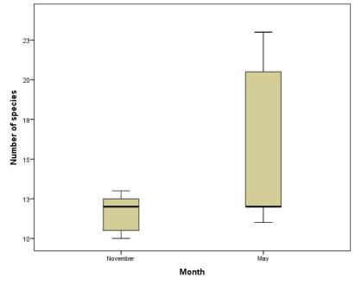

Figure 9.6 Total number of species present within the Mallowa wetland plots surveyed during the November 2013 and May 2014 sampling periods.

Table 9.2 Vegetation community composition of plots located in the Mallowa Creek wetlands.



<5% cover

>5% cover

* Exotic species

The data reveals a stronger influence of inundation with differences seen in the community composition between plots that were inundated by Commonwealth environmental water and those that were not (Figure 9.7), although this separation was not statistically significant (Permanova, p=0.067). SIMPER analysis suggest that the main contributors to the within group similarity for wet plots were the forb species budda pea (10.85%) and common nardoo (*Marsilia drummondii;* 10.07%), bare ground (10.06%) and the sedge species flat spike-sedge (*Eleocharis plana;* 8.11%). The main contributing variables for the dry sites were Warrego Grass (*Paspalidium jubiflorum*; 12.03%), Litter (10.81%), bare ground (12.97%), mimosa bush (*Vachellia farnesiana*; 10.51%) and river cooba (Acacia stenophylla; 7.39%).

2D Stress = 0.13

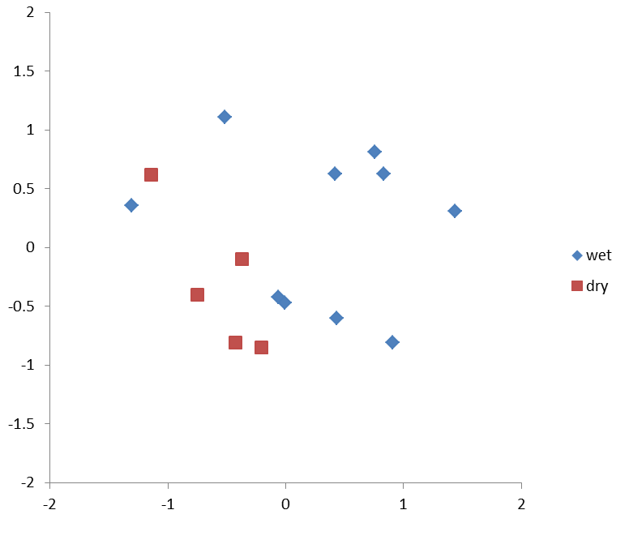

Figure 9.7 A nMDS plots showing the distribution of vegetation plots within the Mallowa Creek wetlands grouped by whether plots were inundated by Commonwealth environmental water (‘wet’), or not (‘dry’).

Univariate analysis was used to further investigate patterns in individual variables identified from the multivariate analysis as potential drivers of change in the vegetation patterns in the Mallowa. An average of 29 ± 26% (S.D) of each plot surveyed was represented by bare ground. While no significant differences were observed between months or treatments separately, wet plots surveyed in May had markedly less bare ground than either dry plots or wet plots surveyed in November (Figure 9.8). This suggests that vegetation cover increased with the addition of environmental water in the system as the season went on.

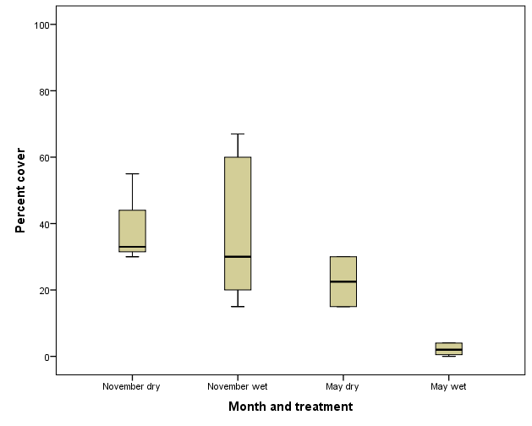

Figure 9.8 Percentage cover of bare ground observed in plots within the Mallowa Creek wetlands grouped by sampling time (month) and treatment (plot subject to Commonwealth environmental water or not)

Significant increases in the cover of several native sedge species were seen in plots inundated by Commonwealth environmental water. For example, the cover of flat spike-sedge was significantly higher in wet plots (30.5±36.7%) than dry plots (0.30±0.27%)(t=2.607, d.f.9, p<0.05; Figure 9.9). In addition, flat spike-sedge individuals showed a greater range in maximum height (range: 0.1-0.6m) than plants in dry plots (range:0.1-0.2m) suggesting that Commonwealth environmental water increased the coverage and vigor of this species. Similarly, Commonwealth environmental water appeared to stimulate the growth of swamp starwort in wet plots with this species being recorded at four of the five wet plots, albeit in lower abundances (Table 9.2), whereas it was not recorded at any of the dry plots surveyed. Positive results were also seen for Common Nardoo, with substantially higher cover observed within the wet plots during May (16.6±17.83%) than either the wet plots in November (0.7±0.27%), or the dry plots in May (0.53±0.45%) and November(0.5±0%; Figure 9.10).

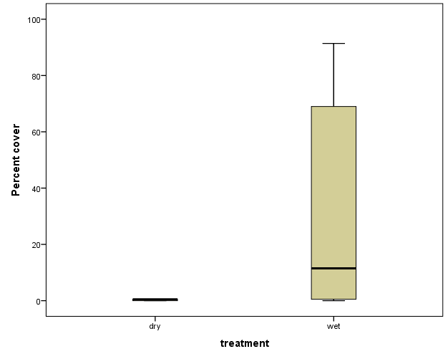

Figure 9.9 Percent cover of flat spike-sedge (*Eliocharis plana*) observed in the Mallowa Creek wetlands grouped by treatment (plot subject to Commonwealth environmental water or not).

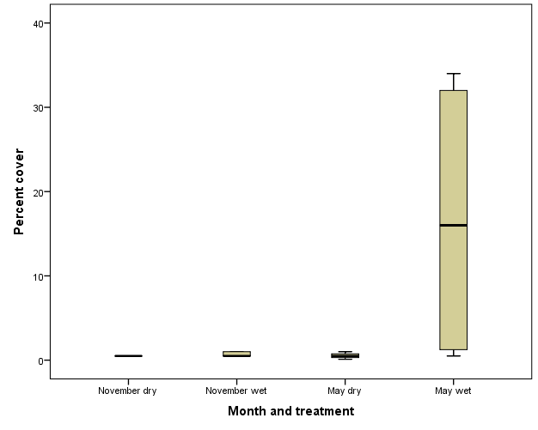

Figure 9.10 Percent cover of Common Nardoo (*Marsilia drummondii*) observed in the Mallowa Creek wetlands grouped by sampling time (month) and treatment (plot subject to Commonwealth environmental water or not)

In contrast to these sedge and forb species, the cover of Warrego Grass significantly declined between the November (22.7±14.8%) and May (4.4±4.8%) sampling times (t=3.292, d.f. 8.6, p<0.05), and while not statistically significant, Commonwealth environmental water also appeared to influence the cover of this species, with the highest cover occurring in the dry plots in November (31±4.3%) and the lowest in the wet plots in May (1.8±2.1%; Figure 11.11). Warrego Grass plants sampled in November also showed a greater range in maximum height (range: 0.1-1.5m) than plants sampled in May (range:0.4 - 0.6m).

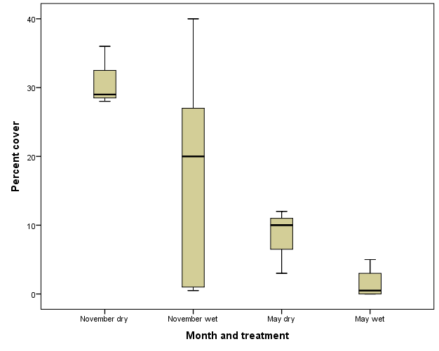

Figure 9.11 Percent cover of Warrego Grass (*Paspalidium jubiflorum*) observed in the Mallowa Creek wetlands grouped by sampling time (month) and treatment (plot inundated by Commonwealth environmental water during 2013-14 or not)

#### Lippia (Phyla canescens) and other exotic vegetation species.

A total of 17 exotic species were recorded within the vegetation plots during the 2013-14 period. Lippia was the most common exotic species being recorded within 22 of the 36 monitored plots on at least one sampling occasion (Table 9.3). Lippia was also the most abundant exotic species with a maximum coverage of 62% within one plot located at the Westholme site in May. Comparing between wetlands, the Gingham had a greater number of exotic species, present in relatively large abundances compared to both the Gwydir and Mallowa Creek wetlands.

Table 9.3 Percent cover of exotic species observed within plots in the study.



>5% cover

<5% cover

Within the Mallowa Creek wetlands, all exotic species were found in low abundances and there were no significant relationships identified between percentage cover and either sampling time or the presence of Commonwealth environmental water. Noogoora Burr (*Xanthium occidentale*) individuals were significantly taller when observed in May (0.22±0.05m) than when they were recorded in November (0.1±0m; Figure 9.12). These individuals however covered only 1% or less of the plots that they were observed within, representing a very minor component of the total vegetation communities at these sites.

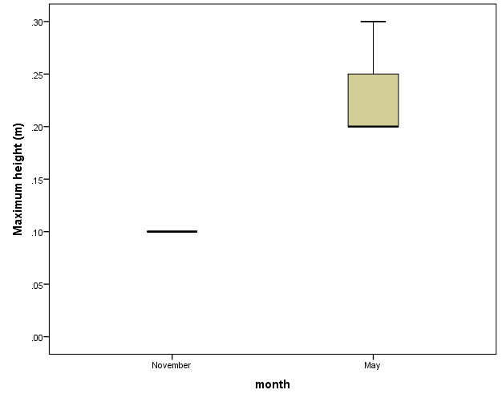

Figure 9.12 Maximum heights of Noogoora Burr (*Xanthium occidentale*) observed in the Mallowa Creek wetlands grouped by sampling time (month).

### Remote sensing based vegetation response

Analysis of the eight Landsat images suggests that vegetation response, measured as dry matter or biomass production (kg ha-1 day-1) varied greatly between the images, with biomass production increasing throughout the season from a maximum of 1.97 kg ha-1 day-1 in July to a maximum of 53.07 kg ha-1 day-1 in March (Table 9.4).

Table 9.4 Dry Matter (biomass) production measured for the Mallowa Creek wetlands from eight Landsat Images captured during the 2013-14 water year.



The spatial distribution of the increases in biomass production closely followed inundation patterns throughout the Mallowa Creek wetlands (Figure 4.9, 9.13). In addition, the relatively stable lower end of the biomass production ranges in each image (Table 9.4) suggests that the biomass production of vegetation that was not subjected to inundation remained relatively constant throughout the season. This suggests that Commonwealth environmental water was driving the increased vegetation response observed in this wetland.

Considering the broad vegetation classes of Bowen and Simpson (2010; Figure 9.14) it appears as if the response was greatest within the Coolibah-River Cooba-Lignum Association vegetation class, and to the western end of the wetlands within the cultivated lands class.

To obtain an estimate of the total biomass produced as a result of Commonwealth environmental water inundation the mean biomass production in each image was multiplied by the area of floodplain surface inundated. These results suggest that total biomass production was initially quite low (<1 t d-1) in July and August, but then increased markedly at the beginning of summer as a result of both increased inundation extent and increased rates of biomass production (Table 9.4). Total biomass production reached a maximum during March at 48.3 t d-1. It is likely that total biomass production in inundated areas would have increased after March with the widespread rainfall in the region; however, this would have been offset to some degree by lower temperatures restricting vegetation growth during this period.

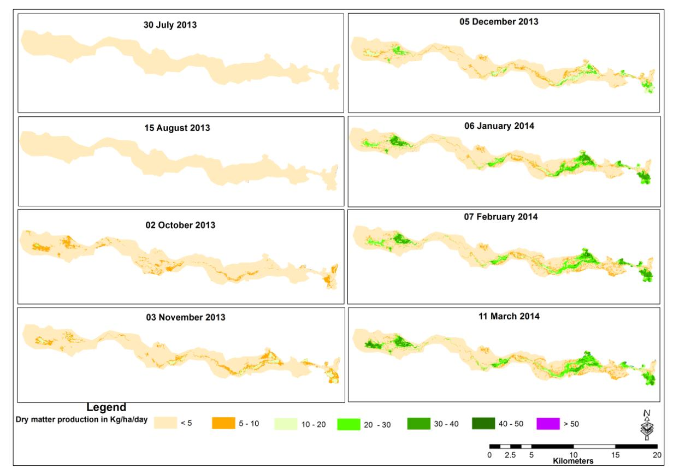

**Biomass production (kg ha-1 day-1)**

Figure 9.13 Maximum biomass production measured throughout the 2013-14 water year in the Mallowa Creek Wetlands.

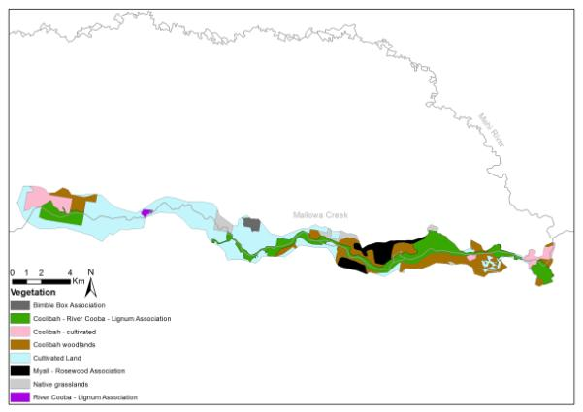

Figure 9.14 Distribution of vegetation community classes defined by Bowen and Simpson (2010) within the boundary of the Mallowa Creek wetlands used in the biomass assessment.

## Outcomes

The composition of vegetation communities within plots and transects studied was quiet different between the three wetlands. Differences observed between the sampling times within each wetland appear to be driven by differing processes. In the Gwydir sites, changes in the vegetation community composition were primarily driven by the wildfire that occurred through the reserve in late March. This increased the dominance of bare ground and litter in these communities as a result of the reduced vegetation cover. Species that were quick to respond following the fire and successive good rainfalls such as Tall spike-rush and budda pea, tended to characterize these communities at the end of the season. By comparison, Gingham vegetation communities tended to expand in coverage through the season reflecting good March rainfalls, with increases in grass species such as paspalum and barnyard grass and also exotic species such as Medic Burr and Lippia, albeit still at relatively low coverages (<3% coverage).

A more focused analysis on the vegetation plots within the Mallowa wetland was undertaken due to this wetland being the only wetland to receive Commonwealth environmental water during 2013-14. In the Mallowa plots, a greater range of species were observed during the May 2014 sampling period, resulting from an increased presence of forb, sedge and grass species in low abundance, presumably driven by both the addition of Commonwealth environmental water and significant Spring rainfall. Differences were also seen in the vegetation community composition between sites inundated by Commonwealth environmental water and those that were not. Here, flooded sites were characterized by forb and sedge species, whereas the dry sites were characterized by grasses, shrubs and litter. Common Nardoo showed a clear response both seasonally and as a result of Commonwealth environmental water with a 15 times increase in its average cover in flooded plots during May. Similarly, Flat spike-sedge was significantly more prolific in flooded plots than in those that didn’t receive Commonwealth environmental water. In addition, plants were typically taller in the flooded plots suggesting that Commonwealth environmental water increased in growth vigor as well as cover. Interestingly, cover of Warrego Grass showed a negative relationship with both season and flooding, with significantly lower cover of this species observed in the flooded plots during May. While this species is commonly associated with inundated areas (Cunningham *et al.,* 1992), in the extensively inundated plots it may have been outcompeted by other species, and/or may have been preferentially grazed by stock, given it is often well utilized by stock (Cunningham *et al.,* 1992). Increases in vegetation cover within the flooded plots significantly decreased the area of bare ground in the flooded plots towards the end of the season. Similar responses of wetland vegetation species to inundation were noted by Wilson *et al.,* (2009) with greater responses observed during summer time inundation events as was experienced in 2013-14 in the Mallowa.

At a broader landscape scale, there was a significant increase in biomass production in areas of the Mallowa Creek wetlands that were subjected to Commonwealth environmental water. Maximum rates of biomass production were over 25 times greater in inundated areas, than those that were not subject to inundation by Commonwealth environmental water. Biomass production tended to be greater within Coolibah-River Cooba-Lignum communities within core wetland areas as well as within some cultivated lands to the western end of the system. While no ground-truthing of these biomass production rates was undertaken within the study area, the figures obtained in this report are comparable to those measured in riparian areas within Yanga National Park on the Lower Murrumbidgee River (Shilpakar 2013). In addition, they provide a robust evaluation of the relative change in biomass production and growth vigor of vegetation as a result of Commonwealth environmental water delivery to the Mallowa system in 2013-14.

# Implications

The implications of the findings of this project to meeting the expected outcomes and to future use of Commonwealth environmental water are distilled in this chapter. In an attempt to structure these implications, several questions are addressed and these are discussed in terms of both the wetland inundation that occurred in the Mallowa Creek system and the in-channel freshes provided by the Commonwealth down the Mehi and Carole channels during 2013-14.

## To what degree were the expected outcomes achieved?

***Mallowa Creek wetlands***

There was a clear response in wetland vegetation observed in the Mallowa Creek wetlands, with increased coverage of responsive wetland vegetation species in flooded areas (Spike rush, Common Nardoo). The broader landscape vegetation response also suggested significant increases in biomass production from vegetation communities inundated by Commonwealth environmental water, which suggests that, the permanent and semi-permanent vegetation communities were maintained within this system during 2013-14.

A response was also observed in number of common frog species within the Mallowa Creek wetlands with a breeding event recorded in November 2013. Low rainfalls in the previous two months suggest that this breeding event was triggered by Commonwealth environmental water.

Other expected outcomes included the promotion of waterbird survival, condition, reproduction and fledgling and to promote fish movement, nutrient and carbon cycling, and primary production. This project did not directly monitor these outcomes within the Mallowa system, however, given the increased longitudinal and lateral hydrological connections provided by Commonwealth environmental water in this system, increased movement of fish, cycling of nutrients and carbon and primary production were highly likely.

***Mehi River and Carole Creek***

The Commonwealth environmental water in channel flow pulses delivered down the Mehi and Carole channels did increase the diversity of flows, especially in the lower parts of both channels. The influence of these flows was somewhat diminished higher in both channels as Commonwealth environmental water flows were soon drowned out by irrigation orders limiting their influence. The Commonwealth environmental water flow down the Mehi River was successful in providing longitudinal hydrological connectivity through to the Barwon River. Such connections are important for a range of ecosystem processes providing opportunities for biotic movement and dispersal, nutrient and organic matter transfers, and they can also improve downstream water quality.

The influence of Commonwealth environmental water flows in supporting nutrient and carbon cycling and primary productivity was less obvious, in part because no sampling was undertaken before the flows for comparison. However, a general increase in TN, TP and DOC in November and December was observed suggesting some influence of Commonwealth environmental water on nutrient cycling and primary production. Other water quality parameters such as conductivity and Dissolved Oxygen stayed in the range acceptable for aquatic biota in the Carole and Mehi systems driven by the delivery of both Commonwealth environmental water and irrigation water. Levels of these parameters increased to stressful levels for biota in the other channels, as a result of low water levels, especially in the lower Gingham waterholes.

Commonwealth environmental water flows appeared to contribute to the abundance of several fish species in the Mehi and Carole Creeks with increases in larval fish numbers being tied directly to Commonwealth environmental water releases for bony bream and spangled perch. While fish condition was not directly measured, increases in macroinvertebrate and zooplankton abundances observed through the season in both the Carole and Mehi suggest that the availability of these as food sources for fish would have been high. In addition, the high abundances of shrimps recorded in these systems would have also contributed to consumers higher in the food chain.

## What was the ecological significance of the outcomes of environmental watering?

***Mallowa Creek wetlands***

Commonwealth environmental water flows appeared to maintain and promote vegetation growth in the Mallowa Creek wetlands, aided by flows in previous years, and also good Spring rainfall. As a result these communities would be more resilient to future stresses than communities, which did not receive Commonwealth environmental water which tended to have a higher proportion of bare ground, and also reduced abundances of wetland vegetation species.

In terms of frog communities within the Mallowa, the trigger of a breeding event, followed by a relatively long duration of inundation, would have provided sufficient time for juveniles to reach maturity. In contrast, significant frog breeding was observed in ephemeral locations on the lower Gwydir floodplain, driven by Spring rainfall. However, the low permanency of these habitats may have resulted in relatively poor recruitment for species requiring longer periods to reach maturity. Thus, increasing the importance of the Mallowa breeding event for frog species.

***Mehi River and Carole Creek***

The Commonwealth environmental water delivered down the Mehi river was the first significant flow in the season to provided full connectivity throughout this system. Apart from stimulating fish to breed, this flow is likely to have been important for improving water quality in the lower sections of this channel and replenishing waterholes to contribute to their longevity. Fish recruitment associated with the Commonwealth environmental water events in both the Mehi and Carole channels is likely to be significant for these populations given the overall low fish abundances observed across all channels during 2013-14.

## In future, what changes to the watering regime might enhance outcomes?

Being able to accurately prescribe watering regimes to fulfill multiple ecological outcomes is a difficult task, especially in highly variable systems where the fauna and flora may respond to flows in various ways depending on the antecedent conditions and local site specific factors. As Wilson *et al.,* (2009) identified, our knowledge of the ecology of the Lower Gwydir system is limited on many fronts. This knowledge however is forever growing and we can certainly learn from past and future monitoring and research to further improve the successes of environmental watering efforts.

***Mallowa Creek wetlands***

In terms of the wetland inundation generated by Commonwealth environmental water in the Mallowa Creek system during 2013-14, the area, timing and duration of that inundation appeared to produce a good response from both vegetation communities and reptiles (frogs). This was aided by the preceding several years of wetland inundation in this system. Timing inundation to occur during the peak growing period of vegetation species, such as occurred in 2013-14, will ensure the best possible ecological response is achieved. Several years of successful watering in the Mallowa system appears to have limited the cover of Lippia by assisting native species to outcompete this weed.

***Mehi River and Carole Creek***

Otolith analysis undertaken in this project suggests that spawning of bony bream, spangled perch and carp occurred in response to flow events early in the season across several channels. This highlights the importance of proving a flow peak to stimulate breeding in these species. In the Mehi River, the breeding response was seen at the most downstream site, where the actual hydrograph best mimicked the intended Commonwealth environmental water flow hydrograph. Further upstream where the Commonwealth environmental water event was shortly followed by elevated irrigation releases, no breeding activity was observed. This highlights the importance of segregating flows aimed at stimulating fish breeding from other flows as far as possible, to maximise the benefit of the steady drawdown and allowing a period of low flows to enable larvae to better establish. Thus we would suggest the timing and shape of environmental flow releases (especially the extended nature of the falling limb) may be more important than the magnitude of the flow peak for triggering fish breeding. Notwithstanding this, the size of the flow peak will influence the inundation of bank habitat and potential nutrient stores, which may also encourage an ecological response.

‘Piggy backing’ environmental water onto other water deliveries is a common practice when delivering environmental flows. While this improves efficiencies in the amount of water required to reach certain flow magnitudes and volumes, it may also influence the nature of the flow hydrograph downstream. As was observed in the current project, the nature of the flow hydrograph was very different at upstream and downstream locations within both channels where Commonwealth environmental water was delivered. This may influence the ecological response observed at different locations along the channel.

Olive Perchlet, an endangered species in the Gwydir river system were recorded in in the Boyanga and Gingham waterholes to the downstream end of the Gingham watercourse during 2013-14. This is a significant finding as to our knowledge this species has not been recorded in the Gwydir catchment previously with their existence possibly result from overland flows from northern catchments during the large floods in 2011-12. Unfortunately, however, Boyanga waterhole dried during the summer period, and the population in this waterhole was lost. Assuming a viable population exists in the Gingham waterhole, consideration of flows to maintain water levels and suitable water quality should be made in future, to increase the chances of this population establishing in the Gwydir system. Larger floodplain waterholes such as these, play an important role as refuges in systems such as the lower Gwydir, and their quality should be maintained where possible to promote their ability to support aquatic biota during dry times.

While this project was successful in describing a number of ecological responses to the Commonwealth environmental water delivered in the Lower Gwydir system during 2013-14, it was also restricted by the failure to collect any data from directly before the delivery of Commonwealth environmental water due to time constraints. Gaining an understanding of the character of the system and the communities within it directly before the delivery of environmental water is critical to being able to provide a robust evaluation of the ecological response to these flows. In future we would suggest that emphasis be put on sampling at the beginning of a season before any environmental flows are delivered to allow for a more complete evaluation of the ecological response of environmental water.

# References

Altig, R., Whiles, M.R. & Taylor, C.L. (2007) What do tadpoles really eat? Assessing the trophic status of an understudied and imperiled group of consumers in freshwater habitats. *Freshwater Biology* **52**, 386-95

Anstis, M. (2002) *Tadpoles of South-eastern Australia; a guide with keys.* New Holland Reed, Australia.

Babbitt, K.J. & Tanner, G.W. (2000) Use of temporary wetlands by anurans in a hydrologically modified landscape. *Wetlands* **20**, 313-22

Baldwin, D. S., & Mitchell, A. M. (2000). The effects of drying and re‐flooding on the sediment and soil nutrient dynamics of lowland river–floodplain systems: a synthesis. Regulated Rivers: Research & Management, 16(5), 457-467.

Bauru of Meteorology (BOM) (2014). Climate and past weather. <http://www.bom.gov.au/climate/> accessed: 20th August 2014.

Bowen S. (2013) *NSW OEH Environmental Flow Monitoring Program: methods for monitoring of flood-dependent vegetation communities.* Unpublished report, NSW OEH. Sydney.

Bowen, S and Simpson, S. L. (2010) Changes in Extent and Condition of the Vegetation Communities of the Gwydir Wetlands and Floodplain 1996-2008: Final Report NSW Wetland Recovery Program. NSW Department of Environment Climate Change and Water: Sydney

Chander, G.,Markham, B.L., Helder, D.L. 2009. Summary of current radiometric calibration coefficients for Landsat MSS, TM, ETM+, and EO-1 ALI sensors. *Remote Sensing of Environment* **113**: 893-903.DOI: 10.1016/j.rse.2009.01.007.

CSIRO (2007) Water availability in the Gwydir, a report to the Australian Government by CSIRO – Murray Darling Basin Sustainable Yeilds Project, CSIRO, Australia

Cunningham, G.M., Mulham, P.L., Milthorpe, P.L. and Leigh, J.H. (1992) *Plants of western New South Wales.* CSIRO Publishing, Collingwood.

Department of Environment, Climate Change and Water (DECCW)(2011) *Gwydir Wetlands Adaptive Environmental Management Plan.* DECCW, Sydney, pp 84

Field, C.B., Randerson, J.T., Malmström, C.M. 1995. Global net primary production: combining ecology and remote sensing. *Remote Sensing of Environment* **51**: 74-88.

Frazier, PS, Page KJ. 2000. Water body detection and delineation with Landsat TM data. *Photogrammetric Engineering and Remote Sensing*, **66**, 1461-1468.

Gawne B, Brooks S, Butcher R, Cottingham P, Everingham P and Hale J (2013) Final Long-term Intervention Monitoring Project Monitoring and Evaluation Gwydir river system Requirements for Commonwealth environmental water. Report prepared for the Commonwealth Environmental Water Office by The Murray-Darling Freshwater Research Centre, MDFRC Publication 01.2/2013, May, 19pp.

Green, D. and Bennet, M. (1991) *Wetlands of the Gwydir Valley* : Progress Report to the Murray-Darling Basin Commission for the Barwon Darling Wetland Survey. NSW Department of Water Resources Technical Services Division, Sydney NSW.

Gordon, N. D., McMahon T.A. and Finlayson, B.L. (1992). *Stream Hydrology - An introduction for Ecologists.* Brisbane, Wiley.

Hill, M.J., Donald, G.E., Hyder, M.W. and Smith, R.C. (2004). Estimation of pasture growth rate in the south west of Western Australia from AVHRR NDVI and climate data. *Remote Sensing of Environment,* **93**, 528-545.

Humphries, J. and Albertson, D. (2013) *Gwydir Environmental Watering Annual Report 2012-2013 Water Year*. A report to the Gwydir Environmental Contingency Allowance Operations Advisory Committee and the wider community. Office of Environment and Heritage, NSW Department of Premier and Cabinet.

Humphries, P., King A. J. and Keohn, J.D. (1999). "Fish, flows and floodplains: links between freshwater fishes and their environment in the Murray Darling River system, Australia." *Environmental Biology of Fishes* **56**: 129-151.

Huang, N., Niu, Z., Wu, C. and Tappert, M.C. (2010). Modeling net primary production of a fast-growing forest using a light use efficiency model. *Ecological Modelling*, **221**, 2938-2948.

Kanniah, K.D.,Beringer, J. and Hutley, L.B. (2011). Environmental controls on the spatial variability of savanna productivity in the Northern Territory, Australia. *Agricultural and Forest Meteorology* **151**: 1429-1439.DOI: http://dx.doi.org/10.1016/j.agrformet.2011.06.009.

Kupferberg, S. (1997) Facilitation of periphyton production by tadpole grazing; Functional differences between species. *Freshwater Biology* **37**, 427-39

McCosker, R.O., Brizga, S.O., Arthington, A. A. & Macfarlane, W. (1999). Gwydir environmental scan. Other publication details unavailable.

NSW Office of Environment and Heritage (OEH) (2013*) Gwydir Valley Annual Environmental Watering Plan 2013-14.* OEH, Sydney, pp 24

Ocock, J.F. (2013). *‘Linking frogs with flow: Amphibian community response to flow and rainfall on a dry floodplain wetland’* PhD Thesis. University of New South Wales, Australia. p 118

Preece, R. M., & Jones, H. A. (2002). The effect of Keepit Dam on the temperature regime of the Namoi River, Australia. River Research and Applications, 18(4), 397-414.

Potter, C. S., Randerson, J. T., Field, C. B., Matson, P. A., Vitousek, P. M., Mooney, H. A., and Klooster, S. A. (1993). Terrestrial ecosystem production: a process model based on global satellite and surface data. *Global Biogeochemical Cycles*, ***7***, 811-841.

Rayburg, S, Thoms, M. 2009. A coupled hydraulic–hydrologic modelling approach to deriving a water balance model for a complex floodplain wetland system. *Hydrology Research* **40**: 364-379.

Resh V.H. (2008) Which group is best? Attributes of different biological assemblages used in freshwater biomonitoring programs. *Environ Monit Assess*, **138**: 131-138.

Robbins, W.D, Choat, J.H (2002) *Age-based dynamics of tropical reef fishes; A guide to the processing, analysis and interpretation of tropical fish otoliths.* Townsville, Australia, p 1-39.

Rosenberg, D.M. and Resh, V.H. (1993) *Freshwater Biomonitoring and Benthic Macroinvertebrates.* Chapman and Hall, New York.

Sheldon, F., Thoms, M.C., Berry, O. & Puckridge, J. 2000. Using disaster to prevent catastrophe: Referencing the impacts of flow changes in large dryland rivers. *Regulated Rivers: Research and Management* **16**: 403-420

Shilpaker, R.L. (2013) *‘Floodplain Vegetation Landscapes: An Ecotone or a Dynamic Patch Maosaic?’*. PhD Thesis, University of New Englang.

Sivertsen, D. (2009) *Native Vegetation Interim Type Standard*. NSW Department of Environment, Climate Change and Water NSW, Sydney. <http://www.environment.nsw.gov.au/resources/nativeveg/10060nvinttypestand.pdf>

Thomas, R., Bowen, S., Simpson, S., Cox, S. and Sims, N. (2010). *Inundation response of vegetation communities of the Macquarie Marshes in semi-arid Australia.* In N Saintilan and I Overton (eds) *Ecosystem Response Modelling in the Murray - Darling Basin*. Melbourne, CSIRO.

Ward, J. V. (1989). "The four-dimensional nature of lotic ecosystems." *Journal of the North American Benthological Society* **8**: 2-8

Wilson, G.G., Bickel, T.O., Berney, P.J. & Sisson, J.L. 2009. *Managing environmental flows in an agricultural landscape: the Lower Gwydir floodplain*. Final Report to the Commonwealth Department of Environment, Water, Heritage and the Arts. University of New England and Cotton Catchment Communities Cooperative Research Centre, Armidale, New South Wales. 178pp

Wilson, G.G. & Ellison, T.L. 2010. *Pindari Dam fish monitoring project.* Final report to the New South Wales Office of Water. University of New England, Armidale, New South Wales. 59pp

Wilson, G.G. In Prep. Flooding as a disturbance agent: fish responses to multiple flow pulses in a hydrologically-variable dryland river system, Australia’s northern Murray-Darling Basin.

Xu, H. (2006). Modification of normalised difference water index (NDWI) to enhance open water features in remotely sensed imagery. *International Journal of Remote Sensing,* **27**, 3025-3033.

Xiao, X.,Hollinger, D.,Aber, J.,Goltz, M., Davidson, E.A., Zhang, Q. and Moore, I.B. (2004). Satellite-based modeling of gross primary production in an evergreen needleleaf forest. *Remote Sensing of Environment* **89**: 519-534.DOI: http://dx.doi.org/10.1016/j.rse.2003.11.008.

Young, J.E., Christian, K.A., Donnellan, S., Tracy, C.R. and Parry D. (2005) Comparative analysis of cutaneous evaporative water loss in frogs demonstrates correlation with ecological habits. *Physiological and Biochemical Zoology* **78**, 847-56.

# Appendix 1 – Plot locations at frog sampling sites monitored in the study

| **Site/plot** | **Zone Easting Northing GDA** | **Altitude** |
| --- | --- | --- |
| **Gwydir 1 Wetland Site** | | |
| Gwydir 1 East Dry | 55 J 725977 6752085 | 172 m |
| Gwydir 1 East Dry 1 | 55 J 725983 6752097 | 174 m |
| Gwydir 1 East Dry 2 | 55 J 725994 6752083 | 175 m |
| Gwydir 1 East Dry 3 | 55 J 726001 6752094 | 175 m |
| Gwydir 1 East Edge | 55 J 725978 6752048 | 174 m |
| Gwydir 1 East Edge 1 | 55 J 726004 6752046 | 173 m |
| Gwydir 1 East Edge 2 | 55 J 726002 6752056 | 174 m |
| Gwydir 1 East Edge 3 | 55 J 725987 6752060 | 173 m |
| Gwydir 1 East Wet | 55 J 725954 6752032 | 173 m |
| Gwydir 1 East Wet 1 | 55 J 725965 6752014 | 173 m |
| Gwydir 1 East Wet 2 | 55 J 725977 6752024 | 173 m |
| Gwydir 1 East Wet 3 | 55 J 725965 6752038 | 172 m |
| Gwydir 1 West Dry | 55 J 725784 6752024 | 171 m |
| Gwydir 1 West Dry 1 | 55 J 725762 6752020 | 171 m |
| Gwydir 1 West Dry 2 | 55 J 725767 6752030 | 171 m |
| Gwydir 1 West Dry 3 | 55 J 725779 6752013 | 170 m |
| Gwydir 1 West Edge | 55 J 725825 6751992 | 170 m |
| Gwydir 1 West Edge 1 | 55 J 725840 6752005 | 171 m |
| Gwydir 1 West Edge 2 | 55 J 725849 6751997 | 171 m |
| Gwydir 1 West Edge 3 | 55 J 725831 6751983 | 171 m |
| Gwydir 1 West Wet | 55 J 725899 6751937 | 174 m |
| Gwydir 1 West Wet 1 | 55 J 725874 6751943 | 169 m |
| Gwydir 1 West Wet 2 | 55 J 725881 6751953 | 169 m |
| Gwydir 1 West Wet 3 | 55 J 725889 6751929 | 169 m |
| **Gwydir 2 Wetland Site** | | |
| Gwydir 2 North Dry | 55 J 724148 6751729 | 170 M |
| Gwydir 2 North Dry 1 | 55 J 724144 6751735 | 171 M |
| Gwydir 2 North Dry 2 | 55 J 724167 6751743 | 170 M |
| Gwydir 2 North Dry 3 | 55 J 724169 6751732 | 170 M |
| Gwydir 2 North Edge | 55 J 724181 6751719 | 171 M |
| Gwydir 2 North Edge 1 | 55 J 724163 6751698 | 171 M |
| Gwydir 2 North Edge 2 | 55 J 724163 6751711 | 172 M |
| Gwydir 2 North Edge 3 | 55 J 724182 6751707 | 171 M |
| Gwydir 2 North Wet | 55 J 724252 6751670 | 173 M |
| Gwydir 2 North Wet 1 | 55 J 724261 6751691 | 173 M |
| Gwydir 2 North Wet 2 | 55 J 724262 6751666 | 173 M |
| Gwydir 2 North Wet 3 | 55 J 724247 6751688 | 174 M |
| Gwydir 2 South Dry | 55 J 724200 6751753 | 170 M |
| Gwydir 2 South Dry 1 | 55 J 724216 6751768 | 170 M |
| Gwydir 2 South Dry 2 | 55 J 724201 6751765 | 170 M |
| Gwydir 2 South Dry 3 | 55 J 724222 6751759 | 170 M |
| Gwydir 2 South Edge | 55 J 724211 6751714 | 173 M |
| Gwydir 2 South Edge 1 | 55 J 724208 6751722 | 172 M |
| Gwydir 2 South Edge 2 | 55 J 724229 6751732 | 172 M |
| Gwydir 2 South Edge 3 | 55 J 724232 6751721 | 173 M |
| Gwydir 2 South Wet | 55 J 724280 6751652 | 173 M |
| Gwydir 2 South Wet 1 | 55 J 724279 6751640 | 174 M |
| Gwydir 2 South Wet 2 | 55 J 724299 6751646 | 173 M |
| Gwydir 2 South Wet 3 | 55 J 724300 6751654 | 173 M |
| **Gingham 3 Wetland Site** | | |
| Gingham 3 East Dry | 55 J 731333 6759118 | 187 M |
| Gingham 3 East Dry 1 | 55 J 731321 6759133 | 187 M |
| Gingham 3 East Dry 2 | 55 J 731312 6759124 | 186 M |
| Gingham 3 East Dry 3 | 55 J 731328 6759109 | 187 M |
| Gingham 3 East Edge | 55 J 731351 6759133 | 190 M |
| Gingham 3 East Edge 1 | 55 J 731341 6759129 | 188 M |
| Gingham 3 East Edge 2 | 55 J 731332 6759141 | 187 M |
| Gingham 3 East Edge 3 | 55 J 731337 6759148 | 187 M |
| Gingham 3 East Wet | 55 J 731347 6759158 | 189 M |
| Gingham 3 East Wet 1 | 55 J 731363 6759146 | 187 M |
| Gingham 3 East Wet 2 | 55 J 731355 6759139 | 188 M |
| Gingham 3 East Wet 3 | 55 J 731339 6759151 | 189 M |
| Gingham 3 West Dry | 55 J 731261 6759170 | 186 M |
| Gingham 3 West Dry 1 | 55 J 731243 6759183 | 183 M |
| Gingham 3 West Dry 2 | 55 J 731249 6759191 | 183 M |
| Gingham 3 West Dry 3 | 55 J 731268 6759179 | 186 M |
| Gingham 3 West Edge | 55 J 731289 6759199 | 186 M |
| Gingham 3 West Edge 1 | 55 J 731270 6759215 | 185 M |
| Gingham 3 West Edge 2 | 55 J 731265 6759205 | 185 M |
| Gingham 3 West Edge 3 | 55 J 731282 6759192 | 186 M |
| Gingham 3 West Wet | 55 J 731304 6759216 | 185 M |
| Gingham 3 West Wet 1 | 55 J 731290 6759231 | 185 M |
| Gingham 3 West Wet 2 | 55 J 731283 6759227 | 185 M |
| Gingham 3 West Wet 3 | 55 J 731299 6759211 | 185 M |
| **Gingham 4 Wetland Site** | | |
| Gingham 4 East Dry | 55 J 731351 6758972 | 185 M |
| Gingham 4 East Dry 1 | 55 J 731365 6758966 | 184 M |
| Gingham 4 East Dry 2 | 55 J 731367 6758987 | 184 M |
| Gingham 4 East Dry 3 | 55 J 731357 6758992 | 184 M |
| Gingham 4 East Edge | 55 J 731384 6758957 | 184 M |
| Gingham 4 East Edge 1 | 55 J 731373 6758961 | 185 M |
| Gingham 4 East Edge 2 | 55 J 731387 6758976 | 184 M |
| Gingham 4 East Edge 3 | 55 J 731395 6758973 | 184 M |
| Gingham 4 East Wet | 55 J 731408 6758947 | 183 M |
| Gingham 4 East Wet 1 | 55 J 731422 6758965 | 182 M |
| Gingham 4 East Wet 2 | 55 J 731412 6758968 | 182 M |
| Gingham 4 East Wet 3 | 55 J 731398 6758950 | 183 M |
| Gingham 4 West Dry | 55 J 731383 6759006 | 183 M |
| Gingham 4 West Dry 1 | 55 J 731395 6759023 | 183 M |
| Gingham 4 West Dry 2 | 55 J 731406 6759018 | 183 M |
| Gingham 4 West Dry 3 | 55 J 731388 6759003 | 183 M |
| Gingham 4 West Edge | 55 J 731412 6759014 | 183 M |
| Gingham 4 West Edge 1 | 55 J 731403 6758993 | 182 M |
| Gingham 4 West Edge 2 | 55 J 731416 6758989 | 183 M |
| Gingham 4 West Edge 3 | 55 J 731423 6759007 | 184 M |
| Gingham 4 West Wet | 55 J 731434 6759004 | 183 M |
| Gingham 4 West Wet 1 | 55 J 731426 6758985 | 183 M |
| Gingham 4 West Wet 2 | 55 J 731438 6758980 | 182 M |
| Gingham 4 West Wet 3 | 55 J 731439 6759002 | 184 M |
| **Mallowa Wetland site** | | |
| Valletta East Dry | 55 J 716515 6723662 | 169 m |
| Valletta East Dry | 55 J 716537 6723667 | 170 m |
| Valletta East Dry | 55 J 716533 6723656 | 170 m |
| Valletta East Dry | 55 J 716515 6723672 | 170 m |
| Valletta East Edge | 55 J 716532 6723640 | 168 m |
| Valletta East Edge | 55 J 716511 6723651 | 170 m |
| Valletta East Edge | 55 J 716512 6723639 | 169 m |
| Valletta East Edge | 55 J 716530 6723652 | 169 m |
| Valletta East Wet | 55 J 716535 6723612 | 161 m |
| Valletta East Wet | 55 J 716507 6723624 | 166 m |
| Valletta East Wet | 55 J 716534 6723627 | 168 m |
| Valletta East Wet | 55 J 716510 6723613 | 166 m |
| Valletta West Dry | 55 J 716485 6723667 | 171 m |
| Valletta West Dry | 55 J 716468 6723681 | 170 m |
| Valletta West Dry | 55 J 716488 6723673 | 171 m |
| Valletta West Dry | 55 J 716466 6723672 | 169 m |
| Valletta West Edge | 55 J 716480 6723646 | 170 m |
| Valletta West Edge | 55 J 716463 6723660 | 170 m |
| Valletta West Edge | 55 J 716484 6723653 | 169 m |
| Valletta West Edge | 55 J 716460 6723654 | 170 m |
| Valletta West Wet | 55 J 716474 6723629 | 168 m |
| Valletta West Wet | 55 J 716459 6723648 | 170 m |
| Valletta West Wet | 55 J 716478 6723636 | 170 m |
| Valletta West Wet | 55 J 716457 6723640 | 169 m |