

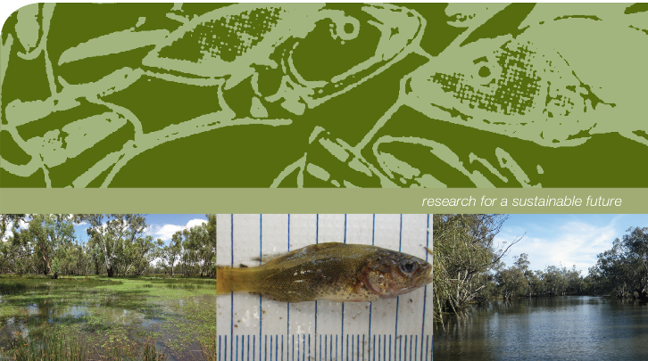

Monitoring the ecological response of Commonwealth environmental water delivered in 2012-13 to the Murrumbidgee river system
Report 1
September 2013
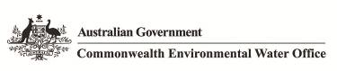

Monitoring the ecological response of Commonwealth environmental water delivered in 2013-13 to the Murrumbidgee River and connected wetlands

Prepared by: Wassens, S.ª, Bindokas, J.^{b}, Jenkins, K.^{c} Lenon, E.^{d}, Spencer, J.^{e}, Watts, R.J.ª, Kobyashi, T^{e}., Iles, J.^{d} Baumgartner, L.^{b}, Thomas, R.^{e}, Hall, A.ª

 | Institute for Land, Water and Society. Charles Sturt University, PO Box789, Albury, NSW 2640
 | NSW Trade and Investment Narrandera Fisheries Centre, PO Box 182, Narrandera NSW 2700
 | Australian Wetlands Rivers and Landscapes Centre, University of New South Wales, Sydney, NSW, 2052
 | Murrumbidgee Catchment Management Authority, Level 1, 42-45 Johnston Street (PO Box 5224). Wagga Wagga NSW 2650
 | Water, Wetlands & Coasts Science Branch, NSW Office of Environment and Heritage, Department of Premier and Cabinet, PO Box A290, Sydney South, NSW 1232
This monitoring project was commissioned and funded by Commonwealth Environmental Water Office with additional in-kind support from the NSW Office of Environment and Heritage and the Murrumbidgee Catchment Management Authority.
The views and opinions expressed in this publication are those of the authors and do not necessarily reflect those of the Australian Government or the Minister for Sustainability, Environment, Water, Population and Communities. While reasonable efforts have been made to ensure that the contents of this publication are factually correct, the Commonwealth does not accept responsibility for the accuracy or completeness of the contents, and shall not be liable for any loss or damage that may be occasioned directly or indirectly through the use of, or reliance on, the contents of this publication.
© Commonwealth of Australia 2013. This work is copyright. Apart from any use as permitted under the Copyright Act 1968, no part may be reproduced by any process without prior written permission from the Commonwealth. Requests and enquiries concerning reproduction and rights should be addressed to Department of Sustainability, Environment, Water, Population and Communities, Public Affairs, GPO Box 787 Canberra ACT 2601 or email public.affairs@environment.gov.au
Monitoring of ecosystem responses to the delivery of environmental water in the Murrumbidgee system
Report 2 May 2012

Executive summary
The Murrumbidgee River and connected wetlands provide critical habitats for aquatic, semi-aquatic and flood dependent species. The mid-Murrumbidgee wetlands and Lowbidgee floodplain are listed as wetlands of national importance (Environment Australia, 2001) and provide habitat for many species of fauna and flora. The River, wetlands and floodplains have experienced large scale flow changes and varying degrees of decline as a result of river regulation.
Commonwealth environmental watering activities for the Murrumbidgee River and connected wetlands in 2012-13 involved two actions; an in-stream spring environmental flow, delivered along the length of the Murrumbidgee River between October and December 2012, designed to benefit large-bodied native fish by inundating nesting habitat and providing suitable flow conditions for the dispersal and survival of larval fish. The second action delivered environmental water to ecologically significant wetlands in the Western Lakes and northern sections of the Lowbidgee floodplain between September and December 2012 with the aim of improving vegetation health and providing suitable conditions for wetland fauna.
The monitoring project in 2012-13 builds on past projects which focused on the responses of key wetland fauna and flora during environmental releases targeting the mid-Murrumbidgee in 2011-12. The aim of this monitoring is to provide a clear, objective and scientifically defensible assessment of the ecological outcomes of environmental water delivery through the Murrumbidgee River, wetlands and floodplains.
This document details: (1) information on the study sites and regions targeted as part of the monitoring program; (2) background on ecological indicators and the employed methodology; and (3) preliminary results of monitoring activities. While the report presents general results for important taxa targeted as part of the monitoring program, data collection will continue until winter 2013 and further assessment and statistical analysis is required before these preliminary results can be directly attributed to Commonwealth environmental water. Detailed outcomes of the monitoring activities will be presented in the final report in late 2013.
The monitoring program considers the physicochemical and biotic outcomes of the 2012-13 Commonwealth environmental watering actions, with a focus on:
- Breeding and recruitment of native fish
- Maintenance of habitat for native fish
- Maintenance of existing riparian, floodplain and native wetland vegetation communities
- Reproduction and recruitment opportunities for riparian, floodplain and wetland flora and fauna
- Mobilisation, transport and dispersal of biotic and abiotic material
- Creation and maintenance of bed, bank and riparian habitat.
Monitoring activities commenced in August 2012 and will continue until June 2013 and focus on four key regions within the Murrumbidgee: (1) The upper Murrumbidgee downstream of Burrinjuck dam, comprising fast flowing, shallow water characterised by stony riffles and pools; (2) The mid-Murrumbidgee River and connected wetlands between Gundagai and Hay; (3) The lower Murrumbidgee River and Lowbidgee floodplain between Maude and Balranald; and (4) The Western Lakes situated northwest of Balranald.
Preliminary results of work completed to date are as follows:
- Fish community sampling prior to the environmental water release identified adults of six native fish species; the Murray Cod, Trout Cod, Golden Perch, Australian Smelt, Carp Gudgeon and River Blackfish. Further fish community sampling will be conducted in June 2013 to examine changes in fish community abundance and age structure in association with environmental flow delivery
- Larval fish sampling was conducted before, during and after the environmental release in the Murrumbidgee River. Surveys have identified larval Murray Cod, River Blackfish and Australian Smelt. An acoustic array has been established at key locations along the Murrumbidgee River in order to monitor changes in fish movement patterns in response to environmental flow delivery. A total of 40 individuals have been implanted with acoustic tags: 27 Murray cod; six Trout Cod; five golden perch; and two Silver Perch
- In wetlands, over 50,000 individuals of 12 fish species (seven native fish species and five introduced species) have been recorded across the mid-Murrumbidgee, Lowbidgee and Western Lakes. Native species vastly out number introduced species by more than 5 to 1 in wetlands
- Six species of frog have been recorded, including the Southern Bell Frog which is listed as vulnerable under the Commonwealth Environment Protection Biodiversity Conservation Act (1999), four species were recorded breeding: the Barking Marsh Frog; Spotted Marsh Frog; Inland Banjo Frog; and Plains Froglet
- Across the catchment, six waterbird species listed on international bird agreements that Australia has with Japan (Japan–Australia Migratory Bird Agreement), China (China–Australia Migratory Bird Agreement) and the Republic of Korea (Republic of Korea–Australia Migratory Bird Agreement)) have been observed, including two threatened species (NSW Threatened Species Act 1995), the Blue-billed Duck and Freckled Duck which were observed in the Western Lakes
- Still water habitats favour zooplankton production and this was reflected in the higher abundance and diversity of microcrustaceans in wetlands compared to the pelagic zone in the Murrumbidgee River channel
- Assessment of water quality, carbon and nutrients in wetlands and the main river channel found no evidence of low dissolved oxygen events or associated risk factors at sites receiving Commonwealth environmental water.

