|  |  |
| --- | --- |
|  | **National**  **Landcare Advisory**  **Committee** |

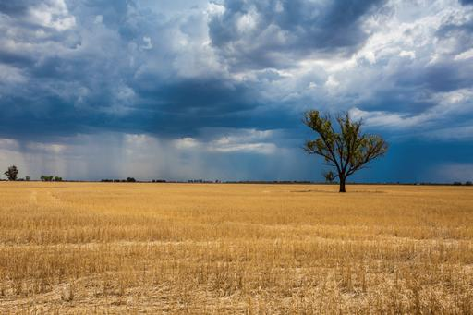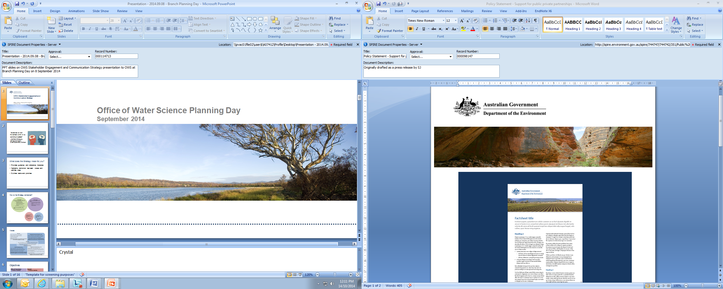

Economic benefits of Landcare

Three case studies highlight some of the on-farm and off-farm economic impacts of Landcare

For over 25 years, Landcare has improved the productivity of Australian agriculture through increasing the adoption of sustainable agricultural practices which not only protect and enhance the productivity of our landscapes, but also improve yields and boost income for farmers. The spread of these practices has had flow-on benefits for local economies, as farmers use more products and services from local suppliers and experts to meet the needs of their growing business.

In three case studies, the combined market value of selected on-farm and off-farm economic benefits from Landcare investment has been estimated in excess of $1 billion.

Multiple benefits of Landcare

Investment in Landcare has supported a number of local and regional initiatives designed to protect and restore the environment and make agriculture more sustainable and productive.1

To build on our knowledge of the benefits of Landcare activities, the National Landcare Advisory Committee and Department of the Environment commissioned Natural Decisions Pty Ltd to develop a systems model approach and examine, and quantify, economic benefits of Landcare.

Scope of study

The researchers used three industry case studies to test the systems model approach. A limited number of on-farm and off-farm direct market impacts were examined for a small number of practices within these industries, enabling only simple initial assessment.

The research is an important first step in quantifying how Landcare activities benefit communities and businesses. Further analysis of more practices across more industries and a more robust valuation of environmental benefits would offer a more comprehensive assessment of the various economic flow-on impacts that can be attributed to Australian Government investment in Landcare.

Key findings

The study found that investment in Landcare has changed the mindset of landholders and generally led to greater and faster adoption of sustainable agricultural practices. However, as with any land management intervention, there is often significant time lag between investment and achieving impacts on and off-farm.

**On-farm benefits** - Sustainable agricultural practices have generally resulted in net economic benefits on-farm including: improved yields, increased farm income, and reduced farm costs. In some cases, revegetation activities and riparian management practices reduced the area needed for production. Economic valuation of on-farm benefits for the different case studies ranged from $30 – $790 million to   
$0.2 - $17 million, depending on the case study. This large range reflects the complexities of valuing on-farm benefits and the variety of different practices employed.

**Off-farm benefits** - Sustainable agricultural practices have also led to direct economic benefits off-farm, such as increased rural supplier sales, and increased use of labour, contractor and consulting services. Economic valuation of off-farm benefits ranged from   
$25 – $48 million to $0.3 - $9.8 million. This large range is also a reflection of the challenges of valuing the diverse off-farm benefits and the variety of different economic circumstances across regions and agricultural industries.

Knowledge gaps and opportunities

Whilst the study identified significant knowledge gaps about the complex economic flow on effects of investment in Landcare practices, it has provided a better foundation for understanding those impacts. The outputs from the study provide governments, natural resource managers and communities with an approach for assessing some of the economic value of Landcare investment. Understanding the benefits of Landcare is becoming more important for building the Australian agricultural brand and accessing global markets.

Using existing biophysical indicators collected in MERIT2 , the natural resource management monitoring

and reporting tool, and readily available financial data, such as gross margins, additional measurement of economic impacts could be conducted. Such an analysis would be complemented by additional non-market economic valuations of key assets and services that are products of Landcare and other programmes. Comprehensive valuations of such impacts could also contribute to a value for money assessment, which was not within the scope of this study.

**Case study results – Liming in the WA grains industry**

The grains industry is the largest agricultural sector in WA. The grains and mixed livestock zone in the south-west region was examined and liming was identified as a key sustainable agricultural practice by local experts.

Liming involves the application of lime to manage soil pH and increase the availability of soil nutrients to plants. Although a number of initiatives have influenced the uptake of liming, since the 1990’s, investment in Landcare specifically has sped up adoption, almost doubling the overall uptake (tonnes of lime sold).

Liming has increased yields, and consequently farm profit, over time across its area of application   
(1.6 million ha as of 2015). This has been estimated to have a present market value of $316 million.

Through extension activities, awareness building, encouraging soil testing, provision of Landcare funding and encouraging cooperation with neighbours, Landcare is responsible for approximately 41%, $131 million, of the present market value.

The lime supplier industry has directly benefited from increased sales. Approximately $48 million profit (assuming a 30% profit margin) can been attributed to Landcare interventions.

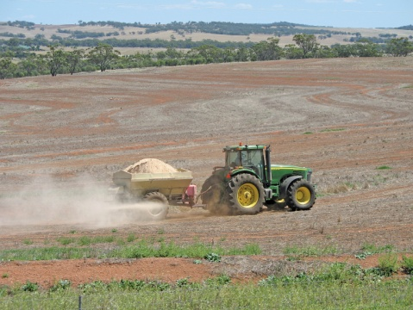

Agricultural liming in WA

**Case study results – Riparian management in the cotton industry**

The cotton industry is an integral part of the Australian economy, worth more than $2 billion annually in export earnings. The major cotton growing areas of QLD and NSW were examined, which are typically located in floodplain areas associated with major river systems and their tributaries. Livestock are often grazed in areas not suitable for cropping, including riparian zones. Local experts identified riparian management as a key sustainable agricultural practice within the industry.

Significant Australian Government and state government funding has been provided to support riparian management activities in the industry. Riparian management involves stock proof fencing to reduce grazing pressure and provision of off-stream watering, which may include crash grazing to control weeds or provide drought fodder. Since 1998, investment in Landcare specifically has sped up adoption of riparian management activities and increased overall uptake by 40% (km of fencing). Landcare has provided funding, encouraged collaboration between farmers to provide landscape scale changes, built capacity to implement change and increased awareness of the value of riparian vegetation.

Landholders have demonstrated strong environmental stewardship by contributing to upfront and maintenance costs associated with fencing, watering and in some cases reduced cropping areas. Numerous on-farm and off-farm flow on benefits, all of economic value, arise from riparian management in the cotton industry:

* Reduced river bank erosion and loss of land
* Increased sediment trapping and improved water quality, including for stock and human use
* Increased recreational fishing and tourism resulting from improved river condition
* Increased habitat and corridors for supporting biodiversity, including beneficial predators and insects
* Reduced flood and storm damage
* Improved social licence to farm

Fencing and watering equipment suppliers and contractors have also directly benefited from increased sales. Approximately $1.5 million profit (assuming a 30% profit margin) can be attributed to Landcare interventions.

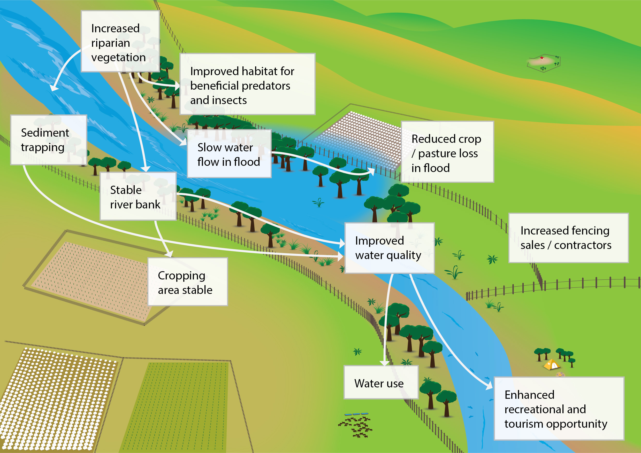



**1** [www.nrm.gov.au/national-landcare-programme](http://www.nrm.gov.au/national-landcare-programme)

**2**Monitoring, evaluation, reporting and improvement tool (MERIT) [www.nrm.gov.au/my-project/monitoring-and-reporting-plan/merit](http://www.nrm.gov.au/my-project/monitoring-and-reporting-plan/merit)

**© Commonwealth of Australia, 2016.**

[](http://creativecommons.org/licenses/by/4.0/)

This publication is licensed by Commonwealth of Australia under a Creative Commons Attribution 3.0 Australia licence and should be attributed as ‘Department of the Environment, *Assessing economic benefits of Landcare*, Commonwealth of Australia 2016’.

The views and opinions expressed in this publication are those of the authors and do not necessarily reflect those of the Australian Government, the Minister for the Environment or the Minister for Agriculture.

Dairying in Gippsland. Photo credit Dairy Australia.

**Case study results – Nutrient and effluent management in the VIC dairy industry**

Dairying is Australia’s third largest rural industry valued at $13 billion annually. The Gippsland dairying region was examined in this study and local experts identified nutrient and effluent management as key sustainable agricultural practices in the industry.

Good practice nutrient and effluent management involves containing effluent within the farm, soil testing and targeted fertiliser application, and utilisation of effluent as a fertiliser. Although a number of initiatives have influenced the uptake of effluent and nutrient management since 2000, investment in Landcare has sped up adoption, increasing overall uptake by over 50% (approximately 72,000 hectares).

Good practice nutrient and effluent management has improved yields and reduced on-farm fertiliser costs, consequently increasing farm profit. Through increasing farmer knowledge, Landcare funding, encouraging soil testing and increasing awareness, the on- farm present economic value was estimated to be $17 million.

The rural consulting industry and soil testing laboratories have also directly benefited from increased servicing in the Gippsland region. Approximately $1.7 million profit (assuming a 30% profit margin) can be attributed to Landcare interventions.

[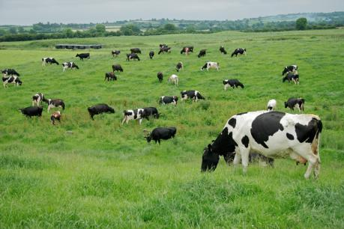](http://www.google.com.au/url?sa=i&rct=j&q=&esrc=s&frm=1&source=images&cd=&cad=rja&uact=8&ved=0CAcQjRxqFQoTCN2FhbqzgskCFePjpgodfx4FYg&url=http://www.dairybusiness.com.au/&bvm=bv.106923889,d.dGY&psig=AFQjCNGfequggrBYvRLpnpTaUvsUTefLAQ&ust=1447125437775977)